Source: CoU AHG
Title: “Compilation of Understanding” for the oneM2M Initiative for M2M Standardization – V5 Internal Living Document
Agenda item: {?} (For Discussion and Action)

Foreword
This living document is intended to reflect the compilation of agreements after each meeting of the Potential Partners. This version 4 reflects the agreements till the conclusion of March 5, 2012 Virtual Meeting.
Note: Revisions compared with previous version are visible in red.
Note: The Plenary is also invited to comment and give guidance on the structure and approach of this document, in addition to assessing the correctness of the content.
Note: The CoU document will record “contentwise” agreed results, views and targets but not actions and processes (e.g. setting up adhoc groups etc.) for achieving the results and agreements.
Note: Main version numbers like x (x=1,2,3, …) are used for Plenary level documents. Interim versions x.y (y=0…9) are used for the CoU AdHoc group internal process during the Plenary meetings/calls.

{oneM2M Initiative for Global M2M Standardization}
“Compilation of Understanding”

This Compilation is an expression of the joint understanding of status of the common work toward mutually agreed upon goals; however, this Compilation of Understanding, as such, is not an Agreement to be signed and binding upon the associations.

Introduction
ARIB, ATIS, CCSA, ETSI, TIA, TTA, and TTC (the “SDOs”) recognize that M2M services often rely upon telecommunications providers for connectivity between the myriad of devices in the field and the M2M application servers. There is a need for a common efficient, easily and widely available M2M Service Layer, which can be readily embedded within various hardware and software. Thus, the SDOs have identified the need for a cooperative M2M community standards activity which leads to regularly enhanced releases of the M2M Service Layer specifications. This standards activity is known as “oneM2M”.

Objectives and Purpose
The SDOs have reached a common understanding on the benefits to form a M2M initiative, and agree to proceed forward in the formal establishment of “oneM2M” with a common understanding on its purpose as being a global initiative to:
- Develop one globally agreed M2M specifications with initial focus on Service Layer, using common use cases and end-to-end architecture principles across several vertical M2M applications.
- Interface this Service Layer to higher layer applications and underlying network transport capabilities through a standardized adaptation layer, if necessary.
- Develop or leverage existing work in other fora for Service Layer network and device APIs, as desired.
- Consolidate current M2M Service Layer standards activities into the oneM2M initiative.
- Identify a common Service Layer architecture and identify gaps where existing standards do not fulfill the requirements and provide or initiate the creation of specifications to fill these gaps.
- Develop and maintain Technical Specifications and Technical Reports in support of the M2M common Service Layer architecture framework.
- Partner/Collaborate with wireless and wireline SDOs and fora responsible for developing standards for Core and Access Networks.
- Partner/Collaborate with SDOs and fora in charge of developing the vertical markets (i.e., domain-specific) aspects of M2M applications.
- Partner/Collaborate with SDOs and fora in charge of developing auxiliary specifications (e.g., OMA Device Management and Device APIs, W3C for Device APIs).
- Develop specifications that will help drive the industry towards a goal of lower operating expenses, lower capital expenses, faster time-to-market, and mass-market economies of scale.
Scope
The SDOs have reached a common understanding on the scope of the oneM2M initiative to include:
- Use cases and requirements for a common set of Service Layer capabilities
- Service Layer aspects with high level and detailed service architecture, in light of an access independent view of end-to-end services
- Protocols/APIs/standard objects based on this architecture (open interfaces & protocols)
- Security and privacy aspects (authentication, encryption, integrity verification)
- Reachability and discovery of applications
- Interoperability, including test and conformance specifications
- Charging aspects (charging data, not billing)
- Identification and naming of devices and applications
- Information models and data management (including store and subscribe/notify functionality)
- Management aspects (including remote management of entities)
- Common use cases, terminal/module aspects, including Service Layer interfaces/APIs between:
  - Application and Service Layers
  - Service Layer and communication functions
Responsibility
The SDOs have reached a common understanding that the oneM2M initiative shall have the responsibility to develop and maintain specifications and reports related to a globally interoperable framework, taking an end-to-end view, to facilitate Machine-to-Machine (M2M) business, with attention to Service aspects, specifically:
- To identify areas where standardization would facilitate M2M business and to develop, approve and maintain the necessary set of Technical Specifications and Technical Reports within Scope above.
- To consider the evolution of M2M
- To facilitate dissemination and usage of the developed Technical Specifications and Technical Reports
- To facilitate awareness of its activities and of solutions it develop

Principles
The SDOs agree that participation in the oneM2M initiative will be open and well balanced; provide opportunities for various levels of participation; accommodate companies and organizations, and provide flexibility for inputs from all market segments.
The oneM2M initiative will avoid overlap with existing work and focus on cooperative efforts, and prioritize work efforts based upon importance and work assignments.
Participation
Participation is under discussion

Structure
The SDOs have a common understanding to:
- Establish a simple and effective operational structure
- Be responsive to the needs of the vertical market stakeholders (individual and organizational), SDOs, and service providers
- Balance regional requirements and differences
- Address timeframe objectives across the regions
- Support global harmonization and consolidation
- Afford a level playing field for all stakeholders
- Constrain resource and travel commitments, and leverage electronic tools as much as possible
- Develop common procedures, including common policy for essential IPR, using existing FRAND/RAND IPR policies of the participating partners.

Note: Working assumption is that the initiative is a non-legal entity

The SDOs agree that the structure will include a Steering Committee and a Technical Plenary which reports to the Steering Committee.
Note from CoU group leader: The responsibilities listed below still seem to be for further study and may not be considered as agreed. We need to decide if we keep this list now or remove it and bring it back in proper shape when decisions have been made. Maybe we could keep this under the notion “possible” as it says in the verticals slide set.
Possible Steering Committee Responsibilities:
- Manages work scope & direction
  - Approves Terms of Reference (ToR)
  - Approves scope of Technical Plenary
- Develops Working Procedures
  - Defines procedures for resolving deadlocks at technical plenary level
  - Approves new liaison relationships
  - Deals with other organizational issues as they arise
  - May create task groups with responsibility to handle issues as they arise
- Organizational Oversight
  - Handles appeals of process issues
  - Elects Steering Committee leadership
  - Approves Technical Plenary leadership
  - Develops and manages budget
  - Manages secretariat
  - Handles marketing and public relationship

Possible Technical Plenary Responsibilities:
- Technical Program Management
  - Responsible for technical program and its management
  - Manages and approves Work Items and Study Items (scope, timescale, responsible groups)
  - Determines whether specific regional requirements will be addressed
  - Handles release process and change process
  - Creates Working Groups (WGs) and Ad Hoc Groups (AHGs) as needed
- Technical Oversight
  - Elects leadership (subject to Steering Committee approval)
  - Approves WG leadership
  - Approves Terms of Reference (ToR) and scope of WGs and AHGs
  - Resolves deadlocks within WGs

Note: Partners agreed on March 5th to add Working Procedures in the scope of work.
Timeline
Note: Revised Timeline and associated modified milestones were proposed during meeting on March 5th for decision in the meeting on March 14th. (Possible changes will be added here when agreed.)
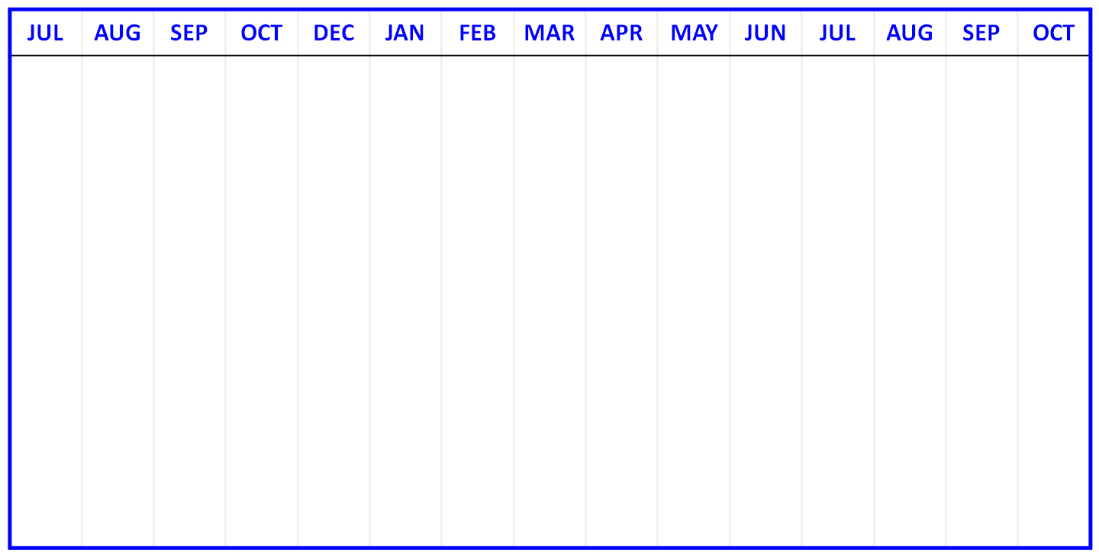

SDO Meeting#01,
Seoul, 21 Jul

SDO Meeting#02,
Washington,
17-18 Aug

SDO Meeting#03,
Berlin, 15-16 Dec
Reach out to verticals

M1: “Soft Launch”

M2: Final Consensus

M4: Official Signing

Technical Plenary Meeting#1
Virtual SDO meetings

SDO Meeting#04,
Tokyo, 28-29 Mar

M3: Final Draft
Virtual meetings

Steering Committee Meeting#1

Steering Committee Meeting#2

M5:
TP start prepared

M6:
WG start prepared

Events | Targeted Date | Completed Date | Note/Current Outlook
Milestone M1 | Jan 18, 2012 | Jan 18, 2012 | “Soft Launch”
Milestone M2 | Feb 17, 2012 | Not completed | Final Consensus/ Feb 17, 2012
Milestone M3 | Mar 9, 2012 |  | Final Draft/ Mar 9, 2012
Milestone M4 | Mar 30, 2012 |  | Official Signing/ Mar 30, 2012
Milestone M5 | Jun 19, 2012 |  | TP Start Prepared/ Jun 19, 2012
Milestone M6 | Jul 31, 2012 |  | WG Start Prepared/ Jul 31, 2012
SC Meeting #1 | TBD
TG Meeting #1 | TBD
WG Meeting #1 | TBD

Table 1: Key Dates for Milestones and Planned Events

Milestone M1 – “Soft Launch”
- IPR regime agreed
- Communiqué released
- Material for communication with verticals updated to include Berlin meeting results
- Target date: 18 Jan 2012 - Completed
Milestone M2 – Final Consensus
- Feedback from vertical reach outs incorporated into major principles
- Final consensus reached and documented on all major principles (scope, partnership and participation principles, structure, legal status, participation rules, rights and responsibilities, level of secretariat services, funding)
- Initial Organizations identified and start work on drafting the founding documents
- Target date: 17 Feb 2012 - Not completed
Milestone M3 – Final Draft
- Final review of feedback from vertical reach outs
- Final draft of founding documents available
(Participation rules, procedures, IPR policy and anti-trust policy, member fees, budget plan for first year)
- Secretariat support activities identified
(online web presence, on-site meeting support, document editing, document management, branding/publicity)
- Convener of Steering Committee nominated
- Target date: 9 Mar 2012
Milestone M4 – Official Signing
- Founding agreement signed
- Members of Steering Committee identified
- Preliminary list of members of the initiative identified
- Target date: 30 Mar 2012
Milestone M5 – TP start prepared
- Convenor of Technical Plenary nominated
- Participants of Technical Plenary identified
- Working Procedures approved
- List of standards/specifications to be transferred into GI agreed
- Target date: 19 Jun 2012
Milestone M6 – WG start prepared
- Initial Work Plan defined
- Initial Working Groups defined
- Convenors of Working Groups nominated
- Meeting schedule defined
- Target date: 31 Jul 2012
Note from CoU group leader: Below the ToR agreed in the Berlin meeting has been inserted. We have already sections in this document with similar content. In the discussion views have been expressed to keep the ToR in the document and to remove the ToR. As a result, for the time being we keep both in the CoU document.
Term of Reference
- Definitions
  - Machine-to-Machine (M2M) is related to control/monitoring system comprising of sensor/actuator/processing nodes that are connected via communication networks, designed in such a way that exchange of information can be triggered without human interaction.
  - oneM2M is the agreed name for this M2M Collaboration Initiative
- Scope
  - Use cases and requirements for a common set of Service Layer capabilities
  - Service Layer aspects with high level and detailed service architecture, in light of an access independent view of end-to-end services
  - Protocols/APIs/standard objects based on this architecture (open interfaces & protocols)
  - Security and privacy aspects (authentication, encryption, integrity verification)
  - Reachability and discovery of applications
  - Interoperability, including test and conformance specifications
  - Charging aspects (charging data, not billing)
  - Identification and naming of devices and applications
  - Information models and data management (including store and subscribe/notify functionality)
  - Management aspects (including remote management of entities)
  - Common use cases, terminal/module aspects, including Service Layer interfaces/APIs between:
    - Application and Service Layers
    - Service Layer and communication functions
- Responsibility
  - oneM2M shall have the responsibility to develop and maintain specifications and reports related to a globally interoperable framework, taking an end-to-end view, to facilitate Machine-to-Machine (M2M) business, with attention to Service aspects, specifically:
    - To identify areas where standardization would facilitate M2M business and to develop, approve and maintain the necessary set of Technical Specifications and Technical Reports within Scope above.
    - To consider the evolution of M2M
    - To facilitate dissemination and usage of the developed Technical Specifications and Technical Reports
    - To facilitate awareness of its activities and of solutions it develops
- Organization and working methods
  - oneM2M and groups operating within oneM2M shall work in accordance with the Working Procedures – a document to be developed during the start-up phase

Summary of Commitment to the Global Initiative for M2M Standardization
The SDOs have agreed to collaborate in the formation of oneM2M initiative. The SDOs have reviewed the proposed purpose, scope, and principles of oneM2M and will progress the initiative as defined in the timeline within this Compilation of Understanding.
In Berlin meeting the SDOs agreed to make a public statement (jointly agreed and issued Communique) in January. Final draft of the communiqué was approved during January 18, 2012 Virtual Meeting. The communiqué has since been released by various SDOs.

