CHANGE REQUEST
Group Name:* | WG2
Source:* | Barbara Pareglio, NEC, Barbara.pareglio@neclab.eu
Format:* | ARC10
Date:* | 2014-03-28
Contact:* | Barbara Pareglio, NEC, Barbara.pareglio@neclab.eu
Reason for Change/s:* | Made common attributes consistent by aligning AccessControlPolicy and labels
CR against: Release*
CR against: TS/TR* | TS-0001 v 0.4.2
Clauses/Sub Clauses* | 9.6.x, Annex D
Type of change: * | Editorial change  Bug Fix or Correction  Change/correction to existing feature or functionality  New feature or functionality
Post Freeze checking:* | This CR contains only essential changes and corrections  YES NO

oneM2M Notice
The document to which this cover statement is attached is submitted to oneM2M. Participation in, or attendance at, any activity of oneM2M, constitutes acceptance of and agreement to be bound by terms of the Working Procedures and the Partnership Agreement, including the Intellectual Property Rights (IPR) Principles Governing oneM2M Work found in Annex 1 of the Partnership Agreement.
GUIDELINES for Change Requests:
Provide an informative introduction containing the problem(s) being solved, and a summary list of proposals.
Each CR should contain changes related to only one particular issue/problem.
Follow the principle of completeness, where all changes related to the issue or problem within a deliverable are simultaneously proposed to be made E.g. A change impacting 5 tables should not only include a proposal to change only 3 tables. Includes any changes to references, definitions, and acronyms in the same deliverable.
Follow the drafting rules.
All pictures must be editable.
Check spelling and grammar to the extent practicable.
Use Change bars for modifications.
The change should include the current and surrounding clauses to clearly show where a change is located and to provide technical context of the proposed change. Additions of complete sections need not show surrounding clauses as long as the proposed section number clearly shows where the new section is proposed to be located.
Multiple changes in a single CR shall be clearly separated by horizontal lines with embedded text such as, start of change 1, end of change 1, start of new clause, end of new clause.
When subsequent changes are made to content of a CR, then the accepted version should not show changes over changes. The accepted version of the CR should only show changes relative to the baseline approved text.

Introduction
This contribution proposes to following modifications:
- Fixed the location of some resource that were not defined where they belong to, such as <locationPolicy>
- Change <entity> to <CSEBase>
- Made the resourceType attribute consistent for all resource, it should always be a WO.
- Made the access control policy also consistent in all resources. After also some discussion on WG3 it seems that the easiest way is to be consistent with other attributes like labels that is a single occurrence of the attribute but which may contain a list of values, so the proposal is to use 0..1. If the accessControlPolicy is not present explicitly: the one of the parent shall be used.
- Consistently added labels attribute
- removed creator from the common attributes, but left on the polling channel, charging rlated resources and removed from other resources.

-----------------------Start of change 1-------------------------------------------

9.6.1 Common Attributes
Many of the attributes of the resources described in the present document are common. Such attributes are described here once in order to avoid duplicating the description for every resource that contains it.
Attributes that are only used in one or two resource types are described only in the clause for that resource type.
In all tables representing resource attributes, each attribute name is followed by its "short name" in brackets that shall be used in resource representations to be transferred across reference points.

Table 9.6.1-1: Common Attributes
Common Attribute | Description
resourceType (rT) | Resource Type. This WO resourceType attribute identify the type of resource as specified in section 9.6., e.g. CO for <container>, CI for <instance> AP for <Application> or similar.  Each resource shall have a resourceType attribute, The value of such an attribute is given at creation time and it cannot be change.
parentID (pID) | The identifier identifies the parent resource.  Editor's Note: The adoption of a URI format is still to be confirmed.  The system shall assign the value to this attribute according to the parameters given in the CREATE request.
accessControlPolicies (aRI) | The attribute contains a list of identifiers (either an ID or a URI depending if it is a local resource or not) of an <accessControlPolicy> resource. The privileges defined in the <accessControlPolicy> resource that are referenced determine who is allowed to access the resource containing this attribute for a specific purpose (e.g. Retrieve, Update, Delete, etc.).  If a resource type does not have an accessControlPolicies attribute definition, then the accessControlPolicy for that resource is governed in a different way, for example, the accessControlPolicy associated with the parent may apply to a child resource that does not have an accessControlPolicies attribute definition, or the privileges for access are fixed by the system. Refer to the corresponding resourceType and procedures to see how permissions are handled in such cases.  If a resource type does have an accessControlPolicies attribute definition, but the (optional) accessControlPolicies attribute is not set, or it is set to a value that does not correspond to a valid, existing <accessControlPolicy> resource, or it refers to an <accessControlPolicy> resource that is not reachable (e.g. because it is located on a remote CSE that is offline or not reachable), then the system default access privileges shall apply.  All resources are accessible only if the permissionprivileges from the Access Control PolicyRight grants it, therefore all resources shall have an associated AccessControlPoliciesRightID attribute, either explicitly (setting the attribute in the resource itself) or implicitly (either by using the parent privileges or the system defaults). Which means that the system shall provide a default access privileges in case that the Originator does not provide a specific AccessControlPolicies during the creation of the resource, Default access grants the configuresall permissions privileges (i.e. the full set of permissionsFlags) to the following permission holdersto the originator (e.g. depending on the prefix of URI of the resource).:  This attribute is absent in some cases in the resource, especially if the resource shall have the same privileges of the parent resource; such an attribute is therefore not needed.
creationTime (cT) | Time/date of creation of the resource.  This attribute is mandatory for all resource and the value to such an attribute is assigned by the system at the time that the resource is locally created. Such an attribute cannot be changed.
expirationTime (eT) | Time/date after which the resource will be deleted by the hosting CSE. This attribute can be provided by the Originator, and in such a case it will be regarded as a hint to the hosting CSE on the lifetime of the resource. The hosting CSE can however decide on the real expirationTime. If the hosting CSE decides to change the expirationTime attribute value, this is communicated back to the Originator.  The lifetime of the resource can be extended by providing a new value for this attribute in an UPDATE verb. Or by deleting the attribute value, e.g. by not providing the attribute when doing a full UPDATE, in which case the hosting CSE can decide on a new value.  This attribute shall be mandatory, if the Originator does not provide a value in the CREATE operation the system shall assign an appropriate value depending on its local policies and/or M2M service subscription agreements.
lastModifiedTime (lMT) | Last modification time/date of the resource.  This attribute shall be mandatory and its value is assigned automatically by the system each time that the addressed target resource is modified by means of the UPDATE operation.
versionTag (vT) | An incremental counter of modification on the resource. When a resource is created, this counter is set to 0, and it will be incremented on every modification of the resource.  NOTE: In order to enable detection of overflow, the counter needs to be capable of expressing sufficiently long numbers. .
labels(lBs) | Tokens used as keys for discovering resources.  This attribute is optional and if not present it means that the resource cannot be found by means of discovery procedure which uses labels as key parameter of the discovery.
link (ln) | This attribute shall be present only for the announced resource. This attribute shall provide the URI to the original resource.
announceTo (aT) | This attributes shall be present for the announceable original resource only.  This attribute maintains the list of URIs to the announced resources. Updates on this attribute will trigger new resource announcement or de-announcement.  In case of new resource announcement, either the exact URI to the announced resource that is to be created can be provided, or the CSE-ID of the remote CSE can be provided. This means the original resource-hosting CSE will decide the exact location of the announced resource in the remote CSE identified by the CSE-ID.
announcedAttribute (aA) | This attributes shall be present for the announceable original resource only.  This attribute maintains the list of the announced attributes in the original resource. Updates on this attribute will trigger new attribute announcement if a new attribute is added or de-announcement if the existing attribute is removed.

-----------------------End of change 1---------------------------------------------

-----------------------Start of change 2-------------------------------------------

9.6.3 Resource Type CSEBase
A <CSEBase> resource shall represent a CSE. This <CSEBase> resource shall be the root for all the resources that are residing on the CSE.
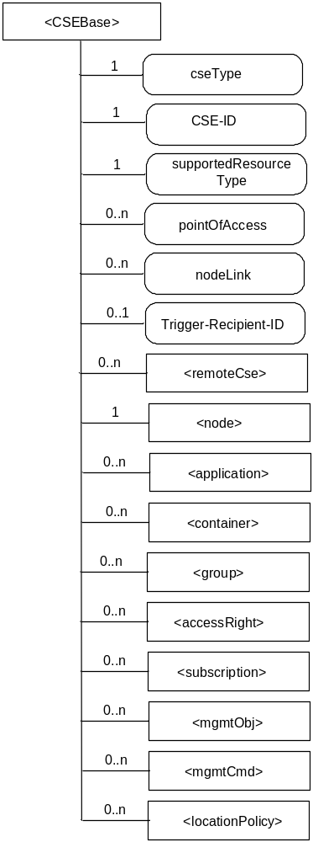

Figure 9.6.3-1: Structure of <CSEBase> resource
(only resource specific attributes are shown)
This resource shall contain the child resources according to their multiplicity in Table 9.6.3-1 (0 indicates the optionality of the child resource).
Table 9.6.3-1: Child resources of <CSEBase> resource
Child Resource Name of <CSEBase> | Child Resource Type | Multiplicity | Description
[variable] | <remoteCSE> | 0..n | See section 9.6.4
[variable] | <node> | 1 | See section 9.6.19
[variable] | <application> | 0..n | See section 9.6.5
[variable] | <container> | 0..n | See section 9.6.6
[variable] | <group> | 0..n | See section 9.6.13
[variable] | <accessControlPolicy> | 0..n | See section 9.6.2
[variable] | <subscription> | 0..n | See section 9.6.8
[variable] | <mgmtObj> | 0..n | See section 9.6.15
[Variable] | <mgmtCmd> | 0..n | See section 9.6.17
[Variable] | <locationPolicy> | 0..n | See section 9.6.10

Editor’s Note: this list should be updated. Which resource types are added is FFS.
Editor’s Note: how to extend functionality is FFS.
The <CSEBase> resource shall contain the attributes described in Table 9.6.3-2.
Table 9.6.3-2: Attributes of <CSEBase> resource
Attribute Name of <CSEBase> | Multiplicity | RW/  RO/  WO | Description
resourceType (rT) | 1 | RO | See section 9.6.1 where this common attribute is described.
creationTime (cT) | 1 | RO | See section 9.6.1 where this common attribute is described.
lastModifiedTime (lMT) | 1 | RO | See section 9.6.1 where this common attribute is described.
accessControlPolicies (aRI) | 0..1 | RW | See section 9.6.1 where this common attribute is described.
labels (lBs) | 0..1 | RW | See section 9.6.1 where this common attribute is described.
cseType (csT) | 1 | WO | Indicates the type of CSE node represented by the created resource.
CSE-ID | 1 | WO | The globally unique CSE identifier.
supportedResourceType (sRT) | 1 | RO | List of the resource types which are supported in CSE. this attribute contains subset of resource types listed in section 9.2
pointOfAccess (poA) | 0..n | RW | represents the list of physical addresses to be used for remote CSEs to connect to this CSE (e.g. IP address, FQDN). This attribute is used to announce its value to remote CSEs.
nodeLink | 0..1 | RO | A reference (URI) of a <node> resource that stores the node specific information only if this <application> resource is about ADN-AE and the <node> resource is existed in the parent resource, <CSEBase>.
Trigger-Recipient-ID | 0..1 | RW | See section 7.1.10 where this attribute is described.

9.6.4 Resource Type remoteCSE
A <remoteCSE> resource shall represent a remote CSE that is registered to the local CSE. CSE resources shall be located directly under the <CSEBase>.
Conversely each registered CSE shall also be represented as a sub-set of <remoteCSE> resource in the registering CSE's <CSEBase>.
For example, when CSE1 registers with CSE2, there will be two <remoteCSE> resources created: one in CSE1 <CSEBase1>/<remoteCSE2> and one in CSE2 <CSEBase2>/<remoteCSE1>.
Note that the creation of the two resources does not imply mutual registration. The <CSEBase1>/<remoteCSE2> is only local to CSE1 and is for its internal use.
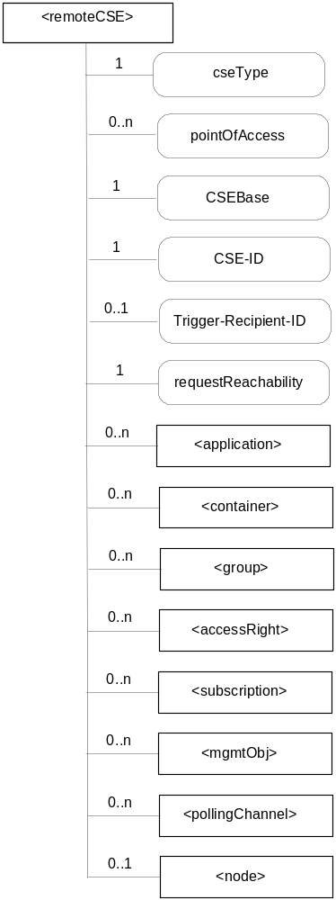

Figure 9.6.4-1: Structure of <remoteCSE> resource
(only resource specific attributes are shown)
Editor's Note: To update the picture to include "link", "announceTo" and "announcedAttribute" attribute.
This resource shall contain the child resources according to their multiplicity in Table 9.6.4-1 (0 indicates the optionality of the child resource).

Table 9.6.4-1: Child resources of <remoteCSE> resource
Child Resource Name of <remoteCSE> | Child Resource Type | Multiplicity | Description | <remoteCSEAnnc> Child Resource Types
[variable] | <application> | 0..n | See clause 9.6.5 | <applicatoinAnnc>
[variable] | <container> | 0..n | See clause 9.6.6 | <containerAnnc>
[variable] | <group> | 0..n | See clause 9.6.13 | <groupAnnc>
[variable] | <accessControlPolicy> | 0..n | See clause 9.6.2 | <accessControlPolicyAnnc>
[variable] | <subscription> | 0..n | See clause 9.6.8 | <subscription>
[variable] | <mgmtObj> | 0..n | See clause 9.6.15 | <mgmtObjAnnc>
[variable] | <pollingChannel> | 0..n | See section 9.6.22.  If requestReachability is FALSE, the CSE that created this <remoteCSE> should create a <pollingChannel> resource and perform long polling. | ??
[variable] | <node> | 0..1 | See section 9.6.19.  This child resource contains the node specific information only when the information represented by this resource is from a node of type ASN or MN. | ??

The <remoteCSE> resource shall contain the attributes described in Table 9.6.4-2.

Table 9.6.4-2: Attributes of <remoteCSE> resource
Attribute Name of <remoteCSE> | Multiplicity | RW/  RO/  WO | Description | <remoteCSEAnnc> Attributes
resourceType (rT) | 1 | RO | See clause 9.6.1 where this common attribute is described. | MP
parentID (pID) | 1 | RO | See clause 9.6.1 where this common attribute is described. | MP
creationTime (cT) | 1 | RO | See clause 9.6.1 where this common attribute is described. | MP
lastModifiedTime (lMT) | 1 | RO | See clause 9.6.1 where this common attribute is described. | MP
expirationTime (eT) | 0..1 | RW | See clause 9.6.1 where this common attribute is described. | MP
accessControlPolicies (aRI) | 0..1 | RW | See clause 9.6.1 where this common attribute is described. | MP
labels (lBs) | 0..1 | RW | See clause 9.6.1 where this common attribute is described. | MP
link | 1 | WO | See section 9.6.1 where this common attribute is described. This is only for <remoteCSEAnnc>. | MP
announceTo | 1 | RW | See section 9.6.1 where this common attribute is described. | NP
announcedAttribute | 1 | RW | See section 9.6.1 where this common attribute is described. | NP
cseType (csT) | 1 | WO | Indicates the type of CSE node represented by the created resource. | OP
pointOfAccess (poA) | 0..n | RW | For request-reachable remote CSE it represents the list of physical addresses to be used to connect to it (e.g. IP address, FQDN). The attribute is absent if the remote CSE is not request-reachable. | OP
CSEBase (bRt) | 1 | WO | The URI of the CSEBase of the original CSE represented by remote CSE. | OP
CSE-ID | 1 | WO | The globally unique CSE identifier. | OP
Trigger-Recipient-ID | 0..1 | RW | See section 7.1.10 where this attribute is described. | ??
requestReachability | 1 | RW | If the CSE that created this <remoteCSE> can receive a request from other AE/CSE(s), this attribute is set to “TRUE” otherwise “FALSE”.  NOTE: Even if this attribute is set to “FALSE”, it does not mean it AE/CSE is always unreachable by all entities. E.g., the requesting AE/CSE is behind the same NAT, so it can communicate within the same NAT. | ??

<remoteCSE> and announced <remoteCSE> shall have different resourceType coding.
Editor's Note on CSE-ID: an alignment between CSE-ID and CSEBase is needed.
Editor's Note on CSEBase: the alignment with naming convention proposed for inter-M2M service provider is needed.
Editor's Note on child resources: child resources of <remoteCse> resource can accommodate listed resources and their announced versions.

9.6.5 Resource Type application
The <application> resource represents information about an Application Entity known to a given Common Services Entity.
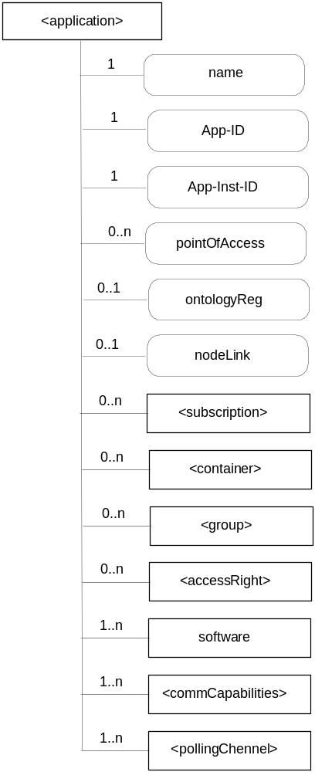
Figure 9.6.5-1: Structure of <application> resource
(only resource specific attributes are shown)
Editor's Note: To update the picture to include "link", "announceTo" and "announcedAttribute" attribute.
This resource shall contain the child resources according to their multiplicity in Table 9.6.5-1 (0 indicates the optionality of the child resource)T

Table 9.6.5-1: Child resources of <application> resource
Child Resource Name of <application> | Child Resource Type | Multiplicity | Description | <applicationAnnc> Child Resource Type
[variable] | <subscription> | 0..n | See clause 9.6.8 | <subscription>
[variable] | <container> | 0..n | See clause 9.6.6 | <containerAnnc>
[variable] | <group> | 0..n | See clause 9.6.13 | <groupAnnc>
[variable] | <accessControlPolicy> | 0..n | See clause 9.6.2 | <accessControlPolicyAnnc>
software | <mgmtObj> | 1..n | See clause 9.6.15 for <mgmtObj>.  This resource represents the software component (or components, if the multiplicity is greater than 1) that compose the application. This mgmtObj shall have at least the following <parameters> child resources of its "parameters" subresource:  name (multiplicity 1)  version (multiplicity 1)  state (multiplicity 1) | <mgmtObjAnnc>
[variable] | <commCapabilities> | 1..n | Resource <commCapabilities> needs to be defined.  This resource describes the communication capabilities (essentially the protocols) supported and used by the corresponding Application Entity over the Mca reference point to this CSE. | <commCapabilitiesAnnc>
[variable] | <pollingChannel> | 0..n | See section 9.6.22.  When the local CSE of this AE is request-unreachable, the AE should create this <pollingChannel> resource and perform long polling. | ??

The <application> resource shall contain the attributes described in Table 9.6.5-2.

Table 9.6.5-2: Attributes of <application> resource
Attribute Name of <application> | Multiplicity | RW/  RO/  WO | Description | <applicationAnnc> Attributes
resourceType (rT) | 1 | RO | See clause 9.6.1 where this common attribute is described. | MP
parentID (pID) | 1 | RO | See clause 9.6.1 where this common attribute is described. | MP
expirationTime (eT) | 0..1 | RW | See clause 9.6.1 where this common attribute is described. | MP
accessControlPolicies (aRI) | 0..1 | RW | See clause 9.6.1 where this common attribute is described. | MP
creationTime (cT) | 1 | RW | See clause 9.6.1 where this common attribute is described. | MP
lastModifiedTime (lMT) | 1 | RO | See clause 9.6.1 where this common attribute is described. | MP
labels (lBs) | 0..1 | RO | See clause 9.6.1 where this common attribute is described. | MP
link | 1 | WO | See section 9.6.1 where this common attribute is described. This is only for <applicationAnnc>. | MP
announceTo | 1 | RW | See section 9.6.1 where this common attribute is described. | NP
announcedAttribute | 1 | RW | See section 9.6.1 where this common attribute is described. | NP
name | 1 | RO | The (usually human readable) name of the application, as declared by the application developer (e.g. "HeatingMonitoring") | OP
App-ID | 1 | RO | Application Identifier | OP
App-Inst-ID | 1 | RO | When the application resource refers to an actual application instance in the executing environment. | OP
pointOfAccess | 0..n | RW | The list of addresses for communicating with the registered Application Entity over Mca reference point via the transport services provided by Underlying Network (e.g., IP address, FQDN, URI). This attribute shall be accessible only by the Application and the hosting CSE. | ??
ontologyRef | 0..1 | RW | A reference (URI) of the ontology used to represent the information that is managed and understood by the application; to be passed to the application | OP
nodeLink | 0..1 | RO | A reference (URI) of a <node> resource that stores the node specific information only if this <application> resource is about ADN-AE and the <node> resource is existed in the parent resource, <CSEBase>. | ??

Editor's Note: Cardinality of pointOfAccess attribute (0..n) needs to be investigated for all its occurrences.

9.6.6 Resource Type container
This resource represents a container for data instances. It is used to share information among other entities and potentially to track the data. A <container> resource has no associated content, only attributes and child resources.
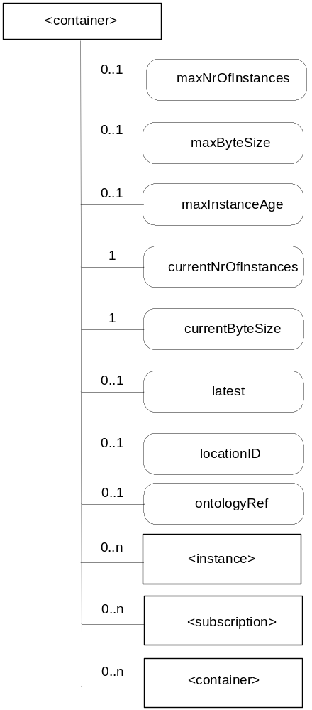
Figure 9.6.6-1: Structure of <container> resource
(only child resources and resource specific attributes are shown)
Editor's Note: To update the picture to include "link", "announceTo" and "announcedAttribute" attribute.
This resource shall contain the child resources according to their multiplicity in Table 9.6.6-1 (0 indicates the optionality of the child resource).
Editor's Note: Susbscription relation with this resource is for FFS.
Editor's Note: location resource relation with containers is for FFS.

Table 9.6.6-1: Child resources of <container> resource
Child Resource Name of <container> | Child Resource Type | Multiplicity | Description | <containerAnnc> Child Resource Type
[variable] | <instance> | 0..n | See clause 9.6.7 | <instanceAnnc>
[variable] | <subscription> | 0..n | See clause 9.6.8 | <subscriptionAnnc>
[variable] | <container> | 0..n | See clause 9.6.6 | <containerAnnc>

This resource shall contain the attributes according to their multiplicity in Table 9.6.6-2 (0 indicates the optionality of the attribute).

Table 9.6.6-2: Attribute of <container> resource
Attribute Name of <container> | Multiplicity | RW/  RO/  WO | Description | <containerAnnc> Attributes
resourceType (rT) | 1 | RO | See clause 9.6.1 where this common attribute is described. | MP
parentID (pID) | 1 | RO | See clause 9.6.1 where this common attribute is described. | MP
expirationTime (eT) | 1 | RW | See clause 9.6.1 where this common attribute is described. | MP
accessControlPolicies (aRI) | 0..1 | RW | See clause 9.6.1 where this common attribute is described. If no accessConytolPolicyID is given at the time of creation, the accessControlPolicies of the parent resource is linked to this attribute | MP
labels (lBs) | 0..1 | RO | See clause 9.6.1 where this common attribute is described. | MP
creationTime (st) | 1 | RW | See clause 9.6.1 where this common attribute is described. | MP
creator (cr) | 1 | RW | The App-inst-ID or CSE-ID of the entity which created the resource | MP
lastModifiedTime (lMT) | 1 | RO | See clause 9.6.1 where this common attribute is described. | MP
versionTag (vT) | 1 | RO | See clause 9.6.1 where this common attribute is described. | ??
link | 1 | WO | See section 9.6.1 where this common attribute is described. This is only for <containerAnnc>. | MP
announceTo | 1 | RW | See section 9.6.1 where this common attribute is described. | NP
announcedAttribute | 1 | RW | See section 9.6.1 where this common attribute is described. | NP
maxNrOfInstances (mi) | 0..1 | RW | Maximum number of instances of <instance> child resources. | OP
maxByteSize (mb) | 0..1 | RW | Maximum number of bytes that are allocated for a <container> resource for all instances in the <container> resource. | OP
maxInstanceAge (ma) | 0..1 | RW | Maximum age of the instances of <instance> resources within the <container>. The value is expressed in seconds. | OP
currentNrOfInstances (ni) | 1 | RO | Current number of instances in a <container> resource. It is limited by the maxNrOfInstances. | OP
currentByteSize (nb) | 1 | RO | Current size in bytes of data stored in a <container> resource. It is limited by the maxNrOfBytes. | OP
latest (lt) | 0..1 | RO | Reference to latest instance, when present. | OP
locationID (LID ) | 0..1 | RW | URI of the resource where the attributes/policies that define how location information are obtained and managed. This attribute is defined only when the <container> resource is used for containing location information. | OP
ontologyRef (oR) | 0..1 | RW | A reference (URI) of the ontology used to represent the information that is stored in the instances of the container.  (see note)  NOTE: The access to this URI is out of scope of oneM2M. | OP

Editor's Note: Mechanisms for announcing are FFS.
Editor's Note: The container type is FFS.
Editor's Note: The following attributes are FFS depending on resource structure discussions:
- child: resources with child relation with the considered resource
- parent: resources with paren relation with the considered resource

9.6.7 Resource Type instance
The <instance> resource represents a data instance in the container. The content of the instance is opaque to the M2M platform and it might even be encrypted. However, there is meta-data associated with an instance which shall be accessible.
Contrary to other resources, the <instance> resource cannot be modified once created, regardless of the accessControlPolicies associated with the parent resource. An instance may be deleted explicitly or it may be deleted by the platform based on policies. If the platform has policies for the instance retention these shall be represented by the attributes maxByteSize, maxNrOfInstances and/or maxInstanceAge on the <container> resource. If multiple policies are in effect, the strictest policy shall apply.
The <instance> resource inherits the same access rights of the parent <container> resource, and does not have its own <accessControlPolicy> attribute.
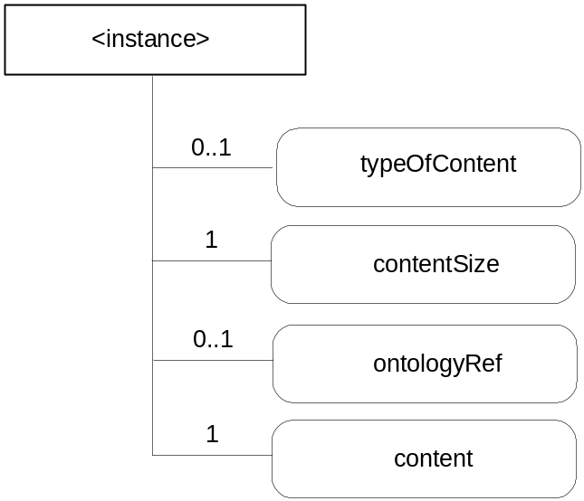
Figure 9.6.7-1: Structure of <instance> resource
(only child resources and resource specific attributes are shown)
Editor's Note: To update the picture to include "link", "announceTo" and "announcedAttribute" attribute.
This resource shall contain the attributes according to their multiplicity in Table 9.6.7-1 (0 indicates the optionality of the attribute).

Table 9.6.7-1: Attributes of <instance> resource
Attribute Name of <instance> | Multiplicity | RW/  RO/  WO | Description | <instanceAnnc> Attributes
resourceType (rT) | 1 | RO | See clause 9.6.1 where this common attribute is described. | MP
parentID (pID) | 1 | RO | See clause 9.6.1 where this common attribute is described. | MP
labels (lBs) | 0..1 | RW | See clause 9.6.1 where this common attribute is described. | MP
creationTime (cT) | 1 | RO | See clause 9.6.1 where this common attribute is described. | MP
lastModifiedTime (lMT) | 1 | RO | See clause 9.6.1 where this common attribute is described. | MP
versionTag (vT) | 1 | RO | See clause 9.6.1 where this common attribute is described.  The versionTag attribute of the parent resource should be incremented first and copied into this versionTag attribute when a new instance is added to the parent resource. | ??
link | 1 | WO | See section 9.6.1 where this common attribute is described. This is only for <instanceAnnc>. | MP
announceTo | 1 | RW | See section 9.6.1 where this common attribute is described. | NP
announcedAttribute | 1 | RW | See section 9.6.1 where this common attribute is described. | NP
typeOfContent (tOC) | 0..1 | WO | Optional type of the content included in the content attribute. This is media-type as defined in <reference to stage 3 document>. | OP
contentSize (cS) | 1 | WO | Size in bytes of the content attribute. | OP
ontologyRef | 0..1 | RW | A reference (URI) of the ontology used to represent the information that is stored in the instances of the container. If this attribute is not present, the instance inherits the ontologyRef from the parent <container> resource if present  (see note)  NOTE: Access to this URI is out of scope of oneM2M. | OP
content (c) | 1 | WO | Actual opaque content of an instance. This may for example be an image taken by a security camera, or a temperature measurement taken by a temperature sensor. | OP

9.6.8 Resource Type subscription
The <subscription> resource contains subscription information for its subscribed-to resource.
The list of subscribable resources is as follows.
- <CSEBase> resource (see clause 9.6.3)
- <application> resource (see clause 9.6.5)
- <accessControlPolicy> resource (see clause 9.6.2)
- <container> resource (see clause 9.6.6)
- <group> resource (see clause 9.6.13)
- <CSEBase> resource (see clause 9.6.3)
Editor's Note: It is not yet clear how or where to best to explain the applicability of the resource <subscription>. Subscribable resources can be added to the list above, Non-subscribable resources can also be added to the list above, and/or we could ensure that the applicability of the resource <subscription> is clearly described with each resource, removing or keeping the list here.
The relationship between a subscribed-to resource and a <subscription> resource shall be represented as parent-child resource in each subscribable resource. For example, <container> resource has <subscription> resource as a child resource (see clause 9.6.6). A <subscription> resource shall be deleted when a parent subscribed-to resource is deleted.
The <subscription> resource shall represent a subscription to a subscribed-to resource. An Originator shall be able to create a resource of <subscription> resource type when the originator has RETRIEVE permission to the subscribable resource. The Originator of a <subscription> resource becomes a resource subscriber.
When a modification to the subscribed-to resource occurs, that modification is compared to the filter criteria attribute to determine whether a notification is to be sent to the resource subscriber.
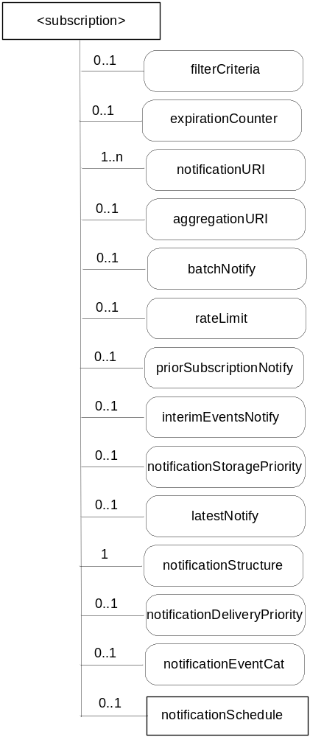
Figure 9.6.8-1: Structure of <subscription> resource
(only resource specific attributes are shown)
This resource shall contain the child resources according to their multiplicity in Table 9.6.8-1.

Table 9.6.8-1: Child resources of <subscription> resource
Child Resource Name of <subscription> | Child Resource Type | Multiplicity | Description
notificationSchedule | <schedule> | 0..1 | See clause 9.6.9

Editor's Note: criteria is shown as an attribute, However, whether we need a separate attribute or child resource for notification policy is FFS.
The <subscription> resource shall contain the attributes described in Table 9.6.8-2.

Table 9.6.8-2: Attributes of <subscription> resource
Attribute Name of <subscription> | Multiplicity | RW/  RO/  WO | Description
resourceType (rT) | 1 | WO | See clause 9.6.1 where this common attribute is described.
parentID (pID) | 1 | RO | See clause 9.6.1 where this common attribute is described.
expirationTime (eT) | 1 | RW | See clause 9.6.1 where this common attribute is described.
creationTime (cT) | 1 | RO | See clause 9.6.1 where this common attribute is described.
lastModifiedTime (lMT) | 1 | RO | See clause 9.6.1 where this common attribute is described.
labels (lBs) | 0..1 | RW | See clause 9.6.1 where this common attribute is described.
accessControlPolicies (aRI) | 0..1 | RW | See clause 9.6.1 where this common attribute is described.  If no accessControlPolicies is given at the time of creation, the accesControlPolicyID of the parent resource is linked to this attribute.
filterCriteria | 0..1 | RW | Filtering conditions that when applied and provide a not empty matching set of resources, then a notification can be sent to notificationURI.
expirationCounter | 0..1 | RW | When the number of notifications becomes the same as this counter, the <subscription> resource shall be deleted.
notificationURI | 1..n | RW | URI where the resource subscriber will receive notifications.
aggregationURI | 0..1 | RW | URI to aggregate notifications from group members of a <group> resource.
batchNotify | 0..1 | RW | Indicates that notifications should be batched for delivery. When set, notification events are temporarily stored until either a specified number is ready to send or until a duration after the first notification event has expired.
rateLimit | 0..1 | RW | Indicates that notifications should be rate-limited. When set, notification events that exceed a specified number within a specified time are temporarily stored then sent when the number of events sent per specified time falls below the limit.
priorSubscriptionNotify | 0..1 | WO | Indicates that when this subscription is created, whether notification events prior to subscription should be sent, e.g. send prior "n" notifications, if available.
interimEventsNotify | 0..1 | RW | Indicates the notification action to be taken following a period of unreachability, when the resource subscriber becomes reachable (e.g. send "n" iterim notificiations, if available.)
notificationStoragePriority | 0..1 | RW | Indicates a priority for this subscription relative to other subscriptions belonging to this same subscriber for retention of notification events when storage is congested. The storage congestion policy which uses this attribute as input is specified in clause TBD.
latestNotify | 0..1 | RW | Indicates if the subscriber wants only the latest notification or all the notification. If the subscriber only wants the latest notification, older notifications can be discarded. The attribute is mutual exclusive with batchNotify.
notificationStructure | 1 | RW | Type of information that shall be contained in notifications. E.g. modified attribute only of a subscribed-to resource, a whole subscribed-to resource, and/or URI of a corresponding <subscription> resource.
notificationDeliveryPriority | 0..1 | RW | Indicate a delivery priority for the notification. That is, this attribute defines the how to handle sending of notifications when notifications need to be sent.
notificationEventCat | 0..1 | RW | Defines the Event Categories for the notification message triggered by the <subscription> resource.

Editor's Note: In the case when there are Intermediate Nodes between the Originator and a Receiver, the Intermediate Nodes may not act in accordance with the subscription notification policy. Examples include: a policy of batching subscribed events for up to 30 seconds then deliver immediately, but an intermediate node may decide to delay or further aggregate the subscription notifications. The solution to this problem is FFS, but may include sending a representation of policy with the subscription notifications, which is to be considered by Intermediate Nodes (e.g. Request Expiration Time).

Filter criteria attribute shall be configured a priori in <subscription> resource and only if an event matches the filter criteria conditions, then a notification shall be delivered.
The following Table describes the filter criteria conditions.
Table 9.6.8-3: Filter criteria conditions
Condition tag | Multiplicity | Matching condition
createdBefore | 0..1 | The creationTime attribute of the resource is chronologically before the specified value.
createdAfter | 0..1 | The creationTime attribute of the resource is chronologically after the specified value.
modifiedSince | 0..1 | The lastModifiedTime attribute of the resource is chronologically after the specified value.
unmodifiedSince | 0..1 | The lastModifiedTime attribute of the resource is chronologically before the specified value.
expireBefore | 0..1 | The expirationTime attribute of the resource is chronologically before the specified value.
expireAfter | 0..1 | The expirationTime attribute of the resource is chronologically after the specified value.
labels | 0..n | The labels attributes of the resource matches the specified value.
resourceType | 0..n | The resourceType attribute of the resource is the same as the specified value. It also allows discriminating between normal and announced resources.
sizeAbove | 0..1 | The contentSize attribute of the <instance> resource is equal to or greater than the specified value.
sizeBelow | 0..1 | The contentSize attribute of the <instance> resource is smaller than the specified value.
contentType | 0..n | The typeOfContent attribute of the <instance> resource matches the specified value
resourceStatus | 0..n | When the resource is changed by the operations or expiration, the resource status of the resource is the same as the specified value. Possible values are: created, updated, deleted.
operationMonitor | 0..n | The operations accessing the resource matches with the specified value. It allows monitoring which operation is attempted to the subscribed resource regardless of whether the operation is performed. This feature is useful when to find malicious AEs. Possible string arguments are: create, retrieve, update, delete.
attribute | 0..n | Attribute token name to be provided to reduce the scope of filtering to resource attributes.

9.6.9 Resource Type schedule
The <schedule> resource contains scheduling information for delivery of messages.
Editor's Note: It is expected that the reachability period will be extended by the duration of a transaction which is currently occurring, but the details need further study.
The list of resources, which use <schedule> resource, is as follows.
- TBD
Editor's Note: This list will be revised as resources are further progressed
The <schedule> resource shall represent scheduling information in the context of its parent resource. An Originator shall have the same access rights to the <schedule> resource as it has to its parent resource.
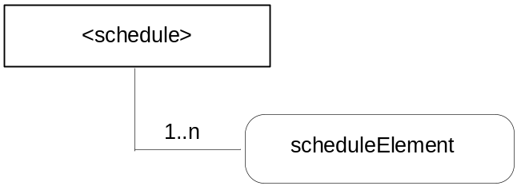
Figure 9.6.9-1: Structure of <schedule> resource
(only resource specific attributes are shown)
Editor's Note: To update the picture to include "link", "announceTo" and "announcedAttribute" attribute.
The <schedule> resource shall contain the attributes described in Table 9.6.9-1.

Table 9.6.9-1: Attributes of <schedule> resource
Attribute Name of <schedule> | Multiplicity | RW/  RO/  WO | Description | <scheduleAnnc> Attributes
resourceType | 1 | RO | See clause 9.6.1 where this common attribute is described. | MP
expirationTime (eT) | 1 | RW | See clause 9.6.1 where this common attribute is described. | MP
parentID (pID) | 1 | RO | See clause 9.6.1 where this common attribute is described. | MP
creationTime (cT) | 1 | RO | See clause 9.6.1 where this common attribute is described. | MP
lastModifiedTime (lMT) | 1 | RO | See clause 9.6.1 where this common attribute is described. | MP
labels | 0..1 | RO | See section 9.6.1 where this common attribute is described. | MP
link | 1 | WO | See section 9.6.1 where this common attribute is described. This is only for <scheduleAnnc>. | MP
announceTo | 1 | RW | See section 9.6.1 where this common attribute is described. | NP
announcedAttribute | 1 | RW | See section 9.6.1 where this common attribute is described. | NP
scheduleElement | 1..n | RW | Expresses time periods defined by second, minute, hour day of month, month, and year. Supports repeating periods, and wildcards. | OP

Editor's Note: The multiplicity of attribute must be aligned to the new understanding.

9.6.10 Resource Type locationPolicy
The <locationPolicy> resource in LOC CSF represents the method for obtaining and managing geographical location information of an M2M Node.
The actual location information shall be stored in the <instance> resource, a child resource of <container> resource. The <container> resource has the locationId attribute which holds the URI of this <locationPolicy> resource as a linkage. The LOC CSF can obtain location information based on the attributes defined under <locationPolicy> resource, and store the location information in the target <container> resource.
Based on the locationSource attribute, the way of obtaining location information of an M2M Node can be differentiated: Network-based where the CSE on behalf of the AE obtains the target M2M Node's location information from Underlying Network, Device-based where the ASN is equipped with any location capable modules or technologies (e.g. GPS) and is able to position itself, and Sharing-based where the ADN has no GPS and Underlying Network connection capability, but its location information can be retrieved from either ASN or MN.
NOTE: Geographical location information is more than longitude and latitude.

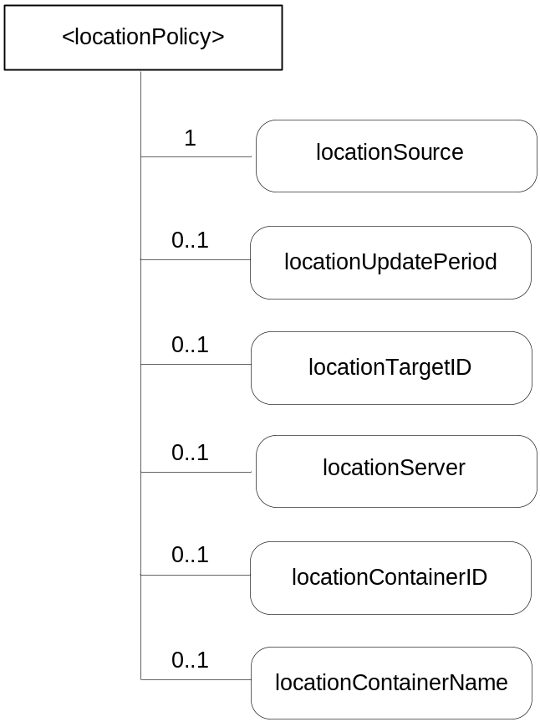
Figure 9.6.10-1: Structure of <locationPolicy> resource
(only resource specific attributes are shown)
Editor's Note: To update the picture to include "link", "announceTo" and "announcedAttribute" attribute.
This resource shall contain the attributes according to their multiplicity in Table 9.6.10-1 (0 indicates the optionality of the attribute).

Table 9.6.10-1: Attributes of <locationPolicy> resource
Attribute Name of <locationPolicy> | Multiplicity | RW/  RO/  WO | Description | <locationPolicyAnnc> Attributes
resourceType (rT) | 1 | RO | See clause 9.6.1 where this common attribute is described. | MP
expirationTime (eT) | 1 | RW | See clause 9.6.1 where this common attribute is described. | MP
parentID (pID) | 1 | RO | See clause 9.6.1 where this common attribute is described. | MP
accessControlPolicies (aRI) | 0..1 | RW | See clause 9.6.1 where this common attribute is described. | MP
creationTime (cT) | 1 | RO | See clause 9.6.1 where this common attribute is described. | MP
lastModifiedTime (lMT) | 1 | RO | See clause 9.6.1 where this common attribute is described. | MP
labels (lBs) | 0..1 | RW | See clause 9.6.1 where this common attribute is described. | MP
link | 1 | WO | See section 9.6.1 where this common attribute is described. This is only for <locationPolicyAnnc>. | MP
announceTo | 1 | RW | See section 9.6.1 where this common attribute is described. | NP
announcedAttribute | 1 | RW | See section 9.6.1 where this common attribute is described. | NP
locationSource | 1 | RW | Indicates the source of location information  Network Based  GPS Based  Sharing Based | OP
locationUpdatePeriod | 0..1 | RW | Indicates the period for updating location information. If the value is marked '0' or not defined, location information is updated only when a retrieval request is triggered. | OP
locationTargetId | 0..1 | RW | The identifier to be used for retrieving the location information of a remote Node and this attribute is only used in the case that location information is provided by a location server. | OP
locationServer | 0..1 | RW | Indicates the identity of the location server. This attribute is only used in that case location information is provided by a location server. | OP
locationContainerID | 0..1 | RO | A URI of the <container> resource where the actual location information of a M2M Node is stored. | OP
locationContainerName | 0..1 | RW | A Name of the <container> resource where the actual location information of a M2M Node is stored. If it is not assigned, the Hosting CSE automatically assigns a name of the resource.  Note: The created <container> resource related to this policy shall be stored only in the Hosting CSE. | OP

9.6.11 Resource Type delivery
When a CSE is requested to initiate an operation (CRUD) targeting resources on another CSE, then it needs to involve the CMDH CSF in order to do proper scheduling and execution of delivery of data from the source CSE to the target CSE in line with provisioned policies. It is possible to do that in two different ways: Using delivery aggregation ("da" information set to on) or by forwarding the original request as a separate request on the Mcc reference point without changes.
In order to be able to initiate and manage the execution of data delivery in a resource-based manner, the resource type delivery is defined. This resource type needs to be used for forwarding requests from one CSE to another CSE when "da" information in the request is set to ON. If the "da" information is set to OFF, the original request shall be forwarded without change to the next CSE.
Operations to Retrieve, Update or Delete a <delivery> resource will allow authorized entities to inquire the status of a delivery, change delivery attributes or cancel a delivery.
Editor's Note: Further details on mechanisms how to do delivery handling are FFS.
Editor's Note: The particular position in the addressable space of resources id FFS.
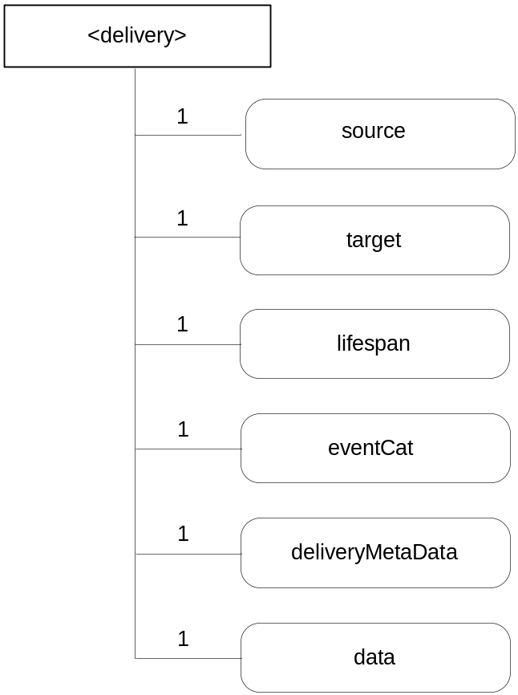
Figure 9.6.11-1: Structure of resource <delivery>
(only resource specific attributes are shown)
The resource <delivery> shall contain the attributes according to their multiplicity shown in Table 9.6.11-1.

Table 9.6.11-1: Attributes of <delivery> resource
Attribute Name of <delivery> | Multiplicity | RW/  RO/  WO | Description
expirationTime (eT) | 1 | RW | See clause 9.6.1 where this common attribute is described.
parentID (pID) | 1 | RO | See clause 9.6.1 where this common attribute is described.
creationTime (cT) | 1 | RO | See clause 9.6.1 where this common attribute is described.
lastModifiedTime (lMT) | 1 | RO | See clause 9.6.1 where this common attribute is described.
accessControlPolicies | 0..1 | RW | See section 9.6.1 where this common attribute is described.
labels | 0..1 | RO | See section 9.6.1 where this common attribute is described.
versionTag (vT) | 1 | RO | See clause 9.6.1 where this common attribute is described.
Source | 1 | WO | The CSE-ID of the CSE that initiated the delivery process represented by this <delivery> resource.
Target | 1 | WO | A list of CSE-IDs that defines one or more target CSEs for delivering the data contained in the data attribute
Lifespan | 1 | RW | Defines the time limit when the delivery of the information in the data attribute needs to complete. If the lifespan expires before successful delivery, no further attempts to deliver the information in the data attribute need to be executed. If the delivery fails, a feedback may be expected by the source CSE depending on options reflected in the deliveryMetaData attribute. The lifespan attribute of a <delivery> resource shall be set consistent with the rqet parameters of the set of original requests contained in the Data attribute, i.e. lifespan shall not extend beyond the earliest expiring rqet parameter in the set of the original requests contained in the Data attribute.
eventCat | 1 | RW | Defines the category of the event that triggered the delivery request represented by this <delivery> resource
deliveryMetaData | 1 | RW | Contains meta information on the delivery process represented by this <delivery> resource, such as delivery status, delivery options, tracing information, etc
data | 1 | WO | Attribute containing the data to be delivered to the target CSE(s). This data represents one or more original requests that were targeting the same CSE(s).

9.6.12 Resource Type request
The use of this resource type is optional depending on the configuration.
When a CSE is requested to initiate an operation for which the result should be available to the Originator by reference ('rt' information of the request set to 'Acknowledgement'), the local CSE which received the Request directly from the Originator may need to provide a reference back to the Originator so that the Originator can access attributes of the Request at a later time - for instance in order to retrieve the result of an operation that was taking a longer time. The Originator (or any other authorized entity depending on access rights) can access the request status and the requested operation result through it.
The <request> resource may get deleted by the CSE that is hosting it:
- when the result of the requested operation (if any result was requested at all) has been sent back to the Originator (either by notification to the Originator or by retrieval initiated by the Originator);
- when the expiration time of the <request> resource is reached;
- at any other time - depending on local settings in the CSE that hosts the <request> resource.
Editor's Note: The exact way how to define that setting (e.g. via DM) is FFS.
For the purpose of providing a standardized structure for expressing and accessing the context of a previously issued Request, the resource type request is defined.
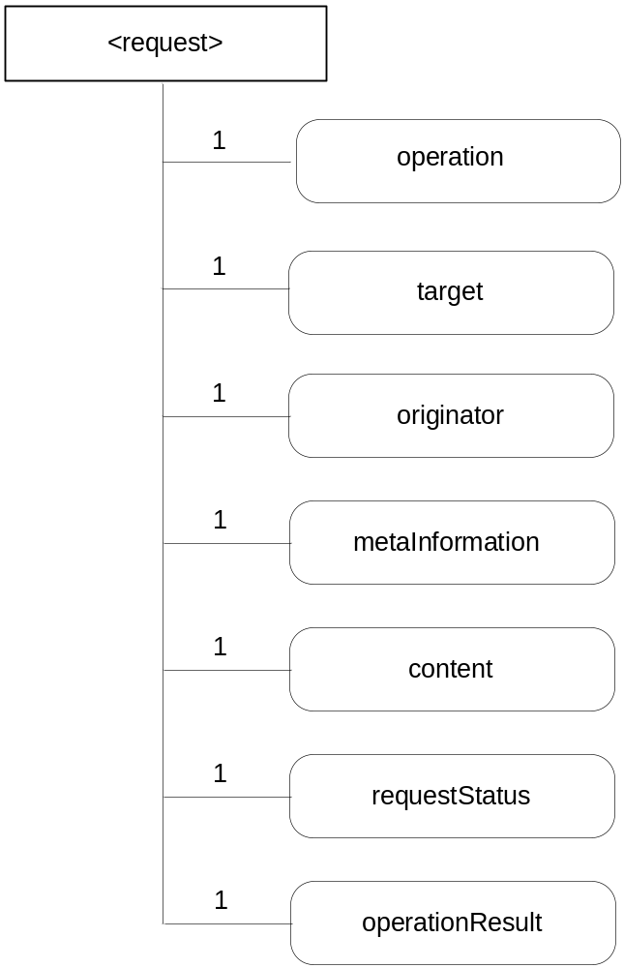
Figure 9.6.12-1: Structure of <request> resource
(only resource specific attributes are shown)
The resource <request> shall contain the attributes according to their multiplicity shown in Table 9.6.12-1.

Table 9.6.12-1: Attributes of <request> resource
Attribute Name of <request> | Multiplicity | RW/  RO/  WO | Description
expirationTime (et) | 1 | RW | See clause 9.6.1 where this common attribute is described.
parentID (pID) | 1 | RO | See clause 9.6.1 where this common attribute is described.
creationTime (cT) | 1 | RO | See clause 9.6.1 where this common attribute is described.
lastModifiedTime (lMT) | 1 | RO | See clause 9.6.1 where this common attribute is described.
accessControlPolicies | 1 | RO | See section 9.6.1 where this common attribute is described.
labels | 0..1 | RO | See section 9.6.1 where this common attribute is described.
versionTag (vT) | 1 | RO | See clause 9.6.1 where this common attribute is described.
operation | 1 | RO | The operation requested by the Originator, e.g. modifying the content of a container, registering an Application.
target | 1 | RO | The address or the target resource for the requested operation.
originator | 1 | RO | The originating entity for the request.
metaInformation | 1 | RO | Meta information about the request. The content of this attribute is equivalent to the "mi" information in clause 8.1.
content | 1 | RO | Contains the content that is supposed to be sent to the target resource.
requestStatus | 1 | RO | Contains information on the current status of the Request, e.g. "accepted and pending".
operationResult | 1 | RO | Contains information on the result of the requested action, e.g. "Resource created with URI: XXX".

Creation of a <request> resource can only be done on a local CSE implicitly by an AE issuing a generic CRUD request for any other resource type to the Local CSE. A Local CSE cannot accept requests to create a <request> resource directly.
Retrieving of <request> resources or attributes of a <request> resource is allowed for authorized entities.
Update of a <request> resource can only be done by the CSE that hosts the <request> resource or by CSEs that provide operation results pertaining to the request (for instance when the result of an operation requested for a remote CSE becomes available).
Deletion of a <request> resource is possible by authorized entities. If the execution of the request was still pending at the time of deletion, the hosting CSE should to stop any further attempts to execute the request.

9.6.13 Resource Type group
The <group> resource represents a group of resources of the same or mixed types. The <group> resource can be used to do bulk manipulations on the resources represented by the members. The <group> resource contains an attribute that represents the members of the group and a virtual resource (the members) that allows verbs to be applied to the resources represented by those members.
When used as one of the permission holders in an <accessControlPolicy> resource, the group can be used to grant a collection of applications (represented by <application> resources) or CSEs (represented by <CSEBase> resources) permissions for accessing (Creating children, Retrieving, etc.) a resource.
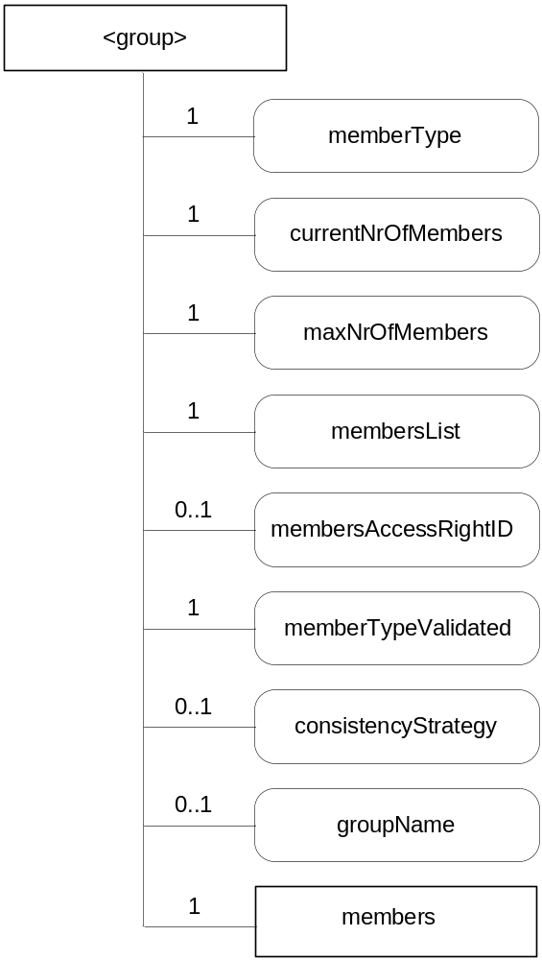
Figure 9.6.13-1: Structure of <group> resource
(only resource specific attributes are shown)
Editor's Note: To update the picture to include "link", "announceTo" and "announcedAttribute" attribute.
This resource shall contain the child resources according to their multiplicity in Table 9.6.13-1.

Table 9.6.13-1: Child resources of <group> resource
Child Resource Name of <group> | Child Resource Type | Multiplicity | Description | <groupAnnc> Child Resource Type
members | <Members> | 1 | See clause 9.6.14 | n/a

The <group> resource shall contain the attributes with the indicated multiplicity in Table 9.6.13-2

Table 9.6.13-2: Attributes of <group> resource
Attribute Name of <group> | Multiplicity | RW/  RO/  WO | Description | <groupAnnc> Attributes
resourceType (rT) | 1 | RO | See clause 9.6.1 where this common attribute is described. | MP
expirationTime (eT) | 1 | RW | See clause 9.6.1 where this common attribute is described. | MP
parentID (pID) | 1 | RO | See clause 9.6.1 where this common attribute is described. | MP
accessControlPolicies (aRI) | 0..1 | RW | See clause 9.6.1 where this common attribute is described. | MP
labels (lBs) | 0..1 | RO | See clause 9.6.1 where this common attribute is described. | MP
creationTime (cT) | 1 | RO | See clause 9.6.1 where this common attribute is described. | MP
creator (cr) | 0..1 | RW | The App-inst-ID or CSE-ID of the entity which created the resource | MP
lastModifiedTime (lMT) | 1 | RO | See clause 9.6.1 where this common attribute is described. | MP
link | 1 | WO | See section 9.6.1 where this common attribute is described. This is only for <groupAnnc>. | MP
announceTo | 1 | RW | See section 9.6.1 where this common attribute is described. | NP
announcedAttribute | 1 | RW | See section 9.6.1 where this common attribute is described. | NP
memberType (mT) | 1 | WO | It is the resource type of the member resources of the group if all member resources (including the member resources in any sub-groups) are of the same type. Otherwise, it's a type of 'mixed'. | OP
currentNrOfMembers (nM) | 1 | RO | Current number of members in a group. It is limited by the maxNrOfMembers. | OP
maxNrOfMembers (mM) | 1 | RW | Maximum number of members in the group. | OP
membersList (mL) | 1 | RW | List of zero or more member URIs referred to in the remaining of this specification as memberID. Each URI (memberID) should refer to a member resource or a (sub-) group resource of the group. | OP
membersAccessControlPolicies(mAR) | 0..1 | RW | URIs of the accessControlPolicy resources defining who is allowed to access the members attribute. | OP
memberTypeValidated(mTV) | 1 | RO | Denotes if memberType of all member resources of the group has been validated. | OP
consistencyStrategy (cS) | 0..1 | WO | This attribute determines how to deal with the <group> resource if the memberType validation fails.Which means delete the inconsistent member if the attribute is ABANDON_MEMBER; delete the group if the attribute is ABANDON_GROUP; set the memberType to "mixed" if the attribute is SET_MIXED. | OP
groupName (gN) | 0..1 | RW | Human readable name of the group. | OP

9.6.14 Resource Type Members
The <Members> resource is a virtual resource because it does not have a representation. It is the child resource of a <group> resource. Whenever the request is sent to the <Members> resource, the request is fanned out to each of the members of the <group> resource indicated by the membersList attribute of the <group> resource. The responses (to the request) from each member are then aggregated and returned to the Originator.
The <Members> resource does not have a resource representation by itself and consequently it does not have an accessControlPolicies attribute. The <accessControlPolicy> resource used for access right validation is indicated by the membersAccessControlPolicies attribute in the parent <group> resource.

9.6.15 Resource Type mgmtObj
The mgmtObj resource contains management data which represents individual M2M management functions. It represents a general structure to map to external management technology (e.g. OMA DM [Error: Reference source not found], BBF [ref] TR-0069 [Error: Reference source not found] and LWM2M [ref]) data models.
Editor's note - add references?
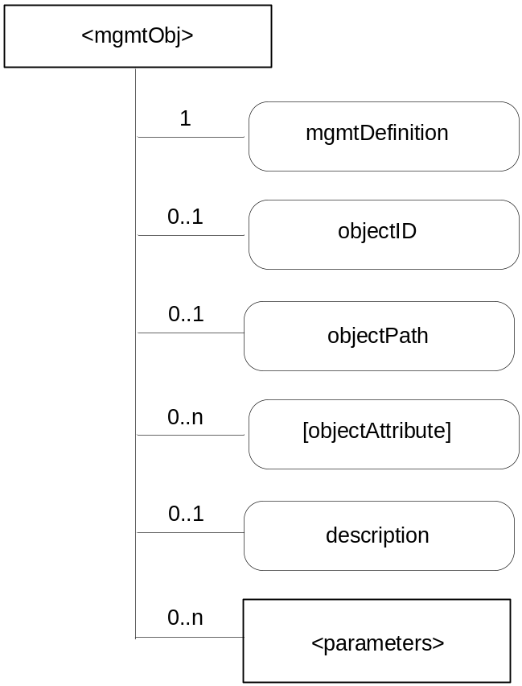
Figure 9.6.15-1: Structure of <mgmtObj> resource
(only resource specific attributes are shown)
Editor's Note: To update the picture to include "link", "announceTo" and "announcedAttribute" attribute.
This resource shall contain the child resources according to their multiplicity in Table 9.6.15-1 (0 indicates the optionality of the child resource).

Table 9.6.15-1: Child resources of <mgmtObj> resource
Child Resource Name of <mgmtObj> | Child Resource Type | Multiplicity | Description | <mgmtObjAnnc> Child Resource Type
[variable] | <parameters> | 0..n | See clause 9.6.16.  Collects multiple parameters or attributes for management purpose. A <parameters> resource can have zero or more other <parameters> sub-resources so as to form hierarchical structure, i.e. the management data for this specific <mgmtObj>. Such structure helps to import existing management objects as defined in OMA DM, BBF TR-069, LWM2M, or any other technology. | none

The <mgmtObj> resource shall contain the attributes described in Table 9.6.15-2.

Table 9.6.15-2: Attributes of <mgmtObj> resource
Attribute Name of <mgmtObj> | Multiplicity | RW/  RO/  WO | Description | <mgmtObjAnnc> Attributes
resourceType (rT) | 1 | WO | See clause 9.6.1 where this common attribute is described | MP
parentID (pID) | 1 | RO | See clause 9.6.1 where this common attribute is described. | MP
expirationTime (eT) | 1 | RW | See clause 9.6.1 where this common attribute is described | MP
accessControlPolicies (aRI) | 0..1 | RW | See clause 9.6.1 where this common attribute is described | MP
creationTime (cT) | 1 | RO | See clause 9.6.1 where this common attribute is described | MP
lastModifiedTime (lMT) | 1 | RO | See clause 9.6.1 where this common attribute is described | MP
labels | 0..1 | RO | See clause 9.6.1 where this common attribute is described | MP
link | 1 | WO | See section 9.6.1 where this common attribute is described. This is only for <mgmtObjAnnc>. | MP
announceTo | 1 | RW | See section 9.6.1 where this common attribute is described. | NP
announcedAttribute | 1 | RW | See section 9.6.1 where this common attribute is described. | NP
mgmtDefinition | 1 | WO | Specifies the type of mgmtObj resource e.g. software, firmware, memory. The list of the value of the attribute can be seen in Annex D. | MP
objectID | 0..1 | WO | Contains a URN that uniquely identifies the external management technology data model used for this <mgmtObj> resource as well as the managed function and version it represents. This attribute shall be provided during the creation of the <mgmtObj> resource and shall not be modifiable afterwards.  This is mandatory for the <mgmtObj>, for which the data model is not specified by oneM2M but mapped from external management technology data model specified in other device management protocols (e.g. OMA-DM, BBF TR-069 and LWM2M). | OP
objectPath | 0..1 | WO | Contains the local path of the external management object instance on the managed entity which is represented by the <mgmtObj> resource in the hosting CSE.  This attribute shall be provided during the creation of the <mgmtObj>, so that the hosting CSE can correlate the created <mgmtObj> with the external management object instance on the managed entity for further management operations. It shall not be modifiable after creation.  The format of this attribute shall be a local external management object path in the form as specified by existing management protocols. (e.g. "./anyPath/Fw1" in OMA DM, "Device.USBHosts.Host.3." in BBF TR-069). | OP
[objectAttribute] | 0..n | RW | Each [objectAttribute] is mapped from a leaf node of a hierarchical structured management object (including oneM2M data model and the existing management data models) based on the mapping rules below the table. | OP
description | 0..1 | RW | Text format description of mgmtObj. | OP

When mapping resources from management technologies to a corresponding <mgmtObj> resource, the following rules shall apply:
- The root resource of external management objects maps to the <mgmtObj> resource
- For child resource of the root resource of specific technology:
- Rule1: If the child external management object cannot have a child external management object, the external management object maps to the [objectAttribute] attribute of the <mgmtObj> resource with the same resource name;
- Rule2: If the child external management object can have another child external management object, the external management object maps to the <parameters> resource with the same resource name.
- For the external management object that is mapped to the <parameters> resource, the child external management object of the external management object are mapped to the [objectAttribute] attribute or to the <parameter> resource according to the Rule1 and Rule2.

9.6.16 Resource Type parameters
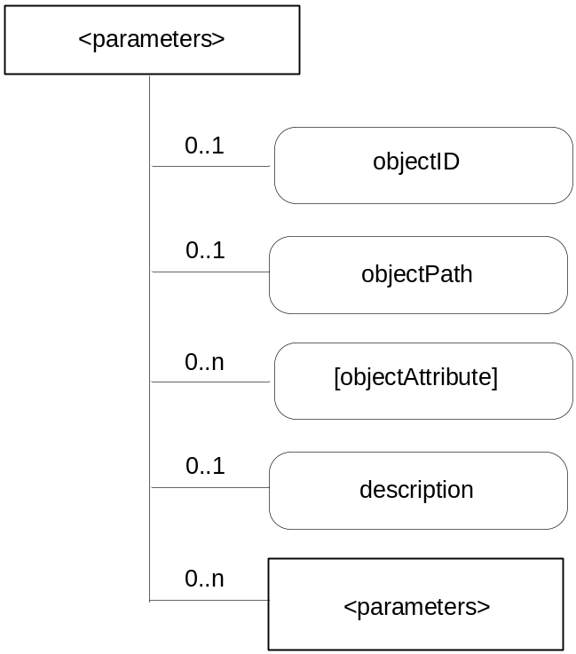
Figure 9.6.16-1: Structure of <parameters> resource
(only resource specific attributes are shown)
This resource shall contain the child resources according to their multiplicity in Table 9.6.16-1 (0 indicates the optionality of the child resource).

Table 9.6.16-1: Table Child resources of <parameters> resource
Child Resource Name of <parameters> | Child Resource Type | Multiplicity | Description
[variable] | <parameters> | 0..n | See clause 9.6.16

The <parameters> resource shall contain the attributes described in Table 9.6.16-2.

Table 9.6.16-2: Attributes of <parameters> resource
Attribute Name of <parameters> | Multiplicity | RW/  RO/  WO | Description
resourceType | 1 | WO | See section 9.6.1 where this common attribute is described
accessControlPolicies (aRI) | 0..1 | RW | See clause 9.6.1 where this common attribute is described
parentID (pID) | 1 | RO | See clause 9.6.1 where this common attribute is described.
creationTime (cT) | 1 | RO | See clause 9.6.1 where this common attribute is described
lastModifiedTime (lMT) | 1 | RO | See clause 9.6.1 where this common attribute is described
labels | 0..1 | RO | See section 9.6.1 where this common attribute is described.
objectID | 0..1 | WO | See Table 9.6.15-2
objectPath | 0..1 | WO | See Table 9.6.15-2
[objectAttribute] | 0..n | RW | See Table 9.6.15-2
description | 0..1 | RW | Text format description of mgmtObj.

9.6.17 Resource Type mgmtCmd
The <mgmtCmd> resource represents a method to execute management procedures or to model commands and remote procedure calls (RPC) required by existing management protocols (e.g. BBF TR-069 [Error: Reference source not found]), and enables AEs to request management procedures to be executed on a remote entity. It also enables cancellation of cancellable and initiated yet unfinished management procedures or commands.
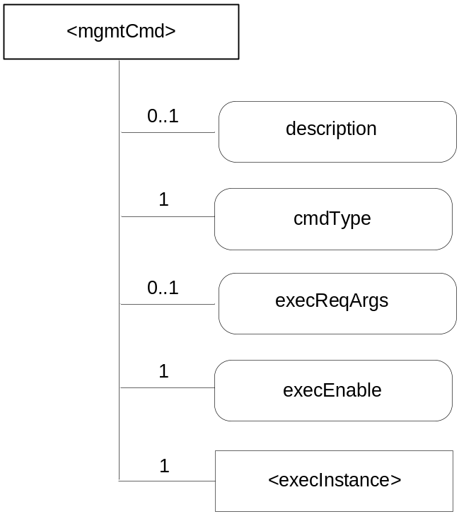
Figure 9.6.17-1: Structure of <mgmtCmd> resource
(only resource specific attributes are shown)
Each <mgmtCmd> corresponds to a specific type of management command, as defined by its attribute cmdType. For multiple requests of the same management command, <mgmtCmd> may use the child-resource (i.e. <execInstance>) to contain all execution instances. The execution of the management procedure represented by <mgmtCmd> shall be triggered using the UPDATE method to its attribute "execEnable".
This resource shall contain the child resources according to their multiplicity in Table 9.6.17-1 (0 indicates the optionality of the child resource).

Table 9.6.17-1: Child resources of <mgmtCmd> resource
Child Resource Name of <mgmtCmd> | Child Resource Type | Multiplicity | Description
[variable] | <execInstance> | 1 | See clause 9.6.18

The <mgmtCmd> resource shall contain the attributes described in Table 9.6.17-2.

Table 9.6.17-2: Attributes of <mgmtCmd> resource
Attribute Name of <mgmtCmd> | Multiplicity | RW/  RO/  WO | Description
resourceType (rT) | 1 | WO | See clause 9.6.1 where this common attribute is described
parentID (pID) | 1 | RO | See clause 9.6.1 where this common attribute is described.
expirationTime (eT) | 1 | RW | See clause 9.6.1 where this common attribute is described
accessControlPolicies (aRI) | 0..1 | RW | See clause 9.6.1 where this common attribute is described
labels (lBs) | 0..1 | RW | See clause 9.6.1 where this common attribute is described
creationTime (cT) | 1 | RO | See clause 9.6.1 where this common attribute is described
lastModifiedTime (lMT) | 1 | RO | See clause 9.6.1 where this common attribute is described
description | 0..1 | RW | The text-format description of this resource
cmdType | 1 | WO | The type to identify the management operation (e.g. download).
execReqArgs | 0..1 | RW | Structured attribute (e.g. abstract type) to contain any command-specific arguments of the request.
execEnable | 1 | RO | The attribute can be blank without any value or it can contain a URI that can be used to trigger execution of <mgmtCmd> using UPDATE method.

Editor's Note: The types of management operations (e.g. cmdType) to be used by mgmtCmd are FFS.

9.6.18 Resource Type execInstance
The <execInstance> resource represents a successful instance of <mgmtCmd> execution request, which had been triggered by a M2M network application using the UPDATE method to the attribute "execEnable" of <mgmtCmd>.
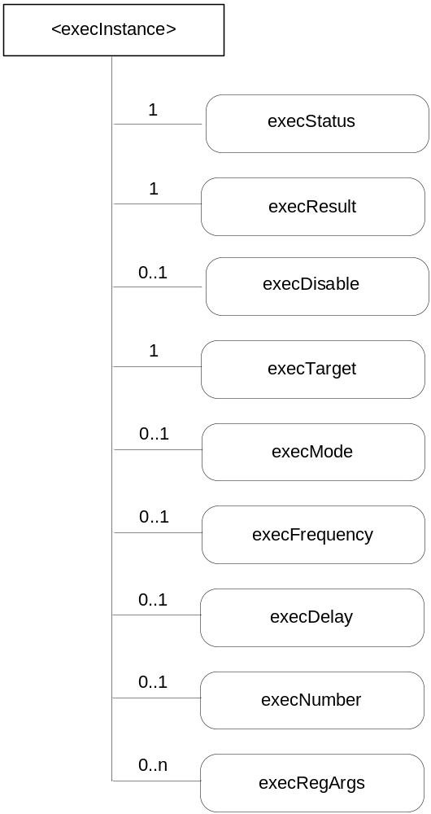
Figure 9.6.18-1: Structure of <execInstance> resource
(only resource specific attributes are shown)
The <execInstance> resource shall contain the attributes described in Table 9.6.18-1.

Table 9.6.18-1: Attributes of <execInstance> resource
Attribute Name of <execInstance> | Multiplicity | RW/  RO/  WO | Description
resourceType | 1 | RO | See clause 9.6.1 where this common attribute is described
expirationTime (eT) | 1 | RO | See clause 9.6.1 where this common attribute is described
parentID (pID) | 1 | RO | See clause 9.6.1 where this common attribute is described.
accessControlPolicies (aRI) | 0..1 | RW | See clause 9.6.1 where this common attribute is described
creationTime (cT) | 1 | RO | See clause 9.6.1 where this common attribute is described
lastModifiedTime (lMT) | 1 | RO | See clause 9.6.1 where this common attribute is described
labels | 0..1 | RO | See section 9.6.1 where this common attribute is described.
execStatus | 1 | RO | The status of <execInstance>. It can be Initiated, Started, Finished, Cancelled, or Deleted.
execResult | 1 | RO | The execution result of <execInstance>.
execDisable | 0..1 | RW | The attribute is used to cancel <execInstance> using UPDATE method.
execTarget | 1 | RW | M2M-Node-ID of the target.
execMode | 0..1 | RW | Modes used to specify how the command will be executed (e.g. Immediate Once, Immediate and Repeatedly, Random Once, Random and Repeatedly). May be used together with execFrequency, execDelay and execNumber to provide the scheduling information.
execFrequency | 0..1 | RW | The interval between two executions, to be used in conjunction with execMode.
execDelay | 0..1 | RW | The delay before the instance should be executed
execNumber | 0..1 | RW | The number of times the instance should be executed, to be used in conjunction with execMode.
execReqArgs | 0..n | RW | Structured attribute (e.g. abstract type) to contain any command-specific arguments used to trigger this <execInstance>.

Editor's note: the relationships between execMode, execFrequncy and execNumber are FFS.

9.6.19 Resource Type node
The <node> resource represents specific information of a M2M Node that can be utilized by other oneM2M operations. For example, the CMDH CSF can determine when the CSE sends a request message to the target CSE based on the target CSE's reachability schedule. This resource type mainly contains the properties of an M2M Node such as reachability schedule, context information (e.g. memory and storage) and network topology.
This node specific information stored in this resource type such as memory and storage can be obtained either by the existing device management technologies (OMA DM, BBF TR-069 [Error: Reference source not found]) or any other way (e.g. through JNI (Java Native Interface)). Since <mgmtObj> resource type represents the management functions including both ways, the types of sub-resources are <mgmtObj> resource type.
The location of <node> resource can be differentiated according to the type of node.
- ASN: under <CSEBase> of the ASN-CSE.
- ADN: under <CSEBase> resource of the local CSE. The <application> resource regarding the ADN shall have the proper link (URI) to the <node> resource that contain node specific information of the ADN.
- MN: under <CSEBase> of the MN CSE.
Editor's Note: ADN case needs to be defined
Editor's Note: More specific information regarding a node can be added.
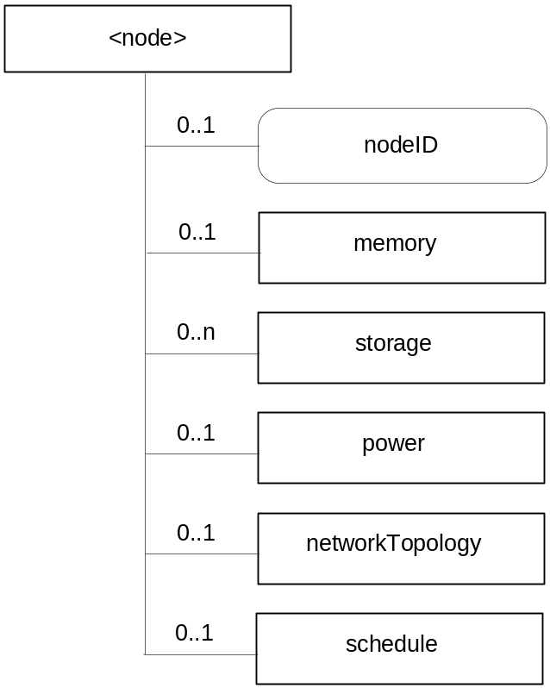
Figure 9.6.19-1: Structure of <node> resource
(only resource specific attributes are shown)
Editor's Note: To update the picture to include "link", "announceTo" and "announcedAttribute" attribute.
This resource shall contain the child resources according to their multiplicity in Table 9.6.19-1 (0 indicates the optionality of the child resource).
Table 9.6.19-1: Child resources of <node> resource
Child Resource Name of <node> | Child Resource Type | Multiplicity | Description | <nodeAnnc> Child Resource Type
memory | <mgmtObj> | 0..1 | This resource provides the memory (typically RAM) information of the node. (e.g. the amount of total volatile memory), See clause 9.6.15 for <mgmtObj>. | <mgmtObjAnnc>
storage | <mgmtObj> | 0..n | This resource provides the storage (typically flash or disk) information of the node. (e.g. the amount of total writable persistent storage). See clause 9.6.15 for <mgmtObj>. | <mgmtObjAnnc>
power | <mgmtObj> | 0..1 | The resource provides the power information of the node. (e.g. remaining battery charge). See clause 9.6.15 for <mgmtObj>. | <mgmtObjAnnc>
networkTopology | <mgmtObj> | 0..1 | This resource describes the list of Nodes attached behind the MN node and its underlying relation among the nodes in the M2M Area Network. This attribute is defined in case the Node is MN. See clause 9.6.15 for <mgmtObj>. | <mgmtObjAnnc>
schedule | <schedule> | 0..1 | This resource defines the reachability schedule information of the node. See clause 9.6.9 for <schedule>. | <scheduleAnnc>

The <node> resource shall contain the attributes described in Table 9.6.19-2.

Table 9.6.19-2: Attributes of <node> resource
Attribute Name of <node> | Multiplicity | RW/  RO/  WO | Description | <nodeAnnc> Attributes
resourceType (rT) | 1 | RO | See clause 9.6.1 where this common attribute is described. | MP
parentID (pID) | 1 | RO | See clause 9.6.1 where this common attribute is described. | MP
expirationTime (eT) | 1 | RW | See clause 9.6.1 where this common attribute is described. | MP
accessControlPolicies (aRI) | 0..1 | RW | See clause 9.6.1 where this common attribute is described. | MP
creationTime (cT) | 1 | RO | See clause 9.6.1 where this common attribute is described. | MP
lastModifiedTime (lMT) | 1 | RO | See clause 9.6.1 where this common attribute is described. | MP
link | 1 | WO | See section 9.6.1 where this common attribute is described. This is only for <nodeAnnc>. | MP
announceTo | 1 | RW | See section 9.6.1 where this common attribute is described. | NP
announcedAttribute | 1 | RW | See section 9.6.1 where this common attribute is described. | NP
labels (lBs) | 0..1 | RW | See clause 9.6.1 where this common attribute is described. | OP
nodeID | 1 | RW | The ID of the Node which is specified in the resource type. This attribute is identical to M2M-Node-ID. | OP
hostedCSEID | 1 | RW | The ID of the CSEBase that is hosted on this node. | ??

9.6.20 Resource Type m2mServiceSubscription
This resource represents an M2M Service Subscription. It is used to represent all data pertaining to the M2M Service Subscription (the technical part of the contract between an M2M Application provider and an M2M Service Provider).
Editor's Note: The link between the M2M Service Subscription resource and RBAC will be added once RBAC is included in the specification.
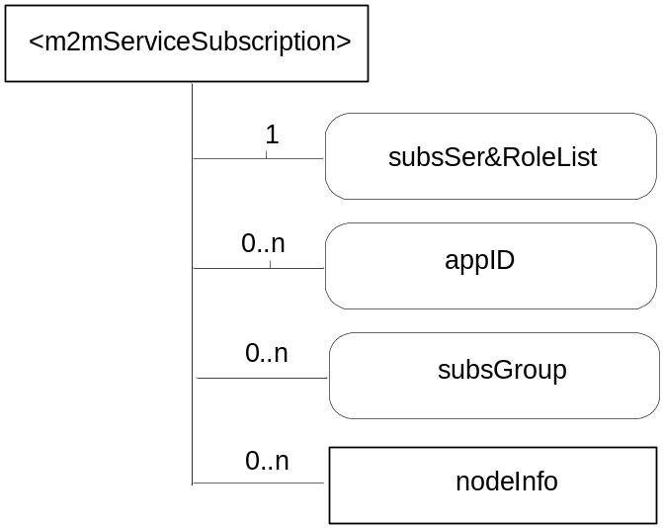
Figure 9.6.20-1: Structure of <m2mServiceSubscription> resource
(only resource specific attributes are shown)
Editor's Note: the M2M-Sub-ID storage is FFS
The <m2mServiceSubscription> resource shall contain the attributes described in Table 9.6.20-1.
This resource shall contain the child resources according to their multiplicity in Table 9.6.20-1 (0 indicates the optionality of the child resource).
Table 9.6.20-1: Child resources of <m2mServiceSubscription> resource
Child Resource Name of <m2mServiceSubscription> | Child Resource Type | Multiplicity | Description
nodeInfo | <nodeInfo> | 0..n | See section 9.6.21

The <m2mServiceSubscription> resource shall contain the attributes described in Table 9.6.20-2.

Table 9.6.20-2: Attributes of <m2mServiceSubscription> resource
Attribute Name of <m2mServiceSubscription> | Multiplicity | RW/  RO/  WO | Description
resourceType (rT) | 1 | RO | See clause 9.6.1 where this common attribute is described.
parentID (pID) | 1 | RO | See clause 9.6.1 where this common attribute is described.
expirationTime (eT) | 1 | RW | See clause 9.6.1 where this common attribute is described.
accessControlPolicies (aRI) | 0..1 | RW | See clause 9.6.1 where this common attribute is described. If no accessControlPolicies is given at the time of creation, the accessControlPolicies of the parent resource is linked to this attribute
creationTime (cT) | 1 | RW | See clause 9.6.1 where this common attribute is described.
labels | 0..1 | RO | See section 9.6.1 where this common attribute is described.
lastModifiedTime (lMT) | 1 | RO | See clause 9.6.1 where this common attribute is described.
subsSer&RoleList | 0..n | WO | This attribute indicates the list of subscribed services and roles.
appID | 0..n | RW | The value of this attribute shall be set to an application identifier as defined in section 7.1.3 pertaining to applications in infrastructure domain (IN-AE) of this M2M service subscription.
subsGroup | 0..n | RW | This attribute contains a group created by the subscriber for the purpose of helping easy setting of Access Rights. An example of the subscriber defined group is all node applications within this service subscription with app-ID set to a specific value.

9.6.21 Resource Type nodeInfo
This resource represents M2M node information that is needed as part of the M2M Service Subscription resource. It shall contain information about the node as well as application identifiers running on that node.
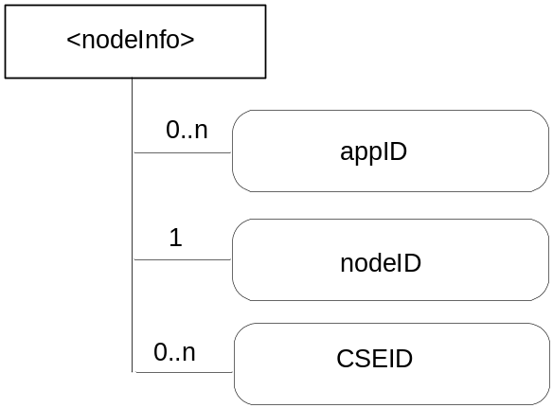
Figure 9.6.21-1: Structure of <nodeInfo> resource
(only resource specific attributes are shown)
The <nodeInfo> resource shall contain the attributes described in Table 9.6.21-1.
Table 9.6.21-1: Attributes of <nodeInfo> resource
Attribute Name of <nodeInfo> | Multiplicity | RW/  RO/  WO | Description
resourceType (rT) | 1 | RO | See section 9.6.1 where this common attribute is described.
parentID (pID) | 1 | RO | See section 9.6.1 where this common attribute is described.
expirationTime (eT) | 1 | RW | See section 9.6.1 where this common attribute is described.
accessControlPolicies (aRI) | 0..1 | RW | See section 9.6.1 where this common attribute is described. If no accessControlPolicies is given at the time of creation, the accessControlPolicies of the parent resource is linked to this attribute
creationTime (cT) | 1 | RW | See section 9.6.1 where this common attribute is described.
labels | 0..1 | RO | See section 9.6.1 where this common attribute is described.
lastModifiedTime (lMT) | 1 | RO | See section 9.6.1 where this common attribute is described.
nodeID | 1 | RW | Node identifier indicating where the M2M Service Subscription applies. Wildcard may be used to allow all the Nodes within a M2M Service Provider.
AppID | 0..n | RW | See section 7.1.3. application ID pertaining to an application running on this node
CSEID | 0..1 | RW | cseID pertaining to this node (for nodes that have a CSE). The cseID becomes know once the pre CSE registration procedure is triggered.

9.6.22 Resource Type pollingChannel
The <pollingChannel> resource shall represent a channel that can be used for a request-unreachable entity (i.e., an AE or a CSE which is behind NAT so it cannot receive a request from others). The request-unreachable entity creates a <pollingChannel> resource on a request-reachable CSE, and it polls any type of request(s) for itself from the <pollingChannel> hosting CSE. For example, an AE can retrieve notifications by long polling on the channel when it cannot receive notifications asynchronously from a subscription hosting CSE.
This <pollingChannel> resource shall have "channelHandle" virtual attribute which is an input/output end point of the channel. After AE or CSE created this resource, it performs long polling on channelHandle of this resource with RETRIEVE operation. The response to the long polling request is pending until there are any requests received on the channel.
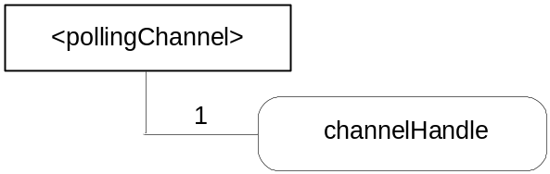
Figure 9.5.22-1: Structure of <pollingChannel> resource

This resource shall contain the attributes according to their multiplicity in Table 9.6.22-1 (0 indicated the optionality of the attribute).
Table 9.6.22-1: Attributes of <pollingChannel>
AttributeName of <pollingChannel> | Multiplicity | RW/  RO/  WO | Description
resourceType | 1 | RO | See section 9.6.1 where this common attribute is described.
parentID | 1 | RO | See section 9.6.1 where this common attribute is described.
creationTime | 1 | RO | See section 9.6.1 where this common attribute is described.
lastModifiedTime | 1 | RO | See section 9.6.1 where this common attribute is described.
expirationTime | 1 | RW | See section 9.6.1 where this common attribute is described.
accessControlPolicies | 0..1 | RW | See section 9.6.1 where this common attribute is described.
labels | 0..1 | RW | See section 9.6.1 where this common attribute is described.
creator | 0..1 | WO | The App-inst-ID or CSE-ID of the entity which created the resource
channelHandle | 1 | WO | A virtual attribute that represents a polling URI. This URI is used for long polling. Accessing this attribute is intended to push request(s) (clause 10.2.x.6) and retrieve the request(s) (clause 10.2.x.7).

9.6.23 Resource Type cmdhPolicy
The <cmdhPolicy> resource type represents a set of rules defining which CMDH parameters will be used by default when a request issued by a local originator (eg. locally registered AE or another CSF inside the local CSE) contains the “ec” parameter but not all other CMDH parameters.
One or several resources of type <cmdhPolicy> may be linked as child resources of the local <CSEBase> resource, thus defining a set of CMDH policies applicable whenever this local hosting CSE receives requests.
In addition, one or several resources of type <cmdhPolicy> may be linked as child resources of other resources of type <application> or <remoteCSE>, thus overriding the default set of policies for the relevant locally registered Application Entities or remote CSEs.
Editor’s Note: The parent resource for this <cmdhPolicy> resource type is TBD. The <cmdhPolicy> resource type will be defined as a management Object.

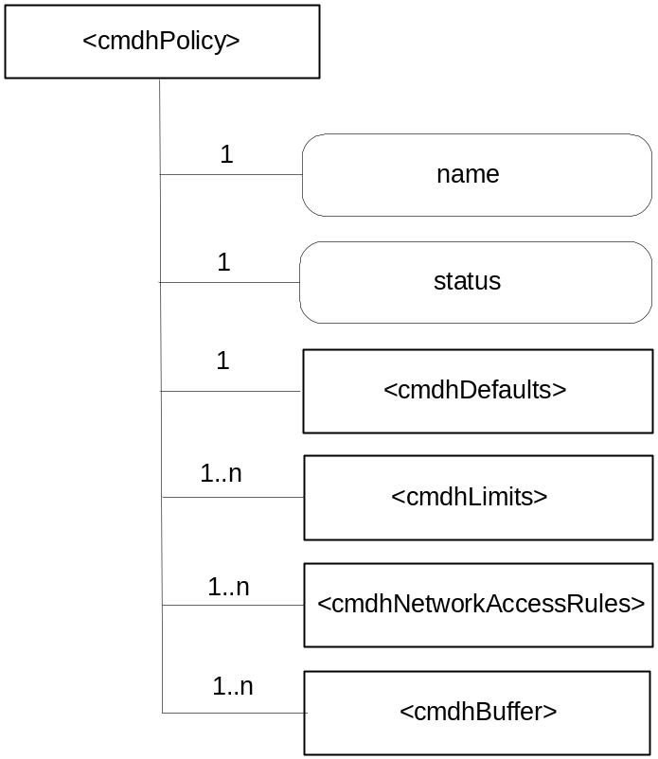
Figure 9.6.23-.1: Structure of <cmdhPolicy> resource
(only resource specific attributes are shown)
The resource <cmdhPolicy> shall contain child resources according to their multiplicity shown in Table 9.6.23-1. A value of "0" for multiplicity indicates the child resource is optional.
Table 9.6.23-1: Child resources of <cmdhPolicy> resource
Child Resource Name of <cmdhPolicy> | Child Resource Type | Multiplicity | Description
[variable] | <cmdhDefaults> | 1. | See section 9.6.24 where the type of this child resource is described.
[variable] | <cmdhLimits> | 1..n | See section 9.6.27 where the type of this child resource is described.
[variable] | <cmdhNetworkAccessRules> | 1..n | See section 9.6.28 where the type of this child resource is described.
[variable] | <cmdhBuffer> | 1..n | See section 9.6.30 where the type of this child resource is described.

The resource <cmdhPolicy> shall contain attributes according to their multiplicity shown in Table 9.6.23-2. A value of "0" for multiplicity indicates the attribute is optional.

Table 9.6.23-2: Attributes of <cmdhPolicy> resource
Attribute Name of <cmdhPolicy> | Multiplicity | RW/  RO/  WO | Description
resourceType (rT) | 1 | RO | See section 9.6.1 where this common attribute is described.
expirationTime (eT) | 1 | RW | See section 9.6.1 where this common attribute is described.
accessControlPolicies (aR) | 0..1 | RW | See section 9.6.1 where this common attribute is described.
creationTime (cT) | 1 | RO | See section 9.6.1 where this common attribute is described.
lastModifiedTime (lMT) | 1 | RO | See section 9.6.1 where this common attribute is described.
labels | 0..1 | RO | See section 9.6.1 where this common attribute is described.
name | 1 | RW | A name under which the CMDH policy will be referred.
status | 1 | RW | Either “active” or “inactive”, this attribute allows to provision policies without activating them immediately, thus sparing the need to completely erase policies and then reprovision them remotely when one only needs to deactivate them temporarily. Only one policy can be “active” at any given time.

NOTE: In order to avoid race conditions, it may be better that the CSE refers to the currently active cmdhPolicy instead of using the “status” attribute.
Editor’s Note: When the <CSEBase> resource is accepted, an attribute or link in the <CSEBase> resource could be used to point to the active <cmdhPolicy> resource.

9.6.24 Resource Type cmdhDefaults
The <cmdhDefaults> resource type is used to define default values that shall be used for CMDH-related parameters when requests issued by Originators (registered AEs or functions inside the CSE itself) do not contain a value for the parameters ec (event category), rqet (request expiration timestamp), rset (result expiration timestamp), oet (operational execution time), rp (response persistence), and/or da (delivery aggregation).
Upon receiving a request, the CSE will first look if the ec (event category) parameter is set. If not, it will use the cmdhDefEcValue child resources (see below) to determine a value that should be used for ec.
Then, if any of the parameters rqet, rset, oet, rp or da is not set, the CSE will use the cmdhEcDefParamValues child resources (see below) to populate the missing parameters (and only the missing ones).
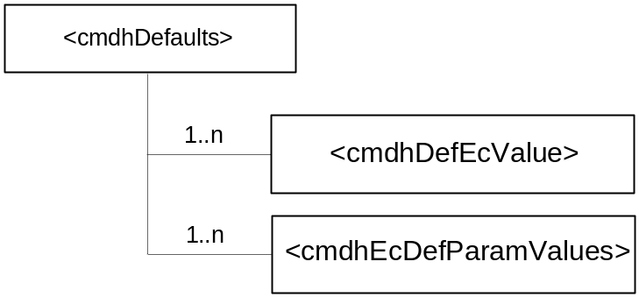
Figure 9.6.24-.1: Structure of <cmdhDefaults> resource
(only resource specific attributes are shown)
The resource <cmdhDefaults> shall contain child resources according to their multiplicity shown in Table 9.6.24-1. A value of "0" for multiplicity indicates the child resource is optional.
Table 9.6.24-1: Child resources of <cmdhDefaults> resource
Child Resource Name of <cmdhDefaults> | Child Resource Type | Multiplicity | Description
[variable] | <cmdhDefEcValue> | 1..n | See section 9.6.25 where the type of this child resource is described.
[variable] | <cmdhEcDefParamValues> | 1..n | See section 9.6.26 where the type of this child resource is described.

The resource <cmdhDefaults> shall contain attributes according to their multiplicity shown in Table 9.6.24-2. A value of "0" for multiplicity indicates the attribute is optional.
Table 9.6.24-2: Attributes of <cmdhDefaults> resource
Attribute Name of <cmdhDefaults> | Multiplicity | RW/  RO/  WO | Description
resourceType (rT) | 1 | RO | See section 9.6.1
expirationTime (eT) | 1 | RW | See section 9.6.1
accessControlPolicies (aR) | 0..1 | RW | See section 9.6.1
creationTime (cT) | 1 | RO | See section 9.6.1
lastModifiedTime (lMT) | 1 | RO | See section 9.6.1
labels | 0..1 | RO | See section 9.6.1 where this common attribute is described.

9.6.25 Resource Type cmdhDefEcValue
The <cmdhDefEcValue> is used to define a value for the ec (event category) parameter of an incoming request when it is not defined.
Upon receiving a request, the CSE will go through all the <cmdhDefEcValue> resources (in the order of their "order" attribute), check the <requestOrigin> and any present<requestContext> and <requestCharacteristics> sub-resources to see if they match (see description of matching), and if they all do, assign the value stored in the defEcValue attribute to the ec parameter.
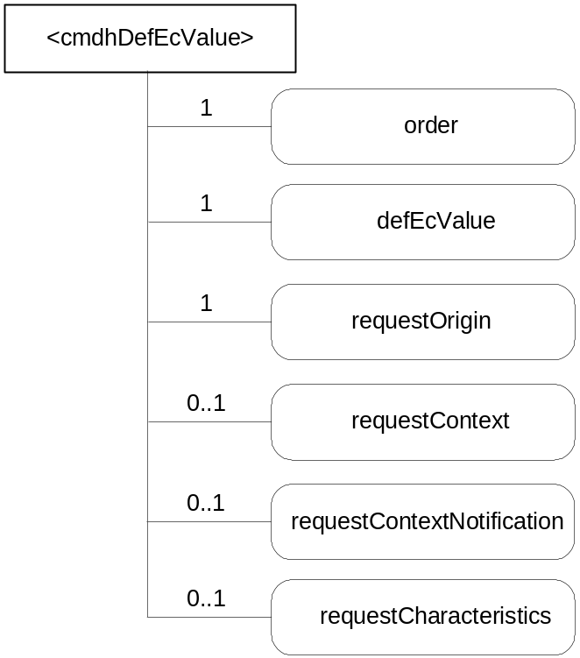
Figure 9.6.25-1: Structure of <cmdhDefEcValue> resource
(only resource specific attributes are shown)
The resource <cmdhEcDefEcValue> shall contain attributes according to their multiplicity shown in Table 9.6.25-1. A value of "0" for multiplicity indicates the attribute is optional.
Table 9.6.25-1: Attributes of <cmdhDefEcValue> resource
Attribute Name of <cmdhDefEcValue> | Multiplicity | RW/  RO/  WO | Description
resourceType (rT) | 1 | RO | See section 9.6.1
expirationTime (eT) | 1 | RW | See section 9.6.1
accessControlPolicies (aR) | 0..1 | RW | See section 9.6.1
creationTime (cT) | 1 | RO | See section 9.6.1
lastModifiedTime (lMT) | 1 | RO | See section 9.6.1
labels | 0..1 | RO | See section 9.6.1 where this common attribute is described.
order(or) | 1 | RW | The index indicating in which order the cmdhDefEcValue resource will be treated by the CSE to determine a value for the ec parameter
defEcValue (dev) | 1 | RW | The actual value to use for the ec parameter if the conditions expressed in the requestOrigin, requestContext and requestCharacteristics all match. If none of these attributes are defined, then the defEcValue shall be applied.
requestOrigin (rorig) | 1 | RW | The requestOrigin attribute is a list of zero or more local App-Inst-IDs, App-IDs, or the strings ‘localAE’ or ‘thisCSE’.  When an App-Inst-ID appears in the requestOrigin attribute, the default ec value defined inside the defEcValue attribute is applicable for the ec if the request was issued by that specific Application Instance.  When an App-ID appears in the requestOrigin attribute, the default ec value defined inside the defEcValue attribute is applicable for the ec if the request was issued by any instance of the Application with that App-ID unless covered by another <cmdhDefEcValue> resource with a requestOrigin attribute containing its specific App-Inst-ID..  When the string ‘localAE’ appears in the requestOrigin attribute, the default ec value defined inside the defEcValue attribute is applicable for the ec for requests issued by all local AEs unless covered by another <cmdhDefEcValue> resource with a requestOrigin attribute containing the specfifc App-Inst-ID or App-ID of the originator of the request.  When the string ‘thjsCSE’ appears in the requestOrigin attribute, the default ec value defined inside the defEcValue attribute is applicable for the ec for requests that are originating from within the local CSE .  The hosting CSE shall contain at least one <cmdhDefEcValue> resource that contains ‘localAE’ in the ‘requestOrigin’ attribute and has no ‘requestContext’ and no ‘requestCharacteristics’ attribute.  The hosting CSE shall contain at least one <cmdhDefEcValue> resource that contains ‘thisCSE’ in the ‘requestOrigin’ attribute and has no ‘contextCondtion’ and no ‘requestCharacteristics’ attribute.
requestContext (rctxt) | 0..1 | RW | The requestContext attribute represents the Dynamic Context condition under which the default ec value defined inside the defEcValue attribute is applicable for the ec.  This may refer to conditions such as current battery status, or current network signal strength.
requestContextNotification | 0..1 | RW | True or false. If set to true, then this CSE will establish a subscription to the dynamic context information defined in the requestContext attribute as well as a subscription to this <cmdhDefEcValue> resource for all AEs corresponding to the App-Inst-ID or an App-ID appearing in the requestOrigin attribute. Both, changes in the context information and changes to the <cmdhDefEcValue> resource will be notified to the respective AEs. The subscription(s) is/are established when the <cmdhDefEcValue> is provisioned or updated.
requestCharacteristics | 0..1 | RW | The requestCharacteristics attribute represents conditions pertaining to the request itself, such as the requested response type (rt attribute) or other attributes of the request.

9.6.26 Resource Type cmdhEcDefParamValues
The <cmdhEcDefParamValues> resource type is used to represent a specific set of default values for the CMDH related parameters rqet (request expiration timestamp), rset (result expiration timestamp), oet (operational execution time), rp (response persistence) and da (delivery aggregation) that are applicable for a given ec (event category) if these parameters are not specified in the request.
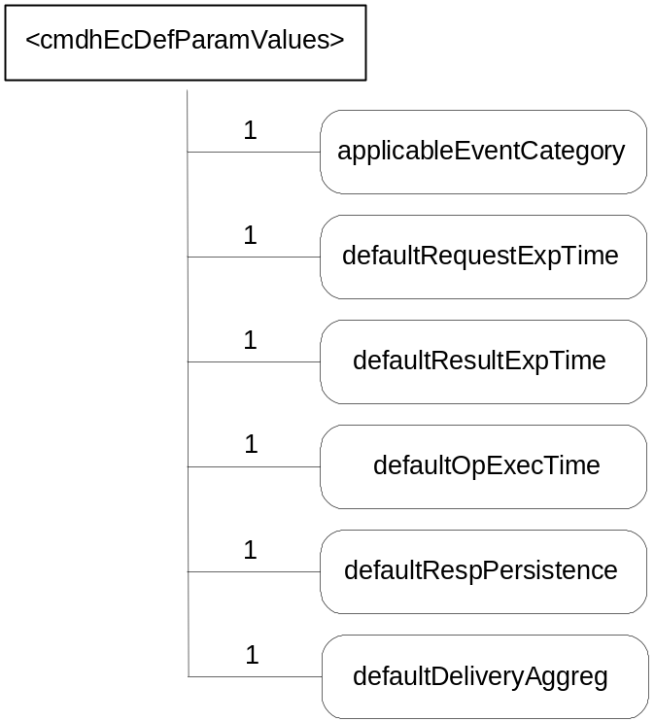
Figure 9.6.26-.1: Structure of <cmdhEcDefParamValues> resource
(only resource specific attributes are shown)

The resource <cmdhEcDefParamValues> shall contain attributes according to their multiplicity shown in Table 9.6.26-1. A value of "0" for multiplicity indicates the attribute is optional.
Table 9.6.26-1: Attributes of <cmdhEcDefParamValues> resource
Attribute Name of <cmdhEcDefParamValues> | Multiplicity | RW/  RO/  WO | Description
resourceType (rT) | 1 | RO | See section 9.6.1
expirationTime (eT) | 1 | RW | See section 9.6.1
accessControlPolicies (aR) | 0..1 | RW | See section 9.6.1
creationTime (cT) | 1 | RO | See section 9.6.1
lastModifiedTime (lMT) | 1 | RO | See section 9.6.1
labels | 0..1 | RO | See section 9.6.1 where this common attribute is described.
applicableEventCategory (aEC) | 1 | RW | This attribute defines the event categories for which this set of default parameters defined in this <cmdhEcDefParamValues> resource are applicable.This attribute is a list of zero or more Event Category values (‘ec’ parameter of a request), or the string ‘default’.  When an Event Category value appears in the ‘applicableEventCategory’ attribute, the set of default parameters defined in this <cmdhEcDefParamValues> resource are applicable for requests associated with that specific Event Category (‘ec’) value.  When the string ‘default’ appears in the ‘applicableEventCategory’ attribute, the set of default parameters defined in this <cmdhEcDefParamValues> resource are applicable for all requests whose associated Event Category value (‘ec’) is not listed in the ‘applicableEventCategory’ attribute of any other provisioned <cmdhEcDefParamValues> resource on the hosting CSE.  A specific Event Category value (‘ec’) shall appear at most once in any of the ‘applicableEventCategory’ attributes of any of the provisioned <cmdhEcDefParamValues> resources on the hosting CSE.  The string ‘default’ shall appear exactly once in any of the ‘applicableEventCategory’ attributes of any of the provisioned <cmdhEcDefParamValues> resources on the hosting CSE.  .
defaultRequestExpTime (dRqET) | 1 | RW | Default value for the request expiration time parameter (‘rqet’) in a request when the ‘rqet’ attribute of the request is not set.
defaultResultExpTime (dRsET) | 1 | RW | Default value for the result expiration time parameter (‘rset’) in a request when the ‘rset’ attribute of the request is not set.
defaultOpExecTime | 1 | RW | Default value for the operational execution time parameter (‘oet’) in a request when the ‘oet’ attribute of the request is not set.
defaultRespPersistence | 1 | RW | Default value for the response persistence parameter (‘rp’) in a request when the ‘rp’ attribute of the request is not set.
defaultDelAggregation | 1 | RW | Default value for the delivery aggregation parameter (‘da’) in a request when the ‘da’ attribute of the request is not set.

9.6.27 Resource Type cmdhLimits
The <cmdhLimits> resource type is used to define limits for CMDH related parameter values used in requests issued by Originators (registered AEs or functions inside the CSE itself). When an incoming request is processed that does not comply with the limits defined by the corresponding <cmdhLimits> resource, the request shall be rejected by the CSE.
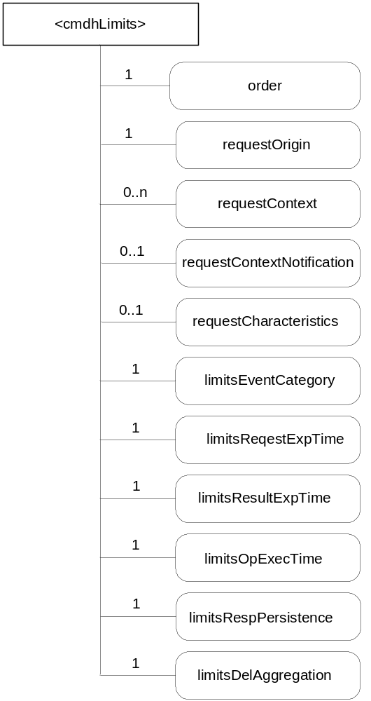
Figure 9.6.27-.1: Structure of <cmdhLimits> resource
(only resource specific attributes are shown)
The resource <cmdhLimits> shall contain attributes according to their multiplicity shown in Table 9.6.27-1. A value of "0" for multiplicity indicates the attribute is optional.
Table 9.6.27-1: Attributes of <cmdhLimits> resource
Attribute Name of <cmdhLimits> | Multiplicity | RW/  RO/  WO | Description
resourceType (rT) | 1 | RO | See section 9.6.1 where this common attribute is described.
expirationTime (eT) | 1 | RW | See section 9.6.1 where this common attribute is described.
accessControlPolicies (aR) | 0..1 | RW | See section 9.6.1 where this common attribute is described.
creationTime (cT) | 1 | RO | See section 9.6.1 where this common attribute is described.
lastModifiedTime (lMT) | 1 | RO | See section 9.6.1 where this common attribute is described.
labels | 0..1 | RO | See section 9.6.1 where this common attribute is described.
order(or) | 1 | RW | The index indicating in which order the cmdhLimits resource will be treated by the CSE to determine a value for the limit parameters.
requestOrigin(rorig) | 1 | RW | The requestOrigin attribute is a list of zero or more local App-Inst-IDs, App-IDs, or the strings ‘localAE’ or ‘thisCSE’.  When an App-Inst-ID appears in the requestOrigin attribute, the CMDH parameter limits defined inside <cmdhLimits> child resources are applicable for requests issued by that specific Application Instance.  When an App-ID appears in the requestOrigin attribute, the CMDH parameter limits defined inside <cmdhLimits> child resources are applicable for requests issued by any instance of the Application with that App-ID unless already covered by another <cmdhLimits> resource with a requestOrigin attribute containing its specific App-Inst-ID.  When the string ‘localAE’ appears in the requestOrigin attribute, CMDH parameter limits defined inside <cmdhLimits> child resources are applicable for all local AEs unless covered by another <cmdhLimits> resource with a requestOrigin attribute containing the specific App-Inst-ID or App-ID of the originator of the request.  When the string ‘thisCSE’ appears in the requestOrigin attribute, CMDH parameter limits defined inside <cmdhLimits> resources are applicable for all requests that are originating from within the hosting CSE.  The hosting CSE shall contain at least one <cmdhLimits> resource that contains ‘localAE’ in the ‘requestOrigin’ attribute and has no ‘contextCondtion’ and no ‘requestCharacteristics’ attribute.  The hosting CSE shall contain at least one <cmdhLimits> resource that contains ‘thisCSE’ in the ‘requestOrigin’ attribute and has no ‘requestContext’ and no ‘requestCharacteristics’ attribute.
requestContext (rctxt) | 0..1 | RW | The requestContext attribute represents the Dynamic Context condition under which CMDH parameter limits defined inside the <cmdhLimits> resource is applicable.  This may refer to conditions such as current battery status, or current network signal strength.
requestContextNotification | 0..1 | RW | True or false. If set to true, then this CSE will establish a subscription to the dynamic context information defined in the requestContext attribute as well as a subscription to this <cmdhLimits> resource for all AEs corresponding to the App-Inst-ID or an App-ID appearing in the requestOrigin attribute. Both, changes in the context information and changes to the <cmdhLimits> resource will be notified to the respective AEs. The subscription(s) is/are established when the <cmdhLimits> is provisioned or updated
requestCharacteristics | 0..1 | RW | The requestCharacteristics attribute represents conditions pertaining to the request itself, such as the requested response type (rt attribute) or other attributes of the request.
limitsEventCategory (lEC) | 1 | RW | Allowed values for the event category parameter (‘ec’) in a request of any of the originators indicated in the requestOrigin attribute.
limitsRequestExpTime (lRqET) | 1 | RW | Range of allowed values for the request expiration time parameter (‘rqet’) in a request of any of the originators indicated in the requestOrigin attribute.
limitsResultExpTime (lRsET) | 1 | RW | Range of allowed values for the result expiration time parameter (‘rset’) in a request of any of the originators indicated in the requestOrigin attribute.
limitsOpExecTime (lOET) | 1 | RW | Range of allowed values for the operational execution time parameter(‘oet’) in a request of any of the originators indicated in the requestOrigin attribute.
limitsRespPersistence (IRP) | 1 | RW | Range of allowed values for the response persistence parameter (‘rp’) in a request of any of the originators indicated in the requestOrigin attribute.
limitsDelAggregation(lDA) | 1 | RW | List of allowed values for the delivery aggregation parameter (‘da’) in a request of any of the originators indicated in the requestOrigin attribute.

9.6.28 Resource Type cmdhNetworkAccessRules
The <cmdhNetworkAccessRules> resource type is used to define the usage of underlying networks for forwarding information to other CSEs during processing of CMDH-related requests in a CSE. When an incoming request is processed by a CSE, it can only use underlying networks for forwarding any information to other CSEs in compliance with the rules defined by the corresponding <cmdhNetworkAccessRules> resource.
If a request cannot be successfully completed in compliance with the rules defined in the corresponding <cmdhNetworkAccessRules> resource, that request shall either be rejected in case it has not already been accepted by the CSE or it has to be purged. Error reporting on failed CMDH processing depends on error reporting parameters (TBD).
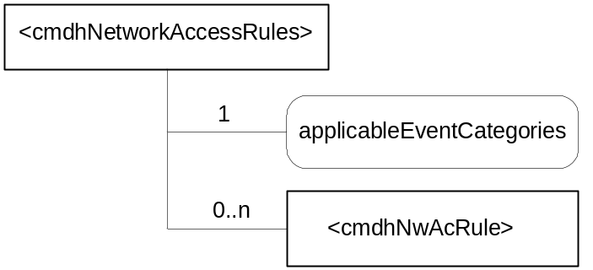
Figure 9.6.28-.1: Structure of <cmdhNetworkAccessRules> resource
(only resource specific attributes are shown)
The resource <cmdhNetworkAccessRules> shall contain child resources according to their multiplicity shown in Table 9.6.28-1. A value of "0" for multiplicity indicates the child resource is optional.
Table 9.6.28-1: Child resources of <cmdhNetworkAccessRules> resource
Child Resource Name of <cmdhNetworkAccessRules>> | Child Resource Type | Multiplicity | Description
[variable] | <cmdhNwAccessRule> | 0..n | See section 9.6.29 where the type of this child resource is described.

If a <cmdhNetworkAccessRules> resource has no <cmdhNwAccessRules> child resources (i.e. multiplicity of 0), requests that match with the ’applicableEventCategories’ attribute (see description of attributes in Table 9.6.28-2) will not be allowed to use any underlying network for forwarding information, i.e such requests need to be rejected.
The resource <cmdhNetworkAccessRules> shall contain attributes according to their multiplicity shown in Table 9.6.28-2. A value of "0" for multiplicity indicates the attribute is optional.
Table 9.6.28-2: Attributes of <cmdhNetworkAccessRules> resource
Attribute Name of <cmdhNetworkAccessRules> | Multiplicity | RW/  RO/  WO | Description
resourceType (rT) | 1 | RO | See section 9.6.1 where this common attribute is described.
expirationTime (eT) | 1 | RW | See section 9.6.1 where this common attribute is described.
accessControlPolicies (aR) | 0..1 | RW | See section 9.6.1 where this common attribute is described.
creationTime (cT) | 1 | RO | See section 9.6.1 where this common attribute is described.
lastModifiedTime (lMT) | 1 | RO | See section 9.6.1 where this common attribute is described.
labels | 0..1 | RO | See section 9.6.1 where this common attribute is described.
applicableEventCategories (aec) | 1 | RW | This attribute defines for which requests the rules contained in <cmdhNwAccessRule> child resources of this <cmdhNetworkAccessRules> resource shall be applied.  This attribute is a list of zero or more Event Category values (‘ec’ parameter of a request), or the string ‘default’.  When an Event Category value appears in the ’applicableEventCategories’ attribute, the network usage rules defined inside <cmdhNwAccessRule> child resources are applicable for requests associated with that specific Event Category (‘ec’) value.  When the string ‘default’ appears in the ’applicableEventCategories’attribute, the network usage rules defined inside <cmdhNwAccessRule> child resources are applicable for all requests whose associated Event Category value (‘ec’) is not listed in the ’applicableEventCategories’attribute of any other provisioned <cmdhNetworkAccessRules> resource on the hosting CSE.  A specific Event Category value (‘ec’) shall appear at most once in any of the ’applicableEventCategories’attributes of any of the provisioned <cmdhNetworkAccessRules> resources on the hosting CSE.  The string ‘default’ shall appear exactly once in any of the ’applicableEventCategories’attributes of any of the provisioned <cmdhNetworkAccessRules> resources on the hosting CSE.

O9.6.29 Resource Type cmdhNwAccessRule
The <cmdhNwUsageRule> resource type is used define limits in usage of specific underlying networks for forwarding information to other CSEs during processing of CMDH-related requests.
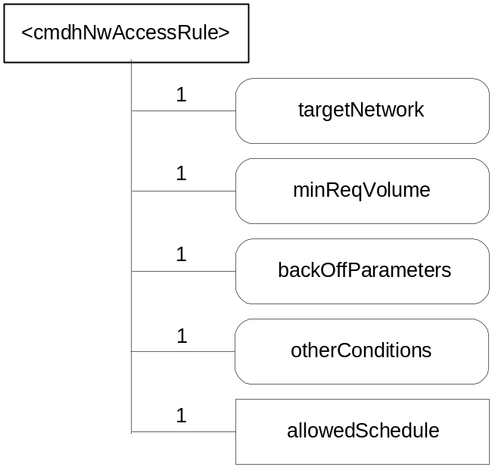
Figure 9.6.29-.1: Structure of <cmdhNwAccessRule> resource
(only resource specific attributes are shown)
The resource <cmdhNwAccessRule> shall contain child resources according to their multiplicity shown in Table 9.6.29-1. A value of "0" for multiplicity indicates the child resource is optional.
Table 9.6.29-1: Child resources of <cmdhNwAccessRule> resource
Child Resource Name of <cmdhNwAccessRule> | Child Resource Type | Multiplicity | Description
allowedSchedule | <schedule> | 1 | See section 9.6.9 where the type of this child resource is described.

The allowedSchedule child resource defines the periods of time during which it is allowed to use the underlying networks that match with the ’targetNetwork’ attribute of this <cmdhNwAccessRule> resource (see description of attributes in Table 9.6.29-2) when forwarding information to other CSEs due to requests that match the ’applicableEventCategories’ attribute of the parent <cmdhNetworkAccessRules> resource of this <cmdhNwAccessRule> resource.
The resource <cmdhNwAccessRule> shall contain attributes according to their multiplicity shown in Table 9.6.29-2. A value of "0" for multiplicity indicates the attribute is optional.
Table 9.6.29-2: Attributes of <cmdhNwAccessRule> resource
Attribute Name of <cmdhNwAccessRule> | Multiplicity | RW/  RO/  WO | Description
resourceType (rT) | 1 | RO | See section 9.6.1 where this common attribute is described.
expirationTime (eT) | 1 | RW | See section 9.6.1 where this common attribute is described.
accessControlPolicies (aR) | 0..1 | RW | See section 9.6.1 where this common attribute is described.
creationTime (cT) | 1 | RO | See section 9.6.1 where this common attribute is described.
lastModifiedTime (lMT) | 1 | RO | See section 9.6.1 where this common attribute is described.
labels | 0..1 | RO | See section 9.6.1 where this common attribute is described.
targetNetwork (tNet) | 1 | RW | The targetNetwork attribute defines for which underlying networks the usage limits contained in this <cmdhNwAccessRule> resource shall be applied.  The targetNetwork attribute is a list of one or more strings identifying names of underlying networks or the string ‘default’. Note: An agreed naming convention for Underlying Network names are TBD.  When a name of an Underlying Network appears in the targetNetwork attribute, the usage limits contained in this <cmdhNwAccessRule> resource shall be applied for usage of that specific Underlying Network when processing requests matching with the parent <cmdhNetworkAccessRules> resource’s ’applicableEventCategories’attribute.  When the string ‘default’ appears in the targetNetwork attribute, the usage limits contained in this <cmdhNwAccessRule> resource shall be applied for usage of all Underlying Networks that are not listed with their specific name in the targetNetwork attribute of any other <cmdhNwAccessRule> sibling under the same parent <cmdhNetworkAccessRules> resource when processing requests matching with the parent <cmdhNetworkAccessRules> resource’s targetNetwork.  Each Underlying Network name or the string ‘default’ shall appear at most once in any of the targetNetwork attributes of any of the provisioned <cmdhNwAccessRule> sibling resources under the same parent <cmdhNetworkAccessRules> resource.
minReqVolume (mRV) | 1 | RW | Minimum amount of data that needs to be aggregated before any of the Underlying Networks matching with the targetNetwork attribute of this <cmdhNwAccessRule> resource can be used for forwarding information to other CSEs.
backOffParameters (bOP) | 1 | RW | Parameters that define how usage of any of the Underlying Networks matching with the targetNetwork attribute of this <cmdhNwAccessRule> resource shall be handled when attempts to use such networks have failed.  The backOffParameters attribute consists of 3 values:  A back-off time that defines how long a CSE needs to wait before attempting to use a specific Underlying Network again after a first failed attempt  A back-off time increment that defines by how much the back-off time shall be increased after each additional consecutive failed attempt to use the same Underlying Network without success  A maximum back-off time that defines the maximum wait time before attempting to use an Underlying Network again after previous failures.
otherConditions | 0..n | RW | Additional conditions that needs to be fulfilled before any of the Underlying Networks matching with the targetNetwork attribute of this <cmdhNwAccessRule> resource can be used for forwarding information to other CSEs.

9.6.30 Resource Type cmdhBuffer
The <cmdhBuffer> resource type is used to define limits in usage of buffers for temporarily storing information that needs to be forwarded to other CSEs during processing of CMDH-related requests in a CSE. When an incoming request is processed by a CSE, it can only use buffers for temporary storage in compliance with the rules defined by the corresponding <cmdhBuffer> resource.
If a request cannot be processed in compliance with the rules defined in the corresponding <cmdhBuffer> resource, that request shall either be rejected in case it has not already been accepted by the CSE or it has to be purged. Error reporting on failed CMDH processing depends on error reporting parameters (TBD).
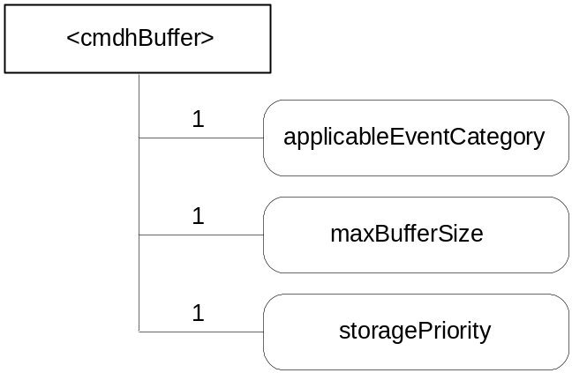
Figure 9.6.30-.1: Structure of <cmdhBuffer> resource
(only resource specific attributes are shown)
The resource <cmdhBuffer> shall contain attributes according to their multiplicity shown in Table 9.6.30-1. A value of "0" for multiplicity indicates the attribute is optional.
Table 9.6.30-1: Attributes of <cmdhBuffer> resource
Attribute Name of <cmdhBuffer> | Multiplicity | RW/  RO/  WO | Description
resourceType (rT) | 1 | RO | See section 9.6.1 where this common attribute is described.
expirationTime (eT) | 1 | RW | See section 9.6.1 where this common attribute is described.
accessControlPolicies (aR) | 0..1 | RW | See section 9.6.1 where this common attribute is described.
creationTime (cT) | 1 | RO | See section 9.6.1 where this common attribute is described.
lastModifiedTime (lMT) | 1 | RO | See section 9.6.1 where this common attribute is described.
labels | 0..1 | RO | See section 9.6.1 where this common attribute is described.
applicableEventCategory  (aEC) | 1 | RW | The ‘applicableEventCategory’ attribute defines for which requests the limits contained in this <cmdhBuffer> resource shall be applied.  The ‘applicableEventCategory’ attribute is a list of zero or more Event Category values (‘ec’ parameter of a request), or the string ‘default’.  When an Event Category vlaue appears in the ‘applicableEventCategory’ attribute, the buffer usage limits defined inside this <cmdhBuffer> resource are applicable for requests associated with that specific Event Category (‘ec’) value.  When the string ‘default’ appears in the ‘applicableEventCategory’ attribute, the buffer usage limits defined inside this <cmdhBuffer> resource are applicable for all requests whose associated Event Category value (‘ec’) is not listed in the ’applicableEventCategory’ attribute of any other provisioned <cmdhBuffer> resource on the hosting CSE.  A specific Event Category value (‘ec’) shall appear at most once in any of the ‘applicableEventCategory’ attributes of any of the provisioned <cmdhBuffer> resources on the hosting CSE.  The string ‘default’ shall appear exactly once in any of the ‘applicableEventCategory’ attributes of any of the provisioned <cmdhBuffer> resources on the hosting CSE.
maxBufferSize (mBS) | 1 | RW | Maximum amount of memory that can be used for buffering requests matching with the ‘applicableEventCategory’ attribute of this <cmdhBuffer> resource.
storagePriority (sP) | 1 | RW | Storage priority for data that is stored for buffering requests matching with the ‘applicableEventCategory’ attribute of this <cmdhBuffer> resource.  The storage priority defines the how to handle purging of buffered data when buffer memory is exhausted and buffered requests need to be purged. Buffered requests associated with a lower storage priority shall be purged before buffered requests with a higher storage priority. The range of storage priority is from 1 … 10.

9.6.18 Resources for Service Charging and Accounting
The <statsConfig> and <statsCollect> resources enable the SCA CSF to provide statistics for service layer operations for applications, based on the configuration and requests from the applications.

9.6.31 Resource Type statsConfig
The <statsConfig> resource shall be used to store configuration of statistics for applications. The <statsConfig> may be established by the service provider. It may be provisioned using device management. The <statsConfig> shall be applied to the Infrastructure Node. The <statsConfig> resource shall be located directly under <CSEBase> of IN-CSE. The <eventConfig> sub-resource shall be used to define events that trigger statistics collection. Below are some examples of events that can be configured by a Service Provider:
- Collection based on a certain operation: collects any RETRIEVE operations on the data created by the collecting entity
- Collection based on storage size: collects the size of storage when a <container> resource created by the collecting entity exceeded a quota
- Combined configuration: collects all RETRIEVE operations on the data created by the collecting entity during a period of time
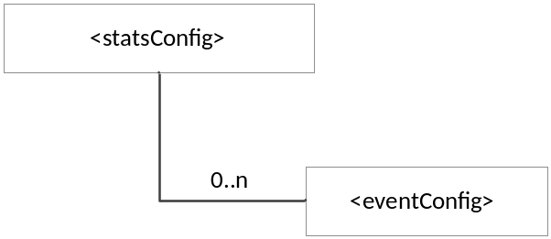
Figure 9.6.31-1: Structure of <statsConfig> resource
(only resource specific attributes are shown)
This resource shall contain the child resources according to their multiplicity in Table 9.6.31-1 (0 indicates the optionality of the child resource).
Table 9.6.31-1: Child resources of <statsConfig> resource
Child Resource Name of <statsConfig> | Child Resource Type | Multiplicity | Description
[variable] | <eventConfig> | 0..n | See section 9.6.32. This resource configures an event for statistics collection.

The <statsConfig> resource shall contain the attributes described in Table 9.6.31-2.
Table 9.6.31-2: Attributes of <statsConfig> resource
Attribute Name of <statsConfig> | Multiplicity | RW/  RO/  WO | Description
resourceType (rT) | 1 | RO | See section 9.6.1 where this common attribute is described
parentID (pID) | 1 | RO | See section 9.6.1 where this common attribute is described.
accessControlPolicies (aRI) | 0..1 | RW | See section 9.6.1 where this common attribute is described
creator (cr) | 1 | RW | The App-inst-ID or CSE-ID of the entity which created the resource
creationTime (cT) | 1 | RO | See section 9.6.1 where this common attribute is described
expirationTime (eT) | 1 | RW | See section 9.6.1 where this common attribute is described
lastModifiedTime (lMT) | 1 | RO | See section 9.6.1 where this common attribute is described
labels (lBs) | 0..1 | RW | See section 9.6.1 where this common attribute is described

9.6.32 Resource Type eventConfig
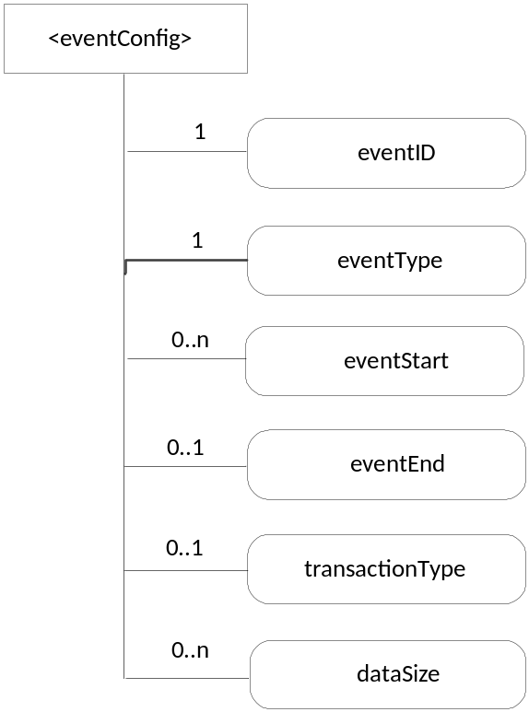
Figure 9.6.32-1: Structure of <eventConfig> resource
(only resource specific attributes are shown)
The <eventConfig> resource shall contain the attributes described in Table 9.6.32-1.
Table 9.6.32-1: Attributes of <eventConfig> resource
Attribute Name of <eventConfig> | Multiplicity | RW/  RO/  WO | Description
resourceType (rT) | 1 | RO | See section 9.6.1 where this common attribute is described
parentID (pID) | 1 | RO | See section 9.6.1 where this common attribute is described.
accessControlPolicies (aRI) | 0..1 | RW | See section 9.6.1 where this common attribute is described
creator (cr) | 1 | RW | The App-inst-ID or CSE-ID of the entity which created the resource
creationTime (cT) | 1 | RO | See section 9.6.1 where this common attribute is described
expirationTime (eT) | 1 | RW | See section 9.6.1 where this common attribute is described
lastModifiedTime (lMT) | 1 | RO | See section 9.6.1 where this common attribute is described
labels (lBs) | 0..1 | RW | See section 9.6.1 where this common attribute is described
eventID | 1 | RO | This attribute uniquely identifies the event to be collected for statistics for applications.
eventType | 1 | RW | This attribute indicates the type of the event, such as timer based, data operation, storage based, etc.
eventStart | 0..1 | RW | This attribute indicates the start time of the event.
eventEnd | 0..1 | RW | This attribute indicates the end time of the event
transactionType | 0..1 | RW | This attribute defines the type of the operation to be collected by statistics, such as CREATE, RETRIEVE.
dataSize | 0..1 | RW | This attribute defines the data size if an event is triggered when the stored data exceeded a certain size.

9.6.33 Resource Type statsCollect
The resource type <statsCollect> shall be used to define different triggers for the IN-CSE to collect statistics for applications. One node may setup multiple triggers. One trigger may be activated or de-activated. The <statsCollect> resource shall be located directly under <CSEBase> of IN-CSE.
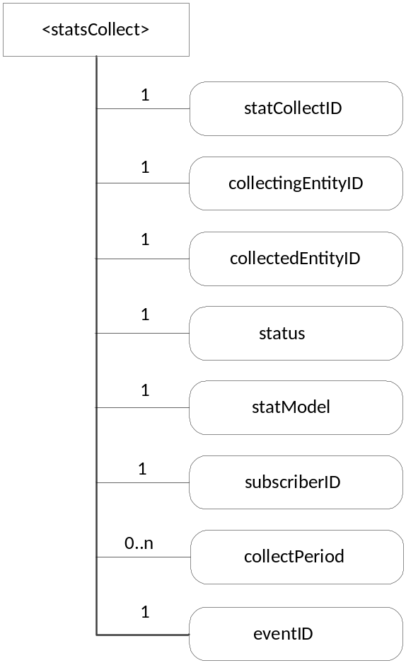
Figure 9.6.33-1: Structure of <statsCollect> resource
(only resource specific attributes are shown)
The <statsCollect> resource shall contain the attributes described in Table 9.6.33-1.
Table 9.6.33-1: Attributes of <statsCollect> resource
Attribute Name of <statsCollect> | Multiplicity | RW/  RO/  WO | Description
resourceType (rT) | 1 | RO | See section 9.6.1 where this common attribute is described
parentID (pID) | 1 | RO | See section 9.6.1 where this common attribute is described.
accessControlPolicies (aRI) | 0..1 | RW | See section 9.6.1 where this common attribute is described
creator (cr) | 1 | RW | The App-inst-ID or CSE-ID of the entity which created the resource
creationTime (cT) | 1 | RO | See section 9.6.1 where this common attribute is described
expirationTime (eT) | 1 | RW | See section 9.6.1 where this common attribute is described
lastModifiedTime (lMT) | 1 | RO | See section 9.6.1 where this common attribute is described
labels (lBs) | 0..1 | RW | See section 9.6.1 where this common attribute is described
statsCollectID | 1 | RO | This is the unique ID to identify a specific statistics collection scenario. It is created by the IN-CSE when the statsCollect resource is first created.
collectingEntityID | 1 | WO | This is the unique ID of the entity that requests the collection of statistics. For example, it can be an application ID (App-ID) or a CSE ID (CSE-ID).
collectedEntityID | 1 | WO | This is the unique ID of the entity whose operations at IN-CSE will be collected. For example, it can be an application ID (App-ID) or a CSE ID (CSE-ID) . If no specific value is provided for this attribute, the IN-CSE interprets it as “any entity”.
status | 1 | RW | This attribute indicates whether the rule is “active” or “inactive”.
statModel | 1 | RW | This attribute indicates the collection model, such as “Subscriber based”, “event based”, etc.
subscriberID | 1 | WO | This attribute indicates the service subscriber (M2M-Sub-ID) being recorded.
collectPeriod | 0..1 | RW | This attribute defines the duration for the SCA to collect service statistics information.
eventID | 0..1 | RW | This attribute refers to the statsConfig resource that defines the events that can be collected by the IN-CSE. . It is mandatory if the statmodel is event based.

9.6.34 Resource Announcement
A resource can be announced to one or more remote CSEs to inform the remote CSEs of the existence of the original resource. With the resource announcement, the original resource can be discovered more easily since the remote CSEs with the interests on the specific resource do not need to contact huge number of CSEs. An announced resource has only a limited set of attributes and a limited set of child resources from the original resource, including a link to the original resource hosted by the resource-hosting CSE.
In case that the original resource is deleted, all announced resources for the original resource shall be deleted as well. If the announced resource is not deleted promptly (e.g. the announced resource is not reachable), the announced resource can be deleted later either by the original resource hosting CSE or by the expiration of the announced resource itself. The original resource shall store the list of link for the announced resources for those purposes.
The labels attribute in the announced resource shall have the same value asthe original resource in order to facilitate the discovery of the original resource. Synchronization between the original resource and the announced resource is the responsibility of the original resource hosting CSE, and the access right for the announced resource shall be properly configured to allow the updates from the original resource hosting CSE.
Some resources are announceable, while others are not. The resource specification for the announceable resources shall specify an additional column as specified in section 9.5.1.1.
The announceable original resource shall have announceTo and announcedAttribute attributes. An AE or other CSE can request the original resource hosting CSE for announcing the original resource to the URI(s) listed in the announceTo attribute. Update to the announceTo attribute will trigger new resource announcement(s) or the de-announcement(s) of the announced resource.
To announce the attribute marked as OP (see section 9.5.1.1), the announcedAttribute attribute can be used. If the attribute marked as OP in the original resource is announced to the announced resource, the attribute shall be created in the announced resource; otherwise it shall not be present in the announced resource. Update to the announcedAttribute attribute in the original resource will trigger new attribute announcement or the de-announcement of the announced attribute(s). The attribute listed in the announcedAttribute attribute shall have the same value as the original resource, and synchronization between the original resource and the announced resource is the responsibility of the original resource hosting CSE.
In the announced resource, the child resource shall not be present unless the original resource hosting CSE requests to create them. The child resource types for the announced resource are specified by the resource specification following the resource template in the section 9.5.1. The child resource of the announced resource can be created by using the resource announcement mechanism in case that the child resource is the announced resource type.
Editor's Note: For the announced resource type, some postfix shall be used for the resource type. The naming convention is FFS.

-----------------------End of change 2---------------------------------------------

-----------------------Start of change 3-------------------------------------------

Annex D (Normative) <mgmtObj> Resource Instances Description

D.1 oneM2M Management Functions
This clause describes the management functions supported by oneM2M. These functions are fulfilled by defining instances of <mgmtObj> resources. The instances are resources of <mgmtObj> type with specific designing to support different management capabilities through operations defined by oneM2M. The instances are service layer information models for the purpose of management. The instances can then be used within the M2M service layer or they can be further mapped to existing management technologies such as OMA DM, OMA LWM2M and BBF TR-069 to enable the management of devices with OMA or BBF compliant management clients.
NOTE: The resource instances defined in this section are all of type <mgmtObj>. The instances are distinguished by attribute mgmtDefinition. The names of the instances are not fixed.
Editor’s Note: The notation for addressing the resources in this section still need to be further studied.

D.2 Resource firmware
<firmware>
mgmtDefinition
objectID
objectPath
description
version
name
URL
update
updateStatus
1
0..1
0..1
0..1
1
1
1
1
1
Figure D.2-1: Structure of <firmware> resource
(only resource specific attributes are shown)
The <firmware> resource shall contain the attributes described in Table D.2-1.
Table D.2-1: Attributes of <firmware> resource
Attribute Name of <firmware> | Multiplicity | RW/RO/WO | Description
resourceType | 1 | WO | See section 9.6.1 where this common attribute is described
parentID | 1 | RO | See section 9.6.1 where this common attribute is described.
expirationTime | 1 | RW | See section 9.6.1 where this common attribute is described
accessControlPolicies | 0..1 | RW | See section 9.6.1 where this common attribute is described
creationTime | 1 | RO | See section 9.6.1 where this common attribute is described
lastModifiedTime | 1 | RO | See section 9.6.1 where this common attribute is described
labels | 0..1 | RO | See section 9.6.1 where this common attribute is described.
mgmtDefinition | 1 | WO | Has fixed value “Firmware” to indicate the resource is for firmware management.
objectID | 0..1 | WO | See section 9.6.13
objectPath | 0..1 | WO | See section 9.6.13
description | 0..1 | RW | See section 9.6.13
version | 1 | RW | The version of the firmware.
name | 1 | RW | The name of the firmware to be used on the device.
URL | 1 | RW | The URL from which the firmware image can be downloaded.
update | 1 | RW | The action that downloads and installs a new firmware in a single operation.
updateStatus | 1 | RO | Indicates the status of the update.

D.3 Resource software

<software>
mgmtDefinition
objectID
objectPath
description
version
name
URL
install
installStatus
1
0..1
0..1
0..1
1
1
1
1
1
activate
deactivate
activateStatus
1
1
1
Figure D.3-1: Structure of <software> resource
(only resource specific attributes are shown)
The <software> resource shall contain the attributes described in Table D.3-1.

Table D.3-1: Attributes of <software> resource
Attribute Name of <software> | Multiplicity | RW/  RO/  WO | Description
resourceType | 1 | WO | See section 9.6.1 where this common attribute is described
parentID | 1 | RO | See section 9.6.1 where this common attribute is described.
expirationTime | 1 | RW | See section 9.6.1 where this common attribute is described
accessControlPolicies | 0..1 | RW | See section 9.6.1 where this common attribute is described
creationTime | 1 | RO | See section 9.6.1 where this common attribute is described
lastModifiedTime | 1 | RO | See section 9.6.1 where this common attribute is described
labels | 0..1 | RO | See section 9.6.1 where this common attribute is described.
mgmtDefinition | 1 | WO | Has fixed value “Software” to indicate the resource is for software management.
objectID | 0..1 | WO | See section 9.6.13
objectPath | 0..1 | WO | See section 9.6.13
description | 0..1 | RW | See section 9.6.13
version | 1 | RW | The version of the software.
name | 1 | RW | The name of the software to be used on the device.
URL | 1 | RW | The URL from which the software package can be downloaded.
install | 1 | RW | The action that downloads and installs new software in a single operation.
installStatus | 1 | RO | Indicates the status of the install.
activate | 0..1 | RW | The action that activates software previously installed.
deactivate | 0..1 | RW | The action that deactivates software.
activeStatus | 0..1 | RW | The status of active or deactivate action.

Editor’s Note: The state machine diagram is to be added according to section 6.2.1.2.3. The names of the attributes also need to be aligned with the wording in the same section.

D.4 Resource memory
<memory>
mgmtDefinition
objectID
objectPath
description
memAvailable
memTotal
1
0..1
0..1
0..1
1
1
Figure D.4-1: Structure of <memory> resource
(only resource specific attributes are shown)
The <memory> resource shall contain the attributes described in Table D.4-1.
Table D.4-1: Attributes of <memory> resource
Attribute Name of <memory> | Multiplicity | RW/  RO/  WO | Description
resourceType | 1 | WO | See section 9.6.1 where this common attribute is described
parentID | 1 | RO | See section 9.6.1 where this common attribute is described.
expirationTime | 1 | RW | See section 9.6.1 where this common attribute is described
accessControlPolicies | 0..1 | RW | See section 9.6.1 where this common attribute is described
creationTime | 1 | RO | See section 9.6.1 where this common attribute is described
lastModifiedTime | 1 | RO | See section 9.6.1 where this common attribute is described
labels | 0..1 | RO | See section 9.6.1 where this common attribute is described.
mgmtDefinition | 1 | WO | Has fixed value “Memory” to indicate the resource is for memory management.
objectID | 0..1 | WO | See section 9.6.13
objectPath | 0..1 | WO | See section 9.6.13
description | 0..1 | RW | See section 9.6.13
memAvailable | 1 | RW | The current available amount of memory.
memTotal | 1 | RW | The total amount of memory.

D.5 Resource areaNwkInfo
<areaNwkInfo>
mgmtDefinition
objectID
objectPath
description
areaNwkType
listOfDevices
1
0..1
0..1
0..1
1
1
Figure D.5-1: Structure of <areaNwkInfo> resource
(only resource specific attributes are shown)
The <areaNwkInfo> resource shall contain the attributes described in Table D.5-1.
Table D.5-1: Attributes of <areaNwkInfo> resource
Attribute Name of <areaNwInfo> | Multiplicity | RW/  RO/  WO | Description
resourceType | 1 | WO | See section 9.6.1 where this common attribute is described
parentID | 1 | RO | See section 9.6.1 where this common attribute is described.
expirationTime | 1 | RW | See section 9.6.1 where this common attribute is described
accessControlPolicies | 0..1 | RW | See section 9.6.1 where this common attribute is described
creationTime | 1 | RO | See section 9.6.1 where this common attribute is described
lastModifiedTime | 1 | RO | See section 9.6.1 where this common attribute is described
labels | 0..1 | RO | See section 9.6.1 where this common attribute is described.
mgmtDefinition | 1 | WO | Has fixed value “AreaNwkInfo” to indicate the resource is for area network information.
objectID | 0..1 | WO | See section 9.6.13
objectPath | 0..1 | WO | See section 9.6.13
description | 0..1 | RW | See section 9.6.13
areaNwkType | 1 | RW | The areaNwkType is an implementation-chosen string that indicates the type of M2M Area Network.
listOfDevices | 1 | RW | Indicates the list of devices in the M2M Area Network. The attribute contains references to AreaNwkDeviceInfo resource. From listOfDevices, the topology of the area network can be discovered and retrieved.

D.6 Resource areaNwkDeviceInfo

<areaNwkDeviceInfo>
mgmtDefinition
objectID
objectPath
description
deviceId
deviceType
areaNwkId
sleepDuration
sleepInterval
1
0..1
0..1
0..1
1
1
1
0..1
0..1
status
listOfNeighbors
0..1
1
Figure D.6-1: Structure of <areaNwkDeviceInfo> resource
(only resource specific attributes are shown)
The <areaNwkDeviceInfo> resource shall contain the attributes described in Table D.6-1.
Table D.6-1: Attributes of <areaNwkDeviceInfo> resource
Attribute Name of <areaNwkDeviceInfo> | Multiplicity | RW/  RO/  WO | Description
resourceType | 1 | WO | See section 9.6.1 where this common attribute is described
parentID | 1 | RO | See section 9.6.1 where this common attribute is described.
expirationTime | 1 | RW | See section 9.6.1 where this common attribute is described
accessControlPolicies | 0..1 | RW | See section 9.6.1 where this common attribute is described
creationTime | 1 | RO | See section 9.6.1 where this common attribute is described
lastModifiedTime | 1 | RO | See section 9.6.1 where this common attribute is described
labels | 0..1 | RO | See section 9.6.1 where this common attribute is described.
mgmtDefinition | 1 | WO | Has fixed value “AreaNwkDeviceInfo” to indicate the resource is for area network device information.
objectID | 0..1 | WO | See section 9.6.13
objectPath | 0..1 | WO | See section 9.6.13
description | 0..1 | RW | See section 9.6.13
devId | 1 | RW | Indicates the id of the device. It could be the id of the hardware or nodeId.
devType | 1 | RW | Indicates the type of the device. The attribute also indicates the functions or services that are provided by the device. Examples include temperature sensor, actuator, Zigbee coordinator or Zigbee router.
areaNwkId | 1 | RW | The reference to an AreaNwkInfo resource which this device associates with.
sleepInterval | 0..1 | RW | The interval between two sleeps.
sleepDuration | 0..1 | RW | The time duration of each sleep.
status | 0..1 | RW | The status of the device (sleeping or waked up).
listOfNeighbors | 1 | RW | Indicates the neighbour devices of the same area network. When modified, the connection relationship of the devices shall be modified accordingly.

D.7 Resource Type battery
This resource is used to share information regarding the battery. The resource type of the Resource battery is <mgmtObj>.
Editor's Note: Using [battery] notation needs more discussion with WG2.
Editor's Note: The notation used for describing [battery] needs to be discussed and to be added to the Guidelines section 9.1
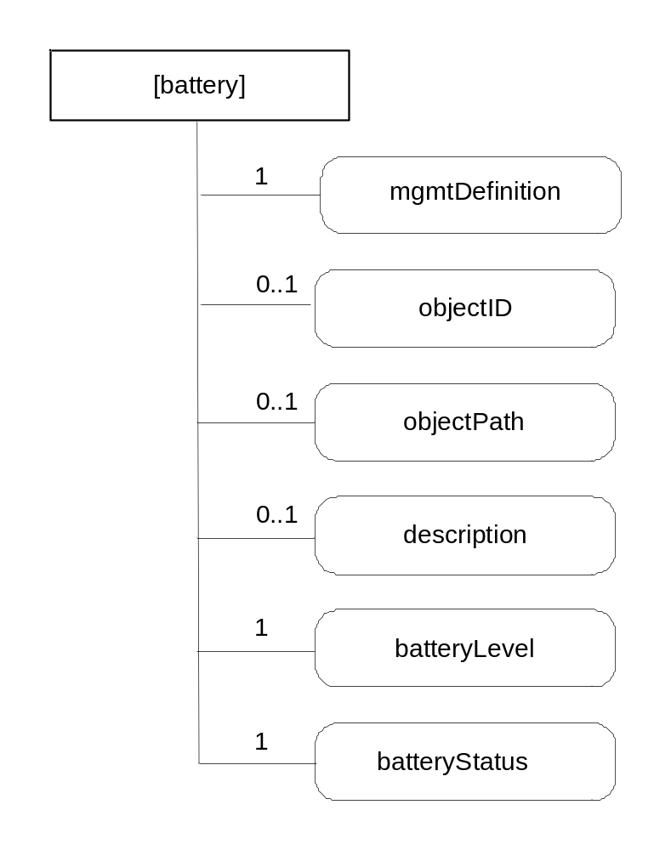
Figure D.7-1: Structure of <battery> resource
This resource shall contain the attributes according to their multiplicity in Table D.7-1 (0 indicates the optionality of the attribute).
Table D.7-1: Attributes of <battery> resource
Attribute Name of <battery> | Multiplicity | RW/  RO/  WO | Description
resourceType (rT) | 1 | WO | See section 9.6.1 where this common attribute is described
parentID (pID) | 1 | RO | See section 9.6.1 where this common attribute is described.
expirationTime (eT) | 1 | RW | See section 9.6.1 where this common attribute is described
accessControlPolicies (aRI) | 0..1 | RW | See section 9.6.1 where this common attribute is described
creationTime (cT) | 1 | RO | See section 9.6.1 where this common attribute is described
lastModifiedTime (lMT) | 1 | RO | See section 9.6.1 where this common attribute is described
labels | 0..1 | RO | See section 9.6.1 where this common attribute is described.
mgmtDefinition | 1 | WO | See section 9.6.10. This attribute shall have the fixed value “battery”.
objectID | 0..1 | WO | See section 9.6.13
objectPath | 0..1 | WO | See section 9.6.13
description | 0..1 | RW | See section 9.6.13
batteryLevel | 1 | RO | The current battery level.
batteryStatus | 1 | RO | Indicates the status of the battery.

D.8 Resource Type deviceInfo
This resource is used to share information regarding the device. The resource type of the Resource deviceInfo is <mgmtObj>.
Editor's Note: The notation used for describing [deviceInfo] needs to be discussed and to be added to the Guidelines section 9.1
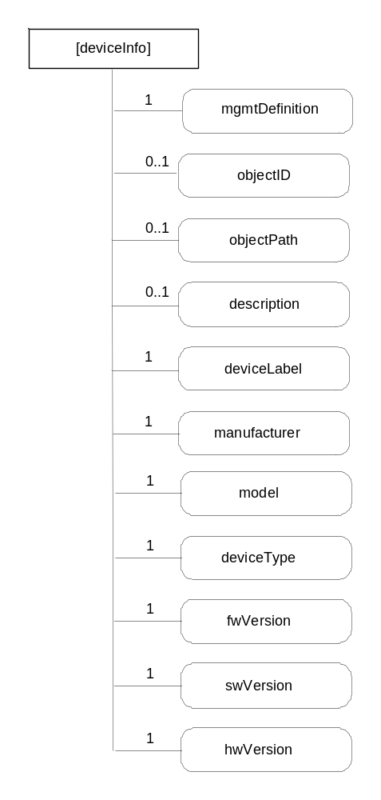
Figure D.8-1: Structure of <deviceInfo> resource
This resource shall contain the attributes according to their multiplicity in Table D.8-1 (0 indicates the optionality of the attribute).
Table D.8-1: Attributes of <deviceInfo> resource
Attribute Name of <deviceInfo> | Multiplicity | RW/  RO/  WO | Description
resourceType (rT) | 1 | WO | See section 9.6.1 where this common attribute is described
parentID (pID) | 1 | RO | See section 9.6.1 where this common attribute is described.
expirationTime (eT) | 1 | RW | See section 9.6.1 where this common attribute is described
accessControlPolicies (aRI) | 0..1 | RW | See section 9.6.1 where this common attribute is described
creationTime (cT) | 1 | RO | See section 9.6.1 where this common attribute is described
lastModifiedTime (lMT) | 1 | RO | See section 9.6.1 where this common attribute is described
labels | 0..1 | RO | See section 9.6.1 where this common attribute is described.
mgmtDefinition | 1 | WO | See section 9.6.10. This attribute shall have the fixed value “deviceInfo”.
objectID | 0..1 | WO | See section 9.6.13
objectPath | 0..1 | WO | See section 9.6.13
description | 0..1 | RW | See section 9.6.10
deviceLabel | 1 | RO | Unique device label assigned by the manufacturer. The uniqueness may be global or only valid within a certain domain (e.g. vendor-wise or for a certain deviceType).
Manufacturer | 1 | RO | The name/identifier of the device manufacturer.
Model | 1 | RO | The name/identifier of the device mode assigned by the manufacturer.
deviceType | 1 | RO | The type (e.g. cell phone, photo frame, smart meter) or product class (e.g. X-series) of the device.
fwVersion | 1 | RO | The firmware version of the device.  NOTE: If the device only supports one kind of Software this is identical to softwareVersion.
swVersion | 1 | RO | The software version of the device.
hwVersion | 1 | RO | The hardware version of the device.

D.9 Resource Type deviceCapability
This resource is used to manage the device capabilities. The resource type of the Resource deviceCapability is <mgmtObj>.
Editor's Note: The notation used for describing [deviceapability] needs to be discussed.

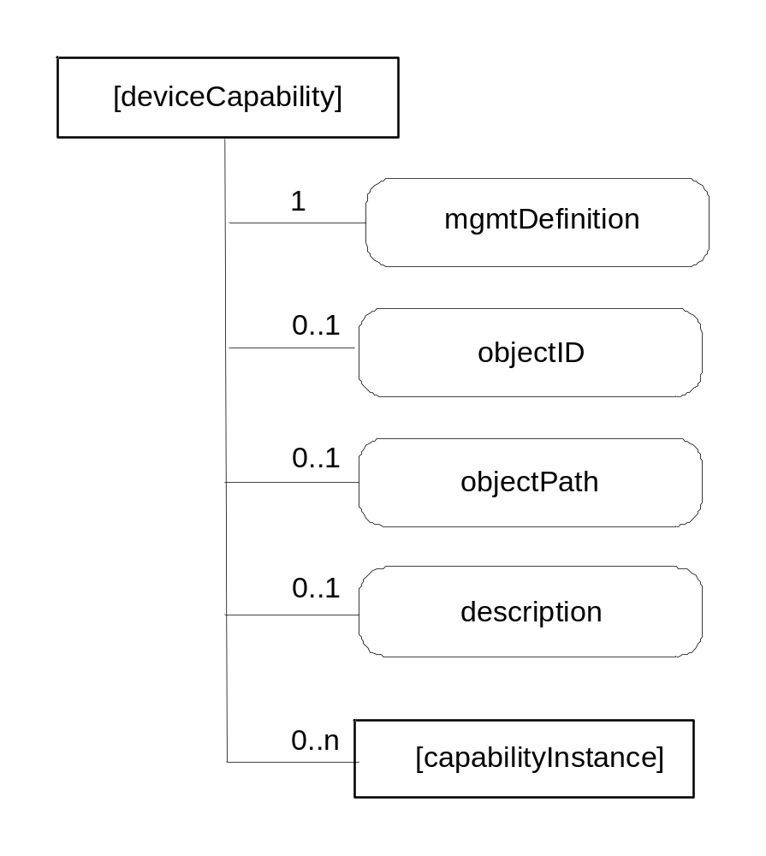
Figure D.9-1: Structure of <deviceCapability> resource
This resource shall contain the child resources according to their multiplicity in Table D.9-1 (0 indicates the optionality of the child resource).
Table D.9-1: Child resources of <deviceCapability> resource
Child Resource Name of <deviceCapability> | Child Resource Type | Multiplicity | Description
[variable] | <parameter> | 0..n | See section 9.6.14

This resource shall contain the attributes according to their multiplicity in Table D.9-2 (0 indicates the optionality of the attribute).
Table D.9-2: Attributes of <deviceCapability> resource
Attribute Name of <deviceCapability> | Multiplicity | RW/  RO/  WO | Description
resourceType (rT) | 1 | WO | See section 9.6.1 where this common attribute is described
parentID (pID) | 1 | RO | See section 9.6.1 where this common attribute is described.
expirationTime (eT) | 1 | RW | See section 9.6.1 where this common attribute is described
accessControlPolicies (aRI) | 0..1 | RW | See section 9.6.1 where this common attribute is described
creationTime (cT) | 1 | RO | See section 9.6.1 where this common attribute is described
lastModifiedTime (lMT) | 1 | RO | See section 9.6.1 where this common attribute is described
labels | 0..1 | RO | See section 9.6.1 where this common attribute is described.
mgmtDefinition | 1 | WO | See section 9.6.10. This attribute shall have the fixed value “deviceCapability”.
objectID | 0..1 | WO | See section 9.6.13
objectPath | 0..1 | WO | See section 9.6.13
description | 0..1 | RW | See section 9.6.13

D.10 Resource Type capabilityInstance
This resource is the instance for representing each device capability. The resource type of the Resource capabilityInstance is <parameter>.
Editor's Note: The notation used for describing [capabilityInstance] needs to be discussed .

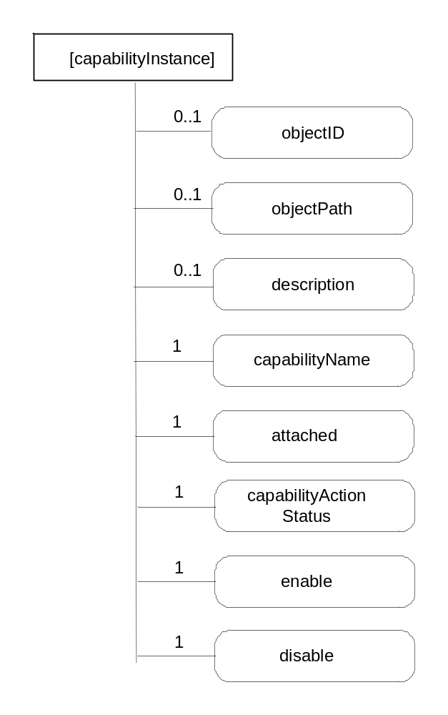
Figure D.10-1: Structure of <capabilityInstance> resource
This resource shall contain the attributes according to their multiplicity in Table D.10-1 (0 indicates the optionality of the attribute).
Table D.10-1: Attributes of <capabilityInstance> resource
Attribute Name of <capabilityInstance> | Multiplicity | RW/  RO/  WO | Description
resourceType (rT) | 1 | WO | See section 9.6.1 where this common attribute is described
parentID (pID) | 1 | RO | See section 9.6.1 where this common attribute is described.
expirationTime (eT) | 1 | RW | See section 9.6.1 where this common attribute is described
accessControlPolicies (aRI) | 0..1 | RW | See section 9.6.1 where this common attribute is described
creationTime (cT) | 1 | RO | See section 9.6.1 where this common attribute is described
lastModifiedTime (lMT) | 1 | RO | See section 9.6.1 where this common attribute is described
labels | 0..1 | RO | See section 9.6.1 where this common attribute is described.
objectID | 0..1 | WO | See section 9.6.13
objectPath | 0..1 | WO | See section 9.6.13
description | 0..1 | RW | See section 9.6.13
capabilityName | 1 | WO | The name of the capability.
attached | 1 | RO | Indicates whether the capability is attached to the device or not.
capabilityActionStatus | 1 | RO | Indicates the status of the Action (including a progress indicator, a final state and a reminder of the requested action).
enable | 0..1 | WO | The action that allows enabling the device capability.
disable | 0..1 | WO | The action that allows disabling the device capability.

D.11 Resource Type reboot
This resource is used to reboot the device. The resource type of the Resource reboot is <mgmtObj>.
Editor's Note: The notation used for describing [deviceapability] needs to be discussed.

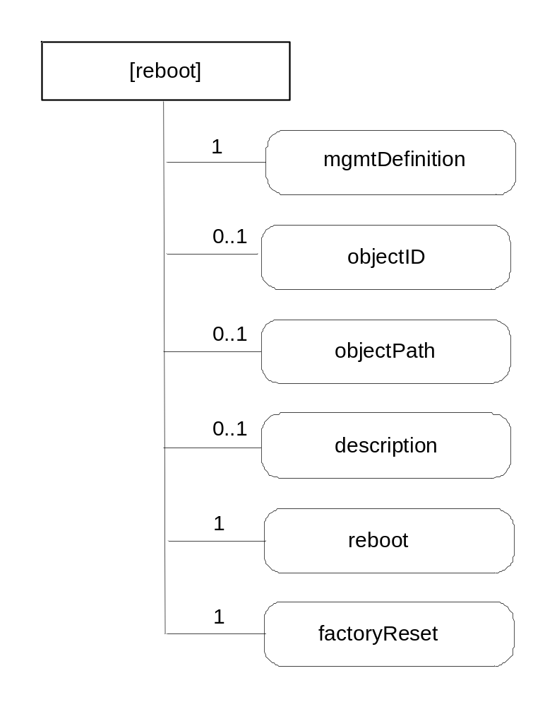
Figure D.11-1: Structure of <reboot> resource
This resource shall contain the attributes according to their multiplicity in Table D.11-1 (0 indicates the optionality of the attribute).
Table D.11-1: Attributes of <reboot> resource
Attribute Name of <reboot> | Multiplicity | RW/  RO/  WO | Description
resourceType (rT) | 1 | WO | See section 9.6.1 where this common attribute is described
parentID (pID) | 1 | RO | See section 9.6.1 where this common attribute is described.
expirationTime (eT) | 1 | RW | See section 9.6.1 where this common attribute is described
accessControlPolicies (aRI) | 0..1 | RW | See section 9.6.1 where this common attribute is described
creationTime (cT) | 1 | RO | See section 9.6.1 where this common attribute is described
lastModifiedTime (lMT) | 1 | RO | See section 9.6.1 where this common attribute is described
labels | 0..1 | RO | See section 9.6.1 where this common attribute is described.
mgmtDefinition | 1 | WO | See section 9.6.10. This attribute shall have the fixed value “reboot”.
objectID | 0..1 | WO | See section 9.6.13
objectPath | 0..1 | WO | See section 9.6.13
description | 0..1 | RW | See section 9.6.13
reboot | 1 | RW | The action that allows rebooting the device.
factoryReset | 1 | RW | The action that allows making the device returning to the factory settings.

D.12 Resource Type eventLog
This resource is used to record the event log for the device. The resource type of the Resource eventLog is <mgmtObj>.
Editor's Note: The notation used for describing [deviceapability] needs to be discussed.

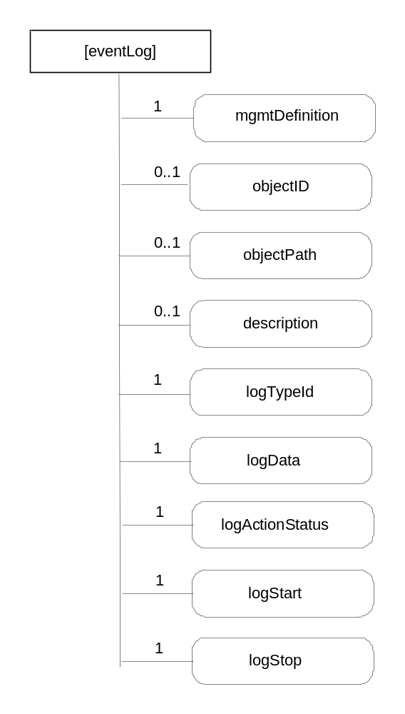
Figure D.12-1: Structure of <eventLog> resource
This resource shall contain the attributes according to their multiplicity in Table D.12-1 (0 indicates the optionality of the attribute).
Table D.12-1: Attributes of <eventLog> resource
Attribute Name of <eventLog> | Multiplicity | RW/  RO/  WO | Description
resourceType (rT) | 1 | WO | See section 9.6.1 where this common attribute is described
parentID (pID) | 1 | RO | See section 9.6.1 where this common attribute is described.
expirationTime (eT) | 1 | RW | See section 9.6.1 where this common attribute is described
accessControlPolicies (aRI) | 0..1 | RW | See section 9.6.1 where this common attribute is described
creationTime (cT) | 1 | RO | See section 9.6.1 where this common attribute is described
lastModifiedTime (lMT) | 1 | RO | See section 9.6.1 where this common attribute is described
labels | 0..1 | RO | See section 9.6.1 where this common attribute is described.
mgmtDefinition | 1 | WO | See section 9.6.10. This attribute shall have the fixed value “eventLog”.
objectID | 0..1 | WO | See section 9.6.13
objectPath | 0..1 | WO | See section 9.6.13
description | 0..1 | RW | See section 9.6.13
logTypeId | 1 | RW | Identifies the types of log to be recorded. E.g., security log, system log.
logData | 1 | R | Diagnostic data logged upon event of interests defined by this diagnostic function.
logActionStatus | 1 | RO | Indicates the status of the Action. E.g., Started, Stopped.
logStart | 1 | RW | The action that allows starting the log corresponding to the mentioned logTypeId.
logStop | 1 | RW | The action that allows stopping the log corresponding to the mentioned logTypeId.

-----------------------End of change n---------------------------------------------

CHECK LIST
- Does this change request include an informative introduction containing the problem(s) being solved, and a summary list of proposals.?
- Does this CR contain changes related to only one particular issue/problem?
- Does this change request make all the changes necessary to address the issue or problem? E.g. A change impacting 5 tables should not only include a proposal to change only 3 tables. Includes any changes to references, definitions, and acronyms in the same deliverable?
- Does this change request follow the drafting rules?
- Are all pictures editable?
- Have you checked the spelling and grammar?
- Have you used change bars for all modifications?
- Does the change include the current and surrounding clauses to clearly show where a change is located and to provide technical context of the proposed change? (Additions of complete sections need not show surrounding clauses as long as the proposed section number clearly shows where the new section is proposed to be located.)
- Are multiple changes in this CR clearly separated by horizontal lines with embedded text such as, start of change 1, end of change 1, start of new clause, end of new clause.?

