INPUT CONTRIBUTION
Group Name:* | WG2
Title:* | TS-0007 Mca Subscribe Services
Source:* | Tim Carey, ALU, timothy.carey@alcatel-lucent.com
Contact: | Tim Carey, ALU, timothy.carey@alcatel-lucent.com
Date:* | 2014-03-19
Abstract:* | Add services for Data Exchange Services requests across the Mca using the Publish-Subscribe-Notify MEP
Agenda Item:* | TP#10
Work item(s): | TS-0007 WI
Document(s)  Impacted* | TS-0007
Intended purpose of  document:* | Decision  Discussion  Information  Other <specify>
Decision requested or recommendation:* | Update TS for inclusion

oneM2M Notice
The document to which this cover statement is attached is submitted to oneM2M. Participation in, or attendance at, any activity of oneM2M, constitutes acceptance of and agreement to be bound by terms of the Working Procedures and the Partnership Agreement, including the Intellectual Property Rights (IPR) Principles Governing oneM2M Work found in Annex 1 of the Partnership Agreement.

6 M2M Services
This clause describes the M2M Services provided by the M2M Services Platform.

6.1 Introduction
The M2M Services defined in this clause are utilized by the Business Services described in the Annexes of this specification.
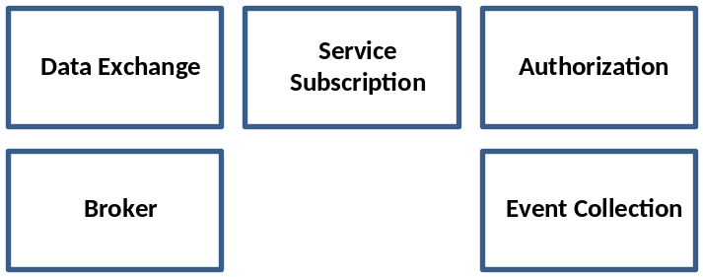
Figure 6.1-1: oneM2M Services

6.2 Service Subscription
The Service Subscription service provides the ability to:
- Validate that service capabilities (e.g., requests, notifications) that transpire across the Mca reference point
- Assist in authorization of a service capability by returning a role for the requested service capability
- Assist in returning the Broker instance needed to exchange data for publish and subscribe service capabilities.

6.2.1 Service Capabilities

6.2.1.3 getBroker
This service capability obtains the Broker instance that will be used to subscribe and publish requests based on the requested service capability (e.g., publishRequest, subscribeRequest), AE and Resource.
For the publishRequest service capability the AE is the fromApp and the resource is the toResource representing a leaf node from the publication resource.
For the subscribeRequest service capability the AE is the toApp and the resource is the publication resource.

6.2.1.3.1 Pre-conditions
A correlation between a Service Subscription, fromAPP and Broker exist..

6.2.1.3.2 Signature
Parameter name | Direction | Optional | Description
subscriptionId | IN | NO | The M2M Service Subscription Identifier (M2M-Sub-ID)
serviceId | IN | NO | The M2M Service Identifier (M2M-Serv-ID) of the service capability
appId | IN | NO | The identifier of the AE that is to target of the request (M2M-AppInst-ID)
broker | OUT | NO | The returned instance of the Broker service associated with the subscription.
returnCode | OUT | NO | Return codes:  - Service exists for Service  - Subscription does not exist for Service
Table 6.2.1.1.2-1 validateBusService Signature

6.2.1.3.3 Post-Conditions
Not Applicable

6.2.1.3.4 Exceptions
Not Applicable

6.2.1.3.5 Policies for Use
Message Exchange Patterns: In-Out
Transaction Pattern: Participation allowed

6.2.1.3.6 oneM2M Resource Interworking
This service capability interworks with the following oneM2M Resource operations that are interworked are:
- TBD
Editors note: The oneM2M Resource Interworking will be identified if a M2M Service Subscription operation is identified

6.2.1.3.7 oneM2M Roles Association
Editors note: The oneM2M Roles Association will be identified once Annex G of TS-0001 has identified the roles for the M2M Services

6.3 Data Exchange

6.3.1 Overview
The Data Exchange service provides the ability to exchange payloads between AEs across the Mca reference point using supported data exchange patterns. This service utilizes an underyling transport adapter to provide the transportation functions.
The supported data exchange patterns are:
- Subscribe-Publish-Notify

6.3.1.1 Subscribe-Publish-Notify Data Exchange
This data exchange pattern permits AEs to subscribe to publication resources. When an AE publishes data to a specific publication resource, the AEs that have subscribe to the publication resource are notified of the publication by receiving the published data.

6.3.1.1.1 Business Rules
A publication resource is an entity that represents the mechanism used by underlying publish and subscribe protocols which represent one or more queues in the underlying protocol. A publication resource in the data exchange service provides capabilities to reference one or more queues in the underlying protocol using a tree mechanism where wildcards are placed to represent all elements of the tree branch or leaf.

6.3.1.1.1.1 Publication Resources
When a AE publishes a payload to a publication resource, the publication resource is evaluated to obtain the leaf node of the tree. The AEs that have subscribed to leaf nodes of the tree receive the message via the notify service capability.

6.3.1.1.1.2 Delivery Policy
As part of the notify service capability the Service Layer attempts to honor the delivery policy of the subscriber and publisher. The delivery policy is the attempt by the Service Layer to provide a reliable delivery of the payload that was published using the mechanisms of the underlying Broker. The reliable delivery of a payload is defined in the deliveryPolicy parameter.

Attribute | Description
retryLimit | The number of retries by the Broker to connected subscribers before assuming failure of the notification.
Table 6.3.1.1.1..2-1 Parameter: deliveryPolicy

6.3.1.1.1.3 Message Retainment Policy
When a message is published, the M2M Service Layer, using the resources of the underlying Broker, attempts to retain messages according to a retainment policy. Retainment of messages permits AEs that are subscribed to the publication resource but not connected to the underlying Broker to receive messages, upto the retainLimit once the AE connects to the Broker. The message retainment policy is defined in the retainmentPolicy parameter.

Attribute | Description
retainLimit | The maximum number of messages retained by the Broker for a subscriber that is not connected to the underlying Broker.
Table 6.3.1.1.1..3-1 Parameter: retainmentPolicy

6.3.1.1.1.4 Service Subscription Integration
In order for the Data Exchange Service to take advantage of the underlying transport, there shall be an association between the AE and the identifier of the underlying transport within the context of the Service Subscription.

6.3.2 Service Capabilities

6.3.2.1 subscribe
This service capabiltiy provides the ability for AEs to subscribe to receive payloads based on a publication resource.
As part of the subsciption, the subscribing AE can provide a deliveryPolicy to enhance the robustness of the notification to AEs that have subscribed to the publication resource identified in the request.

6.3.2.1.1 Pre-conditions
The pre-conditions for MCA Received Requests are met.
A correlation between a Service Subscription, fromAPP and Broker exist.

6.3.2.1.2 Signature - subscribe
Parameter name | Direction | Optional | Description
issuer | IN | NO | See Table A.2.1.1.2-1
subscriptionId | IN | NO | See Table A.2.1.1.2-1
fromApp | IN | NO | See Table A.2.1.1.2-1
publicationResource | IN | NO | The publication resource. See 6.3.1.1.1.1
deliveryPolicy | IN | YES | The delivery policy when notifying the subscriber. See 6.3.1.1.1.2
returnCode | OUT | YES | Unique return codes for this service.  Note: Consumed services also provide return codes.  - Exception: Request may not have been completed
Table 6.3.2.1.2-1 Data Exchange Service – subscribe capability

6.3.2.1.2 Service Interactions
The interactions of service capabilities required for this service capability:
- Issue the subscribe request to the Business Service to validate the request
- Issue the request to the broker to subscribe the fromApp for the publicationResource
- Issue the subscribe complete subscription request to the Business Service

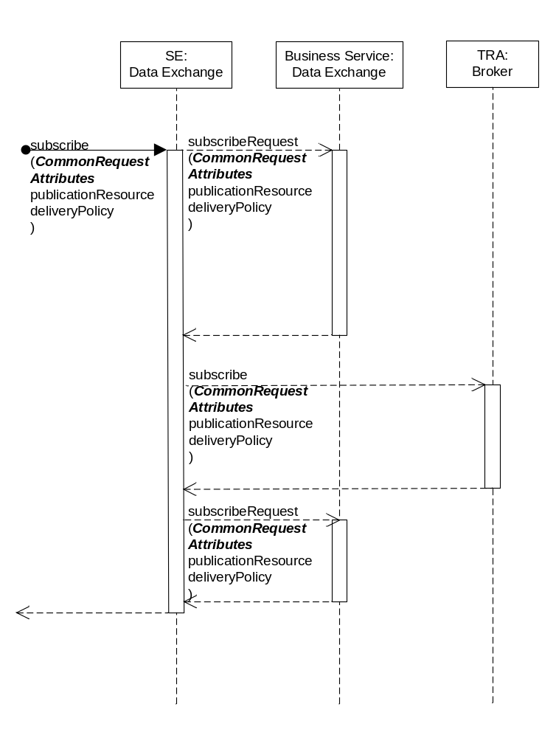
Table 6.3.2.1.2-1 Data Exchange Service – subscribe capability

6.3.2.1.3 Post-Conditions
Not Applicable

6.3.2.1.4 Exceptions
Not Applicable

6.3.2.1.5 Policies for Use
Message Exchange Patterns: In-Out
Transaction Pattern: Participation allowed

6.3.2.1.6 oneM2M Resource Interworking
This service capability interworks with the following oneM2M Resource operations that are interworked are:
- TBD
Editors note: The oneM2M Resource Interworking will be identified if a M2M Service Subscription operation is identified

6.3.2.1.7 oneM2M Roles Association
Editors note: The oneM2M Roles Association will be identified once Annex G of TS-0001 has identified the roles for the M2M Services

6.3.2.2 publish
This service capabiltiy provides the ability for AEs to publish payloads to a leaf node of a publication resource.
As part of the publication, the publishing AE can provide delivery and retainment policies to enhance the robustness of the publication to AEs that have subscribed to the Resource identified in the request.

6.3.2.2.1 Pre-conditions
The pre-conditions for MCA Received Requests are met.
A correlation between a Service Subscription, fromAPP and Broker exist.

6.3.2.2.2 Signature – publish
Parameter name | Direction | Optional | Description
issuer | IN | NO | See Table A.2.1.1.2-1
subscriptionId | IN | NO | See Table A.2.1.1.2-1
fromApp | IN | NO | See Table A.2.1.1.2-1
toResource | IN | NO | The leaf node of a publication resource. See 6.3.1.1.1.1
deliveryPolicy | IN | YES | The delivery policy when notifying the subscriber. See 6.3.1.1.1.2
retainmentPolicy | IN | YES | The retainment policy for unconnected subscribers. See 6.3.1.1.1.3
payload | IN | NO | The payload to published.
returnCode | OUT | YES | Unique return codes for this service.  Note: Consumed services also provide return codes.  - Exception: Request may not have been completed
Table 6.3.2.2.2-1 Data Exchange Service – publish capability

6.3.2.2.2 Service Interactions
The interactions of service capabilities required for this service capability:
- Issue the publish request to the Business Service to validate the request
- Issue the request to the broker to publish the payload from the fromApp to the toResource
- Issue the complete publication request to the Business Service
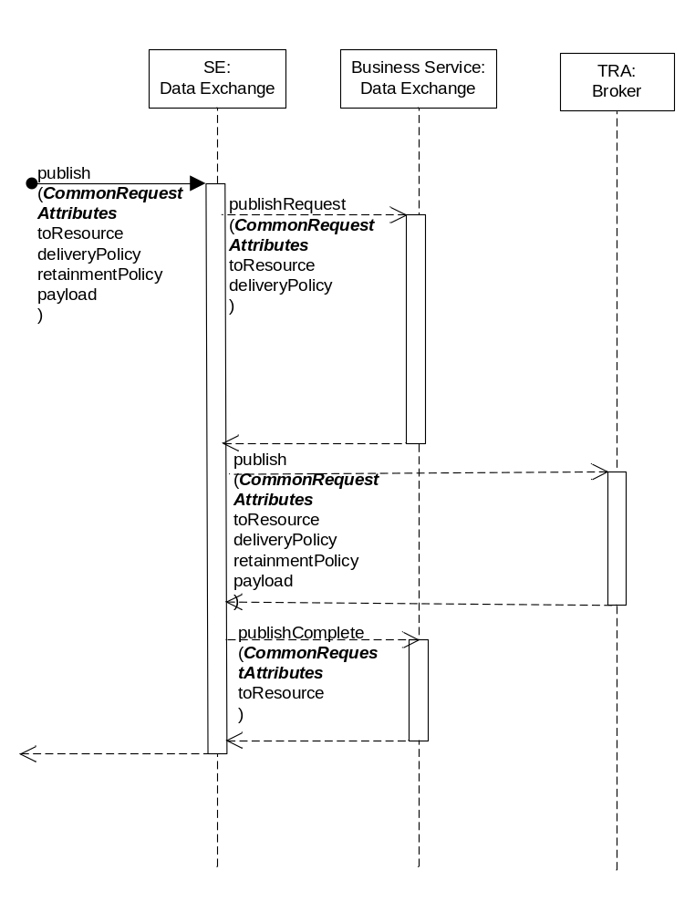
Table 6.3.2.2.2-1 Data Exchange Service –publish (In-Out) capability

6.3.2.2.3 Post-Conditions
Not Applicable

6.3.2.2.4 Exceptions
Not Applicable

6.3.2.2.5 Policies for Use
Message Exchange Patterns: In-Out, In-Only
The In-Only message exchange pattern would return a transport layer acknowledgement if supported by the underlying transport layer protocol. Return codes or Exceptions are not returned in this message exchange pattern.
Transaction Pattern: Participation allowed

6.3.2.2.6 oneM2M Resource Interworking
This service capability interworks with the following oneM2M Resource operations that are interworked are:
- TBD
Editors note: The oneM2M Resource Interworking will be identified if a M2M Service Subscription operation is identified

6.3.2.2.7 oneM2M Roles Association
Editors note: The oneM2M Roles Association will be identified once Annex G of TS-0001 has identified the roles for the M2M Services

6.3.2.3 notify
This service capabiltiy provides the ability to notify AEs that have subscribed to the publication resource identified in the request.

6.3.2.3.1 Pre-conditions
A correlation between a Service Subscription, toApp and Broker exist.

6.3.2.3.2 Signature – notify
Parameter name | Direction | Optional | Description
issuer | IN | NO | See Table A.2.1.1.2-1
subscriptionId | IN | NO | See Table A.2.1.1.2-1
toApp | IN | NO | See Table A.2.1.1.2-1
fromResource | IN | NO | The leaf node of a publication resource. See 6.3.1.1.1.1
deliveryPolicy | IN | YES | The delivery policy when notifying the subscriber. See 6.3.1.1.1.2
payload | IN | NO | The Payload of the message to notify to the AE
returnCode | OUT | YES | Unique return codes for this service.  Note: Consumed services also provide return codes.  - Exception: Request may not have been completed
Table 6.3.2.3.2-1 Data Exchange Service – notify capability

6.3.2.3.3 Post-Conditions
Not Applicable

6.3.2.3.4 Exceptions
Not Applicable

6.3.2.3.5 Policies for Use
Message Exchange Patterns: In-Out
Transaction Pattern: Participation allowed

6.3.2.3.6 oneM2M Resource Interworking
This service capability interworks with the following oneM2M Resource operations that are interworked are:
- TBD
Editors note: The oneM2M Resource Interworking will be identified if a M2M Service Subscription operation is identified

6.3.2.3.7 oneM2M Roles Association
Editors note: The oneM2M Roles Association will be identified once Annex G of TS-0001 has identified the roles for the M2M Services

6.4 Event Collection
The Event Collection service provides the capability to record events for accounting purposes.
Editors Note: Event Collection for accounting purposes is FFS.

6.5 Broker

6.5.1 Overview
The Broker service provides the ability to adapt the Publish-Subscribe-Notify data exchange patterns to the underlying transport protocol and deployment configuration.

6.5.2 Service Capabilities

6.5.2.1 subscribe
This service capabiltiy provides the ability for AEs to subscribe to receive payloads based on a publication resource.
As part of the publication, the publishing AE can provide a deliveryPolicy to enhance the robustness of the notification to AEs that have subscribed to the Resource identified in the request.

6.5.2.1.1 Pre-conditions
A correlation between a Service Subscription, fromApp and Broker exist.

6.5.2.1.2 Signature – subscribe
Parameter name | Direction | Optional | Description
issuer | IN | NO | See Table A.2.1.1.2-1
subscriptionId | IN | NO | See Table A.2.1.1.2-1
fromApp | IN | NO | See Table A.2.1.1.2-1
publicationResource | IN | NO | The publication resource. See 6.3.1.1.1.1
deliveryPolicy | IN | YES | The delivery policy when notifying the subscriber. See 6.3.1.1.1.2
returnCode | OUT | YES | Unique return codes for this service.  Note: Consumed services also provide return codes.  - Exception: Request may not have been completed

Table 6.3.2.2.2-1 Broker – subscribe capability

6.5.2.3.3 Post-Conditions
Not Applicable

6.5.2.3.4 Exceptions
Not Applicable

6.5.2.3.5 Policies for Use
Message Exchange Patterns: In-Out
The In-Only message exchange pattern would return a transport layer acknowledgement if supported by the underlying Transaction Pattern: Participation allowed

6.5.2.2 publish
This service capabiltiy provides the ability for AEs to publish payloads to a leaf node of a publication resource.
As part of the publication, the publishing AE can provide delivery and retainment policies to enhance the robustness of the publication to AEs that have subscribed to the Resource identified in the request.

6.5.2.2.1 Pre-conditions
A correlation between a Service Subscription, fromApp and Broker exist.

6.5.2.2.2 SIgnature – publish
Parameter name | Direction | Optional | Description
issuer | IN | NO | See Table A.2.1.1.2-1
subscriptionId | IN | NO | See Table A.2.1.1.2-1
fromApp | IN | NO | See Table A.2.1.1.2-1
toResource | IN | NO | The leaf node of a publication resource. See 6.3.1.1.1.1
deliveryPolicy | IN | YES | The delivery policy when notifying the subscriber. See 6.3.1.1.1.2
retainmentPolicy | IN | YES | The retainment policy for unconnected subscribers. See 6.3.1.1.1.3
payload | IN | NO | Payload to be published.
returnCode | OUT | YES | Unique return codes for this service.  Note: Consumed services also provide return codes.  - Exception: Request may not have been completed

Table 6.3.2.2.2-1 Broker – publish capability

6.5.2.3.3 Post-Conditions
Not Applicable

6.5.2.3.4 Exceptions
Not Applicable

6.5.2.3.5 Policies for Use
Message Exchange Patterns: In-Out
The In-Only message exchange pattern would return a transport layer acknowledgement if supported by the underlying Transaction Pattern: Participation allowed

6.5.2.3.6 oneM2M Resource Interworking
This service capability interworks with the following oneM2M Resource operations that are interworked are:
- TBD
Editors note: The oneM2M Resource Interworking will be identified if a M2M Service Subscription operation is identified

6.5.2.3.7 oneM2M Roles Association
Editors note: The oneM2M Roles Association will be identified once Annex G of TS-0001 has identified the roles for the M2M Services

6.5.2.3 notify
This service capabiltiy provides the ability for the Broker to notify AEs that have subscribed to the publication resource identified in the request.

6.5.2.3.1 Pre-conditions
The Broker maintains the AEs (toApp, clientId) that have subscribed to publicationResources.
The Broker maintains the Service Subscription (subscriptionId) for AE subscriptions to publicationResources.
A correlation between a Service Subscription, toApp and Broker exist.

6.5.2.3.2 Signature – notify
Parameter name | Direction | Optional | Description
payload | IN | NO | See Table A.2.1.1.2-1
fromResource | IN | NO | The leaf node of a publication resource. See 6.3.1.1.1.1
deliveryPolicy | IN | YES | The delivery policy when notifying the subscriber. See 6.3.1.1.1.2
returnCode | OUT | YES | Unique return codes for this service.  Note: Consumed services also provide return codes.  - Issuer does not have a Broker for the requested toResource  - Issuer has requested an invalid deliveryPolicy  - Exception: Request may not have been completed
Table 6.3.2.3.2-1 Broker – notify capability

6.5.2.3.2 Service Interactions
For each AE subscribed to the resource perform the interactions of service capabilities required for this service capability:
- Issue the notify request to the Business Service to validate the request
- Issue the request to the SE: Data Exchange
- Issue the complete publication request to the Business Service
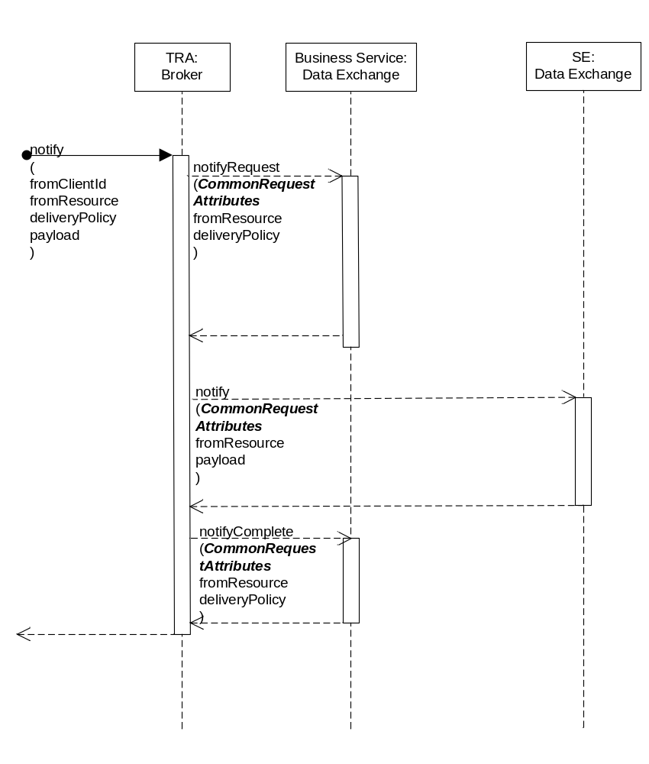
Table 6.5.2.3.2-1 Broker –notify (In-Out) capability

6.5.2.3.3 Post-Conditions
Not Applicable

6.5.2.3.4 Exceptions
Not Applicable

6.5.2.3.5 Policies for Use
Message Exchange Patterns: In-Out, In-Only
The In-Only message exchange pattern would return a transport layer acknowledgement if supported by the underlying transport layer protocol. Return codes or Exceptions are not returned in this message exchange pattern.
Transaction Pattern: Participation allowed

6.5.2.3.6 oneM2M Resource Interworking
This service capability interworks with the following oneM2M Resource operations that are interworked are:
- TBD
Editors note: The oneM2M Resource Interworking will be identified if a M2M Service Subscription operation is identified

6.5.2.3.7 oneM2M Roles Association
Editors note: The oneM2M Roles Association will be identified once Annex G of TS-0001 has identified the roles for the M2M Services

7 M2M Service Components
This clause describes the M2M Service Components provided by the M2M Services Platform.

7.1.1 Service Component Interaction Cross Reference
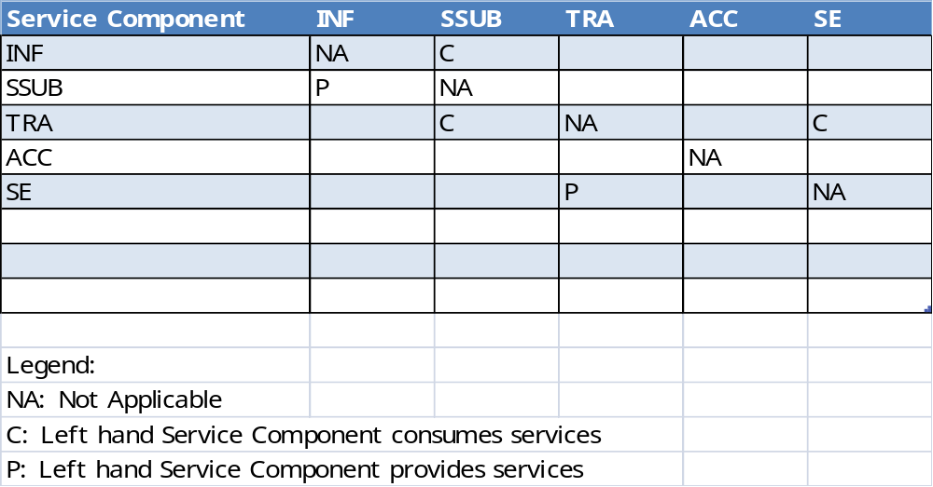
Table 7.1-1 Service Component Cross Reference

7.5 Transport Adapter (TRA)
The TRA component provides Services are used to integrate or adapt Data Exchange requests to the underlying Data Exchange transport (e.g., XMPP or MQTT Broker).

7.5.1 TRA to Service Cross Reference
Broker: All Service Capabilities
SE:Data Exchange: notify

7.6 Accounting (ACC)
The ACC Component provides Services that are record events necessary to charge for the Services provided to AEs.

7.6.1 Accounting to Service Cross Reference
Event Collection: All Service Capabilities

7.6 Service Exposure (SE)
The SE Component acts as the primary interface for AEs to interact with the M2M Service Layer across the Mca reference point.

7.6.1 Service Exposure to Service Cross Reference
SE Data Exchange: All Service Capabilities
Service Subscription: getBroker
Broker: publish, subscribe

Annex B (Informative): Data Exchange Services

B.1 Overview
This annex illustrates the usage of the services for requests to exchange data from AEs across the Mca Reference Point.

B.2 Business Services

B.2.1 Subscribe-Publish-Notify Message Exchange
This service provides the capability to exchange data using the publish and subscribe message patterns where AEs:
- Request to receive payloads from a publication resource by subscribing to the publication resource.
- Request to publish a payload to a resource.

B.2.1.2 Service Capabilities

B.2.1.2.1 subscribeRequest
This service capabiltiy provides the ability to validate a subscription request from an AE.

B.2.1.2.1.1 Pre-conditions
The pre-conditions for MCA Received Requests are met.
A correlation between a Service Subscription, fromAPP and Broker exist.

B.2.1.2.1.2 Signature - subscribeRequest
Parameter name | Direction | Optional | Description
issuer | IN | NO | See Table A.2.1.1.2-1
subscriptionId | IN | NO | See Table A.2.1.1.2-1
fromApp | IN | NO | See Table A.2.1.1.2-1
publicationResource | IN | NO | The publication resource. See 6.3.1.1.1.1
deliveryPolicy | IN | YES | The delivery policy when notifying the subscriber. See 6.3.1.1.1.2
returnCode | OUT | YES | Unique return codes for this service.  Note: Consumed services also provide return codes.  - Issuer does not have a Broker for the requested Resource  - Delivery policy not supported by the underlying Broker
Table B.2.1.2.1.2-1 Data Exchange Service – subscribeRequest capability

B.2.1.2.1.3 Service Interactions
The interactions of service capabilities required for this service capability:
- Determine the Broker to be used for the fromApp and publicationResource
- Perform the Common Request Services for requests across the Mca reference point
- Validate the deliveryPolicy
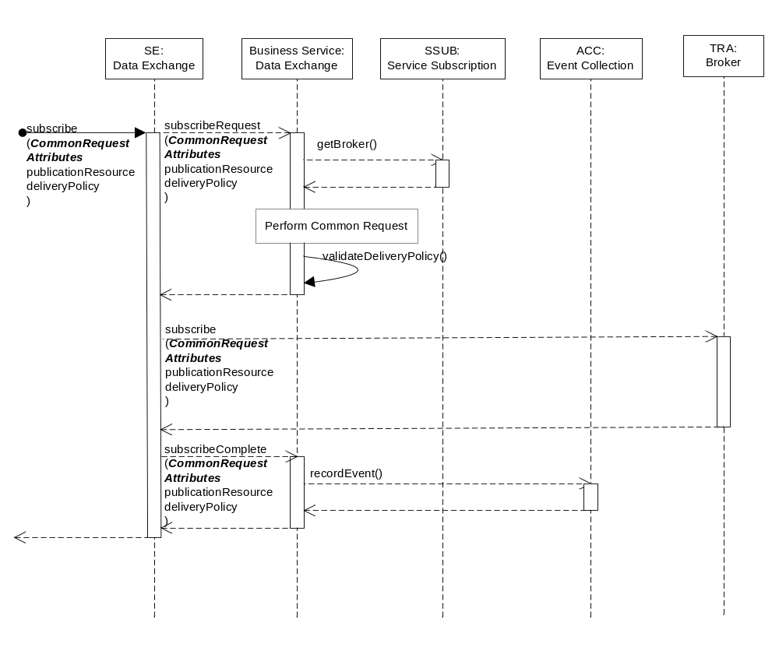
Figure B.2.1.2.1.3-1 subscribeRequest and subscribeComplete Interaction Diagram

B.2.1.2.1.4 Post-Conditions
Success case: The request is permitted.
Failure case: The request is not permitted and a return code is transmitted back the request issuer.

B.2.1.2.1.5 Exceptions
No unique exceptions for this service capability.
Consumed services may throw exceptions which are forwarded by this service capability.

B.2.1.2.1.6 Policies for Use
Message Exchange Patterns: In-Out
Transaction Pattern: Participation allowed
Maximum Response: 250ms

B.2.1.2.2 subscribeComplete
This service capabiltiy provides the ability to complete the actions required once the subscription request has been completed in the Broker.

B.2.1.2.2.1 Pre-conditions
No unique pre-conditions for this service capability.

B.2.1.2.2.2 Signature - subscribeComplete
Parameter name | Direction | Optional | Description
issuer | IN | NO | See Table A.2.1.1.2-1
subscriptionId | IN | NO | See Table A.2.1.1.2-1
fromApp | IN | NO | See Table A.2.1.1.2-1
publicationResource | IN | NO | The publication resource. See 6.3.1.1.1.1
deliveryPolicy | IN | YES | The delivery policy when notifying the subscriber. See 6.3.1.1.1.2
returnCode | OUT | YES | Unique return codes for this service.  Note: Consumed services also provide return codes.  - Exception: Request may not have been completed
Table B.2.1.2.2.2-1 Data Exchange Service – subscribeComplete capability

B.2.1.2.2.3 Service Interactions
The interactions of service capabilities required for this service capability as shown in Figure B.2.1.2.1.3-1:
- Upon a successful subscribe by the Broker, record the event for accounting purposes

B.2.1.2.2.4 Post-Conditions
Success case: The request is permitted.
Failure case: The request is not permitted and a return code is transmitted back the request issuer.

B.2.1.2.2.5 Exceptions
No unique exceptions for this service capability.
Consumed services may throw exceptions which are forwarded by this service capability.

B.2.1.2.2.6 Policies for Use
Message Exchange Patterns: In-Out
Transaction Pattern: Participation allowed
Maximum Response: 50ms

B.2.1.2.3 publishRequest
This service capabiltiy provides the ability to validate a publication request from an AE..
As part of the publication, the publishing AE can provide delivery and retainment policies to enhance the robustness of the publication to AEs that have subscribed to the Resource identified in the request.

B.2.1.2.3.1 Pre-conditions
The pre-conditions for MCA Received Requests are met.
A correlation between a Service Subscription, fromAPP and Broker exist.

B.2.1.2.3.2 Signature - publishRequest
Parameter name | Direction | Optional | Description
issuer | IN | NO | See Table A.2.1.1.2-1
subscriptionId | IN | NO | See Table A.2.1.1.2-1
fromApp | IN | NO | See Table A.2.1.1.2-1
toResource | IN | NO | The leaf node of a publication resource. See 6.3.1.1.1.1
deliveryPolicy | IN | YES | The delivery policy when notifying the subscriber. See 6.3.1.1.1.2
retainmentPolicy | IN | YES | The retainment policy for unconnected subscribers. See 6.3.1.1.1.3
returnCode | OUT | YES | Unique return codes for this service.  Note: Consumed services also provide return codes.  - Issuer does not have a Broker for the requested toResource  - Issuer has requested an invalid deliveryPolicy  - Issuer has requested an invalid retainmentPolicy  - Delivery policy not supported by the underlying Broker  - Retainment policy not supported by the underlying Broker  - Exception: Request may not have been completed

Table B.2.1.2.3.2-1 Data Exchange Service – publishRequest capability

B.2.1.2.3.3 Service Interactions
The interactions of service capabilities required for this service capability:
- Determine the Broker to be used for the fromApp and toResource
- Perform the Common Request Services for requests across the Mca reference point
- Validate the deliveryPolicy and retainmentPolicy for the Broker
- Upon a successful publication to the Broker, record the event for accounting purposes
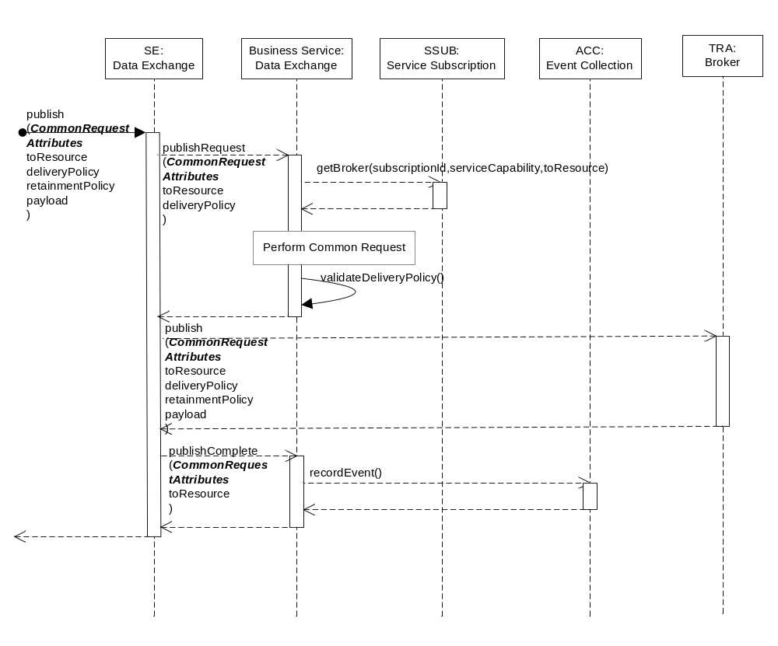
Figure B.2.1.2.3.3-2 publishRequest and publishComplete Interaction Diagram

B.2.1.2.3.4 Post-Conditions
Success case: The request is permitted.
Failure case: The request is not permitted and a return code is transmitted back the request issuer.

B.2.1.2.3.5 Exceptions
No unique exceptions for this service capability.
Consumed services may throw exceptions which are forwarded by this service capability.

B.2.1.2.3.6 Policies for Use
Message Exchange Patterns: In-Out
Transaction Pattern: Participation allowed
Maximum Response: 300ms

B.2.1.2.4 publishComplete
This service capabiltiy provides the ability to complete the actions required once the publication request has been completed in the Broker.

B.2.1.2.4.1 Pre-conditions
No unique pre-conditions for this service capability.

B.2.1.2.4.2 Signature - publishComplete
Parameter name | Direction | Optional | Description
issuer | IN | NO | See Table A.2.1.1.2-1
subscriptionId | IN | NO | See Table A.2.1.1.2-1
fromApp | IN | NO | See Table A.2.1.1.2-1
toResource | IN | NO | The leaf node of a publication resource. See 6.3.1.1.1.1
deliveryPolicy | IN | YES | The delivery policy when notifying the subscriber. See 6.3.1.1.1.2
retainmentPolicy | IN | YES | The retainment policy for unconnected subscribers. See 6.3.1.1.1.3
returnCode | OUT | YES | Unique return codes for this service.  Note: Consumed services also provide return codes.  - Exception: Request may not have been completed
Table B.2.1.2.3.2-1 Data Exchange Service – pubishComplete capability

B.2.1.2.4.3 Service Interactions
The interactions of service capabilities required for this service capability as shown in Figure B.2.1.2.1.3-1:
- Upon a successful subscribe by the Broker, record the event for accounting purposes

B.2.1.2.4.4 Post-Conditions
Success case: The request is permitted.
Failure case: The request is not permitted and a return code is transmitted back the request issuer.

B.2.1.2.4.5 Exceptions
No unique exceptions for this service capability.
Consumed services may throw exceptions which are forwarded by this service capability.

B.2.1.2.4.6 Policies for Use
Message Exchange Patterns: In-Out
Transaction Pattern: Participation allowed
Maximum Response: 50ms

B.2.1.2.5 notifyRequest
This service capabiltiy provides the ability to validate a notification request to an AE.
As part of the notification, delivery policy that is requested to be used is validated and adjusted if necessary.

B.2.1.2.5.1 Pre-conditions
A correlation between a Service Subscription, toApp and Broker exist.
The pre-conditions for MCA Received Requests are met.

B.2.1.2.5.2 Signature - notifyRequest
Parameter name | Direction | Optional | Description
issuer | IN | NO | See Table A.2.1.1.2-1
subscriptionId | IN | NO | See Table A.2.1.1.2-1
toApp | IN | NO | See Table A.2.1.1.2-1
fromResource | IN | NO | The leaf node of a publication resource. See 6.3.1.1.1.1
deliveryPolicy | IN-OUT | YES | The delivery policy when notifying the subscriber. See 6.3.1.1.1.2
returnCode | OUT | YES | Unique return codes for this service.  Note: Consumed services also provide return codes.  - Issuer does not have a Broker for the requested toResource  - Issuer has requested an invalid deliveryPolicy  - Exception: Request may not have been completed

Table B.2.1.2.5.2-1 Data Exchange Service – notifyRequest capability

B.2.1.2.5.3 Service Interactions
The interactions of service capabilities required for this service capability:
- Perform the Common Request Services for requests across the Mca reference point
- Validate that deliveryPolicy requested by the Broker is allowed for the toApp and subscriptionId
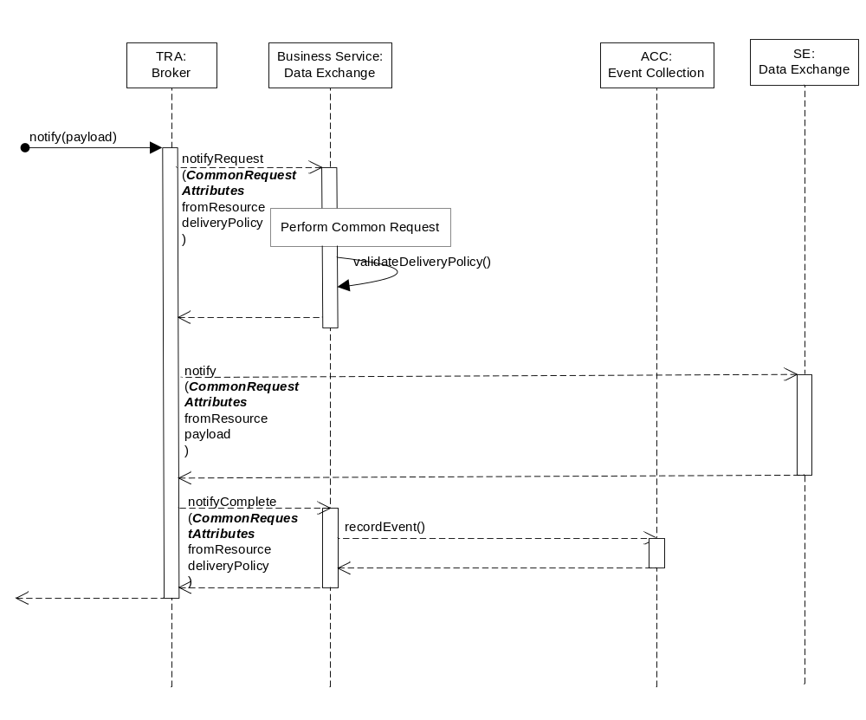
Figure B.2.1.2.5.3-3 notifyRequest and notifyComplete Interaction Diagram

B.2.1.2.5.4 Post-Conditions
Success case: The request is permitted.
Failure case: The request is not permitted and a return code is transmitted back the request issuer.

B.2.1.2.5.5 Exceptions
No unique exceptions for this service capability.
Consumed services may throw exceptions which are forwarded by this service capability.

B.2.1.2.5.6 Policies for Use
Message Exchange Patterns: In-Out
Transaction Pattern: Participation allowed
Maximum Response: 300ms

B.2.1.2.6 publishComplete
This service capabiltiy provides the ability to complete the actions required once the notification request has been completed in the Data Exchange service.

B.2.1.2.6.1 Pre-conditions
No unique pre-conditions for this service capability.

B.2.1.2.6.2 Signature - notifyComplete
Parameter name | Direction | Optional | Description
issuer | IN | NO | See Table A.2.1.1.2-1
subscriptionId | IN | NO | See Table A.2.1.1.2-1
toApp | IN | NO | See Table A.2.1.1.2-1
fromResource | IN | NO | The leaf node of a publication resource. See 6.3.1.1.1.1
deliveryPolicy | IN | YES | The delivery policy when notifying the subscriber. See 6.3.1.1.1.2
returnCode | OUT | YES | Unique return codes for this service.  Note: Consumed services also provide return codes.  - Exception: Request may not have been completed
Table B.2.1.2.63.2-1 Data Exchange Service – pubishComplete capability

B.2.1.2.6.3 Service Interactions
The interactions of service capabilities required for this service capability as shown in Figure B.2.1.2.5.3-3:
- Upon a successful notification by the Data Exchange, record the event for accounting purposes

B.2.1.2.6.4 Post-Conditions
Success case: The request is permitted.
Failure case: The request is not permitted and a return code is transmitted back the request issuer.

B.2.1.2.6.5 Exceptions
No unique exceptions for this service capability.
Consumed services may throw exceptions which are forwarded by this service capability.

B.2.1.2.6.6 Policies for Use
Message Exchange Patterns: In-Out
Transaction Pattern: Participation allowed
Maximum Response: 50ms

