CHANGE REQUEST
Group Name:* | WG2 ARC
Source:* | InterDigital
Format:* | ARC
Date: | 2014-07-16
Contact:* | Guang Lu, InterDigital, Guang.Lu@InterDigital.com
Reason for Change/s:* | Figure 6.1-1 “Configurations supported by oneM2M Architecture” needs to be revised since the representation of Nodes is not matching with the description in section 6.1
CR against: Release* | 0.8.0 (oneM2M Functional Architecture Baseline Draft)
CR against: TS/TR* | oneM2M-TS 0001 Technical Architecture v 0.8.0
Clauses/Sub Clauses* | 6.1
Types of change:* | Editorial change  Bug Fix or Correction  Change/correction to existing feature or functionality  New feature or functionality
Post Freeze checking:* | This CR contains only essential changes and corrections  YES NO

oneM2M Notice
The document to which this cover statement is attached is submitted to oneM2M. Participation in, or attendance at, any activity of oneM2M, constitutes acceptance of and agreement to be bound by terms of the Working Procedures and the Partnership Agreement, including the Intellectual Property Rights (IPR) Principles Governing oneM2M Work found in Annex 1 of the Partnership Agreement.

GUIDELINES for Change Requests:
Provide an informative introduction containing the problem(s) being solved, and a summary list of proposals.
Each CR should contain changes related to only one particular issue/problem.
Follow the principle of completeness, where all changes related to the issue or problem within a deliverable are simultaneously proposed to be made E.g. A change impacting 5 tables should not only include a proposal to change only 3 tables. Includes any changes to references, definitions, and acronyms in the same deliverable.
Follow the drafting rules.
All pictures must be editable.
Check spelling and grammar to the extent practicable.
Use Change bars for modifications.
The change should include the current and surrounding clauses to clearly show where a change is located and to provide technical context of the proposed change. Additions of complete sections need not show surrounding clauses as long as the proposed section number clearly shows where the new section is proposed to be located.
Multiple changes in a single CR shall be clearly separated by horizontal lines with embedded text such as, start of change 1, end of change 1, start of new clause, end of new clause.
When subsequent changes are made to content of a CR, then the accepted version should not show changes over changes. The accepted version of the CR should only show changes relative to the baseline approved text.

Introduction
Figure 6.1-1 (TS-0001-V.0.8.0) includes the Configurations supported by oneM2M Architecture. Section 6.1(TS-0001-V.0.8.0) describes the Nodes of Figure 6.1-1. However, the description in section 6.1 is conflicting with the representation of the figure. We have also used an editable figure.
Following are the changes to the figure:
Change 1: text says “An Infrastructure Node is a Node that contains one Common Services Entity and contains zero or more Application Entities.”
Changed the IN-AE node in the Infrastructure Domain to dotted line.
Change 2: text says “There may be zero or more Middle Nodes in the Field Domain of an M2M System.
Changed the MN-Node with dotted line.
Change 3: text says “There may be zero or more ASNs in the Field Domain of an M2M System”
Changed the ASN-Node with dotted line.
Change 4: text says “There may be zero or more ADNs in the Field Domain of an M2M System.”
Changed the AND-Node with dotted line.

----------------------- Start of change 1 -----------------------

6.1 Relationships among oneM2M Entities
Figure 6.1-1 illustrates the relationships among oneM2M entities supported by the oneM2M architecture as shown in figure 5.2.1-1. The illustration does not constrain the multiplicity of the entities nor require that all relationships shown are present.

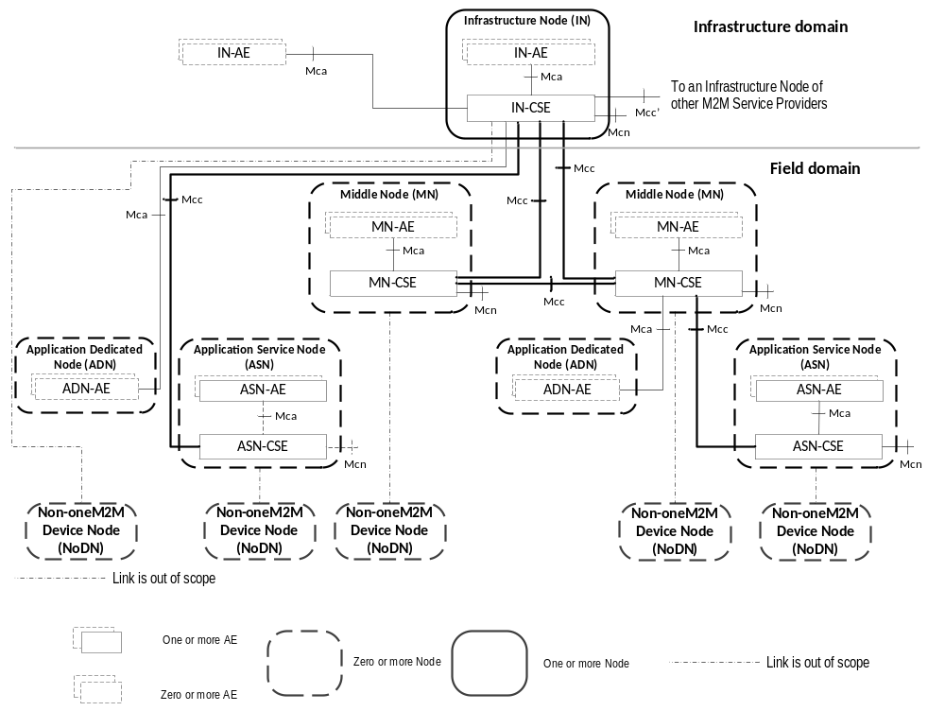

Figure 6.1-1: Configurations supported by oneM2M Architecture

----------------------- End of change 1 -----------------------

CHECK LIST
- Does this change request include an informative introduction containing the problem(s) being solved, and a summary list of proposals.?
- Does this CR contain changes related to only one particular issue/problem?
- Does this change request make all the changes necessary to address the issue or problem? E.g. A change impacting 5 tables should not only include a proposal to change only 3 tables. Includes any changes to references, definitions, and acronyms in the same deliverable?
- Does this change request follow the drafting rules?
- Are all pictures editable?
- Have you checked the spelling and grammar?
- Have you used change bars for all modifications?
- Does the change include the current and surrounding clauses to clearly show where a change is located and to provide technical context of the proposed change? (Additions of complete sections need not show surrounding clauses as long as the proposed section number clearly shows where the new section is proposed to be located.)
- Are multiple changes in this CR clearly separated by horizontal lines with embedded text such as, start of change 1, end of change 1, start of new clause, end of new clause.?

