CHANGE REQUEST
Group Name:* | WG2 ARC
Source:* | NTT DOCOMO, Huawei, ZTE, Cisco, InterDigital, Intel, Alcatel-Lucent Technogies, Oberthur Technologies, LG Electronics
Format:* | ARC
Date:* | <2014-09-04>
Contact:* | Syed Husain, NTT DOCOMO, shusain2016@live.com  Mitch Tseng, Huawei, mitch@T-infoserv.com  Rajesh Bhalla, ZTE, rabhalla@ztetx.com  Philip Jacobs, Cisco, phjacobs@cisco.com  Phillip Brown, InterDigital, phillip.brown@interdigital.com  Puneet Jain, Intel, puneet.jain@intel.com  Timothy Carey, ALU, timothy.carey@alcatel-lucent.com  Dragan Vujcic, Oberthur Technologies, V.Dragan@oberthur.com  Heedong Chos, LG Electronics, heedong.choi@lge.com
Reason for Change/s:* | Clean-up of Clause 6
CR against: Release* | 1
CR against: TS/TR* | oneM2M-TS-0001 - V-1.1.0
Clauses/Sub Clauses* | 6
Type of change: * | Editorial change  Bug Fix or Correction  Change/correction to existing feature or functionality  New feature or functionality
Post Freeze checking:* | This CR contains only essential changes and corrections  YES NO

oneM2M Notice
The document to which this cover statement is attached is submitted to oneM2M. Participation in, or attendance at, any activity of oneM2M, constitutes acceptance of and agreement to be bound by terms of the Working Procedures and the Partnership Agreement, including the Intellectual Property Rights (IPR) Principles Governing oneM2M Work found in Annex 1 of the Partnership Agreement.
GUIDELINES for Change Requests:
Provide an informative introduction containing the problem(s) being solved, and a summary list of proposals.
Each CR should contain changes related to only one particular issue/problem.
Follow the principle of completeness, where all changes related to the issue or problem within a deliverable are simultaneously proposed to be made E.g. A change impacting 5 tables should not only include a proposal to change only 3 tables. Includes any changes to references, definitions, and acronyms in the same deliverable.
Follow the drafting rules.
All pictures must be editable.
Check spelling and grammar to the extent practicable.
Use Change bars for modifications.
The change should include the current and surrounding clauses to clearly show where a change is located and to provide technical context of the proposed change. Additions of complete sections need not show surrounding clauses as long as the proposed section number clearly shows where the new section is proposed to be located.
Multiple changes in a single CR shall be clearly separated by horizontal lines with embedded text such as, start of change 1, end of change 1, start of new clause, end of new clause.
When subsequent changes are made to content of a CR, then the accepted version should not show changes over changes. The accepted version of the CR should only show changes relative to the baseline approved text.

Introduction
This contribution provides editorial changes to Clause 6 of TS-0001. The title of Clause 6 is changed as this clause is more than just oneM2M configurations. This is the final cleanup of this clause prior to the ratification and publication of TS-0001.

---------------------------------Start of changes -----------------------------------------

6 oneM2M Architectural Aspects

6.1 Configurations supported by oneM2M Architecture
The possible configurations of inter-connecting the various oneM2M entities supported by the oneM2M functional architecture, as shown in figure 5.2.1-1, is illustrated in Figure 6.1-1. The illustration does not constrain the multiplicity of the entities nor require that all relationships shown are present.
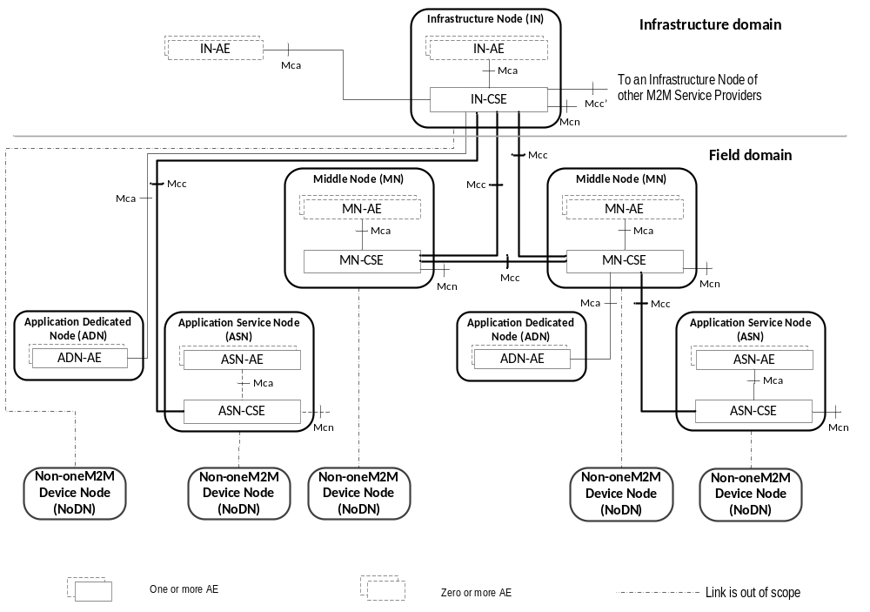

Figure 6.1-1: Configurations supported by oneM2M Architecture
Nodes:
Nodes are logical entities that are individually identifiable in the oneM2M System. Nodes are either CSE-Capable or Non-CSE-Capable:
- A CSE-Capable Node is a logical entity that contains at least one oneM2M CSE and contains zero or more oneM2M AEs. The ASN, IN and MN are examples of CSE-Capable Nodes.
- A Non-CSE-Capable Node is a logical entity that does not contain a oneM2M CSE and contains zero or more oneM2M AEs. The ADN and Non-oneM2M Node are examples of Non-CSE-Capable Nodes.
CSEs resident in different Nodes can be different and are dependent on the services supported by the CSE and the characteristics (e.g. different memory, firmware) of the physical entity that contains the CSE’s Node.
Description of Node types:
The oneM2M architecture enables the following types of Nodes. As logical objects, such Nodes may or may not be mapped to physical objects.
Application Service Node (ASN):
An ASN is a Node that contains one CSE and contains at least one Application Entity (AE). There may be zero or more ASNs in the Field Domain of the oneM2M System.
The CSE in an ASN communicates over the Mcc reference point with one CSE residing in a MN or in an IN.
An AE in an ASN communicates over the Mca reference point with the CSE residing in the same ASN.
An ASN communicates over Mcn with NSEs.
Example of physical mapping: an ASN could reside in an M2M Device.
Application Dedicated Node (ADN):
An ADN is a Node that contains at least one AE and does not contain a CSE. There may be zero or more ADNs in the Field Domain of the oneM2M System.
An AE in the ADN communicates over the Mca reference point with a CSE residing in a MN or in an IN.
Example of physical mapping: an ADN could reside in a constrained M2M Device.
Middle Node (MN):
A MN is a Node that contains one CSE and contains zero or more AEs. There may be zero or more MNs in the Field Domain of the oneM2M System.
The CSE in a MN communicates over the Mcc reference point with one CSE residing in a MN or in an IN and with one or more other CSEs residing in MNs or in ASNs.
In addition, the CSE in the MN can communicate over the Mca reference point with AEs residing in the same MN or residing in an ADN.
A CSE in a MN communicates over Mcn with NSEs.
Example of physical mapping: a MN could reside in an M2M Gateway.
Infrastructure Node (IN):
An IN is a Node that contains one CSE and contains zero or more AEs. There is exactly one IN in the Infrastructure Domain per oneM2M Service Provider. A CSE in an IN may contain CSE functions not applicable to other node types.
The CSE in the IN communicates over the Mcc reference point with one or more CSEs residing in MN(s) and/or ASN(s).
The CSE in the IN communicates over the Mca reference point with one or more AEs residing in the same IN or residing in an ADN.
The CSE in the IN communicates over the Mcn reference point with NSEs, and over the Mcc' reference point with CSEs residing in the INs of other M2M Service Providers.

Example of physical mapping: an IN could reside in an M2M Service Infrastructure.
Non-oneM2M Node (NoDN):
A non-oneM2M Node is a Node that does not contain oneM2M Entities (neither AEs nor CSEs). Such Nodes represent devices attached to the oneM2M system for interworking purposes, including management.
A Non-oneM2M Node communicates (as shown by dotted lines in Figure 6.1-1) with the oneM2M System according to Annex F.
Domain Types:
The Infrastructure Domain of any particular M2M Service Provider contains exactly one Infrastructure Node.
The Field Domain of any particular M2M Service Provider can contain Application Service Nodes, Application Dedicated Nodes, Middle Nodes and Non-oneM2M Nodes.

6.2 Common Services Functions
This clause describes the services provided by the Common Services Layer in the M2M System. Such services reside within a CSE and are referred to as Common Services Functions (CSFs). The CSFs provide services to the AEs via the Mca reference point and to other CSEs via the Mcc reference point. CSEs interact with the NSE via the Mcn reference point. An instantiation of a CSE in a Node comprises a subset of the CSFs from the CSFs described in the present document.
The CSF descriptions in this clause are provided for the understanding of the oneM2M Architecture functionalities and are informative. The CSFs contained inside the CSE can interact with each other but how these interactions take place are not specified in the present document.
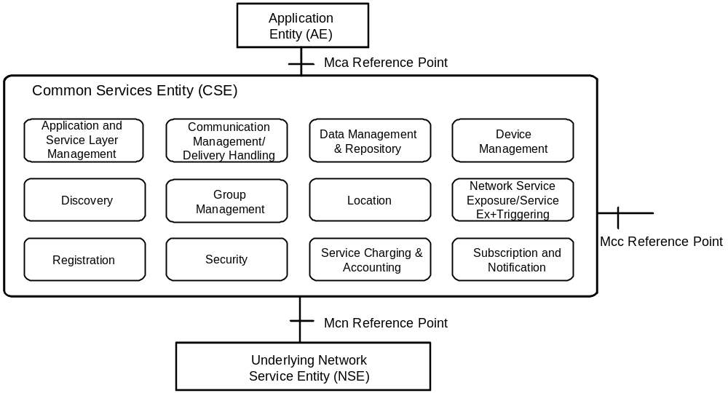

Figure 6.2-1: Common Services Functions

6.2.1 Application and Service Layer Management

6.2.1.1 General Concepts
The Application and Service Layer Management (ASM) CSF provides management of the AEs and CSEs on the ADNs, ASNs, MNs and INs. This includes capabilities to configure, troubleshoot and upgrade the functions of the CSE, as well as to upgrade the AEs.

6.2.1.2 Detailed Descriptions
The ASM CSF provides management capabilities for CSEs and AEs.
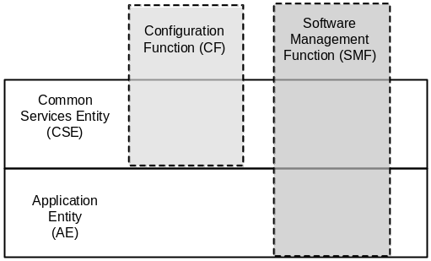

Figure 6.2.1.2-1: Management Layers and Function
The ASM CSF utilizes the functions provided by the Device Management (DMG) CSF for interaction with the Management Server.
The management functions include:
- Configuration Function (CF): This function enables the configuration of the capabilities and features of the CSE (e.g. CMDH policies).
- Software Management Function (SMF): This function provides lifecycle management for software components and associated artifacts (e.g. configuration files) for different entities such as CSE and AE.

6.2.1.2.1 Software Management Function
The Software Management Function (SMF) provides the capability to manage software components (e.g. Software Package, Software Module) for AEs and CSEs.
The ASM CSF provides the capability to manage the lifecycle of the Software Packages for a CSE or an AE. AE Software Packages may be deployed on any Node that supports the AE; including those on the MNs, ADNs and ASNs.
The lifecycle of a Software Package consists of states (e.g. Installing, Installed, Updating, Uninstalling and Uninstalled) that transition when an action (e.g. Download, Install, Update and Remove) is applied to the Software Package.
When a Software Package is installed into an execution environment the software component that is capable of executing in the Execution Environment is called a Software Module. The lifecycle of a Software Module consists of states (e.g. Idle, Starting, Active, Stopping) that transition when an action (e.g. Start, Stop) is applied to the Software Module.

6.2.2 Communication Management and Delivery Handling

6.2.2.1 General Concepts
The Communication Management and Delivery Handling (CMDH) CSF provides communications with other CSEs, AEs and NSEs.
The CMDH CSF decides at what time to use which communication connection for delivering communications (e.g. CSE-to-CSE communications) and, when needed and allowed, to buffer communication requests so that they can be forwarded at a later time. This processing in the CMDH CSF is carried out per the provisioned CMDH policies and delivery handling parameters that can be specific to each request for communication.
For communication using the Underlying Network data transport services, the Underlying Network can support the equivalent delivery handling functionality. In such case the CMDH CSF uses the Underlying Network, and it may act as a front end to access the Underlying Network equivalent delivery handling functionality.

6.2.2.2 Detailed Descriptions
The service that AEs or CSEs can request from the CMDH CSF is to transport some data to a specific target (CSE or AE), according to given delivery parameters while staying within the constraints of provisioned communication management and delivery handling policies.
The content of the data provided by the Originator is not be visible to the CMDH CSF and does not influence its behaviour. Consequently, the CMDH CSF is not aware of the specific operation requested at the target entity, including the parameters passed to the operation at the destination CSF. This means that all attributes intended to be delivered to the destination entity (e.g. which CSF is the destination on the target entity, what that CSF does with the data etc.) are hidden to the CMDH CSF.
The target entity may be reached either directly or via the CSE(s) of a MN(s).
As part of the delivery request, the CMDH CSF can be provided with acceptable delivery parameters for the Originator (e.g. acceptable expiration time for delivery).
The functions supported by the CMDH CSF are as follows:
- Ability for the M2M Service Provider to derive CMDH policies describing details for the usage of the specific Underlying Network(s). These policies may be based on the M2M Service Subscription associated with Application and Service Entities (AEs and CSEs) in the Field Domain and on the agreements on usage of Underlying Network communication resources. CMDH Policies can be provisioned into the respective CSEs in the Field Domain.
- For the delivery of communication, ability to select appropriate communication path to use at any given time in line with provisioned CMDH policies and with CMDH-related parameters set by the Originator of requests, and when needed and allowed, how long to buffer communication requests so that they can be forwarded at a later time. This policy-driven use of communication resources allows an M2M Service Provider to control which Originators of requests are allowed to consume - possibly costly - communication resources at certain times.
- For the delivery of communication, ability to be aware of the availability of the Underlying Networks.
- Ability to manage the proper use of buffers for store-and-forward processing through use of CMDH policies.

6.2.3 Data Management and Repository

6.2.3.1 General Concepts
One of the purposes of CSEs is to enable AEs to exchange data with each other.
The Data Management and Repository (DMR) CSF is responsible for providing data storage and mediation functions. It includes the capability of collecting data for the purpose of aggregating large amounts of data, converting this data into a specified format, and storing it for analytics and semantic processing. The data can be either raw data transparently retrieved from an M2M Device, or processed data which is calculated and/or aggregated by M2M entities.
NOTE: Collection of large amounts of data is known as the Big Data Repository and is not part of this document.

6.2.3.2 Detailed Descriptions
The DMR CSF provides the capability to store data such as Application data, subscriber information, location information, device information, semantic information, communication status, access permission, etc. The data stored by the DMR CSF enables management of the data and provides the foundation of Big Data.
The following are examples of DMR CSF functionalities:
- Ability to store data in an organized fashion so it is discernible. This includes storage of contextual information such as data types, semantic information, time stamps, location, etc., to complement the data stored in order to access and search the data based on a set of parameters. This is part of data semantics capability which is not part of the present document.
- Provides the means to aggregate data received from different entities.
- Ability to grant access to data from remote CSEs and AEs based on defined access control policies, and trigger data processing based on data access.
- Ability to provide the means to perform data analytics on large amount of data to allow service providers to provide value-added services.

6.2.4 Device Management

6.2.4.1 General Concepts
The Device Management (DMG) CSF provides management of device capabilities on MNs (e.g. M2M Gateways), ASNs and ADNs (e.g. M2M Devices), as well as devices that reside within an M2M Area Network. Application Entities (AE) can manage the device capabilities on those Nodes by using the services provided by the DMG CSF alleviating the need for the AE to have knowledge of the management technology specific protocols or data models. While the AE does not require an understanding of the management technology specific protocols or data models, this information is provided to the AE so that an AE can utilize this information for administrative purposes (e.g. diagnostics, troubleshooting).

6.2.4.1.1 Device Management Architecture
In order to manage the CSE and device capabilities of the MNs, ASNs and ADNs, the DMG can utilize existing device management technologies (e.g. TR-069 [Error: Reference source not found], OMA-DM [Error: Reference source not found], and LWM2M [Error: Reference source not found]) in addition to management of Management Resources across the Mcc reference point. When the device management technology is used to manage the MN, ASN or ADN, the DMG of the IN translates or adapts the management related requests from other CSEs or from AEs to the device management commands of the corresponding device management technology.
In order to perform the translation and adaptation functions, the DMG has a functional component termed the Management Adapter (figure 6.2.4.1.1-1). The Management Adapter in the DMG of the IN (IN-DMG-MA) performs the adaptation between the DMG and Management Servers; while the Management Adapter in the DMG of the MN (MN-DMG-MA) and ASN (ASN-DMG-MA) performs translation and adaptation between the DMG and the Management Client. Only one Management Adapter is shown in the DMG although it can interact with Management Server using different management technologies.
The interface between Management Server and Management Client (figure 6.2.4.1.1-1) is the mc interface which is subject to the device management technology that is used (e.g. TR-069 [Error: Reference source not found] or LWM2M [Error: Reference source not found]). The mc interface is technology dependent and is outside the scope of this specification.
The DMG in the CSE of the MN has the same functionality as the DMG in the CSE of the ASN. In addition, the DMG in the MN can be used to manage devices in the M2M Area Network. In this case, the DMG is deployed with proxy functionality that interacts with the Proxy Management Client using the mp interface. The mp interface is technology dependent and is outside the scope of this specification.
The Management Server and Management Client can be implemented as an entity external to the Node or they can be implemented as an entity embedded within the Node (figure 6.2.4.1.1-1). The Management Server and the Management Client are located on the boundary of the Node to indicate this situation as well as to depict that an IN can utilize multiple Management Servers from various M2M and Network Service Providers.
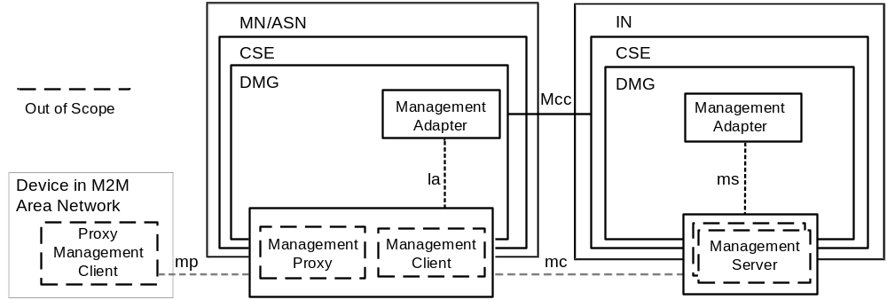

Figure 6.2.4.1.1-1: Device Management Architecture

6.2.4.1.2 Management Server Interaction

6.2.4.1.2.1 Overview
The DMG CSF in the IN has the capability to utilize Management Servers from existing device management technologies (e.g. TR-069 [Error: Reference source not found], OMA DM [Error: Reference source not found], LWM2M [Error: Reference source not found]) to implement the Device Management functions. The IN-DMG-MA communicates with the Management Server using the ms interface that is provided by the Management Server. Note that ms interface is outside the scope of this specification. The IN-DMG-MA takes the following roles:
- Protocol Translation between DMG and the Management Server:
- After the DMG receives the requests from the request Originator, the IN-DMG-MA translates the requests from the request Originator to requests with associated identifiers that can be understood by the Management Server. Likewise the IN-DMG-MA translates events from the Management Server and delivers the events to M2M Entities (e.g. AE, CSE) that are subscribed to the event. When the Management Server is embedded within the IN-DMG, the Management Adapter translates the request and accepts events in the protocol understood by the Management Client.
- Interaction with the Management Server:
- By using ms interface, the IN-DMG-MA can communicate with the Management Server. This is for delivering the requests from the request Originator to the Management Server, or receiving information from the Management Server that will be notified to subscribing M2M Entities (e.g. AE, CSE). The communication between the IN-DMG-MA and the Management Server requires an establishment of a session. The establishment of a session between the IN-DMG-MA and Management Server provides security dimensions for Access Control, Authentication, Non-repudiation, Data confidentiality, Communication security, Data integrity and Privacy. The IN-DMG-MA can utilize a policy that defines when a session between the IN-DMG-MA and Management Server is established and torn down.
- Management Server selection:
- When the IN-DMG-MA communicates with multiple Management Servers that have different level of access control privileges to resources from the Management Server the IN-DMG-MA selects the proper Management Server that has the access control privileges to perform the management requests. The access control policy information for resources from Management Servers may be discovered using the ms interface.
- Discovery of external management objects:
- When the IN-DMG-MA maintains information (i.e. metadata, values) of the external management objects managed by a Management Server using the ms interface, the IN-DMG-MA will be capable of discovering and keep up to date the external management object's information that are managed by the IN-DMG and a Management Server.
A Management Server can be located in the Underlying Network using the Mcn reference point as depicted in figure 6.2.4.1.2.1-1 or the Management Server can be located in the M2M Service Layer as depicted in figure 6.2.4.1.2.1-2.

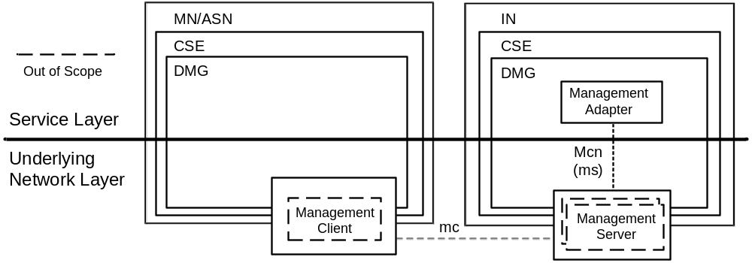

Figure 6.2.4.1.2.1-1: Management Server in Underlying Network

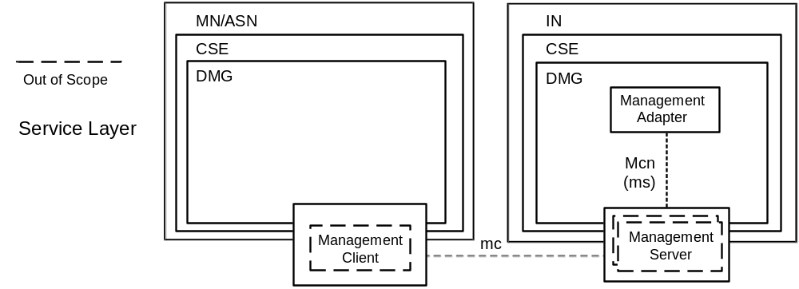

Figure 6.2.4.1.2.1-2: Management Server in M2M Service Layer
The ms interface is functionally the same interface regardless if the Management Server resides in the Underlying Network or the Service Layer. However, the access control privileges that the Management Server has for resources from the management technology can be different depending whether the Management Server resides in the Underlying Network or in the Services Layer. For example in figure 6.2.4.1.2.1-1, the Management Server in the Underlying Network controls access of the exposed resources from the management technology while, in the figure 6.2.4.1.2.1-2, the Management Server in the M2M Service Layer controls access to the resources.

6.2.4.1.2.2 Management Server - Access Permissions
When an operation on an M2M Service Layer Resource is performed and if the access to the Resource is granted and the operation for the Resource utilizes a Management Server external to the service layer, the IN-DMG CSF selects one or more among the authenticated Management Servers necessary to access the requested resources. The procedure for the selection of Management Servers is implementation specific and outside the scope of the present document.
The DMG CSF management functions that cause impacts to the Underlying Network utilize access permissions that are delegated from the provider of the network service layer.
6.2.4.1.2.3 Management Server - External management object discovery
An IN-DMG-MA discovers information of the external management objects managed by a Management Server using the ms interface. The discovery of this information includes the:
- M2M devices, devices in the M2M Area Network and M2M Applications to which the Management Server has access.
- The metadata associated with the external management objects associated the M2M devices, devices in the M2M Area Network and M2M Applications. This metadata includes items such as the supported data/object model.
The IN-DMG-MA is capable of being kept up-to-date of the changes in the M2M Devices, devices in the M2M Area Network and M2M Applications or the metadata of the external management objects associated with those entities. In addition, the IN-DMG-MA can maintain the value associated external management objects, associated the M2M devices, devices in the M2M Network and M2M Applications.

6.2.4.1.3 Management Client Interaction

6.2.4.1.3.1 Overview
The DMG CSF in the MN or ASN can use the Management Client from existing management technologies (e.g. TR-069 [Error: Reference source not found], OMA DM [Error: Reference source not found], LWM2M [Error: Reference source not found]) to implement the Device Management functions. The MN-DMG-MA or ASN-DMG-MA communicates with the Management Client using the la interface (e.g. DM-7, 8, 9 ClientAPI in OMA DM [Error: Reference source not found]) that is provided by the Management Client. Note that the la interface is outside the scope of this specification. The MN-DMG-MA or ASN-DMG-MA takes the following roles:
- Interaction with the Management Client:
- By using la interface, the Management Adapter can communicate with the Management Client to discover the external management objects supported by the Management Client.
- Mapping between the DMG and Management Client:
- After the Management Adapter discovers the external management objects supported by the Management Client; the Management Adapter performs the mapping between the external management objects to resources. The DMG in the MN or ASN can create those resources in the IN-CSE, and the resources can be used by the IN-AE to manage the device capabilities pertaining to the MN or ASN.

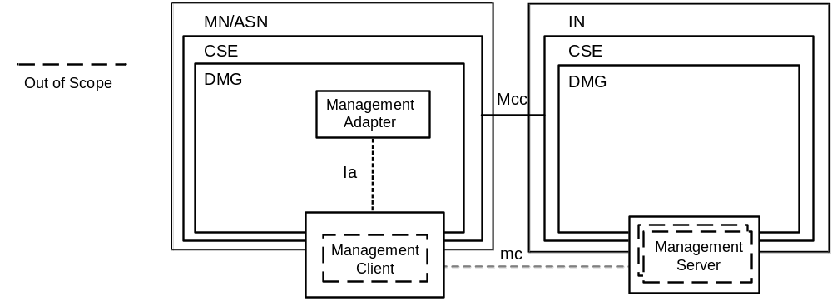

Figure 6.2.4.1.3.1-1: Management Client Interaction using "Ia" interface

6.2.4.1.4 Device Management Resource Lifecycle

6.2.4.1.4.1 Resource Attributes from Device Management Resources
The lifecycle of a Device Management Resource is implemented using the resource management information defined in clause 9.1 through clause 9.5 and the corresponding procedures to Create, Retrieve, Update and Delete the resources are defined in clause 10. This clause describes additional resource management and procedures for Device Management Resources.

6.2.4.1.4.2 Overview
Clauses 9.1 through 9.5 define resource management information that is applicable to any type of resource, including Device Management Resources. In addition a Device Management Resource also maintains information and relationships that are specific to Device Management Resources. This information is used to:
- Manage external management objects via a Management Server which requires the information necessary to identify and access the Management Server.
- Invoke the security mechanism of the Management Server in order to authorize access to the external management objects.

6.2.4.1.4.3 Procedures for Creation, Update and Deletion of Device Management Resources
Clause 10 defines the procedures to Create, Update and Delete resources. These procedures are also applicable to Device Management Resources in addition to the procedures Device Management Resources are Created, Updated or Deleted:
- By administrative means using the Mca reference point.
- Directly by a CSE based on a discovery or another event within the CSE.
- Indirectly by the Management Server or Management Client when an event (such as firmware update, or fault notification) occurs within the Management Server or Client.
Regardless of the Create, Update or Delete operation, the Originator of the operation will be authorized to perform the operation. In addition, at most one Management Server is able to Create, Delete or Update addressable elements of a Management Resource.

6.2.4.2 Detailed Descriptions
The DMG CSF provides capabilities for the purpose of managing M2M Devices/Gateways as well as devices in M2M Area Networks.
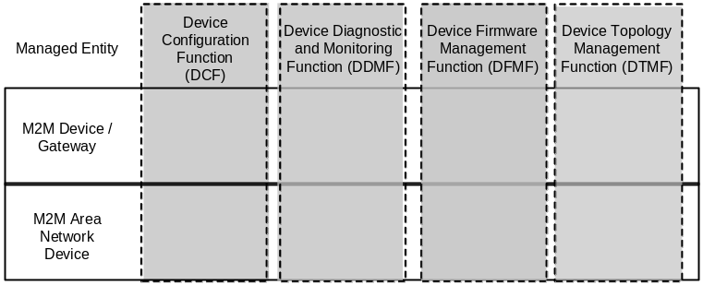

Figure 6.2.4.2-1: Device Management Entities and Functions
[Note to Editor: Please revise the above figure by bringing the DCF box to the front similar to other boxes in the figure.]
Such capabilities include:
- Device Configuration Function (DCF): This function includes the configuration of the capabilities of the M2M Device, M2M Gateway or device in the M2M Area Network.
- Device Diagnostics and Monitoring Function (DDMF): This function includes the troubleshooting through the use of diagnostic tests and retrieval of operational status and statistics associated with the M2M Device, M2M Gateway or device in the M2M Area Network.
- Device Firmware Management Function (DFMF): This function provides the software lifecycle management for firmware components and associated artifacts for the M2M Device, M2M Gateway or device in the M2M Area Network.
- Device Topology Management Function (DTMF): This function provides the management of the topology of the M2M Area Network. An M2M Area Network is comprised of ADNs and other devices in the M2M Area Network.

6.2.4.2.1 Device Configuration Function
The Device Configuration Function (DCF) provides the configuration of device capabilities that are necessary to support M2M Services and AEs in M2M Devices, M2M Gateways or devices in an M2M Area Network.
These device configuration capabilities include:
- Discovery of a device's management objects and attributes.
- Ability to enable or disable a device capability.
- Provisioning configuration parameters of a device.

6.2.4.2.2 Device Diagnostics and Monitoring Function
The Device Diagnostics and Monitoring Function (DDMF) permits the troubleshooting of device capabilities that are necessary to support M2M Services and AEs in M2M Devices, M2M Gateways or devices in an M2M Area Network.
These device diagnostic and monitoring capabilities include:
- Configuration of diagnostics and monitoring parameters on the device.
- Retrieval of device information that identifies a device and its model and manufacturer.
- Retrieval of device information for the software and firmware installed on the device.
- Retrieval of information related to a battery within the device.
- Retrieval of information associated with the memory in use by a device.
- Retrieval of the event logs from a device.
- Device reboot diagnostic operation.
- Device factory reset diagnostic operation.

6.2.4.2.3 Device Firmware Management Function
The Device Firmware Management Function (DFMF) provides lifecycle management for firmware associated with a device.
Device firmware is comprised of firmware modules and artefacts (e.g. configuration files) that are maintained on a device. A device can maintain more than one firmware image and the capability to manage individual firmware images. The firmware lifecycle includes actions to download, update or remove a firmware image. In addition firmware could be downloaded and updated within the same action.

6.2.4.2.4 Device Topology Management Function
The Device Topology Management Function (DTMF) is a function that is specific to M2M Gateways where an M2M Gateway maintains zero or more M2M Area Networks.
These device topology management capabilities include:
- Configuration of the topology of the M2M Area Network.
- Retrieval of information related to the devices attached to the M2M Area Network.
- Retrieval of information that describes the transport protocol associated with the M2M Area Network.
- Retrieval of information that describes the characteristics associated with online/offline status of devices in the M2M Area Network.

6.2.5 Discovery

6.2.5.1 General Concepts
The Discovery (DIS) CSF searches information about applications and services as contained in attributes and resources. The result of a discovery request from an Originator depends upon the filter criteria and is subject to access control policy allowed by M2M Service Subscription. An Originator could be an AE or another CSE. The scope of the search could be within one CSE, or in more than one CSE. The discovery results are returned back to the Originator.

6.2.5.2 Detailed Descriptions
The DIS CSF uses the Originator provided filter criteria (e.g. a combination of keywords, identifiers, location and semantic information) that can limit the scope of information returned to the Originator.
The discovery request indicates the address (e.g. URI) of the resource where the discovery is to be performed. Upon receiving such request, the DIS CSF discovers, identifies, and returns the matching information regarding discovered resources according to the filter criteria.
A successful response includes the discovered information or address(es) (e.g. URI(s)) pertaining to the discovered resources. In the latter case the Originator can retrieve the resources using such discovered address. Based on the policies or Originator request, the CSE which received the discovery request can forward the request to other registered ASN-CSEs, MN-CSEs or IN-CSEs.

6.2.6 Group Management

6.2.6.1 General Concepts
The Group Management (GMG) CSF is responsible for handling group related requests. The request is sent to manage a group and its membership as well as for the bulk operations supported by the group. When adding or removing members to/from a group, it is necessary to validate whether the group member complies with the purpose of the group. Bulk operations include read, write, subscribe, notify, device management, etc. Whenever a request or a subscription is made via the group, the group is responsible for aggregating its responses and notifications. The members of a group can have the same role with regards to access control policy control towards a resource. In this case, access control is facilitated by grouping. When the Underlying Network provides broadcasting and multicasting capability, the GMG CSF is able to utilize such capability.

6.2.6.2 Detailed Descriptions
The GMG CSF enables the M2M System to perform bulk operations on multiple devices, applications or resources that are part of a group. In addition, the GMG CSF supports bulk operations to multiple resources of interest and aggregates the results. It facilitates access control based on grouping. When needed and available, the GMG CSF can leverage the existing capabilities of the Underlying Network including broadcasting/multicasting.
When facilitating access control using a group, only members with the same access control policy towards a resource are included in the same group. Also, only AEs or CSEs which have a common role with regards to access control policy are included in the same group. This is used as a representation of the role when facilitating role based access control.
The service functions supported by the GMG CSF are as follows:
- Handles the requests to create, query, update, and delete a group. An AE or a CSE may request the creation/retrieve/update/deletion of a group as well as the addition and deletion of members of the group.
- Creates one or more groups in CSEs in any of the Nodes in oneM2M System for a particular purpose (e.g. facilitation of access control, device management, fan-out common operations to a group of devices, etc.).
- Handles the requests to retrieve the information (e.g. URI, metadata, etc.) of a group and its associated members.
- Manages group membership and handles requests to add or remove members to and from a group's member list. A member may belong to one or more groups. A group may be a member of another group. When new members are added to a group, the GMG CSF validates if the member complies with the purpose of the group.
- Leverages the capabilities of other CSFs in order to fulfill the functionalities supported by the GMG CSF service functions. Examples include: Security CSF for authentication and authorization.
- Forwards requests to all members in the group. In case the group contains another group as a member, the forwarding process is done recursively, i.e. the nested group forwards the request to its members. After forwarding the request to all members in the group, the GMG CSF generates an aggregated response by aggregating the corresponding responses from the Group members.
- Supports subscriptions to individual groups. Subscriptions to a group is made only if the subscriber is interested in all members of the group. If subscription to a group is made, the GMG CSF aggregates the notifications from the group members, and notifies the subscriber with the aggregated notification. Responses and event notifications relevant to a subscription may be selectively filtered by filtering criteria.

6.2.7 Location

6.2.7.1 General Concepts
The Location (LOC) CSF allows AEs to obtain geographical location information of Nodes (e.g., ASN, MN) for location-based services. Such location information requests can be from an AE residing on either a local Node or a remote Node.
NOTE: Geographical location information can include more than simply the longitude and the latitude information.

6.2.7.2 Detailed Descriptions
The LOC CSF obtains and manages geographical location information based on requests from AEs residing on either a local Node or a remote Node. The LOC CSF interacts with any of the following:
- A location server in the Underlying Network;
- A GPS module in an M2M device; or
- Information for inferring location stored in other Nodes.
In order to update the location information, an AE can configure an attribute (e.g. update period). Based on such defined attributes, the LOC CSF can update the location information using one of the location retrieval mechanisms listed above.
NOTE: The location technology (e.g., Cell-ID, assisted-GPS, and fingerprint) used by the Underlying Network depends on its capabilities.
The functions supported by the LOC CSF are as follows:
- Requests other Nodes to share and report their own or other Nodes' geographical location information with the requesting AEs.
- Provides means for protecting the confidentiality of geographical location information.

6.2.8 Network Service Exposure, Service Execution and Triggering

6.2.8.1 General Concepts
The Network Service Exposure, Service Execution and Triggering (NSSE) CSF manages communications with the Underlying Networks for accessing network service functions over the Mcn reference point. The NSSE CSF uses the available/supported methods for service "requests" on behalf of AEs. The NSSE CSF shields other CSFs and AEs from the specific technologies and mechanisms supported by the Underlying Networks.
NOTE: The NSSE CSF provides adaptation for different sets of network service functions supported by various Underlying Networks.
The network service functions provided by the Underlying Network include service functions such as, but not limited to, device triggering, small data transmission, location notification, policy rules setting, location queries, IMS services, device management. Such services do not include the general transport services.

6.2.8.2 Detailed Descriptions
The NSSE CSF manages communication with the Underlying Networks for obtaining network service functions on behalf of other CSFs, remote CSEs or AEs. The NSSE CSF uses the Mcn reference point for communicating with the Underlying Networks.
The M2M System allows the Underlying Networks to control network service procedures and information exchange over the Underlying Networks while providing such network services. For example, for the 3GPP networks, the Underlying Network can choose to provide the network services based on control plane signalling mechanisms.
Other CSFs in a CSE that need to use the services offered by the Underlying Network use the NSSE CSF.
The service functions supported by the NSSE CSF are as follows:
- The NSSE CSF shields other CSFs and AEs from the specific technology and mechanisms supported by the Underlying Networks.
NOTE: The NSSE CSF provides adaptation for different sets of network service functions supported by various Underlying Networks.
- The NSSE CSF maintains the necessary connections and/or sessions over the Mcn reference point, between the CSE and the Underlying Network when local CSFs are in need of a network service.
- The NSSE CSF provides information to the CMDH CSF related to the Underlying Network so the CMDH CSF can include that information to determine proper communication handling.

6.2.9 Registration

6.2.9.1 General Concepts
The Registration (REG) CSF processes a request from an AE or another CSE to register with a Registrar CSE in order to allow the registered entities to use the services offered by the Registrar CSE.

6.2.9.2 Detailed Descriptions
Registration is the process of delivering AE or CSE information to another CSE in order to use M2M Services.
An AE on an ASN, an MN or an IN performs registration locally with the corresponding CSE in order to use M2M services offered by that CSE. An AE on an ADN performs registration with the CSE on an MN or an IN in order to use M2M services offered by that CSE. An IN-AE performs registration with the corresponding CSE on an IN in order to use M2M services offered by that IN CSE. An AE can have interactions with its Registrar CSE (when it is the target CSE) without the need to have the Registrar CSE register with other CSEs.
The CSE on an ASN performs registration with the CSE in the MN in order to be able to use M2M Services offered by the CSE in the MN. As a result of successful ASN-CSE registration with the MN-CSE, the CSEs on the ASN and the MN establish a relationship allowing them to exchange information.
The CSE on an MN performs registration with the CSE of another MN in order to be able to use M2M Services offered by the CSE in the other MN. As a result of successful MN-CSE registration with the other MN-CSE, the CSEs on the MNs establish a relationship allowing them to exchange information.
The CSE on an ASN or on an MN perform registration with the CSE in the IN in order to be able to use M2M Services offered by the CSE in the IN. As a result of successful ASN/MN registration with the IN-CSE, the CSEs on ASN/MN and IN establish a relationship allowing them to exchange information.
Following a successful registration of an AE to a CSE, the AE is able to access, assuming access privilege is granted, the resources in all the CSEs that are potential targets of request from the Registrar CSE.
The capabilities supported by the REG CSF are as follows:
- Ability for AEs to register to their associated CSE, as per table 6.2.9.2-1;
- Ability for CSE to register to the other CSE, as per table 6.2.9.2-1;
- Ability for an ASN-CSE/MN-CSE to register association of its M2M-Ext-ID (if available) with its CSE-ID, (see clause 7.1.8).
- Ability for an ASN-CSE/MN-CSE to register association of its Trigger-Recipient-ID (if available) with its CSE-ID, (see clause 7.1.8). When Trigger-Recipient-ID is not present, it is assumed that the CSE is not able to receive triggers.
NOTE: Such registrations are applicable to a single M2M Service Provider Domain.
Registration information for a Node includes:
- Identifier of the Node.
- Reachability schedules; which are elements of a Node's policy, and specify when messaging can occur between Nodes. Reachability schedules can be used in conjunction with other policy elements. When reachability schedules are not present in a Node then that Node is expected to be always reachable.

6.2.10 Security

6.2.10.1 General Concepts
The Security (SEC) CSF comprises the following functionalities:
- Sensitive data handling;
- Security administration;
- Security association establishment;
- Access control including identification, authentication and authorization;
- Identity management.
Sensitive data handling functionality in the SEC CSF protects the local credentials on which security relies during storage and manipulation. Sensitive data handling functionality performs other sensitive functions such as security algorithms. This functionality is able to support several cryptographically separated security environments.
Security management capabilities are provided by the Security Administration functionality as specified in TS-0003 [1].
NOTE: ASM and DMG CSFs do not include security management capabilities of the SEC CSF.
Security administration functionality enables services such as the following:
- Creation and administration of dedicated security environment supported by Sensitive Data Handling functionality;
- Post-provisioning of a root credential protected by the security environment;
- Provisioning and administration of subscriptions related to M2M Common Services and M2M Application Services.
Security association establishment functionality establishes security association between corresponding M2M Nodes, in order to provide services such as confidentiality and integrity.
Access control functionality authorizes services and specific operations (e.g. Read/Update) on resources identified and authenticated entities, according to provisioned access control policies and assigned roles.
While unique identifier of an entity are used for authentication and identity management, this functionality provides pseudonyms which serve as temporary identifiers which cannot be linked to the true identity of either the associated entity or its user.

6.2.10.2 Detailed Descriptions
The functionalities supported by the SEC CSF are as follows:
- Sensitive data handling:
- Provides the capability to protect the local credentials on which security relies during storage and manipulation.
- Extends sensitive data handling functionality to other sensitive data used in the M2M Systems such as subscription related information, access control policies and personal data pertaining to individuals.
- Performs other sensitive functions as well, such as security algorithms running in cryptographically separated secure environments.
- Security administration:
- Creates and administers dedicated secure environment supported by sensitive data handling functionality.
- Post-provisions master credentials protected by the secure environment.
NOTE: The secure environment can also be pre-provisioned with a master credentials prior to deployment; therefore this capability is not always required. Post-provisioning is required when secure remote provisioning needs to be performed or re-initiated after deployment.
- Provisioning and administration of subscriptions related to M2M Services and M2M application services. Besides the associated master credentials, a subscription includes other information classified as sensitive data such as authorization roles and identifiers for access control management.
- Security association establishment:
- Establishes security associations between corresponding M2M Nodes in order to provide specific security services (e.g. confidentiality, integrity, or support for application level signature generation and verification) involving specified security algorithms and sensitive data. This involves key derivation based on provisioned master credentials. This functionality of the SEC CSF is mandatory when security is supported.
- Access control:
- Authorizes services and specific operations (e.g. Read/Update) on resources to identified and authenticated entities, according to provisioned access control policies and assigned roles. This functionality is mandatory when any services relying on authorization and access control are present. Among other usages, the services of this functionality may be applied to personal information as a means to preserve privacy.
- Identity protection:
- Provides pseudonyms to be used instead of the unique identifiers of an entity to serve as temporary identifiers not linkable to the true identity of either the associated entity or its user.
Detailed functionalities are described in the Security Solutions Technical Specification [1].

6.2.11 Service Charging and Accounting

6.2.11.1 General Concepts
The Service Charging and Accounting (SCA) CSF provides charging functions for the Service Layer. It supports different charging models which also include online real time credit control. The SCA CSF manages service layer charging policies and configuration capturing service layer chargeable events, generating charging records and charging information. The SCA CSF can interact with the charging System in the Underlying Network also. The SCA CSF in the IN-CSE handles the charging information.

6.2.11.2 Detailed Descriptions
The SCA CSF performs information recording corresponding to a chargeable event based on the configured charging policies. The SCA CSF sends the charging information transformed from the specific recorded information to the billing domain by the use of a standard or proprietary interface for charging purposes.
The SCA CSF supports "independent service layer charging" and "correlated charging with the Underlying Network" charging system. For independent service layer charging, only charging functions in the M2M service layer are involved. For correlated charging, charging functions in both the service layer and the Underlying Network are involved.
The SCA CSF supports one or multiple charging models, such as the following:
- Subscription based charging: A service subscriber is charged based on service layer subscriptions.
- Event based charging: Charging is based on service layer chargeable events. A chargeable event refers to the discrete transactions. For example, an operation on data (Create, Update, Retrieve) can be an event. Chargeable event can also be timer based. Chargeable events are configurable to initiate information recording. More than one chargeable event can be simultaneously configured and triggered for information recording.
The Service Layer charging system consists of the following logical functions:
- Charging management function: This function handles charging related policies, configurations, function communications, and interacting with the charging system in the Underlying Network. Charging related policies.
- Charging triggering function: This function resides in the service layer. It captures the chargeable event and generates recorded information for charging. Recorded information may contain mandatory and optional elements.
- Offline charging function: This function handles offline charging related operations. Offline charging does not affect services provided in real time. Charging triggering information is generated at the CSFs where the chargeable transaction happens. The offline charging function generates service charging records based on recorded information. A service charging record is a formatted collection of information about a chargeable event (e.g. amount of data transferred) for use in billing and accounting.
NOTE: Charging triggering and offline charging function are based on charging policies. The system may record information for other purposes such as for event logging. Some of such information may be applicable for charging purposes.

6.2.12 Subscription and Notification

6.2.12.1 General Concepts
The Subscription and Notification (SUB) CSF provides notifications pertaining to a subscription that tracks event changes on a resource (e.g. deletion of a resource). A subscription to a resource is initiated by an AE or a CSE, and is granted by the hosting CSE subject to access control policies. During an active resource subscription, the hosting CSE sends a notification regarding a notification event to the address(es) where the resource subscriber wants to receive it.

6.2.12.2 Detailed Descriptions
The SUB CSF manages subscriptions to resources, subject to access control policies, and sends corresponding notifications to the address(es) where the resource subscribers want to receive them. An AE or a CSE is the subscription resource subscriber. AEs and CSEs subscribe to resources of other CSEs. A subscription hosting CSE sends notifications to the address(es) specified by the resource subscriber when modifications to a resource are made. The scope of a resource subscription includes tracking changes of attribute(s) and direct child resource(s) of the subscribed-to resource. It does not include tracking the change of attribute(s) of the child resource(s). Furthermore, the scope includes tracking operations on attributes and direct child resources, but does not include tracking operations on attributes of child resources. Each subscription may include notification policies that specify which, when, and how notifications are sent. These notification policies may work in conjunction with CMDH policies.
A subscription is represented as resource subscription in the CSE resource structure.
The functions supported by the SUB CSF are as follows:
- Inclusion of the resource subscriber ID, the hosting CSE-ID and subscribed-to resource address(es) per resource subscription request. It may also include other criteria (e.g. resource modifications of interest and notification policy) and the address(es) where to send the notifications.
- Ability to subscribe to a single resource via a single subscription, or subscribe to multiple resources via a single subscription when they are grouped and represented as a single group resource.

6.3 Security Aspects
The Technical Report TR-0008 on Analysis of Security Solutions for the oneM2M System [i.xx] differentiates security domains related to the transport layer (Underlying Network), service layer (M2M common services), and Application Layer. It also considers possible trust scenarios involving these different security domains, and investigates countermeasures to threats that potentially affect the security of the M2M System.
[Note to Editor: Please add TR-0008 as a new reference in clause 2.2, based on Phil Brown’s suggestion. This is the correct reference to be used in this clause.]
Each of the security domains may provide their own set of security capabilities. The oneM2M security solution shall provide configurable security services through an API for upper security domains to leverage, or enable the use of the exposed security features of other security domains when appropriate.
As a result, beyond providing security solutions that protect the integrity of the M2M Service Layer, the oneM2M architecture exposes, through its APIs, further security services that are made available to M2M Applications. This enables M2M Applications to benefit from security solutions deployed in the M2M Service Architecture, without adding redundant and/or proprietary security solutions.
NOTE: It remains the responsibility of M2M Application Service Providers to perform their own security risk assessment process in identifying the specific threats affecting them and derive their actual security needs.
Security aspects are described in oneM2M Security Solutions Technical Specification [Error: Reference source not found].

6.4 Intra-M2M SP Communication
Within the same SP domain a CSE shall perform registration with another CSE, over the Mcc reference point, to be able to use M2M Services offered by that CSE and to allow the other CSE to use its services. As a result of successful registration the CSEs establish a relationship allowing them to exchange information.
An AE shall perform registration with a CSE in order to be able to use M2M Services offered by that CSE. As a result of successful AE registration, the AE and the CSE establish a relationship allowing them to exchange information.
The following table shows which oneM2M entity types shall be able to register with which other entity types:
Table 6.4-1: Entity Registration
Originator  (Registree) | Receiver  (Registrar) | Registration Procedure
ADN-AE | MN-CSE, IN-CSE | AE registration procedure see clause 10.1.1.2.2
ASN-AE | ASN-CSE | AE registration procedure see clause 10.1.1.2.2
MN-AE | MN-CSE | AE registration procedure see clause 10.1.1.2.2
IN-AE | IN-CSE | AE registration procedure see clause 10.1.1.2.2
ASN-CSE | MN-CSE, IN-CSE | CSE registration  procedure  see clause 10.1.1.2.1
MN-CSE | MN-CSE, IN-CSE | CSE registration  procedure  see clause 10.1.1.2.1

The Originator (Registree) in table 6.4-1 requests the registration and the Receiver (Registrar) is responsible for verifying the request, and checking the authentication and authorization of the Originator in order to establish a peer relationship.
- An AE shall not be registered to more than one CSE (ASN-CSE, MN-CSE or IN-CSE).
- An ASN-CSE shall be able to be registered to at most one other CSE (MN-CSE or IN-CSE).
- An MN-CSE shall be able to be registered to at most one other CSE (MN-CSE or IN-CSE).
An MN-CSE shall be able to support only a single registration towards another MN-CSE or an IN-CSE. A concatenation (registration chain) of multiple uni-directional registrations shall not form a loop. E.g., two MN-CSEs A and B, cannot register with each other. Three MN-CSEs A, B and C, where A registers to B, and B registers to C, then C cannot register to A.

6.5 Inter-M2M SP Communication

6.5.1 Inter M2M SP Communication for oneM2M Compliant Nodes
To enable M2M entities (e.g. CSE, AE) in different M2M Service Provider (SP) domains to communicate, configuration within the M2M domain determines if such a communication is allowed. If allowed, the M2M System shall support routing of the traffic across the originating M2M SP domain and within the target M2M SP domain.
Communication between different M2M SPs which occurs over the reference point Mcc', is subject to business agreements. The offered functionality is typically a subset of the functionality offered over the Mcc reference point.
Any interM2M SP communication in support of a request originating from one M2M SP domain shall be processed and forwarded through the Infrastructure Node of the originating M2M domain towards the Infrastructure Node of the target M2M SP domain and finally forwarded to its target CSE, if different from the Infrastructure Node. Hence the Infrastructure Node in both M2M domains shall be the exit and entry points, respectively, for all inter M2M SP communication traffic.
In this configuration approach, public DNS shall be used to support traffic routing for inter M2M SP communication in accordance with [Error: Reference source not found]. This relies on public domain names being allocated to communicating CSE entities within the oneM2M architecture, and to whom access across domains is permitted through policies. To that effect, an M2M SP supporting inter- M2M SP communication shall ensure that the public domain names for the CSEs whose functionality is available across domains are held in its public DNS and shall always point to the IP address associated with the Infrastructure Node for the domain (being the entry point) for accessibility purposes.
The M2M SP could optionally also have additional policies (example: black list or white list) that governs accessibility from other domains to CSE functionality located within its own domain. These policies are however out of scope of this document.
The public domain names of CSEs to whom access from other domains is allowed by policies, shall be created in the DNS of the M2M SP by the Infrastructure Node at registration time of these CSEs, and shall be removed at de-registration. DNS entries for CSEs can also be created/removed for registered CSEs at any time by the M2M SP through administrative means to handle dynamic policies.

6.5.1.1 Public Domain Names and CSEs
To enable the usage of public DNSs as described above, there is a need for a naming convention for public names for CSEs. This naming convention facilitates the creation of the necessary entries of the public domain names of CSEs in the DNS by the infrastructure node.
CSEs public domain names shall be a sub-domain of the Infrastructure Node's public domain name. This naming convention allows the Infrastructure Node to include the needed DNS entry corresponding to the CSE to whom access from other domains is allowed. This would typically occur when the CSE registers with the Infrastructure Node, subject to policies, or administratively.
Accordingly, the structure of the public domain of the CSEs in IN/MN/ASN shall follow the following naming convention, which relies on the CSE identifier (CSE-ID) as part of the naming convention to facilitate the DNS entry creation:
- Infrastructure Node CSE public domain name: <Infrastructure Node CSE Identifier>.<M2M Service Provider domain name>.
- Middle Node CSE public domain name: <Middle Node CSE Identifier>.<Infrastructure Node public domain name>.
- Application Service Node CSE public domain name: <Application Service Node CSE Identifier>.<Infrastructure Node public domain name>.
Both the MN-CSE and the ASN-CSE public domain names are sub-domains of the Infrastructure Node public domain name.
The A/AAAA records in the DNS, as per [Error: Reference source not found], [Error: Reference source not found] and [Error: Reference source not found] shall consist of the public domain name of the CSE and the IP address of the M2M Infrastructure Node, since the M2M Infrastructure Node is the entry point of the M2M Service Provider domain name where it belongs to.
Note that entries in the public domain names of the three nodes depicted above do not imply that the actual CSE-Identifier allocated for that node has to be used in the DNS entry. Rather any name, including indeed the CSE Identifier for the node, can be used there as long as the entry resolves to the intended Node.
EXAMPLE:
These 3 host entries are valid entries in the DNS:
- MN-CSEID.IN-CSEID.m2m.myoperator.org
- node1.node2.m2m.myoperator.org
- MN-CSEID.node22.m2m.myoperator.org

6.5.2 Inter M2M SP Generic Procedures
This clause describes the behaviour of the M2M Nodes in support of inter-M2M SP procedures.

6.5.2.1 Actions of the Originating M2M Node in the Originating Domain
The Originator in the originating domain can be any M2M Node such as ADN, an MN, or an ASN, and shall send a request to the Registrar CSE to retrieve a resource located in another M2M SP domain.
The Originator shall use any of the options defined in clause 9.3.1 to identify the target host and resource for that purpose.

6.5.2.2 Actions of the Receiving CSE in the Originating Domain
The receiving CSE in the originating domain shall check if the addressed resource is locally available. If the addressed resource is not locally available, then the request shall be forwarded to the next hop.
If the receiving CSE is on an IN, it shall check if the addressed resource is locally available within its domain. If the addressed resource is not located within its own domain, then the IN shall perform a DNS lookup by using the target hostname provided in the RETRIEVE request. A successful DNS lookup shall return to the origin IN in the originating domain the IP address of the M2M IN residing in the target M2M SP domain.
Subsequently, the IN in the originating domain shall forward the request to the IN of the target domain.

6.5.2.3 Actions in the IN of the Target Domain
The IN is the entry point of the target M2M SP domain. The IN shall check if the addressed resource is a local resource. If it is not a local resource it shall forward the request to the appropriate CSE, after identifying the hosting CSE within its domain, using the pointOfAccess attribute.
Once the request reaches the target hosting-CSE, the CSE shall apply the access control policies applicable to the request. Consequently, the hosting-CSE shall forward the response for the incoming request following the same path of the incoming request.

6.5.3 DNS Provisioning for Inter-M2M SP Communication
As specified previously, any M2M SP supporting inter-M2M SP communication shall ensure that the public domain names for the CSEs whose functionality is available across domains are held in the M2M SP's DNS and shall always point to the IP address associated with the Infrastructure domain CSE (being the entry point) for accessibility purposes.
This implies that the IN-CSE shall be responsible for creating the appropriate entry in the DNS for a successfully registered CSE in the IN-CSE, if the M2M SP policies do allow access to the CSE across multiple M2M domains. Similarly the IN-CSE shall be responsible for deleting the appropriate entry in the M2M SP's DNS for a successfully de-registered CSE in the IN-CSE if the M2M SP policies do allow access to the CSE across multiple M2M domains.

6.5.3.1 Inter-M2M SP Communication Access Control Policies
Additional M2M SP policies that further restrict access to CSEs to requests originating from configured M2M SPs only, can complement the DNS entries created by the IN-CSE. These policies are out of scope of the present document.

6.5.4 Conditional Inter-M2M Service Provider CSE Registration
Inter-M2M Service Provider CSE registration shall be supported to enable M2M entities (e.g., CSE, AE) in peer M2M Service Provider (SP) domains with the ability to create and operate resources with the equivalent set of possibilities as offered in the intra-M2M Service Provider domain, subject to the following:
- The AE or CSE in either domain requires a representation of its own domain, notably the IN-CSE of its domain, in the peer domain to create resources in the peer domain. As an example, when it is required for an AE or a CSE to create and operate under the representation of an IN-CSE resource from a different M2M SP Domain. This enables the AE or CSE to have a behavior that is identical in both the intra- and inter-M2M SP cases.
An AE or CSE that does not require to use the remoteCSE representations of the other domain as parent resources, can create resources in the peer domain if it knows the parent of the resource to be created and as such does not require IN to IN registration. Hence creating subscriptions within a peer M2M SP shall not require IN to IN registration between peer domains (but remains subject to inter –M2M SP business agreements, and access control policies).
Registration between M2M SPs occurs over the reference point Mcc', and is subject to business agreements. These agreements can limit the offered functionalities in comparison to those offered over the Mcc reference point.
No additional security is required respect to the basic procedure as described in 6.5.1, 6.5.2 and 6.5.3.
The following table shows which oneM2M entity types can register with which other entity types across the Mcc’ reference point.
Table 6.5.4-1: Inter M2M SP Entity Registration
Originator  (Registree) | Receiver  (Registrar) | Registration Procedure
IN-CSE | IN-CSE | CSE registration procedure. See clause 10.1.1.2.1

An IN-CSE is allowed to register to the IN-CSE of multiple different M2M SP domains in the oneM2M System.
Any inter-M2M SP communications in support of a request originating from one M2M SP domain shall be processed and forwarded through the IN of the originating M2M domain towards the IN of the target M2M SP domain and finally forwarded to its target CSE, if different from the target domain’s IN. Hence the IN in both M2M domains shall be the exit and entry points, respectively, for all inter-M2M SP communication traffic.

6.6 M2M Service Subscription
The M2M Service Subscription defines the technical part of the contract between an M2M Subscriber (typically an M2M Application Service Provider) and an M2M Service Provider. Each M2M Service Subscription shall have a unique identifier, the M2M-Sub-ID, as specified in clause 7.1.11. An M2M Service Subscription establishes a link between one or more AEs; one or more M2M Nodes, one or more roles associated with an M2M Service Subscription as well as subscriber defined groups used for access control policies.
An M2M Service is the marketable service offered to M2M service subscriber (organizations or individuals). Examples of services include device management, location, data exchange, etc.
In each M2M Service, one or multiple M2M Service role(s) shall be defined by the M2M Service Provider. An M2M Service subscription role is defined as a set of privileges pertaining to a resource types which are associated with M2M Service. The M2M Subscriber subscribes as one or multiple roles within the M2M Services, depending upon which role(s) the M2M Subscribers are interested in.
An example of the set of M2M Services and M2M Service subscription roles is provided in annex G.
It shall be possible for an M2M Service Providers to define their own services and roles.
An M2M Service Subscription governs an M2M subscription, the M2M Nodes where AEs can reside and execute the M2M Service roles and subscriber defined groups used for access control policies. An example of the Subscriber defined group is "all node applications within this service subscription with App-ID set to a specific value". Access control policy resource configuration shall comply with the M2M Service Subscription. For authorization of accessing the resource, access control policy is applied and can be based on M2M Service subscription roles.
How to authorize the request operation based on M2M Service Subscription resource are defined in TS-0003 [Error: Reference source not found].
An M2M Service Subscription shall be used for the following purposes:
- Serve as a basis for authorization for resource operations.
- Serve as the basis for charging.
- Identify which Nodes are part of this M2M Service Subscription.

-----------------------------End of changes ----------------------------------------

CHECK LIST
- Does this change request include an informative introduction containing the problem(s) being solved, and a summary list of proposals.?
- Does this CR contain changes related to only one particular issue/problem?
- Does this change request make all the changes necessary to address the issue or problem? E.g. A change impacting 5 tables should not only include a proposal to change only 3 tables. Includes any changes to references, definitions, and acronyms in the same deliverable?
- Does this change request follow the drafting rules?
- Are all pictures editable?
- Have you checked the spelling and grammar?
- Have you used change bars for all modifications?
- Does the change include the current and surrounding clauses to clearly show where a change is located and to provide technical context of the proposed change? (Additions of complete sections need not show surrounding clauses as long as the proposed section number clearly shows where the new section is proposed to be located.)
- Are multiple changes in this CR clearly separated by horizontal lines with embedded text such as, start of change 1, end of change 1, start of new clause, end of new clause.?

