INPUT CONTRIBUTION
Group Name:* | WG2
Title:* | TS-0007 event collection services
Source:* | Guang Lu
Contact: | Guang.Lu@InterDigital.com
Date:* | 2014-09-13
Abstract:* | This contribution defined the Event Collection service and its service capabilities
Agenda Item:*
Work item(s): | TS-0007 WI
Document(s)  Impacted* | TS-0007
Intended purpose of  document:* | Decision  Discussion  Information  Other <specify>
Decision requested or recommendation:* | If agreed, update TS for inclusion

oneM2M Notice
The document to which this cover statement is attached is submitted to oneM2M. Participation in, or attendance at, any activity of oneM2M, constitutes acceptance of and agreement to be bound by terms of the Working Procedures and the Partnership Agreement, including the Intellectual Property Rights (IPR) Principles Governing oneM2M Work found in Annex 1 of the Partnership Agreement.

Rationale 3
6.10 Event Collection 6
6.10.1 Overview 6
6.10.2 Service Capabilities 6
6.10.2.1 setEventCollectionPolicy 6
6.10.2.1.1 Pre-conditions 6
6.10.2.1.2 Signature – setEventCollectionPolicy 6
6.10.2.1.3 Post-Conditions 9
6.10.2.1.4 Exceptions 9
6.10.2.1.5 Policies for Use 9
6.10.2.1.6 Service Interactions 9
6.10.2.1.7 oneM2M Resource Interworking 9
6.10.2.2 getEventCollectionPolicy 10
6.10.2.2.1 Pre-conditions 10
6.10.2.2.2 Signature – getEventCollectionPolicy 10
6.10.2.2.3 Post-Conditions 10
6.10.2.2.4 Exceptions 10
6.10.2.2.5 Policies for Use 10
6.10.2.2.6 Service Interactions 11
6.10.2.2.7 oneM2M Resource Interworking 11
6.10.2.3 setEventCollectionTriggers 11
6.10.2.3.1 Pre-conditions 11
6.10.2.3.2 Signature – setEventCollectionTriggers 11
6.10.2.3.3 Post-Conditions 12
6.10.2.3.4 Exceptions 12
6.10.2.3.5 Policies for Use 12
6.10.2.3.6 Service Interactions 12
6.10.2.3.7 oneM2M Resource Interworking 13
6.10.2.4 getEventCollectionTriggers 13
6.10.2.4.1 Pre-conditions 13
6.10.2.4.2 Signature – getEventCollectionTriggers 13
6.10.2.4.3 Post-Conditions 14
6.10.2.4.4 Exceptions 14
6.10.2.4.5 Policies for Use 14
6.10.2.4.6 Service Interactions 14
6.10.2.4.7 oneM2M Resource Interworking 14
6.10.2.5 recordEvent 14
6.10.2.5.1 Pre-conditions 15
6.10.2.5.2 Signature – recordEvent 15
6.10.2.5.3 Post-Conditions 15
6.10.2.5.4 Exceptions 15
6.10.2.5.5 Policies for Use 15
6.10.2.5.6 Service Interactions 15
6.10.2.5.7 oneM2M Resource Interworking 16
6.10.2.6 getRecords 16
6.10.2.6.1 Pre-conditions 16
6.10.2.6.2 Signature – getRecords 16
6.10.2.6.3 Post-Conditions 16
6.10.2.6.4 Exceptions 16
6.10.2.6.5 Policies for Use 16
6.10.2.6.6 Service Interactions 16
6.10.2.6.7 oneM2M Resource Interworking 17
6.10.2 Event Record Template 17
Annex G (informative): List of M2M Services [2] 18

R01:
- Removed the change to Annex G in TS 0001 since it should be included in ARC-2014-1542R01
- Removed the notion of CSEs all over the document

R02: updated to address comments at the meeting. Removed eventType complex type; removed operationType

Rationale
This contribution defines the services for Event Collection. This section describes the rationale of the service definitions and how it works. Figure 1 shows the SOA event collection architecture. The Event Collection Service contains three logical functions. Event Collection Policy provides the service to set up event collection policies. Event Collection Triggers provides the service to define specific collectable triggers. Event Collection Execution provides the service for event recording when the trigger happens. Each logical function contains two functions as shown in yellow boxes, and these functions are defined in this contribution.
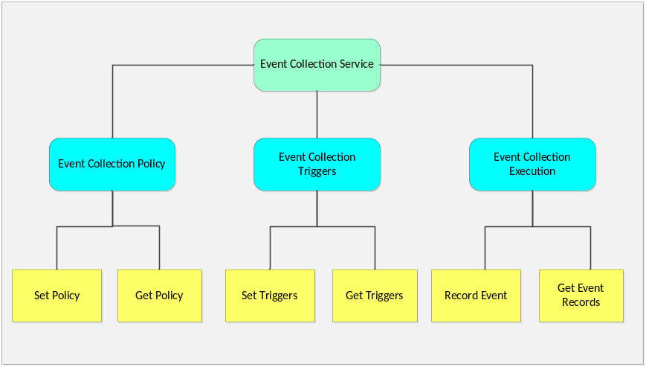
Figure 1 SOA Event Collection Architecture

Use of Event Collection Service
The following two figures show the sequences of event collection. For readability, the operations are divided by two parts: part 1 is the configuration of event collection policy and event triggers, and part 2 is the event collection
when triggers happened.
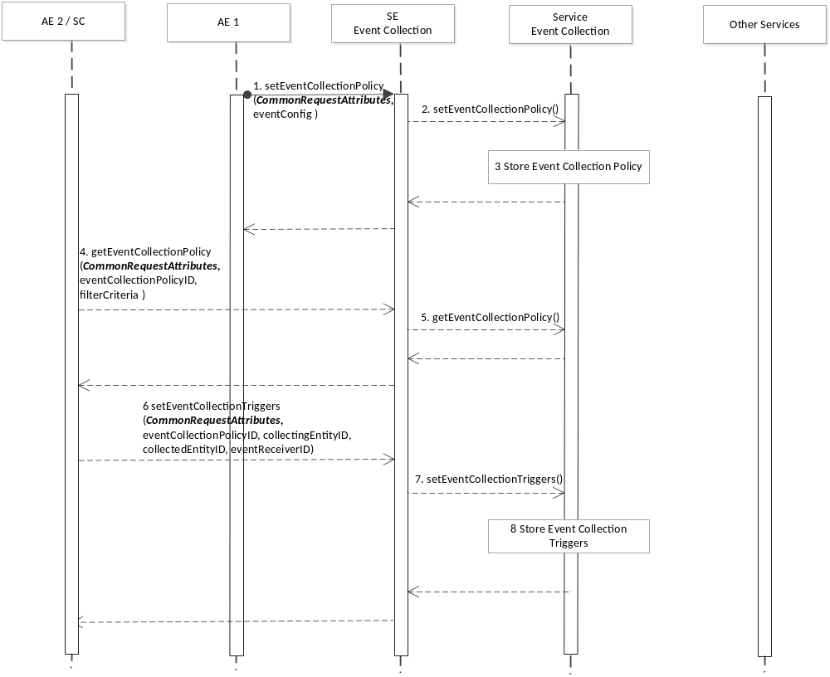
Figure 2 Part 1 - Event Collection Configuration
Step 1-3: An AE (identified as AE1) configures event collection policy at the Service Exposure. The Service Exposure entity passes the message to the Event Collection service. The message contains the information element of “eventConfig” which defines the specific policies. The policy is stored at the Event Collection service entity.
Step 4 -5: Another AE or service capability (identified as AE2 or SC) can retrieve the event collection policy available for discovery.
Step 6-8: AE2 or SC configures event collection triggers based on the event collection policy it obtained. Such triggers are stored at the Event Collection entity.
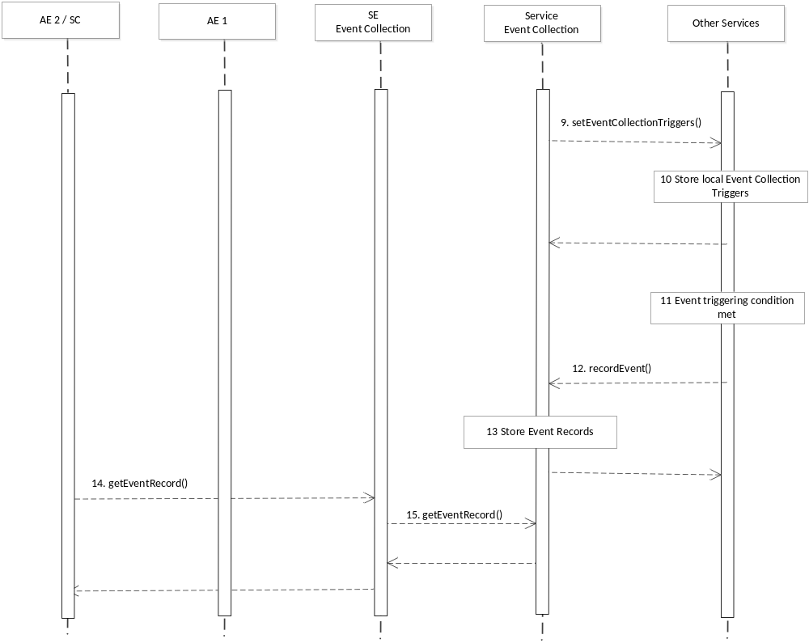
Figure 3 Part 2 – Event Recording

Step 9-10: The Event Collection service entity passes the event collection triggers to the appropriate services, such as Data Exchange service. The other services store a local version of the triggers.
Step 11-13: When the conditions of the configured event happens, the other services generate the event and request the Event Collection entity to record the event. For example, when the Data Exchange service receives the subscribeComplete message, it triggers the recordEvent message and sends it to the Event Collection service entity. The Event Collection service entity stores the event records.
Step 14-15: AE2 or SC obtains the event records from the Event Collection service entity. For example, it can obtain all events related to itself for a period of time.

-----------------------Start of change 1 (new content)---------------------------------

6.10 Event Collection

6.10.1 Overview
The Event Collection service provides the capability to record events for accounting purposes.

6.10.2 Service Capabilities

6.10.2.1 setEventCollectionPolicy
This service capability provides the ability for AEs to configure event collection policies for statistics and charging purposes. This service capability applies to the Mca reference point.

6.10.2.1.1 Pre-conditions
The originator can be an AE, and the originator wants to configure event collection policies at a receiving service capability. The receiving service capability conducts event collection according to the policies. The receiving service capability may establish its own event collection policies.
The originator, if different from the receiving service capability, is subscribed and registered to the receiving service capability.

6.10.2.1.2 Signature – setEventCollectionPolicy
Parameter name | Direction | Optional | Description
commonParameters | IN | NO | See Table A.2.1.1.2-1
serviceId | IN | NO | The M2M Service Identifier (M2M-Serv-ID)
eventConfig | IN | NO | The configuration of the event collection policy
eventCollectionPolicyID | OUT | NO | The receiving service capability generates a unique policy ID for each policy.
responseType | OUT | YES | Unique response types for this service. Exception:  - Policy already exists

Table 6.10.2.1.2-1 Event Collection – setEventCollectionPolicy capability

Parameter name | Optional | Description
eventType | NO | This attribute indicates the type of the event, such as “subscribeComplete”, “downloadFirmware “, “timer based”,, “storage based”, etc. The eventType can be a combination of multiple sub-types, for example, it can be based on both “subscribeComplete” and a timer.
serviceRoleIds | YES | Defines the specific service role.
eventStart | YES | This attribute indicates the start time of the event. It is mandatory if the eventType includes “timer based”.
eventEnd | YES | This attribute indicates the end time of the event. It is mandatory if the eventType includes “timer based”.
dataSize | YES | This attribute defines the data size if an event is triggered when the stored data exceeds a certain size. It is mandatory if the eventType is “storage based”.
Table 6.10.2.1.2-2 Event Collection – eventConfig Complex Data Type

defines examples of eventType Complex Data Types. More events can be defined when more services are available.

6.10.2.1.3 Post-Conditions
Not Applicable

6.10.2.1.4 Exceptions
- The originator has no access right to create the policy

6.10.2.1.5 Policies for Use
Message Exchange Patterns: In-Out

6.10.2.1.6 Service Interactions
The interactions of service capabilities required for this service capability:
- Issue the request to the Supporting Service to perform the operation

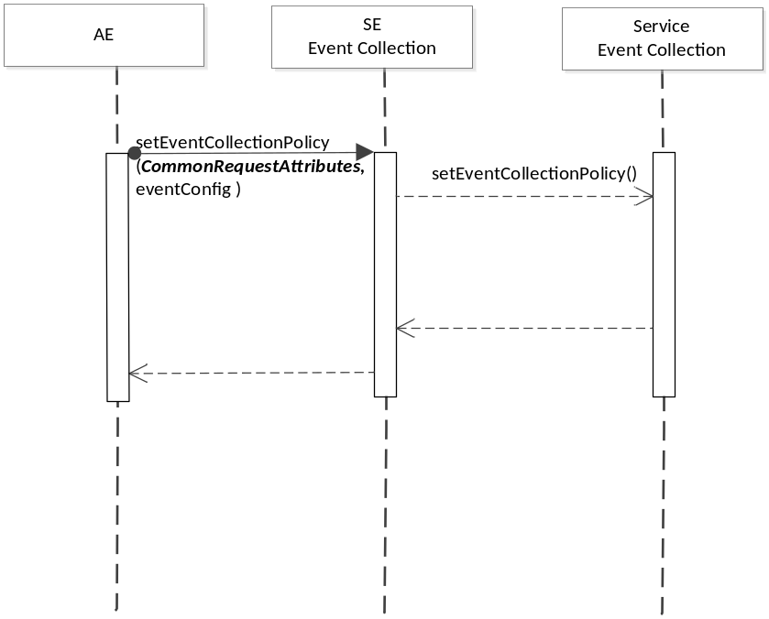
Figure 6.10.2.1.6-1 setEventCollectionPolicy Diagram

6.10.2.1.7 oneM2M Resource Interworking
The service capability aligns with the <eventConfig> resource and maps to the CREATE procedure for the resource.

6.10.2.2 getEventCollectionPolicy
This service capability provides the ability for entities, such as an AE or a service capability, to retrieve the existing policies stored at a service capability. This service capability applies to the Mca and Msc reference point.

6.10.2.2.1 Pre-conditions
The originator can be an AE or a service capability, and the originator wants to retrieve event collection policies at a receiving service capability.
The originator, if different from the receiving service capability, is subscribed and registered to the receiving service capability. The originator is only allowed to retrieve with the proper access right.

6.10.2.2.2 Signature – getEventCollectionPolicy
Parameter name | Direction | Optional | Description
commonParameters | IN | NO | See Table A.2.1.1.2-1
eventCollectionPolicyID | IN | NO | See Table 6.10.2.1.2-2. The eventCollectionPolicyID specifies the specific event collection policy to retrieve, if the originator has such information. If the originator does not have the information regarding eventCollectionPolicyID, it indicates eventCollectionPolicyID with a specific value that represents “any IDs”, and uses the filterCriteria to filter selected policies.
filterCriteria | IN | YES | See Table 6.8.1.1.1-1
responseType | OUT | YES | Unique response types for this service. Exception:  - eventCollectionPolicyID does not exist

Table 6.10.2.2.2-1 Event Collection – getEventCollectionPolicy capability

6.10.2.2.3 Post-Conditions
Not Applicable

6.10.2.2.4 Exceptions
- The originator has no access right to retrieve the policy

6.10.2.2.5 Policies for Use
Message Exchange Patterns: In-Out

6.10.2.2.6 Service Interactions
The interactions of service capabilities required for this service capability:
- Issue the request to the Supporting Service to perform the operation

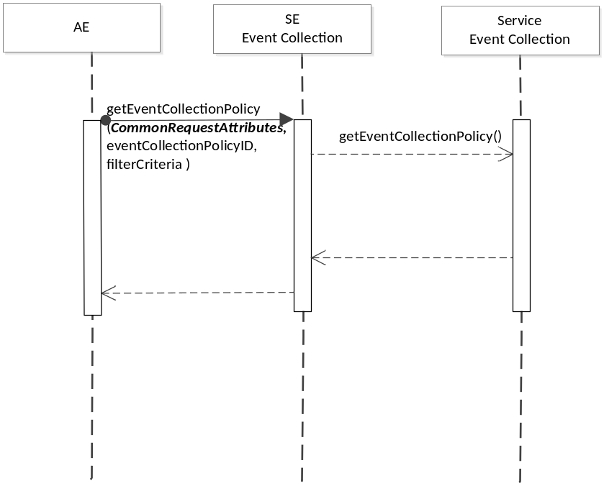
Figure 6.10.2.2.6-1 getEventCollectionPolicy Diagram

6.10.2.2.7 oneM2M Resource Interworking
The service capability aligns with the <eventConfig> resource and maps to the RETRIEVE procedure for the resource.

6.10.2.3 setEventCollectionTriggers
This service capability provides the ability for AEs and service capabilities to configure specific triggers for event collection, based on the Event Collection Policy. This service capability applies to the Mca and Msc reference point.

6.10.2.3.1 Pre-conditions
The originator can be an AE or a service capability, and the originator wants to configure event collection triggers based on existing event collection policy available at the collecting service capability.

6.10.2.3.2 Signature – setEventCollectionTriggers
Parameter name | Direction | Optional | Description
commonParameters | IN | NO | See Table A.2.1.1.2-1
eventCollectionPolicyID | IN | NO | This attribute specify the policy used to define the specific event collection trigger.
collectingEntityID | IN | NO | This is the ID of the entity where the event is being collected. If not specified, the default collecting entity is the receiving service capability.
collectedEntityID | IN | NO | This is the ID of the entity that triggered the event collection. If not specified, the default is all entities triggered the event at the collecting entity.
eventReceiverID | IN | YES | In cases when there is another entity, other than the collecting entity (such as a service capability), wants to receive the collected event, this attribute provides the unique ID of this entity.
serviceRoleIds | IN | YES | Specifies the service roles that trigger the event collection.
serviceId | IN | YES | Specifies the services that trigger the event collection.
triggerStatus | IN | YES | This attribute indicates if the trigger is activated or not. If not defined, the trigger is activated.
eventCollectionTriggerID | OUT | NO | The receiving service capability generates a unique ID for each event collection trigger.
responseType | OUT | YES | Unique response types for this service. Exception:  - eventCollectionPolicyID is invalid  - collectingEntityID is invalid  - collectedEntityID is invalid  - eventReceiverID is invalid  - triggerStatus is invalid

Table 6.5.2.2.2-1 Event Collection – setEventCollectionTriggers capability

6.10.2.3.3 Post-Conditions
After the successful creation of event collection triggers, when the defined event happens at the collectingEntity, and when the event collection trigger status is ACTIVE, the collectingEntity shall collect the event. The supporting service shall send a recordEvent message to the Event Collection entity.

6.10.2.3.4 Exceptions
- The originator has no access right to create the event collection triggers

6.10.2.3.5 Policies for Use
Message Exchange Patterns: In-Out

6.10.2.3.6 Service Interactions
The interactions of service capabilities required for this service capability:
- Issue the request to the Supporting Service to perform the operation

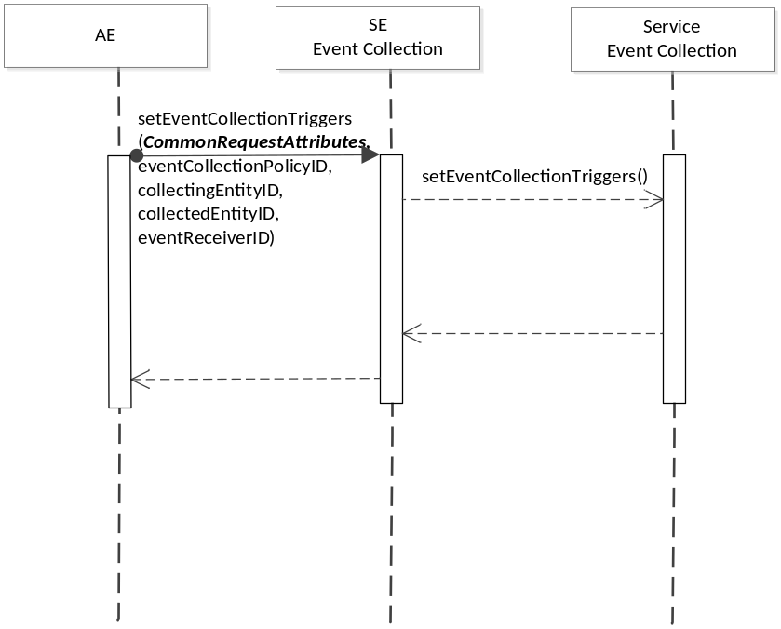
Figure 6.10.2.3.6-1 setEventCollectionTriggers Diagram

6.10.2.3.7 oneM2M Resource Interworking
The service capability aligns with the <statsCollect> resource and maps to the CREATE procedure for the resource.

6.10.2.4 getEventCollectionTriggers
This service capability provides the ability for AEs and service capabilities to retrieve event collection triggers at a receiving service capability. This service capability applies to the Mca and Msc reference point.

6.10.2.4.1 Pre-conditions
Originating AEs and service capabilities are subscribed and registered to the receiving service capability. Originator has the access right to retrieve.

6.10.2.4.2 Signature – getEventCollectionTriggers
Parameter name | Direction | Optional | Description
commonParameters | IN | NO | See Table A.2.1.1.2-1
eventCollectionTriggerID | IN | YES | This attribute specifies which event collection triggers to retrieve. If not specified, any event collection trigger matching the filter criteria should be retrieved. If the originator does not have the information regarding eventCollectionTriggerID, it indicates with a specific value that represents “any IDs”, and uses the filterCriteria to filter selected event triggers.
filterCriteria | IN | YES | See Table 6.8.1.1.1-1
responseType | OUT | YES | Unique response types for this service. Exception:  - eventCollectionTriggerID does not exist

Table 6.5.2.2.2-1 Event Collection – getEventCollectionTriggers capability

6.10.2.4.3 Post-Conditions
Not Applicable

6.10.2.4.4 Exceptions
- The originator has no access right to retrieve the event collection triggers

6.10.2.4.5 Policies for Use
Message Exchange Patterns: In-Out

6.10.2.4.6 Service Interactions
The interactions of service capabilities required for this service capability:
- Issue the request to the Supporting Service to perform the operation

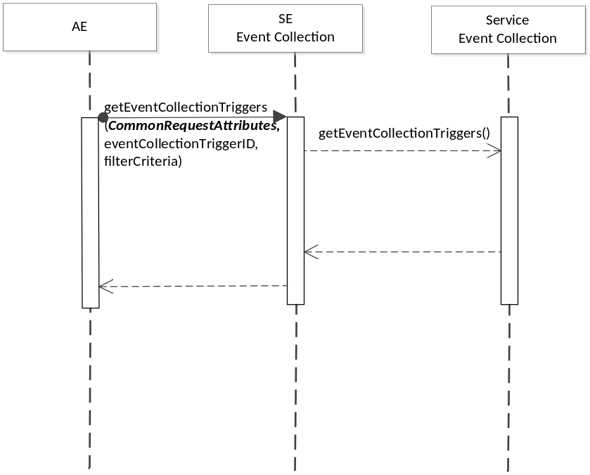
Figure 6.10.2.4.6-1 getEventCollectionTriggers Diagram

6.10.2.4.7 oneM2M Resource Interworking
The service capability aligns with the <statsCollect> resource and maps to the RETRIEVE procedure for the resource.

6.10.2.5 recordEvent
This service capability provides the ability for a service (such as Data Exchange service) to trigger the event collection service to record an event. This service applies to the Msc reference point.

6.10.2.5.1 Pre-conditions
Event Collection Triggers have been created by the setEventCollectionTriggers capability.

6.10.2.5.2 Signature – recordEvent
Parameter name | Direction | Optional | Description
commonParameters | IN | NO | See Table A.2.1.1.2-1
eventCollectionPolicyID | IN | YES | This attribute specify the policy used to define the specific event collection trigger.
eventCollectionTriggerID | IN | NO | The service where the trigger happens provides the eventCollectionTriggerID being used.
eventDescription | IN | NO | This attribute describes the event triggered at the service. It is a subset of the eventConfig data structure. It contains one or more parameters defined in the eventConfig data type.
recordID | OUT | NO | The event collection service generates a unique recordID.
responseType | OUT | YES | Unique response types for this service. Exception:.  - Event recording cannot be completed

Table 6.5.2.2.2-1 Event Collection – recordEvent capability

6.10.2.5.3 Post-Conditions
Not Applicable

6.10.2.5.4 Exceptions
Not Applicable

6.10.2.5.5 Policies for Use
Message Exchange Patterns: In-Out

6.10.2.5.6 Service Interactions
The request comes from the service where the event was triggered to the Event Collection entity.

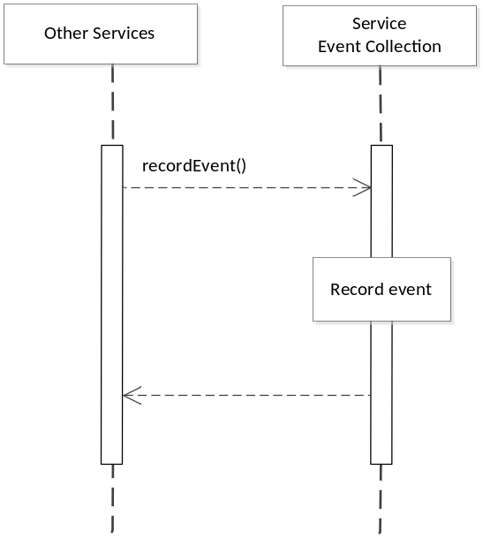
Figure 6.10.2.5.6-1 recordEvent Diagram

6.10.2.5.7 oneM2M Resource Interworking
Not Applicable

6.10.2.6 getEventRecords
This service capability provides the ability for AEs and service capabilities to retrieve the recorded events for statistical or charging purposes. This service capability applies to the Mca and Msc reference point.

6.10.2.6.1 Pre-conditions
Originating AEs and service capabilities are subscribed and registered to the receiving service capability.

6.10.2.6.2 Signature – getEventRecords
Parameter name | Direction | Optional | Description
commonParameters | IN | NO | See Table A.2.1.1.2-1
eventRecordID | IN | NO | This attribute specifies which record to retrieve. If not specified, any event records matching the filter criteria should be retrieved. If the originator does not have the information regarding the eventRecordID, it indicates with a specific value that represents “any IDs”, and use the filterCriteria to filter selected records of events.
filterCriteria | IN | YES | See Table 6.8.1.1.1-1
responseType | OUT | YES | Unique response types for this service. Exception:  - The eventRecordID

Table 6.5.2.2.2-1 Event Collection – getRecords capability

6.10.2.6.3 Post-Conditions
Not Applicable

6.10.2.6.4 Exceptions
Not Applicable

6.10.2.6.5 Policies for Use
Message Exchange Patterns: In-Out

6.10.2.6.6 Service Interactions
The originator sends the request to the Event Collection entity to obtain the event records that it is
interested in.

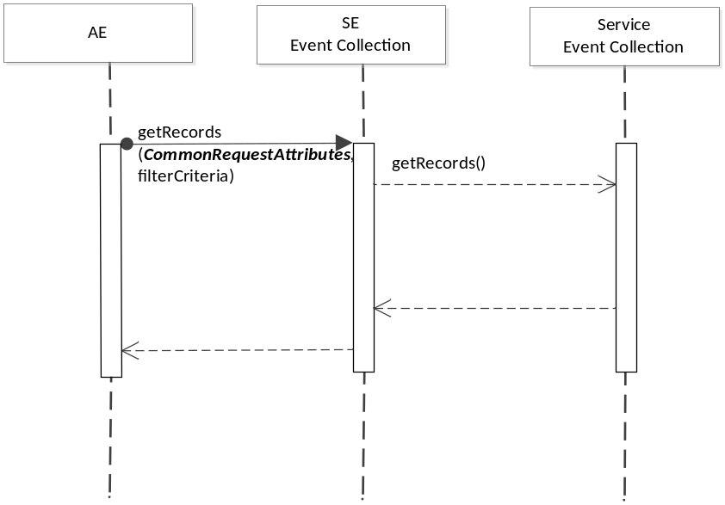
Figure 6.10.2.6.6-1 getEventRecords Diagram

6.10.2.6.7 oneM2M Resource Interworking
Not Applicable

6.10.2 Event Record Template
Information Element | Optional | Description
eventRecordID | NO | It is the unique ID that identifies a specific event record.
eventCollectionTriggerID | NO | It is the unique ID that identifies a specific event collection triggering scenario, which triggers information recording for a specific event.
collectingEntityID | NO | This is the unique ID of the entity that collects the statistics. It can be an AE-ID or M2M Service Capability Identifier (M2M-Srv-ID)
collectedEntityID | NO | This is the unique ID of the entity whose service layer operation statistics are being collected. It can be an AE-ID or M2M Service Capability Identifier (M2M-Srv-ID).
serviceProfileID | YES | An M2M Service Profile Identifier defines M2M Services and/or M2M Service Roles and AEs applicable to M2M Nodes.
eventDescription | NO | Describes the event triggered at the service. It is a subset of the eventConfig data structure. The specific structure depends on the specific event defined by the Event Collection Trigger.
Vendor Specific Information | YES | Defines Vendor specific information

-----------------------End of change 1-------------------------------------------

G-1: M2M Services

Allowed Operations

