Input Contribution
Meeting ID* | ARC#21
Title:* | AllJoyn interface mapping
Source:* | LG Electronics, SeungMyeong JEONG (seungmyeong.jeong@lge.com)
Uploaded Date:* | 2016-01-11
Document(s)  Impacted* | TS-0021 oneM2M-AllJoyn interworking
Intended purpose of  document:* | Decision  Discussion  Information  Other <specify>
Decision requested or recommendation:* | Incorporate the text into the TS.
Template Version:23 February 2015 (Dot not modify)

oneM2M Notice
The document to which this cover statement is attached is submitted to oneM2M. Participation in, or attendance at, any activity of oneM2M, constitutes acceptance of and agreement to be bound by terms of the Working Procedures and the Partnership Agreement, including the Intellectual Property Rights (IPR) Principles Governing oneM2M Work found in Annex 1 of the Partnership Agreement.
This contribution proposes three AllJoyn base service mapping in Annex B as supposed to be:

6.4.2 AllJoyn base service mapping
The list of AllJoyn base services [i.2]:
- OnBoarding,
- Configuration,
- Notification,
- ControlPanel,
- Audio Streaming
The present document specifies base services mapping for Configuration, Notification, ControlPanel. See Annex B AllJoyn base service mapping.
Editor’s Note: Annex B is TBD.
OnBoarding service is intended to support AllJoyn network onboarding (Wi-Fi connection support) for the device that does not have user interface. This is out of scope for oneM2M interworking.
Audio Streaming is also out of scope since oneM2M system does not support in-bound streaming feature.

In R01: alignment with the AllJoyn generic mapping (contribution: ARC-2016-xxxx), in the resource tree figure, “xx” means fix name and italic means variable name.

----------------------- Start of text 1 -----------------------

Annex <B> (Normative) AllJoyn interface mapping to oneM2M resource structure
B.1 Notification service
B.1.1 Notification interface
AllJoyn Notification(org.alljoyn.Notification) interface and its members shall be mapped with the following structure.
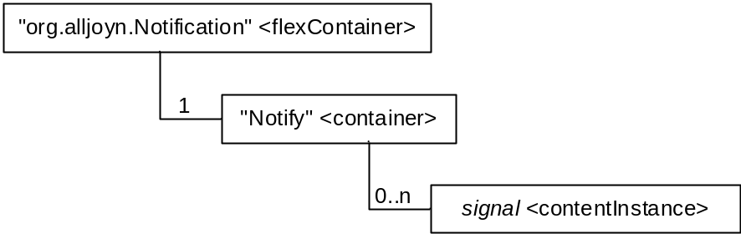
Figure B.1.1-1: Structure of Notification interface mapping

Each resource in the figure above shall have the attribute values as follows.
Table B.1.1-1: Attribute values of org.alljoyn.Notification resource
Attribute | Value | Description
resourceType | “xx” | Enumeration value for the flexContainer resource type
resourceName | “org.alljoyn. Notification” | AllJoyn interface name
containerDefinition | “alljoynInterface” | AllJoyn interface
version | “1” | Version property value is “1”.
Editor’s Note: enumeration value for flexContainer will be updated once it is set in Core Protocol TS. And this will affect the whole Annex B.
Table B.1.1-2: Attribute values of Notify resource
Attribute | Value | Description
resourceType | “3” | Enumeration value for the container resource type
resourceName | “Notify” | “Notify” signal

Table B.1.1-3: Attribute values of signal resource
Attribute | Value | Description
resourceType | “4” | Enumeration value for the contentInstance resource type
resourceName | (variable)
content | (variable) | Signal message

B.1.2 Notification Producer interface
AllJoyn Notification Producer(org.alljoyn.Notification.Producer) interface and its members shall be mapped with the following structure.

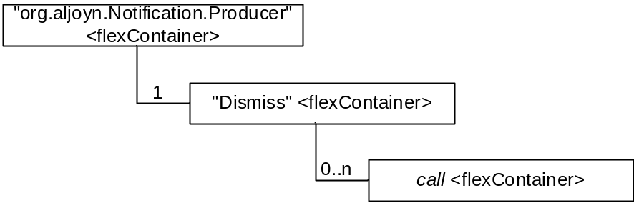
Figure B.1.2-1: Structure of Notification Producer interface mapping

Each resource in the figure above shall have the attribute values as follows.
Table B.1.2-1: Attribute values of org.alljoyn.Notification.Producer resource
Attribute | Value | Description
resourceType | “xx” | Enumeration value for the flexContainer resource type
resourceName | “org.alljoyn.Notification.Producer” | AllJoyn interface name
containerDefinition | “allJoynInterface” | AllJoyn interface
version | “1” | Version property value is “1”.

Table B.1.2-2: Attribute values of Dismiss resource
Attribute | Value | Description
resourceType | “xx” | Enumeration value for the flexContainer resource type
resourceName | “Dismiss” | “Dismiss” method
containerDefinition | “alljoynMethod” | AllJoyn interface method

Table B.1.2-3: Attribute values of call resource
Attribute | Value | Description
resourceType | “xx” | Enumeration value for the flexContainer resource type
resourceName | (variable)
containerDefinition | “alljoynMethodCall” | Method call instance
input | (variable) | key-value pair of “msgId”

B.1.3 Dismisser interface
AllJoyn Dismisser(org.alljoyn.Notification.Dismisser) interface and its members shall be mapped with the following structure.
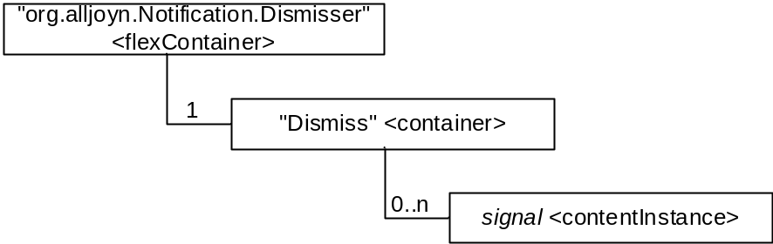
Figure B.1.3-1: Structure of Dismisser interface mapping

Each resource in the figure above shall have the attribute values as follows.
Table B.1.3-1: Attribute values of org.alljoyn.Notification.Dismisser resource
Attribute | Value | Description
resourceType | “xx” | Enumeration value for the flexContainer resource type
resourceName | “org.alljoyn.Notification.Dismisser” | AllJoyn interface name
containerDefinition | “allJoynInterface” | AllJoyn interface
version | “1” | Version property value is “1”.

Table B.1.3-2: Attribute values of Dismiss resource
Attribute | Value | Description
resourceType | “3” | Enumeration value for the container resource type
resourceName | “Dismiss” | “Dismiss” signal

Table B.1.3-3: Attribute values of signal resource
Attribute | Value | Description
resourceType | “4” | Enumeration value for the contentInstance resource type
resourceName | (variable)
content | (variable) | Signal message

B.2 Control Panel service
B.2.1 Container interface
AllJoyn Container(org.alljoyn.ControlPanel.Container) interface and its members shall be mapped with the following structure.
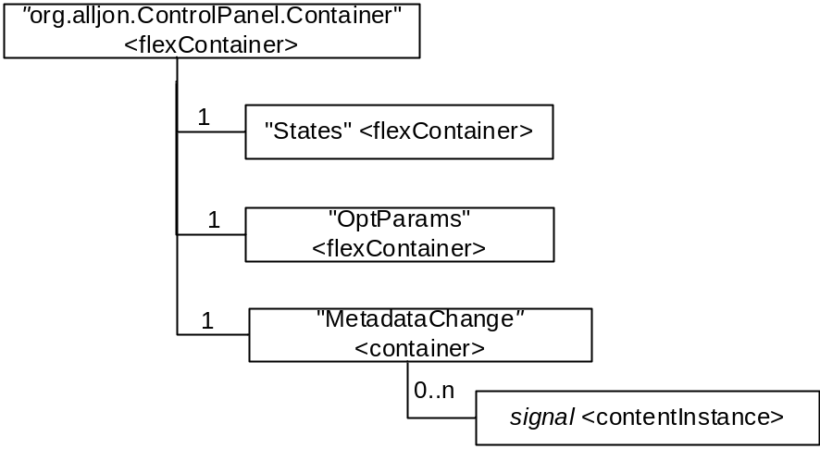
Figure B.2.1-1: Structure of Container interface mapping

Each resource in the figure above shall have the attribute values as follows.
Table B.2.1-1: Attribute values of org.alljoyn.ControlPanel.Container resource
Attribute | Value | Description
resourceType | “xx” | Enumeration value for the flexContainer resource type
resourceName | “org.alljoyn.ControlPanel.Container” | AllJoyn interface name
containerDefinition | “allJoynInterface” | AllJoyn interface
version | “1” | Version property value is “1”

Table B.2.1-2: Attribute values of States resource
Attribute | Value | Description
resourceType | “xx” | Enumeration value for the flexContainer resource type
resourceName | “OptParams” | “States” property
containerDefinition | “alljoynProperty” | AllJoyn interface property
currentValue | (variable) | Read-only state “enabled”

Table B.2.1-3: Attribute values of OptParams resource
Attribute | Value | Description
resourceType | “xx” | Enumeration value for the flexContainer resource type
resourceName | “OptParams” | “OptParams” property
containerDefinition | “alljoynProperty” | AllJoyn interface property
currentValue | (variable) | Read-only “Container” widget metadata

Table B.2.1-4: Attribute values of MetadataChange resource
Attribute | Value | Description
resourceType | “3” | Enumeration value for the container resource type
resourceName | “MetadataChange” | “MetadataChange” signal

Table B.2.1-5: Attribute values of signal resource
Attribute | Value | Description
resourceType | “4” | Enumeration value for the contentInstance resource type
resourceName | (variable)
content | “changed” | Notificiation that the metadata is changed

B.2.2 Property interface
AllJoyn Property(org.alljoyn.ControlPanel.Property) interface and its members shall be mapped with the following structure.
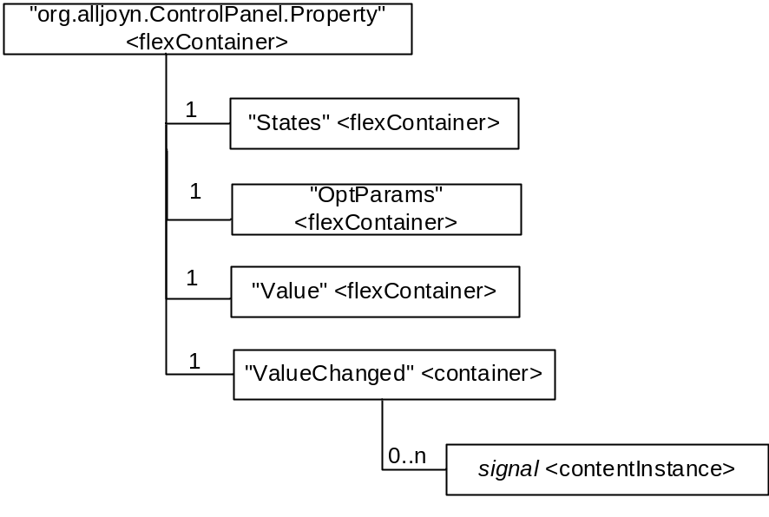
Figure B.2.2-1: Structure of Property interface mapping

Each resource in the figure above shall have the attribute values as follows.
Table B.2.2-1: Attribute values of org.alljoyn.ControlPanel.Property resource
Attribute | Value | Description
resourceType | “3” | Enumeration value for the container resource type
resourceName | “org.alljoyn.ControlPanel.Container” | AllJoyn interface name
containerDefinition | “allJoynInterface” | AllJoyn interface
version | “1” | Version property value is “1”

Table B.2.2-2: Attribute values of States resource
Attribute | Value | Description
resourceType | “xx” | Enumeration value for the flexContainer resource type
resourceName | “States” | “States” property
containerDefinition | “alljoynProperty” | AllJoyn interface property
currentValue | (variable) | Read-only state “enabled” and “writable”

Table B.2.2-3: Attribute values of OptParams resource
Attribute | Value | Description
resourceType | “xx” | Enumeration value for the flexContainer resource type
resourceName | “OptParams” | “OptParams” property
containerDefinition | “alljoynProperty” | AllJoyn interface property
currentValue | (variable) | Read-only “OptParams” widget metadata

Table B.2.2-4: Attribute values of Value resource
Attribute | Value | Description
resourceType | “xx” | Enumeration value for the flexContainer resource type
resourceName | “Value” | “Value” property
containerDefinition | “alljoynProperty” | AllJoyn interface property
requestedValue | (variable) | Suggested Property value
currentValue | (variable) | Current Property value

Table B.2.2-5: Attribute values of ValueChanged resource
Attribute | Value | Description
resourceType | “3” | Enumeration value for the container resource type
resourceName | “ValueChanged” | “ValueChanged” signal

Table B.2.2-6: Attribute values of signal resource
Attribute | Value | Description
resourceType | “4” | Enumeration value for the contentInstance resource type
resourceName | (variable)
content | (variable) | Key-value pairs of property or metadata

B.2.3 LabelProperty interface
AllJoyn LabelProperty(org.alljoyn.ControlPanel.LabelProperty) interface and its members shall be mapped with the following structure.
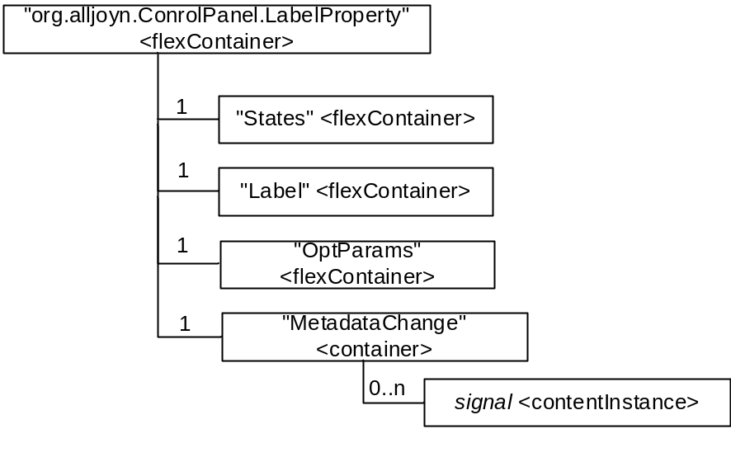
Figure B.2.3-1: Structure of LabelProperty interface mapping

Each resource in the figure above shall have the attribute values as follows.
Table B.2.3-1: Attribute values of org.alljoyn.ControlPanel.LabelProperty resource
Attribute | Value | Description
resourceType | “xx” | Enumeration value for the flexContainer resource type
resourceName | “org.alljoyn.ControlPanel.LabelProperty” | AllJoyn interface name
containerDefinition | “allJoynInterface” | AllJoyn interface
version | “1” | Version property value is “1”

Table B.2.3-2: Attribute values of States resource
Attribute | Value | Description
resourceType | “xx” | Enumeration value for the flexContainer resource type
resourceName | “States” | “States” property
containerDefinition | “alljoynProperty” | AllJoyn interface property
currentValue | (variable) | Read-only state “enabled”

Table B.2.3-3: Attribute values of Label resource
Attribute | Value | Description
resourceType | “xx” | Enumeration value for the flexContainer resource type
resourceName | “Label” | “Label” property
containerDefinition | “alljoynProperty” | AllJoyn interface property
currentValue | (variable) | Read-only label

Table B.2.3-4: Attribute values of OptParams resource
Attribute | Value | Description
resourceType | “3” | Enumeration value for the container resource type
resourceName | “pOptParams” | “OptParams” property
containerDefinition | “alljoynProperty” | AllJoyn interface property
currentValue | (variable) | Read-only LabelProperty widget metadata

Table B.2.3-5: Attribute values of MetadataChange resource
Attribute | Value | Description
resourceType | “3” | Enumeration value for the container resource type
resourceName | “MetadataChange” | “MetadataChange” signal

Table B.2.3-6: Attribute values of signal resource
Attribute | Value | Description
resourceType | “4” | Enumeration value for the contentInstance resource type
resourceName | (variable)
content | “changed” | Notificiation that the metadata is changed

B.2.4 Action interface
AllJoyn Action(org.alljoyn.ControlPanel.Action) interface and its members shall be mapped with the following structure.
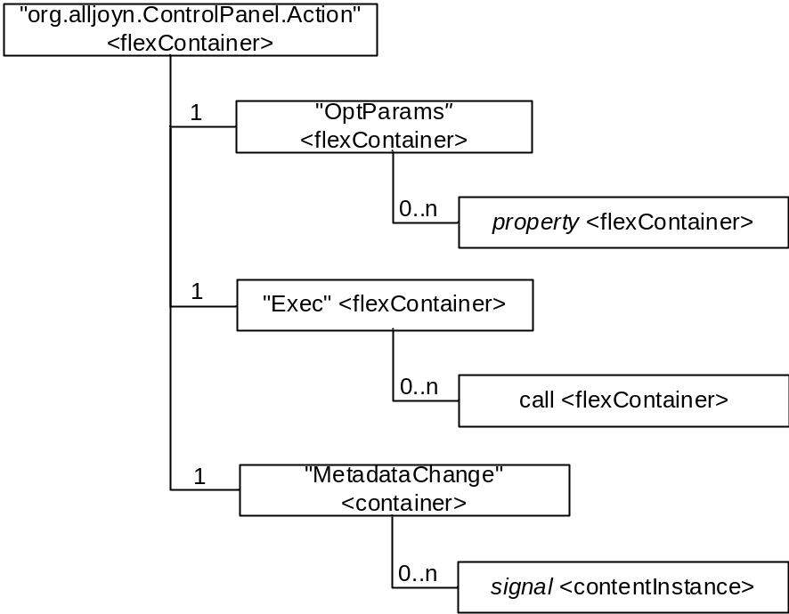
Figure B.2.4-1: Structure of Action interface mapping

Each resource in the figure above shall have the attribute values as follows.
Table B.2.4-1: Attribute values of org.alljoyn.ControlPanel.Action resource
Attribute | Value | Description
resourceType | “xx” | Enumeration value for the flexContainer resource type
resourceName | “org.alljoyn.ControlPanel.Container” | AllJoyn interface name
containerDefinition | “allJoynInterface” | AllJoyn interface
version | “1” | Version property value is “1”

Table B.2.4-2: Attribute values of States resource
Attribute | Value | Description
resourceType | “xx” | Enumeration value for the flexContainer resource type
resourceName | “States” | “States” property
containerDefinition | “alljoynProperty” | AllJoyn interface property
currentValue | (variable) | Read-only state “enabled”

Table B.2.4-3: Attribute values of OptParams resource
Attribute | Value | Description
resourceType | “xx” | Enumeration value for the flexContainer resource type
resourceName | “OptParams” | “OptParams” property
containerDefinition | “alljoynProperty” | AllJoyn interface property
currentValue | (variable) | Read-only “Action” widget metadata

Table B.2.4-4: Attribute values of Exec resource
Attribute | Value | Description
resourceType | “xx” | Enumeration value for the flexContainer resource type
resourceName | “Exec” | “Exec” method
containerDefinition | “alljoynMethod” | AllJoyn interface method

Table B.2.4-5: Attribute values of call resource
Attribute | Value | Description
resourceType | “xx” | Enumeration value for the flexContainer resource type
resourceName | (variable)
containerDefinition | “alljoynMethodCall” | Method call instance

Table B.2.4-6: Attribute values of MetadataChange resource
Attribute | Value | Description
resourceType | “3” | Enumeration value for the container resource type
resourceName | “MetadataChange” | “MetadataChange” signal

Table B.2.4-7: Attribute values of signal resource
Attribute | Value | Description
resourceType | “4” | Enumeration value for the contentInstance resource type
resourceName | (variable)
content | “changed” | Notificiation that the metadata is changed

B.2.5 NotificationAction interface
AllJoyn NotificationAction(org.alljoyn.ControlPanel.Container) interface and its members shall be mapped with the following structure.
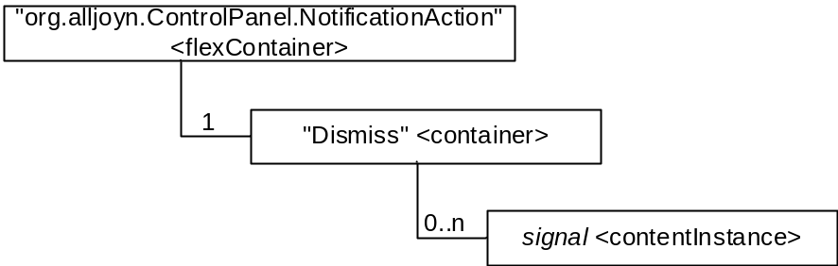
Figure B.2.5-1: Structure of NotificationAction interface mapping

Each resource in the figure above shall have the attribute values as follows.
Table B.2.5-1: Attribute values of org.alljoyn.ControlPanel.NotificationAction resource
Attribute | Value | Description
resourceType | “xx” | Enumeration value for the flexContainer resource type
resourceName | “org.alljoyn.ControlPanel.NotificationAction” | AllJoyn interface name
containerDefinition | “allJoynInterface” | AllJoyn interface
version | “1” | Version property value is “1”

Table B.2.5-2: Attribute values of Dismiss resource
Attribute | Value | Description
resourceType | “3” | Enumeration value for the container resource type
resourceName | “Dismiss” | “Dismiss” signal

Table B.2.5-3: Attribute values of signal resource
Attribute | Value | Description
resourceType | “4” | Enumeration value for the contentInstance resource type
resourceName | (variable)
content | “dismiss” | Dismiss the notification panel

B.2.6 Dialog interface
AllJoyn Dialog(org.alljoyn.ControlPanel.Dialog) interface and its members shall be mapped with the following structure.
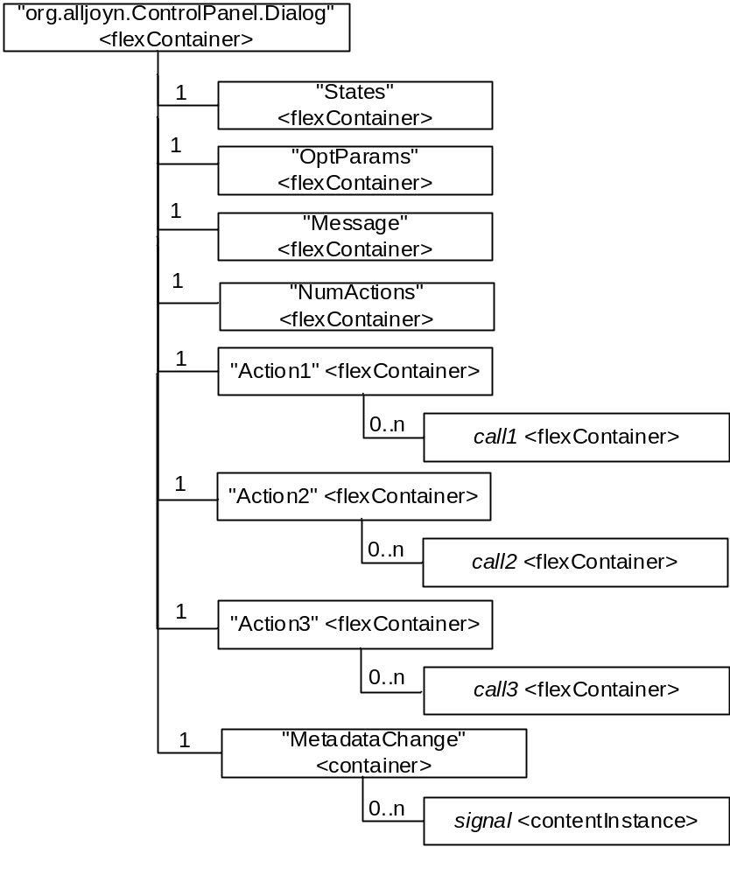
Figure B.2.6-1: Structure of Dialog interface mapping

Each resource in the figure above shall have the attribute values as follows.
Table B.2.6-1: Attribute values of org.alljoyn.ControlPanel.Dialog resource
Attribute | Value | Description
resourceType | “3” | Enumeration value for the container resource type
resourceName | “ControlPanel.Dialog” | org.alljoyn.ControlPanel.Dialog interface
containerDefinition | “allJoynInterface” | AllJoyn interface
version | “1” | Version property value is “1”

Table B.2.6-2: Attribute values of States resource
Attribute | Value | Description
resourceType | “xx” | Enumeration value for the flexContainer resource type
resourceName | “States” | “States” property
containerDefinition | “alljoynProperty” | AllJoyn interface property
currentValue | (variable) | Read-only state “enabled”

Table B.2.6-3: Attribute values of OptParams resource
Attribute | Value | Description
resourceType | “xx” | Enumeration value for the flexContainer resource type
resourceName | “OptParams” | “OptParams” property
containerDefinition | “alljoynProperty” | AllJoyn interface property
currentValue | (variable) | Read-only “Dialog” widget metadata

Table B.2.4-4: Attribute values of Message resource
Attribute | Value | Description
resourceType | “xx” | Enumeration value for the flexContainer resource type
resourceName | “States” | “States” property
containerDefinition | “alljoynProperty” | AllJoyn interface property
currentValue | (variable) | Read-only display message

Table B.2.4-5: Attribute values of NumActions resource
Attribute | Value | Description
resourceType | “xx” | Enumeration value for the flexContainer resource type
resourceName | “States” | “States” property
containerDefinition | “alljoynProperty” | AllJoyn interface property
currentValue | (variable) | Read-only number of actions

Table B.2.6-6: Attribute values of Action1 resource
Attribute | Value | Description
resourceType | “xx” | Enumeration value for the flexContainer resource type
resourceName | “Action1” | “Action1” method
containerDefinition | “alljoynMethod” | AllJoyn interface method

Table B.2.6-7: Attribute values of call1 resource
Attribute | Value | Description
resourceType | “xx” | Enumeration value for the flexContainer resource type
resourceName | (variable)
containerDefinition | “alljoynMethodCall” | AllJoyn interface method call

Table B.2.6-8: Attribute values of Action2 resource
Attribute | Value | Description
resourceType | “xx” | Enumeration value for the flexContainer resource type
resourceName | “Action2” | “Action2” method
containerDefinition | “alljoynMethod” | AllJoyn interface method

Table B.2.6-9: Attribute values of call2 resource
Attribute | Value | Description
resourceType | “xx” | Enumeration value for the flexContainer resource type
resourceName | (variable)
containerDefinition | “alljoynMethodCall” | AllJoyn interface method call

Table B.2.6-10: Attribute values of Action3 resource
Attribute | Value | Description
resourceType | “xx” | Enumeration value for the flexContainer resource type
resourceName | “Action3” | “Action3” method
containerDefinition | “alljoynMethod” | AllJoyn interface method

Table B.2.6-11: Attribute values of call3 resource
Attribute | Value | Description
resourceType | “xx” | Enumeration value for the flexContainer resource type
resourceName | (variable)
containerDefinition | “alljoynMethodCall” | AllJoyn interface method call

Table B.2.6-12: Attribute values of MetadataChange resource
Attribute | Value | Description
resourceType | “3” | Enumeration value for the container resource type
resourceName | “MetadataChange” | “MetadataChange” signal

Table B.2.6-13: Attribute values of signal resource
Attribute | Value | Description
resourceType | “4” | Enumeration value for the contentInstance resource type
resourceName | (variable)
content | “changed” | Notificiation that the metadata is changed

B.2.7 ListProperty interface
AllJoyn ListProperty(org.alljoyn.ControlPanel.ListProperty) interface and its members shall be mapped with the following structure.
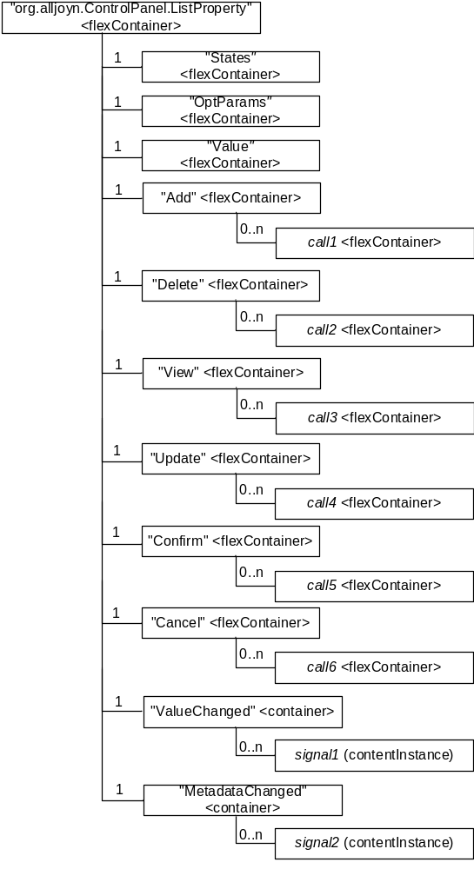
Figure B.2.7-1: Structure of ListProperty interface mapping

Each resource in the figure above shall have the attribute values as follows.
Table B.2.7-1: Attribute values of org.alljoyn.ControlPanel.ListProperty resource
Attribute | Value | Description
resourceType | “xx” | Enumeration value for the flexContainer resource type
resourceName | “org.alljoyn.ControlPanel.ListProperty” | AllJoyn interface name
containerDefinition | “allJoynInterface” | AllJoyn interface
version | “1” | Version property value is “1”

Table B.2.7-2: Attribute values of States resource
Attribute | Value | Description
resourceType | “xx” | Enumeration value for the flexContainer resource type
resourceName | “States” | “States” property
containerDefinition | “alljoynProperty” | AllJoyn interface property
currentValue | (variable) | Read-only state “enabled”

Table B.2.7-3: Attribute values of OptParams resource
Attribute | Value | Description
resourceType | “xx” | Enumeration value for the flexContainer resource type
resourceName | “OptParams” | “OptParams” property
containerDefinition | “alljoynProperty” | AllJoyn interface property
currentValue | (variable) | Read-only “ListProperty” widget metadata

Table B.2.7-4: Attribute values of Value resource
Attribute | Value | Description
resourceType | “xx” | Enumeration value for the flexContainer resource type
resourceName | “Value” | “Value” property
containerDefinition | “alljoynProperty” | AllJoyn interface property
currentValue | (variable) | Read-only list of records

Table B.2.7-5: Attribute values of Add resource
Attribute | Value | Description
resourceType | “xx” | Enumeration value for the flexContainer resource type
resourceName | “Add” | “Add” method
containerDefinition | “alljoynMethod” | AllJoyn interface method

Table B.2.7-6: Attribute values of call1 resource
Attribute | Value | Description
resourceType | “xx” | Enumeration value for the flexContainer resource type
resourceName | (variable)
containerDefinition | “alljoynMethodCall” | AllJoyn interface method call

Table B.2.7-7: Attribute values of Delete resource
Attribute | Value | Description
resourceType | “xx” | Enumeration value for the flexContainer resource type
resourceName | “Delete” | “Delete” method
containerDefinition | “alljoynMethod” | AllJoyn interface method

Table B.2.7-8: Attribute values of call2 resource
Attribute | Value | Description
resourceType | “xx” | Enumeration value for the flexContainer resource type
resourceName | (variable)
containerDefinition | “alljoynMethodCall” | AllJoyn interface method call
input | (variable) | recordID

Table B.2.7-9: Attribute values of View resource
Attribute | Value | Description
resourceType | “xx” | Enumeration value for the flexContainer resource type
resourceName | “View” | “View” method
containerDefinition | “alljoynMethod” | AllJoyn interface method

Table B.2.7-10: Attribute values of call3 resource
Attribute | Value | Description
resourceType | “xx” | Enumeration value for the flexContainer resource type
resourceName | (variable)
containerDefinition | “alljoynMethodCall” | AllJoyn interface method call
input | (variable) | recordID

Table B.2.7-11: Attribute values of Update resource
Attribute | Value | Description
resourceType | “xx” | Enumeration value for the flexContainer resource type
resourceName | “Update” | “Update” method
containerDefinition | “alljoynMethod” | AllJoyn interface method

Table B.2.7-12: Attribute values of call4 resource
Attribute | Value | Description
resourceType | “xx” | Enumeration value for the flexContainer resource type
resourceName | (variable)
containerDefinition | “alljoynMethodCall” | AllJoyn interface method call
input | (variable) | recordID

Table B.2.7-13: Attribute values of Confirm resource
Attribute | Value | Description
resourceType | “xx” | Enumeration value for the flexContainer resource type
resourceName | “Confirm” | “Confirm” method
containerDefinition | “alljoynMethod” | AllJoyn interface method

Table B.2.7-14: Attribute values of call5 resource
Attribute | Value | Description
resourceType | “xx” | Enumeration value for the flexContainer resource type
resourceName | (variable)
containerDefinition | “alljoynMethodCall” | AllJoyn interface method call

Table B.2.7-15: Attribute values of Cancel resource
Attribute | Value | Description
resourceType | “xx” | Enumeration value for the flexContainer resource type
resourceName | “Cancel” | “Cancel” method
containerDefinition | “alljoynMethod” | AllJoyn interface method

Table B.2.7-16: Attribute values of call6 resource
Attribute | Value | Description
resourceType | “xx” | Enumeration value for the flexContainer resource type
resourceName | (variable)
containerDefinition | “alljoynMethodCall” | AllJoyn interface method call

Table B.2.7-17: Attribute values of ValueChanged resource
Attribute | Value | Description
resourceType | “3” | Enumeration value for the container resource type
resourceName | “Changed” | “ValueChanged” signal

Table B.2.7-18: Attribute values of signal1 resource
Attribute | Value | Description
resourceType | “4” | Enumeration value for the contentInstance resource type
content | “ValueChanged”” | Notificiation that the property value is changed

Table B.2.7-19: Attribute values of MetadataChanged resource
Attribute | Value | Description
resourceType | “3” | Enumeration value for the container resource type
resourceName | “Changed” | “MetadataChanged” signal

Table B.2.7-20: Attribute values of signal2 resource
Attribute | Value | Description
resourceType | “4” | Enumeration value for the contentInstance resource type
content | “MetadataChanged” | Notificiation that the metadata is changed

B.3 Configuration service
B.3.1 Config interface
AllJoyn Config(org.alljoyn.Config) interface and its members shall be mapped with the following structure.
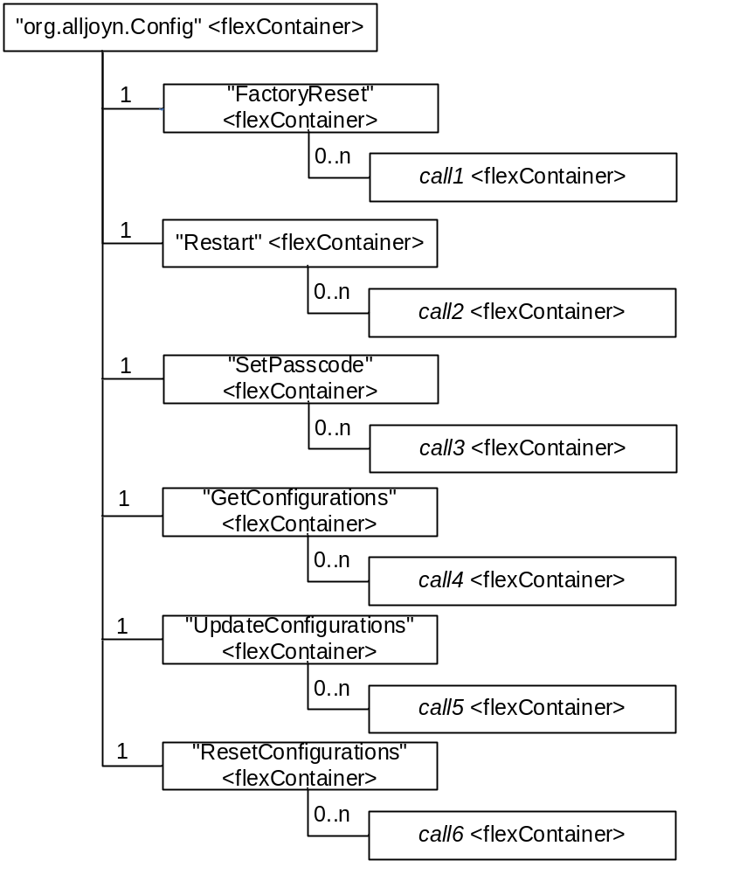
Figure B.3.1-1: Structure of Config interface mapping

Each resource in the figure above shall have the attribute values as follows.
Table B.3.1-1: Attribute values of Config resource
Attribute | Value | Description
resourceType | “xx” | Enumeration value for the flexContainer resource type
resourceName | “org.alljoyn.Config” | AllJoyn interface name
containerDefinition | “allJoynInterface” | AllJoyn interface
version | “1” | Version property value is “1”

Table B.2.3-2: Attribute values of FactoryReset resource
Attribute | Value | Description
resourceType | “xx” | Enumeration value for the flexContainer resource type
resourceName | “FactoryReset” | “FactoryReset” method
containerDefinition | “alljoynMethod” | AllJoyn interface method

Table B.2.3-3: Attribute values of call1 resource
Attribute | Value | Description
resourceType | “xx” | Enumeration value for the flexContainer resource type
resourceName | (variable)
containerDefinition | “alljoynMethodCall” | AllJoyn interface method call

Table B.2.3-4: Attribute values of Restart resource
Attribute | Value | Description
resourceType | “xx” | Enumeration value for the flexContainer resource type
resourceName | “Restart” | “Restart” method
containerDefinition | “alljoynMethod” | AllJoyn interface method

Table B.2.3-5: Attribute values of call2 resource
Attribute | Value | Description
resourceType | “xx” | Enumeration value for the flexContainer resource type
resourceName | (variable)
containerDefinition | “alljoynMethodCall” | AllJoyn interface method call

Table B.2.3-6: Attribute values of SetPasscode resource
Attribute | Value | Description
resourceType | “xx” | Enumeration value for the flexContainer resource type
resourceName | “SetPasscode” | “SetPasscode” method
containerDefinition | “alljoynMethod” | AllJoyn interface method

Table B.2.3-7: Attribute values of call3 resource
Attribute | Value | Description
resourceType | “xx” | Enumeration value for the flexContainer resource type
resourceName | (variable)
containerDefinition | “alljoynMethodCall” | AllJoyn interface method call
input | (variable) | “daeonRealm” and “newPasscode” parameter

Table B.2.3-8: Attribute values of GetConfigurations resource
Attribute | Value | Description
resourceType | “xx” | Enumeration value for the flexContainer resource type
resourceName | “GetConfigurations” | “GetConfigurations” method
containerDefinition | “alljoynMethod” | AllJoyn interface method

Table B.2.3-9: Attribute values of call4 resource
Attribute | Value | Description
resourceType | “xx” | Enumeration value for the flexContainer resource type
resourceName | (variable)
containerDefinition | “alljoynMethodCall” | AllJoyn interface method call
input | (variable) | “languageTag” parameter

Table B.2.3-10: Attribute values of UpdateConfigurations resource
Attribute | Value | Description
resourceType | “xx” | Enumeration value for the flexContainer resource type
resourceName | “UpdateConfigurations” | “UpdateConfigurations” method
containerDefinition | “alljoynMethod” | AllJoyn interface method

Table B.2.3-11: Attribute values of call5 resource
Attribute | Value | Description
resourceType | “xx” | Enumeration value for the flexContainer resource type
resourceName | (variable)
containerDefinition | “alljoynMethodCall” | AllJoyn interface method call
input | (variable) | “languageTag” and “configMap” parameter

Table B.2.3-12: Attribute values of ResetConfigurations resource
Attribute | Value | Description
resourceType | “xx” | Enumeration value for the flexContainer resource type
resourceName | “ResetConfigurations” | “ResetConfigurations” method
containerDefinition | “alljoynMethod” | AllJoyn interface method

Table B.2.3-13: Attribute values of call6 resource
Attribute | Value | Description
resourceType | “xx” | Enumeration value for the flexContainer resource type
resourceName | (variable)
containerDefinition | “alljoynMethodCall” | AllJoyn interface method call
input | (variable) | “languageTag” and “fieldList” parameter

----------------------- End of text 1 -----------------------

