CHANGE REQUEST
Meeting:* | WG2 Architecture - ARC 21
Source:* | InterDigital / Ericsson
Date:* | 2016-01-12
Contact:* | Dale Seed (dale.seed@interdigital.com )  George Foti (george.foti@ericsson.com )
Reason for Change/s:* | There are requirements to support multimedia session
CR against: Release*
CR against: WI* | Active <WI-0034>  MNT Maintenace / <Work Item number(optional)>  STE Small Technical Enhancements / <Work Item number (optional)>  Only ONE of the above shall be ticked
CR against: TS/TR* | TS-0001 V 2.5.0
Clauses/Sub Clauses* | Various
Type of change: * | Editorial change  Bug Fix or Correction  Change/correction to existing feature or functionality  New feature or functionality
Post Freeze checking:* | This CR contains only essential changes and corrections? YES NO  This CR is a mirror CR? YES NO if YES, please indicate the document number of the original CR:  <Document Number)<CR Number of the original CR to the current Release>

oneM2M Notice
The document to which this cover statement is attached is submitted to oneM2M. Participation in, or attendance at, any activity of oneM2M, constitutes acceptance of and agreement to be bound by terms of the Working Procedures and the Partnership Agreement, including the Intellectual Property Rights (IPR) Principles Governing oneM2M Work found in Annex 1 of the Partnership Agreement.
GUIDELINES for Change Requests:
Provide an informative introduction containing the problem(s) being solved, and a summary list of proposals.
Each CR should contain changes related to only one particular issue/problem.
Follow the principle of completeness, where all changes related to the issue or problem within a deliverable are simultaneously proposed to be made E.g. A change impacting 5 tables should not only include a proposal to change only 3 tables. Includes any changes to references, definitions, and acronyms in the same deliverable.
Follow the drafting rules.
All pictures must be editable.
Check spelling and grammar to the extent practicable.
Use Change bars for modifications.
The change should include the current and surrounding clauses to clearly show where a change is located and to provide technical context of the proposed change. Additions of complete sections need not show surrounding clauses as long as the proposed section number clearly shows where the new section is proposed to be located.
Multiple changes in a single CR shall be clearly separated by horizontal lines with embedded text such as, start of change 1, end of change 1, start of new clause, end of new clause.
When subsequent changes are made to content of a CR, then the accepted version should not show changes over changes. The accepted version of the CR should only show changes relative to the baseline approved text.

Introduction
To support the following TS-0002 requirements:
NO | Requirement | Status
OSR-003 | The oneM2M System shall support the ability to maintain peer-to-peer M2M Session in coordination with application session for those M2M Applications that require it. | Partially implemented in Rel-1  NOTE : No support for peer-to-peer service layer session.
CRPR-005 | The oneM2M System shall be able to maintain context associated with M2M sessions (e.g. security context or network connectivity context during the interruption of the session). | Partially implemented in Rel-1  NOTE : Long lived security context and registration is covered, M2M Sessions are not covered.
OSR-042 | The oneM2M System shall be able to support different QoS-levels specifying parameters, such as guaranteed bitrate, delay, delay variation, loss ratio and error rate, etc. | Not implemented in Rel-1

The collecction use cases from TR-0001 have also the following uses cases which require multimedia streaming session to fulfil them.
- Secure remote patient care and monitoring (see TR-0001, section 7.3).
- Real Time Audio/Video Communication (see TR-000, section 9.4).

Background:
IETF defines the Session Description Protocol (SDP). SDP is not really a protocol but a descriptor format for describing multimedia communication sessions between endpoints. SDP descriptors can be used for session announcement, session invitation, and session parameter negotiation. The format of the SDP descriptors are based on a standard content type (i.e. MIME type) which serves as the basis of the SDP protocol. IETF (IANA) maintains a registry that defines SDP descriptor parameters (http://www.iana.org/assignments/sdp-parameters/sdp-parameters.xhtml). Some examples of the SDP parameter types include media type (e.g. audio, video, image, etc) and protocol type (e.g. RTP, RTP/AVP, etc).
Its worth noting that the SDP specifications do not define a messaging / transport protocol used to exchange SDP descriptions between endpoints, and hence SDP is reliant on other protocols or mechanisms for exchange of SDP descriptors between endpoints.
The oneM2M framework can be used by AEs as a transport to allow them to exchange session descriptors (e.g. SDP descriptors) for the purposes of multimedia session announcement, session invitation, and parameter negotiation.
In addition, the oneM2M framework can also be used to further complement multimedia session communication between AEs, by interworking with underlying networks to assist with the configuration of session parameters such as QoS.
At TP20, contribution ARC-2015-2233R02-Streaming-Session-Support was agreed to for insertion into section 8.3 of TR-0020. This contribution proposes a framework for supporting streaming sessions between AEs in which the session control/management is performed through the oneM2M system and the streaming media bypasses the oneM2M system and is sent directly between the AEs via the underlying network.
Proposed Contribution:
This contribution proposes to resource and procedures to support multimedia session support.

-----------------------Start of change 1-------------------------------------------

2.2 Informative references
Add the following new reference
[i.31] IETF RFC 6871: "Session Description Protocol (SDP) Media Capabilities Negotiation".

-----------------------Start of change 2-------------------------------------------

3.2 Abbreviations and Acronyms
Add the following abbreviation:
SDP Session Description Protocol
QoS Quality of Service

-----------------------Start of change 3-------------------------------------------

6.7 Support for Multimedia Sessions
Multimedia sessions refer to a session where two peers communicating with the oneM2M system, typically, two AEs, exchange media that has to be streamed between them and that requires specific Quality of Service (QoS). The streamed media will not traverse the oneM2M control nodes but will go directly between the two peers. The oneM2M system role is twofold:
- To facilitate the exchange of multimedia session descriptors (e.g. SDP descriptors) between two AEs for the purposes of multimedia session management (e.g. discovery, establishment, update and teardown).
- When applicable, to ensure that the underlying network nodes that the streamed media traverse shall be provisioned with the proper QoS for the session. The required QoS for the streamed media shall be negotiated between the two AEs through the oneM2M system.
Negotiation between AEs requiring a multimedia session shall be based on SDP as defined in [i.31]. Two modes for negotiation shall be supported by oneM2M:
- In the first mode, the originating AE provides only one offer that the target AE can reject or accept as is.
- In the second mode, the originating AE provides multiple offers and the target AE can reject all offers or accept one and return the accepted offer in the response.
A multimedia session has typically 3 procedures associated with it: session establishment; session update, and session termination.
To modify (UPDATE) an ongoing session, the session shall be put on hold first, and after successful updating, it shall be resumed. Note that SDP as defined [i.31] specifies all these aspects.

6.7.1 Roles of M2M Nodes to support Multimedia sessions
There are several potential types of deployment scenarios involving multimedia sessions. Some examples are as follows:
- Scenario 1 where two ADN-AEs and an IN-CSE are involved
- Scenario 2 where two ADN-AEs, an MN-CSE and an IN-CSE are involved
- Scenario 3 where two ADN-AEs, two MN-CSEs, and an IN-CSE are involved
See Annex K for examples.

-----------------------Start of change 4-------------------------------------------

9.6.X Resource Type multimediaSession
An <multimediaSession> resource shall represent information about a multimedia session involving two AEs.

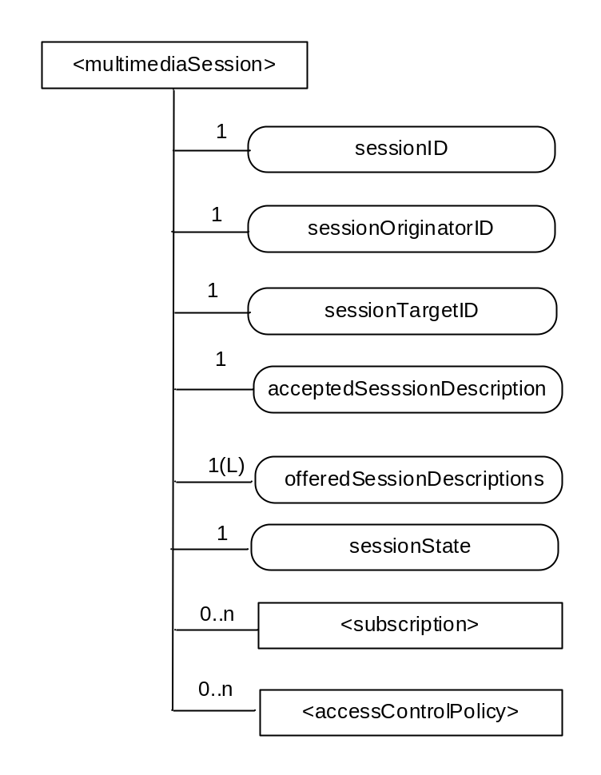
Figure 9.6.X-1: Structure of <multimediaSession> resource
The <multimediaSession> resource shall contain the child resources specified in table 9.6.X-1.

Table 9.6.X-1: Child resources of <multimediaSession> resource
Child Resources of <SS> | Child Resource Type |  |  | Multiplicity | Description | <SSAnnc> Child Resource Types
[variable] |  | <subscription> | 0..n |  | See clause 9.6.8 | <subscription>
[variable] |  | <accessControlPolicy> | 0..n |  | See clause 9.6.2 | <accessControlPolicy>  <accessControlPolicyAnnc>

The <multimediaSession> resource shall contain the attributes specified in table 9.6.X-2-2.

Table 9.6.X-2: Attributes of <multimediaSession> resource
Attributes of  <multimediaSession> | Multiplicity | RW/  RO/  WO | Description | <multimediaSessionAnnc> Attributes
resourceType | 1 | RO | See clause 9.6.1.3 where this common attribute is described. | NA
resourceID | 1 | RO | See clause 9.6.1.3 where this common attribute is described. | MA
resourceName | 1 | WO | See clause 9.6.1.3 where this common attribute is described. | MA
parentID | 1 | RO | See clause 9.6.1.3 where this common attribute is described. | NA
expirationTime | 1 | RW | See clause 9.6.1.3 where this common attribute is described. | MA
accessControlPolicyIDs | 0..1 (L) | RW | See clause 9.6.1.3 where this common attribute is described. | MA
creationTime | 1 | RW | See clause 9.6.1.3 where this common attribute is described. | NA
lastModifiedTime | 1 | RO | See clause 9.6.1.3 where this common attribute is described. | NA
labels | 0..1 (L) | RO | See clause 9.6.1.3 where this common attribute is described. | MA
sessionID | 1 | RO | The sessionID shall be the same as the resourceID | NA
sessionOriginator ID | 1 | WO | The M2M identifier of the originator of the multimedia session. | NA
SessionTargetID | 1 | WO | The M2M identifier of the target of the multimedia session. | NA
acceptedSessionDescription | 1 | RW | Session description, including charateristics of the session. The sessionDescription attribute is compliant to [i.31]. This is the the final accepted and agreed upon session description based on the received response from the target of the multimedia session. | NA
offeredSessionDescriptions | 1 | RW | A list of session descriptions offered by the originator of the session to the target. The attribute contains a list of session descriptors that are compliant to to [i.31]. | NA
sessionState | 1 | RW | The current state of the multimedia session. The supported values are ONLINE and OFFLINE. When the session is in the OFFLINE state, the corresponding AE session endpoints shall not initiate the flow of media between one another. When in the ONLINE state, the AEs are free to initiate the flow of media. | NA

-----------------------Start of change 5-------------------------------------------

10.2.X <multimediaSession> Resource Procedures

10.2.X.1 Create <multimediaSession>
This procedure shall be used for creating an <multimediaSession> resource.
Table 10.2.X-1: < multimediaSession > CREATE
< multimediaSession > CREATE
Associated Reference Point | Mca, and Mcc
Information in Request message | All parameters defined in table 8.1.2-2 apply with the specific details for:  To: Address of <AE>. Only an originating AE can create an multimediaSession resource over Mca.  For Mcc, the To address shall be set to the Address of <remote CSE> of the originating CSE . Only a registered CSE can create an multimediaSession resource over Mcc.  Content: The resource content shall provide the information as defined in clause 9.6.35
Processing at Originator before sending Request | According to clause 10.1.1.1
Processing at Receiver | According to clause 10.1.1.1 with the replacement for sub-step 1) of Step 002 as follows:  For a request over Mca, the Hosting CSE shall check if the Originator ID is the same as the AE-ID of the parent resource which is the <AE> resource and If the check fails, the request shall be rejected.  For a request over Mcc, the Hosting CSE shall check if the Originator ID is the same as the CSE-ID of the parent resource which is the <remoteCSE> resource and If the check fails, the request shall be rejected
Information in Response message | According to clause 10.1.1.1
Processing at Originator after receiving Response | According to clause 10.1.1.1
Exceptions | According to clause 10.1.1.1

10.2.X.2 Retrieve < multimediaSession >
This procedure shall be used for retrieving the attributes of an < multimediaSession > resource.
Table 10.2.X.2-1: < multimediaSession > RETRIEVE
< multimediaSession > RETRIEVE
Associated Reference Point | Mca, and Mcc
Information in Request message | All parameters defined in table 8.1.2-2 apply.
Processing at Originator before sending Request | According to clause 10.1.2
Processing at Receiver | According to clause 10.1.2
Information in Response message | All parameters defined in table 8.1.3-1 apply.
Processing at Originator after receiving Response | According to clause 10.1.2
Exceptions | According to clause 10.1.2

10.2.X.3 Update < multimediaSession >
This procedure shall be used for updating attributes of an < multimediaSession > resource.
Table 10.2.X.3-1: < multimediaSession > UPDATE
< multimediaSession > UPDATE
Associated Reference Point | Mca, and Mcc
Information in Request message | All parameters defined in table 8.1.2-2 apply.  To modify (UPDATE) an ongoing session, the session shall be put on hold first by configuring the sessionState attribute to OFFLINE, and after successful updating, it shall be resumed.
Processing at Originator before sending Request | According to clause 10.1.3
Processing at Receiver | According to clause 10.1.3  The Hosting CSE shall enforce the session state (hold, modify) principles for UPDATES
Information in Response message | According to clause 10.1.3
Processing at Originator after receiving Response | According to clause 10.1.3
Exceptions | According to clause 10.1.3

10.2.X.4 Delete <multimediaSession>
This procedure shall be used for deleting an <multimediaSession> resource .
Table 10.2.X.4-1: <multimediaSession> DELETE
<multimediaSession> DELETE
Associated Reference Point | Mca, and Mcc
Information in Request message | All parameters defined in table 8.1.2-2 apply
Processing at Originator before sending Request | According to clause 10.1.4.1
Processing at Receiver | According to clause 10.1.4.1
Information in Response message | According to clause 10.1.4.1
Processing at Originator after receiving Response | According to clause 10.1.4.1
Exceptions | According to clause 10.1.4.1

-----------------------Start of change 6-------------------------------------------

9.6 Resource Types
Add the following info in Table 9.6.1.1-1 Resource Types

Table 9.6.1.1-1 Resource Types
Resource Type | Short Description | Child Resource Types | Parent Resource Types | Clause
multimediaSession | Stores a representation of a multimedia session information requested by a registering AE | Subscription, accessControlPolicy | AE for request over Mca, or remoteCSE for request over Mcc | 9.6.X

-----------------------Start of change7 -------------------------------------------

9.6.4 Resource Type remoteCSE
A <remoteCSE> resource shall represent a Registree CSE that is registered to the Registrar CSE. <remoteCSE> resources shall be located directly under the <CSEBase> resource of Registrar CSE.
Similarly <remoteCSE> resource shall also represent a Registrar CSE. <remoteCSE> resource shall be located directly under the <CSEBase> resource of Registree CSE.
For example, when CSE1 (Registree CSE) registers with CSE2 (Registrar CSE), there will be two <remoteCSE> resources created: one in CSE1: <CSEBase1>/<remoteCSE2> and one in CSE2: <CSEBase2>/<remoteCSE1>.
Note that the creation of the two resources does not imply mutual registration. The <CSEBase1>/<remoteCSE2> does not mean CSE2 registered with CSE1 in the example above.
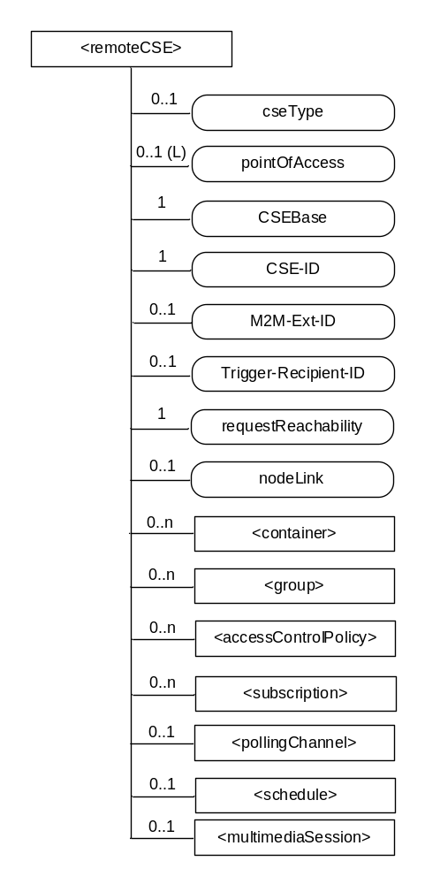

Figure 9.6.4-1: Structure of <remoteCSE> resource

The <remoteCSE> resource shall contain the child resources specified in table 9.6.4-1. The <remoteCSE> resource may contain <remoteCSEAnnc> child resources.
Table 9.6.4-1: Child resources of <remoteCSE> resource
Child Resources of <remoteCSE> | Child Resource Type | Multiplicity | Description | <remoteCSEAnnc> Child Resource Types
[variable] | <container> | 0..n | See clause 9.6.6 | <container> <containerAnnc>
[variable] | <group> | 0..n | See clause 9.6.13 | <group>  <groupAnnc>
[variable] | <accessControlPolicy> | 0..n | See clause 9.6.2 | <accessControlPolicy>  <accessControlPolicyAnnc>
[variable] | <subscription> | 0..n | See clause 9.6.8 | <subscription>
[variable] | <pollingChannel> | 0..1 | See clause 9.6.21. If requestReachability is FALSE, the CSE that created this <remoteCSE> resource should create a <pollingChannel> resource and perform long polling. The <pollingChannel> shall be utilized by the the parent resource. | None
[variable] | <schedule> | 0..1 | This resource defines the reachability schedule information of the node. See clause 9.6.9 for <schedule>. | <scheduleAnnc>
variable] | <multimediaSession> |  | See Clause 9.6.35. This resources holds information describing the established multimedia session | NA
[variable] | <nodeAnnc> | 0..n | This resource is the <nodeAnnc> resource representing the node where the CSE represented by this <remoteCSE> resource resides. | <nodeAnnc>

Table 9.6.4-2: Child announced resources of <remoteCSE> resource
Child Announced Resources of <remoteCSE> | Child Announced Resource Type | Multiplicity | Description
[variable] | Refer to table 9.6.26.1-1 Announced Resource Types | 0..n

The <remoteCSE> resource shall contain the attributes specified in table 9.6.4-3.
Table 9.6.4-3: Attributes of <remoteCSE> resource
Attributes of <remoteCSE> | Multiplicity | RW/  RO/  WO | Description | <remoteCSEAnnc> Attributes
resourceType | 1 | RO | See clause 9.6.1.3 where this common attribute is described. | NA
resourceID | 1 | RO | See clause 9.6.1.3 where this common attribute is described. | NA
resourceName | 1 | WO | See clause 9.6.1.3 where this common attribute is described. | NA
parentID | 1 | RO | See clause 9.6.1.3 where this common attribute is described. | NA
creationTime | 1 | RO | See clause 9.6.1.3 where this common attribute is described. | NA
lastModifiedTime | 1 | RO | See clause 9.6.1.3 where this common attribute is described. | NA
expirationTime | 1 | RW | See clause 9.6.1.3 where this common attribute is described. | MA
accessControlPolicyIDs | 0..1 (L) | RW | See clause 9.6.1.3 where this common attribute is described. | MA
labels | 0..1 (L) | RW | See clause 9.6.1.3 where this common attribute is described. | MA
announceTo | 0..1 (L) | RW | See clause 9.6.1.3 where this common attribute is described. | NA
announcedAttribute | 0..1 (L) | RW | See clause 9.6.1.3 where this common attribute is described. | NA
cseType | 0..1 | WO | Indicates the type of CSE represented by the created resource.  - Mandatory for an IN-CSE, hence multiplicity (1).  - Its presence is subject to SP configuration in case of an ASN-CSE or a MN-CSE. | OA
pointOfAccess | 0..1 (L) | RW | For request-reachable remote CSE it represents the list of physical addresses to be used to connect to it (e.g. IP address, FQDN). The attribute is absent if the remote CSE is not request-reachable.  If this information is not provided, the CSE should use <pollingChannel> resource. Then the Hosting CSE can forward a request to the CSE without using the PoA. | OA
CSEBase | 1 | WO | The address of the CSEBase resource represented by this <remoteCSE> resource. | OA
CSE-ID | 1 | WO | The CSE identifier in SP-relative CSE-ID format (clause 7.2). | OA
M2M-Ext-ID | 0..1 | RW | Supported when Registrar is IN-CSE.  See clause 7.1.8 where this attribute is described. This attribute is used only for the case of dynamic association of M2M-Ext-ID and CSE-ID. | NA
Trigger-Recipient-ID | 0..1 | RW | Supported when Registrar is IN-CSE. See clause 7.1.10 where this attribute is described. This attribute is used only for the case of dynamic association of M2M-Ext-ID and CSE-ID. | NA
requestReachability | 1 | RW | If the CSE that created this <remoteCSE> resource can receive a request from other AE/CSE(s), this attribute is set to "TRUE" otherwise "FALSE" (see note) | OA
nodeLink | 0..1 | RW | The resourceID of a <node> resource that hosts the CSE represented by the <remoteCSE> resource. | OA
NOTE: Even if this attribute is set to "FALSE", it does not mean it AE/CSE is always unreachable by all entities. E.g. the requesting AE/CSE is behind the same NAT, so it can communicate within the same NAT.

-----------------------Start of change 8 -------------------------------------------

9.6.5 Resource Type AE
An <AE> resource shall represent information about an Application Entity registered to a CSE.
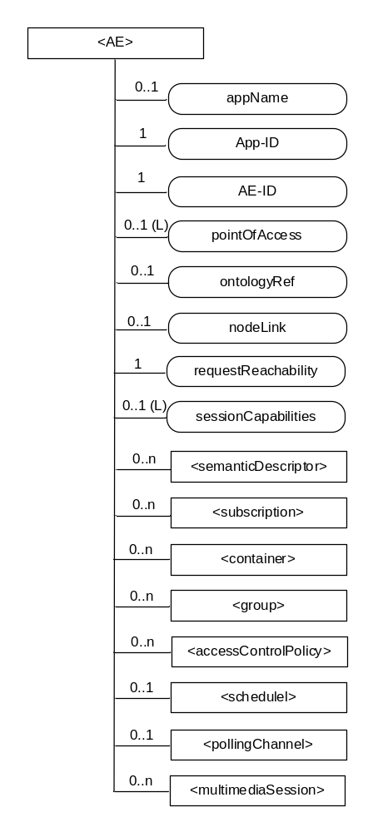

Figure 9.6.5-1: Structure of <AE> resource
Instruction to Editor: Please udpdate the Figure
The <AE> resource shall contain the child resources specified in table 9.6.5-1.
Table 9.6.5-1: Child resources of <AE> resource
Child Resources of <AE> | Child Resource Type | Multiplicity | Description | <AEAnnc> Child Resource Types
semanticDescriptor | <semanticDescriptor> | 0..n | See clause 9.6.30 | <semanticDescriptor>, <semanticDescriptorAnnc>
[variable] | <subscription> | 0..n | See clause 9.6.8 | <subscription>
[variable] | <container> | 0..n | See clause 9.6.6 | <container> <containerAnnc>
[variable] | <group> | 0..n | See clause 9.6.13 | <group>  <groupAnnc>
[variable] | <accessControlPolicy> | 0..n | See clause 9.6.2 | <accessControlPolicy>  <accessControlPolicyAnnc>
[variable] | <schedule> | 0..1 | See clause 9.6.9 | <scheduleAnnc>
[variable] | <pollingChannel> | 0..1 | See clause 9.6.21.  When the AE is request-unreachable, the AE should create this <pollingChannel> resource and perform long polling. The <pollingChannel> shall be utilized by the the parent resource. | None
variable] | <multimediaSession> |  | See Clause 9.6.35. This resources holds information describing the established multimedia session | NA

The <AE> resource shall contain the attributes specified in table 9.6.5-2.
Table 9.6.5-2: Attributes of <AE> resource
Attributes of  <AE> | Multiplicity | RW/  RO/  WO | Description | <AEAnnc> Attributes
resourceType | 1 | RO | See clause 9.6.1.3. | NA
resourceID | 1 | RO | See clause 9.6.1.3. Contains the AE-ID-Stem of the AE (see clause 7.2 on identifier formats and clause 10.1.1.2.2 for AE registration procedure). | NA
resourceName | 1 | WO | See clause 9.6.1.3. | NA
parentID | 1 | RO | See clause 9.6.1.3. | NA
expirationTime | 1 | RW | See clause 9.6.1.3. | MA
accessControlPolicyIDs | 0..1 (L) | RW | See clause 9.6.1.3. | MA
creationTime | 1 | RO | See clause 9.6.1.3. | NA
lastModifiedTime | 1 | RO | See clause 9.6.1.3. | NA
labels | 0..1 (L) | RW | See clause 9.6.1.3. | MA
announceTo | 0..1 (L) | RW | See clause 9.6.1.3. | NA
announcedAttribute | 0..1 (L) | RW | See clause 9.6.1.3. | NA
appName | 0..1 | RW | The name of the application, as declared by the application developer(e.g. "HeatingMonitoring").  Several sibling resources may share the appName. | OA
App-ID | 1 | WO | The identifier of the Application (see clause 7.1.2). | OA
AE-ID | 1 | RO | The identifier of the Application Entity (see clause 7.1.2). | OA
pointOfAccess | 0..1 (L) | RW | The list of addresses for communicating with the registered Application Entity over Mca reference point via the transport services provided by Underlying Network (e.g. IP address, FQDN, URI). This attribute shall be accessible only by the AE and the Hosting CSE.  If this information is not provided, the AE should use <pollingChannel> resource. Then the Hosting CSE can forward a request to the AE without using the PoA. | OA
ontologyRef | 0..1 | RW | A URI of the ontology used to represent the information that is managed and understood by the AE. | OA
requestReachability | 1 | RW | If the AE that created this <AE> resource can receive a request, this attribute is set to "TRUE" otherwise "FALSE" | OA
nodeLink | 0..1 | RO | The resourceID of a <node> resource that stores the node specific information where the AE resides. | OA
sessionCapabilities | 0..1 (L) | RW | The list of supported session media types (e.g. audio, video, image) and supported session protocols (e.g. RTP, RTP/AVP) as defined by session parameters as defined by the IETF IANA Session Descriptor Protocol (SDP) Parameter Registry. | OA

-----------------------Start of change9-------------------------------------------

Annex K (informative):
Multimedia Session examples
This annex provides some examples for the establishment/update of a multimedia session to clarify the usage of applicable resources and the service description in section 6.2.1.2

K.1 Deployment Scenario Examples
There are several potential types of deployment scenarios involving multimedia sessions. Some examples are as follows:
- Scenario 1 where two ADN-AEs and an IN-CSE are involved
- Scenario 2 where two ADN-AEs, an MN-CSE and an IN-CSE are involved
- Scenario 3 where two ADN-AEs, two MN-CSEs, and an IN-CSE are involved
For scenario 1, both ADN-AEs are registered to a common IN-CSE. The IN-CSE shall be used by the AEs to facilitate the exchange of multimedia session descriptors (e.g. SDP descriptors) between the two AEs for the purposes of multimedia session management (e.g. discovery, establishment, update and teardown). The IN-CSE may also interwork with the underlying network to ensure that the underlying network is provisioned with the proper QoS for the session based on the QoS negotiated between the two AEs through the oneM2M system. For example, the underlying network may be a 3GPP Core Network and via the Mcn reference point the IN-CSE can interwork with the PCRF function in the 3GPP Network to ensure the communication session between the ADN-AEs is provisioned with the proper QoS level. The details of how the IN-CSE interworks with the 3GPP Core Network are out of scope for this document however these details are the focus of another active oneM2M work item (WI-0037 3GPP Release 13 Interworking).
The figure below depicts scenario 1 using 3GPP as an underlying network.
ADN-AE 2
-
Multimedia
Session
Control

Session
Announcement,
Discovery,
Invitation,
Negotiatoin

IN-CSE
Mca
Internal
Mca
Underlying Network
Mcn
ADN-AE 1
Multimedia
Session
Control

Session
Announcement,
Discovery,
Invitation,
Negotiatoin

Internal
Multimedia
Session
Streamed
Data
Multimedia
Session
Streamed
Data
PCRF
Gx/Gac
Packet
Core
network
Nodes
E.g. 3GPP Core Network
Figure K.1-1: Two AEs in a real time multimedia session established via an IN-CSE

For scenario 2, ADN-AE 1 is registered to the MN-CSE, the MN-CSE is registered to the IN-CSE, and the ADN-AE 2 is registered to the IN-CSE. Both the MN-CSE and IN-CSE shall be used by the AEs to facilitate the exchange of multimedia session descriptors (e.g. SDP descriptors) between the two AEs for the purposes of multimedia session management (e.g. discovery, establishment, update and teardown). Similar to scenario 1, the IN-CSE may also interwork with the underlying transport network to ensure that the underlying network is provisioned with the proper QoS for the session based on the QoS negotiated between the two AEs through the oneM2M system.
Note, if the registrar CSE of the AE that is the target of a multimedia session is not the IN-CSE, then it is the responsibility of this CSE to create the necessary multimedia session resource in the IN-CSE before an offer can be accepted by the target AE and before a response is returned to the multimedia session originator.
Note, if a multimedia session requires updating, regardless of which AE initiated the update, if the registrar CSE of the AE that is the target of a multimedia session is not the IN-CSE, then it is the responsibility of this CSE to also update the necessary multimedia session resource in the IN-CSE before the update can be completed and before a response is returned to the multimedia session originator.

IN-AE
Multimedia
Session
Control

Session
Announcement,
Discovery,
Invitation,
Negotiatoin

IN-CSE
Mca
Internal
Mca
Underlying Transport
Network
Mcn
ADN-AE
Multimedia
Session
Control

Session
Announcement,
Discovery,
Invitation,
Negotiatoin

Internal
Multimedia
Session
Streamed
Data
Multimedia
Session
Streamed
Data
PCRF
Gx/Gac
Packet
Core
network
Nodes
E.g. 3GPP Core Network
MN-CSE
Mcc
Figure K.1-2: Two AEs in a real time multimedia session established via an IN-CSE and MN-CSE

For scenario 3, ADN-AE 1 is registered to MN-CSE 1 which is registered to the IN-CSE. Similarly, ADN-AE 2 is registered to MN-CSE 2 which is registered to the IN-CSE. Both MN-CSEs and IN-CSE shall be used by the AEs to facilitate the exchange of multimedia session descriptors (e.g. SDP descriptors) between the two AEs for the purposes of multimedia session management (e.g. discovery, establishment, update and teardown). Similar to scenario 1, the IN-CSE may also interwork with the underlying transport network to ensure that the underlying network is provisioned with the proper QoS for the session based on the QoS negotiated between the two AEs through the oneM2M system.
Note, if the registrar CSE of an AE that is the target of a multimedia session is not the IN-CSE, then it is the responsibility of this CSE to create the necessary multimedia session resource in the IN-CSE before an offer can be accepted by the target AE and before a response is returned to the multimedia session originator.
Note, if a multimedia session requires updating, regardless of which AE initiated the update, if the registrar CSE of the AE that is the target of a multimedia session is not the IN-CSE, then it is the responsibility of this CSE to also update the necessary multimedia session resource in the IN-CSE before the update can be completed and before a response is returned to the multimedia session originator.

ADN-AE 2
Multimedia
Session
Control

Session
Announcement,
Discovery,
Invitation,
Negotiatoin

IN-CSE
Mca
Internal
Mca
Underlying Transport
Network
Mcn
ADN-AE 1
Multimedia
Session
Control

Session
Announcement,
Discovery,
Invitation,
Negotiatoin

Internal
Multimedia
Session
Streamed
Data
Multimedia
Session
Streamed
Data
PCRF
Gx/Gac
Packet
Core
network
Nodes
E.g. 3GPP Core Network
MN-CSE
1
Mcc
MN-CSE
2
Mcc
Figure K.1-3: Two AEs in a real time multimedia session established via an IN-CSE and two MN-CSEs

K.2 Example 1 - Establishing Multimedia Session (ADN-ADN)
This example is based on the scenario 1 captured is Figure K.1-1. The corresponding call flow is captured in Figure K.2-1. In this example, ADN-AE 1 is registered with the IN-CSE and wishes to establish a multimedia session with a target ADN-AE 2 that is also registered to the IN-CSE. In this scenario the IN-CSE may also be involved to ensure that the wide area network resources are configured with the proper QoS for the negotiated session.

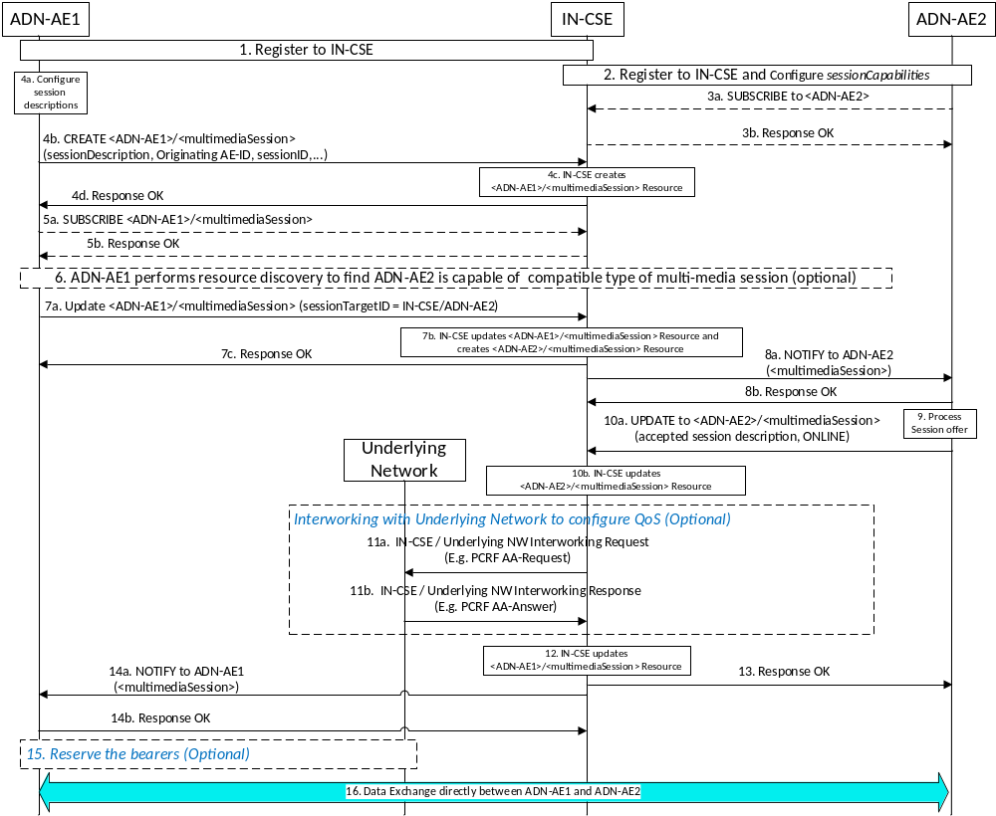
Figure K.2-1: Establishing Real time multimedia session between ADN-AEs via IN-CSE
The following is a brief description of the steps in the above call flow:
- In steps 1 and 2, the originating ADN-AE 1 and target ADN-AE 2 register to the IN-CSE by creating resources of type <AE>. ADN-AE 2 also configures the sessionCapabilities attribute of its <AE> resource to advertise its multimedia session capabilities such that other AEs can discover this information.
- In steps 3a and 3b, ADN-AE 2 subscribes to its < ADN-AE2> resource hosted in the IN-CSE to receive notifications of multimedia session offers from originator AEs. Note, these steps may be optional if CSE supports sending notification to AE without a subscription when <multimediaSession> resource is created/update/deleted.
- In steps 4a-d, the originating ADN-AE 1 creates a child resource of type <multimediaSession> under its < ADN-AE1> resource hosted in the IN-CSE. This resource is configured with the session descriptions that ADN-AE 1 wishes to offer to target AEs.
- In steps 5a and 5b, ADN-AE 1 subscribes to its <multimediaSession> resource hosted in the IN-CSE to receive notifications of multimedia session updates from target AEs . Note, these steps may be optional if CSE supports sending notification to AE without a subscription when <multimediaSession> resource is created/update/deleted.
- In step 6, ADN-AE 1 performs a resource discovery operation to query and find potential target AEs having desired multimedia sessionCapabilities that are compatible with its own. In this example, the response returns a URI of <ADN-AE2>.
- In steps 7a-c, ADN-AE 1 sends a multimedia session offer to ADN-AE 2. This is accomplished by ADN-AE 1 updating the sessionTargetID attribute of the <ADN-AE1>/<multimediaSession> resource with the resourceID of <ADN-AE2>. The IN-CSE processes the update and as a result triggers the creation of a <ADN-AE2>/<multimediaSession> resource as a result.
- In steps 8a and 8b, the IN-CSE sends a notification to ADN-AE 2 containing the representation of the newly created <ADN-AE2>/<multimediaSession> resource.
- In step 9, ADN-AE 2 processes the notification, detects it is a multimedia session offer, examines the offered session descriptions and selects a session description that it wishes to accept.
- In steps 10a and 10b, ADN-AE 2 updates the <ADN-AE2>/<multimediaSession> resource based on the incoming offer and the session description it wishes to accept. It also changes the session state to ONLINE.
- In steps 11a and 11b, the IN-CSE optionally interfaces with the underlying network (in this example the Rx reference point of the PCRF of a 3GPP LTE network) to configure the proper QoS for the corresponding multimedia session.
- In step 12, the IN-CSE updates the <ADN-AE1>/<multimediaSession> resource with the accepted offer.
- In steps 13, the IN-CSE returns a response to ADN-AE 2 indicating that the update was successful.
- In steps 14a and b the IN-CSE sends a notification to ADN-AE 1 indicating the session description that the target has agreed upon and changes the session state to ONLINE.
- In step 15, the originating ADN-AE 1 may need to reserve access bearers. This is optional.
- In step 16, ADN-AE 1 and ADN-AE 2 exchange media over the established multimedia session.

K.3 Example 2 - Establishing Multimedia Session between ADN-AEs via MN-CSEs and IN-CSE
This example is based on the scenario 3 that is captured in Figure K.1-2. The corresponding call flow is captured in Figure K.3-1. In this example, ADN-AE #1 is registered with MN-CSE #1 and wishes to establish a multimedia session with a target ADN-AE #2 that is registered to IN-CSE. In this scenario the IN-CSE may also be involved to ensure that the wide area network resources are configured with the proper QoS for the negotiated session.
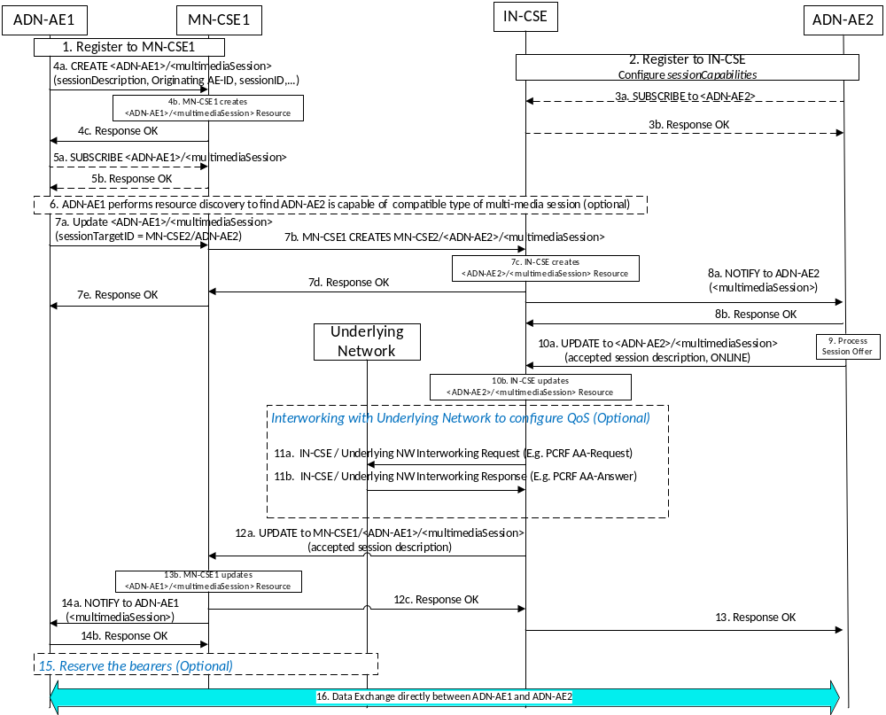
Figure K.3-1: Establishing Real time multi-media session between ADN-AEs via MN-CSEs/IN-CSE

The following is a brief description of the steps in the call flow:
- In steps 1 and 2, the originating ADN-AE 1 registers to MN-CSE 1 and ADN-AE 2 registers to IN-CSE by creating resources of type <AE>. ADN-AE 2 also configures the sessionCapabilities attribute of its <ADN-AE2> resource to advertise its multimedia session capabilities such that other AEs can discover this information.
- In steps 3a and 3b, ADN-AE 2 subscribes to its <ADN-AE2> resource hosted in the IN-CSE to receive notifications of multimedia session offers from originator AEs. Note, these steps may be optional if CSE supports sending notification to AE without a subscription when <multimediaSession> resource is created/update/deleted.
- In steps 4a-d, the originating ADN-AE 1 creates a child resource of type <multimediaSession> under its <ADN-AE1> resource hosted in the MN-CSE 1. This resource is configured with the session descriptions that ADN-AE 1 wishes to offer to target AEs.
- In steps 5a and 5b, ADN-AE 1 subscribes to its <multimediaSession> resource hosted in the MN-CSE 1 to receive notifications of multimedia session updates from target AEs . Note, these steps may be optional if CSE supports sending notification to AE without a subscription when <multimediaSession> resource is created/update/deleted.
- In step 6, ADN-AE 1 performs a resource discovery operation to query and find potential target AEs having desired multimedia sessionCapabilities that are compatible with its own. In this example, the response returns a URI of <ADN-AE2>.
- In steps 7a-c, ADN-AE 1 sends a multimedia session offer to ADN-AE 2. This is accomplished by ADN-AE 1 updating the sessionTargetID attribute of the IN-CSE/<ADN-AE1>/<multimediaSession> resource with the resourceID of <ADN-AE2>. The IN-CSE processes the update and as a result triggers the creation of a IN-CSE/<ADN-AE2>/<multimediaSession> resource as a result.
- In steps 8a and 8b, the IN-CSE sends a notification to ADN-AE 2 containing the representation of the newly created IN-CSE/<ADN-AE2>/<multimediaSession> resource.
- In step 9, ADN-AE 2 processes the notification, detects it is a multimedia session offer, examines the offered session descriptions and selects a session description that it wishes to accept.
- In steps 10a and 10b, ADN-AE 2 updates the IN-CSE/<ADN-AE2>/<multimediaSession> resource based on the incoming offer and the session description it wishes to accept and changes the session state to ONLINE.
- In steps 11a and 11b, the IN-CSE optionally interfaces with the underlying network (in this example the Rx reference point of the PCRF of a 3GPP LTE network) to configure the proper QoS for the corresponding multimedia session.
- In steps 12a-c, the IN-CSE updates the MN-CSE1/<ADN-AE1>/<multimediaSession> resource with the accepted offer.
- In steps 13, the IN-CSE returns a response to ADN-AE 2 indicating that the update was successful.
- In steps 14a and b the MN-CSE1 sends a notification to ADN-AE 1 indicating the session description that the target has agreed upon and changes the session state to ONLINE.
- In step 15, the originating ADN-AE 1 may need to reserve access bearers. This is optional.
- In step 16, ADN-AE 1 and ADN-AE 2 exchange media over the established multimedia session.

K.4 Example 3 - Establishing Multimedia Session between ADN-AEs via MN-CSEs and IN-CSE
This example is based on the scenario 3 that is captured in Figure K.1-3. The corresponding call flow is captured in Figure K.4-1. In this example, ADN-AE #1 is registered with MN-CSE #1 and wishes to establish a multimedia session with a target ADN-AE #2 that is registered to MN-CSE #2. In this scenario the IN-CSE may also be involved to ensure that the wide area network resources are configured with the proper QoS for the negotiated session.
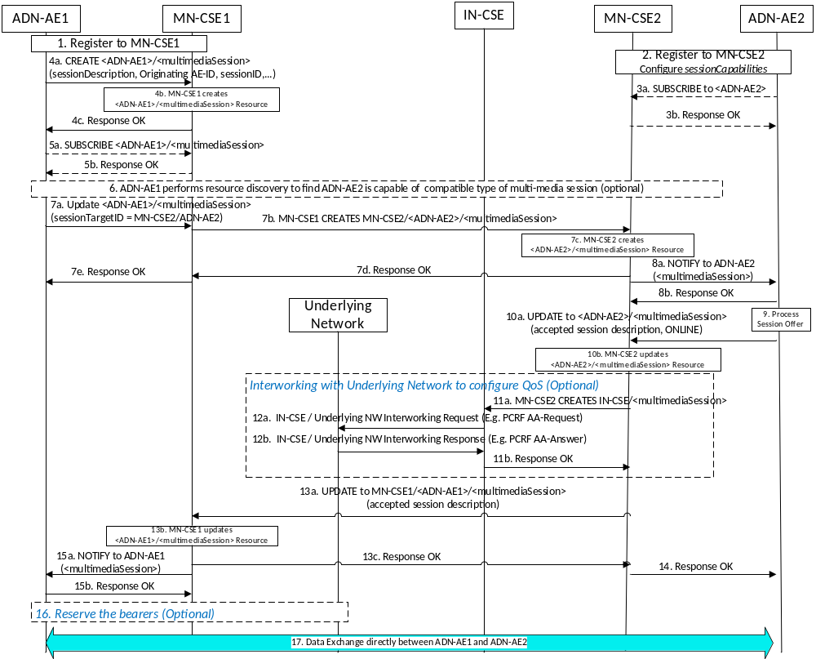
Figure K.4-1: Establishing Real time multi-media session between ADN-AEs via MN-CSEs/IN-CSE

The following is a brief description of the steps in the call flow:
- In steps 1 and 2, the originating ADN-AE 1 and target ADN-AE 2 register to their corresponding MN-CSEs by creating resources of type <AE>. ADN-AE 2 also configures the sessionCapabilities attribute of its <ADN-AE2> resource to advertise its multimedia session capabilities such that other AEs can discover this information.
- In steps 3a and 3b, ADN-AE 2 subscribes to its <ADN-AE2> resource hosted in the MN-CSE 2 to receive notifications of multimedia session offers from originator AEs. Note, these steps may be optional if CSE supports sending notification to AE without a subscription when <multimediaSession> resource is created/update/deleted.
- In steps 4a-d, the originating ADN-AE 1 creates a child resource of type <multimediaSession> under its <ADN-AE1> resource hosted in the MN-CSE 1. This resource is configured with the session descriptions that ADN-AE 1 wishes to offer to target AEs.
- In steps 5a and 5b, ADN-AE 1 subscribes to its <multimediaSession> resource hosted in the MN-CSE 1 to receive notifications of multimedia session updates from target AEs . Note, these steps may be optional if CSE supports sending notification to AE without a subscription when <multimediaSession> resource is created/update/deleted.
- In step 6, ADN-AE 1 performs a resource discovery operation to query and find potential target AEs having desired multimedia sessionCapabilities that are compatible with its own. In this example, the response returns a URI of <ADN-AE2>.
- In steps 7a-c, ADN-AE 1 sends a multimedia session offer to ADN-AE 2. This is accomplished by ADN-AE 1 updating the sessionTargetID attribute of the MN-CSE1<ADN-AE1>/<multimediaSession> resource with the resourceID of <ADN-AE2>. The IN-CSE processes the update and as a result triggers the creation of a MN-CSE2/<ADN-AE2>/<multimediaSession> resource as a result.
- In steps 8a and 8b, the IN-CSE sends a notification to ADN-AE 2 containing the representation of the newly created MN-CSE2/<ADN-AE2>/<multimediaSession> resource.
- In step 9, ADN-AE 2 processes the notification, detects it is a multimedia session offer, examines the offered session descriptions and selects a session description that it wishes to accept.
- In steps 10a and 10b, ADN-AE 2 updates the MN-CSE2/<ADN-AE2>/<multimediaSession> resource based on the incoming offer and the session description it wishes to accept and changes the session state to ONLINE.
- In steps 11a and 11b, MN-CSE2 sends a CREATE Request based on the accepted offer to the IN-CSE to create a multimedia session resource on the IN-CSE to trigger it to configure the QoS on the underlying network.
- In steps 12a and 12b, the IN-CSE optionally interfaces with the underlying network (in this example the Rx reference point of the PCRF of a 3GPP LTE network) to configure the proper QoS for the corresponding multimedia session.
- In steps 13a-c, the MN-CSE2 updates the MN-CSE1/<ADN-AE1>/<multimediaSession> resource with the accepted offer.
- In steps 14, the MN-CSE2 returns a response to ADN-AE 2 indicating that the update was successful.
- In steps 15a and b the MN-CSE1 sends a notification to ADN-AE 1 indicating the session description that the target has agreed upon and changes the session state to ONLINE.
- In step 16, the originating ADN-AE 1 may need to reserve access bearers. This is optional.
- In step 17, ADN-AE 1 and ADN-AE 2 exchange media over the established multimedia session.

K.5 Example 4 – Updating an Established Multimedia Session
This example below shows the scenario where an established session between two ADNs require supdating. To update a multimedia session, the flow of media must first be stopped or be put on hold to enable the session to be updated. This can be accomplished by updating the session state of the corresponding oneM2M multimedia session resources which will result in the AEs pausing the media flow in the underlying network. Thereafter, the session description can be updated and the flow of media can be re-started by again by updating the state of the corresponding oneM2M multimedia session resources.
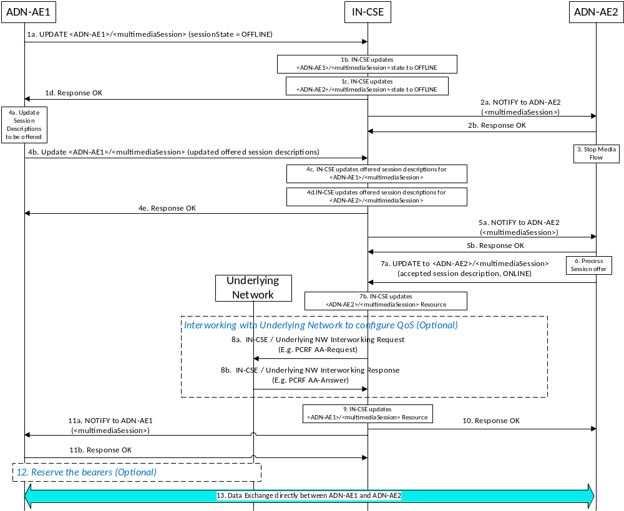
Figure K.5-1: Updating Real time multimedia session between ADN-AEs via IN-CSE
The following is a brief description of the steps in the above call flow:
- In steps 1a-d, ADN-AE 1 sends an UPDATE request to the IN-CSE to modify the state of the multimedia session to OFFLINE. Upon receiving the request the IN-CSE first updates the session state of the <ADN-AE1>/<multimediaSession> resource and then updates the state of the <ADN-AE2>/<multimediaSession> resource as well.
- In steps 2a and 2b, the IN-CSE send a notification to ADN-AE 2 that includes the updated <multimediaSession> resource representation.
- In step 3, ADN-AE 2 processes the notification and detects that the multimedia session state has been changed to OFFLINE. As a result, ADN-AE 2 pauses its media flow.
- In steps 4a-e, ADN-AE 1 configures its updated session descriptions that it wants to offer and sends an UPDATE request to the IN-CSE to update the offered session descriptions. Upon receiving the request the IN-CSE first updates the offered session descriptions of the <ADN-AE1>/<multimediaSession> resource and then updates the same for the <ADN-AE2>/<multimediaSession> resource as well.
- In steps 5a and 5b, the IN-CSE send a notification to ADN-AE 2 that includes the updated <multimediaSession> resource representation.
- In step 6, ADN-AE 2 processes the notification and detects that the offered session descriptions have changed. As a result, ADN-AE 2 examines the offered session descriptions and selects a session description that it wishes to accept.
- In steps 7a and 7b, ADN-AE 2 updates the <ADN-AE2>/<multimediaSession> resource based on the incoming offer and the session description it wishes to accept. It also changes the session state to ONLINE.
- In steps 8a and 8b, the IN-CSE optionally interfaces with the underlying network (in this example the Rx reference point of the PCRF of a 3GPP LTE network) to configure the proper QoS for the corresponding accepted multimedia session description.
- In step 9, the IN-CSE updates the <ADN-AE1>/<multimediaSession> resource with the accepted offer.
- In step 10, the IN-CSE returns a response to ADN-AE 2 indicating that the update was successful.
- In steps 11a and b the IN-CSE sends a notification to ADN-AE 1 indicating the session description that the target has agreed upon and changes the session state to ONLINE.
- In step 12, the originating ADN-AE 1 may need to reserve access bearers. This is optional.
- In step 13, ADN-AE 1 and ADN-AE 2 exchange media over the established multimedia session.

-----------------------End of change X---------------------------------------------

CHECK LIST
- Does this change request include an informative introduction containing the problem(s) being solved, and a summary list of proposals.?
- Does this CR contain changes related to only one particular issue/problem?
- Does this change request make all the changes necessary to address the issue or problem? E.g. A change impacting 5 tables should not only include a proposal to change only 3 tables. Includes any changes to references, definitions, and acronyms in the same deliverable?
- Does this change request follow the drafting rules?
- Are all pictures editable?
- Have you checked the spelling and grammar?
- Have you used change bars for all modifications?
- Does the change include the current and surrounding clauses to clearly show where a change is located and to provide technical context of the proposed change? (Additions of complete sections need not show surrounding clauses as long as the proposed section number clearly shows where the new section is proposed to be located.)
- Are multiple changes in this CR clearly separated by horizontal lines with embedded text such as, start of change 1, end of change 1, start of new clause, end of new clause.?

