CHANGE REQUEST
Meeting:* | ARC#21.3
Source:* | C-DOT
Date:* | 2016-02-21
Contact:* | Suman Sheoran(ssheoran@cdot.in) ,Poornima (poornima@cdot.in)
Reason for Change/s:* | See the introduction
CR against: Release* | Rel-2
CR against: WI* | Active <Work Item number>  MNT Maintenance / < Work Item number(optional)>  STE Small Technical Enhancements / < Work Item number (optional)>  Only ONE of the above shall be ticked
CR against: TS/TR* | oneM2M-TS-0001-v2.6.0
Clauses/Sub Clauses* | Section 9.6.6, 9.6.8, 9.6.19, 9.6.20, 9.6.29, 9.6.31, 9.6.32, 9.6.33,9.6.36,9.6.43
Type of change: * | Editorial change  Bug Fix or Correction  Change to existing feature or functionality  New feature or functionality  Only ONE of the above shall be ticked
Post Freeze checking:* | This CR contains only essential changes and corrections? YES NO  This CR is a mirror CR? YES NO if YES, please indicate the document number of the original CR: ARC-2016-0135

oneM2M Notice
The document to which this cover statement is attached is submitted to oneM2M. Participation in, or attendance at, any activity of oneM2M, constitutes acceptance of and agreement to be bound by terms of the Working Procedures and the Partnership Agreement, including the Intellectual Property Rights (IPR) Principles Governing oneM2M Work found in Annex 1 of the Partnership Agreement.
GUIDELINES for Change Requests:
Provide an informative introduction containing the problem(s) being solved, and a summary list of proposals.
Each CR should contain changes related to only one particular issue/problem.
In case of a correction, and the change apply to previous releases, a separated “mirror CR” should be posted at the same time of this CR
Follow the principle of completeness, where all changes related to the issue or problem within a deliverable are simultaneously proposed to be made E.g. A change impacting 5 tables should not only include a proposal to change only 3 tables. Includes any changes to references, definitions, and acronyms in the same deliverable.
Follow the drafting rules.
All pictures must be editable.
Check spelling and grammar to the extent practicable.
Use Change bars for modifications.
The change should include the current and surrounding clauses to clearly show where a change is located and to provide technical context of the proposed change. Additions of complete sections need not show surrounding clauses as long as the proposed section number clearly shows where the new section is proposed to be located.
Multiple changes in a single CR shall be clearly separated by horizontal lines with embedded text such as, start of change 1, end of change 1, start of new clause, end of new clause.
When subsequent changes are made to content of a CR, then the accepted version should not show changes over changes. The accepted version of the CR should only show changes relative to the baseline approved text.

Introduction
In TS-0001, the description for accessControlPolicyIDs attribute is given as below for various resources
<container> , <subscription> , <m2mServiceSubscriptionProfile> , <serviceSubscribedNode> , <serviceSubscribedAppRule>,<notificationTargetMgmtPolicyRef> , <notificationTargetPolicy> <policyDeletionRules> ,<timeSeries>, < dynamicAuthorizationConsultation>

accessControlPolicyIDs | 0..1 (L) | RW | See clause 9.6.1.3 . If no accessControlPolicyIDs are provided at the time of creation, the accessControlPolicyIDs of the parent resource is linked to this attribute | MA

So, if we interpret it as
“If no accessControlPolicyIDs are provided at the time of creation, the accessControlPolicyIDs of the parent resource is copied to this attribute”, then accessControlPolicyIDs should always be there , either sent by originator or set by receiver with the acpid of the parent resource at the time of creation for these above mentioned resources.
So multiplicity of accessControlPolicyIDs should be 1(L) not 0...1(L).
The CR proposes to correct the multiplicity of accessControlPolicyIDs to 1(L) for above mentioned resources.

-----------------------Start of change 1-------------------------------------------

9.6.6 Resource Type container
The <container> resource represents a container for data instances. It is used to share information with other entities and potentially to track the data. A <container> resource has no associated content. It has only attributes and child resources.
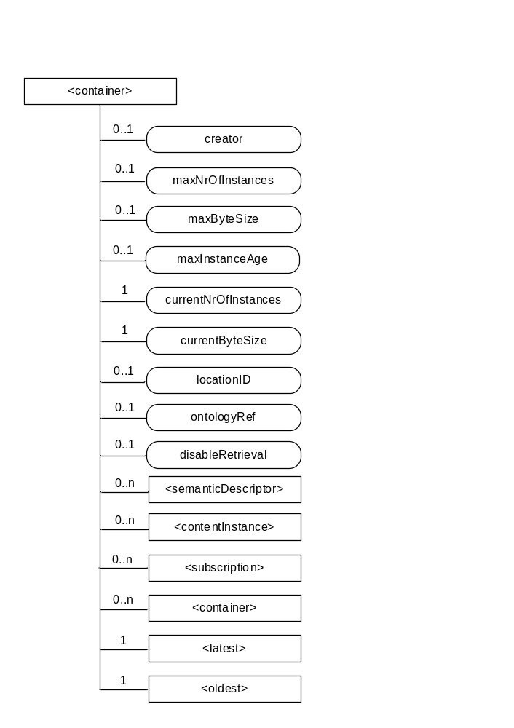
Figure 9.6.6-1: Structure of <container> resource
The <container> resource shall contain the child resources specified in table 9.6.6-1.
Table 9.6.6-1: Child resources of <container> resource
Child Resources of <container> | Child Resource Type | Multiplicity | Description | <containerAnnc> Child Resource Types
semanticDescriptor | <semanticDescriptor> | 0..n | See clause 9.6.30 | <semanticDescriptor>, <semanticDescriptorAnnc>
[variable] | <contentInstance> | 0..n | See clause 9.6.7 | <contentInstance>, <contentInstanceAnnc>
[variable] | <subscription> | 0..n | See clause 9.6.8 | <subscription>
[variable] | <container> | 0..n | See clause 9.6.6 | <container>  <containerAnnc>
latest | <latest> | 1 | See clause 9.6.27 | None
oldest | <oldest> | 1 | See clause 9.6.28 | None

The <container> resource shall contain the attributes specified in table 9.6.6-2.
Table 9.6.6-2: Attribute of <container> resource
Attributes of  <container> | Multiplicity | RW/  RO/  WO | Description | <containerAnnc> Attributes
resourceType | 1 | RO | See clause 9.6.1.3. | NA
resourceID | 1 | RO | See clause 9.6.1.3. | NA
resourceName | 1 | WO | See clause 9.6.1.3. | NA
parentID | 1 | RO | See clause 9.6.1.3. | NA
expirationTime | 1 | RW | See clause 9.6.1.3. | MA
accessControlPolicyIDs | 1 (L) | RW | See clause 9.6.1.3 . If no accessControlPolicyIDs are provided at the time of creation, the accessControlPolicyIDs of the parent resource is -copied to this attribute | MA
labels | 0..1 (L) | RW | See clause 9.6.1.3. | MA
creationTime | 1 | RO | See clause 9.6.1.3. | NA
lastModifiedTime | 1 | RO | See clause 9.6.1.3. | NA
stateTag | 1 | RO | See clause 9.6.1.3. | OA
announceTo | 0..1 (L) | RW | See clause 9.6.1.3. | NA
announcedAttribute | 0..1 (L) | RW | See clause 9.6.1.3. | NA
dynamicAuthorizationConsultationIDs | 0..1 (L) | RW | See clause 9.6.1.3. | OA
creator | 0..1 | RO | The AE-ID or CSE-ID of the entity which created the resource. | NA
maxNrOfInstances | 0..1 | RW | Maximum number of direct child <contentInstance> resources in the <container> resource. | OA
maxByteSize | 0..1 | RW | Maximum size in bytes of data(i.e., content attribute of a <contentInstance> resource) that is allocated for the <container> resource for all direct child <contentInstance> resources in the <container> resource. | OA
maxInstanceAge | 0..1 | RW | Maximum age of a direct child <contentInstance> resource in the <container> resource. The value is expressed in seconds. | OA
currentNrOfInstances | 1 | RO | Current number of direct child <contentInstance> resource in the <container> resource. It is limited by the maxNrOfInstances. | OA
currentByteSize | 1 | RO | Current size in bytes of data(i.e., content attribute of a <contentInstance> resource) stored in all direct child <contentInstance> resources of a <container> resource. This is the summation of contentSize attribute values of the <contentInstance> resources. It is limited by themaxByteSize. | OA
locationID | 0..1 | RW | An ID of the resource where the attributes/policies that define how location information are obtained and managed. This attribute is defined only when the <container> resource is used for containing location information. | OA
ontologyRef | 0..1 | RW | A reference (URI) of the ontology used to represent the information that is stored in the child <contentInstance> resources of the present <container> resource (see note). | OA
disableRetrieval | 0..1 | RW | Boolean value to control RETRIE/UPDATE/DELETE operation on the child <contentInsance> resource.  When the value is set to ‘TRUE’, RETRIEVE/DELETE/UPDATE operations for child <contentInstance> shall be rejected at all times.  When the value is updated from 'TRUE' to 'FALSE', all existing <contentInstance> are deleted immediately.  When the value is set to ‘FALSE’, all operations are permitted on the <contentInstance> resource as per existing procedures. | OA
NOTE: The access to this URI is out of scope of oneM2M.

-----------------------End of change 1---------------------------------------------

-----------------------Start of change 2---------------------------------------------

9.6.8 Resource Type subscription
The <subscription> resource contains subscription information for its subscribed-to resource. The <subscription> resource is a child of the subscribed-to resource.
The <subscription> resource shall be represented as child resource of the subscribed-to resource. For example, <container> resource has <subscription> resource as a child resource (see clause 9.6.6). A <subscription> resource shall be deleted when the parent subscribed-to resource is deleted.
The <subscription> resource shall represent a subscription to a subscribed-to resource. An Originator shall be able to create a resource of <subscription> resource type when the Originator has RETRIEVE privilege to the subscribe-to resource. The Originator which creates a <subscription> resource becomes the resource subscriber.
Each <subscription> may include notification policies that specify which, when, and how notifications are sent. These notification policies may work in conjunction with CMDH policies.
When a <subscription> resource is deleted, a Notify request shall be sent to the subscriberURI if it is provided by the Originator.
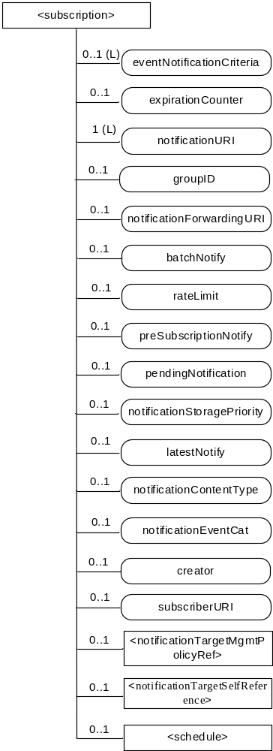
Figure 9.6.8-1: Structure of <subscription> resource
The <subscription> resource shall contain the child resources specified in table 9.6.8-1.
Table 9.6.8-1: Child resources of <subscription> resource
Child Resources | Child Resource Type | Multiplicity | Description
notificationSchedule | <schedule> | 0..1 | In the context of the <subscription> resource, the notificationSchedule specifies when notifications may be sent by the Hosting CSE to the notificationURI(s). See clause 9.6.9.
[variable] | < notificationTargetMgmtPolicyRef > | 0..n | See 9.6.31 for this type of resource.
notificationTargetSelfReference | < notificationTargetSelfReference> | 1 | See 9.6.34 for this type of resource.

The <subscription> resource shall contain the attributes specified in table 9.6.8-2.
Table 9.6.8-2: Attributes of <subscription> resource
Attributes of <subscription> | Multiplicity | RW/  RO/  WO | Description
resourceType | 1 | RO | See clause 9.6.1.3.
resourceID | 1 | RO | See clause 9.6.1.3.
resourceName | 1 | WO | See clause 9.6.1.3.
parentID | 1 | RO | See clause 9.6.1.3.
expirationTime | 1 | RW | See clause 9.6.1.3.
creationTime | 1 | RO | See clause 9.6.1.3.
lastModifiedTime | 1 | RO | See clause 9.6.1.3.
labels | 0..1 (L) | RW | See clause 9.6.1.3.
accessControlPolicyIDs | 1 (L) | RW | See clause 9.6.1.3.  If no accessControlPolicyIDs is given at the time of creation, the accesControlPolicies of the parent resource is –copied to this attribute.
dynamicAuthorizationConsultationIDs | 0..1 (L) | RW | See clause 9.6.1.3.
eventNotificationCriteria | 0..1 (L) | RW | This attribute (notification policy) indicates the event criteria for which a notification is to be generated.
expirationCounter | 0..1 | RW | This attribute (notification policy) indicates that the subscriber wants to set the life of this subscription to a limit of a maximum number of notifications. When the number of notifications sent reaches the count of this counter, the <subscription> resource shall be deleted, regardless of any other policy.
notificationURI | 1 (L) | RW | This attribute shall be configured as a list consisting of one or more targets that the Hosting CSE shall send notifications to. A target shall be formatted as a oneM2M compliant Resource-ID as defined in clause 7.2 or as an identifier compliant with a oneM2M supported protocol binding (e.g. http, coap, mqtt).  If a target is formatted as a oneM2M compliant Resource-ID, then the target shall be formatted as a structured or unstructured CSE-Relative-Resource-ID, SP-Relative-Resource-ID, and/or Absolute-Resource-ID. A Hosting CSE shall use this information to determine proper pointOfAccess, requestReqchability and/or pollingChannel information needed to send a notification to the target. The following is an example.  /CSE0001/AE0001  For a target that is formatted as an identifier compliant with a oneM2M supported protocol binding, the details of this format are defined by the respective oneM2M protocol specification. The following is an example of an HTTP URI compliant with oneM2M HTTP protocol binding.  https://172.25.30.25:7000/notification/handler  For a group-related subscription, the group hosting CSE shall configure the notificationForwardingURI of a fanout subscription request with the configured notificationURI of the original subscription request. The group hosting CSE shall also configure the notificationURI of the fanout subscription request with a Resource-ID specified by the group Hosting CSE.
groupID | 0..1 | RW | The ID of a <group> resource in case the subscription is made through a group. This attribute may be used in the Filter Criteria to discover all subscription resources created via a <fanoutPoint> resource to a specific groupID.
notificationForwardingURI | 0..1 | RW | The attribute is a forwarding attribute that shall be present only for group related subscriptions. It represents the resource subscriber notificationtarget. It shall be used by group Hosting CSE for forwarding aggregated notifications. See clauses 10.2.7.11 and 10.2.7.12.  This attribute shall be configured with target of the subscriber. The target is used by the Hosting CSE to determine where to send aggregated notifications. A target shall be formatted as a oneM2M compliant Resource-ID as defined in clause 7.2 or as an identifier compliant with one of the oneM2M supported protocol bindings (the detailed format of which are defined by each respective oneM2M protocol binding specification).
batchNotify | 0..1 | RW | This attribute (notification policy) indicates that the subscription originator wants to receive batches of notifications rather than receiving them one at a time. This attribute includes : the number of notifications to be batched for delivery and the duration. When only the number is specified by the subscription originator, the Hosting CSE shall set the default duration given by M2M Service Provider.  If batchNotify is used simultaneously with latestNotify, only the latest notification shall be sent and have the Event Category set to "latest".
rateLimit | 0..1 | RW | This attribute (notification policy) indicates that the subscriber wants to limit the rate at which it receives notifications. This attribute expresses the subscriber's notification policy and includes two values: a maximum number of events that may be sent within some duration, and the rateLimit window duration. When the number of generated notifications within the rateLimit window duration exceeds the maximum number, notification events are temporarily stored, until the end of the window duration, when the sending of notification events restarts in the next window duration. The sending of notification events continues as long as the maximum number of notification events is not exceeded during the window duration. The rateLimit policy may be used simultaneously with other notification policies.
preSubscriptionNotify | 0..1 | WO | This attribute (notification policy) indicates that the subscriber wants to be sent notifications for events that were generated prior to the creation of this subscription. This attribute has a value of the number of prior notification events requested. If up-to-date caching of retained events is supported on the Hosting CSE and contains the subscribed events then prior notification events will be sent up to the number requested. The preSubscriptionNotify policy may be used simultaneously with any other notification policy.
pendingNotification | 0..1 | RW | This attribute (notification policy), if set, indicates how missed notifications due to a period of connectivity (according to the reachability and notification schedules). The possible values for pendingNotification are:  - "sendLatest"  - "sendAllPending"  This policy depends upon caching of retained notifications on the hosted CSE. When this attribute is set to "sendLatest", only the last notification shall be sent and it shall have the Event Category set to "latest". If this attribute is not present, the Hosting CSE sends no missed notifications. This policy applies to all notifications regardless of the selected delivery policy (batchNotify, latestNotify, etc.) Note that unreachability due to reasons other than scheduling is not covered by this policy.
notificationStoragePriority | 0..1 | RW | Indicates that the subscriber wants to set a priority for this subscription relative to other subscriptions belonging to this same subscriber. This attribute sets a number within the priority range. When storage of notifications exceeds the allocated size, this policy is used as an input with the storage congestion policy (notificationCongestionPolicy) specified in clause 9.6.3 to determine which stored and generated notifications to drop and which ones to retain.
latestNotify | 0..1 | RW | This attribute (notification policy) indicates if the subscriber wants only the latest notification. If multiple notifications of this subscription are buffered, and if the value of this attribute is set to true, then only the last notification shall be sent and it shall have the Event Category value set to "latest".
notificationContentType | 0..1 | RW | Indicates a notification content type that shall be contained in notifications. The allowed values are:  - “modified attributes”  - “all attributes”  - “ID” of the resource indicated in the eventType condition  If it is not given by the Originator at the creation procedure, default is “all attributes”.
notificationEventCat | 0..1 | RW | This attribute (notification policy) indicates the subscriber's requested Event Category to be used for notification messages generated by this subscription.
creator | 0..1 | WO | AE-ID or CSE-ID which created the <subscription> resource.
subscriberURI | 0..1 | WO | This attribute shall be configured with the target of the subscriber. The target is used by the Hosting CSE to determine where to send a notification when the subscription is deleted. A target shall be formatted as a oneM2M compliant Resource-ID as defined in clause 7.2 or as an identifier compliant with one of the oneM2M supported protocol bindings (the detailed format of which are defined by each respective oneM2M protocol binding specification).

Table 9.6.8-3 describes the eventNotificationCriteria conditions.
Table 9.6.8-3: eventNotificationCriteria conditions
Condition tag | Multiplicity | Matching condition
createdBefore | 0..1 | The creationTime attribute of the resource is chronologically before the specified value.
createdAfter | 0..1 | The creationTime attribute of the resource is chronologically after the specified value.
modifiedSince | 0..1 | The lastModifiedTime attribute of the resource is chronologically after the specified value.
unmodifiedSince | 0..1 | The lastModifiedTime attribute of the resource is chronologically before the specified value.
stateTagSmaller | 0..1 | The stateTag attribute of the resource is smaller than the specified value.
stateTagBigger | 0..1 | The stateTag attribute of the resource is bigger than the specified value.
expireBefore | 0..1 | The expirationTime attribute of the resource is chronologically before the specified value.
expireAfter | 0..1 | The expirationTime attribute of the resource is chronologically after the specified value.
sizeAbove | 0..1 | The contentSize attribute of the <contentInstance> resource is equal to or greater than the specified value.
sizeBelow | 0..1 | The contentSize attribute of the <contentInstance> resource is smaller than the specified value.
eventType | 0..n | The type of event. Possible event type values are:  - Update to attributes of the subscribed-to resource  - Deletion of the subscribed-to resource ,  - Creation of a direct child of the subscribed-to resource ,  - Deletion of a direct child of the subscribed-to resource  - An attempt to retrieve a <contentInstance> direct-child-resource of a subscribed-to <container> resource is performed while this <contentInstance> child resource is an obsolete resource or the reference used for retrieving this resource is not assigned.This retrieval is performed by a RETRIEVE request targeting the subscribed-to resource with the Result Content parameter set to either “child-resources” or “attributes+child-resources”  The other conditions in eventNotificationCriteria conditions apply to the selected eventType.  For example, if eventType is “Creation of a direct child of the subscribed-to resource” then other eventNotificationCriteria conditions is applied to the direct child resources of the subscribed-to resource.  If this condition is not specified, the default value is “Update to attributes of the subscribed-to resource”.  The notion of “obsolete resource” is defined in clause 9.6.1.3.2 (Common attributes ).
operationMonitor | 0..n | The operations accessing the subscribed-to resource matches with the specified value. It allows monitoring which operation is attempted to the subscribed-to resource regardless of whether the operation is performed. This feature is useful when to find malicious AEs. Possible string arguments are: create, retrieve, update, delete.
attribute | 0..n | A list of attribute names of a subscribed-to-resource. This list is only applicable when eventType has a value of “Update to attributes of the subscribed-to resource”.  If this list is present, then it is used to specify a subset of a subscribed-to-resource’s attributes for which updates shall result in a notification. If ANY attribute specified on this list is updated, then a notification shall be generated. If an attribute that is not specified in this list is updated, then a notification shall not be generated.  If this list is not presented, then the default attribute list is the full set of a subscribed-to-resource’s attributes. If ANY attribute of a subscribed-to-resouce is updated, then a notification shall be generated.
missingData | 0..1 | The missingData includes two values, a minimum specified missing number of the Time Series Data within the specified window duration, and the window duration. The condition only applies to subscribed-to resources of type <timeSeries>.

-----------------------End of change 2---------------------------------------------

-----------------------Start of change 3---------------------------------------------

9.6.19 Resource Type m2mServiceSubscriptionProfile
The <m2mServiceSubscriptionProfile> resource represents an M2M Service Subscription. It is used to represent all data pertaining to the M2M Service Subscription, i.e. the technical part of the contract between an M2M Application Service Provider and an M2M Service Provider and is only stored on IN-CSE. The data is also represented in <serviceSubscribedNode> and <serviceSubscribedAppRule> resources as well as <m2mServiceSubscriptionProfile> resource. The relationship among those three resource types are depicted as follows. Note that the diagram does not capture all attributes and child resources. Those resource types shall only be instanciated on IN-CSE.
Editor’s Note: The relationship between this resource type and the M2M Service Profile Identifier will be specified (see clause 7.1.13).
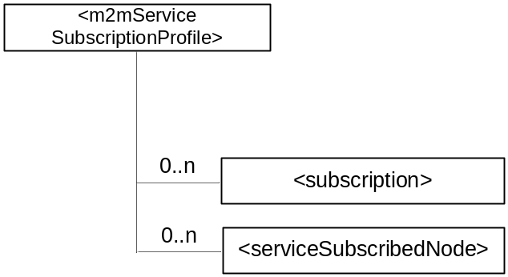
Figure 9.6.19-1: Structure of <m2mServiceSubscriptionProfile> resource
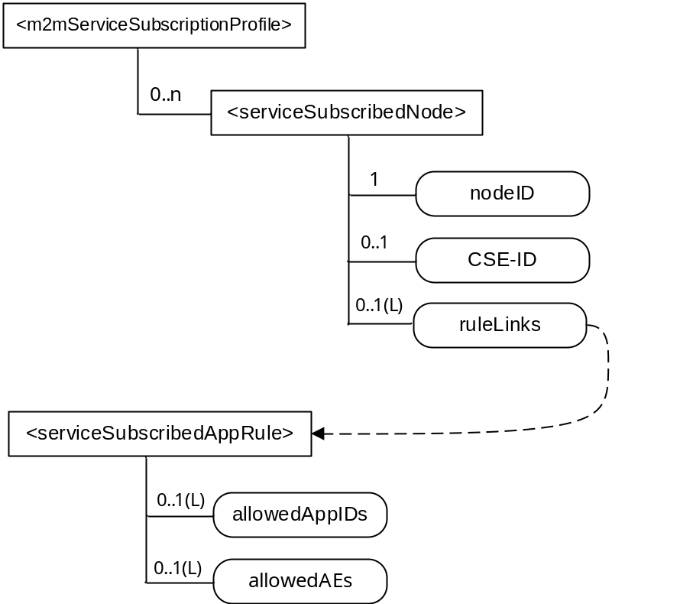
Figure 9.6.19-2: Relationship among M2M Service Subscription related resources
The <m2mServiceSubscriptionProfile> resource shall contain the child resources specified in table 9.6.19-1.
Table 9.6.19-1: Child resources of <m2mServiceSubscriptionProfile> resource
Child Resources of <m2mServiceSubscriptionProfile> | Child Resource Type | Multiplicity | Description
[variable] | <subscription> | 0..n | See clause 9.6.8
[variable] | <serviceSubscribedNode> | 0..n | See clause 9.6.20

The <m2mServiceSubscriptionProfile> resource shall contain the attributes specified in table 9.6.19-2.
Table 9.6.19-2: Attributes of <m2mServiceSubscriptionProfile> resource
Attributes of <m2mServiceSubscriptionProfile> | Multiplicity | RW/  RO/  WO | Description
resourceType | 1 | RO | See clause 9.6.1.3.
resourceID | 1 | RO | See clause 9.6.1.3.
resourceName | 1 | WO | See clause 9.6.1.3.
parentID | 1 | RO | See clause 9.6.1.3.
expirationTime | 1 | RW | See clause 9.6.1.3.
accessControlPolicyIDs | 1 (L) | RW | See clause 9.6.1.3 . If no accessControlPolicyIDs is given at the time of creation, the accessControlPolicyIDs of the parent resource is -copied to this attribute.
creationTime | 1 | RO | See clause 9.6.1.3.
labels | 0..1 (L) | RW | See clause 9.6.1.3
lastModifiedTime | 1 | RO | See clause 9.6.1.3.
dynamicAuthorizationConsultationIDs | 0..1 (L) | RW | See clause 9.6.1.3.

-----------------------End of change 3---------------------------------------------

-----------------------Start of change 4---------------------------------------------

9.6.20 Resource Type serviceSubscribedNode
The <serviceSubscribedNode> resource represents M2M Node information that is needed as part of the M2M Service Subscription resource and is only stored on IN-CSE. It contain M2M-Node-ID and optionally CSE-ID running on that Node.
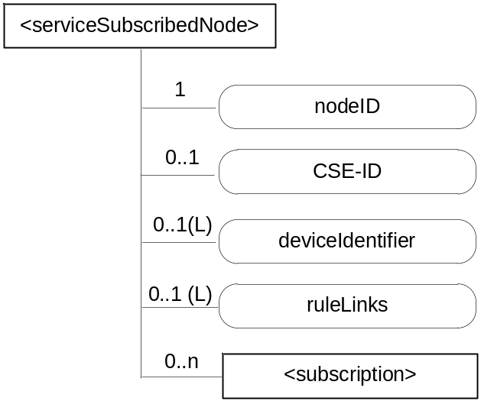
Figure 9.6.20-1: Structure of <serviceSubscribedNode> resource
The <serviceSubscribedNode> resource shall contain the child resource specified in table 9.6.20-1.
Table 9.6.20-1: Child resources of <serviceSubscribedNode> resource
Child Resources of <serviceSubscribedNode> | Child Resource Type | Multiplicity | Description
[variable] | <subscription> | 0..n | See clause 9.6.8

The <serviceSubscribedNode> resource shall contain the attributes specified in table 9.6.20-2.
Table 9.6.20-2: Attributes of <serviceSubscribedNode> resource
Attributes of <serviceSubscribedNode> | Multiplicity | RW/  RO/  WO | Description
resourceType | 1 | RO | See clause 9.6.1.3.
resourceID | 1 | RO | See clause 9.6.1.3.
resourceName | 1 | WO | See clause 9.6.1.3.
parentID | 1 | RO | See clause 9.6.1.3.
expirationTime | 1 | RW | See clause 9.6.1.3.
accessControlPolicyIDs | 1 (L) | RW | See clause 9.6.1.3. If no accessControlPolicyIDs is given at the time of creation, the accessControlPolicyIDs of the parent resource is –copied to this attribute.
creationTime | 1 | RO | See clause 9.6.1.3.
labels | 0..1 (L) | RW | See clause 9.6.1.3
lastModifiedTime | 1 | RO | See clause 9.6.1.3.
dynamicAuthorizationConsultationIDs | 0..1 (L) | RW | See clause 9.6.1.3.
nodeID | 1 | WO | M2M-Node-ID of the node that is represented by this instance.
CSE-ID | 0..1 | WO | CSE-ID pertaining to this node (for nodes that have a CSE).
deviceIdentifier | 0..1 (L) | WO | A list of device identifiers. A deviceIdentifier identifies a device using a Universally Unique IDentifier (UUID). The UUID specifies a valid, hex digit character string as defined in IETF RFC 4122 [Error: Reference source not foundi.26]. The format of the URN is one of the following:  - Case 1: Identify a device using the format <OUI> "-" <ProductClass> "-" <SerialNumber> as defined in section 3.4.4 of TR-069 [Error: Reference source not foundi.2]. The format of the URN is urn:dev:ops:<OUI> "-" <ProductClass> "-" <SerialNumber>.  - Case 2: Identify a device using the format <OUI> "-"<SerialNumber> as defined in section 3.4.4 of TR-069 [i.2]. The format of the URN is urn:dev:os:<OUI> "-"<SerialNumber>.  - Case 3: Identify a device using an International Mobile Equipment Identifiers of 3GPP TS 23.003 [i.23]. This URN specifies a valid, 15 digit IMEI. The format of the URN is urn:imei:###############.  - Case 4: Identify a device using an Electronic Serial Number. The ESN specifies a valid, 8 digit ESN. The format of the URN is urn:esn:########.  - Case 5: Identify a device using a Mobile Equipment Identifier. This URN specifies a valid, 14 digit MEID. The format of the URN is urn:meid:##############.  - Case 6: Identify a device using an Object IDentifier (OID). This URN specifies a valid OID – see Annex H for one possible naming convention. The format of the URN is urn:oid:#########<OID>.
ruleLinks | 0..1 ((L) | RW | This attribute contains a list of links towards <serviceSubscribedAppRule> resources pertaining to this <serviceSubscribedNode>. See clause 9.6.29 for an explanation of the <serviceSubscribedAppRule> resource. This attribute shall exist only when the CSE-ID attribute is present. When the list is empty, it means no applications are allowed to register on the CSE which is indicated by the CSE-ID attribute.

-----------------------End of change 4 ---------------------------------------------

-----------------------Start of change 5 ---------------------------------------------

9.6.29 Resource Type serviceSubscribedAppRule
The <serviceSubscribedAppRule> resource represents a rule that defines allowed Role-ID, App-ID and AE-ID combinations that are acceptable for registering an AE on a Registrar CSE and is only stored on IN-CSE. The rule in a <serviceSubscribedAppRule> resource shall apply for CSEs for which the associated <serviceSubscribeNode> resource is linked with the <serviceSubscribedAppRule> via the ruleLinks attribute of the <serviceSubscribedNode> resource. The rule contained in a <serviceSubscribedAppRule> resource defines a mapping between:
- one or more Credential-ID(s); and
- combinations of one or more Role-ID(s), one or more App-ID(s) and one or more AE-ID(s) which are allowed to be used for registering AE(s) that issued a registration request via a Security Association established with the credentials associated with the Credential-ID(s) listed in (a).
When applications shall be allowed in situations where no Security Association has been established prior to issuing the registration request, the Credential-ID 'None' shall be used in the rule.
The parent resource of a <serviceSubscribedAppRule> resource is the <CSEBase> resource of the IN-CSE hosting the <serviceSubscribedNode> resource(s) that point to the <serviceSubscribedAppRule> resource.
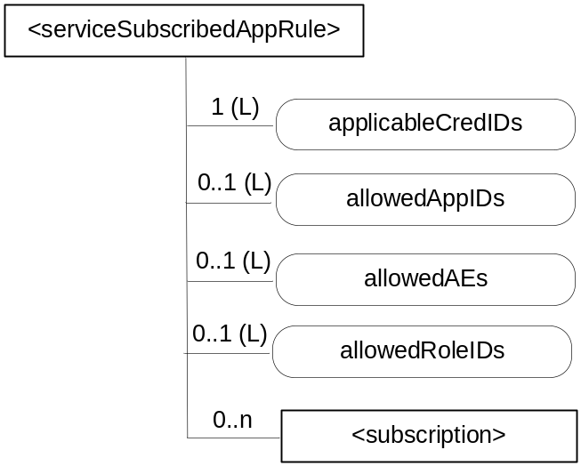
Figure 9.6.29-1: Structure of <serviceSubscribedAppRule> resource
The <serviceSubscribedAppRule> resource shall contain the child resource specified in table 9.6.29-1.
Table 9.6.29-1: Child resources of <serviceSubscribedAppRule> resource
Child Resources of <serviceSubscribedAppRule> | Child Resource Type | Multiplicity | Description
[variable] | <subscription> | 0..n | See clause 9.6.8 where the type of this resource is described.

The <serviceSubscribedAppRule> resource shall contain the attributes specified in table 9.6.29-2.
Table 9.6.29-2: Attributes of <serviceSubscribedAppRule> resource
Attributes of <serviceSubscribedAppRule> | Multiplicity | RW/  RO/  WO | Description
resourceType | 1 | RO | See clause 9.6.1.3.
resourceID | 1 | RO | See clause 9.6.1.3.
resourceName | 1 | WO | See clause 9.6.1.3.
parentID | 1 | RO | See clause 9.6.1.3.
expirationTime | 1 | RW | See clause 9.6.1.3.
accessControlPolicyIDs | 1 (L) | RW | See clause 9.6.1.3. If no accessControlPolicyIDs is given at the time of creation, the accessControlPolicyIDs of the parent resource is -copied to this attribute.
creationTime | 1 | RO | See clause 9.6.1.3.
labels | 0..1 (L) | RW | See clause 9.6.1.3
lastModifiedTime | 1 | RO | See clause 9.6.1.3.
dynamicAuthorizationConsultationIDs | 0..1 (L) | RW | See clause 9.6.1.3.
applicableCredIDs | 1 (L) | RW | List of credential IDs for which this rule is applicable, i.e. for registration requests coming into a CSE via a Security Association Endpoint (SEA) [2], that was authenticated using credentials that match with any of these credential-IDs, the current rule applies. This can contain a '*' for any credential ID or 'None' for not authenticated case. Also Wildcards within an element of this list are possible (e.g. 'C123*X' for any Credential ID that starts with 'C123' and ends with 'X') to define sets or ranges of Credential-IDs.
allowedApp-IDs | 0..1 (L) | RW | List of App-IDs that shall be considered to be allowed for AE registration requests received via Security Association Endpoint (SEA) [2] associated with credentialID stored in the attribute applicableCredID. This can contain '*' for any App-ID. Also Wildcards within an element of this list are possible (e.g. 'C123*X' for any App-ID that starts with 'C123' and ends with 'X') to define sets or ranges of App-IDs.
allowedAEs | 0..1 (L) | RW | List of allowed AE-ID-Stems to be used for the registering AEs. This can contain zero or more specific AE-ID-Stem values, 'S*' for any SP-Assigned AE-ID-Stem, 'C*' for any CSE-assigned AE-ID-Stem, or '*' for any AE-ID-Stem. Also Wildcards within an element of this list are possible (e.g. 'C123*X' for any AE-ID that starts with 'C123' and ends with 'X') to define sets or ranges of AE-ID-Stems.
allowedRole-IDs | 0..1(L) | RW | List of Role-IDs that shall be considered to be allowed in Request operations.

-----------------------End of change 5 ---------------------------------------------

-----------------------Start of change 6 ---------------------------------------------

9.6.31 Resource Type notificationTargetMgmtPolicyRef
The <notificationTargetMgmtPolicyRef> resource is a child resource of a <subscription> resource and lists a reference to the policy to be followed by the hosting CSE for every Target Notification of a subscription. The policy is applied by the hosting CSE when it receives a request to stop receiving a notification from a Target Notification. If no policy is defined for the Target Notification, then the hosting CSE shall apply the default policy. The default policy is either created by the subscription originator or the hosting CSE shall have a system created default one to apply. The system created default policy shall be configurable by the M2M Service Provider.
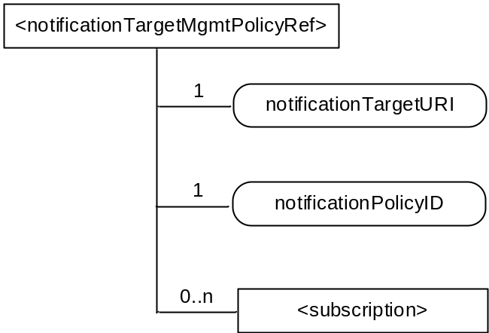
Figure 9.6.31-1: Structure of <notificationTargetMgmtPolicyRef> resource

Table 9.6.31-1: Child resources of <notificationTargetMgmtPolicyRef> resource
Child Resources | Child Resource Type | Multiplicity | Description
[variable] | <subscription> | 0..n | See clause 9.6.8

Table 9.6.31-2: Attributes of <notificationTargetMgmtPolicyRef> resource
Attributes | Multiplicity | RW/  RO/  WO | Description
resourceType | 1 | RO | See clause 9.6.1.3.
resourceID | 1 | RO | See clause 9.6.1.3.
resourceName | 1 | WO | See clause 9.6.1.3.
parentID | 1 | RO | See clause 9.6.1.3.
expirationTime | 1 | RW | See clause 9.6.1.3.
accessControlPolicyIDs | 1 (L) | RW | See clause 9.6.1.3. If no accessControlPolicyIDs is given at the time of creation, the accessControlPolicyIDs of the parent resource is -copied to this attribute.
creationTime | 1 | RO | See clause 9.6.1.3.
labels | 0..1 (L) | RW | See clause 9.6.1.3
lastModifiedTime | 1 | RO | See clause 9.6.1.3.
dynamicAuthorizationConsultationIDs | 0..1 (L) | RW | See clause 9.6.1.3.
notificationTargetURI | 1 (L) | RW | address(es) of the resource subscriber receiving a notification.The notificationTarget URI shall be listed in the notificationURI attribute of the parent <subscription> resource, otherwise the default Notification Target policy shall apply.
notificationlPolicyID | 1 | RW | A link to the <notificationTargetPolicy> resource applicable to the notificationTargetURI. If none is specified than the default policy shall apply to the targetNotificationURI. See clause 9.6.32 for an explanation of the <notificationTargetPolicy > resource.

-----------------------End of change 6 ---------------------------------------------

-----------------------Start of change 7 ---------------------------------------------

9.6.32 Resource Type notificationTargetPolicy
The <notificationTargetPolicy> resource is a child resource of <CSEBase> resource and lists the policies to be applied by the hosting CSE. A policy has a rules(s), representd by the <policyDeletionRules> and an action. The action is applied when the rules in the policy are fulfilled.
Rules are grouped in 2 groups to support a combination of rules for flexbiblilty eg. ((rule 1 AND rule 2) OR rule 3) A maximum of two groups of <policyDeletionRules> can be defined. The relationship to be applied between the 2 groups (AND/OR) shall be defined in the ruleRelationShip attribute. If no rules are defined for a <notificationTargetPolicy> then the action is executed
Each policy has the policyLabel which can take any form. There shall be at minimum a single notificationTargetPolicy which can be defined by the subscription originator with the label “default” to be applied when no specific policy is defined for a Target Notification. If a default policy is required and none is defined by the subscription originator then the syetem defined default policy shall be applied.

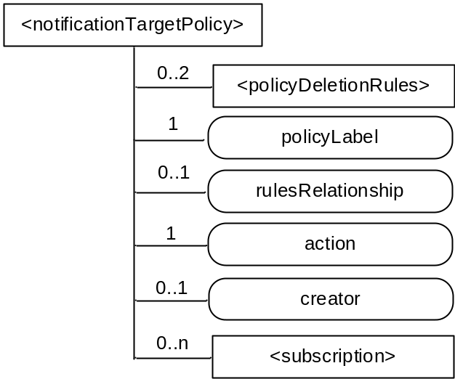
Figure 9.6.32-1: Structure of <notificationTargetPolicy> resource

Table 9.6.32-1: Child resources of <notificationTargetPolicy> resource
Child Resources | Child Resource Type | Multiplicity | Description
[variable] | <policyDeletionRules> | 0..2 | Groups listing the rules that apply to this policy and that needs to be fulfilled for the listed action to take place, Only two groups of rules shall be supported. See 9.6.33
[variable] | <subscription> | 0..n | See clause 9.6.8

Table 9.6.32-2: Attributes of <notificationTargetPolicy> resource
Attributes | Multiplicity | RW/  RO/  WO | Description
resourceType | 1 | RO | See clause 9.6.1.3.
resourceID | 1 | RO | See clause 9.6.1.3.
resourceName | 1 | WO | See clause 9.6.1.3.
parentID | 1 | RO | See clause 9.6.1.3.
expirationTime | 1 | RW | See clause 9.6.1.3.
accessControlPolicyIDs | 1 (L) | RW | See clause 9.6.1.3. If no accessControlPolicyIDs is given at the time of creation, the accessControlPolicyIDs of the parent resource is -copied to this attribute.
creationTime | 1 | RO | See clause 9.6.1.3.
labels | 0..1 (L) | RW | See clause 9.6.1.3
lastModifiedTime | 1 | RO | See clause 9.6.1.3.
dynamicAuthorizationConsultationIDs | 0..1 (L) | RW | See clause 9.6.1.3.
action | 1 | RW | Defines the action to be performed if the groups of rules are fulfilled.  The action includes one of the following; accept request, reject request, seek authorization from subscription originator before responding, or inform the subscription originator without taking any action;
policyLabel | 1 | RW | At minimum a default policy shall be specified. The policyLabel “Default” shall be used in this case.
rulesRelationship | 0..1 | RW | Shall be either AND or OR This attribute is mandatory if more than one policy DeletionRule is specified
creator | 0..1 | RO | The AE-ID or CSE-ID of the entity which created the resource.

-----------------------End of change 7 ---------------------------------------------

-----------------------Start of change 8 ---------------------------------------------

9.6.33 Resource Type policyDeletionRules
The <policyDeletionRules> resource lists the rules to be applied by the hosting CSE during policy execution. Each <policyDeletionRules> can define any number of rules with an AND or OR relationship to be applied between them. The attribute deletionRulesRelation define the relationship between rules. It can have an AND or OR value
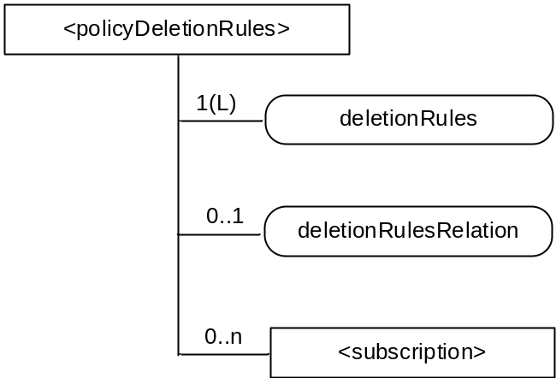
Figure 9.6.33-1: Structure of <policyDeletionRules> resource

Table 9.6.33-1:: Child resources of <policyDeletionRules> resource
Child Resources | Child Resource Type | Multiplicity | Description
[variable] | <subscription> | 0..n | See clause 9.6.8

Table 9.6.33-2: Attributes of <policyDeletionRules> resource
Attributes | Multiplicity | RW/  RO/  WO | Description
resourceType | 1 | RO | See clause 9.6.1.3.
resourceID | 1 | RO | See clause 9.6.1.3.
resourceName | 1 | WO | See clause 9.6.1.3.
parentID | 1 | RO | See clause 9.6.1.3.
expirationTime | 1 | RW | See clause 9.6.1.3.
accessControlPolicyIDs | 1 (L) | RW | See clause 9.6.1.3. If no accessControlPolicyIDs is given at the time of creation, the accessControlPolicyIDs of the parent resource is -copied to this attribute.
creationTime | 1 | RO | See clause 9.6.1.3.
labels | 0..1 (L) | RW | See clause 9.6.1.3
lastModifiedTime | 1 | RO | See clause 9.6.1.3.
dynamicAuthorizationConsultationIDs | 0..1 (L) | RW | See clause 9.6.1.3.
deletionRules | 0..1(L) | RW | Lists the applicable rules. The rules include at minimum ; time of the day, geaographical location of the Target Notification. Where the rule applies
deletionRulesRelation | 0..1 | RW | Defines the relation to be applied between the deletionRules. This shall be either AND or OR.

-----------------------End of change 8---------------------------------------------

-----------------------Start of change 9---------------------------------------------

9.6.36 Resource Type timeSeries
The <timeSeries> resource represents a container for Time Series Data instances. It is used to share information with other entities and potentially to track, detect and report the missing data in Time Series. A <timeSeries> resource has no associated content. It has only attributes and child resources.
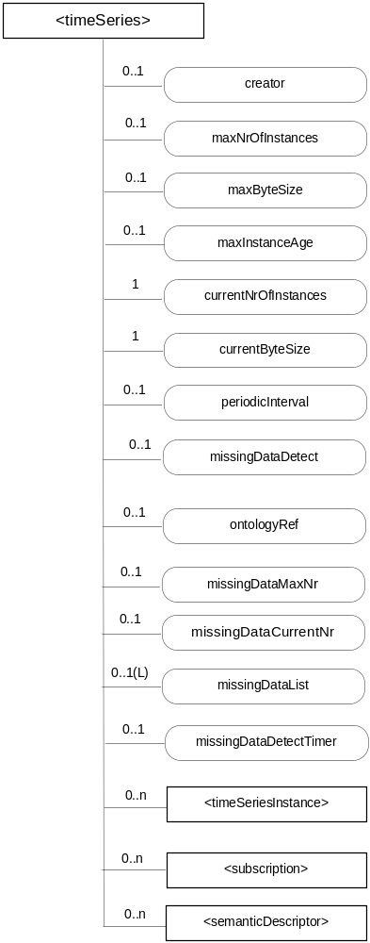
Figure 9.6.36-1: Structure of <timeSeries> resource

Table 9.6.36-1:Child resources of <timeSeries> resource
Child Resources of <timeSeries> | Child Resource Type | Multiplicity | Description | <timeSeriesAnnc> Child Resource Types
semanticDescriptor | <semanticDescriptor> | 0..n | See clause 9.6.30 | <semanticDescriptor>, <semanticDescriptorAnnc>
[variable] | <timeSeriesInstance> | 0..n | See clause 9.6.37 | <timeSeriesInstance>,  <timeSeriesInstanceAnnc>
[variable] | <subscription> | 0..n | See clause 9.6.8 | <subscription>

The <timeSeries> resource shall contain the attributes specified in table 9.6.36-2.
Table 9.6.36-2: Attributes of <timeSeries> resource
Attributes of  <timeSeries> | Multiplicity | RW/  RO/  WO | Description | <timeSeriesAnnc> Attributes
resourceType | 1 | RO | See clause 9.6.1.3. | NA
resourceID | 1 | RO | See clause 9.6.1.3. | NA
resourceName | 1 | WO | See clause 9.6.1.3. | NA
parentID | 1 | RO | See clause 9.6.1.3. | NA
expirationTime | 1 | RW | See clause 9.6.1.3 | MA
accessControlPolicyIDs | 1 (L) | RW | See clause 9.6.1.3. If no accessControlPolicyIDs are provided at the time of creation, the accessControlPolicyIDs of the parent resource is -copied to this attribute | MA
labels | 0..1 (L) | RW | See clause 9.6.1.3. | MA
creationTime | 1 | RO | See clause 9.6.1.3. | NA
lastModifiedTime | 1 | RO | See clause 9.6.1.3. | NA
stateTag | 1 | RO | See clause 9.6.1.3. | OA
announceTo | 0..1 (L) | RW | See clause 9.6.1.3. | NA
announcedAttribute | 0..1 (L) | RW | See clause 9.6.1.3. | NA
dynamicAuthorizationConsultationIDs | 0..1 (L) | RW | See clause 9.6.1.3. | OA
creator | 1 | RO | The AE-ID or CSE-ID of the entity which created the resource. | NA
maxNrOfInstances | 0..1 | RW | Maximum number of direct child <timeSeriesInstance> resources in the <timeSeries> resource. | OA
maxByteSize | 0..1 | RW | Maximum size in bytes of data that is allocated for the <timeSeriesInstance> resource for all direct child<timeSeriesInstance> resources. | OA
maxInstanceAge | 0..1 | RW | Maximum age of a direct child <timeSeriesInstance> resource in the <timeSeries> resource. The value is expressed in seconds. | OA
currentNrOfnstances | 1 | RO | Current number of direct child <timeSeriesInstance> resource in the <timeSeries> resource. It is limited by the maxNrOfInstances. | OA
currentByteSize | 1 | RO | Current size in bytes of data stored in all direct child <timeSeriesInstance> resources of a <timeSeries> resource. It is limited by the maxByteSize. | OA
periodicInterval | 0..1 | WO | If the Time Sereis Data is periodic, this attribute shall contain the expected amount of time between two instances of Time Series Data. | OA
missingDataDetect | 0..1 | WO | Indicates whether the Receiver shall detect the missing Time Series Data if it is periodic. | NA
ontologyRef | 0..1 | RW | A reference (URI) of the ontology used to represent the information that is stored in the child <timeSeriesInstance> resources of the present <timeSeriesData> resource (see note). | OA
missingDataMaxNr | 0..1 | RW | Maximum number of entries in the missingDataList if the periodicInterval is set and the missingDataDetect is TRUE. | OA
missingDataList | 0..1(L) | RO | The list of the dataGenerationTime value representing the missing Time Series Data in descending order by time if the periodicInterval is set and the missingDataDetect is TRUE. | OA
missingDataCurrentNr | 0..1 | RO | Current number of the missing Time Series Data in the missingDataList. | OA
missingDataDetectTimer | 0..1 | RW | The missingDataDetectTimer shall be set if the periodicInterval is set and the missingDataDetect is TRUE.  The expecting Time Series Data shall be considered to be lost when the amount of time equal to missingDataDetectTimer has passed. | OA
NOTE: The access to this URI is out of scope of oneM2M.

-----------------------End of change 9---------------------------------------------

-----------------------Start of change 10---------------------------------------------

9.6.43 Resource Type dynamicAuthorizationConsultation
The < dynamicAuthorizationConsultation> resource shall be used by a CSE to perform consultation-based dynamic access control to resources as specified in the present document and in oneM2M TS-0003 [2].
The <dynamicAuthorizationConsultation> resource is comprised of configuration information that a resource Hosting CSE may use to determine whether or not to initiate a consultation-based dynamic authorization request.
For a resource that is not of <dynamicAuthorizationConsultation> resource type, the common attribute dynamicAuthorizationConsultationIDs for such resources (defined in table 9.6.1.3.2-1) may contain a list of identifiers which link that resource to <dynamicAuthorizationConsultation> resources.
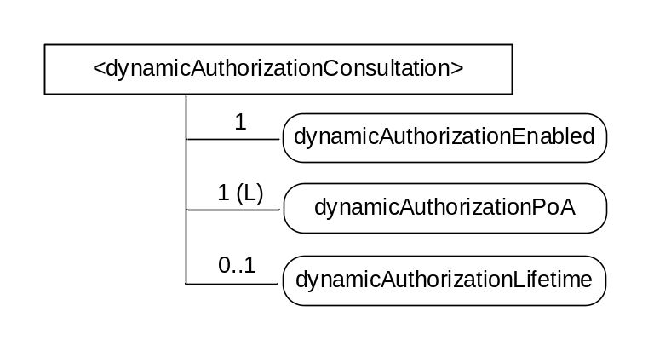
Figure 9.6.43-1: Structure of <dynamicAuthorizationConsultation> resource
The <dynamicAuthorizationConsultation> resource shall contain the attributes specified in table 9.6.43-1.
Table 9.6.43-1: Attributes of <dynamicAuthorizationConsultation> resource
Attributes of < dynamicAuthorizationConsultation > | Multiplicity | RW/  RO/  WO | Description
resourceType | 1 | RO | See clause 9.6.1.3.
resourceID | 1 | RO | See clause 9.6.1.3.
resourceName | 1 | WO | See clause 9.6.1.3.
parentID | 1 | RO | See clause 9.6.1.3.
expirationTime | 1 | RW | See clause 9.6.1.3.
creationTime | 1 | RO | See clause 9.6.1.3.
lastModifiedTime | 1 | RO | See clause 9.6.1.3.
labels | 0..1 (L) | RW | See clause 9.6.1.3.
accessControlPolicyIDs | 1 (L) | RW | See clause 9.6.1.3.  If no accessControlPolicyIDs is given at the time of creation, the accesControlPolicies of the parent resource is -copied to this attribute.
dynamicAuthorizationEnabled | 1 | RW | Controls whether consultation-based dynamic authorization is enabled or disabled. If disabled, Hosting CSE shall NOT initiate consultation-based dynamic authorization. Valid values are “TRUE” or “FALSE”.
dynamicAuthorizationPoA | 1 (L) | RW | A list of contact URIs of supporting consultation-based dynamic authorization.
dynamicAuthorizationLifetime | 0..1 | RW | The preferred lifetime of dynamic access control privileges that CSE shall specifiy as a parameter when issuing a consultation-based dynamic authorization request.

-----------------------End of change 10---------------------------------------------

CHECK LIST
- Does this change request include an informative introduction containing the problem(s) being solved, and a summary list of proposals.?
- Does this CR contain changes related to only one particular issue/problem?
- Have any mirror crs been posted?
- Does this change request make all the changes necessary to address the issue or problem? E.g. A change impacting 5 tables should not only include a proposal to change only 3 tables. Includes any changes to references, definitions, and acronyms in the same deliverable?
- Does this change request follow the drafting rules?
- Are all pictures editable?
- Have you checked the spelling and grammar?
- Have you used change bars for all modifications?
- Does the change include the current and surrounding clauses to clearly show where a change is located and to provide technical context of the proposed change? (Additions of complete sections need not show surrounding clauses as long as the proposed section number clearly shows where the new section is proposed to be located.)
- Are multiple changes in this CR clearly separated by horizontal lines with embedded text such as, start of change 1, end of change 1, start of new clause, end of new clause.?

