CHANGE REQUEST
Meeting:* | ARC 23.1
Source:* | Joerg Swetina, NEC, Joerg.swetina@neclab.eu
Date:* | 2016-03-03
Contact:* | Joerg Swetina, NEC, Joerg.swetina@neclab.eu
Reason for Change/s:* | When the resource type <flexContainer> was introduced it was agreed that it can be a child resource of < CSEBase >,< remoteCSE >,<AE> and <container>. This was incompletely reflected in table 9.6.1.1-1 (Resource Types) and not at all in sections 9.6.5 (Resource Type AE) and 9.6.6 (Resource Type container)
CR against: Release* | 2
CR against: WI* | Active <Work Item number>  MNT maintenace / < Work Item number(optional)>  STE Small Technical Enhancements / < Work Item number (optional)>  Only ONE of the above shall be ticked
CR against: TS/TR* | TS-0001 V2.6.0
Clauses/Sub Clauses* | 9.6.1.1, 9.6.5, 9.6.6,
Type of change: * | Editorial change  Bug Fix or Correction  Change to existing feature or functionality  New feature or functionality  Only ONE of the above shall be ticked
Post Freeze checking:* | This CR contains only essential changes and corrections? YES NO  This CR may break backwards compatibility with the last approved version of the TS? YES NO  This CR is a mirror CR? YES if YES, please indicate the document number of the original CR: <Document Number) : NO
Template Version:27 May 2015 (Dot not modify)

oneM2M Notice
The document to which this cover statement is attached is submitted to oneM2M. Participation in, or attendance at, any activity of oneM2M, constitutes acceptance of and agreement to be bound by terms of the Working Procedures and the Partnership Agreement, including the Intellectual Property Rights (IPR) Principles Governing oneM2M Work found in Annex 1 of the Partnership Agreement.
GUIDELINES for Change Requests:
Provide an informative introduction containing the problem(s) being solved, and a summary list of proposals.
Each CR should contain changes related to only one particular issue/problem.
In case of a correction, and the change apply to previous releases, a separated “mirror CR” should be posted at the same time of this CR
Follow the principle of completeness, where all changes related to the issue or problem within a deliverable are simultaneously proposed to be made E.g. A change impacting 5 tables should not only include a proposal to change only 3 tables. Includes any changes to references, definitions, and acronyms in the same deliverable.
Follow the drafting rules.
All pictures must be editable.
Check spelling and grammar to the extent practicable.
Use Change bars for modifications.
The change should include the current and surrounding clauses to clearly show where a change is located and to provide technical context of the proposed change. Additions of complete sections need not show surrounding clauses as long as the proposed section number clearly shows where the new section is proposed to be located.
Multiple changes in a single CR shall be clearly separated by horizontal lines with embedded text such as, start of change 1, end of change 1, start of new clause, end of new clause.
When subsequent changes are made to content of a CR, then the accepted version should not show changes over changes. The accepted version of the CR should only show changes relative to the baseline approved text.

Introduction
<Provide an introduction containing the problem(s) being solved, and a summary list of proposals. Discuss any risk of breaking backwards compatibility with last published version of the impacted TS.>

-----------------------Start of change 1-------------------------------------------

9.6.1.1 Resource Type Summary
Table 9.6.1.1-1 introduces the normal and virtual resource types and their related child or parent resource types. Details of each resource type follow in the remainder of this clause.
Table 9.6.1.1-1 lists each specified <resourceType>. An addition of suffix "Annc" to such <resourceTypes> indicates the associated announced resource type.
Among the resource types listed in Table 9.6.1.1-1, the following are termed “Content Sharing Resources” in oneM2M Specifications for the purpose of referring to any of those resource types:
- container
- contentInstance
- flexContainer
- timeSeries
- timeSeriesInstance

Table 9.6.1.1-1 Resource Types
Resource Type | Short Description | Child Resource Types | Parent Resource Types | Clause
accessControlPolicy | Stores a representation of privileges. It is associated with resources that shall be accessible to entities external to the Hosting CSE. It controls "who" is allowed to do "what" and the context in which it can be used for accessing resources | subscription | AE, AEAnnc, remoteCSE, remoteCSEAnnc, CSEBase | 9.6.2
AE | Stores information about the AE. It is created as a result of successful registration of an AE with the Registrar CSE | subscription, container,  flexContainer, group, accessControlPolicy,  schedule, pollingChannel，semanticDescriptor,  timeSeries | remoteCSE, remoteCSEAnnc, CSEBase | 9.6.5
container | Shares data instances among entities. Used as a mediator that buffers data exchanged between AEs and/or CSEs. The exchange of data between AEs (e.g. an AE on a Node in a field domain and the peer-AE on the infrastructure domain) is abstracted from the need to set up direct connections and allows for scenarios where both entities in the exchange do not have the same reachability schedule | container,  flexContainer, contentInstance, subscription, latest, oldest，semanticDescriptor | AE, AEAnnc, container, containerAnnc, remoteCSE, remoteCSEAnnc,  CSEBase,  flexContainer, flexContainerAnnc | 9.6.6
contentInstance | Represents a data instance in the <container> resource | semanticDescriptor | Container, containerAnnc | 9.6.7
flexContainer | A template which allows to define specialized (customizable) versions of containers with a flexible and lightweight structure | container,  flexContainer, subscription, semanticDescriptor, | AE, AEAnnc, container, containerAnnc,  flexContainer, flexContainerAnnc,  remoteCSE, remoteCSEAnnc,  CSEBase | 9.6.35
CSEBase | The structural root for all the resources that are residing on a CSE. Stores information about the CSE itself | remoteCSE, remoteCSEAnnc, node, AE, container, group, accessControlPolicy, subscription,, mgmtCmd, locationPolicy, statsConfig, statsCollect, request, delivery,  schedule,  notificationTargetPolicy,  flexContainer,  timeSeries | None specified | 9.6.3
delivery | Forwards requests from CSE to CSE | subscription | CSEBase | 9.6.11
eventConfig | Defines events that trigger statistics collection | subscription | statsConfig | 9.6.24
execInstance | Contains all execution instances of the same Management Command | subscription | mgmtCmd | 9.6.17
fanOutPoint (V) | Virtual resource containing target for group request  It is used for addressing bulk operations to all the resources that belong to a group | None specified | group | 9.6.14
group | Stores information about resources of the same type that need to be addressed as a Group. Operations addressed to a Group resource shall be executed in a bulk mode for all members belonging to the Group | fanOutPoint,  subscription,  semanticFanOutPoint | AE, AEAnnc, remoteCSE, remoteCSEAnnc, CSEBase | 9.6.13
latest (V) | Virtual resource that points to most recently created <contentInstance> child resource within a <container> resource | None specified | container | 9.6.27
locationPolicy | Includes information to obtain and manage geographical location. It is only referenced within a container, the contentInstances of the container provide location information | subscription | CSEBase | 9.6.10
mgmtCmd | Management Command resource represents a method to execute management procedures required by existing management protocols | execInstance,  subscription | CSEBase | 9.6.16
mgmtObj | Management Object resource represents management functions that provides an abstraction to be mapped to external management technology. It represents the node and the software installed in the node (see note) | subscription, mgmtObj, schedule | node, mgmtObj, mgmtObjAnnc | 9.6.15  Annex D
m2mServiceSubscriptionProfile | Data pertaining to the M2M Service Subscription | serviceSubscribedNode,  subscription | CSEBase | 9.6.19
node | Represents specific Node information | mgmtObj,  subscription | CSEBase, remoteCSE | 9.6.18
notificationTargetMgmtPolicyRef | Represents a list of notification targets and the deletion policy | subscription | subscription | 9.6.31
notificationTargetPolicy | Represents a notification target deletion policy with pre-defined action and deletion rules | subscription, policyDeletionRules | CSEBase | 9.6.32
notificationTargetSelfReference (V) | Virtual resource used to remove the Notification Target | None specified | subscription | 9.6.34
oldest (V) | Virtual resource that points to first created <contentInstance> child resource within a <container> resource | None specified | container | 9.6.28
pollingChannel | Represent a channel that can be used for a request-unreachable entity | pollingChannelURI | remoteCSE, AE | 9.6.21
pollingChannelURI (V) | Virtual resource used to perform service layer long polling of a resource Hosting CSE by a request-unreachable entity | None specified | pollingChannel | 9.6.22
policyDeletionRules | Represents a set of rules which is associated with notification target removal policy | subscription | notificationTargetPolicy | 9.6.33
remoteCSE | Represents a remote CSE for which there has been a registration procedure with the registrar CSE identified by the CSEBase resource | AE, container, flexContainer, group, accessControlPolicy, subscription, pollingChannel, schedule, node,  timeSeries | CSEBase | 9.6.4
request | Expresses/access context of an issued Request | subscription | CSEBase | 9.6.12
schedule | Contains scheduling information for delivery of messages | subscription | subscription, CSEBase, remoteCSE,  AE | 9.6.9
serviceSubscribedNode | Node information | subscription | m2mServiceSubscriptionProfile | 9.6.20
statsCollect | Defines triggers for the IN-CSE to collect statistics for applications | subscription | CSEBase (in IN-CSE) | 9.6.25
statsConfig | Stores configuration of statistics for applications | eventConfig,  subscription | CSEBase (in IN-CSE) | 9.6.23
subscription | Subscription resource represents the subscription information related to a resource. Such a resource shall be a child resource for the subscribe-to resource | schedule, notificationTargetSelfReference, notificationTargetMgmtPolicyRef | accessControlPolicy,accessControlPolicyAnnc, AE, AEAnnc, container, CSEBase, delivery, eventConfig, execInstance, group, groupAcce, locationPolicy, mgmtCmd, mgmtObj, mgmtObjAnnc, m2mServiceSubscriptionProfile, node, nodeAnnc, serviceSubscribedNode, remoteCSE, remoteCSEAnnc, request, schedule,  semanticDescriptor,  statsCollect, statsConfig,  flexContainer, flexContainerAnnc | 9.6.8
serviceSubscribedAppRule | Represents a rule that defines allowed App-ID and AE-ID combinations that are acceptable for registering an AE on a Registrar CSE | subscription | CSEBase | 9.6.29
semanticDescriptor | Stores semantic description pertaining to a resource and potentially sub-resources. | subscription | AE, container, contentInstance | 9.6.30
semanticFanOutPoint | Virtual resource used as target for semantic discovery aimed at a logical graph distributed over multiple semanticDescriptor resources, which belong to the corresponding group parent resource | None specified | group | 9.6.14a
trafficCharacteristics | Represents the characteristic information (e.g. communication pattern, mobility pattern, etc..) of a field domain node. | trafficPattern,  subscription | Node, AE | 9.6.41
trafficPattern | Represents the communication pattern and the mobility pattern of a field domain node. | schedule,  subscription | trafficCharacteristics | 9.6.42
dynamicAuthorizationConsultation | Represents consultation information used by a CSE when performing consultation-based dynamic authorization | None Specified | AE, AEAnnc, remoteCSE, remoteCSEAnnc, CSEBase | 9.6.43
timeSeries | Stores and Shares Time Series Data instances among entities. | timeSeriesInstance, subscription, semanticDescriptor | AE, AEAnnc, remoteCSE, remoteCESAnnc, CSEBase | 9.6.36
timeSeriesInstance | Represents a Time Series Data instance in the <timeSeries> resource | None specified | timeSeries, timeSeriesAnnc | 9.6.37
NOTE: See clause 9.6.12 for a summary of specializations of <mgmtObj>.

-----------------------End of change 1---------------------------------------------

-----------------------Start of change 2-------------------------------------------

9.6.5 Resource Type AE
An <AE> resource shall represent information about an Application Entity registered to a CSE.
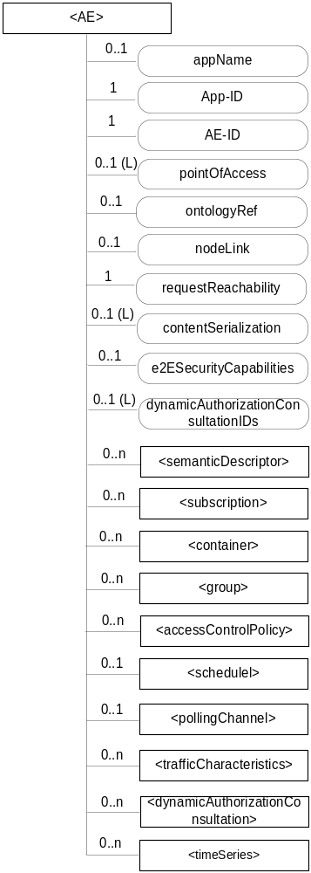
Figure 9.6.5-1: Structure of <AE> resource
The <AE> resource shall contain the child resources specified in table 9.6.5-1.
Table 9.6.5-1: Child resources of <AE> resource
Child Resources of <AE> | Child Resource Type | Multiplicity | Description | <AEAnnc> Child Resource Types
semanticDescriptor | <semanticDescriptor> | 0..n | See clause 9.6.30 | <semanticDescriptor>, <semanticDescriptorAnnc>
[variable] | <subscription> | 0..n | See clause 9.6.8 | <subscription>
[variable] | <container> | 0..n | See clause 9.6.6 | <container> <containerAnnc>
[variable] | <flexContainer> | 0..n | See clause 9.6.35 | <flexContainer>  <flexContainerAnnc>
[variable] | <group> | 0..n | See clause 9.6.13 | <group>  <groupAnnc>
[variable] | <accessControlPolicy> | 0..n | See clause 9.6.2 | <accessControlPolicy>  <accessControlPolicyAnnc>
[variable] | <schedule> | 0..1 | See clause 9.6.9 | <scheduleAnnc>
[variable] | <pollingChannel> | 0..1 | See clause 9.6.21.  When the AE is request-unreachable, the AE should create this <pollingChannel> resource and perform long polling. The <pollingChannel> shall be utilized by the the parent resource. | None
trafficCharacteristics | <trafficCharacteristics> | 0..n | See clause 9.6.41 | <trafficCharacteristics>
[variable] | <dynamicAuthorizationConsultation> | 0..n | See clause 9.6.43 | <dynamicAuthorizationConsultationAnnc>
[variable] | <timeSeries> | 0..n | See clause 9.6.36 | <timeSeriesAnnc>

The <AE> resource shall contain the attributes specified in table 9.6.5-2.
Table 9.6.5-2: Attributes of <AE> resource
Attributes of  <AE> | Multiplicity | RW/  RO/  WO | Description | <AEAnnc> Attributes
resourceType | 1 | RO | See clause 9.6.1.3. | NA
resourceID | 1 | RO | See clause 9.6.1.3. Contains the AE-ID-Stem of the AE (see clause 7.2 on identifier formats and clause 10.1.1.2.2 for AE registration procedure). | NA
resourceName | 1 | WO | See clause 9.6.1.3. | NA
parentID | 1 | RO | See clause 9.6.1.3. | NA
expirationTime | 1 | RW | See clause 9.6.1.3. | MA
accessControlPolicyIDs | 0..1 (L) | RW | See clause 9.6.1.3. | MA
creationTime | 1 | RO | See clause 9.6.1.3. | NA
lastModifiedTime | 1 | RO | See clause 9.6.1.3. | NA
labels | 0..1 (L) | RW | See clause 9.6.1.3. | MA
announceTo | 0..1 (L) | RW | See clause 9.6.1.3. | NA
announcedAttribute | 0..1 (L) | RW | See clause 9.6.1.3. | NA
dynamicAuthorizationConsultationIDs | 0..1 (L) | RW | See clause 9.6.1.3. | OA
appName | 0..1 | RW | The name of the application, as declared by the application developer(e.g. "HeatingMonitoring").  Several sibling resources may share the appName. | OA
App-ID | 1 | WO | The identifier of the Application (see clause 7.1.2). | OA
AE-ID | 1 | RO | The identifier of the Application Entity (see clause 7.1.2). | OA
pointOfAccess | 0..1 (L) | RW | The list of addresses for communicating with the registered Application Entity over Mca reference point via the transport services provided by Underlying Network (e.g. IP address, FQDN, URI). This attribute shall be accessible only by the AE and the Hosting CSE.  If this information is not provided and the <pollingChannel> resource does exist, the AE should use <pollingChannel> resource. Then the Hosting CSE can forward a request to the AE without using the PoA. | OA
ontologyRef | 0..1 | RW | A URI of the ontology used to represent the information that is managed and understood by the AE. | OA
requestReachability | 1 | RW | If the AE that created this <AE> resource can receive a request, this attribute is set to "TRUE" otherwise "FALSE" | OA
nodeLink | 0..1 | RW | The resourceID of a <node> resource that stores the node specific information where this AE resides. | OA
contentSerialization | 0..1 (L) | RW | The list of supported serializations of the Content primitive parameter for receiving a request from its registrar CSE. (e.g. XML, JSON). The list shall be ordered so that the most preferred format comes first. | OA
e2ESecurityCapabilities | 0..1 | RW | See clause 9.6.1.3. | MA

-----------------------End of change 2---------------------------------------------

-----------------------Start of change 3-------------------------------------------

9.6.6 Resource Type container
The <container> resource represents a container for data instances. It is used to share information with other entities and potentially to track the data. A <container> resource has no associated content. It has only attributes and child resources.

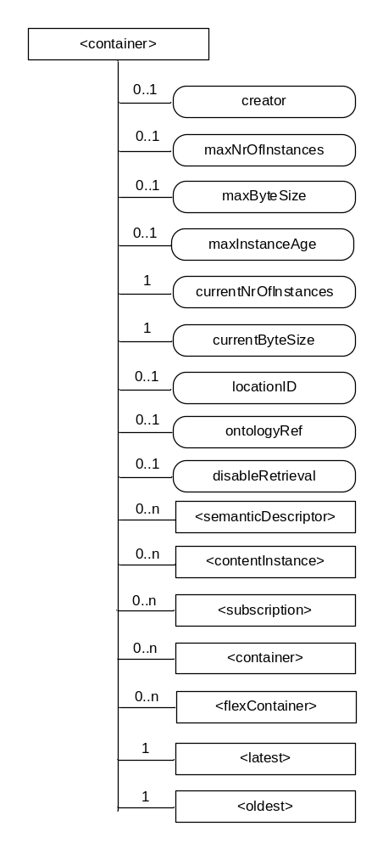
Figure 9.6.6-1: Structure of <container> resource
The <container> resource shall contain the child resources specified in table 9.6.6-1.
Table 9.6.6-1: Child resources of <container> resource
Child Resources of <container> | Child Resource Type | Multiplicity | Description | <containerAnnc> Child Resource Types
semanticDescriptor | <semanticDescriptor> | 0..n | See clause 9.6.30 | <semanticDescriptor>, <semanticDescriptorAnnc>
[variable] | <contentInstance> | 0..n | See clause 9.6.7 | <contentInstance>, <contentInstanceAnnc>
[variable] | <subscription> | 0..n | See clause 9.6.8 | <subscription>
[variable] | <container> | 0..n | See clause 9.6.6 | <container>  <containerAnnc>
[variable] | <flexContainer> | 0..n | See clause 9.6.35 | <flexContainer>  <flexContainerAnnc>
latest | <latest> | 1 | See clause 9.6.27 | None
oldest | <oldest> | 1 | See clause 9.6.28 | None

The <container> resource shall contain the attributes specified in table 9.6.6-2.
Table 9.6.6-2: Attribute of <container> resource
Attributes of  <container> | Multiplicity | RW/  RO/  WO | Description | <containerAnnc> Attributes
resourceType | 1 | RO | See clause 9.6.1.3. | NA
resourceID | 1 | RO | See clause 9.6.1.3. | NA
resourceName | 1 | WO | See clause 9.6.1.3. | NA
parentID | 1 | RO | See clause 9.6.1.3. | NA
expirationTime | 1 | RW | See clause 9.6.1.3. | MA
accessControlPolicyIDs | 0..1 (L) | RW | See clause 9.6.1.3 . If no accessControlPolicyIDs are provided at the time of creation, the accessControlPolicyIDs of the parent resource is linked to this attribute | MA
labels | 0..1 (L) | RW | See clause 9.6.1.3. | MA
creationTime | 1 | RO | See clause 9.6.1.3. | NA
lastModifiedTime | 1 | RO | See clause 9.6.1.3. | NA
stateTag | 1 | RO | See clause 9.6.1.3. | OA
announceTo | 0..1 (L) | RW | See clause 9.6.1.3. | NA
announcedAttribute | 0..1 (L) | RW | See clause 9.6.1.3. | NA
dynamicAuthorizationConsultationIDs | 0..1 (L) | RW | See clause 9.6.1.3. | OA
creator | 0..1 | RO | The AE-ID or CSE-ID of the entity which created the resource. | NA
maxNrOfInstances | 0..1 | RW | Maximum number of direct child <contentInstance> resources in the <container> resource. | OA
maxByteSize | 0..1 | RW | Maximum size in bytes of data(i.e., content attribute of a <contentInstance> resource) that is allocated for the <container> resource for all direct child <contentInstance> resources in the <container> resource. | OA
maxInstanceAge | 0..1 | RW | Maximum age of a direct child <contentInstance> resource in the <container> resource. The value is expressed in seconds. | OA
currentNrOfInstances | 1 | RO | Current number of direct child <contentInstance> resource in the <container> resource. It is limited by the maxNrOfInstances. | OA
currentByteSize | 1 | RO | Current size in bytes of data(i.e., content attribute of a <contentInstance> resource) stored in all direct child <contentInstance> resources of a <container> resource. This is the summation of contentSize attribute values of the <contentInstance> resources. It is limited by themaxByteSize. | OA
locationID | 0..1 | RW | An ID of the resource where the attributes/policies that define how location information are obtained and managed. This attribute is defined only when the <container> resource is used for containing location information. | OA
ontologyRef | 0..1 | RW | A reference (URI) of the ontology used to represent the information that is stored in the child <contentInstance> resources of the present <container> resource (see note). | OA
disableRetrieval | 0..1 | RW | Boolean value to control RETRIE/UPDATE/DELETE operation on the child <contentInsance> resource.  When the value is set to ‘TRUE’, RETRIEVE/DELETE/UPDATE operations for child <contentInstance> shall be rejected at all times.  When the value is updated from 'TRUE' to 'FALSE', all existing <contentInstance> are deleted immediately.  When the value is set to ‘FALSE’, all operations are permitted on the <contentInstance> resource as per existing procedures. | OA
NOTE: The access to this URI is out of scope of oneM2M.

-----------------------End of change 3---------------------------------------------

-----------------------Start of change 4---------------------------------------------

9.6.3 Resource Type CSEBase
A <CSEBase> resource shall represent a CSE. The <CSEBase> resource shall be the root for all resources that are residing in the CSE.

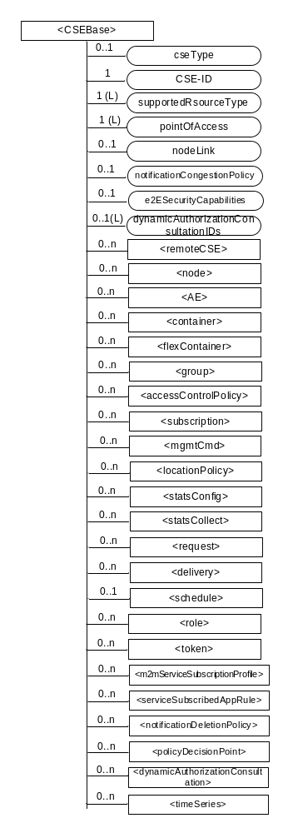
Figure 9.6.3-1: Structure of <CSEBase> resource
Figure 9.6.3-1 does not show the child announce resource types defined in table 9.6.3-2.
Editor’s Note: Annex E should be updated to include provisioning of the notification deletion policy.

The <CSEBase> resource shall contain the child resources specified in table 9.6.3-1.
Table 9.6.3-1: Child resources of <CSEBase> resource
Child Resources of <CSEBase> | Child Resource Type | Multiplicity | Description
[variable] | <remoteCSE> | 0..n | See clause 9.6.4
[variable] | <node> | 0..n | See clause 9.6.18
[variable] | <AE> | 0..n | See clause 9.6.5
[variable] | <container> | 0..n | See clause 9.6.6
[variable] | <flexContainer> | 0..n | See clause 9.6.35
[variable] | <group> | 0..n | See clause 9.6.13
[variable] | <accessControlPolicy> | 0..n | See clause 9.6.2
[variable] | <subscription> | 0..n | See clause 9.6.8
[variable] | <mgmtCmd> | 0..n | See clause 9.6.16
[variable] | <locationPolicy> | 0..n | See clause 9.6.10
[variable] | <statsConfig> | 0..n | See clause 9.6.23
[variable] | <statsCollect> | 0..n | See clause 9.6.25
[variable] | <request> | 0..n | See clause 9.6.12
[variable] | <delivery> | 0..n | See clause 9.6.11
[variable] | <schedule> | 0..1 | This resource defines the reachability schedule information of the entity. The absence of this resource implies the entity is always reachable. See clause 9.6.9
[variable] | <role> | 0..n | See clause 9.6.38
[variable] | <token> | 0..n | See clause 9.6.39
[variable] | <m2mServiceSubscriptionProfile> | 0..n | See clause 9.6.19
[variable] | <serviceSubscribedAppRule> | 0..n | See clause 9.6.29
[variable] | <notificationTargetPolicy> | 0..n | See clause 9.6.32
[variable] | <policyDecisionPoint> | 0..n | See clause 9.6.40
[variable] | <dynamicAuthorizationConsultation> | 0..n | See clause 9.6.43
[variable] | <timeSeries> | 0..n | See clause 9.6.36

Table 9.6.3-2: Child announced resources of <CSEBase> resource
Child Announced Resources of <CSEBase> | Child Announced Resource Type | Multiplicity | Description
[variable] | Refer Table 9.6.26.1-1 Announced Resource Types | 0..n

The child announced resources of <CSEBase> resource defined in table 9.6.3-2 should be created when an Originator CSE (i.e. original resource Hosting CSE) and a Hosting CSE (i.e. announced resource Hosting CSE) have no registration relationship (e.g. the Originator CSE has not created <remoteCSE> resource on the Hosting CSE).
The <CSEBase> resource shall contain the attributes specified in table 9.6.3-3.
Table 9.6.3-3: Attributes of <CSEBase> resource
Attributes of <CSEBase> | Multiplicity | RW/  RO/  WO | Description
resourceType | 1 | RO | See clause 9.6.1.3.
resourceID | 1 | RO | See clause 9.6.1.3.
resourceName | 1 | RO | See clause 9.6.1.3.
creationTime | 1 | RO | See clause 9.6.1.3.
lastModifiedTime | 1 | RO | See clause 9.6.1.3.
accessControlPolicyIDs | 0..1 (L) | RO | See clause 9.6.1.3.
labels | 0..1 (L) | RO | See clause 9.6.1.3.
dynamicAuthorizationConsultationIDs | 0..1 (L) | RO | See clause 9.6.1.3.
cseType | 0..1 | RO | Indicates the type of CSE represented by the created resource.  Mandatory for an IN-CSE, hence multiplicity (1).  Its presence is subject to SP configuration in case of an ASN-CSE or a MN-CSE.
CSE-ID | 1 | RO | The CSE identifier in SP-relative CSE-ID format (clause 7.2).
supportedResourceType | 1 (L) | RO | List of the resource types which are supported in the CSE. This attribute contains subset of resource types listed in clause 9.2. This also includes the supported optional attributes for each supported resource type.
pointOfAccess | 1 (L) | RO | Represents the list of physical addresses to be used by remote CSEs to connect to this CSE (e.g. IP address, FQDN). This attribute is exposed to its Registree.
nodeLink | 0..1 | RO | The resourceID of a <node> resource that represents the node specific information.
notificationCongestionPolicy | 0..1 | RO | This attribute applies to CSEs generating subscription notifications. It specifies the rule which is applied when the storage of notifications for each subscriber (an AE or CSE) reaches the maximum storage limit for notifications for that subscriber. E.g. Delete stored notifications of lower notificationStoragePriority to make space for new notifications of higher notificationStoragePriority, or delete stored notifications of older creationTime to make space for new notifications when all notifications are of the same notificationStoragePriority.
e2ESecurityCapabilities | 0..1 | RW | See clause 9.6.1.3.
NOTE: All the attributes of this resource type can be changed by an offline configuration mechanism, but not over the reference points (all attributes are "RO").

-----------------------End of change 4---------------------------------------------

-----------------------Start of change 5---------------------------------------------

9.6.4 Resource Type remoteCSE
A <remoteCSE> resource shall represent a Registree CSE that is registered to the Registrar CSE. <remoteCSE> resources shall be located directly under the <CSEBase> resource of Registrar CSE.
Similarly <remoteCSE> resource shall also represent a Registrar CSE. <remoteCSE> resource shall be located directly under the <CSEBase> resource of Registree CSE.
For example, when CSE1 (Registree CSE) registers with CSE2 (Registrar CSE), there will be two <remoteCSE> resources created: one in CSE1: <CSEBase1>/<remoteCSE2> and one in CSE2: <CSEBase2>/<remoteCSE1>.
Note that the creation of the two resources does not imply mutual registration. The <CSEBase1>/<remoteCSE2> does not mean CSE2 registered with CSE1 in the example above.

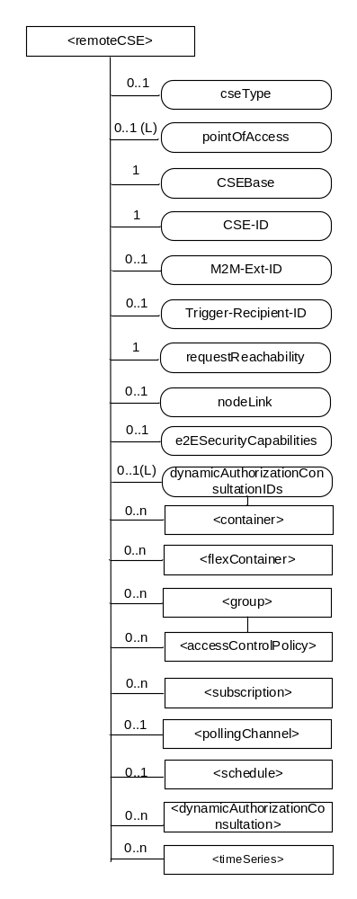
Figure 9.6.4-1: Structure of <remoteCSE> resource
The <remoteCSE> resource shall contain the child resources specified in table 9.6.4-1. The <remoteCSE> resource may contain <remoteCSEAnnc> child resources.
Table 9.6.4-1: Child resources of <remoteCSE> resource
Child Resources of <remoteCSE> | Child Resource Type | Multiplicity | Description | <remoteCSEAnnc> Child Resource Types
[variable] | <container> | 0..n | See clause 9.6.6 | <container> <containerAnnc>
[variable] | <flexContainer> | 0..n | See clause 9.6.35 | <flexContainer>  <flexContainerAnnc>
[variable] | <group> | 0..n | See clause 9.6.13 | <group>  <groupAnnc>
[variable] | <accessControlPolicy> | 0..n | See clause 9.6.2 | <accessControlPolicy>  <accessControlPolicyAnnc>
[variable] | <subscription> | 0..n | See clause 9.6.8 | <subscription>
[variable] | <pollingChannel> | 0..1 | See clause 9.6.21. If requestReachability is FALSE, the CSE that created this <remoteCSE> resource should create a <pollingChannel> resource and perform long polling. The <pollingChannel> shall be utilized by the the parent resource. | None
[variable] | <schedule> | 0..1 | This resource defines the reachability schedule information of the node. See clause 9.6.9 for <schedule>. | <scheduleAnnc>
[variable] | <nodeAnnc> | 0..n | This resource is the <nodeAnnc> resource representing the node where the CSE represented by this <remoteCSE> resource resides. | <nodeAnnc>
[variable] | <dynamicAuthorizationConsultation> | 0..n | See clause 9.6.43 | <dynamicAuthorizationConsultationAnnc>
[variable] | <timeSeries> | 0..n | See clause 9.6.36 | <timeSeriesAnnc>

Table 9.6.4-2: Child announced resources of <remoteCSE> resource
Child Announced Resources of <remoteCSE> | Child Announced Resource Type | Multiplicity | Description
[variable] | Refer to table 9.6.26.1-1 Announced Resource Types | 0..n

The <remoteCSE> resource shall contain the attributes specified in table 9.6.4-3.
Table 9.6.4-3: Attributes of <remoteCSE> resource
Attributes of <remoteCSE> | Multiplicity | RW/  RO/  WO | Description | <remoteCSEAnnc> Attributes
resourceType | 1 | RO | See clause 9.6.1.3. | NA
resourceID | 1 | RO | See clause 9.6.1.3. | NA
resourceName | 1 | WO | See clause 9.6.1.3. | NA
parentID | 1 | RO | See clause 9.6.1.3. | NA
creationTime | 1 | RO | See clause 9.6.1.3. | NA
lastModifiedTime | 1 | RO | See clause 9.6.1.3. | NA
expirationTime | 1 | RW | See clause 9.6.1.3. | MA
accessControlPolicyIDs | 0..1 (L) | RW | See clause 9.6.1.3. | MA
labels | 0..1 (L) | RW | See clause 9.6.1.3. | MA
announceTo | 0..1 (L) | RW | See clause 9.6.1.3. | NA
announcedAttribute | 0..1 (L) | RW | See clause 9.6.1.3. | NA
dynamicAuthorizationConsultationIDs | 0..1 (L) | RW | See clause 9.6.1.3. | OA
cseType | 0..1 | WO | Indicates the type of CSE represented by the created resource.  Mandatory for an IN-CSE, hence multiplicity (1).  Its presence is subject to SP configuration in case of an ASN-CSE or a MN-CSE. | OA
pointOfAccess | 0..1 (L) | RW | For request-reachable remote CSE it represents the list of physical addresses to be used to connect to it (e.g. IP address, FQDN).  If this information is not provided and <pollingChannel> resource does exis, the CSE should use <pollingChannel> resource. Then the Hosting CSE can forward a request to the CSE without using the PoA. | OA
CSEBase | 1 | WO | The address of the CSEBase resource represented by this <remoteCSE> resource. | OA
CSE-ID | 1 | WO | The CSE identifier in SP-relative CSE-ID format (clause 7.2). | OA
M2M-Ext-ID | 0..1 | RW | Supported when Registrar is IN-CSE.  See clause 7.1.8 where this attribute is described. This attribute is used only for the case of dynamic association of M2M-Ext-ID and CSE-ID. | NA
Trigger-Recipient-ID | 0..1 | RW | Supported when Registrar is IN-CSE. See clause 7.1.10 where this attribute is described. This attribute is used only for the case of dynamic association of M2M-Ext-ID and CSE-ID. | NA
requestReachability | 1 | RW | If the CSE that created this <remoteCSE> resource can receive a request from other AE/CSE(s), this attribute is set to "TRUE" otherwise "FALSE" (see note) | OA
nodeLink | 0..1 | RW | The resourceID of a <node> resource that hosts the CSE represented by the <remoteCSE> resource. | OA
e2ESecurityCapabilities | 0..1 | RW | See clause 9.6.1.3. | MA
NOTE: Even if this attribute is set to "FALSE", it does not mean it AE/CSE is always unreachable by all entities. E.g. the requesting AE/CSE is behind the same NAT, so it can communicate within the same NAT.

-----------------------End of change 5---------------------------------------------

CHECK LIST
- Does this change request include an informative introduction containing the problem(s) being solved, and a summary list of proposals.?
- Does this CR contain changes related to only one particular issue/problem?
- Have any mirror crs been posted?
- Does this change request make all the changes necessary to address the issue or problem? E.g. A change impacting 5 tables should not only include a proposal to change only 3 tables. Includes any changes to references, definitions, and acronyms in the same deliverable?
- Does this change request follow the drafting rules?
- Are all pictures editable?
- Have you checked the spelling and grammar?
- Have you used change bars for all modifications?
- Does the change include the current and surrounding clauses to clearly show where a change is located and to provide technical context of the proposed change? (Additions of complete sections need not show surrounding clauses as long as the proposed section number clearly shows where the new section is proposed to be located.)
- Are multiple changes in this CR clearly separated by horizontal lines with embedded text such as, start of change 1, end of change 1, start of new clause, end of new clause.?

