CHANGE REQUEST
Meeting:* | ARC 23
Source:* | Phil Hawkes, Qualcomm, phawkes@qti.qualcomm.com  Wolfgang Granzow, Qualcomm, wgranzow@qti.qualcomm.com  Josef Blanz, Qualcomm, jblanz@qti.qualcomm.com
Date:* | 2016-05-16
Contact:* | As above
Reason for Change/s:* | Clean-up of End-to-End Security of Primitives in TS-0001 Rel 2
CR against: Release* | 2
CR against: WI* | Active WI-0019 Dynamic Authorization  MNT Maintenance / < Work Item number(optional)>  STE Small Technical Enhancements / < Work Item number (optional)>  Only ONE of the above shall be ticked
CR against: TS/TR* | TS-0001 and 2.8.0
Clauses/Sub Clauses* | 9.6.1.3.2, 9.6.3, 9.6.4, 9.6.5, 10.2.1.5, 10.2.3.5, 11.4.2
Type of change: * | Editorial change  Bug Fix or Correction  Change to existing feature or functionality  New feature or functionality  Only ONE of the above shall be ticked
Post Freeze checking:* | This CR contains only essential changes and corrections? YES NO  This CR may break backwards compatibility with the last approved version of the TS? YES NO  This CR is a mirror CR? YES if YES, please indicate the document number of the original CR: <Document Number) : NO
Template Version:27 May 2015 (Dot not modify)

oneM2M Notice
The document to which this cover statement is attached is submitted to oneM2M. Participation in, or attendance at, any activity of oneM2M, constitutes acceptance of and agreement to be bound by terms of the Working Procedures and the Partnership Agreement, including the Intellectual Property Rights (IPR) Principles Governing oneM2M Work found in Annex 1 of the Partnership Agreement.

Introduction
This CR is a clean-up of clause 11.4.2 “Functional Architecture Specifications for End-to-End Security of Primitives (ESPrim)”. All changes are bug-fixes or editorial.
R00 Changes: This version was uploaded for SEC review prior to ARC discussions
- Editorial
  - receiverE2ERandTriple, sharedReceiverE2ERandTriple and originatorE2ERandTriple have been renamed to receiverESPrimRandObject, sharedReceiverESPrimRandObject and originatorESPrimRandObject respectively (to align with TS-0003)
  - The numbering format for the steps have been updated, based on advice from editHelp.
  - Table 11.4.2-2: “End-to-End Security Info” is shortened to correct name “Security Info”
- Bug Fixes
  - The call flow previously included use of a virtual attribute in sub-steps of step/phase B.2. The author has since learnt that virtual attributes are not presently supported, and the call flow has been altered slightly to avoid use of virtual resources.
  - Figure 11.4.2-1: “The transport details for establishing pairwiseESPrimKey and establishing sessionESPrimKey in the End-to-End Security of Primitives (ESPrim) Procedure” has been updated accordingly.
R01
- Editorial
  - e2eSecurityCapabilities changed to e2eSecInfo
  - E2E in names changed to ESPrim, e.g. receiverE2ERandObject changed to receiveESPrimRandObject.
  - Removed “-“ from the middle of names
- Bug Fixes
  - Need to add a Point of attachment for addressing the NOTIFY requests for (a) retrieving receiveESPrimRandObject and (b) transporting the ESPrim Object. Added esprimRandPoA and esprimPoA in e2eSecInfo attribute to provide this information. CR to TS-0004 has been provided to align with this change.
R03
- Corrected e2ESecurityCapabilities attribute name to e2eSecInfo in common attributes (9.6.1.3.2) resource resource definitions for <CSEBase> (9.6.3) , <remoteCSE> (9.6.4) and <AE> (9.6.5) resources.
- Provide Resource-Type-Specific procedures for Notify <AE> (used to send notification data to an AE) and Notify <CSEBase> (used to send notification data to an AE)
- The text referring to the esprimRandPoA and esprimPoA in e2eSecInfo attribute is now incorrect. This text is replaced with “resource-ID of the Receiver’s <CSEBase> or <AE> resource”.
R04: Changes the e2eSecInfo attribute in <CSEBase> to being “RO” (it was “RW”).
R05: Changes “resource-ID” to “address”. Cleanup Notify <AE> and Notify <CSEBase> resource.

----------------------- Start of change 0 ------------------------------------------

9.6.1.3.2 Common attributes
The following attributes are commonly used in multiple, but not all, resource types which are normal, not virtual or announced. Common attributes for announced resource types are independently defined in claused 9.6.26.3.
NOTE: The list of attributes in table 9.6.1.3.2-1 is not exhaustive.
Table 9.6.1.3.2-1: Common Attributes
Attribute Name | Description
accessControlPolicyIDs | The attribute contains a list of identifiers of an <accessControlPolicy> resource. The privileges defined in the <accessControlPolicy> resource that are referenced determine who is allowed to access the resource containing this attribute for a specific purpose (e.g. Retrieve, Update, Delete, etc.).  If a resource type does not have an accessControlPolicyIDs attribute definition, then the accessControlPolicyIDs for that resource is governed in a different way, for example, the accessControlPolicy associated with the parent may apply to a child resource that does not have an accessControlPolicyIDs attribute definition, or the privileges for access are fixed by the system. Refer to the corresponding resource type definitions and procedures to see how access control is handled in such cases.  If a resource type does have an accessControlPolicyIDs attribute definition, but the (optional) accessControlPolicyIDs attribute is not set, or it is set to a value that does not correspond to a valid, existing <accessControlPolicy> resource, or it refers to an <accessControlPolicy> resource that is not reachable (e.g. because it is located on a remote CSE that is offline or not reachable), then the system default access privileges shall apply.  All resources are accessible if and only if the privileges (i.e. shored as privileges or selfPrivileges attribute of <accessControlPolicy> resource) allow it, therefore all resources shall have an associated AccessControlPolicyIDs attribute, either explicitly (setting the attribute in the resource itself) or implicitly (either by using the parent privileges or the system default policies). Which means that the system shall provide a default access privileges in case that the Originator does not provide a specific accessControlPolicyIDs during the creation of the resource.  To update this attribute, a Hosting CSE shall check whether an Originator has Update permission in any selfPrivileges of the <accessControlPolicy> resources which this attribute originally indicates.
stateTag | An incremental counter of modification on the resource. When a resource is created, this counter is set to 0, and it will be incremented on every modification of the resource (see notes 1 and 2). The modification also includes direct child resource creation and deletion.
announceTo | This attribute may be included in a CREATE or UPDATE Request in which case it contains a list of addresses/CSE-IDs where the resource is to be announced. For the case that CSE-IDs are provided, the announced-to CSE shall decide the location of the announced resources based on the rules described in clause 9.6.26.  For the original resource, this attribute shall only be present if it has been successfully announced to other CSEs. This attribute maintains the list of the resource addresses to the successfully announced resources. Updates on this attribute will trigger new resource announcement or de-announcement.  If announceTo attribute includes resource address(s), the present document does not provide any means for validating these address(s) for announcement purposes. It is the responsibility of the Hosting-CSE referenced by the resource address(s) to validate the access privileges of the originator of the Request that triggers the announcement.
announcedAttribute | This attributes shall only be present at the original resource if some Optional Announced (OA) type attributes have been announced to other CSEs. This attribute maintains the list of the announced Optional Attributes (OA type attributes) in the original resource. Updates to this attribute will trigger new attribute announcement if a new attribute is added or de-announcement if the existing attribute is removed.
labels | Tokens used to add meta-information to resources.  This attribute is optional.  The value of the labels attribute is a list of individual labels, each of them being:  - Either a standalone label-key, used as a simple “tag”, that can be used for example for discovery purposes when looking for particular resources that one can “tag” using that label-key  - Or a composite element made of a label-key and a label-value, separated by a special character defined in [3]. A label-key itself can consist of several sub-elements, separated by a special character also defined in [3].  The list of allowed characters in a label (and in label-keys and label-values) and separator characters is defined in [3], clause 6.3.3.
e2eSecInfo | Present in a resource representing an AE or CSE. Indicates the end-to-end security capabilities supported by the AE or CSE. May indicate supported end-to-end security frameworks. May also contains a certificate or credential identifier used by the AE or CSE. May include random values for use in end-to-end security protocols. The details of this attributes are described in oneM2M TS-0003 [Error: Reference source not found].  This attribute is optional and if not present it means that the represented entity does not support oneM2M end-to-end security procedures.
dynamicAuthorizationConsultationIDs | This attribute contains a list of identifiers of <dynamicAuthorizationConsultation> resources. The information defined in a <dynamicAuthorizationConsultation> resource is used by a CSE for initiating consultation-based dynamic authorization requests.  Consultation-based dynamic authorization is only performed for a targeted resource if and only if it is linked to an enabled <dynamicAuthorizationConsultation> resource.  If the attribute is not set or has a value that does not correspond to a valid <dynamicAuthorizationConsultation> resource(s), or it refers to an <dynamicAuthorizationConsultation> resource(s) that is not reachable, then the dynamicAuthorizationConsultationIDs associated with the parent may apply to the child resource if present, or a system default <dynamicAuthorizationConsultation> may apply if present.
NOTE 1: In order to enable detection of overflow, the counter needs to be capable of expressing sufficiently long numbers.
NOTE 2: This attribute has the scope to allow identifying changes in resources within a time interval that is lower than the one supported by the attribute lastModifiedTime (e.g. less than a second or millisecond). This attribute can also be used to avoid race conditions in case of competing modifications.

----------------------- End of change 0 ------------------------------------------

----------------------- Start of change 1------------------------------------------

9.6.3 Resource Type CSEBase
A <CSEBase> resource shall represent a CSE. The <CSEBase> resource shall be the root for all resources that are residing in the CSE.
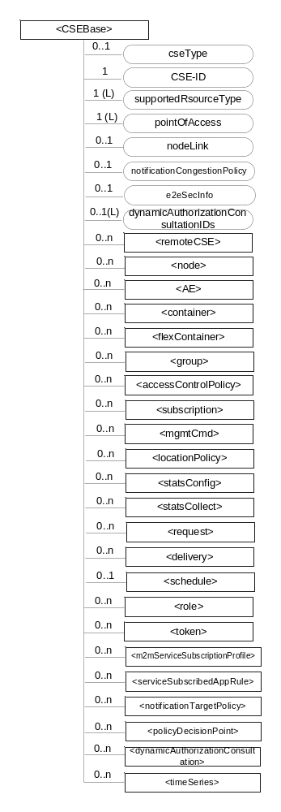
Figure 9.6.3-1: Structure of <CSEBase> resource
Figure 9.6.3-1 does not show the child announce resource types defined in table 9.6.3-2.
Editor's Note: Annex E should be updated to include provisioning of the notification deletion policy.
The <CSEBase> resource shall contain the child resources specified in table 9.6.3-1.
Table 9.6.3-1: Child resources of <CSEBase> resource
Child Resources of <CSEBase> | Child Resource Type | Multiplicity | Description
[variable] | <remoteCSE> | 0..n | See clause 9.6.4
[variable] | <node> | 0..n | See clause 9.6.18
[variable] | <AE> | 0..n | See clause 9.6.5
[variable] | <container> | 0..n | See clause 9.6.6
[variable] | <flexContainer> | 0..n | See clause 9.6.35
[variable] | <group> | 0..n | See clause 9.6.13
[variable] | <accessControlPolicy> | 0..n | See clause 9.6.2
[variable] | <subscription> | 0..n | See clause 9.6.8
[variable] | <mgmtCmd> | 0..n | See clause 9.6.16
[variable] | <locationPolicy> | 0..n | See clause 9.6.10
[variable] | <statsConfig> | 0..n | See clause 9.6.23
[variable] | <statsCollect> | 0..n | See clause 9.6.25
[variable] | <request> | 0..n | See clause 9.6.12
[variable] | <delivery> | 0..n | See clause 9.6.11
[variable] | <schedule> | 0..1 | This resource defines the reachability schedule information of the entity. The absence of this resource implies the entity is always reachable. See clause 9.6.9
[variable] | <role> | 0..n | See clause 9.6.38
[variable] | <token> | 0..n | See clause 9.6.39
[variable] | <m2mServiceSubscriptionProfile> | 0..n | See clause 9.6.19
[variable] | <serviceSubscribedAppRule> | 0..n | See clause 9.6.29
[variable] | <notificationTargetPolicy> | 0..n | See clause 9.6.32
[variable] | <policyDecisionPoint> | 0..n | See clause 9.6.40
[variable] | <dynamicAuthorizationConsultation> | 0..n | See clause 9.6.43
[variable] | <timeSeries> | 0..n | See clause 9.6.36

Table 9.6.3-2: Child announced resources of <CSEBase> resource
Child Announced Resources of <CSEBase> | Child Announced Resource Type | Multiplicity | Description
[variable] | Refer Table 9.6.26.1-1 Announced Resource Types | 0..n

The child announced resources of <CSEBase> resource defined in table 9.6.3-2 should be created when an Originator CSE (i.e. original resource Hosting CSE) and a Hosting CSE (i.e. announced resource Hosting CSE) have no registration relationship (e.g. the Originator CSE has not created <remoteCSE> resource on the Hosting CSE).
The <CSEBase> resource shall contain the attributes specified in table 9.6.3-3.
Table 9.6.3-3: Attributes of <CSEBase> resource
Attributes of <CSEBase> | Multiplicity | RW/  RO/  WO | Description
resourceType | 1 | RO | See clause 9.6.1.3.
resourceID | 1 | RO | See clause 9.6.1.3.
resourceName | 1 | RO | See clause 9.6.1.3.
creationTime | 1 | RO | See clause 9.6.1.3.
lastModifiedTime | 1 | RO | See clause 9.6.1.3.
accessControlPolicyIDs | 0..1 (L) | RO | See clause 9.6.1.3.
labels | 0..1 (L) | RO | See clause 9.6.1.3.
dynamicAuthorizationConsultationIDs | 0..1 (L) | RO | See clause 9.6.1.3.
cseType | 0..1 | RO | Indicates the type of CSE represented by the created resource:  - Mandatory for an IN-CSE, hence multiplicity (1).  - Its presence is subject to SP configuration in case of an ASN-CSE or a MN-CSE.
CSE-ID | 1 | RO | The CSE identifier in SP-relative CSE-ID format (clause 7.2).
supportedResourceType | 1 (L) | RO | List of the resource types which are supported in the CSE. This attribute contains subset of resource types listed in clause 9.2. This also includes the supported optional attributes for each supported resource type.
pointOfAccess | 1 (L) | RO | Represents the list of physical addresses to be used by remote CSEs to connect to this CSE (e.g. IP address, FQDN). This attribute is exposed to its Registree.
nodeLink | 0..1 | RO | The resourceID of a <node> resource that represents the node specific information.
notificationCongestionPolicy | 0..1 | RO | This attribute applies to CSEs generating subscription notifications. It specifies the rule which is applied when the storage of notifications for each subscriber (an AE or CSE) reaches the maximum storage limit for notifications for that subscriber. E.g. Delete stored notifications of lower notificationStoragePriority to make space for new notifications of higher notificationStoragePriority, or delete stored notifications of older creationTime to make space for new notifications when all notifications are of the same notificationStoragePriority.
e2eSecInfo | 0..1 | RO | See clause 9.6.1.3.
NOTE: All the attributes of this resource type can be changed by an offline configuration mechanism, but not over the reference points (all attributes are "RO").

9.6.4 Resource Type remoteCSE
A <remoteCSE> resource shall represent a Registree CSE that is registered to the Registrar CSE. <remoteCSE> resources shall be located directly under the <CSEBase> resource of Registrar CSE.
Similarly <remoteCSE> resource shall also represent a Registrar CSE. <remoteCSE> resource shall be located directly under the <CSEBase> resource of Registree CSE.
For example, when CSE1 (Registree CSE) registers with CSE2 (Registrar CSE), there will be two <remoteCSE> resources created: one in CSE1: <CSEBase1>/<remoteCSE2> and one in CSE2: <CSEBase2>/<remoteCSE1>.
Note that the creation of the two resources does not imply mutual registration. The <CSEBase1>/<remoteCSE2> does not mean CSE2 registered with CSE1 in the example above.
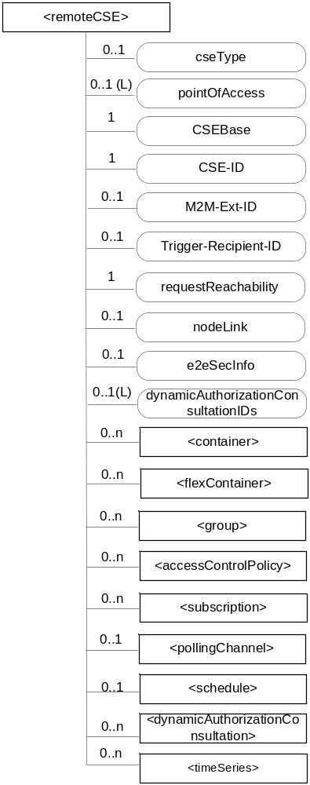
Figure 9.6.4-1: Structure of <remoteCSE> resource
The <remoteCSE> resource shall contain the child resources specified in table 9.6.4-1. The <remoteCSE> resource may contain <remoteCSEAnnc> child resources.
Table 9.6.4-1: Child resources of <remoteCSE> resource
Child Resources of <remoteCSE> | Child Resource Type | Multiplicity | Description | <remoteCSEAnnc> Child Resource Types
[variable] | <container> | 0..n | See clause 9.6.6 | <container> <containerAnnc>
[variable] | <flexContainer> | 0..n | See clause 9.6.35 | <flexContainer>  <flexContainerAnnc>
[variable] | <group> | 0..n | See clause 9.6.13 | <group>  <groupAnnc>
[variable] | <accessControlPolicy> | 0..n | See clause 9.6.2 | <accessControlPolicy>  <accessControlPolicyAnnc>
[variable] | <subscription> | 0..n | See clause 9.6.8 | <subscription>
[variable] | <pollingChannel> | 0..1 | See clause 9.6.21. If requestReachability is FALSE, the CSE that created this <remoteCSE> resource should create a <pollingChannel> resource and perform long polling. The <pollingChannel> shall be utilized by the the parent resource. | None
[variable] | <schedule> | 0..1 | This resource defines the reachability schedule information of the node. See clause 9.6.9 for <schedule>. | <scheduleAnnc>
[variable] | <nodeAnnc> | 0..n | This resource is the <nodeAnnc> resource representing the node where the CSE represented by this <remoteCSE> resource resides. | <nodeAnnc>
[variable] | <dynamicAuthorizationConsultation> | 0..n | See clause 9.6.43 | <dynamicAuthorizationConsultationAnnc>
[variable] | <timeSeries> | 0..n | See clause 9.6.36 | <timeSeriesAnnc>

Table 9.6.4-2: Child announced resources of <remoteCSE> resource
Child Announced Resources of <remoteCSE> | Child Announced Resource Type | Multiplicity | Description
[variable] | Refer to table 9.6.26.1-1 Announced Resource Types | 0..n

The <remoteCSE> resource shall contain the attributes specified in table 9.6.4-3.
Table 9.6.4-3: Attributes of <remoteCSE> resource
Attributes of <remoteCSE> | Multiplicity | RW/  RO/  WO | Description | <remoteCSEAnnc> Attributes
resourceType | 1 | RO | See clause 9.6.1.3. | NA
resourceID | 1 | RO | See clause 9.6.1.3. | NA
resourceName | 1 | WO | See clause 9.6.1.3. | NA
parentID | 1 | RO | See clause 9.6.1.3. | NA
creationTime | 1 | RO | See clause 9.6.1.3. | NA
lastModifiedTime | 1 | RO | See clause 9.6.1.3. | NA
expirationTime | 1 | RW | See clause 9.6.1.3. | MA
accessControlPolicyIDs | 0..1 (L) | RW | See clause 9.6.1.3. | MA
labels | 0..1 (L) | RW | See clause 9.6.1.3. | MA
announceTo | 0..1 (L) | RW | See clause 9.6.1.3. | NA
announcedAttribute | 0..1 (L) | RW | See clause 9.6.1.3. | NA
dynamicAuthorizationConsultationIDs | 0..1 (L) | RW | See clause 9.6.1.3. | OA
cseType | 0..1 | WO | Indicates the type of CSE represented by the created resource.  - Mandatory for an IN-CSE, hence multiplicity (1).  - Its presence is subject to SP configuration in case of an ASN-CSE or a MN-CSE. | OA
pointOfAccess | 0..1 (L) | RW | For request-reachable remote CSE it represents the list of physical addresses to be used to connect to it (e.g. IP address, FQDN).  If this information is not provided and <pollingChannel> resource does exis, the CSE should use <pollingChannel> resource. Then the Hosting CSE can forward a request to the CSE without using the PoA. | OA
CSEBase | 1 | WO | The address of the CSEBase resource represented by this <remoteCSE> resource. | OA
CSE-ID | 1 | WO | The CSE identifier in SP-relative CSE-ID format (clause 7.2). | OA
M2M-Ext-ID | 0..1 | RW | Supported when Registrar is IN-CSE.  See clause 7.1.8 where this attribute is described. This attribute is used only for the case of dynamic association of M2M-Ext-ID and CSE-ID. | NA
Trigger-Recipient-ID | 0..1 | RW | Supported when Registrar is IN-CSE. See clause 7.1.10 where this attribute is described. This attribute is used only for the case of dynamic association of M2M-Ext-ID and CSE-ID. | NA
requestReachability | 1 | RW | If the CSE that created this <remoteCSE> resource can receive a request from other AE/CSE(s), this attribute is set to "TRUE" otherwise "FALSE" (see note) | OA
nodeLink | 0..1 | RW | The resourceID of a <node> resource that hosts the CSE represented by the <remoteCSE> resource. | OA
e2eSecInfo | 0..1 | RW | See clause 9.6.1.3. | MA
NOTE: Even if this attribute is set to "FALSE", it does not mean it AE/CSE is always unreachable by all entities. E.g. the requesting AE/CSE is behind the same NAT, so it can communicate within the same NAT.

9.6.5 Resource Type AE
An <AE> resource shall represent information about an Application Entity registered to a CSE.
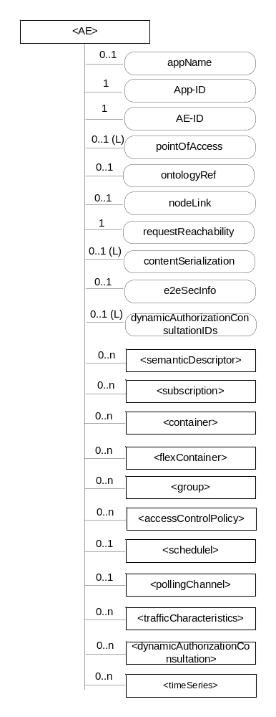
Figure 9.6.5-1: Structure of <AE> resource
The <AE> resource shall contain the child resources specified in table 9.6.5-1.
Table 9.6.5-1: Child resources of <AE> resource
Child Resources of <AE> | Child Resource Type | Multiplicity | Description | <AEAnnc> Child Resource Types
semanticDescriptor | <semanticDescriptor> | 0..n | See clause 9.6.30 | <semanticDescriptor>, <semanticDescriptorAnnc>
[variable] | <subscription> | 0..n | See clause 9.6.8 | <subscription>
[variable] | <container> | 0..n | See clause 9.6.6 | <container> <containerAnnc>
[variable] | <flexContainer> | 0..n | See clause 9.6.35 | <flexContainer>  <flexContainerAnnc>
[variable] | <group> | 0..n | See clause 9.6.13 | <group>  <groupAnnc>
[variable] | <accessControlPolicy> | 0..n | See clause 9.6.2 | <accessControlPolicy>  <accessControlPolicyAnnc>
[variable] | <schedule> | 0..1 | See clause 9.6.9 | <scheduleAnnc>
[variable] | <pollingChannel> | 0..1 | See clause 9.6.21  When the AE is request-unreachable, the AE should create this <pollingChannel> resource and perform long polling. The <pollingChannel> shall be utilized by the the parent resource | None
trafficCharacteristics | <trafficCharacteristics> | 0..n | See clause 9.6.41 | <trafficCharacteristicsAnnc>
[variable] | <dynamicAuthorizationConsultation> | 0..n | See clause 9.6.43 | <dynamicAuthorizationConsultationAnnc>
[variable] | <timeSeries> | 0..n | See clause 9.6.36 | <timeSeriesAnnc>

The <AE> resource shall contain the attributes specified in table 9.6.5-2.
Table 9.6.5-2: Attributes of <AE> resource
Attributes of  <AE> | Multiplicity | RW/  RO/  WO | Description | <AEAnnc> Attributes
resourceType | 1 | RO | See clause 9.6.1.3. | NA
resourceID | 1 | RO | See clause 9.6.1.3. Contains the AE-ID-Stem of the AE (see clause 7.2 on identifier formats and clause 10.1.1.2.2 for AE registration procedure). | NA
resourceName | 1 | WO | See clause 9.6.1.3. | NA
parentID | 1 | RO | See clause 9.6.1.3. | NA
expirationTime | 1 | RW | See clause 9.6.1.3. | MA
accessControlPolicyIDs | 0..1 (L) | RW | See clause 9.6.1.3. | MA
creationTime | 1 | RO | See clause 9.6.1.3. | NA
lastModifiedTime | 1 | RO | See clause 9.6.1.3. | NA
labels | 0..1 (L) | RW | See clause 9.6.1.3. | MA
announceTo | 0..1 (L) | RW | See clause 9.6.1.3. | NA
announcedAttribute | 0..1 (L) | RW | See clause 9.6.1.3. | NA
dynamicAuthorizationConsultationIDs | 0..1 (L) | RW | See clause 9.6.1.3. | OA
appName | 0..1 | RW | The name of the application, as declared by the application developer(e.g. "HeatingMonitoring").  Several sibling resources may share the appName. | OA
App-ID | 1 | WO | The identifier of the Application (see clause 7.1.2). | OA
AE-ID | 1 | RO | The identifier of the Application Entity (see clause 7.1.2). | OA
pointOfAccess | 0..1 (L) | RW | The list of addresses for communicating with the registered Application Entity over Mca reference point via the transport services provided by Underlying Network (e.g. IP address, FQDN, URI). This attribute shall be accessible only by the AE and the Hosting CSE.  If this information is not provided and the <pollingChannel> resource does exist, the AE should use <pollingChannel> resource. Then the Hosting CSE can forward a request to the AE without using the PoA. | OA
ontologyRef | 0..1 | RW | A URI of the ontology used to represent the information that is managed and understood by the AE. | OA
requestReachability | 1 | RW | If the AE that created this <AE> resource can receive a request, this attribute is set to "TRUE" otherwise "FALSE" | OA
nodeLink | 0..1 | RW | The resourceID of a <node> resource that stores the node specific information where this AE resides. | OA
contentSerialization | 0..1 (L) | RW | The list of supported serializations of the Content primitive parameter for receiving a request from its registrar CSE. (e.g. XML, JSON). The list shall be ordered so that the most preferred format comes first. | OA
e2eSecInfo | 0..1 | RW | See clause 9.6.1.3. | MA

----------------------- End of change 1-------------------------------------------

-----------------------Start of change 2 (new clause)-----------------------------

10.2.1.5 Notify <AE>
This procedure shall be used for sending a Notify request to an <AE> resource. This procedure is used for sending notification data to an AE. In this description, the Receiver is the CSE hosting the <AE>.
Table 10.2.1.5-1: <AE> NOTIFY
<AE> NOTIFY
Associated Reference Point | Mca, Mcc and Mcc'
Information in Request message | All parameters defined in table 8.1.2-3 apply
Processing at Originator before sending Request | According to clause 10.1.5
Processing at Receiver | The Hosting CSE shall re-target the Notify request to the AE according to clause 9.3.2.3.1.
Information in Response message | According to clause 10.1.5
Processing at Originator after receiving Response | According to clause 10.1.5
Exceptions | According to clause 10.1.5

----------------------- End of change 2-------------------------------------------

-----------------------Start of change 3-------------------------------------------

10.2.3.5 Notify <CSEBase>
This procedure shall be used for sending a Notify request to a <CSEBase> resource. This procedure is used for sending notification data to a CSE. In this description, the Receiver is the Hosting CSE of the <CSEBase> resource.
Table 10.2.3.5-1: <CSEBase> NOTIFY
<CSEBase> NOTIFY
Associated Reference Point | Mca, Mcc and Mcc'
Information in Request message | All parameters defined in table 8.1.2-3 apply
Processing at Originator before sending Request | According to clause 10.1.5
Processing at Receiver | According to clause 10.1.5.
Information in Response message | According to clause 10.1.5
Processing at Originator after receiving Response | According to clause 10.1.5
Exceptions | According to clause 10.1.5

----------------------- End of change 3-------------------------------------------

-----------------------Start of change 4-------------------------------------------

11.4.2 Functional Architecture Specifications for End-to-End Security of Primitives (ESPrim)
End-to-End Security for Primitives (ESPrim) provides an interoperable framework for securing oneM2M primitives so CSEs do not need to be trusted with the confidentiality and integrity of the primitive. ESPrim provides mutual authentication, confidentiality, integrity protection and a freshness guarantee (bounding the age of secured primitives).
The credential management aspects and data protection aspects for ESPrim are specified in TS-0003 [2]. The present clause specifies the transport of secured primitives.
The primitive to be secured is called the inner primitive, and the primitive which is used to transport a secured inner primitive is called the outer primitive. The inner primitive is protected using an encryption and integrity protection, which takes a symmetric key sessionESPrimKey as input. The sessionESPrimKey is derived from a pairwiseESPrimKey, established between the Originator and Receiver, and a receiverESPrimRandObject and originatorESPrimRandObject. The receiverESPrimRandObject and originatorESPrimRandObject

are specified in TS-0003 [2].
The transport details for the ESPrim Procedure are shown in Figures 11.4.2-1 and 11.4.2-2, and described in the following text.
NOTE 1: The outer primitive is not acting on resources because the outer primitive is only used to transport the ESPrim object securing the inner primitive. This is the reason that the NOTIFY procedure is used for the outer primitive.
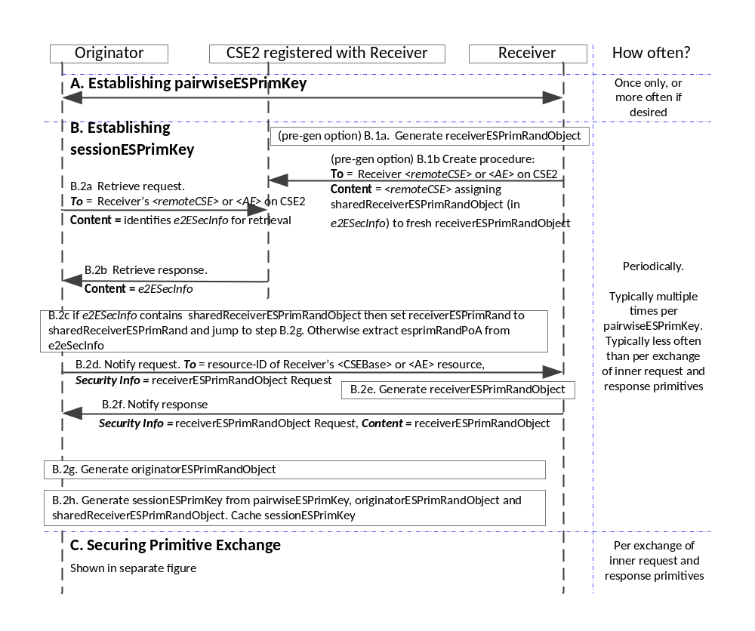
Figure 11.4.2-1: The transport details for establishing pairwiseESPrimKey and establishing sessionESPrimKey in the End-to-End Security of Primitives (ESPrim) Procedure. This message flow shows the sequence of events for Blocking Mode.
- Establishing pairwiseESPrimKey: The pairwiseESPrimKey shall be established as specified in clause 8.4.2 “End-to-End Security of Primitives (ESPrim) Architecture” in TS-0003 [2].
- Establishing sessionESPrimKey: The Receiver shall select to either (a) pre-generate a receiverESPrimRandObject which is distributed for used by multiple Originators for establishing sessionESPrimKey, or (b) generate a unique receiverESPrimRandObject upon request (in which case no action is required prior to receiving such a request).
  - (Optional) Receiver pre-generates and distributes receiverESPrimRandObject. If the Receiver selected to pre-generate and distribute a receiverESPrimRandObject, the Receiver performs the following steps every time the Receiver wishes to provide a new shared receiverESPrimRandObject:
    - The Receiver shall generate a receiverESPrimRandObject as described in TS-0003 [2].
    - The Receiver shall update the Receiver’s <remoteCSE> or <AE> resource on all CSEs to which the Receiver is registered, with the sharedReceiverESPrimRandObject parameter of the e2eSecInfo attribute containing the generated receiverESPrimRandObject.
In the latter case, the Receiver shall ensure that the sharedReceiverESPrimRandObject parameter is not present in the e2eSecInfo attribute in the Receiver’s <remoteCSE> or <AE> resource on all CSEs to which the Receiver is registered. The absence of the sharedReceiverESPrimRandObject parameter indicates that the Receiver will provide a unique receiverESPrimRandObject upon request.
  - Originator obtains receiverESPrimRandObject
    - The Originator shall perform a Retrieve on the e2eSecInfo attribute in the Receiver’s <remoteCSE> or <AE> resource on a CSE, here denoted CSE2, with which the Receiver is registered.
    - If the e2eSecInfo attribute is present in the Receiver’s <remoteCSE> or <AE> resource on CSE2, then CSE2 shall returns the e2eSecInfo attribute. Otherwise CSE2 shall return an appropriate error message.
    - (This step is also described in TS-0003 [2]. Where there is a conflict, TS-0003 [2] is to be treated as the authoritative description).
    - The Originator determines if the Receiver supports ESPrim, which requires that the e2ESecInfo attribute is present and the e2ESecInfo attribute indicates support for ESPrim.
      - If the Receiver does not support ESPrim, then the Originator aborts the procedure.
      - If the Receiver supports ESPrim, and the e2eSecInfo attribute includes a sharedReceiverESPrimRandObject parameter, then the Originator shall examine the ESPrimRandExpiry in this parameter to determine if the sharedReceiverESPrimRandObject has expired. If the sharedReceiverESPrimRandObject has not expired, then the Originator sets receiverESPrimRandObject to the value of receiverESPrimRandObject and proceeds to step B.2.g. If the sharedReceiverESPrimRandObject has expired, then the Originator sets receiverESPrimRandObject to the value of receiverESPrimRandObject and proceeds to step B.2.d.
      - If the Receiver supports ESPrim, and the e2eSecInfo attribute does not include a sharedReceiverESPrimRandObject parameter, then the Originator proceeds to step B.2.d.

      - The Originator shall send a NOTIFY request to the Receiver with the To parameter set to the address of the Receiver’s <CSEBase> or <AE> resource, and the Security Info primitive parameter indicating that this is NOTIFY request is a “receiverESPrimRandObject request”.
NOTE 2: When the Receiver is a CSE, the Originator can use the Receiver’s CSE-ID followed by “/.” as the address of the Receiver’s <CSEBase>.
    - The Receiver, upon receiving such a NOTIFY request, shall generate a receiverESPrimRandObject as described in TS-0003 [2].
    - The Receiver shall send a NOTIFY response to the Originator with the Security Info parameter indicating that this is a “receiverESPrimRandObject request” and containing the receiverESPrimRandObject.

    - The Originator shall generate an originatorESPrimRandObject as described in clause 8.4.2 TS-0003 [2].
    - The Originator shall generate the sessionESPrimKey from the pairwiseESPrimKey, originatorESPrimRandTuple and receiverESPrimRandTuple as described in clause 8.4.2 TS-0003 [2].
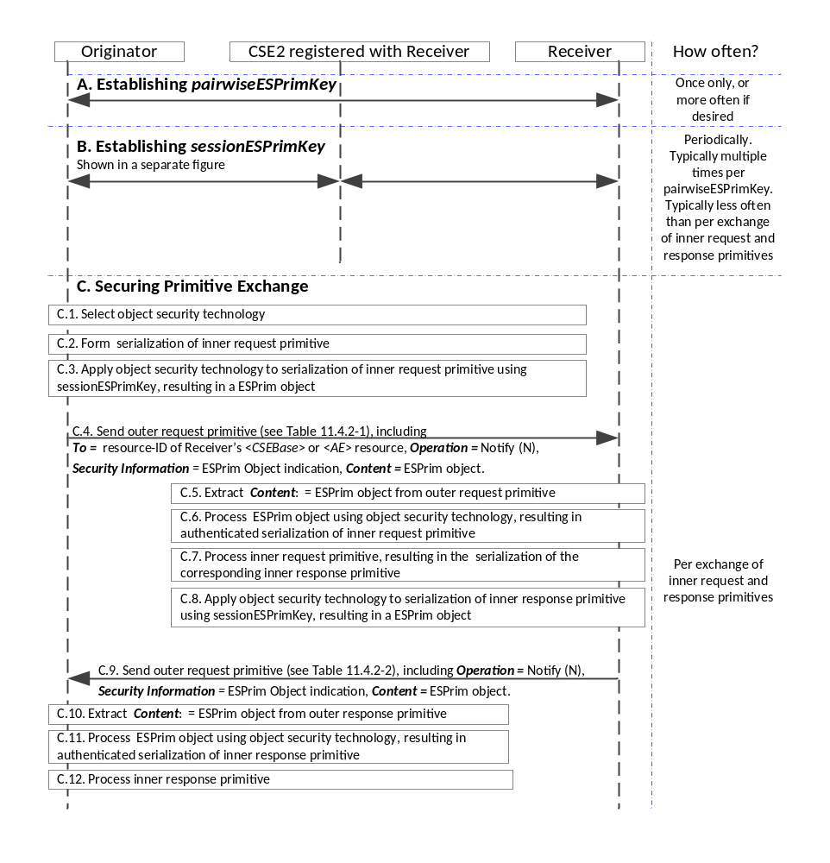Figure 11.4.2-2: The transport details for Securing a Primitive Exchange in the End-to-End Security of Primitives (ESPrim) Procedure. This message flow shows the sequence of events for Blocking Mode.
- Securing a Primitive Exchange
  - The Originator selects the object security technology as described in clause 8.4.2 of TS-0003 [2].
  - The Originator shall form the serialization of the inner request primitive.
  - The Originator shall produce a ESPrim Object from the serialization of the inner request primitive by applying the selected object security technology using the established parameters, as described in clause 8.4.2 of TS-0003 [2].
  - The Originator shall send the ESPrim Object to the Receiver in the Security Info parameter of an outer request primitive, and including the indication that Security Info contains an ESPrim Object. The outer request primitive shall be a NOTIFY request primitive with To set to the address of the Receiver’s <CSEBase> or <AE> resource. See Note 2. The parameters of the outer request primitive shall be assigned as described in Table 11.4.2-1.
  - The Receiver shall process the outer request primitive as for normal NOTIFY request primitives. The Receiver shall extract the
  - Security Info: processing the indication that it contains an ESPrim Object, and
  - extract the ESPrim Object containing the secured inner request primitive.
  - The Receiver shall process the ESPrim Object according to the indicated object security technology resulting in the verified serialization of the inner request primitive. This processing is described in 8.4.2 of TS-0003 [2].
    - If this processing is unsuccessful, then the Receiver shall generate an error message,
      - If the Receiver knows a currently valid sessionESPrimKey previously established with the Originator, then the receiver shall secure the error message using ESPrim as described in clause 8.4.2 of TS-0003 [2]. In this case the message flow skips to step C.9.
      - If Receiver does not knows a currently valid sessionESPrimKey previously established with the Originator, then the Receiver shall send a NOTIFY response with the (unsecured) error message in the Content parameter. The Originator processes the response as for a normal error case.
  - The Receiver shall process the inner request primitive, resulting in a serialization of the corresponding inner response primitive.
NOTE: Steps C.3 to C.7 are mirrored closely by C.10 to C.16, with the Originator and Receiver swapping their participation in the exchange, and the request primitives replaced by response primitives.
  - The Receiver shall produce a ESPrim Object from the serialization of the inner response primitive by applying the selected object security technology using the established parameters, as described in clause 8.4.2 of TS-0003 [2].
  - The Receiver shall send the ESPrim Object to the Originator in the Security Info parameter of an outer response primitive, including the indication that Security Info contains an ESPrim Object. The outer response primitive shall be a NOTIFY response primitive. The parameters of the outer request primitive shall be assigned as described in Table 11.4.2-2.
  - The Originator shall process the outer response primitive as for normal NOTIFY response primitives. The Originator shall extract the
  - Security Info: processing the indication that the Security Info contains an ESPrim Object, and extracting
  - the ESPrim Object containing the secured inner response primitive.
  - The Originator shall process the ESPrim Object according to the indicated object security technology resulting in the verified serialization of the inner response primitive or an error message. This processing is described in 8.4.2 of TS-0003 [2].
  - The Originator shall process the inner response primitive or error message.

Table 11.4.2-1: NOTIFY Request Message Parameters when using ESPrim
Request message parameter |  | Mandatory/ Optional for ESPrim | Details
Mandatory | Operation - operation to be executed | M | NOTIFY
Mandatory | To - the address of the target resource on the target CSE | M | Address of the Receiver’s <CSEBase> or <AE> resource
Mandatory | From - the identifier of the message Originator | M
Mandatory | Request Identifier - uniquely identifies a Request message | M | May be independent of the Request Identifier of the inner request primitive
Operation dependent | Content - to be transferred | NP | -
Operation dependent | Resource Type - of resource to be created | N/A | N/A
Optional | Originating Timestamp - when the message was built | O | Time when the outer request primitive was build
Optional | Request Expiration Timestamp - when the request message expires | O | Copied from the corresponding parameter in the inner request primitive.
Optional | Result Expiration Timestamp - when the result message expires | O | Copied from the corresponding parameter in the inner request primitive.
Optional | Operational Execution Time - the time when the specified operation is to be executed by the target CSE | N/A | The operation execution here is the cryptographic operations performed by the Receiver, which shall be executed immediately.
Optional | Response Type - type of response that shall be sent to the Originator | O | Any mode may be applied.
Optional | Result Persistence - the duration for which the reference containing the responses is to persist | N/A | N/A for NOTIFY
Optional | Result Content - the expected components of the result | N/A | The result content here is the Result Content of the outer primitive, which is always ESPrim Object
Optional | Event Category - indicates how and when the system should deliver the message | O | Copied from the corresponding parameter in the inner request primitive.
Optional | Delivery Aggregation - aggregation of requests to the same target CSE is to be used | O | Copied from the corresponding parameter in the inner request primitive.
Optional | Group Request Identifier - Identifier added to the group request that is to be fanned out to each member of the group | N/A | This parameter may be present in the inner request primitive, but shall not be present in the outer primitive.
Optional | Filter Criteria - conditions for filtered retrieve operation | N/A | N/A for NOTIFY
Optional | Discovery Result Type - format of information returned for Discovery operation | N/A | N/A for NOTIFY
Optional | Security Info – information about the Content if it contains an end-to-end security protocol message | M | Indication that the Security Info contains an ESPrim Object, and the ESPrim Object

Table 11.4.2-2: NOTIFY Response Message Parameters when using ESPrim
Response message parameter/success or not | Mandatory/ Optional for ESPrim | Details
Request Identifier - uniquely identifies a Request message | M | Matches corresponding parameter in outer request primitive
Content - to be transferred | NP | ESPrim Object
To - the identifier of the Originator or the Transit CSE that sent the corresponding non-blocking request | O | As for NOTIFY
From - the identifier of the Receiver | O | As for NOTIFY
Originating Timestamp - when the message was built | O | Time when the outer request primitive was build
Result Expiration Timestamp - when the message expires | O | Copied from the corresponding parameter in the inner request primitive.
Event Category - what event category shall be used for the response message | O | Copied from the corresponding parameter in the inner request primitive.
Content Status | N/A | N/A for NOTIFY
Content Offset | N/A | N/A for NOTIFY
Security Info – information about the Content if it contains security parameters | M | Indicating that the Security Info contains an ESPrim Object, and the ESPrim Object

-----------------------End of change 4 -------------------------------------------

