CHANGE REQUEST
Meeting:* | ARC#25
Source:* | InterDigital and Huawei
Date:* | 2016-10-09
Contact:* | Dale Seed (dale.seed@InterDigital.com )  Jing Li (Jessie) (lijing80@huawei.com )
Reason for Change/s:* | Introducing functionality for re-targeting <contentInstance> RETRIEVE and CREATE requests to AEs by enhancing <container> resource.
CR against: Release* | Release-3
CR against: WI* | Active WI-0063 (Generic Interworking Enhancements)  MNT Maintenance / < Work Item number(optional)>  STE Small Technical Enhancements / < Work Item number (optional)>  Only ONE of the above shall be ticked
CR against: TS/TR* | TS-0001- V2.10.0
Clauses/Sub Clauses* | 9.6.6, 9.6.27, 10.2.22.1, 10.2.19.2
Type of change: * | Editorial change  Bug Fix or Correction  Change to existing feature or functionality  New feature or functionality  Only ONE of the above shall be ticked
Post Freeze checking:* | This CR contains only essential changes and corrections? YES NO  This CR is a mirror CR? YES NO if YES, please indicate the document number of the original CR:
Template Version:23 February 2015 (Dot not modify)

oneM2M Notice
The document to which this cover statement is attached is submitted to oneM2M. Participation in, or attendance at, any activity of oneM2M, constitutes acceptance of and agreement to be bound by terms of the Working Procedures and the Partnership Agreement, including the Intellectual Property Rights (IPR) Principles Governing oneM2M Work found in Annex 1 of the Partnership Agreement.
GUIDELINES for Change Requests:
Provide an informative introduction containing the problem(s) being solved, and a summary list of proposals.
Each CR should contain changes related to only one particular issue/problem.
In case of a correction, and the change apply to previous releases, a separated “mirror CR” should be posted at the same time of this CR
Follow the principle of completeness, where all changes related to the issue or problem within a deliverable are simultaneously proposed to be made E.g. A change impacting 5 tables should not only include a proposal to change only 3 tables. Includes any changes to references, definitions, and acronyms in the same deliverable.
Follow the drafting rules.
All pictures must be editable.
Check spelling and grammar to the extent practicable.
Use Change bars for modifications.
The change should include the current and surrounding clauses to clearly show where a change is located and to provide technical context of the proposed change. Additions of complete sections need not show surrounding clauses as long as the proposed section number clearly shows where the new section is proposed to be located.
Multiple changes in a single CR shall be clearly separated by horizontal lines with embedded text such as, start of change 1, end of change 1, start of new clause, end of new clause.
When subsequent changes are made to content of a CR, then the accepted version should not show changes over changes. The accepted version of the CR should only show changes relative to the baseline approved text.

Introduction
Motivation:
Today many existing technologies such as OCF, LWM2M, ZigBee Smart Energy 2.0, etc. are RESTful in nature and are based on the premise that the device applications themselves host their own local resources which can be directly targeted by CRUD requests. For example, an IoT device application may host the following resource structure.
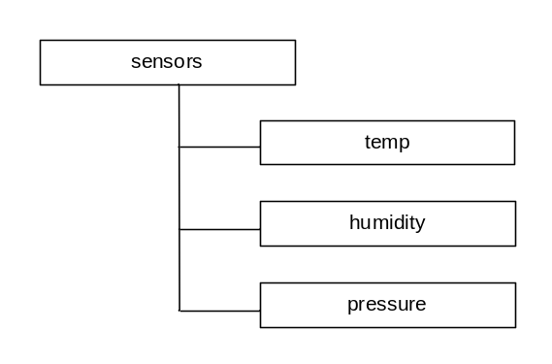
Currently oneM2M has the following interworking restrictions:
- AEs (or IPEs) must mirror any resources they locally host into CSE hosted resources (e.g. <container> resources). Once mirrored, these resources in the CSE must then be kept synchronized with the local resources hosted by an AE (or IPE). This mirroring and synchronization can introduce extra complexity and overhead for AEs and IPEs (especially those hosted on resource constrained IoT/M2M devices). This mirroring can also increase the end-to-end latency for requests flowing through a CSE.
- oneM2M only supports sending NOTIFY requests to AEs. Other request types are not allowed.
For some deployment scenarios, these restrictions are viewed as limitations in the eyes of potential application developers evaluating whether or not to adopt and use oneM2M.
Proposal:
To support more flexible and transparent implementation of AEs and interworking with existing RESTful IoT technologies, this contribution proposes to add re-targeting functionality to a oneM2M <container> resource. This functionality allows a Hosting CSE to selectively re-target <contentInstance> RETRIEVE or CREATE requests to an AE for it to process based on whether the parent <container> has been configured to re-target requests or not.
Example 1 – Sensor:
An AE is hosted on a device implementing a temperature sensor resource. The complete URI to this temperature sensor resource is:
coap://172.25.0.50:6000/sensors/temp
To interface this temperature sensor to a oneM2M CSE, a lightweight temperature sensor AE is built that supports the following functionality:
- The temperature sensor AE registers the temperature sensor to the CSE by creating an <AE> resource and configures its pointOfAccess attribute with the value coap://172.25.0.50:6000 and also creates an instance of the newly proposed <AEHostedResource> as a child resource of the <AE> resource(see separate companion contribution for additional details on <AEHostedResource>). The AE configures the retargetPointOfContact attribute of the <AEHostedResource> with a value of sensors/temp.
- The temperature sensor AE creates a <container> resource as a child of the <AE> and configures the newly proposed AEHostedResourceID attribute with the resourceID of the <AEHostedResource> resource. .
Sometime later, a second AE that monitors temperature attempts to RETRIEVE the latest <contenInstance> from this container. Depending on whether a <contentInstance> exists or not in the container, the Hosting CSE determines whether or not to re-target the RETRIEVE request to the AE. If a <contentInstance> does not exist, then the Hosting CSE re-targets the request to the AE to process. If a <contentInstance> does exist, the Hosting CSE evaluates whether it meets any Filter Criteria that may be specified in the request. If the Filter Criteria are not met, then the Hosting CSE attempts to re-target the request to the AE to process. Otherwise, the Hosting CSE can use an existing <contentInstamce> to process the request.
When re-targeting the RETRIEVE request to the temperature sensor AE, the Hosting CSE forms a URI by concatenating the AE’s pointOfAccess with the retargetPointOfContact specified in the <AEHostedResource> resource.
RETRIEVE coap://172.25.0.50:6000/sensors/temp
Upon receiving the re-targeted request, the temperature sensor AE processes it, and returns a temperature reading (e.g. 80 F) to the CSE. The response is formatted as a oneM2M <contentInstance>. Upon receiving the response, the Hosting CSE returns the response to the temperature monitor AE that originated the request. The Hosting CSE also creates a corresponding <contentInstance> child resource in the targeted <container> which can be used to service future requests.
A corresponding call flow for this example is shown below.
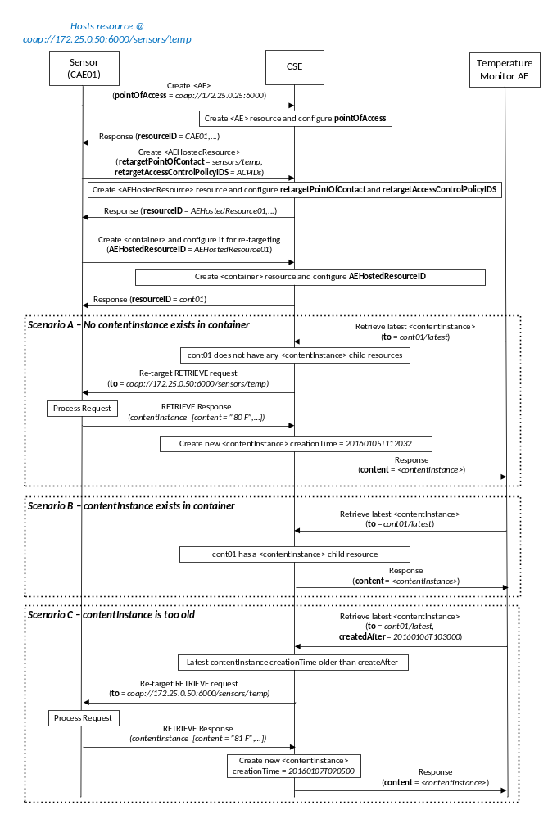
Example 2 – Actuator:
An AE is hosted on a device implementing a door-lock actuator resource. The complete URI to this door-lock actuator resource is:
coap:\\172.25.0.50:6000\actuator\doorlock
To interface this door-lock actuator to a oneM2M CSE a lightweight door-lock actuator AE is built that supports the following functionality:
- The door-lock actuator AE registers to the CSE by creating an <AE> resource and configures its pointOfAccess attribute with the value coap:\\172.25.0.50:6000 and also creates an instance of the newly proposed <AEHostedResource> as a child resource of the <AE> resource (see separate companion contribution for additional details on this attribute). The AE configures the retargetPointOfContact attribute of the <AEHostedResource> with a value of actuators\doorlock.
- The door-lock actuator AE creates a <container> resource as a child of the <AE> and configures the AEHostedResourceID with a value of the resourceID of the <AEHostedResource>.
A second AE is used to control locking or unlocking the door. This door-lock control AE performs a <contentInstance> CREATE to the <container> resource. In this request, the door-lock control AE includes a command in the content attribute of the <contentInstance> resource (e.g. “LOCK” or “UNLOCK”). The Hosting CSE detects that the targeted <container> has a AEHostedResourceID configured. As a result, the Hosting CSE re-targets the <contentInstance> CREATE request to the door-lock actuator at the following URI.
CREATE coap:\\172.25.0.50:6000\actuators\doorlock
The door-lock actuator AE receives the request, processes it by locking the door, and returns a response to the CSE. The response is formatted as a oneM2M <contentInstance> CREATE response. Upon receiving the response, the Hosting CSE returns the response to the door-lock control AE that originated the request in the form of a <contentInstance> CREATE response. The Hosting CSE also creates a corresponding <contentInstance> child resource in the targeted <container> resource.
A corresponding call flow for this example is shown below.
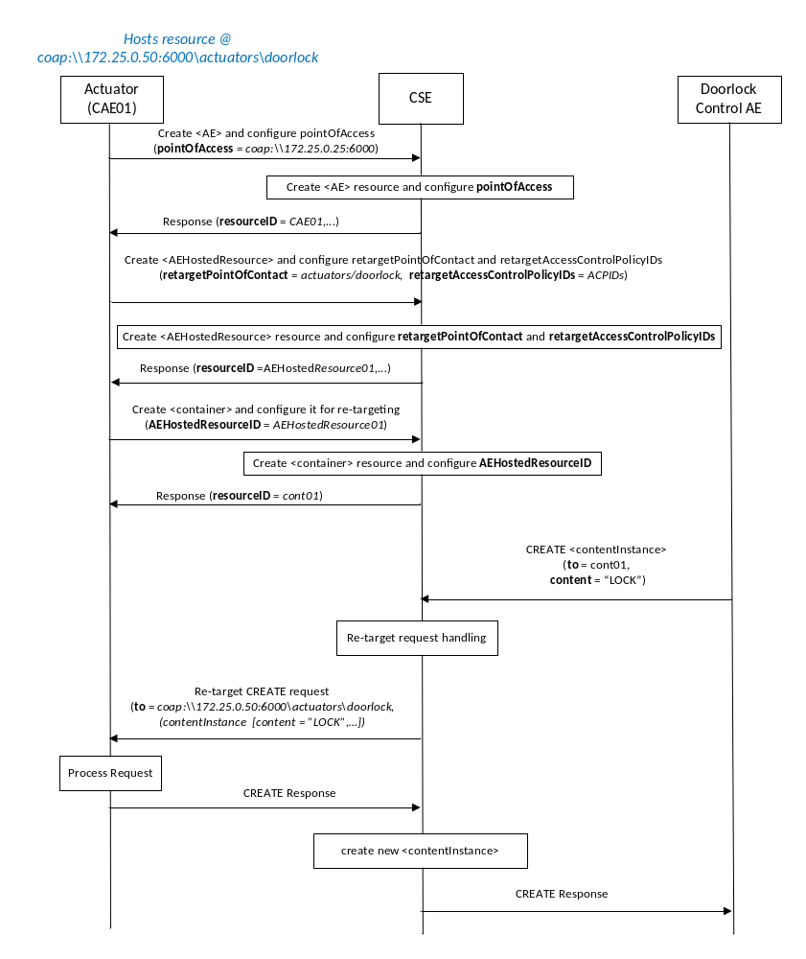

-----------------------Start of change 1-------------------------------------------

9.6.6 Resource Type container
The <container> resource represents a container for data instances. It is used to share information with other entities and potentially to track the data. A <container> resource has no associated content. It has only attributes and child resources.
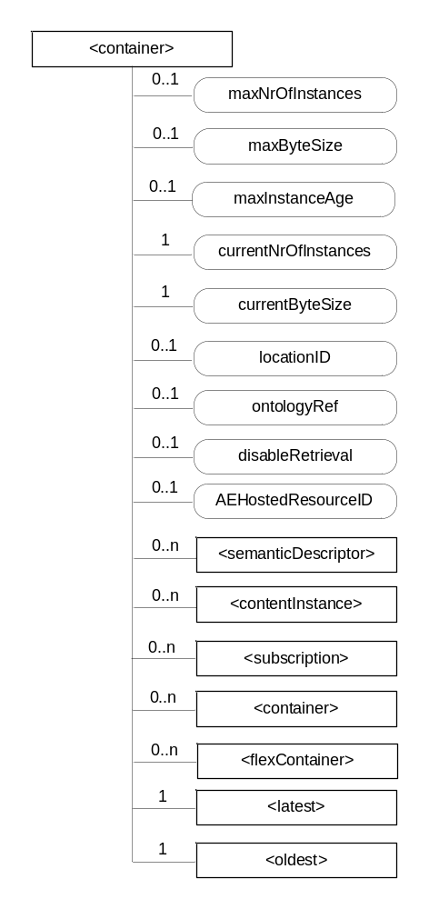

Figure 9.6.6-1: Structure of <container> resource
The <container> resource shall contain the child resources specified in table 9.6.6-1.
Table 9.6.6-1: Child resources of <container> resource
Child Resources of <container> | Child Resource Type | Multiplicity | Description | <containerAnnc> Child Resource Types
semanticDescriptor | <semanticDescriptor> | 0..n | See clause 9.6.30 | <semanticDescriptor>, <semanticDescriptorAnnc>
[variable] | <contentInstance> | 0..n | See clause 9.6.7 | <contentInstance>, <contentInstanceAnnc>
[variable] | <subscription> | 0..n | See clause 9.6.8 | <subscription>
[variable] | <container> | 0..n | See clause 9.6.6 | <container>  <containerAnnc>
[variable] | <flexContainer> | 0..n | See clause 9.6.35 | <flexContainer>  <flexContainerAnnc>
latest | <latest> | 1 | See clause 9.6.27 | None
oldest | <oldest> | 1 | See clause 9.6.28 | None

The <container> resource shall contain the attributes specified in table 9.6.6-2.
Table 9.6.6-2: Attribute of <container> resource
Attributes of  <container> | Multiplicity | RW/  RO/  WO | Description | <containerAnnc> Attributes
resourceType | 1 | RO | See clause 9.6.1.3. | NA
resourceID | 1 | RO | See clause 9.6.1.3. | NA
resourceName | 1 | WO | See clause 9.6.1.3. | NA
parentID | 1 | RO | See clause 9.6.1.3. | NA
expirationTime | 1 | RW | See clause 9.6.1.3. | MA
accessControlPolicyIDs | 0..1 (L) | RW | See clause 9.6.1.3. If no accessControlPolicyIDs are provided at the time of creation, the accessControlPolicyIDs of the parent resource is linked to this attribute. | MA
labels | 0..1 (L) | RW | See clause 9.6.1.3. | MA
creationTime | 1 | RO | See clause 9.6.1.3. | NA
lastModifiedTime | 1 | RO | See clause 9.6.1.3. | NA
stateTag | 1 | RO | See clause 9.6.1.3. | OA
announceTo | 0..1 (L) | RW | See clause 9.6.1.3. | NA
announcedAttribute | 0..1 (L) | RW | See clause 9.6.1.3. | NA
dynamicAuthorizationConsultationIDs | 0..1 (L) | RW | See clause 9.6.1.3. | OA
creator | 0..1 | RO | See clause 9.6.1.3. | NA
maxNrOfInstances | 0..1 | RW | Maximum number of direct child <contentInstance> resources in the <container> resource. | OA
maxByteSize | 0..1 | RW | Maximum size in bytes of data (i.e. content attribute of a <contentInstance> resource) that is allocated for the <container> resource for all direct child <contentInstance> resources in the <container> resource. | OA
maxInstanceAge | 0..1 | RW | Maximum age of a direct child <contentInstance> resource in the <container> resource. The value is expressed in seconds. | OA
currentNrOfInstances | 1 | RO | Current number of direct child <contentInstance> resource in the <container> resource. It is limited by the maxNrOfInstances. | OA
currentByteSize | 1 | RO | Current size in bytes of data(i.e. content attribute of a <contentInstance> resource) stored in all direct child <contentInstance> resources of a <container> resource. This is the summation of contentSize attribute values of the <contentInstance> resources. It is limited by themaxByteSize. | OA
locationID | 0..1 | RW | An ID of the resource where the attributes/policies that define how location information are obtained and managed. This attribute is defined only when the <container> resource is used for containing location information. | OA
ontologyRef | 0..1 | RW | A reference (URI) of the ontology used to represent the information that is stored in the child <contentInstance> resources of the present <container> resource (see note). | OA
disableRetrieval | 0..1 | RW | Boolean value to control RETRIE/UPDATE/DELETE operation on the child <contentInsance> resource.  When the value is set to 'TRUE', RETRIEVE/DELETE/UPDATE operations for child <contentInstance> shall be rejected at all times.  When the value is updated from 'TRUE' to 'FALSE', all existing <contentInstance> are deleted immediately.  When the value is set to 'FALSE', all operations are permitted on the <contentInstance> resource as per existing procedures. | OA
AEHostedResourceID | 0..1 | RW | This attribute shall be configured with a oneM2M compliant Resource-ID of an <AEHostedResource> resource (e.g. AEHostedResource01)  When this attribute is configured the Hosting CSE shall perform AE re-targeting functionality for this container. Otherwise it shall not.  See clause 10.2.22.1. | NA
NOTE: The access to this URI is out of scope of oneM2M.

-----------------------End of change 1-------------------------------------------

-----------------------Start of change 2-------------------------------------------

9.6.27 Resource Type latest
The <latest> resource is a virtual resource because it does not have a representation. It is the child resource of a <container> resource.
When a RETRIEVE request addresses the <latest> virtual resource, the Hosting CSE shall first attempt to service the request using the latest <contentInstance> available. If a <contentInstance> is not available or does not meet a specified Filter Criteria (e.g. creationTime of the latest <contentInstance> available is older than a specified createdAfter condition), then the Hosting CSE shall determine whether the request is a candidate for re-targeting to an AE to process as defined in clause 10.2.22.1.
The <latest> resource inherits access control policies that apply to the parent <container> resource.

-----------------------End of change 2-------------------------------------------

-----------------------Start of change 3 -------------------------------------------

10.2.22.1 Retrieve <latest>
This procedure shall apply to the latest <contentInstance> resource among all existing <contentInstance> resources in the parent <container> resource. If there is no <contentInstance> resource in the parent <container> resource, the Hosting CSE shall attempt to re-target the request to an AE to process if re-targeting is enabled (i.e. AEHostedResourceID is configured) in the parent <container> resource. If re-targeting is not enabled, or re-targeting results in an error, then the Hosting CSE shall respond with an error. .
Below is the detailed procedure for re-targeting of a RETRIEVE request to an AE to process.
Originator sends a RETRIEVE request to a <latest> resource. The request may optionally include one or more Filter Criteria conditions (e.g. createdAfter or expirationAfter).
Hosting CSE performs processing to determine whether to process request using locally hosted <contentInstance> or re-target the request to be processed by an AE. When a RETRIEVE request addresses the <latest> resource, the Hosting CSE first attempts to service the request using the latest <contentInstance> available. If a <contentInstance> is not available or does not meet the specified Filter Criteria conditions, then the Hosting CSE attempts to re-target the request. When receiving a response back from the AE, the Hosting CSE creates a new <contentInstance> resource using the <contentInstance> returned in the response from the AE. The Hosting CSE then re-targets the response from the AE back to the Originator. This response includes the <contentInstance>.
Receiver The Receiver (Hosting CSE or AE) performs local processing to verify the existence of requested resource. After successful verification, the Receiver returns a <contentInstance> representation to the Originator, otherwise an error indication is returned.
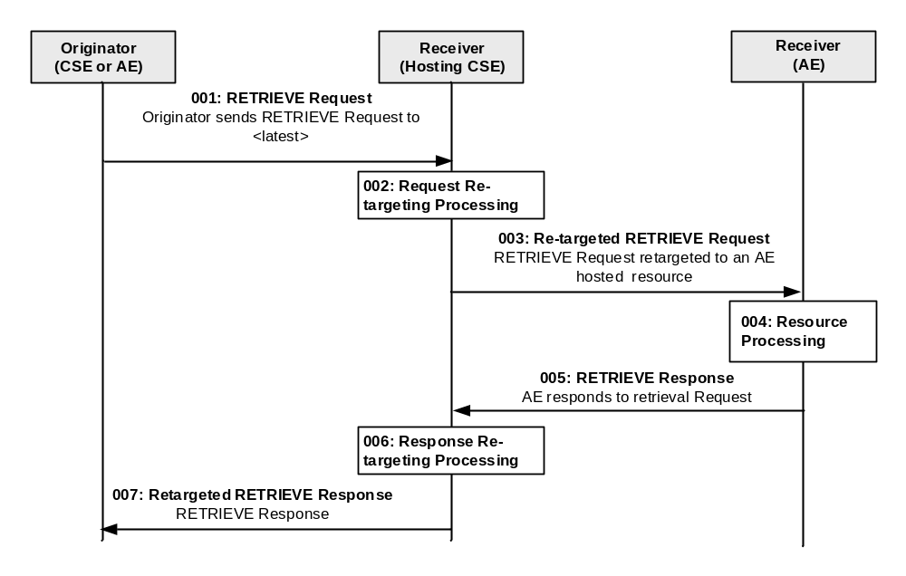
Figure 10.1.2-1: Procedure for Retargeting a RETRIEVE <latest>
Step 001: The Originator shall send RETRIEVE request targeting a <latest> resource. Originator shall send mandatory parameters and may send optional parameters in Request message for RETRIEVE operation as specified in clause 8.1.2.
Step 002: The Hosting CSE shall first attempt to service the request using the latest <contentInstance> available, and based on the same procedures defined in clause 10.2.19.3 for a <contentInstance> RETRIEVE. If a <contentInstance> is not available or does not meet the specified Filter Criteria, then the Hosting CSE shall attempt to re-target the RETRIEVE request. The Hosting CSE shall determine whether re-targeting of RETRIEVE requests is enabled in the parent <container> resource by checking whether the AEHostedResourceID is configured with a resourceID of an existing <AEHostedResource> resource. If this check passes, the Hosting CSE shall next check whether the Originator of the request has proper privileges to perform the re-targeted request by applying the access control policies applicable to the <AEHostedResource>. If these checks pass, the Hosting CSE shall re-target the request otherwise it will return an error.
Step 003: The Hosting CSE shall send a re-targeted RETRIEVE request to the AE corresponding to the parent <AE> resource of the <AEHostedResource> referenced by the container’s AEHostedResourceID attribute. The request shall be targeted to an address derived from the AE’s pointOfAccess and the <AEHostedResource> retargetPointOfContact information. For example, if an <AE> resource has a pointOfAccess attribute configured with a value of coap://172.25.0.50:6000 and the <AEHostedResource> has a retargetPointOfContact configured with a value of sensors/temp, then the Hosting CSE shall re-target the RETRIEVE request to coap://172.25.0.50:6000/sensors/temp.
Step 004: The Receiver processes the RETRIEVE request
Step 005: The Receiver shall respond to the Hosting CSE with a response formatted as a <contentInstance> retrieve response with mandatory parameters and may send optional parameters in the response message for RETRIEVE operation as specified in clause 8.1.3.
Step 006: The Hosting CSE shall process the received RETRIEVE response. If the response includes a properly formatted <contentInstance>, the Hosting CSE shall create a <contentInstance> and store the response information.
Step 007: The Hosting CSE shall respond to Originator with a response formatted as a <contentInstance> with mandatory parameters and may send optional parameters in Response message for RETRIEVE operation as specified in clause 8.1.3.
General Exceptions:
- The targeted resource/attribute in To parameter does not exist. The Hosting CSE or Receiver responds with an error.
- The Originator does not have RETRIEVE privileges to retrieve information stored in the resource on the Hosting CSE or privileges for request to be re-targeted to retrieve information stored in the resource on the Receiver. The Hosting CSE responds with an error.
- The Originator does not have valid retargetPointOfContact to re-target a request to the Receiver. The Hosting CSE does not re-target the request.
- A <contentInstance> RETRIEVE request re-targeted to an AE results in an error. The Receiver and Hosting CSE respond with an error.

-----------------------End of change 3 -------------------------------------------

-----------------------Start of change 4 -------------------------------------------

10.2.19.2 <contentInstance> CREATE
This procedure shall be used for creating a <contentInstance> resource.
Table 10.2.19.2-1: <contentInstance> CREATE
<contentInstance> CREATE
Associated Reference Point | Mca, Mcc and Mcc'.
Information in Request message | All parameters defined in table 8.1.2-3 apply with the specific details for:  Content: The resource content shall provide the information as defined in clause 9.6.7.
Processing at Originator before sending Request | According to clause 10.1.1.1.
Processing at Receiver | According to clause 10.1.1.1.  If the newly created <contentInstance> resource violates any of the policies defined in the parent <container> resource (e.g. maxNrOfInstances or maxByteSize), then the oldest <contentInstance> resources shall be removed from the <container> to enable the creation of the new <contentInstance> resource.
Information in Response message | All parameters defined in table 8.1.3-1 apply with the specific details for:  - Content: Address of the created <contentInstance> resource, according to clause 10.1.1.1.
Processing at Originator after receiving Response | According to clause 10.1.1.1.
Exceptions | According to clause 10.1.1.1.

When a <contentInstance> CREATE request addresses a <container> resource, then depending on the state of the AEHostedResourceID attribute of the parent <container> resource, the Hosting CSE shall determine whether or not to attempt re-targeting the CREATE request.
Below is the detailed procedure for re-targeting of a CREATE <contentInstance> request.
Originator sends a CREATE request to the <container> resource having a AEHostedResourceID attribute configured. See clause 8.1.2 for the information to be included in the Request message.
Hosting CSE If <contentInstance> CREATE is enabled in the targeted <container>, then the Hosting CSE re-targets request to the Receiver. When receiving a successful response back from the AE, the Hosting CSE creates a new <contentInstance> resource. The Hosting CSE returns a response back to the Originator.
Receiver The Receiver verifies the existence of requested resource. After successful verification, performs local processing to CREATE <contentInstance> locally and returns a response, otherwise an error indication.

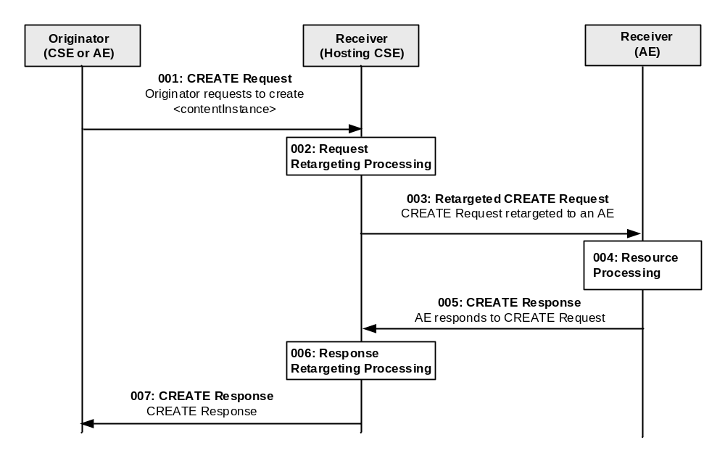
Figure 10.1.2-1: Procedure for Retargeting a CREATE
Step 001: The Originator shall send <contentInstance> CREATE request targeting a <container> resource. Originator shall send mandatory parameters and may send optional parameters in Request message for CREATE operation as specified in clause 8.1.2.
Step 002: The Hosting CSE shall verify the existence of the <container> resource. If it exists, the Hosting CSE shall verify that the Originator has appropriate privileges to perform the CREATE of the <contentInstance>. If privileges are granted, the Hosting CSE shall check whether <contentInstance> CREATE re-targeting is enabled for the <container> resource. If not, then the Hosting CSE shall create a <contentInstance>. If enabled, the Hosting CSE shall attempt to re-target the CREATE request. To determine whether CREATE re-targeting is enabled, the Hosting CSE shall first check whether the AEHostedResourceID is configured with a resourceID of an existing <AEHostedResource> resource. If this check passes, the Hosting CSE shall next check whether the Originator of the request has proper privileges to perform the re-targeted request by applying the access control policies applicable to the <AEHostedResource>. If these checks pass, the Hosting CSE shall re-target the request to a URI formed by concatenating the AE’s pointOfAccess with the path specified in the retargetPointContact of the <AEHostedResource> resource. For example, if an <AE> resource has a pointOfAccess attribute configured with a value of coap://172.25.0.50:6000 and the <AEHostedResource> has a retargetPointOfContact configured with a value of actuators/doorlock, then the Hosting CSE shall re-target the CREATE request to coap://172.25.0.50:6000/actuators/doorlock
Step 003: The Hosting CSE shall send a re-targeted <contentInstance> CREATE request to the retargetPointOfContact.
Step 004: The Receiver processes the <contentInstance> CREATE request
Step 005: The Receiver shall respond to Hosting CSE with a <contentInstance> CREATE response with mandatory parameters and may send optional parameters in Response message for CREATE operation as specified in clause 8.1.3.
Step 006: The Hosting CSE shall process the received <contentInstance> CREATE response. If the response is a success, then the Hosting CSE shall create a <contentInstance> in the <container>.
Step 007: The Hosting CSE shall respond to Originator with a <contentInstance> CREATE response with mandatory parameters and may send optional parameters in Response message for CREATE operation as specified in clause 8.1.3.

General Exceptions:
- The targeted resource/attribute in To parameter does not exist. The Hosting CSE or Receiver responds with an error.
- The Originator does not have privileges to create <contentInstance>. The Hosting CSE responds with an error.
- The Originator does not have privileges to re-target <contentInstance> CREATE request to AE. The Hosting CSE responds with an error.
- A <contentInstance> CREATE request re-targeted to an AE results in an error. The Hosting CSE and/or Receiver responds with an error.

-----------------------End of change 4 -------------------------------------------

