CHANGE REQUEST
Meeting:* | ARC#25
Source:* | C-DOT
Date:* | 2016-10-14
Contact:* | Poornima (poornima@cdot.in), Chaitan(chaitan.yadav@cdot.in),  Anupama(anupama@cdot.in)
Reason for Change/s:* | See the introduction
CR against: Release* | Release 2
CR against: WI* | Active <Work Item number>  MNT maintenace / < Work Item number(optional)>  STE Small Technical Enhancements / < Work Item number (optional)>  Only ONE of the above shall be ticked
CR against: TS/TR* | TS-0001 v2.10.0
Clauses/Sub Clauses* | Section 9.6.1.3.2
Type of change: * | Editorial change  Bug Fix or Correction  Change to existing feature or functionality  New feature or functionality  Only ONE of the above shall be ticked
Post Freeze checking:* | This CR contains only essential changes and corrections? YES NO  This CR may break backwards compatibility with the last approved version of the TS? YES NO  This CR is a mirror CR? YES if YES, please indicate the document number of the original CR: : NO
Template Version:27 May 2015 (Dot not modify)

oneM2M Notice
The document to which this cover statement is attached is submitted to oneM2M. Participation in, or attendance at, any activity of oneM2M, constitutes acceptance of and agreement to be bound by terms of the Working Procedures and the Partnership Agreement, including the Intellectual Property Rights (IPR) Principles Governing oneM2M Work found in Annex 1 of the Partnership Agreement.
GUIDELINES for Change Requests:
Provide an informative introduction containing the problem(s) being solved, and a summary list of proposals.
Each CR should contain changes related to only one particular issue/problem.
In case of a correction, and the change apply to previous releases, a separated “mirror CR” should be posted at the same time of this CR
Follow the principle of completeness, where all changes related to the issue or problem within a deliverable are simultaneously proposed to be made E.g. A change impacting 5 tables should not only include a proposal to change only 3 tables. Includes any changes to references, definitions, and acronyms in the same deliverable.
Follow the drafting rules.
All pictures must be editable.
Check spelling and grammar to the extent practicable.
Use Change bars for modifications.
The change should include the current and surrounding clauses to clearly show where a change is located and to provide technical context of the proposed change. Additions of complete sections need not show surrounding clauses as long as the proposed section number clearly shows where the new section is proposed to be located.
Multiple changes in a single CR shall be clearly separated by horizontal lines with embedded text such as, start of change 1, end of change 1, start of new clause, end of new clause.
When subsequent changes are made to content of a CR, then the accepted version should not show changes over changes. The accepted version of the CR should only show changes relative to the baseline approved text.

Introduction
In TS-0001, accessControlPolicyIDs description, it is mentioned that acp linked with accessControlPolicyIDs can be present on some remote CSEs as highlighted below:
accessControlPolicyIDs | The attribute contains a list of identifiers of an <accessControlPolicy> resource. The privileges defined in the <accessControlPolicy> resource that are referenced determine who is allowed to access the resource containing this attribute for a specific purpose (e.g. Retrieve, Update, Delete, etc.).  If a resource type does not have an accessControlPolicyIDs attribute definition, then the accessControlPolicyIDs for that resource is governed in a different way, for example, the accessControlPolicy associated with the parent may apply to a child resource that does not have an accessControlPolicyIDs attribute definition, or the privileges for access are fixed by the system. Refer to the corresponding resource type definitions and procedures to see how access control is handled in such cases.  If a resource type does have an accessControlPolicyIDs attribute definition, but the (optional) accessControlPolicyIDs attribute is not set, or it is set to a value that does not correspond to a valid, existing <accessControlPolicy> resource, or it refers to an <accessControlPolicy> resource that is not reachable (e.g. because it is located on a remote CSE that is offline or not reachable), then the system default access privileges shall apply.  All resources are accessible if and only if the privileges (i.e. shored as privileges or selfPrivileges attribute of <accessControlPolicy> resource) allow it, therefore all resources shall have an associated accessControlPolicyIDs attribute, either explicitly (setting the attribute in the resource itself) or implicitly (either by using the parent privileges or the system default policies). Which means that the system shall provide a default access privileges in case that the Originator does not provide a specific accessControlPolicyIDs during the creation of the resource.  To update this attribute, a Hosting CSE shall check whether an Originator has Update permission in any selfPrivileges of the <accessControlPolicy> resources which this attribute originally indicates.

But there is no procedure mentioned in TS-0001 and TS-0004(section 7.3.3.15 check authorization of the originator) for how to go to remote CSE to get linked ACP. It could be an expensive process because just for providing the authorization, it would mean hopping to many nodes with a new retrieve request for finding the linked <accessControlPolicy> as depicted in the diagram below:
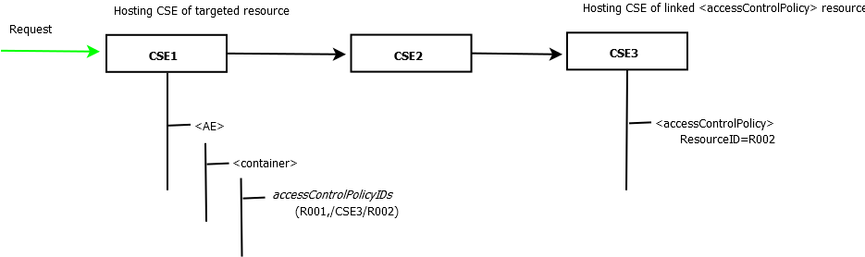

So one proposal is to delete this line.
Or
Another proposal to provide mechanism to get remotely located ACPs

-----------------------Start of change 1----------------------------------------------
Depending upon the decision taken

-----------------------End of change 1----------------------------------------------

CHECK LIST
- Does this change request include an informative introduction containing the problem(s) being solved, and a summary list of proposals.?
- Does this CR contain changes related to only one particular issue/problem?
- Have any mirror crs been posted?
- Does this change request make all the changes necessary to address the issue or problem? E.g. A change impacting 5 tables should not only include a proposal to change only 3 tables. Includes any changes to references, definitions, and acronyms in the same deliverable?
- Does this change request follow the drafting rules?
- Are all pictures editable?
- Have you checked the spelling and grammar?
- Have you used change bars for all modifications?
- Does the change include the current and surrounding clauses to clearly show where a change is located and to provide technical context of the proposed change? (Additions of complete sections need not show surrounding clauses as long as the proposed section number clearly shows where the new section is proposed to be located.)
- Are multiple changes in this CR clearly separated by horizontal lines with embedded text such as, start of change 1, end of change 1, start of new clause, end of new clause.?

