CHANGE REQUEST
Meeting:* | ARC 26
Source:* | Datang, CATR
Date:* | 2016-12-05
Contact:* | Wei Zhou, Datang, zhouwei@catt.cn  Jiadong Du, dujiadong@caict.ac.cn  Ying Huang, huangying@caict.ac.cn
Reason for Change/s:* | New defined resource types and procedures for supporting distributed authorization system
CR against: Release* | Release 3
CR against: WI* | Active WI-0061 - Distributed Authorization  MNT Maintenace / < Work Item number(optional)>  STE Small Technical Enhancements / < Work Item number (optional)>  Only ONE of the above shall be ticked
CR against: TS/TR* | TS-0001-V2.10.1
Clauses/Sub Clauses* | 9.6.1.1 Resource Type Summary  9.6.3 Resource Type CSEBase  9.6.x Resource Type authorizationDecision  9.6.y Resource Type authorizationPolicy  9.6.z Resource Type authorizationInformation  10.2.i <authorizationDecision> Resource Procedures  10.2.j <authorizationPolicy> Resource Procedures  10.2.k <authorizationInformation> Resource Procedures
Type of change: * | Editorial change  Bug Fix or Correction  Change to existing feature or functionality  New feature or functionality  Only ONE of the above shall be ticked
Post Freeze checking:* | This CR contains only essential changes and corrections? YES NO  This CR is a mirror CR? YES NO if YES, please indicate the document number of the original CR:
Template Version:23 February 2015 (Dot not modify)

oneM2M Notice
The document to which this cover statement is attached is submitted to oneM2M. Participation in, or attendance at, any activity of oneM2M, constitutes acceptance of and agreement to be bound by terms of the Working Procedures and the Partnership Agreement, including the Intellectual Property Rights (IPR) Principles Governing oneM2M Work found in Annex 1 of the Partnership Agreement.

Introduction
This contribution is about how to implement distributed authorization in the oneM2M System.
The major comments received in last TP meeting (TP22) are:
- Using normal resources to replace the virtual resources (addressed by this contribution);
- Authorization requests shall conform to RESTful (addressed by this contribution);
- Shall provide a whole solution, for example, how the PEP find a PDP to which an access control decision request shall be sent (addressed by another contribution).
According to these comments, this contribution proposes 3 new resource types representing PDP, PRP and PIP respectively. These resource types are <authorizationDecision>, <authorizationPolicy> and <authorizationInformation>. They are oneM2M normal resource.
The following figure shows the new solution for implementing distributed authorization:
- RETRIEVE <authorizationDecision> for obtaining access control decision;
- RETRIEVE <authorizationPolicy> for obtaining access control policy;
- RETRIEVE <authorizationInformation> for obtaining access control information.
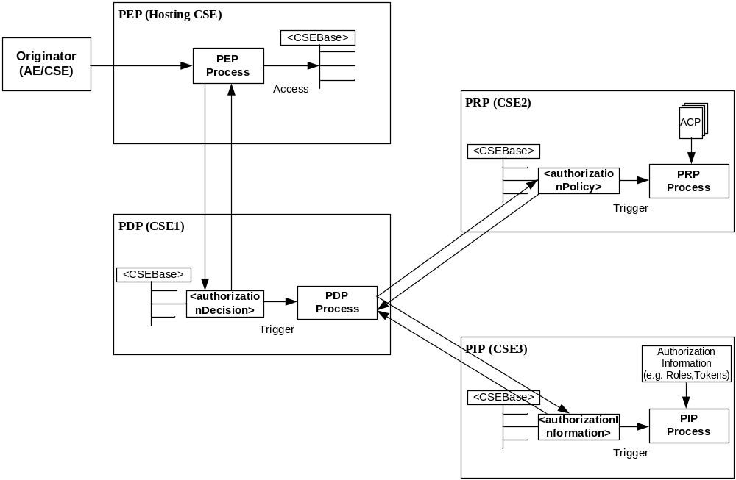
The resource attributes in these resources can be classified into two categories according to their usage. One is used for returning retrieved results (output parameters), for example the “decision” attribute in the <authorizationDecision> resource; the other is used for providing input parameters, for example, “from”, “to”, “operation” and so on in the <authorizationDecision> resource. This contribution proposes using “Filter Criteria” to carry input parameters, so we do not need to design new request parameters for supporting distributed authorization.

-----------------------Start of change 1---------------------------------------------

9.6.1.1 Resource Type Summary
Table 9.6.1.1-1 introduces the normal and virtual resource types and their related child or parent resource types. Details of each resource type follow in the remainder of this clause.
Table 9.6.1.1-1 lists each specified ordinary – i.e. not announced – resource type. An addition of suffix "Annc" to the respective resource type identifier indicates the associated announced resource type. Resource types that can occur as child resources of announced resources are summarized in Table 9.6.26.1-1 "Announced Resource Types".
Among the resource types listed in Table 9.6.1.1-1, the following are termed "Content Sharing Resources" in oneM2M Specifications for the purpose of referring to any of those resource types:
- container;
- contentInstance;
- flexContainer;
- timeSeries;
- timeSeriesInstance.
Table 9.6.1.1-1: Resource Types
Resource Type | Short Description | Child Resource Types | Parent Resource Types | Clause
accessControlPolicy | Stores a representation of privileges. It is associated with resources that shall be accessible to entities external to the Hosting CSE. It controls "who" is allowed to do "what" and the context in which it can be used for accessing resources | subscription | AE, AEAnnc, remoteCSE, remoteCSEAnnc, CSEBase | 9.6.2
AE | Stores information about the AE. It is created as a result of successful registration of an AE with the Registrar CSE | subscription, container,  flexContainer,  group, accessControlPolicy,  schedule, pollingChannelsemanticDescriptor,  timeSeries | CSEBase | 9.6.5
container | Shares data instances among entities. Used as a mediator that buffers data exchanged between AEs and/or CSEs. The exchange of data between AEs (e.g. an AE on a Node in a field domain and the peer-AE on the infrastructure domain) is abstracted from the need to set up direct connections and allows for scenarios where both entities in the exchange do not have the same reachability schedule | container,  flexContainer, contentInstance, subscription, latest, oldest，semanticDescriptor | AE, AEAnnc, container, containerAnnc, remoteCSE, remoteCSEAnnc,  CSEBase,  flexContainer, flexContainerAnnc | 9.6.6
contentInstance | Represents a data instance in the <container> resource | semanticDescriptor | Container, containerAnnc | 9.6.7
flexContainer | A template which allows to define specialized (customizable) versions of containers with a flexible and lightweight structure | container,  flexContainer, subscription, semanticDescriptor | AE, AEAnnc, container, containerAnnc,  flexContainer, flexContainerAnnc, remoteCSE, remoteCSEAnnc,  CSEBase | 9.6.35
CSEBase | The structural root for all the resources that are residing on a CSE. Stores information about the CSE itself | remoteCSE, remoteCSEAnnc, node, AE, container, group, accessControlPolicy, subscription, mgmtCmd, locationPolicy, statsConfig, statsCollect, request, delivery,  schedule,  notificationTargetPolicy,  flexContainer,  timeSeries | None specified | 9.6.3
delivery | Forwards requests from CSE to CSE | subscription | CSEBase | 9.6.11
eventConfig | Defines events that trigger statistics collection | subscription | statsConfig | 9.6.24
execInstance | Contains all execution instances of the same Management Command | subscription | mgmtCmd | 9.6.17
fanOutPoint (V) | Virtual resource containing target for group request  It is used for addressing bulk operations to all the resources that belong to a group | None specified | group | 9.6.14
group | Stores information about resources of the same type that need to be addressed as a Group. Operations addressed to a Group resource shall be executed in a bulk mode for all members belonging to the Group | fanOutPoint,  subscription,  semanticFanOutPoint, semanticDescriptor | AE, AEAnnc, remoteCSE, remoteCSEAnnc, CSEBase | 9.6.13
latest (V) | Virtual resource that points to most recently created <contentInstance> child resource within a <container> resource | None specified | container | 9.6.27
locationPolicy | Includes information to obtain and manage geographical location. It is only referenced within a container, the contentInstances of the container provide location information | subscription | CSEBase | 9.6.10
mgmtCmd | Management Command resource represents a method to execute management procedures required by existing management protocols | execInstance,  subscription | CSEBase | 9.6.16
mgmtObj | Management Object resource represents management functions that provides an abstraction to be mapped to external management technology. It represents the node and the software installed in the node (see note) | subscription, mgmtObj, schedule | node, mgmtObj, mgmtObjAnnc | 9.6.15  Annex D
m2mServiceSubscriptionProfile | Data pertaining to the M2M Service Subscription | serviceSubscribedNode,  subscription | CSEBase | 9.6.19
node | Represents specific Node information | mgmtObj,  subscription, semanticDescriptor | CSEBase | 9.6.18
notificationTargetMgmtPolicyRef | Represents a list of notification targets and the deletion policy | subscription | subscription | 9.6.31
notificationTargetPolicy | Represents a notification target deletion policy with pre-defined action and deletion rules | subscription, policyDeletionRules | CSEBase | 9.6.32
notificationTargetSelfReference (V) | Virtual resource used to remove the Notification Target | None specified | subscription | 9.6.34
oldest (V) | Virtual resource that points to first created <contentInstance> child resource within a <container> resource | None specified | container | 9.6.28
pollingChannel | Represent a channel that can be used for a request-unreachable entity | pollingChannelURI | remoteCSE, AE | 9.6.21
pollingChannelURI (V) | Virtual resource used to perform service layer long polling of a resource Hosting CSE by a request-unreachable entity | None specified | pollingChannel | 9.6.22
policyDeletionRules | Represents a set of rules which is associated with notification target removal policy | subscription | notificationTargetPolicy | 9.6.33
remoteCSE | Represents a remote CSE for which there has been a registration procedure with the registrar CSE identified by the CSEBase resource | container, containerAnnc,  flexContainer, flexContainerAnnc,  group, groupAnnc, accessControlPolicy, accessControlPolicyAnnc, subscription, pollingChannel, schedule,  timeSeries,  timeSeriesAnnc,  remoteCSEAnnc,  nodeAnnc,  AEAnnc,  locationPolicyAnnc | CSEBase | 9.6.4
request | Expresses/access context of an issued Request | subscription | CSEBase | 9.6.12
schedule | Contains scheduling information for delivery of messages | subscription | subscription, CSEBase, remoteCSE,  AE | 9.6.9
serviceSubscribedNode | Node information | subscription | m2mServiceSubscriptionProfile | 9.6.20
statsCollect | Defines triggers for the IN-CSE to collect statistics for applications | subscription | CSEBase (in IN-CSE) | 9.6.25
statsConfig | Stores configuration of statistics for applications | eventConfig,  subscription | CSEBase (in IN-CSE) | 9.6.23
subscription | Subscription resource represents the subscription information related to a resource. Such a resource shall be a child resource for the subscribe-to resource | schedule, notificationTargetSelfReference, notificationTargetMgmtPolicyRef | accessControlPolicy,accessControlPolicyAnnc, AE, AEAnnc, container, containerAnnc, CSEBase, delivery, eventConfig, execInstance, group, groupAnnc, locationPolicy, locationPolicyAnnc, mgmtCmd, mgmtObj, mgmtObjAnnc, m2mServiceSubscriptionProfile, node, nodeAnnc, serviceSubscribedNode, remoteCSE, remoteCSEAnnc, request, schedule, scheduleAnnc,  semanticDescriptor, semanticDescriptorAnnc, statsCollect, statsConfig,  flexContainer, flexContainerAnnc,  timeSeries, timeSeriesAnnc | 9.6.8
serviceSubscribedAppRule | Represents a rule that defines allowed App-ID and AE-ID combinations that are acceptable for registering an AE on a Registrar CSE | subscription | CSEBase | 9.6.29
semanticDescriptor | Stores semantic description pertaining to a resource and potentially sub-resources. | subscription | AE, container, contentInstance，group, node, flexContainer, timeSeries | 9.6.30
semanticFanOutPoint | Virtual resource used as target for semantic discovery aimed at a logical graph distributed over multiple semanticDescriptor resources, which belong to the corresponding group parent resource | None specified | group | 9.6.14a
trafficPattern | Represents the communication pattern and the mobility pattern of a Field Domain Node. | schedule,  subscription | Node, AE | 9.6.41
dynamicAuthorizationConsultation | Represents consultation information used by a CSE when performing consultation-based dynamic authorization | None Specified | AE, AEAnnc, remoteCSE, remoteCSEAnnc, CSEBase | 9.6.40
timeSeries | Stores and Shares Time Series Data instances among entities. | timeSeriesInstance, subscription, semanticDescriptor | AE, AEAnnc, remoteCSE, remoteCESAnnc, CSEBase | 9.6.36
timeSeriesInstance | Represents a Time Series Data instance in the <timeSeries> resource | None specified | timeSeries, timeSeriesAnnc | 9.6.37
authorizationDecision | Represents an access control decision point | subscription | CSEBase | 9.6.x
authorizationPolicy | Represents an access control policy retrieval point | subscription | CSEBase | 9.6.y
authorizationInformation | Represents an access control information point | role  token  subscription | CSEBase | 9.6.z
NOTE: See clause 9.6.12 for a summary of specializations of <mgmtObj>.

-----------------------End of change 1---------------------------------------------

-----------------------Start of change 2---------------------------------------------

9.6.3 Resource Type CSEBase
A <CSEBase> resource shall represent a CSE. The <CSEBase> resource shall be the root for all resources that are residing in the CSE.
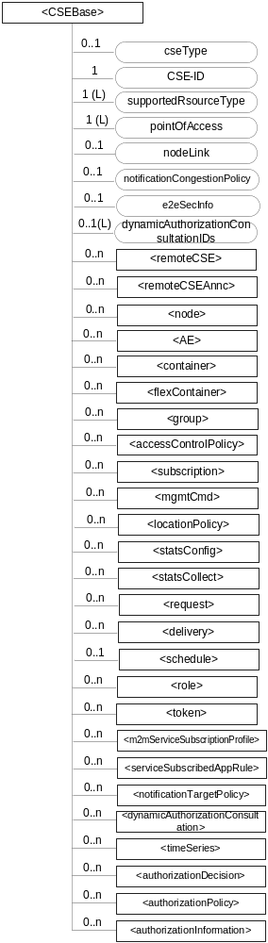
Figure 9.6.3-1: Structure of <CSEBase> resource
Figure 9.6.3-1 does not show the child announce resource types defined in table 9.6.3-2.
The <CSEBase> resource shall contain the child resources specified in table 9.6.3-1.
Table 9.6.3-1: Child resources of <CSEBase> resource
Child Resources of <CSEBase> | Child Resource Type | Multiplicity | Description
[variable] | <remoteCSE> | 0..n | See clause 9.6.4
[variable] | <remoteCSEAnnc> | 0..n | Announced variant of <remoteCSE>. Resource with CSE-specific information for a CSE that announced itself to another CSE with which it does not have a registration relationship.
[variable] | <node> | 0..n | See clause 9.6.18
[variable] | <AE> | 0..n | See clause 9.6.5
[variable] | <container> | 0..n | See clause 9.6.6
[variable] | <flexContainer> | 0..n | See clause 9.6.35
[variable] | <group> | 0..n | See clause 9.6.13
[variable] | <accessControlPolicy> | 0..n | See clause 9.6.2
[variable] | <subscription> | 0..n | See clause 9.6.8
[variable] | <mgmtCmd> | 0..n | See clause 9.6.16
[variable] | <locationPolicy> | 0..n | See clause 9.6.10
[variable] | <statsConfig> | 0..n | See clause 9.6.23
[variable] | <statsCollect> | 0..n | See clause 9.6.25
[variable] | <request> | 0..n | See clause 9.6.12
[variable] | <delivery> | 0..n | See clause 9.6.11
[variable] | <schedule> | 0..1 | This resource defines the reachability schedule information of the entity. The absence of this resource implies the entity is always reachable. See clause 9.6.9
[variable] | <role> | 0..n | See clause 9.6.38
[variable] | <token> | 0..n | See clause 9.6.39
[variable] | <m2mServiceSubscriptionProfile> | 0..n | See clause 9.6.19
[variable] | <serviceSubscribedAppRule> | 0..n | See clause 9.6.29
[variable] | <notificationTargetPolicy> | 0..n | See clause 9.6.32
[variable] | <dynamicAuthorizationConsultation> | 0..n | See clause 9.6.40
[variable] | <timeSeries> | 0..n | See clause 9.6.36
[variable] | <authorizationDecision> | 0..n | See clause 9.6.x
[variable] | <authorizationPolicy> | 0..n | See clause 9.6.y
[variable] | <authorizationInformation> | 0..n | See clause 9.6.z

An instance of a <remoteCSEAnnc> resource shall be created as a child of a <CSEBase> resource when an Originator CSE of an announcement request (i.e. original resource Hosting CSE) and a targeted Hosting CSE of an announced resource (i.e. announced resource Hosting CSE) have no registration relationship (e.g. the Originator CSE has not created <remoteCSE> resource on the Hosting CSE), see clause 9.6.26.
The <CSEBase> resource shall contain the attributes specified in table 9.6.3-2.
Table 9.6.3-2: Attributes of <CSEBase> resource
Attributes of <CSEBase> | Multiplicity | RW/  RO/  WO | Description
resourceType | 1 | RO | See clause 9.6.1.3.
resourceID | 1 | RO | See clause 9.6.1.3.
resourceName | 1 | RO | See clause 9.6.1.3.
parentID | 1 | RO | See clause 9.6.1.3. Shall be NULL.
creationTime | 1 | RO | See clause 9.6.1.3.
lastModifiedTime | 1 | RO | See clause 9.6.1.3.
accessControlPolicyIDs | 0..1 (L) | RO | See clause 9.6.1.3.
labels | 0..1 (L) | RO | See clause 9.6.1.3.
dynamicAuthorizationConsultationIDs | 0..1 (L) | RO | See clause 9.6.1.3.
cseType | 0..1 | RO | Indicates the type of CSE represented by the created resource:  Mandatory for an IN-CSE, hence multiplicity (1).  Its presence is subject to SP configuration in case of an ASN-CSE or a MN-CSE.
CSE-ID | 1 | RO | The CSE identifier in SP-relative CSE-ID format (clause 7.2).
supportedResourceType | 1 (L) | RO | List of the resource types which are supported in the CSE. This attribute contains subset of resource types listed in clause 9.2.
pointOfAccess | 1 (L) | RO | Represents the list of physical addresses to be used by remote CSEs to connect to this CSE (e.g. IP address, FQDN). This attribute is exposed to its Registree.
nodeLink | 0..1 | RO | The resource identifier of a <node> resource that stores the node specific information of the node on which the CSE represented by this <CSEBase> resource resides.
notificationCongestionPolicy | 0..1 | RO | This attribute applies to CSEs generating subscription notifications. It specifies the rule which is applied when the storage of notifications for each subscriber (an AE or CSE) reaches the maximum storage limit for notifications for that subscriber. E.g. Delete stored notifications of lower notificationStoragePriority to make space for new notifications of higher notificationStoragePriority, or delete stored notifications of older creationTime to make space for new notifications when all notifications are of the same notificationStoragePriority.
e2eSecInfo | 0..1 | RO | See clause 9.6.1.3.

-----------------------End of change 2---------------------------------------------

-----------------------Start of change 3---------------------------------------------

9.6.x Resource Type authorizationDecision
The <authorizationDecision> resource represents an access control decision. It is the child resource of a <CSEBase> resource. When a RETRIEVE request addresses the <authorizationDecision> resource, the Hosting CSE acts as a Policy Decision Point (PDP) as defined in clause 6.2.2 of TS-0003 [2] and shall make an access control decision according to the access control decision request provided in the request and provide the access control decision as the response of the request.
The <authorizationDecision> resource specific attributes are used for describing an access control decision request and the corresponding access control decision response. The decision and status attributes represent an access control decision response. The other resource specific attributes represent an access control decision request.
NOTE 1: From the view of an access control decision requester, the access control decision request and the corresponding access control decision are already in the <authorizationDecision> resource. The requester can always retrieve it through a retrieve operation.
An access control decision requester shall use a RETRIEVE request with a Filter Criteria parameter to retrieve an access control decision. The Filter Criteria parameter of the request shall be used to describe an access control decision request with attribute, filterUsage and filterOperation condition tags. List of attribute condition tags are used to describe pairs of access control decision request parameter names and their values which are mapped to the resource specific attributes. The filterUsage condition tag shall be set to generic retrieve operation. The filterOperation condition tag shall be set to logical AND.
A PDP process bound to an <authorizationDecision> resource can be triggered only when the following conditions are satisfied:
- A RETRIEVE request addresses the <authorizationDecision> resource.
- The requester shall have RETRIEVE privilege to the <authorizationDecision> resource.
- Name of decision and status attributes of the resource shall be listed in the Content parameter of the request.
- A valid Filter Criteria parameter of the request as described above in the request shall be provided.
The triggered PDP process intercepts the RETRIEVE request, and performs the following operations:
- Extracting the access control decision request from the RETRIEVE request.
- Evaluating the access control decision request against access control policies.
- Generating a RETRIEVE response according the evaluation result using the decision and status attributes of the resource.
In case the bound PDP process is triggered, the resource specific attributes are not touched during the entire process. These attributes are only used as templates by the access control decision requester for constructing access control decision requests through general retrieve requests and by the PDP process for constructing access control decision responses through general retrieve responses. In case the bound PDP process is not triggered, the <authorizationDecision> resource behaves in the same way as normal resources.
An <authorizationDecision> resource shall be created by an authorized entity. The values of all resource specific attributes shall be set to null, and all the resource specific attributes are not updatable. An <authorizationDecision> resource can act as an entrance of a PDP only when it is bound to a PDP process. How a PDP process is bound to an <authorizationDecision> resource is however out of scope of the specification.
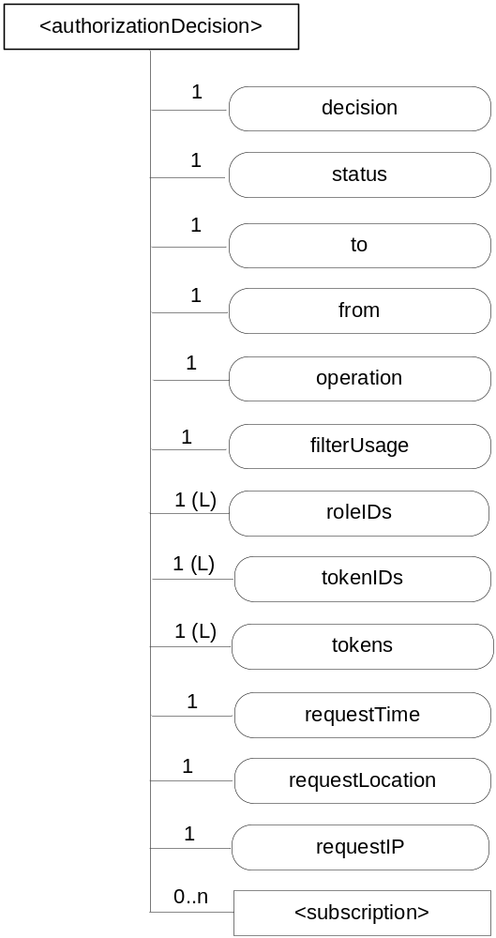
Figure 9.6.x-1: Structure of <authorizationDecision> resource
The <authorizationDecision> resource shall contain the child resources specified in table 9.6.x-1.
Table 9.6.x-1: Child resources of <authorizationDecision> resource
Child Resources of <role> | Child Resource Type | Multiplicity | Description
[variable] | <subscription> | 0..n | See clause 9.6.8

The <authorizationDecision> resource shall contain the attributes specified in table 9.6.x-2
Table 9.6.x-2: Attributes of <authorizationDecision> resource
Attributes of <role> | Multiplicity | RW/  RO/  WO | Description
resourceType | 1 | RO | See clause 9.6.1.3.
resourceID | 1 | RO | See clause 9.6.1.3.
resourceName | 1 | WO | See clause 9.6.1.3.
parentID | 1 | RO | See clause 9.6.1.3.
expirationTime | 1 | RW | See clause 9.6.1.3.
accessControlPolicyIDs | 0..1 (L) | RW | See clause 9.6.1.3.
creationTime | 1 | RO | See clause 9.6.1.3.
labels | 0..1 (L) | RW | See clause 9.6.1.3.
lastModifiedTime | 1 | RO | See clause 9.6.1.3.
decision | 1 | RO | Authorization decision for an access control decision request. See clause 7 in oneM2M TS-0003 [2].
status | 1 | RO | Status of an authorization evaluation process. See clause 7 in oneM2M TS-0003 [2].
to | 1 | RO | Same as the To parameter in the request sent from the Originator to the Hosting CSE. See clause 7 in oneM2M TS-0003 [2].
from | 1 | RO | Same as the From parameter in the request sent from the Originator to the Hosting CSE. See clause 7 in oneM2M TS-0003 [2].
operation | 1 | RO | Same as the Operation parameter in the request sent from the Originator to the Hosting CSE. See clause 7 in oneM2M TS-0003 [2].
filterUsage | 1 | RO | Same as the filterUsage parameter in the request sent from the Originator to the Hosting CSE. See clause 7 in oneM2M TS-0003 [2].
roleIDs | 1 (L) | RO | Same as the Role IDs parameter in the request sent from the Originator to the Hosting CSE. See clause 7 in oneM2M TS-0003 [2].
tokenIDs | 1 (L) | RO | Same as the Token IDs parameter in the request sent from the Originator to the Hosting CSE. See clause 7 in oneM2M TS-0003 [2].
tokens | 1 (L) | RO | Same as the Tokens parameter in the request sent from the Originator to the Hosting CSE. See clause 7 in oneM2M TS-0003 [2].
requestTime | 1 | RO | Time stamp when the request message was received at the hosting CSE. Obtained by the hosting CSE's system time clock. See clause 7 in oneM2M TS-0003 [2].
requestLocation | 1 | RO | Location information about the Originator of the request. Obtained over the Mcn reference point. See clause 7 in oneM2M TS-0003 [2].
requestIP | 1 | RO | IP source address associated with the IP packets that carry the request message. Obtained over the Mcn reference point. See clause 7 in oneM2M TS-0003 [2].

9.6.y Resource Type authorizationPolicy
The <authorizationPolicy> resource represents an access control policy. It is the child resource of a <CSEBase> resource. When a RETRIEVE request addresses the <authorizationPolicy> resource, the Hosting CSE acts as a Policy Retrieval Point (PRP) as defined in clause 6.2.2 of TS-0003 [2] and shall retrieve the applicable access control policies according to the access control policy request provided in the request and provide the access control policies as the response of the request.
The <authorizationPolicy> resource specific attributes are used for describing an access control policy request and the corresponding access control policy response. The policies and combiningAlgorithm attributes represent an access control policy response. The other resource specific attributes represent an access control policy request.
NOTE : From the view of an access control policy requester, the access control policy request and the corresponding access control policies are already in the <authorizationPolicy> resource. The requester can always retrieve it through a retrieve operation.
An access control policy requester shall use a RETRIEVE request with a Filter Criteria parameter to retrieve the access control policies. The Filter Criteria parameter of the request shall be used to describe an access control policy request with attribute, filterUsage and filterOperation condition tags. List of attribute condition tags are used to describe pairs of access control policy request parameter names and their values which are mapped to the resource specific attributes. The filterUsage condition tag shall be set to generic retrieve operation. The filterOperation condition tag shall be set to logical AND
A PRP process bound to an <authorizationPolicy> resource can be triggered only when the following conditions are satisfied:
- A RETRIEVE request addresses the <authorizationPolicy> resource.
- The requester shall have RETRIEVE privilege to the <authorizationPolicy> resource.
- Name of policies and combiningAlgorithm attributes of the resource shall be listed in the Content parameter of the request.
- A valid Filter Criteria parameter of the request as described above in the request shall be provided.
The triggered PRP process intercepts the RETRIEVE request, and performs the following operations:
- Extracting the access control policy request from the RETRIEVE request.
- Retrieving applicable access control policies and policy combining algorithm according to the access control policy request. How a PRP gets the applicable access control policies and policy combining algorithm is however out of scope of the specification.
- Generating a RETRIEVE response based on the retrieved access control policies and policy combining algorithm using the policies and combiningAlgorithm attributes of the resource.
In case the bound PRP process is triggered, the resource specific attributes are not touched during the entire process. These attributes are only used as templates by the access control policy requester for constructing access control policy requests through general retrieve requests and by the PRP process for constructing access control policy responses through general retrieve responses. In case the bound PRP process is not triggered, the <authorizationPolicy> resource behaves in the same way as normal resources.
An <authorizationPolicy> resource shall be created by an authorized entity. The values of all resource specific attributes shall be set to null, and all the resource specific attributes are not updatable. An <authorizationPolicy> resource can act as an entrance of a PRP only when it is bound to a PRP process. How a PRP process is bound to an <authorizationPolicy> resource is however out of scope of the specification.

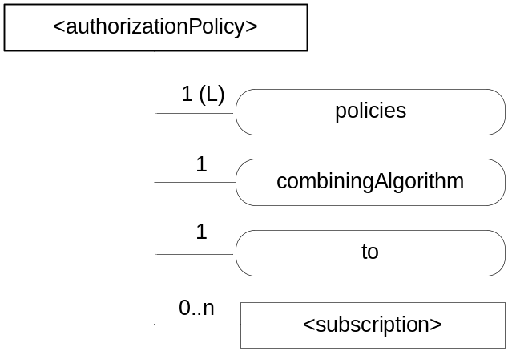
Figure 9.6.y-1: Structure of <authorizationPolicy> resource
The <authorizationPolicy> resource shall contain the child resources specified in table 9.6.y-1.
Table 9.6.y-1: Child resources of <authorizationPolicy> resource
Child Resources of <role> | Child Resource Type | Multiplicity | Description
[variable] | <subscription> | 0..n | See clause 9.6.8

The <authorizationPolicy> resource shall contain the attributes specified in table 9.6.y-2
Table 9.6.y-2: Attributes of <authorizationPolicy> resource
Attributes of <role> | Multiplicity | RW/  RO/  WO | Description
resourceType | 1 | RO | See clause 9.6.1.3.
resourceID | 1 | RO | See clause 9.6.1.3.
resourceName | 1 | WO | See clause 9.6.1.3.
parentID | 1 | RO | See clause 9.6.1.3.
expirationTime | 1 | RW | See clause 9.6.1.3.
accessControlPolicyIDs | 0..1 (L) | RW | See clause 9.6.1.3.
creationTime | 1 | RO | See clause 9.6.1.3.
labels | 0..1 (L) | RW | See clause 9.6.1.3.
lastModifiedTime | 1 | RO | See clause 9.6.1.3.
policies | 1 (L) | RO | List of access control policies for an access control policy request. Each access control policy contains a set of access control rules as specified in clause 9.6.2. See clause 7 in oneM2M TS-0003 [2].
combiningAlgorithm | 1 | RO | Algorithm used for combining multiple access control policies. See clause 7 in oneM2M TS-0003 [2].
to | 1 | RO | Same as the To parameter in the access control decision request. See clause 7 in oneM2M TS-0003 [2].

9.6.z Resource Type authorizationInformation
The <authorizationInformation> resource represents an access control information. It is the child resource of a <CSEBase> resource. When a RETRIEVE request addresses the <authorizationInformation> resource, the Hosting CSE acts as a Policy Information Point (PIP) as defined in clause 6.2.2 of TS-0003 [2] and shall retrieve the required access control information according to the access control information request provided in the request and provide the access control information as the response of the request.
The <authorizationInformation> resource specific attributes and child resources are used for describing an access control information request and the corresponding access control information response. The <role> and <token> resources represent an access control information response. The other resource specific attributes represent an access control information request.
NOTE : From the view of an access control information requester, the access control information request and the corresponding access control information are already in the <authorizationInformation> resource. The requester can always retrieve it through a retrieve operation.
An access control information requester shall use a RETRIEVE request with a Filter Criteria parameter to retrieve the access control information. The Filter Criteria parameter of the request shall be used to describe an access control information request with attribute, filterUsage and filterOperation condition tags. List of attribute condition tags are used to describe pairs of access control information request parameter names and their values which are mapped to the resource specific attributes. The filterUsage condition tag shall be set to generic retrieve operation.The filterOperation condition tag shall be set to logical AND.
A PIP process bound to an <authorizationInformation> resource can be triggered only when the following conditions are satisfied:
- A RETRIEVE request addresses the <authorizationInformation> resource.
- The requester shall have RETRIEVE privilege to the <authorizationInformation> resource.
- The Content parameter of the request shall be empty and Result Content parameter of the request shall be set to child-resources.
- A valid Filter Criteria parameter of the request as described above in the request shall be provided.
The triggered PIP process intercepts the RETRIEVE request, and performs the following operations:
- Extracting the access control information request from the RETRIEVE request.
- Retrieving applicable access control information according to the access control information request. How a PIP gets the applicable access control information is however out of scope of the specification.
- Generating a RETRIEVE response based on the retrieved access control information using the <role> and/or <token> child resources of the resource.
In case the bound PIP process is triggered, the resource specific attributes or child resources are not touched during the entire process. These attributes and child resources are only used as templates by the access control information requester for constructing access control information requests through general retrieve requests and by the PIP process for constructing access control information responses through general retrieve responses. In case the bound PIP process is not triggered, the <authorizationInformation> resource behaves in the same way as normal resources.
An <authorizationInformation> resource shall be created by an authorized entity. The values of all resource specific attributes and child resources shall be set to null, and all the resource specific attributes and child resources are not updatable. An <authorizationInformation> resource can act as an entrance of a PIP only when it is bound to a PIP process. How a PIP process is bound to an <authorizationInformation> resource is however out of scope of the specification.

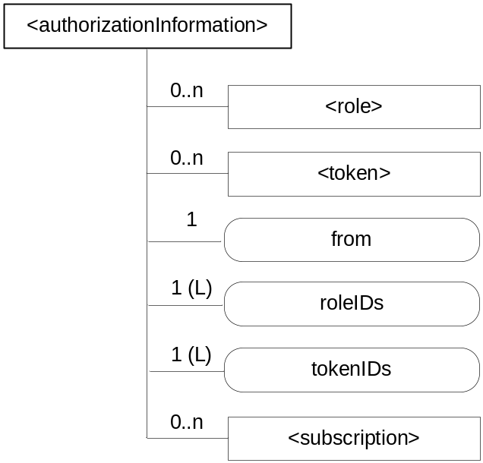
Figure 9.6.z-1: Structure of <authorizationInformation> resource
The <authorizationInformation> resource shall contain the child resources specified in table 9.6.z-1.
Table 9.6.y-1: Child resources of <authorizationInformation> resource
Child Resources of <role> | Child Resource Type | Multiplicity | Description
[variable] | <role> | 0..n | See clause 9.6.38
[variable] | <token> | 0..n | See clause 9.6.39
[variable] | <subscription> | 0..n | See clause 9.6.8

The <authorizationInformation> resource shall contain the attributes specified in table 9.6.z-2
Table 9.6.z-2: Attributes of <authorizationInformation> resource
Attributes of <role> | Multiplicity | RW/  RO/  WO | Description
resourceType | 1 | RO | See clause 9.6.1.3.
resourceID | 1 | RO | See clause 9.6.1.3.
resourceName | 1 | WO | See clause 9.6.1.3.
parentID | 1 | RO | See clause 9.6.1.3.
expirationTime | 1 | RW | See clause 9.6.1.3.
accessControlPolicyIDs | 0..1 (L) | RW | See clause 9.6.1.3.
creationTime | 1 | RO | See clause 9.6.1.3.
labels | 0..1 (L) | RW | See clause 9.6.1.3.
lastModifiedTime | 1 | RO | See clause 9.6.1.3.
from | 1 | RO | Same as the From parameter in the request. See clause 7 in oneM2M TS-0003 [2].
roleIDs | 1 (L) | RO | Same as the Role IDs parameter in the request. See clause 7 in oneM2M TS-0003 [2].
tokenIDs | 1 (L) | RO | Same as the Token IDs parameter in the request. See clause 7 in oneM2M TS-0003 [2].

-----------------------End of change 3---------------------------------------------

-----------------------Start of change 4---------------------------------------------

10.2.i <authorizationDecision> Resource Procedures

10.2.i.1 Introduction
This clause describes the manipulation procedures of the <authorizationDecision> resources which are used to implement distributed authorization system. Each <authorizationDecision> resource represents an entrance of a Policy Decision Point (PDP) that is responsible for making access control decisions.
Multiple <authorizationDecision> resources can be created under one <CSEBase> resource. The access control policies associated to an <authorizationDecision> resource can be used to group access control decision requesters, i.e. which CSEs can retrieve access control decisions from a given <authorizationDecision> resource.
The resource specific resource specific attributes of an <authorizationDecision> resource can be classified into two categories according to their usages. One category is used for describing access control decisions, e.g. the decision and status attributes. The other category is used for describing access control decision requests, e.g. to, from, operation, roleIDs and so on.
A CSE can request an access control decision through sending a RETRIEVE request to an <authorizationDecision> resource. The Filter Criteria parameter of the request is used for carrying access control decision request that is expressed using attribute condition tags. For example, an access control decision request can be expressed with filter criteria: "from=//m2m.prov.com/CSE3219/C9886", "to=/CSE987776/a234361", "operation=retrieve". The resource attributes (e.g. decision and status) representing the access control decision are the target attributes that the decision requester wants to retrieve.
A RETRIEVE operation on an <authorizationDecision> resource will trigger an access control decision making process. After making an access control decision, the access control decision and/or status are returned back to the decision requester as the retrieved resource attributes through a retrieve response.
The details of distributed authorization procedures are described in TS-0003 [2].

10.2.i.2 Create <authorizationDecision>
This procedure shall be used for creating an <authorizationDecision> resource.
NOTE: Before a created <authorizationDecision> resource is bound to a PDP process, the <authorizationDecision> resource behaves in the same way as normal resources.
Table 10.2.i.2-1: <authorizationDecision> CREATE
<authorizationDecision> CREATE
Associated Reference Point | Mca, Mcc and Mcc'
Information in Request message | All parameters defined in table 8.1.2-3 apply with the specific details for:  Content: The resource content shall provide the information as defined in clause 9.6.x, and all the values of resource specific attributes shall be set to null.
Processing at Originator before sending Request | According to clause 10.1.1.1
Processing at Receiver | According to clause 10.1.1.1
Information in Response message | According to clause 10.1.1.1
Processing at Originator after receiving Response | According to clause 10.1.1.1
Exceptions | According to clause 10.1.1.1

10.2.i.3 Retrieve <authorizationDecision>
This procedure shall be used for retrieving the attributes of an <authorizationDecision> resource.
Originator: The Originator shall request to obtain an access control decision by using RETRIEVE operation on an <authorizationDecision> resource. The access control decision shall be specified with decision and/or status attributes that are the target attributes to be retrieved, and the access control decision request shall be specified with Filter Criteria parameter using other resource specific attributes.
Receiver: The Receiver shall execute an access control decision making process according to the access control decision request provided in the RETRUEVE request, and return the access control decision in the RETRIEVE response.
Table 10.2.i.3-1: <authorizationDecision> RETRIEVE
<authorizationDecision> RETRIEVE
Associated Reference Point | Mcc and Mcc'
Information in Request message | According to clause 10.1.2 with the following additions:  From: Identifier of the CSE that initiates the Request  To: Address of the <authorizationDecision> resource  Content: The names of decision and/or status attributes that represent the access control decision.  Filter Criteria: The representation of an access control decision request constructed using attribute condition tags. See clause 7 in oneM2M TS-0003 [2] for the mandatory and optional parameters,
Processing at Originator before sending Request | According to clause 10.1.2
Processing at Receiver | The Receiver should perform the following operations:  - Check if the Originator has RETRIEVE privilege on the <authorizationDecision> resource  - Check the validity of the parameters in the request, including the Content and Filter Criteria parameters  - Obtain applicable access control policies and requested access control information, and then make an access control decision. The details of this process are described in TS-0003 [2].
Information in Response message | All parameters defined in table 8.1.3-1 apply with the specific details for:  Content: The decision and/or status attributes of the <authorizationDecision> resource as defined in clause 9.6.x
Processing at Originator after receiving Response | According to clause 10.1.2
Exceptions | According to clause 10.1.2

10.2.i.4 Update <authorizationDecision>
This procedure shall be used for updating attributes of an <authorizationDecision> resource.
Table 10.2.i.4-1: <authorizationDecision> UPDATE
<authorizationDecision> UPDATE
Associated Reference Point | Mca, Mcc and Mcc'
Information in Request message | All parameters defined in table 8.1.2-3 apply.
Processing at Originator before sending Request | According to clause 10.1.3
Processing at Receiver | According to clause 10.1.3
Information in Response message | According to clause 10.1.3
Processing at Originator after receiving Response | According to clause 10.1.3
Exceptions | According to clause 10.1.3

10.2.i.5 Delete <authorizationDecision>
This procedure shall be used for deleting an existing <authorizationDecision> resource.
NOTE: After an <authorizationDecision> resource is deleted, the bound PDP process may still exist in the system. How to deal with the unbound PDP process is however out of scope of the specification.
Table 10.2.i.5-1: <authorizationDecision> DELETE
<authorizationDecision> DELETE
Associated Reference Point | Mca, Mcc and Mcc'
Information in Request message | All parameters defined in table 8.1.2-3 apply
Processing at Originator before sending Request | According to clause 10.1.4.1
Processing at Receiver | According to clause 10.1.4.1
Information in Response message | According to clause 10.1.4.1
Processing at Originator after receiving Response | According to clause 10.1.4.1
Exceptions | According to clause 10.1.4.1

10.2.j <authorizationPolicy> Resource Procedures

10.2.j.1 Introduction
This clause describes the manipulation procedures of the <authorizationPolicy> resources which are used to implement distributed authorization system. Each <authorizationPolicy> resource represents an entrance of a Policy Retrieval Point (PRP) that is responsible for retrieving access control policies.
Multiple <authorizationPolicy> resources can be created under one <CSEBase> resource. The access control policies associated to an <authorizationPolicy> resource can be used to group access control policy requesters, i.e. which CSEs can retrieve access control policies from a given <authorizationPolicy> resource.
The resource specific attributes of an <authorizationPolicy> resource can be classified into two categories according to their usages. One category is used for describing access control policies, e.g. the policies and combiningAlgorithm attributes. The other category is used for describing access control policy requests, e.g. the to attribute.
A CSE can request access control policies through sending a RETRIEVE request to an <authorizationPolicy> resource. The Filter Criteria parameter of the request is used for carrying access control policy request that is expressed using attribute condition tags. For example, an access control policy request can be expressed with filter criteria: "to=/CSE987776/a234361". The resource attributes (e.g. policies and combiningAlgorithm) representing the access control policies are the target attributes that the policy requester wants to retrieve.
A RETRIEVE operation on an <authorizationPolicy> resource will trigger an access control policy retrieving process. After obtaining the access control policies and policy combining algorithm, the access control policies and/or policy combining algorithm are returned back to the policy requester as the retrieved resource attributes through a retrieve response.
The details of distributed authorization procedures are described in TS-0003 [2].

10.2.j.2 Create <authorizationPolicy>
This procedure shall be used for creating an <authorizationPolicy> resource.
NOTE: Before a created <authorizationPolicy> resource is bound to a PRP process, the <authorizationPolicy> resource behaves in the same way as normal resources.
Table 10.2.j.2-1: <authorizationPolicy> CREATE
<authorizationPolicy> CREATE
Associated Reference Point | Mca, Mcc and Mcc'
Information in Request message | All parameters defined in table 8.1.2-3 apply with the specific details for:  Content: The resource content shall provide the information as defined in clause 9.6.y, and all the values of resource specific attributes shall be set to null.
Processing at Originator before sending Request | According to clause 10.1.1.1
Processing at Receiver | According to clause 10.1.1.1
Information in Response message | According to clause 10.1.1.1
Processing at Originator after receiving Response | According to clause 10.1.1.1
Exceptions | According to clause 10.1.1.1

10.2.j.3 Retrieve <authorizationPolicy>
This procedure shall be used for retrieving the attributes of an <authorizationPolicy> resource.
Originator: The Originator shall request to obtain access control policies by using RETRIEVE operation on an <authorizationPolicy> resource. The access control policies shall be specified with policies and/or combiningAlgorithm attributes that are the target attributes to be retrieved, and the access control policy request shall be specified with Filter Criteria parameter using other resource specific attributes.
Receiver: The Receiver shall execute an access control policy retrieving process according to the access control policy request provided in the RETRUEVE request, and return the access control policies in the RETRIEVE response.
Table 10.2.j.3-1: <authorizationPolicy> RETRIEVE
<authorizationPolicy> RETRIEVE
Associated Reference Point | Mcc and Mcc'
Information in Request message | According to clause 10.1.2 with the following additions:  From: Identifier of the CSE that initiates the Request  To: Address of the <authorizationPolicy> resource  Content: The names of policies and/or combiningAlgorithm attributes that represent the access control policies.  Filter Criteria: The representation of an access control policy request constructed using attribute condition tags. See clause 7 in oneM2M TS-0003 [2] for the mandatory and optional parameters,
Processing at Originator before sending Request | According to clause 10.1.2
Processing at Receiver | The Receiver should perform the following operations:  - Check if the Originator has RETRIEVE privilege on the <authorizationPolicy> resource  - Check the validity of the parameters in the request, including the Content and Filter Criteria parameters  - Obtain applicable access control policies. The details of this process are described in TS-0003 [2].
Information in Response message | All parameters defined in table 8.1.3-1 apply with the specific details for:  Content: The policies and/or combiningAlgorithm attributes of the <authorizationPolicy> resource as defined in clause 9.6.y
Processing at Originator after receiving Response | According to clause 10.1.2
Exceptions | According to clause 10.1.2

10.2.j.4 Update <authorizationPolicy>
This procedure shall be used for updating attributes of an <authorizationPolicy> resource.
Table 10.2.j.4-1: <authorizationPolicy> UPDATE
<authorizationPolicy> UPDATE
Associated Reference Point | Mca, Mcc and Mcc'
Information in Request message | All parameters defined in table 8.1.2-3 apply.
Processing at Originator before sending Request | According to clause 10.1.3
Processing at Receiver | According to clause 10.1.3
Information in Response message | According to clause 10.1.3
Processing at Originator after receiving Response | According to clause 10.1.3
Exceptions | According to clause 10.1.3

10.2.j.5 Delete <authorizationPolicy>
This procedure shall be used for deleting an existing <authorizationPolicy> resource.
NOTE: After an <authorizationPolicy> resource is deleted, the bound PRP process may still exist in the system. How to deal with the unbound PRP process is however out of scope of the specification.
Table 10.2.j.5-1: <authorizationPolicy> DELETE
<authorizationPolicy> DELETE
Associated Reference Point | Mca, Mcc and Mcc'
Information in Request message | All parameters defined in table 8.1.2-3 apply
Processing at Originator before sending Request | According to clause 10.1.4.1
Processing at Receiver | According to clause 10.1.4.1
Information in Response message | According to clause 10.1.4.1
Processing at Originator after receiving Response | According to clause 10.1.4.1
Exceptions | According to clause 10.1.4.1

10.2.k <authorizationInformation> Resource Procedures

10.2.k.1 Introduction
This clause describes the manipulation procedures of the <authorizationInformation> resources which are used to implement distributed authorization system. Each <authorizationInformation> resource represents an entrance of an Policy Information Point (PIP) that is responsible for retrieving access control information, e.g. a role or token.
Multiple <authorizationInformation> resources can be created under one <CSEBase> resource. The access control policies associated to an <authorizationInformation> resource can be used to group access control information requesters, i.e. which CSEs can retrieve access control information from a given <authorizationInformation> resource.
The resource specific attributes or child resources of an <authorizationInformation> resource can be classified into two categories according to their usages. One category is used for describing access control information, e.g. the <role> and <token> resources. The other category is used for describing access control Information requests, e.g. the from, roleIDs and tokenIDs attributes.
A CSE can request access control information through sending a RETRIEVE request to an <authorizationInformation> resource. The Filter Criteria parameter of the request is used for carrying access control information request that is expressed using attribute condition tags. For example, an access control Information request can be expressed with filter criteria: "roleIDs=/CSE987776/r234361", "tokenIDs=/CSE987776/t234361 /CSE987776/t234362". The child resources (e.g. <role> and <token>) representing the access control information are the target child resources that the Information requester wants to retrieve.
A RETRIEVE operation on an <authorizationInformation> resource will trigger an access control information retrieving process. After obtaining the access control information, the access control information is returned back to the information requester as the retrieved child resources through a retrieve response.
The details of distributed authorization procedures are described in TS-0003 [2].

10.2.k.2 Create <authorizationInformation>
This procedure shall be used for creating an <authorizationInformation> resource.
NOTE: Before a created <authorizationInformation> resource is bound to a PIP process, the <authorizationInformation> resource behaves in the same way as normal resources.
Table 10.2.k.2-1: <authorizationInformation> CREATE
<authorizationInformation> CREATE
Associated Reference Point | Mca, Mcc and Mcc'
Information in Request message | All parameters defined in table 8.1.2-3 apply with the specific details for:  Content: The resource content shall provide the information as defined in clause 9.6.z, and all the values of resource specific attributes shall be set to null, and any resource specific child resource shall not be created.
Processing at Originator before sending Request | According to clause 10.1.1.1
Processing at Receiver | According to clause 10.1.1.1
Information in Response message | According to clause 10.1.1.1
Processing at Originator after receiving Response | According to clause 10.1.1.1
Exceptions | According to clause 10.1.1.1

10.2.k.3 Retrieve <authorizationInformation>
This procedure shall be used for retrieving the attributes of an <authorizationInformation> resource.
Originator: The Originator shall request to obtain an access control information by using RETRIEVE operation on an <authorizationInformation> resource. The access control information shall be specified with <role> and/or <token> resources that are the target child resources to be retrieved, and the access control information request shall be specified with Filter Criteria parameter using other resource specific attributes.
Receiver: The Receiver shall execute an access control information retrieving process according to the access control information request provided in the RETRUEVE request, and return the access control information in the RETRIEVE response.
Table 10.2.k.3-1: <authorizationInformation> RETRIEVE
<authorizationInformation> RETRIEVE
Associated Reference Point | Mcc and Mcc'
Information in Request message | According to clause 10.1.2 with the following additions:  From: Identifier of the CSE that initiates the Request  To: Address of the <authorizationInformation> resource  Result Content: It shall be set as child-resources  Filter Criteria: The representation of an access control Information request constructed using attribute condition tags. See clause 7 in oneM2M TS-0003 [2] for the mandatory and optional parameters,
Processing at Originator before sending Request | According to clause 10.1.2
Processing at Receiver | The Receiver should perform the following operations:  - Check if the Originator has RETRIEVE privilege on the <authorizationInformation> resource  - Check the validity of the parameters in the request, including the Result Content and Filter Criteria parameters  - Obtain applicable access control information. The details of this process are described in TS-0003 [2].
Information in Response message | All parameters defined in table 8.1.3-1 apply with the specific details for:  Content: The <role> and/or <token> resources of the <authorizationInformation> resource as defined in clause 9.6.z
Processing at Originator after receiving Response | According to clause 10.1.2
Exceptions | According to clause 10.1.2

10.2.k.4 Update <authorizationInformation>
This procedure shall be used for updating attributes of an <authorizationInformation> resource.
Table 10.2.k.4-1: <authorizationInformation> UPDATE
<authorizationInformation> UPDATE
Associated Reference Point | Mca, Mcc and Mcc'
Information in Request message | All parameters defined in table 8.1.2-3 apply.
Processing at Originator before sending Request | According to clause 10.1.3
Processing at Receiver | According to clause 10.1.3
Information in Response message | According to clause 10.1.3
Processing at Originator after receiving Response | According to clause 10.1.3
Exceptions | According to clause 10.1.3

10.2.k.5 Delete <authorizationInformation>
This procedure shall be used for deleting an existing <authorizationInformation> resource.
NOTE: After an <authorizationInformation> resource is deleted, the bound PIP process may still exist in the system. How to deal with the unbound PIP process is however out of scope of the specification.
Table 10.2.k.5-1: <authorizationInformation> DELETE
<authorizationInformation> DELETE
Associated Reference Point | Mca, Mcc and Mcc'
Information in Request message | All parameters defined in table 8.1.2-3 apply
Processing at Originator before sending Request | According to clause 10.1.4.1
Processing at Receiver | According to clause 10.1.4.1
Information in Response message | According to clause 10.1.4.1
Processing at Originator after receiving Response | According to clause 10.1.4.1
Exceptions | According to clause 10.1.4.1

-----------------------End of change 4 ---------------------------------------------

-----------------------Start of change 5---------------------------------------------

11.3.4 M2M Authorization Procedure
The M2M authorization procedure controls access to resources and services by CSEs and AEs. This procedure requires that the Originator has been identified to an M2M Authentication Function and mutually authenticated and associated with an M2M Service Subscription. Authorization depends on:
The privileges set by the M2M Service Subscription associated with the Originator (e.g. service/role assigned to the Originator).
These privileges are set-up based on the access control policies associated with the accessed resource or service. They condition the allowed operations (e.g. CREATE) based on the Originator's privileges and other access control attributes (e.g. contextual attributes such as time or geographic location).
Role-IDs which have been associated with the Originator.
The authorization/access grant involves an Access Decision step to determine what the authenticated CSE or AE can actually access, by evaluating applicable access control policies based on the CSE or AE privileges. Access Decision is described in oneM2M TS-0003 [Error: Reference source not found].
The following set of access control policy attributes shall be available for an Access Decision.
Access control attributes of Originator and Originator's Role (e.g. Role-IDs, CSE_IDs, AE-IDs, etc.).
Access control attributes of Environment/Context (e.g. time, day, IP address, etc.).
Access control attributes of Operations (e.g. Create, Execute, etc.).
The M2M Service Provider/administrator and owner of resources are responsible to establish access control policies that determine by whom, in what context and what operations may be performed upon those resources. If the request satisfies the owner's access control policy, then the access to the resource is granted.
Dynamic Authorization: Dynamic Authorization encompasses:
- authorizing the creation of a limited-lifetime access control policy authorizing the Originator to perform specific operations on the requested resource; and
- issuing limited-lifetime Tokens associating the Originator with Role-IDs and/or access control policies for identified resources.
Two forms of Dynamic Authorization are supported: Direct Dynamic Authorization and Indirect Dynamic Authorization.
In the event that the request does not satisfy any of the owner's access control policies, then Dynamic Authorization may be requested from Dynamic Authorization System (DAS) Servers; this is called Direct Dynamic Authorization, and relevant details are provided clause 11.5.2. The request is then re-evaluated to determine if the owner's access control policy is now satisfied and access is granted.
If access is still denied, then the Originator is provided with Token Request Information used to request the issuance of Tokens by a Dynamic Authorization System. A Token identifies Role-IDs and/or access control policies (for identified resources) which have been temporarily associated with the Originator. The Originator then resends the request from the Originator, this time adding any Token or Token-IDs received from the Dynamic Authorization System. This is called Indirect Dynamic Authorization, and relevant details are provided clause 11.5.3.
NOTE: A DAS Server can be triggered, by Dynamic Authorization, to update the access control policy configuration using oneM2M request primitives.
In the event that the requesting entity does not satisfy the owner's access control policy, a Hosting CSE shall check to see if the resource (or one of its parents) has a dynamicAuthorizationConsultationIDs which links to a valid <dynamicAuthorizationConsultation> resource. If there is no valid <dynamicAuthorizationConsultation> resource or if the dynamicAuthorizationEnabled attribute is set to "false", then then the Hosting CSE shall not attempt to perform direct dynamic authorization on behalf of the requesting entity. However, if there is a valid <dynamicAuthorizationConsultation> resource available and if the dynamicAuthorizationEnabled attribute is set to "true", then the Hosting CSE shall initiate a direct dynamic authorization request to the specified dynamicAuthorizationPoA. If direct dynamic authorization results in sufficient privilges being granted to the requesting entity, the Hosting CSE shall grant it access. In addition the Hosting CSE may also dynamically create a new access control policy and configure it with the granted privileges along with any specified lifetime associated with the privileges based on a resource creation process initiated by the dynamic authorization system.
This function shall fetch the subscription related information in order to check if a Role-ID used in a request is allowed by the M2M service subscription.The authorization procedure shall be implemented as specified in the oneM2M TS-0003 [Error: Reference source not found].
Editor’s Note: A paragraph providing a brief overview on distributed authorization will be added here in a future contribution.

-----------------------End of change 5---------------------------------------------

