CHANGE REQUEST
Meeting:* | ARC#27
Source:* | ZTE Corporation
Date:* | 2017-02-04
Contact:* | Qiuting Li, li.qiuting@zte.com.cn  Weixiang Shao, shao.weixiang@zte.com.cn
Reason for Change/s:* | Editorial correction for reference numbers
CR against: Release* | Rel-3
CR against: WI* | Active WI  MNT maintenance / < Work Item number(optional)>  STE Small Technical Enhancements / < Work Item number (optional)>  Only ONE of the above shall be ticked
CR against: TS/TR* | TS-0001 v3.2.0
Clauses/Sub Clauses* | Clause 10
Type of change: * | Editorial change  Bug Fix or Correction  Change to existing feature or functionality  New feature or functionality  Only ONE of the above shall be ticked
Post Freeze checking:* | This CR contains only essential changes and corrections? YES NO  This CR may break backwards compatibility with the last approved version of the TS? YES NO  This CR is a mirror CR? YES if YES, please indicate the document number of the original CR: <Document Number) : NO
Template Version:27 May 2015 (Dot not modify)

oneM2M Notice
The document to which this cover statement is attached is submitted to oneM2M. Participation in, or attendance at, any activity of oneM2M, constitutes acceptance of and agreement to be bound by terms of the Working Procedures and the Partnership Agreement, including the Intellectual Property Rights (IPR) Principles Governing oneM2M Work found in Annex 1 of the Partnership Agreement.
GUIDELINES for Change Requests:
Provide an informative introduction containing the problem(s) being solved, and a summary list of proposals.
Each CR should contain changes related to only one particular issue/problem.
In case of a correction, and the change apply to previous releases, a separated “mirror CR” should be posted at the same time of this CR
Follow the principle of completeness, where all changes related to the issue or problem within a deliverable are simultaneously proposed to be made E.g. A change impacting 5 tables should not only include a proposal to change only 3 tables. Includes any changes to references, definitions, and acronyms in the same deliverable.
Follow the drafting rules.
All pictures must be editable.
Check spelling and grammar to the extent practicable.
Use Change bars for modifications.
The change should include the current and surrounding clauses to clearly show where a change is located and to provide technical context of the proposed change. Additions of complete sections need not show surrounding clauses as long as the proposed section number clearly shows where the new section is proposed to be located.
Multiple changes in a single CR shall be clearly separated by horizontal lines with embedded text such as, start of change 1, end of change 1, start of new clause, end of new clause.
When subsequent changes are made to content of a CR, then the accepted version should not show changes over changes. The accepted version of the CR should only show changes relative to the baseline approved text.

Introduction
This contribution is proposal to fix incorrect reference clause/figure/table numbers to keep pace with the new numbers which changed in clause 10 re-structuring procedure.
Main clause changes as follows:
Basic Procedures | Clause Changes
CREATE(C) | Clause 10.1.1 →Clause 10.1.2, sub-clause 10.1.1.2.1→Clause 10.2.2.7, sub-clause 10.1.1.2.2→Clause 10.2.2.2
RETRIEVE(R) | Clause 10.1.2 →Clause 10.1.3
UPDATE(U) | Clause 10.1.3 →Clause 10.1.4, sub-clause 10.1.4.2.1→Clause 10.2.2.10, sub-clause 10.1.4.2.2→Clause 10.2.2.5
DELETE(D) | Clause 10.1.4 →Clause 10.1.5
NOTIFY(N) | Clause 10.1.5 →Clause 10.1.6

Other changes are such as clause 10.2.12.2.1→Clause 10.2.10.8, clause 10.2.13.7→Clause 10.2.5.18, table 10.2.12-1→table 10.2.10.7-1 and so on.

-----------------------Start of change 1-------------------------------------------

10 Information Flows

10.1 Basic Procedures

10.1.1 Overview
As a pre-condition to the execution of the following procedures, M2M operational security procedures as specified in clauses 11.3.1 through 11.3.3 shall have been performed. In case of failure, the error shall be reported as specified in oneM2M TS-0004 [Error: Reference source not found].
The procedures in the following clauses assume blocking requests as described in clause 8.2.2.

10.1.2 CREATE (C)
Originator requests to create a resource by using the CREATE method. See clause 8.1.2 for the parameters to be included in the Request message.
Hosting CSE If the request is allowed by the given privileges, the Receiver shall create the resource.
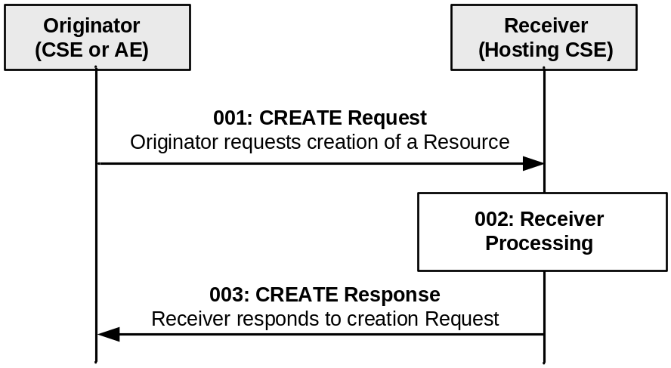
Figure 10.1.2-1: Procedure for CREATEing a Resource
Step 001: The Originator shall send mandatory parameters and may send optional parameters in Request message for CREATE operation as specified in clause 8.1.2.
Step 002: The Receiver shall:
Check if the Originator has the appropriate privileges for performing the request. Privileges of the targeted resource are linked by the accessControlPolicyIDs attribute. Different handlings for a target resource which does not have the accessControlPolicyIDs attribute by the resource type definition(e.g. schedule resource type) or a target resource which has the definition but the attribute has no value and so on are defined in the Table 9.6.1.3.2-1 (common attributes description).
- Verify that the name for the created resource as suggested by the resourceName attribute in Content parameter, if provided by the Originator in the CREATE Request message, does not already exist among child resources of the target resource. If no child within the targeted resource exists with the same resourceName as suggested by the Originator, use that name for the resource to be created. If a child uses the resourceName already, the Receiver shall reject the request and return an error to the Originator. If the name was not suggested by the Originator, assign a name generated by the Receiver to the resource to be created.
NOTE: The name of a resource in general is not the same as its Resource ID. While a name of a resource only needs to be unique among the children of the same parent resource, the Resource ID needs to be unique in context of the Hosting CSE. When the name of the resource to be created is assigned by the Receiver, it may choose to use a name that is identical to the Unstructured-CSE-relative-Resource ID.
- Assign a Resource-ID (see resourceID attribute in common attribute table 9.6.1.3.2-1) to the resource to be created.
- Assign values for mandatory RO mode attributes of the resource and override values provided for other mandatory attributes, where needed, and where allowed by the resource type definition and if not provided by the Originator itself.
- the Receiver shall assign a value to the following common attributes specified in clause 9.6.1.3:
a) parentID;
b) creationTime;
c) expirationTime: if not provided by the Originator, the Receiver shall assign the maximum value possible (within the restriction of the Receiver policies). If the value provided by the Originator cannot be supported, due to either policy or subscription restrictions, the Receiver will assign a new value;
d) lastModifiedTime: which is equals to the creationTime;
e) Any other RO (Read Only) attributes within the restriction of the Receiver policies.
- The Receiver shall check whether a creator attribute is included in the Content parameter of the request. If included, the creator attribute shall not have a value in the Content parameter of the request. If the creator attribute is included in the request and the creator attribute is supported for the type of resource being created, then the Receiver shall to include the creator attribute in the resource to be created. The Receiver shall assign a value equal to the value carried in the From request parameter. In the event that the originator provides a value for the creator attribute within the request, this request shall be deemed invalid.
On the other hand if the creator attribute is not included in the Content parameter of the request, then the Receiver shall not include the creator attribute in the resource to be created.
- On successful validation of the Create Request, the Receiver shall create the requested resource.
- The Receiver shall check if the created child resource leads to changes in its parent resource's attribute(s), if so the parent resource's attribute(s) shall be updated.
Step 003: The Receiver shall respond with mandatory parameters and may send optional parameters in Response message for CREATE operation as specified in clause 8.1.3.
General Exceptions:
The Originator does not have the privileges to create a resource on the Receiver. The Receiver responds with an error.
- The resource with the specified name (if provided) already exists at the Receiver. The Receiver responds with an error.
- The provided information in Content is not accepted by the Receiver (e.g. missing mandatory parameter). The Receiver responds with an error.

10.1.3 RETRIEVE (R)
The RETRIEVE operation shall be used for retrieving the information stored for any of the attributes for a resource at the Receiver CSE. The Originator CSE or AE may request to retrieve a specific attribute by including the name of such attribute in the Content parameter in the request message.
Originator requests retrieval of all attributes or a specific attributes of the target resource by using RETRIEVE Request. See clause 8.1.2 for the information to be included in the Request message. If only some specific attributes need to be retrieved, the name of such attributes shall be included in the Content parameter of the Request message.
Receiver The Receiver performs local processing to verify the existence of requested resource and checks privileges for retrieving the information related to the resource. After successful verification, the Receiver shall return the requested information, otherwise an error indication shall be returned.
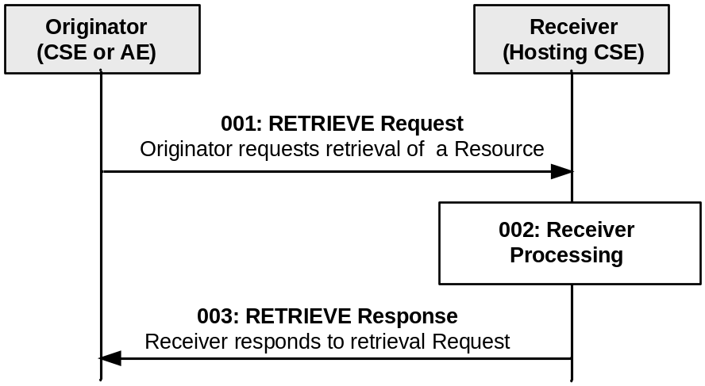
Figure 10.1.3-1: Procedure for RETRIEVing a Resource
Step 001: The Originator shall send mandatory parameters and may send optional parameters in Request message for RETRIEVE operation as specified in clause 8.1.2.
Step 002: The Receiver shall verify the existence (including Filter Criteria checking, if it is given) of the target resource or the attribute and check if the Originator has appropriate privileges to retrieve information stored in the resource/attribute. This privilege checking follows the rules defined in the Table 9.6.1.3.2-1 (common attributes description).
Step 003: The Receiver shall respond with mandatory parameters and may send optional parameters in Response message for RETRIEVE operation as specified in clause 8.1.3.
General Exceptions:
The targeted resource/attribute in To parameter does not exist. The Receiver responds with an error.
- The Originator does not have privileges to retrieve information stored in the resource on the Receiver. The Receiver responds with an error.

10.1.4 UPDATE (U)
The UPDATE operation shall be used for updating the information stored for any of the attributes at a target resource. Especially important is the expirationTime, since a failure in refreshing this attribute may result in the deletion of the resource. The Originator CSE or AE can request to update, create or delete specific attribute(s) at the target resource by including the name of such attribute(s) and its values in the Content parameter of the request message.
Originator requests update any of the attributes at the target resource by using UPDATE Request message. The Originator shall send new (proposed) values for the attribute(s) that need to be updated. The UPDATE operation allows to modify or create previously non-existing attributes of the resource type (defined in clause 9.6) that are indicated as "RW" (Read Write) for the specific resource type definition.
The Originator requests to delete attributes at the target resource by using UPDATE Request message. The Originator shall send the name of the attributes to be deleted (defined in clause 9.6) for the specific resource type with their value set to NULL, in the Request message.
See clause 8.1.2 for the information to be included in the Request message.
Receiver The Receiver verifies the existence of the addressed resource, the validity of the attributes provided and the privileges to modify them, the Receiver shall update the attributes provided and shall return a Response message to the Originator with the operation results as specified in clause 8.1.3.
If the attributes provided do not exist, after verifying the existence of the addressed resource, the Receiver validates the attributes provided and the privileges to create them. On successful validation, the Receiver shall create the attributes provided with their associated values and shall return a Response message to the Originator with the operation results as specified in clause 8.1.3.
If the attributes provided have their value set to NULL, after verifying the existence of the addressed resource, the Receiver validates the attributes provided and the privileges to delete them. On successful validation, the Receiver shall delete such attributes and shall return a Response message to the Originator with the operation results as specified in clause 8.1.3.
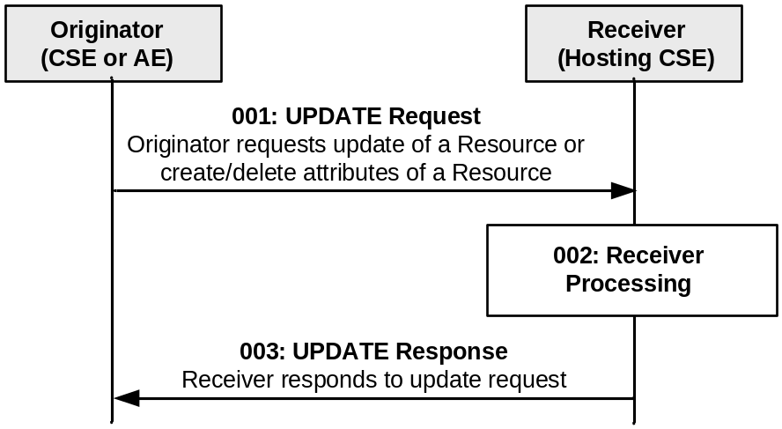
Figure 10.1.4-1: Procedure for UPDATing a Resource
Step 001: The Originator shall send mandatory parameters and may send optional parameters in Request message for UPDATE operation as specified in clause 8.1.2.
Step 002: The Receiver shall verify the existence (including Filter Criteria checking, if it is given) of the requested resource and if the Originator has the appropriate privilege to update the resource. This privilege checking follows the rules defined in the Table 9.6.1.3.2-1 (common attributes description). On successful validation, the Receiver shall update the resource as requested. If the attributes provided do not exist, the Receiver shall validate if the Originator has appropriate privileges to create the attributes at the target resource. On successful validation, the Receiver shall create the attributes with their associated values at the resource as requested. If the attributes provided have their value set to NULL, the Receiver shall validate if the Originator has appropriate privileges to delete the attributes at the target resource. On successful validation, the Receiver shall delete such attributes. The Receiver shall check if the updated target resource is a child of a parent resource having a stateTag attribute and increment the stateTag if present.
Step 003: The Receiver shall respond with mandatory parameters and may send optional parameters in Response message for UPDATE operation as specified in clause 8.1.3.
General Exceptions:
The targeted resource in To parameter does not exist. The Receiver responds with an error.
- The Originator does not have the privilege to modify the resource, create attributes or delete attributes on the Receiver. The Receiver responds with error.
- The provided information in the Content is not accepted by the Receiver. The Receiver responds with error.

10.1.5 DELETE (D)
The DELETE operation shall be used by an Originator CSE or AE to delete a resource at a Receiver CSE. For such operation, the DELETE procedure shall consist of the deletion of all related information of the target resource.
Originator requests deletion of a resource by using a DELETE Request message. See clause 8.1.2 for the information to be included in the Request message.
Receiver The Receiver verifies the existence of the requested resource, and the privileges for deleting the resource.
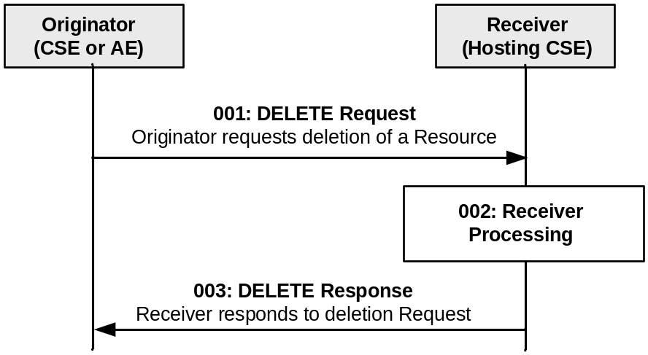
Figure 10.1.5-1: Procedure for DELETING a Resource
Step 001: The Originator shall mandatory parameters and may send optional parameters in Request message for DELETE operation as specified in clause 8.1.2.
Step 002: The Receiver shall verify the existence (including Filter Criteria checking, if it is given) of the requested resource and if the Originator has the appropriate privilege to delete the resource. This privilege checking follows the rules defined in the Table 9.6.1.3.2-1 (common attributes description). On successful validation, the Receiver shall check for child resources and delete all child resources and the associated references in parent resources and it shall remove the resource itself. For any child resources deleted, the Receiver shall check if their parent resources have stateTag attributes and increment the stateTag if present.
Step 003: The Receiver shall respond with mandatory parameters and may send optional parameters in Response message for DELETE operation as specified in clause 8.1.3.
General Exceptions:
The targeted resource in To information does not exist. The Receiver responds with an error.
- The Originator does not have the privileges to delete the resource on the Receiver. The Receiver responds with an error.

10.1.6 NOTIFY (N)
The NOTIFY operation shall be used for notifying information. All the specific notification procedures defined in this present document are listed in clause 10.1.6 (Notification procedures).
Originator: The Originator requests to notify an entity by using NOTIFY method. See clause 8.1.2 for the information to be included in a Request message.
Receiver: The Receiver responds to the Originator with the operation results as specified in clause 8.1.3.
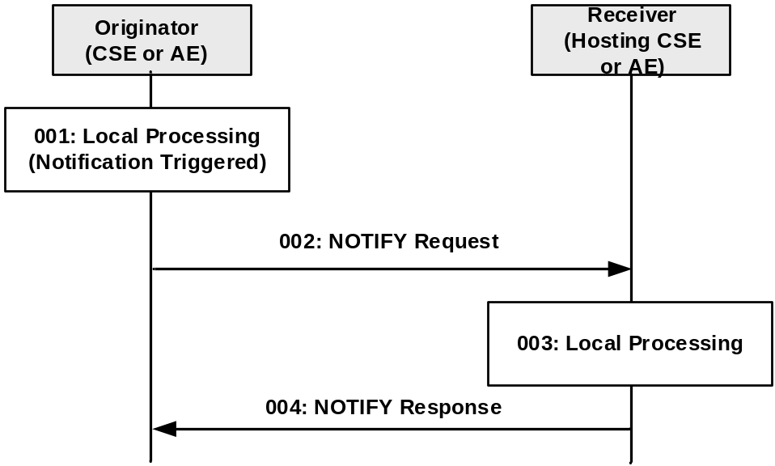
Figure 10.1.6-1: Procedure for NOTIFYing Information
Step 001: A notification to be sent to the Receiver is triggered in the Originator.
Step 002: The Originator shall send mandatory parameters and may send optional parameters in Request message for NOTIFY operation as specified in clause 8.1.2.
Step 003: Local Processing.
Step 004: The Receiver shall respond with mandatory parameters and may send optional parameters in Response message for NOTIFY operation as specified in clause 8.1.3.
General Exceptions:
- See oneM2M TS-0003 [Error: Reference source not found].
In the present specification, notification procedures are defined in the following procedures:
- <subscription> resource handling (clause 10.2.10)
  - to notify Receiver(s) of modifications of a resource for an associated <subscription> resource
  - to notify aggregated notifications from <subscription> member resources of <group> resource
  - to request Receiver(s) to perform resource subscription verification
  - to notify deletion of the <subscription> resource
  - to seek authorization from the subscription creator during a notification target deletion
- Asynchronous non-blocking request handling (clause 8.2.2.3)
to send the result of the request
- <pollingChannelURI> resource handling (clause 10.2.5.19)
to send the response corresponding to a request delivered via service layer long polling
- IPE on-demand discovery handling (clause 10.2.6)
to notify Receiver(s)(i.e., IPE) for on-demand discovery request.
- End-to-end security handling (clause 11.4)
to send the request/response that cannot be readable by Transit CSEs
- Dynamic authorization consultation handling (clause 11.5)
to seek authorization to access a resource from Dynamic Authorization Server

10.2 Functional procedures

10.2.1 Overview
The basic procedure for the corresponding operations as specified in clause 10.1 shall be performed with the modifications specific to the resource type procedures as described in clause 10.2.
For resources without defined resource type-specific operations, the basic operations in clause 10.1 shall apply.

10.2.2 Registration

10.2.2.1 AE registration
Editor's Note: put some introductory texts

10.2.2.2 Create <AE>
This procedure shall be used for creating an <AE> resource. This operation is part of the registration procedure for AEs on the Registrar CSE (which is also the Hosting CSE), as described in clause 10.2.2.2.
Table 10.2.2.2-1: <AE> CREATE
<AE> CREATE
Associated Reference Point | Mca
Information in Request message | All parameters defined in table 8.1.2-3 apply with the specific details for:  From: Registree AE only  Content: The resource content shall provide the information as defined in clause 9.6.5
Processing at Originator before sending Request | According to clause 10.2.2.2
Processing at Receiver | According to clause 10.2.2.2
Information in Response message | All parameters defined in table 8.1.3-1
Processing at Originator after receiving Response | According to clause 10.2.2.2
Exceptions | According to clause 10.2.2.2

The procedure for AE registration follows the message flow description depicted in figure 10.2.2.2-1. It defines in which cases additional procedures need to be initiated by the Registrar CSE for creating or updating of <AEAnnc> resources hosted on the M2M SP's IN-CSE in case an AE-ID-Stem starting with an 'S' character shall be used, see table 7.2-1 for the definition of AE-ID-Stem.
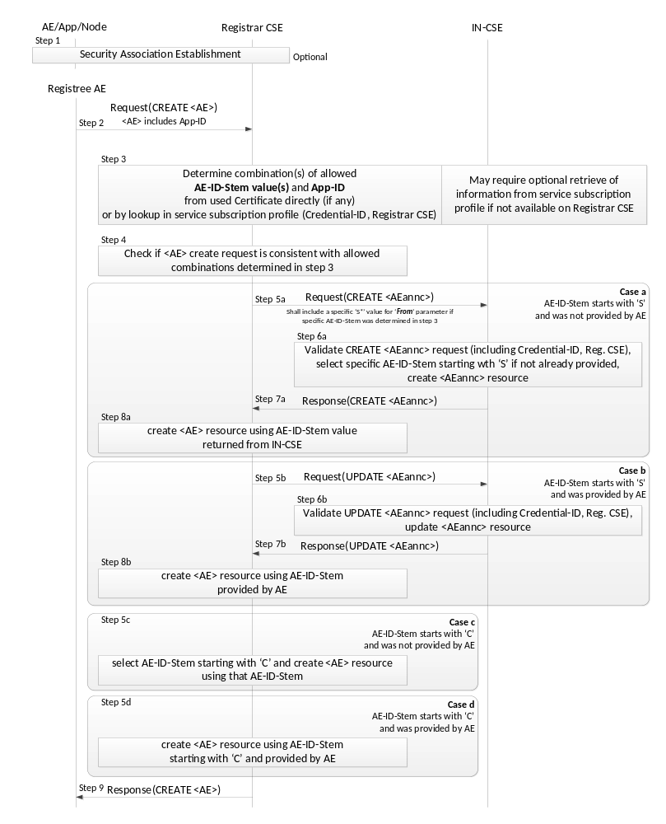
Figure 10.2.2.2-1: Procedure for Creating an <AE> Resource
Originator: The Originator shall be the Registree AE.
Receiver: The Receiver shall allow the creation of the <AE> resource according to the access control policy and information in the applicable m2m service subscription profile. To validate the m2m service subscription profile, the Receiver shall check the corresponding <serviceSubscribedNode> resource, by matching the CSE-ID in the m2m service subscription profile against the Receiver owned CSE-ID. Subsequently the Receiver shall check whether the Registree AE is included in the linked (i.e. ruleLinks attribute) <serviceSubscribedAppRules> resource(s).
Step 001: Optional: In case the Registree AE intends to use a Security Association to perform the registration, a Security Association Establishment procedure (see clause 11.2.2) shall get carried out first. In some cases (e.g. registration of AE internal to an MN or ASN), this may not be required depending on deployment choices of the M2M SP. Therefore, this step is optional. This optional Security Association can be established between the following entities:
- The Registree AE and the Registrar CSE - in which case the specific AE that is subsequently sending the request to get registered shall be authenticated.
- The Node on which the Registree AE is hosted and the Registrar CSE - in which case only the Node from which the registration request is received at the Registrar CSE shall be authenticated. In this case one or more AEs hosted on the authenticated node may communicate over either a single Security Association or over individual Security Associations.
NOTE: The Node authentication should be used only when the M2M Service Provider trusts the AE (on the Node) to provide the correct AE-ID and App-ID. The present document does not provide mechanisms by which the M2M Service Provider can obtain assurance about the trustworthiness of the AE when using Node authentication. For example, such a mechanism (by which the M2M Service Provider can obtain assurance about the trustworthiness of the AE) could be provided by executing the M2M Application on a secure environment.
The identifier of the security credentials used for establishing the Security Association in this step shall be termed 'Credential-ID' for the remainder of this procedure description. If no Security Association has been performed the Credential-ID shall be assumed to have the value 'None'.
Step 002: The Originator shall send the information defined in clause 10.1.2 for the registration CREATE procedure with the following specific information in the CREATE Request message:
From: AE-ID-Stem or NULL:
- In case the Registree AE has already registered successfully before, then deregistered and intends to register again with the same AE-ID-Stem value as before, the Registree AE shall include that AE-ID-Stem value into the From parameter.
- In case the Registree AE has not registered successfully before and intends to get an M2M-SP-assigned AE-ID-Stem starting with an 'S' character assigned to itself but it does not have any specific value to suggest, it shall set the From parameter to the character 'S'.
- In case the Registree AE has not registered successfully before and intends to get a Registrar CSE-assigned AE-ID-Stem starting with an 'C' character assigned to itself but it does not have any specific value to suggest, it shall set the From parameter to the character 'C'.
- In case the Registree AE intends to initiate a fresh registration and has no preference for the AE-ID-Stem value, the From parameter shallnot be sent.
The CSE shall allow unknown AEs to attempt the ‘CREATE’ before they are granted this permission. See TS-0003[2] further detail about authentication for the AE.
Step 003: The Receiver shall determine whether the request to register the Registree AE meets any of the following conditions:
- In case the Security Association Establishment in Step 001 was performed using security credentials in form of a Certificate that included an App-ID and an AE-ID-Stem attribute, check if they match with the App-ID attribute in the Content parameter of the request and the AE-ID-Stem in the From parameter of the request.
- Check if the applicable service subscription profile lists a combination of (allowed AE-ID-Stem value and allowed App-ID value) for the Credential-ID and the Registrar CSE-ID (see clause 11.2.2) that match with the App-ID attribute in the Content parameter of the request and the AE-ID-Stem in the From parameter of the request. If the information needed to perform that checking is not available to the Registrar CSE locally, the Registrar CSE shall retrieve that information from the applicable service subscription profile(s) from the IN-CSE. If the From parameter was not be sent in the request and the allowed AE-ID-Stem has wild card ("*") in service subscription profile, the Registrar CSE shall assign the starting character ('S', 'C') in accordance with provisioned Service Provider policy. The applicable rules for this checking are contained in the <serviceSubscribedAppRule> resource(s) which are linked to by the ruleLinks attribute of the <m2mServiceSubscribedNode> resource(s) associated with the Registrar CSE. The <m2mServiceSubscribedNode> resource(s) associated with the Registrar CSE can be retrieved from the IN-CSE by applying the Filter Criteria parameter set to "CSE-ID={Registrar-CSE-ID}"where {Registrar-CSE-ID} needs to be substituted by the actual CSE-ID of the Registrar-CSE.
If none of the conditions are met, the registration is not allowed and the Receiver shall respond with an error.
Step 004: If the From parameter of the request provides an AE-ID-Stem value, the Registrar CSE shall check whether an <AE> resource with an Unstructured-CSE-relative-Resource-ID identical to the AE-ID-Stem value provided in the From parameter of the request does already exist. If so, there is still an active registration using the same AE-ID-Stem on the Registrar CSE and the Registrar CSE shall respond with an error. If not, the Registrar CSE shall perform action (3) in Step 002 of clause 10.1.2.
The procedure continues with one for the following cases a) - d) depending on the listed conditions:
Case a) AE-ID-Stem starts with 'S' and AE does not include an AE-ID-Stem (initial registration):
Condition: In Step 003 it was determined that the AE-ID-Stem value to be used for the Registree AE starts with an 'S' character but no specific AE-ID-Stem was provided with the CREATE request of the Registree AE. This case applies when the Registree AE is supposed to use an M2M-SP-assigned AE-ID and wants to perform the initial registration:
- Step 005a: The Receiver shall send a CREATE request for an <AEAnnc> resource to the IN-CSE in order to create an <AEAnnc> resource on the IN-CSE that is associated with the Registree AE. The following information shall be sent with that CREATE request:
- In case no specific AE-ID-Stem value to be used for the Registree AE was determined during Step 003, the value 'S' shall be used in what follows for the AE-ID-Stem. Otherwise use the value determined in step 003.
- The From parameter of the CREATE request for the <AEAnnc> resource shall be set to the SP-relative-CSE-ID or Absolute-CSE-ID followed by ‘/S’.
- The link attribute of the <AEAnnc> resource to be created shall be set to the SP-Relative-Resource-ID format of a - not yet existent - <AE> resource hosted on the Registrar CSE constructed with a Unstructured-CSE-relative-Resource-ID that is equal to the AE-ID-Stem value used for the Registree AE.
- The App-ID attribute of the <AEAnnc> resource to be created shall be present and set to the App-ID attribute value of the Registree AE.
- The concatenation of the string 'Credential-ID:' and the actual Credential-ID of the Security Association used by the Registree AE - if any - shall be placed into the labels attribute of the <AE Annc> resource. If no noSecurity Association was used by the Registree AE, a value of 'None' shall be used for Credential-ID.
- Step 006a: Upon reception of the CREATE <AEAnnc> request, the IN-CSE shall validate the request and verify whether the provided values of the App-ID attribute and the AE-ID-Stem in the From parameter is allowed for the combination of Credential-ID included in the labels attribute and the CSE-ID of the Registrar CSE included in the link attribute, according to the applicable service subscription profile. If that verification is successful and no specific AE-ID-Stem is provided, i.e. if the From parameter contains only the character 'S', the IN-CSE shall select an AE-ID-Stem in line with the applicable service subscription profile.
- Step 007a: When the validation and verification in Step 006a completed successfully, the IN-CSE shall create <AEAnnc> resource with an Unstructured-CSE-relative-Resource-ID equal to the value of the AE-ID-Stem, insert the AE-ID-Stem into the link attribute if it was selected by the IN-CSE, and send a successful response to the Registrar CSE.
- Step 008a: Upon reception of a successful response from the IN-CSE, the Registrar CSE shall use the Unstructured-CSE-relative-Resource-ID that was used for the <AEAnnc> resource on the IN-CSE also as the assigned Unstructured-CSE-relative-Resource-ID for the <AE> resource to be created on the Registrar CSE and continue with action (4) of Step 002 of the non-registration related CREATE procedure in clause 10.1.2.
Case b) AE-ID-Stem starts with 'S' and AE includes an AE-ID-Stem (re-registration):
Condition: In Step 003 it was determined that the AE-ID-Stem value to be used for the Registree AE starts with an 'S' character and a specific AE-ID-Stem was provided with the CREATE request of the Registree AE. This case applies when the Registree AE is supposed to use an M2M-SP-assigned AE-ID and wants to perform a re-registration using its already assigned AE-ID-Stem:
- Step 005b: The Receiver shall send an UPDATE request for an <AEAnnc> resource to the IN-CSE in order to update the already existing <AEAnnc> resource on the IN-CSE that is associated with the Registree AE. The following information shall be sent with that CREATE request:
- The To parameter shall contain the SP-relative-Resource-ID format of the Resource ID for the <AEAnnc> resource which shall be constructed from the CSE-ID of the IN-CSE and the AE-ID-Stem that the Registree AE provided.
- From parameter of the UPDATE request for the <AEAnnc> resource shall be set to the SP-relative-CSE-ID or Absolute-CSE-ID followed by
- The link attribute of the <AEAnnc> resource shall be updated to the SP-Relative-Resource-ID format of a - not yet existent - <AE> resource hosted on the Registrar CSE constructed with an Unstructured-CSE-relative-Resource-ID that is equal to the AE-ID-Stem value used for the Registree AE.
- The labels attribute of the <AEAnnc> resource shall be updated with the concatenation of the string 'Credential-ID:' and the Credential-ID of the Security Association used by the Registree AE, replacing the existing entry starting with 'Credential-ID:'. If no Security Association was used by the Registree AE, a value of 'None' shall be used for Credential-ID.
- Step 006b: Upon reception of the UPDATE <AEAnnc> request, the IN-CSE shall validate the request and verify whether the values suggested to be updated for the Credential-ID included in the labels attribute - if any - and the CSE-ID of the Registrar CSE included in the From parameter still match with any of the allowed combinations of App-ID attribute and the AE-ID-Stem in the link attributeaccording to the applicable service subscription profile.
- Step 007b: When the validation and verification in Step 006b completed successfully, the IN-CSE shall update the <AEAnnc> resource.
- Step 008b: Upon reception of a successful response from the IN-CSE, the Registrar CSE shall use the Unstructured-CSE-relative-Resource-ID equal to the AE-ID-Stem in the link attribute for the <AE> resource to be created on the Registrar CSE and continue with action (4) of Step 002 of the non-registration related CREATE procedure in clause 10.1.2.
Case c) AE-ID-Stem starts with 'C' and AE does not include an AE-ID-Stem (initial registration):
Condition: In Step 003 it was determined that the AE-ID-Stem value to be used for the Registree AE starts with an 'C' character but no specific AE-ID-Stem was provided with the CREATE request of the Registree AE. This case applies when the Registree AE is not supposed to use an M2M-SP-assigned AE-ID and wants to perform the initial registration:
Step 005c: The Registrar CSE shall select an AE-ID-Stem starting with a 'C' character and use it for the Unstructured-CSE-relative-Resource-ID for the <AE> resource to be created on the Registrar CSE and continue with action (4) of Step 002 of the non-registration related CREATE procedure in clause 10.1.2.
Case d) AE-ID-Stem starts with 'C' and AE includes an AE-ID-Stem (re-registration):
Condition: In Step 003 it was determined that the AE-ID-Stem value to be used for the Registree AE starts with an 'C' character and a specific AE-ID-Stem was provided with the CREATE request of the Registree AE. This case applies when the Registree AE is not supposed to use an M2M-SP-assigned AE-ID and wants to perform a re-registration:
- Step 005d: The Registrar CSE shall use the Unstructured-CSE-relative-Resource-ID equal to the AE-ID-Stem in the From parameter for the <AE> resource to be created on the Registrar CSE and continue with action (4) of Step 002 of the non-registration related CREATE procedure in clause 10.1.2.

10.2.2.3 Retrieve <AE>
This procedure shall be used for retrieving the representation of the <AE> resource.
Table 10.2.2.3-1: <AE> RETRIEVE
<AE> RETRIEVE
Associated Reference Point | Mca, Mcc and Mcc'
Information in Request message | All parameters defined in table 8.1.2-3
Processing at Originator before sending Request | According to clause 10.1.3
Processing at Receiver | According to clause 10.1.3
Information in Response message | All parameters defined in table 8.1.3-1 apply with the specific details for:  Content: attributes of the <AE> resource as defined in clause 9.6.5
Processing at Originator after receiving Response | According to clause 10.1.3
Exceptions | According to clause 10.1.3

10.2.2.4 Update <AE>
This procedure shall be used for updating the attributes and the actual data of an <AE> resource.
Table 10.2.2.4-1: <AE> UPDATE
<AE> UPDATE
Associated Reference Point | Mca, Mcc and Mcc'
Information in Request message | All parameters defined in table 8.1.2-3 apply with the specific details for:  Content: attributes of the <AE> resource as defined in clause 9.6.5 which need be updated
Processing at Originator before sending Request | According to clause 10.1.4
Processing at Receiver | According to clause 10.1.4  If the pointOfAccess attribute is updated and there are any messages in the buffer for store-and-forward procedure, Receiver shall send all buffered messages
Information in Response message | According to clause 10.1.4
Processing at Originator after receiving Response | According to clause 10.1.4
Exceptions | According to clause 10.1.4

10.2.2.5 Delete <AE>
This procedure shall be used for deleting the <AE> resource with all related information.
Table 10.2.2.5-1: <AE> DELETE
<AE> DELETE
Associated Reference Point | Mca, Mcc and Mcc'
Information in Request message | All parameters defined in table 8.1.2-3 apply
Processing at Originator before sending Request | According to clause 10.1.5
Processing at Receiver | According to clause 10.1.5
Information in Response message | According to clause 10.1.5
Processing at Originator after receiving Response | According to clause 10.1.5
Exceptions | According to clause 10.1.5

Application Entity Deregistration is performed by requesting a Delete operation for the <AE> resource representing the Application Entity.
In case an <AE> resource hosted on a MN-CSE or ASN-CSE with AE-ID-Stem starting with "S" is requested to be deleted, the <AEAnnc> resource that was created on the IN-CSE during the initial registration of the associated Application Entity shall be updated with an empty value for the link attribute, indicating that the associated Application Entity is currently not registered. After this update of the <AEAnnc> resource is completed, the procedure for AE Deregistration shall follow the procedure described in 10.2.2.5.
In case an <AE> resource with AE-ID-Stem not starting with "S" is requested to be deleted, the procedure for AE Deregistration follows the procedure described in clause 10.1.5.

10.2.2.6 CSE registration
Editor's Note: Write some texts to explain registration relation with <CSEBase> and <remoteCSE> resources
The Create procedure shall be not apply to <CSEBase>. <CSEBase> can be created via management operation not defined in this version of the specification.
The Update procedure shall not apply to <CSEBase>. <CSEBase> can be updated via management operation not defined in this version of the specification.
The Delete procedure shall not apply to <CSEBase>. <CSEBase> can be deleted via management operation not defined in this version of the specification.

10.2.2.7 Create <remoteCSE>
This procedure shall be used for creating a <remoteCSE> resource. It is part of the registration procedure for remote CSEs on the Registrar CSE (which is also the Hosting CSE), as described in clause 10.2.2.7.
Table 10.2.2.7-1: <remoteCSE> CREATE
<remoteCSE> CREATE
Associated Reference Point | Mcc and Mcc'
Information in Request message | All parameters defined in table 8.1.2-3 apply with the specific details for:  From: Originator CSE-ID  Content: The resource content shall provide the information as defined in clause 9.6.4
Processing at Originator before sending Request | According to clause 10.2.2.7
Processing at Receiver | According to clause 10.2.2.7  If the IN-CSE is the receiver and if the M2M SP policies do allow access to the CSEs across multiple domains, then the IN shall create the appropriate entry in the M2M SP's DNS for successfully registered CSE
Information in Response message | All parameters defined in table 8.1.3-1 apply with the specific details for:  Content: Address of the created <remoteCSE> resource, according to clause 10.2.2.7
Processing at Originator after receiving Response | According to clause 10.2.2.7. the Originator starts a Retrieve operation and uses the result to create a remoteCSE representation of the Receiver
Exceptions | According to clause 10.2.2.7

The procedure for CSE Registration follows the procedure described in clause 10.1.2, but with some deviations. Below is the detailed description on how to perform the CSE Registration and which part of the procedure deviates from the one described in clause 10.1.2.
The Registration procedure requires the creation of two resources (a <remoteCSE> on the Receiver CSE and a <remoteCSE> on the Originator CSE) rather than one resource. The Registration procedure is always initiated by a CSE in the field domain except in the inter-domain case described in clause 6.5.
Originator: The Originator shall be the registering CSE.
Receiver: The Receiver shall create the <remoteCSE> resource.
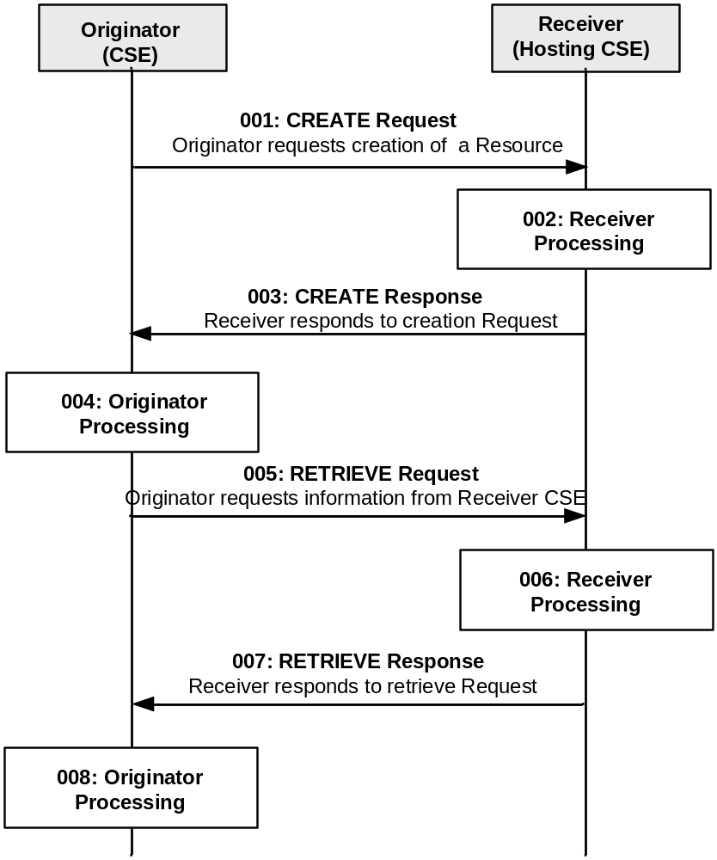
Figure 10.2.2.7-1: Procedure for CREATEing a <remoteCSE> Resource
All the parameters of the request and steps that are not indicated do not deviate from clause 10.1.2.
Step 001: The Originator shall send mandatory parameters and may send optional parameters in Request message for CREATE operation as specified in clause 8.1.2.
Step 002: The Receiver shall:
The registrar CSE shall allow unknown remote CSE to attempt to ‘CREATE’ when it was authenticated by credential provided by the entity. See TS-0003[2] further detail about authentication for the CSE.
- Perform sub-steps: 2)-8), from step 002 from clause 10.1.2 are applicable.
NOTE: Optionally, if the M2M Service Provider supports inter-domain communication, the Receiver could perform this step if the attribute CSEBase (part of the Content parameter of the request) contains the public domain of the CSE. The Receiver could construct the domain as described in clause 6.4 and 6.5. The Receiver could add an AAA or AAAA record in DNS with the public domain name of the Originator CSE and the IP address of the IN-CSE associated with the Originator.
Step 003: See clause 10.1.2.
Step 004: The Originator, upon receipt of the CREATE response message, shall create a <remoteCSE> resource locally under its <CSEBase> resource. This resource is representing the Receiver CSE. The Originator shall provide the appropriate values to all mandatory parameters as described in clause 9.6.4.
Step 005: The Originator may issue a RETRIEVE Request towards the Receiver (same To as for the CREATE request message) to obtain the optional parameters of the <remoteCSE> resource created at the Receiver as for step 004 (e.g. labels, accessControlPolicyIDs attributes). The RETRIEVE procedure is described in clause 10.1.3.
See clauses 8.1.2 for the information to be included in the Request message.
Step 006: The Receiver verifies that the Originator has the appropriate privileges to access the information.
Step 007: The Receiver sends a RETRIEVE response message, according to the procedure described in clause 10.1.3.
See clauses 8.1.3 and 8.1.4 for the information to be included in the Response message.
Step 008: The Originator shall update the created <remoteCSE> resource for the Receiver with the information obtained in step 007.
General Exceptions:
All exceptions from clause 10.1.2 are applicable; in addition the following exception may occur:
The Originator does not have the privileges to retrieve the attributes of the Receiver CSE. The Receiver responds with an error.

10.2.2.8 Retrieve <remoteCSE>
This procedure shall be used for retrieving the representation of the <remoteCSE> resource with its attributes.
Table 10.2.2.8-1: <remoteCSE> RETRIEVE
<remoteCSE> RETRIEVE
Associated Reference Point | Mca, Mcc and Mcc'
Information in Request message | All parameters defined in table 8.1.2-3 apply
Processing at Originator before sending Request | According to clause 10.1.3
Processing at Receiver | According to clause 10.1.3
Information in Response message | All parameters defined in table 8.1.3-1 apply with the specific details for:  Content: attributes of the <remoteCSE> resource as the Originator requested
Processing at Originator after receiving Response | According to clause 10.1.3
Exceptions | According to clause 10.1.3

10.2.2.9 Update <remoteCSE>
This procedure shall be used for updating the attributes and the actual data of an <remoteCSE> resource.
Table 10.2.2.9-1: <remoteCSE> UPDATE
<remoteCSE> UPDATE
Associated Reference Point | Mcc and Mcc'
Information in Request message | All parameters defined in table 8.1.2-3 apply with the specific details for:  Content: attributes of the <remoteCSE> resource as defined in clause 9.6.4 which need be updated
Processing at Originator before sending Request | According to clause 10.1.4
Processing at Receiver | According to clause 10.1.4  If the pointOfAccess attribute is updated and there are any messages in the buffer for store-and-forward procedure, Receiver shall send all buffered messages
Information in Response message | According to clause 10.1.4
Processing at Originator after receiving Response | According to clause 10.1.4
Exceptions | According to clause 10.1.4

10.2.2.10 Delete <remoteCSE>
This procedure shall be used for deleting the <remoteCSE> resource with all related information.
Table 10.2.2.10-1: <remoteCSE> DELETE
<remoteCSE> DELETE
Associated Reference Point | Mca, Mcc and Mcc'
Information in Request message | All parameters defined in table 8.1.2-3 apply
Processing at Originator before sending Request | According to clause 10.1.5
Processing at Receiver | According to clause 10.1.5  If the IN-CSE is the receiver and it has created an entry in the DNS to allow access to the CSE across multiple M2M domains, then it shall delete the entry from the DNS
Information in Response message | According to clause 10.1.5
Processing at Originator after receiving Response | According to clause 10.1.5
Exceptions | According to clause 10.1.5

The procedure for CSE Deregistration follows the procedure described in clause 10.1.5, but with some exceptions. Below is the detailed description on how to perform the CSE Deregistration and which part of the procedure deviates from the one described in clause 10.1.5.
The Deregistration procedure accompanies the deletion of two resources (a <remoteCSE> on the Hosting CSE and a <remoteCSE> on the Originator CSE) rather than one resource. The Deregistration procedure can be initiated by either Registree CSE or Registrar CSE.
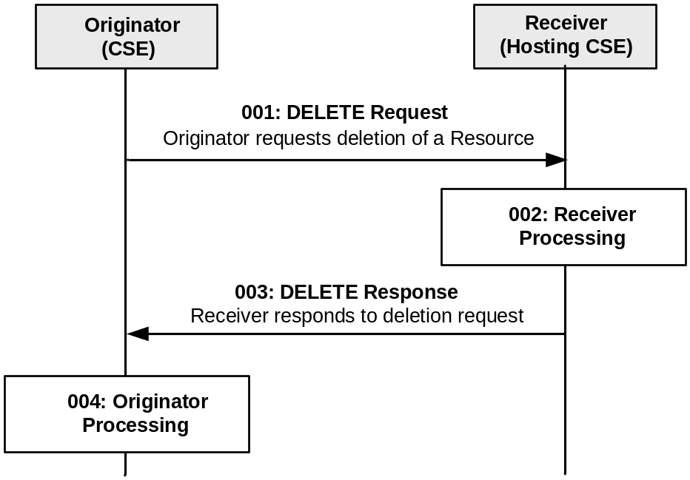
Figure 10.2.2.10-1: Procedure for DELETING a <remoteCSE> Resource
Step 001: See clause 10.1.5.
Step 002: See clause 10.1.5.
Step 003: See clause 10.1.5.
Step 004: The Originator, upon receipt of the DELETE response, shall delete a <remoteCSE> resource locally under its <CSEBase> resource.
General Exceptions:
All exceptions from 10.1.5 are applicable; in addition the following exception may occur:
If the Receiver rejects the DELETE request and responds with an error in the DELETE response, the Originator cannot perform the action described in the Step 004.

10.2.2.11 Retrieve <CSEBase>
This procedure shall be used for retrieving the representation of the <CSEBase> resource with its attributes.
Table 10.2.2.11-1: <CSEBase> RETRIEVE
<CSEBase> RETRIEVE
Associated Reference Point | Mca, Mcc and Mcc'
Information in Request message | All parameters defined in table 8.1.2-3 apply
Processing at Originator before sending Request | According to clauses 10.1.3 and 10.2.2.7
Processing at Receiver | According to clauses 10.1.3 and 10.2.2.7
Information in Response message | All parameters defined in table 8.1.3-1 apply with the specific details for:  Content: attributes of the <CSEBase> resource as requested by the Originator
Processing at Originator after receiving Response | According to clauses 10.1.3 and 10.2.2.7  When this procedure is used during CSE Registration, a <remoteCSE> resource is created using the retrieved resource
Exceptions | According to clauses 10.1.3 and 10.2.2.7

10.2.3 Authorization

10.2.3.1 Introduction

This clause describes the procedures for creation, retrieval, update and deletion of the different types of authorization resources (i.e. <accessControlPolicy>, <dynamicAuthorizationConsultation>, <role> and <token>). These resources are used by a CSE to control access to other resources based on the different authorization methods as specified in the present document and in oneM2M TS-0003 [2].

10.2.3.2 Authorization using <accessControlPolicy>
This clause describes the procedures for creation, retrieval, update and deletion of the <accessControlPolicy> resource. The <accessControlPolicy> resource is used by a CSE to control access to other resources as specified in clauses 9.6.2 and 11.3.4.

10.2.3.3 Create <accessControlPolicy>
This procedure shall be used to create an <accessControlPolicy> resource.
Table 10.2.3.3-1: <accessControlPolicy> CREATE
<accessControlPolicy> CREATE
Associated Reference Point | Mca, Mcc and Mcc'.
Information in Request message | Same as clause 10.1.2.
Pre-Processing at Originator | Same as clause 10.1.2.
Processing at Receiver | Same as clause 10.1.2. However the action (1) in step 002 shall be omitted.
Information in Response message | Same as clause 10.1.2.
Post-Processing at Originator | Same as clause 10.1.2.
Exceptions | Same as clause 10.1.2.

10.2.3.4 Retrieve <accessControlPolicy>
This procedure shall be used to retrieve attributes and child resource information of the <accessControlPolicy> resource.
Table 10.2.3.3-1: <accessControlPolicy> RETRIEVE
<accessControlPolicy> RETRIEVE
Associated Reference Point | Mca, Mcc and Mcc'.
Information in Request message | Same as clause 10.1.3.
Pre-Processing at Originator | Same as clause 10.1.3.
Processing at Receiver | Addition to clause 10.1.3:  - The Receiver shall check access control rules defined in selfPrivileges of the <accessControlPolicy> resource>.
Information in Response message | Same as clause 10.1.3.
Post-Processing at Originator | Same as clause 10.1.3.
Exceptions | Addition to clause 10.1.3.

10.2.3.5 Update <accessControlPolicy>
This procedure shall be used to update attributes information of the <accessControlPolicy> resource.
Table 10.2.3.5-1: <accessControlPolicy> UPDATE
<accessControlPolicy> UPDATE
Associated Reference Point | Mca, Mcc and Mcc'.
Information in Request message | Same as clause 10.1.4.
Pre-Processing at Originator | Same as clause 10.1.4.
Processing at Receiver | Addition to clause 10.1.4:  - The Receiver shall check access control rules defined in selfPrivileges of the <accessControlPolicy> resource.
Information in Response message | Same as clause 10.1.4.
Post-Processing at Originator | Same as clause 10.1.4.
Exceptions | Addition to clause 10.1.4.

10.2.3.6 Delete <accessControlPolicy>
This procedure shall be used to delete the <accessControlPolicy> resource.
Table 10.2.3.6-1: <accessControlPolicy> DELETE
<accessControlPolicy> DELETE
Associated Reference Point | Mca, Mcc and Mcc'
Information in Request message | Same as clause 10.1.5.
Pre-Processing at Originator | Same as clause 10.1.5.
Processing at Receiver | Addition to clause 10.1.5:  - The Receiver shall check access control rules defined in selfPrivileges of the <accessControlPolicy> resource.
Information in Response message | Same as clause 10.1.5.
Post-Processing at Originator | Same as clause 10.1.5.
Exceptions | Addition to clause 10.1.5.

10.2.3.7 Authorization using <dynamicAuthorizationConsultation>
This clause describes the procedures for creation, retrieval, update and deletion of the <dynamicAuthorizationConsultation> resource. The <dynamicAuthorizationConsultation> resource is used by a CSE to control access to resources in a dynamic manner as specified in clause 11.5.

10.2.3.8 Create <dynamicAuthorizationConsultation>
This procedure shall be used to create a <dynamicAuthorizationConsultation> resource.
Table 10.2.3.8-1: <dynamicAuthorizationConsultation> CREATE
<dynamicAuthorizationConsultation> CREATE
Associated Reference Point | Mca, Mcc and Mcc'.
Information in Request message | Same as clause 10.1.2.
Pre-Processing at Originator | Same as clause 10.1.2.
Processing at Receiver | Same as clause 10.1.2.
Information in Response message | Same as clause 10.1.2.
Post-Processing at Originator | Same as clause 10.1.2.
Exceptions | Same as clause 10.1.2.

10.2.3.9 Retrieve <dynamicAuthorizationConsultation>
This procedure shall be used to retrieve attributes and child resource information of the <dynamicAuthorizationConsultation> resource.
Table 10.2.3.9-1: <dynamicAuthorizationConsultation> RETRIEVE
<dynamicAuthorizationConsultation> RETRIEVE
Associated Reference Point | Mca, Mcc and Mcc'.
Information in Request message | Same as clause 10.1.3.
Pre-Processing at Originator | Same as clause 10.1.3.
Processing at Receiver | Same as clause 10.1.3.
Information in Response message | Same as clause 10.1.3.
Post-Processing at Originator | Same as clause 10.1.3.
Exceptions | Addition to clause 10.1.3.

10.2.3.10 Update <dynamicAuthorizationConsultation>
This procedure shall be used to update attributes information of the <dynamicAuthorizationConsultation> resource.
Table 10.2.3.10-1: <dynamicAuthorizationConsultation> UPDATE
<dynamicAuthorizationConsultation> UPDATE
Associated Reference Point | Mca, Mcc and Mcc'.
Information in Request message | Same as clause 10.1.4.
Pre-Processing at Originator | Same as clause 10.1.4.
Processing at Receiver | Addition to clause 10.1.4.
Information in Response message | Same as clause 10.1.4.
Post-Processing at Originator | Same as clause 10.1.4.
Exceptions | Addition to clause 10.1.4.

10.2.3.11 Delete <dynamicAuthorizationConsultation>
This procedure shall be used to delete the <dynamicAuthorizationConsultation> resource.
Table 10.2.3.11-1: <dynamicAuthorizationConsultation> DELETE
<dynamicAuthorizationConsultation> DELETE
Associated Reference Point | Mca, Mcc and Mcc'.
Information in Request message | Same as clause 10.1.5.
Pre-Processing at Originator | Same as clause 10.1.5.
Processing at Receiver | Addition to clause 10.1.5.
Information in Response message | Same as clause 10.1.5.
Post-Processing at Originator | Same as clause 10.1.5.
Exceptions | Addition to clause 10.1.5.

10.2.3.12 Authorization using <role>
This clause describes the procedures for creation, retrieval, update and deletion of the <role> resource. The <role> resource is used to assign a role to an AE or CSE. The role is used to control access to resources in a role-based manner as specified in oneM2M TS-0003 [2].

10.2.3.13 Create <role>
This procedure shall be used for creating a <role> resource.
Table 10.2.3.13-1: <role> CREATE
<role> CREATE
Associated Reference Point | Mca, Mcc and Mcc'
Information in Request message | All parameters defined in table 8.1.2-3 apply with the specific details for:  From: Identifier of the AE that initiates the request  To: Address the resource where the <role> resource is intended to be created  Content: The resource content shall provide the information as defined in clause 9.6.38
Processing at Originator before sending Request | According to clause 10.1.2
Processing at Receiver | According to clause 10.1.2
Information in Response message | All parameters defined in table 8.1.3-1 apply with the specific details for:  Content: Address of the created <role> resource, according to clause 10.1.2
Processing at Originator after receiving Response | According to clause 10.1.2
Exceptions | According to clause 10.1.2

10.2.3.14 Retrieve <role>
This procedure shall be used for retrieving the attributes of a <role> resource.
Table 10.2.3.14-1: <role> RETRIEVE
<role> RETRIEVE
Associated Reference Point | Mca, Mcc and Mcc'
Information in Request message | All parameters defined in table 8.1.2-3 apply with the specific details for:  Content: void
Processing at Originator before sending Request | According to clause 10.1.3
Processing at Receiver | According to clause 10.1.3
Information in Response message | All parameters defined in table 8.1.3-1 apply with the specific details for:  Content: attributes of the <role> resource as defined in clause 9.6.38
Processing at Originator after receiving Response | According to clause 10.1.3
Exceptions | According to clause 10.1.3

10.2.3.15 Update <role>
This procedure shall be used for updating attributes of a <role> resource.
Table 10.2.3.15-1: <role> UPDATE
<role> UPDATE
Associated Reference Point | Mca, Mcc and Mcc'
Information in Request message | All parameters defined in table 8.1.2-3 apply
Processing at Originator before sending Request | According to clause 10.1.4
Processing at Receiver | According to clause 10.1.4
Information in Response message | According to clause 10.1.4
Processing at Originator after receiving Response | According to clause 10.1.4
Exceptions | According to clause 10.1.4

10.2.3.16 Delete <role>
This procedure shall be used for deleting an existing <role> resource.
Table 10.2.3.16-1: <role> DELETE
<role> DELETE
Associated Reference Point | Mca, Mcc and Mcc'
Information in Request message | All parameters defined in table 8.1.2-3 apply
Processing at Originator before sending Request | According to clause 10.1.5
Processing at Receiver | According to clause 10.1.5
Information in Response message | According to clause 10.1.5
Processing at Originator after receiving Response | According to clause 10.1.5
Exceptions | According to clause 10.1.5

10.2.3.17 Authorization using <token>
This clause describes the procedures for creation, retrieval, update and deletion of the <token> resource. The <token> resource is used for storing a token that is issued to an AE or CSE. The token is used to control access to resources in a dynamic manner as specified in clause 11.5 of the present document and in oneM2M TS-0003 [2].

10.2.3.18 Create <token>
This procedure shall be used for creating a <token> resource.
Table 10.2.3.18-1: <token> CREATE
<token> CREATE
Associated Reference Point | Mca, Mcc and Mcc'
Information in Request message | All parameters defined in table 8.1.2-3 apply with the specific details for:  From: Identifier of the AE that initiates the request  To: Address the resource where the <token> resource is intended to be created  Content: The resource content shall provide the information as defined in clause 9.6.39
Processing at Originator before sending Request | According to clause 10.1.2
Processing at Receiver | According to clause 10.1.2
Information in Response message | All parameters defined in table 8.1.3-1 apply with the specific details for:  Content: Address of the created <token> resource, according to clause 10.1.2
Processing at Originator after receiving Response | According to clause 10.1.2
Exceptions | According to clause 10.1.2

10.2.3.19 Retrieve <token>
This procedure shall be used for retrieving the attributes of a <token> resource.
Table 10.2.3.19-1: <token> RETRIEVE
<token> RETRIEVE
Associated Reference Point | Mca, Mcc and Mcc'
Information in Request message | All parameters defined in table 8.1.2-3 apply with the specific details for:  Content: void
Processing at Originator before sending Request | According to clause 10.1.3
Processing at Receiver | According to clause 10.1.3
Information in Response message | All parameters defined in table 8.1.3-1 apply with the specific details for:  Content: attributes of the <token> resource as defined in clause 9.6.39
Processing at Originator after receiving Response | According to clause 10.1.3
Exceptions | According to clause 10.1.3

10.2.3.20 Update <token>
This procedure shall be used for updating attributes of a <token> resource.
Table 10.2.3.20-1: <token> UPDATE
<token> UPDATE
Associated Reference Point | Mca, Mcc and Mcc'
Information in Request message | All parameters defined in table 8.1.2-3 apply
Processing at Originator before sending Request | According to clause 10.1.4
Processing at Receiver | According to clause 10.1.4
Information in Response message | According to clause 10.1.4
Processing at Originator after receiving Response | According to clause 10.1.4
Exceptions | According to clause 10.1.4

10.2.3.21 Delete <token>
This procedure shall be used for deleting an existing <token> resource.
Table 10.2.3.21-1: <token> DELETE
<token> DELETE
Associated Reference Point | Mca, Mcc and Mcc'
Information in Request message | All parameters defined in table 8.1.2-3 apply
Processing at Originator before sending Request | According to clause 10.1.5
Processing at Receiver | According to clause 10.1.5
Information in Response message | According to clause 10.1.5
Processing at Originator after receiving Response | According to clause 10.1.5
Exceptions | According to clause 10.1.5

10.2.3.22 Authorization using <authorizationDecision>
Each <authorizationDecision> resource represents an entrance of a Policy Decision Point (PDP) that is responsible for making access control decisions.
Multiple <authorizationDecision> resources can be created under one <CSEBase> resource. The access control policies associated to an <authorizationDecision> resource can be used to group access control decision requesters, i.e. which CSEs can retrieve access control decisions from a given <authorizationDecision> resource.
The resource specific resource specific attributes of an <authorizationDecision> resource can be classified into two categories according to their usages. One category is used for describing access control decisions, e.g. the decision and status attributes. The other category is used for describing access control decision requests, e.g. to, from, operation, roleIDs and so on.
A CSE can request an access control decision through sending a RETRIEVE request to an <authorizationDecision> resource. The Filter Criteria parameter of the request is used for carrying access control decision request that is expressed using attribute condition tags. For example, an access control decision request can be expressed with filter criteria: "from=//m2m.prov.com/CSE3219/C9886", "to=/CSE987776/a234361", "operation=retrieve". The resource attributes (e.g. decision and status) representing the access control decision are the target attributes that the decision requester wants to retrieve.
A RETRIEVE operation on an <authorizationDecision> resource will trigger an access control decision making process. After making an access control decision, the access control decision and/or status are returned back to the decision requester as the retrieved resource attributes through a retrieve response.
The details of distributed authorization procedures are described in TS-0003 [2].

10.2.3.23 Create <authorizationDecision>
This procedure shall be used for creating an <authorizationDecision> resource.
Table 10.2.3.23-1: <authorizationDecision> CREATE
<authorizationDecision> CREATE
Associated Reference Point | Mca, Mcc and Mcc'
Information in Request message | All parameters defined in table 8.1.2-3 apply with the specific details for:  Content: The resource content shall provide the information as defined in clause 9.6.42, and all the values of resource specific attributes shall be set to null.
Processing at Originator before sending Request | According to clause 10.1.2
Processing at Receiver | According to clause 10.1.2
Information in Response message | According to clause 10.1.2
Processing at Originator after receiving Response | According to clause 10.1.2
Exceptions | According to clause 10.1.2

10.2.3.24 Retrieve <authorizationDecision>
This procedure shall be used for retrieving the attributes of an <authorizationDecision> resource.
Originator: The Originator shall request to obtain an access control decision by using RETRIEVE operation on an <authorizationDecision> resource. The access control decision shall be specified with decision and/or status attributes that are the target attributes to be retrieved, and the access control decision request shall be specified with Filter Criteria parameter using other resource specific attributes.
Receiver: The Receiver shall execute an access control decision making process according to the access control decision request provided in the RETRUEVE request, and return the access control decision in the RETRIEVE response.
Table 10.2.3.24-1: <authorizationDecision> RETRIEVE
<authorizationDecision> RETRIEVE
Associated Reference Point | Mcc and Mcc'
Information in Request message | According to clause 10.1.3 with the following additions:  From: Identifier of the CSE that initiates the Request  To: Address of the <authorizationDecision> resource  Content: The names of decision and/or status attributes that represent the access control decision.  Filter Criteria: The representation of an access control decision request constructed using attribute condition tags. See clause 7 in oneM2M TS-0003 [2] for the mandatory and optional parameters,
Processing at Originator before sending Request | According to clause 10.1.3
Processing at Receiver | The Receiver should perform the following operations:  - Check if the Originator has RETRIEVE privilege on the <authorizationDecision> resource  - Check the validity of the parameters in the request, including the Content and Filter Criteria parameters  - Obtain applicable access control policies and requested access control information, and then make an access control decision. The details of this process are described in TS-0003 [2].
Information in Response message | All parameters defined in table 8.1.3-1 apply with the specific details for:  Content: The decision and/or status attributes of the <authorizationDecision> resource as defined in clause 9.6.42
Processing at Originator after receiving Response | According to clause 10.1.3
Exceptions | According to clause 10.1.3

10.2.3.25 Update <authorizationDecision>
This procedure shall be used for updating attributes of an <authorizationDecision> resource.
Table 10.2.3.25-1: <authorizationDecision> UPDATE
<authorizationDecision> UPDATE
Associated Reference Point | Mca, Mcc and Mcc'
Information in Request message | All parameters defined in table 8.1.2-3 apply.
Processing at Originator before sending Request | According to clause 10.1.4
Processing at Receiver | According to clause 10.1.4
Information in Response message | According to clause 10.1.4
Processing at Originator after receiving Response | According to clause 10.1.4
Exceptions | According to clause 10.1.4

10.2.3.26 Delete <authorizationDecision>
This procedure shall be used for deleting an existing <authorizationDecision> resource.
Table 10.2.3.26-1: <authorizationDecision> DELETE
<authorizationDecision> DELETE
Associated Reference Point | Mca, Mcc and Mcc'
Information in Request message | All parameters defined in table 8.1.2-3 apply
Processing at Originator before sending Request | According to clause 10.1.5
Processing at Receiver | According to clause 10.1.5
Information in Response message | According to clause 10.1.5
Processing at Originator after receiving Response | According to clause 10.1.5
Exceptions | According to clause 10.1.5

10.2.3.27 Authorization using <authorizationPolicy>
Each <authorizationPolicy> resource represents an entrance of a Policy Retrieval Point (PRP) that is responsible for retrieving access control policies.
Multiple <authorizationPolicy> resources can be created under one <CSEBase> resource. The access control policies associated to an <authorizationPolicy> resource can be used to group access control policy requesters, i.e. which CSEs can retrieve access control policies from a given <authorizationPolicy> resource.
The resource specific attributes of an <authorizationPolicy> resource can be classified into two categories according to their usages. One category is used for describing access control policies, e.g. the policies and combiningAlgorithm attributes. The other category is used for describing access control policy requests, e.g. the to attribute.
A CSE can request access control policies through sending a RETRIEVE request to an <authorizationPolicy> resource. The Filter Criteria parameter of the request is used for carrying access control policy request that is expressed using attribute condition tags. For example, an access control policy request can be expressed with filter criteria: "to=/CSE987776/a234361". The resource attributes (e.g. policies and combiningAlgorithm) representing the access control policies are the target attributes that the policy requester wants to retrieve.
A RETRIEVE operation on an <authorizationPolicy> resource will trigger an access control policy retrieving process. After obtaining the access control policies and policy combining algorithm, the access control policies and/or policy combining algorithm are returned back to the policy requester as the retrieved resource attributes through a retrieve response.
The details of distributed authorization procedures are described in TS-0003 [2].

10.2.3.28 Create <authorizationPolicy>
This procedure shall be used for creating an <authorizationPolicy> resource.
Table 10.2.3.28-1: <authorizationPolicy> CREATE
<authorizationPolicy> CREATE
Associated Reference Point | Mca, Mcc and Mcc'
Information in Request message | All parameters defined in table 8.1.2-3 apply with the specific details for:  Content: The resource content shall provide the information as defined in clause 9.6.43, and all the values of resource specific attributes shall be set to null.
Processing at Originator before sending Request | According to clause 10.1.2
Processing at Receiver | According to clause 10.1.2
Information in Response message | According to clause 10.1.2
Processing at Originator after receiving Response | According to clause 10.1.2
Exceptions | According to clause 10.1.2

10.2.3.29 Retrieve <authorizationPolicy>
This procedure shall be used for retrieving the attributes of an <authorizationPolicy> resource.
Originator: The Originator shall request to obtain access control policies by using RETRIEVE operation on an <authorizationPolicy> resource. The access control policies shall be specified with policies and/or combiningAlgorithm attributes that are the target attributes to be retrieved, and the access control policy request shall be specified with Filter Criteria parameter using other resource specific attributes.
Receiver: The Receiver shall execute an access control policy retrieving process according to the access control policy request provided in the RETRUEVE request, and return the access control policies in the RETRIEVE response.
Table 10.2.3.29-1: <authorizationPolicy> RETRIEVE
<authorizationPolicy> RETRIEVE
Associated Reference Point | Mcc and Mcc'
Information in Request message | According to clause 10.1.3 with the following additions:  From: Identifier of the CSE that initiates the Request  To: Address of the <authorizationPolicy> resource  Content: The names of policies and/or combiningAlgorithm attributes that represent the access control policies.  Filter Criteria: The representation of an access control policy request constructed using attribute condition tags. See clause 7 in oneM2M TS-0003 [2] for the mandatory and optional parameters,
Processing at Originator before sending Request | According to clause 10.1.3
Processing at Receiver | The Receiver should perform the following operations:  - Check if the Originator has RETRIEVE privilege on the <authorizationPolicy> resource  - Check the validity of the parameters in the request, including the Content and Filter Criteria parameters  - Obtain applicable access control policies. The details of this process are described in TS-0003 [2].
Information in Response message | All parameters defined in table 8.1.3-1 apply with the specific details for:  Content: The policies and/or combiningAlgorithm attributes of the <authorizationPolicy> resource as defined in clause 9.6.43
Processing at Originator after receiving Response | According to clause 10.1.3
Exceptions | According to clause 10.1.3

10.2.3.30 Update <authorizationPolicy>
This procedure shall be used for updating attributes of an <authorizationPolicy> resource.
Table 10.2.3.30-1: <authorizationPolicy> UPDATE
<authorizationPolicy> UPDATE
Associated Reference Point | Mca, Mcc and Mcc'
Information in Request message | All parameters defined in table 8.1.2-3 apply.
Processing at Originator before sending Request | According to clause 10.1.4
Processing at Receiver | According to clause 10.1.4
Information in Response message | According to clause 10.1.4
Processing at Originator after receiving Response | According to clause 10.1.4
Exceptions | According to clause 10.1.4

10.2.3.31 Delete <authorizationPolicy>
This procedure shall be used for deleting an existing <authorizationPolicy> resource.
Table 10.2.3.31-1: <authorizationPolicy> DELETE
<authorizationPolicy> DELETE
Associated Reference Point | Mca, Mcc and Mcc'
Information in Request message | All parameters defined in table 8.1.2-3 apply
Processing at Originator before sending Request | According to clause 10.1.5
Processing at Receiver | According to clause 10.1.5
Information in Response message | According to clause 10.1.5
Processing at Originator after receiving Response | According to clause 10.1.5
Exceptions | According to clause 10.1.5

10.2.3.32 Authorization using <authorizationPolicy>
Each <authorizationInformation> resource represents an entrance of an Policy Information Point (PIP) that is responsible for retrieving access control information, e.g. a role or token.
Multiple <authorizationInformation> resources can be created under one <CSEBase> resource. The access control policies associated to an <authorizationInformation> resource can be used to group access control information requesters, i.e. which CSEs can retrieve access control information from a given <authorizationInformation> resource.
The resource specific attributes or child resources of an <authorizationInformation> resource can be classified into two categories according to their usages. One category is used for describing access control information, e.g. the <role> and <token> resources. The other category is used for describing access control Information requests, e.g. the from, roleIDs and tokenIDs attributes.
A CSE can request access control information through sending a RETRIEVE request to an <authorizationInformation> resource. The Filter Criteria parameter of the request is used for carrying access control information request that is expressed using attribute condition tags. For example, an access control Information request can be expressed with filter criteria: "roleIDs=/CSE987776/r234361", "tokenIDs=/CSE987776/t234361 /CSE987776/t234362". The child resources (e.g. <role> and <token>) representing the access control information are the target child resources that the Information requester wants to retrieve.
A RETRIEVE operation on an <authorizationInformation> resource will trigger an access control information retrieving process. After obtaining the access control information, the access control information is returned back to the information requester as the retrieved child resources through a retrieve response.
The details of distributed authorization procedures are described in TS-0003 [2].

10.2.3.33 Create <authorizationInformation>
This procedure shall be used for creating an <authorizationInformation> resource.
Table 10.2.3.33-1: <authorizationInformation> CREATE
<authorizationInformation> CREATE
Associated Reference Point | Mca, Mcc and Mcc'
Information in Request message | All parameters defined in table 8.1.2-3 apply with the specific details for:  Content: The resource content shall provide the information as defined in clause 9.6.44, and all the values of resource specific attributes shall be set to null, and any resource specific child resource shall not be created.
Processing at Originator before sending Request | According to clause 10.1.2
Processing at Receiver | According to clause 10.1.2
Information in Response message | According to clause 10.1.2
Processing at Originator after receiving Response | According to clause 10.1.2
Exceptions | According to clause 10.1.2

10.2.3.34 Retrieve <authorizationInformation>
This procedure shall be used for retrieving the attributes of an <authorizationInformation> resource.
Originator: The Originator shall request to obtain an access control information by using RETRIEVE operation on an <authorizationInformation> resource. The access control information shall be specified with <role> and/or <token> resources that are the target child resources to be retrieved, and the access control information request shall be specified with Filter Criteria parameter using other resource specific attributes.
Receiver: The Receiver shall execute an access control information retrieving process according to the access control information request provided in the RETRUEVE request, and return the access control information in the RETRIEVE response.
Table 10.2.3.34-1: <authorizationInformation> RETRIEVE
<authorizationInformation> RETRIEVE
Associated Reference Point | Mcc and Mcc'
Information in Request message | According to clause 10.1.3 with the following additions:  From: Identifier of the CSE that initiates the Request  To: Address of the <authorizationInformation> resource  Result Content: It shall be set as child-resources  Filter Criteria: The representation of an access control Information request constructed using attribute condition tags. See clause 7 in oneM2M TS-0003 [2] for the mandatory and optional parameters,
Processing at Originator before sending Request | According to clause 10.1.3
Processing at Receiver | The Receiver should perform the following operations:  - Check if the Originator has RETRIEVE privilege on the <authorizationInformation> resource  - Check the validity of the parameters in the request, including the Result Content and Filter Criteria parameters  - Obtain applicable access control information. The details of this process are described in TS-0003 [2].
Information in Response message | All parameters defined in table 8.1.3-1 apply with the specific details for:  Content: The <role> and/or <token> resources of the <authorizationInformation> resource as defined in clause 9.6.44
Processing at Originator after receiving Response | According to clause 10.1.3
Exceptions | According to clause 10.1.3

10.2.3.35 Update <authorizationInformation>
This procedure shall be used for updating attributes of an <authorizationInformation> resource.
Table 10.2.3.35-1: <authorizationInformation> UPDATE
<authorizationInformation> UPDATE
Associated Reference Point | Mca, Mcc and Mcc'
Information in Request message | All parameters defined in table 8.1.2-3 apply.
Processing at Originator before sending Request | According to clause 10.1.4
Processing at Receiver | According to clause 10.1.4
Information in Response message | According to clause 10.1.4
Processing at Originator after receiving Response | According to clause 10.1.4
Exceptions | According to clause 10.1.4

10.2.3.36 Delete <authorizationInformation>
This procedure shall be used for deleting an existing <authorizationInformation> resource.
Table 10.2.3.36-1: <authorizationInformation> DELETE
<authorizationInformation> DELETE
Associated Reference Point | Mca, Mcc and Mcc'
Information in Request message | All parameters defined in table 8.1.2-3 apply
Processing at Originator before sending Request | According to clause 10.1.5
Processing at Receiver | According to clause 10.1.5
Information in Response message | According to clause 10.1.5
Processing at Originator after receiving Response | According to clause 10.1.5
Exceptions | According to clause 10.1.5

10.2.4 Data management

10.2.4.1 Introduction
Editor's Note: add introduction text

10.2.4.2 Data management using <container> and <contentInstance>
Since <contentInstance> resource is immutable once created, there is no procedure for updating it.
Only Retrieve and Delete operations shall be allowed for the <latest> resource.
Only Retrieve and Delete operations shall be allowed for the <oldest> resource.

10.2.4.3 Create <container>
This procedure shall be used for creating a <container> resource.
Table 10.2.4.3-1: <container> CREATE
<container> CREATE
Associated Reference Point | Mca, Mcc and Mcc'
Information in Request message | All parameters defined in table 8.1.2-3 apply with the specific details for:  Content: The resource content shall provide the information as defined in clause 9.6.6
Processing at Originator before sending Request | According to clause 10.1.2
Processing at Receiver | According to clause 10.1.2
Information in Response message | All parameters defined in table 8.1.3-1 apply with the specific details for:  Content: Address of the created <container> resource, according to clause 10.1.2
Processing at Originator after receiving Response | According to clause 10.1.2
Exceptions | According to clause 10.1.2

10.2.4.4 Retrieve <container>
This procedure shall be used for retrieving the attributes of a <container> resource.
Table 10.2.4.4-1: <container> RETRIEVE
<container> RETRIEVE
Associated Reference Point | Mca, Mcc and Mcc'.
Information in Request message | All parameters defined in table 8.1.2-3 apply with the specific details for:  Content: void.
Processing at Originator before sending Request | According to clause 10.1.3.
Processing at Receiver | The Receiver shall verify the existence (including Filter Criteria checking, if it is given) of the target resource or the attribute and check if the Originator has appropriate privileges to retrieve information stored in the resource/attribute.  When the child <contentInstance> resource has to be part of the response (ResultContent is child-resources or attributes+child-resources) and there is no <contentInstance> resource in the parent or if all existing ones are obsolete then 2 situations:  a) there is a subscription on the <container> resource with the eventType 'e)' set (oneM2M TS-0001, table 9.6.8-3) so a notification is triggered,a timer shall be set and the Receiver shall delay the response until a <constentInstance> resource is available in the <container> resource, or until the timer expires; in that last case the Receiver shall respond with an error. If the Result Expiration Timestamp parameter is received from the Originator, the timer should be set to enforce this parameter, otherwise, the timer is set, based on the local policy configured at the Hosting CSE.  b) there is no subscription on the <container> resource with the eventType 'e)' set, then the Receiver shall respond with an error.  Otherwise clause 10.1.3 applies.
Information in Response message | All parameters defined in table 8.1.3-1 apply with the specific details for:  Content: attributes of the <container> resource as defined in clause 9.6.6.
Processing at Originator after receiving Response | According to clause 10.1.3.
Exceptions | According to clause 10.1.3.  In addition : a timer has expired. The Receiver responds with an error.

10.2.4.5 Update <container>
This procedure shall be used for updating the attributes and the actual data of a <container> resource.
Table 10.2.4.5-1: <container> UPDATE
<container> UPDATE
Associated Reference Point | Mca, Mcc and Mcc'
Information in Request message | All parameters defined in table 8.1.2-3 apply with the specific details for:  Content: attributes of the <container> resource as defined in clause 9.6.6 which need be updated
Processing at Originator before sending Request | According to clause 10.1.4
Processing at Receiver | According to clause 10.1.4
Information in Response message | According to clause 10.1.4
Processing at Originator after receiving Response | According to clause 10.1.4
Exceptions | According to clause 10.1.4

10.2.4.6 Delete <container>
This procedure shall be used for deleting a <container> resource residing under a <container> resource.
Table 10.2.4.6-1: <container> DELETE
<container> DELETE
Associated Reference Point | Mca, Mcc and Mcc'
Information in Request message | All parameters defined in table 8.1.2-3 apply
Processing at Originator before sending Request | According to clause 10.1.5
Processing at Receiver | According to clause 10.1.5 with the following:  If the IN-CSE is the receiver and it has created an entry in the DNS to allow access to the CSE across multiple M2M domains, then it shall delete the entry from the DNS
Information in Response message | According to clause 10.1.5
Processing at Originator after receiving Response | According to clause 10.1.5
Exceptions | According to clause 10.1.5

10.2.4.7 Create <contentInstance>
This procedures shall be used for creating a <contentInstance> resource.
Table 10.2.4.7-1: <contentInstance> CREATE
<contentInstance> CREATE
Associated Reference Point | Mca, Mcc and Mcc'.
Information in Request message | All parameters defined in table 8.1.2-3 apply with the specific details for:  Content: The resource content shall provide the information as defined in clause 9.6.7.
Processing at Originator before sending Request | According to clause 10.1.2.
Processing at Receiver | According to clause 10.1.2.  If the newly created <contentInstance> resource violates any of the policies defined in the parent <container> resource (e.g. maxNrOfInstances or maxByteSize), then the oldest <contentInstance> resources shall be removed from the <container> to enable the creation of the new <contentInstance> resource.
Information in Response message | All parameters defined in table 8.1.3-1 apply with the specific details for:  - Content: Address of the created <contentInstance> resource, according to clause 10.1.2.
Processing at Originator after receiving Response | According to clause 10.1.2.
Exceptions | According to clause 10.1.2.

10.2.4.8 Retrieve <contentInstance>
This procedure shall be used for retrieving the attributes of a <contentInstance> resource.
Table 10.2.4.8-1: <contentInstance> RETRIEVE
<contentInstance> RETRIEVE
Associated Reference Point | Mca, Mcc and Mcc'.
Information in Request message | According to clause 10.1.3.
Processing at Originator before sending Request | According to clause 10.1.3.
Processing at Receiver | According to clause 10.1.3.  If the disableRetrieval attribute of the parent <container> resource was set as 'TRUE', then the RETRIEVE request shall be rejected (see note).
Information in Response  message | All parameters defined in table 8.1.3-1 apply with specific details for:  Content: Attributes of the <contentInstance> resources as defined in clause 9.6.7.
Processing at Originator after receiving Response | According to clause 10.1.3.
Exceptions | According to clause 10.1.3.
NOTE: Notification regarding <subscription> on the parent <container> resource shall be.

10.2.4.9 Update <contentInstance>
The Update operation shall not apply to <contentInstance> resource.

10.2.4.10 Delete <contentInstance>
This procedure shall be used for deleting a <contentInstance> resource residing under a <container> resource.
Table 10.2.4.10-1: <contentInstance> DELETE
<contentInstance> DELETE
Associated Reference Point | Mca, Mcc and Mcc'
Information in Request message | All parameters defined in table 8.1.2-3 apply.
Processing at Originator before sending Request | According to clause 10.1.5.
Processing at Receiver | According to clause 10.1.5.  The Receiver shall delete the <contentInstance> resource.
Information in Response message | According to clause 10.1.5.
Processing at Originator after receiving Response | According to clause 10.1.5.
Exceptions | According to clause 10.1.5.

10.2.4.11 Retrieve <latest>
This procedure shall apply to the latest <contentInstance> resource among all existing <contentInstance> resources in the parent <container> resource. If there is no <contentInstance> resource in the parent, then the Receiver shall responsed with an error.
This procedure is the same as the procedures in clause 10.2.4.8 <contentInstance> RETRIEVE

10.2.4.12 Delete <latest>
This procedure shall apply to the latest <contentInstance> resource among all existing <contentInstance> resources in the parent <container> resource. If there is no <contentInstance> resource in the parent, then the Receiver shall responsed with an error.
After deletion, the <latest> contentInstance will point to the latest <contentlnstance> among all remaining <contentInstance> resources in the parent <container> resource. This procedure is the same as the procedures in clause 10.2.4.10 <contentInstance> DELETE.

10.2.4.13 Retrieve <oldest>
This procedure shall apply to the oldest <contentInstance> resource among all existing <contentInstance> resources in the parent <container> resource. If there is no <contentInstance> resource in the parent, then the Receiver shall responsed with an error.
This procedure is the same as the procedures in clause 10.2.4.8 <contentInstance> RETRIEVE

10.2.4.14 Delete <oldest>
This procedure shall apply to the oldest <contentInstance> resource among all existing <contentInstance> resources in the parent <container> resource. If there is no <contentInstance> resource in the parent, then the Receiver shall responsed with an error.
After deletion, the <oldest> contentInstance will point to the oldest <contentlnstance> among all remaining <contentInstance> resources in the parent <container> resource.
This procedure is the same as the procedure in as clause 10.2.10.10 <contentInstance> DELETE.

10.2.4.15 Data management using <flexContainer>
Editor's Note: add introduction text

10.2.4.16 Create <flexContainer>
This procedure shall be used for creating a <flexContainer> resource.
Table 10.2.4.16-1: <flexContainer> CREATE
<flexContainer> CREATE
Associated Reference Point | Mca, Mcc and Mcc'
Information in Request message | According to clause 10.1.2
Processing at Originator before sending Request | According to clause 10.1.2
Processing at Receiver | According to clause 10.1.2
Information in Response message | All parameters defined in table 8.1.3-1 apply with the specific details for:  Content: Address of the created <flexContainer> resource, according to clause 10.1.2
Processing at Originator after receiving Response | According to clause 10.1.2
Exceptions | According to clause 10.1.2 with the following addition:  - The parent resource type of this newly created <flexContainer> resource shall follow the definition in clause 9.6.1.2.2 (Specializations of <flexContainer>).

10.2.4.17 Retrieve <flexContainer>
This procedure shall be used for retrieving the attributes of a <flexContainer> resource.
Table 10.2.4.17-1: <flexContainer> RETRIEVE
<flexContainer> RETRIEVE
Associated Reference Point | Mca, Mcc and Mcc'
Information in Request message | All parameters defined in table 8.1.2-2 apply with the specific details for:  Content: void
Processing at Originator before sending Request | According to clause 10.1.3
Processing at Receiver | According to clause 10.1.3
Information in Response message | All parameters defined in table 8.1.3-1 apply with the specific details for:  Content: attributes of the <flexContainer> resource as defined in clause 9.6.6
Processing at Originator after receiving Response | According to clause 10.1.3
Exceptions | According to clause 10.1.3

10.2.4.18 Update <flexContainer>
This procedure shall be used for updating the attributes and the actual data of a <flexContainer> resource.
Table 10.2.4.18-1: <flexContainer> UPDATE
<flexContainer> UPDATE
Associated Reference Point | Mca, Mcc and Mcc'
Information in Request message | All parameters defined in table 8.1.2-2 apply with the specific details for:  Content: attributes of the <flexContainer> resource as defined in clause 9.6.6 which need be updated
Processing at Originator before sending Request | According to clause 10.1.4
Processing at Receiver | According to clause 10.1.4
Information in Response message | According to clause 10.1.4
Processing at Originator after receiving Response | According to clause 10.1.4
Exceptions | According to clause 10.1.4

10.2.4.19 Delete <flexContainer>
This procedure shall be used for deleting a <flexContainer> resource.
Table 10.2.4.19-1: <flexContainer> DELETE
<flexContainer> DELETE
Associated Reference Point | Mca, Mcc and Mcc'
Information in Request message | All parameters defined in table 8.1.2-2 apply
Processing at Originator before sending Request | According to clause 10.1.5
Processing at Receiver | According to clause 10.1.5
Information in Response message | According to clause 10.1.5
Processing at Originator after receiving Response | According to clause 10.1.5
Exceptions | According to clause 10.1.5

10.2.4.20 Data management using <timeSeries> and <timeSeriesInstance>
Editor's Note: add introduction texts

10.2.4.21 Create <timeSeries>
This procedure shall be used for creating a <timeSeries> resource.
Table 10.2.4.21-1: <timeSeries> CREATE
<timeSeries> CREATE
Associated Reference Point | Mca, Mcc and Mcc'
Information in Request message | All parameters defined in table 8.1.2-2 apply with the specific details for:  Content: The resource content shall provide the information as defined in clause 9.6.36
Processing at Originator before sending Request | According to clause 10.1.2
Processing at Receiver | According to clause 10.1.2:  - Conditionally, in the case that the periodicInterval are set and the missingDataDetect is TRUE, the Hosting CSE shall monitor the Time Series Data based on its periodicalInterval later
Information in Response message | All parameters defined in table 8.1.3-1 apply with the specific details for:  Content: Address of the created <timeSeries> resource, according to clause 10.1.2
Processing at Originator after receiving Response | According to clause 10.1.2
Exceptions | According to clause 10.1.2

10.2.4.22 Retrieve <timeSeries>
This procedure shall be used for retrieving the attributes of a <timeSeries> resource.
Table 10.2.4.22-1: <timeSeries> RETRIEVE
<timeSeries> RETRIEVE
Associated Reference Point | Mca, Mcc and Mcc'
Information in Request message | All parameters defined in table 8.1.2-2 apply with the specific details for:  Content: void
Processing at Originator before sending Request | According to clause 10.1.3
Processing at Receiver | According to clause 10.1.3
Information in Response message | All parameters defined in table 8.1.3-1 apply with the specific details for:  Content: attributes of the <timeSeries> resource as defined in clause 9.6.36
Processing at Originator after receiving Response | According to clause 10.1.3
Exceptions | According to clause 10.1.3

10.2.4.23 Update <timeSeries>
This procedure shall be used for updating the attributes in a <timeSeries> resource.
Table 10.2.4.23-1: <timeSeries> UPDATE
< timeSeries > UPDATE
Associated Reference Point | Mca, Mcc and Mcc'
Information in Request message | All parameters defined in table 8.1.2-2 apply with the specific details for:  Content: attributes of the <timeSeries> resource as defined in clause 9.6.36 which need be updated
Processing at Originator before sending Request | According to clause 10.1.4
Processing at Receiver | According to clause 10.1.4
Information in Response message | According to clause 10.1.4
Processing at Originator after receiving Response | According to clause 10.1.4
Exceptions | According to clause 10.1.4

10.2.4.24 Delete <timeSeries>
This procedure shall be used for deleting a <timeSeries> resource residing under a <timeSeries> resource.
Table 10.2.4.24-1: <timeSeries> DELETE
<timeSeries> DELETE
Associated Reference Point | Mca, Mcc and Mcc'.
Information in Request message | All parameters defined in table 8.1.2-2 apply.
Processing at Originator before sending Request | According to clause 10.1.5.
Processing at Receiver | According to clause 10.1.5.
Information in Response message | According to clause 10.1.5.
Processing at Originator after receiving Response | According to clause 10.1.5.
Exceptions | According to clause 10.1.5.

10.2.4.25 Create <timeSeriesInstance>
This procedures shall be used for creating a <timeSeriesInstane> resource.
Table 10.2.4.25-1: <timeSeriesInstance> CREATE
<timeSereisInstance> CREATE
Associated Reference Point | Mca, Mcc and Mcc'.
Information in Request message | All parameters defined in table 8.1.2-2 apply with the specific details for:  Content: The resource content shall provide the information as defined in clause 9.6.37.
Processing at Originator before sending Request | According to clause 10.1.2.
Processing at Receiver | According to clause 10.1.2.  If the newly created <timeSeriesInstance> resource violates any of the policies defined in the parent <timeSeries> resource (i.e. maxInstanceAge,maxNrOfInstances or maxByteSize), then the <timeSeriesInstance> resource with the oldest dataGenerationTime attribute shall be removed to enable the creation of the new <timeSeriesInstance> resource.  The Create Request of the other entities except the creator, shall be rejected.
Information in Response message | All parameters defined in table 8.1.3-1 apply with the specific details for:  Content: Address of the created <timeSeriesInstance> resource, according to clause 10.1.2.
Processing at Originator after receiving Response | According to clause 10.1.2.
Exceptions | According to clause 10.1.2.

10.2.4.26 Retrieve <timeSeriesInstance>
This procedure shall be used for retrieving the attributes of a <timeSeriesInstance> resource.
Table 10.2.4.26-1: <timeSeriesInstance> RETRIEVE
<timeSeriesInstance> RETRIEVE
Associated Reference Point | Mca, Mcc and Mcc'.
Information in Request message | According to clause 10.1.3.
Processing at Originator before sending Request | According to clause 10.1.3.
Processing at Receiver | According to clause 10.1.3.
Information in Response  message | According to clause 10.1.3.
Processing at Originator after receiving Response | According to clause 10.1.3.
Exceptions | According to clause 10.1.3.

10.2.4.27 Update <timeSeriesInstance>
The Update operation shall not apply to <timeSeriesInstance> resource.

10.2.4.28 Delete <timeSeriesInstance>
This procedure shall be used for deleting a <timeSeriesInstance> resource residing under a <timeSeries> resource.
Table 10.2.4.28-1: <timeSeriesInstance> DELETE
<timeSeriesInstance> DELETE
Associated Reference Point | Mca, Mcc and Mcc'.
Information in Request message | All parameters defined in table 8.1.2-2 apply.
Processing at Originator before sending Request | According to clause 10.1.5.
Processing at Receiver | According to clause 10.1.5.
Information in Response message | According to clause 10.1.5.
Processing at Originator after receiving Response | According to clause 10.1.5.
Exceptions | According to clause 10.1.5.

10.2.4.29 Procedure for Time Series Data Detecting and Reporting
In the case that the periodicInterval is set and the missingDataDetect is TRUE, the Hosting CSE shall monitor the Time Series Data based on its periodicalInterval. When the Hosting CSE detects a missing data point, the dataGenerationTime of the missing data point is inserted into the missingDataList attribute and the missingDataCurrentNr shall be increased by one. When the missingDataCurrentNr reaches the missingDataMaxNr, the oldest dataGenerationTime shall be removed from missingDataList to enable the insertion of the new missing data point information.
When an AE wants to be informed of the number of missing data points in a given renewable time duration, the AE should request the creation of a <subscription> resource and set the missingData in the eventNotificationCriteria conditions to specify the reporting policy. This enables the AE to keep track of the number of missing data points and the corresponding time-stamps over a predefined but renewable duration (i.e. the “window durarion” of the missingData condition).
When the Hosting CSE reports missing data points, it shall check the missingData condition in the applicable subscription resource created by the AE for that purpose.
When the first missing data point is detected(i.e. a detection of the first discontinuous time-stamp), following the creation of the subscription, the Hosting CSE shall start a timer, and keep counting the number of the missing data points. The timer is set according to the “window duration” in the missingData condition. The reporting policy is governed by the rules below:

- If the total number of missing data points become equal to or greater than the “minimum specified missing number of the Time Series Data” specified in missingData condition over before the timer expires, a NOTIFY request shall be sent with the missingDataList and currentMissingDataNr included in the NOTIFY request. The missing data points counter is reset back to 0 and counting resumes while the timer continues to run (since it did not expire). Initiating NOTIFY request to report missing data points, as well as counter reset, shall follow the same logic described above until such time as the timer expires (see next bullet for behavior when the timer expires).
- If the total number of missing data points do not exceed the “minimum specified missing number of the Time Series Data” specified in missingData condition over at timer expiry, a NOTIFY Request shall not be sent with the missing datapoints and the timer is restarted, and the missing data points counter is rest back to 0.
- The renewal of the timer and the missing data points counter upon timer expiry shall continue until such time as the subscription is cancelled or terminated. Once a subscription is terminated, a final NOTIFY request is sent out with the current number of missing data points and the timer is stopped.
- If no missing points have been detected at all during the life time of a subscription, then no timer shall be started at all. But once a timer is started triggered by the first missing data point, then the above rules in the previous bullets shall apply.
Figure 10.2.39-1 depicts the above rules.
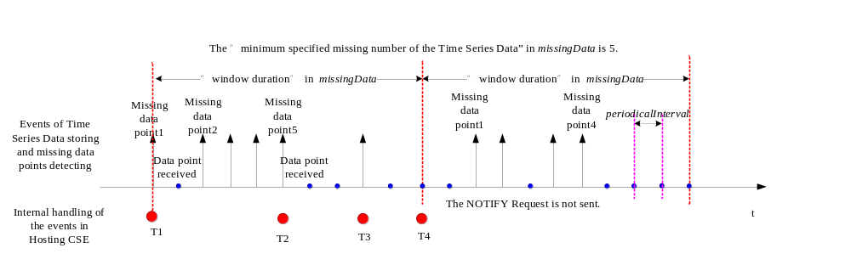
Figure 10.2.4.29-1: Time Series Data Detecting and Reporting Mechanism
T1: the timer is started and the number of the missing data points is counted.
T2: the NOTIFY Request is sent because the total number of missing data points becomes equal to or greater than the “minimum specified missing number of the Time Series Data” in missingData condition.
T3: the NOTIFY Request is sent.
T4: the timer is restarted and the missing data points counter is reset back to 0.

10.2.5 Request message handling

10.2.5.1 Introduction
Editor's Note: add summary of different mechanisms

10.2.5.2 Non-blocking communication management
Editor's Note: add introduction texts

10.2.5.3 Create <request>
As specified in clause 9.6.12, creation of a <request> resource can only be done on a Receiver CSE implicitly when a Registree AE or a Registree/Registrar CSE of the Receiver CSE issues a request to the Receiver CSE for targeting any other resource type or requesting a notification in non-blocking mode. Therefore, the creation procedure of a <request> resource cannot be initiated explicitly by an Originator. Creation of a <request> procedure is processed on a Receiver CSE to support a standardized interface to information representing the context and current status of a non-blocking request issued by a Registree AE or a Registree/Registrar CSE to the Receiver CSE at an earlier time.
The specific condition when a <request> resource is created is as follows: When an AE or CSE issues a request for targeting any other resource type or requesting a notification in non-blocking mode , i.e. the Response Type parameter of the request is set to either 'nonBlockingRequestSynch' or 'nonBlockingRequestAsynch', and if the Receiver CSE supports the <request> resource type as indicated by the supportedResourceType attribute of the <CSEBase> resource representing the Receiver CSE, the Receiver CSE shall create an instance of <request> resource to capture and expose the context of the associated non-blocking request.
A request message for creating a <request> resource is not Applicable. A <request> resource shall not be created explicitly. The Receiver CSE of a non-blocking Request that was issued by either:
- a Registrar AE of the Receiver CSE; or
- a Registree/Registrar CSE of the Receiver CSE;
is the Hosing CSE for the <request> resource that shall be associated with the non-blocking request.
The Hosting CSE shall follow the procedure outlined in this clause.
Step 001: The Receiver shall:
Assign values to the resourceID and resourceName attributes of the <request> resource to be created.
- Assign a value to the following common attributes specified in clause 9.6.1.3:
a) parentID;
b) creationTime;
c) expirationTime: The Receiver shall assign a value that is consistent with the Request Expiration Timestamp, Result Expiration Timestamp and Result Persistence parameters effective for the associated non-blocking request that implied the creation of this <request> resource (within the restriction of the Receiver policies). If a value consistent with the Request Expiration Timestamp, Result Expiration Timestamp and Result Persistence parameters effective for the associated non-blocking request that implied the creation of this <request> resource cannot be supported, due to either policy or subscription restrictions, the Receiver will assign a new value.
d) lastModifiedTime: which is equals to the creationTime;
e) stateTag;
f) accessControlPolicyIDs: Populate with one ID of an <accessControlPolicy> that contains the following:
i) In the privileges attribute:
1) Allow RETRIEVE, UPDATE and DELETE operations to <request> resource being created to the Hosting CSE.
2) Allow RETRIEVE and DELETE operations to this <request> resource being created to the Originator of the associated non-blocking request, i.e. the value of the parameter From in the associated non-blocking request that implied the creation of this <request> resource.
ii) In the selfPrivileges attribute:
1) Allow UPDATE operations on the parent <accessControlPolicy> resource to the Originator of the associated non-blocking request, i.e. the value of the parameter From in the associated non-blocking request that implied the creation of this <request> resource.
- Assign any other RO (Read Only) attributes of <request> resource type within the restriction of the Receiver policies:
a) Operation: Value of the parameter Operation in the associated non-blocking request that implied the creation of this <request> resource;
b) Target: Value of the parameter To in the associated non-blocking request that implied the creation of this <request> resource;
c) Originator: Value of the parameter From in the associated non-blocking request that implied the creation of this <request> resource;
d) requestIdentifier: Value of the parameter Request Identifier in the associated non-blocking request that implied the creation of this <request> resource;
e) metaInformation: The content of this attribute is set to information in any other optional parameters described in clause 8.1. given in the associated non-blocking request that implied the creation of this <request> resource;
f) content: Value of the parameter Content - if any - in the associated non-blocking request that implied the creation of this <request> resource;
g) requestStatus: Information on the initial status of the associated non-blocking request that implied the creation of this <request> resource. The initial value of this attribute shall be identical to the status that is contained in the Acknowledgement response message of the associated non-blocking request. Possible values for status information contained in this attribute are specified in oneM2M TS-0004 [Error: Reference source not found]. The value of this attribute is subject to changes according to the progress in processing of the non-blocking request that implied the creation of this <request> resource;
h) operationResult: Initially empty. This attribute will be used for representing the result of the originally requested operation - if any - in line with the Result Content parameter in the associated non-blocking request that implied the creation of this <request> resource.
Step 002: The Receiver shall create the <request> resource.
Table 10.2.5.3-1: <request> CREATE
<request> CREATE
Associated Reference Point | None
Information in Request message | Not applicable. For <request> resources, explicit creation via a Request message shall not be supported
Pre-Processing at Originator | Not applicable. There is no Originator. <request> resources are only created implicitly
Processing at Receiver | Different to the non-registration CREATE procedure described in clause 10.1.2, see outlined steps described in the present clause above
Information in Response message | Not applicable. Since <request> resources shall not be created explicitly, no response messages will be sent after creation. However, the address of a <request> resource will be passed back as a reference to the Originator of an associated non-blocking request that implied the creation of this <request> resource
Post-Processing at Originator | None
Exceptions | None

10.2.5.4 Retrieve <request>
This procedure shall be used for retrieving the attributes of a <request> resource.
Table 10.2.5.4-1: <request> RETRIEVE
<request> RETRIEVE
Associated Reference Point | Mca, Mcc and Mcc'
Information in Request message | All parameters defined in table 8.1.2-3 apply with the specific details for:  Content: Void
Pre-Processing at Originator | According to clause 10.1.3 with the following specific processing:  Originator needs to retrieve information about an associated previously issued non-blocking request
Processing at Receiver | According to clause 10.1.3 with the following specific processing:  The Receiver shall provide the content of the addressed <request> resource or the addressed attributes thereof
Information in Response message | All parameters defined in table 8.1.3-1 apply with the specific details for:  Content: Attributes of the <request> resource as defined in clause 9.6.12
Post-Processing at Originator | According to clause 10.1.3
Exceptions | According to clause 10.1.3 According to clause 10.1.2 with the following:  - The Originator CSE is not authorized to retrieve the <request> resource or the addressed parts of it  - The addressed <request> resource does not exist

10.2.5.5 Update <request>
For a <request> resource explicit update requests shall not be supported. Changes in the attributes of a <request> resource can only be done by the Hosting CSE due to changes of the status of the associated non-blocking request that implied the creation of this <request> resource or due to reception of an operation result in response to the associated non-blocking request that implied the creation of this <request> resource.

10.2.5.6 Delete <request>
This procedure shall be used for deleting an existing <request> resource. Deletion of an existing <request> resource shall terminate any further processing of an associated pending non-blocking request that implied the creation of this <request> resource if the pending request was not already completed or forwarded.
Table 10.2.5.6-1: <request> DELETE
<request> DELETE
Associated Reference Point | Mca, Mcc and Mcc'
Information in Request message | All parameters defined in table 8.1.2-3 apply
Pre-Processing at Originator | According to clause 10.1.5 with the following:  Originator needs to cancel a previously issued non-blocking request that is still pending, i.e. it has not yet been completed or Originator needs to remove the <request> resource representing the context of an already completed non-blocking request
Processing at Receiver | According to clause 10.1.5:  - Receiver CSE checks if the associated non-blocking request process is still pending. If so, it stops that request process  - Receiver CSE removes the addressed <request> resource
Information in Response message | According to clause 10.1.5 with the following specific information:  Successful Response message indicating that the associated non-blocking request process was stopped as requested or the context of an already completed associated non-blocking request was deleted
Post-Processing at Originator | According to clause 10.1.5
Exceptions | According to clause 10.1.5 with the following:  - The Originator CSE is not authorized to delete the <request> resource  - The addressed <request> resource does not exist

10.2.5.7 Request delivery aggregation
In this introduction an example for delivering information from a source CSE to a target CSE via the use of the <delivery> resource is explained.
The information flow depicted in figure 10.2.5.7-1 defines the exchange of Requests/Responses for processing an original request targeting a resource that is not hosted on the Registrar CSE of the request Originator. The following assumptions hold:
- Originator is AE1.
- AE1 is registered with CSE1, i.e. CSE1 is the Registrar CSE for AE1.
- The original Request is an UPDATE to a remote resource hosted on CSE3, i.e. CSE3 is the Hosting CSE for the target resource.
- UPDATE options in the original Request are selected such that no feedback after completion of the update operation was requested, i.e. AE1 decided that it does not need to hear back from CSE3; this is expressed by setting the Result Content information to "nothing", see clause 8.1.2.
- Delivery related parameters included in the original UPDATE request (may be set via CMDH policies): Request Expiration Timestamp, Event Category, Delivery Aggregation and Result Persistence:
- Request Expiration Timestamp indicates how long the forwarding of the request can last.
- Event Category indicates the event category that should be used by CMDH to handle this request.
- Result Persistence indicates how long after the request has expired, the local request context should still be available for retrieving status or result information.
- Delivery Aggregation would be set to ON indicating that <delivery> resource shall be used for forwarding the request.
- CSE1 is the CSE of an Application Service Node.
- CSE1 is registered with CSE2 and interacts with CSE2 via the reference point Mcc(1).
- CSE2 is the CSE of a Middle Node.
- CSE2 is registered with CSE3 and interacts with CSE3 via the reference point Mcc(2)
- CSE3 is the CSE of an Infrastructure Node.
The Originator AE1 shall get a confirmation from CSE1 when the original Request is accepted. The response informs AE1 that CSE1 has accepted the Request and has accepted responsibility to execute on the requested operation. Furthermore, AE1 has expressed by setting Result Conent to "nothing" that no result of the requested operation is expected to come back from CSE3. With the provided reference (Req-Ref in figure 10.2.5.7-1. AE1 can retrieve the status of the issued request at a later time, for instance to find out if the request was already forwarded to CSE2 or if it is still waiting for being forwarded on CSE1. Before accepting the request from AE1, CSE1 has also verified if the delivery related parameters expressed by AE1 (settings of Request Expiration Timestamp and Event Category) are in line with provisioned CMDH policies. AE1 may not be authorized to use certain values for Request Expiration Timestamp or Event Category.
In line with the delivery related parameters, CSE1 is generating a local <delivery> resource on CSE1 and attempts to forward the content of it in line with provisioned CMDH policies at a suitable time and via a suitable connection to CSE2 by requesting the creation of a <delivery> resource on CSE2. In this example case, the lifespan attribute of this delivery resource is set to the same value as the Request Expiration Timestamp parameter expressed by AE1. In general - i.e. also in cases where more than one original request is aggregated into a single create request for a <delivery> resource - the lifespan and eventCat attributes of the created <delivery> resource shall be set consistent with the Request Expiration Timestamp and Event Category parameters in the set of original requests. See the attribute definitions in clause 9.6.11.
CSE1 shall use a blocking request for requesting creation of a <delivery> resource on CSE2.
When CSE2 has accepted the incoming request from CSE1, CSE1 may delete the data attribute of the local <delivery> resource. Furthermore - if the expiration time of the local <delivery> resource is not exhausted - the Registrar CSE shall update the status of the local <delivery> resource to indicate that it has been forwarded to CSE2. CSE1 shall also update the status of the original request to indicate that it has been forwarded and it may delete the data attribute of the original request.
When CSE2 has accepted the request to create a local <delivery> resource, it shall attempt to forward it to CSE3. In line with the delivery related parameters, CSE2 shall create a local <delivery> resource on CSE2 and shall attempt to forward it in line with provisioned CMDH policies at a suitable time and via a suitable connection to CSE3 by requesting the creation of a <delivery> resource on CSE3.
CSE2 shall use a blocking request for requesting creation of a <delivery> resource on CSE3.
When CSE3 has accepted the incoming request from CSE2, CSE2 may delete the data attribute of the local <delivery> resource. Furthermore - if the expiration time of the local <delivery> resource is not exhausted - the Registrar CSE shall update the status of the local <delivery> resource to indicate that it has been forwarded to CSE3.
When CSE3 has accepted the request to create a local <delivery> resource, it shall determine that the target of the delivery was CSE3 itself. Therefore it shall forward internally the original request contained in the data attribute of the <delivery> resource.
Within CSE3, functions that are responsible for checking and executing local access to resources in CSE3 will execute the originally requested UPDATE operation. If successful, the targeted resource will be updated with the content provided by the Originator.
Since in the depicted case no result needed to be sent back to the Originator, the processing for the requested operation is then completed.
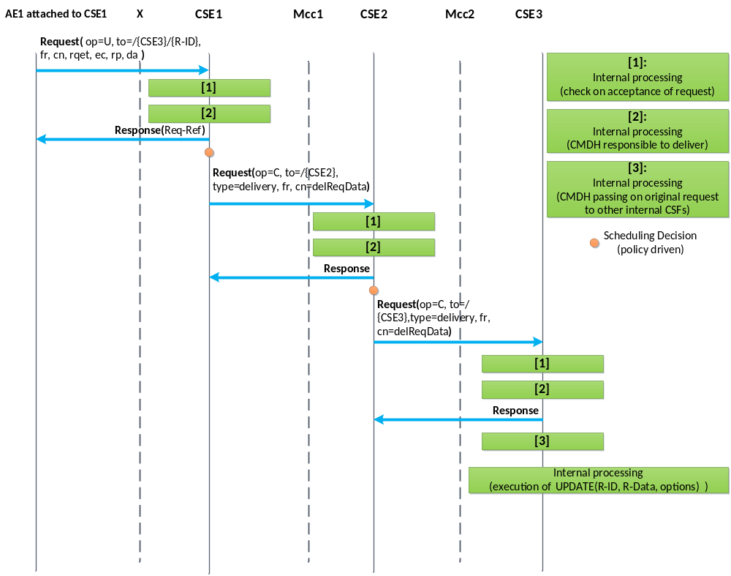
Figure 10.2.5.7-1: CMDH information flow for 2 hops -
no result needs to be returned after operation completes
The following procedures shall be triggered by requesting the corresponding operations on a <delivery> resource:
- Initiate the delivery of one or more original request(s) stored for later forwarding from one CSE to another CSE:
- Request a CREATE operation for a <delivery> resource from an issuing CSE to a receiving CSE.
- The original request(s) need to be contained in the "data" attribute of the <delivery> resource.
- If successful, the receiving CSE takes the responsibility to further execute on the delivery process for the original Request.
- If not successful, the issuing CSE cannot assume that the receiving CSE will carry out the delivery of the original request.
- Get information about the status of a pending delivery process for an original request:
- Request a RETRIEVE operation of the content of a <delivery> resource representing a pending delivery or part of it.
- The status of the pending forwarding process is reflected the "deliveryMetaData" attribute defined in the <delivery> resource.
- Change parameters of pending delivery process:
- Request an UPDATE operation on applicable attributes of the <delivery> resource representing the pending delivery.
- For instance the time allowed for completion of a delivery process could be modified by updating the "lifespan" attribute of an existing <delivery> resource.
- Cancel a pending delivery request:
- Request a DELETE operation of a <delivery> resource that represents a pending delivery process.

10.2.5.8 Create <delivery>
This procedure shall be used for requesting a CSE to take responsibility to deliver the provided data to a target CSE in line with CMDH parameters and provisioned CMDH policies in case <delivery> resource based CMDH processing is used. If indicated by the Originator, the Receiver shall confirm the acceptance of delivery responsibility by a successful Response.
Originator: The Originator of a Create request for a <delivery> resource can only be a CSE. The Originator needs to provide the content of a <delivery> resource type together with the Create request or can Update it after a successful creation of the <delivery> resource with empty data attribute. Otherwise the Receiver cannot accept the Create Request. The Originator shall use a blocking request for issuing the Create request to the Receiver.
Receiver: The receiver of a Create request for a <delivery> resource is a Registrar or Registree CSE of the Originator and it shall check the access control policies to assure the Originator is authorized to request a delivery procedure. The Receiver of the Create Request shall further check whether the provided attributes of the <delivery> resource that is requested to be created represents a valid request for forwarding data to a target CSE. If the Originator of the Create request is authorized and the Request is valid, the Receiver shall check whether it can actually satisfy the requested delivery in line with provisioned CMDH policies and requested eventCat and lifespan attributes of the <delivery> resource. If all these checks are positive, the Receiver shall create the requested <delivery> resource and assumes responsibility for delivering the requested data to the target CSE as soon as the content of the data attribute is available. In case an operation result is expected by the Originator, the Receiver shall confirm acceptance of the responsibility by indicating a successful creation of the <delivery> resource. If the Receiver CSE is the target CSE of the requested delivery, it shall forward the content of the delivered data - which represents one or more forwarded original request(s) - to the internal functions that handle incoming requests and continue processing of the forwarded request(s).
Table 10.2.5.8-1: <delivery> CREATE
<delivery> CREATE
Associated Reference Point | Mcc and Mcc'
Information in Request message | All parameters defined in table 8.1.2-3 apply with the specific details for:  From: CSE only  Content: The resource content shall provide the information as defined in clause 9.6.11  Response Type: Shall be set to "blockingRequest" which means a blocking request is issued
Processing at Originator before sending Request | According to clause 10.1.2 with the following specific processing:  The Originator needs to provide the content of a <delivery> resource type together with the Create request or can Update it after a successful creation of the <delivery> resource with empty data attribute. Otherwise the Receiver cannot accept the Create Request. The Originator shall use a blocking request for issuing the Create request to the Receiver
Processing at Receiver | According to clause 10.1.2 with the following specific processing:  - Check whether the provided attributes of the <delivery> resource that is requested to be created represents a valid request for delivering data to a target CSE  - Check whether Receiver CSE can actually satisfy the requested delivery in line with provisioned policies and requested delivery parameters  - If all checks are positive, the receiver shall create the requested <delivery> resource and assumes responsibility for delivering the provided data to the target CSE  - If the Receiver CSE is the target CSE of the requested delivery, it shall forward the content of the delivered data attribute to the internal CSFs that will interpret the delivered data as a forwarded request(s) from a remote Originator
Information in Response message | All parameters defined in table 8.1.3-1 apply, with the following specific information:  In case the Originator CSE has not asked for a Result of the requested Operation (Result Content set to "nothing"), the Response only contains an Acknowledgement indicator. This only indicates that the Receiver CSE received the Request. It does NOT indicate whether the Receiver CSE was able to take on responsibility for delivery of the data  In case the Originator CSE asked for the status of the requested Operation to be contained in the Result of the requested Operation (Result Content not set to "nothing"), the Receiver CSE shall respond with a Success or Failure indicator  In case the Originator CSE asked for the status of the requested Operation and the address of the created Resource to be contained in the Result of the Request, the Receiver CSE shall respond with a Success indicator including the address of the created <delivery> resource in case it has taken on responsibility to deliver the data to the target CSE or with Failure indicator including an error indication otherwise
Processing at Originator after receiving Response | According to clause 10.1.2 with the following specific processing:  The Originator CSE shall update the local <delivery> resource to reflect the new status of the delivery process (e.g. '{Receiver-CSE-ID} accepted delivery responsibility')  In case the Originator CSE got a Success indicator as a Response, it shall stop any further delivery attempts. In that case or if there was no indication of a need to provide a result of the operation, the Originator CSE may delete the content of the 'data' attribute of the local <delivery> resource  In case the Originator CSE got a Failure indicator as a response, it may initiate further delivery attempts in line with CMDH policies and delivery parameters and depending on the reason for Failure  In case the Receiver CSE is the target CSE of the delivery, the Receiver CSE needs to execute on the forwarded request contained in the delivered data
Exceptions | According to clause 10.1.2 with the following:  - The Originator CSE is not authorized to request a delivery procedure on the Receiver CSE  - The provided content of the <delivery> resource is not in line with the specified structure  - The provided content of the <delivery> resource represents a request for delivery that is not consistent (e.g. lifespan attribute already expired)  - The provided content of the <delivery> resource represents a request for delivery that cannot be met by the Receiver CSE within the limits of the provided delivery parameters and the provisioned CMDH policies on the Receiver CSE

10.2.5.9 Retrieve <delivery>
This procedure shall be used for requesting a CSE to provide information on a previously created <delivery> resource which represents delivery of data to a target CSE.
Table 10.2.5.9-1: <delivery> RETRIEVE
<delivery> RETRIEVE
Associated Reference Point | Mcc and Mcc'
Information in Request message | All parameters defined in table 8.1.2-3 apply with the specific details for:  Content: void
Processing at Originator before sending Request | According to clause 10.1.3 with the following specific processing:  Originator needs to retrieve information about a previously issued delivery
Processing at Receiver | According to clause 10.1.3 with the following specific processing:  The Receiver shall provide the content of the addressed <delivery> resource or the addressed attributes thereof
Information in Response message | All parameters defined in table 8.1.3-1 apply with the specific details for:  Content: attributes of the <delivery> resource as defined in clause 9.6.11
Processing at Originator after receiving Response | According to clause 10.1.3
Exceptions | According to clause 10.1.3 with the following:  - The Originator CSE is not authorized to retrieve the <delivery> resource or the addressed parts of it  - The addressed <delivery> resource does not exist

10.2.5.10 Update <delivery>
This procedure shall be used for requesting a CSE to update information on a previously created <delivery> resource which represents a pending delivery of data to a target CSE. The update may have impact on further processing of the delivery.
Table 10.2.5.10-1: <delivery> UPDATE
<delivery> UPDATE
Associated Reference Point | Mcc and Mcc'
Information in Request message | All parameters defined in table 8.1.2-3 apply with the specific details for:  - Address of the <delivery> resource  - Content of a <delivery> resource in line with the definition in clause 9.6.11 representing a valid request for delivery of data to a target CSE
Processing at Originator before sending Request | According to clause 10.1.4 with the following specific processing:  - Originator needs to modify information about a previously issued delivery that is still pending, i.e. it has not yet been forwarded to another CSE
Processing at Receiver | According to clause 10.1.4 with the following specific processing:  - Receiver CSE checks if the requested changes to the delivery process can actually be accomplished  - If possible, the Receiver CSE modifies the previously established delivery process and changes the respective content of the <delivery> resource
Information in Response message | According to clause 10.1.4
Processing at Originator after receiving Response | According to clause 10.1.4
Exceptions | According to clause 10.1.4 with the following:  - The Originator CSE is not authorized to modify the <delivery> resource or the addressed parts of it  - The addressed <delivery> resource does not exist  - The responsibility for the further processing of the delivery process represented by the addressed <delivery> process was already forwarded to another CSE

10.2.5.11 Delete <delivery>
This procedure shall be used for requesting a CSE to cancel a pending delivery of data to a target CSE or to delete the <delivery> resource of an already executed delivery.
Table 10.2.5.11-1: <delivery> DELETE
<delivery> DELETE
Associated Reference Point | Mcc and Mcc'
Information in Request message | All parameters defined in table 8.1.2-3 apply
Processing at Originator before sending Request | According to clause 10.1.5 with the following:  - Originator needs to cancel a previously issued delivery that is still pending, i.e. it has not yet been forwarded to another CSE or Originator needs to remove the <delivery> resource representing an already executed delivery
Processing at Receiver | According to clause 10.1.5:  - Receiver CSE checks if the corresponding delivery process is still pending. If so, it stops that delivery process  - Receiver CSE removes the addressed <delivery> resource and stop the corresponding delivery process if it is still pending
Information in Response message | According to clause 10.1.5 with the following specific information:  - Successful Response messages indicate that the delivery process was stopped as requested
Processing at Originator after receiving Response | According to clause 10.1.5
Exceptions | According to clause 10.1.5 with the following:  - The Originator CSE is not authorized to delete the <delivery>  - The addressed <delivery> resource does not exist

10.2.5.12 Request message polling
An AE or a CSE that is request unreachable cannot receive a request from other entities directly. Instead this AE/CSE can retrieve requests that others sent to this AE/CSE once it created <pollingChannel> resource on a request reachable CSE.
This clause consist of manipulation procedures of <pollingChannel> resource (clauses 10.2.5.13 to 10.2.5.16), re-targeting request to <pollingChannel> resource (clause 10.2.5.17), the long polling procedure to retrieve requests from <pollingChannel> resource (clause 10.2.5.18) and the responding to the request received by long polling (clause 10.2.5.19). This is depicted in figure 10.2.5.12-1.
Figure 10.2.5.12-1 depicts the case when the Originator sent a request("req2") to the Target as a blocking request. The request can be any of the requests defined in clause 10.2 (e.g. <container> resource creation on the Target CSE). As defined in clause 10.2.5.18, polling response contains the "req2" in step 0004. Also as per clause 10.2.5.19, in step 005 the "req3" contains the "resp2", which is the response to the the "req2" in step 002 and step 004, in the "req3". Finally the "resp2" is forwarded to the Originator in step 006.
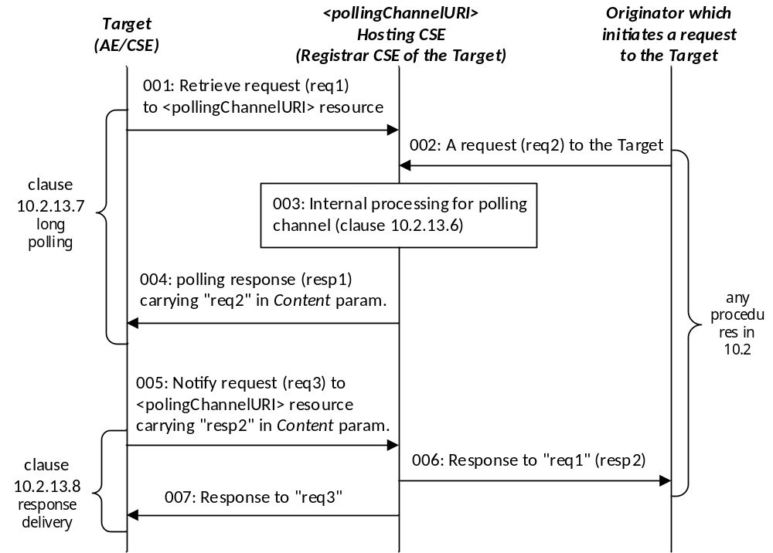
Figure 10.2.5.12-1: Request/response delivery via polling channel
Editor's Note: update the figure to adopt the new clause numbers

10.2.5.13 Create <pollingChannel>
Table 10.2.5.13-1: <pollingChannel> CREATE
<pollingChannel> CREATE
Associated Reference Point | Mca and Mcc
Information in Request message | All parameters defined in table 8.1.2-3 apply with the specific details for:  To: Address of <AE> or <remoteCSE> resource  Content: attributes of the <pollingChannel> resource as defined in clause 9.6.21
Processing at Originator before sending Request | According to clause 10.1.2 with the following additions:  - If an AE is the Originator, it shall address the <AE> resource that it already created. Otherwise, if a CSE is the Originator, it shall address the <remoteCSE> resource that it already created
Processing at Receiver | According to clause 10.1.2 with thereplacement for sub-step 1) of Step 002 as follows:  - The Hosting CSE shall check if the Originator ID is the same as the CSE-ID or AE-ID of the parent resource which is the <remoteCSE> or <AE> resource If the check fails, the request shall be rejected
Information in Response message | According to clause 10.1.2
Processing at Originator after receiving Response | The Originator should send a retrieve request to the <pollingChannelURI> resource
Exceptions | According to clause 10.1.2

10.2.5.14 Retrieve <pollingChannel>
This procedure is used to retrieve a <pollingChannel> resource and an AE/CSE can be an Originator.
Table 10.2.5.14-1: <pollingChannel> RETRIEVE
<pollingChannel> RETRIEVE
Associated Reference Point | Mca and Mcc
Information in Request message | All parameters defined in table 8.1.2-3 apply with the specific details for:  Content: void
Processing at Originator before sending Request | According to clause 10.1.3
Processing at Receiver | According to clause 10.1.3 with the following for Step 002:  - For access privilege checking, the Hosting CSE shall check if the Originator ID is the same as the CSE-ID or AE-ID of the parent resource which is the <remoteCSE> or <AE> resource, respectively. If the check fails, the request shall be rejected
Information in Response message | All parameters defined in table 8.1.3-1 apply with the specific details for:  Content: attributes of the <pollingChannel> resource as defined in clause 9.6.21
Processing at Originator after receiving Response | According to clause 10.1.3
Exceptions | According to clause 10.1.3

10.2.5.15 Update <pollingChannel>
This procedure is used to update a <pollingChannel> resource and an AE/CSE can be an Originator.
Table 10.2.5.15-1: <pollingChannel> UPDATE
<pollingChannel> UPDATE
Associated Reference Point | Mca and Mcc
Information in Request message | All parameters defined in table 8.1.2-3 apply with the specific details for:  Content: attributes of the <pollingChannel> resource as defined in clause 9.6.21
Processing at Originator before sending Request | According to clause 10.1.4
Processing at Receiver | - According to clause 10.1.3 with the following for Step 002:For access privilege checking, the Hosting CSE shall check if the Originator ID is the same as the CSE-ID or AE-ID of the parent resource which is the <remoteCSE> or <AE> resource, respectively. If the check fails, the request shall be rejected
Information in Response message | According to clause 10.1.4
Processing at Originator after receiving Response | According to clause 10.1.4
Exceptions | According to clause 10.1.4

10.2.5.16 Delete <pollingChannel>
This procedure is used to delete a <pollingChannel> resource and an AE/CSE can be an Originator.
Table 10.2.5.16-1: <pollingChannel> DELETE
<pollingChannel> DELETE
Associated Reference Point | Mca and Mcc
Information in Request message | All parameters defined in table 8.1.2-3 apply
Processing at Originator before sending Request | According to clause 10.1.5
Processing at Receiver | According to clause 10.1.5 for Step 002:  - For access privilege checking, the Hosting CSE shall check if the Originator ID is the same as the CSE-ID or AE-ID of the parent resource which is the <remoteCSE> or <AE> resource, respectively. If the check fails, the request shall be rejected
Information in Response message | According to clause 10.1.5
Processing at Originator after receiving Response | According to clause 10.1.5
Exceptions | According to clause 10.1.5

10.2.5.17 Internal Processing for Polling Channel
This procedure is used to forward a request to a request-unreachable AE or CSE(i.e. requestReachability attribute of its <AE> or <remoteCSE> resource is set to FALSE) which has created a <pollingChannel> resource as a child of its <AE> or <remoteCSE> resource. When a <pollingChannel> Hosting CSE receives a request towards the AE or CSE, it shall forward the request to the AE or CSE in the Content parameter of the response to polling response (see clause 10.2.5.18). If there is no pending polling request from the AE or CSE, then the <pollingChannel> Hosting CSE shall store the request and forward it when it receives the polling request. When the stored request expires according to its Request Expiration Timestamp parameter the Hosting CSE shall return an error to the entity that initiated the request.

10.2.5.18 Long Polling on Polling Channel
This procedure is originated by a request-unreachable entity to poll requests from a polling channel. Once the Originator starts long polling on a polling channel by sending a RETRIEVE request, the Receiver who is the <pollingChannel> Hosting CSE holds the request until it has any requests to return to the Originator. If the request expires and there's no available request to return, the Receiver shall send the response with a status indicating a timeout has occurred to inform the Originator that a new polling request should be generated again.
Table 10.2.5.18-1: <pollingChannelURI>RETRIEVE
Long Polling RETRIEVE
Associated Reference Point | Mca and Mcc
Information in Request message | All parameters defined in table 8.1.2-3 apply with the specific details for:  To: Address of <pollingChannelURI> child resource of the <pollingChannel> resource
Processing at Originator before sending Request | According to clause 10.1.3
Processing at Receiver | According to clause 10.1.3 with the following privilege check for Step 002:  - The Hosting CSE shall check if the Originator ID is the same as the CSE-ID or AE-ID of the grant parent <remoteCSE> or <AE> resource, respectively  - The Hosting CSE shall check if there is any request to be returned to the Originator. If there is any, the Hosting CSE shall generate the response containing the request(s) for the Originator. If none, the Hosting CSE shall wait for any request for the Originator to be reached at the polling channel until the request expiration time
Information in Response message | All parameters defined in table 8.1.3-1 apply with the specific details for:  Content: request message(s) targeting the Originator
Processing at Originator after receiving Response | If the Originator receives the response from the Receiver that the long polling request is expired, the Originator should send a new long polling request
Exceptions | If the long polling request is expired at the Receiver, the Receiver shall send an unsuccessful response to the Originator

10.2.5.19 Delivering the response to the request sent over polling channel
When a Registree CSE received a request from the <pollingChannel> Hosting CSE contained in a <pollingChannelURI> Retrieve response (clause 10.2.5.18), the Registree CSE shall send the response to the received request in a new request to the <pollingChannelURI> Hosting CSE. This request, which contains the response in the Content parameter, shall target the <pollingChannelURI> resource with Notify operation.
When the Hosting CSE receives a Notify request to the <pollingChannelURI> resource, the Hosting CSE shall send the response, which was contained in the Content parameter of the Notify request, to the entity that sent the associated request to the Hosting CSE. The associated request is the request that the Hosting CSE received and forwarded to the Registree CSE over the polling channel. The association shall be done by matching the Request Identifier parameter of the request delivered in <pollingChannelURI> Retrieve response and the Request Identifier parameter of the response delivered in the Content parameter in a <pollingChannelURI> Notify request.
Table 10.2.5.19-1: <pollingChannelURI> NOTIFY
<pollingChannelURI> NOTIFY
Associated Reference Point | Mcc
Information in Request message | All parameters defined in table 8.1.2-3 apply with the specific details for:  To: Address of <pollingChannelURI> resource  Content: The response to the request contained in <pollingChannelURI> Retrieve response
Processing at Originator before sending Request | Originator shall handle and generate the response to the request contained in the <pollingChannelURI> Retrieve response
Processing at Receiver | - The Hosting CSE shall send the response contained in the Content parameter of Notify request to the entity that sent a associated request to the Hosting CSE
Information in Response message | All parameters defined in table 8.1.3-1 apply
Processing at Originator after receiving Response | According to clause 10.1.6
Exceptions | If the Originator is not the CSE-ID of the <remoteCSE> resource which is the grandparent resource of the <pollingChannelURI> resource, then the Hosting CSE shall reject the request with access privilege error information

10.2.5.20 End-to-end secure communication
Editor's Note: bring texts in 11.4, or at least put the reference to it

10.2.5.21 End-to-AE communication
Editor's Note: add texts to explain end-to-end communication when the target is an AE. also describe the relation to <AE> notify procedure which can also be used for notification re-targeting
This procedure shall be used for sending a Notify request to an <AE> resource. This procedure is used for sending notification data to an AE. In this description, the Receiver is the CSE hosting the <AE>.
Table 10.2.5.21-1: <AE> NOTIFY
<AE> NOTIFY
Associated Reference Point | Mca, Mcc and Mcc'
Information in Request message | All parameters defined in table 8.1.2-3 apply
Processing at Originator before sending Request | According to clause 10.1.6
Processing at Receiver | The Hosting CSE shall re-target the Notify request to the AE according to clause 10.2.5.23.
Information in Response message | According to clause 10.1.6
Processing at Originator after receiving Response | According to clause 10.1.6
Exceptions | According to clause 10.1.6

10.2.5.22 End-to-CSE communication
Editor's Note: add texts to explain end-to-end communication when the target is an CSE.
This procedure shall be used for sending a Notify request to a <CSEBase> resource. This procedure is used for sending notification data to a CSE. In this description, the Receiver is the Hosting CSE of the <CSEBase> resource.
Table 10.2.5.22-1: <CSEBase> NOTIFY
<CSEBase> NOTIFY
Associated Reference Point | Mca, Mcc and Mcc'
Information in Request message | All parameters defined in table 8.1.2-3 apply
Processing at Originator before sending Request | According to clause 10.1.6
Processing at Receiver | According to clause 10.1.6.
Information in Response message | According to clause 10.1.6
Processing at Originator after receiving Response | According to clause 10.1.6
Exceptions | According to clause 10.1.6

10.2.5.23 Notification Re-targeting
A Notify request to an AE is sent by targeting <AE> resource on a Hosting CSE. If the Hosting CSE verifies access control privilege of the Originator, the Hosting CSE shall re-target the request to the address specified as AE-PoA (i.e. pointOfAccess attribute of <AE> resource). The AE-PoA may be initially configured in the <AE> resource when the AE registers to the Registrar CSE. If the <AE> resource does not contain an AE-PoA, an active communication link, if available, can be used for re-targeting. If neither of them is available, the request cannot be re-targeted to the AE.
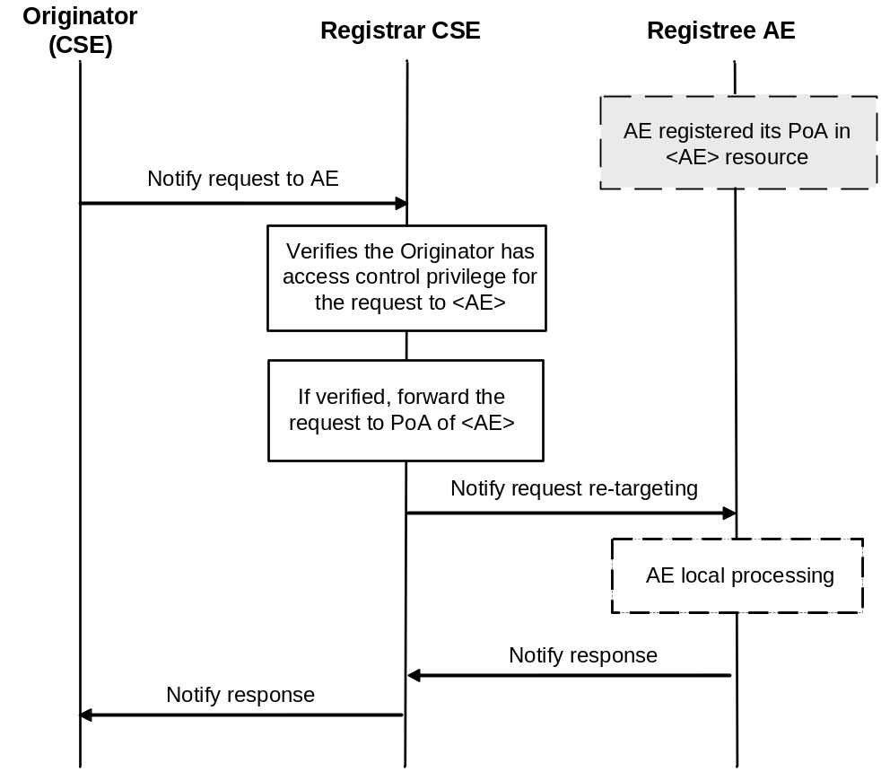
Figure 10.2.5.23-1: Re-targeting a notification request to an AE

10.2.6 Discovery

10.2.6.1 Discovery without Result Content parameter
Editor's Note: this is normal discovery procedure that returns a list of resource addresses
The resource discovery procedures allow discovering of resources residing on a CSE. The use of the Filter Criteria parameter allows limiting the scope of the results.
Resource discovery shall be accomplished using the RETRIEVE method by an Originator which shall also include the root of where the discovery begins: e.g. <CSEBase>. The unfiltered result of the resource discovery procedure includes all the child resources under the root of where the discovery begins, which the Originator has a Discover access right on. For the allowed Result Content parameter options for Discovery related RETRIEVE see section 8.1.2.
Filter criteria conditions may be provided as parameters to the RETRIEVE method. The filter criteria conditions describe the rules for resource discovery, e.g. resource types, creation time and matching string. The filter criteria can also contain the parameters for specifying the maximum number of discovered resources included in the response, the maximum limit on the number of levels in the resource tree (starting from the target resource) that the Hosting CSE shall perform the discovery request upon and an offset for specifying the number of discovered resources the Hosting CSE shall skip over and not include within the response. Table 8.1.2-2 describes the Filter Criteria parameter.
A match shall happen when a resource matches the configured filter criteria conditions and the Originator has a Discover access right on the resource. A successful response contains a list for the matched resources addressable in any of the forms expressed in clause 9.3.1 if matches are found. If no matches are found, a successful response returns no matched resources. If Discovery Result Type parameter is specified in a discovery request, the Hosting CSE shall choose the addressing form specified by the Discovery Result Type parameter.
The discovery results may be modified by the Hosting CSE to restrict the scope of discoverable resources according to the Originator's access control policy or M2M service subscription.
The Hosting CSE may also implement a configured upper limit on the size of the answer. In such a case when the Originator and the Hosting CSE have different upper limits, the smaller of the two shall apply.
This procedure shall be used for the discovery of resources under <CSEBase> that match the provided Filter Criteria parameter. The discovery result shall be returned to the Originator using a successful Response message.
Table 10.2.6.1-1: Discovery procedure via Retrieve Operation
<resource> RETRIEVE
Associated Reference Point | Mca, Mcc and Mcc'.
Information in Request message | All parameters defined in table 8.1.2-3 apply with the specific details for:  For the allowed Result Content parameter options for Discovery related RETRIEVE see clause 8.1.2.  To: Address of the root of where the discovery begins.  Filter Criteria: Filter criteria for searching and expected returned result. The filterUsage parameter shall be set in this case.  Discovery Result Type: optional, format of discovery results returned (see clause 8.1.2 for options applicable to Discovery, and how results shall be displayed).
Processing at Originator before sending Request | According to clause 10.1.3 with the following:  - Setup the RETRIEVE operation in the Request.  - Include the conditions in the filter criterion to limit the scope of the discovery results.  - Specify the desired format of returned discovery results.
Processing at Receiver | According to clause 10.1.3 with the following specific processing:  - Checks the validity of the Request (e.g. format of Filter Criteria).  - Checks if the request is in accordance with the M2M service subscription.  - May change the filter criteria according to local policies.  - Searches matched resources from the addressed resource hierarchy.  - Limits the discovery result according to DISCOVER privileges of the discovered resources.  - Limits the discovery result according to the upper limit on the size of the answer.  The Hosting CSE shall read the values of all attributes belonging to the addressed resource structure and the references of all sub-resources and it shall build a representation of these. The Hosting CSE shall use the appropriate addressing (see clause 9.3.1) form for each element included in the list in accordance with the incoming request. If Filter Criteria is provided in the request, the Hosting CSE uses it identifying the resources whose attributes match the Filter Criteria. The Hosting CSE shall respond to the Originator with the appropriate list of discovered resources in the Hosting CSE.  If the Filter Criteria includes filterUsage element set to "IPEOnDemandDiscovery", the target is the <AE> resource and the Hosting CSE has no match from the discovery of existing resources, then the Hosting CSE shall send a NOTIFY request containing the Filter Criteria to the AE(i.e. pointOfAccess of the <AE> resource) and the Originator ID of this discovery request. When the CSE gets the successful NOTIFY response with the resource address(es) which are created under the <AE> resource, then the CSE shall check the DISCOVER privilege and return the address(es) to the Originator. When the CSE gets the unsuccessful NOTIFY response, then the CSE shall send the Response Status Code in the NOTIFY response to the Originator.  The Hosting CSE may modify the Filter Criteria including upper limit provided by the Originator or the discovery results based on the local policies.  If the size of the result list is bigger than the upper limit or the scope of discoverable resources, according to the Originator's access control policy or service subscription has been modified by the Hosting CSE, the full list is not returned. Instead, an incomplete list is returned and an indication is added in the response for warning the requestor.
Information in Response message | All parameters defined in table 8.1.3-1 apply with the specific details for:  - Contains the address list of discovered resources expressed in any of the methods depicted in clause 9.3.1. The address list may be empty if no result matching the filter criterion is discovered.  - Contains an incomplete list warning if the full list is not returned.
Processing at Originator after receiving Response | According to clause 10.1.3.
Exceptions | According to clause 10.1.3, with the following:  - The requesting M2M AE or CSE is not registered.  - The request contains invalid parameters.  - The on-demand discovery was rejected by the requested M2M Application.

10.2.6.2 Discovery with Result Content parameter
Editor's Note: this is the other discovery mechanism that returns resource meta information like resource type. the request contains Result Content parameter with “child-resource-references” value.

10.2.7 Group management

10.2.7.1 Introduction
This clause describes different procedures for managing membership verification, creation, retrieval, update and deletion of the information associated with a <group> resource. Bulk management of all group member resources by invoking the corresponding operations upon the virtual resource <fanOutPoint> of a <group> resource are detailed. This clause also describes the use of retrieve operations in conjunction with the virtual resource <semanticFanOutPoint>, for the purpose of semantic discovery. As such, this virtual resource shall be the target of RETRIEVE requests only. The <semanticFanOutPoint> resource is created and deleted at the same time with the parent <group> resource.
Editor's Note: add texts to explain<semanticFanOutPoint> resource is optional depending on the semanticSupportIndicator attribute of a <group> resource.
Figure 10.2.7.1-1 illustrates how the <fanOutPoint> virtual resource works on the group Hosting CSE. The procedures in the figure apply to clauses 10.2.7.6 to 10.2.7.9.
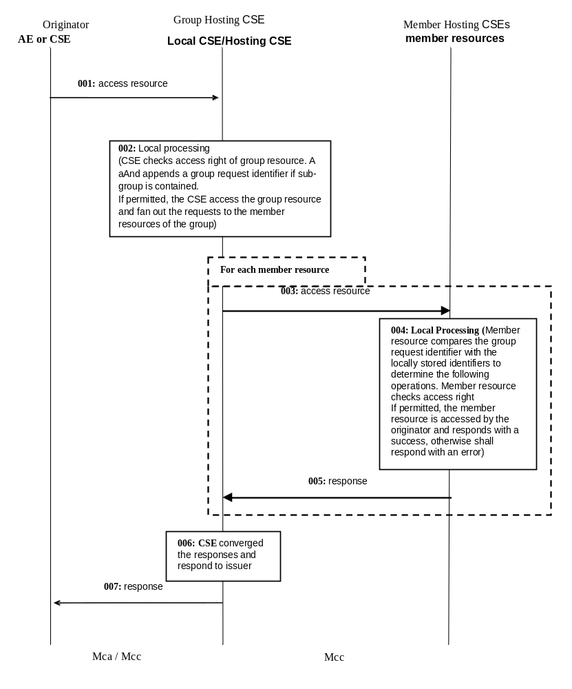
Figure 10.2.7.1-1: Group content management procedures
If the group resource, whose fanOutPoint virtual sub-resource is addressed by the request, contains <group> resources as member resources, when fanning out the request, the Group Hosting CSE shall address the fanOutPoint virtual sub-resource of the member <group> resource in step 3. So that the member <group> resource Hosting CSE could further fan out the request to its members correspondingly.

10.2.7.2 Create <group>
This procedure shall be used for creating a <group> resource.
Table 10.2.7.2-1: <group> CREATE
<group> CREATE
Associated Reference Point | Mcc, Mca and Mcc'
Information in Request message | From: Identifier of the AE or the CSE that initiates the Request  To: The address of the <CSEBase>, <AE>, or <remoteCSE> where the <group> resource is intended to be Created  Content: The representation of the <group> resource for which the attributes are described in clause 9.6.13
Processing at Originator before sending Request | The Originator shall request to Create a <group> resource by using the CREATE operation. The request shall address <CSEBase>, <remoteCSE> or <AE> resource of a Hosting CSE. The Request shall also provide memberIDs and may provide expirationTime attributes. The Originator may be an AE or a CSE
Processing at Receiver | For the CREATE procedure, the Receiver shall:  - Check if the Originator has CREATE permissions on the target resource  - Check the validity of the provided attributes  - Validate that there are no duplicate members present in the memberIDs attribute  - Validate that the resource type of every member on each member Hosting CSE conforms to the memberType attribute in the request, if the memberType attribute of the <group> resource is not 'mixed'. Set the memberTypeValidated attribute to TRUE upon successful validation.  - Upon successful validation of the provided attributes, create a new group resource including the <fanOutPoint> child-resource in the Hosting CSE. If the CSE supports semantic discovery functionality, the Hosting CSE shall also set the semanticSupportIndicator attribute to TRUE and create the <semanticFanOutPoint> child-resource.  - Conditionally, in the case that the group resource contains temporarily. unreachable Hosting CSE of sub-group resources as member resource, set the memberTypeValidated attribute of the <group> resource to FALSE  - Respond to the Originator with the appropriate generic Response with the representation of the <group> resource if the memberTypeValidated attribute is FALSE, and the address of the created <group> resource if the CREATE was successful  - As soon as any Hosting CSE that hosts the unreachable resource becomes reachable, the memberType validation procedure shall be performed. If the memberType validation fails, the Hosting CSE shall deal with the <group> resource according to the policy defined by the consistencyStrategy attribute of the <group> resource provided in the request. or by default if the attribute is not provided
Information in Response message | The representation of the <group> resource if the memberTypeValidated attribute is FALSE
Processing at Originator after receiving Response | None
Exceptions | No change from the basic procedure in clause 10.1.2

10.2.7.3 Retrieve <group>
This procedure shall be used for retrieving <group> resource.
Table 10.2.7.3-1: <group> RETRIEVE
<group> RETRIEVE
Associated Reference Point | Mcc, Mca and Mcc'
Information in Request message | From: Identifier of the AE or the CSE that initiates the Request  To: The address of the <group> resource
Processing at Originator before sending Request | The Originator shall request to obtain <group> resource information by using the RETRIEVE operation. The request shall address the specific <group> resource of a Hosting CSE. The Originator may be an AE or a CSE
Processing at Receiver | No change from the basic procedure in clause 10.1.3
Information in Response message | No change from the basic procedure in clause 10.1.3
Processing at Originator after receiving Response | None
Exceptions | No change from the basic procedure in clause 10.1.3

10.2.7.4 Update <group>
This procedure shall be used for updating an existing <group> resource.
Table 10.2.7.4-1: <group> UPDATE
<group> UPDATE
Associated Reference Point | Mca, Mcc and Mcc'
Information in Request message | From: Identifier of the AE or the CSE that initiates the Request  To: The address of the <group> resource
Processing at Originator before sending Request | The Originator shall request to update attributes of an existing <group> resource by using an UPDATE operation. The Request shall address the specific <group> resource of a CSE. The Originator may be an AE or a CSE
Processing at Receiver | The UPDATE procedure shall be:  - Check if the Originator has UPDATE permissions on the <group> resource.  - Check the validity of provided attributes  - Validate that there are no duplicated members present in the memberIDs attribute  - Validate that the resource type of every member on each member Hosting CSE conforms to the memberType attribute in the request, if the memberType attribute of the <group> resource is not 'mixed'. Set the memberTypeValidated attribute to TRUE upon successful validation  - Upon successful validation of the provided attributes, update the <group> resource in the Hosting CSE  - Conditionally, in the case that the <group> resource contains temporarily unreachable Hosting CSE of sub-group resources as members resource set the memberTypeValidated attribute of the <group> resource to FALSE  - Respond to the Originator with the appropriate generic response with the representation of the <group> resource if the memberTypeValidated attribute is FALSE, and the address of the created <group> resource if the UPDATE is successful  - As soon as any Hosting CSE that hosts unreachable resource becomes reachable, the memberType validation procedure shall be performed. If the memberType validation fails, the Hosting CSE shall deal with the <group> resource according to the policy defined by the consistencyStrategy attribute of the <group> resource provided in the request, or by default if the attribute is not provided
Information in Response message | The representation of the <group> resource if the memberTypeValidated attribute is FALSE
Processing at Originator after receiving Response | None
Exceptions | No change from the basic procedure in clause 10.1.4

10.2.7.5 Delete <group>
This procedure shall be used for deleting an existing <group> resource.
Table 10.2.7.5-1: <group> DELETE
<group> DELETE
Associated Reference Point | Mcc, Mca and Mcc'
Information in Request message | From: Identifier of the AE or the CSE that initiates the Request  To: The address of the <group> resource
Processing at Originator before sending Request | The Originator shall request to delete an existing <group> resource by using the DELETE operation. The request shall address the specific <group> resource of a Hosting CSE. The Originator may be an AE or a CSE  This operation shall also delete the child virtual resources <fanOutPoint> and <semanticFanOutPoint>
Processing at Receiver | No change from the basic procedure in clause 10.1.5
Information in Response message | No change from the basic procedure in clause 10.1.5
Processing at Originator after receiving Response | None
Exceptions | No change from the basic procedure in clause 10.1.5

10.2.7.6 Create <fanOutPoint>
This procedure shall be used for creating the content of all members resources belonging to an existing <group> resource.
Table 10.2.7.6-1: <fanOutPoint> CREATE
<fanOutPoint> CREATE
Associated Reference Point | Mca, Mcc and Mcc'
Information in Request message | From: Identifier of the AE or the CSE that initiates the Request  To: The address of the <fanOutPoint> virtual resource  Content: The representation of the resource the Originator intends to create  Group Request Identifier: The group request identifier  Response Type: If the parameter is set to BlockingSynch, it indicates that the group hosting CSE shall return the aggregated response once. Otherwise if the parameter is set to nonBlockingRequestSynch, nonBlockingRequestAsynch or flexBlocking, it indicates that the Group Hosting CSE shall return the aggregated response in a batched mode  Result Expiration Time: Indicates the maximum time limit in which the Group Hosting CSE has to respond the aggregated response.
Processing at Originator before sending Request | The Originator shall request to create the resource that have the same content in all members resources belonging to an existing <group> resource by using a CREATE operation. The Request may address the virtual child resource <fanOutPoint> of the specific <group> resource of a group Hosting CSE. The request may also address the address that results from appending a relative address to the <fanOutPoint> address in order to create the resources that have the same content under the corresponding child resources represented by the relative address with respect to all members resources. The Originator may be an AE or CSE.
Processing at Group Hosting CSE | For the CREATE procedure, the Group Hosting CSE shall:  - Check if the Originator has CREATE privilege in the <accessControlPolicy> resource referenced by the membersAccessControlPolicyIDs in the <group> resource. In the case members membersAccessControlPolicyIDs is not provided the access control policy defined for the <group> resource shall be used  - Upon successful validation, obtain the IDs of all members resources from the attribute membersIDs of the addressed <group> resource  - Generate fan out requests addressing the obtained address (appended with the relative address if any) to the member hosting CSEs as indicated in figure 10.2.7.1-1.The From parameter in the fanout request is set to ID of the Originator from the request from the original Originator. The Response Type parameter in the fanout request may be set by the group hosting CSE differently according to its local policy  - In the case that a member resource is a <group> resource and the request to be fanned out does not contain a group request identifier already, generate a unique group request identifier, include the group request identifier in all the requests to be fanned out and locally store the group request identifier  - If the group Hosting CSE determines that multiple members resources belong to one CSE according to the IDs of the members resources, it may converge the requests accordingly before sending out. This may be accomplished by the group Hosting CSE creating a <group> resource on the members Hosting CSE to collect all the members on that members Hosting CSE  - After receiving the responses from the members hosting CSEs, respond to the Originator with the aggregated results and the associated members list. Depending on the Response Type, the Group Hosting CSE shall:  - blockingRequest: respond with the aggregated responses before the Result Expiration Time reaches and discard the member responses received after  - nonBlockingRequestSynch: prepare the operationResult of the <request> resource and indicate that if all the member responses have been aggregated by setting the requestStatus of the <request> resource before the Result Expiration Time reaches. There may be multiple updates of the operationResult attribute. - nonBlockingRequestAsynch: notify with the aggregated response from all or part of the members before the Result Expiration Time reaches. There may be more than one notifications.  - flexBlocking: continue aggregate the member response until the group hosting CSE determines to send the aggregated responses, if all member responses has been aggregated, respond the aggregated response as in the blockingRequest case. Otherwise, respond an acknowledgement together with the current aggregated member responses and the reference to the created <request> resource. Then continue aggregate and deliver the remaining member response to the Originator as defined in the nonBlockingRequestSynch or the nonBlockingRequestAsynch case.  - After the Result Expiration Time, there shall not be any further updates to the aggregated responses.  (See note)
Processing at Member Hosting CSE | For the CREATE procedure, the Member Hosting CSE shall:  - Check if the request has a group request identifier. Check if the group request identifier is contained in the requested identifiers stored locally. If match is found, ignore the current request and respond an error. If no match is found, locally store the group request identifier until the expiration of the request expiration time or local policy  - Check if the original Originator has the CREATE permission on the addressed resource. Upon successful validation, perform the create procedures for the corresponding type of addressed resource as described in other sub-clauses of clause 10.2  - Send the corresponding response to the Group Hosting CSE
Information in Response message | Converged responses from members hosting CSEs
Processing at Originator after receiving Response | None
Exceptions | - Same request with identical group request identifier received  - Originator does not have the CREATE permission to access the <fanOutPoint> resource
NOTE: If Result Expiration Time is not provide in the original request from the Originator, the group hosting CSE may decide the timer based on its local policy.

10.2.7.7 Retrieve <fanOutPoint>
This procedure shall be used for retrieving the content of all member resources belonging to an existing <group> resource.
Table 10.2.7.7-1: <fanOutPoint> RETRIEVE
<fanOutPoint> RETRIEVE
Associated Reference Point | Mca, Mcc and Mcc'
Information in Request message | From: Identifier of the AE or the CSE that initiates the Request  To: The address of the <fanOutPoint> virtual resource  Content: The representation of the resource the Originator intends to retrieve  Group Request Identifier: The group request identifier  Response Type: If the parameter is set to BlockingSynch, it indicates that the group hosting CSE shall return the aggregated response once. Otherwise if the parameter is set to nonBlockingRequestSynch or nonBlockingRequestAsynch, it indicates that the Group Hosting CSE shall return the aggregated response in a batched mode.  Result Expiration Time: Indicates the maximum time limit in which the Group Hosting CSE has to respond the aggregated response.
Processing at Originator before sending Request | The Originator shall request to obtain the resource or specific attributes of all member resources belonging to an existing <group> resource by using a RETRIEVE operation. The request may address the virtual child resource <fanOutPoint> of the specific <group> resource of a group Hosting CSE. The request may also address the address that results from appending a relative address to the <fanOutPoint> address in order to retrieve the corresponding attributes or child resources represented by the relative address with respect to all members resources. The Originator may be an AE or CSE
Processing at Group Hosting CSE | For the RETRIEVE procedure, the Group Hosting CSE shall:  - Check if the Originator has RETRIEVE permission in the <accessControlPolicy> resource referenced by the membersAccessControlPolicyIDs in the addressed <group> resource. In the case membersAccessControlPolicyIDs is not provided, the access control policy defined for the group resource shall be used  - Upon successful validation, obtain the IDs of all members resources from the membersIDs attribute of the addressed <group> resource  - Generate fan out requests addressing the obtained address (appended with the relative address if any) to the members hosting CSEs as indicated in figure 10.2.7.1-1.The From parameter in the fanout request is set to ID of the Originator from the request from the original Originator. The Response Type parameter in the fanout request may be set by the group hosting CSE differently according to its local policy  - In the case that a member resource is a <group> resource, generate a unique group request identifier and the request to be fanned out does not contain a group request identifier already, include the group request identifier in all the requests to be fanned out and locally store the group request identifier  - If the group hosting CSE determines that multiple members resources belong to one CSE according to the IDs of the members resources, it may converge the requests accordingly before sending out. This may be accomplished by the group Hosting CSE creating a <group> resource on the members Hosting CSE to collect all the members on that members Hosting CSE  - After receiving the responses from the members hosting CSEs, respond to the Originator with the aggregated results and the associated members list. Depending on the Response Type, the Group Hosting CSE shall:  - BlockingRequest: respond with the aggregated responses before the Result Expiration Time reaches and discard the member responses received after.  - nonBlockingRequestSynch: prepare the operationResult of the <request> resource and indicate that if all the member responses have been aggregated by setting the requestStatus of the <request> resource before the Result Expiration Time reaches. There may be multiple updates of the operationResult attribute.  - nonBlockingRequestAsynch: notify with the aggregated response from all or part of the members before the Result Expiration Time reaches. There may be more than one notifications.  - flexBlocking: continue aggregate the member response until the group hosting CSE determines to send the aggregated responses. If all member responses has been aggregated, respond the aggregated response as in the blockingRequest case. Otherwise, respond an acknowledgement together with the current aggregated member responses and the reference to the created <request> resource. Then continue aggregate and deliver the remaining member response to the Originator as defined in the nonBlockingRequestSynch or the nonBlockingRequestAsynch case.  - After the Result Expiration Time, there shall not be any further updates to the aggregated responses.  (See note)
Processing at Member Hosting CSE | For the RETRIEVE procedure, the Member Hosting CSE shall:  - Check if the request has a group request identifier. Check if the group request identifier is contained in the requested identifier stored locally. If match is found, ignore the current request and respond an error. If no match is found, locally store the request identifier until the expiration of the request expiration time or local policy  - Check if the original Originator has the RETRIEVE permission on the addressed resource. Upon successful validation, perform the retrieve procedures for the corresponding type of addressed resource as described in other sub-clauses of clause 10.2  - Send the corresponding response to the group Hosting CSE
Information in Response message | Converged responses from members hosting CSEs
Processing at Originator after receiving Response | None
Exceptions | - Same request with identical group request identifier received  - Originator does not have RETRIEVE permission to access the <fanOutPoint> resource
NOTE: If Result Expiration Time is not provide in the original request from the Originator, the group hosting CSE may decide the timer based on its local policy.

10.2.7.8 Update <fanOutPoint>
This procedure shall be used for updating the content of all member resources belonging to an existing <group> resource.
Table 10.2.7.8-1: <fanOutPoint> UPDATE
<fanOutPoint> UPDATE
Associated Reference Point | Mca, Mcc and Mcc'
Information in Request message | From: Identifier of the AE or the CSE that initiates the Request  To: The address of the <group> resource  Content: The representation of the resource the Originator intend to Update  Group Request Identifier: The group request identifier  Response Type: If the parameter is set to BlockingSynch, it indicates that the group hosting CSE shall return the aggregated response once. Otherwise if the parameter is set to nonBlockingRequestSynch or nonBlockingRequestAsynch, it indicates that the Group Hosting CSE shall return the aggregated response in a batched mode  Result Expiration Time: Indicates the maximum time limit in which the Group Hosting CSE has to respond the aggregated response.
Processing at Originator before sending Request | The Originator shall request to update all member resources belonging to an existing <group> resource with the same data by using a UPDATE operation. The request may address the virtual child resource <fanOutPoint> of the specific <group> resource of a group Hosting CSE. The request may also address the address that results from appending a relative address to the <fanOutPoint> in order to update the corresponding child resources represented by the relative address with respect to all <members> resources. The Originator may be an AE or CSE
Processing at Group Hosting CSE | For the UPDATE procedure, the Group Hosting CSE shall:  - Check if the Originator has UPDATE permission in the <accessControlPolicy> resource referenced by the membersAccessControlPolicyIDs in the group resource. In the case members membersAccessControlPolicyIDs is not provided the access control policy defined for the group resource shall be used  - Upon successful validation, obtain the IDs of all member resources from the attribute membersIDs of the addressed <group> resource  - Generate fan out requests addressing the obtained address (appended with the relative address if any) to the members hosting CSEs as indicated in figure10.2.7.1-1.The From parameter in the fanout request is set to ID of the Originator from the request from the original Originator. The Response Type parameter in the fanout request may be set by the group hosting CSE differently according to its local policy  - In the case that a member resource is a <group> resource and the request to be fanned out does not contain a group request identifier already, generate a unique group request identifier, include it in all the requests to be fanned out and locally store the group request identifier  - If the group Hosting CSE determines that multiple members resources belong to one CSE according to the IDs of the member resources, it may converge the requests accordingly before sending out. This may be accomplished by the group Hosting CSE creating a <group> resource on the member Hosting CSE to collect all the members on that members Hosting CSE  - After receiving the responses from the members hosting CSEs, respond to the Originator with the aggregated results and the associated members list. Depending on the Response Type, the Group Hosting CSE shall:  - BlockingRequest: respond with the aggregated responses before the Result Expiration Time reaches and discard the member responses received after  - nonBlockingRequestSynch: prepare the operationResult of the <request> resource and indicate that if all the member responses have been aggregated by setting the requestStatus of the <request> resource before the Result Expiration Time reaches. There may be multiple updates of the operationResult attribute.  - nonBlockingRequestAsynch: notify with the aggregated response from all or part of the members before the Result Expiration Time reaches. There may be more than one notifications.  - flexBlocking: continue aggregate the member response until the group hosting CSE determines to send the aggregated responses, if all member responses has been aggregated, respond the aggregated response as in the blockingRequest case. Otherwise, respond an acknowledgement together with the current aggregated member responses and the reference to the created <request> resource. Then continue aggregate and deliver the remaining member response to the Originator defined in the nonBlockingRequestSynch or the nonBlockingRequestAsynch case  - After the Result Expiration Time, there shall not be any further updates to the aggregated responses.  (See note)
Processing at Member Hosting CSE | For the UPDATE procedure, the Member Hosting CSE shall:  - Check if the request has a group request identifier. Check if the request identifier is contained in the requested identifier stored locally. If match is found, ignore the current request and respond an error. If no match is found, locally store the request identifier until the expiration of the request expiration time or local policy  - Check if the original Originator has the UPDATE permission on the addressed resource. Upon successful validation, perform the update procedures for the corresponding type of addressed resource as described in other sub-clauses of clause 10.2  - Send the corresponding response to the group Hosting CSE
Information in Response message | Converged responses from members hosting CSEs
Processing at Originator after receiving Response | None
Exceptions | - Same request with identical group request identifier received  - Originator does not have the UPDATE permissions to access the <fanOutPoint> resource
NOTE: If Result Expiration Time is not provide in the original request from the Originator, the group hosting CSE may decide the timer based on its local policy.

10.2.7.9 Delete <fanOutPoint>
This procedure shall be used for deleting the content of all members resources belonging to an existing <group> resource.
Table 10.2.7.9-1: <fanOutPoint> DELETE
<fanOutPoint> DELETE
Associated Reference Point | Mca, Mcc and Mcc'
Information in Request message | From: Identifier of the AE or the CSE that initiates the Request  To: The address of the <fanOutPoint> virtual resource  Content: The representation of the resource the Originator intends to delete  Group Request Identifier: The group request identifier  Response Type: If the parameter is set to BlockingSynch, it indicates that the group hosting CSE shall return the aggregated response once. Otherwise if the parameter is set to nonBlockingRequestSynch or nonBlockingRequestAsynch, it indicates that the Group Hosting CSE shall return the aggregated response in a batched mode  Result Expiration Time: Indicates the maximum time limit in which the Group Hosting CSE has to respond the aggregated response.
Processing at Originator before sending Request | The Originator shall request to delete all members resources belonging to an existing <group> resource by using a DELETE operation. The request may address the virtual child resource <fanOutPoint> of the specific <group> resource of a group Hosting CSE. The request may also address the address that results from appending a relative address to the <fanOutPoint> in order to delete the corresponding child resources represented by the relative address with respect to all member resources. The Originator may be an AE or a CSE
Processing at Group Hosting CSE | For the DELETE procedure, the <group> Hosting CSE shall:  - Check if the Originator has DELETE permission in the <accessControlPolicy> resource referenced by the membersAccessControlPoliciIDs in the <group> resource. In the case membersAccessControlPolicyIDs is not provided the access control policy defined for the group resource shall be used  - Upon successful validation, obtain the IDs of all member resources from the attribute membersIDs of the addressed <group> resource  - Generate fan out requests addressing the obtained address (appended with the relative address if any) to the member hosting CSEs as indicated in figure 10.2.7.1-1. From parameter in the fanout request is set to ID of the Originator from the request from the original Originator. The Response Type parameter in the fanout request may be set by the group hosting CSE differently according to its local policy  - In the case that the members resources is a <group> resource and the request to be fanned out does not contain a group request identifier already, generate a unique group request identifier, include the group request identifier in all the requests to be fanned out and locally store the group request identifier  - If the <group> Hosting CSE determines that multiple members resources belong to one CSE according to the IDs of the members resources, it may converge the requests accordingly before sending out. This may be accomplished by the group Hosting CSE creating a <group> resource on the member Hosting CSE to collect all the members on that member Hosting CSE  - After receiving the responses from the members hosting CSEs, respond to the Originator with the aggregated results and the associated members list. Depending on the Response Type, the Group Hosting CSE shall:  - BlockingRequest: respond with the aggregated responses before the Result Expiration Time reaches and discard the member responses received after  - nonBlockingRequestSynch: prepare the operationResult of the <request> resource and indicate that if all the member responses have been aggregated by setting the requestStatus of the <request> resource before the Result Expiration Time reaches. There may be multiple updates of the operationResult attribute.  - nonBlockingRequestAsynch: notify with the aggregated response from all or part of the members before the Result Expiration Time reaches. There may be more than one notifications.  - flexBlocking: continue aggregate the member response until the group hosting CSE determines to send the aggregated responses, if all member responses has been aggregated, respond the aggregated response as in the blockingRequest case. Otherwise, respond an acknowledgement together with the current aggregated member responses and the reference to the created <request> resource. Then continue aggregate and deliver the remaining member response to the Originator as defined in the nonBlockingRequestSynch or the nonBlockingRequestAsynch case  - After the Result Expiration Time, there shall not be any further updates to the aggregated responses.  (See note)
Processing at Member Hosting CSE | For the DELETE procedure, the Members Hosting CSE shall:  - Check if the request has a group request identifier. Check if the group request identifier is contained in the requested identifier stored locally. If match is found, ignore the current request and respond an error. If no match is found, locally store the group request identifier until the expiration of the request expiration time or local policy  - Check if the original Originator has the DELETE permission on the addressed resource. Upon successful validation, perform the delete procedures for the corresponding type of addressed resource as described in other sub-clauses of clause 10.2  - Send the corresponding response to the Group Hosting CSE
Information in Response message | Converged responses from members hosting CSEs
Processing at Originator after receiving Response | None
Exceptions | - Same request with identical group request identifier received  - Originator does not have the DELETE permissions to access the <fanOutPoint> resource
NOTE: If Result Expiration Time is not provide in the original request from the Originator, the group hosting CSE may decide the timer based on its local policy.

10.2.7.10 Subscribe and Un-Subscribe <fanOutPoint> of a group
This procedure shall be used for receiving information about modifications of all member resources belonging to an existing <group> resource.
Table 10.2.7.10-1: <fanOutPoint> Subscribe/Un-subscribe
<fanOutPoint> Subscribe/Un-subscribe
Associated Reference Point | Mca, Mcc and Mcc'
Information in Request message | From: Identifier of the AE or CSE that initiates the request  To: The address of the <fanOutPoint> resource appended with the ID of the <subscription> resource to be created  Group Request Identifier: The group request identifier
Processing at Originator before sending Request | The Originator shall request to create a subscription resource under all member resources belonging to an existing <group> resource by using a CREATE operation. The request may address the virtual child resource <fanOutPoint> of the specific <group> resource of a group Hosting CSE. The request may also address the address that results from appending a relative address to the <fanOutPoint> in order to create the corresponding subscription to the resource represented by the relative address with respect to all member resources. In both cases the targeted resource shall the parent of the newly created <subscription> resource(s). The request shall include notificationForwardingURI attribute if the Originator wants the group Hosting CSE to aggregate the notifications. The request shall include the required information and may include the optional information as described in subscription management clause 10.2.10. The Originator may be an AE or a CSE
Processing at Group Hosting CSE | The <group> Hosting CSE shall:  - Check if the Originator has CREATE privilege in the <accessControlPolicy> resource referenced by the membersAccessControlPolicyIDs in the group resource. In the case membersAccessControlPolicyIDs is not provided the access control policy defined for the group resource shall be used  - If the subscription resource in the request contains an notificationForwardingURI attribute, assign a URI to replace the notificationURI of the subscription resource which will be used to receive notifications from member hosting CSEs. The ID of the <group> resource shall be set to the groupID attribute of the <subscription> resource. The group Hosting CSE shall maintain the mapping of the generated notificationURI and the former notificationURI  Upon successful validation, obtain the IDs of all member resources from the  attribute membersIDs of the addressed <group> resource  Generate fan out requests addressing the obtained address (appended with  the relative address if any) to the member hosting CSEs as indicated in figure  10.2.7.1-1. From parameter in the request is set to ID of the Originator from  the request from the original Originator  - If the group Hosting CSE determines that multiple members resources belong to one CSE according to the IDs of the member resources, it may converge the requests accordingly before sending out. This may be accomplished by the <group> Hosting CSE creating a <group> resource on the members Hosting CSE to collect all the members on that members Hosting CSE  - After receiving the responses from the member hosting CSEs, respond to the Originator with the aggregated results and the associated members list
Processing at Member Hosting CSE | For the subscribe/un-subscribe procedure, the Members Hosting CSE shall treat the request received from the group Hosting CSE as a normal SUBSCRIBE request on the addressed member resource as if it comes from the original Originator. Therefore the members Hosting CSE shall:  Check if the request has a group request identifier. Check if the group request  identifier is contained in the requested identifier stored locally. If match is  found, ignore the current request and respond an error. If no match is found,  locally store the group request identifier until the expiration of the request expiration time or local policy  - Check if the original Originator has the READ permission on the members resource  - Upon successful validation, perform the subscribe procedures for the corresponding type of member resource as described in clause 10.2.10  - Send the corresponding response to the group Hosting CSE
Information in Response message | Converged responses from member hosting CSEs
Processing at Originator after receiving Response | None
Exceptions | - Same request with identical request identifier received  - Originator does not have the access control privilege to access the <fanOutPoint> resource

Un-subscribing to the members of a <group> resource uses the “Delete <fanOutPoint>” procedure defined in 10.2.7.9.

10.2.7.11 Aggregate the Notifications by group
This procedure shall be used for the group Hosting CSE to aggregate the notifications from member hosting CSEs and forward the aggregated notification to the subscriber.
Table 10.2.7.11-1: Aggregation of Notifications by group
Aggregate Notifications by group
Associated Reference Point | Mca, Mcc and Mcc'
Information in Request message | The same as table 10.2.10.7-1
Processing at Originator before sending Request  (Member Hosting CSE) | Whenever the resource that is subscribed-to is modified in a way that matches the policies as is specified in clause 9.6.8, notification needs to be sent to the subscriber, the Members Hosting CSE shall:  - Notify the subscriber at the notificationURI and include the notificationForwardingURI in the notification, if it exists
Processing at Group Hosting CSE | For the notification procedure, the Group Hosting CSE shall:  - On receiving the notifications from the member hosting CSEs at the notificationURI generated by the group Hosting CSE during fanning out the <subscription> creation request, validate if the notification is sent from its member resource and contain a notificationForwardingURI attribute  - Upon successful validation, aggregate the notifications which have the same notificationForwardingURI which contains address of a single subscriber. Send the aggregated notification to the subscriber according to the notificationForwardingURI in the notification. In the case the addressed group is the member of another group through which the subscription is created the notification shall be sent according to the mapping of the notificationURI of the two <group> hosting CSEs  - Wait for the response. After receiving the response, split the response and respond to the members hosting CSEs separately  - The group Hosting CSE may stop aggregating the notifications when the expirationTime of the corresponding subscription expires
Processing at Member Hosting CSE | The subscriber shall treat every notification extracted from the aggregated notification as a separate notification received from the subscribed resource and generate corresponding responses. The subscriber shall aggregate the responses to these notifications and send the aggregated response to the group Hosting CSE
Information in Response message | According to clause 10.1.6
Processing at Originator after receiving Response | According to clause 10.1.6
Exceptions | According to clause 10.1.6

10.2.7.12 Retrieve <semanticFanOutPoint>
This procedure shall be used for performing a semantic discovery procedure using the descriptor content of all member <semanticDescriptor> resources belonging to an existing <group> resource.
Table 10.2.7.12-1: <semanticFanOutPoint> RETRIEVE
<semanticFanOutPoint> RETRIEVE
Associated Reference Point | Mca, Mcc and Mcc'
Information in Request message | According to clause 10.1.3
Processing at Originator before sending Request | The Originator shall request a semantic discovery to be performed using the content of the semantic descriptors of all member resources belonging to an existing <group> resource. The Originator may be an AE or CSE
Processing at Receiver | The Receiver shall:  - Check if the Originator has RETRIEVE privilege in the <accessControlPolicy> resource referenced by the membersAccessControlPolicyIDs in the parent <group> resource. In the case membersAccessControlPolicyIDs is not provided, the access control policy defined for the parent <group> resource shall be used  - Upon successful validation, obtain the URIs of all the member <semanticDescriptor> resources from the memberIDs attribute of the parent<group> resource  - If there are <semanticDescriptor> resources stored on different CSEs, individual RETRIEVE requests are sent to each CSE for retrieving the descriptors, otherwise the descriptor attributes are simply retrieved for all the <semanticDescriptor> resources hosted locally. All semantic descriptors are accessed based on the respective access control policies  - Once all of the related descriptor attributes have been retrieved, the SPARQL request is being executed on the combined content
Information in Response message | The result of the SPARQL request executed on the combined content of the members' descriptors
Processing at Originator after receiving Response | According to clause 10.1.3
Exceptions | According to clause 10.1.3

10.2.8 Device management

10.2.8.1 Introduction
Editor's Note: add summary of different mechanisms

10.2.8.2 Node management
Editor's Note: add introduction texts

10.2.8.3 Create <node>
This procedure shall be used for creating a <node> resource.
NOTE: The creation of the <node> resource is on discretion of the Originator. In general the resource is created when the Originator is not always reachable and therefore it is convenient that the entity that the Originator is registered to is aware of the characteristic of the node.
Table 10.2.8.3-1: <node> CREATE
<node> CREATE
Associated Reference Point | Mca, Mcc and Mcc'
Information in Request message | All parameters defined in table 8.1.2-3 apply with the specific details for:  Content: The representation of the <node> resource described in clause 9.6.18  The following attributes from clause 9.6.18 are mandatory for the request:  - resourceType which shall be set to the appropriate tag that identify the <node> resource as defined in clause 9.6.1.3  (see note)
Processing at Originator before sending Request | According to clause 10.1.2
Processing at Receiver | According to clause 10.1.2
Information in Response message | All parameters defined in table 8.1.3-1 apply with the specific details for:  - Content: Address of the created <node> resource, according to clause 10.1.2
Processing at Originator after receiving Response | According to clause 10.1.2
Exceptions | According to clause 10.1.2
NOTE: If the Originator is a CSE, it could take the information that is stored in the <node> resource under its own <CSEBase> resource and provide the information in the Content.

10.2.8.4 Retrieve <node>
This procedure shall be used for retrieving the attributes of a <node> resource.
Table 10.2.8.4-1: <node> RETRIEVE
<node> RETRIEVE
Associated Reference Point | Mca, Mcc and Mcc'
Information in Request message | All parameters defined in table 8.1.2-3 apply with the specific details for:  Content: Void
Processing at Originator before sending Request | According to clause 10.1.3
Processing at Receiver | According to clause 10.1.3
Information in Response message | All parameters defined in table 8.1.3-1 apply with the specific details for:  Content: Attributes of the <node> resource as defined in clause 9.6.6
Processing at Originator after receiving Response | According to clause 10.1.3
Exceptions | According to clause 10.1.3

10.2.8.5 Update <node>
This procedure shall be used for updating the attributes and the actual data of a <node> resource and its child resources.
Table 10.2.8.5-1: <node> UPDATE
<node> DELETE
Associated Reference Point | Mca, Mcc and Mcc'
Information in Request message | All parameters defined in table 8.1.2-3 apply with the specific details for:  Content: attributes of the <node> resource as defined in clause 9.6.18 which need be updated, with the exception of the Read Only (RO) attributes cannot be modified
Processing at Originator before sending Request | According to clause 10.1.4
Processing at Receiver | According to clause 10.1.4 with the following:  - The Receiver shall check whether the provided attributes of the <node> resource represent a valid request for updating <node> resource
Information in Response message | According to clause 10.1.4
Processing at Originator after receiving Response | According to clause 10.1.4
Exceptions | According to clause 10.1.4

10.2.8.6 Delete <node>
This procedure shall be used for deleting an existing <node> resource.
Table 10.2.8.6-1: <node> DELETE
<node> DELETE
Associated Reference Point | Mca, Mcc and Mcc'
Information in Request message | All parameters defined in table 8.1.2-3 apply
Processing at Originator before sending Request | According to clause 10.1.5
Processing at Receiver | According to clause 10.1.5
Information in Response message | According to clause 10.1.5
Processing at Originator after receiving Response | According to clause 10.1.5
Exceptions | According to clause 10.1.5

10.2.8.7 Device management using <mgmtObj>
This clause describes the management procedures over Mca and Mcc reference points. If technology specific protocols are used for management, different operations addressing a <mgmtObj> resource (or its attributes or child resources) shall be translated by IN-CSE into technology specific requests performed on the mapped technology specific data model object on the managed entity. In this case, the <mgmtObj> resources are hosted on the IN-CSE. Although management requests by the AE are agnostic to the technology specific protocol, the <mgmtObj> resource exposes information about the technology specific protocol. AEs have the capability to retrieve this information within the objectIDs attribute of the <mgmtObj> resource.
In the scenario where the <mgmtObj> resource does not utilize a external management technology but instead uses the M2M Service Layer to perform the management request, the <mgmtObj> resource is hosted on the CSE of the managed entity when the managed entity is an ASN, MN or IN. If the managed entity is an ADN node or the managed entity is co-located on an ASN, MN or IN, the <mgmtObj> resource is hosted on the registrar CSE of the managed entity. The <mgmtObj> resource and its parent <node> resource hosted on node's CSE may be announced to associated IN-CSEs.
In the scenario where the managed entity is an NoDN, the managed entities' <mgmObj> resources are hosted by the CSE of the node to which the managed entity is attached.

10.2.8.8 Create <mgmtObj>
This procedure shall be used to create a specific <mgmtObj> resource in the Hosting CSE to expose the corresponding management function of a managed entity (i.e. M2M Device/Gateway) over the Mca reference point. Depending on the data model being used, the created <mgmtObj> resource may be a partial or complete mapping from the technology specific data model object on the managed entity. If such an technology specific data model object is missing from the managed entity, it shall be added to the managed entity. Further operations performed on the created <mgmtObj> resource shall be converted by the Hosting CSE into a corresponding technology specific request performed on the mapped technology specific data model object on the managed entity using technology specific protocol (e.g. OMA-DM [Error: Reference source not found] or BBF TR-069 [Error: Reference source not found]).
Besides the generic create procedure defined in clause 10.1.2, the procedure in the following table shall be used when management is performed using technology specific protocols.
If the management is performed by service layer entities, the procedure is the same as generic create procedure defined in clause 10.1.2. In this case, local APIs (drivers) on the managed entity is required to monitor the change of the <mgmtObj> resource and reflect the change to the managed entity.
Table 10.2.8.8-1: <mgmtObj> CREATE
<mgmtObj> CREATE
Associated Reference Point | Mcc and Mca
Information in Request message | From: Identifier of the AE or the CSE that initiates the Request  To: The address of the <node> where the <mgmtObj> resource is intended to be Created  Content: The representation of the <mgmtObj> resource for which the attributes are described in clause 9.6.15
Processing at Originator before sending Request | The Originator shall be an IN-AE, or a CSE which the managed entity is associated with:  - The Originator is a CSE: In this case, the CSE first collects the original technology specific data model object (the management tree structure or also the value of the tree nodes if needed) of the local device and transforms the object into the <mgmtObj> resource representation, then requests the Hosting CSE to create the corresponding <mgmtObj> resource.  - The Originator is an AE: In this case, the AE requests the Hosting CSE to add the corresponding technology specific data model object to the managed entity by creating an <mgmtObj> resource in the Hosting CSE  (See notes 1 and 2)
Processing at Receiver | For the CREATE operation, besides the common create operation defined in clause 10.1.1, the Receiver shall:  - If the Originator is an AE: Check if there is existing management session between the management server and the managed entity. If not, request the management server to establish a management session towards the managed entity. Send the technology specific request to the managed entity or to the management server to add the corresponding technology specific data model object to the managed entity based on technology specific protocol  - Maintain the mapping relationship between the created <mgmtObj> resource and the technology specific data model object on the managed entity  - Respond to the Originator with the appropriate responses based on the technology specific response . It shall also provide in the response the address of the created new resource
Information in Response message | Error code if the new technology specific data model object is not created
Processing at Originator after receiving Response | None
Exceptions | - The creation of the technology specific data model object is not allowed  - The created technology specific data model object already exists  - Corresponding technology specific data model object cannot be added to the managed entity for some reason (e.g. not reachable, memory shortage)
NOTE 1: The IN-CSE can create the <mgmtObj> resource locally by itself. The details are out of scope. In this case, the Hosting CSE first collects the original technology specific data model object on the managed entity via technology speciffic protocol (e.g. OMA DM [Error: Reference source not found], BBF TR-069 [Error: Reference source not found] or LWM2M [Error: Reference source not found]), then transforms the object into the <mgmtObj> resource representation and create the <mgmtObj> resource locally in the IN-CSE.
NOTE 2: The <mgmtObj> resource can be created in the Hosting CSE by other offline provisioning means which are out of scope.

10.2.8.9 Retrieve <mgmtObj>
This procedure shall be used to retrieve information from an existing <mgmtObj> resource. Besides the generic retrieve procedure defined in clause 10.1.3, the procedure in the following table shall be used when management is performed using technology specific protocols. If the management is performed by service layer entities, the procedure is the same as generic retrieve procedure defined in 10.1.3.
Table 10.2.8.9-1: <mgmtObj> RETRIEVE
<mgmtObj> RETRIEVE
Associated Reference Point | Mcc and Mca
Information in Request message | From: Identifier of the AE or the CSE that initiates the Request  To: The address of the <mgmtObj> resource
Processing at Originator before sending Request | The Originator shall be an AE, or a CSE which the managed entity is associated with
Processing at Receiver | For the RETRIEVE operation, besides the common retrieve operation defined in clause 10.1.3, the Receiver shall:  - If the Originator is an AE and if the requested information of the <mgmtObj> resource is not available, identify the corresponding technology specific data object on the managed entity according to the mapping relationship that the IN-CSE maintains. Check if there is an existing management session between the management server and the managed entity. If not, request the management server to establish a management session towards the managed entity. Send the technology specific request to get the corresponding technology specific data model object from the managed entity based on the external management technology, then return the result to the Originator based on the technology specific response
Information in Response message | Error code if the new technology specific data model object cannot be retrieved
Processing at Originator after receiving Response | None
Exceptions | - Corresponding technology specific data model object data cannot be retrieved from the managed entity (e.g. technology specific data model object not found)

10.2.8.10 Update <mgmtObj>
This procedure shall be used to update information of an existing <mgmtObj> resource. Besides the generic update procedure defined in clause 10.1.4, the procedure in the following table shall be used when management is performed using technology specific protocol. If the management is performed by service layer entities, the procedure is the same as generic update procedure defined in clause 10.1.4. In this case, local APIs (drivers) on the managed entity is required to monitor the change of the <mgmtObj> resource and reflect the change to the managed entity.
Table 10.2.8.10-1: <mgmtObj> UPDATE
<mgmtObj> UPDATE
Associated Reference Point | Mcc and Mca
Information in Request message | From: Identifier of the AE or the CSE that initiates the Request  To: The address of the <mgmtObj> resource  Content: The representation of the <mgmtObj> resource for which the attributes are described in clause 9.6.15
Processing at Originator before sending Request | The Originator shall be an IN-AE, or a CSE which the on a managed entity is associated with
Processing at Receiver | For the UPDATE operation, besides the common update operation defined in clause 10.1.4, the Receiver shall:  - If the Originator is an IN-AE, identify the corresponding technology specific data model object on the managed entity according to the mapping relationship it maintains. Check if there is an existing management session between the management server and the managed entity. If not, request the management server to establish a management session towards the managed entity. Send the technology specifc request to update the corresponding technology specific data model object in the managed entity accordingly based on technology specific protocol  - Respond to the Originator with the appropriate response based on the technology specific response from the external management technology
Information in Response message | Error code if the technology specific data model object cannot be updated
Processing at Originator after receiving Response | None
Exceptions | - Corresponding technology specific data model object cannot be updated to managed entity (e.g. not reachable, technology specific data model object not found)

10.2.8.11 Delete <mgmtObj>
This procedure shall be used to delete an existing <mgmtObj> resource. An IN-AE uses this procedure to remove the corresponding technology specific data model object (e.g. an obsolete software package) from the managed entity. Besides the generic delete procedure defined in clause 10.1.5, the procedure in the following table shall be used when management is performed using external management technologies. If the management is performed by service layer entities, the procedure is the same as generic delete procedure defined in clause 10.1.5. In this case, local APIs (drivers) on the managed entity is required to monitor the change of the <mgmtObj> resource and reflect the change to the managed entity.
Table 10.2.8.11-1: <mgmtObj> DELETE
<mgmtObj> DELETE
Associated Reference Point | Mcc and Mca
Information in Request message | From: Identifier of the IN-AE, or the CSE that initiates the Request  To: The address of the <mgmtObj> resource
Processing at Originator before sending Request | The Originator shall be an IN-AE or CSE which the managed entity is associated with:  - The Originator is a CSE: In this case, the CSE issues the request to the Hosting CSE to hide the corresponding management function from being exposed by the <mgmtObj> resource  - The Originator is an IN-AE: In this case, the IN-AE requests the Hosting CSE to delete the <mgmtObj> resource from the Hosting CSE and to remove the corresponding technology specific data model object from the managed entity  (See notes 1 and 2)
Processing at Receiver | For the DELETE operation, besides the common create operation defined in clause 10.1.5, the Receiver shall:  - If the Originator is an IN-AE, identify the corresponding technology specific data model object on the managed entity according to the mapping relationship IN-CSEmaintains. Check if there is an existing management session between the management server and the managed entity. If not, request the management server to establish a management session towards the managed entity. The IN-CSE sends technology specific request to remove the corresponding technology specific data model object from the managed entity based on technology specific protocol  - Respond to the Originator with the appropriate generic responses based on the technology specific response
Information in Response message | Error code if the technology specific data model object cannot be deleted
Processing at Originator after receiving Response | None
Exceptions | - Corresponding technology specific data model object cannot be deleted from managed entity (e.g. not reachable, technology specific data model object not found)
NOTE 1: The Hosting IN-CSE can delete the <mgmtObj> resource locally by itself. This internal procedure is out of scope.
NOTE 2: The <mgmtObj> resource can be deleted in the Hosting CSE by offline provisioning means which are out of scope.

10.2.8.12 Execute <mgmtObj>
This procedure shall be used to execute a technology specific requests on a managed entity through an existing <mgmtObj> resource on the Hosting CSE.
Table 10.2.8.12-1: <mgmtObj> EXECUTE
<mgmtObj> EXECUTE
Associated Reference Point | Mcc and Mca
Information in Request message | From: Identifier of the IN-AE, or the CSE that initiates the Request  To: The address of the <mgmtObj> resource
Processing at Originator before sending Request | The Originator shall be an IN-AE. The Originator shall request to execute a management command which is represented by a <mgmtObj> resource or its attribute by using an UPDATE operation  The request shall address the executable <mgmtObj> resource. For an execute operation on an attribute(s), the Content parameter shall be included with the name of such attribute(s) with predefined value(s) to trigger the respective action  After the execution request, the Originator shall request to retrieve the execution result or status from the executable <mgmtObj> resource or its attribute/child resource by using a RETRIEVE operation as specified in clause 10.2.8.9
Processing at Receiver | For the EXECUTE operation , the Receiver shall:  - Check if the Originator has the WRITE privilege on the addressed <mgmtObj> resource or its attribute  - Check if there is an existing management session between the management server and the managed entity. If not, request the management server to establish a management session towards the managed entity. Send the technology specific request to execute the corresponding management command (e.g. "Exec" in OMA DM [Error: Reference source not found]) on the managed entity based on technology specific protocol  - Respond to the Originator with the appropriate response based on the technology specific response. If available, the technology specific response shall contain execution results  - Retrieve the execution result or status from the executable <mgmtObj> resource or its attribute, perform the procedures as described in clause 10.2.8.9  - Upon receiving a management notification (e.g. OMA-DM [Error: Reference source not found] "Generic Alert" message or BBF TR-069 [Error: Reference source not found] "Inform" message) from a managed entity regarding the execution result or status, the Receiver shall send the technology specific request to retrieve the execution result or status of the technology specific data model object information received from the managed entity and update the corresponding <mgmtObj> resource or its attribute
Information in Response message | Error code if the technology specific request cannot be executed
Processing at Originator after receiving Response | None
Exceptions | - Corresponding technology specific request cannot be executed in managed entity (e.g. not reachable, technology specific data model object not found)

10.2.8.13 Device management using <mgmtCmd> and <execInstance>
This clause describes how RESTful management operations may be performed using <mgmtCmd> resources over the Mca and Mcc reference points. The <mgmtCmd> resource, together with its attributes or sub-resources, may be used in the process of translating between RESTful operations and management commands and procedures from existing management technologies (e.g. BBF TR-069 [Error: Reference source not found]). These procedures can then be performed on the managed entity, using the Management Adapter and the procedures described in the following clauses.

10.2.8.14 Create <mgmtCmd>
A CREATE request shall be used by an Originator to create a specific <mgmtCmd> resource in a Hosting CSE.
The created <mgmtCmd> resource will be mapping a RESTful method to management commands and/or procedures which may be translated from existing management protocols (e.g. BBF TR-069 [Error: Reference source not found]). At run-time the Hosting CSE can expose the translated commands, over the Mcc reference point, to the managed entities (i.e. ASN/MN-CSE).
The Originator may be:
- An AE registered to the IN-CSE.
- The CSE on the managed entity: In this case, the CSE transforms supported management command into the <mgmtCmd> resource representation, then requests the Hosting CSE to create the corresponding <mgmtCmd> resource.
NOTE 1: The Hosting IN-CSE in the network domain may also create the <mgmtCmd> resource locally by itself. The details are out of scope. Then an AE can discover the created <mgmtCmd> and manipulate it.
NOTE 2: The <mgmtCmd> resource could also be created in the Hosting CSE by other offline provisioning means which are out of scope.
The Receiver shall be an IN-CSE.
Table 10.2.8.14-1: <mgmtCmd> CREATE
<mgmtCmd> CREATE
Associated reference point | Mcc and Mca
Information in Request message | The attributes of the <mgmtCmd> resource. The mandatory and/or optional attributes defined in clause 9.6.16, as needed
Processing at Originator before sending Request | According to clause 10.1.2 with the following:  - The CSE on the originating node shall first collect local management command
Processing at the Receiver | According to clause 10.1.2 with the following:  - The Receiver CSE shall maintain the mapping between the created <mgmtCmd> resource and the corresponding nonRESTful commands represented by the cmdType attribute of <mgmtCmd> resource
Information in Response message | According to clause 10.1.2 with the following specific information:  - Content: Address of created <mgmtCmd> resource
Processing at Originator after receiving Response | According to clause 10.1.2
Exceptions | According to clause 10.1.2

10.2.8.15 Retrieve <mgmtCmd>
This procedure shall be used for retrieving all or part information from a previously created <mgmtCmd> resource on a target CSE.
The Originator may be:
- An AE.
- A CSE.
The Receiver shall be an IN-CSE.
Table 10.2.8.15-1: <mgmtCmd> RETRIEVE
<mgmtCmd> RETRIEVE
Associated reference point | Mcc and Mca
Information in Request message | According to clause 10.1.3, with the mandatory and/or optional attributes defined in clause 9.6.16, as needed
Processing at Originator before sending Request | According to clause 10.1.3
Processing at Receiver | According to clause 10.1.3
Information in Response message | According to clause 10.1.3
Processing at Originator after receiving Response | According to clause 10.1.3
Exceptions | According to clause 10.1.3

10.2.8.16 Update <mgmtCmd>
This procedure shall be used for updating some of the attributes (other than execEnable) of an existing <mgmtCmd> resource with new attribute values. An UPDATE method applied to the execEnable attribute is used to trigger the execution of the management procedure represented by <mgmtCmd>, as described in section 10.2.8.18.
The Originator may be:
- An AE.
- A CSE.
The Receiver shall be an IN-CSE.
Table 10.2.8.16-1: <mgmtCmd> UPDATE
<mgmtCmd> UPDATE
Associated reference point | Mcc and Mca
Information in Request message | According to clause 10.1.4, including mandatory and/or optional attributes defined in clause 9.6.16, as needed
Processing at Originator before sending Request | According to clause 10.1.4
Processing at Receiver | According to clause 10.1.4
Information in Response message | According to clause 10.1.4
Processing at the Originator after receiving Response | According to clause 10.1.4
Exceptions | According to clause 10.1.4

10.2.8.17 Delete <mgmtCmd>
This procedure shall be used for deletion of an existing <mgmtCmd> resource on a Hosting CSE. An AE may also use this procedure to cancel any initiated <execInstance> of an <mgmtCmd> if applicable.
The Originator may be:
- The CSE on the manageable entity: In this case, the CSE issues the request to the Hosting CSE to hide the corresponding management command from being exposed by the <mgmtCmd> resource.
- An AE: In this case, the AE requests the Hosting CSE to delete the <mgmtCmd> resource from the Hosting CSE and cancel all initiated <execInstance> of an <mgmtCmd> if applicable.
NOTE 1: The Hosting CSE in the network domain could also delete an <mgmtCmd> resource locally by itself. This internal procedure is out of scope.
NOTE 2: The <mgmtCmd> resource could also be deleted in the Hosting CSE by other offline provisioning means which are out of scope.
If the Originator is an AE and there is any initiated <execInstance> under the <mgmtCmd> that can be cancelled by a corresponding management command. The Hosting CSE shall also issue the management command to the managed entity to cancel those initiated <execInstance> based on existing management protocol (i.e. BBF TR-069 [Error: Reference source not found]). Then the CSE shall respond to the Originator with the appropriate generic responses.
The Receiver shall be an IN-CSE.
Table 10.2.8.17-1: <mgmtCmd> DELETE by ASN-CSE or MN-CSE
<mgmtCmd> DELETE by ASN-CSE or MN-CSE
Associated reference point | Mcc
Information in Request message | According to clause 10.1.5
Processing at Originator before sending Request | According to clause 10.1.5 with the following:  - Before issuing a DELETE request to the IN-CSE, the originating CSE may perform cancelling of the corresponding management command locally
Processing at Receiver | According to clause 10.1.5 with the following:  - The Receiver IN-CSE shall verify if there are any initiated <execInstance> commands under the <mgmtCmd> which are cancellable by using a corresponding management command. If there are, the Receiver IN-CSE shall issue the management command to the managed entity to cancel those initiated <execInstance> based on existing management protocol (i.e. BBF TR-069 [Error: Reference source not found])  - The <mgmtCmd> resource shall be deleted from the repository of the Receiver IN-CSE  - Then the Receiver IN-CSE shall respond to the Originator ASN-CSE or MN-CSE with the appropriate responses
Information in Response message | According to clause 10.1.5
Processing at Originator after receiving Response | According to clause 10.1.5
Exceptions | According to clause 10.1.5 with the following:  - If the deletion is not allowed or the specific <mgmtCmd> resource does not exist, there is no local processing in the Receiver IN-CSE and a proper error code shall be returned to the Originator ASN-CSE or MN-CSE  - If the corresponding initiated commands cannot be deleted from the managed entity due to some reason (e.g. not found) a response with the proper indication shall be returned to the Originator ASN-CSE or MN-CSE

Table 10.2.8.17-2: <mgmtCmd> DELETE by an AE
<mgmtCmd> DELETE by an AE
Associated Reference Points | Mca
Information in Request message | According to clause 10.1.5
Processing at the Originator before sending Request | According to clause 10.1.5
Processing at Receiver | According to clause 10.1.5 with the following:  - If there is any initiated <execInstance> under <mgmtCmd> and it is cancellable, the Receiver IN-CSE shall cancel those initiated <execInstance> from the managed entity using corresponding management procedures in existing management protocol (i.e. CancelTransfer RPC in BBF TR-069 [Error: Reference source not found])  The <mgmtCmd> resource shall be deleted from the repository of the Receiver IN-CSE
Information in Response message | According to clause 10.1.5
Processing at Originator after receiving Response | According to clause 10.1.5
Exceptions | According to clause 10.1.5 with the following:  - If the deletion is not allowed or the specific <mgmtCmd> resource does not exist, there is no local processing in the Receiver IN-CSE and a proper error code shall be returned to the Originator AE  - If the corresponding initiated commands cannot be deleted from managed entity due to some reason (e.g. not found) a response with the proper indication shall be returned to the Originator AE

10.2.8.18 Execute <mgmtCmd>
The Execute procedure shall be used by an Originator in order to trigger execution of a specific management command on a managed entity, by employing an UPDATE method to the execEnable attribute of an existing <mgmtCmd> resource on the Hosting CSE.
The Originator shall be an AE.
The Receiver shall be an IN-CSE.
Table 10.2.8.18-1: <mgmtCmd> EXECUTE
<mgmtCmd> EXECUTE
Associated reference Points | Mca
Information in Request message | According to clause 10.1.4, with the following (see attributes defined in clause 9.6.16):  - The UPDATE request shall address the execEnable attribute with a predefined value to trigger the EXECUTE action
Processing at the Originator before sending Request | According to clause 10.1.4, with the following:  After issuing the execution request, the Originator may request to retrieve the execution result or status from <execInstance> sub-resources of the <mgmtCmd>by using a RETRIEVE method as described in clause 10.2.8.15
Processing at the Receiver | According to clause 10.1.4 with the following:  - The Receiver shall check if the Originator has the UPDATE privilege on the addressed <mgmtCmd> resource. Upon successful validation, the Hosting CSE shall perform command conversion and mapping, and send the converted management command to execute with the provided arguments on the remote entity based on existing device management protocol (i.e. BBF TR 069 [Error: Reference source not found])  - Then the Hosting CSE shall create for each target a corresponding <execInstance> resource under <mgmtCmd> and shall respond to the Originator with the appropriate generic responses. It shall also provide in the response the URL of the created <execInstance> resource  - If the execTarget attribute of the addressed <mgmtCmd> addresses a group, the Hosting CSE shall create corresponding <execInstance> resources for each target in the group and provide the corresponding URLs in the response  Upon receiving from any remote entity a management notification (i.e. BBF TR-069 [Error: Reference source not found] "Inform" message) regarding the execution result or status, the Hosting CSE may update the corresponding <execInstance> sub-resource locally
Information in Response message | According to clause 10.1.4
Processing at Originator after receiving Response | According to clause 10.1.4, with additional processing which is dependent on the type of the command and execution status. The following actions may occur in any order after the command execution is finished:  - The managed entity may send responses including execution results to the Receiver CSE, who will store the execution results in corresponding <execInstance> resource  - The Originator AE may use normal RETRIEVE procedure to retrieve the execution results or status of an <execInstance>. After receiving a RETRIEVE request from the Originator AE, the Receiver CSE can retrieve the execution status or results on the managed entity using existing management protocol  - A response shall be returned to the Originator AE
Exceptions | - If the execution is not allowed or the specified <mgmtCmd> resource does not exist, no further processing is required on the Receiver CSE, and a proper error code shall be returned to the Originator AE in the message response  - If the corresponding management command cannot be executed on the managed entity, an error code shall be returned with the response to Originator AE

10.2.8.19 Cancel <execInstance>
The Cancel procedure shall be used by an originating AE to disable/stop/cancel an initiated management command execution on the remote entity, through an UPDATE method to the execDisable attribute of an existing <execInstance> resource on the Hosting CSE.
The Originator shall be an AE.
The Receiver shall be an IN-CSE.
Table 10.2.8.19-1: <execInstance> CANCEL
<execInstance> CANCEL
Associated reference Points | Mca
Information in Request message | According to clause 10.1.4, with the following (see attributes defined in clause 9.6.17):  The UPDATE request shall address the execDisable attribute with a predefined value in order to trigger the CANCEL action
Processing at the Originator before sending Request | Originator needs to disable/stop/cancel an initiated management command execution on the managed entity using an <execInstance> sub-resource at the Receiver, by using an UPDATE operation  See also clause 10.1.4
Processing at Receiver | The Receiver shall check if the Originator has the UPDATE privilege on the addressed <execInstance> resource  Then, the Receiver shall check if the management operation is initiated and cancellable. Upon successful validation, the Receiver IN-CSE shall perform command conversion and mapping, then use existing management protocol (i.e. BBF TR-069 [Error: Reference source not found]) to cancel the corresponding management command execution initiated on the managed entity  The Receiver IN-CSE shall respond to the Originator with the appropriate responses
Information in Response message | According to clause 10.1.4
Processing at Originator after receiving ResponsePost- | According to clause 10.1.4
Exceptions | - If the <execInstance> has not been initiated, is already complete or it is not cancellable, or the specified <execInstance> resource does not exist in the Receiver IN-CSE, the post processing on Receiver CSE shall be skipped and a proper error code shall be returned to Originator in the Response message

10.2.8.20 Retrieve <execInstance>
This procedure shall be used for retrieving all or part information from an <execInstance> resource on a target CSE.
The Originator shall be an AE.
The Receiver shall be an IN-CSE.
Table 10.2.8.20-1: <execInstance> RETRIEVE
<execInstance> RETRIEVE
Associated Reference Points | Mca
Information in Request message | According to clause 10.1.3, with the mandatory and/or optional attributes defined in clause 9.6.17, as needed
Processing at the Originator before sending Request | Originator needs to create a resource
Processing at Receiver | According to clause 10.1.3, with the following:  - If the retrieval is allowed, the Receiver IN-CSE can retrieve the execution status or results on the managed entity using existing management protocol (i.e. BBF TR-069 [Error: Reference source not found])  - If the retrieval is allowed, the addressed attributes of the <execInstance> resource shall be retrieved from the repository of the Receiver IN-CSE
Information in Response message | According to clause 10.1.3
Processing at Originator after receiving Response | According to clause 10.1.3
Exceptions | If the retrieval is not allowed or the specific <execInstance> resource does not exist in the Receiver IN-CSE, there is no local processing on the Receiver CSE and a proper error code shall be returned to Originator AE in the Response Message

10.2.8.21 Delete <execInstance>
The DELETE request procedure shall be used by an originating AE to delete an existing <execInstance> resource on a Receiver IN-CSE.
The Originator shall be an AE.
NOTE 1: The Receiver IN-CSE in the network domain could also delete an <execInstance> resource locally by itself. This internal procedure is out of scope.
NOTE 2: The <execInstance> resource could also be deleted in the Receiver IN-CSE by other offline provisioning means which are out of scope.
Receiver: The Receiver shall check if the Originator has the DELETE permission on the addressed <execInstance> resource. Upon successful validation, the Hosting CSE shall remove the resource from its repository. If a corresponding management command has been initiated and is pending finished on the managed entity and the management command is cancellable, the Hosting CSE shall use existing management protocols (i.e. BBF TR-069 [Error: Reference source not found] CancelTransfer RPC) to cancel the corresponding management currently initiated at the managed entity. Then the CSE shall respond to the Originator with the appropriate generic responses.
The Hosting CSE shall be an IN-CSE.
Table 10.2.8.21-1: <execInstance> DELETE
<execInstance> DELETE
Associated Reference Point | Mca
Information in Request message | According to clause 10.1.5
Processing at the Originator before sending Request | According to clause 10.1.5
Processing at Receiver | According to clause 10.1.5 with the following:  - If the <execInstance> has not been initiated, is already complete or it is not cancellable, the <execInstance> resource shall be deleted from the repository of the IN-CSE  - If the <execInstance> is pending and it is cancellable, the Receiver IN-CSE shall first cancel the <execInstance> from the managed entity using corresponding management procedures in existing management protocol (i.e. CancelTransfer RPC in BBF TR-069 [Error: Reference source not found]). Afterwards, the <execInstance> resource shall be deleted from the repository of the Receiver IN-CSE  If the corresponding initiated commands cannot be successfully cancelled on the managed entity for some reason, the <execInstance> resource shall be still deleted  Then the Receiver IN-CSE shall respond to the Originator with the appropriate generic responses
Information in Response message | According to clause 10.1.5
Processing at Originator after receiving Response | According to clause 10.1.5
Exceptions | If the deletion is not allowed or the specific <execInstance> resource does not exist on the Receiver IN-CSE, there is no processing at the Receiver and a proper error code shall be returned to the Originator

10.2.9 Location management

10.2.9.1 Introduction
This clause introduces the procedures for obtaining and managing a target M2M Node's location information, which are associated with the <locationPolicy> resource that contains the method for obtaining and managing location information. Since the actual location information of a target M2M Node shall be stored in the <contentInstance> resource as per the configuration described in the associated <locationPolicy> resource, this clause introduces the procedures related to the <contentInstance> and <container> resource.

10.2.9.2 Create <locationPolicy>
This procedure shall be used for creating a <locationPolicy> resource.
Table 10.2.9.2-1: <locationPolicy> CREATE
<locationPolicy> CREATE
Associated Reference Point | Mca, Mcc and Mcc'
Information in Request message | From: Identifier of the AE or the CSE that initiates the Request  To: the address of the <CSEBase> resource  Content: The representation of the <locationPolicy> resource described in clause 9.6.10
Processing at Originator before sending Request | According to clause 10.1.2
Processing at Receiver | - Check whether the Originator is authorized to request the procedure  - Check whether the provided attributes of the <locationPolicy> resource represent a valid Request  - Upon successful validation of the above procedures, the Hosting CSE creates the <locationPolicy> resource and automatically creates <container> resource where the actual location information is/are stored and the resources shall contain cross-reference between the both resources: locationContainerID attribute for <locationPolicy> resource and locationID attribute for <container> resource  - Check the defined locationSource attribute to determine which method is used. The locationSource attribute shall be set based on the capabilities of a target M2M Node, the required location accuracy of the Originator and the Underlying Network in which a target M2M Node resides:  - For the Network-based case, the Hosting CSE shall transform the Request, requesting the location information of the target device, from the Originator into Location Server request following the attributes (e.g. locationTargetID, locationServer, M2M-Ext-ID) defined in the <locationPolicy> resource. Additionally, the Hosting CSE shall also provide default values for other parameters (e.g. required quality of position) in the Location Server request [Error: Reference source not found] according to local policies. The request towards the Location Server crosses over the Mcn reference point. Then the Location Server in the Underlying Network verifies whether the external entity is authorized to request the location information, and only if the AE is permitted, the Location server performs positioning procedures, and returns the successful results over the Mcn reference point  - The specific mechanism used to communicate with the network Location Server depends on the capabilities of the Underlying Network and other factors. For example, it could be either the OMA Mobile Location Protocol [Error: Reference source not found] or OMA RESTful NetAPI for Terminal Location [Error: Reference source not found]  Check the assigned locationInformationType attribute and if the value of this attribute is Geo-fence event, following the steps below:  The Hosting CSE shall check the target Node's capability (Positionable, Non-Positionable or both) by retrieving the stored <node> resource or <mgmtCmd> procedure(e.g. checking the Node's capability through RPC-based procedure) and the Hosting CSE shall create <mgmtCmd> resource type with appropriate configuration based on the node capability and attributes stored in the created <locationPolicy> resource (e.g. locationUpdatePeriod attribute of <locationPoicy> to execFrequency attribute of <mgmtCmd>) to obtain the Geo-fence relavant information (e.g. measurement or position fix) from the target Node. The node shall respond the information and the Hosting CSE shall create <execInstance> resource type as a placeholder for the information. The Hosting CSE shall forward this information to Geo-Fence Server (refer to locationServer attribute) and returns the results (e.g. event type) over the Mcn reference point. The result shall be stored in the created <container> resource as explained in clause 10.2.9.6.  (see note)  - For the Device-based case, this case is applicable if the Originator is ASN-AE and the ASN has location determination capabilities (e.g. GPS). The Hosting CSE is capable of performing positioning procedure using the module or technologies. For example, if the ASN has a GPS module itself, the ASN-CSE obtains the location information of Node from the GPS module through internal interfaces (e.g. System call or JNI [Error: Reference source not found]). The detail procedure is out-of-scope  - For the Sharing-based case, this case shall be applicable if the Originator is an ADN-AE and the Hosting CSE is MN CSE and the ADN is a resource constrained node, no location determination capabilities (e.g. GPS) and Network-based positioning capabilities. Also according to the required location accuracy of the AE, the Originator may choose this case  When the Hosting CSE receives the CREATE request and if the Hosting CSE can find the closest Node that is registered with the Hosting CSE and has location information from the Originator in the M2M Area Network, the location information of the closest Node shall be stored as the location information of the Originator, or if the Hosting CSE cannot find any closest Node or has no topology information, the location information of the Node of the Hosting CSE (MN) shall be stored as the location information of the Originator. The closest Node can be determined by the minimum hop based on the topology information stored in the <node> resource.
Information in Response message | The representation of the created <locationPolicy> resource
Processing at Originator after receiving Response | According to clause 10.1.2
Exceptions | No change from the generic procedure
NOTE: The details of the mechanisms are addressed in the oneM2M TS-0004 [Error: Reference source not found].

10.2.9.3 Retrieve <locationPolicy>
This procedure shall be used for retrieving an existing <locationPolicy> resource.
Originator: The Originator shall request to obtain <locationPolicy> resource information by using RETRIEVE operation. The Originator is either an AE or a CSE.
Receiver: The Receiver shall check if the Originator has RETRIEVE permission on the <locationPolicy> resource. Upon successful validation, the Hosting CSE shall respond to the Originator with the appropriate responses.
Table 10.2.9.3-1: <locationPolicy> RETRIEVE
<locationPolicy> RETRIEVE
Associated Reference Point | Mca, Mcc and Mcc'
Information in Request message | From: Identifier of the AE or the CSE that initiates the Request  To: The address of the target <locationPolicy> resource
Processing at Originator before sending Request | None
Processing at Receiver | According to clause 10.1.3
Information in Response message | According to clause 10.1.3
Processing at Originator after receiving Response | None
Exceptions | According to clause 10.1.3

10.2.9.4 Update <locationPolicy>
This procedure shall be used for updating an existing <locationPolicy> resource.
Originator: The Originator shall request to update attributes of an existing <locationPolicy> resource by using an UPDATE operation. The request shall address the specific <locationPolicy> resource of a CSE. The Originator may be either an AE or a CSE.
Receiver: The Receiver of an UPDATE request shall check whether the Originator is authorized to request the operation. The receiver shall further check whether the provided attributes of the <locationPolicy> resource represent a valid request for updating <locationPolicy> resource.
Table 10.2.9.4-1: <locationPolicy> UPDATE
<locationPolicy> UPDATE
Associated Reference Point | Mca, Mcc and Mcc'
Information in Request message | From: Identifier of the AE or the CSE that initiates the Request  To: The address of the target <locationPolicy> resource  Content: The attributes which are to be updated
Processing at Originator before sending Request | None
Processing at Receiver | According to clause 10.1.4 with the following:  - If the value of locationUpdatePeriod attribute is updated to 0 or NULL, the Hosting CSE shall stop periodical positioning procedure and perform the procedure when Originator retrieves the <latest> resource of the linked <container> resource. See clause 10.2.9.6and clause 10.2.9.7 for more detail  - If the value of locationUpdatePeriod attribute is updated to bigger than 0 (e.g. 1 hour) from 0 or NULL, the Hosting CSE shall start periodical positioning procedure
Information in Response message | According to clause 10.1.4
Processing at Originator after receiving Response | None
Exceptions | According to clause 10.1.4

10.2.9.5 Delete <locationPolicy>
This procedure shall be used for deleting an existing <locationPolicy> resource.
Originator: The Originator shall request to delete an existing <locationPolicy> resource by using the DELETE operation. The Originator may be either an AE or a CSE. This request can be occurred when the locationSource attribute of the created <locationPolicy> resource is "sharing-based" and the Originator is an AE that disconnects from the registered MN-CSE.
Receiver: The Receiver shall check if the Originator has DELETE permission on the <locationPolicy> resource. Upon successful validation, the CSE shall remove the resource from its repository and shall respond to the Originator with appropriate responses.
Table 10.2.9.5-1: <locationPolicy> DELETE
<locationPolicy> DELETE
Associated Reference Point | Mca, Mcc and Mcc'
Information in Request message | From: Identifier of the AE or the CSE that initiates the Request  To: the address of the target <locationPolicy> resource
Processing at Originator before Sending Request | None
Processing at Receiver | According to clause 10.1.5
Information in Response message | According to clause 10.1.5
Processing at Originator after receiving Response | Once the <locationPolicy> resource is deleted, the Receiver shall delete the associated resources (i.e. <container>, <contentInstance> resources). If the locationSource attribute and the locationUpdatePeriod attribute of the <locationPolicy> resource has been set with appropriate value, the Receiver shall tear down the session. The specific mechanism used to tear down the session depends on the support of the Underlying Network and other factors
Exceptions | According to clause 10.1.5

10.2.9.6 Procedure for <container> resource that stores the location information
This procedure is mainly triggered by the creation of <locationPolicy> resource. Based on the defined attributes related to the <container> resource such as 'locationContainerID' and 'locationContainerName', the Hosting CSE shall create <container> resource to store the location information in its child resource, <contentInstance> resource after the CSE obtains the actual location information of a target M2M Node. If the Originator provides the 'locationContainerName' and the given 'locationContainerName' does not exist in the Hosting CSE, the Hosting CSE shall set the 'resourceName' of the created <container> resource to the 'locationContainerName' provided by the Originator. If the given 'locationContainerName' already exists in the Hosting CSE, the Hosting CSE shall respond with an error following the general exceptions written in clause 10.1.2. If the Originator does not provide the 'locationContainerName' the Hosting CSE shall provide 'resourceName' for the created <container> resource. After the creation of the <container> resource, theresourceID attribute of the resource shall be stored in the 'locationContainerID'.

10.2.9.7 Procedure for <contentInstance> resource that stores location information
After the <container> resource that stores the location information is created, each instance of location information shall be stored in the different <contentInstance> resources. In order to store the location information in the <contentInstance> resource, the Hosting CSE firstly checks the defined locationUpdatePeriod attribute. If a valid period value is set for this attribute, the Hosting CSE shall perform the positioning procedures as defined period value, locationUpdatePeriod, in the associated <locationPolicy> resource and stores the results (e.g. position fix and uncertainty) in the <contentInstanace> resource under the created <container> resource. However, if no value (e.g. null or zero) is set, the positioning procedure shall be performed when an Originator requests to retrieve the <latest> resource of the <container> resource and the result shall be stored as a <contentInstance> resource under the <container> resource.

10.2.10 Subscription and notification

10.2.10.1 Introduction
An Originator may create a <subscription> resource on a subscribed-to resource Hosting CSE to be notified when the resource is modified. After successful <subscription> resource creation, the Hosting CSE shall notify the Originator of a subscribed-to resource modification that meets conditions configured in the <subscription> resource.
A subscription shall be represented by a <subscription> resource (see clause 9.6.8). This allows manipulation of the subscription in a resource oriented manner, e.g. the conditions of a subscription may be modified by modifying a <subscription> resource, or a resource subscriber may unsubscribe by deleting the <subscription> resource.
The following clauses describe procedures for Creation, Retrieval, Update and Deletion of a <subscription> resource.

10.2.10.2 Create <subscription>
This procedure shall be used to request the creation of a new <subscription> resource to be notified for the modifications of a subscribed-to resource. The generic create procedure is described in clause 10.1.2.
Table 10.2.10.2-1: <subscription> CREATE
<subscription> CREATE
Associated Reference Point | Mca, Mcc and Mcc'
Information in Request message | All parameters defined in table 8.1.2-3 apply with the specific details for:  Content: The resource content shall provide the information as defined in clause 9.6.8
Processing at Originator before sending Request | According to clause 10.1.2 with the following additions:  The Request shall address a subscribable resource  The Request shall include notificationURI(s)  If the request includes notificationURI(s) which is not the Originator, the Originator should send the request as non-blocking request (see clauses 8.2.2 and 9.6.12)
Processing at Receiver | According to clause 10.1.2 with the following  Which is also the Hosting CSE shall validate the followings:  - Check if the subscribed-to resource, addressed in the To parameter in the Request, is a subscribable resource  - Check if the Originator has privileges for retrieving the subscribed-to resource  - If a notificationURI is not the Originator, the Hosting CSE may send a Notify request to the notificationURI to verify this <subscription> creation request. If the Hosting CSE initiates the verification, it shall check if the verification result in the Notify response is successful or not. If any notificationURI contained in a list fails verification then the <subscription> create process fails  If any of the checks above fails, the Hosting CSE shall send an unsuccessful responseto the Originator with corresponding error information. Otherwise, the Hosting CSE shall create the <subscription> resource and send a successful response to the Originator
Information in Response message | All parameters defined in table 8.1.3-1 apply with the specific details for:  - Content: address of the created <subscription> resource, according to clause 10.1.2
Processing at Originator after receiving Response | According to clause 10.1.2
Exceptions | According to clause 10.1.2

10.2.10.3 Retrieve <subscription>
This procedure shall be used to retrieve attributes and child resource information of a <subscription> resource. The generic retrieve procedure is described in clause 10.1.3.
Table 10.2.10.3-1: <subscription> RETRIEVE
<subscription> RETRIEVE
Associated Reference Point | Mca, Mcc and Mcc'
Information in Request message | All parameters defined in table 8.1.2-3 apply with the specific details for:  Content: void
Processing at Originator before sending Request | According to clause 10.1.3
Processing at Receiver | According to clause 10.1.3
Information in Response message | All parameters defined in table 8.1.3-1 apply with the specific details for:  Content: attributes of the <subscription> resource as defined in clause 9.6.8
Processing at Originator after receiving Response | According to clause 10.1.3
Exceptions | According to clause 10.1.3

10.2.10.4 Update <subscription>
This procedure shall be used to update an existing subscription, e.g. extension of its lifetime or the modification of the list of notificationURI(s). The generic update procedure is described in clause 10.1.4.
Table 10.2.10.4-1: <subscription> UPDATE
<subscription> UPDATE
Associated Reference Point | Mca, Mcc and Mcc'
Information in Request message | All parameters defined in table 8.1.2-3 apply with the specific details for:  Content: attributes of the <subscription> resource as defined in clause 9.6.8 which need be updated
Processing at Originator before sending Request | According to clause 10.1.4
Processing at Receiver | According to clause 10.1.4  - If a notificationURI is not the Originator, see table 10.2.10.2-1 in clause 10.2.10.2  - If the latestNotify attribute is set, the Hosting CSE shall assign Event Category parameter of value 'latest' of the notifications generated pertaining to the subscription created
Information in Response message | According to clause 10.1.4
Processing at Originator after receiving Response | According to clause 10.1.4
Exceptions | According to clause 10.1.4

10.2.10.5 Delete <subscription>
This procedure shall be used to unsubscribe an existing subscription. The generic delete procedure is described in clause 10.1.5.
Table 10.2.10.5-1: <subscription> DELETE
<subscription> DELETE
Associated Reference Point | Mca, Mcc and Mcc'
Information in Request message | All parameters defined in table 8.1.2-3 apply
Processing at Originator before sending Request | According to clause 10.1.5
Processing at Receiver | According to clause 10.1.5
Information in Response message | According to clause 10.1.5
Processing at Originator after receiving Response | According to clause 10.1.5
Exceptions | According to clause 10.1.5

10.2.10.6 Notification procedures
This procedure shall be used to notify Notification Targets of modifications of a resource for an associated <subscription> resource and notify the <subscription> resource deletion. Also, this procedure shall be used to request resource subscription verification to Notification Target which is not the Originator.
When the notification is forwarded or aggregated by transit CSEs, the Hosting CSE or an transit CSE shall check whether there is a latestNotify notification policy to enforce between subscription resource Hosting CSE and the notification target. In that case, the transit CSE as well as the Hosting CSE shall process notification(s) by using the corresponding policy and send processed notification(s) to the next CSE with notification policies related to the enforcement so that the transit CSE is able to enforce the policy defined by the Originator. The notification policies related to the enforcement at this time is verified by using the subscription reference in the Notify request message. If any transit CSE doesn't recognize the attribute, then it should ignore it.
A notifier can request verification of a Notification Target by including the Originator ID of the subscription creator in the notify request that it generates towards the Notification Target for that purpose. In this case, the Notification Target shall check if both the Notify Originator and the corresponding <subscription> creation Originator have NOTIFY privilege.
- If either of the two checks are not successful, the Receiver shall return an unsuccessful response to the Originator with subscription verification failure information.
- Otherwise, the Receiver shall send successful response to the Originator.
If the Notification Target wants to remove itself from the Notification Target list (i.e. notificationURI attribute of the corresponding <subscription> resource), it shall follow one of the procedures below:
- The Notification Target shall set in a Notify response the 'targetRemoval' indicator to TRUE after receiving a Notify request.
NOTE: In this case the Notification Target will not know the outcome of its removal request immediately.
- The Notifciation Target shall send a Delete Request to the <notificationTargetRemove> virtual resource.
For either of the above procedures, the Notifier shall handle that according to the action attribute defined in the corresponding < notificationTargteDisposition> resource for the Notification Target.

10.2.10.7 Notification message handling procedure
When a Hosting CSE receives a <subscription> creation request which requires verification (see clause 10.2.10.2), the Hosting CSE may send a notification to perform subscription verification. In this case, the notification shall include the ID of the Originator of the <subscription> resource creation.
When there is an event for a <subscription> resource, the <subscription> Hosting CSE shall include in the notification the creator if the <subscription> resource has creator attribute.
Further details of Hosting CSE related notification policies follow:
The expirationCounter shall be decreased by one when the Hosting CSE successfully sends the notification request to Receiver(s). If the counter reaches zero, the corresponding subscription resource shall be deleted.
In the case an Originator wants to create batches of notifications rather than have the Hosting CSE send notifications one by one, it may set the batchNotify attribute to express its notification policy. The batchNotify attribute (notification policy) is based on two values, the number of notifications to be batched for delivery, and/or a duration. When the Hosting CSE generates a notification event it checks the batchNotify policy, if a duration value is specified then a timer is started which expires after the duration value. If a number of notifications is specified then notification events are accumulated until the accumulated notification events reaches the specified number. If only the duration is specified, then the accumulated notifications are sent as a batch when the timer expires. If both values are set then accumulated notifications are sent as a batch when either the timer expires or the number is reached whichever happens first. When the first notification event is generated then a timer shall be started and keep batching notifications for the duration. After the duration, batched notification shall be sent and a timer shall be set again at the next notification event. For example, a batchNotify policy having a duration of 10 minutes and a number of 20 notifications will accumulate notifications which is sent when the first of these two conditions are satisfied. The sending order is first-in first out (FIFO). The batch timer shall be reset once the batched notifications are being sent. notificationEventCat is checked at the time of batch transmission and applied to each notification individually in the batch. Stored notification events may be dropped according to the notificationStoragePriority and the notificationCongestionPolicy (see clause 9.6.3). When the batchNotify and latestNotify attributes (notification policies) are used together, they enable two ways of sampling notification events for notification generation. If the number of notification is set high then the duration value will drive the policy, and the latestNotify policy will cause a single event notification every duration period, e.g. send the latest event notification every hour. If the duration value is set high then the number of notifications will drive the policy, and the latestNotify policy will cause a single notification for every specified number of notifications, e.g. send the latest event notification for every 500 events notifications generated. The scope of the batchNotify policy is the Hosting CSE for the one subscription it is set in, and does not extend to transit CSEs.
In the case when an Originator wants to limits the rate at which notifications are sent, it may set the rateLimit attribute (notification policy) to express its notification policy. The rateLimit policy is based on two values, a maximum specified number of events (e.g. 10, 000) that may be sent within some specified rateLimit window duration (e.g. 60 seconds), and the rateLimit window duration. When the Hosting CSE generates a notification event it checks the rateLimit policy and whether the current total number of events sent is less than the maximum number of events within the current rateLimit window duration. If the current total is less than the maximum number then the notification may be sent. If it is equal or more then the notification is temporarily stored until the end of the current window duration, when the sending of notification events restarts in the next window duration. The sending of notification events continues as long as the maximum number of notification events is not exceeded within the window duration. The rateLimit windows are sequential (not rolling). The rateLimit policy may be used simultaneously with batchNotify and notificationStoragePriority policies. The scope of the rateLimit policy is the Hosting CSE for the one subscription it is set in, and does not extend to transit CSEs.
The pendingNotification attribute (notification policy) indicates the notification procedure to be followed following a connectionless period (due to lack of notification schedule or reachability schedule). When the Hosting CSE generates a notification with the pendingNotification, it shall check the notification schedule of the subscription and the reachability schedule associated with theNotification Target. If there is no restriction then the notification is immediately sent, otherwise the notification may be cached according to the pendingNotification. If caching of retained notifications is supported on the Hosting CSE and contains the subscribed events then pending notification (those that occurred during the connectionless period) will be sent to Notification Target per the pendingNotification policy. If it is set to the "sendLatest", most recent notification should be sent and it shall have the Event Category set to "latest". Figure 10.2.10.7-1 illustrates an example for this case. If it is set to "sendAllPending", all the missed cached notifications should be sent in the order they occurred. Figure 10.2.10.7-2 illustrates an example of this case. The Hosting CSE may use the pendingNotification policy to determine whether and how many interim notifications to retain in its cache. The pendingNotification policy may be used simultaneously with any other notification policy, which would impact what would be sent during the connection period. The scope of the pendingNotification is the Hosting CSE for the one subscription it is set in, and does not extend to transit CSEs.
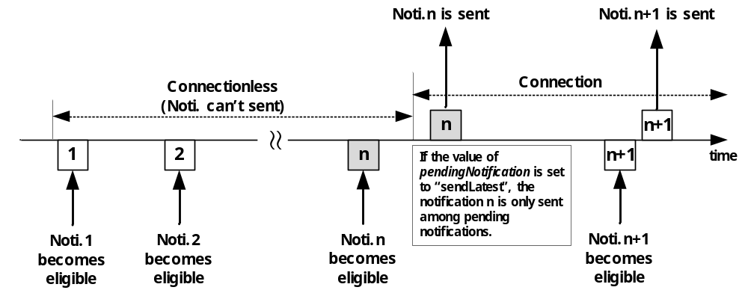
Figure 10.2.10.7-1: Notification Mechanism when pendingNotification (sendLatest) is used
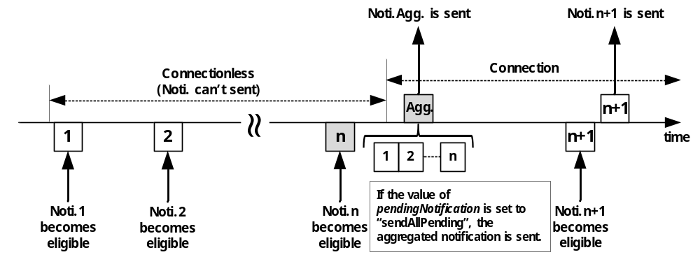
Figure 10.2.10.7-2: Notification Mechanism when pendingNotification (sendAllPending) is used
In the case an Originator wants (for example in the case where notification events occur on an irregular basis) that notifications are be sent for events generated prior to the creation of this subscription, it may set the preSubscriptionNotify attribute (notification policy) to express its notification policy. The preSubscriptionNotify policy is based upon a number of prior notifications that the Originator wants to be sent. When creating a subscription the Hosting CSE checks the preSubscriptionNotify policy. If caching of retained notifications is supported on the Hosting CSE and contains the subscribed events then prior notification events shall be sent to Receiver(s) up to the number requested by the preSubscriptionNotify policy. If caching of retained notifications is supported for the subscribed events but the available number of prior notification events is less than the number requested then the Hosting CSE shall send those notifications. If caching of retained notifications is not supported, then the response to the subscription creation request shall include a warning. The preSubscriptionNotify policy may be used simultaneously with any other notification policy. The scope of the preSubscriptionNotify policy is the Hosting CSE for the one subscription it is set in, and does not extend to transit CSEs.
The latestNotify attribute (notification policy) indicates if the Originator is only interested in the latest state of the subscribed-to resource. If the latestNotify attribute is set, the Hosting CSE shall assign Event Category parameter of value 'latest' to the latest notifications generated pertaining to the subscription created. In the case the Receiver is a transit CSE which forwards or aggregates the notifications before sending them to the Originator or the other transit CSEs, upon receiving the notification with the Event Category set to 'latest', the transit CSE shall identify the latest notification with the same subscription reference while storing the notifications locally. When the Receiver as a transit CSE needs to send the pending notifications, it shall send the latest notification only for that subscription. The scope of the latestNotify policy is the Hosting CSE as well as transit CSEs.
The notificationContentType attribute (notification policy) indicates the notification content type that shall be contained in notifications. The notificationContentType values shall be " modified attributes " (i.e. send a modified attribute only), or "all attributes" (i.e. send all attributes of the subscribed-to resource), or "ID" of the resource indicated in the eventType condition. If it is not given by the Originator at the creation procedure, the default is "all attributes". The scope of the notificationContentType policy is the Hosting CSE for all Originator's subscriptions, and does not extend to transit CSEs.
The notificationEventCat attribute (notification policy) indicates an event category of the subscription that shall be included in the notification request to be able for the Notification Target to correctly handle the notification. When the notificationEventCat policy is not configured by the Originator, it shall be determined as a default value by the CMDH policy. The scope of the notificationEventCat policy is the Hosting CSE for all Originator's subscriptions, and does not extend to transit CSEs.
When the Hosting CSE receives unsuccessful Notify response with subscription verification failure information, the Hosting CSE shall send unsuccessful result to the Originator of the corresponding <subscription> creation procedure if it has not created the <subscription> resource, otherwise the Hosting CSE may delete the corresponding <subscription> resource.
Table 10.2.10.7-1: Notification Procedure
Description
Associated Reference Point | Mca, Mcc and Mcc'
Information in Request message | According to clause 10.1.6 with the following additions:  Content:  - notification data that represents the content of subscribed-to resource may be included. The content is decided by notificationContentType attribute  - subscription reference (i.e. address of the corresponding <subscription> resource) that generates this notification shall be included  - notification event type shall be included  - monitored operation and its Originator information shall be included when operationMonitor condition in the eventNotificationCriteria attribute is configured  - notificationForwardingURI in case the subscriber intends the group to aggregate the notifications
Processing at Originator before sending Request | Notification is triggered regarding subscription information in a <subscription> resource
Processing at Receiver | According to clause 10.1.6
Information in Response message | According to clause 10.1.6
Processing at Originator after receiving Response | If the response includes 'targetRemoval' indicator which is set to TRUE, then the Notifier(i.e. the Originator of the Notify request) shall perform the procedure in clause 10.2.10.8 (Notification target removal handling procedure)
Exceptions | According to clause 10.1.6

10.2.10.8 Notification Target removal procedure
Editor's Note: add introduction like we have for polling channel mechanism
The Notifier(i.e. the Originator of the Notify request) shall handle the notification target removal based on a <notificationTargetPolicy> resource. Selecting the applicable<notificationTargetPolicy> resource shall be performed as follows:
- Check if there's a <notificationTargetMgmtPolicyRef> resource as a child of the <subscription> resource which includes the Notification Target in the notificationTargetURI attribute. If one is located , the Notifier shall apply the <notificationTargetPolicy> resource specified in the notificationPolicyID attribute in the matching <notificationTargetMgmtPolicyRef> resource.
- Otherwise, the Notifier shall check if there is a <notificationTargetMgmtPolicyRef> resource which has the creator attribute set in the corresponding <subscription> resource and there is a <notificationTargetPolicy> resource which has the policyLabel attribute set as "default" and the creator attribute is equal to the creator of the <subscription> resource.
- Otherwise, the Notifier shall fetch the <notificationTargetPolicy> resource which has the policyLabel attribute set as "default".
With the selected <notificationTargetPolicy> resource, the Notifier shall handle the target removal as specified in the action attribute of the <notificationTargetPolicy> resource. If there's <policyDeletionRules> resource(s) then the action shall be applied when the rule(s) is satisfied.
The action shall be performed as follows:
- If the action is "accept", then the Notifier shall remove the address which is corresponding to the Notification Target and returns a successful response if applicable.
- If the action is "reject" and if the target removal was requested with Delete request (clause 10.2.10.9), then the Notifier shall return an unsuccessfull response if applicable.
- If the action is "seek authorization from the subscription creator", then the Notifier shall return a successful response to the Notification Target if applicable and shall send a Notify request including the ID of the <subscription> resource, the Notification Target, and the 'removalAuthorization' indicator which is set as TRUE, to the subscription creator. When the Notifier gets successful response from the creator, then the Notifier shall remove the address which is corresponding to the Notification Target.
- If the action is "inform the subscription creator", then the Notifier shall return a successful response to the Notification Target if applicable and shall send a Notify request including the ID of the <subscription> resource, the Notification Target, and the 'targetRemoval' indicator which is set as TRUE to the subscription creator.

10.2.10.9 Delete <notificationTargetSelfReference>
Only Delete operations shall be allowed for the <notificationTargetRemove> resource.
This procedure shall apply to the <subscription> resource . Whenever a Delete Request is received at the <notificationTargetSelfReference> virtual resource from a Notification Target, the Notifier shall handle the request according to the action attribute defined in the <notificationTargetPolicy> resource which is linked from the <notificationTargteDisposition> resource. Detailed handling procedure is specified in the clause 10.2.10.8 (Notification Target removal handling procedure).

10.2.10.10 Create <notificationTargetMgmtPolicyRef>
This procedure shall be used for creating a <notificationTargetMgmtPolicyRef> resource.
Table 10.2.10.10-1: <notificationTargetMgmtPolicyRef> CREATE
<notificationTargetMgmtPolicyRef> CREATE
Associated Reference Point | Mca, Mcc and Mcc'
Information in Request message | All parameters defined in table 8.1.2-3 apply with the specific details for:  Content: The resource content shall provide the information as defined in clause 9.6.6
Processing at Originator before sending Request | According to clause 10.1.2
Processing at Receiver | According to clause 10.1.2
Information in Response message | According to clause 10.1.2
Processing at Originator after receiving Response | According to clause 10.1.2
Exceptions | According to clause 10.1.2

10.2.10.11 Retrieve <notificationTargetMgmtPolicyRef>
This procedure shall be used for retrieving the attributes of a <notificationTargetMgmtPolicyRef> resource.
Table 10.2.10.11-1: <notificationTargetMgmtPolicyRef> RETRIEVE
<notificationTargetMgmtPolicyRef> RETRIEVE
Associated Reference Point | Mca, Mcc and Mcc'
Information in Request message | All parameters defined in table 8.1.2-3 apply.
Processing at Originator before sending Request | According to clause 10.1.3
Processing at Receiver | According to clause 10.1.3
Information in Response message | All parameters defined in table 8.1.3-1 apply.
Processing at Originator after receiving Response | According to clause 10.1.3
Exceptions | According to clause 10.1.3

10.2.10.12 Update <notificationTargetMgmtPolicyRef>
This procedure shall be used for updating attributes of a <notificationTargetMgtPolicyRef> resource.
Table 10.2.10.12-1: <notificationTargetMgmtPolicyRef> UPDATE
<notificationTargetMgmtPolicyRef> UPDATE
Associated Reference Point | Mca, Mcc and Mcc'
Information in Request message | All parameters defined in table 8.1.2-3 apply
Processing at Originator before sending Request | According to clause 10.1.4
Processing at Receiver | According to clause 10.1.4
Information in Response message | According to clause 10.1.4
Processing at Originator after receiving Response | According to clause 10.1.4
Exceptions | According to clause 10.1.4

10.2.10.13 Delete <notificationTargetMgmtPolicyRef>
This procedure shall be used for deleting a <notificationTargetMgmtPolicyRef> resource.
Table 10.2.10.13-1: <notificationTargetMgmtPolicyRef> DELETE
<notificationTargetMgmtPolicyRef> DELETE
Associated Reference Point | Mca, Mcc and Mcc'
Information in Request message | All parameters defined in table 8.1.2-3 apply
Processing at Originator before sending Request | According to clause 10.1.5
Processing at Receiver | According to clause 10.1.5
Information in Response message | According to clause 10.1.5
Processing at Originator after receiving Response | According to clause 10.1.5
Exceptions | According to clause 10.1.5

10.2.10.14 Create <notificationTargetPolicy>
This procedure shall be used for creating a <notificationTargetPolicy> resource.
Table 10.2.10.14-1: <notificationTargetPolicy> CREATE
<notificationTargetPolicy> CREATE
Associated Reference Point | Mca, Mcc and Mcc'
Information in Request message | All parameters defined in table 8.1.2-3 apply with the specific details for:  Content: The resource content shall provide the information as defined in clause 9.6.6
Processing at Originator before sending Request | According to clause 10.1.2
Processing at Receiver | According to clause 10.1.2
Information in Response message | According to clause 10.1.2
Processing at Originator after receiving Response | According to clause 10.1.2
Exceptions | According to clause 10.1.2

10.2.10.15 Retrieve <notificationTargetPolicy>
This procedure shall be used for retrieving the attributes of a <notificationTargetPolicy> resource.
Table 10.2.10.15-1: <notificationTargetPolicy> RETRIEVE
<notificationTargetPolicy> RETRIEVE
Associated Reference Point | Mca, Mcc and Mcc'
Information in Request message | All parameters defined in table 8.1.2-3 apply
Processing at Originator before sending Request | According to clause 10.1.3
Processing at Receiver | According to clause 10.1.3
Information in Response message | All parameters defined in table 8.1.3-1 apply
Processing at Originator after receiving Response | According to clause 10.1.3
Exceptions | According to clause 10.1.3

10.2.10.16 Update <notificationTargetPolicy>
This procedure shall be used for updating attributes of a <notificationTargetPolicy> resource.
Table 10.2.10.16-1: <notificationTargetPolicy> UPDATE
<notificationTargetPolicy> UPDATE
Associated Reference Point | Mca, Mcc and Mcc'
Information in Request message | All parameters defined in table 8.1.2-3 apply
Processing at Originator before sending Request | According to clause 10.1.4
Processing at Receiver | According to clause 10.1.4
Information in Response message | According to clause 10.1.4
Processing at Originator after receiving Response | According to clause 10.1.4
Exceptions | According to clause 10.1.4

10.2.10.17 Delete <notificationTargetPolicy>
This procedure shall be used for deleting a <notificationTargetPolicy> resource.
Table 10.2.10.17-1: <notificationTargetPolicy> DELETE
<notificationTargetPolicy> DELETE
Associated Reference Point | Mca, Mcc and Mcc'
Information in Request message | All parameters defined in table 8.1.2-3 apply
Processing at Originator before sending Request | According to clause 10.1.5
Processing at Receiver | According to clause 10.1.5
Information in Response message | According to clause 10.1.5
Processing at Originator after receiving Response | According to clause 10.1.5
Exceptions | According to clause 10.1.5

10.2.10.18 Create <policyDeletionRules>
This procedure shall be used for creating a <policyDeletionRules> resource.
Table 10.2.10.18-1: <policyDeletionRules> CREATE
<policyDeletionRules> CREATE
Associated Reference Point | Mca, Mcc and Mcc'
Information in Request message | All parameters defined in table 8.1.2-3 apply with the specific details for:  Content: The resource content shall provide the information as defined in clause 9.6.6
Processing at Originator before sending Request | According to clause 10.1.2
Processing at Receiver | According to clause 10.1.2
Information in Response message | According to clause 10.1.2
Processing at Originator after receiving Response | According to clause 10.1.2
Exceptions | According to clause 10.1.2

10.2.10.19 Retrieve <policyDeletionRules>
This procedure shall be used for retrieving the attributes of a <policyDeletionRules> resource.
Table 10.2.10.19-1: <policyDeletionRules> RETRIEVE
<policyDeletionRules> RETRIEVE
Associated Reference Point | Mca, Mcc and Mcc'
Information in Request message | All parameters defined in table 8.1.2-3 apply
Processing at Originator before sending Request | According to clause 10.1.3
Processing at Receiver | According to clause 10.1.3
Information in Response message | All parameters defined in table 8.1.3-1 apply
Processing at Originator after receiving Response | According to clause 10.1.3
Exceptions | According to clause 10.1.3

10.2.10.20 Update <policyDeletionRules>
This procedure shall be used for updating attributes of a <policyDeletionRules> resource.
Table 10.2.10.20-1: <policyDeletionRules> UPDATE
<poiicyDeletionRules> UPDATE
Associated Reference Point | Mca, Mcc and Mcc'
Information in Request message | All parameters defined in table 8.1.2-3 apply
Processing at Originator before sending Request | According to clause 10.1.4
Processing at Receiver | According to clause 10.1.4
Information in Response message | According to clause 10.1.4
Processing at Originator after receiving Response | According to clause 10.1.4
Exceptions | According to clause 10.1.4

10.2.10.21 Delete <policyDeletionRules>
This procedure shall be used for deleting a <policyDeletionRules> resource.
Table 10.2.10.21-1: <policyDeletionRules> DELETE
<policyDeletionRules> DELETE
Associated Reference Point | Mca, Mcc and Mcc'
Information in Request message | All parameters defined in table 8.1.2-3 apply
Processing at Originator before sending Request | According to clause 10.1.5
Processing at Receiver | According to clause 10.1.5
Information in Response message | According to clause 10.1.5
Processing at Originator after receiving Response | According to clause 10.1.5
Exceptions | According to clause 10.1.5

10.2.11 Service Charging and Accounting Procedures

10.2.11.1 Service event-based statistics collection for applications
This clause is informative and provides a use case example to explain how the Infrastructure Node provides statistics for AEs using the <statsConfig> and <statsCollect> resources as defined in clauses 9.6.23, 9.6.24.and 9.6.25.
Figure 10.2.11.1-1 shows an example of service layer event-based charging based on the Infrastructure Node.
Step 1-2: A statistics collection resource called <statsConfigSCA1> was created at the IN-CSE by a billing application. Note that the <statsConfig> can also be provisioned. In this use case, the <statsConfigSCA1> has the <eventConfigSCA1> sub-resource. For this specific use case, the <eventConfigSCA1> can be set as following: The eventID attribute is set with a unique ID to differentiate from other chargeable events. The eventType attribute defines what event will trigger the generation of service statistics collection record and is set to "Data Operation" for this case. eventStart and eventEnd attributes apply to timer based event so they will not be included in this event. operationType attribute will be "RETRIEVE". dataSize attribute does not apply so it is not included.
Step 3-5: In this example, AE1 already registered to IN-CSE. IN-CSE can make the statistics collection configuration accessible by AE. Based on the <statsConfigSCA1>, AE1 creates a statistics collection trigger for itself, stored in <statsCollectAE1>. AE1 will fill in the information for the collection rule. For example, it fills the collectingEntityID attribute with the AE-ID of AE1, and the collectedEntityID attribute empty, which means to collect for any entities. status attribute is set to "Active". The statModel is event-based. The eventID is set with the same ID value as the eventID in the <eventConfigSCA1>. This event collection trigger can be stored in the <eventConfigSCA1> resource at the IN-CSE and IN-CSE will assign a unique ID in attribute statsCollectID.
Step 6-8: When the configured event happens, i.e. when AE2 performed a RETRIEVE operation to the data stored by AE1 at IN-CSE, the event is recorded by IN-CSE. IN-CSE generates a service statistics collection record and sends it to AE1. AE1 can choose to use such information for statistics or billing. Transfer of the statistics is out of scope of the present document.
Step 9: The AE of billing application can update or retrieve the charging policies and collection scenarios that it has the access control privilege.
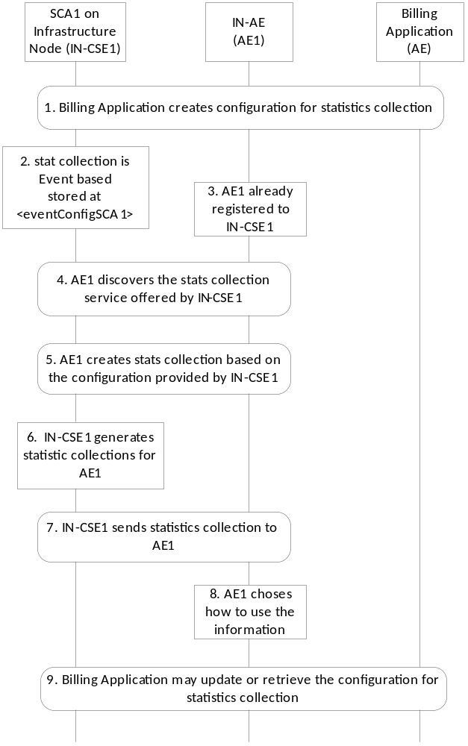
Figure 10.2.11.1-1: Event-based Statistics Collection for Applications

10.2.11.2 Create <statsConfig>
This procedure shall be used for the Originator to establish a set of configurations for statistics collection at the Receiver.
The configurations shall be stored at the <statsConfig> resource and each instance of the <statsConfig> resource shall represent a specific configuration.
The Originator shall be an AE that wants to set up the statistics collection configurations.
The Receiver shall be an IN-CSE.
Table 10.2.11.2-1: <statsConfig> CREATE
<statsConfig> CREATE
Associated Reference Points | Mca
Information in Request message | From: Identifier of the AE that initiates the Request  To: The address of the <CSEBase> where the <statsConfig> resource is intended to be Created.  Content: The representation of the <statsConfig> resource for which the attributes are described in clause 9.6.23  Other information in the Request message is defined according to clause 10.1.2
Processing at Originator before sending Request | The Originator shall request to Create a new <statsConfig> resource by addressing to the <CSEBase> resource of a Hosting CSE. The Originator shall be an AE
Processing at Receiver | According to clause 10.1.2
Information in Response message | According to clause 10.1.2
Processing at Originator after receiving Response | None
Exceptions | According to clause 10.1.2

10.2.11.3 Retrieve <statsConfig>
The RETRIEVE procedure shall be used for the Originator to retrieve the existing <statsConfig> resource from the Receiver.
The Originator shall be an AE that is allowed to retrieve configuration information available for AEs within an IN-CSE.
The Receiver shall be the IN- CSE containing the <statsConfig> resource.
Table 10.2.11.3-1: <statsConfig> RETRIEVE
<statsConfig> RETRIEVE
Associated Reference Points | Mca
Information in Request message | From: ID of the Originator  To: Address of the <statsConfig> resource or its attribute to be retrieved
Processing at Originator before sending Request | The Originator shall request to obtain <statsConfig> resource information by using the RETRIEVE operation. The request shall address the specific <statsConfig> resource or its attributes of a Hosting CSE. The Originator shall be an AE
Processing at Receiver | According to clause 10.1.3
Information in Response message | According to clause 10.1.3
Processing at Originator after receiving Response | According to clause 10.1.3
Exceptions | According to clause 10.1.3

10.2.11.4 Update <statsConfig>
This procedure shall be used for updating <statsConfig> resource.
An UPDATE procedure on the <statsConfig> resource is used for the Originator to update charging related policies at the Receiver.
The Originator shall be the AE that created the <statsConfig> resource. The same AE shall be able to update the resource.
The Receiver shall be a CSE containing the <statsConfig> resource.
Table 10.2.11.4-1: <statsConfig> UPDATE
<statsConfig> UPDATE
Associated Reference Points | Mca
Information in Request message | From: ID of the Originator  To: Address of the <statsConfig> resource to be updated  Content: the Originator provides the attributes of <statsConfig> to be updated
Processing at Originator before sending Request | According to clause 10.1.4
Processing at Receiver | According to clause 10.1.4
Information in Response message | According to clause 10.1.4
Processing at Originator after receiving Response | None
Exceptions | According to clause 10.1.4

10.2.11.5 Delete <statsConfig>
This procedure shall be used for deleting <statsConfig> resource.
The Originator shall be the AE that created the <statsConfig> resource.
The Receiver shall be a CSE containing the <statsConfig> resource.
Table 10.2.11.5-1: <statsConfig> DELETE
<statsConfig> DELETE
Associated Reference Points | Mca
Information in Request message | From: ID of the Originator  To: Address of the <statsConfig> resource to be deleted
Processing at Originator before sending Request | According to clause 10.1.5
Processing at Receiver | According to clause 10.1.5
Information in Response message | According to clause 10.1.5
Processing at Originator after receiving Response | None
Exceptions | According to clause 10.1.5

10.2.11.6 Create <eventConfig>
This procedure shall be used to create <eventConfig> resource.
Table 10.2.11.6-1: <eventConfig> CREATE
<eventConfig> CREATE
Associated Reference Points | Mca
Information in Request message | From: Identifier of the AE that initiates the Request  To: The address of the <statsConfig> resource where the <eventConfig> sub-resource is intended to be Created  Content: The representation of the <eventConfig> resource for which the attributes are described in clause 9.6.24  Other information in the Request message is defined according to clause 10.1.2
Processing at Originator before sending Request | The Originator shall be an AE. The Originator shall request to Create a new <eventConfig> resource by addressing to the <statsConfig> resource of a Hosting CSE
Processing at Receiver | The Receiver shall be an IN-CSE:  - The Receiver shall verify whether the eventID is unique or not, and if not, provides a new value  - The Receiver shall verify that the eventEnd time is greater than the eventStart time if these two attributes are present  - The Receiver shall verify that the dataSize attribute is present and contains a value greater to zero if the eventType is set to "Storage based"
Information in Response message | According to clause 10.1.2
Processing at Originator after receiving Response | None
Exceptions | According to clause 10.1.2

10.2.11.7 Retrieve <eventConfig>
The RETRIEVE procedure shall be used for the Originator to retrieve the existing <eventConfig> resource from the Receiver.
The Originator shall be an AE that is allowed to retrieve configuration information available for AEs within an IN-CSE.
The Receiver shall be the IN-CSE containing the <eventConfig> resource.
Table 10.2.11.7-1: <eventConfig> RETRIEVE
<eventConfig> RETRIEVE
Associated Reference Points | Mca
Information in Request message | From: ID of the Originator  To: Address of the <eventConfig> resource or its attributes to be retrieved.
Processing at Originator before sending Request | The Originator shall request to obtain <eventConfig> resource information by using the RETRIEVE operation. The request shall address the specific <eventConfig> resource or its attributes of a Hosting CSE. The Originator shall be an AE
Processing at Receiver | According to clause 10.1.3
Information in Response message | According to clause 10.1.3
Processing at Originator after receiving Response | According to clause 10.1.3
Exceptions | According to clause 10.1.3

10.2.11.8 Update <eventConfig>
This procedure shall be used for updating an existing <eventConfig> resource.
The Originator shall be the AE that created the <eventConfig> resource. The same AE shall be able to update the resource.
The Receiver shall be the IN-CSE containing the <eventConfig> resource.
Table 10.2.11.8-1: <eventConfig> UPDATE
<eventConfig> UPDATE
Associated Reference Points | Mca
Information in Request message | From: ID of the Originator  To: Address of the <eventConfig> resource to be updated  Content: The Originator provides the attributes of <eventConfig> to be updated  The Originator can update attributes under <eventConfig> to update event-based configuration for statistics collection
Processing at Originator before sending Request | According to clause 10.1.4
Processing at Receiver | According to clause 10.1.4
Information in Response message | According to clause 10.1.4
Processing at Originator after receiving Response | None
Exceptions | According to clause 10.1.4

10.2.11.9 Delete <eventConfig>
This procedure shall be used for deleting <eventConfig> resource.
The Originator shall be the AE that created the <eventConfig> resource.
The Receiver shall be the IN-CSE containing the <eventConfig> resource.
Table 10.2.11.9-1: <eventConfig> DELETE
<eventConfig> DELETE
Associated Reference Points | Mca
Information in Request message | From: ID of the Originator  To: Address of the <eventConfig> resource to be deleted
Processing at Originator before sending Request | According to clause 10.1.5
Processing at Receiver | According to clause 10.1.5
Information in Response message | According to clause 10.1.5
Processing at Originator after receiving Response | None
Exceptions | According to clause 10.1.5

10.2.11.10 Create <statsCollect>
This procedure shall be used for the Originator to establish collection scenarios at the Receiver.
The collection scenarios are stored at the <statsCollect> resource. Multiple collection scenarios can be created based on one instance of <statsConfig>.
The Receiver shall be an IN-CSE. The Receiver shall validate whether the Originator has proper permissions for creating a <statsCollect> resource. Upon successful validation, create a new <statsCollect> resource with the provided attributes. The IN-CSE shall also create a unique statsCollectID.
Table 10.2.11.10-1: <statsCollect> CREATE
<statsCollect> CREATE
Associated Reference Points | Mca
Information in Request message | From: Identifier of the AE that initiates the Request  To: The Address of the <CSEBase> where the <statsCollect> resource is intended to be Created  Content: Contain the resource representation of <statsCollect>  Other information in the Request message is defined according to clause 10.1.2
Processing at Originator before sending Request | The Originator shall be an AE that wants to set up the collection scenarios to an IN-CSE. The Originator shall request to Create a new <statsCollect> resource by addressing to the <CSEBase> resource of a Hosting CSE  The Originator shall populate the attributes for the <statsCollect> resource as defined in clause 9.6.25, except for statsCollectID
Processing at Receiver | In addition to procedures defined in clause 10.1.2, the Receiver shall perform the following specific operations:  - Create statsCollectID which shall be unique in the same service provider domain  - Once a <statsCollect> resource instance is created and the status is "ACTIVE", the IN-CSE shall generate service statistics collection records when the conditions defined by the <statsCollect> are met
Information in Response message | According to clause 10.1.2
Processing at Originator after receiving Response | None
Exceptions | According to clause 10.1.2

10.2.11.11 Retrieve <statsCollect>
The RETRIEVE procedure shall be used for the Originator to retrieve the existing <statsCollect> resource from the Receiver.
The Originator shall be an AE that is allowed to retrieve the collection scenario information from the IN-CSE.
The Receiver shall be the IN- CSE containing the <statsCollect> resource.
Table 10.2.11.11-1: <statsCollect> RETRIEVE
<statsCollect> RETRIEVE
Associated Reference Points | Mca
Information in Request message | From: ID of the Originator  To: Address of the <statsCollect> resource or its attribute to be retrieved
Processing at Originator before sending Request | The Originator shall request to obtain <statsCollect> resource information by using the RETRIEVE operation. The request shall address the specific <statsCollect> resource or its attributes of a Hosting CSE. The Originator shall be an AE
Processing at Receiver | According to clause 10.1.3
Information in Response message | According to clause 10.1.3
Processing at Originator after receiving Response | According to clause 10.1.3
Exceptions | According to clause 10.1.3

10.2.11.12 Update <statsCollect>
An UPDATE procedure on the <statsCollect> resource shall be used for the Originator to update chargeable scenarios at the Receiver.
The Originator shall be the AE that created the <statsCollect> resource. The same AE shall be able to update the resource.
The Receiver shall be the IN-CSE containing the <statsCollect> resource.
Table 10.2.11.12-1: <statsCollect> UPDATE
<statsCollect> UPDATE
Associated Reference Points | Mca
Information in Request message | From: ID of the Originator  To: Address of the <statsCollect> resource to be updated  Content: the Originator provides the attributes of <statsCollect> to be updated
Processing at Originator before sending Request | According to clause 10.1.4
Processing at Receiver | According to clause 10.1.4
Information in Response message | According to clause 10.1.4
Processing at Originator after receiving Response | None
Exceptions | According to clause 10.1.4

10.2.11.13 Delete <statsCollect>
This procedure shall be used for deleting <statsCollect> resource.
The Originator shall be the AE that created the <statsCollect> resource.
The Receiver shall be a CSE containing the <statsCollect> resource.
Table10.2.11.13-1: <statsCollect> DELETE
<statsCollect> DELETE
Associated Reference Points | Mca
Information in Request message | From: ID of the Originator  To: Address of the <statsCollect> resource to be deleted
Processing at Originator before sending Request | According to clause 10.1.5
Processing at Receiver | According to clause 10.1.5
Information in Response message | According to clause 10.1.5
Processing at Originator after receiving Response | None
Exceptions | According to clause 10.1.5

10.2.11.14 Service Statistics Collection Record
When the Service Statistics Collection is supported, the Information Elements shall be generated according to table 10.2.11.14-1.
The contents of each Service statistics collection record are decided by the specific collection scenario that triggered the information recording.
Transfer of the Statistics Collection Records over the Mch reference point is not defined in the present document.
Table 10.2.11.14-1: Information Elements for Service Statistics Collection Record
Information Element | Mandatory/ optional | Description
statsCollectID | M | It is the unique ID that identifies a specific statistics collection scenario, which triggers information recording for a specific event.
collectingEntityID | M | This is the unique ID of the entity that collects the statistics. It can be an AE-ID or CSE-ID.
collectedEntityID | M | This is the unique ID of the entity whose service layer operation statistics are being collected. It can be an AE-ID or CSE-ID.
event | O | This indicates a specific event type in each record, such as timer based, data operation, storage triggering. It is only present if the statModel is "event based".
eventStart | O | The start time for the recording the M2M event record.
eventEnd | O | The end time for the recording the M2M event record.
transactionType | O | Specifies the detailed type of a transaction, such as CREATE, RETRIEVE, etc.
dataSize | O | Storage Memory in Kbytes, where applicable, to store data associated events with container related operations.
Vendor Specific Information | O | Defines Vendor specific information.

10.2.12 M2M service subscription management

10.2.12.1 Introduction
This clause describes the procedures for creation, retrieval, update and deletion of the M2M Service Subscription related resources (i.e. <m2mServiceSubscriptionProfile>, <serviceSubscribedNode> and <serviceSubscribedAppRule>). These resources are used to store M2M Service Subscription related information regarding an established contract between a M2M Service Provider and M2M Application Service Providers. The relationship between these three resource types is specified in clause 9.6.19.

10.2.12.2 Create <m2mServiceSubscriptionProfile>
This procedure shall be used for creating a <m2mServiceSubscriptionProfile> resource.
Table 10.2.12.2-1: <m2mServiceSubscriptionProfile> CREATE
<m2mServiceSubscriptionProfile> CREATE
Associated Reference Point | Mca and Mcc
Information in Request message | All parameters defined in table 8.1.2-3 apply with the specific details for:  To: The Receiver or Hosting CSE shall be an IN-CSE  Content: The resource content shall provide the information as defined in clause 9.6.19
Processing at Originator before sending Request | According to clause 10.1.2
Processing at Receiver | According to clause 10.1.2
Information in Response message | All parameters defined in table 8.1.3-1 apply with the specific details for:  Content: Address of the created <m2mServiceSubscriptionProfile> resource, according to clause 10.1.1
Processing at Originator after receiving Response | According to clause 10.1.2
Exceptions | According to clause 10.1.2

10.2.12.3 Retrieve <m2mServiceSubscriptionProfile>
This procedure shall be used for retrieving the attributes of a <m2mServiceSubscriptionProfile> resource.
Table 10.2.12.3-1: <m2mServiceSubscriptionProfile> RETRIEVE
<m2mServiceSubscriptionProfile> RETRIEVE
Associated Reference Point | Mca, Mcc, Mcc'
Information in Request message | All parameters defined in table 8.1.2-3 apply with the specific details for:  To: The Receiver or Hosting CSE shall be an IN-CSE  Content: Void
Processing at Originator before sending Request | According to clause 10.1.3
Processing at Receiver | According to clause 10.1.3
Information in Response message | All parameters defined in table 8.1.3-1 apply with the specific details for:  Content: Attributes of the <m2mServiceSubscriptionProfile> resource as defined in clause 9.6.19
Processing at Originator after receiving Response | According to clause 10.1.3
Exceptions | According to clause 10.1.3

10.2.12.4 Update <m2mServiceSubscriptionProfile>
This procedure shall be used for updating the attributes of a <m2mServiceSubscriptionProfile> resource.
Table 10.2.12.4-1: <m2mServiceSubscriptionProfile> UPDATE
<m2mServiceSubscriptionProfile> UPDATE
Associated Reference Point | Mca and Mcc
Information in Request message | All parameters defined in table 8.1.2-3 are applicable as indicate in the table with the specific details for:  To: The Receiver or Hosting CSE shall be an IN-CSE  Content: Attributes of the <m2mServiceSubscriptionProfile> resource as defined in clause 9.6.19 which need be updated, with the exception of the following that cannot be modified:  - "lastModifiedTime"
Processing at Originator before sending Request | According to clause 10.1.4
Processing at Receiver | According to clause 10.1.4
Information in Response message | According to clause 10.1.4
Processing at Originator after receiving Response | According to clause 10.1.4
Exceptions | According to clause 10.1.4

10.2.12.5 Delete <m2mServiceSubscriptionProfile>
This procedure shall be used for deleting a <m2mServiceSubscriptionProfile> resource residing under a <m2mServiceSubscriptionProfile> resource.
Table 10.2.12.5-1: <m2mServiceSubscriptionProfile> DELETE
<m2mServiceSubscriptionProfile> DELETE
Associated Reference Point | Mca and Mcc
Information in Request message | All parameters defined in table 8.1.2-3 apply with specific details for:  To: The Receiver or Hosting CSE shall be an IN-CSE
Processing at Originator before sending Request | According to clause 10.1.5
Processing at Receiver | According to clause 10.1.5
Information in Response message | According to clause 10.1.5
Processing at Originator after receiving Response | According to clause 10.1.5
Exceptions | According to clause 10.1.5

10.2.12.6 Create <serviceSubscribedNode>
This procedure shall be used for creating a <serviceSubscribedNode> resource which is sub-resource of <m2mServiceSubscriptionProfile> resource.
Table 10.2.12.6-1: <serviceSubscribedNode> CREATE
<serviceSubscribedNode> CREATE
Associated Reference Point | Mca and Mcc
Information in Request message | All parameters defined in table 8.1.2-3 apply with the specific details for:  To: The Receiver or Hosting CSE shall be an IN-CSE  Content: The resource content shall provide the information as defined in clause 9.6.20
Processing at Originator before sending Request | According to clause 10.1.2
Processing at Receiver | According to clause 10.1.2
Information in Response message | All parameters defined in table 8.1.3-1 apply with the specific details for:  Content: Address of the created <serviceSubscribedNode> resource, according to clause 10.1.2
Processing at Originator after receiving Response | According to clause 10.1.2
Exceptions | According to clause 10.1.2

10.2.12.7 Retrieve <serviceSubscribedNode>
This procedure shall be used for retrieving the attributes of a <serviceSubscribedNode> resource which is sub-resource of <m2mServiceSubscriptionProfile> resource.
Table 10.2.12.7-1: <serviceSubscribedNode> RETRIEVE
<serviceSubscribedNode> RETRIEVE
Associated Reference Point | Mca, Mcc and Mcc'
Information in Request message | All parameters defined in table 8.1.2-3 apply with the specific details for:  To: The Receiver or Hosting CSE shall be an IN-CSE  Content: Void
Processing at Originator before sending Request | According to clause 10.1.3
Processing at Receiver | According to clause 10.1.3
Information in Response message | All parameters defined in table 8.1.3-1 apply
Processing at Originator after receiving Response | According to clause 10.1.3
Exceptions | According to clause 10.1.3

10.2.12.8 Update <serviceSubscribedNode>
This procedure shall be used for updating the attributes of a <serviceSubscribedNode> resource which is sub-resource of <m2mServiceSubscriptionProfile> resource.
Table 10.2.12.8-1: <serviceSubscribedNode> UPDATE
<serviceSubscribedNode> UPDATE
Associated Reference Point | Mca and Mcc
Information in Request message | All parameters defined in table 8.1.2-3 are applicable as indicate in the table with the specific details for:  To: The Receiver or Hosting CSE shall be an IN-CSE  Content: Attributes of the <serviceSubscribedNode> resource as defined in clause 9.6.16 which need be updated, with the exception of the following that cannot be modified: "lastModifiedTime"
Processing at Originator before sending Request | According to clause 10.1.4
Processing at Receiver | According to clause 10.1.4
Information in Response message | According to clause 10.1.4
Processing at Originator after receiving Response | According to clause 10.1.4
Exceptions | According to clause 10.1.4

10.2.12.9 Delete <serviceSubscribedNode>
This procedure shall be used for deleting a <serviceSubscribedNode> resource residing under a <m2mServiceSubscriptionProfile> resource.
Table 10.2.12.9-1: <serviceSubscribedNode> DELETE
<serviceSubscribedNode> DELETE
Associated Reference Point | Mca and Mcc
Information in Request message | All parameters defined in table 8.1.2-3 apply with the specific details for:  To: The Receiver or Hosting CSE shall be an IN-CSE
Processing at Originator before sending Request | According to clause 10.1.5
Processing at Receiver | According to clause 10.1.5
Information in Response message | According to clause 10.1.5
Processing at Originator after receiving Response | According to clause 10.1.5
Exceptions | According to clause 10.1.5

10.2.12.10 Create <serviceSubscribedAppRule>
This procedure shall be used for creating an <serviceSubscribedAppRule> resource. The information represented in the attributes of a <serviceSubscribedAppRule> resource impacts the Application Entity Registration procedure as outlined in clause 10.2.2.2. Instances of <serviceSubscribedAppRule> resources are associated with specific CSEs by linking to them via the ruleLinks attribute of a <serviceSubscribedNode> resource that contains the respective CSE-ID in its CSE-ID attribute.
Table 10.2.12.10-1: <serviceSubscribedAppRule> CREATE
<serviceSubscribedAppRule> CREATE
Associated Reference Point | Mca and Mcc.
Information in Request message | All parameters defined in table 8.1.2-3 apply with the specific details for:  To: The Hosting CSE shall be an IN-CSE.  Content: The resource content shall provide the information as defined in clause 9.6.29.
Processing at Originator before sending Request | According to clause 10.1.2.
Processing at Receiver | According to clause 10.1.2.
Information in Response message | All parameters defined in table 8.1.3-1 apply.
Processing at Originator after receiving Response | According to clause 10.1.2.
Exceptions | According to clause 10.1.2.

10.2.12.11 Retrieve <serviceSubscribedAppRule>
This procedure shall be used for retrieving the representation of the <serviceSubscribedAppRule> resource.
Table 10.2.12.11-1: <serviceSubscribedAppRule> RETRIEVE
<serviceSubscribedAppRule> RETRIEVE
Associated Reference Point | Mca, Mcc and Mcc'.
Information in Request message | All parameters defined in table 8.1.2-3 apply with the specific details for:  To: The Hosting CSE shall be an IN-CSE.  Content: void.
Processing at Originator before sending Request | According to clause 10.1.3.
Processing at Receiver | According to clause 10.1.3.
Information in Response message | All parameters defined in table 8.1.3-1 apply.
Processing at Originator after receiving Response | According to clause 10.1.3.
Exceptions | According to clause 10.1.3.

10.2.12.12 Update <serviceSubscribedAppRule>
This procedure shall be used for updating the attributes of the <serviceSubscribedAppRule> resource.
Table 10.2.12.12-1: <serviceSubscribedAppRule> UPDATE
<serviceSubscribedAppRule> UPDATE
Associated Reference Point | Mca and Mcc.
Information in Request message | All parameters defined in table 8.1.2-3 apply with the specific details for:  To: The Hosting CSE shall be an IN-CSE.  Content: Attributes of the <serviceSubscribedAppRule> resource as defined in clause 9.6.29.
Processing at Originator before sending Request | According to clause 10.1.4.
Processing at Receiver | According to clause 10.1.4.
Information in Response message | All parameters defined in table 8.1.3-1 apply.
Processing at Originator after receiving Response | According to clause 10.1.4.
Exceptions | According to clause 10.1.4.

10.2.12.13 Delete <serviceSubscribedAppRule>
This procedure shall be used for deleting the <serviceSubscribedAppRule> resource with all related information.
Table 10.2.12.13-1: <serviceSubscribedAppRule> DELETE
<serviceSubscribedAppRule> DELETE
Associated Reference Point | Mca and Mcc.
Information in Request message | All parameters defined in table 8.1.2-3 apply with the specific details for:  To: The Hosting CSE shall be an IN-CSE.
Processing at Originator before sending Request | According to clause 10.1.5.
Processing at Receiver | According to clause 10.1.5.
Information in Response message | All parameters defined in table 8.1.3-1 apply.
Processing at Originator after receiving Response | According to clause 10.1.5.
Exceptions | According to clause 10.1.5.

10.2.13 Resource announcement

10.2.13.1 Introduction
Editor's Note: add introduction texts

10.2.13.2 Procedure for AE and CSE to initiate Creation of an Announced Resource
This clause describes the procedure for an AE or a CSE to initiate the creation of an announced resource.
Figure 10.2.13.2-1 depicts how creation of and announced resource is initiated (clause 10.2.13.2) and the announced resource is created on an announcement target CSE (clause 10.2.13.5).
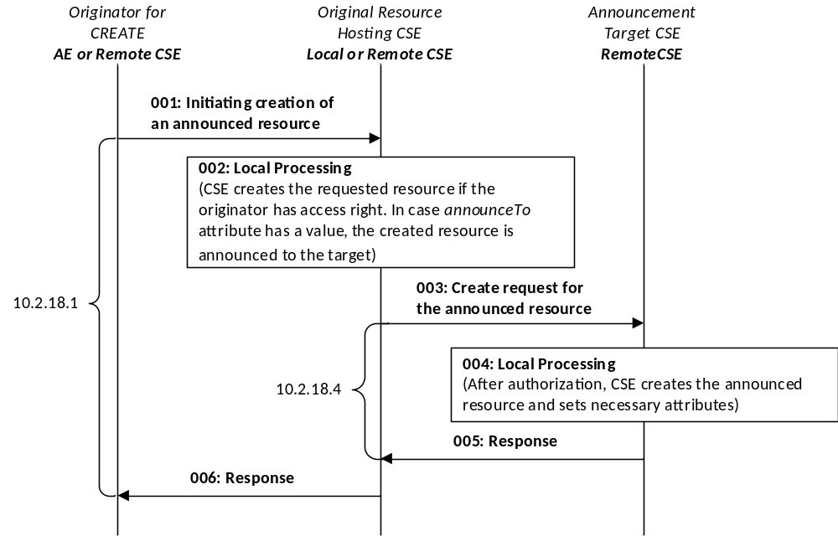
Figure 10.2.13.2-1: Announced resource CREATE procedures
Editor's Note: update the figure to adopt new clause numbers
The Originator of a Request for initiating resource announcement can be either an AE or a CSE. Two methods are supported for initiating the creation of an announced resource:
- CREATE: The Originator can initiate the creation of an announced resource during the creation of the original resource by providing announceTo attribute in the CREATE Request.
- UPDATE: The Originator can initiate the creation of an announced resource by using the UPDATE Request to update the announceTo attribute at the original resource.
Table 10.2.13.2-1: Initiate Resource Announcement: UPDATE or CREATE
Initiate Resource Announcement: CREATE or UPDATE
Associated Reference Points | Mca and Mcc.
Information in Request message | All parameters defined in table 8.1.2-3 are applicable as indicated in that table. In addition, for the case of the CREATE procedure for a specific resource is described in clause 10.2. The Originator suggests the address(es) or the CSE-ID(s) to which the resource will be announced in the Content parameter.
Processing at the Originator before sending Request | Content: contains address where the resource needs to be announced (within announceTo attribute):  - The Originator provides either the address(es) for the announced resource or the list of CSE-IDs of the remote CSEs where the original resource needs to be announced by including such information within the announceTo attribute of the UPDATE or CREATE Request.
Processing at the Receiver | Once the Originator has been successfully authorized, the Receiver (which shall be the original resource Hosting CSE) shall grant the Request after successful validation of the Request:  - If the Request provides address(es) for the announced resource that are not already stored in the announceTo attribute or for newly created announceTo attribute, the Receiver shall announce the resource to the announcement target CSE.  - If the Request provides a list of CSE-IDs of the remote CSEs that are not already stored in the announceTo attribute of for the newly created or updated announceTo attribute, the Receiver shall decide the location at the remote CSE(s) identified by CSE-ID(s) and announce the resource to the announcement target CSE.  The original resource Hosting CSE shall first check if the parent resource of the original resource has a representation at the announcement target CSE. If that is the case, the announced resource shall be created as a child resource of that representation of the parent resource. If that is not the case, the original Hosting CSE shall next check if it has announced itself to the announcement target CSE. If that is the case, the announced resource shall be created as a child resource of the original Hosting CSE's <remoteCSEAnnc> resource. Otherwise, the original Hosting CSE shall first announce itself by creating a <remoteCSEAnnc> resource as a child resource of the <CSEBase> resource of the announcement target CSE. Next, the announced resource shall be created as a child resource of the original Hosting CSE's <remoteCSEAnnc> resource.
Information in Response message | On successful completion of resource announcement as in clause 10.2.13.5, the Receiver shall provide all parameters defined in table 8.1.3-1 that are applicable as indicated in that table in the Response message:  - The Receiver shall provide the address(es) of the announced resource to the Originator by updating the content of the announceTo attribute in the original resource and by providing it in the UPDATE or CREATE Response message depending on the type of the Request.
Processing at Originator after receiving Response | According to clause 10.1.2 in case of CREATE Request.  According to clause 10.1.4 in case of UPDATE Request.
Exceptions | All exceptions described in the basic procedures (clause 10.1.2) are applicable.

10.2.13.3 Procedure at AE or CSE to Retrieve information from an Announced Resource
This clause describes the procedures that shall be use for an AE or a CSE to retrieve information about an announced resource or the corresponding original resource.
Figure 10.2.13.3-1 depicts how the announced resource is retrieved from an announcement target CSE.

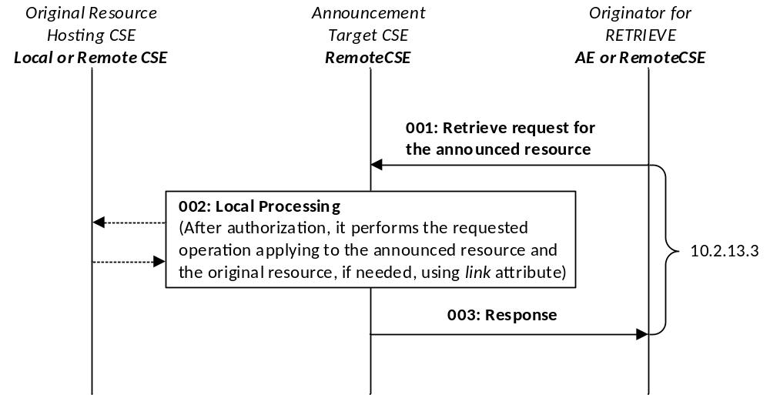
Figure 10.2.13.3-1: Announced resource RETRIEVE procedures
The Originator of a Request for initiating retrieval of information about a resource can be either an AE or a CSE. The Originator initiates this procedure by using RETRIEVE Request.
Table 10.2.13.3-1: Announced Resource Information Retrieval: RETRIEVE
Resource Retrieval: RETRIEVE
Associated Reference Points | Mca and Mcc.
Information in Request message | Clause 8.1.2 specifies the information to be included in the Request message. Table 8.1.2-3 also describes the parameters that are applicable in the Request message:  - Specifically, the To parameter is set to the address of the announced resource to be retrieved.  - If a specific attribute is to be retrieved, the address of such attribute is included in the To parameter.  - The Originator can specify one of the values for the optional Result Content parameter.  - The Originator can request retrieval of the original resource by targeting the announced resource at the Hosting CSE by setting the Result Content parameter to the "original-resource".
Processing at the Originator before sending Request | The Originator can request retrieval of information from an announced resource at the Hosting CSE. Optionally, the Originator can request retrieval of the original resource by targeting the announced resource at the Hosting CSE by setting the Result Content parameter to the "original-resource.
Processing at the Receiver | Once the Originator has been successfully authorized, the Receiver (Hosting CSE) shall grant the Request after successful validation of the Request:  - Information from the identified announced resource (at Hosting CSE) shall be returned to Originator via RETRIEVE Response, as described in clause 8.1.2.  - If Result Content request message parameter set to "original-resource" is included in the Request message, the Receiver shall provide the representation of the original resource indicated by the link attribute in the announced resource. The Receiver shall retrieve the original resource to return the representation of the original resource to the Originator.
Information in Response message | Information from the identified announced resource (at Hosting CSE), or the original resource shall be returned to Originator via RETRIEVE Response, as described in clause 8.1.3.
Exceptions | All exceptions described in the basic procedure (clause 10.1.3) are applicable.

10.2.13.4 Procedure for AE and CSE to initiate Deletion of an Announced Resource
This clause describes the procedure that shall be used for an AE or a CSE (not the original resource Hosting CSE) to initiate the deletion of an announced resource.
The Originator of a Request for initiating resource de-announcement can be either an AE or a CSE. Two methods are supported for initiating resource de-announcement.
- UPDATE: The Originator can request to initiate the deletion of an announced resource by using UPDATE Request to the announceTo attribute at the original resource Hosting CSE.
- DELETE: Resource de-announcement (deletion) shall also be performed when the Originator deletes the original resource at the original resource Hosting CSE by using DELETE Request.
Table 10.2.13.4-1: Initiate Resource De-Announcement: UPDATE and DELETE
Initiate Resource De-Announcement: UPDATE or DELETE
Associated Reference Points | Mca and Mcc.
Information in Request message | All parameters defined in table 8.1.2-3 are applicable as indicated in that table.
Processing at the Originator before sending Request | The Originator shall perform one of the following for the deletion of an announced resource:  - The Originator shall request to update the announceTo attribute at the original resource Hosting CSE by providing new content of the announceTo attribute which does not include the CSE-IDs of the announcement target CSEs where the announced resource needs to be de-announced (deleted) by the UPDATE operation.  - The Originator shall request to delete the announceTo attribute at the original resource Hosting CSE by sending UPDATE Request that sets the value of the announceTo attribute to NULL for the deletion of all announced resources.  - For DELETE operation, the Originator shall include the resource address of the original resource Hosting CSE that needs to be deleted, in the DELETE Request.  - Content: Void.
Processing at the Receiver | Once the Originator has been successfully authorized, the Receiver (which shall be the original resource Hosting CSE) shall grant the Request after successful validation of the Request. The Receiver shall be the resource Hosting CSE. On receiving the UPDATE or DELETE Request, the Receiver shall perform as follows:  - For UPDATE Request, the Receiver shall request to delete the announced resource(s) whose address(es) is/are not included in the announceTo attribute of the request as per procedures in clause 10.2.13.6.  - For DELETE Request, the Receiver shall request to delete all announced resources in the announceTo attribute as per procedures in clause 10.2.13.6.
Information in Response message | On successful completion of resource de-announcement procedure in clause 10.2.13.6, the Receiver knows that the announced resource has been deleted:  - The Receiver shall provide confirmation of resource de-announcement to the Originator.  - The content of the updated announceTo attribute shall be provided to the Originator to indicate the successfully deleted announced resource, if the announceTo attribute is not deleted by the Originator in the Request message.
Exceptions | All exceptions described in the basic procedure (clause 10.1.3) are applicable for UPDATE operation.  All exceptions described in the basic procedure (clause 10.1.5) are applicable for DELETE operation.

10.2.13.5 Procedure for original resource Hosting CSE to Create an Announced Resource
This clause explains the resource announcement procedure that shall be used by the original resource Hosting CSE to announce the original resource to the remote CSE(s).
See figure 10.2.13.2-1 for the graphical explanation.
The Originator of this Request shall be the original resource Hosting CSE. The Originator shall request to create the announced resource by using CREATE Request.
Table 10.2.13.5-1: Resource Hosting CSE to Announce Resource: CREATE
Resource Announcement: CREATE
Associated Reference Points | Mcc.
Information in Request message | All parameters defined in table 8.1.2-3 are applicable as indicated in that table.  Content: contains MA attributes and OA attributes that are included in announcedAttribute attribute.
Processing at the Originator before sending Request | Other details for the information in the Request message shall be as follows:  - Attributes marked with MA and attributes marked with OA that are included in the announcedAttribute attribute at the original resource shall be provided in the CREATE Request. Such attributes shall have the same value as for the original resource.  - resourceType which shall be set to the appropriate tag that identifies the <Annc> resource.  - expirationTime provided by the Originator equal to the one for the original resource.  - The link attribute of the announced resource shall have the address of the original resource in SP-relative Resource-ID format or Absolute Resource-ID format.  - The labels attribute of the announced resource shall have the same value as for the original resource.  - The accessControlPolicyIDs attribute shall always be provided in the CREATE Request even if it is not present in the original resource. In this case the original resource shall include accessControlPolicyIDs from its parent resource or from the local policy at the original resource, as needed.  - accessControlPolicyIDs and labels attributes, if present at the original resource, shall be provided by the original resource Hosting CSE in the CREATE Request. Such attributes shall have the same value at the original resource and at the announced resource(s).
Processing at the Receiver | Once the Originator has been successfully authorized, the Receiver shall grant the Request after successful validation of the Request. The Receiver shall perform as follows:  - The basic procedure (clause 10.1.2) for the Receiver of the CREATE Request apply.  - The created announced resource shall include the common attributes specified in clause 9.6.26.1. The created announced resource shall contain the additional attributes that are provided by the Originator; i.e. attributes marked with MA and the attributes marked with OA that are included in the announcedAttribute attribute.  - The created announced resource shall set the accessControlPolicyIDs attribute to the value received in the Request message, and shall set the labels attribute (if present) and the link attribute to the value received in the Request message.  - Respond to the Originator with the CREATE Response. In this Response, the address of the successfully announced resource shall be provided.
Information in Response message | All parameters defined in table 8.1.3-1 are applicable as indicated in that table with the specific details for:  Content: address where the announced resource is created according to clause 10.1.2.
Processing at Originator after receiving Response | The Originator after receiving the Response from the Receiver shall perform the following steps:  - If the announced resource has been successfully created, the announceTo attribute of the original resource shall be updated to include the address for the successfully announced resource at the Receiver. The announcedAttribute attribute shall be updated as well to represent the successfully announced attributes as received in the Response.  - For the attributes marked as MA and for the attributes marked as OA that are included in the announcedAttribute attribute, the Originator shall further take the responsibility to keep their values synchronized at the announced resource by using UPDATE operation (clause 10.1.4).
Exceptions | All exceptions described in the basic procedures (clause 10.1.2) are applicable.

10.2.13.6 Procedure for original resource Hosting CSE to Delete an Announced Resource
This clause explains the procedure that shall be used for deleting an announced resource (i.e. the resource de-announcement). This procedure shall be used by the original resource Hosting CSE for deleting the announced resource that resides at the remote CSE.
The Originator of this Request shall be the original resource Hosting CSE.
Table 10.2.13.6-1: Resource Hosting CSE to De-Announce Resource: DELETE
Resource De-Announcement: DELETE
Associated Reference Points | Mcc.
Information in Request message | All parameters defined in table 8.1.2-3 are applicable as indicate in that table.  From: Identifier of the CSE that initiates the Request.  To: The address where announced resource needs to be deleted.
Processing at the Originator before sending Request | The Originator shall request to delete an announced resource by using the DELETE Request.  To: Parameter provides a address that identifies the announced resource to be deleted.
Processing at the Receiver | If the value of the From parameter in Request message is identical with the CSE-ID included in the link attribute in the announced resource, the Receiver shall grant the Request after successful validation of the Request:  - Delete the announced resource identified by the To parameter in the Request, as per basic procedure in clause 10.1.5.  - Respond to the Originator with the appropriate DELETE Response, as per basic procedure in clause 10.1.5.
Information in Response message | No change from the basic procedure (clause 10.1.5).
Processing at Originator after receiving Response | The Originator after receiving the Response from the Receiver shall:  - If the announced resource is successfully deleted, the announceTo attribute in the original resource shall be updated to delete the address for the deleted announced resource.
Exceptions | All exceptions described in the basic procedures (clause 10.1.5) are applicable.

10.2.13.7 Procedure for AE and CSE to initiate the Creation of an Announced Attribute
This clause describes the procedure that shall be used for an AE and CSE (not the original resource Hosting CSE) to initiate the creation of an announced attribute (attribute announcement).
The Originator of a Request, for initiating attribute announcement, can be either AE or CSE (not the original resource Hosting CSE).
Table 10.2.13.7-1: Initiate Creation of Announced Attributes
Initiate Attribute Announcement: UPDATE
Associated Reference Points | Mca and Mcc.
Information in Request message | Parameters defined in table 8.1.2-3 that are applicable for UPDATE.  Content parameter includes the names of the attributes to be announced.
Processing at the Originator before sending Request | The Originator shall request attribute announcement by updating the announcedAttribute attribute at the original resource:  - The Originator shall update the announcedAttribute attribute at the original resource by adding the attribute name for the attribute that needs to be announced by using the UPDATE Request. Only the attributes marked with OA can be announced to remote announced resources.
Processing at the Receiver | Once the Originator has been successfully authorized, the Receiver, which shall be the original resource Hosting CSE, shall grant the Request after successful validation of the Request.  - The attributes received in the Request, which are not marked as OA, are invalid.  - The attributes received in the Request, which are not present in the original resource structure, are invalid.  - If some attributes received in the Request do not already exist in the announcedAttribute attribute, the Receiver shall announce such attributes to all announced resources listed in the announceTo attribute as per procedures in clause 10.2.13.9.  On successful announcement of attributes as per procedures in clause 10.2.13.9, the Receiver shall perform the following:  - The Receiver shall respond to the Originator (requesting AE/CSE) with UPDATE Response as specified in clause 10.1.4. The content of the announced attributes can be provided in such Response.
Information in Response message | Parameters defined in table 8.1.3-1 that are applicable.
Exceptions | All exceptions described in the basic procedures (clause 10.1.4) are applicable.

10.2.13.8 Procedure for AE and CSE to initiate the Deletion of an Announced Attribute
This clause describes the procedure that shall be used for an AE and CSE (not the original resource Hosting CSE) to initiate the deletion of announced attributes (attribute de-announcement).
The Originator of a Request, for initiating attribute de-announcement, can be either AE or CSE (not the original resource Hosting CSE).
Table 10.2.13.8-1: Initiate Deletion of Announced Attributes
Initiate Attribute De-Announcement: UPDATE
Associated Reference Points | Mca and Mcc.
Information in Request message | Parameters defined in table 8.1.2-3 that are applicable for UPDATE.  Content parameter does not include the names of the attributes to be de-announced.
Processing at the Originator before sending Request | The Originator shall request attribute de-announcement by updating the announcedAttribute attribute at the original resource as follows:  - The Originator shall update the announcedAttribute attribute at the original resource by deleting the attribute name for the attribute that needs to be de-announced by using the UPDATE Request. Only the attributes marked with OA can be de-announced to remote announced resources.
Processing at the Receiver | Once the Originator has been successfully authorized, the Receiver, which shall be the original resource Hosting CSE, shall grant the Request after successful validation of the Request:  - The attributes received in the Request, which are not marked as OA, are invalid.  - If some attributes that exist in the announcedAttribute attribute are not received in the Request (i.e. attributes that need to be deleted by the UPDATE Request), the Receiver shall de-announce such attributes to all announced resources listed in the announceTo attributes as per procedure in clause 10.2.13.10.  On successful de-announcement of all attributes as per procedures in clause 10.2.13.10, the Receiver shall perform the following:  - The Receiver shall respond to the Originator (requesting AE/CSE) with UPDATE Response as specified in clause 10.1.4. The names of the de-announced attributes can be provided in such Response.
Information in Response message | Parameters defined in table 8.1.3-1 that are applicable.
Exceptions | All exceptions described in the basic procedures (clause 10.1.4) are applicable.

10.2.13.9 Procedure for original resource Hosting CSE for Announcing Attributes
This clause describes procedure that shall be used by the original resource Hosting CSE to create announced attributes at the remote announced resources (i.e. the attribute announcement).
The Originator of this Request shall be the original resource Hosting CSE.
Table 10.2.13.9-1: Original Resource Hosting CSE to Announce Attribute: UPDATE
Attribute Announcement: UPDATE
Associated Reference Points | Mcc
Information in Request message | Information described for the Originator of the UPDATE Request as in clause 10.1.4.  Content: Parameter includes the names of the attributes to be announced and their values.
Processing at the Originator before sending Request | The Originator shall request to create attributes at the announced resources by using the UPDATE Request as specified in clause 10.1.4. Only parameters marked with OA can be announced.
Processing at the Receiver | Once the Originator has been successfully authorized, the Receiver (CSE hosting announced resource) shall grant the Request after successful validation of the Request. The Receiver shall perform as follows:  - Create announced attributes at the announced resource as per procedures in clause 10.1.4. The initial value for the announced attributes shall use the same value as with the original resource.  - Respond to the Originator with UPDATE Response as in clause 10.1.4.
Information in Response message | Parameters defined in table 8.1.3-1 that are applicable.
Processing at Originator after receiving Response | Originator after receiving the Response from the Receiver shall perform the following steps:  - If the announced attributes have been successfully created, the announcedAttribute attribute shall be updated to include the attribute names for the successfully announced attributes.  - For the newly announced attributes in the announcedAttribute attribute, the Originator shall take the responsibility to keep their values synchronized at the announced resources by using UPDATE operation as in clause 10.1.4.
Exceptions | All exceptions described in the basic procedures (clause 10.1.4) are applicable.

10.2.13.10 Procedure for original resource Hosting CSE for De-Announcing Attributes
This clause describes procedure that shall be used by the original resource Hosting CSE to remove announced attributes at remote announced resources (i.e. the attribute de-announcement).
The Originator of this Request shall be the original resource Hosting CSE.
Table 10.2.13.10-1: Original Resource Hosting CSE to De-Announce Attribute: UPDATE
Attribute De-Announcement: UPDATE
Associated Reference Point | Mcc.
Information in Request message | Information described for the Originator of the UPDATE Request as in clause 10.1.4.  Content: Parameter includes the names of the attributes to be deleted (de-announced) with their values set to NULL.
Processing at the Originator before sending Request | The Originator shall request to delete the announced attributes by using the UPDATE Request as specified in clause 10.1.4. Only attributes marked as OA can be de-announced:  Content: Parameter in the UPDATE Request shall provide the names of the attributes to be de-announced by setting their values set to NULL.
Processing at the Receiver | If the value of the From parameter in Request message is identical with the CSE-ID included in the link attribute in the announced resource, the Receiver (CSE hosting announced resource) shall grant the Request after successful validation of the Request. The Receiver shall perform as follows:  - Delete the de-announced attributes identified by the Content parameter in the UPDATE Request as per procedures in clause 10.1.4.  - Respond to the Originator with the appropriate UPDATE Response as in clause 10.1.4.
Information in Response message | Parameters defined in table 8.1.3-1 that are applicable.
Processing at Originator after receiving Response | The Originator after receiving the Response from the Receiver shall perform the following steps:  - If the attributes have been successfully removed, the announcedAttribute attribute shall be updated so as to remove the attribute names for the successfully de-announced attributes.
Exceptions | All exceptions described in the basic procedures (clause 10.1.4) are applicable.

10.2.13.11 Procedure for original resource Hosting CSE for Updating Attributes
This clause describes procedure that shall be used by the original resource Hosting CSE to update announced attributes at the remote announced resources.The Originator of this Request shall be the original resource Hosting CSE.
Table 10.2.13.11-1: Original Resource Hosting CSE to Update Attribute: UPDATE
Attribute Update: UPDATE
Associated Reference Point | Mcc.
Information in Request message | Information described for the Originator of the UPDATE Request as in clause 10.1.4.  Content: Parameter includes the names of the attributes to be updated with their target values.
Processing at the Originator before sending Request | The Originator shall request to update the announced attributes by using the UPDATE Request as specified in clause 10.1.4. Attributes marked as MA or OA can be updated:  Content: Parameter in the UPDATE Request shall provide the names of the attributes to be updated by setting their target values.
Processing at the Receiver | If the value of the From parameter in Request message is identical with the CSE-ID included in the link attribute in the announced resource, the Receiver (CSE hosting announced resource) shall grant the Request after successful validation of the Request. The Receiver shall perform as follows:  - Update the target attributes identified by the Content parameter in the UPDATE Request as per procedures in clause 10.1.4.  - Respond to the Originator with the appropriate UPDATE Response as in clause 10.1.4.
Information in Response message | Parameters defined in table 8.1.3-1 that are applicable.
Exceptions | All exceptions described in the basic procedures (clause 10.1.4) are applicable.

10.2.13.12 Notification Procedure targeting an AE Announced Resource
This clause describes handling of notifications received at an <AEAnnc> resource Hosting CSE.
Table 10.2.13.12-1: Notification Procedure for AE Announced Resource
Notification Procedure for AE Announced Resource
Associated Reference Point | Mcc
Information in Request message | Notification message made according to clause 10.2.10
Processing at the Originator before sending Request | According to clause 10.1.6
Processing at the Receiver | <AEAnnc> hosting CSE shall forward received notification message to original resource Hosting CSE targeting original <AE> resource when <AE> resource is available
Information in Response message | According to clause 10.1.6
Processing at Originator after receiving Response | According to clause 10.1.6
Exceptions | According to clause 10.1.6

10.2.14 Semantics management

10.2.14.1 Introduction
The <semanticDescriptor> resource is used to annotate a semantic description (e.g. RDF triples) to a resource (e.g. <AE>, <container>, etc.). Annotating resources with semantic descriptions, allows the resources to be discovered in a semantic aware fashion.
This clause describes the procedures for creation, retrieval, update and deletion of a <semanticDescriptor> resource. This clause also describes the different procedures for discovering resources based on annotated semantic descriptions.

10.2.14.2 Create <semanticDescriptor>
This procedure shall be used for creating a <semanticDescriptor > resource.
Table 10.2.14.2-1: <semanticDescriptor> CREATE
<semanticDescriptor> CREATE
Associated Reference Point | Mca, Mcc and Mcc'
Information in Request message | All parameters defined in table 8.1.2-2 apply with the specific details for:  Content: The resource content shall provide the information as defined in clause 9.6.30
Processing at Originator before sending Request | According to clause 10.1.2
Processing at Receiver | According to clause 10.1.2
Information in Response message | According to clause 10.1.2
Processing at Originator after receiving Response | According to clause 10.1.2
Exceptions | According to clause 10.1.2

10.2.14.3 Retrieve <semanticDescriptor>
This procedure shall be used for retrieving the attributes of a <semanticDescriptor> resource.
Table 10.2.14.3-1: <semanticDescriptor> RETRIEVE
<semanticDescriptor > RETRIEVE
Associated Reference Point | Mca, Mcc and Mcc'.
Information in Request message | All parameters defined in table 8.1.2-2.
Processing at Originator before sending Request | According to clause 10.1.3.
Processing at Receiver | According to clause 10.1.3.
Information in Response message | All parameters defined in table 8.1.3-1 apply.
Processing at Originator after receiving Response | According to clause 10.1.3.
Exceptions | According to clause 10.1.3.

10.2.14.4 Update <semanticDescriptor>
This procedure shall be used for updating attributes of a <semanticDescriptor > resource.
Table 10.2.14.4-1: <semanticDescriptor> UPDATE
<semanticDescriptor> UPDATE
Associated Reference Point | Mca, Mcc and Mcc'
Information in Request message | All parameters defined in table 8.1.2-2 apply with the specific details for:  Content:  1) full representation of the descriptor attribute  2) partial representation of the descriptor attribute are defined with SPARQL statements that shall be specified in the SPARQL query language [Error: Reference source not found]
Processing at Originator before sending Request | According to clause 10.1.4
Processing at Receiver | According to clause 10.1.4
Information in Response message | According to clause 10.1.4
Processing at Originator after receiving Response | According to clause 10.1.4
Exceptions | According to clause 10.1.4

10.2.14.5 Delete <semanticDescriptor>
This procedure shall be used for deleting a <semanticDescriptor> resource.
Table 10.2.14.5-1: <semanticDescriptor> DELETE
<semanticDescriptor> DELETE
Associated Reference Point | Mca, Mcc and Mcc'
Information in Request message | All parameters defined in table 8.1.2-2 apply
Processing at Originator before sending Request | According to clause 10.1.5
Processing at Receiver | According to clause 10.1.5
Information in Response message | According to clause 10.1.5
Processing at Originator after receiving Response | According to clause 10.1.5
Exceptions | According to clause 10.1.5

10.2.14.6 Semantic discovery
This clause describes semantic discovery procedures on semantic descriptions represented as RDF triples, given that an overall semantic description (logical tree) may be distributed across several <semanticDescriptor> resources.
Semantic discovery procedures may be performed using RETRIEVE operations as follows:
Using <semanticFanOutPoint> resource
Targeting any resource other than <semanticFanOutPoint>:
- The receiver begins processing the request by retrieving the <semanticDescriptor> resource of the request target and its descriptor attribute. Related descriptors are discovered and accessed according to clause 10.2.14.7or clause 10.2.14.8. The content of related descriptor attributes are added to the content on which the SPARQL request is being executed. Depending on which of the options described in clauses 10.2.14.7 or 10.2.14.8 is chosen, all potentially relevant descriptor attributes are added before executing the SPARQL request or they are added when needed during the execution of the SPARQL request.
- The resulting content subject to the SPARQL request is provided to the SPARQL engine for processing.
Targeting a <semanticFanOutPoint> resource (see also clauses 10.2.7.12):
- In this case the related descriptors are the members of the <group> resource parent of the targeted <semanticFanOutPoint>. Based on the memberID attribute of the parent <group> resource all the related descriptors are discovered, and those on the <group> hosting CSE are retrieved together.
- If there are descriptors stored on a different CSE, individual RETRIEVE requests are sent to each CSE for retrieving the external descriptors.
- All semantic descriptors are retrieved based on the respective access control policies.
- Once all of the related <semanticDescriptor>(s) have been accessed, the content of each of the descriptor attribute is added to the content on which the SPARQL request is being executed.
- The full/enlarged content subject to the SPARQL request is provided to the SPARQL engine for processing.
Not using <semanticFanOutPoint> resource
Given that an overall semantic description (logical tree) may be distributed across the <semanticDescriptor> resources, there are two methods of constructing the logical tree in the scope of a semantic discovery targeting any resource other than <semanticFanOutPoint>.
- If the attribute relatedSemantics is empty or does not exist, the "Annotation-based method" (using resourceDescriptorLink) detailed in clause 10.2.14.7 shall be used.
- If the attribute relatedSemantics is not empty the "Resource link-based method" (using relatedSemantics) detailed in clause 10.2.14.8 shall be used.

10.2.14.7 Annotation-based semantic discovery method
In this option, the links to related <semanticDescriptor> resources are encoded in the semantic description itself, which is encoded as RDF triples [Error: Reference source not found] logically structured as <subject> <predicate> <object>. For this purpose, an annotation property called onem2m:resourceDescriptorLink is introduced. It is formally specified as part of the oneM2M Base Ontology defined in [Error: Reference source not found] and can be used as a predicate in any RDF triple with any subject and without further relation to the oneM2M Base Ontology. Only the use of the onem2m namespace is required to uniquely identify the annotation property.
Whenever further information about a semantic instance <X> is stored in another <semanticDescriptor> resource, a new RDF triple <X> onem2m:resourceDescriptorLink <SemanticDescriptorURL> may be added to this semantic description, where <SemanticDescriptorURL> is the URL of the other semanticDescriptor resource containing additional information related to <X>. If multiple <semanticDescriptor> resources contain relevant further information, these can be added to a <group> resource and the <SemanticDescriptorURL> then refers to the virtual <fanOutPoint> resource of this group, which will be used for retrieving the aggregated information.
NOTE: The RDF triple syntax in this paragraph is only used for illustration purposes. The actual encoding of the RDF triples used in oneM2M is defined in oneM2M TS-0004 [3].
To make use of the onem2m:resourceDescriptorLink property, the evaluation of semantic queries formulated as SPARQL requests by the SPARQL engine has to be adapted in the following way:
- The SPARQL request is executed on the content of the semantic description in the descriptor attribute of the semanticDescriptor resource.
- For each semantic instance matched in the SPARQL request, it is checked whether one or more onem2m:resourceDescriptorLink annotations exist.
- If this is the case, the execution of the SPARQL request is halted.
- The content of the descriptor attribute of each of the semanticDescriptor resources referenced by the onem2m:semanticDescriptorLink annotations is added to the content on which the SPARQL request is being executed. If the onem2m:semanticDescriptorLink annotation references a group, the additional descriptor content is accessed by performing a retrieve request to the virtual <fanOutPoint> resource referenced.
- The execution of the SPARQL request is continued on the enlarged content.

10.2.14.8 Resource link-based method
In this option, the links to related <semanticDescriptor> resources are specified in the relatedSemantics attribute.
Processing of the SPARQL engine procedures at the receiver :
- The receiver retrieves the <semanticDescriptor> resource of the request target.
- Based on the relatedSemantics attribute of the <semanticDescriptor> resource targeted, all the related descriptors are discovered, as follows:
- If the relatedSemantics attribute includes a list of links, each of the linked Descriptors are accessed based on the respective access control policies.
- If the relatedSemantics points to a <group> resource, the group members from the memberID attribute are used and each of their <semanticDescriptor>(s) are accessed based on the respective access control policies.
- Once all of the related <semanticDescriptor>(s) have been accessed, the content of each of the descriptor attribute is added to the content on which the SPARQL request is being executed.
- The full/enlarged content subject to the SPARQL request is provided to the SPARQL engine for processing.

10.2.15 3GPP network interworking

10.2.15.1 Introduction
Editor's Note: add introduction texts to say the following procedures are the ones supported by oneM2M and further APIs would be defined later. A diagram to explain the call flow including Mcn reference point would be better.

10.2.15.2 Create <trafficPattern>
This procedure shall be used for creating a <trafficPattern> resource.
Table 10.2.15.2-1: <trafficPattern> CREATE
<trafficPattern> CREATE
Associated Reference Point | Mca, Mcc and Mcc'
Information in Request message | All parameters defined in table 8.1.2-3 apply with the specific details for:  Content: The resource content shall provide the information as defined in clause 9.6.41
Processing at Originator before sending Request | According to clause 10.1.2
Processing at Receiver | According to clause 10.1.2 with the following modifications:  When checking validity of the request the hosting CSE can include a check of consistency with <schedule> resources (see note 1).  The CSE shall:  - Select a NSE of the target Network for which the traffic pattern is applicable to request for the configuration of the TP parameter sets to Underlying Network, (see note 2).  - The CSE shall send a request to provide TP parameter sets for the Field Domain Node to the NSE, using the appropriate Mcn protocol.  - Upon receceipt of a successful response to that request the CSE shall UPDATE the providedToNSE attribute of the <trafficPattern> resource with the value TRUE.  Upon receceipt of a unsuccessful response to that request the CSE shall UPDATE the providedToNSE attribute of the <trafficPattern> resource with the value FALSE
Information in Response message | According to clause 10.1.2
Processing at Originator after receiving Response | According to clause 10.1.2
Exceptions | According to clause 10.1.2
NOTE 1: The validation check of the request from the Originator can include,
- Consistency with traffic patterns of AEs residing on the entity (ASD, ADN, MN) of that Node.
- Consistency with other network related schedules of this Node (e.g. contained in the <schedule> resource pointed at by the mgmtLink attribute of a <cmdhNwAccessRule> resource of the Node).
- If several TP parameter sets exist for one Field Domain Node, then ensure that the schedules of the different TP parameter sets for a particular target network are not overlapping.
NOTE 2: In the case of a 3GPP network the correct NSE can be found by following of a chain of links of multiple resources in the IN-CSE, e.g. the <node> resource having the hostedCSELink linking to the <remoteCSE> resource having the M2M-Ext-ID linking to the UNetwork-ID of the NSE (see clauses 7.1.8 and 7.1.9).

10.2.15.3 Retrieve <trafficPattern>
This procedure shall be used for retrieving the attributes of a <trafficPattern> resource.
Table 10.2.15.3-1: <trafficPattern> RETRIEVE
<trafficPattern> RETRIEVE
Associated Reference Point | Mca, Mcc and Mcc'
Information in Request message | All parameters defined in table 8.1.2-3 apply
Processing at Originator before sending Request | According to clause 10.1.3
Processing at Receiver | According to clause 10.1.3
Information in Response message | All parameters defined in table 8.1.3-1 apply
Processing at Originator after receiving Response | According to clause 10.1.3
Exceptions | According to clause 10.1.3

10.2.15.4 Update <trafficPattern>
This procedure shall be used for updating attributes of a <trafficPattern> resource.
Table 10.2.15.4-1: <trafficPattern> UPDATE
<trafficPattern> UPDATE
Associated Reference Point | Mca, Mcc and Mcc'
Information in Request message | All parameters defined in table 8.1.2-3 apply
Processing at Originator before sending Request | According to clause 10.1.4
Processing at Receiver | According to clause 10.1.4 with the following modifications:  When checking validity of the request the hosting CSE can include a check of consistency with <schedule> resources (see note 1).  The CSE shall  - Select a NSE of the target Network for which the traffic pattern is applicable  - send a request to delete the previous TP parameter sets for the Field Domain Node to the NSE, using the appropriate Mcn protocol.  - send a request to provide the new TP parameter sets for the Field Domain Node to the NSE, using the appropriate Mcn protocol.  - Upon receceipt of a successful response to that request the CSE shall UPDATE the providedToNSE attribute of the <trafficPattern> resource with the value TRUE  Upon receceipt of a unsuccessful response to that request the CSE shall UPDATE the providedToNSE attribute of the <trafficPattern> resource with the value FALSE
Information in Response message | According to clause 10.1.4
Processing at Originator after receiving Response | According to clause 10.1.4
Exceptions | According to clause 10.1.4
NOTE 1: The validation check of the request from the Originator can include,
- Consistency with traffic patterns of AEs residing on the entity (ASD, ADN, MN) of that Node.
- Consistency with other network related schedules of this Node (e.g. contained in the <schedule> resource pointed at by the mgmtLink attribute of a <cmdhNwAccessRule> resource of the Node).
- If several TP parameter sets exist for one Field Domain Node, then ensure that the schedules of the different TP parameter sets for a particular target network are not overlapping.

10.2.15.5 Delete <trafficPattern>
This procedure shall be used for deleting a <trafficPattern> resource.
Table 10.2.15.5-1: <trafficPattern> DELETE
<trafficPattern> DELETE
Associated Reference Point | Mca, Mcc and Mcc'
Information in Request message | All parameters defined in table 8.1.2-3 apply
Processing at Originator before sending Request | According to clause 10.1.5
Processing at Receiver | According to clause 10.1.5 with the following modifications:  The CSE shall  - Select a NSE of the target Network for which the traffic pattern is applicable  - send a request to delete the previous TP parameter sets for the field domain node to the NSE, using the appropriate Mcn protocol.
Information in Response message | According to clause 10.1.5
Processing at Originator after receiving Response | According to clause 10.1.5
Exceptions | According to clause 10.1.5

-----------------------End of change 1---------------------------------------------

CHECK LIST
- Does this change request include an informative introduction containing the problem(s) being solved, and a summary list of proposals.?
- Does this CR contain changes related to only one particular issue/problem?
- Have any mirror crs been posted?
- Does this change request make all the changes necessary to address the issue or problem? E.g. A change impacting 5 tables should not only include a proposal to change only 3 tables. Includes any changes to references, definitions, and acronyms in the same deliverable?
- Does this change request follow the drafting rules?
- Are all pictures editable?
- Have you checked the spelling and grammar?
- Have you used change bars for all modifications?
- Does the change include the current and surrounding clauses to clearly show where a change is located and to provide technical context of the proposed change? (Additions of complete sections need not show surrounding clauses as long as the proposed section number clearly shows where the new section is proposed to be located.)
- Are multiple changes in this CR clearly separated by horizontal lines with embedded text such as, start of change 1, end of change 1, start of new clause, end of new clause.?

