CHANGE REQUEST
Meeting:* | < ARC 28>
Source:* | Huawei
Date:* | 2017-03-14
Contact:* | echo, echo.xubei@huawei.com  Ada, xiaoyang.xiao@huawei.com
Reason for Change/s:* | Add the parameters and the flow for the AE Authorization Relationship Mapping process which has been agreed in SEC WG.
CR against: Release* | Release 3
CR against: WI* | Active WI 0019  MNT maintenace / < Work Item number(optional)>  STE Small Technical Enhancements / < Work Item number (optional)>  Only ONE of the above shall be ticked
CR against: TS/TR* | TS-0001 v3.4.0
Clauses/Sub Clauses* | 8.1.2 Request  8.1.3 Response  11.5 Functional Architecture Specifications for Dynamic Authorization
Type of change: * | Editorial change  Bug Fix or Correction  Change to existing feature or functionality  New feature or functionality  Only ONE of the above shall be ticked
Post Freeze checking:* | This CR contains only essential changes and corrections? YES NO  This CR may break backwards compatibility with the last approved version of the TS? YES NO  This CR is a mirror CR? YES if YES, please indicate the document number of the original CR: <Document Number) : NO
Template Version:27 May 2015 (Dot not modify)

oneM2M Notice
The document to which this cover statement is attached is submitted to oneM2M. Participation in, or attendance at, any activity of oneM2M, constitutes acceptance of and agreement to be bound by terms of the Working Procedures and the Partnership Agreement, including the Intellectual Property Rights (IPR) Principles Governing oneM2M Work found in Annex 1 of the Partnership Agreement.
GUIDELINES for Change Requests:
Provide an informative introduction containing the problem(s) being solved, and a summary list of proposals.
Each CR should contain changes related to only one particular issue/problem.
In case of a correction, and the change apply to previous releases, a separated “mirror CR” should be posted at the same time of this CR
Follow the principle of completeness, where all changes related to the issue or problem within a deliverable are simultaneously proposed to be made E.g. A change impacting 5 tables should not only include a proposal to change only 3 tables. Includes any changes to references, definitions, and acronyms in the same deliverable.
Follow the drafting rules.
All pictures must be editable.
Check spelling and grammar to the extent practicable.
Use Change bars for modifications.
The change should include the current and surrounding clauses to clearly show where a change is located and to provide technical context of the proposed change. Additions of complete sections need not show surrounding clauses as long as the proposed section number clearly shows where the new section is proposed to be located.
Multiple changes in a single CR shall be clearly separated by horizontal lines with embedded text such as, start of change 1, end of change 1, start of new clause, end of new clause.
When subsequent changes are made to content of a CR, then the accepted version should not show changes over changes. The accepted version of the CR should only show changes relative to the baseline approved text.

Introduction
This contribution adds the related content of the AE Authorization Relationship Mapping based on the approved CR SEC-2016-0169R05:
Add the parameters used for the AE Authorization Relationship Mapping in clause 8;
Add the flow for the AE Authorization Relationship Mapping in clause 11;
Add the Abbreviations and Acronyms used in the AE Authorization Relationship Mapping.

-----------------------Start of change 1-------------------------------------------

8.1.2 Request
Requests over the Mca and Mcc reference points, from an Originator to a Receiver, shall contain mandatory and may contain optional parameters. Certain parameters may be mandatory or optional depending upon the Requested operation. In this clause, the mandatory parameters are detailed first, followed by those that are operation dependent, and then by those that are optional:
- To: Address of the target resource or target attribute for the operation. The To parameter shall conform to clause 9.3.1.
NOTE 1: To parameter can be known either by pre-provisioning (clause 11.2) or by discovery (clause 10.2.6 for discovery). Discovery of <CSEBase> resource is not supported in this release of the document. It is assumed knowledge of <CSEBase> resource is by pre-provisioning only.
NOTE 2: The term target resource refers to the resource which is addressed for the specific operation. For example the To parameter of a Create operation for a resource <example> would be "/m2m.provider.com/exampleBase". The To parameter for the Retrieve operation of the same resource <example> is "/m2m.provider.com/exampleBase/example".
NOTE 3: For Retrieve operation (clause 10.1.2), the To parameter can be the URI of an attribute to be retrieved.
- From: Identifier representing the Originator.
The From parameter is used by the Receiver to check the Originator identity for access privilege verification.
- Operation: operation to be executed: Create (C), Retrieve (R), Update (U), Delete (D), Notify (N).
The Operation parameter shall indicate the operation to be executed at the Receiver:
- Create (C): To is the address of the target resource where the new resource (parent resource).
- Retrieve (R): an existing To addressable resource is read and provided back to the Originator.
- Update (U): the content of an existing To addressable resource is replaced with the new content as in Content parameter. If some attributes in the Content parameter do not exist at the target resource, such attributes are created with the assigned values. If some attributes in the Content parameter are set to NULL, such attributes are deleted from the addressed resource.
- Delete (D): an existing To addressable resource and all its sub-resources are deleted from the Resource storage.
- Notify (N): information to be sent to the Receiver, processing on the Receiver is not indicated by the Originator.
- Request Identifier: request Identifier (see clause 7.1.7).
Example usage of request identifier includes enabling the correlation between a Request and one of the many received Responses.
Operation dependent Parameters:
- Content: resource content to be transferred.
The Content parameter shall be present in Request for the following operations:
- Create (C): Content is the content of the new resource with the resource type ResourceType.
- Update (U): Content is the content to be replaced in an existing resource. For attributes to be updated at the resource, Content includes the names of such attributes with their new values. For attributes to be created at the resource, Content includes names of such attributes with their associated values. For attributes to be deleted at the resource, Content includes the names of such attributes with their value set to NULL.
- Notify (N): Content is the notification information.
The Content parameter may be present in Request for the following operations:
- Retrieve (R): Content is the list of attribute names from the resource that needs to be retrieved. The values associated with the attribute names shall be returned.
- Resource Type: type of resource.
The ResourceType parameter shall be present in Request for the following operations:
- Create (C): Resource Type is the type of the resource to be created.
Optional Parameters:
- Role IDs: optional, required when role based access control is applied. A list of Role-IDs that are allowed by the service subscription shall be provided otherwise the request is considered not valid.
The Role IDs parameter shall be used by the Receiver to check the Access Control privileges of the Originator.
- Originating Timestamp: optional originating timestamp of when the message was built.
Example usage of the originating timestamp includes: to measure and enable operation (e.g. message logging, correlation, message prioritization/scheduling, accept performance requests, charging, etc.) and to measure performance (distribution and processing latency, closed loop latency, SLAs, analytics, etc.)
- Request Expiration Timestamp: optional request message expiration timestamp. The Receiver CSE should handle the request before the time expires. If a Receiver CSE receives a request with Request Expiration Timestamp with the value indicating a time in the past, then the request shall be rejected.
Example usage of the request expiration timestamp is to indicate when request messages (including delay-tolerant) should expire and to inform message scheduling/prioritization. When a request with set expiration timestamp demands an operation on a Hosting CSE different than the current Receiver CSE, then the current CSE shall keep trying to deliver the Request to the Hosting CSE until the request expiration timestamp time, in line with provisioned policies.
- Result Expiration Timestamp: optional result message expiration timestamp. The Receiver CSE should return the result of the request before the time expires.
Example usage of the result expiration timestamp: An Originator indicates when result messages (including delay-tolerant) should expire and informs message scheduling/prioritization. It can be used to set the maximum allowed total request/result message sequence round trip deadline.
- Response Type: optional response message type: Indicates what type of response shall be sent to the issued request and when the response shall be sent to the Originator:
- nonBlockingRequestSynch: In case the request is accepted by the Receiver CSE, the Receiver CSE responds, after acceptance, with an Acknowledgement confirming that the Receiver CSE will further process the request. The Receiver CSE includes in the response to an accepted request a reference that can be used to access the status of the request and the result of the requested operation at a later time. Processing of Non-Blocking Requests is defined in clause 8.2.2 and in particular for the synchronous case in clause 8.2.2.2.
- nonBlockingRequestAsynch {optional list of notification targets}: In case the request is accepted by the Receiver CSE, the Receiver CSE shall respond, after acceptance, with an Acknowledgement confirming that the Receiver CSE will further process the request. The result of the requested operation needs to be sent as notification(s) to the notification target(s) provided optionally within this parameter as a list of entities or to the Originator when no notification target list is provided. When an empty notification target list is provided by the Originator, no notification with the result of the requested operation shall be sent at all. Processing of Non-Blocking Requests is defined in clause 8.2.2 and in particular for the asynchronous case in clause 8.2.2.3.
- blockingRequest: In case the request is accepted by the Receiver CSE, the Receiver CSE responds with the result of the requested operation after completion of the requested operation. Processing of Blocking Requests is defined in clause 8.2.1. This is the default behaviour when the Response Type parameter is not given the request.
- flexBlocking {optional list of notification targets}: When Response Type in the request received by the Receiver CSE is set to flexBlocking, it means that the Originator of the request has the capability to accept the following types of responses: nonBlockingRequestSynch, nonBlockingRequestAsynch and blockingRequest.
The Receiver CSE shall make the decision to respond using blocking or non-blocking based on its own local context (memory, processing capability, etc.) if not defined in the resource handling procedure.
If the Receiver CSE choose to respond using non-blocking mode, based on the presence of notification targets in the request:
- If the notification targets are provided in the request and the Recerver CSE is responding, the Receiver CSE shall notify the result using nonBlockingRequestAsynch.
- If notification targets are not provided, the Receiver CSE shall respond with the address of <request> resource using nonBlockingRequestSynch.
Example usage of the response type set to nonBlockingRequestSynch: An Originator that is optimized to minimize communication time and energy consumption wants to express a Request to the receiver CSE and get an acknowledgement on whether the Request got accepted. After that the Originator may switch into a less power consuming mode and retrieve a Result of the requested Operation at a later time.
Further example usage of response type set to nonBlockingRequestSynch: When the result content is extremely large, or when the result consists of multiple content parts from a target group which are to be aggregated asynchronously over time.
- Result Content: optional result content: Indicates what are the expected components of the result of the requested operation. The Originator of a request may not need to get back a result of an operation at all. This shall be indicated in the Result Content parameter. Settings of Result Content depends on the requested operation specified in Operation. Possible values of Result Content are:
- attributes: Representation of the requested resource shall be returned as content, without the address(es) of the child resource(s) or their descendants. For example, if the request is to retrieve a <container> resource, the address(es) of the <contentInstance> child-resource(s) is not provided. This setting shall be only valid for Create, Retrieve, Update, Delete operation. When this is used for Create operation, only assigned/modified attributes shall be included in the content. If the Originator does not set Result Content parameter in the request message, this setting shall be the default value when the Receiver processes the request message.
- hierarchical-address: Representation of the address of the created resource. This shall be only valid for a Create operation. The address shall be in hierarchical address scheme.
- hierarchical-address+attributes: Representation of the addresss in hierarchical address scheme and assigned/modified attributes of the created resource. This shall be only valid for a Create operation.
- attributes+child-resources: Representation of the requested resource, along with a nested representation of all of its child resource(s) , and their descendants, in line with any provided filter criteria as given in the Filter Criteria parameter shall be returned as content. If there is no filter criteria parameter in the request message then all children/descendants are returned along with their attributes. For example, if the request is to retrieve a <container> resource that only has <contentInstance> children, the attributes of that <container> resource and a representation of all of its <contentInstance> child-resource(s) , including their attributes, are provided.
The originator may request to limit the maximum number of allowed nesting levels. The orginator may also include an offset that indicates the starting point of the direct child resource. The offset shall start at 1. The hosting CSE shall return all direct child resources and their descendants, or up to the maximum nesting level specififed in a request subject to maximum size limit that may be imposed by the hosting CSE. The offset, maximum number/size and maximum level shall be specified in Filter Criteria as offset, limit, and level condition, respectively, by the Originator.
The hosting CSE shall list parent resources before their children. This means that the originator of the request will not receive a discovered resource without having received its parents. The hosting CSE shall also ensure that proper nesting representation of all the children is incorporated in its listing for parents and children.
Nested processing is applicable at every level in the resource tree. If a direct child resource and all its descendants cannot be included in the returned content due to size limitations imposed by the hosting CSE then the direct child resource shall not be included in the response.
An indication shall be included in the response signalling if the returned content is partial. If the indication is for partial content, the response shall include an offset for the direct child resource where processing can restart for the remaining direct child resources
This shall be only valid for a Retrieve operation.
- child-resources: A nested representation of the resource's child resource(s) their descendants and their attributes shall be returned as content. The resources that are returned are subject to any filter criteria that are given in the Filter Criteria parameter (if there are no filter criteria then all children and their descendants are returned). The attributes of the parent resource are not returned, but all the attributes of the children are returned. For example, if the request is to retrieve a <container> resource that only has <contentInstance> children, only a representation of all of its <contentInstance> child-resource(s) is provided.
The offset, maximum number/size and maximum level shall be specified in Filter Criteria as offset, limit, and level condition, respectively, by the Originator. Processing of direct child resources, size limitations, maximum nesting level, and offset for the starting of direct child resource processing of the attributes+child-resources option shall apply to this option as well.
This shall be only valid for a Retrieve operation.
- attributes+child-resource-references : Representation of the requested resource, along with the address(es) of the child resource(s), and their descendants shall be returned as content. For example, if the request is to retrieve a <container> resource, the <container> resource and the address(es) of the <contentInstance> child-resource(s) are provided.
The offset, maximum number/size and maximum level shall be specified in Filter Criteria as offset, limit, and level condition, respectively, by the Originator. Processing of child resources, size limitations, maximum nesting level, and offset for the starting of child resource processing of the attributes+child-resources option shall apply to this option as well.
This shall be only valid for a Retrieve operation.
- child-resource-references: Address(es) of the child resources and their descendants, without any representation of the actual requested resource shall be returned as content. For example, if the request is to retrieve a <container> resource, only the address(es) of the <contentInstance> child-resource(s) is provided.
The offset, maximum number/size and maximum level shall be specified in Filter Criteria as offset, limit, and level condition, respectively, by the Originator. Processing of child resources, size limitations, maximum nesting level, and offset for the starting of child resource processing of the attributes+child-resources option shall apply to this option as well.
This shall be only valid for a Retrieve operation.
This option can be used within the context of resource discovery mechanisms (see clause 10.2.6).
- nothing: Nothing shall be returned as operational result content. This setting shall be valid for a Create/Update/Delete/Notify operation.
EXAMPLE: If the request is to delete a resource, this setting indicates that the response shall not include any content.
- original-resource: Representation of the original resource pointed by the link attribute in the announced resource shall be returned as content, without the address(es) of the child resource(s). This shall be only valid for a Retrieve operation where the To parameter targets the announced resource.
Note that for any of the above options, Discovery access control is applied against discovery related procedures, while Retrieve access control procedures is applied against non-discovery related Retrieve operations.
Note that the fitter criteria usage governs the purpose of a Retrieve operation.
Table 8.1.2-1: Summary of Result Content Values
Value | Create | Retrieve | Update | Delete | Notify
attributes | Default | default | default | default | n/a
hierarchical-address | Valid | n/a | n/a | n/a | n/a
hierarchical-address+attributes | Valid | n/a | n/a | n/a | n/a
attributes+child-resources | n/a | valid | n/a | n/a | n/a
child-resources | n/a | valid | n/a | n/a | n/a
attributes+child-resource-references | n/a | valid | n/a | n/a | n/a
child-resource-references | n/a | valid | n/a | n/a | n/a
nothing | Valid | n/a | valid | valid | valid
original-resource | n/a | valid | n/a | n/a | n/a

- Result Persistence: optional result persistence: indicates the time for which the response may persist to. The parameter is used in case of non-blocking request where the result attribute of the <request> resource should be kept at the CSE, for example, with the purpose of sharing, tracking and analytics.
In the case the response of a request is required to be kept in the CSE, for example the procedures of <request> resource, <delivery> resource and <group> resource, the Result Persistence indicates the time duration for which the CSE keeps the response available after receiving it.
Example usage of result persistence includes requesting sufficient persistence for analytics to process the response content aggregated asynchronously over time. If a result expiration time is specified then the result persistence lasts beyond the result expiration time.
- Operation Execution Time: optional operation execution time: indicates the time when the specified operation Operation is to be executed by the target CSE. A target CSE shall execute the specified operation of a Request having its operational execution time indicator set, starting at the operational execution time. If the execution time has already passed or if the indicator is not set, then the specified operation shall be immediately executed, unless the request expiration time, if set, has been reached.
Example usage of operational execution time includes asynchronous distribution of flows, which are to be executed synchronously at the operational execution time.
NOTE 6: Time-based flows could not supported depending upon time services available at CSEs.
- Event Category: optional event category: Indicates the event category that should be used to handle this request. Event categories are impacting how Requests to access remotely hosted resources are processed in the CMDH CSF. Selection and scheduling of connections via CMDH are driven by policies that can differentiate event categories.
Example usage of "event category" set to specific value X: When the request is demanding an operation to be executed on a Hosting CSE that is different from the current Receiver CSE, the request may be stored in the current Receiver CSE that is currently processing the request on the way to the Hosting CSE until it is allowed by provisioned policies for that event category X to use a communication link to reach the next CSE on a path to the Hosting CSE or until the request expiration timestamp is expired.
The following values for Event Category shall have a specified pre-defined meaning:
- Event Category = immediate: Requests of this category shall be sent as soon as possible and shall not be subject to any further CMDH processing, i.e. the request will not be subject to storing in CMDH buffers when communication over an underlying network is possible. In particular, CMDH processing will respect values for Request Expiration Timestamp, Result Expiration Timestamp given in the original request and not fill in any default values if they are missing.
- Event Category = bestEffort: Requests of this category can be stored in CMDH buffers at the discretion of the CSE that is processing the request for an arbitrary time and shall be forwarded via Mcc on a best effort basis. The CSE does not assume any responsibility to meet any time limits for delivering the information to the next CSE. Also the maximum amount of buffered requests for this category is at the discretion of the processing CSE.
- Event Category = latest:
- If this category is used in a request asking for a CRUD operation on a resource, the following shall apply:
CRUD requests using this category shall undergo normal CMDH processing as outlined further below in the present document and in oneM2M TS-0004 [Error: Reference source not found] with a maximum buffer size of one pending request for a specific pair of From and To parameters that appear in the request. If a new request message is received by the CSE with a pair of parameters From and To that has already been buffered for a pending request, the newer request will replace the buffered older request.
- If this category is used in a notification request triggered by a subscription, the following shall apply:
Notification requests triggered by a subscription using this category shall undergo normal CMDH processing as outlined further below in the present document and in oneM2M TS-0004 [Error: Reference source not found] with a maximum buffer size of one pending notification request per subscription reference that appears in a notification request. If a new notification request is received by the CSE with a subscription reference that has already been buffered for a pending notification request, the newer request will replace the buffered older request.
- If no further CMDH policies are provisioned for this event category, the forwarding process shall follow the 'bestEffort' rules defined above.
The M2M Service Provider shall be able to provision CMDH policies describing details for the usage of the specific Underlying Network(s) and the applicable rules as defined in the [cmdhPolicy] resource type for other Event Category values not listed above.
- Delivery Aggregation: optional delivery aggregation on/off: Use CRUD operations of <delivery> resources to express forwarding of one or more original requests to the same target CSE(s). When this parameter is not given in the request, the default behaviour is determined per the provisioned CMDH policy if available. If there is no such CMDH policy, then the default value is "aggregation off".
NOTE 7: Since Delivery Aggregation is optional, there could be a default value to be used when not present in the Request. This parameter could not be exposed to AEs via Mca.
Example usage of delivery aggregation set on: The CSE processing a request shall use aggregation of requests to the same target CSE by requesting CREATE of a <delivery> resource on the next CSE on the path to the target CSE.
- Group Request Identifier: optional group request identifier: Identifier optionally added to the group request that is to be fanned out to each member of the group in order to detect loops and avoid duplicated handling of operation in case of loops of group and common members between groups that have parent-child relationship.
- Filter Criteria: optional filter criteria: conditions for filtered retrieve operation are described in table 8.1.2-2. This is used for resource discovery (clause 10.2.6) and general retrieve, update, delete requests (clauses 10.1.2, 10.1.3 and 10.1.4).
Example usage of retrieve requests with filter criteria using modifiedSince condition tag: if a target resource is modified since 12:00 then the Hosting CSE will send a resource representation.
- Discovery Result Type: Optional Discovery result format. This parameter applies to discovery related requests (see filterUsage in table 8.1.2-2 and clause 10.2.6) to indicate the preference of the Originator for the format of returned information in the result of the operation. This parameter shall take on one of the following values reflecting the options in clause 9.3.1:
- Hierarchical addressing method.
- Non-hierarchical addressing method.
For example if Discovery Result Type is set to Non-hierarchical addressing method, then the request Originator indicates that the discovered resources should be in the form of Non-hierarchical address.
The absence of the parameter implies that the result shall be in the form of a Hierarchical address.
- Token Request Indicator: Optional parameter used to indicate that the Originator supports the Token Request procedure, and the Originator may attempt the Token Request procedure if the Receiver provides a Token Request Information parameter in the response.
- Tokens: Optional parameter used to transport ESData-protected Tokens applicable to the request for use in Indirect Dynamic Authorization.
- Token IDs: Optional parameter used to transport Token-IDs applicable to the request for use in Indirect Dynamic Authorization.
- Local Token IDs: Optional parameter used to transport Local-Token-IDs applicable to the request for use in Indirect Dynamic Authorization.
- Authorization Signature Indicator: Optional parameter used to indicate the capability to sign for creating AuthorRelMapRecord when Originator is an AE. If the Hosting CSE does not support this parameter, the Hosting CSE should ignore it. The details of the AuthorRelMapRecord are described in clause 7.3.2.2 of oneM2M TS-0003 [Error: Reference source not found].
- Authorization Signature: Optional parameter used to transport the signatures for Token(s) or TokenID(s) generated using the certificate of the AE or a MIC generated using a symmetric key shared between the AE and DAS server.
- Authorization Relationship Indicator: Optional parameter used to indicate that the relationship between the AE and the Token(s) are maintained in the DAS server.
- Table 8.1.2-2: Filter Criteria conditions
Condition tag | Multiplicity | Matching condition
createdBefore | 0..1 | The creationTime attribute of the resource is chronologically before the specified value.
createdAfter | 0..1 | The creationTime attribute of the resource is chronologically after the specified value.
modifiedSince | 0..1 | The lastModifiedTime attribute of the resource is chronologically after the specified value.
unmodifiedSince | 0..1 | The lastModifiedTime attribute of the resource is chronologically before the specified value.
stateTagSmaller | 0..1 | The stateTag attribute of the resource is smaller than the specified value.
stateTagBigger | 0..1 | The stateTag attribute of the resource is bigger than the specified value.
expireBefore | 0..1 | The expirationTime attribute of the resource is chronologically before the specified value.
expireAfter | 0..1 | The expirationTime attribute of the resource is chronologically after the specified value.
labels | 0..1 | The labels attributes of the resource matches the specified value.
resourceType | 0..n | The resourceType attribute of the resource is the same as the specified value. It also allows differentiating between normal and announced resources.
sizeAbove | 0..1 | The contentSize attribute of the <contentInstance> resource is equal to or greater than the specified value.
sizeBelow | 0..1 | The contentSize attribute of the <contentInstance> resource is smaller than the specified value.
contentType | 0..n | The contentInfo attribute of the <contentInstance> resource matches the specified value.
limit | 0..1 | The maximum number of resources to be returned in the response. This may be modified by the Hosting CSE. When it is modified, then the new value shall be smaller than the suggested value by the Originator.
attribute | 0..n | This is an attribute of resource types (clause 9.6). Therefore, a real tag name is variable and depends on its usage and the value of the attribute can have wild card *. E.g. creator of container resource type can be used as a filter criteria tag as "creator=Sam" , "creator=Sam*" , "creator=*Sam" .
filterUsage | 0..1 | Indicates how the filter criteria is used. If provided, possible values are 'discovery' and 'IPEOnDemandDiscovery'.  If this parameter is not provided, the Retrieve operation is a generic retrieve operation and the content of the child resources fitting the filter criteria is returned.  If filterUsage is'discovery', the Retrieve operation is for resource discovery (clause 10.2.6), i.e.only the addresses of the child resources are returned.  If filterUsage is 'IPEOnDemandDiscovery', the other filter conditions are sent to the IPE as well as the discovery Originator ID. When the IPE successfully generates new resources matching with the conditions, then the resource address(es) shall be returned. This value shall only be valid for the Retrieve request targeting an <AE> resource that represents the IPE.
semanticsFilter | 0..n | The semantic description contained in one of the <semanticDescriptor> child resources matches the semanticFilter that shall be specified in the SPARQL query language [Error: Reference source not found]. Examples for matching semantic filters in SPARQL to semantic descriptions can be found in [Error: Reference source not found].
filterOperation | 0..1 | Indicates the logical operation (AND/OR) to be used for different condition tags. The default value is logical AND.
contentFilterSyntax | 0..1 | Indicates the Identifier for syntax to be applied for content-based discovery.
contentFilterQuery | 0..1 | The query string shall be specified when contentFilterSyntax parameter is present.
level | 0..1 | The maximum level of resource tree that the Hosting CSE shall perform the operation starting from the target resource (i.e. To parameter). This shall only be appiled for Retrieve operation. The level of the target resource itself is zero and the level of the direct children of the target is one.
offset | 0..1 | The number of direct child and descendant resources that a Hosting CSE shall skip over and not include within a Retrieve response when processing a Retrieve request to a targeted resource.

The rules when multiple conditions are used together shall be as follows:
- Different condition tags shall use the "AND/OR" logical operation based on the filterOperation specified;
e.g. createdBefore = "time1" AND unmodifiedSince = "time2" if filterOperation = "AND" or "NULL", or createdBefore = "time1" OR unmodifiedSince = "time2" if filterOperation = "OR".
- Same condition tags shall use the "OR" logical operation, i.e. filterOperation doesn't apply to same conditions.
No mixed AND/OR filter operation will be supported.
Once the Request is delivered, the Receiver shall analyze the Request to determine the target resource.
If the target resource is addressing another M2M Node, the Receiver shall route the request appropriately.
If the target resource is addressing the Receiver, it shall:
- Check the existence of To addressed resource.
- Identify the resource type by Resource Type.
- Check the privileges for From Originator to perform the requested operation.
- Perform the requested operation (using Content content when provided) according to the provided request parameters as described above.
- Depending on the request result content, respond to the Originator with indication of successful or unsuccessful operation results. In some specific cases (e.g. limitation in the binding protocol or based on application indications), the Response could be avoided.
Table 8.1.2-3 summarizes the parameters specified in this clause for the Request message, showing any differences as applied to C, R, U, D or N operations. "M" indicates mandatory, "O" indicates optional, "N/A" indicates "not applicable".
Table 8.1.2-3: Summary of Request Message Parameters
Request message parameter |  | Operation
 |  | Create | Retrieve | Update | Delete | Notify
Mandatory | Operation - operation to be executed | M | M | M | M | M
Mandatory | To - the address of the target resource on the target CSE | M | M | M | M | M
Mandatory | From - the identifier of the message Originator | O  See note | M | M | M | M
Mandatory | Request Identifier - uniquely identifies a Request message | M | M | M | M | M
Operation dependent | Content - to be transferred | M | O | M | N/A | M
Operation dependent | Resource Type - of resource to be created | M | N/A | N/A | N/A | N/A
Optional | Originating Timestamp - when the message was built | O | O | O | O | O
Optional | Request Expiration Timestamp - when the request message expires | O | O | O | O | O
Optional | Result Expiration Timestamp - when the result message expires | O | O | O | O | O
Optional | Operational Execution Time - the time when the specified operation is to be executed by the target CSE | O | O | O | O | O
Optional | Response Type - type of response that shall be sent to the Originator | O | O | O | O | O
Optional | Result Persistence - the duration for which the reference containing the responses is to persist | O | O | O | O | N/A
Optional | Result Content - the expected components of the result | O | O | O | O | N/A
Optional | Event Category - indicates how and when the system should deliver the message | O | O | O | O | O
Optional | Delivery Aggregation - aggregation of requests to the same target CSE is to be used | O | O | O | O | O
Optional | Group Request Identifier - Identifier added to the group request that is to be fanned out to each member of the group | O | O | O | O | O
Optional | Filter Criteria - conditions for filtered retrieve operation | N/A | O | O | O | N/A
Optional | Discovery Result Type - format of information returned for Discovery operation | N/A | O | N/A | N/A | N/A
Optional | Token Request Indicator - indicating that the Originator may attempt Token Request procedure (for Dynamic Authorization) if initiated by the Receiver | O | O | O | O | O
Optional | Tokens - for use in dynamic authorization | O | O | O | O | O
Optional | Token IDs - for use in dynamic authorization | O | O | O | O | O
Optional | Role IDs - for use in role based access control | O | O | O | O | O
Optional | Local Token IDs - for use in dynamic authorization | O | O | O | O | O
Optional | Authorization Signature Indicator – for use in Authorization Relationship Mapping | O | O | O | O | N/A
Optional | Authorization Signature – for use in Authorization Relationship Mapping | O | O | O | O | N/A
Optional | Authorization Relationship Indicator - for use in Authorization Relationship Mapping | O | O | O | O | N/A
NOTE: From parameter is optional in case of an AE CREATE request and mandatory for all other requests.

8.1.3 Response
The Response received by the Originator of a Request accessing resources over the Mca and Mcc reference points shall contain mandatory and may contain optional parameters. Certain parameters may be mandatory or optional depending upon the Requested operation (CRUDN) or the mandatory response code. In this clause, the mandatory parameters are detailed first, followed by those that are conditional, and then by those that are optional:
Mandatory Parameters:
- Response Status Code: response status code: This parameter indicates that a result of the requested operation is successful, unsuccessful, acknowledgement or status of processing such as authorization timeout, etc.:
- A successful code indicates to the Originator that the Requested operation has been executed successfully by the Hosting CSE.
- An unsuccessful code indicates to the Originator that the Requested operation has not been executed successfully by the Hosting CSE.
- An acknowledgement indicates to the Originator that the Request has been received and accepted by the attached CSE, i.e. by the CSE that received the Request from the issuing Originator directly, but the Request operation has not been executed yet. The success or failure of the execution of the Requested operation is to be conveyed later.
Details of successful, unsuccessful and acknowledge codes are provided in clause 6.6 of oneM2M TS-0004 [Error: Reference source not found].
- Request Identifier: Request Identifier. The Request Identifier in the Response shall match the Request Identifier in the corresponding Request.
Conditional Parameters:
- Content: resource content:
- If Response Status Code is successful then:
The Content parameter may be present in a Response in the following cases:
- Create (C): Content is the address and/or the content of the created resource depending on Result Content value (i.e. attributes, address and address+attributes).
- Update (U): Content is the content replaced in an existing resource. If attributes are created at an existing resource, Content includes the names of the attributes created and their associated values. If attributes are updated at an existing resource, Content includes the names of the attributes updated and their associated values. If attributes are deleted at an existing resource, Content includes the names of the attributes deleted.
- Delete (D): Optionally, Content is all the information that got deleted.
The Content parameter shall be present in a Response in the following cases:
- Retrieve (R): Content is the retrieved resource content or aggregated contents or address list of discovered resources.
If present in the Request, Result Content, indicates which components of the result of the requested operation are to be included in the Response.
- If Response Status Code is unsuccessful then the Content parameter may be present in a Response to provide more error information.
- If Response Status Code is acknowledgment then the Content parameter:
- Shall contain the address of a <request> resource if the response was an acknowledgement of a non-blocking request and the <request> resource type is supported by the Receiver CSE.
- Is not present otherwise.
- Content Status: This parameter shall be present in the response to a Retrieve operation when the returned content is partial. More specifically, this parameter takes the value of partial depending on the Content parameter.
- If Response Code is successful then and the Content parameter is present due to the following case:
- Retrieve (R): Content is the retrieved resource content or aggregated contents of discovered resources and the retrieved content is partial
Then Content Status parameter shall be present in the response for a Retrieve (R) operation
- Content Offset: This parameter includes the point where a Hosting CSE left off with processing a Retrieve operation that resulted in a response with partial content (i.e. due to reaching the limit on the number of resources allowed in a response). This parameter shall be expressed as a number which can be used in a subsequent Retrieve request. The parameter shall be used by the Hosting CSE to skip over the specified number of direct child and descendant resources of a targeted resource and retrieve the remaining direct child and descendant resources. Its value depends on the information included in the Content Status parameter
- If Content Status parameter is complete then this parameter shall not be included
- If Content Status parameter is partial then this shall include the offset where processing can restart for the remaining descendant resources in the resource tree.
Then Content Offset parameter shall be present in the response for a Retrieve (R) operation.
Optional parameters:
- To: ID of the Originator or the Transit CSE.
- From: ID of the Receiver.
The To and From parameters can be used in the response for specific protocol bindings (e.g. MQTT):
- Originating Timestamp: originating timestamp of when the message was built.
- Result Expiration Timestamp: result expiration timestamp. The Receiver shall echo the result expiration timestamp if set in the Request message, or may set the result expiration timestamp itself.
Example usage of the Receiver setting the result expiration timestamp is when the value of the delivery time is dependent upon some changing Receiver context e.g. Result message deadline for aircraft position based upon velocity.
- Event Category: event category: Indicates the event category that should be used to handle this response. The definition of event category is the same as in the case of requests in clause 8.1.2.
Example usage of "event category" set to specific value X: When the response is targeted to an entity that is different from the Transit CSE currently processing the response message and is not an AE registered with the Transit CSE that is currently processing the response message, the response may be stored in the Transit CSE that is currently processing the response on the way to the destination of the response message until it is allowed by provisioned policies for that event category X to use a communication link to reach the next CSE on a path to the destination of the response message or until the result expiration timestamp is expired.
- Token Request Information: Optional parameter which may be used for requesting Tokens from Dynamic Authorization Systems.
- Assigned Token Identifiers: Optional parameter containing the mapping from assigned Local-Token-IDs to corresponding Token-IDs.
- Authorization Signature Request Information: Optional parameter used to request the Authorization Signature(s) of the Token(s) from an AE which is the holder of the Token(s).
Table 8.1.3-1 summarizes the parameters specified in this clause for the Response messages, showing any differences as applied to successful C, R, U, D or N operations, and unsuccessful operations. "M" indicates mandatory, "O" indicates optional, "N/A" indicates "not applicable".
Table 8.1.3-1: Summary of Response Message Parameters
Response message parameter/success or not |  | Response Status Code
 | Ack |  |  | successful: Operation = Create |  | successful: Operation = Retrieve |  | successful. Operation = Update | successful. Operation = Delete |  |  | successful Operation = Notify |  | unsuccessful  Operation = C,R,U,D |  | unsuccessful  Operation = or N
Response Status Code - successful, unsuccessful, ack |  | M | M |  | M |  | M |  |  | M | M |  | M |  | M
Request Identifier - uniquely identifies a Request message |  | M | M |  | M |  | M |  |  | M | M |  | M |  | M
Content - to be transferred |  | O  (address of <request> resource if response is ACK of a non-blocking request) | O  (The address and/or the content of the created resource) |  | M  (the retrieved resource content or aggregated contents or an address list) |  | O  (The content replaced in an existing resource. The content of the new attributes created. The name of the attributes deleted.) |  |  | O  (The content actually deleted) | O (see note, end-to-end security protocol message) |  | O  (Additional error info) |  | O (see note, additional error info secured using ESPrim)
To - the identifier of the Originator or the Transit CSE that sent the corresponding non-blocking request |  | O | O |  | O |  | O |  |  | O | O |  | O |  | O
From - the identifier of the Receiver |  | O | O |  | O |  | O |  |  | O | O |  | O |  | O
Originating Timestamp - when the message was built |  | O | O |  | O |  | O |  |  | O | O |  | O |  | O
Result Expiration Timestamp - when the message expires |  | O | O |  | O |  | O |  |  | O | O (see note) |  | O |  | O (see note)
Event Category - what event category shall be used for the response message |  | O | O |  | O |  | O |  |  | O | O |  | O
Content Status |  | N/A | N/A |  | O |  | N/A |  |  | N/A | N/A |  | N/A
Content Offset |  | N/A | N/A |  | O |  | N/A |  |  | N/A | N/A |  | N/A
Token Request Information |  | N/A | N/A |  | N/A |  | N/A |  |  | N/A | N/A |  | O |  | O
Assigned Token Identifiers |  | N/A | O |  | O |  | O |  |  | O | O |  | O |  | O
Authorization Signature Request Information |  | N/A | N/A |  | N/A |  | N/A |  |  | N/A | N/A |  | O |  | N/A
NOTE: This parameter is present if the response contains an end-to-end security protocol message. Otherwise this parameter is not applicable.

-----------------------End of change 1---------------------------------------------

-----------------------Start of change 2-------------------------------------------

11.5 Functional Architecture Specifications for Dynamic Authorization

11.5.1 Dynamic Authorization Reference Model
The Dynamic Authorization reference model is shown in figure 11.5.1-1
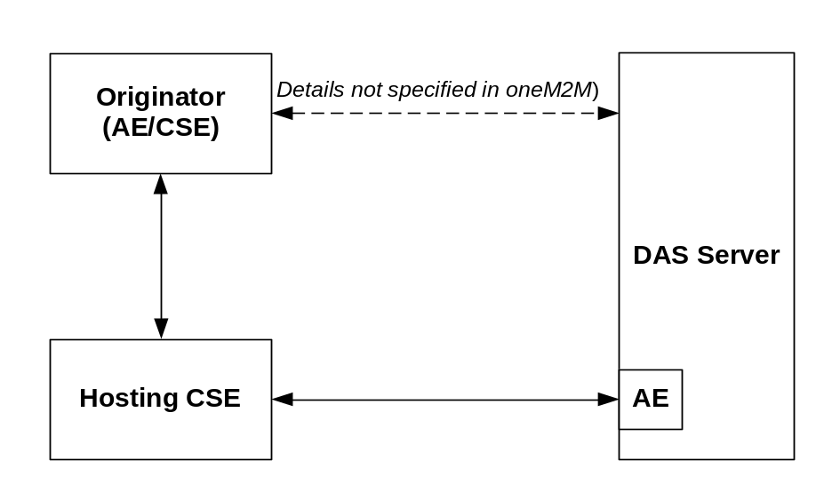
Figure 11.5.1-1: Dynamic Authorization reference model
The Dynamic Authorization reference model introduces the following systems and entities:
- Dynamic Authorization System (DAS): A system supporting dynamically authorization on behalf of resources owners. The present document does not describe the processing and exchange of messages within the Dynamic Authorization System. This system may reside either internally or externally within the service provider network.
- Dynamic Authorization System (DAS) Server: A server configured with policies for dynamic authorization, and provided with credentials for issuing Tokens. The DAS Server may include an AE for interaction with the oneM2M system.
The following Dynamic Authorization procedures are specified:
- Direct Dynamic Authorization, summarized in figure 11.5.1-2. In this procedure, Hosting CSE interacts with the DAS Server to obtain Dynamic Authorization. When AE, Hosting CSE and the DAS server support to create the Authorization Relationship Mapping Record, steps 5-7 will be applied.

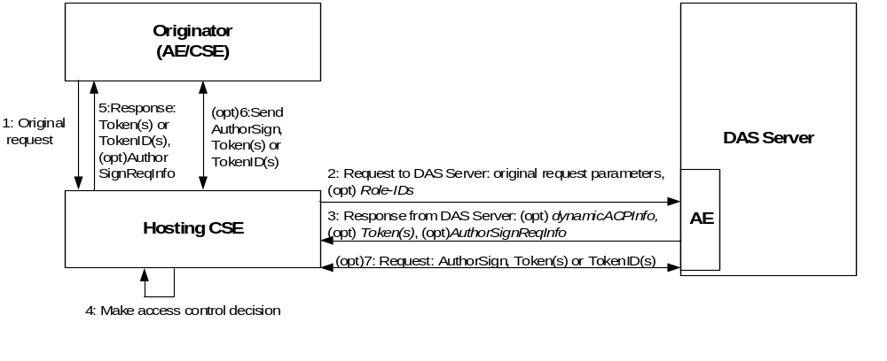
Figure 11.5.1-2: Direct Dynamic Authorization
- Indirect Dynamic Authorization, summarized in figure 11.5.1-3:
- Steps 1-2: The Hosting CSE may provide the Originator with Token Request Information in the unsuccessful response.
- Steps 3: The Originator interacts with the DAS Server with the intention that the DAS Server issue Tokens authorizing the Originator, and the Originator is provided with the Token or a Token-ID. If the Originator is an AE, whose AE-ID-Stem is assigned by the registrar CSE, and both AE and DAS server support to create the Authorization Relationship Mapping Record, the DAS Server shall request the AE to create the authorization relationship mapping record. The interaction is not described in the present specification.
- Steps 4: If the DAS Server starts the process of Authorization Relationship Mapping Record creation in step 3, the AE shall request to create the Authorization Relationship Mapping Record in the DAS Server.
- Steps 5-8: The Originator provides the Hosting CSE with a Token, Token-ID to indicate that the Token is to be considered in the access decision. In the case of a token-ID, the Hosting CSE retrieves the corresponding Token via an AE of the DAS Server. These are then used in the access decision. If the Authorization Relationship Mapping Record is created in step 4, the originator shall also indicate the related information to the Hosting CSE. The Hosting CSE may provide the Originator with a Local-Token-ID may be used to identify the Token.

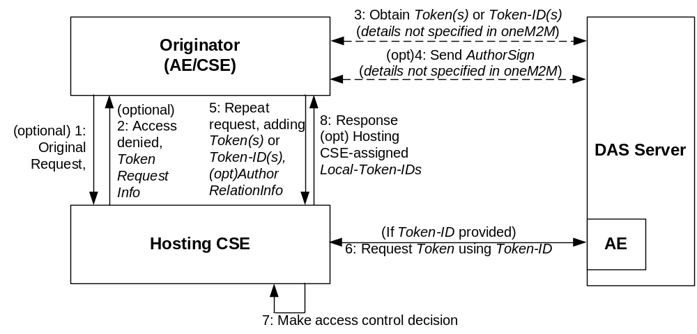
Figure 11.5.1-3: Indirect Dynamic Authorization

11.5.2 Direct Dynamic Authorization
The parameters exchanged for Direct Dynamic Authorization, and the corresponding processing, are specified in clause 7.3.2.2, oneM2M TS-0003 [Error: Reference source not found]. The present clause specifies the transportation of parameters when oneM2M primitives are used. The step numbers are aligned with the procedure in clause 7.3.2.2, oneM2M TS-0003 [Error: Reference source not found]. Further details for each step in the present clause can be obtained by examining the corresponding steps in clause 7.3.2.2, oneM2M TS-0003 [Error: Reference source not found].
The message flow for Direct Dynamic Authorization is shown in figure 11.5.2-1, and described in the following text. This call flow assumes that the Hosting CSE has already received the resource access request from the Originator.

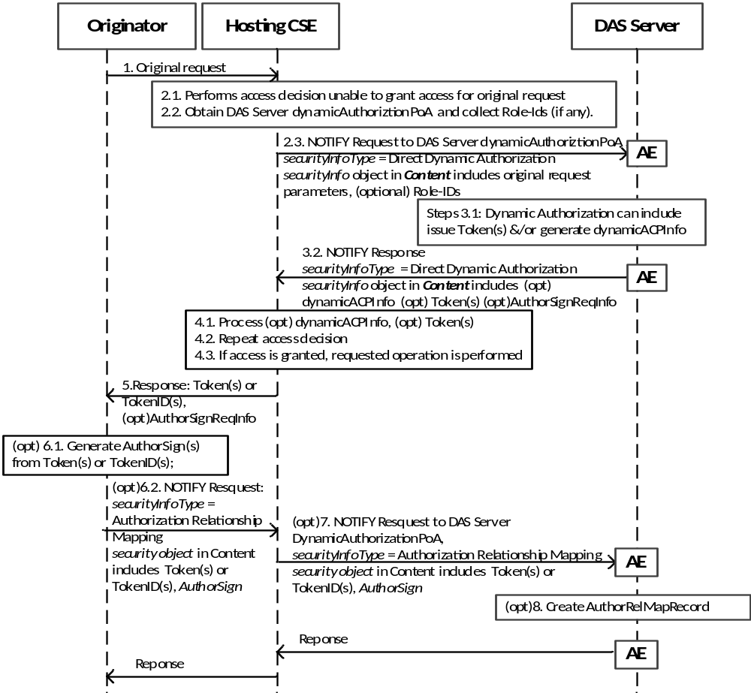

Figure 11.5.2-1: Message flow showing transport details for Direct Dynamic Authorization
- The Originator sends request (called the request from the Originator for this message flow) to the Hosting CSE. This request may include Tokens, Token IDs or LocalToken IDs; see the clause 11.5.3 "Indirect Dynamic Authorization".
- Initial Hosting CSE processing:
2.1 If the request from the Originator includes Token, Token IDs s or Local Token IDs then these are processed as described in clause 11.5.3 "Indirect Dynamic Authorization". The Hosting CSE evaluates the access decision algorithm, but is unable to grant access for the request from the Originator based on configured access control policies.
2.2 The Hosting CSE examines the <accessControlPolicy> resources and <dynamicAuthorizationConsultation> resources to obtain the DAS Server dynamicAuthorizationPoA with which it may perform Direct Dynamic Authorization. The Hosting CSE selects a DAS Server and forms the set of applicable Role-IDs (if any) to send to the corresponding DAS Server.
2.3 The Hosting CSE shall send a Notify request primitive to the DAS Server AE, with the following details specific to Direct Dynamic Authorization
- The securityInfo Type element shall indicate that the Notify request primitive is for Direct Dynamic Authorization.
- The Content parameter shall contain information that the DAS Server can use in deciding what Dynamic Authorizations should be applied. This information includes primitive parameters from the request from the Originator and the set of applicable Role-IDs (if any). Clauses 7.3.2.2, oneM2M TS-0003 [Error: Reference source not found] lists the primitive parameters to be included.
- DAS Server processing:
3.1 The DAS Server shall extract and parse the Content parameter of the received message. The DAS Server may issue Token(s) and/or generate dynamicACPInfo which will be used by the Hosting CSE to create a dynamic <accesscontrolPolicy> resource.
3.2 The DAS Server shall send a Notify response primitive via the DAS Server AE to the Hosting CSE, with the following details specific to Direct Dynamic Authorization:
- The securityInfo Type elementshall indicate that the Notify response primitive is for Direct Dynamic Authorization.
- If Step 3.1 resulted in a Token(s) and/or dynamicACPInfo parameter, then these parameters shall be included in the Content parameter, otherwise the Content parameter shall not be present.
- In the case the DAS Server issues a Token(s), if in the Step 3.1 DAS Server extracts the AuthorSignIndicator from the received message and the DAS server itself also supports to trigger creating the authorization relationship mapping record, an AuthorSignReqInfo shall be included in the Content parameter.
- Hosting CSE Processing:
4.1 The Hosting CSE shall process the Content parameter (if present) of the NOTIFY Response from the DAS Server:
- The Hosting CSE shall verify and cache the Token(s) in the list (if present), described in Clauses 7.3.2.2 of oneM2M TS-0003 [Error: Reference source not founde.
- The Hosting CSE shall create a dynamic <accessControlPolicy> resource from dynamicACPInfo (if present).
4.2 The Hosting CSE repeats the access decision mechanism.
4.3 If access is granted, then the Hosting CSE performs the operation requested in the request from the Originator.
- If in the step 4.1, the Hosting CSE gets AuthorSignReqInfo from the Content parameter, the Hosting CSE shall forward AuthorSignReqInfo in a response primitive to Originator to request the AuthorSign. If the AuthorSignReqInfo is not included in the Content, then the steps 6-8 shall not be appliedare not applied.
- Originator Processing:
6.1 If the Originator receives AuthorSignReqInfo, it shall generate AuthorSign for each Token. How the AuthorSignare generated is described in the Clauses 7.3.2.2of oneM2M TS-0003 [Error: Reference source not found].
6.2 The Originator shall send a Notify request primitive to the Hosting CSE, with the following details:
- The securityInfo Type element shall indicate that the Notify resquest primitive is for Authorization Relationship Mapping.
- AuthorSign with the corresponding Token(s) or TokenID(s) shall be included in the Content parameter.
- The Hosting CSE Processing shall forward this Notify request primitive to the DAS Server AE.
- The DAS server AE shall create authorization relationship mapping record using the AuthorSign described in the Clauses 7.3.2.2 of oneM2M TS-0003 [Error: Reference source not found].

11.5.3 Indirect Dynamic Authorization
The parameters exchanged for Indirect Dynamic Authorization, and the corresponding processing, are specified in clause 7.3.2.3, oneM2M TS-0003 [Error: Reference source not found]. The present clause specifies the transportation of parameters when oneM2M primitives are used. Further details for each step in the present clause can be obtained by examining the corresponding steps in clause 7.3.2.3, oneM2M TS-0003 [Error: Reference source not found].
The message flow for the Indirect Dynamic Authorization Procedure is shown in figure 11.5.3-1, and described in the following text.

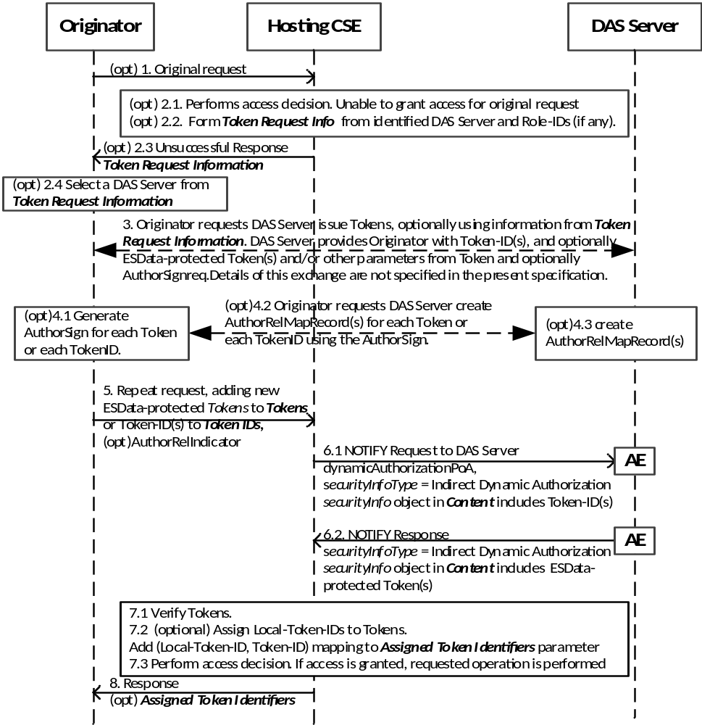
Figure 11.5.3-1: Message flow for Indirect Dynamic Authorization
- (Optional) The Originator sends request to the Hosting CSE. This request may include Tokens, Token IDs or Local Token IDs, but this message flow assumes that these do not provide sufficient permissions for accessing the requested resource.
- (Optional) Initial Hosting CSE processing:
2.1 Hosting CSE performs the access decision for the request from the Originator. This call flow assumes that the request from the Originator is denied as a result of the access decision.
2.2 The Hosting CSE forms the Token Request Information primitive parameter.
2.3 The Hosting CSE shall send, to the Originator, an unsuccessful resource access response with the following details specific to the Indirect Dynamic Authorization procedure:
- The Response Status Code shall be set to "UNAUTHORIZED".
- The Token Request Information primitive parameter shall be included.
2.4 The Originator selects a DAS Server identified in Token Request Information primitive parameter.
- The Originator shall interact with the DAS Server to request the issuance of one or more Tokens. The Originator can provide information for the DAS Server provided in the Token Request Information, and parameters from the original resource access request. If the Originator is AE and the AE-ID-Stem is assigned by the registrar CSE of the AE, and the Originator supports to create the authorization relationship mapping record, then the Originator shall provide AuthorSignIndicator parameter. The DAS Server issues a Token(s) and provides the Token-ID(s) and optionally the ESData-protected Token(s) to the Originator. The DAS Server can also provide the Originator with other parameters from the Token; for example, the time window in which the Token is valid. If DAS Server receives the AuthorSignIndicator from the Originator, and the DAS server supports to create the authorization relationship mapping record, then the DAS server shall provide the Originator with a AuthorSignReqInfo to request the Originator to return AuthorSign(s) for each Token. This interaction is specific to the Dynamic Authorization System technology being used.
- If the Originator receives an AuthorSignReqInfo from DAS server, the Originator shall return the AuthorSignto DAS server:
4.1 The Originator generates AuthorSign for each Token described in the Clauses 7.3.2.2 of oneM2M TS-0003 [Error: Reference source not found].
4.2 The Originator sends AuthorSign to DAS server with the corresponding Token(s) or TokenID(s).
4.3 The DAS server shall create, for each Token, the authorization relationship mapping record containing the information listed in Table 7.3.2.2-3 of oneM2M TS-0003 [Error: Reference source not found].
- The Originator shall repeat the original resource access request, with the following changes:
- Tokens: add the ESData-protected Token(s) provided by the DAS Sevrer; and
- Token IDs: add Token-ID if the ESData-protected Token(s) was not provided by the DAS Server;
- AuthorRelIndicator: add AuthorRelIndicator to indicate that the relationship between the AE and the Token(s) are maintained in the DAS server
- (Optional) If the request includes Token-DI(s), then for each Token-ID the Hosting CSE identifies the corresponding DAS Server AE from which to request the corresponding Token, and the following steps shall be performed. The Hosting CSE may collect the Token-ID(s) corresponding to a single DAS Server and perform the following steps once rather than repeating the steps for each token:
6.1 The Hosting CSE shall send a Notify request primitive to the DAS Server AE, with the following details specific to Indirect Dynamic Authorization:
- The securityInfo Type object parameter shall indicate that the Notify request primitive is for Indirect Dynamic Authorization.
- The Content parameter shall contain the Token-ID(s) associated with that DAS Server.
6.2 The DAS Server shall send a Notify response primitive via the DAS Server AE to the Hosting CSE, with the following details specific to Direct Dynamic Authorization:
- The securityInfo Type object parameter shall indicate that the Notify response primitive is for Indirect Dynamic Authorization.
- The Content parameter shall contain the valid ESData-protected Token(s) corresponding to the supplied Token-ID(s). The DAS Server shall provide only those Token(s) which are applicable to the Hosting CSE.
- Hosting CSE Processing:
7.1 The Hosting CSE shall process the ESData-protected Token(s) to extract the authenticated Token(s). Additional checking shall also be applied. The Hosting CSE may cache the Token(s), as described in Clause 7.3.2.3 of oneM2M TS-0003 [Error: Reference source not found]e
7.2 The Hosting CSE may assign Local-Token-ID(s) to cached Token(s).
7.3 The Hosting CSE shall perform the access decision, including the Token(s) identified in the request. If access is granted, then the requested operation shall be performed.
- Response:
8.1 The Hosting CSE may send a response to the Originator. For each new Local-Token-ID(s) has been assigned, the Local-Token-ID and corresponding Token-ID shall be included in the Assigned Token Identifiers parameter of the response.
8.2 The Originator shall associate the Local-Token-ID with Token-ID. In subsequent requests, the Originator may use the Local-Token-ID instead of the Token or Token-ID.

-----------------------End of change 2---------------------------------------------

-----------------------Start of change 3-------------------------------------------

11.5.X AE Authorization Relationship Update

11.5.X.1 AE Direct Authorization Relationship Update
The parameters exchanged for AE Direct Authorization Relationship Update, and the corresponding processing, are specified in clause 7.3.2.7.1, oneM2M TS-0003[2]. The present clause specifies the transportation of parameters when oneM2M primitives are used. The step numbers are aligned with the procedure in clause 7.3.2.7.1 of oneM2M TS-0003[2]. Futher details for each step in the present clause can be obtained by examining the corresponding steps in clause 7.3.2.7.1 of oneM2M TS-0003[2].
The message flow for the Direct Authorization Relationship Update is shown in the Figure 11.5.X.1 - 1, which is described in the following text.
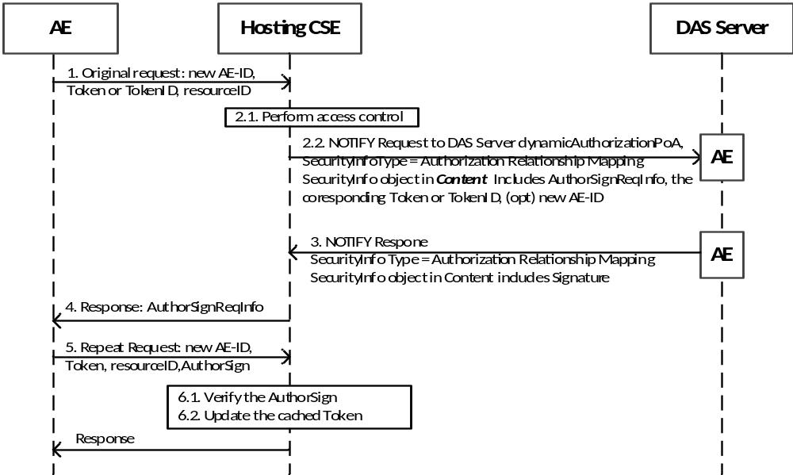
Figure 11.5.X.1 - 1: AE Direct Authorization Relationship Update
- An AE sends a resource access request message to a Hosting CSE, which carries the new AE-ID, and the Token or the TokenID issued for it.
- Hosting CSE processing
2.1 The Hosting CSE shall verify this Token or the Token identified by this TokenID. If the result is vaild, and the holder attribute of the Token is not equal to the new AE-ID of the originator, the Hosting CSE performs the following steps to verify whether the AE has the possession of the Token.
2.2 The Hosting CSE sends a Notify request primitive to DAS Server AE, with the following details:
- The securityInfo Type element shall indicate that the Notify request primitive is for Authorization Relationship Mapping.
- The Content parameter shall contain information: AuthorSignReqInfo, the corresponding Token or TokenID received from the AE.
- The DAS Server AE shall extract and parse the Content parameter of the received message. The DAS Server shall examine its authorization relationship mapping record list. If there is a record whose Token parameter is equal to the Token included in the Content parameter or the Token identified by the Token ID in the Content parameter, the DAS Server AE sends a Notify response primitive to the Hosting CSE including the AuthorSign stored in this record:
- The securityInfo Type element shall indicate that the Notify response primitive is for Authorization Relationship Mapping.
- The Content parameter shall contain information: Signature which is described in Table 7.3.2.2-3 of TS-0003 [Error: Reference source not found].
- The Hosting CSE rejects the request to access the resource, including a AuthorSignReqInfo in the response message to indicate AE to return the AuthorSign for this Token.
- The AE sends the repeat request including the information: AuthorSign, resourceID and Token.
- After receiving the AuthorSign, Hosting CSE shall check whether the AuthorSign is equal to the Signature returned from DAS Server AE. And if they are the same, the Hosting CSE shall update the cached Token as described in clause 7.3.2.7.1 of oneM2M TS-0003 [Error: Reference source not found].

11.5.X.2 AE Indirect Authorization Relationship Update
The parameters exchanged for Indirect Authorization Relationship Update, and the corresponding processing, are specified in clause 7.3.2.7.2 of oneM2M TS-0003 [Error: Reference source not found]. The present clause specifies the transportation of parameters when oneM2M primitives are used. Further details for each step in the present clause can be obtained by examining the corresponding steps in clause 7.3.2.7., of oneM2M TS-0003 [Error: Reference source not found].
The message flow for the Indirect Authorization Relationship Update is shown in the Figure 11.5.X.2 - 1, which is described in the following text.

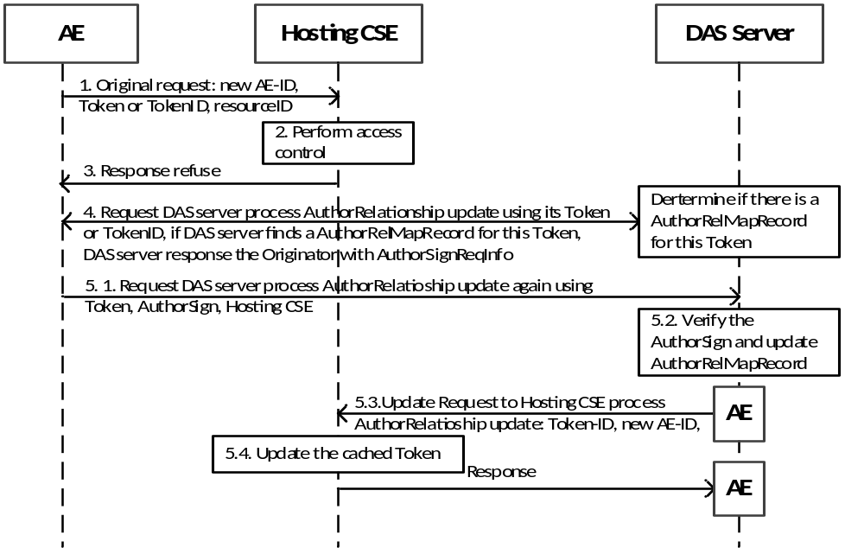
Figure 7.3.2.x-2: AE Indirect Authorization Relationship Update
- The AE sends a request to the Hosting CSE. This request may include the new AE-ID, and Token or TokenID issued for it.
- The Hosting CSE performs the access decision for the request from the Originator.This call flow assumes that the Token or Token identified by the TokenID is valid and the holder attribute of the cached Token is not equal to the new AE-ID of the originator.
- The Hosting CSE shall send, to the Originator, an unsuccessful resource access.
- The AE requests DAS Server to update the authorization relationship using the Token or TokenID, and DAS server shall search if there is an Authorization Relationship Mapping Record of which the Token parameter or TokenID of the Token parameter is the same as the Token or TokenID received from AE. If the result is ok, DAS server shall return an AuthorSignReqInfo to AE to request the AuthorSign for the Token.
- The AE provides the AuthorSign to prove the possession of the token:
5.1 The AE sends the update request containing Hosting CSE ID, AuthorSign, resourceID and Token.
5.2 After receiving the AuthorSign, the DAS Server shall check if this AuthorSign is equal to Signature stored in the Authorization Relationship Mapping Record corresponding to this Token.
5.3 If the result in step 5.2 is ok, the DAS Server AE shall send an Update request primitive to the Hosting CSE to update the cached Token.
NOTE: Before the update action, DAS Server AE may get the resource ID of the cached Token locally stored on the Hosting CSE through discovery or other offline ways, there is no limitation on how to get the resource ID of the cached Token.
5.4 The Hosting CSE updates the cached Token as described in clause 7.3.2.7.2 of oneM2M TS-0003 [Error: Reference source not found].

-----------------------End of change 3---------------------------------------------

-Start of changes to Definitions Symbols Abbreviations Acronyms -

3 Definitions, symbols, abbreviations and acronyms

3.1 Definitions
<defined term>: <definition>
<defined term>[N]: <definition>

3.2 Symbols
<symbol> <Explanation>

3.3 Abbreviations and Acronyms
AuthorSignReqInfo Authorization Signature Request Information
AuthorSign Authorization Signature
AuthorRelMapRecord Authorization Relationship Mapping Record
AuthorRelIndicator Authorization Relationship Indicator
AuthorSignIndicator Authorization Signature Indicator

---End of changes to Definitions, Symbols, Abbreviations, Acronyms ---

CHECK LIST
- Does this change request include an informative introduction containing the problem(s) being solved, and a summary list of proposals.?
- Does this CR contain changes related to only one particular issue/problem?
- Have any mirror crs been posted?
- Does this change request make all the changes necessary to address the issue or problem? E.g. A change impacting 5 tables should not only include a proposal to change only 3 tables. Includes any changes to references, definitions, and acronyms in the same deliverable?
- Does this change request follow the drafting rules?
- Are all pictures editable?
- Have you checked the spelling and grammar?
- Have you used change bars for all modifications?
- Does the change include the current and surrounding clauses to clearly show where a change is located and to provide technical context of the proposed change? (Additions of complete sections need not show surrounding clauses as long as the proposed section number clearly shows where the new section is proposed to be located.)
- Are multiple changes in this CR clearly separated by horizontal lines with embedded text such as, start of change 1, end of change 1, start of new clause, end of new clause.?

