CHANGE REQUEST
eeting ID:* | ARC31
Source:* | Xu Li, Convida, li.xu@convidawireless.com  Chonggang Wang, Convida, wang.chonggang@convidawireless.com  Catalina Mladin, Convida, mladin.catalina@convidawireless.com
Date:* | 2017-09-08
Reason for Change/s:* | Editorial changes for Table 9.6.1.1-1: Resource Types.
CR against: Release* | Release 3
CR against: WI* | Active WI-0053 for Rel-3 Enhancements on Semantic Support  MNT maintenance / < Work Item number(optional)>  Is this a companion CR? Yes No  Companion CR number: (Note to Rapporteur - use latest agreed revision)Is this a mirror CR? Yes No  Mirror CR number: (Note to Rapporteur - use latest agreed revision)  STE Small Technical Enhancements / < Work Item number (optional)>  Only ONE of the above shall be ticked
CR against: TS/TR* | TS-0001, v3.7.0
Clauses * | 9.6.1.1
Type of change: * | Editorial change  Bug Fix or Correction  Change to existing feature or functionality  New feature or functionality  Only ONE of the above shall be ticked
Impacted other TS/TR(s) | <TS/TR number>, <Version Number>, and <Description on which aspect should be reflected in this TS/TR>
Post Freeze checking:* | This CR contains only essential changes and corrections? YES NO  This CR may break backwards compatibility with the last approved version of the TS? YES NO
Template Version: January 2017 (Do not modify)

oneM2M Notice
The document to which this cover statement is attached is submitted to oneM2M. Participation in, or attendance at, any activity of oneM2M, constitutes acceptance of and agreement to be bound by terms of the Working Procedures and the Partnership Agreement, including the Intellectual Property Rights (IPR) Principles Governing oneM2M Work found in Annex 1 of the Partnership Agreement.

Introduction
During TP30, ARC-2017-0292R02 (which includes new resource types and CRUD operations for semantic mashup) was agreed to TS-0001. For example, in the newly-added row of <semanticMashupJobProfile> resource in TS-0001 Table 9.6.1.1-1: Resource Types, it shows that a <semanticMashupJobProfile> resource can be a child resource of a <CSEBase>, <RemoteCSE> or <AE> resource. However, the “Child Resource Types” column in the rows of <CSEBase>, <RemoteCSE> or <AE> resources also need to be updated for consistence.
This contribution makes the following editorial changes:
- Update the rows of <CSEBase>, <RemoteCSE> or <AE> resources in Table 9.6.1.1-1: Resource Types and it updates the “Child Resource Types” column for those rows to include semantic mashup related resources if applied (See Change #1).
- For consistence, it also updates the corresponding resource structure figures and child resource table of <CSEBase>, <RemoteCSE> or <AE> resources, respectively (See Change #2).

-----------------------Start of change 1-------------------------------------------

9.6.1 Overview

9.6.1.1 Resource Type Summary
Table 9.6.1.1-1 introduces the normal and virtual resource types and their related child or parent resource types. Details of each resource type follow in the remainder of this clause.
Table 9.6.1.1-1 lists each specified ordinary – i.e. not announced – resource type. An addition of suffix "Annc" to the respective resource type identifier indicates the associated announced resource type. Resource types that can occur as child resources of announced resources are summarized in Table 9.6.26.1-1 "Announced Resource Types".
Among the resource types listed in Table 9.6.1.1-1, the following are termed "Content Sharing Resources" in oneM2M Specifications for the purpose of referring to any of those resource types:
- container;
- contentInstance;
- flexContainer;
- timeSeries;
- timeSeriesInstance.

Table 9.6.1.1-1: Resource Types
Resource Type | Short Description | Child Resource Types | Parent Resource Types | Clause
accessControlPolicy | Stores a representation of privileges. It is associated with resources that shall be accessible to entities external to the Hosting CSE. It controls "who" is allowed to do "what" and the context in which it can be used for accessing resources | subscription, transaction | AE, AEAnnc, remoteCSE, remoteCSEAnnc, CSEBase | 9.6.2
AE | Stores information about the AE. It is created as a result of successful registration of an AE with the Registrar CSE | subscription, container,  flexContainer,  group, accessControlPolicy,  pollingChannel, semanticDescriptor,  timeSeries, transaction, transactionMgmt,  triggerRequest, crossResourceSubscription, backgroundDataTransfer, semanticMashupInstance | CSEBase | 9.6.5
container | Shares data instances among entities. Used as a mediator that buffers data exchanged between AEs and/or CSEs. The exchange of data between AEs (e.g. an AE on a Node in a field domain and the peer-AE on the infrastructure domain) is abstracted from the need to set up direct connections and allows for scenarios where both entities in the exchange do not have the same reachability schedule | container,  flexContainer, contentInstance, subscription, latest, oldest，semanticDescriptor, timeSeries, transaction | AE, AEAnnc, container, containerAnnc, remoteCSE, remoteCSEAnnc,  CSEBase,  flexContainer, flexContainerAnnc | 9.6.6
contentInstance | Represents a data instance in the <container> resource | semanticDescriptor, transaction | Container, containerAnnc | 9.6.7
flexContainer | A template which allows to define specialized (customizable) versions of containers with a flexible and lightweight structure | container,  flexContainer, subscription, semanticDescriptor, timeSeries, transaction | AE, AEAnnc, container, containerAnnc,  flexContainer, flexContainerAnnc, remoteCSE, remoteCSEAnnc,  CSEBase | 9.6.35
CSEBase | The structural root for all the resources that are residing on a CSE. Stores information about the CSE itself | remoteCSE, remoteCSEAnnc, node, AE, container, group, accessControlPolicy, subscription, mgmtCmd, locationPolicy, statsConfig, statsCollect, request, delivery,  schedule,  notificationTargetPolicy,  flexContainer,  timeSeries, AEContactList, transaction, transactionMgmt, crossResourceSubscription, backgroundDataTransfer, semanticMashupJobProfile, semanticMashupInstance | None specified | 9.6.3
delivery | Forwards requests from CSE to CSE | subscription, transaction | CSEBase | 9.6.11
eventConfig | Defines events that trigger statistics collection | subscription, transaction | statsConfig | 9.6.24
execInstance | Contains all execution instances of the same Management Command | subscription, transaction | mgmtCmd | 9.6.17
fanOutPoint (V) | Virtual resource containing target for group request  It is used for addressing bulk operations to all the resources that belong to a group | None specified | group | 9.6.14
group | Stores information about resources of the same type that need to be addressed as a Group. Operations addressed to a Group resource shall be executed in a bulk mode for all members belonging to the Group | fanOutPoint,  subscription,  semanticFanOutPoint, semanticDescriptor, transaction | AE, AEAnnc, remoteCSE, remoteCSEAnnc, CSEBase | 9.6.13
latest (V) | Virtual resource that points to most recently created <contentInstance> and <timeSeriesInstance> child resource within a <container> and a <timeSeries> resource | None specified | container, timeSeries | 9.6.27
locationPolicy | Includes information to obtain and manage geographical location. It is only referenced within a container, the contentInstances of the container provide location information | subscription, transaction | CSEBase | 9.6.10
mgmtCmd | Management Command resource represents a method to execute management procedures required by existing management protocols | execInstance,  subscription, transaction | CSEBase | 9.6.16
mgmtObj | Management Object resource represents management functions that provides an abstraction to be mapped to external management technology. It represents the node and the software installed in the node (see note) | subscription, mgmtObj, transaction | node, mgmtObj, mgmtObjAnnc | 9.6.15  Annex D
m2mServiceSubscriptionProfile | Data pertaining to the M2M Service Subscription | serviceSubscribedNode,  subscription, transaction | CSEBase | 9.6.19
node | Represents specific Node information | mgmtObj,  subscription, semanticDescriptor,schedule, transaction | CSEBase | 9.6.18
notificationTargetMgmtPolicyRef | Represents a list of notification targets and the deletion policy | subscription, transaction | subscription | 9.6.31
notificationTargetPolicy | Represents a notification target deletion policy with pre-defined action and deletion rules | subscription, policyDeletionRules, transaction | CSEBase | 9.6.32
notificationTargetSelfReference (V) | Virtual resource used to remove the Notification Target | None specified | subscription | 9.6.34
oldest (V) | Virtual resource that points to first created <contentInstance> and <timeSeriesInstance> child resource within a <container> and a <timeSeries> resource | None specified | container, timeSeries | 9.6.28
pollingChannel | Represent a channel that can be used for a request-unreachable entity | pollingChannelURI | remoteCSE, AE | 9.6.21
pollingChannelURI (V) | Virtual resource used to perform service layer long polling of a resource Hosting CSE by a request-unreachable entity | None specified | pollingChannel | 9.6.22
policyDeletionRules | Represents a set of rules which is associated with notification target removal policy | subscription, transaction | notificationTargetPolicy | 9.6.33
remoteCSE | Represents a remote CSE for which there has been a registration procedure with the registrar CSE identified by the CSEBase resource | container, containerAnnc,  flexContainer, flexContainerAnnc,  group, groupAnnc, accessControlPolicy, accessControlPolicyAnnc, subscription, pollingChannel,  timeSeries,  timeSeriesAnnc,  remoteCSEAnnc,  nodeAnnc,  AEAnnc,  locationPolicyAnnc, transaction, crossResourceSubscription, backgroundDataTransfer, semanticMashupJobProfile, semanticMashupJobProfileAnnc, semanticMashupInstance,  semanticMashupInstanceAnnc | CSEBase | 9.6.4
request | Expresses/access context of an issued Request | subscription, transaction | CSEBase | 9.6.12
schedule | Contains scheduling information for delivery of messages | subscription, transaction | subscription, CSEBase,  - node | 9.6.9
serviceSubscribedNode | Node information | subscription, transaction | m2mServiceSubscriptionProfile | 9.6.20
statsCollect | Defines triggers for the IN-CSE to collect statistics for applications | subscription, transaction | CSEBase (in IN-CSE) | 9.6.25
statsConfig | Stores configuration of statistics for applications | eventConfig,  subscription, transaction | CSEBase (in IN-CSE) | 9.6.23
subscription | Subscription resource represents the subscription information related to a resource. Such a resource shall be a child resource for the subscribe-to resource | schedule, notificationTargetSelfReference, notificationTargetMgmtPolicyRef, transaction | accessControlPolicy,accessControlPolicyAnnc, AE, AEAnnc, container, containerAnnc, CSEBase, delivery, eventConfig, execInstance, group, groupAnnc, locationPolicy, locationPolicyAnnc, mgmtCmd, mgmtObj, mgmtObjAnnc, m2mServiceSubscriptionProfile, node, nodeAnnc, serviceSubscribedNode, remoteCSE, remoteCSEAnnc, request, schedule, scheduleAnnc,  semanticDescriptor, semanticDescriptorAnnc, statsCollect, statsConfig,  flexContainer, flexContainerAnnc,  timeSeries, timeSeriesAnnc | 9.6.8
serviceSubscribedAppRule | Represents a rule that defines allowed App-ID and AE-ID combinations that are acceptable for registering an AE on a Registrar CSE | subscription, transaction | CSEBase | 9.6.29
semanticDescriptor | Stores semantic description pertaining to a resource and potentially sub-resources. | subscription, transaction | AE, container, contentInstance，group, node, flexContainer, timeSeries | 9.6.30
semanticFanOutPoint | Virtual resource used as target for semantic discovery aimed at a logical graph distributed over multiple semanticDescriptor resources, which belong to the corresponding group parent resource | transaction | group | 9.6.14a
dynamicAuthorizationConsultation | Represents consultation information used by a CSE when performing consultation-based dynamic authorization | transaction | AE, AEAnnc, remoteCSE, remoteCSEAnnc, CSEBase | 9.6.40
timeSeries | Stores and Shares Time Series Data instances among entities. | timeSeriesInstance, subscription, semanticDescriptor,  latest, oldest, transaction | AE, AEAnnc, remoteCSE, remoteCSEAnnc, CSEBase,  container, containerAnnc, flexContainer, flexContainerAnnc | 9.6.36
timeSeriesInstance | Represents a Time Series Data instance in the <timeSeries> resource | transaction | timeSeries, timeSeriesAnnc | 9.6.37
authorizationDecision | Represents an access control decision point | subscription, transaction | CSEBase | 9.6.41
authorizationPolicy | Represents an access control policy retrieval point | subscription, transaction | CSEBase | 9.6.42
authorizationInformation | Represents an access control information point | role  token  subscription, transaction | CSEBase | 9.6.43
localMulticastGroup | Stores local multicast group information of member hosting CSE. | transaction | CSEBase | 9.6.44
AEContactList | Contains information about a CSE that has resources that referencing an AE-ID | AEContactListPerCSE, subscription | CSEBase | 9.6.45
AEContactListPerCSE | Contains information about a CSE that has resources that referencing an AE resource identifier for tracking purposes | None specified | AEContactList | 9.6.46
transactionMgmt |  | subscription | CSEBase, AE, remoteCSE | 9.6.47
transaction |  | None specified | All non-virtual resource types with the exception of the following:  request, delivery, pollingChannel, transactionMgmt, transaction | 9.6.48
triggerRequest | Used by an AE to initiate, replace or recall a device trigger request | subscription | AE | 9.6.49
ontologyRepository | Represents the collection of the managed ontologies and the semantic validation service | ontology, semanticValidation, subscription | CSEBase | 9.6.50
ontology | Store the representation of an ontology | subscription | ontologyRepository | 9.6.51
semanticValidation | A virtual resource as the interface to perform semantic validation on the received <semanticDescriptor> resource against the referenced ontology. | None specified | ontologyRepository | 9.6.52
semanticMashupJobProfile | Represents the profile and description of a semantic mashup service | semanticMashupInstance, semanticDescriptor, subscription | CSEBase, remoteCSE | 9.6.53
semanitcMashupInstance | Represents a semantic mashup instance | semanticMashupResult, semanticDescriptor, mashup, subscription | semanticMashupJobProfile, AE, remoteCSE, CSEBase | 9.6.54
mashup | A virtual resource use to trigger the calculation and generation of new mashup result | Not specified | semanticMashupInstance | 9.6.55
semanticMashupResult | Represent semantic mashup results | semanticDescriptor, subscription | semanticMashupInstance | 9.6.56
multimediaSession | Stores a representation of a multimedia session information requested by a registering AE | subscription, accessControlPolicy | AE, remoteCSE | 9.6.57
crossResourceSubscription | represents the cross-resource subscription information related to multiple subscribed-to resources. Such a resource shall include a list of subscribed-to resources as its attribute, or shall be created as a child resource of a <group> resource where member resources shall be the subscribed-to resources. | schedule, notificationTargetSelfReference, notificationTargetMgmtPolicyRef, subscriptionLinkDeletion | CSEBase, remoteCSE, AE | 9.6.58
subscriptionLinkDeletion | Virtual resource used to remove a <subscription> resource from the subscriptionResourcesAsTarget list of a <crossResourceSubscription> resource. | None specified | crossResourceSubscription | 9.6.59
backgroundDataTransfer | Stores information for a background data transfer request | None specified | AE, remoteCSE, CSEBase | 9.6.60
NOTE: See clause 9.6.12 for a summary of specializations of <mgmtObj>.

-----------------------End of change 1----------------------------------

-----------------------Start of change 2-------------------------------------------

9.6.3 Resource Type CSEBase
A <CSEBase> resource shall represent a CSE. The <CSEBase> resource shall be the root for all resources that are residing in the CSE.
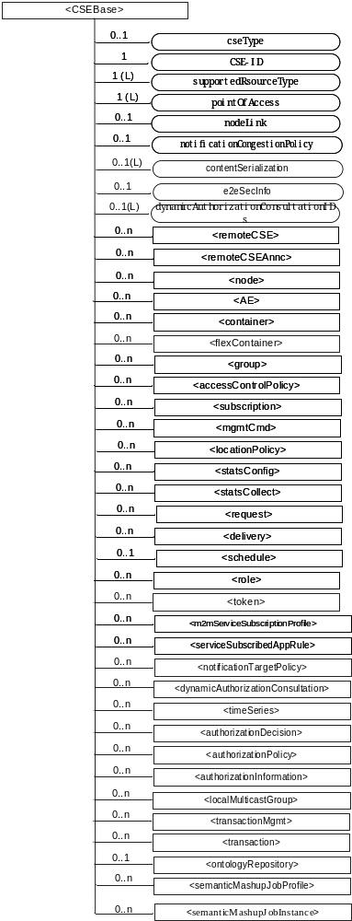
Figure 9.6.3-1: Structure of <CSEBase> resource
Figure 9.6.3-1 does not show the child announce resource types defined in table 9.6.3-2.
The <CSEBase> resource shall contain the child resources specified in table 9.6.3-1.
Table 9.6.3-1: Child resources of <CSEBase> resource
Child Resources of <CSEBase> | Child Resource Type | Multiplicity | Description
[variable] | <remoteCSE> | 0..n | See clause 9.6.4
[variable] | <remoteCSEAnnc> | 0..n | Announced variant of <remoteCSE>. Resource with CSE-specific information for a CSE that announced itself to another CSE with which it does not have a registration relationship.
[variable] | <node> | 0..n | See clause 9.6.18
[variable] | <AE> | 0..n | See clause 9.6.5
[variable] | <container> | 0..n | See clause 9.6.6
[variable] | <flexContainer> | 0..n | See clause 9.6.35
[variable] | <group> | 0..n | See clause 9.6.13
[variable] | <accessControlPolicy> | 0..n | See clause 9.6.2
[variable] | <subscription> | 0..n | See clause 9.6.8
[variable] | <mgmtCmd> | 0..n | See clause 9.6.16
[variable] | <locationPolicy> | 0..n | See clause 9.6.10
[variable] | <statsConfig> | 0..n | See clause 9.6.23
[variable] | <statsCollect> | 0..n | See clause 9.6.25
[variable] | <request> | 0..n | See clause 9.6.12
[variable] | <delivery> | 0..n | See clause 9.6.11
[variable] | <schedule> | 0..1 | This resource defines the reachability schedule information of the entity. The absence of this resource implies the entity is always reachable. See clause 9.6.9
[variable] | <role> | 0..n | See clause 9.6.38
[variable] | <token> | 0..n | See clause 9.6.39
[variable] | <m2mServiceSubscriptionProfile> | 0..n | See clause 9.6.19
[variable] | <serviceSubscribedAppRule> | 0..n | See clause 9.6.29
[variable] | <notificationTargetPolicy> | 0..n | See clause 9.6.32
[variable] | <dynamicAuthorizationConsultation> | 0..n | See clause 9.6.40
[variable] | <timeSeries> | 0..n | See clause 9.6.36
[variable] | <authorizationDecision> | 0..n | See clause 9.6.41
[variable] | <authorizationPolicy> | 0..n | See clause 9.6.42
[variable] | <authorizationInformation> | 0..n | See clause 9.6.43
[variable] | <localMulticastGroup> | 0..n | See clause 9.6.44
[variable] | <transactionMgmt> | 0..n | See clause 9.6.47
[variable] | <transaction> | 0..n | See clause 9.6.48
[variable] | <ontologyRepository> | 0..1 | See clause 9.6.50
[variable] | <semanticMashupJobProfile> | 0..n | See clause 9.6.53
[variable] | <semanticMashupInstance> | 0..n | See clause 9.6.54

9.6.4 Resource Type remoteCSE
A <remoteCSE> resource shall represent a Registree CSE that is registered to the Registrar CSE. <remoteCSE> resources shall be located directly under the <CSEBase> resource of Registrar CSE.
Similarly <remoteCSE> resource shall also represent a Registrar CSE. <remoteCSE> resource shall be located directly under the <CSEBase> resource of Registree CSE.
For example, when CSE1 (Registree CSE) registers with CSE2 (Registrar CSE), there will be two <remoteCSE> resources created: one in CSE1: <CSEBase1>/<remoteCSE2> and one in CSE2: <CSEBase2>/<remoteCSE1>.
Note that the creation of the two resources does not imply mutual registration. The <CSEBase1>/<remoteCSE2> does not mean CSE2 registered with CSE1 in the example above.
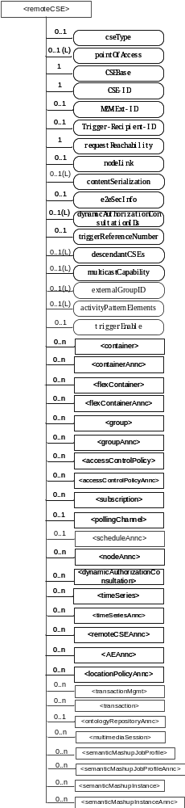
Figure 9.6.4-1: Structure of <remoteCSE> resource
The <remoteCSE> resource shall contain the child resources specified in table 9.6.4-1. The <remoteCSE> resource may contain <remoteCSEAnnc> child resources.
Table 9.6.4-1: Child resources of <remoteCSE> resource
Child Resources of <remoteCSE> | Child Resource Type | Multiplicity | Description | <remoteCSEAnnc> Child Resource Types
[variable] | <container> | 0..n | See clause 9.6.6 | <container>
[variable] | <containerAnnc> | 0..n | Announced variant of <container>. See clause 9.6.6 | <containerAnnc>
[variable] | <flexContainer> | 0..n | See clause 9.6.35 | <flexContainer>
[variable] | <flexContaineAnnc> | 0..n | Announced variant of <flexContainer>. See clause 9.6.35 | <flexContainerAnnc>
[variable] | <group> | 0..n | See clause 9.6.13 | <group>
[variable] | <groupAnnc> | 0..n | Announced variant of <group>. See clause 9.6.13 | <groupAnnc>
[variable] | <accessControlPolicy> | 0..n | See clause 9.6.2 | <accessControlPolicy>
[variable] | <accessControlPolicyAnnc> | 0..n | Announced variant of <accessControlPolicy>. See clause 9.6.2 | <accessControlPolicyAnnc>
[variable] | <subscription> | 0..n | See clause 9.6.8 | <subscription>
[variable] | <pollingChannel> | 0..1 | See clause 9.6.21. If requestReachability is FALSE, the CSE that created this <remoteCSE> resource should create a <pollingChannel> resource and perform long polling. The <pollingChannel> shall be utilized by the the parent resource. | None
[variable] | <nodeAnnc> | 0..n | Announced variant of <node>. This announced resource is assoiated with a <node> resource that is hosted on a CSE which is represented by the parent <remoteCSE> or <remoteCSEAnnc> resource. See clause 9.6.18 for <node>. | <nodeAnnc>
[variable] | <dynamicAuthorizationConsultation> | 0..n | See clause 9.6.40
[variable] | <timeSeries> | 0..n | See clause 9.6.36 | <timeSeries>
[variable] | <timeSeriesAnnc> | 0..n | Announced variant of <timeSeries>. See clause 9.6.36 | <timeSeriesAnnc>
[variable] | <remoteCSEAnnc> | 0..n | Announced variant of <remoteCSE> defined in the present clause 9.6.4. | <remoteCSEAnnc>
[variable] | <AEAnnc> | 0..n | Announced variant of <AE>. See clause 9.6.5 | <AEAnnc>
[variable] | <locationPolicyAnnc> | 0..n | Announced variant of <locationPolicy>. See clause 9.6.10 | <locationPolicyAnnc>
[variable] | <transactionMgmt> | 0..n | See clause 9.6.47 | <transactionMgmt>
[variable] | <transaction> | 0..n | See clause 9.6.48 | <transaction>
[variable] | <ontologyRepositoryAnnc> | 0..1 | Announced variant of <ontologyRepository>. See clause 9.6.50 | <ontologyRepositoryAnnc>
[variable] | <multimediaSession> | 0..n | See Clause 9.6.x. This resources holds information describing the established multimedia session | None
[variable] | <semanticMashupJobProfile> | 0..n | See clause 9.6.53 | <semanticMashupJobProfile>
[variable] | <semanticMashupJobProfileAnnc> | 0..n | Announced variant of <semanticMashupJobProfile>. See clause 9.6.53 | <semanticMashupJobProfileAnnc>
[variable] | <semanticMashupInstance> | 0..n | See clause 9.6.54 | <semanticMashupInstance>
[variable] | <semanticMashupInstanceAnnc> | 0..n | Announced variant of <semanticMashupInstance >. See clause 9.6.54. | <semanticMashupInstanceAnnc>

9.6.5 Resource Type AE
An <AE> resource shall represent information about an Application Entity registered to a CSE.
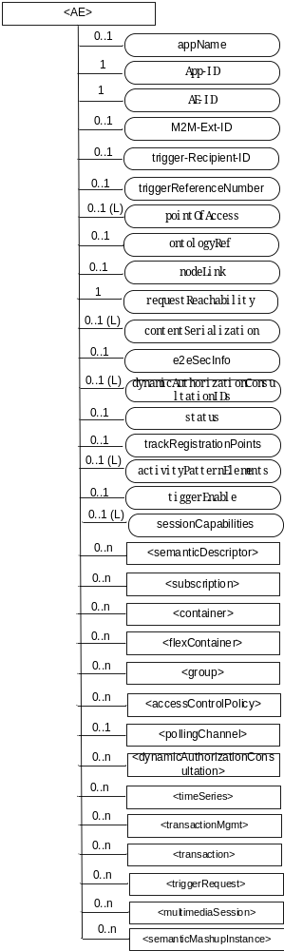
Figure 9.6.5-1: Structure of <AE> resource
The <AE> resource shall contain the child resources specified in table 9.6.5-1.
Table 9.6.5-1: Child resources of <AE> resource
Child Resources of <AE> | Child Resource Type | Multiplicity | Description | <AEAnnc> Child Resource Types
[variable] | <semanticDescriptor> | 0..n | See clause 9.6.30 | <semanticDescriptor>, <semanticDescriptorAnnc>
[variable] | <subscription> | 0..n | See clause 9.6.8 | <subscription>
[variable] | <container> | 0..n | See clause 9.6.6 | <container> <containerAnnc>
[variable] | <flexContainer> | 0..n | See clause 9.6.35 | <flexContainer>  <flexContainerAnnc>
[variable] | <group> | 0..n | See clause 9.6.13 | <group>  <groupAnnc>
[variable] | <accessControlPolicy> | 0..n | See clause 9.6.2 | <accessControlPolicy>  <accessControlPolicyAnnc>
[variable] | <pollingChannel> | 0..1 | See clause 9.6.21  When the AE is request-unreachable, the AE should create this <pollingChannel> resource and perform long polling. The <pollingChannel> shall be utilized by the parent resource | None
[variable] | <dynamicAuthorizationConsultation> | 0..n | See clause 9.6.40 | None
[variable] | <timeSeries> | 0..n | See clause 9.6.36 | <timeSeries>  <timeSeriesAnnc>
[variable] | <transactionMgmt> | 0..n | See clause 9.6.47 | <transactionMgmt>
[variable] | <transaction> | 0..n | See clause 9.6.48 | <transaction>
[variable] | <triggerRequest> | 0..n | See clause 9.6.49 | None
[variable] | <multimediaSession> | 0..n | See Clause 9.6.57. This resources holds information describing the established multimedia session | None
[variable] | <semanticMashupInstance> | 0..n | See clause 9.6.54 | <semanticMashupInstance>  <semanticMashupInstanceAnnc>

The <AE> resource shall contain the attributes specified in table 9.6.5-2.

-----------------------Start of change 2-------------------------------------------

