CHANGE REQUEST
Meeting ID:* | ARC#31.1
Source:* | Sachin Sharma, C-DOT, sachins@cdot.in  Anil Kumar Sharma, C-DOT, anils@cdot.in  Pankaj Dalela, C-DOT, pdalela@cdot.in  Vipin Tyagi, C-DOT, vipin@cdot.in
Date:* | 2017-10-12
Reason for Change/s:* | See the introduction
CR against: Release* | Release 3
CR against: WI* | Active <Work Item number>  MNT maintenance / < Work Item number(optional)>  Is this a mirror CR? Yes No  mirror CR number: (Note to Rapporteur - use latest agreed revision)  STE Small Technical Enhancements / < Work Item number (optional)>  Only ONE of the above shall be ticked
CR against: TS/TR* | TS-0001 v3_6_0
Clauses * | 6.2.4
Type of change: * | Editorial change  Bug Fix or Correction  Change to existing feature or functionality  New feature or functionality  Only ONE of the above shall be ticked
Impacted other TS/TR(s) | <TS/TR number>, <Version Number>, and <Description on which aspect should be reflected in this TS/TR>
Post Freeze checking:* | This CR contains only essential changes and corrections? YES NO  This CR may break backwards compatibility with the last approved version of the TS? YES NO
Template Version: January 2017 (Do not modify)

oneM2M Notice
The document to which this cover statement is attached is submitted to oneM2M. Participation in, or attendance at, any activity of oneM2M, constitutes acceptance of and agreement to be bound by terms of the Working Procedures and the Partnership Agreement, including the Intellectual Property Rights (IPR) Principles Governing oneM2M Work found in Annex 1 of the Partnership Agreement.
GUIDELINES for Change Requests:
Provide an informative introduction containing the problem(s) being solved, and a summary list of proposals.
Each CR should contain changes related to only one particular issue/problem.
In case of a correction, and the change apply to previous releases, a separate “mirror CR” should be posted at the same time of this CR
Mirror CR: applies only when the text, including clause numbering are exactly the same.
Companion CR: applies when the change means the same but the baselines differ in some way (e.g. clause number).
Follow the principle of completeness, where all changes related to the issue or problem within a deliverable are simultaneously proposed to be made E.g. A change impacting 5 tables should not only include a proposal to change only 3 tables. Includes any changes to references, definitions, and acronyms in the same deliverable.
Follow the drafting rules.
All pictures must be editable.
Check spelling and grammar to the extent practicable.
Use Change bars for modifications.
The change should include the current and surrounding clauses to clearly show where a change is located and to provide technical context of the proposed change. Additions of complete clauses need not show surrounding clauses as long as the proposed clause number clearly shows where the new clause is proposed to be located.
Multiple changes in a single CR shall be clearly separated by horizontal lines with embedded text such as, start of change 1, end of change 1, start of new clause, end of new clause.
When subsequent changes are made to content of a CR, then the accepted version should not show changes over changes. The accepted version of the CR should only show changes relative to the baseline approved text.

Introduction
This CR proposes change in clause 6.2.4.1.1 where Device Management Architecture is discussed. The DMG in the CSE of the ASN has the same functionality as the DMG in the CSE of the MN. And the DMG in the ASN can also be used to manage devices in the M2M Area Network. The DMG is deployed with proxy functionality that interacts with the Proxy Management Client using the mp interface.
So this statement, “In addition, the DMG in the MN can be used to manage devices in the M2M Area Network” should be modified as : “The DMG in the MN or ASN can be used to manage devices in the M2M Area Network”.
Referf to the device management architecture diagram shown below:
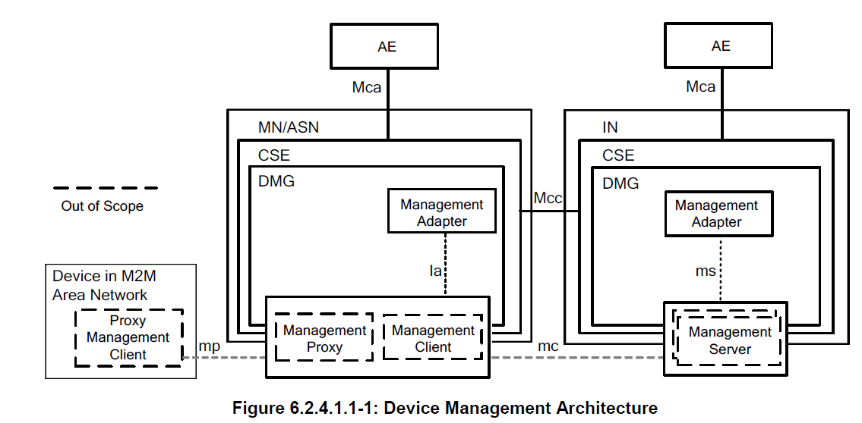

-----------------------Start of change 1-------------------------------------------

6.2.4 Device Management

6.2.4.1 General Concepts

6.2.4.1.0 Overview
The Device Management (DMG) CSF provides management of device capabilities on MNs (e.g. M2M Gateways), ASNs and ADNs (e.g. M2M Devices), as well as devices that reside within an M2M Area Network. Application Entities (AE) can manage the device capabilities on those Nodes by using the services provided by the DMG CSF alleviating the need for the AE to have knowledge of the technology specific protocols or data models. While the AE does not require an understanding of the technology specific protocols or data models, this information is provided to the AE so that an AE can utilize this information for administrative purposes (e.g. diagnostics, troubleshooting).

6.2.4.1.1 Device Management Architecture
In order to manage the CSE and device capabilities of the MNs, ASNs and ADNs, the DMG can utilize existing technology specific protocols(e.g. BBF TR-069 [i.2], OMA-DM [i.3], and LWM2M [i.4]) in addition to management of Management Resources across the Mcc reference point. When the technology specific protocols are used to manage the MN, ASN or ADN, the DMG of the IN translates or adapts the management related requests from other CSEs or from AEs to the techonology specific requests of the correspondingtechnologies.
In order to perform the translation and adaptation functions, the DMG has a functional component termed the Management Adapter (figure 6.2.4.1.1-1). The Management Adapter in the DMG of the IN (IN-DMG-MA) performs the adaptation between the DMG and Management Servers using the ms interface; while the Management Adapter in the DMG of the MN (MN-DMG-MA) and ASN (ASN-DMG-MA) performs translation and adaptation between the DMG and the Management Client using the la interface. Only one Management Adapter is shown in the DMG although it can interact with Management Server using different technology specific protocols.
The interface between Management Server and Management Client (figure 6.2.4.1.1-1) is the mc interface which is subject to the technology specific protocol that is used (e.g. BBF TR-069 [i.2] or LWM2M [i.4]). The mc interface is technology dependent and is outside the scope of the present document.
The DMG in the CSE of the MN has the same functionality as the DMG in the CSE of the ASN. The DMG in the MN or ASN can be used to manage devices in the M2M Area Network. In this case, the DMG is deployed with proxy functionality that interacts with the Proxy Management Client using the mp interface. The mp interface is technology dependent and is outside the scope of the present document.
The Management Server and Management Client can be implemented as an entity external to the Node or they can be implemented as an entity embedded within the Node (figure 6.2.4.1.1-1). The Management Server and the Management Client are located on the boundary of the Node to indicate this situation as well as to depict that an IN can utilize multiple Management Servers from various M2M and Network Service Providers.

-----------------------End of change 1---------------------------------------------

-----------------------Start of Changes to References Section -------------

2.1 Normative references
The following referenced documents are necessary for the application of the present document.
[1] oneM2M Drafting Rules (http://www.onem2m.org/images/files/oneM2M-Drafting-Rules.pdf))

2.2 Informative references
[i.1] oneM2M Drafting Rules (http://www.onem2m.org/images/files/oneM2M-Drafting-Rules.pdf)

-----------------------End of Changes to References -------------

-Start of changes to Definitions Symbols Abbreviations Acronyms -

3 Definitions, symbols, abbreviations and acronyms

3.1 Definitions
<defined term>: <definition>
<defined term>[N]: <definition>

3.2 Symbols
<symbol> <Explanation>

3.3 Abbreviations and Acronyms
<ABBREVIATION/ACRONYM> <Explanation>

---End of changes to Definitions, Symbols, Abbreviations, Acronyms ---

CHECK LIST
- Does this Change Request include an informative introduction containing the problem(s) being solved, and a summary list of proposals.?
- Does this CR contain changes related to only one particular issue/problem?
- Have any mirror CRs been posted?
- Does this Change Request make all the changes necessary to address the issue or problem? E.g. A change impacting 5 tables should not include a proposal to change only 3 tables?Does this Change Request follow the drafting rules?
- Are all pictures editable?
- Have you checked the spelling and grammar?
- Have you used change bars for all modifications?
- Does the change include the current and surrounding clauses to clearly show where a change is located and to provide technical context of the proposed change? (Additions of complete clauses need not show surrounding clauses as long as the proposed clause number clearly shows where the new clause is proposed to be located.)
- Are multiple changes in this CR clearly separated by horizontal lines with embedded text such as, start of change 1, end of change 1, start of new clause, end of new clause.?

