CHANGE REQUEST
Meeting ID:* | ARC 32
Source:* | Yuan Tao, CNICG, taoyuan@cnicg.cn;  Ye Tian, CNIC, tianye@cnic.cn;  Yang Liu, CAICT, liuyang1@ritt.cn.
Date:* | 2017-11-13
Reason for Change/s:* | Insert potential solution for interworking with identification resolution systems.
CR against: Release* | Release 3
CR against: WI* | Active (WI-0069)  MNT maintenance / < Work Item number(optional)>  Is this a companion CR? Yes No  Companion CR number: (Note to Rapporteur - use latest agreed revision)Is this a mirror CR? Yes No  Mirror CR number: (Note to Rapporteur - use latest agreed revision)  STE Small Technical Enhancements / < Work Item number (optional)>  Only ONE of the above shall be ticked
CR against: TS/TR* | TR-0044 Version 1.0.0
Clauses * | 8.2
Type of change: * | Editorial change  Bug Fix or Correction  Change to existing feature or functionality  New feature or functionality  Only ONE of the above shall be ticked
Impacted other TS/TR(s) | N/A
Post Freeze checking:* | This CR contains only essential changes and corrections? YES NO  This CR may break backwards compatibility with the last approved version of the TS? YES NO
Template Version: January 2017 (Do not modify)

oneM2M Notice
The document to which this cover statement is attached is submitted to oneM2M. Participation in, or attendance at, any activity of oneM2M, constitutes acceptance of and agreement to be bound by terms of the Working Procedures and the Partnership Agreement, including the Intellectual Property Rights (IPR) Principles Governing oneM2M Work found in Annex 1 of the Partnership Agreement.

Introduction
This contribution adds the potential solution for the case that the identification resolution systems assist oneM2M system for discovery. The prerequisite is to realize the interworking between oneM2M system and the external identification resolution systems.

----------------------- Start of change 1 -----------------------

8.2 Potential solutions

8.2.1 Discovery on oneM2M node
As section 8.1.2 case1, oneM2M node (the CSE4 in the case) maintains the mapping information, it can process and respond the physical address to the query application (the AE3 in the case) .
This section includes the changes needed in TS-0001 in existing resources, Figures and Tables to support the above scenarios. Impacted sections in TS-0001 will be shown using the applicable section number.

9.6.6 Resource Type container
The <container> resource represents a container for data instances. It is used to share information with other entities and potentially to track the data. A <container> resource has no associated content. It has only attributes and child resources.
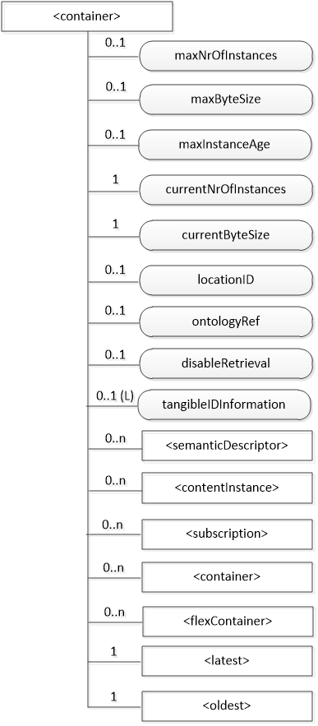
Figure 9.6.6-1: Structure of <container> resource
The <container> resource shall contain the child resources specified in table 9.6.6-1.
Table 9.6.6-1: Child resources of <container> resource
Child Resources of <container> | Child Resource Type | Multiplicity | Description | <containerAnnc> Child Resource Types
[variable] | <semanticDescriptor> | 0..n | See clause 9.6.30 | <semanticDescriptor>, <semanticDescriptorAnnc>
[variable] | <contentInstance> | 0..n | See clause 9.6.7 | <contentInstance>, <contentInstanceAnnc>
[variable] | <subscription> | 0..n | See clause 9.6.8 | <subscription>
[variable] | <container> | 0..n | See clause 9.6.6 | <container>  <containerAnnc>
[variable] | <flexContainer> | 0..n | See clause 9.6.35 | <flexContainer>  <flexContainerAnnc>
la | <latest> | 1 | See clause 9.6.27 | None
ol | <oldest> | 1 | See clause 9.6.28 | None

The <container> resource shall contain the attributes specified in table 9.6.6-2.
Table 9.6.6-2: Attribute of <container> resource
Attributes of  <container> | Multiplicity | RW/  RO/  WO | Description | <containerAnnc> Attributes
resourceType | 1 | RO | See clause 9.6.1.3. | NA
resourceID | 1 | RO | See clause 9.6.1.3. | NA
resourceName | 1 | WO | See clause 9.6.1.3. | NA
parentID | 1 | RO | See clause 9.6.1.3. | NA
expirationTime | 1 | RW | See clause 9.6.1.3. | MA
accessControlPolicyIDs | 0..1 (L) | RW | See clause 9.6.1.3. If no accessControlPolicyIDs value is configured, the accessControlPolicyIDs of the parent resource shall be applied for privilege checking. | MA
labels | 0..1 (L) | RW | See clause 9.6.1.3. | MA
creationTime | 1 | RO | See clause 9.6.1.3. | NA
lastModifiedTime | 1 | RO | See clause 9.6.1.3. | NA
stateTag | 1 | RO | See clause 9.6.1.3. | OA
announceTo | 0..1 (L) | RW | See clause 9.6.1.3. | NA
announcedAttribute | 0..1 (L) | RW | See clause 9.6.1.3. | NA
dynamicAuthorizationConsultationIDs | 0..1 (L) | RW | See clause 9.6.1.3. | OA
creator | 0..1 | RO | See clause 9.6.1.3. | NA
maxNrOfInstances | 0..1 | RW | Maximum number of direct child <contentInstance> resources in the <container> resource. | OA
maxByteSize | 0..1 | RW | Maximum size in bytes of data (i.e. content attribute of a <contentInstance> resource) that is allocated for the <container> resource for all direct child <contentInstance> resources in the <container> resource. | OA
maxInstanceAge | 0..1 | RW | Maximum age of a direct child <contentInstance> resource in the <container> resource. The value is expressed in seconds. | OA
currentNrOfInstances | 1 | RO | Current number of direct child <contentInstance> resource in the <container> resource. It is limited by the maxNrOfInstances. The currentNrOfInstances attribute of the <container> resource shall be updated on successful creation or deletion of direct child <contentInstance> resource of <container> resource | OA
currentByteSize | 1 | RO | Current size in bytes of data(i.e. content attribute of a <contentInstance> resource) stored in all direct child <contentInstance> resources of a <container> resource. This is the summation of contentSize attribute values of the <contentInstance> resources. It is limited by themaxByteSize. The currentByteSize attribute of the <container> resource shall be updated on successful creation of deletion of direct child <contentInstance> resource of <container> resource | OA
locationID | 0..1 | RW | An ID of the resource where the attributes/policies that define how location information are obtained and managed. This attribute is defined only when the <container> resource is used for containing location information. | OA
ontologyRef | 0..1 | RW | A reference (URI) of the ontology used to represent the information that is stored in the child <contentInstance> resources of the present <container> resource (see note). | OA
disableRetrieval | 0..1 | RW | Boolean value to control RETRIE/UPDATE/DELETE operation on the child <contentInsance> resource.  When the value is set to 'TRUE', RETRIEVE/DELETE/UPDATE operations for child <contentInstance> shall be rejected at all times.  When the value is updated from 'TRUE' to 'FALSE', all existing <contentInstance> are deleted immediately.  When the value is set to 'FALSE', all operations are permitted on the <contentInstance> resource as per existing procedures. | OA
tangibleIDInformation | 0..1(L) | RW | This attribute represents a set of tangible identifiers and its related information. The attribute is comprised of 2-tuples (tangibleID, IDType) with parameters shown in table 9.6.4-3. At least one of them shall be contained in this attribute. | OA
NOTE: The access to this URI is out of scope of oneM2M.

The tangibleIDInformation attribute shall contain the parameters specified in table 9.6.4-3.
Table 9.6.4-3: Parameters in tangibleIDInformation attribute
Parameters in tangibleIDInformation | Multiplicity | Description
tangibleID | 0..1(L) | It represents the set of tangible identifiers  that is associated with the specific physical entities. It is described as a list of tangible identifiers (e.g. 86.1000.11/70140703307739, 1.2.156.20000.2010319).  It shall be present in case IDType parameter is null.
IDType | 0..1 | - It shall be present in case tangibleID parameter is null. If the tangibleID parameter is present,  - it represents the corresponding type of the tangible identfiers. If the tangibleID parameter is not present,it represents the identifier type that is supported by the creation originator. The identifier type is expressed in string：  - epc;  - handle;  - oid;  - ucode;  - mcode;  - ecode.

8.2.2 Discovery based on interworking with external systems
As section 8.1.2 case 2, the mapping information is not recorded by oneM2M node, so it is needed to request the external identification resolution systems to implement resolution. The prerequisite is oneM2M system could interwork with the identification resolution systems, such as ONS, Handle system, uCodeRP and so on.
- Identification resolution systems register to oneM2M system
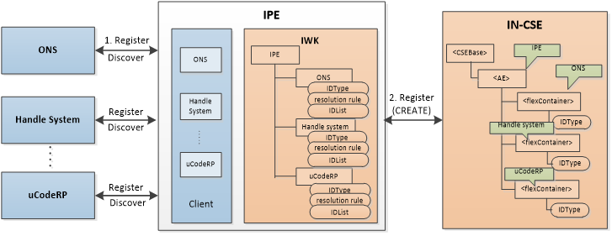
Figure 8.2.2-1: Procedure of registration on oneM2M system

Step 1: The external identification resolution systems register to the IPE, or IPE discovers it proactively. Then the resource which is related to the identification resolution systems and able to recognize by oneM2M system will be created on the IPE. IPE consists of two components:
Client: mainly provides the interfaces for interworking with various identification resolution systems. Each identification resolution system has its corresponding interface module. In addition, the client is responsible for authentication of the resolution systems. Client calls the resolutionRule attribute created by the IWK to assist the resolution operations.
IWK (interworking module): creates the resource for each registered identification resolution system, and the attributes of resource include:
IDType - indicates the identifier type that identification resolution system supports, and the format should be a string, such as ‘epc’, ‘handle’, ‘oid’, ‘ucode’, ‘mcode’ and so on.
resolutionRule - indicates the resolution rules of various resolution systems. The attribute is comprised of 4-tuples:
flag: an indicator to identify various identification interface modules. For instance, the integer field ‘01’is assigned to ONS interface, and ‘02’is assigned to Handle system interface.
protocol: indicates the communication protocol that the identification resolution systems require, such as HTTP, CoAP and so on.
validateExpression: provides the validate expression (e.g. regular expression) to verify the format of identifier meets the standards.
serverAddr: provides the address of identification resolution system.
IDList - a list of mapping information between the tangible identifier and physical address. This attribute is used to store the mapping information, and the results related the specific tangible identifier can be discovered quickly from the IPE subsequently. IPE is responsible to guarantee the mapping information is correct.
Step 2: IPE creates <AE> resource on IN-CSE. Optionally, IPE creates <flexContainer> for each identification resolution system and IDType attribute to indicate its supported identifier type. The structure of <IPE> resource is shown in Figure 8.2.2-2.
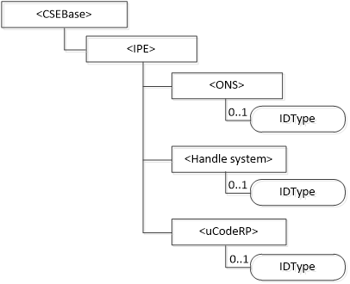
Figure 8.2.2-2: Structure of <IPE> resource on IN-CSE

- Identification resolution systems assist to discovery

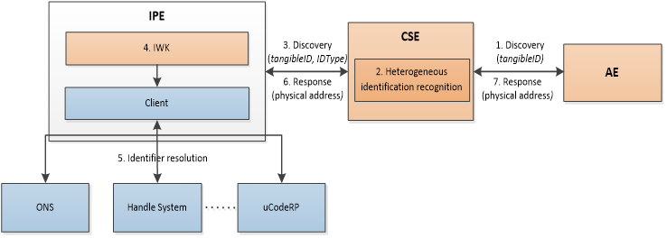
Figure 8.2.2-3: Procedure of discovery based on interworking with external systems

Step 1: AE (e.g. a query application) sends a RETRIEVE request to CSE (e.g. a service platform) to discover the information related the tangible identifier.
Step 2: CSE receives the request, it recognizes the identifier type of tangible identifier by the Heterogeneous identification recognition function. And it researches the corresponding information of the identifier in the resource.
Step 3: In the case that the IN-CSE doesn’t store any information related to the tangible identifier, it would send request to IPE.
Step 4: IWK module search the IDList attribute firstly, if the information related to tangible identifier can not be found in the attribute, the IPE would interwork with the corresponding identification resolution system by the interface, according to the IDType and resolutionRule attributes.
Step 5: The identification resolution system resolves the tangible identifier, and responds the result to IPE. The result is the physical address of the entity that stores the tangible identifier related information, for example, a IP address of ASN.
Step 6: IPE forwards the result to CSE.
Step 7: CSE sends the result to AE. Then the AE can communicate with node according to the physical address, and retrieve the information related to tangible identifier.

----------------------- End of change 1 -----------------------

