Input contribution
Use case
Use Case Title:* | A device abstraction technology in Home Gateway
Group Name:* | WG5
Source:* | NEC Europe (ETSI), NEC Corporation (TTC), Deutsche Telekom (ETSI)
Contact: | JaeSeung Song, NEC (jaeseung.song@neclab.eu),  Andreas Sayegh (Andreas.Sayegh@telekom.de),  Joerg Swetina, NEC (joerg.swetina@neclab.eu),  Ataru Kobayashi, NEC (a-kobayashi@df.jp.nec.com)
Date:* | 2013-07-28
Abstract:* | This contribution introduces a high-level device abstraction concept in Home Gateway.
Agenda Item:* | TBD
Work item(s): | WI0005
Document(s)  Impacted* | Technical Report: Study on Abstraction and Semantics Enablement
Intended purpose of  document:* | Decision  Discussion  Information  Other <specify>
Decision requested or recommendation:* | Incorporate the proposed text if approved.

oneM2M IPR CHARACTERISTICSMENT
“Participation in, or attendance at, any activity of oneM2M, constitutes acceptance of an agreement to be bound by all provisions of IPR policy of the admitting Partner Type 1 and permission that all communications and characteristicsments, oral or written, or other information disclosed or presented, and any translation or derivative thereof, may without compensation, and to the extent such participant or attendee may legally and freely grant such copyright rights, be distributed, published, and posted on oneM2M’s web site, in whole or in part, on a non-exclusive basis by oneM2M or oneM2M Partners Type 1 or their licensees or assignees, or as oneM2M SC directs.

------------------------------------------ 1st Change ------------------------------------------

2.2 Informative references
The following referenced documents are not necessary for the application of the present document but they assist the user with regard to a particular subject area.
[i.x] HGI02029: "Smart Home Architecture and System Requirements".

----------------------------------------- 2nd Change ------------------------------------------

6 Abstraction Technologies

6.1 Overview

6.2 Introduction of Existing Technologies

6.2.x Introduction to Home Gateway Device Abstraction Concept

6.2.x.1 Architecture
Smart Home Abstraction Layer (SHAL) maps appliances to a common representation independent of the home automation technology. SHAL translates protocol-independent requests from applications to protocol-specific ones and then forwards them to the appropriate driver. SHAL represents an Abstract Application Interface for appliances – a technology agnostic description of appliances. The following Figure shows a high-level conceptual architecture for Home Gateway device abstraction technology. [i.x]
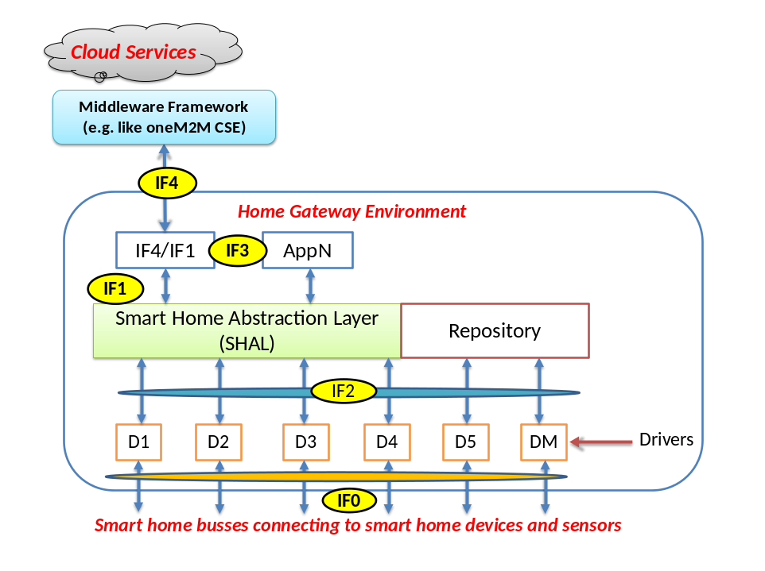
Figure 1 A high-level conceptual HGI architecture
IF1 Abstraction Application Interface: provides a common representation of appliances in the Home Domain to the Execution Environment, so that HG Applications can be independent of the different home automation technologies. For example a ZigBee lamp and a ZWave lamp are represented in the same way through an Error: Reference source not found Service, so that an application can switch both off without dealing with Zigbee/ZWave specifics.
IF2 Device Application Interface: In some cases (mainly for management purposes) it is useful to have direct access to the home automation protocol, in order to do for example protocol-specific configuration or troubleshooting.
IF3: provides “higher-level” service application interface
IF4 Remote Representation: defines the representation of the abstract application interfaces for the backend over a remote protocol. The data corresponds to the data available through IF1, 2 and 3. This reference point also maps remote protocol events to a suitable local notification service for the HG apps.

IF0 External Reference Point: defines the external reference point with bindings to selected protocols.
SHAL Middleware translates ALL of protocol and data models into IF1 primitives what is needed by local networked Appliances. The Home Gateway supports the Cloud protocol(s) over IF4, providing required handshaking and (proxied) status information from Appliances. There is a need to extract the data and commands from the Cloud protocol and translate ALL aspects to primitives on IF1 software interface. Each driver for a local network technology MUST properly translate IF1 primitives into the (proprietary or standardized) signalling on the local network.
Main goals of SHAL are as follows:
- To provide unified APIs for application developers to command, control and query home appliances
- Independence of underlying HAN technologies so that an application developer doesn’t need to know anything about Zigbee, Z-Wave, wireless m-bus etc.
- To enable applications to be portable across different HGI compliant devices
- To enable extending the system with additional HAN technology support without service interruption
- Application should be able to use a pass-through mechanism to use technology-specific functions
The abstract appliance interface descriptions should be mappable to various environments such as Java and/or OSGi, other execution environments (i. e. iOS, Android), REST APIs and other remote protocols (SOAP, CORBA etc.)

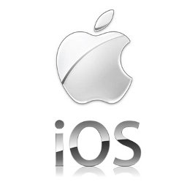
Abstract Interface Descriptions
(e. g. XML)

SOAP
REST
Figure 2 Abstract Interface Descriptions

