Input contribution
Use case
Use Case Title:* | Gym Use Case
Group Name:* | WG5
Source:* | InterDigital Communications
Contact: | Lijun.Dong@InterDigital.com  Catalina.Mladin@InterDigital.com
Date:* | 2014-02-18
Abstract:* | Gym Semantics Use Case
Agenda Item:*
Work item(s):
Document(s)
Impacted*
Intended purpose of  document:* | Decision  Discussion  Information  Other <specify>
Decision requested or recommendation:* | Approval

oneM2M Notice
The document to which this cover statement is attached is submitted to oneM2M. Participation in, or attendance at, any activity of oneM2M, constitutes acceptance of and agreement to be bound by terms of the Working Procedures and the Partnership Agreement, including the Intellectual Property Rights (IPR) Principles Governing oneM2M Work found in Annex 1 of the Partnership Agreement.

  - Title
Gym Use Case on Semantics
  - Description
In the gym use case, as shown in Figure 1 and Figure 2, a gym local area network is set up to provide capabilities enabled locally or, by a Service Provider, via a Service Layer, with which the gym CSE registers at set-up. Devices available in the area network host various applications and are used to enable services. For example, treadmill applications and ambient sensor applications discover the local network and register with it.
The local area network capabilities are used by the users/gym members through devices like a phone, which discover the network and connect to the Service Layer when the member/user arrives. The member also uses devices such as a watch to collect biometric data (pulse, blood pressure, etc.) and feed it to the phone, which might use it within different applications. In this use case an application from the insurance company gathers data to give him points for staying in shape, and another gym-specific application is used to find and schedule available training devices (such as treadmills) or as personal trainer to monitor goals.
In order for the gym application on the phone able to discover and select available training devices, their semantic descriptions should be known to the gym application.

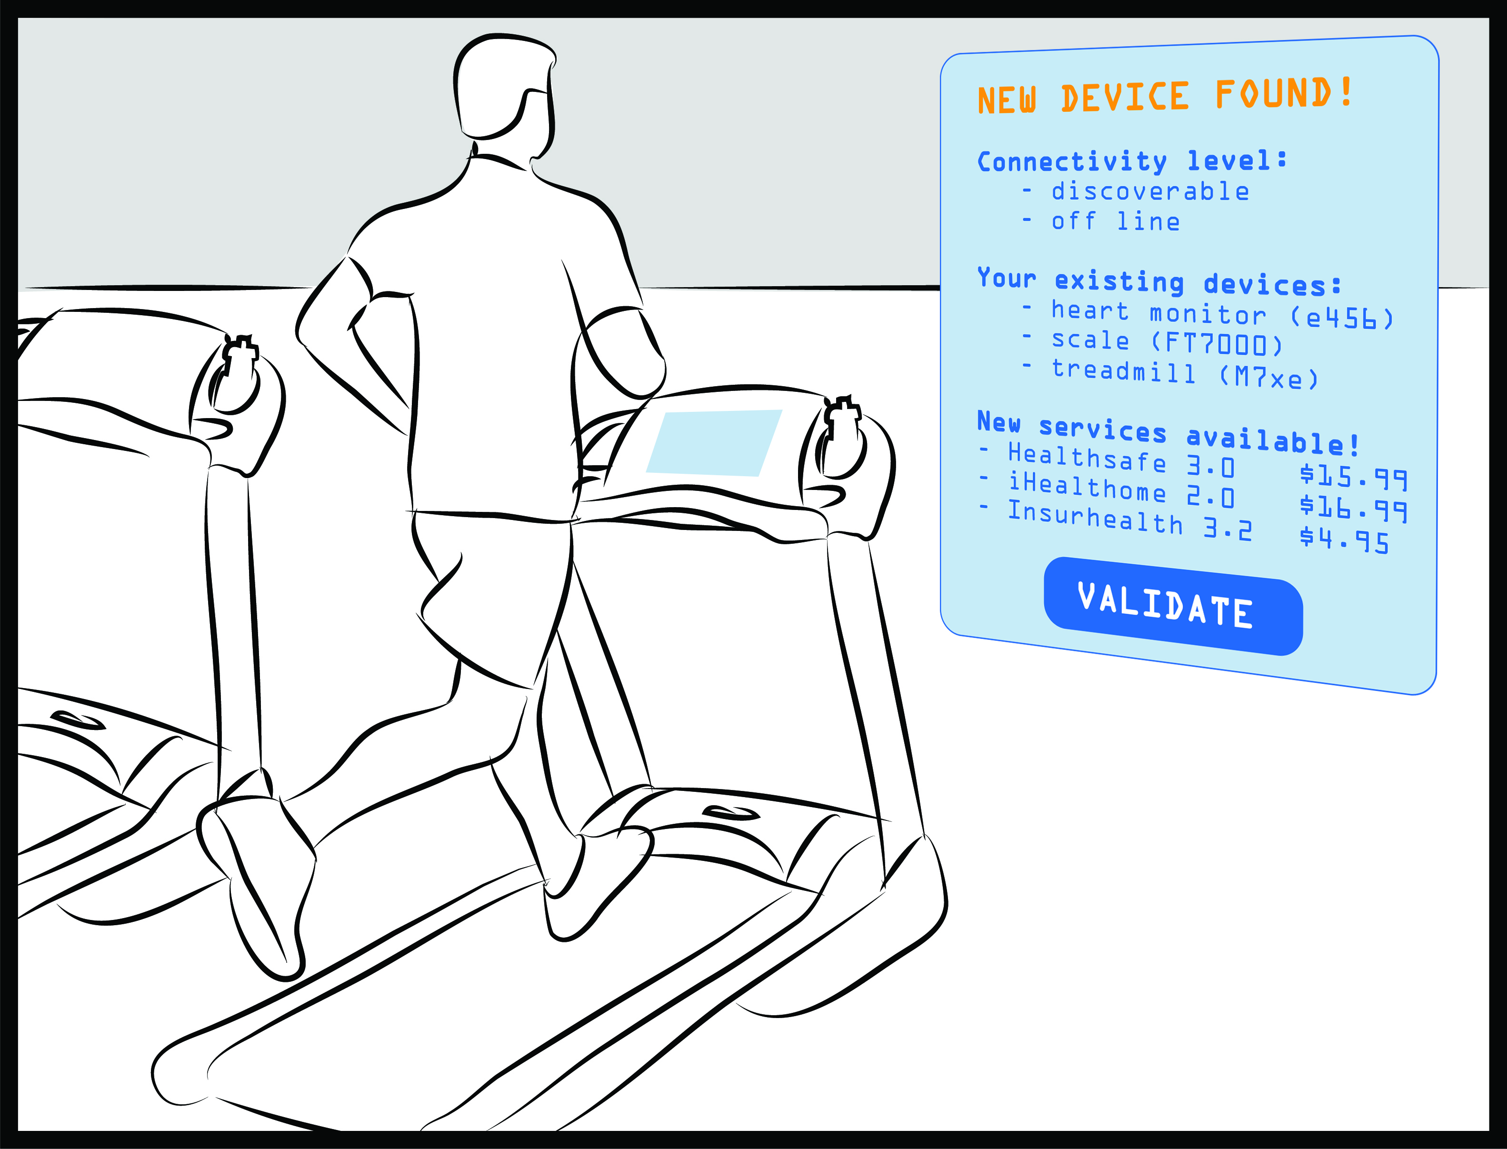
Figure 1 Gym Use Case

Similarly, the health insurance application on the phone collects biometric measurements from the watch. It also collects the data from the gym ambient sensors (e.g. temperature, humidity), and the finished gym training program from the used training device via the gym CSE. The health score of the user can be calculated only based on the collected data and its associated semantics.
The health insurance application on the phone shares its information with the health insurance company application, which can determine and adjust the user’s insurance premium based on it. In order to let the health insurance company application have the same interpretation of the data, the semantics of those resources need to be appropriately added and enabled.

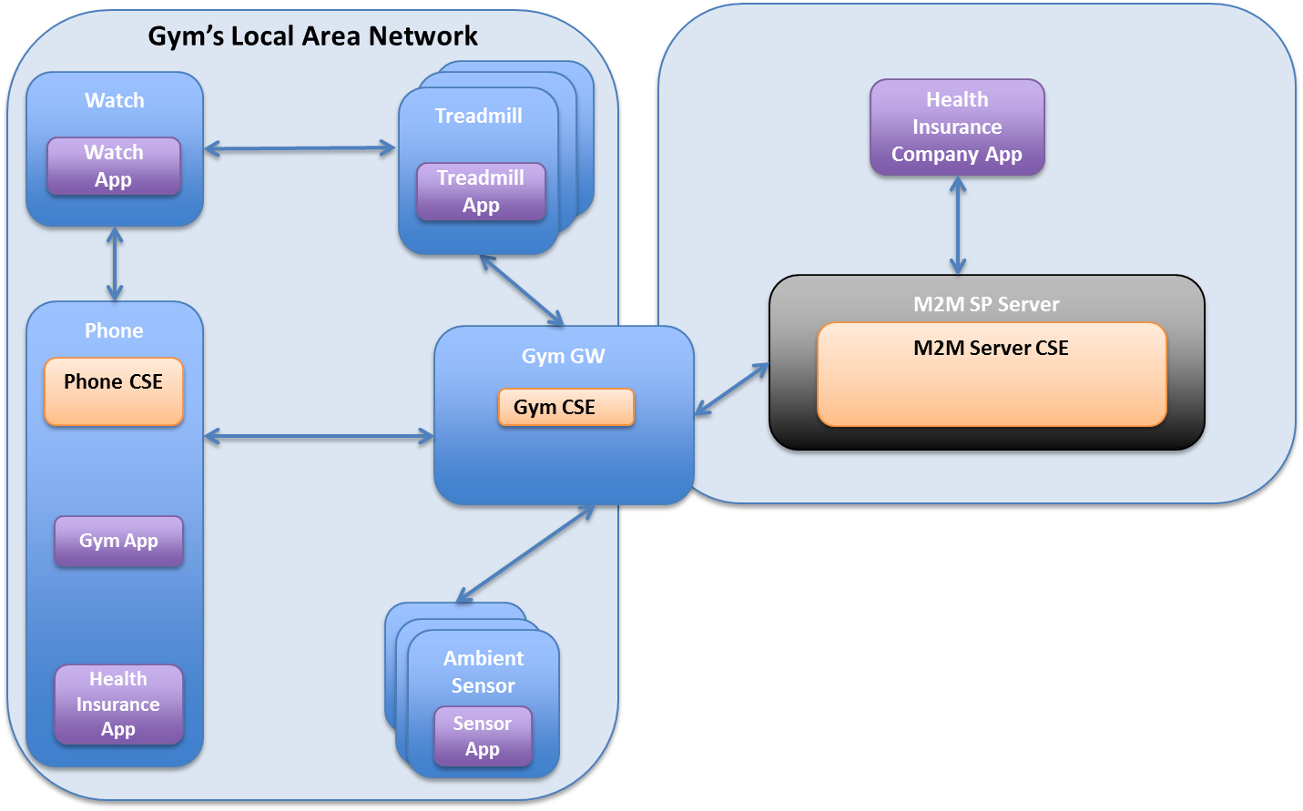
Figure 2 Gym Use Case Architecture

In Figure 3 , we give the ontology model of the gym use case. In Figure 4, we give the ontology model of the treadmills in the gym.
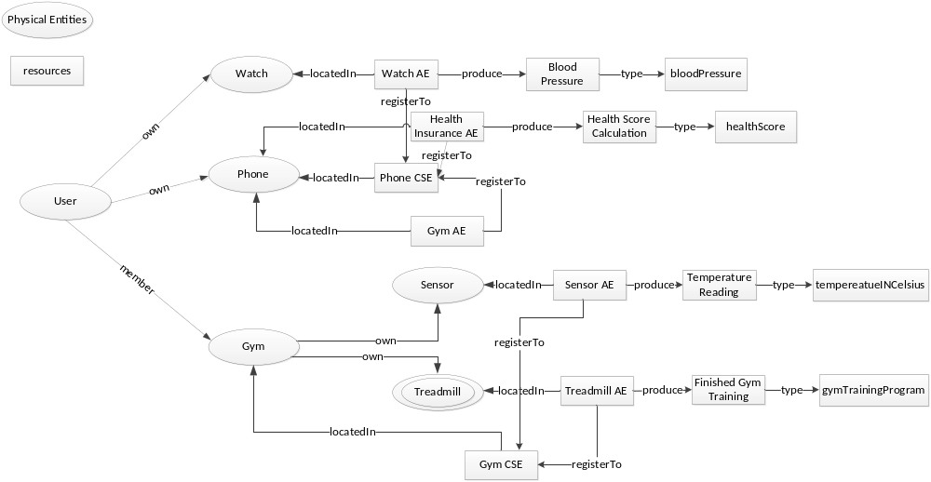
Figure 3 Ontology Model of Gym Use Case
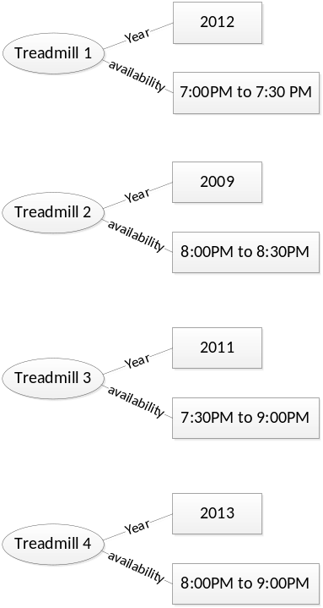
Figure 4 Ontology Model of Treadmills
  - Source
InterDigital Communications

  - Actors
- Gym area network: The local area network in the gym that provides Internet connection to the gym members’ personal devices.
- Ambient sensors: The ambient sensors that are deployed in the gym to measure the environmental parameter in the gym, such as the temperature, humidity.
- Training devices: The training devices that are deployed and available in the gym for the gym members, such as treadmills, elliptical.
- Gym member: The members of the gym who consumes services provided by the gym owners, such as the training devices, gym applications, network connection to their personal wireless devices.
- Gym member’s personal wireless devices: The personal wireless devices that are carried with the gym member into the gym, such as phone, watch, which can measure the person’s vitals, collect the person’s training data, and calculate the person’s health score.
- Health insurance company: The health insurance company provides service to its members for any health insurance related information as well as keeps track of the members’ gym training history and health scores.
- M2M service platform: Gym and health insurance system host which collects, stores, manages and processes data from the user’ devices, the training devices used by the user. It accepts registration from the service providers (gym owner, health insurance company) and the users’ personal devices. It accepts/enforces policies governing data exchange and access from the M2M Service Providers.
  - Pre-conditions
The person has membership contract with the gym service provider, the health insurance provider. The gym service provider and the health insurance provider have business relationship with the M2M Service Provider.
The M2M Service Provider provides the mechanisms to govern the data exchange and access.

  - Triggers
A variety of triggers might be associated with the use case, for examples see flow.

  - Normal Flow

See Figure 7

1), 4), 6), 9) AEs register to the CSEs: watch AE, health insurance AE, gym AE on the phone registers to the phone CSE; ambient sensor AEs and device AEs (e.g. treadmills) register to the gym CSE. The registration message includes semantics associated with each application.
2), 5), 7), 10) Applications create resources to store measurement data in the phone CSE and gym CSE. The semantics of the data needs to be published by the corresponding application as well, which may be linking to other resources on other locations such as the semantics repository. In order to understand it, the relevant resource representation needs to be retrieved by the phone CSE, gym CSE.
3), 8), 11) Semantics relevant resources to the newly created resources (AEs, measurement resources) are retrieved by the phone CSE, gym CSE and made available. Resources will be made available together with the context included in resource representation and associated semantics. The phone CSE and the gym CSE are able to parse and interpret the newly created resources, and support semantics-based query on those resources.
12) Registered applications request actions based on available resources. In this case the gym application on the phone can query which treadmill will be unoccupied for a certain period of time.
13) The gym CSE provides a value added service using semantics, for example through the treadmill availability query. From the OWL ontology shown in Figure 4, the following SPARQL queries can be processed to find the treadmills that are available from 8:00PM to 8:30PM. The query and its result are shown in Figure 5 and Table 1.

PREFIX gym:<coap://example.org/gym.owl#>
PREFIX xsd: <http://www.w3.org/2001/XMLSchema#>
SELECT ?treadmill
WHERE {
?treadmill gym:availability ?availability .
FILTER(?availability >= 20:00:00^^xsd:time && ?availability <= 20:30:00^^xsd:time ) .
}
Figure 6 Query

Table 1 Query Result
treadmill
treadmill2
treadmill3
treadmill4

14) The response to the semantics-based query is returned; in this case the query response may include the URI of the resources and associated semantics.
15) The requesting application uses the response to the query, including the semantics associated with the resources in the response.
16) An application subscribes to data stored on the gym CSE and the phone CSE. Subscribed data such as ambient sensor measurements, user biometrics and finished gym training program are collected.
17), 20) The subscribing application retrieves the relevant resource representation as well as its associated semantics from the gym CSE and the phone CSE. The resource associated semantics may link to other resources on the semantics repository, which need to be retrieved as well in order to provide data analysis. The semantic descriptions are parsed and interpreted.
18), 21) The application uses the data and associated semantics for analysis and computation.
19) An application subscribes to data stored on the gym CSE and the phone CSE. Subscribed data such as the health score computed by the health insurance application, the user finished gym training program.

  - Post-conditions
N/A

  - High Level Illustration
See Figure 7

  - Potential requirements
- The M2M System shall provide the capability to publish semantic descriptions.
- The M2M System shall support parsing and interpreting semantic descriptions.
- The M2M System shall support resource discovery based on semantics.

  - Reference
- Resource Description Framework (RDF): Concepts and Abstract Syntax (http://www.w3.org/TR/rdf-concepts/)
- RDF Vocabulary Description Language 1.0: RDF Schema, http://www.w3.org/TR/rdf-schema/
- SPARQL Query Language for RDF, http://www.w3.org/TR/rdf-sparql-query/
- Web Ontology Language (OWL), http://www.w3.org/2001/sw/wiki/OWL
- Open Geospatial Consortium, OpenGIS Sensor Model Language (SensorML), http://www.opengeospatial.org/standards/sensorml .
- W3C Semantic Sensor Network Incubator Group, Semantic Sensor Network Ontology, \http://www.w3.org/2005/Incubator/ssn/ssnx/ssn.
- Dbpedia, http://dbpedia.org/About

- 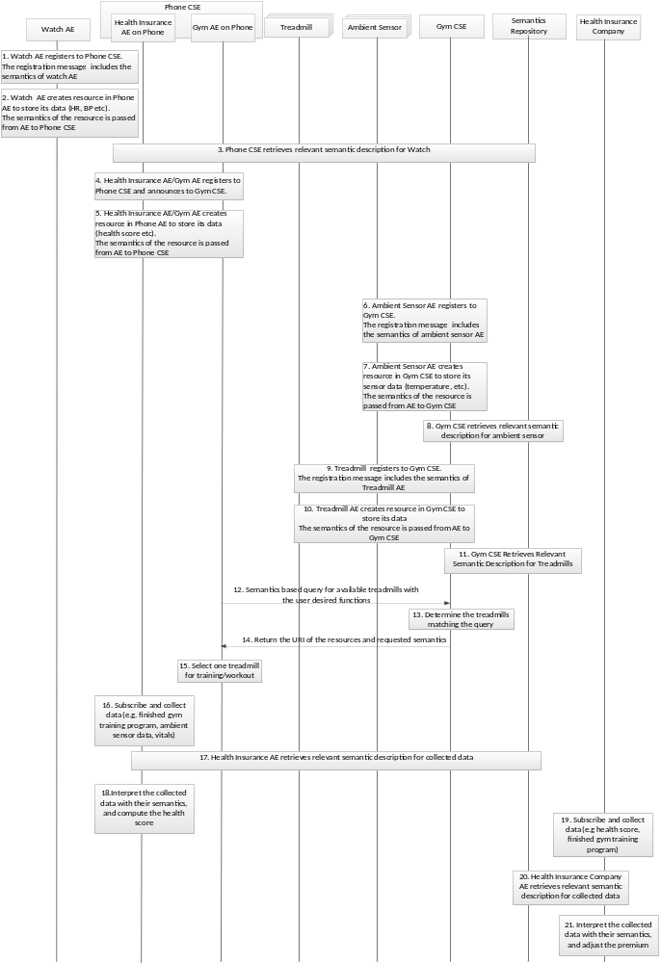
Figure 8 Flow

