INPUT CONTRIBUTION
Group Name:* | WG#5
Title:* | Using Semantics to model Interworking with non-oneM2M Devices  in Rel-1
Source:* | NEC (ETSI, TTC)
Contact: | Martin Bauer, NEC, martin.bauer@neclab.eu  Joerg Swetina, NEC, joerg.swetina@neclab.eu  Ataru Kobayashi, NEC, a-kobayashi@df.jp.nec.com
Date:* | 2014-07-18
Abstract:* | This contribution shows how in Rel-1 semantics can be used in a limited way for non-oneM2M devices and Area Networks that are interworking with the oneM2M System. It builds upon the concept of “Interworking Proxy” as described in Annex F of TS 0001.  The contribution is proposed to be included as section 8.4 in TR 0007:  8 Support for Abstraction and Semantics in oneM2M  8.1 Summary of Requirements  8.2 Modeling aspects for abstraction and semantics in oneM2M  8.3 oneM2M architectural considerations for abstraction and semantics  8.4 Interworking with non-oneM2M Devices and Area Networks in Rel-1 (new section)  Additionally, two references are added to section 2.2
Agenda Item:* | TBD
Work item(s): | oneM2M-WI-0005-Abstraction_&_Semantics_Capability_Enablement
Document(s)  Impacted* | oneM2M-TR-0007-Study_on_Abstraction_and_Semantics_Enablement  V0_10_0
Intended purpose of  document:* | Decision  Discussion  Information  Other <specify>
Decision requested or recommendation:*

oneM2M Notice
The document to which this cover statement is attached is submitted to oneM2M. Participation in, or attendance at, any activity of oneM2M, constitutes acceptance of and agreement to be bound by terms of the Working Procedures and the Partnership Agreement, including the Intellectual Property Rights (IPR) Principles Governing oneM2M Work found in Annex 1 of the Partnership Agreement.

New section 8.4

8.4 Interworking with non oneM2M Devices and Area Networks
in Rel-1
8.4.1 Semantic support in oneM2M Release 1
oneM2M Release 1 does not yet provide full semantic functions. However some limited aspects of semantics can already be used in Rel-1 to support interworking with Area networks and non-oneM2M devices. For that purpose only the structure information (concepts, relations), that is contained in ontologies, is proposed to be used in Rel-1.
A mechanism (a “cook book”) is described that shows how that structure information can be utilized to create oneM2M resources (AEs and Containers) that are needed for interworking with non-oneM2M devices and area networks.
For that purpose the “ontologyRef” attribute of AEs and Containers as described in oneM2M TS 0001 [i.38] is used.
It should be noted that this approach for Rel-1 does not yet allow for more dynamic usage of semantic information like discovery, reasoning or mesh-ups.
8.4.2 Basic functional principles
Annex F of TS 0001 describes Interworking / Integration of non-oneM2M solutions and protocols with the oneM2M System. Interworking is accomplished through specialized M2M Applications, called “Interworking Proxy Applications” (IPAs).
An Interworking Proxy Application interfaces
- a CSE of the oneM2M System (IN-CSE, MN-CSE or ASN-CSE)
- one or more Area Networks and the Non-oneM2M devices in these Area Networks.
The Interworking Proxy maps the native data model and communication primitives of the Non-oneM2M devices into oneM2M resources that can be accessed by oneM2M procedures (Create, Retrieve, Update, Delete). Interworked non-oneM2M devices communicate over Area Networks with the Nodes (IN, MN or ASN) of oneM2M and these Nodes therefore need to contain communication capabilites to for the Area Networks. Note, that Area Networks for legacy technologies (e.g. Mbus/COSEM) often are not based on IP.
The following figure illustrates how a M2M Application (e.g. a Utility Application) can access non-oneM2M devices (e.g. Sensors/Meters implementing MBus/COSEM or ZigBee technology) that interwork via Interworking Proxies with the oneM2M System.

Sensor/Meter
CSE
Mbus/COSEM
Inter-working Proxy
Application
Mca
Utility Application
Mca
Sensor/Meter
Zigbee telco Profile
Inter-working Proxy
Application
Mca
Application Service Node
CSE
Mcc
Infrastructure Node
Figure X

8.4.3 Generic topology for interworking with non-oneM2M devices and Area Networks
The following figure Y shows the concept model (following the Approach described in Section 8.2.1) representing an Area Network, its non-oneM2M devices as well as its relationship to an Interworking Proxy Application (IPA).

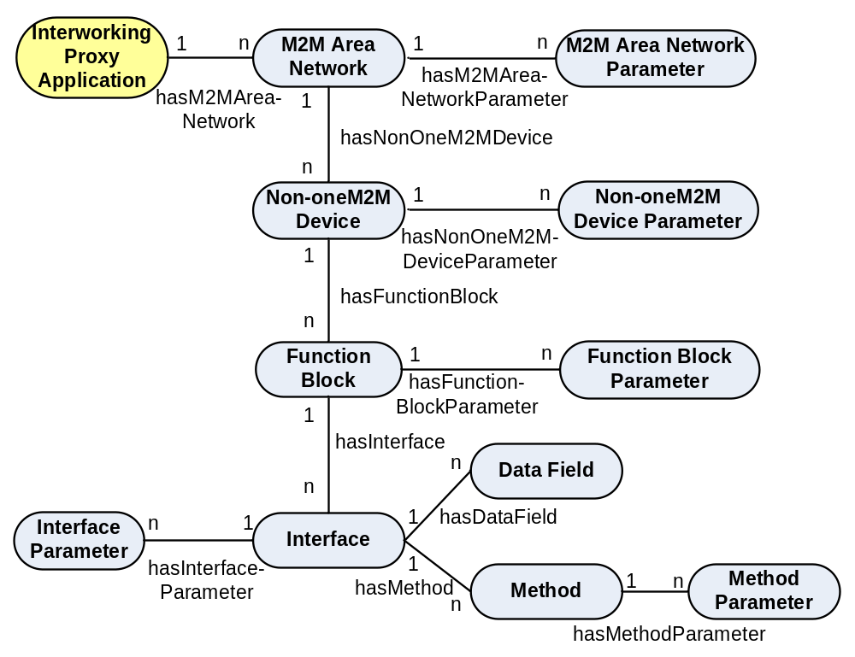Figure Y

An Interworking Proxy Application is an M2M Application that communicates with one or more M2M Area Networks.
The M2M Area Network contains a number of non-oneM2M Devices
(example: ZigBee network with Home Automation Profile)
Each non-oneM2M Device is an entity of the M2M Area Network that contains one or more Function Blocks
(example: ZigBee device object)
A Function Block is a sub-unit of a non-oneM2M Device that performs a some services of the non-oneM2M Device
(example: ZigBee Thermostat, a ZigBee Temperature Sensor)
Each Function Block has Interfaces for communication of data to/from the Function Block. Each Interface consists of combinations of
- Data Fields that can be read and/or updated
- Methods that can be executed
Each Method has its Method Parameters that can (a) be input to the device or (b) output from the device.
8.4.4 Semantic modelling of interworking
In Section 8.4.3 the high-level semantic concepts and their relations have been defined. These high-level concepts are used for defining the oneM2M resource structure for interworking. According to the type modelling described in Section 8.2.2.2 thea specific type related to the respective high-level concepts can be modelled and the ontologyRef attribute can be used to refer to it. For example, a ZigBeeTemperatureSensor can be modelled as a specific device, so the ontologyRef could be http://ZigBeeOntology#TemperatureSensor, indicating that the modelled device AE actually represents a temperature sensor.
For modelling the high-level semantic concepts AE resources and container resources are used. AE resources are used for those concepts where functionality may be handled by independent applications. Other concepts, as well as relations between concepts, are modelled by containers and subcontainers respectively, using the respective ontologyRef attribute to reference the ontology concept (e.g. OWL class) or the relation (e.g. OWL object properties). The values in the final subcontainer instance contain the URL of the oneM2M resource providing the content of the referenced instance. For example, the M2M Area Network may be modelled as an AE Resource. The relation hasNon-oneM2M Device between the concepts M2M Area Network and Non-oneM2M Device to describe that an M2M Area Network contains non-oneM2M Devices is mapped to a container for “hasNon-oneM2M Device”, which has a subcontainer for each Non-oneM2MDevice, which is part of the network. The instance of the subcontainer resource contains the resource URI pointing to the AE Resource of the Non-oneM2MDevice.
In this way, any oneM2M application can utilize the fixed resource structure to access data and semantic-aware oneM2M applications can use the ontologyRef attribute to find out about the more specific semantic content of the resources, e.g. that the Non-oneM2M device is actually a ZigBee temperature sensor.
8.4.5 Mapping into oneM2M resources
This clause describes the mapping principles that are used to map a generic M2M Area Network into a structured tree of oneM2M resources.
As explained before, the IPA is an M2M Application.
The basic principle followed here is to map Non-oneM2M entities (M2M Area Networks, non-oneM2M Devices) that are accessible via the IPA application are mapped into resources of type AE that are linked to the IPA resource. The entities Function Blocks, Interfaces, Data Fields, Methods and Method Parameters are mapped into container resources as sub resources of a non-oneM2M Device AE. Figure 1 shows this high-level mapping.
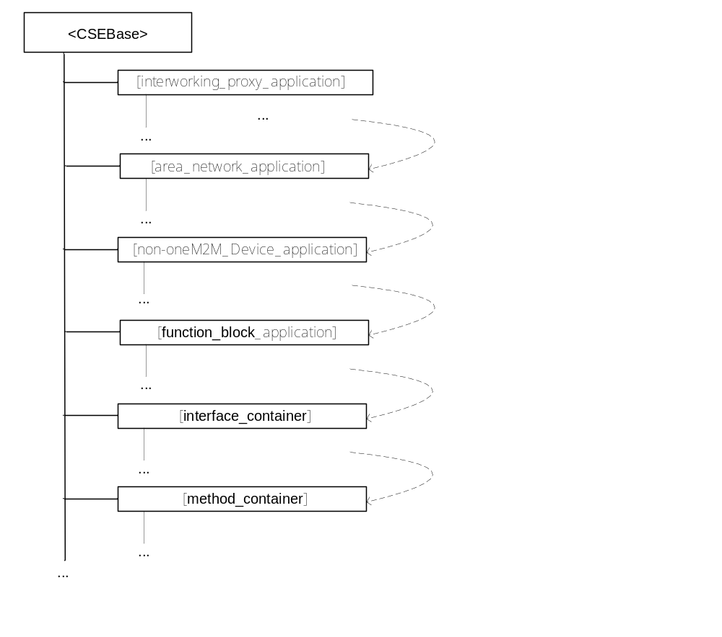
Figure 1 High-level resource structure for interworking
8.4.5.1 Interworking Proxy Application
The Interworking Proxy Application (IPA) is modelled as a resource [interworking_proxy_application] of Resource Type AE. The URI used to access this resource has the following format:
[CSEBase]/[interworking_proxy_application]
e.g.: IN-CSEID.m2m.myoperator.org/CSERoot/myIPA

Note: While the addressing in the example above and in the rest of this section follows the Hierarchical URI Method convention ([i.38], section 9.3.1) all three different methods for addressing a resource within the oneM2M resource structure as described in [i.38], section 9.3.1 are possible.
[CSEBase] is the Hosting CSE (IN-CSE, MN-CSE or ASN-CSE) where the IPA had been created by administrative means.
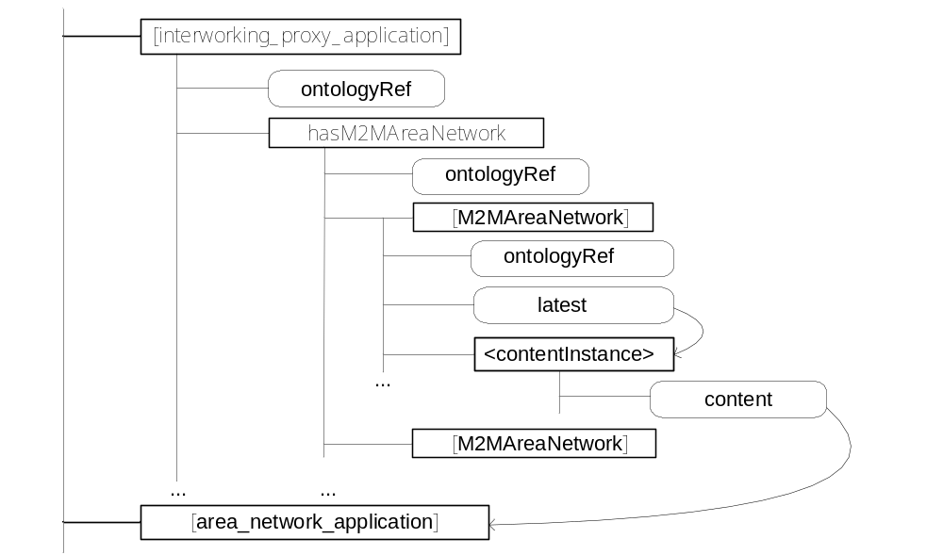
The ontologyRef attribute of the [interworking_proxy_application] resource has a value of:
http:// [oneM2M_ontology] #IPA
or a more specific variant (e.g. a specific IPA for home automation by some industry group) that is a sub-class of the IPA class in the oneM2M_ontology.
8.4.5.1.1 Linking the Interworking Proxy Application to its M2M Area Networks
The Interworking Proxy Application resource contains a sub resource of type container with the fixed name hasM2MAreaNetwork that mirrors the relation hasM2MAreaNetwork between the concepts InterworkingProxyApplication and M2M Area Network. It contains subcontainers with references to each M2M Area Network the IPA supports.
The URI used to access this container resource has the following format:
[CSEBase]/[interworking_proxy_application]/hasM2MAreaNetwork
e.g.: IN-CSEID.m2m.myoperator.org/CSERoot/myIPA/hasM2MAreaNetwork
The hasM2MAreaNetwork resource of type container contains sub-containers of type container. Each sub-container of the hasM2MAreaNetwork container holds a reference to an M2M Application that represents one M2M Area network that is supported by the IPA.
When a new M2M Area network is supported by the IPA then the IPA:
- creates a new M2M Area Network Application
- creates a new sub-container in the hasM2MAreaNetwork container whose contentInstance contains a reference to the M2M Area Network Application
8.4.5.2 M2M Area Network Application:
The M2M Area Network Application is modelled as a resource [area_network_application] of Resource Type AE. An M2M Area Network Application is created by an IPA.
The URI used to access this resource has the following format:
[CSEBase]/[area_network_application]
e.g.: IN-CSEID.m2m.myoperator.org/CSERoot/myIPA_ZigBeeNW
The M2M Area Network Application is responsible for:
- managing the one M2M Area Network, containing technology dependent logic.
The management of the one M2M Area Network may be supported by using oneM2M Management Functions (e.g. by utilizing a related areaNwkInfo resource)
- discovering the M2M Area Network structure (devices, etc.) and keeping track of changes of the structure;
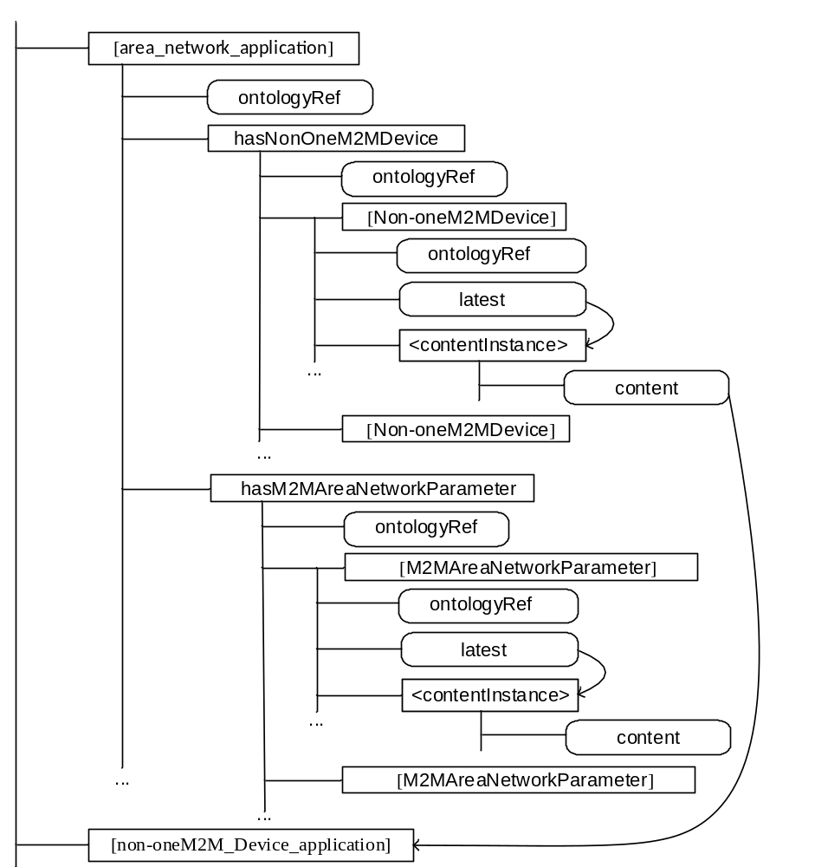

The M2M Area Network Application is dependent on the technology of the M2M Area Network and the hardware (drivers, etc.) of the area network communication module.
The ontologyRef attribute of the [area_network_application] resource has a value of:
http://[oneM2M_ontology] #Area_Network
or a technology specific variant that is a sub-class of the oneM2M_ontology, e.g.:
http:// [ZigBee_ontology] #ZigBee_Area_Network

8.4.5.2.1 Linking the M2M Area Network to its non-oneM2M devices
The M2M Area Network Application resource contains a sub resource of type container with the fixed name hasNonOneM2MDevice that mirrors the relation hasNon-oneM2M Device between the concepts M2M Area Network and Non-oneM2M Device.
The URI used to access this container resource has the following format:
[CSEBase]/[area_network_application]/hasNonOneM2MDevice
e.g.: IN-CSEID.m2m.myoperator.org/CSERoot/myIPA/ hasNonOneM2MDevice
The ontologyRef attribute of the hasNonOneM2MDevice container has a value of:
http://[oneM2M_ontology] #hasNonOneM2MDevice
or a more specific variant that is a sub-property of the hasNonOneM2MDevice property in the oneM2M_ontology.
This hasNonOneM2MDevice container in turn has sub-containers whose contenInstance each holds a reference to an M2M Application that represents one non-oneM2M Device in the M2M Area Network.
The URI used to access a container resource whose contentInstance contains the reference to a Non-oneM2M Device Application has the following format:
[CSEBase]/[area_network_application]/hasNonOneM2MDevice/[Non-oneM2M_Device]
e.g.: IN-CSEID.m2m.myoperator.org/CSERoot/myIPA/ hasNonOneM2MDevice/myNon-oneM2M_Device_1

8.4.5.2.2 Parameters of the M2M Area Network
The M2M Area Network Application resource contains a sub resource of type container with the fixed name hasM2MAreaNetworkParameter that contains the parameters for that M2M Area Network.
The URI used to access this container resource has the following format:
[CSEBase]/[area_network_application]/hasM2MAreaNetworkParameter
e.g.: IN-CSEID.m2m.myoperator.org/CSERoot/myIPA/ hasM2MAreaNetworkParameter
The ontologyRef attribute of the hasM2MAreaNetworkParameter container has a value of:
http://[oneM2M_ontology]#hasM2MAreaNetworkParameter
or a more specific variant that is a sub-property of the hasM2MAreaNetworkParameter property in the oneM2M ontology.

This hasNonOneM2MDevice container in turn has sub-containers [M2MAreaNetworkParameter] that each contain the value of that parameter

8.4.5.2.3 Functional description of the M2M Area Network Application:
When a new non-oneM2M Device is added to/removed from the M2M Area Network then the M2M Area Network Application:
- creates/deletes the Non-oneM2M Device Application
- creates/deletes the sub-container of its hasNonOneM2MDevice container whose contentInstance contains the reference to the Non-oneM2M Device Application

8.4.5.3 Non-oneM2M Device Application:
The Non-oneM2M Device Application is modelled as a resource [non-oneM2M_Device_application] of Resource Type AE. A Non-oneM2M Device Application is created by an M2M Area Network Application.
The URI used to access this resource has the following format:
[CSEBase]/[non-oneM2M_Device_application]
e.g.: IN-CSEID.m2m.myoperator.org/CSERoot/myIPA_ZigBeeNW_HomeController
The Non-oneM2M Device Application is responsible for:
- communicating with the Non-oneM2M Device by using (technology specific) communication means of the M2M Area Network
- exposing function blocks of the Non-oneM2M Device
The ontologyRef attribute of the [non-oneM2M_Device_application] resource has a value of:
http://[oneM2M_ontology] #non_oneM2M_Device
or a technology specific variant that is a sub-class of the oneM2M_ontology, e.g.:
http://[ZigBee_ontology ]#ZigBee_Router_node

8.4.5.3.1 Linking the non-oneM2M device to its Function blocks
The Non-oneM2M Device Application resource contains a sub resource of type “container” with the fixed name “hasFunctionBlock” that mirrors the relation “hasFunctionBlock” between the concepts “Non-oneM2M Device” and “FunctionBlock”.
The URI used to access this container resource has the following format:
[CSEBase]/ [non-oneM2M_Device_application]/hasFunctionBlock
e.g.: IN-CSEID.m2m.myoperator.org/CSERoot/ myIPA_ZigBeeNW_HomeController/hasFunctionBlock
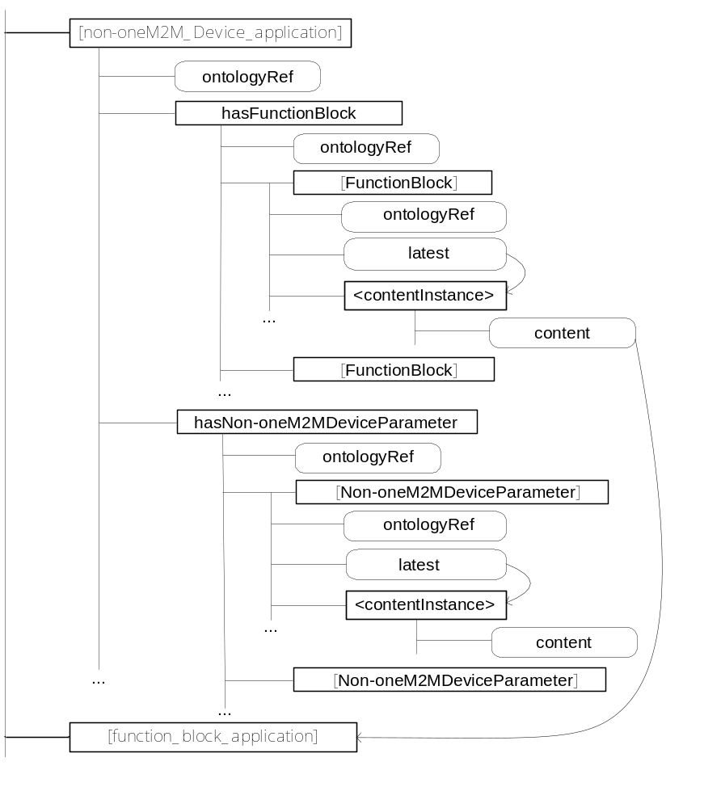
The ontologyRef attribute of the “hasFunctionBlock” container has a value of:
http://[oneM2M_ontology] #hasFunctionBlock
or a more specific variant that is a sub-property of the hasFunctionBlock property in the oneM2M ontology.
This “hasFunctionBlock” container in turn has sub-containers that each hold a reference to an M2M Application that represents one Function Block of the non-oneM2M Device.
8.4.5.3.2 Parameters of the Non-oneM2M Device Application
The Non-oneM2M Device Application resource contains a sub resource of type container with the fixed name hasNon-oneM2M DeviceParameter that contains the parameters for that M2M Area Network.
The ontologyRef attribute of the hasNon-oneM2MDeviceParameter container has a value of:
http://[oneM2M_ontology]#hasNon-oneM2MDeviceParameter
or a more specific variant that is a sub-property of the hasNon-oneM2MDeviceParameter property in the oneM2M ontology.
This hasNon-oneM2M DeviceParameter container in turn has sub-containers [Non-oneM2MDeviceParameter] that each contain the value of that parameter

8.4.5.3.3 Functional description of the Non-oneM2M Device Application:
When a new non-oneM2M Device has been created by the M2M Area Network Application then, by administrative means (manually or automatically if the technology of the non-oneM2M network enables transmission of the relevant information) the Non-oneM2M Device Application:
- creates new Function Block Applications for the non-oneM2M Device
- creates new contentInstances in its hasFunctionBlock container that contains references to the Function Block Applications

8.4.5.4 Function Block Application:
Function Blocks of a non-oneM2M device are sub-functions of the device. Communication with one function block is independent from communication with other function blocks.
An example of a function block could be a ZigBee® application on a ZigBee® node (a non-oneM2M Device).
The Function Block Application is modelled as a resource [function_block_application] of Resource Type AE. A Function Block Application is created by a Non-oneM2M Device Application.
The URI used to access this resource has the following format:
[CSEBase]/ [function_block_application]
The Function Block Application is responsible for:
- communicating with the function block on the Non-oneM2M Device by using (technology specific) communication means of the M2M Area Network
- exposing function blocks of the Non-oneM2M Device
The ontologyRef attribute of the [function_block_application] resource has a value of:
http://[oneM2M_ontology] #function_Block
or a technology specific variant that is a sub-class of the oneM2M_ontology, e.g.:
http://[ZigBee_ontology] #ZigBee_Router_application

8.4.5.4.1 Linking the Function block to its Interfaces
The Function Block Application resource contains sub resources of type containerwith the fixed name hasInterface that mirrors the relation hasInterface between the concepts FunctionBlock and Interface.
The ontologyRef attribute of the hasInterface container has a value of:
http://[oneM2M_ontology] #hasInterface
or a more specific variant that is a sub-property of the hasInterface property in the oneM2M ontology.
This hasInterface container in turn has sub-containers whose contentInstance each holds a reference to a resource of type container, representing one Interface of the Function Block.
The URI used to access this container resource has the following format:
[CSEBase]/ [function_block_application]/hasInterface
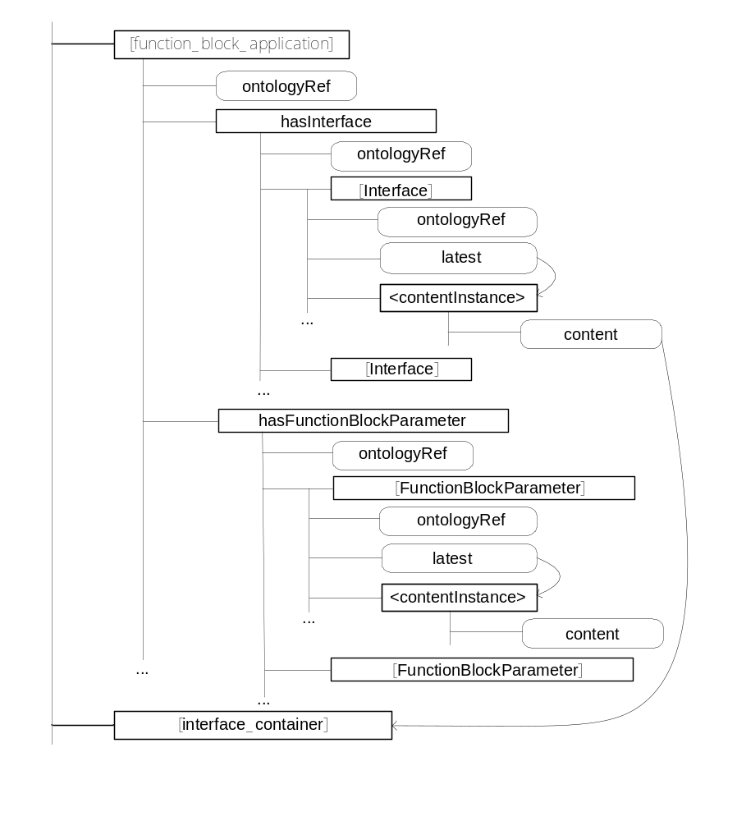
8.4.5.4.2 Parameters of the Function Block Application
The Function Block Application resource contains a sub resource of type container with the fixed name hasFunctionBlockParameter that contains the parameters for that Function Block.
The ontologyRef attribute of the hasFunctionBlockParameter container has a value of:
http://[oneM2M_ontology]#hasFunctionBlockParameter
or a more specific variant that is a sub-property of the hasFunctionBlockParameter property in the oneM2M ontology.
This hasFunctionBlockParameter container in turn has sub-containers [FunctionBlockParameter] that each contain the value of that parameter

8.4.5.4.3 Functional description of the Function Block Application:
When a new Function Block Application has been created by the non-oneM2M Device Application then the Function Block Application:
- creates new Interface containers for the Function Block
- creates new contentInstances in its hasInterface container that contains references to the Interfaces

8.4.5.5 Interface container:
The Interface Container is modelled as a resource [interface_container] of Resource Type container. An M2M Area Network Application is created by an IPA.
The URI used to access this resource has the following format:
[CSEBase]/[interface_container]
e.g.: IN-CSEID.m2m.myoperator.org/CSERoot/mySensorInterface
The Interface Container is the oneM2M representation of the interfaces (data fields and methods of function blocks of non-oneM2M devices,
- providing access to the data fields and/or methods of the interface
- providing access to any parameters that are directly related to the interface

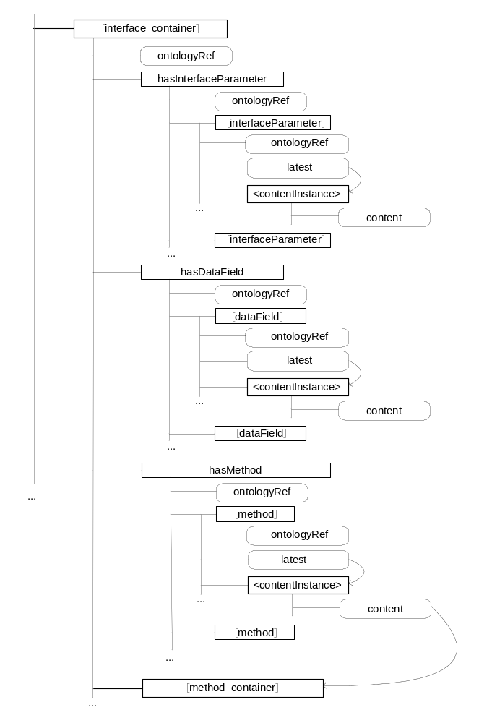
The ontologyRef attribute of the [interface_container] resource has a value of:
http://[oneM2M_ontology] #Interface
or a technology specific variant that is a sub-class of the oneM2M_ontology, e.g.:
http:// [ZigBee_ontology] #ZigBee_Interface

8.4.5.5.1 Linking the Interface to its Data Fields
The Interface Container resource contains a sub resource of type container with the fixed name hasDataField that mirrors the relation hasDataField between the concepts Interface and Data Field.
The URI used to access this container resource has the following format:
[CSEBase]/[interface_container]/hasDataField
e.g.: IN-CSEID.m2m.myoperator.org/CSERoot/mySensorInterface/ hasDataField
The ontologyRef attribute of the hasDataField container has a value of:
http://[oneM2M_ontology] #hasDataField
or a more specific variant that is a sub-class of the hasDataField class in the oneM2M_ontology.

This hasDataField container in turn has sub-containers whose contentInstance contains the value of the Data Field.
The URI used to access a container resource whose contentInstance contains the value of a DataField has the following format:
[CSEBase]/[interface_container]/hasDataField/[dataField]
e.g.: IN-CSEID.m2m.myoperator.org/CSERoot/mySensorInterface/ hasDataField/myDataField

8.4.5.5.2 Linking the Interface to its Methods
The Interface Container resource contains a sub resource of type container with the fixed name hasMethod that mirrors the relation hasMethod between the concepts Interface and Method.
The URI used to access this container resource has the following format:
[CSEBase]/[interface_container]/hasMethod
e.g.: IN-CSEID.m2m.myoperator.org/CSERoot/mySensorInterface/ hasMethod
The ontologyRef attribute of the hasMethod container has a value of:
http://[oneM2M_ontology] #hasMethod
or a more specific variant that is a sub-class of the hasMethod class in the oneM2M_ontology.This hasMethod container in turn has sub-containers whose contenInstances each holds a reference to a sub-container of the [Interface] container that represents one Method of the Interface.
The URI used to access a container resource whose contentInstance contains the reference to a Method container has the following format:
[CSEBase]/[interface_container]/hasMethod/[method]
e.g.: IN-CSEID.m2m.myoperator.org/CSERoot/mySensorInterface/ hasMethod/readTemperatureMethod

8.4.5.5.3 Parameters of the Interface
The Interface resource contains a sub resource of type container with the fixed name hasInterfaceParameter that contains the parameters for that Interface.
The URI used to access this container resource has the following format:
[CSEBase]/[interface_container]/hasInterfaceParameter
e.g.: IN-CSEID.m2m.myoperator.org/CSERoot/mySensorInterface/ hasInterfaceParameter
The ontologyRef attribute of the hasInterfaceParamter container has a value of:
http://[oneM2M_ontology] #hasInterfaceParameter
or a more specific variant that is a sub-property of the hasInterfaceParameter property in the oneM2M_ontology.
This hasInterfaceParameter container in turn has sub-containers[interfaceParameter] whose contentInstances each contain the value of the respective parameter.

8.4.5.5.4 Methods of the Interface
[Interface] container that represents one Method of the Interface
Each [Method] sub-container of the [Interface] resource contains a sub resource of type container with the fixed name hasMethodParameter that contains the parameters for that Parameter of the method.
The URI used to access this container resource has the following format:
[CSEBase]/[interface_container]/hasMethodParameter
e.g.: IN-CSEID.m2m.myoperator.org/CSERoot/mySensorInterface/ hasMethodParameter
The ontologyRef attribute of the hasInterfaceParamter container has a value of:
http://[oneM2M_ontology]#hasMethodParameter
or a more specific variant that is a sub-property of the hasMethodParameter property in the oneM2M_ontology.
This hasMethodParameter container in turn has sub-containers[MethodParameter] whose contentInstances each contain the value of the respective parameter.

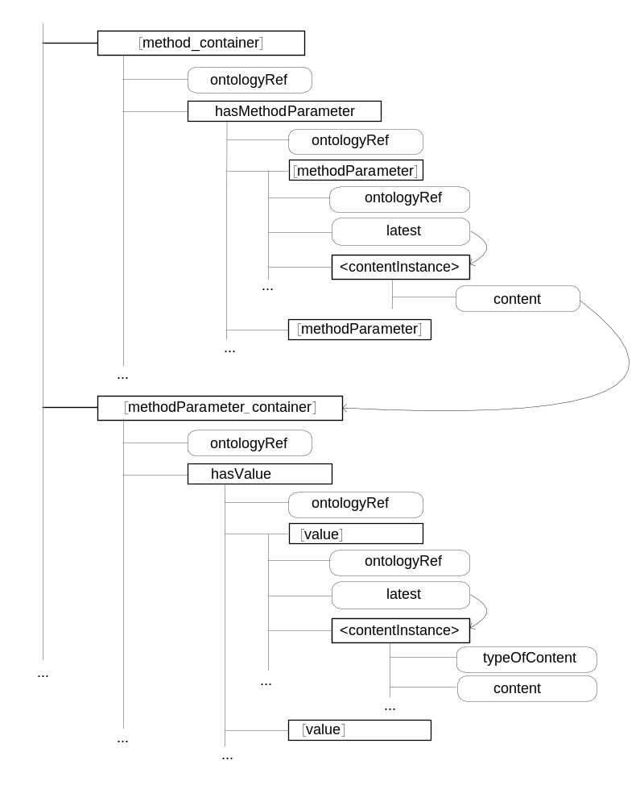

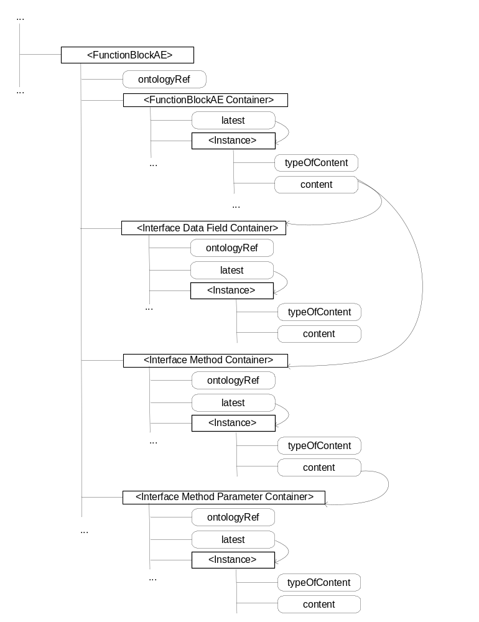

==== end of new section 8.4 =====================================

==== change to section 2.2 (adding reference of artchitecture TS) =======

2.2 Informative references
The following referenced documents are not necessary for the application of the present document but they assist the user with regard to a particular subject area.
…
[i.37] OWL Syntaxes, http://ontogenesis.knowledgeblog.org/88?kblog-transclude=2
[i.38] oneM2M-TS-0001: "oneM2M Functional Architecture"
==== end change ==============================================

