CHANGE REQUEST
Meeting:* | MAS#16
Source:* | Heedong Choi, LG Electronics, heedong.choi@lge.com
Date:* | 2015-03-23
Contact:* | Heedong Choi, LG Electronics, heedong.choi@lge.com
Reason for Change/s:* | Proposes a design principle of abstraction information model
CR against: Release*
CR against: WI* | Active <Work Item number> WI-0017  MNT Maintenace / < Work Item number(optional)>  STE Small Technical Enhancements / < Work Item number (optional)>  Only ONE of the above shall be ticked
CR against: TS/TR* | TR-0017 V.0.1.0
Clauses/Sub Clauses* | 2.1, 5.2 and 5.3
Type of change: * | Editorial change  Bug Fix or Correction  Change to existing feature or functionality  New feature or functionality  Only ONE of the above shall be ticked
Post Freeze checking:* | This CR contains only essential changes and corrections? YES NO  This CR is a mirror CR? YES NO if YES, please indicate the document number of the original CR:  <Document Number)<CR Number of the original CR to the current Release>
Template Version:23 February 2015 (Dot not modify)

oneM2M Notice
The document to which this cover statement is attached is submitted to oneM2M. Participation in, or attendance at, any activity of oneM2M, constitutes acceptance of and agreement to be bound by terms of the Working Procedures and the Partnership Agreement, including the Intellectual Property Rights (IPR) Principles Governing oneM2M Work found in Annex 1 of the Partnership Agreement.
GUIDELINES for Change Requests:
Provide an informative introduction containing the problem(s) being solved, and a summary list of proposals.
Each CR should contain changes related to only one particular issue/problem.
In case of a correction, and the change apply to previous releases, a separated “mirror CR” should be posted at the same time of this CR
Follow the principle of completeness, where all changes related to the issue or problem within a deliverable are simultaneously proposed to be made E.g. A change impacting 5 tables should not only include a proposal to change only 3 tables. Includes any changes to references, definitions, and acronyms in the same deliverable.
Follow the drafting rules.
All pictures must be editable.
Check spelling and grammar to the extent practicable.
Use Change bars for modifications.
The change should include the current and surrounding clauses to clearly show where a change is located and to provide technical context of the proposed change. Additions of complete sections need not show surrounding clauses as long as the proposed section number clearly shows where the new section is proposed to be located.
Multiple changes in a single CR shall be clearly separated by horizontal lines with embedded text such as, start of change 1, end of change 1, start of new clause, end of new clause.
When subsequent changes are made to content of a CR, then the accepted version should not show changes over changes. The accepted version of the CR should only show changes relative to the baseline approved text.

Introduction
This contribution proposes the design principle of abstraction information model.

-----------------------Start of change 1-------------------------------------------

5.2 Design Principle of Abstraction Information Model

This section defines a design principle of the abstraction information model for the home domain appliance. Based on analysis works in the Section 5.1, design principles of abstraction information model may be specified. (That is, serveral design principles can be discussed in this technical report to discovery an optimum information model in the home domain environment.)

5.2.1 Design Principle: Approach 1
Based on the analysis work for the AllJoyn (section 5.1.1) and HomeKit (section 5.1.2), design principles of the abstraction information model are as follows:
- Each device has the information model of its own.
- Vendor-specific function is needed for un-predefined characteristic(s).
- Common/universal characteristics are needed to avoid duplicating the description.
- Home appliances shall be composed of one or more characteristic(s).
Based on the above principles, the basic abstraction information model is designed as shown in figure 5.2-1.
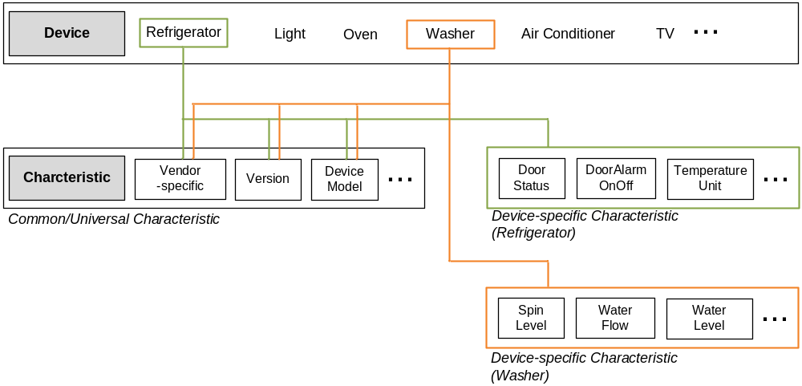
Figure 5.2-1: Design Principle of Abstraction Information Model
- ‘Characteristic’ specifies pre-defined device characteristics which mean an atomic fuction (such as version, device model, door status). Since some characteristic(s) may present in all in all device, the chatacteristic is clarified as common/universal and device-specific characteristic in order to avoid duplicating the description for every device.
- ‘Device’ which represents physical home appliance (such as TV, Air Conditioner, Refrigerator) is composed of one or more pre-defined characteristic(s).

-----------------------End of change 1---------------------------------------------

-----------------------Start of change 2-------------------------------------------

5.3 Define Abstraction and Describe Specific Information Model

This section defines plural abstract information model for the home domain devices based on the design principle.

5.3.1 Information Model: Approach 1
This approach is based on the ‘Design principle: Approach 1’ (section 5.2.1). That is, this section provides details on the ‘Charateristic’ and ‘Device’ for home domain information model. Here, the data type is defined in [x].

5.3.1.1 Common/Universal Chracteristic Sets
This section provides details on the common/universal charateristics for home domain information model. Since some characteristics in all home domain devices may have same values, the common/universal chracteristic sets are considered to avoid duplicating the description.
Chracteristic Name | Description
vendorSpecific | The characteristic contains vendor-specific information.
deviceFirmwareID | Firmware version
deviceType | Device type. Each device type is defined as follows:  - 101: refrigerator  - 201: washer  - 202: dryer  - 301: oven  - 401: airconditioner  - 501: hombot  - 801: boiler  - 901: speaker
deviceAliasName | Device alias name
deviceSubModelName | Device sub-model name
nation | Nation code
deviceModelName | Device model name
deviceID | Device ID

5.3.2 Device Sets
This section provides details on the ‘device’ for home domain information model. Among home domain devices, the washer is considered for representation.

Chracteristic  Name | Data Type | Value | Permission | Description
vendorSpecific | xs:anySimpleType | - | RW | See clause 5.3.1 where this common attribute is described.
deviceFirmwareID | xs:string | - | RO | See clause 5.3.1 where this common attribute is described.
deviceType | xs:positiveInteger | - | RO | See clause 5.3.1 where this common attribute is described.
deviceAlias  Name | xs:positiveInteger | - | RO | See clause 5.3.1 where this common attribute is described.
deviceSub  ModelName | xs:string | - | RO | See clause 5.3.1 where this common attribute is described.
nation | xs:string | - | RO | See clause 5.3.1 where this common attribute is described.
deviceModel  Name | list | - | RO | See clause 5.3.1 where this common attribute is described.
deviceID | xs:string | - | RO | See clause 5.3.1 where this common attribute is described.
error | xs:positiveInteger | 1: door open  2: water supply  3: drainage  4: spin-dry  5: water-level  6: sensor water level  7: temperature sensor  8: motor  9: clutch  17: door lock | RO | Error status
mode | xs:nonNagativeInteger | 0: off  5: preparation  6: pause  20: wash preparation  23: wash  30: rinse  40: spin-dry  50: dry  60: wash off  62: on | RO | Wash status
state | xs:boolean | 0: off  1: on | RW | Power status
smart | xs:boolean | 0: off  1: on | RO | Remote control status
water | xs:nonNagativeInteger | 0: no choice  1: cold water  2: hot water  3: tepid water | RO | Temperature of supply water
total | xs:string | - | RO | Remain time + Reserve time (HHMM)
remain | xs:string | - | RO | Remain time (HHMM)
reserve | xs:string | - | RO | Reserve time (HHMM)
name | xs:positiveInteger | 1: standard/normal  2: wool  3: quick(speed) wash  4: bulky/bedding  6: silent  7: laundry tub dry  8: laundry tub clean  11: frugal wash  12: towel  13: functional clothing  17: double rense  18: stain(soak)  19: spin onlt  20: rinse + spin | RO | Configured washer course
soilLevel | xs:nonNagativeInteger | 0: no wash  1: 3  2: 6  3: 10  4: 12  5: 14  6: 17  7: 19  8: 21  9: 23  10: 25 | RO | Configured soil level
spinLevel | xs:nonNagativeInteger | 0: no spin-dry  1: delicate  2: low  3: medium  4: high  5: highest | RO | Configured spin level
rinse | xs:nonNagativeInteger | 0: 0  1: 1  2: 2  8: 3  9: 4  10: 5 | RO | Configured rinse value
soak | xs:nonNagativeInteger | 0: none  1: 15 minutes  2: 30 minutes  3: 45 minutes  4: 60 minutes  5: 120 minutes  6: 180 minutes | RO | Configured soak information
waterFlow | xs:nonNagativeInteger | 0: None  1: Strong  2: Normal  3: weak | RO | Configured water flow information

-----------------------End of change 2---------------------------------------------

-----------------------Start of Changes to References Section -------------

2.1 Normative references
[x] oneM2M TS-0004, “Service Layer Core Protocol Specification”

-----------------------End of Changes to References -------------

CHECK LIST
- Does this change request include an informative introduction containing the problem(s) being solved, and a summary list of proposals.?
- Does this CR contain changes related to only one particular issue/problem?
- Have any mirror crs been posted?
- Does this change request make all the changes necessary to address the issue or problem? E.g. A change impacting 5 tables should not only include a proposal to change only 3 tables. Includes any changes to references, definitions, and acronyms in the same deliverable?
- Does this change request follow the drafting rules?
- Are all pictures editable?
- Have you checked the spelling and grammar?
- Have you used change bars for all modifications?
- Does the change include the current and surrounding clauses to clearly show where a change is located and to provide technical context of the proposed change? (Additions of complete sections need not show surrounding clauses as long as the proposed section number clearly shows where the new section is proposed to be located.)
- Are multiple changes in this CR clearly separated by horizontal lines with embedded text such as, start of change 1, end of change 1, start of new clause, end of new clause.?

