CHANGE REQUEST
Meeting:* | MAS27
Source:* | Wolfgang Granzow, Qualcomm, wgranzow@qti.qualcomm.com  Phil Hawkes, Qualcomm, phawkes@qti.qualcomm.com  Josef Blanz, Qualcomm, jblanz@qti.qualcomm.com
Date:* | 2017-02-17
Contact:* | As above
Reason for Change/s:* | This CR provides details for [authenticationProfile], [trustAnchorCred] and [MAFClientRefCfg] specializations of <mgmtObj>. The text is aligned with the reorganization proposed in MAS-2017-0023, with architecture level details under clause 7.1 and protocol-level details under clause 7.2.
CR against: Release* | 2.x
CR against: WI* | Active WI-0030: Field Device Configuration  MNT maintenace / < Work Item number(optional)>  STE Small Technical Enhancements / < Work Item number (optional)>  Only ONE of the above shall be ticked
CR against: TS/TR* | TS-0022 V.0.9.0
Clauses/Sub Clauses* | (Changed) 2.1, 3.2, 3.3, 7.1.4, 7.1.5, 7.1.6, 7.3.1*  (new) 7.1.7, 7.2.4, 7.2.5, 7.2.6, 7.2.7 7.3.2  *7.3.1 is a new clause created by MAS-2017-0023. Text was in 7.2.1 of v0.9.0
Type of change: * | Editorial change  Bug Fix or Correction  Change to existing feature or functionality  New feature or functionality  Only ONE of the above shall be ticked
Post Freeze checking:* | This CR contains only essential changes and corrections? YES NO  This CR may break backwards compatibility with the last approved version of the TS? YES NO  This CR is a mirror CR? YES if YES, please indicate the document number of the original CR: <Document Number) : NO
Template Version:27 May 2015 (Dot not modify)

oneM2M Notice
The document to which this cover statement is attached is submitted to oneM2M. Participation in, or attendance at, any activity of oneM2M, constitutes acceptance of and agreement to be bound by terms of the Working Procedures and the Partnership Agreement, including the Intellectual Property Rights (IPR) Principles Governing oneM2M Work found in Annex 1 of the Partnership Agreement.

Introduction
This CR is an extension of MAS-2017-0005R03.
The TS-0032 MAF and MEF interface, where credential management will be specified, will specify Credential Object specializations. Consequently, the following <mgmtObj> specializations are being deleted from TS-0022:
- [symmKeyCred]: this resource will, hereafter, be specified in TS-0032.
  - For the purpose of identifying a symmetric key to use with an [authenticationProfile] , symmKeyID attribute has been merged into [authentionProfile] in this CR to avoid using a mgmtLink
- [myCertFileCred]: this resource will, hereafter, be specified in TS-0032.
- [myCertFingerprintCred]: the attributes of this resource have been merged into a new myCertFingerprint attribute of the [authentionProfile] in this CR, to avoid using a mgmtLink to identify a certificate.
- [myCertIssuerDNCred]: this specialization will cease being specified. The reason is that there this might not uniquely identify a certificate, and may pose a security risk.
- [publicKeyIDCred]: the attribute of this resource has been merged into [authentionProfile] in this CR to avoid using a mgmtLink.
- [MAFKeyRegCred]: these attributes are being merged into [authProfile] in this CR to avoid using a mgmtLink.
The [trustAnchorCred] remains in this specification, but is changed slightly to allow for a different approach for managing trust anchors. This resource now contains a certificate fingerprint to identify a trust anchor certificate, and a URI for retrieving that trust anchor certificate if a copy of the trust anchor certificate is not already in local storage.
As can be seen above, many attributes used for identifying credentials have become attributes of [authenticationProfile]. This has been done for the following reasons; (a) to keep TS-0022 independent of TS-0032 and (b) reduce the number of <mgmtObj> being managed and (c) eliminate un-necessary use of mgmtLinks.
R01: Cleanup based on commetns received offline from Tim Carey (Nokia)
- Corrected numbering
- Corrected heading styles
- Defined datatypes for attributes that we undefined.
- Added reference to IETF RFC 6920, which is used to define two simple oneM2M data types for device configuration
- Other minor editorial corrections and technical clarifications.
R02
- The text is aligned with the reorganization proposed in MAS-2017-0023-CR_DevCfg-V0_9_0_Reorganising_clause_7, with architecture level details under clause 7.1, protocol-level details under clause 7.2 and datatypes in clause 7.3.
- This version assumes that MAS-2017-0024-CR_DevCfg_dataCollection_links_to_ESPrim_authProfile is agreed, which allows [dataCollection] to link to an [authenticationProfile] for the purposes of providing End-to-End Security of Primitives.
- The resources being specified ([authenticationProfile] and [MAFClientRegCfg]) are unchanged, with the following exception
  - Previously, [authenticationProfile] was being used for performing the MAF Key Retrieval procedure. This was unnecessary. Now it is assumed that a MAF Client will perform MAF Key Retrieval without being configured with a corresponding [authenticationProfile]. The change is that the MAFRelativeKeyID attribute is no longer present in [authenticationProfile].
R03: changes from R02 for each specialization are shown below
- [authenticationProfile]
  - Table 7.1.1-1: no change
  - 6.2.2.4, 7.1.4 & 7.2.4.1
    - Added symmKeyValue attribute (we already discussed this).
    - Specified that [trustAnchorCred] are child resources of [authenticationProfile] and removed mgmtLinks. I think this is clearer for people to understand.
  - Additional info in 7.2.4.1
    - Added minimum key length to symmKeyValue (this information was previously in the description of [symmKeyCred]
    - Added table 7.2.4.1-3 describing child resources.

- [myCertFileCred]
  - Table 7.1.1-1: new row for this specialization type
  - 6.2.2.5: New clause “My certificate file credential information elements”
  - New 7.1.5 & 7.2.5.1 based on 7.1.5.4 of v0.9.0.
    - Added description of SUIDs attribute (we already discussed this)
      - Added table 7.1.5-3 listing SUID which are currently supported in the [myCertFileCred] resource. The text refers the reader to table 7.1.4-3 (in the description of the [authenticationProfile]) for references to the corresponding authentication procedure in oneM2M TS-0003 [3] and DTLS/TLS notes.
  - Added table 7.2.5.1-3 describing child resources.

- [trustAnchorCred]
  - (in the previous revision of this CR, this resource type described following [authenticationProfile], but [myCertFileCred] is not inserted in between [authenticationProfile and [trustAnchorCred])
  - Table 7.1.1-1: editorial corrections only
  - 6.2.2.6 – new introductory text.
  - 7.1.6 no change
  - Added table 7.2.6.1-3 describing child resources.

- [MAFClientRegCfg]
  - Table 7.1.1-1: no change
  - 7.1.7 & 7.2.7.1: Added [authenticationProfile] as a child resource, and remove mgmt link. I think this is clearer for people to understand.
  - Added table 7.2.7.1-3 describing child resources.

R04:
- [authenticationProfile]
    - Converted the references to [trustAnchorCred] child resources back into mgmtLink.

- [MAFClientRegCfg]
  - Moved mgmtLink down in the sequence order in both tables and the figure.

-----------------------Start of change 1a-------------------------------------------

Information needed for M2M Service Layer operation

Introduction
The Configuration AE provisions the <mgmtObj> resource types in the IN-CSE and the IN-CSE then interacts with the DM Server, ADN or ASN/MN node or Configuration IPE in order to configure the AE or CSE on the nodes.

Information elements required for M2M Service Layer operation

Introduction
The ASN/MN and ADN in the Field Domain should support the capability to be configured with the <mgmtObj> resource types defined in the present document prior to initial registration with a registrar CSE (enrolment phase). When the AE or CSE has established M2M Service Layer operation with a Registrar CSE (operational phase), the AE or CSE shall provide the capability to be configured with the <mgmtObj> resource types defined in the present document.

M2M Service Layer registration information elements
The information elements used for CSE or AEs to register with a Registrar CSE shall include the following information which depend on the M2M Service Provider:
- PoA information of Registrar CSE
- Protocol binding to be used between AE or CSE and the Registrar CSE.
- CSE-ID of the CSE hosted on the ASN/MN
- AE-ID of an AE hosted on an ASN/MN or ADN
This set of information elements may be linked to a set of authentication profile information elements (see clause 6.2.2.4) providing the configuration for security association establishment with the Registrar CSE.

Application configuration information elements
In order for an AE to operate, the AE may need to know the resource location within the Hosting CSE to maintain its resource structure. In addition, for resources that are frequently provided by the AE to the Hosting CSE, the AE may be configured with information that defines how frequently the AE collects or measures the data as well as the frequency at which the data is transmitted to the Hosting CSE.
When the Hosting CSE is not the Registrar CSE of the AE, then this set of information elements may be linked to a set of authentication profile information elements (see clause 6.2.2.4) providing the configuration for establishing End-to-End Security of Primitives (ESPrim) with the Hosting CSE.

-----------------------End of change 1a -------------------------------------------

-----------------------Start of change 1b: NEW TEXT------------------------------------

6.2.2.4 Authentication profile information elements
Authentication profile information elements may be required to establish mutually-authenticated secure communications.
The applicable security framework is identified via a Security Usage Identifier (SUID). Where the security framework uses TLS or DTLS, a set of permitted TLS ciphersuites may be provided. Then the applicable credentials are identified – with the allowed type of credentials dictated by the SUID.
A security framework can use a pre-provisioned or remotely provisioned symmetric key for establishing mutually-authenticated secure communications. In this cases, the identifier for the symmetric key is provided. If a symmetric key is remotely provisioned, then a Remote Security Provisioning Framework (RSPF) should be used as described in clause 8.3 of oneM2M TS-0003 [3]. Alternatively, the value of the symmetric key may be configured as an information element of the authentication profile.
Certificate-based security frameworks may use one or more trust anchor certificates (also known as "root CA Certificates" or "root of trust certificates"). Information about trust anchor certificates is provided in the child trust anchor credential information elements (see clause 6.2.2.5) of the authentication profile.
MAF-based security frameworks use a MAF to facilitate establishing a symmetric key to be used for mutual authentication. The MAF Client registration configuration credential information elements enable a MAF Client to perform MAF procedures with the MAF.

6.2.2.5 My certificate file credential information elements
A security framework can use a certificate to authenticate the intended security principal in the Managed Entity to other security principals, as part of establishing mutually-authenticated secure communications. The certificate can be pre-provisioned or remotely provisioned, as discussed in oneM2M TS-0003 [3]. If a certificate is remotely provisioned, then a Remote Security Provisioning Framework (RSPF) should be used as described in clause 8.3 of oneM2M TS-0003 [3], or my certificate file credential information elements may be configured to the Managed Entity as described in the present specification.
My certificate file credential information elements include the media type of file containing the certificate, the file containing the certificate, and a list of Security Usage Identifiers (SUID) for which the certificate may be used.

6.2.2.6 Trust anchor credential information elements
A security framework can use one or more trust anchor certificate (also known as "root Certificate Authority certificates" or" root of trust certificates") which a security principal on the Managed Entity is to use for validating certificates of other security principals, as part of establishing mutually-authenticated secure communications.
The trust anchor credential information elements include a hash-value-based identifier of the trust anchor certificate, along with a URL from which the trust anchor certificate can be retrieved. The Managed Entity can compute the hash value for the locally stored trust anchor certificates to determine if there is a match with the hash value in the information elements. If there is no match for the trust anchor certificates in local storage, then the Managed Entity retrieves the trust anchor certificate from the URL, and verifies that the hash value of the retrieved trust anchor certificate is a match for the hash value in the information elements.

6.2.2.7 MAF Client registration configuration information elements
A security framework can use a MAF to facilitate establish symmetric key in a security principal in the Managed Entity and one or more other security principals, with the symmetric key used for establishing mutually-authenticated secure communications between the security principals. In this case, the security principals are MAF Clients. The security principal in the Managed Entity shall perform the MAF Client registration procedure, described in clause 8.8.2.3 of oneM2M TS-0003 [3] before the MAF facilitates establishing the symmetric keys.
The MAF Client registration configuration information elements configure the security principal in the Managed Entity for the MAF Client registration procedure, as described in clause 8.8.3.2 of oneM2M TS-0003 [3].

-----------------------End of change 1b -------------------------------------------

-----------------------Start of change 2-------------------------------------------

Introduction
The present clause specifies <mgmtObj> resource specializations used to configure AEs or CSEs on ADN or ASN/MN nodes in the Field Domain in order to establish M2M Service Layer operation.
Table 6.1.1-1 shows summary of defined <mgmtObj> resource specializations in the present document.
Table 7.1.1-1: Summary of defined <mgmtObj> resources
mgmtDefinition | Intended use | Note
registration | Service Layer Configuration information needed to register an AE or CSE with a Registrar CSE. | This is M2M Service Provider dependent.
dataCollection | Application Configuration information needed to establish collection of data within the AE and transmit the data to the Hosting CSE using <container> and <contentInstance> resource types. | This is M2M Application dependent.
authenticationProfile | Security information needed to establish mutually-authenticated secure communications
myCertFileCred | Configuring a file containing a certificate and associated information
trustAnchorCred | Identifies a trust anchor certificate and provides a URL from which the certificate can be retrieved. The trust anchor certificate can be used to validate a certificate which the Managed Entity uses to authenticate another entity.
MAFClientRegCfg | Instructions for performing the MAF Client Registration procedure with a MAF. Links to an Authentication Profile instance.

-----------------------End of change 2 -------------------------------------------

---------------- Start of change 3a: Delete clauses 7.1.4, 7.1.5, 7.1.6 -------------

Resource specific attributes common to authentication profiles
4
4
4
4

able 7.1.4.1-1
4

SUID which are currently supported in [authSymmKeyProfile], along with reference to the authentication procedure in oneM2M TS-0003 [3] and mapping to symmetric key

able 7.1.4.1-1
4

SUID which are currently supported in [authMAFProfile], along with reference to the authentication procedure in oneM2M TS-0003 [3] and mapping to symmetric key

able 7.1.4.1-1
4

Resource specific attributes common to credential objects
4
4
4
4

able 7.1.4.1-1.
4

able 7.1.4.1-1
4

The specialization-specific details of [myCertFingerprintCred] for the credential object attributes in Table 7.1.5.1-1
4

The specialization-specific details of [myCertIssuerDNCred] for the credential object attributes in Table 7.1.5.1-1
4

The specialization-specific details of [pubKeyIDCred] for the credential object attributes in Table 7.1.5.1-1
4

The specialization-specific details of [trustAnchorCred] for the credential object attributes in Table 7.1.5.1-1
4

4

4

---------------- End of change 3a: -------------

The following text is new, except where noted.

----Start of change 3b: Add new replacement clauses 7.1.4 through 7.1.7 ----

7.1.4 Resource [authenticationProfile]
The [authenticationProfile] <mgmtObj> specialization is used to convey the configuration information regarding establishing mutually-authenticated secure communications. The security principal using this configuration information can be a CSE or AE or the Managed ADN/ASN/MN acting as security principal on behalf of AEs on the Node.
An [authenticationProfile] instance identifies a security framework, TLS Ciphersuites, and credentials to be used. The applicable security framework is identified by the SUID attribute. The interpretation of SUID is specified in table 7.1.4.1-3.
NOTE 1: The present document only provides management objects which use [authenticationProfile] <mgmtObj> specializations for identifying SAEF credentials, ESPrim credentials and credentials for mutual authentication with a M2M Authentication Function (MAF).
The [authenticationProfile] resource does not include any credentials, but either identifies credentials which are stored locally on the Managed Entity or identifies an M2M Authentication Function (MAF) which is to be used to facilitate establishing symmetric keys. The intended security principal on the Managed Entity is the security principal which can use either all the credentials identified by the [authenticationProfile] resource, or (in the case that a MAF is identified) all of the credentials required for mutual authentication with the MAF.
NOTE 2: The other security principal can be any of the following: CSE; AE; an Node terminating the security protocol on behalf of AE on Node; and an M2M Authentication Function (MAF).

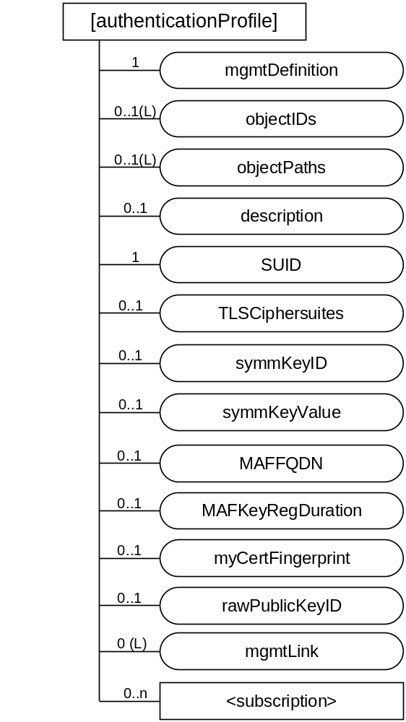
Figure 7.1.4 -1: Structure of [authenticationProfile]
The [authenticationProfile] resource shall contain the child resource specified in table 7.1.4-1.
Table 7.1.4-1: Child resources of [authenticationProfile] resource
Child Resources of [authenticationProfile] | Child Resource Type | Multiplicity | Description
[variable] | <subscription> | 0..n | See clause 9.6.8 of oneM2M TS-0001 [2]
[variable] | [trustAnchorCred] | 0..n | See clause 7.1.6.

The [authenticationProfile] resource shall contain the attributes specified in table 7.1.4-2.
Table 7.1.4-2: Attributes of [authenticationProfile] resource
Attributes of  [authenticationProfile] | Multiplicity | RW/  RO/  WO | Description
resourceType | 1 | RO | See clause 9.6.1.3 of oneM2M TS-0001 [2].
resourceID | 1 | RO | See clause 9.6.1.3 of oneM2M TS-0001 [2].
resourceName | 1 | WO | See clause 9.6.1.3 of oneM2M TS-0001 [2].
parentID | 1 | RO | See clause 9.6.1.3 of oneM2M TS-0001 [2].
expirationTime | 1 | RW | See clause 9.6.1.3 of oneM2M TS-0001 [2].
accessControlPolicyIDs | 0..1 (L) | RW | See clause 9.6.1.3 of oneM2M TS-0001 [2].
creationTime | 1 | RO | See clause 9.6.1.3 of oneM2M TS-0001 [2].
lastModifiedTime | 1 | RO | See clause 9.6.1.3 of oneM2M TS-0001 [2].
labels | 0..1(L) | RW | See clause 9.6.1.3 of oneM2M TS-0001 [2].
mgmtDefinition | 1 | WO | See clause 9.6.15 of oneM2M TS-0001 [2].. This attribute shall have the fixed value "authenticationProfile".
objectIDs | 0..1 (L) | RW | See clause 9.6.15 of oneM2M TS-0001 [2].
objectPaths | 0..1 (L) | RW | See clause 9.6.15 of oneM2M TS-0001 [2].
description | 0..1 | RW | See clause 9.6.15 of oneM2M TS-0001 [2].
SUID | 1 | WO | Describes how the authentication profile is to be used. Further details about interpretation of each SUID are specified in clause 7.1.4.2 of the present document.
TLSCiphersuites | 0..1 | RW | If the security framework identified by SUID uses TLS, then this attributes provides a list of allowed TLS Ciphersuites.
symmKeyID | 0..1 | WO | Present when a symmetric key is to be used for mutual authentication. Identifier for a symmetric key already stored locally on the Managed Entity, or to be provisioned to the Managed Entity
symmKeyValue | 0..2 | WO | Optionally present when a symmetric key is to be used for mutual authentication. Contains the value of the symmetric key to be used for mutual authentication.
MAFFQDN | 0..1 | WO | Present when the a MAF to facilitate establishing a symmetric key to be used for mutual authentication. Identifies the MAF.
MAFKeyRegDuration | 0..1 | WO | Present when the a MAF to facilitate establishing one or more symmetric keys to be used for mutual authentication. Provides the maximum duration for which an established symmetric key may be used.
mycertFingerprint | 0..1 | WO | Present when certificate-based authentication is to be used. Provides a hash value for identifying the certificate to be used by the intended security principal on the Managed Entity to authenticate itself to other security principals.
rawPubKeyID | 0..1 | WO | Present when certificate-based authentication is to be used and the other security principal will authenticate itself with a Raw Public Key Certificate.
mgmtLink | 0..1(L) | RW | List of references pointing to [trustAnchorCred] resources

Table 7.1.4-3: SUID which are currently supported in the [authenticationProfile] resource, along with reference to the authentication procedure in oneM2M TS-0003 [3] and mapping to symmetric key
Value | Interpretation (see Note) | Authentication Procedure in oneM2M TS-0003 [3] | Derived Symmetric Key | DTLS/TLS Notes
10 | A pre-provisioned symmetric key intended to be shared with a MEF | 8.3.2.1 | Kpm | See TLS-PSK Profile in clause 10.2.2 of oneM2M TS-0003 [3]
11 | A pre-provisioned symmetric key intended to be shared with a MAF | 8.8.2.2 | Km | See TLS-PSK Profile in clause 10.2.2 of oneM2M TS-0003 [3]
12 | A pre-provisioned symmetric key intended for use in a Security Associated Establishment Framework (SAEF) | 8.2.2.1 | Kpsa | See TLS-PSK Profile in clause 10.2.2 of oneM2M TS-0003 [3]
13 | A pre-provisioned symmetric key intended for use in End-to-End Security of Primitives (ESPrim) | 8.4.2 | pairwiseESPrimKey | DTLS/TLS is not used
21 | A symmetric key, provisioned via a Remote Security Provisioning Framework (RSPF), and intended to be shared with a MAF | RSPF: 8.3.1.2  MAF: 8.8.2.2, 8.8.3.1* | Km | See TLS-PSK Profile in clause 10.2.2 of oneM2M TS-0003 [3]
22 | A symmetric key, provisioned via a RSPF, and intended for use in a SAEF | RSPF: 8.3.1.2  SAEF: 8.2.2.1, 9.1.1.1* | Kpsa | See TLS-PSK Profile in clause 10.2.2 of oneM2M TS-0003 [3]
23 | A symmetric key, provisioned via a RSPF, and intended for use in ESPrim | RSPF: 8.3.1.2  ESPRIM: 8.4.2 | pairwiseESPrimKey | DTLS/TLS is not used
32 | A MAF-distributed symmetric key intended for use in a SAEF | MAF: 8.8.2.7, 8.8.3.3*  SAEF: 8.2.2.3, 9.1.1.1* | Kpsa | See TLS-PSK Profile in clause 10.2.2 of oneM2M TS-0003 [3]
33 | A MAF-distributed symmetric key intended for use in ESPrim | MAF: 8.8.2.7, 8.8.3.3*  ESPRIM: 8.4.2 | pairwiseESPrimKey | See TLS-PSK Profile in clause 10.2.2 of oneM2M TS-0003 [3]
40 | A certificate intended to be shared with a MEF | 8.3.2.2 | NP | See certificate-based TLS profile in clause 10.2.3 of oneM2M TS-0003 [3]
41 | A certificate intended to be shared with a MAF | 8.8.2.2 | NP
42 | A certificate intended for use in a Security Associated Establishment Framework (SAEF) | 8.2.2.2 | NP
43 | A certificate intended for use in End-to-End Security Certificate-based Key Establishment (ESCertKE) to establish a pairwiseESPrimKey for End-to-End Security of Primitives (ESPrim) | ESCertKE: 8.7  ESPrim: 8.4.2 | NP | For ESCertKE, see certificate-based TLS profile in clause 10.2.3 of oneM2M TS-0003 [3]. For ESPrim, DTLS/TLS is not used
NOTE 1: The interpretation is copied from definition of m2m:suid in oneM2M TS-0004 [4]. The oneM2M TS-0004 [4] description takes precedence.

The Managed Entity shall allow only TLS ciphersuites identified in TLSCiphersuites in the TLS Handshakes for a [authenticationProfile] instance. The final column of table 7.1.4.1-3 provides references to clauses in oneM2M TS-0003 [3] specifying the TLS Profiles to be used with the SUID values. The TLSCiphersuite attribute shall be present only when the value of SUID identifies a security framework that uses TLS or DTLS.
If the value of SUID is 10, 11, 12, 21, 22 or 23, then the symmKeyID attribute shall be present. The symmKeyID provides the symmetric key identifier for a symmetric key which shall be retrieved from local storage on the Managed Entity for use in the TLS Handshake. The symmetric key value may be configured in the symmKeyValue. Otherwise, the symmetric key, and associated symmetric key identifier, may be provisioned to the Managed Entity before or after the [authenticationProfile] is configured. Pre-provisioning or Remote Security Provisioning Frameworks (RSPFs), specified in oneM2M TS-0003 [3], should be used whenever possible to establish symmetric keys. Special care is recommended to ensure the confidentiality and integrity of the credentials when using the symmKeyValue to configure symmetric keys.

If the value of SUID is 32 or 33, then the MAFFQDN attribute and MAFProposedDuration attributes shall be present. These attributes provide the configuration controlling how the Managed Entity shall interact with a MAF to establish the symmetric key subsequently used for mutual authentication. The MAFFQDN attribute identifies the MAF.
- If the Managed Entity has not already performed MAF Client Registration procedure with the identified MAF, then the MAF shall perform MAF Client Registration procedure in clause 8.8.2.3 of oneM2M TS-0003 [3]. This procedure uses the MAF Client Registration Configuration, which can be provided to the Managed Entity using the [MAFClientRegCfg] specialization of the <mgmtObj> specified in clause 7.1.6.3.
- The Managed Entity shall perform the MAF Key Registration Procedure in clause 8.8.2.7 of oneM2M TS-0003 [3] with the identified MAF, with the parameters of table 8.8.2.7-1 of [3] set as follows:
  - The MAF-FQDN parameter shall be set to the value of the MAFFQDN attribute.
  - The expirationTime Parameter shall be set to the time obtained by adding the MAFKeyRegDuration attribute to the present time.
  - The SUID parameter shall be set to the SUID attribute.
  - The targetIDs parameter shall be set to the CSE-ID in the [registration] or [dataCollection] resource.
If the value of SUID is 40, 41, 42, or 43, then the myCertFingerprint attribute shall be present, and either the rawPubKeyID attribute shall be present or one or more [trustAnchorCred] specializations shall be configured as children of the [authenticationProfile] resource. The Managed Entity shall use the certificate matching myCertFingerprint to authenticate itself. The hash value portion of myCertFingerprint shall be computed over the X.509 ASN.1 DER encoded certificate.
- If the rawPubKeyID attribute is present, then the Managed Entity shall compare this value against the public key identifier (similar to a certificate fingerprint) generated from the raw public key certificate presented by the other entity, as specified in clause 10.1.2 of oneM2M TS-0003 [3]. If the rawPubKeyID attribute is present, the Managed Entity shall ignore [trustAnchorCred] resource(s) configured as children of the [authenticationProfile].
- If the rawPubKeyID attribute is not present, then the Managed Entity shall use the one or more [trustAnchorCred] resource instance(s) configured as children of the [authenticationProfile] resource instance to retrieve Certificate Authority certificates to be used by the Managed Entity as a trust anchor certificate (also known as a "root CA certificate" or "trust root certificate") when validating the certificate chains provided by other entities. The Managed Entity shall allow the TLS handshake only if the other entity provides a certificate chaining to one of these trust anchors, using the process specified in clause 8.1.2.2 in oneM2M TS-0003 [3].
[authenticationProfile] resources are expected to be protected by a secure environment on the Managed Entity, in order to preserve integrity of the attributes. Optimal protection is provided when the integrity protection of the management protocol message is verified in the secure environment.

Resource [myCertFileCred]
This <mgmtObj> specialization is used to configure a certificate or certificate chain which the Managed Entity knows the private key.
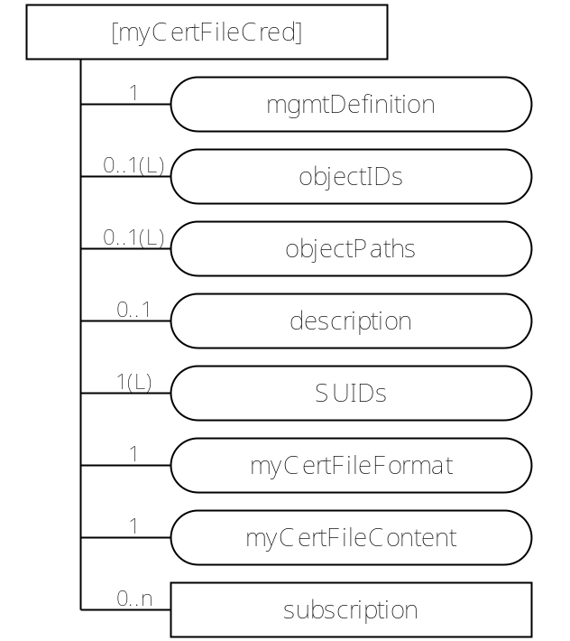
Figure7.6-1: Structure of [myCertFileCred] resource
The [myCertFileCred] resource shall contain the child resource specified in table 7.1.6-1.
Table 7.1.6-1: Child resources of [myCertFileCred] resource
Child Resources of [myCertFileCred] | Child Resource Type | Multiplicity | Description
[variable] | <subscription> | 0..n | See clause 9.6.8 of oneM2M TS-0001 [2]

The [myCertFileCred] resource shall contain the attributes specified in table 7.1.6-2.
Table 7.1.6-2: Attributes of [myCertFileCred] resource
Attributes of  [myCertFileCred] | Multiplicity | RW/  RO/  WO | Description
resourceType | 1 | RO | See clause 9.6.1.3 of oneM2M TS-0001 [2].
resourceID | 1 | RO | See clause 9.6.1.3 of oneM2M TS-0001 [2].
resourceName | 1 | WO | See clause 9.6.1.3 of oneM2M TS-0001 [2].
parentID | 1 | RO | See clause 9.6.1.3 of oneM2M TS-0001 [2].
expirationTime | 1 | RW | See clause 9.6.1.3 of oneM2M TS-0001 [2].
accessControlPolicyIDs | 0..1 (L) | RW | See clause 9.6.1.3 of oneM2M TS-0001 [2].
creationTime | 1 | RO | See clause 9.6.1.3 of oneM2M TS-0001 [2].
lastModifiedTime | 1 | RO | See clause 9.6.1.3 of oneM2M TS-0001 [2].
labels | 0..1(L) | RW | See clause 9.6.1.3 of oneM2M TS-0001 [2].
mgmtDefinition | 1 | WO | See clause 9.6.15 of oneM2M TS-0001 [2]. This attribute shall have the fixed value "myCertFileCred".
objectIDs | 0..1 (L) | RW | See clause 9.6.15 of oneM2M TS-0001 [2].
objectPaths | 0..1 (L) | RW | See clause 9.6.15 of oneM2M TS-0001 [2].
description | 0..1 | RW | See clause 9.6.15 of oneM2M TS-0001 [2].
SUIDs | 1 (L) | RW | Identifies the security framework(s) which may use this credential.
myCertFileFormat | 1 | WO | Media Type of myCertFileContent attribute. Default is "application/pkcs7-mime".
myCertFileContent | 1 | WO | Certificate or certificate chain. Default media-type is "application/pkcs7-mime".

The SUIDs attribute lists the Security Usage Identifiers (SUIDs) of the security frameworks which shall be allowed use this credential for establishing mutually-authenticated secure communication. Any SUID which is not in this list shall be allowed use this credential for establishing mutually-authenticated secure communication. The SUID values allowed in this attribute are listed in table 7.1.5-3. See table 7.1.4.3 for references to the corresponding authentication procedure in oneM2M TS-0003 [3] and DTLS/TLS notes.
Table 7.1.5-3: SUID which are currently supported in the [myCertFileCred] resource
Value | Interpretation (see Note)
40 | A certificate intended to be shared with a MEF
41 | A certificate intended to be shared with a MAF
42 | A certificate intended for use in a Security Associated Establishment Framework (SAEF)
43 | A certificate intended for use in End-to-End Security Certificate-based Key Establishment (ESCertKE) to establish a pairwiseESPrimKey for End-to-End Security of Primitives (ESPrim)
NOTE 1: The interpretation is copied from definition of m2m:suid in oneM2M TS-0004 [4]. The oneM2M TS-0004 [4] description takes precedence.

The Certificate issuer should verify that the corresponding private key is known to the Managed Entity. The present specification does not provide a mechanism for such verification.
NOTE: In many scenarios, if the device management session takes place over a TLS connection in which the Managed Entity is authenticated using an existing certificate (e.g. a manufacturer certificate), then it would be acceptable to issue a certificate with SubjectPublicKeyInfo copied from the existing certificate.
Managed Entities shall support the default certificate-related media type.
If the myCertFingerprint attribute in an [authenticationProfile] resource matches the certificate in a [myCertFileCred] resource, then the authentication protocol based on that [authenticationProfile] shall provide the certificate or certificate chain in the myCertFileContent, and shall use the corresponding private key to authenticate the Managed Entity.
[myCertFileCred] instances are expected to be protected by a secure environment on the Managed Entity, in order to preserve confidentiality and integrity of the attributes. Optimal protection is provided when the decryption and integrity verification of the management protocol message occurs in the secure environment.

Resource [trustAnchorCred]
The [trustAnchorCred] <mgmtObj> specialization is read by AEs or CSEs on ADN or ASN/MN nodes in the Field Domain. A [trustAnchorCred] is configured as a child or children of [authenticationProfile] resources by means of a mgmtLink. A security principal acting on a [authenticationProfile] uses the information in the associated [trustAnchorCred] resources to identify a trust anchor certificate for validation of certificates.
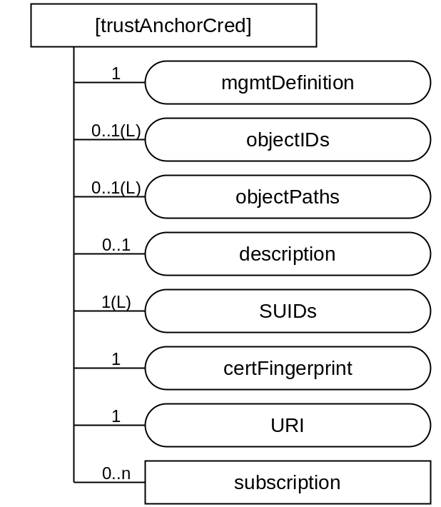
Figure 7.1.6-1: Structure of [trustAnchorCred] resource
The [trustAnchorCred] resource shall contain the child resource specified in table 7.1.6-1.
Table 7.1.6-1: Child resources of [trustAnchorCred] resource
Child Resources of [authenticationProfile] | Child Resource Type | Multiplicity | Description
[variable] | <subscription> | 0..n | See clause 9.6.8 of oneM2M TS-0001 [2]

The [trustAnchorCred] resource shall contain the attributes specified in table 7.1.6-2.
Table 7.1.6-2: Attributes of [trustAnchorCred] resource
Attributes of  [authenticationProfile] | Multiplicity | RW/  RO/  WO | Description
resourceType | 1 | RO | See clause 9.6.1.3 of oneM2M TS-0001 [2].
resourceID | 1 | RO | See clause 9.6.1.3 of oneM2M TS-0001 [2].
resourceName | 1 | WO | See clause 9.6.1.3 of oneM2M TS-0001 [2].
parentID | 1 | RO | See clause 9.6.1.3 of oneM2M TS-0001 [2].
expirationTime | 1 | RW | See clause 9.6.1.3 of oneM2M TS-0001 [2].
accessControlPolicyIDs | 0..1 (L) | RW | See clause 9.6.1.3 of oneM2M TS-0001 [2].
creationTime | 1 | RO | See clause 9.6.1.3 of oneM2M TS-0001 [2].
lastModifiedTime | 1 | RO | See clause 9.6.1.3 of oneM2M TS-0001 [2].
labels | 0..1(L) | RW | See clause 9.6.1.3 of oneM2M TS-0001 [2].
mgmtDefinition | 1 | WO | See clause 9.6.15 of oneM2M TS-0001 [2].. This attribute shall have the fixed value "dataCollection".
objectIDs | 0..1 (L) | RW | See clause 9.6.15 of oneM2M TS-0001 [2].
objectPaths | 0..1 (L) | RW | See clause 9.6.15 of oneM2M TS-0001 [2].
description | 0..1 | RW | See clause 9.6.15 of oneM2M TS-0001 [2].
certFingerprint | 1 | WO | Provides a hash value for identifying a certificate authority certificate to be used for validating certificates presented by other entities
URI | 1 | RW | A URI from which the trust anchor certificate may be retrieved.

The certFingerprint attribute of the [trustAnchorCred] resource identifies a Certificate Authority certificate to be used by the Managed Entity as a trust anchor when validating the certificate chains provided by other entities. The hash value portion of the certFingerprint attribute shall be computed over the X.509 ASN.1 DER encoded certificate. The sha-256 hash algorithm, specified in IETF RFC 6920 [7], shall be used. Where the CA Certificate identified in a [trustAnchorCred] resource is not already in local storage, then the Managed Entity shall retrieve the certificate using the URI attribute in the [trustAnchorCred] resources.
[trustAnchorCred] resources are expected to be protected by a secure environment on the Managed Entity, in order to preserve integrity of the attributes. Optimal protection is provided when the integrity protection of the management protocol message is verified in the secure environment.

7.1.7 Resource [MAFClientRegCfg]
This <mgmtObj> specialization is used to convey instructions regarding the MAF Client Registration procedure (clause 8.8.2.3 of oneM2M TS-0003 [3]).
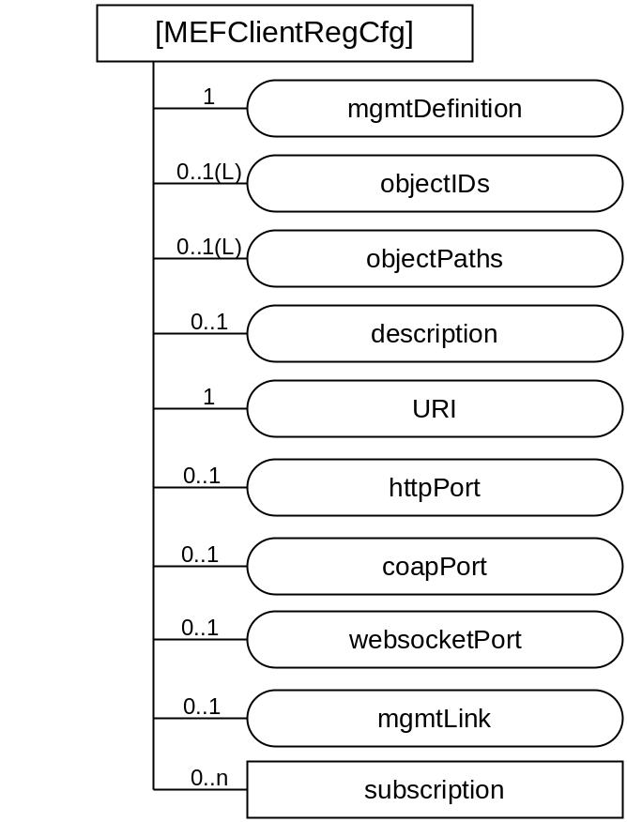
Figure 7.1.7-1: Structure of [MAFClientRegCfg] resource
The [MAFClientRegCfg] resource shall contain the child resource specified in table 7.1.7-1.
Table 7.1.7-1: Child resources of [MAFClientRegCfg] resource
Child Resources of [authenticationProfile] | Child Resource Type | Multiplicity | Description
[variable] | <subscription> | 0..n | See clause 9.6.8 of oneM2M TS-0001 [2]

The [MAFClientRegCfg] resource shall contain the attributes specified in table 7.1.7-2.
Table 7.1.7-2: Attributes of [MAFClientRegCfg] resource
Attributes of  [authenticationProfile] | Multiplicity | RW/  RO/  WO | Description
resourceType | 1 | RO | See clause 9.6.1.3 of oneM2M TS-0001 [2].
resourceID | 1 | RO | See clause 9.6.1.3 of oneM2M TS-0001 [2].
resourceName | 1 | WO | See clause 9.6.1.3 of oneM2M TS-0001 [2].
parentID | 1 | RO | See clause 9.6.1.3 of oneM2M TS-0001 [2].
expirationTime | 1 | RW | See clause 9.6.1.3 of oneM2M TS-0001 [2].
accessControlPolicyIDs | 0..1 (L) | RW | See clause 9.6.1.3 of oneM2M TS-0001 [2].
creationTime | 1 | RO | See clause 9.6.1.3 of oneM2M TS-0001 [2].
lastModifiedTime | 1 | RO | See clause 9.6.1.3 of oneM2M TS-0001 [2].
labels | 0..1(L) | RW | See clause 9.6.1.3 of oneM2M TS-0001 [2].
mgmtDefinition | 1 | WO | See clause 9.6.15 of oneM2M TS-0001 [2].. This attribute shall have the fixed value "dataCollection".
objectIDs | 0..1 (L) | RW | See clause 9.6.15 of oneM2M TS-0001 [2].
objectPaths | 0..1 (L) | RW | See clause 9.6.15 of oneM2M TS-0001 [2].
description | 0..1 | RW | See clause 9.6.15 of oneM2M TS-0001 [2].
URI | 1 | WO | See clause 8.8.3.2 of oneM2M TS-0003 [3]
mgmtLink | 1 | RW | A link to a [authenticationProfile] resource containing the parameters for the MAF Client to establish mutually-authenticated secure communications with the MAF.
httpPort | 0..1 | WO | See clause 8.8.3.2 of oneM2M TS-0003 [3]
coapPort | 0..1 | WO | See clause 8.8.3.2 of oneM2M TS-0003 [3]
websocketPort | 0..1 | WO | See clause 8.8.3.2 of oneM2M TS-0003 [3]
mgmtLink | 1 | RW | A link to a [authenticationProfile] resource containing the parameters for the MAF Client to establish mutually-authenticated secure communications with the MAF.

The MAF Client shall perform the MAF Client Registration Procedure specified in clause 8.8.2.3 of oneM2M TS-0003 [3], using the linked authentication profile for mutual authentication of the MAF Client and MAF.
The MOs configured to the Managed Entity via [MAFClientRegCfg] resources are expected to be protected by a secure environment on the Managed Entity, in order to preserve integrity of the attributes. Optimal protection is provided when the integrity protection of the management protocol message is verified in the secure environment.

----------------------- End of change 3b -------------------------------------------

--------- Start of change 4b: Add new clauses 7.2.4 through 7.2.7 --------

7.2.4 Resource [authenticationProfile]

7.2.4.1 Introduction
Table 7.2.4-1: Data Type Definition of [authenticationProfile]
Data Type ID | File Name | Note
authenticationProfile | DCFG-authenticationProfile-v1_0.xsd

Table 7.2.4.1-2: Resource specific attributes of [authenticationProfile]
Attribute Name | Request Optionality |  | Data Type | Default Value and Constraints
Attribute Name | Create | Update | Data Type | Default Value and Constraints
mgmtDefinition | M | NP | See clause 7.4.15 of oneM2M TS-0004 [4]. | "authenticationProfile"
objectID | O | NP | See clause 7.4.15 of oneM2M TS-0004 [4].
objectPaths | O | NP | See clause 7.4.15 of oneM2M TS-0004 [4].
description | O | O | See clause 7.4.15 of oneM2M TS-0004 [4].
SUID | M | NP | m2m:suid | Allowed values are listed in table 7.1.4-3.
TLSCiphersuites | M | O | dcfg:ListOfTLSCiphersuite
symmKeyID | O | NP | sec:credentialID
symmKeyValue | O | NP | xs:base64binary | The minimum key length is 256 bits.
MAFFQDN | O | NP | xs:anyURI | An FQDN of a MAF
MAFKeyRegDuration | O | NP | xs:duration
mycertFingerprint | O | NP | dcfg:niURI or dcfg:nihURI
rawPubKeyID | O | NP | dcfg:niURI or dcfg:nihURI
mgmntLink | O | NP | See clause 7.4.15 of oneM2M TS-0004 [4].

Table 7.2.4.1-3: Child resources of [authenticationProfile] resource
Child Resource Type | Child Resource Name | Multiplicity | Ref. to in Resource Type Definition
[trustAnchorCred] |  |  | Clause 7.2.6
<subscription> | [variable] | 0..n | Clause Error: Reference source not found of oneM2M TS-0004 [4]

7.2.4.2 Resource specific procedure on CRUD operations
When management is performed using technology specific protocols, the procedures defined in clause 7.4.15.2 of oneM2M TS-0004 [4],'<mgmtObj> specific procedures' shall be used. There is no change from the generic procedures in clause 7.2.2 of oneM2M TS-0004 [4] for operations on this resource. oneM2M TS-0005 [5] and oneM2M TS-0006 [6] provide the mapping of these resources into the technology specific protocol data model.

7.2.5 Resource [myCertFileCred]

7.2.5.1 Introduction
Table 7.2.5.1-1: Data Type Definition of [myCertFileCred]
Data Type ID | File Name | Note
myCertFileCred | DCFG-myCertFileCred-v1_0.xsd

Table 7.2.5.1-2: Resource specific attributes of [myCertFileCred]
Attribute Name | Request Optionality |  | Data Type | Default Value and Constraints
Attribute Name | Create | Update | Data Type | Default Value and Constraints
mgmtDefinition | M | NP | See clause 7.4.15 of oneM2M TS-0004 [4]. | "myCertFileCred"
objectID | O | NP | See clause 7.4.15 of oneM2M TS-0004 [4].
objectPaths | O | NP | See clause 7.4.15 of oneM2M TS-0004 [4].
description | O | O | See clause 7.4.15 of oneM2M TS-0004 [4].
SUIDs | M | O | xs:list of m2m:suid | Allowed values are listed in table 7.1.5-3.
myCertFileFormat | M | NP | xs:anyURI | Media Type of myCertFileContent attribute. Default is "application/pkcs7-mime".
myCertFileContent | M | NP | xs:string | Certificate or certificate chain. Default media-type is "application/pkcs7-mime".

Table 7.2.5.1-3: Child resources of [myCertFileCred] resource
Child Resource Type | Child Resource Name | Multiplicity | Ref. to in Resource Type Definition
<subscription> | [variable] | 0..n | Clause Error: Reference source not found of oneM2M TS-0004 [4]

7.2.5.2 Resource specific procedure on CRUD operations
When management is performed using technology specific protocols, the procedures defined in clause 7.4.15.2 of oneM2M TS-0004 [4],'<mgmtObj> specific procedures' shall be used. There is no change from the generic procedures in clause 7.2.2 of oneM2M TS-0004 [4] for operations on this resource. oneM2M TS-0005 [5] and oneM2M TS-0006 [6] provide the mapping of these resources into the technology specific protocol data model.

7.2.6 Resource [trustAnchorCred]

7.2.6.1 Introduction
Table 7.2.6.1-1: Data Type Definition of [trustAnchorCred]
Data Type ID | File Name | Note
trustAnchorCred | DCFG-trustAnchorCred-v1_0.xsd

Table 7.2.6.1-2: Resource specific attributes of [trustAnchorCred]
Attribute Name | Request Optionality |  | Data Type | Default Value and Constraints
Attribute Name | Create | Update | Data Type | Default Value and Constraints
mgmtDefinition | M | NP | See clause 7.4.15 of oneM2M TS-0004 [4]. | "trustAnchorCred"
objectID | O | NP | See clause 7.4.15 of oneM2M TS-0004 [4].
objectPaths | O | NP | See clause 7.4.15 of oneM2M TS-0004 [4].
description | O | O | See clause 7.4.15 of oneM2M TS-0004 [4].
certFingerprint | M | NP | dcfg:niURI
URI | M | O | xs:anyURI

Table 7.2.6.1-3: Child resources of [trustAnchorCred] resource
Child Resource Type | Child Resource Name | Multiplicity | Ref. to in Resource Type Definition
<subscription> | [variable] | 0..n | Clause Error: Reference source not found of oneM2M TS-0004 [4]

7.2.6.2 Resource specific procedure on CRUD operations
When management is performed using technology specific protocols, the procedures defined in clause 7.4.15.2 of oneM2M TS-0004 [4],'<mgmtObj> specific procedures' shall be used. There is no change from the generic procedures in clause 7.2.2 of oneM2M TS-0004 [4] for operations on this resource. oneM2M TS-0005 [5] and oneM2M TS-0006 [6] provide the mapping of these resources into the technology specific protocol data model.

7.2.7 Resource [MAFClientRegCfg]

7.2.7.1 Introduction
Table 7.2.7-1: Data Type Definition of [MAFClientRegCfg]
Data Type ID | File Name | Note
MAFClientRegCfg | DCFG-MAFClientRegCfg-v1_0.xsd

Table 7.2.7-2: Resource specific attributes of [MAFClientRegCfg]
Attribute Name | Request Optionality |  | Data Type | Default Value and Constraints
Attribute Name | Create | Update | Data Type | Default Value and Constraints
mgmtDefinition | M | NP | See clause 7.4.15 of oneM2M TS-0004 [4]. | "MAFClientRegCfg"
URI | M | NP | See table 12.4.2-1 of oneM2M TS-0003 [3]
httpPort | O | NP | See table 12.4.2-1 of oneM2M TS-0003 [3]
coapPort | O | NP | See table 12.4.2-1 of oneM2M TS-0003 [3]
websocketPort | O | NP | See table 12.4.2-1 of oneM2M TS-0003 [3]
mgmtLink | M | O | m2m:mgmtLinkRef | 1 link to a [authenticationProfile]
NOTE: For further details of these attributes, see clauses 8.8.3.2 and 12.4.2 of oneM2M TS-0003 [3].

Table 7.2.7.1-3: Child resources of [MAFClientRegCfg] resource
Child Resource Type | Child Resource Name | Multiplicity | Ref. to in Resource Type Definition
[authenticationProfile] | [variable] | 1 | Clause 7.2.4
<subscription> | [variable] | 0..n | Clause Error: Reference source not found of oneM2M TS-0004 [4]

7.2.7.2 Resource specific procedure on CRUD operations
When management is performed using technology specific protocols, the procedures defined in clause 7.4.15.2 of oneM2M TS-0004 [4],'<mgmtObj> specific procedures' shall be used. There is no change from the generic procedures in clause 7.2.2 of oneM2M TS-0004 [4] for operations on this resource. oneM2M TS-0005 [5] and oneM2M TS-0006 [6] provide the mapping of these resources into the technology specific protocol data model.

----------------------- End of change 4 -------------------------------------------

----------Start of Change 5: Update 7.3.1 (was 7.2.1 in v0.9.0) -------------

7.3.1 Introduction
The following clauses define data formats of resource attributes and parameters used in present document.
Any data types of XML elements defined for use in present document shall be one of name spaces in table 6.2.1-1.
Table 7.2.1-1: Namespaces used in present document
Name space | prefix | Name space definition
oneM2M protocol CDT | m2m: | http://www.onem2m.org/xml/protocol
Device Configuration | dcfg: | http://www.onem2m.org/xml/deviceConfig
oneM2M Security | sec: | http://www.onem2m.org/xml/securityProtocols

----------------------- End of change 5 -------------------------------------------

----------------------- Start of Change 6: Add clause 7.3.2 ------------------------

7.3.2 Simple oneM2M data types for device configuration
Table 7.3.2-1 describes simple data type definitions specific to security. The types in table7.3.2-1 are either:
- Atomic data types derived from XML Schema data types by restrictions other than enumeration
- List data types constructed from other XML Schema or oneM2M-defined atomic data types.
Table 7.3.2-1: oneM2M simple data types for device configuration
XSD type name | Used for | Examples | Description
dcfg:TLSCiphersuite | A TLS Ciphersuite identifier | C0A5 | Four hexadecimal characters representing a TLS Cipher suite identifier. The list of TLS Ciphersuites identifiers can be found at the IANA TLS Cipher Suite Registry [8]
dcfg:ListOfTLSCiphersuite | A list of TLS Ciphersuite identifiers |  | xs:list of elements of data type dcfg:TLSCiphersuite
dcfg:niURI | Identifying information with a hash value | ni:///sha-256;UyaQV...  ni:///1;UyaQV... (“1” is a short identifier for sha-256) | An xs:anyURI conforming to the Named Information ‘ni’ URI scheme specified in IETF RFC 6920 [7], with no authority field.
dcfg:nihURI | Identifying information with a human speakable encoding of a hash value | nih:sha-256-32;53269057;b  nih:sha-256-32;5326-9057;b  nih:6;5326-9057 (“6” is a short identifier for sha-256-32) | An xs:anyURI conforming to the Human Speakable Named Information ‘nih’ URI scheme specified in IETF RFC 6920 [7], with no authority field. A checkdigit may be present.

----------------------- End of change 3 -------------------------------------------

----------------------- Start of Changes to 2.1 References ------------------

Normative references
The following referenced documents are necessary for the application of the present document.
[1] oneM2M TS-0011, "Common Terminology".
[2] oneM2M TS-0001, "Functional Architecture".
[3] oneM2M TS-0003, "oneM2M Security Solutions".
[4] oneM2M TS-0004, "Service Layer Core Protocol".
[5] oneM2M TS-0005, "Management Enablement (OMA)".
[6] oneM2M TS-0006, "Management Enablement (BBF)".
[7] IETF RFC 6920, "Naming Things with Hashes".
[8] IANA TLS Cipher Suite Registry.
NOTE: Available at http://www.iana.org/assignments/tls-parameters/tls-parameters.xhtml

----------------------- End of Changes to 2.1 References -----------

-----------------------Start of change to 3.2 definitions ------------------------------

Definitions
Application Configuration: procedure that configures an AE on an M2M Node in the Field Domain for M2M Service Layer operation.
Configuration AE: an AE whose role is to configure the M2M System, including the M2M Node in the Field Domain.
Configuration IPE: an IPE that provides the capability to configure the M2M Node in the Field Domain by interworking the exchange of information between the M2M Node and the M2M System.
Service Layer Configuration: procedure that configures a CSE on an M2M Node in the Field Domain for M2M Service Layer operation.
authentication profile: security information needed to establish mutually-authenticated secure communications
security principal: end-point of a security protocol

  - Abbreviations
MO Managed Object (BBF specified management) or Management Object (OMA specified management)
NP Not Present
XML eXtensible Markup Language
XSD XML Schema Definition

----------------------- End of change to 3.2 definitions ----------------------------------

