CHANGE REQUEST
Meeting ID:* | MAS#28
Source:* | Joerg Swetina, NEC, joerg.swetina@neclab.eu  Martin Bauer, NEC, martin.bauer@neclab.eu
Date:* | 2017-03-27
Reason for Change/s:* | Specification of an “Abstraction Application Entity” for device abstraction
CR against: Release* | 3
CR against: WI* | Active WI 0063  Release 3 Enhancements on Base Ontology & Generic Interworking)  MNT maintenance / < Work Item number(optional)>  Is this a companion CR? Yes No  Companion CR number: (Note to Rapporteur - use latest agreed revision)Is this a mirror CR? Yes No  Mirror CR number: (Note to Rapporteur - use latest agreed revision)  STE Small Technical Enhancements / < Work Item number (optional)>  Only ONE of the above shall be ticked
CR against: TS/TR* | TS 0030 v0.1.0
Clauses * | 5.1, 5.2, 6, 3
Type of change: * | Editorial change  Bug Fix or Correction  Change to existing feature or functionality  New feature or functionality  Only ONE of the above shall be ticked
Impacted other TS/TR(s) | TS 0012 contains the “VariableConversion” class that guides behavior of the Abstraction Application
Post Freeze checking:* | This CR contains only essential changes and corrections? YES NO  This CR may break backwards compatibility with the last approved version of the TS? YES NO
Template Version: January 2017 (Do not modify)

oneM2M Notice
The document to which this cover statement is attached is submitted to oneM2M. Participation in, or attendance at, any activity of oneM2M, constitutes acceptance of and agreement to be bound by terms of the Working Procedures and the Partnership Agreement, including the Intellectual Property Rights (IPR) Principles Governing oneM2M Work found in Annex 1 of the Partnership Agreement.
GUIDELINES for Change Requests:
Provide an informative introduction containing the problem(s) being solved, and a summary list of proposals.
Each CR should contain changes related to only one particular issue/problem.
In case of a correction, and the change apply to previous releases, a separate “mirror CR” should be posted at the same time of this CR
Mirror CR: applies only when the text, including clause numbering are exactly the same.
Companion CR: applies when the change means the same but the baselines differ in some way (e.g. clause number).
Follow the principle of completeness, where all changes related to the issue or problem within a deliverable are simultaneously proposed to be made E.g. A change impacting 5 tables should not only include a proposal to change only 3 tables. Includes any changes to references, definitions, and acronyms in the same deliverable.
Follow the drafting rules.
All pictures must be editable.
Check spelling and grammar to the extent practicable.
Use Change bars for modifications.
The change should include the current and surrounding clauses to clearly show where a change is located and to provide technical context of the proposed change. Additions of complete clauses need not show surrounding clauses as long as the proposed clause number clearly shows where the new clause is proposed to be located.
Multiple changes in a single CR shall be clearly separated by horizontal lines with embedded text such as, start of change 1, end of change 1, start of new clause, end of new clause.
When subsequent changes are made to content of a CR, then the accepted version should not show changes over changes. The accepted version of the CR should only show changes relative to the baseline approved text.

Introduction
In oneM2M Rel-1 and Rel-2 the topic of device abstraction has been studied in TR-0007, mainly in section 6. The oneM2M base ontology defines the classes “Function”, which exhibit the - human understandable - meaning what the device "does" and the related “Command” as to indicate the - human understandable - action that can be performed to support the Function.
When two different Services – possibly of different technologies or from different standards – expose the same Function it means, that they do the same thing.
Similarly, different Input- and OutputDataPoints or Operations can expose the same Command, implying that they represent the same action that can be performed by a Function.
If a (technology independent) ontology describes an Abstract Information Model Device and another (technology specific) ontology – used by the IPE – describes a Device Information Model Device and both expose the same Functions and Commands then abstraction between the two systems can be achieved.
A new type of oneM2M Application, called “Abstraction Application Entity” (AAE) translates between the Device Information Model and the Abstract Information Model. It uses VariableConversion rules that are contained in one of the ontologies (preferably the one for the Device Information Model).
Introduction of class “VariableConversion” is the subject of a separate CR to TS-0012
R01 gives a more illustrative example of abstraction using ZigBee, HAIM and SAREF
R02 introduces deployment options and a section on Data flows for IPE and AAE

-----------------------Start of change 1-------------------------------------------

5.1 Basic concepts of Generic Interworking

5.1.1 Generic interworking vs. Specific interworking
Editor’s Note: This section should explain in which cases Generic Interworking can/should/needs to be used and what the difference to specific interworking with FlexContaiers is

5.1.2 Use of ontologies for Generic interworking with Area Networks

5.1.2.1 General Principle
Interworking with Area Networks is accomplished in oneM2M through functionality provided by Interworking Proxy Entities (IPE).

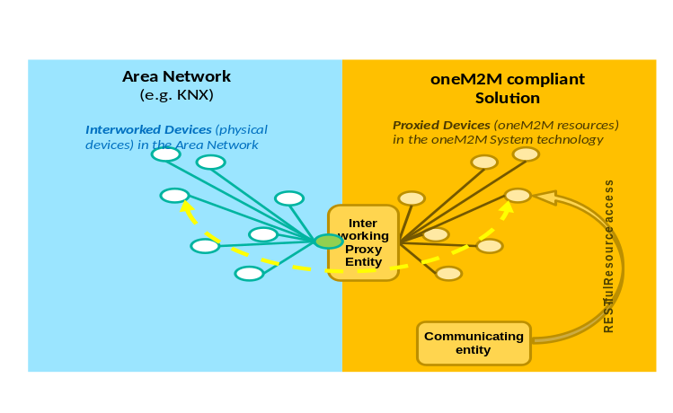
Figure 1: Interworking
The IPE creates "proxied" devices as oneM2M Resources (e.g. AEs) in the oneM2M Solution that can be accessed by communicating entities (e.g. oneM2M Applications) in the usual way.
To accomplish the creation of proxied devices the IPE uses an ontology that describes the Device Information Model of the interworked Area Network and its entities (device types, their operations, etc.).
For example, in figure 1, an ontology that describes a KNX Area Network and its entities would be needed.
To achieve the flexibility for the IPE to create proxied devices for many different types of Area Networks each ontology that describes a specific Device Information Model needs to be derived from the Base Ontology that is specified in [3].
E.g. the OWL representation of an ontology that describes the Device Information Model of an Area Network of type "KNX" needs to:
- contain an 'include' statement which includes Base Ontology;
- the Class of "KNX Nodes" needs to be a subclass of the "Device" Class of oneM2M's Base Ontology;
- the Class of "KNX Communication Objects" needs to be a subclass of the "Service" Class of the Base Ontology;
- etc.
NOTE: For the purpose of Generic interworking with Area Networks the Base Ontology is only used to describe type information and not for describing instances of these types. E.g. the Base Ontology describes the type "Device", but does not contain information about a specific Device.
The Base Ontology therefore only contains Classes and Properties but not instances.

5.1.2.2 tbd
Editor’s Note: should go to TS-0012 ??

5.1.2.3 tbd
Editor’s Note: should go to TS-0012 ??

-----------------------End of change 1---------------------------------------------

-----------------------Start of change 2-------------------------------------------

5.2 Using Generic Interworking with Device Abstraction

5.2.1 General description
As explained in section 5.1 it is the task of an IPE to interact via the Area Network with the Interworked Devices and to provide oneM2M resources (Proxied Devices) to the communicating entities for communication with the Interworked Devices. However these Proxied Devices still exhibit the native data model – the Device Information Model of the external technology of the device – and a communicating entity needs to know that native Device Information Model (e.g. ZigBee information model).
Device abstraction relieves a communicating entity that wants to communicate with an Interworked Device (e.g. a ZigBee device) from the need to know the native Device Information Model of that Interworked Device.
Specific oneM2M Applications, called “Abstraction Application Entities” (AAEs) translate between the – technology specific – native Device Information Model and an Abstract Information Model, that is based on of common functionalities abstracted from a set of Device Information Models. Such Abstract Information Models can be provided by industry associations of a specific industry sector. An example of an Abstract Information Model, which is specified in oneM2M is the Home Appliance Information Model (HAIM), specified in TS-0023 [5].
As in the case of the IPE an Abstract Information Model can be described as an ontology and that ontology needs to be derived from the Base Ontology.
For data exchange with communcating entities the AAE provides oneM2M resources, called Abstract Devices.
Abstract Devices exhibit the data structure and provide the functionality described in the Abstract Information Model. The communicating entity only needs to understand this single data model to be able to communicate with devices via IPEs from multiple technologies when these are abstracted.
The AAE works together with the IPE for which it provides abstraction.
As explained in section 5.1 the IPE creates and uses a Proxied Device resource (<container> or <flexContainer> child resource of the IPE's <AE> resource) for each Interworked Device of the Area Network.
For Abstraction, the AAE additionally creates and uses an Abstract Device resource (<container> or <flexContainer> child resource of the AAE's <AE> resource) for each Proxied Device of the IPE.
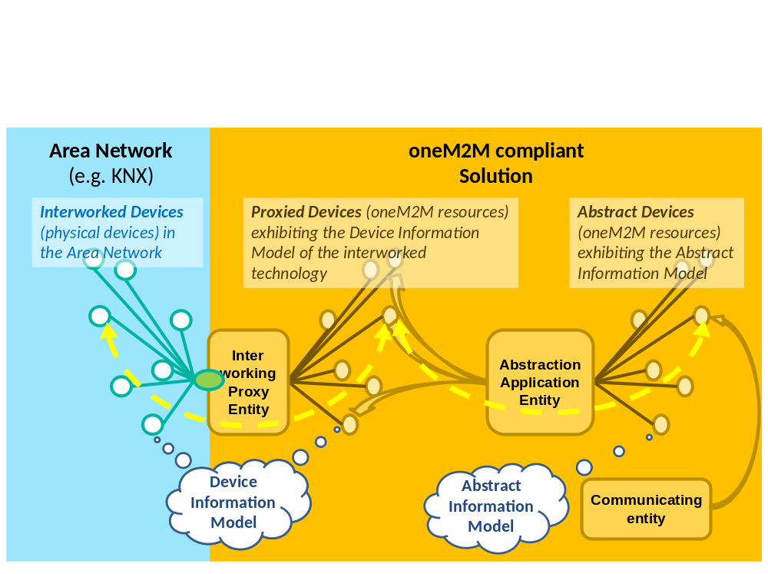
Figure 2: Abstraction
Figure 2 shows the collaboration between IPE and AAE when a a communicating entity - using abstraction – wants to invoke a Service at the Interworked Device:
Instead of invoking the Service of the Proxied Device (using the Device Information Model) the communicating entity invokes the abstracted Service of the Abstract Device (using the Abstract Information Model). This abstracted Service is modelled as a child-resource of the <AE> resource corresponding to the Abstract Device.
The AAE converts the data of the abstracted operation into the data of the Service of the Device Information Model and feeds these data into the Service resource of the Proxied Device.
Finally the IPE uses the data of the Service resource of the Proxied Device and invokes the (native) Service at the Interworked Device.

In order to be able to associate Services (“native Services”) of the ontology for the Device Information Model with their related abstracted Services of the the ontology for the Abstract Information Model (“abstracted Services”) these two different Services need to be equivalent, in the sense that they fulfil exactly the same Function.
This functional equivalce of services is formally expressed in the two ontologies. The two ontologies need to fulfil the following conditions:
- “native” Services need to expose the same Functions as their related “abstracted” Services.
- Similarily, Input- and OutputDataPoints and Operations of these Services need to expose the same Commands.
- Input- and OutputDataPoints and OperationInputs and –Outputs need to be related via VariableConversions
Exposing the same Function by Services of the different ontologies ensures, that they have the same semantic meaning. The Service in the ontology of the Abstract Information Model is therefore an abstraction of the Service in the ontology of the Device Information Model
Note: Functions and Commands can be defined in the ontology for the Device Information Model (e.g. ZigBee) or the the ontology for the Abstract Information Model (e.g. HAIM) or they can be defined in a separate ontology (e.g. SAREF) that is referenced by the tho othere ontologies

5.2.2 An example, involving ZigBee, HAIM and SAREF
The figure x below illustrates this situation for a light switch. In the example the physical implementation is a ZigBee device implementing a ZigBee Service “On/Off Cluster”. An IPE for ZigBee creates the interworking towards the ZigBee network. This device is abstracted as oneM2M device according to the a Home Appliance Information Model (HAIM). In HAIM the corresponding Service is a “binary Switch”.
Both types of Services expose a Function “On Off Function” which is e.g. described in the SAREF ontology.
To turn the switch on SAREF defines an “On Command”.
The corresponding Service in HAIM is executed by setting an Input Datapoint called “powerState” to the binary value “TRUE”.
In Zigbee an operation (ZigBee command) needs to be invoked in the On/Off Cluster with an input parameter (ZigBee Command ID) equal to 0.
A VariableConversion can been specified in the ontology of the ZigBee Device Information Model that contains the rules how to convert a value of InputDataPoint “powerState” into a value of OperationInput “ZigBee Command ID”.
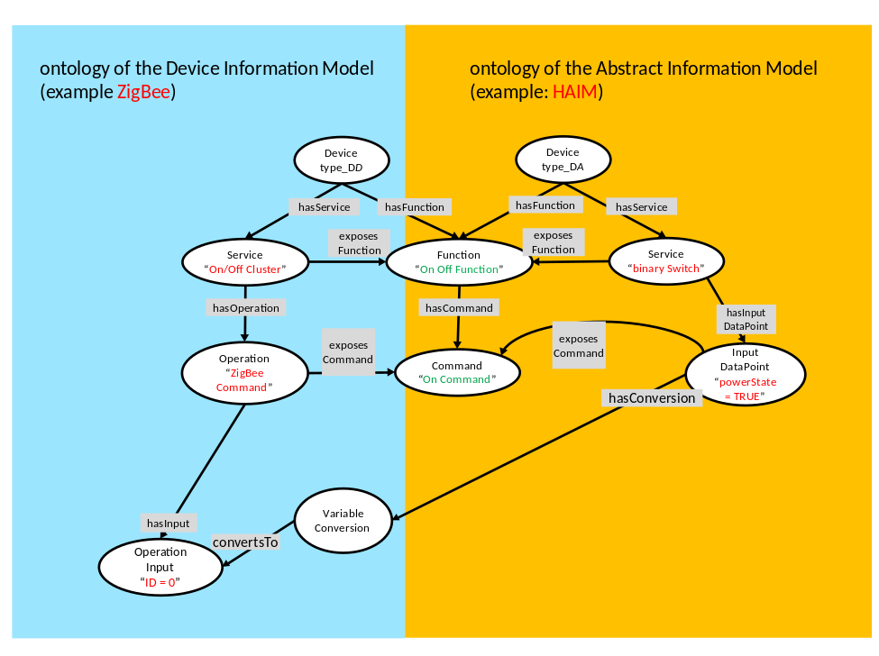
Figure 3: ontologies relations

5.2.3 Deployment options (example)
While IPE and AAE are functionally specified as different types of AEs, individual deployments may or may not choose to integrate them within their respective implementations.
For specific deployments it might be useful to design a an interworking solution that integrates the IPE and the AAE functionality.
Thus this interworking solution could provide
- only Proxied Device resources – i.e. not providing support for abstraction.
- only Abstracted Device resources – i.e. only providing support for abstraction but not for the native Device Information Model.
- Both types. This could allow a communicating entity to use the Abstract Information Model in general but for selected services use the native Device Information Model (which may support functionality that does not exist in the Abstract Information Model).
On the other hand, other deployments may choose to implement IPE and AAE separately.
Such a deployment option may be appropriate when an AAE can provide abstraction (using e.g. the HAIM Information Model) for multiple Device Information Models (e.g. ZigBee, KNX, Echonet lite..). This would allow a communicating entity to always use the same Abstract Device, even if e.g. the Interworked Device had been replaced by another Interworked Device of a different Area Network technology (and the IPE had been replaced by an appropriate IPE).

-----------------------End of change 2---------------------------------------------

-----------------------Start of change 3-------------------------------------------

6 Functional specification of communication with the Generic interworking IPE and Abstraction Application Entity

6.1 Usage of oneM2M resources for IPE and AAE communication

6.1.1 General design principles (informative)
For Generic interworking the oneM2M resource types <AE>, <container>, <flexContainer>, and specializations of <flexContainer>: genericInterworkingService and genericInterworkingOperationInstance are intended to hold data that can be used for data exchange with the IPE or AAE.
For Generic interworking and Abstraction a convention is needed how the IPE and AAE uses these resources to communicate with other oneM2M entities. This is described in the subsequent clauses.
Resources for RESTful communication style vs. procedure call (RPC) style:
A Generic interworking IPE/AAE needs to be able to communicate with non-oneM2M systems that implement some form of RESTful communication style as well as other systems that communicate in a procedure call (RPC) style.
For RESTful systems the use of Input- or OutputDataPoints may be more appropriate.
On the other hand procedure calls can be better modelled using Operations (and their OperationInputs/-Outputs).
Also a combination of both (where Operations additionally receive input from InputDataPoints and/or write output into OutputDataPoints) is possible.
Persistent resources vs. transient resources:
- Persistent resources are genericInterworkingService, <container>s and <flexContainer>s that contain data of Services, Input- or OutputDataPoints. Services, Input- and OutputDataPoints of an Interworked Device usually exist as long as the IPE enables the communication with the Interworked Device.
- Transient resources are genericInterworkingOperationInstances, <container>s and <flexContainer>s that contain data of Operations, OperationInput or OperationOutput.
These resources are created and exist as long as the Interworked Device performs execution of an Operation and receive the output data of the Operation. Once the output data have been deliverd to subscribed communicating entities transient resources may be deleted by the IPE.
NOTE: While in general the present document assumes that semantic information can be made available (using the <semanticDescriptor> resource) the mechanisms described here for IPE communication do not rely on the existence of semanticDescriptors. This allows e.g. very simple devices to exchange their data in "raw" form (e.g. as byte-fields that need to be interpreted by the communicating entity).

6.1.2 Parent-child and linking resource relationships
Figure 4 provides an overview of parent-child resource relationships that are used for communication with AEs (in particular the IPE) in the context of Generic interworking.
It involves the:
- Persistent resource types:
- <AE>, <container> or <flexContainer> - for a oneM2M Device or an Interworked Device
- <container> - for an Input- or OutputDataPoint
- <flexContainer> - for an Input- or OutputDataPoint
- genericInterworkingService specialization of <flexContainer> - for a Service of a a oneM2M Device or an Interworked Device
- Transient resource types:
- <container> - for OperationInput or OperationOutput data of an Operation
- <flexContainer> - for OperationInput or OperationOutput data of an Operation
- genericInterworkingOperationInstance specialization of <flexContainer> - for an Operation of a Service
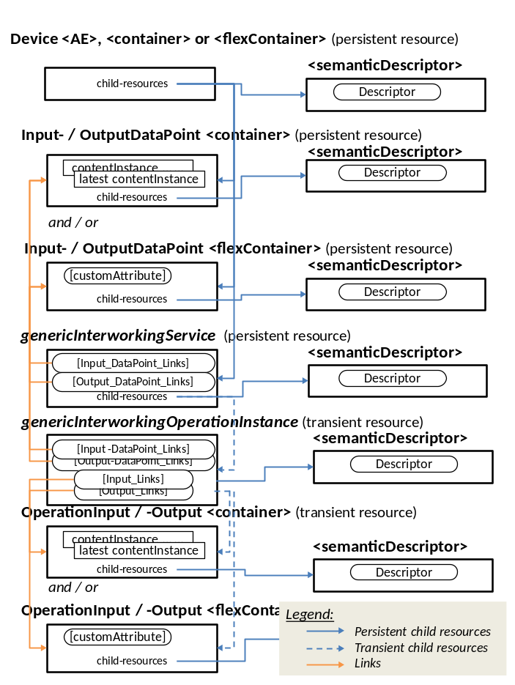
Figure 4: Parent-child and Link relationships in the context of Generic interworking
Parent-child relationships:
- An <AE> resource, required for representing a Device, is created by its AE.
Alternatively, in the case of an Interworked Device, the AE that is the generic interworking IPE may create resources of type <container> or <flexContainer>, that represents the Interworked Device.
- Input- and Output DataPoints (<containers> and/or <flexContainers>) are created by the AE as child resources of its (<AE>, <containers>, <flexContainers>) resource that represents the Device.
- Services (resources of specialization type genericInterworkingService of a <flexContainer>) are created by the AE as child resources of its resource that represents the Device.
- OperationInstances (resources of specialization type genericInterworkingOperationInstance of a <flexContainer>) are created by the AE or by the communicating entity as child resources of the genericInterworkingService of the Service.
- OperationInput (<containers> and/or <flexContainers>) are created by the communicating entity as child resources of the genericInterworkingOperationInstance of the Operation instance.
- OperationOutput (<containers> and/or <flexContainers>) are are created by the AE as child resources of the genericInterworkingOperationInstance of the Operation instance.
- All of the above can contain a <semanticDescriptor> as child resource.
Link relationships:
- Services can contain links to:
- InputDataPoints (contained in the InputDataPointsLinks attribute)
- OutputDataPoints (contained in the ouputDataPointsLinks attribute)
- OperationInstances can contain links to:
- InputDataPoints (contained in the InputDataPointsLinks attribute)
- OutputDataPoints (contained in the ouputDataPointsLinks attribute)
- OperationInputs (contained in the inputLinks attribute)
- OperationOutputs (contained in the outputLinks attribute)

6.1.3 Data flows for IPE and AAE
Both, IPEs and AAEs are types of Application entities (AEs) that act as translating entities.
- IPEs translate data to and from Interworked Devices (entities outside of the oneM2M system) into oneM2M resources (the data of Proxied Devices) that can be accessed by communicating oneM2M entities.
  - In the case of IPE being the translating entity the target entity is the Interworked Device while the communicating entity can be any oneM2M entity (e.g. a CSE, an AE). In particular, if Abstraction is needed in addition to interworking the communicating entity is an AAE.
- AAEs translate data between Proxied Devices and Abstract Devices.
  - In the case of AAE being the translating entity the target entity is the IPE while the communicating entity can be any oneM2M entity (e.g. a CSE, an AE)
The following figures show the data flows for both types of translating entities
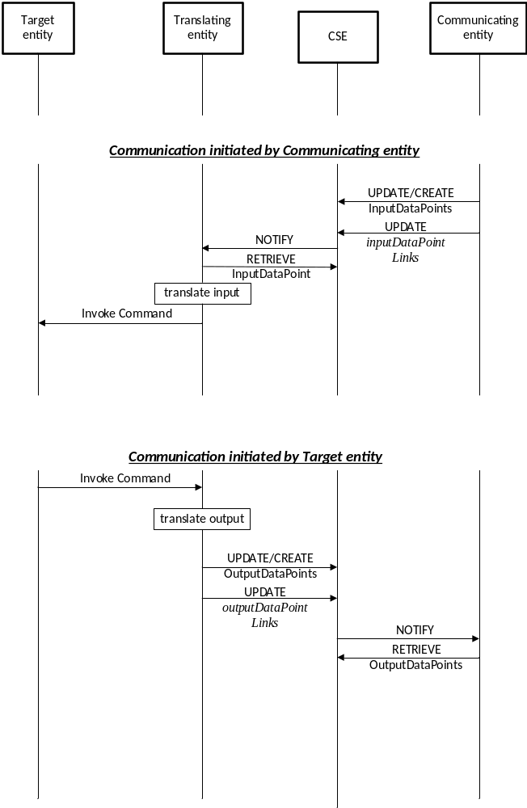
Figure 5: Data flow for a translating entity involving dataPoints
Read/Write operations on datapoints are the simplest form of executing Commands, i.e. a Command is exposed as datapoint of a Service.
- A communicating entity can invoke a Command at the target entity
  - The communicating entity updates an InputDatapoint, which triggers a notification to the translating entity.
  - The translating entity translates the data of the datapoint into the appropriate value and format suitable for the target entity and transmits it to the target entity, who executes the Command.
- In the other direction, a target entity can invoke a Command in the communicating entity
  - The target entity autonomously transmits data of a Command to the translating entity.
  - The translating entity translates the data into the appropriate values and updates the datapoint related to this Command
  - As the communicating entity is subscribed to changes of the datapoint it gets notified, retrieves the value of the datapoint and executes the Command
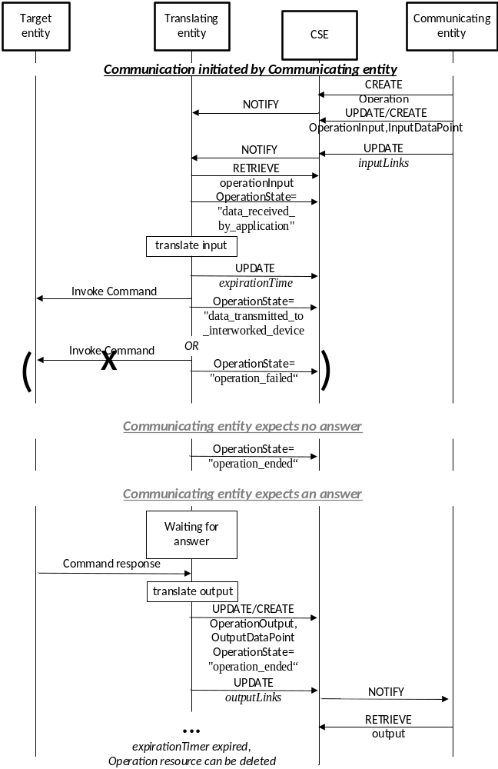
Figure 6: Data flow for a translating entity involving operations
when initiated by a communicating entity
Another form of exposing Commands are operations. Operations allow grouping of input- and output parameters into a single transaction between the communicating entity and the target entity.
- When the communicating entity invokes an operation in the target entity the communicating creates a <genericInterworkingOperation> resource
- It also updates the InputDataPoints and/or create new OperationInputs that are parameters of the operation and that need to be sent in the operation to the target entity.
- To trigger the operation the communicating entity updates the inputLinks and inputDataPointLinks attribute of the <genericInterworkingOperation> resource with the links to InputDataPoints and/or OperationInputs that are used in this operation
- As the translating entity has subscribed to creation and update of the <genericInterworkingOperation> resource it is notified, which triggers the communicating entity to invoke the operation in the target entity.
- The translating entity sets the operationState attribute of the <genericInterworkingOperation> resource to the value “data_received_by_application” and sets an expirationTime
- The translating entity translates the input data contained in the InputDataPoints and/or OperationInputs into appropriate values for the target entity and invokes the command at the target entity.
- If the command can be invoked the translating entity sets the operationState attribute to the value “data_transmitted_to_interworked_device”
- If no output of the operation is foreseen then the translating entity sets the operationState attribute to the value “operation_ended”.
- However, if output of the operation is foreseen the translating entity awaits the command response from the target entity.
- After receiving the command response the translating entity translates the output data into appropriate values and updates/creates related OutputDataPoints and/or OperationOutputs.
- The translating entity updates the outputLinks and outputDataPointLinks attribute
- The translating entity sets the operationState attribute to the value “operation_ended”.
- The communicating entity gets notified about the change in the outputLinks and outputDataPointLinks attribute and can retrieve data from OutputDataPoints and/or OperationOutputs.
- After the has expirationTime passed the translating entity may delete the <genericInterworkingOperation> resource and all its child resources (i.e. OperationInput/OperationOutput containers and flexcontainers).
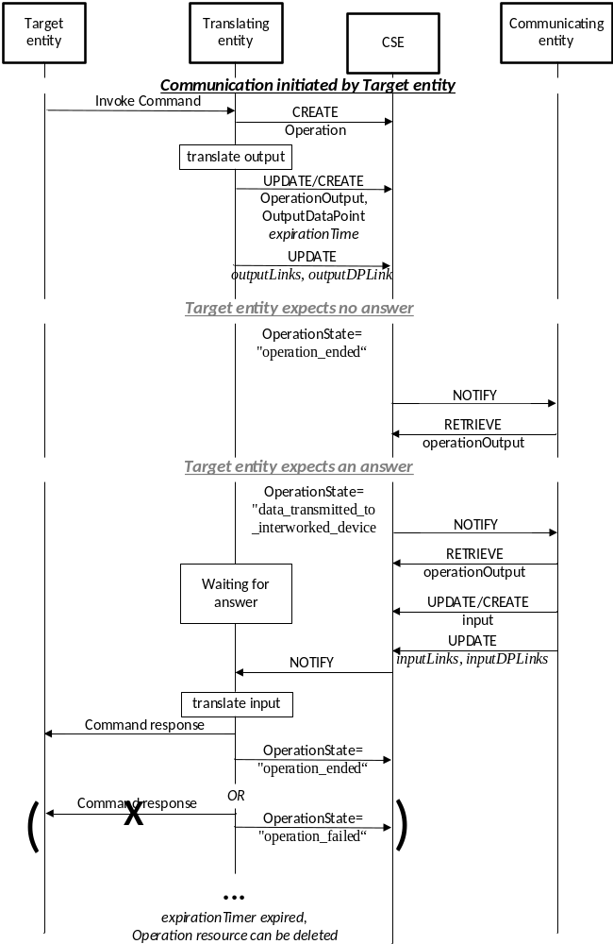
Figure 7: Data flow for a translating entity involving operations
when initiated by a target entity
transaction between the communicating entity and the target entity.
- When the target entity invokes a command that is exposed as an operation the translating entity creates a <genericInterworkingOperation> resource
Editor’s Note: to be completed...

-----------------------End of change 3---------------------------------------------

-----------------------Start of change 4-------------------------------------------

6.4 Specification of the Abstraction Application Entity (AAE)

6.4.1 General functionality of an AAE
The AAE translates between
- data – modelled according to the Device Information Model of the Area Network - that describe Services of a set of Proxied Devices
and
- data – modelled according to the Abstract Information Model - that describe Services of a related set of Abstract Devices.
To that purpose both, the Device Information Model and the Abstract Information Model need to be available as oneM2M compliant ontologies to the AAE.

6.4.2 Initialization of an AAE
First the AAE needs to be configured with the information on the IPE (the <AE> resource of the IPE, the ontology describing the Device Information Model of the IPE) for which it should provide Services abstraction and with the information on the ontology describing the Abstract Information Model.
Depending on the capabilities of the AAE and if the ontologies are made available as a OWL files the AAE may access and parse the OWL files.
By analysing the ontologies the AAE then needs to find out which Services in the ontology describing the Device Information Model can be abstracted into Services in the ontology describing the Abstract Information Model.
Both Services need to expose the same Function.
Similarly, the AAE needs to find out which Input- / OutputDataPoints and Operations of both ontologies expose the same Command.
Finally, the AAE needs to check that for all Variables (Input- / OutputDataPoints and OperationInputs / -Outputs) VariableConversions exist
Note: In many cases the Functions and Commands will be specified in the ontology of the Abstract Information Model and the VariableConversions will be specified in the ontology of the Device Information Model.
The AAE needs to discover the currently existing Proxied Devices of an IPE for which it can provide Services abstraction by retrieving the <container> or <flexContainer> child resources of the IPE's <AE> resource which represent Proxied Devices. For each of these Proxied Devices it will create an Abstract Device

6.4.2 Proxied Device discovery
The AAE shall subscribe to the <AE> resource of the IPE in order to discover Proxied Devices (<container> or <flexContainer> child resource of the IPE's <AE> resource) that the IPE may create in the future and for which the AAE could provide Services abstraction
- For each discovered Proxied Device the AAE shall create a <container> or <flexContainer> child resource of the AAE's <AE> resource for an Abstract Device that represents the Proxied Device
- For each Service (resource type <genericInterworkingService>) of the Proxied Device the AAE shall create the related abstracted Service as child resources of the resource of the Abstract Device.
- The IPE shall create <semanticDescriptor>s as child resources of the Services.
- For each Abstracted Service the AAE shall create the Input- and OutputDataPoints (resource types <container> and/or <flexContainer>) as child resources of the resources of the Abstract Device.
- The AAE shall subscribe to all its created resources.
- The AAE shall subscribe to all discovered Proxied Devices and their child resources to get notified about changes in these resources.

Handling of Input- OutputDataPoints and Operations by the AAE
A Command (datapoint or operation) may be exposed differently in the ontologies of the Device Information Model (of the Proxied Device) and the Abstract Information Model (of the Abstract Device).
The following table specifies the behaviour of the AAE when a communicating entity is initiating the communication with the AAE.
In this case the AAE transforms a Command of the Abstract Device Service into a Command of the Proxied Device Service.
 | Command in the Abstract Device Service is exposed as InputDataPoint  (to trigger the command the communicating entity has UPDATED that InputDataPoint) | Command in the Abstract Device Service is exposed as Operation  (to trigger the command the communicating entity needs to created a <genericInterworkingOperation>)
Command in the Proxied Device Service is exposed as InputDataPoint | Value of InputDataPoint of Abstract Device Service is converted according to VariableConversion and written into InputDataPoint of Proxied Device | The value of OperationInput or InputDataPoint of the <genericInterworkingOperation> of the Abstract Device Service is converted according to VariableConversion and written into the InputDataPoint of the Operation of the Proxied Device.
Command in the Proxied Device Service is exposed as Operation | The AAE creates an OperationInstance (type <genericInterworkingOperation>) resource as child resource of <genericInterworkingService> resource of the Proxied Device Service and subscribes to its outputDatapointLinks, outputLinks and operationState attributes.  The AAE reads the OperationInput or InputDataPoint of the Operation of the Abstract Device Service. The value of OperationInput or InputDataPoint of the Operation of the Abstract Device Service is converted according to VariableConversion and written into the resources for OperationInput or InputDataPoint of the <genericInterworkingOperation> of the Proxied Device.  The AAE updates attributes inputDatapointLinks, and/or inputLinks with the values of the resources for OperationInput or InputDataPoint | The AAE creates an OperationInstance (type <genericInterworkingOperation>) resource as child resource of <genericInterworkingService> resource of the Proxied Device Service and subscribes to its outputDatapointLinks, outputLinks and operationState attributes.  The AAE reads the OperationInput or InputDataPoint of the Operation of the Abstract Device Service. The value of OperationInput or InputDataPoint of the Operation of the Abstract Device Service is converted according to VariableConversion and written into the resources for OperationInput or InputDataPoint of the <genericInterworkingOperation> of the Proxied Device.  The AAE updates attributes inputDatapointLinks, and/or inputLinks with the values of the resources for OperationInput or InputDataPoint  Subsequently, the operationState attribute of the Operation of the Proxied Device shall be monitored for the lifetime of the Operation (<genericInterworkingOperation> resource) of the Proxied Device and copied into the operationState attribute of the Operation of the Abstract Device  When the operationState attribute of the Operation of the Proxied Device indicates the value "operation ended" the AAE shall convert the value of the OperationOutputs or OutputDataPoint of of the Operation of the Proxied Device according to VariableConversion and write it into OperationOutput or OutputDataPoint of the Operation of the Abstracted Device.  The AAE shall set the operationState attribute of the Operation of the Abstracted Device to the value "operation ended"

The following table specifies the behaviour of the AAE when an IPE is initiating the communication with the AAE.
In this case the AAE transforms a Command of the Proxied Device Service into a Command of the Abstract Device Service
 | Command in the Abstract Device Service is exposed as OutputDataPoint | Command in the Abstract Device Service is exposed as Operation
Command in the Proxied Device Service is exposed as OutputDataPoint  (to trigger the command the IPE has UPDATED that OutputDataPoint) | Value of OutputDataPoint of Proxied Device Service is converted according to VariableConversion and written into OutDataPoint of the Abstract Device | The AAE creates an OperationInstance (type <genericInterworkingOperation>) resource as child resource of <genericInterworkingService> resource of the Abstract Device Service  The AAE reads the OutputDataPoint of the Proxied Device Service. The value of the OutputDataPoint is converted according to VariableConversion and written into the resources for OperationOutput or OutputDataPoint of the <genericInterworkingOperation> of the Abstract Device Service.  The AAE updates attribute outputDatapointLinks or outputLinks with the values of the resources for OperationOutput or OutputDataPoint  The AAE shall set the operationState attribute of the Operation of the Abstract Device to the value "operation ended".
Command in the Proxied Device Service is exposed as Operation  (to trigger the command the IPE needs to created a <genericInterworkingOperation>) | The AAE reads the OperationOutput or OutputDataPoint of the <genericInterworkingOperation > resource Operation of the Proxied Device Service. The value of the OperationOutput or OutputDataPoint of the Operation of the Abstract Device Service is converted according to VariableConversion and written into the resource of the OutputDataPoint of the Service of the Abstract Device.  The AAE shall set the operationState attribute of the Operation of the Proxied Device to the value "operation ended". | First, the AAE creates an OperationInstance (type <genericInterworkingOperation > resource as child resource of <genericInterworkingService> resource of the Abstract Device Service) and subscribes to its inputDatapointLinks, inputLinks and operationState attributes.  The value of OperationOutput or OutputDataPoint of the Operation of the Proxied Device Service is converted according to VariableConversion and written into OperationOutput or OutputDataPoint of the Operation of the Abstract Device.  Subsequently, the operationState attribute and expirationTime attribute of the Operation of the Proxied Device shall be copied into the operationState attribute and expirationTime attribute of the Operation of the Abstract Device  In case the Operation contains no OperationInput or InputDataPoint the AAE shall set the value of the operationState attribute of the Operation of the Abstract Device to "operation ended"  If the value of the operationState attribute of the Operation of the Abstract Device is different to "operation ended" or “operation failed” then the AAE shall wait to receive input to this operation (OperationInput or InputDataPoint of the <genericInterworkingOperation> of the Abstract Device Service) by subscribed communicating entities, at maximum until the time indicated by the expirationTime attribute  If the AAE is notified about changes in the inputDatapointLinks, inputLinks attributes of the <genericInterworkingOperation> of the Abstract Device Service the AAE shall convert the values of the OperationInput or InputDataPoint of the <genericInterworkingOperation> of the Abstract Device Service according to VariableConversion and write them into OperationInput or InputDataPoint of the Operation of the Proxied Device.  The AAE shall set the operationState attribute of the Operation of the Abstracted Device to the value "operation ended".  If the AAE is not notified about changes in the inputDatapointLinks, inputLinks attributes of the <genericInterworkingOperation> of the Abstract Device Service until the time indicated by the expirationTime attribute the AAE shall set the the operationState attribute of the Operation of the Abstracted Device to the value "operation failed".  Additionally, the AAE shall set the the operationState attribute of the Operation of the Proxied Device to the value "operation failed".

-----------------------End of change 4---------------------------------------------

-----------------------Start of Changes to References Section -------------

2.1 Normative references
The following referenced documents are necessary for the application of the present document.
[1] oneM2M TS-0011: "Common Terminology".
[2] oneM2M TS-0001: "Functional Architecture".
[3] oneM2M TS-0012: " Base Ontology".
[4] oneM2M TS-0012-v2.0.0: " Base Ontology".
[5] oneM2M TS-0023: " Home Appliances Information Model and Mapping".

-----------------------End of Changes to References -------------

----Start of changes to Definitions Symbols Abbreviations Acronyms -

3 Definitions, symbols, abbreviations and acronyms

3.1 Definitions
For the purposes of the present document, the terms and definitions given in oneM2M TS-0011 [1], TS-0012 [3] and the following apply:
Abstract Device: virtual Device (i.e. a set of oneM2M resources together with an AAE) that allows a communicating entity to communicate with an Interworked Device, using an Abstract Information Model, without the need to know the Device Information Model of that Interworked Device.
Abstract Information Model: Information Model of common functionalities abstracted from a set of Device Information Models (see [1])
Abstraction: process of mapping between a set of Device Information Models and an Abstract Information Model according to a specified set of rules (see [1])
Abstraction Application Entity: A specialized AE that communicates with an IPE and facilitates Abstraction by providing Services that translate between the Abstract Information Model and the Device Information Model of the IPE.
Device Information Model: Information Model of the native protocol (e.g. ZigBee) for the physical device (see [1])
GenericInterworking: generic interworking allows interworking with many types of non- oneM2M Area Networks and Devices that are described in the form of a oneM2M compliant ontology which is derived from the oneM2M Base Ontology (see [3])
NOTE: generic interworking supports the interworking variant "full mapping of the semantic of the non-oneM2M data model to Mca" as indicated in clause F.2 of oneM2M TS-0001 [2].
Interworked Device: non-oneM2M device (NoDN) for which communication with oneM2M entities can be achieved via an Interworking Proxy Application Entity (IPE) (see [3])
Interworking Proxy Application Entity: A specialized AE that facititates interworking between Non-oneM2M Nodes (NoDN) and the oneM2M System. An IPE maps data of the NoDN into oneM2M resources (Interworked Devices). It invokes operations in the NoDN when the related oneM2M resources are modified and modifies oneM2M resources based on the output of NoDN operations. (see [1])
Proxied Device: virtual Device (i.e. a set of oneM2M resources together with an IPE) that represents the Interworked Device in the oneM2M System (see [3])

3.2 Symbols
<symbol> <Explanation>

3.3 Abbreviations and Acronyms

For the purposes of the present document, the abbreviations given in TS-0011 [1], TS-0012 [3] and the following apply:

AAE Abstraction Application Entity
IPE Interworking Proxy Application Entity (see [1])

---End of changes to Definitions, Symbols, Abbreviations, Acronyms ---

