Input Contribution
Meeting ID* | MAS 28
Title:* | New Resources for Semantic Mashup
Source:* | Chonggang Wang, Convida Wireless, Wang.Chonggang@ ConvidaWireless.Com  Junling Mao, China Unicom, maojl11@chinaunicom.cn  Catalina Mladin, Convida Wireless, Mladin.Catalina@ConvidaWireless.Com  Xu Li, Convida Wireless, Xu.Li@ConvidaWireless.Com
Date:* | 2017-03-19
Input related to* | WI-0053, TR-0033
Intended purpose of  document:* | Decision  Discussion  Information  Other <specify>
Impacted other TS/TR(s) | TR-0033, V-0.4.0, New resources for semantic mashup
Decision requested or recommendation:* | Request to agree on the proposed new resources for semantic mashup
Template Version: January 2017 (Do not modify)

oneM2M Notice
The document to which this cover statement is attached is submitted to oneM2M. Participation in, or attendance at, any activity of oneM2M, constitutes acceptance of and agreement to be bound by terms of the Working Procedures and the Partnership Agreement, including the Intellectual Property Rights (IPR) Principles Governing oneM2M Work found in Annex 1 of the Partnership Agreement.
GUIDELINES for Change Requests:
Provide an informative introduction containing the problem(s) being solved, and a summary list of proposals.
Each CR should contain changes related to only one particular issue/problem.
In case of a correction, and the change apply to previous releases, a separated “mirror CR” should be posted at the same time of this CR
Follow the principle of completeness, where all changes related to the issue or problem within a deliverable are simultaneously proposed to be made E.g. A change impacting 5 tables should not only include a proposal to change only 3 tables. Includes any changes to references, definitions, and acronyms in the same deliverable.
Follow the drafting rules.
All pictures must be editable.
Check spelling and grammar to the extent practicable.
Use Change bars for modifications.
The change should include the current and surrounding clauses to clearly show where a change is located and to provide technical context of the proposed change. Additions of complete sections need not show surrounding clauses as long as the proposed section number clearly shows where the new section is proposed to be located.
Multiple changes in a single CR shall be clearly separated by horizontal lines with embedded text such as, start of change 1, end of change 1, start of new clause, end of new clause.
When subsequent changes are made to content of a CR, then the accepted version should not show changes over changes. The accepted version of the CR should only show changes relative to the baseline approved text.

Introduction
The Clause 7.3 in TR-0033 describes Semantic Mashup Function (SMF) including high-level architecture and high-level operations. However, it does not give the details on how to implement the SMF in oneM2M functional architecture (e.g. what new resources may be needed and how to use them to realize the SMF functionality).
This contribution presents implementation details about the SMF. Specially, several new resources (i.e. <semanticMashupJobProfile> and <semanticMashupInstance>) are defined and the corresponding RESTful operations are described.

R01 includes the following changes:
- A new clause 7.3.X.5was added to describe
  - an example of <semanticMashupJobProfile> and
  - an example of <semanticMashupInstane> .

R02 includes the following changes:
- Updated the SPARQL query contained in memberFilter attribute in Figure 7.3.X.5-3. The new SPARQL uses CONSTRUCT feature to return a list of RDF triples; those triples include more information (e.g. the type of each candidate member) so that the mashup function as described in functionDescriptor would know the type of each member candidate (or more information about each member candidate which just need to change CONSTRUCT block to ask for returning more triples) and can appropriately apply those member candidates to generate mashup result.
- Also updated corresponding text which describes memberFilter attribute as shown in Figure 7.3.X.5-3.

-----------------------Start of change 1-------------------------------------------

7.3.X Semantic Mashup Function (SMF) Implementation Details

7.3.X.1 Resource Type semanticMashupJobProfile
The <semanticMashupJobProfile> resource represents a Semantic Mashup Job Profile (SMJP). The <semanticMashupJobProfile> resource shall contain the child resources specified in Table 7.3.X.1-1.
Table 7.3.X.1-1: Child resources of <semanticMashupJobProfile> resource
Child Resources of <semanticMashupJobProfile> | Child Resource Type | Multiplicity | Description
<variable> | <semanticMashupInstance> | 0..n | Represents semantic mashup instances which have been created based on this <semanticMashupJobProfile> resource. This child resource is optional as related<semanticMashupJobProfile> and <semanticMashupInstance> may be stored separately within the resource tree or on different CSEs.
<variable> | <semanticDescriptor> | 0..1 | Describes general semantic information about this <semanticMashupJobProfile> resource.
<variable> | <subscription> | 0..n | Represents subscriptions on this resource.

The <semanticMashupJobProfile> resource shall contain the attributes specified in Table 7.3.X.1-2.

Table 7.3.X.1-2: Attributes of <semanticMashupJobProfile> resource
Attributes of  <semanticMashupJobProfile> | Multiplicity | RW/  RO/  WO | Description
memberFilter | 1 | RW | Semantically describes the types of member resources which are involved in this semantic mashup job profile <semanticMashupJobProfile>. When a <semanticMashupInstance> is created based on this <semanticMashupJobProfile>, the member resources of the <semanticMashupInstance> shall be discovered and selected based on this memberFilter attribute. The value of this attribute is a SPARQL query.
smiID | 0..1(L) | RO | List of identifiers (e.g. URI) of related semantic mashup instance resources which have been created based on this <semanticMashupJobProfile>.
inputDescriptor | 0..1 | RW | Semantically (e.g. in semantic triples) describes the types of input parameters, which are required as input parameters in order to use this <semanticMashupJobProfile>. A Mashup Requestor needs to know and understand all types of input parameters as described in this attribute in order to create a <semanticMashupInstance> based on this <semanticMashupJobProfile>. Some semantic mashup job profiles may not need input parameters and as such this attribute is optional.
outputDescriptor | 1 | RW | Semantically (e.g. in semantic triples) describes the types of output parameters generated as semantic mashup results if using this <semanticMashupJobProfile>.
functionDescriptor | 1 | RW | Semantically (e.g. in semantic triples) describes the mashup function of this <semanticMashupJobProfile>. The mashup function specifies how semantic mashup results should be generated based on input parameters (defined by the inputDescriptor attribute) and original member resources (defined by the memberFilter attribute).

The structure of a <semanticMashupJobProfile> resource is also illustrated in Figure 7.3.X.1-1.
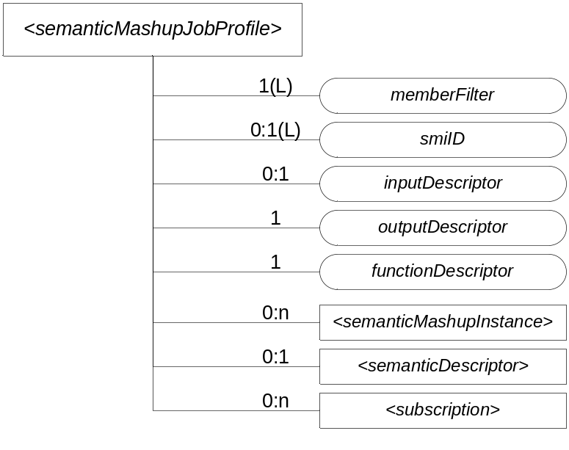
Figure 7.3.X.1-1: Structure of <semanticMashupJobProfile> Resource

7.3.X.2 <semanticMashupJobProfile> Procedures
A <semanticMashupJobProfile> resource can be provisioned to a Hosting CSE which provides semantic mashup function; alternatively, an AE or CSE can request to create <semanticMashupJobProfile> resource at the Hosting CSE. Once a <semanticMashupJobProfile> resource is provisioned or created at the Hosting CSE, other oneM2M CSEs/AEs, which act as Mashup Requestors, can discover, retrieve, update, or delete it based on the requirements.

Figure 7.3.X.2-1 illustrates a generic procedure (e.g. Create/Retrieve/Update/Delete) to operate on a <semanticMashupJobProfile> resource. Detailed descriptions are given in following clauses 7.3.X.2.1, 7.3.X.2.2, 7.3.X.2.3, and 7.3.X.2.4, respectively.

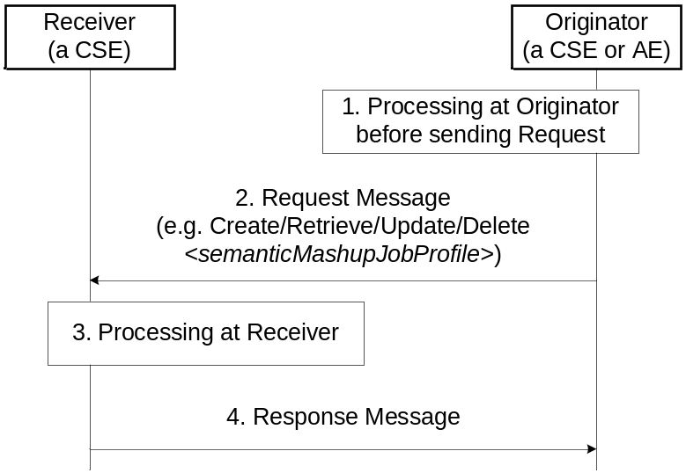
Figure 7.3.X.2-1: Generic procedures for operating a <semanticMashupJobProfile> resource

7.3.X.2.1 Create <semanticMashupJobProfile>
This procedure shall be used for creating a <semanticMashupJobProfile> resource as described in Table 7.3.X.2.1-1.

Table 7.3.X.2.1-1: <semanticMashupJobProfile> CREATE
<semanticMashupJobProfile> CREATE
Associated Reference Point | Mca, Mcc and Mcc'.
Information in Request message | All parameters defined in Table 8.1.2-3 in Error: Reference source not found apply with the specific details for:  Content: The resource content shall provide the information about an <semanticMashupJobProfile> resource (e.g. attribute values) as described in the Clause 7.3.X.1.
Processing at Originator before sending Request | According to clause 10.1.1.1 in Error: Reference source not found.
Processing at Receiver | According to clause 10.1.1.1 in Error: Reference source not found.
Information in Response message | All parameters defined in Table 8.1.3-1 in Error: Reference source not found apply with the specific details for:  Content: Address of the created <semanticMashupJobProfile> resource, according to clause 10.1.1.1 in Error: Reference source not found.
Processing at Originator after receiving Response | According to clause 10.1.1.1 in Error: Reference source not found.
Exceptions | According to clause 10.1.1.1 in Error: Reference source not found

7.3.X.2.2 Retrieve <semanticMashupJobProfile>
This procedure shall be used for retrieving the attributes of a <semanticMashupJobProfile> resource as described in Table 7.3.X.2.2-1.

Table 7.3.X.2.2-1: <semanticMashupJobProfile> RETRIEVE
<semanticMashupJobProfile> RETRIEVE
Associated Reference Point | Mca, Mcc and Mcc'.
Information in Request message | All parameters defined in Table 8.1.2-3 in Error: Reference source not found apply with the specific details for:  Content: void.
Processing at Originator before sending Request | According to clause 10.1.2 in Error: Reference source not found.
Processing at Receiver | The Receiver shall verify the existence (including Filter Criteria checking, if it is given) of the target resource or the attribute and check if the Originator has appropriate privileges to retrieve information stored in the resource/attribute. Otherwise clause 10.1.2 in Error: Reference source not found applies.
Information in Response message | All parameters defined in Table 8.1.3-1 in Error: Reference source not found apply with the specific details for:  Content: attributes of the <semanticMashupJobProfile> resource as defined in clause 7.3.X.1.
Processing at Originator after receiving Response | According to clause 10.1.2 in Error: Reference source not found.
Exceptions | According to clause 10.1.2 in Error: Reference source not found.  In addition, a timer has expired. The Receiver responds with an error.

7.3.X.2.3 Update <semanticMashupJobProfile>
This procedure as described in Table 7.3.X.2.3-1 shall be used to update an existing <semanticMashupJobProfile> resource, e.g. an update to its inputDescriptor attribute. The generic update procedure is described in clause 10.1.3 in Error: Reference source not found.

Table 7.3.X.2.3-1: <semanticMashupJobProfile> UPDATE
<semanticMashupJobProfile> UPDATE
Associated Reference Point | Mca, Mcc and Mcc'.
Information in Request message | All parameters defined in Table 8.1.2-3 in Error: Reference source not found apply with the specific details for:  Content: attributes of the <semanticMashupJobProfile> resource as defined in clause 7.3.X.1 to be updated.
Processing at Originator before sending Request | According to clause 10.1.3 in Error: Reference source not found.
Processing at Receiver | According to clause 10.1.3 in Error: Reference source not found.
Information in Response message | According to clause 10.1.3 in Error: Reference source not found.
Processing at Originator after receiving Response | According to clause 10.1.3 in Error: Reference source not found.
Exceptions | According to clause 10.1.3 in Error: Reference source not found.

7.3.X.2.4 Delete <semanticMashupJobProfile>
This procedure as described in Table 7.3.X.2.4-1 shall be used to delete an existing <semanticMashupJobProfile> resource. The generic delete procedure is described in clause 10.1.4.1 in Error: Reference source not found.

Table 7.3.X.2.4-1: <semanticMashupJobProfile> DELETE
<semanticMashupJobProfile> DELETE
Associated Reference Point | Mca, Mcc and Mcc'.
Information in Request message | All parameters defined in Table 8.1.2-3 in Error: Reference source not found apply.
Processing at Originator before sending Request | According to clause 10.1.4.1 in Error: Reference source not found.
Processing at Receiver | According to clause 10.1.4.1 in Error: Reference source not found.  - If the <semanticMashupJobProfile> to be deleted has smiID attribute and the smiID attribute has a value, the Receiver notifies each <semanticMashupInstance> resource as included in the smiID attribute of the removal of the <semanticMashupJobProfile> since those <semanticMashupInstance> resources use this <semanticMashupJobProfile>.  - If the <semanticMashupJobProfile> to be deleted has <semanticMashupInstance> child resources, all those <semanticMashupInstance> child resources shall be removed accordingly.
Information in Response message | According to clause 10.1.4.1 in Error: Reference source not found.
Processing at Originator after receiving Response | According to clause 10.1.4.1 in Error: Reference source not found.
Exceptions | According to clause 10.1.4.1 in Error: Reference source not found.

7.3.X.3 Resource Type semanticMashupInstance
<semanticMashupInstance> models and represents a Semantic Mashup Instance (SMI) resource. A CSE/AE as a Mashup Requestor can request to create <semanticMashupInstance> resources at another oneM2M CSE which implements the semantic mashup function as described in the clause 7.3.2. Each created <semanticMashupInstance> resource corresponds to a semantic mashup job profile (i.e. a <semanticMashupJobProfile> resource); in other words, how the <semanticMashupInstance> resource should execute the mashup operation to calculate the mashup result is specified in the corresponding <semanticMashupJobProfile> resource. Note that the <semanticMashupInstance> and its corresponding <semanticMashupJobProfile> resources may be placed at the same CSE or at different CSEs, and the smjpID attribute of the <semanticMashupInstance> allows locating the corresponding <semanticMashupJobProfile> resource. If the <semanticMashupInstance> resource has a <semanticMashupResult> as its child resource, the Mashup Requestor may use it to retrieve the mashup result.
<semanticMashupInstance> resource shall contain the child resources specified in Table 7.3.X.3-1.
Table 7.3.X.3-1: Child resources of <semanticMashupInstance> resource
Child Resources of <semanticMashupInstance> | Child Resource Type | Multiplicity | Description
<variable> | <semanticMashupResult> | 0..n | Contains mashup result. A <semanticMashupInstance> resource may have multiple <semanticMashupResult> child resources, with each mashup result instance resulting from different member resource values. The hosting CSE generates <semanticMashupResult> each time when it executes the mashup operation and calculate a new semantic mashup result (e.g. for long-lived mashup application as described in the clause 8.8.3.3).
<variable> | <semanticDescriptor> | 0..1 | Describes general semantic information about this <semanticMashupInstance> resource.
<variable> | <subscription> | 0..n | Stands for any subscription on this <semanticMashupInstance>. This is an existing oneM2M resource.
<mashup> | <mashup> | 0..1 | This is a standard oneM2M virtual resource. When a Mashup Requestor sends a RETRIEVE operation on this virtual resource, it triggers a re-calculation and re-generation of the mashup result.

<semanticMashupInstance> resource shall contain the attributes specified in Table 7.3.X.3-2.

Table 7.3.X.3-2: Attribute of <semanticMashupInstance> resource
Attributes of  <semanticMashupInstance> | Multiplicity | RW/  RO/  WO | Description
smjpID | 1 | RW | Denotes the identifier (e.g. URI) of the semantic mashup job profile resource <semanticMashupJobProfile> which this <semanticMashupInstance> is based on.
smjpInputParameter | 1 | RW | Contains the value of all input parameters which are required to calculate the mashup result. Note that the types of these input parameters are specified by the inputDescriptor attribute of the corresponding <semanticMashupJobProfile> which is denoted by the smjpID attribute of this <semanticMashupInstance> resource. This attribute is not needed if the corresponding <semanticMashupJobProfile> does not have inputDescriptor attribute.
memberStoreType | 1 | RW | Indicates the way which member resources should be stored under this <semanticMashupInstance>. For example,  - If memberStoreType=”URI Only”, the mashupMember attribute contains the URI of each member resource;  - If memberStoreType=”URI and Value”, the mashupMember attribute contains both the URI and the value of each member resource.
mashupMember | 0:1(L) | RW | Stores the URI and/or value of each mashup member resource, which is dependent on the value of memberStoreType attribute.
resultGenType | 1(L) | RW | Describes how the mashup result should be generated using this <semanticMashupInstance>. Example values for this attribute could be one of the following or a combination of them.  - If resultGenType=”When SMI Is Created”, the semantic mashup result is generated when this <semanticMashupInstance> is created by running semantic functions specified by the corresponding <semanticMashupJobProfile>.  - If resultGenType=”When Mashup Requestor Requests”, the mashup result is to be calculated and generated when requested or triggered by a Mashup Requestor which sends a RETRIEVE operation on the virtual child resource mashup.  - If resultGenType=”Periodically”, the CSE which hosts <semanticMashupInstance> calculates and generates the semantic mashup result periodically based on the periodForResultGen attribute.  - If resultGenType=”When A Mashup Member Is Updated”, the CSE which hosts <semanticMashupInstance> calculates and generates the semantic mashup result whenever there is any update on the mashupMember attribute of <semanticMashupInstance>.
periodForResultGen | 0:1 | RW | Is the time period for re-calculating and generating the semantic mashup result. When it is the time to re-calculate the semantic mashup result, the CSE hosting this <semanticMashupInstance> needs to retrieve the latest content value of each member resource if it is not obtained yet. This attribute is needed when resultGenType=”Periodically”.

The structure of <semanticMashupInstance> resource is also illustrated in Figure 7.3.X.3-1.

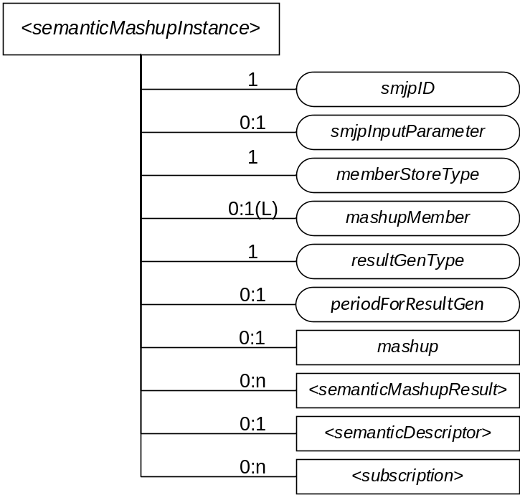
Figure 7.3.X.3-1: Structure of <semanticMashupInstance> Resource

7.3.X.4 <semanticMashupInstance> Procedures
Figure 7.3.X.4-1 illustrates the procedure to operate a <semanticMashupInstance> resource (e.g. Create/Retrieve/Update/Delete a <semanticMashupInstance> resource). Detail descriptions are given in the clause 7.3.X.4.1, 7.3.X.4.2, 7.3.X.4.3, 7.3.X.4.4, and 7.3.X.4.5, respectively.

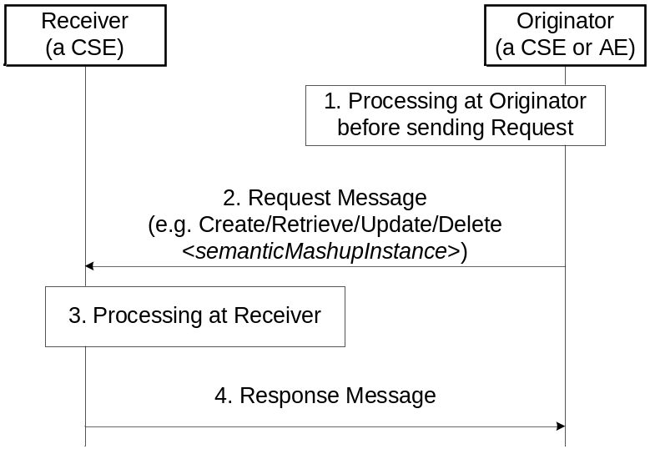
Figure 7.3.X.4-1: Procedures for Operating a <semanticMashupInstance> Resource

7.3.X.4.1 Create <semanticMashupInstance>
This procedure shall be used for creating a <semanticMashupInstance> resource as described in Table 7.3.X.4.1-1.

Table 7.3.X.4.1-1: <semanticMashupInstance> CREATE
<semanticMashupInstance> CREATE
Associated Reference Point | Mca, Mcc and Mcc'.
Information in Request message | All parameters defined in Table 8.1.2-3 in Error: Reference source not found apply with the specific details for:  Content: The resource content shall provide the information about a <semanticMashupInstance> resource (e.g. attribute values) as described in the clause 7.3.X.3.
Processing at Originator before sending Request | According to clause 10.1.1.1 in Error: Reference source not found.  - If the Originator knows the identifier or URI of each mashup member, it can include the value of mashupMember in the Request message.
Processing at Receiver | According to clause 10.1.1.1 in Error: Reference source not found.  - The Receiver shall first check if the corresponding <semanticMashupJobProfile> as denoted by smjpID attribute exists or not. If it does not exist, the Receiver shall not create the <semanticMashupInstance> and shall report an error (e.g. “<semanticMashupJobProfile> does not exist”) in the Response message to the Originator. If it exists, the Receiver shall retrieve its content.  - The Receiver shall check if smjpInputParameter included in the Request message meets the input parameter requirement as specified by the inputDescriptor attribute of corresponding <semanticMashupJobProfile>. If it does not meet the requirement, the Receiver shall not create the <semanticMashupInstance> and shall report an error (e.g. “smjpInputParameter” does not meet the requirement”) in the Response message to the Originator.  - According to the memberFilter attribute of the retrieved <semanticMashupJobProfile>, the Receiver extracts the SPARQL query contained in memberFilterand use it to discover and determine mashup member resources for the <semanticMashupInstance> to be created.  - Dependent on the memberStoreType attribute contained in the Request message, the Receiver maintains each member resource in different ways. If memberStoreType=”URI Only”, the Receiver creates the mashupMember attribute containing the URIs of the determined member resources. If memberStoreType=”URI and Value”, the Receiver creates the mashupMember attribute, retrieves the content value of each member resource and then stores both the identifier and the content value of each member resource in the mashupMember attribute.  - Depending on the resultGenType attribute contained in the Request message, the Receiver prepares to execute the corresponding semantic mashup job profile as follows.  - If resultGenType=” When SMI Is Created”, the Receiver retrieves the content value of each member resource if not retrieved yet; then it executes mashup functions as specified by the <semanticMashupJobProfile> and generates semantic mashup result, which shall be stored in the <semanticMashupResult> child resource.  - If resultGenType=”When A Mashup Requestor Requests”, there is no further processing at the Receiver.  - If resultGenType=”Periodically”, the Receiver shall set up a timer according to the periodForResultGen attribute contained in the Request message. When the timer expires, the Receiver shall retrieve the content value of each member resource and re-generate the mashup result; then it renews the timer.  - If resultGenType=”When A Mashup Member Is Updated”, there is no further processing at the Receiver.
Information in Response message | All parameters defined in Table 8.1.3-1 in Error: Reference source not found apply with the specific details for:  Content: Address of the created <semanticMashupInstance> resource and address of created <semanticMashupResult> resource if any, according to clause 10.1.1.1 in Error: Reference source not found.
Processing at Originator after receiving Response | According to clause 10.1.1.1 in Error: Reference source not found.
Exceptions | According to clause 10.1.1.1 in Error: Reference source not found

7.3.X.4.2 Retrieve <semanticMashupInstance>
This procedure shall be used for retrieving the attributes of a <semanticMashupInstance> resource as described in Table 7.3.X.4.2-1.

Table 7.3.X.4.2-1: <semanticMashupInstance> RETRIEVE
<semanticMashupInstance> RETRIEVE
Associated Reference Point | Mca, Mcc and Mcc'.
Information in Request message | All parameters defined in Table 8.1.2-3 in Error: Reference source not found apply with the specific details for:  Content: void.
Processing at Originator before sending Request | According to clause 10.1.2 in Error: Reference source not found.
Processing at Receiver | The Receiver shall verify the existence (including Filter Criteria checking, if it is given) of the target resource or the attribute and check if the Originator has appropriate privileges to retrieve information stored in the resource/attribute. Otherwise clause 10.1.2 in Error: Reference source not found applies.
Information in Response message | All parameters defined in Table 8.1.3-1 in Error: Reference source not found apply with the specific details for:  Content: attributes of the <semanticMashupInstance> resource as defined in the clause 7.3.X.3.
Processing at Originator after receiving Response | According to clause 10.1.2 in Error: Reference source not found.
Exceptions | According to clause 10.1.2 in Error: Reference source not found.

7.3.X.4.3 Retrieve <semanticMashupInstance>/<mashup>
This procedure shall be used for triggering the CSE which hosts the <semanticMashupInstance> to recalculate mashup results and returning the mashup result back to the requestor (e.g. an AE) of this retrieve request as described in Table 7.3.X.4.3-1.

Table 7.3.X.4.3-1: <semanticMashupInstance>/<mashup> RETRIEVE
<semanticMashupInstance>/<mashup> RETRIEVE
Associated Reference Point | Mca, Mcc and Mcc'.
Information in Request message | All parameters defined in Table 8.1.2-3 in Error: Reference source not found apply with the specific details for:  To: <semanticMashupInstance>/<mashup>  Content: void.
Processing at Originator before sending Request | According to clause 10.1.2 in Error: Reference source not found.
Processing at Receiver | The Receiver shall check if the Originator has appropriate privileges. Otherwise clause 10.1.2 in Error: Reference source not found applies.  - The Hosting CSE triggers the recalculation of semantic mashup result for this <semanticMashupInstance>. The recalculated mashup result shall be stored in a child <semanticMashupResult> resource.
Information in Response message | All parameters defined in Table 8.1.3-1 in Error: Reference source not found apply with the specific details for:  Content: the mashup result, if indicated in the request
Processing at Originator after receiving Response | According to clause 10.1.2 in Error: Reference source not found.
Exceptions | According to clause 10.1.2 in Error: Reference source not found.  In addition: a timer has expired. The Receiver responds with an error.

7.3.X.4.4 Update <semanticMashupInstance>
This procedure as described in Table 7.3.X.4.4-1 shall be used to update an existing <semanticMashupInstance>, e.g. an update to its memberStoreType attribute. The generic update procedure is described in clause 10.1.3 in Error: Reference source not found.

Table 7.3.X.4.4-1: <semanticMashupInstance> UPDATE
<semanticMashupInstance> UPDATE
Associated Reference Point | Mca, Mcc and Mcc'.
Information in Request message | All parameters defined in Table 8.1.2-3 in Error: Reference source not found apply with the specific details for:  Content: attributes of the <semanticMashupInstance> resource as defined Section to be updated.
Processing at Originator before sending Request | According to clause 10.1.3 in Error: Reference source not found.
Processing at Receiver | According to clause 10.1.3 in Error: Reference source not found.  - If the updated attribute in the Request message is smjpInputParameter and if the original resultGenType=”When SMI Is Updated”, the Receiver needs to recalculate the semantic mashup result using the new values of input parameters.  - If the updated attribute in the Request message is memberStoreType, the Receiver needs to change the way to maintain mashup member resources. For example, if memberStoreType is updated from “URI Only” to “URI and Value”, the Receiver needs to retrieve the content value of each mashup member resource and store the values together with URI in mashupMember attribute. If memberStoreType is updated from “URI and Value” to “URI Only”, the Receiver needs mashupMember attribute to only maintain the identifier of each mashup member.  - If the updated attribute in the Request message is resultGenType, the Receiver changes the way to calculate/generate the semantic mashup result accordingly.
Information in Response message | According to clause 10.1.3 in Error: Reference source not found.
Processing at Originator after receiving Response | According to clause 10.1.3 in Error: Reference source not found.
Exceptions | According to clause 10.1.3 in Error: Reference source not found.

7.3.X.4.5 Delete <semanticMashupInstance>
This procedure as described in Table 7.3.X.4.5-1 shall be used to delete an existing <semanticMashupInstance>. The generic delete procedure is described in clause 10.1.4.1 in Error: Reference source not found.

Table 7.3.X.4.5-1: <semanticMashupInstance> DELETE
<semanticMashupInstance> DELETE
Associated Reference Point | Mca, Mcc and Mcc'.
Information in Request message | All parameters defined in Table 8.1.2-3 in Error: Reference source not found apply.
Processing at Originator before sending Request | According to clause 10.1.4.1 in Error: Reference source not found.
Processing at Receiver | According to clause 10.1.4.1 in Error: Reference source not found.  - In addition, The Receiver removes this <semanticMashupInstance> from the smiID attribute of the corresponding <semanticMashupJobProfile>.
Information in Response message | According to clause 10.1.4.1 in Error: Reference source not found.
Processing at Originator after receiving Response | According to clause 10.1.4.1 in Error: Reference source not found.
Exceptions | According to clause 10.1.4.1 in Error: Reference source not found.

7.3.X.5 Examples for <semanticMashupJobProfile> and <semanticMashupInstance>
A concrete example is illustrated below to show how the proposed semantic mashup related resources can be utilized to realize the smart parking mashup application.

For this mashup application, two ontologies are illustrated in Figure 7.3.X.5-1 and Figure 7.3.X.5-2, respectively for parking spot ontology and semantic mashup job profile ontology.
- Figure 7.3.X.5-1 shows a general ontology on parking spot which can be leveraged by various different mashup applications. The following classes are defined in this ontology.
  - parkingSpot, parkingSpotInAParkingBuilding, streetParkingSpot, address, spotSelectionAlgorithm.
  - parkingSpotInAParkingBuilding is a subclass of parkingSpot
  - streetParkingSpot is a subclass of parkingSpot
  - spotSelectionAlgorithm is used to apply “adoptedSelectionCriteria” on the candidate parking spots and address (i.e. user destination) to calculate suitable parking spots.

- Figure 7.3.X.5-2 shows the particular ontology for this mashup application (called SMJP ontology). The following classes are defined in this ontology:
  - semanticMashupJobProfile, input, output, memberCandidate, and mashupFunction.
  - Note that, depending on different applications, those classes defined in the SMJP ontology will be linked to classes of specific ontologies when realizing different mashup applications. For example, when describing the SMJP of the smart parking assistance as shown in Figure 7.3.X.5-3, the classes defined in the SMJP ontology will be linked to the specific classes defined in the parking spot ontology shown in Figure 7.3.X.5-1.

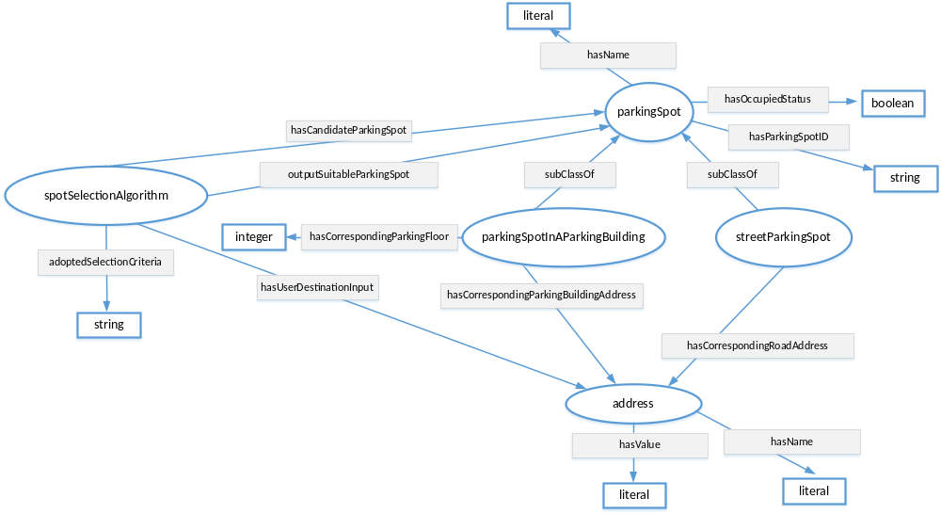
Figure 7.3.X.5-1: Parking Spot Ontology

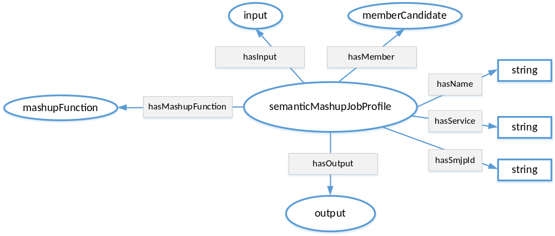
Figure 7.3.X.5-2: Semantic Mashup Job Profile (SMJP) Ontology

Based on those two ontologies, an example of <semanticMashupJobProfile> resource (i.e. <SmartParkingAssistance>) is shown in Figure 7.3.X.5-3. Basically, this <SmartParkingAssistance> resource exposes all the necessary information about the smart parking mashup application. For example:
- memberFilter: This attribute includes the information about which resources are eligible or qualified to provide data inputs for this smart parking mashup application. For example, <SmartParkingAssistance> has two type of member candidates: the first type of member candidate is the type of “building parking spot” and the second type of member candidate is the type of “street parking spot”. This is where how the classes defined in the SMJP ontology are linked to the specific classes defined in the parking spot ontology, i.e., an instance of memberCandidate class defined in SMJP ontology is also an instance of parkingSpot class defined in the parking spot ontology. In the meantime, certain constraints are also defined to describe further application requirements. For example, for a given parking spot (either a building parking spot or a street parking spot), it needs to be in an “unoccupied” status. For this example, the memberFilter contains a SPARQL query as below. The returned result from this SPAQRL query will be a list of RDF triples; each triple represents an instance of parkingSpotInAParkingBuilding or an instance of streetParkingSpot; then the mashup function as described in functionDescriptor is able to know the type of each member candidate and can appropriately apply them accordingly to generate mashup result.

PREFIX ps:<http://parkingspot.example.org>
PREFIX rdf:<http://www.w3.org/1999/02/22-rdf-syntax-ns#>
PREFIX rdfs:<http://www.w3.org/2000/01/rdf-schema#>
PREFIX xsd:<http://www.w3.org/2001/XMLSchema#>

CONSTRUCT {
?BuildingParkingSpot rdf:type ps:parkingSpotInAParkingBuilding .
?StreetParkingSpot rdf:type ps:streetParkingSpot .
}
where
{
?BuildingParkingSpot rdf:type ps:parkingSpotInAParkingBuilding ;
ps:hasOccupiedStatus “unoccupied” .

?StreetParkingSpot rdf:type ps:streetParkingSpot ;
ps:hasOccupiedStatus “unoccupied” .
}

- inputDescriptor: This attribute includes what information is needed from the Mashup Requestor (MR) to leverage/apply this semantic mashup profile. For example, in the smart parking example shown in Figure 7.3.X.5-3, the user/MR will provide his/her destination address (described as “smjp:input1”). Similarly, here an instance of input class defined in SMJP ontology is an instance of address class defined in the parking spot ontology. It is also possible that other inputs may also be provided such as “parking preference”, which is not shown in this example.
- functionDescriptor: This attribute indicates how the mashup result will be generated, which is based on certain application business logic. For example, in the smart parking mashup application, given all the eligible/candidate parking spots, different types of selection criteria could be adopted. In the example shown in Figure 7.3.X.5-3, it indicates that the parking spot having the shortest walking distance will be selected as the “suitable parking spot” that is to be returned to the user (as the mashup result). The real implementation of the application business logic (e.g. how to calculate the walking distance between a parking spot and the user destination? and how to find the shortest walking distance in this smart parking assistance example?) is an implementation-specific (e.g. some script code); this is an internal process of the Common Service Entity (CSE) where <semanticMashupInstance> resides and will not be exposed to via the <semanticMashupInstance> resource.
- outputDescriptor: This attribute describes what the mashup result looks like. For example, in the smart parking example shown in Figure 7.3.X.5-3, this attribute indicates that the mashup result has the name of “suitable parking spot” and it is in fact either a building parking spot or a street parking spot. Since the mashup result is a type of ex:parkingSpotInAParkingBuilding or ex:streetParkingSpot (which are the classes/concepts defined in the adopted ontology), it will be clear that the mashup result in terms of an instance of output class defined in SMJP ontology is also an instance of parkingSpotInAParkingBuilding or streetParkingSpot classes defined in the parking spot ontology, and then the mashup result will have corresponding properties, such as address information, spot ID, etc.
- <semanticDescriptor>/descriptor: The information stored in the <semanticDescriptor>/descriptor can include the general metadata about a <semanticMashupJobProfile>. For example, in the Figure 7.3.X.5-3, it shows that the <SmartParkingAssistance> is type of <semanticMashupJobProfile> resource, and it is for supporting smart parking application and can provide a service called “find suitable parking spot”.

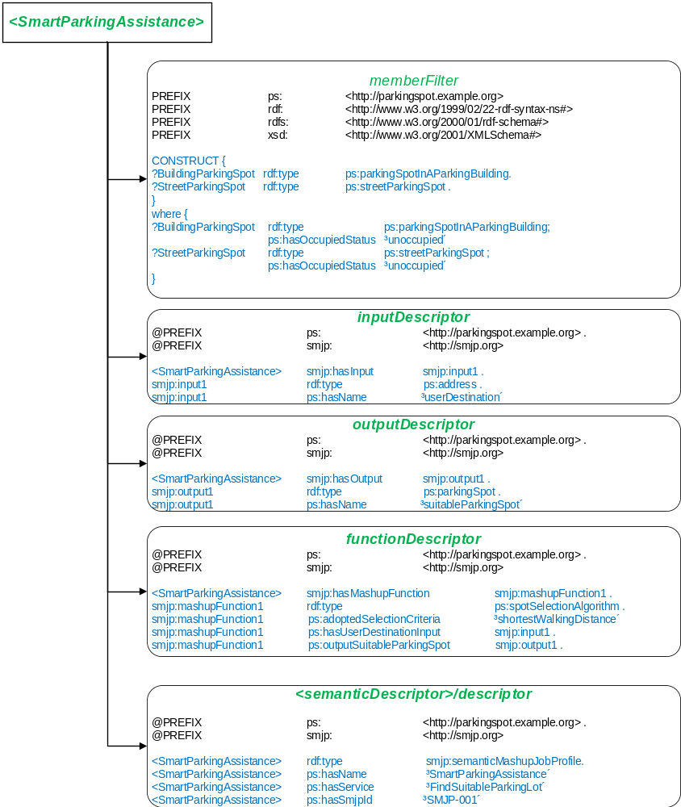
Figure 7.3.X.5-3: An SMJP of Smart Parking Mashup Application using a <semanticMashupJobProfile> Resource
Once an MR identifies a desired <semanticMashupJobProfile>, it can initialize a real mashup process (which corresponds to a “working instance”, i.e., a <semanticMashupInstance>). In the example of smart parking mashup application, when a user intends to find a suitable parking spot around his/her destination, it will send a request to the hosting CSE to trigger a real mashup process for the smart parking assistance application. Accordingly, the hosting CSE will refer to the <semanticMashupJobProfile> of the smart parking assistance (as shown in the Figure 7.3.X.5-3), and create a <semanticMashupInstance> based on this <semanticMashupJobProfile> and the inputs given by the user. Figure 7.3.X.5-4 shows a concrete example of the <semanticMashupInstance> for the smart parking assistance application. In Figure 7.3.X.5-4, it shows a specific <SuitableParkingSpot-1> resource, which is a type of <semanticMashupInstance> resource, and it exposes all the necessary information about this specific SMI. For example:
- smjpID: This attribute indicates this <semanticMashupInstance> is created based on which <semanticMashupJobProfile> resource. In the example shown in Figure 7.3.X.5-4, it shows that the smjpID is “SmartParkingAssistance-001”, which corresponds to smart parking assistance mashup application profile as shown in Figure 7.3.X.5-3.
- smjpInputParameter: This attribute includes the inputs from the MR/user side. For example, it shows that the user is looking for a suitable parking spot around his/her destination, which is “255 36th street, New York City, NY, 10001”.
- memberStoreType: The value of this attribute is “URI and Value”, which means that the mashupMember attribute will show both the URIs of member resources and their attribute values in RDF triples in this example.
- mashupMember: This attribute indicates all the qualified member resources for this particular <semanticMashupInstance>. For example, as shown in Figure 7.3.X.5-4, given user’s destination address (i.e., around “255 36th street, New York City, NY, 10001”), all the potential eligible parking spots will be listed here, which were identified based on the “memberFilter” attribute as defined in the corresponding SMJP of this <semanticMashupInstance>. For example, two parking spots are listed in Figure 7.3.X.5-4, i.e., <buildingParkingSopt-1> (which is a spot in a parking building) and <streetParkingSopt-1> (which is a street parking spot). In particular, the detailed information about those two parking spots are also included in this attribute. For example, the detailed location information about <buildingParkingSopt-1> is as follows: This parking spot is in a parking building at “255 37th street, New York City, NY, 10001”, and this spot is in the 3rd floor, and the specific spot ID is “23”.
- resultGenType: This attribute indicates how the mashup process will be triggered. In this smart parking assistance example, the value is “when SMI is created”. It means that when a user is looking for a suitable parking spot by sending a request to the hosting CSE for SMS, once a corresponding SMI is created, it will immediately generate the mashup result in terms of a suitable parking spot. Note that, the smart parking assistance is type of “short-lived semantic mashup” in the sense that each user will create a respective SMI for his/her own parking needs and the created SMI may be just used once. For another type of mashup application, i.e., “long-lived semantic mashup application” such as the weather reporting mashup application, a given SMI could be re-used and shared by different MRs for multiple times. For example, once an SMI has been created for reporting weather information of New York City Area, the mashup result of this SMI can either be refreshed periodically due to real-time weather changes or the mashup process can be triggered by users’ requests after the SMI is created.
- <semanticMashupResult>: To store the mashup result. For example, in the Figure 7.3.X.5-4, from this <semanticMashupResult> child resource, it can be seen that the suitable parking sport is <buildingParkingSopt-1>, among all the eligible parking spots near the user’s destination.

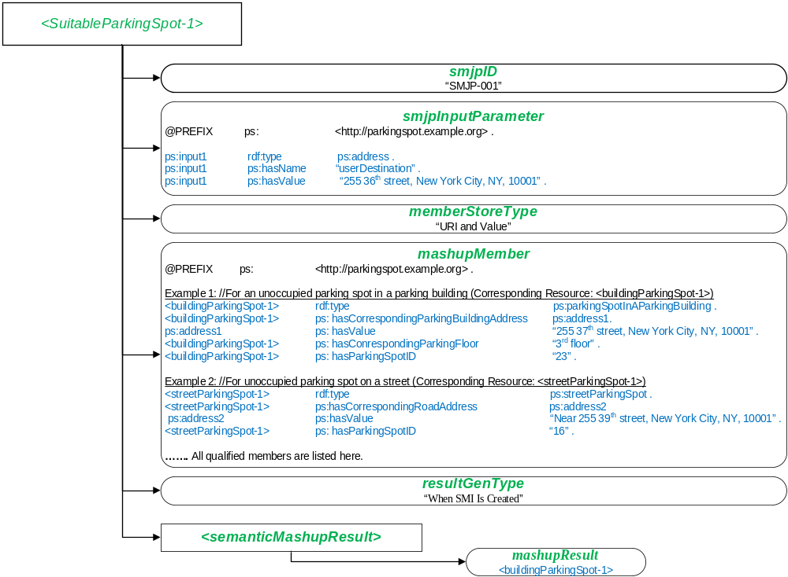
Figure 7.3.X.5-4: An SMI of Smart Parking Mashup Application Represented by a <semanticMashupInstance> Resource

-----------------------End of change 1---------------------------------------------

