Input Contribution
Meeting ID* | MAS 29
Title:* | Semantic Mashup
Source:* | Chonggang Wang, Convida, wang.chonggang@convidawireless.com  Catalina Mladin, Convida, mladin.catalina@convidawireless.com  Xu Li, Convida, li.xu@convidawireless.com
Date:* | 2017-05-22
Input related to* | WI-0053, TS-0034
Intended purpose of  document:* | Decision  Discussion  Information  Other <specify>
Impacted other TS/TR(s) | TS-0034. V-0.0.1, Semantic Support
Decision requested or recommendation:* | Request to agree on the proposed resources and operations for semantic mashup
Template Version: January 2017 (Do not modify)

oneM2M Notice
The document to which this cover statement is attached is submitted to oneM2M. Participation in, or attendance at, any activity of oneM2M, constitutes acceptance of and agreement to be bound by terms of the Working Procedures and the Partnership Agreement, including the Intellectual Property Rights (IPR) Principles Governing oneM2M Work found in Annex 1 of the Partnership Agreement.

Introduction
Semantic mashup including use case, overall architecture, required resources, and procedures have been well defined in TR-0033. It’s ready to consider adopting this feature in TS-0034.

-----------------------Start of change 1-------------------------------------------

2 References
The following text block applies.
References are either specific (identified by date of publication and/or edition number or version number) or non-specific. For specific references, only the cited version applies. For non-specific references, the latest version of the referenced document (including any amendments) applies.

2.1 Normative references
Clause 2.1 only shall contain normative (essential) references which are cited in the document itself. These references have to be publicly available and in English.
The following referenced documents are necessary for the application of the present document.
[1] oneM2M TS-0001: "Functional Architecture".

2.2 Informative references
Clause 2.2 shall only contain informative references which are cited in the document itself.
The following referenced documents are not necessary for the application of the present document but they assist the user with regard to a particular subject area.
[i.1] oneM2M Drafting Rules (http://www.onem2m.org/images/files/oneM2M-Drafting-Rules.pdf)

-----------------------End of change 1-------------------------------------------

-----------------------Start of change 2-------------------------------------------

3.3 Abbreviations
Abbreviations should be ordered alphabetically.
Clause numbering depends on applicability.
For the purposes of the present document, the [following] abbreviations [given in ... and the following] apply:
Abbreviation format
ARIB Association of Radio Industries and Businesses
ATIS Alliance for Telecommunications Industry Solutions
CCSA China Communications Standards Association
ETSI European Telecommunications Standards Institute
TIA Telecommunications Industry Association,
TSDSI Telecommunications Standards Development Society
TTA Telecommunications Technology Association
TTC Telecommunication Technology Committee

AE Application Entity
CRUD Create, Retrieve, Update, Delete
CSE Common Service Entity
CSF Common Service Function
IoT Internet of Things
MR Mashup Requestor
RDF Resource Description Framework
RH Resource Host
SMF Semantic Mashup Function
SMI Semantic Mashup Instance
SMJP Semantic Mashup Job Profile
SPARQL SPARQL Protocol and RDF Query Language

<ABREVIATION1> <Explanation>
<ABREVIATION2> <Explanation>
<ABREVIATION3> <Explanation>

------------------------End of change 2--------------------------------------------

-----------------------Start of change 3-------------------------------------------

6.W Resource Type semanticMashupJobProfile

6.W.1 Definition
Note: This section shows resource types, similar to TS-0001 clause 9.6.
The <semanticMashupJobProfile> resource represents a Semantic Mashup Job Profile (SMJP). The <semanticMashupJobProfile> resource shall contain the child resources specified in Table 6.W.1-1.
Table 6.W.1-1: Child resources of <semanticMashupJobProfile> resource
Child Resources of <semanticMashupJobProfile> | Child Resource Type | Multiplicity | Description
<variable> | <semanticMashupInstance> | 0..n | Represents semantic mashup instances which have been created based on this <semanticMashupJobProfile> resource. This child resource is optional as related<semanticMashupJobProfile> and <semanticMashupInstance> may be stored separately within the resource tree or on different CSEs.
<variable> | <semanticDescriptor> | 0..1 | Describes general semantic information about this <semanticMashupJobProfile> resource.
<variable> | <subscription> | 0..n | Represents subscriptions on this resource.

The <semanticMashupJobProfile> resource shall contain the attributes specified in Table 6.W.1-2.

Table 6.W.1-2: Attributes of <semanticMashupJobProfile> resource
Attributes of  <semanticMashupJobProfile> | Multiplicity | RW/  RO/  WO | Description
memberFilter | 1 | RW | Semantically describes the types of member resources which are involved in this semantic mashup job profile <semanticMashupJobProfile>. When a <semanticMashupInstance> is created based on this <semanticMashupJobProfile>, the member resources of the <semanticMashupInstance> shall be discovered and selected based on this memberFilter attribute. The value of this attribute is a SPARQL query.
smiID | 0..1(L) | RO | List of identifiers (e.g. URI) of related semantic mashup instance resources which have been created based on this <semanticMashupJobProfile>.
inputDescriptor | 0..1 | RW | Semantically (e.g. in semantic triples) describes the types of input parameters, which are required as input parameters in order to use this <semanticMashupJobProfile>. A Mashup Requestor needs to know and understand all types of input parameters as described in this attribute in order to create a <semanticMashupInstance> based on this <semanticMashupJobProfile>. Some semantic mashup job profiles may not need input parameters and as such this attribute is optional.
outputDescriptor | 1 | RW | Semantically (e.g. in semantic triples) describes the types of output parameters generated as semantic mashup results if using this <semanticMashupJobProfile>.
functionDescriptor | 1 | RW | Semantically (e.g. in semantic triples) describes the mashup function of this <semanticMashupJobProfile>. The mashup function specifies how semantic mashup results should be generated based on input parameters (defined by the inputDescriptor attribute) and original member resources (defined by the memberFilter attribute).

The structure of a <semanticMashupJobProfile> resource is also illustrated in Figure 6.W.1-1.

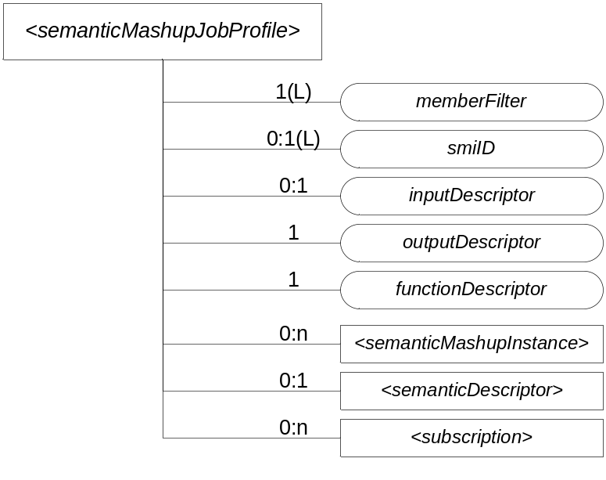
Figure 6.W.1-1: Structure of <semanticMashupJobProfile> Resource

6.W.2 Operations
Note: This section shows resource-type specific operations, i.e. CRUD <X> from TS-0001 clause 10.
A <semanticMashupJobProfile> resource can be provisioned to a Hosting CSE which provides semantic mashup function; alternatively, an AE or CSE can request to create <semanticMashupJobProfile> resource at the Hosting CSE. Once a <semanticMashupJobProfile> resource is provisioned or created at the Hosting CSE, other oneM2M CSEs/AEs, which act as Mashup Requestors, can discover, retrieve, update, or delete it based on the requirements.

Figure 6.W.2-1 illustrates a generic procedure (e.g. Create/Retrieve/Update/Delete) to operate on a <semanticMashupJobProfile> resource. Detailed descriptions are given in following clauses 6.W.2.1, 6.W.2.2, 6.W.2.3, and 6.W.2.4, respectively.

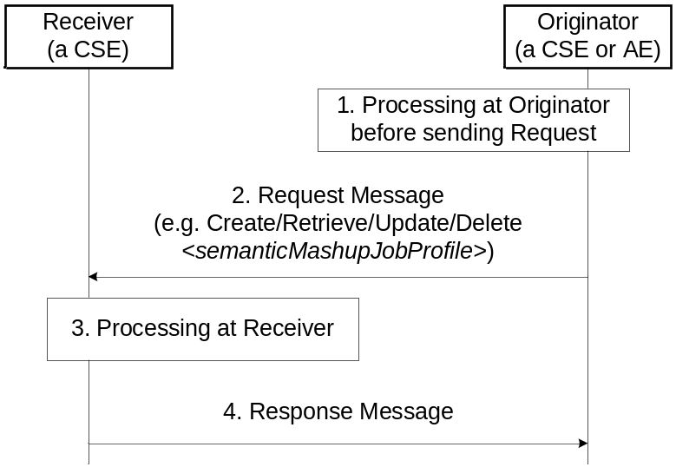
Figure 6.W.2-1: Procedures for operating a <semanticMashupJobProfile> resource

6.W.2.1 Create <semanticMashupJobProfile>
This procedure shall be used for creating a <semanticMashupJobProfile> resource as described in Table 6.W.2.1-1.

Table 6.W.2.1-1: <semanticMashupJobProfile> CREATE
<semanticMashupJobProfile> CREATE
Associated Reference Point | Mca, Mcc and Mcc'.
Information in Request message | All parameters defined in Table 8.1.2-3 in [1] apply with the specific details for:  Content: The resource content shall provide the information about an <semanticMashupJobProfile> resource (e.g. attribute values) as described in the Clause 6.W.1.
Processing at Originator before sending Request | According to clause 10.1.1.1 in [1].
Processing at Receiver | According to clause 10.1.1.1 in [1].
Information in Response message | All parameters defined in Table 8.1.3-1 in [1] apply with the specific details for:  Content: Address of the created <semanticMashupJobProfile> resource, according to clause 10.1.1.1 in [1].
Processing at Originator after receiving Response | According to clause 10.1.1.1 in [1].
Exceptions | According to clause 10.1.1.1 in [1].

6.W.2.2 Retrieve <semanticMashupJobProfile>
This procedure shall be used for retrieving the attributes of a <semanticMashupJobProfile> resource as described in Table 6.W.2.2-1.

Table 6.W.2.2-1: <semanticMashupJobProfile> RETRIEVE
<semanticMashupJobProfile> RETRIEVE
Associated Reference Point | Mca, Mcc and Mcc'.
Information in Request message | All parameters defined in Table 8.1.2-3 in [1] apply with the specific details for:  Content: void.
Processing at Originator before sending Request | According to clause 10.1.2 in [1].
Processing at Receiver | The Receiver shall verify the existence (including Filter Criteria checking, if it is given) of the target resource or the attribute and check if the Originator has appropriate privileges to retrieve information stored in the resource/attribute. Otherwise clause 10.1.2 in [1] applies.
Information in Response message | All parameters defined in Table 8.1.3-1 in [1] apply with the specific details for:  Content: attributes of the <semanticMashupJobProfile> resource as defined in clause 6.W.1.
Processing at Originator after receiving Response | According to clause 10.1.2 in [1].
Exceptions | According to clause 10.1.2 in [1].  In addition, a timer has expired. The Receiver responds with an error.

6.W.2.3 Update <semanticMashupJobProfile>
This procedure as described in Table 6.W.2.3-1 shall be used to update an existing <semanticMashupJobProfile> resource, e.g. an update to its inputDescriptor attribute.

Table 6.W.2.3-1: <semanticMashupJobProfile> UPDATE
<semanticMashupJobProfile> UPDATE
Associated Reference Point | Mca, Mcc and Mcc'.
Information in Request message | All parameters defined in Table 8.1.2-3 in [1] apply with the specific details for:  Content: attributes of the <semanticMashupJobProfile> resource as defined in clause 6.W.1 to be updated.
Processing at Originator before sending Request | According to clause 10.1.3 in [1].
Processing at Receiver | According to clause 10.1.3 in [1].
Information in Response message | According to clause 10.1.3 in [1].
Processing at Originator after receiving Response | According to clause 10.1.3 in [1].
Exceptions | According to clause 10.1.3 in [1].

6.W.2.4 Delete <semanticMashupJobProfile>
This procedure as described in Table 6.W.2.4-1 shall be used to delete an existing <semanticMashupJobProfile> resource.

Table 6.W.2.4-1: <semanticMashupJobProfile> DELETE
<semanticMashupJobProfile> DELETE
Associated Reference Point | Mca, Mcc and Mcc'.
Information in Request message | All parameters defined in Table 8.1.2-3 in [1] apply.
Processing at Originator before sending Request | According to clause 10.1.4.1 in [1].
Processing at Receiver | According to clause 10.1.4.1 in [1].  - If the <semanticMashupJobProfile> to be deleted has smiID attribute and the smiID attribute has a value, the Receiver notifies each <semanticMashupInstance> resource as included in the smiID attribute of the removal of the <semanticMashupJobProfile> since those <semanticMashupInstance> resources use this <semanticMashupJobProfile>.  - If the <semanticMashupJobProfile> to be deleted has <semanticMashupInstance> child resources, all those <semanticMashupInstance> child resources shall be removed accordingly.
Information in Response message | According to clause 10.1.4.1 in [1].
Processing at Originator after receiving Response | According to clause 10.1.4.1 in [1].
Exceptions | According to clause 10.1.4.1 in [1].

6.X Resource Type semanticMashupInstance

6.X.1 Definition
Note: This section shows resource types, similar to TS-0001 clause 9.6.
<semanticMashupInstance> models and represents a Semantic Mashup Instance (SMI) resource. A CSE/AE as a Mashup Requestor can request to create <semanticMashupInstance> resources at another oneM2M CSE which implements the semantic mashup function. Each created <semanticMashupInstance> resource corresponds to a semantic mashup job profile (i.e. a <semanticMashupJobProfile> resource); in other words, how the <semanticMashupInstance> resource should execute the mashup operation to calculate the mashup result is specified in the corresponding <semanticMashupJobProfile> resource. Note that the <semanticMashupInstance> and its corresponding <semanticMashupJobProfile> resources may be placed at the same CSE or at different CSEs, and the smjpID attribute of the <semanticMashupInstance> allows locating the corresponding <semanticMashupJobProfile> resource. If the <semanticMashupInstance> resource has a <semanticMashupResult> as its child resource, the Mashup Requestor may use it to retrieve the mashup result.
<semanticMashupInstance> resource shall contain the child resources specified in Table 6.X.1-1.
Table 6.X.1-1: Child resources of <semanticMashupInstance> resource
Child Resources of <semanticMashupInstance> | Child Resource Type | Multiplicity | Description
<variable> | <semanticMashupResult> | 0..n | Contains mashup result. A <semanticMashupInstance> resource may have multiple <semanticMashupResult> child resources, with each mashup result instance resulting from different input parameters and/or member resource values. The hosting CSE generates <semanticMashupResult> each time when it executes the mashup operation and calculate a new semantic mashup result (e.g. for long-lived mashup application as described in the clause 7.7).
<variable> | <semanticDescriptor> | 0..1 | Describes general semantic information about this <semanticMashupInstance> resource.
<variable> | <subscription> | 0..n | Stands for any subscription on this <semanticMashupInstance>.
<mashup> | <mashup> | 0..1 | This is a standard oneM2M virtual resource. When a Mashup Requestor sends a RETRIEVE operation on this virtual resource, it triggers a re-calculation and re-generation of the mashup result.

<semanticMashupInstance> resource shall contain the attributes specified in Table 6.X.1-2.

Table 6.X.1-2: Attribute of <semanticMashupInstance> resource
Attributes of  <semanticMashupInstance> | Multiplicity | RW/  RO/  WO | Description
smjpID | 1 | RW | Denotes the identifier (e.g. URI) of the semantic mashup job profile resource <semanticMashupJobProfile> which this <semanticMashupInstance> is based on.
smjpInputParameter | 1 | RW | Contains the value of all input parameters which are required to calculate the mashup result. Note that the types of these input parameters are specified by the inputDescriptor attribute of the corresponding <semanticMashupJobProfile> which is denoted by the smjpID attribute of this <semanticMashupInstance> resource. This attribute is not needed if the corresponding <semanticMashupJobProfile> does not have inputDescriptor attribute.
memberStoreType | 1 | RW | Indicates the way which member resources should be stored under this <semanticMashupInstance>. For example,  - If memberStoreType=“URI Only”, the mashupMember attribute contains the URI of each member resource;  - If memberStoreType=“URI and Value”, the mashupMember attribute contains both the URI and the value of each member resource.
mashupMember | 0:1(L) | RW | Stores the URI and/or value of each mashup member resource, which is dependent on the value of memberStoreType attribute.
resultGenType | 1(L) | RW | Describes how the mashup result should be generated using this <semanticMashupInstance>. Example values for this attribute could be one of the following or a combination of them.  - If resultGenType=“When SMI Is Created”, the semantic mashup result is generated when this <semanticMashupInstance> is created by running semantic functions specified by the corresponding <semanticMashupJobProfile>.  - If resultGenType=“When Mashup Requestor Requests”, the mashup result is to be calculated and generated when requested or triggered by a Mashup Requestor which sends a RETRIEVE operation on the virtual child resource mashup.  - If resultGenType=“Periodically”, the CSE which hosts <semanticMashupInstance> calculates and generates the semantic mashup result periodically based on the periodForResultGen attribute.  - If resultGenType=“When A Mashup Member Is Updated”, the CSE which hosts <semanticMashupInstance> calculates and generates the semantic mashup result whenever there is any update on the mashupMember attribute of <semanticMashupInstance>.
periodForResultGen | 0:1 | RW | Is the time period for re-calculating and generating the semantic mashup result. When it is the time to re-calculate the semantic mashup result, the CSE hosting this <semanticMashupInstance> needs to retrieve the latest content value of each member resource if it is not obtained yet. This attribute is needed when resultGenType=“Periodically”.

The structure of <semanticMashupInstance> resource is also illustrated in Figure 6.X.1-1.

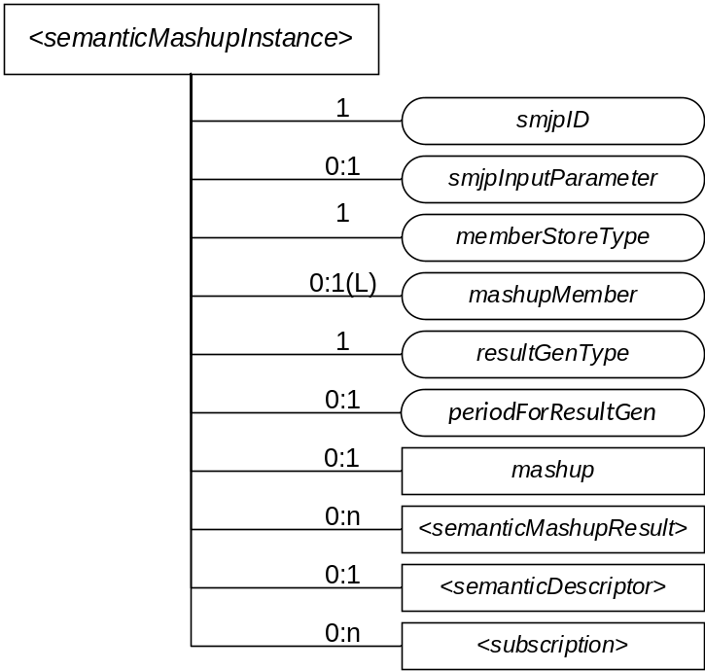
Figure 6.X.1-1: Structure of <semanticMashupInstance> Resource

6.X.2 Operations
Note: This section shows resource-type specific operations, i.e. CRUD <X> from TS-0001 clause 10.
Figure 6.X.2-1 illustrates the procedure to operate a <semanticMashupInstance> resource (e.g. Create/Retrieve/Update/Delete a <semanticMashupInstance> resource). Detail descriptions are given in the clause 6.X.2.1, 6.X.2.2, 6.X.2.3, and 6.X.2.4, respectively.

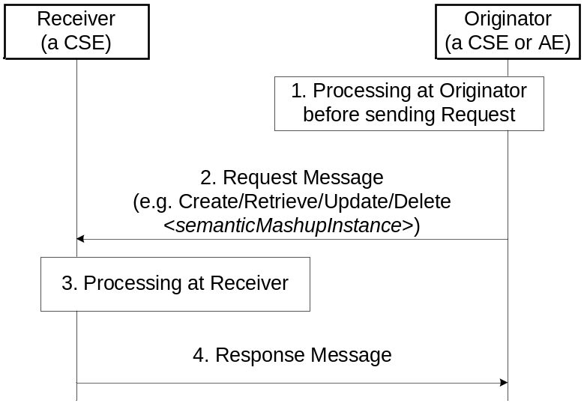
Figure 6.X.2-1: Procedures for Operating a <semanticMashupInstance> Resource

6.X.2.1 Create <semanticMashupInstance>
This procedure shall be used for creating a <semanticMashupInstance> resource as described in Table 6.X.2.1-1.

Table 6.X.2.1-1: <semanticMashupInstance> CREATE
<semanticMashupInstance> CREATE
Associated Reference Point | Mca, Mcc and Mcc'.
Information in Request message | All parameters defined in Table 8.1.2-3 in [1] apply with the specific details for:  Content: The resource content shall provide the information about a <semanticMashupInstance> resource (e.g. attribute values) as described in the clause 6.X.1.
Processing at Originator before sending Request | According to clause 10.1.1.1 in [1].  - If the Originator knows the identifier or URI of each mashup member, it can include the value of mashupMember in the Request message.
Processing at Receiver | According to clause 10.1.1.1 in [1].  - The Receiver shall first check if the corresponding <semanticMashupJobProfile> as denoted by smjpID attribute exists or not. If it does not exist, the Receiver shall not create the <semanticMashupInstance> and shall report an error (e.g. “<semanticMashupJobProfile> does not exist”) in the Response message to the Originator. If it exists, the Receiver shall retrieve its content.  - The Receiver shall check if smjpInputParameter included in the Request message meets the input parameter requirement as specified by the inputDescriptor attribute of corresponding <semanticMashupJobProfile>. If it does not meet the requirement, the Receiver shall not create the <semanticMashupInstance> and shall report an error (e.g. “smjpInputParameter” does not meet the requirement”) in the Response message to the Originator.  - According to the memberFilter attribute of the retrieved <semanticMashupJobProfile>, the Receiver extracts the SPARQL query contained in memberFilterand use it to discover and determine mashup member resources for the <semanticMashupInstance> to be created.  - Dependent on the memberStoreType attribute contained in the Request message, the Receiver maintains each member resource in different ways. If memberStoreType=”URI Only”, the Receiver creates the mashupMember attribute containing the URIs of the determined member resources. If memberStoreType=”URI and Value”, the Receiver creates the mashupMember attribute, retrieves the content value of each member resource and then stores both the identifier and the content value of each member resource in the mashupMember attribute.  - Depending on the resultGenType attribute contained in the Request message, the Receiver prepares to execute the corresponding semantic mashup job profile as follows.  - If resultGenType=” When SMI Is Created”, the Receiver retrieves the content value of each member resource if not retrieved yet; then it executes mashup functions as specified by the <semanticMashupJobProfile> and generates semantic mashup result, which shall be stored in the <semanticMashupResult> child resource.  - If resultGenType=”When A Mashup Requestor Requests”, there is no further processing at the Receiver.  - If resultGenType=”Periodically”, the Receiver shall set up a timer according to the periodForResultGen attribute contained in the Request message. When the timer expires, the Receiver shall retrieve the content value of each member resource and re-generate the mashup result; then it renews the timer.  - If resultGenType=”When A Mashup Member Is Updated”, there is no further processing at the Receiver.
Information in Response message | All parameters defined in Table 8.1.3-1 in [1] apply with the specific details for:  Content: Address of the created <semanticMashupInstance> resource and address of created <semanticMashupResult> resource if any, according to clause 10.1.1.1 in [1].
Processing at Originator after receiving Response | According to clause 10.1.1.1 in [1].
Exceptions | According to clause 10.1.1.1 in [1].

6.X.2.2 Retrieve <semanticMashupInstance>
This procedure shall be used for retrieving the attributes of a <semanticMashupInstance> resource as described in Table 6.X.2.2-1.

Table 6.X.2.2-1: <semanticMashupInstance> RETRIEVE
<semanticMashupInstance> RETRIEVE
Associated Reference Point | Mca, Mcc and Mcc'.
Information in Request message | All parameters defined in Table 8.1.2-3 in [1] apply with the specific details for:  Content: void.
Processing at Originator before sending Request | According to clause 10.1.2 in [1].
Processing at Receiver | The Receiver shall verify the existence (including Filter Criteria checking, if it is given) of the target resource or the attribute and check if the Originator has appropriate privileges to retrieve information stored in the resource/attribute. Otherwise clause 10.1.2 in [1] applies.
Information in Response message | All parameters defined in Table 8.1.3-1 in [1] apply with the specific details for:  Content: attributes of the <semanticMashupInstance> resource as defined in the clause 6.X.1.
Processing at Originator after receiving Response | According to clause 10.1.2 in [1].
Exceptions | According to clause 10.1.2 in [1].

6.X.2.3 Update <semanticMashupInstance>
This procedure as described in Table 6.X.2.3-1 shall be used to update an existing <semanticMashupInstance>, e.g. an update to its memberStoreType attribute.

Table 6.X.2.3-1: <semanticMashupInstance> UPDATE
<semanticMashupInstance> UPDATE
Associated Reference Point | Mca, Mcc and Mcc'.
Information in Request message | All parameters defined in Table 8.1.2-3 in [1] apply with the specific details for:  Content: attributes of the <semanticMashupInstance> resource as defined the clause 6.X.1 to be updated.
Processing at Originator before sending Request | According to clause 10.1.3 in [1].
Processing at Receiver | According to clause 10.1.3 in [1].  - If the updated attribute in the Request message is smjpInputParameter and if the original resultGenType=”When SMI Is Updated”, the Receiver needs to recalculate the semantic mashup result using the new values of input parameters.  - If the updated attribute in the Request message is memberStoreType, the Receiver needs to change the way to maintain mashup member resources. For example, if memberStoreType is updated from “URI Only” to “URI and Value”, the Receiver needs to retrieve the content value of each mashup member resource and store the values together with URI in mashupMember attribute. If memberStoreType is updated from “URI and Value” to “URI Only”, the Receiver needs mashupMember attribute to only maintain the identifier of each mashup member.  - If the updated attribute in the Request message is resultGenType, the Receiver changes the way to calculate/generate the semantic mashup result accordingly.
Information in Response message | According to clause 10.1.3 in [1].
Processing at Originator after receiving Response | According to clause 10.1.3 in [1].
Exceptions | According to clause 10.1.3 in [1].

6.X.2.4 Delete <semanticMashupInstance>
This procedure as described in Table 6.X.2.4-1 shall be used to delete an existing <semanticMashupInstance>.

Table 6.X.2.4-1: <semanticMashupInstance> DELETE
<semanticMashupInstance> DELETE
Associated Reference Point | Mca, Mcc and Mcc'.
Information in Request message | All parameters defined in Table 8.1.2-3 in [1] apply.
Processing at Originator before sending Request | According to clause 10.1.4.1 in [1].
Processing at Receiver | According to clause 10.1.4.1 in [1].  - In addition, The Receiver removes this <semanticMashupInstance> from the smiID attribute of the corresponding <semanticMashupJobProfile>.
Information in Response message | According to clause 10.1.4.1 in [1].
Processing at Originator after receiving Response | According to clause 10.1.4.1 in [1].
Exceptions | According to clause 10.1.4.1 in [1].

6.Y Resource Type mashup

6.Y.1 Definition
Note: This section shows resource types, similar to TS-0001 clause 9.6.
<mashup> is a virtual resource because it does not have a representation. It is the child resource of a <semanticMashupInstance> resource. When a RETRIEVE operation is sent to the <mashup> resource, it triggers a calculation and generation of the mashup result based on its parent resource <semanticMashupInstance>.

6.Y.2 Operations
Note: This section shows resource-type specific operations, i.e. CRUD <X> from TS-0001 clause 10.
Only Retrieve operation shall be allowed on a <mashup> virtual resource. A Create, an Update, or a Delete operation on a <mashup> virtual resource shall not be supported.

6.Y.2.1 Retrieve <mashup>
This procedure shall be used for triggering the CSE which hosts the <semanticMashupInstance> to recalculate mashup results and returning the mashup result back to the requestor (e.g. an AE) of this retrieve request as described in Table 6.Y.2.1-1.

Table 6.Y.2.1-1: <mashup> RETRIEVE
<mashup> RETRIEVE
Associated Reference Point | Mca, Mcc and Mcc'.
Information in Request message | All parameters defined in Table 8.1.2-3 in [1] apply with the specific details for:  To: <semanticMashupInstance>/<mashup>  Content: void.
Processing at Originator before sending Request | According to clause 10.1.2 in [1].
Processing at Receiver | The Receiver shall check if the Originator has appropriate privileges. Otherwise clause 10.1.2 in [1] applies.  - The Hosting CSE triggers the recalculation of semantic mashup result for <mashup>’s parent resource <semanticMashupInstance>. The recalculated mashup result shall be stored in the <semanticMashupInstance>’s child resource <semanticMashupResult>.
Information in Response message | All parameters defined in Table 8.1.3-1 in [1] apply with the specific details for:  Content: the mashup result, if indicated in the request
Processing at Originator after receiving Response | According to clause 10.1.2 in [1].
Exceptions | According to clause 10.1.2 in [1].  In addition: a timer has expired. The Receiver responds with an error.

6.Z Resource Type semanticMashupResult

6.Z.1 Definition
Note: This section shows resource types, similar to TS-0001 clause 9.6.
<semanticMashupResult> resource stores the mashup result. It is the child resource of a <semanticMashupInstance> resource. A <semanticMashupResult> resource shall be automatically generated by a Hosting CSE when it executes a semantic mashup operation on a <semanticMashupInstance> resource. <semanticMashupResult> resource shall contain the child resources specified in Table 6.Z.1-1Table 6.Z.1-1 and the attributes specified in Table 6.Z.1-2. The structure of <semanticMashupResult> resource is also illustrated in Figure 6.Z.1-1.

Table 6.Z.1-1: Child resources of <semanticMashupResult> resource
Child Resources of <semanticMashupResult> | Child Resource Type | Multiplicity | Description
<variable> | <semanticDescriptor> | 0:1 | Describes general semantic information for this <semanticMashupResult> resource.
<variable> | <subscription> | 0:n | Stands for any subscription on this <semanticMashupResult> resource.

Table 6.Z.1-2: Attribute of <semanticMashupResult> resource
Attributes of  <semanticMashupResult> | Multiplicity | RW/  RO/  WO | Description
smjpInputParameter | 0:1 | RO | Contains the value of all input parameters which are required to calculate the mashup result. Note that the types of these input parameters are specified by the inputDescriptor attribute of the corresponding <semanticMashupJobProfile> which is denoted by the smjpID attribute of the parent resource <semanticMashupInstance>. This attribute is not needed if the corresponding <semanticMashupJobProfile> does not have inputDescriptor attribute.  The value of this attribute shall be automatically copied from the smjpInputParameter attribute of the parent resource <semanticMashupInstance>. This attribute shall not be updated by other entities except the Hosting CSE.
mashupResultFormat | 1 | RO | Stands for the format of mashupResult representation (e.g. Integer, Float, Text, XML, JSON, etc.). The value of this attribute can be obtained by a Hosting CSE directly from outputDescriptor attribute of corresponding <semanticMashupJobProfile> resource. This attribute shall not be updated by other entities except the Hosting CSE.
mashupResult | 1 | RO | Contains the representation of mashup result. The value of this attribute shall be only generated by the Hosting CSE when it executes a semantic mashup operation. This attribute shall not be updated by other entities except the Hosting CSE.

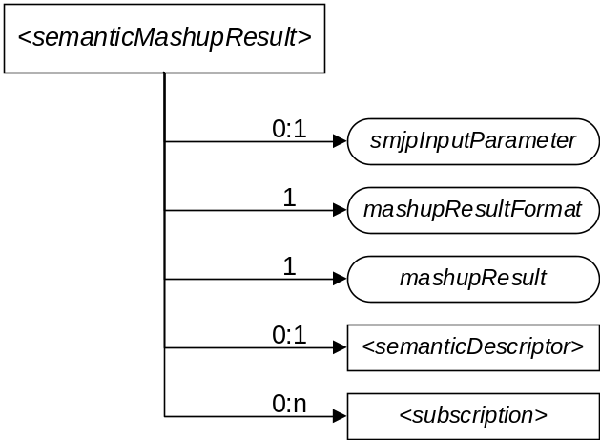
Figure 6.Z.1-1: Structure of <semanticMashupResult>

6.Z.2 Operations
Note: This section shows resource-type specific operations, i.e. CRUD <X> from TS-0001 clause 10.
Figure 6.Z.2-1 illustrates the procedure to operate a <semanticMashupResult> resource. A <semanticMashupResult> resource shall be automatically created when a Hosting CSE executes semantic mashup operation on a <semanticMashupInstance> resource. Only Retrieve and Delete operations shall be allowed on a <semanticMashupResult> resource. Detail descriptions are given in following clauses 6.Z.2.1 and 6.Z.2.2.

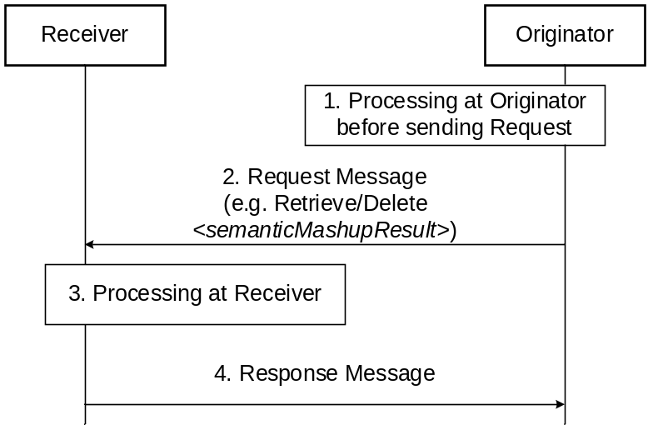
Figure 6.Z.2-1: Procedures for Operating an <semanticMashupResult> Resource

6.Z.2.1 Retrieve <semanticMashupResult>
This procedure shall be used for retrieving the attributes of a <semanticMashupResult> resource as described in Table 6.Z.2.1-1.

Table 6.Z.2.1-1: <semanticMashupResult> RETRIEVE
<semanticMashupResult> RETRIEVE
Associated Reference Point | Mca, Mcc and Mcc'.
Information in Request message | All parameters defined in Table 8.1.2-3 in [1] apply with the specific details for:  Content: void.
Processing at Originator before sending Request | According to clause 10.1.2 in [1].
Processing at Receiver | The Receiver shall verify the existence (including Filter Criteria checking, if it is given) of the target resource or the attribute and check if the Originator has appropriate privileges to retrieve information stored in the resource/attribute. Otherwise clause 10.1.2 in [1] applies.
Information in Response message | All parameters defined in Table 8.1.3-1 in [1] apply with the specific details for:  Content: attributes of the <semanticMashupResult> resource as defined in the clause 6.ZZ.1.
Processing at Originator after receiving Response | According to clause 10.1.2 in [1].
Exceptions | According to clause 10.1.2 in [1].  In addition: a timer has expired. The Receiver responds with an error.

6.Z.2.2 Delete <semanticMashupResult>
This procedure as described in Table 6.Z.2.2-1 shall be used to delete an existing <semanticMashupResult> resource.
Table 6.Z.2.2-1: <semanticMashupResult> DELETE
<semanticMashupResult> DELETE
Associated Reference Point | Mca, Mcc and Mcc'.
Information in Request message | All parameters defined in Table 8.1.2-3 in [1] apply.
Processing at Originator before sending Request | According to clause 10.1.4.1 in [1].
Processing at Receiver | According to clause 10.1.4.1 in [1].
Information in Response message | According to clause 10.1.4.1 in [1].
Processing at Originator after receiving Response | According to clause 10.1.4.1 in [1].
Exceptions | According to clause 10.1.4.1 in [1].

-----------------------End of change 3-------------------------------------------

-----------------------Start of change 4-------------------------------------------

7. Functional Descriptions
Note: This section will contain high level feature description, related flows as well as detailed functional descriptions. The associated resources and their respective CRUD procedures will be referenced from clause 7.

……..

7.7 Semantics Mash-up

7.7.1 Introduction
Existing semantic resource discovery in oneM2M can help in discovering various IoT devices and their data. However, in many application scenarios, the discovered data needs to be further processed (e.g., integrated/orchestrated/combined) based on a certain application business logic. For example, users may just be interested in a metric called “weather comfortability index”, which cannot be directly provided by physical sensors, and in fact can be calculated based on the original sensory data collected from multiple types of physical sensors (e.g., temperature and humility sensors).
In general, the above process is called “Semantic Mashup”, which is defined as a process to discover and collect data from more than one source as inputs, conduct a kind of business logic-related mashup function over the collected data, and eventually generate meaningful mashup results. In particular, semantic mashup emphasizes on leveraging semantic-related technologies during the entire mashup process. For example, in the oneM2M context, an normal resource (e.g., a <AE> resource representing a temperature sensor) may be annotated by semantic descriptions and then they could be discovered and identified as a potential data source for a specific mashup application through the semantic resource discovery.
The above definition also indicates a fact that a complete semantic mashup process may involve multiple stages and multiple entities for each stage. Those entities include:
- Mashup Requestor (MR): The entity which initiates a mashup request to Semantic Mashup Function for a certain need. In the context of oneM2M, an AE or a CSE can be an MR.
- Resource Host (RH): The entity which hosts data source(s) for a given mashup process. In the context of oneM2M, a data source is typically represented by a oneM2M resource (e.g., a temperature <AE> resource) and a RH will be a CSE that hosts oneM2M resources.
- Semantic Mashup Function (SMF): The entity which is responsible for collecting the data inputs from data sources hosted on RHs and mashing them up to generate the mashup result based on a certain business logic. In the context of oneM2M, SMF is a Common Service Function.

7.7.2 Semantic Mashup Function (SMF) Description
Semantic mashup function including high-level architecture and high-level operations will be described in this clause.

7.7.2.1 High-level architecture

The high-level architecture of an SMF is shown in Figure 7.7.2.1-1, which shall contain the following components:
- Semantic Mashup Job Profile (SMJP): Each specific semantic mashup application has a corresponding SMJP, which not only provides functionality/interaction details for external entities to discover (e.g., MRs), but also defines the internal working details regarding how to realize this mashup application (e.g., the criteria of how to select the qualified data sources as well as the definition of mashup function). The content of an SMJP has been defined in the clause 6.W.1.
- Semantic Mashup Instance (SMI): Once an MR identifies a desired SMJP (which can be analogous to a “job description”, but not a real job), it can ask SMF to initialize a real mashup process, which corresponds to a “working instance” of this SMJP and is referred to as a Semantic Mashup Instance (SMI). In order to do so, the SMF will inject the corresponding SMJP into the Mashup Engine of SMF for the SMI instantiation, during which the engine may be involved in: 1) Identifying the qualified data sources according to the data source criteria as defined in the SMJP; 2) Collecting data inputs from those identified data sources; 3) Mashing up the collected inputs by applying mashup functions as defined in the SMJP, and finally deriving the mashup result. The content of an SMI has been defined in the clause 6.X.1.

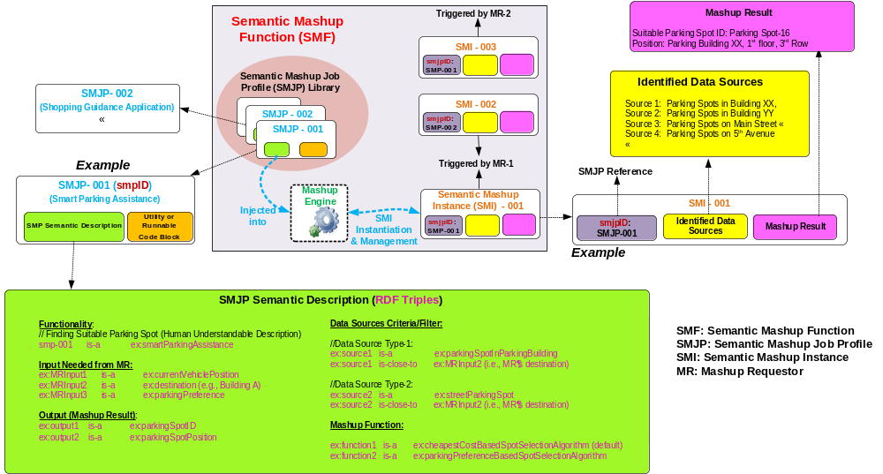
Figure 7.7.2.1-1: High-level architecture of Semantic Mashup Function

7.7.2.2 High-level operations
An SMF as introduced in clause 7.7.2.1 may involve in different tasks/operations for realizing a complete semantic mashup process. This clause is to introduce those major SMF operations. The high-level SMF operations are shown in Figure 7.7.2.2-1, where each operation shall be realized using CRUD operations as specified in the clause 6.W.2, 6.X.2, 6.Y.2, and 6.Z.2, respectively
- Operation 1 - SMJP Discovery: This process is needed when an MR (e.g., MR-1 in Figure 7.7.2.2-1) tries to discover a desired SMJP for its need. The procedure defined in the clause 6.W.2.2 for retrieving a <semanticMashupJobProfile> shall be leveraged for discovering <semanticMashupJobProfile> resources based on resource discovery procedures as defined in [1].
- Operation 2 - SMI Creation: This process is needed when an MR already identified a desired <semanticMashupJobProfile> resource, but there is no corresponding SMI available for use. To implement this operation, an MR shall leverage the procedure defined in the clause 6.X.2.1 to send an SMI creation request to the CSE hosting SMF in order to instantiate a new SMI (i.e. <semanticMashupInstance> resource) for the desired SMJP. Alternatively, the SMF can also create a new SMI by itself instead of being triggered by the SMI creation request from the MR.
- Operation 3 – Mashup Member Identification: This process is needed when an SMF tries to identify the qualified mashup members (i.e., data sources) for a given SMI, by referring to the criteria as defined in the corresponding SMJP of this SMI (i.e. the memberFilter attribute of a <semanticMashupJobProfile> resource). Since in the oneM2M context, data sources (such as sensors) are normally represented as oneM2M resources hosted by RHs, this operation shall be implemented using semantic resource discovery mechanism as defined in [1].
- Operation 4 – Mashup Result Retrieval: This process is needed when an MR tries to retrieve the mashup result from a specific SMI. For a given SMI, it may involve in multiple rounds for mashup result generation especially when the mashup result needs to be refreshed periodically. For each round, the SMF shall collect new data inputs from identified mashup members (via Operation 5) and generate new mashup result which will be stored in the child resource <semanticMashupResult> of corresponding <semanticMashupInstance> resource. There are several alternatives for generating semantic mashup results as defined by the resultGenType attribute of an <semanticMashupInstance> resource in the clause 6.X.1, for example:
  - Option 1: After an SMI is created, the SMF proactively and periodically runs the mashup result generation; each time before generating new mashup result, the SMF shall use Operation 5 to collect data inputs from mashup members. Whenever a new mashup result becomes available, it shall be stored in a <semanticMashupResult> resource and be exposed to MRs for access.
  - Option 2: The SMF shall generate mashup result only after receiving an explicit request from an MR (i.e. using the procedure defined in the clause 6.Y.2.1). The benefit of this approach is that SMF works in an on-demand way, which may reduce overhead as compared to Option 1. However, the downside is that it leads to longer waiting time for an MR before the up-to-date mashup result becomes available because data re-collection and mashup result generation will not be triggered until the SMF receives a request from the MR.
- Operation 5 – Data Input Collection and Mashup Result Generation: This process is needed when an SMF tries to generate a mashup result for a given SMI. Note that Operation 3 focuses on how to identify the mashup members while Operation 5 focuses on how to collect data inputs from those identified/qualified mashup members. Operation 5 shall be implemented using resource retrieval mechanism as defined in [1]. In addition, the working mechanism used for Operation 4 as mentioned above will affect how Operation 5 is conducted by the SMF.
- Operation 6 – SMI Discovery and Re-use: An SMI can be discovered, re-used and shared among different MRs. For example, the same SMI of a weather reporting mashup application for New York City Area can be shared by different users asking weather information for this area. Accordingly, Operation 6 is needed when an MR (e.g., MR-2 in Figure 7.7.2.2-1) tries to discover whether there is already an available/desired SMI ready for use. Since a given SMI is exposed as a <semanticMashupInstance> resource, existing resource discovery mechanism in [1] shall be leveraged to discover a desired SMI from the Hosting CSE. This approach leads to less processing overhead, since other MRs do not need to require the SMF to generate a new SMI (therefore Operation 2 and 3 are not needed).

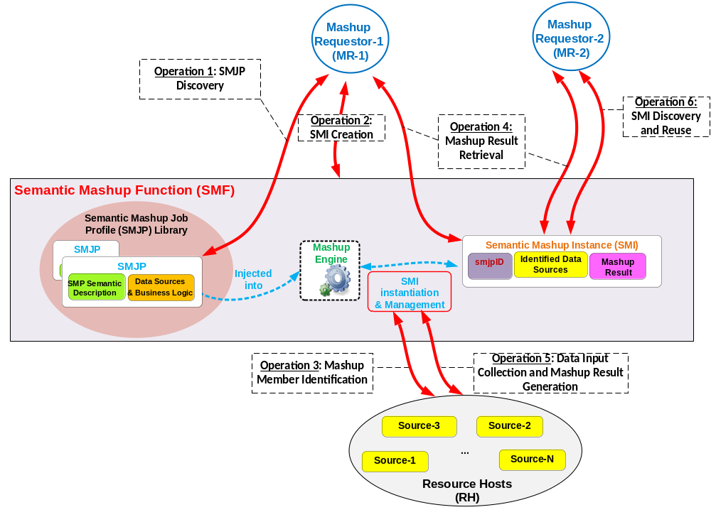
Figure 7.7.2.2-1: High-level operations for Semantic Mashup Function

-----------------------End of change 4-------------------------------------------

