CHANGE REQUEST
Meeting:* | PRO 15
Source:* | FUJITSU
Date:* | 2015-01-20
Contact:* | Raymond Forbes, Ericsson LM (Raymond.forbes@ericsson.com)
Reason for Change/s:* | Remonve Annex. A
CR against: Release* | 1.0 (DRAFT)
CR against: TS/TR* | TS-0004-V0.8.1
Clauses/Sub Clauses*
Type of change: * | Editorial change  Bug Fix or Correction  Change/correction to existing feature or functionality  New feature or functionality
Post Freeze checking:* | This CR contains only essential changes and corrections  YES NO

oneM2M Notice
The document to which this cover statement is attached is submitted to oneM2M. Participation in, or attendance at, any activity of oneM2M, constitutes acceptance of and agreement to be bound by terms of the Working Procedures and the Partnership Agreement, including the Intellectual Property Rights (IPR) Principles Governing oneM2M Work found in Annex 1 of the Partnership Agreement.
GUIDELINES for Change Requests:
Provide an informative introduction containing the problem(s) being solved, and a summary list of proposals.
Each CR should contain changes related to only one particular issue/problem.
Follow the principle of completeness, where all changes related to the issue or problem within a deliverable are simultaneously proposed to be made E.g. A change impacting 5 tables should not only include a proposal to change only 3 tables. Includes any changes to references, definitions, and acronyms in the same deliverable.
Follow the drafting rules.
All pictures must be editable.
Check spelling and grammar to the extent practicable.
Use Change bars for modifications.
The change should include the current and surrounding clauses to clearly show where a change is located and to provide technical context of the proposed change. Additions of complete sections need not show surrounding clauses as long as the proposed section number clearly shows where the new section is proposed to be located.
Multiple changes in a single CR shall be clearly separated by horizontal lines with embedded text such as, start of change 1, end of change 1, start of new clause, end of new clause.
When subsequent changes are made to content of a CR, then the accepted version should not show changes over changes. The accepted version of the CR should only show changes relative to the baseline approved text.

-----------------------Start of change 1-------------------------------------------

Introduction
The <locationPolicy> resource represents the method for obtaining and managing geographical location information of an M2M Node. The detailed description can be found in the clause 9.6.10 in TS-0001 Functional Architecture [Error: Reference source not found] .

-----------------------End of change 1-------------------------------------------

-----------------------Start of change 2-------------------------------------------

Interfaces to the underlying networks
The CSEs access the network service functions provided by the underlying networks such as 3GPP, 3GPP2 and WLAN via Mcn reference point. The following services are provided by the underlying networks:
- Device triggering (see Error: Reference source not found)
- Location request (see Annex G)
- Device Management (see clause Error: Reference source not found)

-----------------------End of change 2-------------------------------------------

Reference
See Annex E.

-----------------------Start of change 3-------------------------------------------

Description of generic procedures

Generic resource request procedure for originator
A generic resource Request procedure shall be comprised of the following actions. Additional actions specific to individual procedures are listed in the respective sections by referencing these actions and providing additional steps. The Originator shall execute the following steps in order:
Orig-1.0: “Compose Request primitive”
Orig-2.0: “Send a Request to the Receiver CSE”
Orig-3.0: “Wait for Response primitive”
Orig-4.0: Request is blocking?
Orig-6.0: Process Response
Orig-5.0: “Retrieve result from <request> resource”
Yes

No

Start
Finish
Figure 7.1.2.1-1: Generic procedure of Originator
Orig-1.0 “Compose Request primitive”: Please refer to clause Error: Reference source not found for details.
Orig-2.0 “Send a Request to the Receiver CSE”: Please refer to clause Error: Reference source not found for details.
Orig-3.0 “Wait for Response primitive”: Please refer to clause Error: Reference source not found for details. If the Originator is using blocking communication, this step should be the last step of the Originator.
Orig-4.0 “Request is blocking?”: This step shall be operated after getting the Response primitive from step Oring-3.0 “Wait for Response primitive”. In this step, the Originator checks whether the request was blocking. If the request was blocking, it goes to step Orig-6.0 “Process Response” (TRUE branch). If the request was non-blocking, it goes to step Orig-5.0 “Retrieve result from the <request> resource” (FALSE branch).
Orig-5.0 “Retrieve result from the <request> resource”: See clause Error: Reference source not found for details.
Orig-6.0 “Process Response”: the Originator processes the response.

Generic request procedure for receiver
The Receiver shall execute the following steps in order. In case of error in any of the steps below, the Receiver shall execute "Create an error response" (refer to clause Error: Reference source not found for details) and then "Send Response primitive" (refer to clause Error: Reference source not found for details). The corresponding Response code shall be included in the Response primitive.

Recv-1.0: “Check the validity of received request primitive”
Recv-2.0: Communication method?
Recv-6.0: Resource handling procedures
Recv-3.0: “Create <request> resource locally”
Recv-4.0: “Create a success Response”
Recv-5.0: “Send Response primitive”
Blocking

Non-Blocking

Recv-6.0: Resource handling procedures
Recv-7.0: “Update <request> resource”
Finish
Start
Figure 7.1.2.2-2: Generic procedure of Receiver
Recv-1.0 “Check the validity of received request primitive”: See clause 1.1.1.3 for details.
Recv-2.0 “Communication method?”: The Receiver CSE checks whether a received request is blocking or non-blocking by using Response Type parameter (see detail in clause 8.1.2 in TS-0001 Functional Architecture [Error: Reference source not found]). If the request is blocking, it goes to step Recv-6.0 “Resource handling procedure” (Blocking branch). If the request is non-blocking, it goes to step Recv-3.0 “Create <request> resource locally” (Non-blocking branch).
Recv-3.0 “Create <request> resource locally”: Please refer to clause Error: Reference source not found for details.
Recv-4.0 “Create a successResponse”: Please refer to clause Error: Reference source not found for details.
Recv-5.0 “Send Response Primitive”: Please refer to clause Error: Reference source not found for details.
Recv-6.0 “Resource handling procedure”: Please refer to Figure 7.1.2.2-3for details.
Recv-7.0 “Update <request> resource”: Please refer to clause Error: Reference source not found for details. This step is only valid when the request is non-blocking.

Recv-6.10: “Queue request primitive and execute CMDH message forwarding procedure”
Recv-6.1: Hosting CSE of the targeted resource?
Start
Recv-6.3: “Check authorization of the Originator”
Recv-6.4: “Check validity of resource representation for the given resource type”
Recv-6.2: “Check existence of the addressed resource”
Recv-6.5: “Create/Update/Retrieve/Delete/Notify operation is performed”
Recv-6.6: “Announce/De-announce the resource”
Finish
Yes

No

Recv-6.7: “Create a success response”
Recv-6.8: “Send Response Primitive”
Recv-6.9: CMDH processing supported?
Recv-6.11: “Forwarding”
No

Yes

Recv-6.0.1: Receiver is Registrar CSE & Originator is AE & operation is create
Recv-6.0.2: “Check Service Subscription Profile”
Yes

No
Figure 7.1.2.2-3: Resource handling procedure
The above figure describes the generic procedure to resource handling procedures.
Recv-6.0.1 “Receiver is Registrar CSE, Originator is AE and operation is create?”: The step checks if the receiver is Registrar CSE, the Originator is AE, and operation is create. If the receiver is Registrar CSE and Originator is an AE, goes to Recv-6.0.2 “Check Service Subscription Profile”. Otherwise, goes to Recv-6.1.
Recv-6.0.2 “Check Service Subscription Profile”: Please refer to clause Error: Reference source not found for details.
Recv-6.1 “Hosting CSE of the targeted resource?”: The step checks if the receiver is a transit CSE or the Hosting CSE of the received Request by examining the To parameter of the Request primitive. If the receiver hosts the resource that the address in the To parameter represents, the receiver is the Hosting CSE (goes to Recv-6.2“Check existence of the addressed resource”, Yes branch). Otherwise, the receiver is the Transit CSE (goes to Recv-6.9 “Queue request primitive and execute CMDH message forwarding procedure”, No branch).
Recv-6.2 “Check existence of the addressed resource”: Please refer to clause Error: Reference source not found for details.
Recv-6.3 “Check authorization of the Originator”: Please refer to clause Error: Reference source not found for details.
Recv-6.4 “Check validity of resource representation”: Please refer to clause Error: Reference source not found and clause Error: Reference source not foundError: Reference source not found for details. Notify is not applicable for this step.
Recv-6.5 “Create/Update/Retrieve/Delete/Notify operation is performed”: The step represents five common operations which are “Create the resource (clause Error: Reference source not found)”, “Retrieve the resource (clause Error: Reference source not found)”, “Update the resource (clause Error: Reference source not found)”, “Delete the resource (clause Error: Reference source not found)” and “Notify re-targeting (clause Error: Reference source not found)”. Notify re-targeting is performed for the Create, Update, Retrieve, Delete, or Notify operation respectively.
Recv-6.6 “Announce/De-announce the resource”: The step represents two common operations which are “Announce the resource” and “De-announce the resource”. Please refer to clause Error: Reference source not found and clause Error: Reference source not foundError: Reference source not found for details. Notify is not applicable for this step.
Recv-6.7 “Create a success response”: Please refer to clause Error: Reference source not found for details.
Recv-6.8 “Send Response Primitive”: Please refer to clause Error: Reference source not found for details. If the Receiver is Hosting CSE, after this step, the procedure is terminated.
Recv-6.9 “CMDH processing supported?”: This step checks whether the Receiver supports the CMDH processing.
Recv-6.10 “Queue request primitive and execute CMDH message forwarding procedure”: If CMDH message is supported, the Receiver CSE shall queue the received request primitive and execute the “CMDH message forwarding procedure”. Please refer to Annex GH.2.4. for details.
Recv-6.11 “Forwarding”: If CMDH processing is not supported, carry out message forwarding as defined in clause 7.2.2.2.8.

-----------------------End of change 3-------------------------------------------

Check the validity of received request primitive
The validity checking of the message carrying the received request primitive is specified by the protocol mapping Technical Specifications (HTTP binding [Error: Reference source not found], CoAP binding [Error: Reference source not found] and MQTT binding [Error: Reference source not found]). The received resource representation (e.g. in plain XML, binary XML or JSON) shall be validated against the provided schema definitions.
If a received request needs to be forwarded to another CSE and if CMDH processing is supported, then in addition, the “CMDH message validation procedure” defined in Annex GH.2.3. shall be carried out.
If the message is not valid, the request shall be rejected with a Response Status Code indicating "BAD_REQUEST" error.

-----------------------Start of change 5-------------------------------------------

<locationPolicy> resource specific procedure on CRUD Operations
This clause describes <locationPolicy> resource specific primitive behaviour for CRUD operations.

Create
Originator:
No change from the generic procedures in clause 1.1.1.1.
Receiver:
The following <locationPolicy> resource type specific procedures shall be performed after Recv-6.5 and before Recv-6.6 generic procedures.
- After the successful creation of <locationPolicy> resource, the Hosting CSE shall create <container> resource where the actual location information will be stored and the resource shall contain cross-references for the both resources, locationCon tainerID attribute for the <locationPolicy> resource and locationID attribute for the <container> resource. The name of the created <container> resource shall be determined by the locationContainerID attribute if it is applicable.
- Check the locationSource and locationUpdatePeriod attributes:
- If the locationSource attribute is set by 'Network Based' and locationUpdatePeriod attribute is set by any duration value (higher than 0 second), then continue with the step 3.
- If the locationSource attribute is set by 'Device Based' and locationUpdatePeriod attribute is set by any duration value (higher than 0 second), then continue with the step 4.
- If the locationSource attribute is set by 'Sharing Based' and locationUpdatePeriod attribute is set by any duration value (higher than 0 second), then continue with the step 5.
- The Hosting CSE shall retrieve the locationTargetID and locationServer attributes from the stored <location Policy> resource.
In case either the locationTargetID or locationServer attribute cannot be obtained, the hosting CSE shall reject the request with the Response Status Code indicating “BAD_REQUEST” error. Then, the Hosting CSE shall transform the location-acquisition request into Location Server request [28], using the attributes stored in <locationPolicy> resource. The Hosting CSE shall also provide default values for other required parameters (e.g. quality of position) in the Location Server request according to local policies.
The Hosting CSE shall send this Location Server request to the location server using, for example, OMA Mobile Location Protocol [i.4] and OMA RESTful NetAPI for Terminal Location [28]. The location server performs positioning procedure based upon the Location Server request. Then continue with step 6.
Based on the period information, locationUpdatePeriod attribute, this step can be periodically repeated or the location server can only notify the Hosting CSE of location information that performs periodically.
NOTE 1: The location server performs the privacy control and only responds successfully if the positioning procedure is permitted.
NOTE 2: The detail information on how the Location Server request message is converted into OMA RESTful NetAPI for Terminal Location message is described in Annex F.
- The Hosting CSE shall perform positioning procedure using location determination modules and technologies (e.g. GPS). Then continue with step 6.
Based on the period information, locationUpdatePeriod attribute, this step can be periodically repeated.
NOTE 3: The Hosting CSE can utilize the internal interface (e.g. System Call) to communicate with the modules and technologies. The detailed procedure is out of scope.
- The Hosting CSE shall collect information of topology of M2M Area Network using <node> resource and find the closest Node from the Originator that has registered with the Hosting CSE and has location information. The closest Node is determined by the minimum hop based on the collected topology information.
- If the Hosting CSE can find the closest Node from the Originator, the location information of the closest Node shall be stored as the location information of the Originator into a <contentInstance> resource under the created <container> resource.
- If the Hosting CSE cannot find the closest Node from the Originator, the location information of the Hosting CSE shall be stored as the location information of the Originator into a <contentInstance> resource under the created <container> resource.
- The Hosting CSE shall receive the corresponding response and transform it into a Response primitive.
- If the positioning procedure is failed, the Hosting CSE shall store a statusCode based on the error code in the locationStatus attribute in the created <locationPolicy> resource.
- If the positioning procedure is successfully complete which means that the Hosting CSE acquires the location information, The Hosting CSE shall store the acquired location information into a <contentInstance> resource under the created <container> resource.

-----------------------End of change 5-------------------------------------------

-----------------------Start of change 6-------------------------------------------
- (informative) Procedures for accessing resources
  - Accessing resources in CSEs – blocking requests
The result of a Request is sent back to the Originator as part of the Response of the Request.This communication mode could result in long blocking times.
The interaction employing blocking involves the following steps in this order:


Figure A.1-4: Blocking access to resource
- The Originator sends a request to accessing a resource. The Response Type parameter of the request is set to ‘blockingRequest’. The Response Type parameter can be omitted in this case since ‘blockingRequest’ is its default value.
- The Hosting CSE receives the request, and it completes the requested processing of resources.
- The Hosting CSE responds to Originator, the response contains the requested results in resource content, and the Response Status Code parameter of response is set to “OK”.
  - Accessing Resources in CSEs - non-blocking requests
    - Non-blocking models
If the Originator chooses the Blocking mode described in clause A.1, it might have to wait a long time for a response from the Receiver. To avoid this possibility it can choose a Non-Blocking mode. In Non-blocking modes, the Receiver sends an Acknowledgement of the request, which provides a reference to the result of the requested operation. The Originator can retrieve the result at a later time.
There are two forms of Non-blocking mode: Synchronous and Asynchronous.
    - Synchronouns case
The Originator asks for non-Blocking Communication by setting the Response Type parameter of the Request to 'nonBlockingRequestSynch'. The Receiver CSE responds after acceptance with an Acknowledgement confirming, that it will process the Request further. The Receiver CSE creates a local <request> resource pertaining to the Request received and returns a reference to this created <request> resource as the Content of the acknowledgement Response. Then the Receiver needs to forward the Request to the next CSE if the Receiver CSE is not the Hosting CSE of the addressed resource. Or the Hosting CSE needs to start handling the Request if the Receiver CSE is the Hosting CSE of the addressed resource.
The Originator of the Request may retrieve the <request> resource afterwards to check on the status of its Request and to inspect the final result of the Request when this is available.
Figure A.2.2-1 illustrates the steps involved in a synchronous non-blocking interaction. In this example the Receiver CSE is the CSE that hosts the resource that is the target of the Originator’s request.


Figure A.2.2-1: non-Blocking access to resource in synchronous mode (no hop)
- The originator sends a request to access a resource, setting the Response Type parameter of request to ‘nonblockingRequestSynch’.
- If the Receiver CSE supports non-blocking synchronous interactions (this is indicated by its support for the <request> resource), it creates an instance of <request> resource. The requestStatus attribute of the <request> resource is set to “ ACCEPTED”. Please refer to Table 7.1.2.2.4-1 and Table 7.1.2.2.4-2for other attributes.
- The Hosting CSE sends a response to the Originator, the Response Status Code parameter of its response is set to “ACCEPTED” , and a reference to the <request> resource is provided in the Content.
- The Hosting CSE processes the resource according to the requested operation . When the requested operation has finished, the Hosting CSE will UPDATE the <request> resource, putting the results of the operation into the operationResult attribute, and updating the value of requestStatus to “COMPLETED”, also the values of stateTag and lastModifiedTime.
- The Originator requests to RETRIEVE the original requested results by addressing the <request> resource.
- The Hosting CSE responds to Originator. The response contains the <request> resource as its Content, and the Originator can examine the <request> resource’s requestStatus attribute to check that the operation has completed and retrieve its results from the operationResult attribute.
A variation of synchronous case is depicted in the following clauses. In this variation it is assumed that the addressed resource is not stored in the Registrar CSE, then the Registrar CSE needs to be a Transit CSE to forward the request to the Hosting CSE.
Figure A.2.2-2 illustrates this case. :

Figure A.2.2-2: non-Blocking access to resource in synchronous mode (one hop)
- The Originator sends a request to its Registrar CSE (this is aTransit CSE, not the Hosting CSE), setting the Response Type parameter of the request to ‘nonblockingRequestSynch’.2. If the Transit CSE supports non-blocking synchronouse interactions (this is indicated by its support for the <request> resource), it creates an instance of <request> resource. The requestStatus attribute of the <request> resource is set to “ACCEPTED”. The Please refer to Error: Reference source not found for other attributes.
- The Transit CSE sends a response to the Originator, the Response Status Code parameter of its response is set to acknowledgement, and a reference to the <request> resource is provided in the Content.
- The Transit CSE forwards the original request to the Hosting CSE.
- If the Hosting CSE supports non-blocking synchronouse interactions (this is indicated by its support for the <request> resource), it creates an instance of <request> resource. The requestStatus attribute of the <request> resource is set to “ACCEPTED”. Please refer to Table 7.1.2.2.4-1 and Table 7.1.2.2.4-2for other attributes..
- The Hosting CSE sends a response to the Transit CSE, the Response Status Code parameter of its response is set to“ACCEPTED” and a reference to the <request> resource is provided in the Content.
- The Hosting CSE processes the resource according to the requested operation. When the requested operation has finihsed, the Hosting CSE will UPDATE the <request> resource, putting the results of the operation into the operationResult attribute, and updating the values of requestStatus to “COMPLETED”, also the values of stateTag and lastModifiedTime.
- The Transit CSE requests to RETRIEVE the original requested results by addressing the <request> resource
- The Hosting CSE sends a response to the Transit CSE. The response contains the <request> resource as its Content.
- The Transit CSE UPDATEs its <request> resource, copying the operationResult from the response that it received from the Hosting CSE. It also updates the values of requestStatus, stateTag and lastModifiedTime.
- The Originator requests to RETRIEVE the original requested results by addressing the <request> resource.
- The Transit CSE responds to Originator. The response contains the <request> resource as its Content, and the Originator can examine the <request> resource’s requestStatus attribute to check that the operation has completed and retrieve its results from the operationResult attribute.

-----------------------End of change 6---------------------------------------------

-----------------------Start of change 7-------------------------------------------
- (informative):
Guidelines for one M2M resource type XSD
This Annex contains rules to be followed when creating XML Schemas Definition (XSD files to represent the oneM2M resources). The XSD files themselves form part of the oneM2M protocol specification, but the rules used to construct them do not, hence this Annex is informative, although it contains normative language.
The purpose of these rules is:
- To keep a consistent style between the schemas for different resources
- To keep the XSD simple
- To allow individual resource schemas to be authored and maintained separately, while minimising the risk of conflict when they are all used together
- Each XSD file should include a schema element with following namespace declaration:
<xs:schema xmlns:xs="http://www.w3.org/2001/XMLSchema"
targetNamespace="http://www.onem2m.org/xml/protocols"
xmlns:m2m=http://www.onem2m.org/xml/protocols
xmlns:xsi="http://www.w3.org/2001/XMLSchema-instance"
elementFormDefault="unqualified" attributeFormDefault="unqualified" >
This defines the prefix xs: for the XML Schema namespace, a target namespace http://www.onem2m.org/xml/protocols, and the prefix m2m: as equivalent for the target namespace. The xsi: namespace can be omitted if the resource has no nillable attributes (see below).
Locally declared elements and attributes shall be unqualified (elementFormDefault and attributeFormDefault declarations are not strictly required since “unqualified” is the default value setting).
- Each Resource XSD file will contain a Global Element Declaration whose name is the name of the Resource Type in accordance with TS-0001 Functional Architecture [Error: Reference source not found] . This means that the root element of a Resource (when represented as an XML instance) contains an m2m: (or equivalent) namespace prefix. If the Resource is announceable, the XSD file will contain a second Global Element Declaration that is used for the Announced variant of the resource. The name of that element will be formed by adding the suffix Annc to the name of the first Global Element. The XSD should not contribute anything to the m2m: namespace other than these root elements.
- The root element of each resource shall have a required attribute called “name” which gives an identifier for that particular resource instance. A URI to the resource instance can be constructed by taking the URI of its parent and appending /<name> where <name> is the value of the name attribute.
- Each resource attribute of the Resource Type in accordance with TS-0001 Functional Architecture [Error: Reference source not found] is represented as a child element of the top level element. It shall be declared as an element that is local to the resource that contains it, and so does not have a namespace prefix in any XML instance representation of the resource.
- Each child resource shall be represented as a child element of the top level element by referring to the global element definition of the child Resource (this allows the child Resource representation to be returned inline). The resource schemas will also include – as an alternative – an element called ‘childResource’ which is used to return a non-hierarchical URI for the associated child resource, if this has been requested. This element shall have two attributes (in XSD) : a) type; Data type ID of instances, b) name; the name of a child resource instance.
- Each Resource attribute shall be declared to use one of the following data types:
  - A data type listed in clause Error: Reference source not found or Error: Reference source not found.
  - A list of one of the data types listed in clause Error: Reference source not found or Error: Reference source not found. If the list type is not already included in Error: Reference source not found it may be defined inside the XSD file for the resource, but if so it will be defined as an anonymous type in the attribute declaration itself.
  - A data type derived by restriction from one of the types listed in clause Error: Reference source not found or Error: Reference source not found. This may be added to clause Error: Reference source not found, or defined inside the XSD file for the resource, but in the latter case it must be defined as an anonymous type in the attribute declaration itself.
  - An anonymous complex type defined as part of the attribute declaration (inside the XSD file for the resource). The complex type should only be composed out of the types listed in clause Error: Reference source not found or Error: Reference source not found.
- If a data type is used by more than one attribute (either in the same resource or in two different resources) it must be included in Error: Reference source not found, and referenced by each attribute that uses it. Options 6b, 6c, 6d should only be used in cases where the type is only used by one attribute.
- All Resource types will extend one of the XML complex types described in clause Error: Reference source not found and included in the file CDT-commonTypes-v1_0_0.xsd.
- The resource-specific attributes and child resources shall appear as a sequence of elements in the XSD file, with their order being determined by the order shown in the tables in clause Error: Reference source not found.
- Each XSD file shall include an XML comment that contains a oneM2M Copyright Notification Notice of Disclaimer & Limitation of Liability, and a change history. The change history is to be filled in only after the initial release.
- To enable distinction between element names used for resource attributes and their data types in the m2m: namespace, it shall be avoided to use identical names. It is recommended to use the text suffix ‘Type’ in data type names. Example: <xs:element name="status" type="m2m:statusType />
- In cases where a Resource has an optional read/write attribute, that attribute should be marked as xsi:nillable in the schema. This is to allow a requester to delete the attribute by supplying a nil value for it. If the resource is subsequently retrieved, the deleted attribute will no longer be included in the resource.
- Each mgmtLink shall be represented as a child element ‘mgmtLink’ which is used to return a non-hierarchical URI for the associated management resource. This element has two attributes (in XSD): a) type; Data type ID of instances, b) name; the name of a child resource instance.
- (Normative): Location request

Location Request is a means by which a CSE requests the geographical or physical location information of a target Node to the location server located in the Underlying Network over Mcn reference point. This annex describes only the case of location request when the attribute locationSource of <locationPolicy> resource type is set to Network Based. Please see Clause 7.3.8.

The specific interface used for this request depends on the capabilities of the Underlying Network and other factors. This annex provides the interfaces for location request used for the communication between the CSE and the location server.
  - Location request by means of OMA-REST-NetAPI-TerminalLocation interface
    - Introduction
This OMA REST Network API for Terminal Location specification v1.0 [28] is generally used to open up service capabilities, especially location capability, in the underlying network toward applications. This clause introduces the resources structure and procedures to handle the oneM2M-specified location request. In addition, since this OMA Network API uses only HTTP as underlying message protocol, some binding mapping are mentioned in the procedures in the clause F.1.3.
    - Resource structure of OMA NetAPI for terminal location
When a CSE needs to request the geographical or physical location information of a target CSE or AE hosted in a M2M Node toward a location server located in the Underlying Network over Mcn reference point. The CSE shall request Terminal Location Query following Procedures for Terminal Location (see Annex.F.1.3).
The OMA REST NetAPI for Terminal Location allows CSE to obtain information about geographical location of a terminal (e.g. Node in oneM2M architecture TS-0001 Functional Architecture [Error: Reference source not found]). In order to obtain location information, CSE shall use one of two services of the Terminal Location API:
- request the current Terminal Location in a single query toward a Location Server
- subscribe to notifications of periodic Terminal Location updates.
Additionally, in order to track the terminal’s movement in relation to the geographic area (circle), crossing in and out (more detail usage is defined in the annex E of TS-0003) it is also proposed to use a service of the Terminal Location API:
- subscribe to notification of area updates
Since oneM2M system utilizes the three services mentioned above, this clause introduces the capabilities that is related to the services from OMA REST NetAPI for Terminal Location [28].
A CSE and a Node shall act as an application and a terminal respectively as described in [28].


Figure F.1.2-1: Resource Structure defined by NetAPI for Terminal Location
The two capabilities used for oneM2M system location request are ‘Terminal location’. ‘Periodic location notification subscriptions’ and ‘area notification subscriptions’. The table below describes the URL structure, data structure and mapping with CRUD operation of each resource.
Table F.1.2-1: Applicable NetAPI for Terminal Location
Capability | URL  Base URL: | Resource Type | Operations
Capability | URL  Base URL: | Resource Type | C | R | U | D
Terminal location | /location | TerminalLocation | no | return current location of the terminal | no | no
Periodic location notification subscriptions | /periodic | PeriodicNotificationSubscription (used for CREATE) | create new subscription | return all subscriptions | no | No
Area notification subscription | /area/circle | CircleNotificationSubscription (used for CREATE) | create a new subscription | return all subscriptions | No | no

Based on the table above, three resource types, TerminalLocation, PeriodicNotificationSubscription and CircleNotificationSubscription shall be used for the location request specified in the oneM2M system. The resource types are described in the tables below. The table also contains the relevant attributes column that is correlated with either <locationPolicy> or <accessControlPolicy> resource type defined (3GPP TS 23.003 Error: Reference source not found). Only attributes that may be utilized by oneM2M system are described. For the detailed information, see the [28].
Table F.1.2-2: Resource Type Definition – TerminalLocation
Attributes | OMA NetAPI  Defined Type | Description | Relevant Attribute defined by oneM2M
Address | xsd:anyURI | Address of the terminal to which the location information applies | locationTargetID in the <locationPolicy>  resource type
locationRetrievalStatus | common:RetrievalStatus | Status of retrieval for this terminal address. | locationStatus in the <locationPolicy>  resource type
currentLocation | LocationInfo | Location of terminal. | Content in the <contentInstance> resource type

Table F.1.2-3: Resource Type Definition – PeriodicNotificationSubscription
Attributes | OMA NetAPI  Defined Type | Description | Relevant Attribute defined by oneM2M
Address | xsd:anyURI | Addresses of terminals to monitor | locationTargetID in the <locationPolicy>  resource type
Frequency | xsd:int | Maximum frequency (in seconds) of notifications (can also be considered minimum time between notifications) per subscription. | locationUpdatePeriod in the <locationPolicy> resource type
Duration | xsd:int | Period of time (in seconds) notifications are provided for. If set to “0” (zero), a default duration time, which is specified by the service policy, will be used. If the parameter is omitted, the notifications will continue until the maximum duration time, which is specified by the service policy, unless the notifications are stopped by deletion of subscription for notifications. | locationUpdatePeriod in the <locationPolicy> resource type

Table F.1.2-4: Resource Type Definition – CircleNotificationSubscription
Attributes | OMA NetAPI  Defined Type | Description | Relevant Attribute defined by oneM2M
Latitude | xsd:float | Latitude of center point. | accessControlLocationRegion in the <accessControlPolicy> resource type
Longitude | xsd:float | Longitude of center point. | accessControlLocationRegion in the <accessControlPolicy> resource type
Radius | xsd:float | Radius of circle around center point in meters. | accessControlLocationRegion in the <accessControlPolicy> resource type
checkImmediate | xsd:boolean | Check location immediately after establishing subscription.

    - Procedures for terminal location
      - Request in a single query toward a location server
This procedure shows how to request and return location for a M2M Node.


Figure F.1.3.1-1: Single Query Toward Location Server
- A Hosting CSE requests location for a single terminal (Node) by means of OMA REST NetAPI for terminal location API. This request message shall contain terminal address and Request URL with the address of Location Server using RETRIEVE operation.
In this step, the TerminalLocation resource type described in Table F.1.2-1 shall be used with RETRIEVE operation.
NOTE: GET operation shall be used for this RETRIEVE operation.
- The Location Server shall retrieve the location information of the terminal.
- After the successful retrieve, the Hosting CSE receives the location information.

    - Subscribe to notifications for periodic location updates
This procedure shows how to control subscriptions for periodic notifications about terminal location.

Figure F.1.4-1: Subscribe to Notification for Periodic Location Updates
- A Hosting CSE shall create a new periodic notification subscription for obtaining location information of a terminal periodically.
In this step, the PeriodicNotificationSubscription resource type described in Table F.1.2-1 shall be used with CREATE operation.
NOTE: POST operation shall be used for this CREATE operation.
- After the successful creation of subscription, the Hosting CSE shall receive the response.
- When the set up timer is expires, the location server shall notify the application of current location information.
In this step, the notification message shall be used as NOTIFY operation.
NOTE: Alternatively, the hosting CSE obtains the notifications using a Notification Channel [i.3]. This is repeated at specific frequency (periodic information) when the CSE is not reachable.
NOTE: POST operation shall be used for this NOTIFY operation
- After the successful receiver of notification, the Hosting CSE shall send a response to the location server.
- Based upon the location configuration change by the Hosting CSE, it updates an individual subscription for periodic location notification.
In this step, the PeriodicNotificationSubscription resource type described in the Table F.1.2-1 shall be used with UPDATE operation.
NOTE: PUT operation shall be used for this UPDATE operation.

    - Subscribe to notifications for area updates
This procedure shows how to subscribe to area update notification.

Figure F.1.5-1: Subscribe to Notification for Area Updates
- A Hosting CSE shall create a new area notification subscription to track the terminal’s movement in relation to the geographical area (circle), crossing in and out. In this step, the CircleNotificationSubscription resource type described in the table-G.1-3 shall be used with CREATE operation.
NOTE: POST operation shall be used for this CREATE operation.
- After the successful creation of subscription, the Hosting CSE shall receive the response.
- When the target terminal crosses in or out the specified area (circle), the location server shall notify the application of current location information.
In this step, the notification message shall be used as NOTIFY operation.
NOTE: Alternatively, the hosting CSE obtains the notifications using a Notification Channel [i.3].
NOTE: POST operation shall be used for this NOTIFY operation
- After the successful receiver of notification, the Hosting CSE shall send a response to the location server.
- Based upon the location configuration change by the Hosting CSE, it updates an individual subscription for area location notification.
In this step, the CircleNotificationSubscription resource type described in the table-G.1-3 shall be used with UPDATE operation.
NOTE: PUT operation shall be used for this UPDATE operation.
- (Normative): CMDH message processing
  - Pre-requisites
The scope of CMDH processing is to decide at which time and via which communication path to forward request or response messages from a receiver CSE to another CSE. A number of message parameters impact the CMDH processing. CMDH-related request message parameters are:
- ec: Event Category
- rqet: Request expiration time
- rset: Result expiration time
- oet: operation execution time
- rp: result persistence
- da: delivery aggregation

CMDH-related response message parameters are:
- ec: Event Category
  - ‘ec’ is needed for response messages as well since response messages can go over multiple hops and CMDH needs to know how to handle them.
- rset: Result expiration time
- da: delivery aggregation
  - When a request message was carried inside a <delivery> resource type, also the corresponding response message shall be carried in a <delivery> resource, i.e. the CSE requested to carry out an operation indicated in a request message that reached that CSE via a <delivery> resource, shall also send the response within a <delivery> resource.

The details on how those parameters impact the CMDH processing are described in the next clauses.
In the following description it is assumed that the CSE behavior for CMDH processing is governed by CMDH policies that are represented by [cmdhPolicy] resources and their child resources which are effective for the respective CSE. If legacy device management technologies are used to provision these policies, the information represented by the effective [cmdhPolicy] resources and their child resources may not be available as oneM2M defined resources on the field nodes hosting the respective CSE. This CMDH related policy information may only be available in form of managed objects specific to the used device management technology. In that case the mapping from oneM2M specified [cmdhPolicy] resources and their child resources to equivalent objects of the deployed legacy device management technology shall be used to substitute the respective information contained in [cmdhPolicy] resources and their child resources in the description below. Therefore, whenever reference to [cmdhPolicy] resources, child resources thereof or any attributes of [cmdhPolicy] resources and their children are used in the description of CMDH processing below, they shall be read as a placeholder for the equivalent objects provided by legacy device management technologies on field nodes that are provisioned with such legacy device management technologies.
For a CSE that is processing request or response messages in CMDH, exactly one set of policies represented by a [cmdhPolicy] resource shall be active, as defined by the [activeCmdhPolicy] child resource of the <node> resource that represents the node which hosts the respective CSE. In case of field nodes that are managed via legacy device management technologies, the active CMDH policy can be represented by management objects of that device management technology. For the sake of simplicity, the term ‘active [cmdhPolicy]’ is used in this and the following clauses to refer to the active CMDH policy information even if no oneM2M specified resources are used to represent CMDH policies. Before any provisioning of CMDH policies has occurred, the ‘active [cmdhPolicy]’ and its corresponding managed objects defined for legacy device management technologies shall contain the specified default values as described in the [cdmhPolicy] specific procedures and procedures specific for all its child resources. For that reason, it can be assumed that information for an ‘active [cmdhPolicy]’ is always present on a CMDH capable CSE.
In addition, the active [cmdhPolicy] can have at least one or more [cmdhLimits] child resources and the active [cmdhPolicy] hosting CSE shall lookup all [cmdhLimits] child resources. If the attribute ‘requestContextNotification’ of any of found [cmdhLimits] resources is present and set to true, the CSE shall establish a subscription to the dynamic context information of the CSE defined in ‘requestContext’ attribute of the found [cmdhLimits] as well as subscription to this [cmdhLimits] resource for all AEs corresponding to the AE-ID or an App-ID appearing in the ‘requestOrigin’ attribute. The subscription(s) shall be established when the [cmdhPolicy] is provisioned or re-provisioned and any of found [cmdhLimits] child resource has the attribute ‘requestContextNotification’ that is set to true. Hence, both this policy establishment and changes of the context information and the [cmdhLimits] resource shall be notified to the respective AEs and the notification shall contain the limits for CMDH related parameter values defined in [cmdhLimits], context information and subscription reference ID. After this, the AEs received the notification shall send only allowed ‘ec’ messages if ‘ec’ is specified by the AEs.
  - CMDH processing: processing request or response messages requiring the receiver CSE to forward information to another CSE
    - Applicability of CMDH processing
If a request or response message that is targeting an entity or a resource in the ‘to’ parameter that is not among any of
- the receiver CSE itself,
- an AE registered with the receiver CSE,
- a resource hosted on the receiver CSE,
and if the message is not a response message with an acknowledgement response code, the receiver CSE of that message needs to forward the message to another CSE via CMDH processing, see also the description in Clause 7.2.1.2. Description of Generic Procedures of this TS. For forwarding a message to the target CSE indicated by the ‘to’ parameter of the message, the receiver CSE shall determine to which CSE the message needs to be forwarded next. In the following clauses this CSE is referred to as the ‘next CSE’. CMDH processing shall be carried out as described in the following clauses.
    - Partitioning of CMDH processing
The CMDH processing consists of two parts:

- CMDH message validation: This includes message parameter pre-processing, deciding on acceptance for transporting the message, and buffering of messages.
This procedure defines how incoming request or response messages that need to be forwarded to other CSE(s) shall be pre-processed, how a decision on acceptance of the message for forwarding to another CSE shall be derived and how the messages shall be queued up before the actual forwarding can happen. Details of CMDH validation are defined in clause GH.2.3. .
- CMDH message forwarding: This includes selecting buffered messages and communication path for forwarding the message to another CSE.
This procedure defines how to select among the messages buffered for forwarding to other CSEs the ones that need to be transported at a certain time and how to select an appropriate communication path for transporting the message(s). Details of CMDH message forwarding are defined in Annex GH.2.4. .

CMDH message validation (Part A) will be carried out for each incoming new message for which CMDH processing is applicable.
If CMDH message validation is successful, the received message shall be queued up for the CMDH message forwarding process (Part B) including the associated ‘storagePriority’ value as defined in the applicable [cmdhBuffer] resource (see details in the CMDH message validation procedure).
If the queued message was a request message and it was done in non-blocking mode then:
- if the Receiver CSE supports the <request> resource type, it shall create a <request> resource representing the pending non-blocking request
- the Receiver CSE shall send an acknowledgement response message to the entity that sent the request message directly via Mca or Mcc to the receiver CSE indicating the acceptance of the request
- if the receiver CSE supports the <request> resource type it shall provide a reference to the created <request> resource in the cn parameter of the response.
After successful forwarding of such a request message, any incoming response message matching with the Request-ID and the Originator in the <request> resource shall be parsed to update the corresponding attributes of the <request> resource. In case a non-blocking synchronous request was forwarded successfully and a response with acknowledgement was received, it is the responsibility of the CSE that forwarded the message to periodically poll the status of the <request> resource created on the next CSE and update the locally created <request> resource accordingly. When the locally created <request> resource expires the hosting CSE can remove it. Details on <request> resource specific procedures for polling results are defined in clause 7.2.2.1.
If the queued message was a request message and it was done in blocking mode then memorize the open blocking request by storing its Request-ID and Originator and set a timer for a timeout until which a matching response message with the same Request-ID and Originator shall be received by the CSE processing this message. If no matching response is received when the timeout expires, the receiver CSE shall send a response message to the entity that sent the request to the Receiver CSE indicating unsuccessful processing of the request, unless the Receiver CSE and the Originator are the same. If Receiver CSE and Originator are the same, the Originator can decide internally whether to retry forwarding of the message.
If CMDH message validation is not successful, then the received message shall either get ignored – in case the received message is a response message – or a new error response message shall be sent back to the entity that sent the message to the Receiver CSE – in case the received message is a request message and the Originator is not the Receiver CSE. If Receiver CSE and Originator are the same, the Originator can decide internally whether to create a new request message.
The CMDH message forwarding process (Part B) will handle all queued up messages that shall be forwarded to another CSE. This process shall always be carried out when messages are pending for forwarding to another CSE.
The flow of CMDH processing is depicted in Figure G.2.2-1:

Figure G.2.2-1: CMDH Processing
    - CMDH message validation procedure

In CMDH message validation, pre-processing of CMDH related parameters of a message for which CMDH-processing applies, deriving the decision on acceptance of a message and the buffering of that messages shall be carried out in line with the following steps. A summary of this processing is depicted in the flow chart at the end of this clause.
- Filling in missing CMDH-related parameters:

  - Determine the value that shall be used for the ‘ec’ parameter of the processed message
    - If the message contains an ‘ec’ parameter: Use the value of the ‘ec’ parameter provided in the message.
    - If the message does not contain an ‘ec’ parameter:
      - Lookup all [cmdhDefEcValue] child resources of the [cmdhDefaults] resource that is a child resource of the provisioned active [cmdhPolicy] resource.
      - If the message is a request message and any of the attributes ‘requestContext’, and ‘requestCharacteristics’ are present in the found [cmdhDefEcValue] resources, discard all [cmdhDefEcValue] resources from the list of found items for which the context conditions or the request characteristics at time of processing the request message are not met, respectively.
      - Among the remaining found [cmdhDefEcValue] resources do the following selection:
        - If present, select the [cmdhDefEcValue] resource containing the AE-ID in the list defined by the ‘requestOrigin’ attribute which matches with the ’fr’ parameter in case of a request message or with the ‘to’ parameter in case of a response message. If multiple [cmdhDefEcValue] resources match, select the one with the lowest value in the ‘order’ attribute. Continue processing with step 1.1.2.4
        - If present, select the [cmdhDefEcValue] resource containing the App-ID in the list defined by the ‘requestOrigin’ attribute which matches with the ’fr’ parameter in case of a request message or with the ‘to’ parameter in case of a response message. If multiple [cmdhDefEcValue] resources match, select the one with the lowest value in the ‘order’ attribute. Continue processing with step 1.1.2.4
        - If present, select the [cmdhDefEcValue] resource containing the string ‘localAE’ in the list defined by the ‘requestOrigin’ attribute in case of processing a message where the ’fr’ parameter is the AE-ID of an AE registered with the CSE processing this message. If multiple [cmdhDefEcValue] resources match, select the one with the lowest value in the ‘order’ attribute. Continue processing with step 1.1.2.4
        - If present, select the [cmdhDefEcValue] resource containing the string ‘thisCSE’ in the list defined by the ‘requestOrigin’ attribute in case of processing a message where the ’fr’ parameter is the CSE-ID of the CSE processing this message. If multiple [cmdhDefEcValue] resources match, select the one with the lowest value in the ‘order’ attribute. Continue processing with step 1.1.2.4
        - Select the [cmdhDefEcValue] resource containing the string ‘default’ in the list defined by the ‘requestOrigin’ attribute in case of processing a message where no other matches were found.
      - If a [cmdhDefEcValue] resource has been selected in steps 1.1.2.3.1 through 1.1.2.3.4: Use the value of the ‘defEcValue’ attribute of the selected [cmdhDefEcValue] resource as the value for the ‘ec’ parameter of the message. Else use the default value of ‘bestEffort’ for the ‘ec’ parameter of the message.
  - Filling in values that shall be used for the remaining CMDH-related parameters of messages
    - If the message contains any of the CMDH-related parameters ‘rqet’, ‘rset’, ‘oet’, ‘rp’: The provided values of the respective parameters in the message shall be used. No filling in is needed for those parameters. If any of the parameters ‘rqet’, ‘rset’, ‘oet’, ‘rp’ present in the message is represented with a duration, the receiving CSE shall translate the values of those parameters into absolute times by adding the duration to the originating timestamp in the ‘ot’ parameter of the message. This ‘ot’ parameter is an optional message parameter and in case it is not present in a message, it shall be filled in by the first receiving CSE of a message using the time when the message was received.
    - If the message parameter ‘ec’ has a value of ‘bestEffort’, use the following values for any missing CMDH-related parameters: For a request message use ‘rqet’ = ‘infinite’, ‘rset’ = ‘infinite’, ‘oet’ = ‘now’, ‘rp’ = ‘none’, ‘da’ = ON. For a response message use ‘rset’ = ‘infinite’, ‘da’ = ON. Continue with step 2.
    - If the message parameter ‘ec’ has a value of ‘immediate’, do not fill in any remaining missing CMDH-related parameters and continue with step 2.
    - For any of the missing CMDH-related parameters fill in values as follows:
      - Lookup all [cmdhEcDefParamValues] child resources of the [cmdhDefaults] resource that is a child resource of the provisioned active [cmdhPolicy] resource.
      - Among the found [cmdhEcDefParamValues] resources do the following selection:
        - If present, select the [cmdhEcDefParamValues] resource containing the value of the ‘ec’ parameter of the message in the list defined by the ‘applicableEventCategory’ attribute. If a match is found, continue processing with step 1.2.4.3
        - Select the [cmdhEcDefParamValues] resource that contains the string ‘default’ in the list defined by the ‘applicableEventCategory’.
      - Use the following attributes of the selected [cmdhEcDefParamValues] resource to fill in any missing CMDH-related message parameters: Fill in the value of the attribute ‘defaultRequestExpTime’ for the parameter ‘rqet’ if it is missing. Fill in the value of the attribute ‘defaultResultExpTime’ for the parameter ‘rset’ if it is missing. Fill in the value of the attribute ‘defaultOpExecTime’ for the parameter ‘oet’ if it is missing. Fill in the value of the attribute ‘defaultRespPersistence’ for the parameter ‘rp’ if it is missing. Fill in the value of the attribute ‘defaultDelAggregation’ for the parameter ‘da’ if it is missing.
- Compare CMDH parameters with allowed CMDH parameter limits:
Check if CMDH-related parameters effective for the message are with allowed limits.
  - Lookup all [cmdhLimits] child resources of the provisioned active [cmdhPolicy] resource.

  - If the message is a request message and any of the attributes ‘requestContext’, and ‘requestCharacteristics’ are present in the found [cmdhLimits] resources, discard all [cmdhLimits] resources from the list of found items for which the context conditions or the request characteristics at time of processing the request message are not met, respectively.
  - Among the remaining found [cmdhLimits] resources do the following selection:
    - If present, select the [cmdhLimits] resource(s) containing the AE-ID in the list defined by the ‘requestOrigin’ attribute which matches with the ’fr’ parameter in case of a request message or with the ‘to’ parameter in case of a response message. If multiple [cmdhLimits] resources match, select the one with the lowest value in the ‘order’ attribute. Continue processing with step 2.4
    - If present, select the [cmdhLimits] resource(s) containing the App-ID in the list defined by the ‘requestOrigin’ attribute which matches with the ’fr’ parameter in case of a request message or with the ‘to’ parameter in case of a response message. If multiple [cmdhLimits] resources match, select the one with the lowest value in the ‘order’ attribute. Continue processing with step 2.4
    - If present, select the [cmdhLimits] resource(s) containing the string ‘localAE’ in the list defined by the ‘requestOrigin’ attribute in case of processing a message where the ’fr’ parameter is the AE-ID of an AE registered with the CSE processing this message. If multiple [cmdhLimits] resources match, select the one with the lowest value in the ‘order’ attribute. Continue processing with step 1.1.2.4
    - If present, select the [cmdhLimits] resource(s) containing the string ‘thisCSE’ in the list defined by the ‘requestOrigin’ attribute in case of processing a message where the ’fr’ parameter is the CSE-ID of the CSE processing this message. If multiple [cmdhLimits] resources match, select the one with the lowest value in the ‘order’ attribute. Continue processing with step 2.4
    - Select the [cmdhLimits] resource containing the string ‘default’ in the list defined by the ‘requestOrigin’ attribute in case of processing a message where no other matches were found.
  - Validate if ‘ec’ parameter is within allowed range:
If the ‘ec’ parameter of the message is not within the list defined by the ‘limitsEventCategory’ attribute of the selected [cmdhLimits] resource, mark CMDH message validation for this message as not successful and exit CMDH message validation.
  - Validate if ‘rqet’ parameter is within allowed range:
If the ‘rqet’ parameter is present in the message and if it is not within the range defined by the ‘limitsRequestExpTime’ attribute of the selected [cmdhLimits] resource, mark CMDH message validation for this message as not successful and exit CMDH message validation.
  - Validate if ‘rset’ parameter is within allowed range:
If the ‘rset’ parameter is present in the message and if it is not within the range defined by the ‘limitsResultExpTime’ attribute of the selected [cmdhLimits] resource, mark CMDH message validation for this message as not successful and exit CMDH message validation.
  - Validate if ‘oet’ parameter is within allowed range:
If the ‘oet’ parameter is present in the message and if it is not within the range defined by the ‘limitsOpExecTime’ attribute of the selected [cmdhLimits] resource, mark CMDH message validation for this message as not successful and exit CMDH message validation.
  - Validate if ‘rp’ parameter is within allowed range:
If the ‘rp’ parameter is present in the message and if it is not within the range defined by the ‘limitsRespPersistence’ attribute of the selected [cmdhLimits] resource, mark CMDH message validation for this message as not successful and exit CMDH message validation.
  - Validate if ‘da’ parameter is within allowed range:
If the ‘da’ parameter is present in the message and if it is not within the list of allowed values defined by the ‘limitsDelAggregation’ attribute of the selected [cmdhLimits] resource, mark CMDH message validation for this message as not successful and exit CMDH message validation.
- Check if message complies with network access rules and buffer limits:
  - Check if ‘ec’ is ‘immediate’:
If the ‘ec’ parameter of the message is ‘immediate’ bypass any checks on buffering or access network usage rules. Mark the CMDH message validation for this message as successful and end CMDH message validation.
  - Check if delivering the message is possible within the boundaries of access network usage rules in CMDH policies:
    - Lookup all [cmdhNetworkAccessRules] child resources of the provisioned active [cmdhPolicy] resource.
    - Among the all found [cmdhNetworkAccessRules] resources do the following selection:
      - If present, select the [cmdhNetworkAccessRules] resource containing the value of the ‘ec’ parameter of the message in the list defined by the ‘applicableEventCategory’ attribute. If a match is found, continue processing with step 3.2.3
      - Select the [cmdhNetworkAccessRules] resource that contains the string ‘default’ in the list defined by the ‘applicableEventCategory’.
    - Lookup all [cmdhNwAccessRule] child resources of the selected [cmdhNetworkAccessRules] resource
    - Among the all found [cmdhNwAccessRule] resources find at least one for which the <schedule> child resource ‘allowedSchedule’ is allowing usage of the corresponding target network consistent with the ‘rqet’ parameter in case of a request message being processed or in line with the ‘rset’ parameter in case of a response message being processed. If no matching [cmdhNwAccessRule] resource is found, mark CMDH validation for this message as not successful due to lack of scheduling opportunities and end CMDH message validation. Otherwise continue.
  - Check if delivering the message is possible within the boundaries of buffer usage rules in CMDH policies:
    - Lookup all [cmdhBuffer] child resources of the provisioned active [cmdhPolicy] resource.
    - Among the all found [cmdhBuffer] resources do the following selection:
      - If present, select the [cmdhBuffer] resource containing the value of the ‘ec’ parameter of the message in the list defined by the ‘applicableEventCategory’ attribute. If a match is found, continue processing with step 3.3.3
      - Select the [cmdhBuffer] resource that contains the string ‘default’ in the list defined by the ‘applicableEventCategory’.
    - Check if the amount of memory needed to buffer the message being validated in addition to the already buffered messages matching with the same buffer usage policy in the selected [cmdhBuffer] resource would exhaust the limit defined by the ‘maxBufferSize’ attribute of the selected [cmdhBuffer] resource or if the available memory for CMDH forwarding on the receiver CSE would get exhausted even when purging buffered messages with lower storage priority.
      - If the check is negative, mark the CMDH message validation for the message being validated as successful, assign the storage priority defined in the ‘storagePriority’ attribute of the selected [cmdhBuffer] resource to the validated message, and end CMDH message validation
      - If the check is positive, mark the CMDH message validation for the message being validated as not successful and end CMDH message validation.

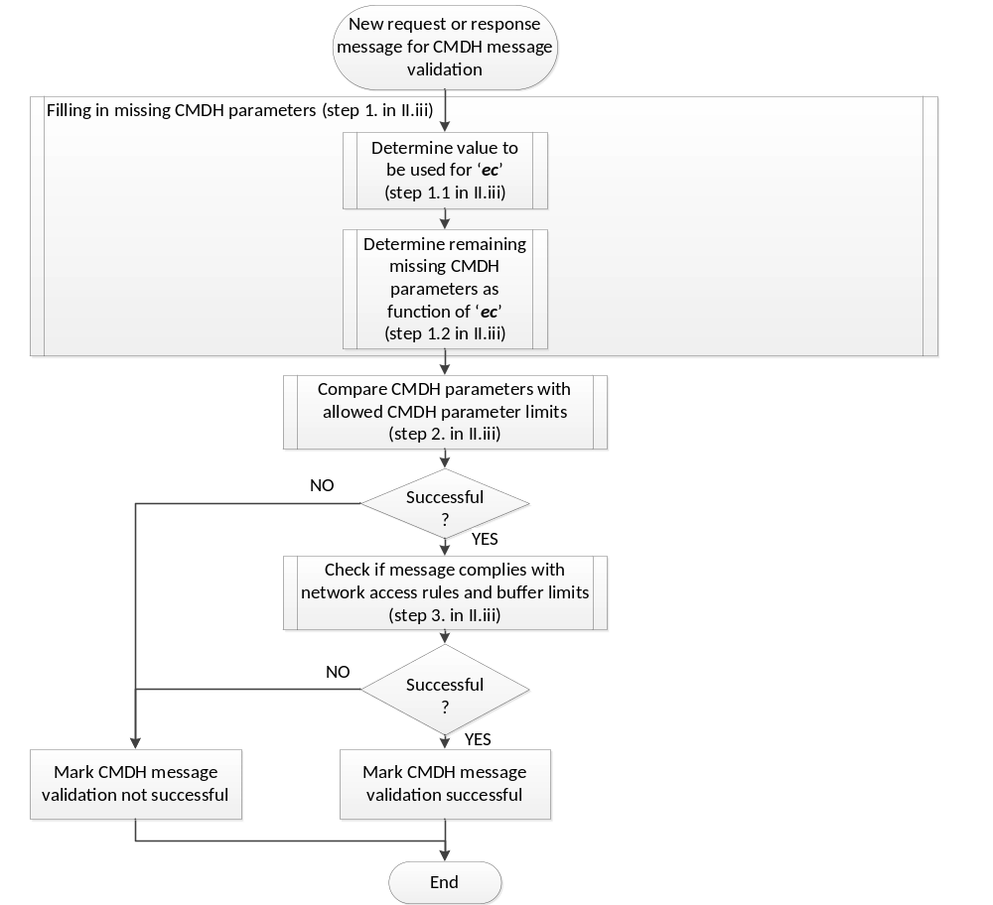
Figure G.2.3-1: CMDH message validation procedure

    - CMDH message forwarding procedure
The high-level sequence of processing steps for the CMDH message forwarding process is depicted in the flow chart below. Note that this flow chart only represents the reference flow for implementing a standard compliant behavior. Other standard compliant implementations may be possible as long as the events defined below will result in the same normative message exchanges via reference points.
Occurrence of the following events shall trigger processing in the CMDH message forwarding:
- One or more new message(s) get(s) queued up for CMDH message forwarding
- Any of the underlying networks becomes usable for message forwarding due to transition(s) in allowed schedule(s) or due to establishing of availability of connectivity (e.g. cable plugged-in, coverage established)
- Any of the underlying networks becomes unusable for message forwarding due to transition(s) in allowed schedule(s) or due to loss of availability of connectivity (e.g. cable unplugged, coverage lost)
- Any message buffered for CMDH forwarding expires

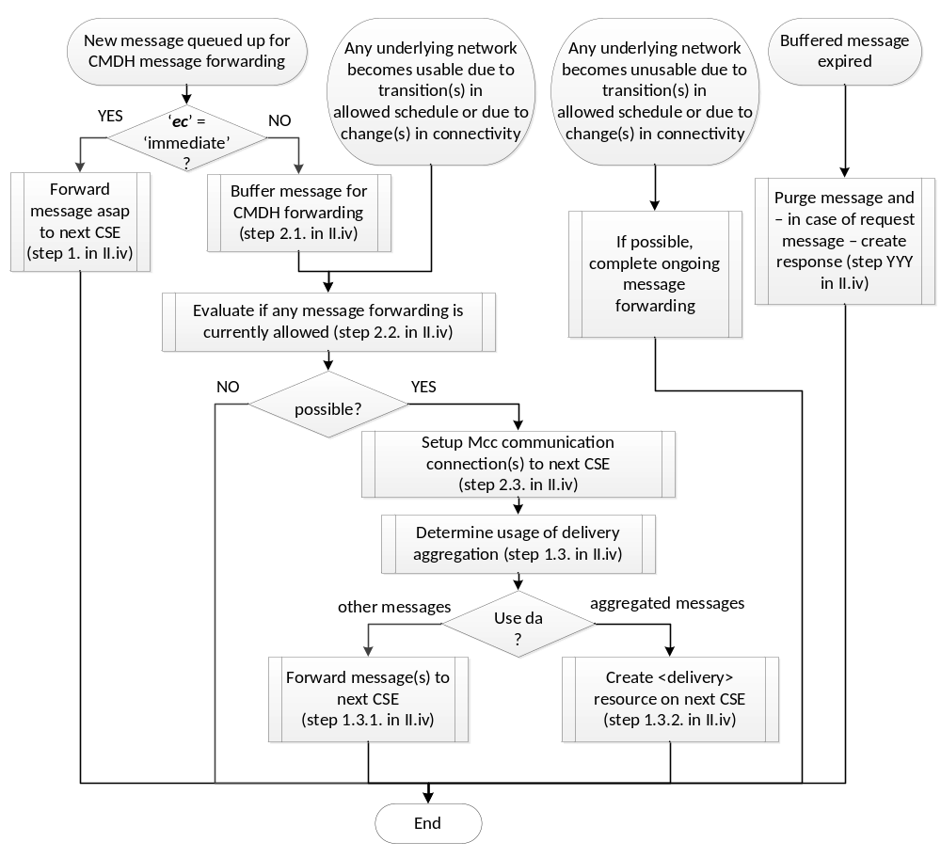
Figure G.2.4-1: CMDH message forwarding procedure

When a new message is getting queued up for CMDH message forwarding, carry out the following:
If the ‘ec’ parameter of the messages has the value ‘immediate’:
Forward message as soon as possible to the next CSE. The processing in this situation is described by the flow chart in below.
  - If a Mcc communication connection to the next CSE for forwarding the message is already established, continue with step 1.3.
  - If no Mcc communication connection to the next CSE for forwarding the message is established pick one underlying network among all underlying networks that can provide communication to the next CSE and establish a Mcc communication connection to the next CSE in line with the rules outlined in clause H.2.5. . If establishment of a Mcc communication connection to the next CSE was not successful before the message expires, continue with step 1.4.
  - Determine whether delivery aggregation or forwarding of the message itself shall be used:
    - If the message contains a ‘da’ parameter set to the value ‘ON’, the Receiver CSE shall forward this message by creation of a <delivery> resource on the next CSE as outlined in clause 7.3.10. The receiver CSE can combine the forwarded message in the same <delivery> resource with other messages for which the ‘da’ parameter set to ‘ON’ and which need to be forwarded to the same target CSE.
    - If the message is not forwarded using a <delivery> resource, the receiver CSE shall forward the message as is to the next CSE via the established Mcc communication connection.
  - If the message could not be forwarded successfully to the next CSE before it expired (e.g. due to repeated unsuccessful attempts to establish a Mcc communication connection or due to the lack of usable underlying networks), the receiver CSE shall carry out the following:
    - If the message was a response message, ignore the message. End this cycle of CMDH message forwarding and wait for new triggering events.
    - If the message was a request message:
      - If the request was a blocking request:
Send an error response to the pending blocking request with a matching Request-ID and Originator indicating the reason for failure and close the blocking request. End this cycle of CMDH message forwarding and wait for new triggering events.
      - If the request was a non-blocking request:
Update the associated <request> resource with matching Request-ID and Originator using an error response code indicating the reason for failure. If the non-blocking request was made in asynchronous mode, send a notification with the error response to the notification target(s) of the request. End this cycle of CMDH message forwarding and wait for new triggering events.
  - Else, i.e. if the message was forwarded successfully to the next CSE:
    - If the message was a response and the Receiver CSE has an open blocking request context with a matching Request-ID and matching Originator, mark the open blocking request as closed, end this cycle of CMDH message forwarding and wait for new triggering events.
    - If the message was a request message:
      - If the request was a blocking request:
Keep the context of the pending blocking request with matching Request-ID and matching Originator open and wait for an incoming response message with the same Request-ID and Originator. End this cycle of CMDH message forwarding and wait for new triggering events.
    - If the request was a non-blocking request:
Wait for a response to the forwarded request (e.g. response with acknowledgement or error response). Update the associated <request> resource with the matching Request-ID and Originator using a response code that reflects the status of the forwarded request (e.g. accepted by next CSE, unsuccessful). If the next CSE responded with an error response message and the request was in non-blocking asynchronous mode, send a notification request message to the Originator of the forwarded request containing the error response of the next CSE. End this cycle of CMDH message forwarding and wait for new triggering events.
- Else, i.e. when the ‘ec’ parameter of the messages does not have the value ‘immediate’:
Buffer the message to be forwarded in the CMDH forwarding buffer:
The processing in this situation is described by the flow chart in below.
    - If the message is a request message and the ‘ec’ parameter of the messages has the value ‘latest’:
      - If the request message is a notification triggered by a subscription:
        - Find any buffered request message that is a notification triggered by a subscription with the same subscription reference.
      - Else, i.e. if the request message is not a notification triggered by a subscription:
        - Find any buffered request message that has the same values in the (‘fr’, ‘to’, ‘op’ ) parameters as the message being processed
      - If any request message was found in steps 2.1.1.1.1 or 2.1.1.2.1, purge the found message from the CMDH forwarding buffer.
    - If there is not enough memory available to buffer the message being processed in the CMDH forwarding buffer:
      - Find any buffered messages with storage priority values lower than the one assigned to the message being processed.
      - If any messages are found:
Purge enough messages among the found messages so that the message being processed can be buffered in the CMDH forwarding buffer. Messages which entered the buffer later shall be purged first. In case any request messages need to be purged, carry out the following:
        - In case of purging a non-blocking request messages:
Update the associated <request> resource with the same Request-ID as the purged request message with a status indicating unsuccessful completion. If the purged message was made in asynchronous mode, send a response to the notification target(s) of the pending non-blocking request
        - In case of purging a blocking request message:
Send an error response to the open blocking request with the same Request-ID as in the purged request message and close the blocking request.
      - Due to the checking of sufficient memory in CMDH message forwarding buffer during CMDH message validation, there should be enough memory available to accommodate the message to be buffered at this point. If that is still not the case, then do the following:
        - In case the message to be buffered is a response message:
Ignore the message to be buffered. End this cycle of CMDH message forwarding and wait for new triggering events.
        - In case the message to be buffered is a non-blocking request message:
Update the associated <request> resource with the same Request-ID as the request message to be buffered with a status indicating unsuccessful completion. If the request message to be buffered was made in asynchronous mode, send a response to the notification target(s) of the pending non-blocking request. End this cycle of CMDH message forwarding and wait for new triggering events.
        - In case the message to be buffered is a blocking request message:
Respond with an error response message to the open blocking request with the same Request-ID as in the request message to be buffered and close the blocking request. End this cycle of CMDH message forwarding and wait for new triggering events.
    - Store the message to be buffered with its assigned storage priority in the CMDH forwarding buffer. Include it in future evaluations for possible message forwarding.
  - Evaluate if any message forwarding is currently allowed:
    - For all buffered messages that are pending in CMDH message forwarding carry out the following evaluation steps:
      - Among all [cmdhNetworkAccessRules] child resources of the provisioned active [cmdhPolicy] resource do the following selection:
        - If present, select the [cmdhNetworkAccessRules] resource containing a value in the list defined by the ‘applicableEventCategory’ attribute that is equal to the value of the ‘ec’ parameter of the buffered message to be evaluated for forwarding. If a match is found, continue processing with step 2.2.1.2.
        - Select the [cmdhNetworkAccessRules] resource that contains the string ‘default’ in the list defined by the ‘applicableEventCategory’.
      - Lookup all [cmdhNwAccessRule] child resources of the selected [cmdhNetworkAccessRules] resource
      - If the attribute ‘otherConditions’ is present in any of the found [cmdhNwAccessRule] resources, discard all [cmdhNwAccessRule] resources from the list of found items for which the conditions expressed by ‘otherConditions’ at time of evaluation of the message for forwarding are not met, respectively.
      - Among the all remaining found [cmdhNwAccessRule] resources find those for which
- the <schedule> child resource ‘allowedSchedule’ is currently allowing usage of the corresponding target network, and
- for which the corresponding target network could be used to reach the next CSE for forwarding the message under evaluation.
If any allowed target network was found, memorize the message under evaluation as an allowed message and the allowed target network(s) for the message under evaluation and continue with the next evaluation of buffered messages
    - When all buffered messages have been evaluated, remove from the memorized list of allowed messages and their allowed target networks those target networks where the amount of data to be forwarded – accumulated over all allowed messages of the same event category – is less than the amount of data indicated in the ‘minReqVolume’ attribute of the corresponding [cmdhNwAccessRule] resource.
    - Remove any messages from the list of allowed messages for forwarding if no allowed target network is left for that message after the previous step.
  - Process messages allowed for forwarding to the next CSE:
If any messages can be forwarded, i.e. if any evaluation of step 2.2 was positive, apply the following steps:
    - Reuse already established Mcc communication connections or – if needed – establish new Mcc communication connection(s) so that all the messages that are allowed to be forwarded to their next CSE can be forwarded. Some messages may be allowed on the same target network. Follow the procedure outlined in clause H.2.5. for setting up a Mcc communication connection to another CSE via a particular target network. If no usable Mcc communication connection could be established for forwarding a particular allowed message before the message expires, execute step 1.4 in this clause above for that message.

    - For all messages allowed for forwarding and for which Mcc communication connections are established, apply steps 1.3 through 1.5 in this clause above.
  - Else, i.e. currently no message forwarding is allowed:
End this cycle of CMDH message forwarding and wait for new triggering events.
When any of the underlying networks becomes usable for message forwarding due to transition(s) in allowed schedule(s) or due to establishing of availability of connectivity (e.g. cable plugged-in, coverage established), carry out the processing above in this clause starting with step 2.2.

When any of the underlying networks becomes unusable for message forwarding due to transition(s) in allowed schedule(s) or due to loss of availability of connectivity (e.g. cable unplugged, coverage lost), complete – if at all possible – any ongoing message forwarding procedures. End this cycle of CMDH message forwarding and wait for new triggering events.

When any message buffered for CMDH forwarding expires, carry out step 1.4 in this clause above. End this cycle of CMDH message forwarding and wait for new triggering events.

Figure G.2.4-2: Forwarding of messages with 'ec' = 'immediate'.
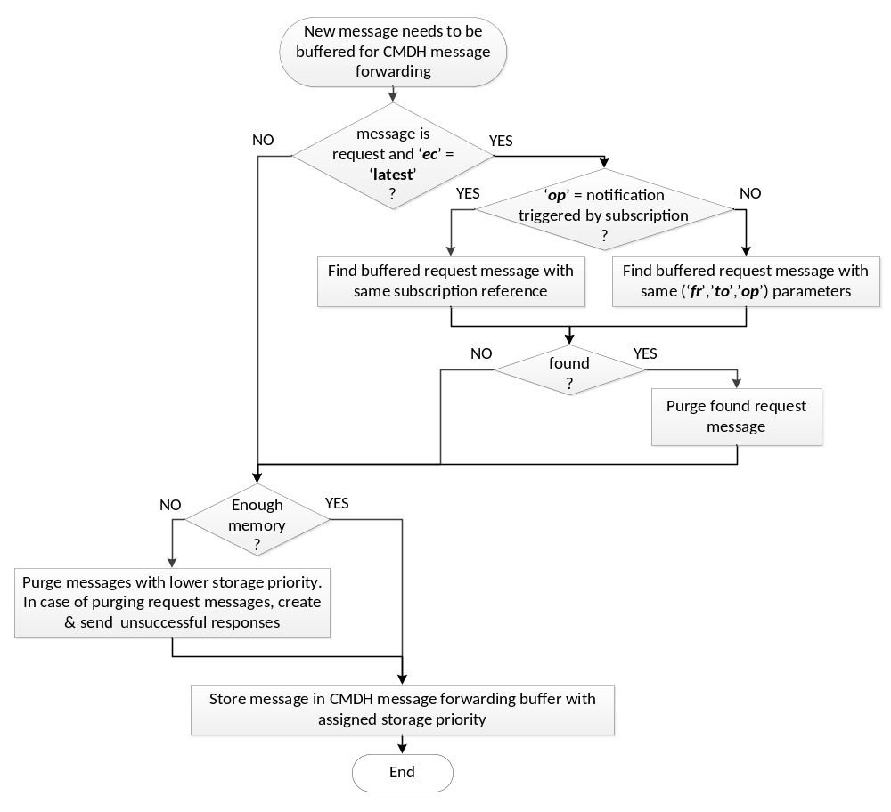
Figure G.2.4-3: Buffering of messages for CMDH message forwarding.

    - Establishment of Mcc communication connection to another CSE
When a Mcc communication connection shall be established via a specific target network for forwarding a message of a specific event category indicated by the ‘ec’ parameter of the message, the process of establishing the Mcc communication connection shall be governed by values contained in the ‘backOffParameters’ attribute of the [cmdhNwAccessRule] resource that was used to evaluate whether the message was allowed to be forwarded, as defined in step 2.2 in the procedure outlined in clause H.2.4. .
When connectivity via the selected target network to reach the next CSE has not already been established for other reasons, then the CSE that is trying to forward a message buffered for CMDH message forwarding shall establish a new Mcc communication connection via the selected target network for transporting oneM2M messages to the next CSE via a new Mcc instance. This communication connection shall be established following the procedures for authentication and security association using TLS or DTLS as defined in TS-0003 Security Solutions [Error: Reference source not found] taking into account provisioned security settings. The protocol mapping for transporting oneM2M specified messages via this instance of Mcc shall be selected according to the capabilities of the two end-points of the Mcc instance.

If establishing the Mcc communication connection via the selected target network fails, a new attempt to establish that communication connection shall only be made after waiting for a back-off time according to the value given in the ‘back-off time’ component of the ‘backOffParameters’ attribute of the effective [cmdhNwAccessRule] resource.
When establishing the Mcc communication connection via the selected target network still fails, for each subsequent new attempt to establish the Mcc communication connection without any successful attempts in-between, the back-off time shall be increased by the value given in the ‘back-off time increment’ component of the ‘backOffParameters’ attribute of the effective [cmdhNwAccessRule] resource.
The back-off time for waiting before making any new attempt to establish the Mcc communication connection via the selected target network shall not exceed the value given by the ‘maximum back-off time’ component of the ‘backOffParameters’ attribute of the effective [cmdhNwAccessRule] resource.
When the next CSE is hosted on a node for which a usable Mcc communication connection for forwarding a message to the next CSE can only be established by the next CSE itself, device triggering mechanisms as defined in TS-0001 shall be used.
In case the next CSE can only be reached via communication connections originating from the node that hosts the next CSE, while it is capable of processing incoming oneM2M messages, it is assumed that such a CSE establishes a polling channel as defined in TS-0001 in order to effectively receive unsolicited oneM2M messages.
- (informative):
Template for one M2M resource type

7.2.x Resource Type <<resource name>>

7.2.x.1 Introduction
The few (2 statements are max.) will be copied from Architecture TS.
The detailed description can be found in clause x.x.x in TS-0001 Functional Architecture [Error: Reference source not found].
Table 7.2.x.1-1: Data Type Definition of <<resource name>>
Data Type ID | File Name | Note
Actual Data Type ID | CDT-<<resource name>>-v1_0_0-<<date of published>>.xsd | some note texts can be added here

Table 7.2.x.1-2: Common Attributes on <<resource name>>
Attribute Name | Request Optionality |  |  |  | Default Value | Resource Specific Note
Attribute Name | C | R | U | D | Default Value | Resource Specific Note
<<common attribute name1>> | M,O,NP | M,O,NP | O | NP |  | Some Resource specific use of <<common attribute name 1>> as text.
<<common attribute name 2>> |  |  | O | NP |  | Another Resource specific use of <<common attribute name2>>

Table 7.2.x.1-3: Resource Specific Attributes on <<resource name>>
Attribute Name | Request Optionality |  |  |  | Data Type | Default Value and Constraints
Attribute Name | C | R | U | D | Data Type | Default Value and Constraints
<<common attribute name1>> | M,O,NP | M,O,NP | O | NP |  | Some Resource specific use of <<common attribute name 1>> as text.
<<common attribute name 2>> |  |  | O | NP |  | Another Resource specific use of <<common attribute name2>>

Table 7.2.x.1-4: Child resources of <<resource name>>
Child Resource Type | Child Resource Name | Multiplicity | Ref. to Resource Type Definition
<<resource type1>> | [name](fixed) | Place 'multiplicity' at resource <<resource type>> | Place the reference to the Resource Type definition in Core Protocol TS
Ex. <AE> | [variable] | Ex. 0..n | Ex. Clause Error: Reference source not found

7.2.x.2 <<resource name>> Resource Specific Procedure on CRUD Operations
This clause describes <<resource name>> resource specific behaviour for CRUD operations.

7.2.x.2.1 Create
The resource specific procedures shall be described here. Those can be mandatory attributes, expecting returning data types, and possible errors

7.2.x.2.2 Retrieve
The resource specific procedures shall be described here. Those can be mandatory attributes, expecting returning data types, and possible errors

7.2.x.2.3 Update
The resource specific procedures shall be described here. Those can be mandatory attributes, expecting returning data types, and possible errors

7.2.x.2.4 Delete
The resource specific procedures shall be described here. Those can be mandatory attributes, expecting returning data types, and possible errors

-----------------------End of change 7---------------------------------------------

CHECK LIST
- Does this change request include an informative introduction containing the problem(s) being solved, and a summary list of proposals.?
- Does this CR contain changes related to only one particular issue/problem?
- Does this change request make all the changes necessary to address the issue or problem? E.g. A change impacting 5 tables should not only include a proposal to change only 3 tables. Includes any changes to references, definitions, and acronyms in the same deliverable?
- Does this change request follow the drafting rules?
- Are all pictures editable?
- Have you checked the spelling and grammar?
- Have you used change bars for all modifications?
- Does the change include the current and surrounding clauses to clearly show where a change is located and to provide technical context of the proposed change? (Additions of complete sections need not show surrounding clauses as long as the proposed section number clearly shows where the new section is proposed to be located.)
- Are multiple changes in this CR clearly separated by horizontal lines with embedded text such as, start of change 1, end of change 1, start of new clause, end of new clause.?

