CHANGE REQUEST
Meeting:* | PRO#24
Source:* | IBM
Date:* | 2016-07-20
Contact:* | Peter Niblett, IBM, peter_niblett@uk.ibm.com
Reason for Change/s:* | See the introduction
CR against: Release* | Release 2
CR against: WI* | Active <Work Item number>  MNT maintenace / < Work Item number(optional)>  STE Small Technical Enhancements / < Work Item number (optional)>  Only ONE of the above shall be ticked
CR against: TS/TR* | TS-0004 v2.6.0
Clauses/Sub Clauses* | 6.3.6, 6.5
Type of change: * | Editorial change  Bug Fix or Correction  Change to existing feature or functionality  New feature or functionality  Only ONE of the above shall be ticked
Post Freeze checking:* | This CR contains only essential changes and corrections? YES NO  This CR may break backwards compatibility with the last approved version of the TS? YES NO  This CR is a mirror CR? YES if YES, please indicate the document number of the original CR: ARC-2016-0330-empty memberIDs clarification(R1) : NO
Template Version:27 May 2015 (Dot not modify)

oneM2M Notice
The document to which this cover statement is attached is submitted to oneM2M. Participation in, or attendance at, any activity of oneM2M, constitutes acceptance of and agreement to be bound by terms of the Working Procedures and the Partnership Agreement, including the Intellectual Property Rights (IPR) Principles Governing oneM2M Work found in Annex 1 of the Partnership Agreement.
GUIDELINES for Change Requests:
Provide an informative introduction containing the problem(s) being solved, and a summary list of proposals.
Each CR should contain changes related to only one particular issue/problem.
In case of a correction, and the change apply to previous releases, a separated “mirror CR” should be posted at the same time of this CR
Follow the principle of completeness, where all changes related to the issue or problem within a deliverable are simultaneously proposed to be made E.g. A change impacting 5 tables should not only include a proposal to change only 3 tables. Includes any changes to references, definitions, and acronyms in the same deliverable.
Follow the drafting rules.
All pictures must be editable.
Check spelling and grammar to the extent practicable.
Use Change bars for modifications.
The change should include the current and surrounding clauses to clearly show where a change is located and to provide technical context of the proposed change. Additions of complete sections need not show surrounding clauses as long as the proposed section number clearly shows where the new section is proposed to be located.
Multiple changes in a single CR shall be clearly separated by horizontal lines with embedded text such as, start of change 1, end of change 1, start of new clause, end of new clause.
When subsequent changes are made to content of a CR, then the accepted version should not show changes over changes. The accepted version of the CR should only show changes relative to the baseline approved text.

Introduction
The Diagram in 6.5 needs to be updated to include new attributes.
Correct the order of the elements in the table in 6.3.6

-----------------------Start of change 1-------------------------------------------

Resource data types

Description
Each oneM2M Resource Data Type is defined using XML Schema (XSD), and supplied as a separate XSD document. This XML Schema defines the attributes of the Resource in accordance with TS-0001 [Error! Reference source not found.]. It represents an entire resource. In other words if and only if a requestor retrieves an entire resource in XML format, the XML that is returned shall be valid with respect to the schema for that resource. Note that the payload of a Create or Update request primitive does not necessarily have to be valid according to the schema, as this payload is not required to contain values for all the resource attributes. For example, a resource might contain mandatory read-only attributes which do not appear in a Create or Update request.
Each Resource Type , along with its Announced variant (if there is one) is defined in a separate XSD file. The name of that file should be prefixed with 'CDT-' and followed by the resource type name and version of the present document.
The individual Resource Types inherit from a set of base resource types. These definitions, which can be found in the file CDT-commonTypes-v2_6_0.xsd, contain definitions for the common and universal attributes, and establish an inheritance hierarchy shown in Figure 6.4.1-1.
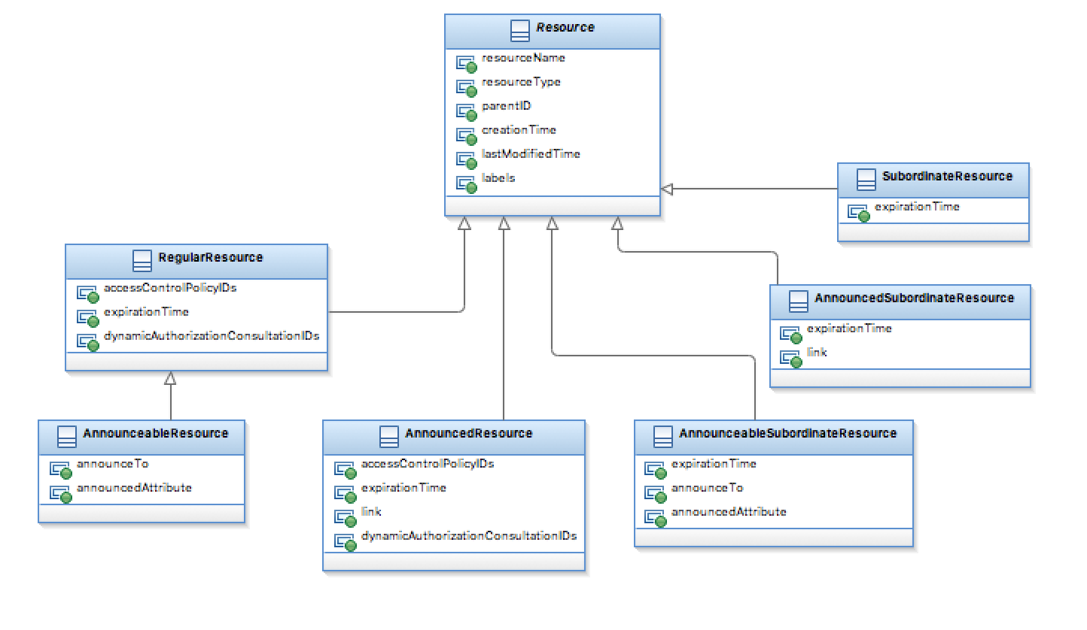
Figure 6.5.1-1: Resource Types

-----------------------End of change 1---------------------------------------------

-----------------------Start of change 2-------------------------------------------

Universal and Common attributes
TS-0001 [Error! Reference source not found.] defines a number of Universal Attributes (which appear in all resources) and Common Attributes (which appear in more than one resource and have the same meaning whenever they do appear). The type and values shall be supported according to the description given inTable 6.2.4-1.
If a Resource is represented as an XML document then the resource attributes (if present) appear in the order listed in this table. They appear before any resource-specific attributes.
Table 6.3.6-1: Universal and Common Attributes
Attribute Name | Data Type | Value restrictions and Notes
resourceType | m2m:resourceType | This attribute is only determined at creation time by the hosting CSE
resourceID | m2m:ID | This attribute is determined at creation time by the hosing CSE and used for non hierarchical addressing method
parentID | m2m:nhURI | This attribute is determined by the hosting CSE and specified in all resource types.For <CSEBase> however, the value of this attribute shall be an empty string.
creationTime | m2m:timestamp | This attribute is determined by the hosting CSE when the resource is locally created
lastModifiedTime | m2m:timestamp | This attribute is determined by the hosting CSE when the addressed resource is modified by means of the UPDATE operation
labels | m2m:labels | Absence of this attribute means there are no labels
accessControlPolicyIDs | m2m:acpType | accessControlPolicyIDs
expirationTime | m2m:timestamp | expirationTime
link | xs:anyURI | Absence of this attribute means that this is not an announced resource
announceTo | list of xs:anyURI | Absence of this attribute means that this is not an announced resource
announcedAttribute | list of xs:NCName | Absence of this attribute means that this is not an announced resource
stateTag | xs:nonNegativeInteger | This attribute is determined by the hosting CSE. When a resource is created this counter is set to '0' and it will be incremented on every modification of the resource
resourceName | xs:NCName
dynamicAuthorizationConsultationIDs | list of xs:anyURI | dynamicAuthorizationConsultationIDs
creator | m2m:ID | The AE-ID or CSE-ID of the entity which created the resource containing this attribute.

Table 6.2.4-2 describes some complex types that group together the universal and common attributes, to be used by Resource Type definitions. Note that stateTag and creator only appear in a limited number of resource types, and therefore are not included in these definitions, instead they are declared in the corresponding XSD files of the resources that support them.
Table 6.3.6-2: Complex Data Types declaring groups of resource common attributes
XSD type name | Child Elements | Child Element Datatype | Multiplicity | Description
m2m:resource | @resourceName | xs:NCName | 1
 | resourceType | m2m:resourceType | 1
 | resourceID | m2m:ID | 1
 | parentID | m2m:nhURI | 1
 | creationTime | m2m:timestamp | 1
 | lastModifiedTime | m2m:timestamp | 1
 | labels | m2m:labels | 0..1
m2m:regularResource | @resourceName | xs:NCName | 1 | Declares the universal / common attributes included in the non-announceable resource types.
 | resourceType | m2m:resourceType | 1
 | resourceID | m2m:ID | 1
 | parentID | m2m:nhURI | 1
 | creationTime | m2m:timestamp | 1
 | lastModifiedTime | m2m:timestamp | 1
 | labels | m2m:labels | 0..1
 | accessControlPolicyIDs | m2m:acpType | 0..1
 | expirationTime | m2m:timestamp | 1
 | dynamicAuthorizationConsultationIDs | list of xs:anyURI | 0..1
m2m:announceableResource | @resourceName | xs:NCName | 1 | Declares the universal / common attributes included in the majority of announceable resource types.
 | resourceType | m2m:resourceType | 1
 | resourceID | m2m:ID | 1
 | parentID | xs:anyURI | 1
 | creationTime | m2m:timestamp | 1
 | lastModifiedTime | m2m:timestamp | 1
 | labels | m2m:labels | 0..1
 | accessControlPolicyIDs | m2m:acpType | 0..1
 | expirationTime | m2m:timestamp | 1
 | dynamicAuthorizationConsultationIDs | list of xs:anyURI | 0..1
 | announceTo | list of xs:anyURI | 0..1
 | announcedAttribute | list of xs:NCName | 0..1
m2m:announcedResource | @resourceName | xs:NCName | 1 | Declares the universal / common attributes in the announced variant of the preceding resources
 | resourceType | m2m:resourceType | 1
 | resourceID | m2m:ID | 1
 | parentID | m2m:nhURI | 1
 | creationTime | m2m:timestamp | 1
 | lastModifiedTime | m2m:timestamp | 1
 | labels | m2m:labels | 0..1
 | accessControlPolicyIDs | m2m:acpType | 0..1
 | expirationTime | m2m:timestamp | 1
 | link | xs:anyURI | 1
 | dynamicAuthorizationConsultationIDs | list of xs:anyURI | 0..1
m2m:subordinateResource | @resourceName | xs:NCName | 1 | Declares the universal / common attributes included in the non-announceable resource types without accessControlPolicyIDs
 | resourceType | m2m:resourceType | 1
 | resourceID | m2m:ID | 1
 | parentID | m2m:nhURI | 1
 | creationTime | m2m:timestamp | 1
 | lastModifiedTime | m2m:timestamp | 1
 | labels | m2m:labels | 0..1
 | expirationTime | m2m:timestamp | 1
m2m:announceableSubordinateResource | @resourceName | xs:NCName | 1 | Declares the universal / common attributes used by resource types that are subordinate children of other resources
 | resourceType | m2m:resourceType | 1
 | resourceID | m2m:ID | 1
 | parentID | xs:anyURI | 1
 | creationTime | m2m:timestamp | 1
 | lastModifiedTime | m2m:timestamp | 1
 | labels | m2m:labels | 0..1
 | expirationTime | m2m:timestamp | 1
 | announceTo | list of xs:anyURI | 0..1
 | announcedAttribute | list of xs: NCName | 0..1
m2m:announcedSubordinateResource | @resourceName | xs:NCName | 1 | Declares the common / universal attributes used in the announced variants of the subordinate resource types
 | resourceType | m2m:resourceType | 1
 | resourceID | m2m:ID | 1
 | parentID | m2m:nhURI | 1
 | creationTime | m2m:timestamp | 1
 | lastModifiedTime | m2m:timestamp | 1
 | labels | m2m:labels | 0..1
 | expirationTime | m2m:timestamp | 1
 | link | xs:anyURI | 1
NOTE: In the above table, names of XML schema attributes are prefixed with a "@" character to differentiate these from Resource attribute names. The "@" character is not part of the actual attribute name.

-----------------------End of change 2---------------------------------------------

CHECK LIST
- Does this change request include an informative introduction containing the problem(s) being solved, and a summary list of proposals.?
- Does this CR contain changes related to only one particular issue/problem?
- Have any mirror crs been posted?
- Does this change request make all the changes necessary to address the issue or problem? E.g. A change impacting 5 tables should not only include a proposal to change only 3 tables. Includes any changes to references, definitions, and acronyms in the same deliverable?
- Does this change request follow the drafting rules?
- Are all pictures editable?
- Have you checked the spelling and grammar?
- Have you used change bars for all modifications?
- Does the change include the current and surrounding clauses to clearly show where a change is located and to provide technical context of the proposed change? (Additions of complete sections need not show surrounding clauses as long as the proposed section number clearly shows where the new section is proposed to be located.)
- Are multiple changes in this CR clearly separated by horizontal lines with embedded text such as, start of change 1, end of change 1, start of new clause, end of new clause.?

