CHANGE REQUEST
Meeting ID:* | PRO 30
Source:* | Francisco Sang-Eon Kim, KT, kim.sangeon@kt.com
Date:* | 2017-07-13
Reason for Change/s:* | See the introduction.
CR against: Release* | Release 2
CR against: WI* | Active <Work Item number>  MNT maintenance WI-0049  Is this a mirror CR? Yes No  mirror CR number: PRO-2017-0154R01  STE Small Technical Enhancements / WI-0050
CR against: TS/TR* | TS-0004-V2.12.0
Clauses * | 6.6.3.2 Informational response class
Type of change: * | Editorial change  Bug Fix or Correction  Change to existing feature or functionality  New feature or functionality  Only ONE of the above shall be ticked
Impacted other TS/TR(s) | None
Post Freeze checking:* | This CR contains only essential changes and corrections? YES NO  This CR may break backwards compatibility with the last approved version of the TS? YES NO
Template Version: January 2017 (Do not modify)

oneM2M Notice
The document to which this cover statement is attached is submitted to oneM2M. Participation in, or attendance at, any activity of oneM2M, constitutes acceptance of and agreement to be bound by terms of the Working Procedures and the Partnership Agreement, including the Intellectual Property Rights (IPR) Principles Governing oneM2M Work found in Annex 1 of the Partnership Agreement.
GUIDELINES for Change Requests:
Provide an informative introduction containing the problem(s) being solved, and a summary list of proposals.
Each CR should contain changes related to only one particular issue/problem.
In case of a correction, and the change apply to previous releases, a separate “mirror CR” should be posted at the same time of this CR
Mirror CR: applies only when the text, including clause numbering are exactly the same.
Companion CR: applies when the change means the same but the baselines differ in some way (e.g. clause number).
Follow the principle of completeness, where all changes related to the issue or problem within a deliverable are simultaneously proposed to be made E.g. A change impacting 5 tables should not only include a proposal to change only 3 tables. Includes any changes to references, definitions, and acronyms in the same deliverable.
Follow the drafting rules.
All pictures must be editable.
Check spelling and grammar to the extent practicable.
Use Change bars for modifications.
The change should include the current and surrounding clauses to clearly show where a change is located and to provide technical context of the proposed change. Additions of complete clauses need not show surrounding clauses as long as the proposed clause number clearly shows where the new clause is proposed to be located.
Multiple changes in a single CR shall be clearly separated by horizontal lines with embedded text such as, start of change 1, end of change 1, start of new clause, end of new clause.
When subsequent changes are made to content of a CR, then the accepted version should not show changes over changes. The accepted version of the CR should only show changes relative to the baseline approved text.

Introduction
The TS-0001 has introduced flexBlocking since Release 2 as following.
When an Originator send Request primitive with nonBlockingRequestSynch of Response Type parameter,
- In case the request is accepted by the Receiver CSE, the Receiver CSE responds, after acceptance, with an Acknowledgement confirming that the Receiver CSE will further process the request. The Receiver CSE includes in the response to an accepted request a reference that can be used to access the status of the request and the result of the requested operation at a later time.
When an Originator send Request primitive with nonBlockingRequestAsynch {optional list of notification targets}of Response Type parameter,
- In case the request is accepted by the Receiver CSE, the Receiver CSE shall respond, after acceptance, with an Acknowledgement confirming that the Receiver CSE will further process the request. The result of the requested operation needs to be sent as notification(s) to the notification target(s) provided optionally within this parameter as a list of entities or to the Originator when no notification target list is provided. When an empty notification target list is provided by the Originator, no notification with the result of the requested operation shall be sent at all.
When an Originator send Request primitive with flexBlocking {optional list of notification targets} of Response Type parameter,
- When Response Type in the request received by the Receiver CSE is set to flexBlocking, it means that the Originator of the request has the capability to accept the following types of responses: nonBlockingRequestSynch, nonBlockingRequestAsynch and blockingRequest.
The Receiver CSE shall make the decision to respond using blocking or non-blocking based on its own local context (memory, processing capability, etc.) if not defined in the resource handling procedure.
If the Receiver CSE choose to respond using non-blocking mode, based on the presence of notification targets in the request:
- If the notification targets are provided in the request and the Recerver CSE is responding, the Receiver CSE shall notify the result using nonBlockingRequestAsynch.
- If notification targets are not provided, the Receiver CSE shall respond with the address of <request> resource using nonBlockingRequestSynch.
TS-0004 is specified as following.

6.3.3.2 Informational response class
Table 6.6.3.2-3 specifies the RSCs for acknowledgement responses for each release.
Table 6.6.3.2-1: Informational response class
Numeric Code | Description
1000 | ACCEPTED

6.3.4.2.6 m2m:responseType
Used for Response Type parameter (as a part of responseTypeInfo, see Clause Error: Reference source not found) in request.
Table 6.3.4.2.6-2: Interpretation of responseType
Value | Interpretation | Note
1 | nonBlockingRequestSynch
2 | nonBlockingRequestAsynch
3 | blockingRequest
4 | flexBlocking
NOTE: See clause Error: Reference source not found "Request message parameter data types".

A blockingRequest is shown in Figure A, B, C, D, E for operations.
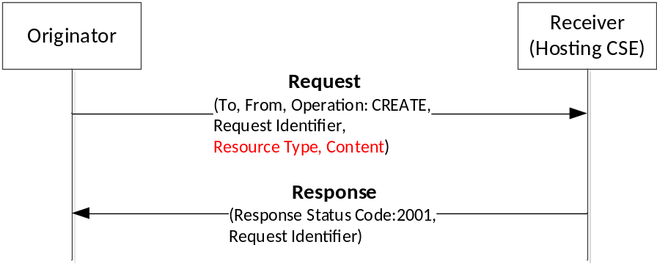
Figure A: Procedure for blockingRequest of CREATE operation
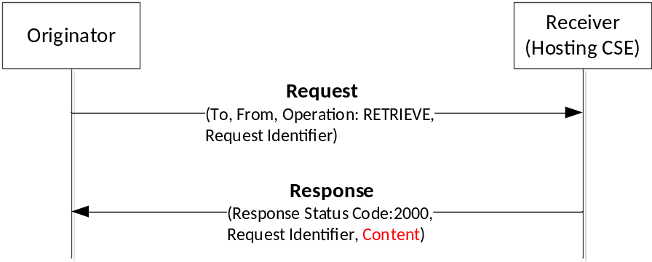
Figure B: Procedure for blockingRequest of RETRIEVE operation
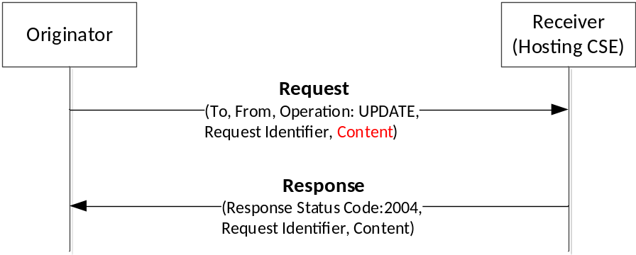
Figure C: Procedure for blockingRequest of UPDATE operation
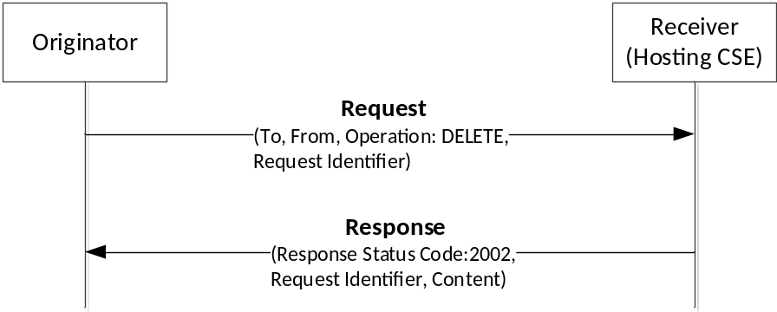
Figure D: Procedure for blockingRequest of DELETE operation
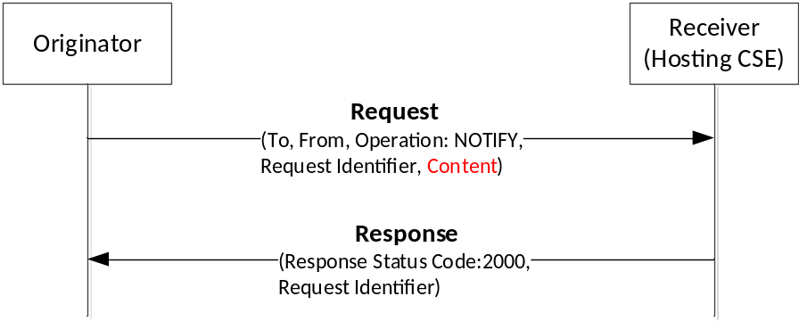
Figure E: Procedure for blockingRequest of NOTIFY operation

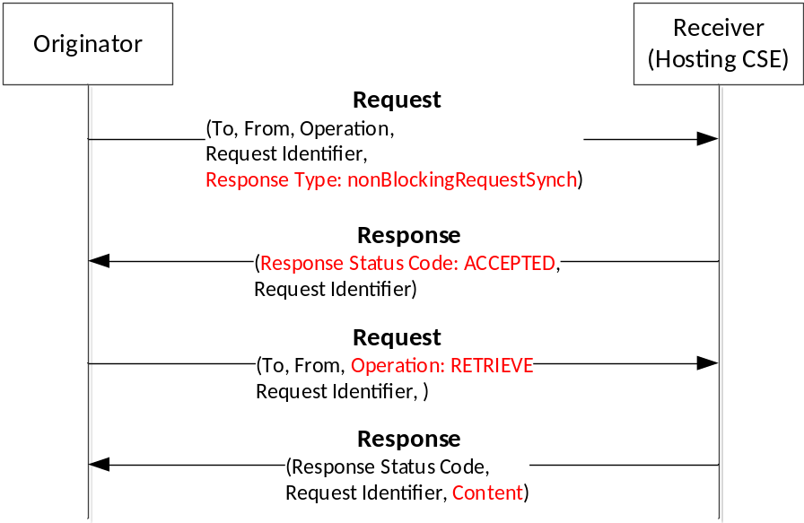
Figure 1: Procedure for nonBlockingRequestSynch

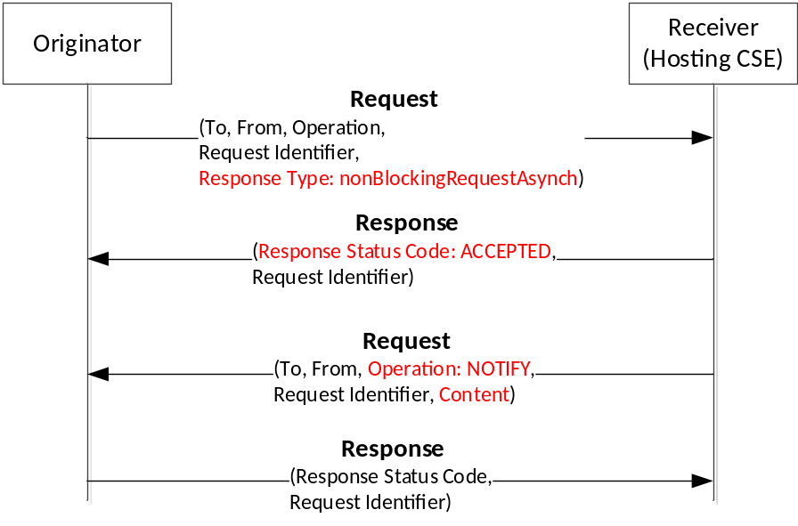
Figure 2: Procedure for nonBlockingRequestAsynch
It describes a conceptual procedure for nonBlockingRequestSynch and nonBlockingRequestAsynch in Figure 1 and Figure 2 respectively.

Problem
The Receiver, Hosting CSE, responses same response status code for accepted of nonBlockingRequestSynch and nonBlockingRequestAsynch as showen in Figure 3.
In case of Request with flexBlocking {optional list of notification targets}, the Originator may have an error because Response Status Code is not clear. If the Receiver intends ‘ACCEPTED’ to process with nonBlockingRequestSynch, the Originator has to retrieve to the Receiver later. If the Receiver intends ‘ACCEPTED’ to process with nonBlockingRequestAsynch, the Originator has to wait notification request from the Receiver later.
Therefore, when an Originator receives same ‘ACCEPTED’ from a Receiver, the Originator can not decide action either waiting a notification for nonBlockingRequestAsynch or retrieve for nonBlockingRequestSynch.
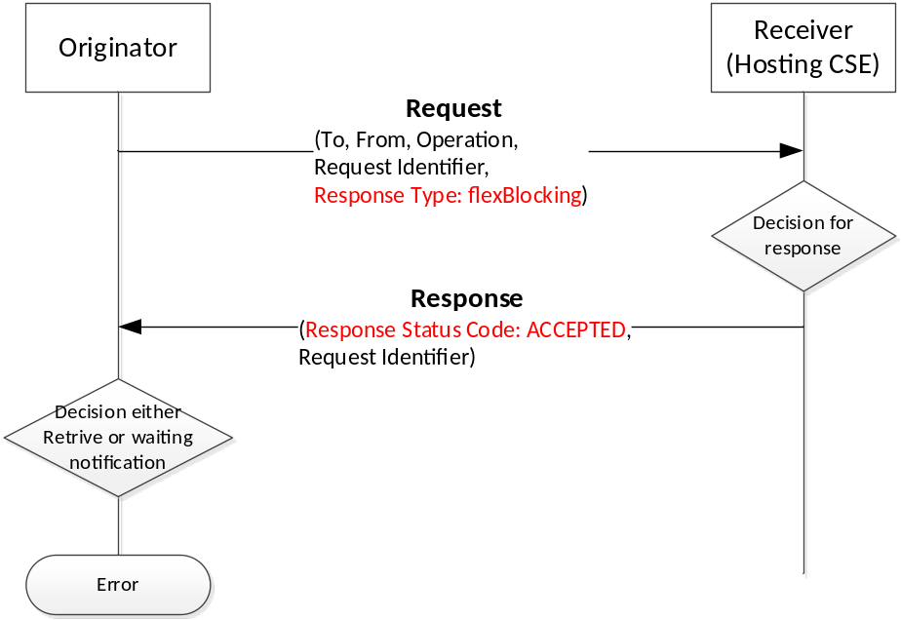
Figure 3: Problem of same RSC between nonBlockingRequestSynch and nonBlockingRequestAsynch

Proposal
A Receiver responses with different response status code between nonBlockingRequestAsynch and nonBlockingRequestSynch
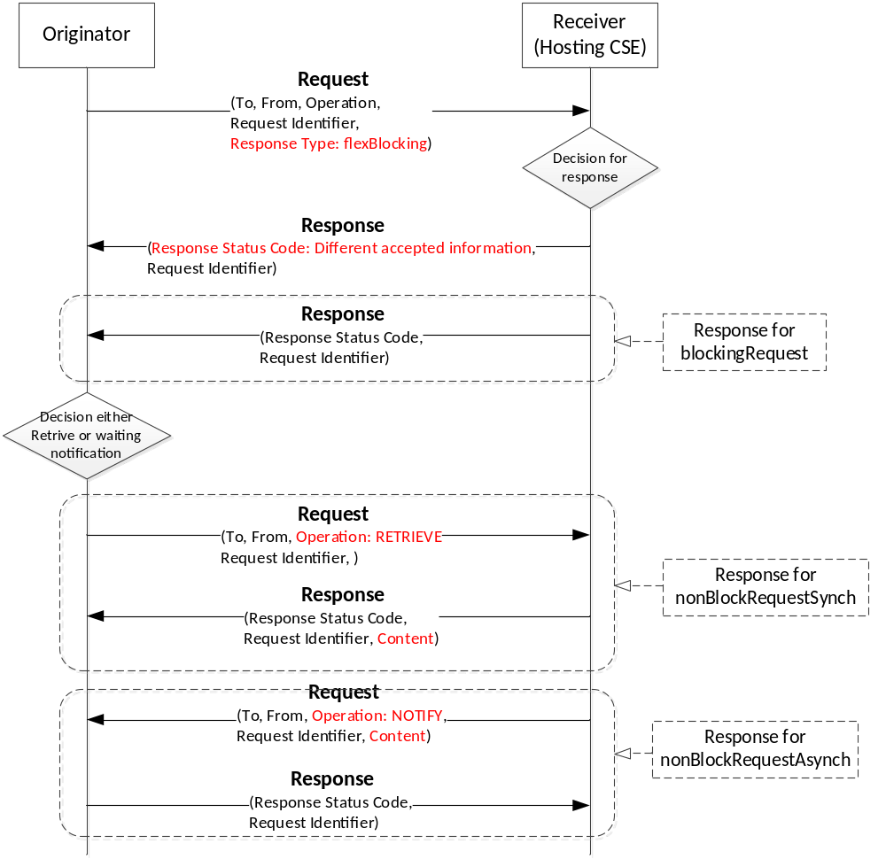
Figure 4: Problem of same RSC between nonBlockingRequestSynch and nonBlockingRequestAsynch
It describes a conceptual process for a decision for response on flexblocking at the Receiver in Figure 5. The 100X is ‘ACCEPTED’ to process nonBlockingRequestSynch. The 100Y is ‘ACCEPTED’ to process nonBlockingRequestAsynch.
If the Originator requests Request with Response Type parameter which is flexBlocking including notification target, the Receiver may select to process that one of the blockingRequest, nonBlockingRequestSynch or nonBlockingRequestAsynch.
If the Originator requests Request with Response Type parameter which is flexBlocking without notification target, the Receiver may select to process that one of the blockingRequest or nonBlockingRequestSynch.
The Figure 5 shows algorithms to decide response and process method at the Receiver that received Request with Response Type parameter which is flexBlocking.
. 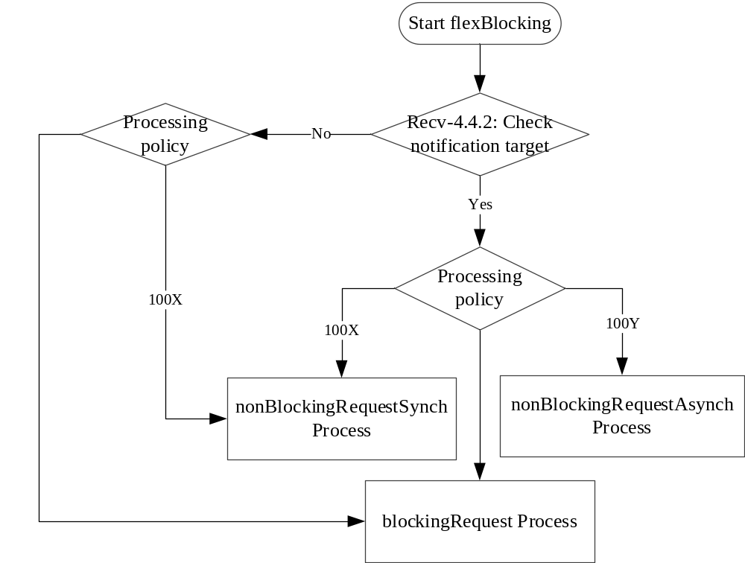
Figure 5: Decision for response on FlexBlocking
R01 includes comments on discussion at ARC/PRO session
- This is MNT that means to be needed mirror.
- Existing RSC, 1000, will be used for backward compatibility

-----------------------Start of change 1-------------------------------------------

6.6.3.2 Informational response class
Table 6.6.3.2-3 specifies the RSCs for acknowledgement responses for each release.
Table 6.6.3.2-3: Informational response class
Numeric Code | Description
1001 | ACCEPTED for nonBlockingRequestSynch
1002 | ACCEPTED for nonBlockingRequestAsynch

-----------------------End of change 1---------------------------------------------

CHECK LIST
- Does this Change Request include an informative introduction containing the problem(s) being solved, and a summary list of proposals.?
- Does this CR contain changes related to only one particular issue/problem?
- Have any mirror CRs been posted?
- Does this Change Request make all the changes necessary to address the issue or problem? E.g. A change impacting 5 tables should not include a proposal to change only 3 tables?Does this Change Request follow the drafting rules?
- Are all pictures editable?
- Have you checked the spelling and grammar?
- Have you used change bars for all modifications?
- Does the change include the current and surrounding clauses to clearly show where a change is located and to provide technical context of the proposed change? (Additions of complete clauses need not show surrounding clauses as long as the proposed clause number clearly shows where the new clause is proposed to be located.)
- Are multiple changes in this CR clearly separated by horizontal lines with embedded text such as, start of change 1, end of change 1, start of new clause, end of new clause.?

