Input contribution
Use case
Use Case Title:* | Use case on collection of m2m system data
Group Name:* | <WG1>
Source:* | ChinaUnicom, Huawei technologies
Contact: | Changwei Hu, China Unicom, hucw5@chinaunicom.cn  Peng Wang, China Unicom, wangpeng@chinaunicom.cn  Xueqin Jia, China Unicom, jiaxq11@chinaunicom.cn  Yi Chen; Huawei technologies ; yi.chen@huawei.com
Date:* | <2013-04-01>
Abstract:* | This proposal is to provide a use case of M2M System data collection.
Agenda Item:* | N/A
Work item(s): | N/A
Document(s)  Impacted* | N/A
Intended purpose of  document:* | Decision  Discussion  Information  Other <specify>
Decision requested or recommendation:* | Approval

oneM2M IPR STATEMENT
“Participation in, or attendance at, any activity of oneM2M, constitutes acceptance of an agreement to be bound by all provisions of IPR policy of the admitting Partner Type 1 and permission that all communications and statements, oral or written, or other information disclosed or presented, and any translation or derivative thereof, may without compensation, and to the extent such participant or attendee may legally and freely grant such copyright rights, be distributed, published, and posted on oneM2M’s web site, in whole or in part, on a non-exclusive basis by oneM2M or oneM2M Partners Type 1 or their licensees or assignees, or as oneM2M SC directs.

  - Title

Use case on collection of M2M System data.
  - Description

M2M Service Providers have a need to provide the Application Service Providers with data and analysis related to the behavior of the M2M System as well as the service provider supplied components of the M2M System (e.g., Device Gateway).

M2M Service Providers can utilize the methods of Big Data by collecting M2M System data for the behavior of the M2M System as well as data from M2M System components provided by the Service Provider.

In this scenario, the data is collected from M2M Gateways and Devices provided by the M2M Service Provider. The M2M System data that is collected from the M2M Devices and Gateways can be described as:
- M2M System Behavior
- Component Properties

M2M System Behavior: Data related to the operation of the M2M Applications within the M2M System. Types of data that is to be collected includes information related Messages transmittal and reception (e.g., bytes, response times, event time).

Component Properties: Data related to the Service Provider supplied components as the component is in use by the M2M System (e.g., location, speed of the component, other anonymous data).

With this data, the M2M Service Provide can provide:
- Analysis of the data without knowledge of content of the Application’s data.
- Insights into the operation of the M2M Applications. For example, the M2M Service Provider can infer the "correct" state of the application or the network status changes, by the analysis of the data, and then trigger some kinds of optimization mechanisms.

  - Source (as applicable)

China Unicom

Huawei technologies
  - FFSActors (as applicable)

Front-end data-collection equipment (e.g. M2M Devices and Gateways)

Management Platform

Monitor Center

Vehicle State Data Demand Department

M2M System data collection center
  - Pre-conditions (if any)

<Conditions that must exist for the use case or scenario to be executed>
  - Triggers (if any)
- Time trigger: collecting data at a specific time;
- Position trigger: collecting data when position changed;
- Behavior trigger: collecting data when certain behavior happened;
- Others
  - Normal Flow (as applicable)
- Front-End Devices need to be registered into the vehicle platform.
- After registration, those devices can send data to the Vehicle Platform by some protocol (e.g. M2M Protocol).
- The Vehicle Platform can send commands t and broadcast some information to those devices.
- The Platform will use a built-in data collector in M2M Devices and Gateways to collect M2M System data and send to the M2M System Data Collection Center.
    - Alternative flow (if any)
  - Post-conditions (if any)

<Conditions resulting from the execution of the use case or scenario>
  - High Level Illustration (as applicable)

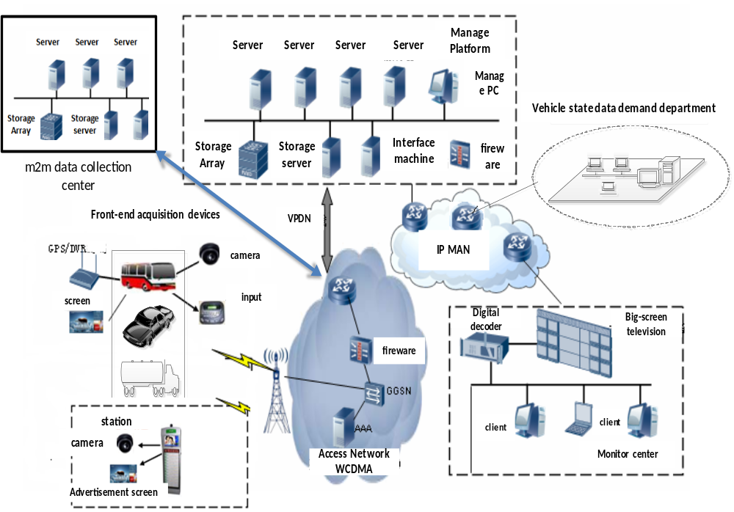

Figure1：Vehicle Operation Management System

Vehicle Operation Management System provide users a new telecommunications business with remote collection, transmission, storage, processing of the image and alarm signals.
- Front-End Data Collection Equipment include Front-End 3G camera, Electronic Station, Car DVR, costumed car GPS, wcdma wireless routers and other equipment.
- Management Platform with business management function, include:
- Forwarding, distribution, or storage of images
- Linkage process of alarms
- Management and maintenance of the vehicle status data.
- Monitor Center: consists of TV wall, soft / hardware decoder, monitor software, etc.
- Vehicle State Data Demand Department: such as auto 4S shop, vehicle repair shop, vehicle management center, automobile and parts manufacturers, government regulatory platform, etc.
- M2M System Data Collection Center: use built-in data collectors resided in Network Equipment,M2M Platform, Costumed M2M Modules and Costumed M2M Terminal Devices to collect M2M System data.
  - Potential requirements (as applicable)

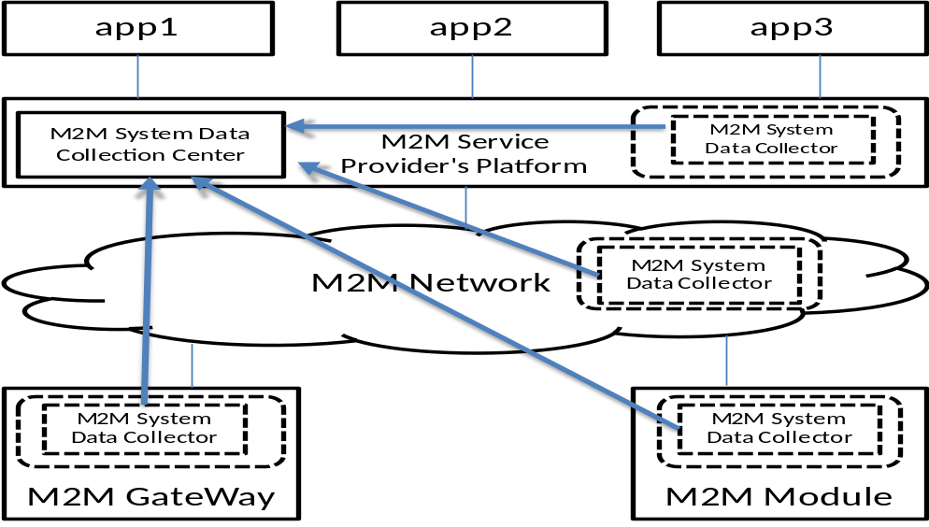

Figure2: M2m system data collection processing flow

As illustrated in Figure 2, we suggest that M2M System data collector should

reside in:
- M2M Service Providers’ Platform
- M2M Network Equipment
- M2M Devices and Gateways
- M2M Communication Module

