Input contribution
Use case
Use Case Title:* | Use case for Device Pairing in Home Domain
Group Name:* | WG1
Source:* | KETI, NEC
Contact: | Sungchan Choi (csc@keti.re.kr)  Yong-Suk Park (yspark@keti.re.kr)  Jaeho Kim (jhkim@keti.re.kr)
Date:* | 2014-09-15
Abstract:* | This use case is about device pairing in the home domain. Home server needs to reflect/update the paring information of the devices.
Agenda Item:*
Work item(s): | WI 0017 – Home Domain Enablement
Document(s)  Impacted* | Technical Specification TR 0013 – Home Domain Enablement TR
Intended purpose of  document:* | Decision  Discussion  Information  Other <specify>
Decision requested or recommendation:* | Approval of the Use case for the Home Domain Enablement TR

oneM2M IPR STATEMENT
“Participation in, or attendance at, any activity of oneM2M, constitutes acceptance of an agreement to be bound by all provisions of IPR policy of the admitting Partner Type 1 and permission that all communications and statements, oral or written, or other information disclosed or presented, and any translation or derivative thereof, may without compensation, and to the extent such participant or attendee may legally and freely grant such copyright rights, be distributed, published, and posted on oneM2M’s web site, in whole or in part, on a non-exclusive basis by oneM2M or oneM2M Partners Type 1 or their licensees or assignees, or as oneM2M SC directs.

6.x Use case for Device Pairing in Home Domain

6.x.1 Overview

6.x.1.1 Description

In home domain environments, there exist many kinds of home appliances such as air conditioner, refrigerator, smart plug, washing machine, lighting equipment, audio player, television, etc., that may be capable of M2M communication.
In this use case it is proposed that under certain circumstances two physically distinct devices in the home domain are correlated to each other.

A refrigerator is a home appliance which is used for storing vegetable, meat, or perishable food such as milk, egg etc. In this use case the refrigerator can provide M2M services (e.g. indicate a shortness of milk) but does not monitor and report its own energy consumption.

A smart plug is a home appliance used for measuring the consumed energy level of a connected home appliance. That is, if a smart plug is connected to a refrigerator, we can interpret that data generated from a smart plug in relation to the consumed energy level of the refrigerator.

Therefore, we can conceptually regard the two physically separate devices as one device.

The physical relationship among the two devices (the smart plug is connected to the refrigerator) can be detected – either manually by the user or automatically by some non-oneM2M technology – through a smart device (e.g. smart phone and tablet device). This relationship is called “pairing” of the two devices.
The smart device sends the information about the pairing relationship configuration to the home server.

In addition, it is supposed that the smart plug connected to the refrigerator is later disconnected from the refrigerator and then is connected to another home appliance such as a washing machine. In this situation, the data from smart plug are no more related to the refrigerator but are related to the washing machine.

The oneM2M System should support this kind of pairing relationship between physically separate home appliances. As the home appliance connected with the smart plug can dynamically be changed the oneM2M System needs to be able to dynamically change the pairing relationship between home appliances.

6.x.1.2 Source

KETI

6.x.1.3 Actors

Home appliances
(include air conditioner, refrigerator, washing machine, smart plug, lightening equipment, etc.). Every home appliance needs to register its registration information with a home server.

Home gatewaynces and data reported from home applinted d reports its data to the home server.

Smart hHome server
is an oneM2M platform provided by a service provider in the infrastructure domain.

A smart device
(e.g. smart phone and tablet device) detects and configures the relationship between the smart plug and the refrigerator

6.x.1.4 Pre-condition

A smart plug and a refrigerator are registered with a home server. In addition, the smart plug is connected to the refrigerator and reports the consumed energy level of the refrigerator to the home server.

6.x.1.5 Triggers

None

6.x.1.6 Normal Flow

A smart device (e.g. smart phone and tablet device) detects and configures the relationship between the smart plug and the refrigerator. It sends the information about relationship configuration to the home server.

In this scenario, the configuration information includes the pairing information between the smart plug and the refrigerator and it implies that the smart plug is connected to the refrigerator and the data from the smart plug is related to the energy consumption of the refrigerator.

Receiving the configuration information, the home server checks its registered device list and makes a pairing/relationship between devices based on the configuration information.

Later, it is supposed that the refrigerator is pulled out of the smart plug and the smart plug is connected to different home appliance e.g. a washing machine.

The smart device detects the new pairing relationship and sends this information to the home server.

The home server receives the updated relationship information and then changes the pairing relationship among its registered devices.

6.x.1.7 Post-conditions

In the home server, the information about the pairing relationship between home appliances is reflected.

A smart home application can discover and use this kind of pairing information between devices.

6.x.1.8 High Level Illustration

The following figure illustrates whenthat at time is t1, the smart socket is connected to the refrigerator and then whenat time is t2, the smart socket is disconnected withfrom the refrigerator and connected to the washing machine. Home server manages the pairing information between home appliances.

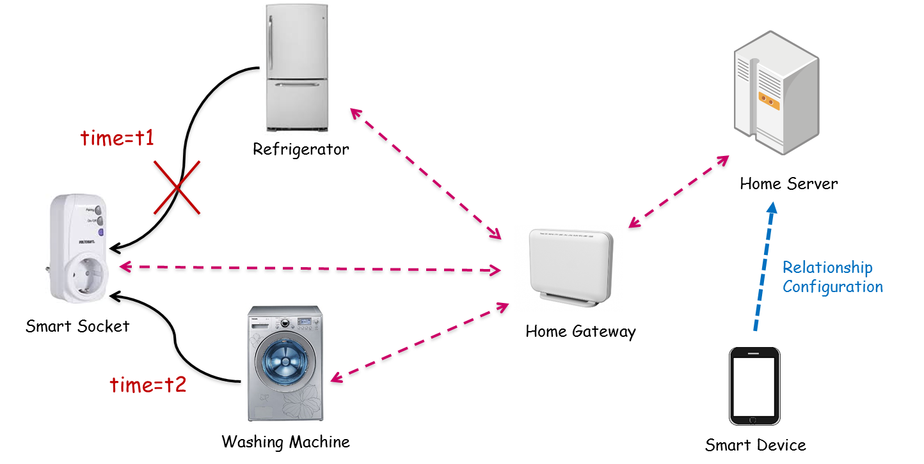

6.x.2 High Level Analysis

6.x.2.1 Functional Impacts

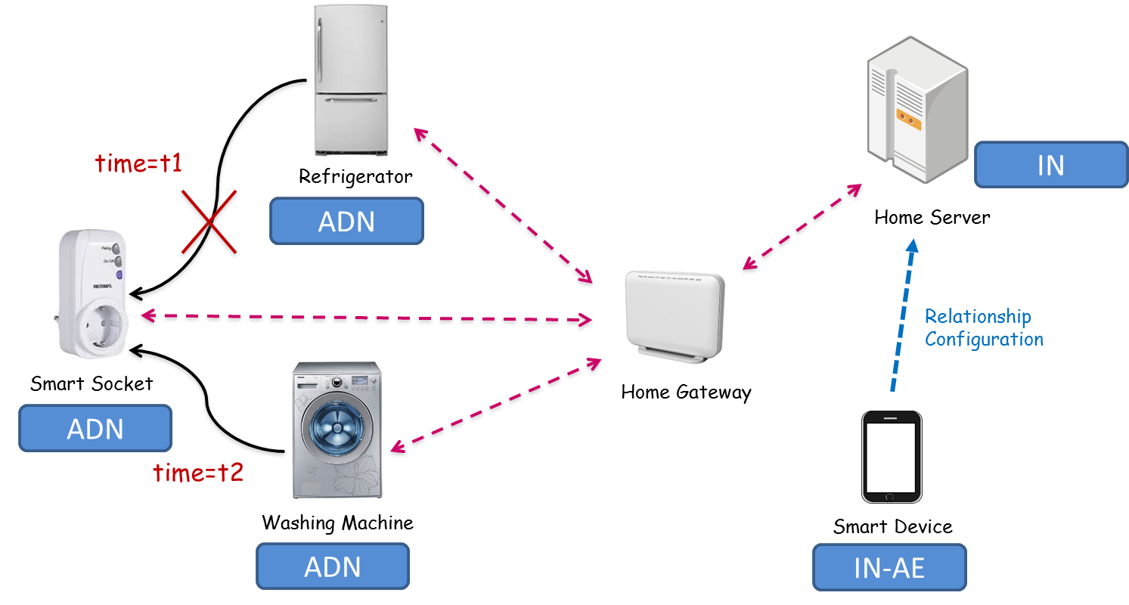

In oneM2M configurations, the smart socket, the refrigerator, and the washing machine can be interpreted as ADN (Application Dedicated Node). The home server can be interpreted as IN (Infrastructure Node) and Smart device as IN-AE.

For enabling this kind of service, first of all, each device needs to register its information with the server. (Registration)

Using smart device, all the registered home appliances can be discovered. (Discovery)

The smart device can make the pairing information between home appliances (Making Pairing informationRp

The home server needs to store the pairing information in its registered device information. (Storing Pairing Reflectoion)

The home server needs to update the pairing information in its registered device information (Updating Pairing pnformation)

6.x.2.2 High Level Information Flows

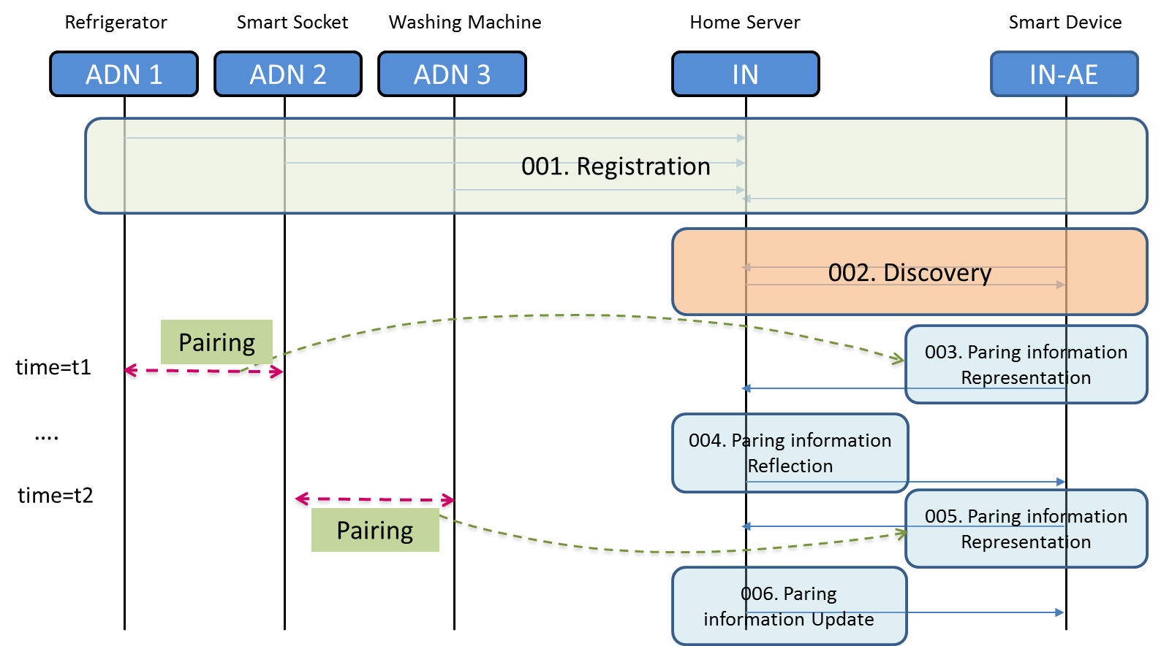

001: ADN1,2,3, and IN-AE register its information with IN. ADN 1,2,3 send their generated data to the IN.

002: IN-AE discovers the registered device list from the IN.

003: The pairing information between ADN 1 and 2 can be represented in the IN-AE and the IN-AE send the pairing information as oneM2M message to the IN.

004: IN receives the pairing information message and storereflects the panformation in its database i.e. oneM2M resource tree.

005: When the connection of the ADN2 is changed from ADN1 to ADN 3, IN-AE sends new pairing information as oneM2M message to the IN.

006: IN received new pairing information message and updates the pairing information in its database i.e. oneM2M resource tree.

Note: We assume that IN-AE can acquire the pairing information from ADNs1,2,3 through a mechanism that is out of scope of oneM2M.

6.x.3 Potential Requirements

The oneM2M System shall support a semantic relation (“Is Paired To”) between two M2M Devices.

The oneM2M System shall be able to store/update information about pairing between two M2M Devices as a relation (“Is Paired To”) between M2M Devices.

The oneM2M System shall enable the creation and deletion of a semantic pairing relation (“Is Paired To”) between M2M Devices by M2M applications, subject to access rights.

The oneM2M System shall be able to make information about pairing between M2M Devices available to M2M Applications.

