CHANGE REQUEST
Meeting:* | REQ#17
Source:* | Hitachi
Date:* | <2015-05-08>
Contact:* | Jiang Miao, miaojiang@hitachi.cn  He Xuan, xhe@hitachi.cn
Reason for Change/s:* | This contribution intends to update the industrial use case 6.1 ‘An industrial use case for on-demand data collection for factories’ in TR0018.
CR against: Release* | Release 2
CR against: WI* | Active <WI-0028>  MNT Maintenace / < Work Item number(optional)>  STE Small Technical Enhancements / < Work Item number (optional)>  Only ONE of the above shall be ticked
CR against: TS/TR* | TR-0018 V0.1.1
Clauses/Sub Clauses* | Section 6
Type of change: * | Editorial change  Bug Fix or Correction  Change to existing feature or functionality  New feature or functionality  Only ONE of the above shall be ticked
Post Freeze checking:* | This CR contains only essential changes and corrections? YES NO  This CR is a mirror CR? YES NO if YES, please indicate the document number of the original CR:  <><CR Number of the original CR to the current Release>
Template Version:23 February 2015 (Dot not modify)

oneM2M Notice
The document to which this cover statement is attached is submitted to oneM2M. Participation in, or attendance at, any activity of oneM2M, constitutes acceptance of and agreement to be bound by terms of the Working Procedures and the Partnership Agreement, including the Intellectual Property Rights (IPR) Principles Governing oneM2M Work found in Annex 1 of the Partnership Agreement.
GUIDELINES for Change Requests:
Provide an informative introduction containing the problem(s) being solved, and a summary list of proposals.
Each CR should contain changes related to only one particular issue/problem.
Follow the principle of completeness, where all changes related to the issue or problem within a deliverable are simultaneously proposed to be made E.g. A change impacting 5 tables should not only include a proposal to change only 3 tables. Includes any changes to references, definitions, and acronyms in the same deliverable.
Follow the drafting rules.
All pictures must be editable.
Check spelling and grammar to the extent practicable.
Use Change bars for modifications.
The change should include the current and surrounding clauses to clearly show where a change is located and to provide technical context of the proposed change. Additions of complete sections need not show surrounding clauses as long as the proposed section number clearly shows where the new section is proposed to be located.
Multiple changes in a single CR shall be clearly separated by horizontal lines with embedded text such as, start of change 1, end of change 1, start of new clause, end of new clause.
When subsequent changes are made to content of a CR, then the accepted version should not show changes over changes. The accepted version of the CR should only show changes relative to the baseline approved text.

Introduction
This contribution update the industrial use case 6.1.

-----------------------Start of change 1-------------------------------------------

6.1.9 High Level Illustration

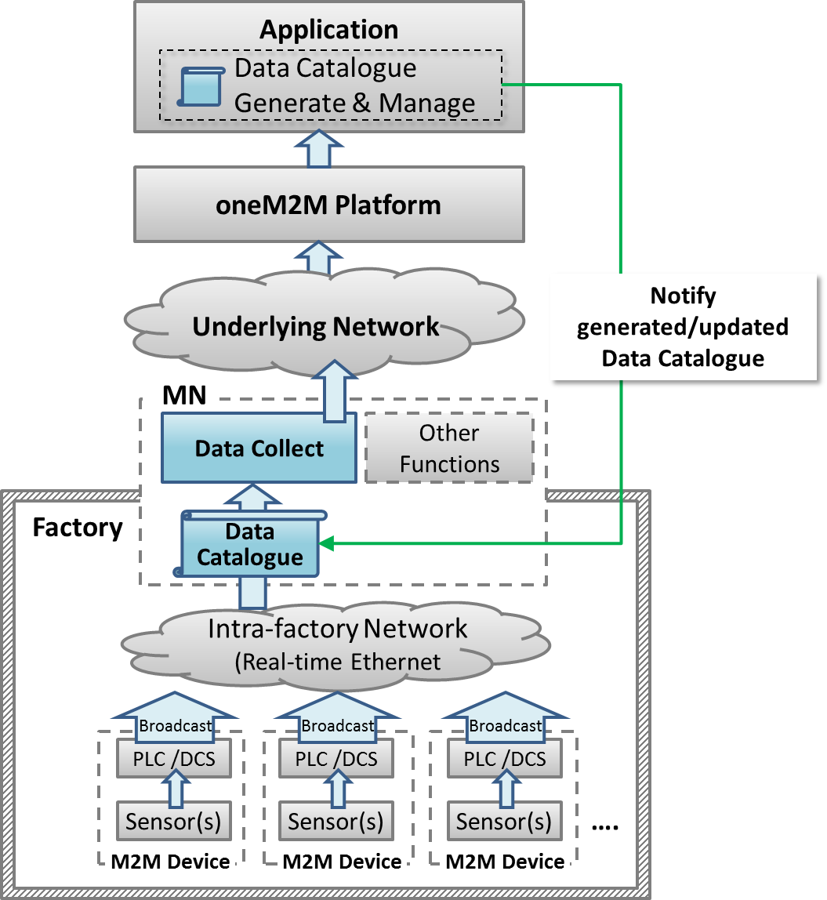

-----------------------End of change 1---------------------------------------------
CHECK LIST
- Does this change request include an informative introduction containing the problem(s) being solved, and a summary list of proposals.?
- Does this CR contain changes related to only one particular issue/problem?
- Does this change request make all the changes necessary to address the issue or problem? E.g. A change impacting 5 tables should not only include a proposal to change only 3 tables. Includes any changes to references, definitions, and acronyms in the same deliverable?
- Does this change request follow the drafting rules?
- Are all pictures editable?
- Have you checked the spelling and grammar?
- Have you used change bars for all modifications?
- Does the change include the current and surrounding clauses to clearly show where a change is located and to provide technical context of the proposed change? (Additions of complete sections need not show surrounding clauses as long as the proposed section number clearly shows where the new section is proposed to be located.)
- Are multiple changes in this CR clearly separated by horizontal lines with embedded text such as, start of change 1, end of change 1, start of new clause, end of new clause.?

