Input contribution
Use case
Use Case Title:* | Use case for Special vehicle priority pass
Group Name:* | TP#24
Source:* | CMCC
Contact: | Yawen Niu (niuyawen@chinamobile.com)
Date:* | 2016-7-18
Abstract:* | Propose to add the use case for Special vehicle priority pass for urgent cases.
Agenda Item:*
Work item(s):
Document(s)  Impacted* | Technical Specification TR 0026 – Vehicular Domain Enablement Technical Report
Intended purpose of  document:* | Decision  Discussion  Information  Other <specify>
Decision requested or recommendation:* | Approval of the Use Case

oneM2M IPR STATEMENT
“Participation in, or attendance at, any activity of oneM2M, constitutes acceptance of an agreement to be bound by all provisions of IPR policy of the admitting Partner Type 1 and permission that all communications and statements, oral or written, or other information disclosed or presented, and any translation or derivative thereof, may without compensation, and to the extent such participant or attendee may legally and freely grant such copyright rights, be distributed, published, and posted on oneM2M’s web site, in whole or in part, on a non-exclusive basis by oneM2M or oneM2M Partners Type 1 or their licensees or assignees, or as oneM2M SC directs.
  - Title

Special vehicle priority pass.

  - Description

In some urgent cases, special vehicles (such as ambulance) need priority pass to save time, especially in a road with heavy traffic. In this case, if the vehicle service centre can make a real-time passing plan for related vehicles and traffic lights, it will help special vehicles to save time a lot.

  - Source

CMCC

  - Actors
- Vehicles (M2M Devices embedded in vehicles)
- Traffic lights (M2M Devices embedded in traffic lights).
- Vehicle Service Centre

  - Pre-conditions

  - Triggers
- The special vehicle sends the priority passing request to Service Centre.

  - Normal Flow
- Vehicles (including special vehicles) report data (such as location, speed, direction…) to vehicle service centre.
- Special vehicle sends the priority pass request to the vehicle service centre
- Vehicle service centre verify the request
- Vehicle service centre analyzes and make a priority passing plan
- Vehicle service centre sends the priority plan to related vehicles and traffic lights

  - Post-conditions (if any)

NONE.
  - High Level Illustration (as applicable)
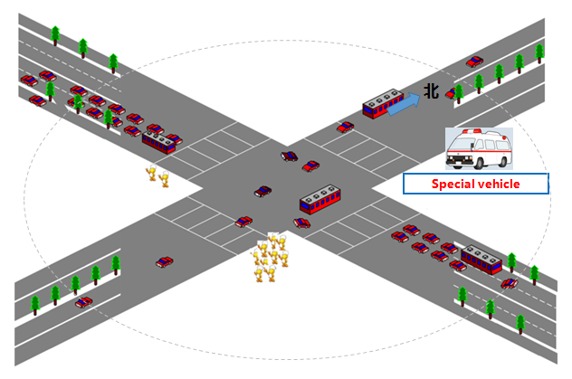

  - Potential requirements (as applicable)
- The M2M service platform can identify the urgent vehicles and verify the request
- The M2M service platform can identify the related devices (for example, the vehicles, traffic lights around, and the road information)
- The M2M service platform can analyze the data and make a priority passing plan for all related M2M devices
- The M2M service platform can send the plan to all related M2M devices (vehicles, traffic lights…)
- The M2M service platform can real-time adjust the plan

