Input contribution
Use case
Use Case Title:* | Use case for information connection
Group Name:* | WG1
Source:* | BOE
Contact: | Albert Zhao, zhaojunjie111@boe.com.cn
Date:* | 2017-11-13
Abstract:* | Propose a use case for information connection
Agenda Item:* | REQ #32
Work item(s): | WI-0015
Document(s)  Impacted* | TR-0001
Intended purpose of  document:* | Decision  Discussion  Information  Other <specify>
Decision requested or recommendation:* | Discuss and make a decision to agree this input contribution.
Template Version:23 February 2015 (Dot not modify)

oneM2M Notice
The document to which this cover statement is attached is submitted to oneM2M. Participation in, or attendance at, any activity of oneM2M, constitutes acceptance of and agreement to be bound by terms of the Working Procedures and the Partnership Agreement, including the Intellectual Property Rights (IPR) Principles Governing oneM2M Work found in Annex 1 of the Partnership Agreement.

Title
Use case for information connection

Description
Different devices have different functions, but these functions may produce related information. For example, a smart watch can be used to monitor the heart rate, number of walks etc., in the meanwhile, a treadmill can be used to monitor the speed, distance, calories burned, when these two devices refer to the same person, then the dates produced by these two devices are highly related, since the dates are all about the health of the person.

Source
BOE Technology Group

Actors
- M2M Device A: the M2M device A has function A and connects to the M2M Service Platform. The M2M Device can be an ADN or ASN.
- M2M Device B: the M2M device B has function B and connects to the M2M Service Platform. The M2M Device can be an ADN or ASN.
- M2M Service Platform: The M2M Service Platform accepts the registration and provide data store and device management etc.

Pre-conditions
The M2M device A and B can be connected with each other, for example, they can discovery each other using Bluetooth technology.

Triggers
N/A

Normal Flow

- M2M device A and B register to the M2M service platform.
- M2M device A send information to the M2M service platform;
- M2M device B send information to the M2M service platform;
- M2M device A establish a connection with B;
- M2M device A initiate an information connection request to the M2M service platform;
- M2M service platform connect the information of the M2M device A and M2M device B;
- M2M device A cancel the connection with B;
- M2M device A initiate an information disconnection request to the M2M service platform;
- M2M service platform disconnect the information of the M2M device A and M2M device B.

Alternative flow
N/A

Post-conditions
N/A

High Level Illustration
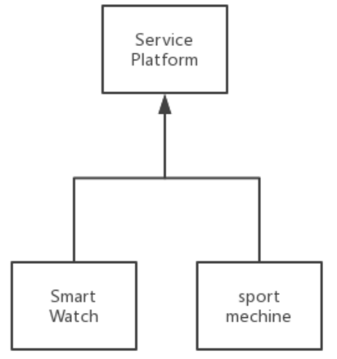

Potential requirements
- M2M should support connect the information of different entities.
- M2M should support disconnect the information of different entities.

