CHANGE REQUEST
Group Name:* | SEC#12
Source:* | LG Electronics
Title | Discussion and Suggestion on Section 8, 9
Date:* | 2014-07-19
Contact:* | seongyoon.kim@lge.com
Reason for Change/s:* | Discussion and Suggestion on Section 8
CR against: | TS-0003
Clauses/Sub Clauses  Affected* | Clause 8 and sub-clauses
Intended purpose of  document:* | Decision  Discussion  Information  Other <specify>
Decision requested or recommendation:* | Agree on changes to current baseline.

oneM2M Notice
The document to which this cover statement is attached is submitted to oneM2M. Participation in, or attendance at, any activity of oneM2M, constitutes acceptance of and agreement to be bound by terms of the Working Procedures and the Partnership Agreement, including the Intellectual Property Rights (IPR) Principles Governing oneM2M Work found in Annex 1 of the Partnership Agreement.

Introduction
Some clarifications are proposed to improve readability of the

-----------------------Start of change 1-------------------------------------------

8 Security Frameworks

8.1 General Introductions to the Security Frameworks

The security frameworks can be categorized into two main types
- Direct Security Frameworks: where the entities authenticate each other directly, without assistance from a Central Key Distribution Server
- Centralized Security Frameworks: where the entities authenticate each other with the assistance of a Central Key Distribution Server.
Editor's Note: Text is needed here to guide reader through the appropriate framework (ACTION Gemalto).

8.1.1 General Introduction to the Direct Security Frameworks

8.1.1.1 General Introduction to the Pre-Provisioned Symmetric Key Framework
Editor's Note: Text is needed here (ACTION Gemalto).

8.1.1.2 General Introduction to the Certificate-Based Security Frameworks
This clause describes the Credential Configuration and Certificate Verification used in the Certificate-Based Security Association Establishment Framework and Certificate-Based Security Bootstrap Framework.

8.1.1.2.1 Credential Configuration for Certificate-Based Security Frameworks
If an entity is to authenticate itself using a Certificate-Based Security Framework, then the entity shall be pre-provisioned with the following information
- The entity's Private Signing Key and the corresponding Public Verification Key.
NOTE 1: An entity authenticates itself to other entities by proving that it knows the Private Signing Key corresponding to a particular Public Verification Key.
Editor's Note: In some cases the Private Signing Key is unique to a single entity. In other cases, the Private Signing Key might be used to authenticate all entity's executing on a particular piece of hardware or used to authenticate all AEs executing a particular piece of software. This needs clarification text. (ACTION Qualcomm)
- The entity's Certificate containing the entity Public Verification Key and the entity's Certificate Name (a unique identity) provided in a name field of the Certificate (e.g. in the X.509 "Subject" or "Subject Alternative Name" attribute). Two options are available:
- The entity is configured with a valid Certificate Chain from the entity's Certificate to a Root Certificate. The entity's Root of Trust is the cryptographic hash of the Public Verification Key in this Root Certificate.
- Alternatively, the entity's Certificate is a self-signed certificate, for which the entity's Private Signing Key is used to generate the Certificate signature (the certificate is verified using the entity's Public Verification Key). In this case the cryptographic hash of entity's Public Verification Key is both the entity's Root of Trust and the entity's Certificate Name. This implies that the cryptographic hash of the entity's Public Verification Key must be present in a name field of the entity's Certificate.
Editor's Note: Conditions under which a self-signed certificate can be trusted or possible means to verify it (e.g. OCSP) are FFS. (ACTION Qualcomm)
NOTE 2: This pre-provisioning (by definition) uses mechanisms not specified by oneM2M.
Editor's Note: Details for OCSP [RFC2560] and Certificate Revocation Lists (CRLs) are FFS.

8.1.1.2.2 Certificate Verification
This clause describes how an entity authenticates the other entity in the Security Handshake of a Certificate-Based Security Framework.
The other entity's Certificate is received during the Security Handshake.
The other entity's Certificate is verified as follows:
- If the other entity's Certificate is a self-signed certificate, then verify each of the following:
- The other entity's Certificate Name and other entity's Root of Trust (received during Association Configuration or Bootstrap Instruction Configuration) are identical.
- The other entity's Certificate Name (received during Association Configuration or Bootstrap Instruction Configuration) is identical to a value in a name field (e.g. in the X.509 "Subject" or "Subject Alternative Name" attribute) of other entity's Certificate (received during the Security Handshake).
- The other entity's Root of Trust (received during Association Configuration or Bootstrap Instruction Configuration) is identical to the Public Verification Key (or hash thereof) in the other entity's Certificate (received during the Security Handshake).
- If the other entity's Certificate is not a self-signed certificate, then verify each of the following:
- The other entity's Certificate Name (received during Association Configuration or Bootstrap Instruction Configuration) is identical to a value in a name field (e.g. in the X.509 "Subject" or "Subject Alternative Name" attribute) of the other entity's Certificate (received during the Security Handshake)..
- The other entity Certificate has a valid Certificate Chain (received during the Security Handshake) to a Certificate whose Public Verification Key (or hash thereof) is identical to the other entity' Root of Trust (received during Association Configuration or Bootstrap Instruction Configuration).
NOTE: After a successful Security Handshake in which the other entity provides a Certificate Chain, the other entity's identity (received during Association Configuration or Bootstrap Instruction Configuration) can be associated with additional information extracted from the other entity's Certificate Chain (e.g. the other entity Manufacturer, other entity owner, or conformance criteria). These details are not described in the present document.
Editor's Note: Details of credentials for OCSP [RFC2560] may be required here.

8.1.2 General Introduction to the Centralized Security Frameworks

8.1.2.1 General Introduction to the M2M Authentication Function Framework
Editor's Note: Text is needed here (ACTION Gemalto).

8.1.2.2 General Introduction to the GBA (Generic Bootstrapping Architecture) Framework
A general introduction to GBA is included in TR-0008 [i.6].
After a successful GBA bootstrapping, the M2M Application Service/Middle Node and the BSF share a security association which consists of a bootstrapping transaction identifier (B-TID) and key material (GBA bootstrap Ks).
This security association may be used by the M2M Application Service/Middle Node to derive NAF keys (Ks_(ext/int)_NAF) shared between a M2M Application Service/Middle Node and a M2M Infrastructure Node or an M2M Authentication Framework.
There are two modes of GBA: ME-based GBA (GBA_ME) and UICC-based GBA (GBA_U). In case of GBA_ME, one NAF-specific key is derived: the key Ks_NAF. In case of GBA_U, two NAF-specific keys are derived: Ks_ext_NAF (available in the ME) and Ks_int_NAF (which remains inside the UICC).
GBA_U requires that the UICC is GBA aware.
The BSF determines which mode to run based on the UICC capability indicated in the GBA User Security Settings (GUSS).
The usage of GBA_U is recommended since it provides a higher level of security than GBA_ME. The implication of this recommendation is that the entity, AE or CSE, using the GBA_U-based NAF keys should be resident in the UICC.


Figure 8.1.2.2-1: GBA framework. Note that the Network application Function (NAF)
may be an Infrastructure Node or an M2M Authentication Function

8.2 Security Association Establishment Frameworks

8.2.1 Overview on Security Association Establishment Frameworks
In the present document, security associations are restricted to single hop on Mcc or Mca reference point.
Editor’s Note: To be clarified throughout existing text (ACTION Qualcomm).
The oneM2M system supports the following Security Association Establishment Frameworks:
- Direct Security Association Establishment Frameworks:
- Pre-Provisioned M2M Secure Connection Key Security Association Establishment. A symmetric key is pre-provisioned to the entities: this is called the Pre-Provisioned M2M Secure Connection Key, and denoted Kpsa. The entities authenticate each other by verifying Message Integrity Codes (MIC) in the Security Handshake which were generated using the symmetric key. For more details see clause 8.2.2.1.
- Certificate-Based Security Association Establishment: The entities are each issued with
- a Private Signing Key that is known only to that entity,
- a Certificate containing the corresponding Public Verification Key, and
- (Optionally) a Certificate Chain from the entity's Certificate to a Root Certificate.
The entities must validate each other's Certificate before trusting the Public Verification Keys in the Certificate. Within the Security Handshake, entity A creates a digital signature of the session parameters using its private signing key and entity B verifies the digital signature using entity A's public verification key. Then the roles are reversed: entity B creates a digital signature and entity A verifies it. For more details see clause 8.2.2.2.
- Centralized Security Association Establishment Frameworks: In such schemes, entity A and a Central Key Distribution Server authenticate each other and derive a M2M Secure Connection key (Kc) that the Central Key Distribution Server delivers to entity B. The entities then authenticate each other using the M2M Secure Connection key (Kc). The oneM2M authentication Frameworks using centralized key distribution are:
- GBA based Security Association Establishment. This Security Association Establishment Framework uses 3GPP or 3GPP2 symmetric keys to authenticate entity A and the Central Key Distribution Server. The details are specified by 3GPP [13] and 3GPP2 [14]. For more details see clause 8.2.2.
- M2M Authentication Function (MAF)-based Security Association Establishment. This Security Association Establishment Framework uses symmetric keys to authenticate the entity A and the Central Key Distribution Server. For more details see clause 8.2.3.1.
For a more detailed description of the above Security Association Establishment Frameworks, it is useful to compare the following aspects of the Security Association Establishment Frameworks:
- Credential Configuration:
- For Central Key Distribution Security Association Establishment Frameworks:
- Entity A is configured with (or otherwise establishes) the Master Credential (Km) that the entity A will use to authenticate the entity A to the Central Key Distribution Server.
- The Central Key Distribution Server is configured with the Master Credential (Km) that will be used to authenticate the Central Key Distribution Server to entity A.
The details for the GBA-Based Security Association Establishment Framework are out of scope.
- For other Security Association Establishment Frameworks, each entity is pre-provisioned with the Credential that the entity will use to authenticate itself to the other entity.
- Association Configuration: Configuration of entity identifiers (that is, CSE-ID or AE-ID) for the entities to be authenticated.
Additionally, in the case of Certificate-Based Authentication Framework: each entity is configured with the Certificate Name and Root of Trust that the entity will use to verify the other entity.
- Association Security Handshake: Identification, authentication and security context establishment between the entities.
  - Central Key Distribution Server Handshake: When a Centralized Security Association Establishment Framework is used, entity A and the Central Key Distribution Server (MAF or GBA-BSF) perform mutual authentication and generate a M2M Secure Connection Key (Kc) which is then used in the Security Handshake for mutual authentication between entity A and entity B. This is not applicable to Direct Security Association Establishment Frameworks.

Figure 8.2.1-1 provides a summary of the above defined four Security Association Establishment Frameworks. In this clause and sub-clause, "Entity A" and "Entity B" correspond to either two CSEs or a CSE and an AE or an AE and a CSE (respectively) if there are no specific descriptions. “IdA” or “IdB” is either AE-ID or CSE-ID.

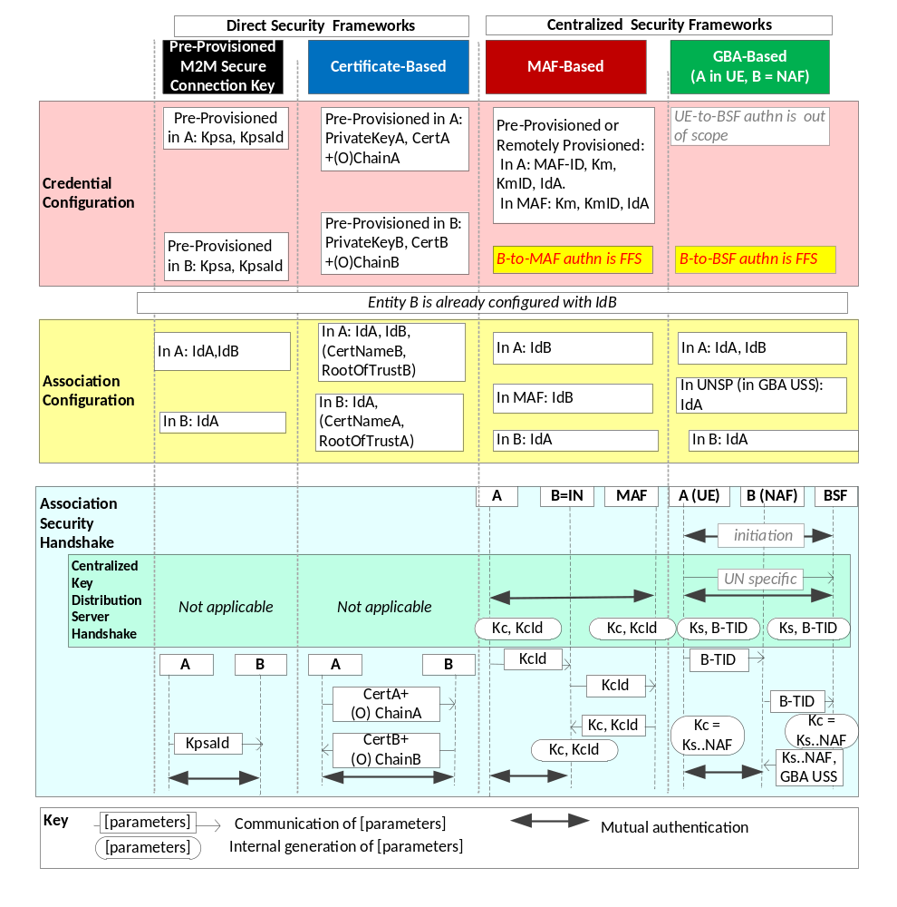
Figure 8.2.1-1: Overview of the Security Association Establishment Frameworks
supported by oneM2M.
Editor's note: In the above figure, the illustrations of the MAF-based centralized security frameworks may need to be updated when the detailed flows have been agreed.

8.2.2 Direct Security Association Establishment Frameworks

8.2.2.1 Pre-Provisioned Symmetric Key Security Association Establishment Frameworks
This clause describes the Pre-Provisioned Secure Connection Key Security Association Establishment Framework. This framework enables mutual authentication of two entities corresponding to either two CSEs or a CSE and an AE. The Credential for this framework is a long-term symmetric key that has been pre-provisioned into the entities to be authenticated. This key is called a Pre-Provisioned Secure Connection Key and is denoted Kpsa. The entities authenticate each other by verifying message integirity codes(MIC) in the Security Handshake which were generated using the Pre-Provisioned Secure Connection Key.
NOTE: Long term Pre-Provisioned Secure Connection Keys can pose a security risk if not adequately secured, and for this reason long term Pre-Provisioned Secure Connection Keys are recommended to be stored in Secure Environments.
Figure 8.2.2.1-1 illustrates the sequence of events when using the Pre-Provisioned Secure Connection Key Security Association Establishment Framework.
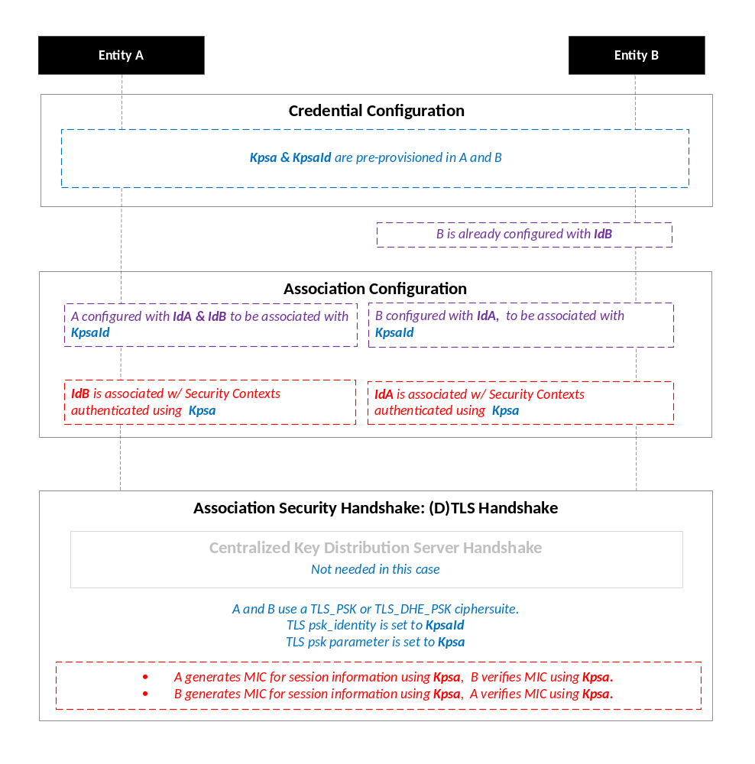
NOTE: The following font colours differentiate the general topic that the text relates to:
Blue italic text highlights details specific to this particular Security Association Establishment Framework.
Purple italic text highlights technical actions that may include steps not specified by oneM2M.
Red italic text highlights security-related properties.

Figure 8.2.2.1-1: The sequence of events when using the Pre-Provisioned Secure Connection Key
Security Association Establishment Framework
Credential Configuration: The Pre-Provisioned Secure Connection Key (Kpsa) and the corresponding Pre-Provisioned Secure Connection Key Identifier, denoted KpsaId, are pre-provisioned to both entities.
NOTE 1: This pre-provisioning (by definition) uses mechanisms not specified by oneM2M.
Association Configuration: Each entity is configured with the information needed for mutual authentication and identification:
- Entity A is commanded to initiate Security Context Establishment, and includes the following arguments:
- The Pre-Provisioned Secure Connection Key Identifier KpsaId.
- Entity A identity (IdA). Entity A is to assume this identity when interacting with Entity B.
- Entity B identity (IdB). Entity A is to use this identity for Entity B authenticating using the above arguments. This identity is also used to route the (D)TLS exchange.
The mechanisms for achieving this are discussed in clause 8.4.1.2 (for the cases where Entity A is in the Field Domain) and Clause 8.4.2 (for the cases where Entity A is in the Infrastructure Domain).
NOTE 2: Entity A will associate Entity B's identity with messages secured within Security Contexts established using the Pre-Provisioned Secure Connection Key Kpsa associated with the Pre-Provisioned Secure Connection Key Identifier KpsaId.
- Entity B is configured with the following arguments describing Entity A authorized to perform Security Context Establishment with the Registrar:
- The Pre-Provisioned Secure Connection Key Identifier KpsaId.
- Entity A identity (IdA). Entity B is to use this identity for Entity A authenticating using the above arguments..
- Entity B Identity (IdB), if not already configured to Entity B. Entity B is to assume this identity when interacting with Entity A.
The mechanisms for achieving this are discussed in clause 8.4.1.2 (for the cases where Entity B is in the Field Domain) and Clause 8.4.2 (for the cases where Entity B is in the Infrastructure Domain).
NOTE 3: Entity B will associate the configured Entity A identity with messages secured within Security Contexts established using the Pre-Provisioned Secure Connection Key Kpsa associated with the Pre-Provisioned Secure Connection Key Identifier KpsaId.
NOTE 4: In many scenarios, the entity identities will be configured when the Pre-Provisioned Secure Connection Key Kpsa is established, so a separate configuration is not required in those scenarios.
Association Security Handshake: The entities perform a (D)TLS-PSK handshake [15] to establish a secure session.
- Centralized Key Distribution Server Handshake: There is no Centralized Key Distribution Server Handshake applied in the Pre-Provisioned Secure Connection Key Security Association Establishment Framework.
- The "psk_identity" parameter [15] is set to the value of the Pre-Provisioned Secure Connection Key Identifier KpsaId.
- The "psk" parameter [15] is set to the value of the Pre-Provisioned Secure Connection Key Kpsa.
- Mandatory and optional (D)TLS cipher suites for this phase are specified in clause 9.2.

8.2.2.2 Certificate-Based Security Association Establishment Frameworks
This clause describes the Certificate-Based Security Association Establishment Framework.
Figure 8.2.2.2-1 illustrates the sequence of events when using the Certificate-Based Security Association Establishment Framework. In this description, "Entity A" and "Entity B" correspond to either two CSEs or a CSE and an AE.
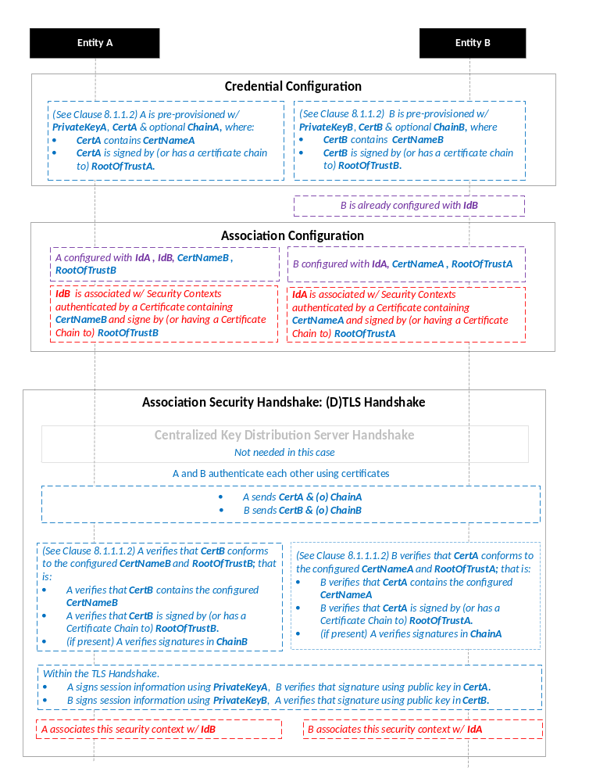
NOTE: The following font colours differentiate the general topic that the text relates to:
Blue italic text highlights details specific to this particular Security Association Establishment Framework.
Purple italic text highlights technical actions that may include steps not specified by oneM2M.
Red italic text highlights security-related properties.

Figure 8.2.2.2-1: The sequence of events when using the Certificate-Based Security
Association Establishment Framework
Credential Configuration: The master credentials for each entity are pre-provisioned as described in clause 8.1.1.2.1 "Credential Configuration for Certificate-Based Security Frameworks".
Association Configuration: Entity A and Entity B are configured with the information needed for the authentication and identification (during Security Handshake) of Entity B and Entity A respectively:
- Entity A is commanded to initiate a Security Handshake, and the command includes the following arguments:
- The Entity B Certificate Name (Entity B Certificate must include this value in a name field).
- The Entity B Root of Trust (Entity B Certificate must be self-signed using this root of trust, or have a Certificate Chain to this root of trust).
- The Entity A identity (IdA) Entity A is to use this entity identity with Entity B.
- The Entity B identity (IdB). Entity A is to use this identity for Entity B authenticating using the above arguments. This is used to route the (D)TLS exchange).
The mechanisms for achieving this are discussed in clause 8.4.1.2 (for the cases where Entity A is in the Field Domain) and clause 8.4.2 (for the cases where Entity A is in the Infrastructure Domain).
NOTE 1: The Entity A will associate Entity B's identity with messages secured within Security Contexts established in accordance with the configured Entity B Certificate Name and Entity B Root of Trust.
- The Entity B is configured with the following arguments describing Entity A authorized to perform Security Handshake with Entity B:
- The Entity A Certificate Name. The Entity A Certificate must include this value in a name field.
- The Entity A Root of Trust. The Entity A Certificate must be self-signed using this root of trust, or have a Certificate Chain to this root of trust.
- The Entity A identity (IdA). Entity B is to use this entity identity for Entity A authenticating using the above arguments.
- The Entity B Identity (IdB), if not already configured to Entity B. Entity B is to assume this identity when interacting with Entity A.
The mechanisms for achieving this are discussed in clause 8.4.1.2 (for the cases where Entity A is in the Field Domain) and Clause 8.4.2 (for the cases where Entity A is in the Infrastructure Domain).
NOTE 2: Entity B will associate Entity A's identity with messages secured within Security Contexts established in accordance with the configured Entity A Certificate Name and Entity A Root of Trust.
Association Security Handshake:
- Centralized Key Distribution Server Handshake: There is no Centralized Key Distribution Server Handshake applied in the Certificate-Based Security Association Establishment Framework.
- Each entity verifies the other entity's certificate as described in clause 8.1.1.2.2 "Certificate Verification".
- The entities authenticate each other using the validated certificates as specified in TLS 1.2 RFC 5246 [16] and DTLS 1.2 RFC 6347 [17] specifications.
- Mandatory and optional (D)TLS cipher suites for this phase are specified in clause 9.2.

8.2.3 Centralized Security Association Establishment Frameworks

8.2.3.1 MAF-Based Symmetric Key Security Association Establishment Frameworks
This clause describes the MAF-based Security Association Establishment Framework.
This release addresses the scenario where the Entity B is an Infrastructure Node.
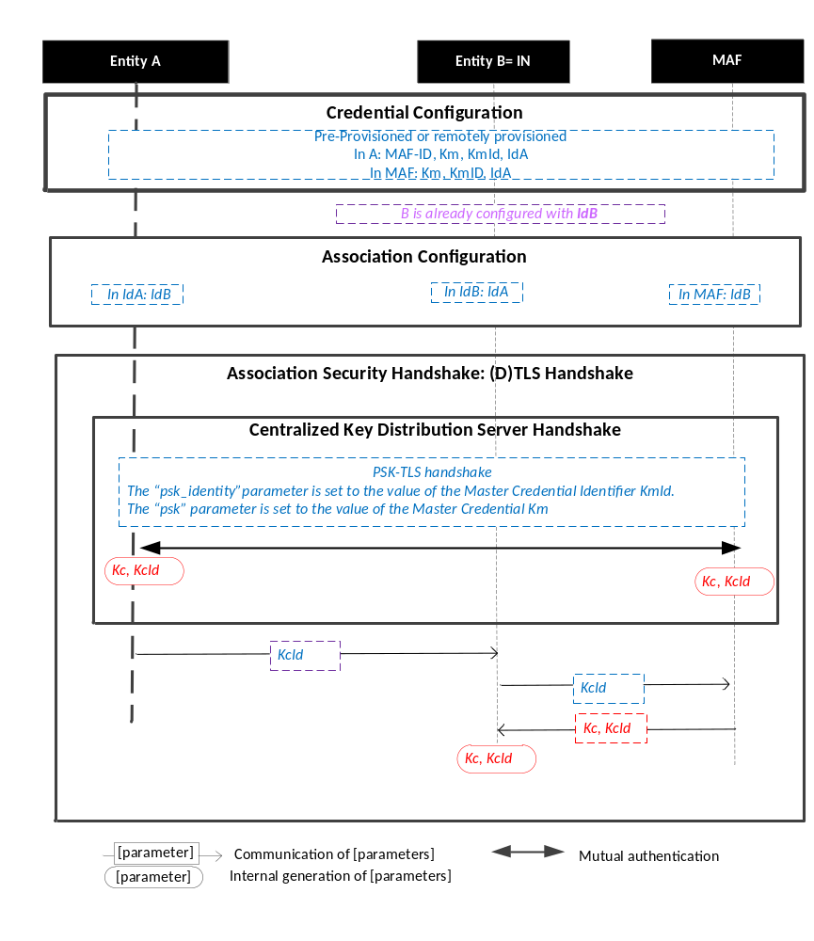
Figure 8.2.3.1-1: The sequence of events when using the MAF-Based Security Association Establishment Framework.
NOTE: The following font colours differentiate the general topic that the text relates to:
Blue italic text highlights details specific to this particular Security Association Establishment Framework.
Purple italic text highlights technical actions that may include steps not specified by oneM2M.
Red italic text highlights security-related properties.

Credential Configuration: The Master Credential (Km) and corresponding Master Credential Identifier (KmId) are either pre-provisioned for Entity A and the MAF or remotely provisioned thanks to Security Bootstrap Frameworks described in Clause 8.3.
Association Configuration: Entity A, Entity B, and the BSF shall be configured with the information needed for the authentication and identification during Centralized Key Distribution Server Handshake and Association Security Handshake:
  - Entity A has to know Entity B Identity (IdB)
  - Entity B has to know Entity A Identity (IdA)
  - The MAF has to know Entity B Identity (IdB). In this case, IdB corresponds to IN Identity.
Association Security Handshake with Centralized Key Distribution Server Handshake:

- Centralized Key Distribution Server Handshake
  - The Centralized Key Distribution Server Handshake in MAF-based Security Association Establishment framework enables the establishment of a M2M Secure Connection Key (Kc) and associated M2M Secure Connection Key Identifier (KcId) shared between the Entity A and the MAF thanks to (D)TLS-PSK handshake [15]
    - The “psk_identity” parameter [15] is set to the value of the Master Credential Identifier KmId.
    - The “psk” parameter [15] is set to the value of the Master Credential Km.
- Entity A sends KcId to Entity B (Infrastructure Node).
- Entity B (Infrastructure Node) can retrieve the M2M Secure Connection Key (Kc) from the MAF.

8.2.3.2 GBA-Based Security Association Establishment Frameworks
This clause describes the GBA-based Security Association Establishment Framework.
To obtain a short term key (Kc) used for M2M Service Connection between a M2M Application Service/Middle Node and a M2M Infrastructure Node, the M2M Application Service/Middle Node shall perform a successful GBA bootstrapping and derive NAF keys (Ks_(ext/int)_NAF). This NAF key is the M2M Secure Connection Key (Kc) used for M2M Service Connection.
In case of GBA, ME, Kc = Ks_NAF.
In case of GBA_U, Kc = Ks_int_NAF, if the application resides in the UICC. Otherwise, Kc = Ks_ext_NAF.

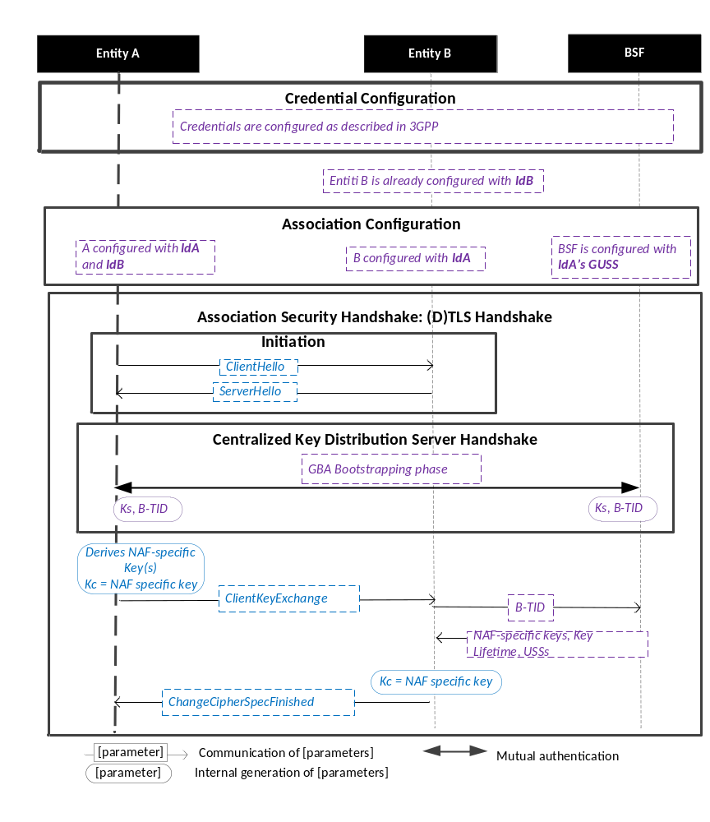
Figure 8.2.3.2-1: The sequence of events when using the GBA-Based Security Association Establishment Framework.
NOTE: The following font colours differentiate the general topic that the text relates to:
Blue italic text highlights details specific to this particular Security Association Establishment Framework.
Purple italic text highlights technical actions that may include steps not specified by oneM2M.

Credential Configuration: The credentials configuration for Entity A, Entity B and the BSF is described in 3GPP specification TS 33.220 [13]. The credentials used to perform mutual authentication between Entity A and BSF are UNSP specific.
Association Configuration: Entity A, Entity B, and the BSF shall be configured with the information needed for the authentication and identification during Centralized Key Distribution Server Handshake and Association Security Handshake:
  - Entity A’s GBA User Security Settings (GUSS) enables to indicate if Entity A is allowed to establish a NAF-specific key with Entity B (NAF) or/and if the BSF can distribute a NAF specific key to Entity B.
Association Security Handshake with Centralized Key Distribution Server Handshake:
- Initiation
  - Entity A and Entity B shall initiate TLS handshake thanks to procedure described in 3GPP TS 33.222 [28]. Informative Annex F of 3GPP TS 24.109 [29] gives signalling flows for TLS-PSK with GBA bootstrapped security association
  - Entity A shall indicate to Entity B that it supports PSK-based TLS by adding one or more PSK ciphersuites to the ClientHello message. This message shall also contain the hostname of Entity B in the server_name extension.
  - Entity B selects one of the PSK-based ciphersuites offered by Entity A and sends it back in the ServerHello message. If UICC is used as M2M Secure Environment supporting Security Association Establishment, GBA-U with Kc = Ks_int_NAF shall be used for authentication and key exchange, In this case the ServerKeyExchange message shall contain a constant string "3GPP-bootstrapping-uicc" as the PSK-identity hint, indicating use of Kc=Ks_int_NAF. Otherwise the ServerKeyExchange message shall contain a constant string "3GPP-bootstrapping" as the PSK-identity hint to indicate that Kc=Ks_NAF in the case of GBA_ME or Kc=Ks_ext_NAF in the case of GBA_U is used for authentication and key exchange. Entity B shall finish the reply to Entity A by sending a ServerHelloDone message.
- Centralized Key Distribution Server Handshake
  - The Centralized Key Distribution Server Handshake in Security Association Establishment framework enables the establishment of a GBA bootstrapped key (Ks) shared between the Entity A and the BSF with associated Bootstrapping Transaction Identifier ( B-TID) and key lifetime, by performing to the GBA Bootstrapping phase described in 3GPP TS 33.220 [13].
  - If a bootstrapped key Ks is already shared between the Entity A and the BSF and still valid, then the Centralized Key Distribution Server Handshake phase is not needed. The Association Security Handshake can take place with the existing GBA Bootstrapped key Ks.
  - Entity A shall derive the NAF-specific keys by performing the procedure described in 3GPP TS 33.220 [13] using the GBA bootstrapped key Ks and B-TID obtained during Centralized Key Distribution Server Handshake. In case of GBA, ME, the M2M Secure Connection Key (Kc) shall be Ks_NAF. In case of GBA_U, the M2M Secure Connection Key (Kc) shall be Ks_int_NAF if HTTP Client application resides in the UICC. Otherwise, Kc = Ks_ext_NAF.
- Entity A then sends a ClientKeyExchange message with PSK-identity containing a prefix "3GPP-bootstrapping-uicc" if Entity A resides in the UICC is used as the M2M Secure Environment supporting Security Association Establishment procedure or "3GPP-bootstrapping" otherwise, a separator character ";" and the B-TID. Entity A shall conclude the TLS handshake by sending the ChangeCipherSpec and Finished messages to the Network M2M Node.
- Entity B shall extract B-TID from the ClientKeyExchange message and use it to retrieve Kc=Ks_NAF or Kc=Ks_ext_NAF or Kc=Ks_int_NAF, and associated key lifetime from the BSF. The retrieval shall be done over the Zn interface as specified in 3GPP TS 29 109 [30]. As a result, Entity A and Entity B share the NAF-specific key which is to be used as the M2M Secure Connection Key (Kc).
- Entity A shall conclude the TLS handshake by sending the ChangeCipherSpec and Finished message to Entity A.
- Entity A and Entity B shall support following TLS profile :
  - TLS_PSK_WITH_AES_128_CCM (RFC 6655) [21]: Mandatory to support;
  - TLS_PSK_WITH_AES_128_CCM_8 (RFC 6655) [21]: Mandatory to support;
  - TLS_DHE_PSK_WITH_AES_128_CCM (RFC 6655) [21]: Optional to support;
  - TLS_DHE_PSK_WITH_AES_128_CCM_8 (RFC 6655) [21]: Optional to support.

8.3 Security Bootstrap Frameworks

8.3.1 Overview on Security Bootstrap Frameworks

8.3.1.1 Purpose of Security Bootstrap Frameworks
The MAF-based Security Association Establishment Framework uses a Master Credential (Km) and corresponding Master Credential Identifier (KmId), shared by a CSE/AE and an M2M Authentication Function, to establish security associations between the CSE/AE and other CSEs and/or AEs as described in clause 8.2.3.
The Master Credential (Km) and corresponding Master Credential Identifier (KmId) shall either be pre-provisioned or remotely provisioned to the CSE/AE and M2M Authentication Function.
The details for pre-provisioning are not described in this specification.
Clause 8.3 describes the set of remotely provisioning mechanisms; called Security Bootstrap Frameworks. An M2M Enrolment Function facilitates the remote provisioning.

8.3.1.2 Overview on Security Bootstrap Frameworks
An AE or CSE that requires remote provisioning of a Master Credential and Master Credential Identifier is called an Enrolee.
The oneM2M system supports the following Security Bootstrap Frameworks:
- Direct Security Bootstrap Frameworks
- Pre-Provisioned Symmetric Enrolee Key Security Bootstrap Framework: A symmetric key is pre-provisioned to the Enrolee and M2M Enrolment Function for the mutually authentication of those entities. For more details, see clause 8.3.2.1.
- Certificate-Based Security Bootstrap Framework: The Enrolee and M2M Enrolment Function are each issued with
- a Private Signing Key that is known only to that entity,
- a Certificate containing the corresponding Public Verification Key, and
- (Optionally) a Certificate Chain from the entity's Certificate to a Root Certificate.
The Enrolee and M2M Enrolment Function shall validate each other's Certificate before trusting the Public Verification Keys in the Certificate. Within the Security Handshake, the M2M Enrolment Function creates a digital signature of the session parameters using its private signing key and the Enrolee verifies the digital signature using the M2M Enrolment Function's public verification key. Then the roles are reversed: the Enrolee creates a digital signature and the M2M Enrolment Function verifies it. For more details see clause 8.3.2.2.
- Centralized Security Bootstrap Frameworks
- GBA-based Security Bootstrap Framework. In this case, the M2M Enrolment Function includes the functionality of a GBA Bootstrap Server Function. This framework uses 3GPP or 3GPP2 symmetric keys to authenticate the Enrolee and the M2M Enrolment Function (which is also a GBA BSF). The details are specified by 3GPP [13] and 3GPP2 [14]. For more details see clause 8.3.3.1.
For a more detailed description of the above Security Bootstrap Frameworks, it is useful to compare the following aspects of the Security Bootstrap Frameworks.
- Bootstrap Credential Configuration: The Enrolee and M2M Enrolment Function are pre-provisioned with the Bootstrap Credential that the entity will use to authenticate itself to the other entity. The mechanisms for this pre-provisioning are not described in this specification.
- Bootstrap Instruction Configuration: The Enrolee and M2M Enrolment Function are provided with
- The M2M Authentication Function Identifier (MAF-ID) identifying the M2M Authentication Function for which the Enrolee is to be remotely provisioned.
NOTE 1: The identity of the M2M Authentication Function is assumed to have been configured prior to the Bootstrap Instruction Configuration phase.
- The CSE-ID or AE-ID that the M2M Authentication Function is to associate with the Enrolee.
Additionally, in the case of Certificate-Based Security Bootstrap Framework:
- The Enrolee is configured with the M2M Enrolment Function URI (for the purpose of routing the (D)TLS messages to the M2M Enrolment Function), M2M Enrolment Function Certificate Name and M2M Enrolment Function Root of Trust that the Enrolee will use to verify the M2M Enrolment Function.
- The M2M Enrolment Function is configured with the Enrolee Certificate Name and Enrolee Root of Trust that the M2M Enrolment Function will use to verify the Enrolee.
- Bootstrap Enrolment Handshake: Identification, authentication and security context establishment between the Enrolee and M2M Enrolment Function.
- Enrolment Key Generation: generating a symmetric Enrolment Key,(Ke) and corresponding Enrolment Key Identifier (KeId) shared by the Enrolee and M2M Enrolment Function, which is used for subsequent generation of the Master Credential (Km).
- Usage in Centralized Key Distribution Server Handshake: During the Centralized Key Distribution Server Handshake of the MAF-Based Security Association Establishment, the following steps occurs
- The Enrolee derives the Master Credential (Km) from the Enrolment Key (Ke) and M2M Authentication Function Identifier (MAF-ID). Details of the derivation are provided in clause 9.4.
- The Enrolee generates the Master Credential Identifier (KmId) from Master Credential (Km) as described in clause 9.1, and stores Km and KmId.
- The Enrolee passes the Enrolment Key Identifier (KeId) to the M2M Authentication Function (see "Centralized Key Distribution Server Handshake" in clause 8.2.3.1)
NOTE 2: When the Enrolee first communicates with the M2M Authentication Function, then the M2M Authentication Function has not yet retrieved the Km from the M2M Enrolment Function. Consequently, the Enrolee provides the KeId to the M2M Authentication function, which is then passed to the M2M Enrolment Function to identify the Enrolment Key. The M2M Enrolment Function then returns the Km from which the M2M Authentication Function can derive the KmId. In subsequent Security Establishments, the Enrolee may provide the KmId or the KeId, and the M2M Authentication Function will know that both identifiers indicate the retrieved Km. For more details, see "Centralized Key Distribution Server Handshake" in clause 8.2.3.1.
- Upon receipt of the KeId, the M2M Authentication Function determines if it already has the corresponding Km and CSE-ID or AE-ID of the Enrolee
- If the M2M Authentication Function already has the corresponding Km and CSE-ID or AE-ID of the Enrolee, then the Km is used for mutual authentication (see "Centralized Key Distribution Server Handshake" in clause 8.2.3.1)
- If the M2M Authentication Function does not have the corresponding Master Credential (Km) and CSE-ID or AE-ID of the Enrolee, then the following steps are followed.
- The M2M Authentication Function (securely) passes the KeId to the M2M Enrolment Function, along with the M2M Authentication Function's URI.
- The M2M Enrolment Function derives the Km from the Ke and MAF-ID. Details of the derivation are provided in clause 9.4.
- The M2M Enrolment Function returns the Km to the M2M Authentication Function. The M2M Enrolment Function also passes the USS, including the CSE-ID or AE-ID of the Enrolee. More details are provided in clause 8.6.
- The M2M Authentication Function generates the Master Credential Identifier (KmId) from Master Credential (Km) as described in clause 9.1, and stores Km and KmId.
- The Master Credential (Km) is used for mutual authentication (see "Centralized Key Distribution Server Handshake" in clause 8.2.3.1).
Figure 8.3.1.2-1 provides a summary of the above defined Security Bootstrap Frameworks.
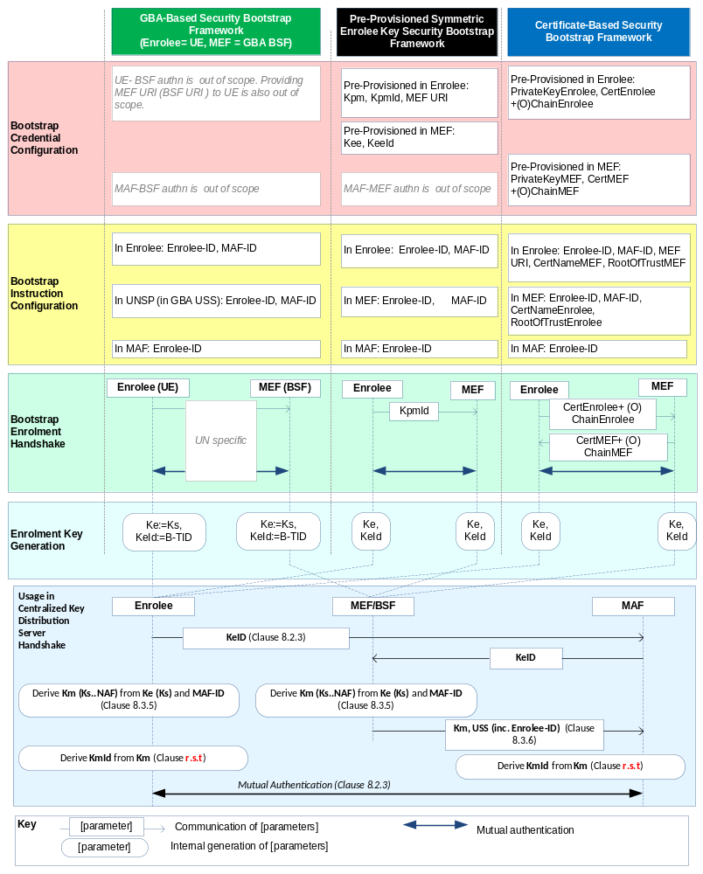
Figure 8.3.1.2-1: Overview of the Security Bootstrap Frameworks supported by oneM2M
Editor's note: In the above figure and other similar ones, more parameters may need to be transferred from MAF to MEF in the "Usage in Centralized Key Distribution Server Handshake". This is FFS. (ACTION Qualcomm)

8.3.2 Direct Security Bootstrap Framework

8.3.2.1 Pre-Provisioned Symmetric Key Security Bootstrap Framework
This clause describes the Pre-Provisioned Symmetric Key Security Bootstrap Framework. The Bootstrap Credential for this framework is a long-term symmetric key that has been pre-provisioned into the Enrolee and M2M Enrolment Function; this key is called a Pre-Provisioned Symmetric Enrolee Key and is denoted Kpm.
NOTE: Long term Pre-Provisioned Symmetric Enrolee Keys can pose a security risk if not adequately secured, and for this reason it is recommended that Long term Pre-Provisioned Symmetric Enrolee Keys are stored in Secure Environments.
Figure 8.3.2.1-1 illustrates the sequence of events when using the Pre-Provisioned Symmetric Enrolee Key Security Bootstrap Framework.
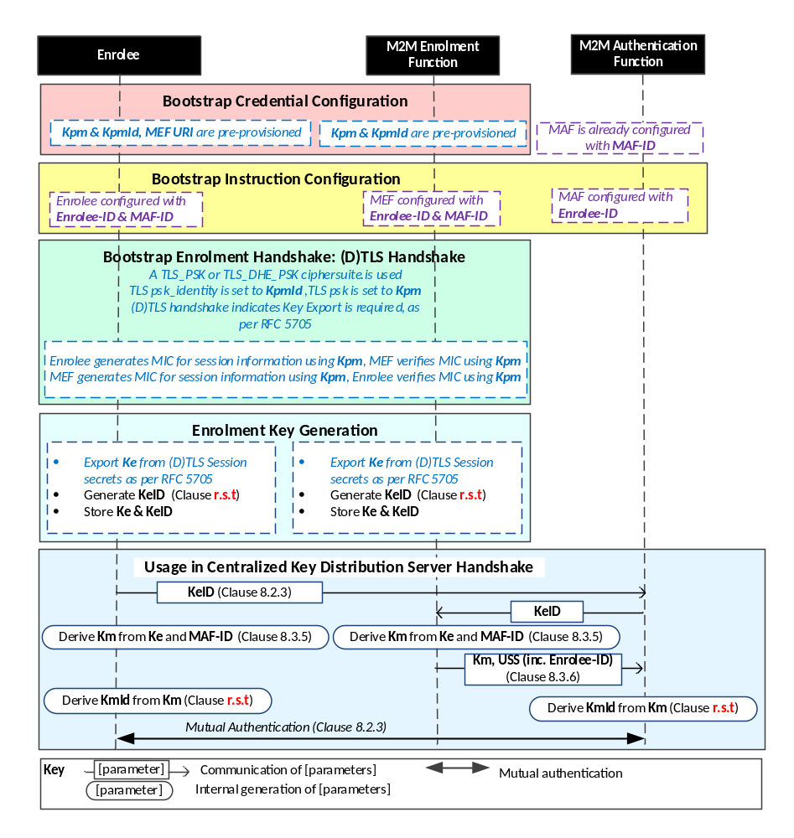
NOTE: The following font colours differentiate the general topic that the text relates to:
Black text contains Security-Bootstrap-Framework-independent details
Blue italic text highlights details specific to this particular Security Bootstrap Framework.
Purple italic text highlights technical actions that may include steps not specified by oneM2M.

Figure 8.3.2.1-1: The sequence of events when using
the Pre-Provisioned Symmetric Key Security Bootstrap Framework
Bootstrap Credential Configuration: The Pre-Provisioned Symmetric Enrolee Key (Kpm) and the corresponding Pre-Provisioned Symmetric Enrolee Key Identifier, denoted KpmId, are pre-provisioned to both entities. The Enrolee is also provisioned with the M2M Enrolment Function's URI (MEF URI), for the purpose of routing the (D)TLS exchange.
NOTE 1: This pre-provisioning (by definition) uses mechanisms not specified by oneM2M.
Bootstrap Instruction Configuration: The Enrolee and M2M Enrolment Function are configured with the information needed for authorizing the remote provisioning:
- The Enrolee is configured with (or otherwise obtains) the following arguments to initiate remote provisioning :
- M2M Authentication Function identity (MAF-ID): Identifying the M2M Authentication Function for which the Enrolee is to be provisioned.
- Enrolee identity (Enrolee-ID): the Enrolee is to use this identity with the identified M2M Authentication Function.
- The Enrolee associates these arguments with the M2M Enrolment Function. The M2M Enrolment Function can be identified to the Enrolee using the Pre-Provisioned Symmetric Enrolee Key Identifier (KpmId) or the M2M Enrolment Function URI.
The mechanisms for achieving this are discussed in clause 8.4.1.3.
- M2M Enrolment Function is configured with the following arguments to authorize the M2M Enrolment Function to remotely provision the Enrolee for a M2M Authentication Function:
- M2M Authentication Function Identity (MAF-ID) of the M2M Authentication Function for which the Enrolee is to be provisioned.
- Enrolee identity (Enrolee-ID). The M2M Enrolment Function is to provide this entity identity for the Enrolee with the Master Credential (Km) to the target M2M Authentication Function, when requested by the M2M Authentication Function.
- The M2M Enrolment Function associates these arguments with an Enrolee. The Enrolee can be identified to the M2M Enrolment Function using the Pre-Provisioned Symmetric Enrolee Key Identifier (KpmId).
The mechanisms for achieving this are discussed in clause 8.4.2.
Bootstrap Security Handshake: The Enrolee and M2M Enrolment Function perform a (D)TLS-PSK handshake [15] to establish a secure session.
- The "psk_identity" parameter [15] is set to the value of the Pre-Provisioned Symmetric Enrolee Key Identifier (KpmId).
- The "psk" parameter [15] is set to the value of the Pre-Provisioned Symmetric Enrolee Key (Kpm).
- Mandatory and optional (D)TLS cipher suites for this phase are specified in clause 9.2.
Enrolment Key Generation:
- The Enrolment Key (Ke) is generated from the (D)TLS session secrets by the Enrolee and M2M Enrolment Function using TLS Key Export (RFC 5705) [18], as described in clause 9.3.
- The Enrolment Key Identifier (KeId) is generated by the Enrolee and M2M Enrolment Function, as described in clause 9.1.
- The Enrolee and M2M Enrolment store the Enrolment Key (Ke) and Enrolment Key Identifier (KeId).
NOTE 2: The Enrolment Key Generation for the Pre-Provisioned Symmetric Enrolee Key Security Bootstrap Framework is identical to the Enrolment Key Generation for the Certificate-Based Security Bootstrap Framework.
Usage in Centralized Key Distribution Server Handshake: See "Overview of Security Frameworks" in clause 8.3.1.

8.3.2.2 Certificate-Based Security Bootstrap Framework
This clause describes the Certificate-Based Security Bootstrap Framework. The Bootstrap Credentials for this framework are Certificates.
Figure 8.3.2.2-1 illustrates the sequence of events when using the Certificate-Based Security Bootstrap Framework.
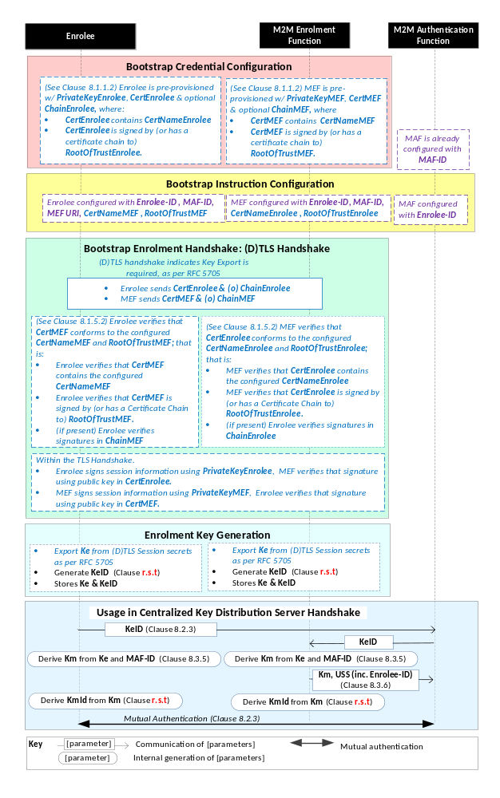
NOTE: The following font colours differentiate the general topic that the text relates to:
Black text contains Security Bootstrap-Framework-independent details.
Blue italic text highlights details specific to this particular Security Bootstrap Framework.
Purple italic text highlights technical actions that may include steps not specified by oneM2M.
Red italic text highlights security-related properties.

Figure 8.3.2.2-1: The sequence of events when using
the Certificate-Based Security Bootstrap Framework.
Bootstrap Credential Configuration: For this Security Bootstrap Framework, Enrolee and M2M Enrolment Function authenticate each other using a Public Key Certificate. The Bootstrap Credentials for the Enrolee and M2M Enrolment Function are pre-provisioned as described in clause 8.1.1.2.1 "Credential Configuration for Certificate-Based Security Frameworks".
NOTE 1: The identities of the M2M Enrolment Function and M2M Authentication Function are assumed to have been configured prior to this phase.
Bootstrap Instruction Configuration: The Enrolee and M2M Enrolment Function are configured with the information needed for authorizing the remote provisioning:
- The Enrolee is configured with (or otherwise obtains) the following arguments to initiate remote provisioning:
- The URI of the M2M Enrolment Function which will facilitate the remote provisioning, for the purpose of routing the (D)TLS exchange.
- The M2M Enrolment Function Certificate Name (M2M Enrolment Function Certificate must include this value in a name field);
- The M2M Enrolment Function Root of Trust (M2M Enrolment Function Certificate must be self-signed using this root of trust, or have a Certificate Chain to this root of trust);
- The target M2M Authentication Function Identity (MAF-ID), with whom the Enrolee is to be provisioned using Security Bootstrap.
- The Enrolee identity (Enrolee-ID): The Enrolee is to use this entity identity with the identified M2M Authentication Function.
The mechanisms for achieving this are discussed in clause 8.4.1.2.
- The M2M Enrolment Function is configured with the following arguments describing Enrolee authorized to perform Security Handshake with M2M Enrolment Function:
- The Enrolee Certificate Name. The Enrolee Certificate must include this value in a name field.
- The Enrolee Root of Trust. The Enrolee Certificate must be self-signed using this root of trust, or have a Certificate Chain to this root of trust.
- The target M2M Authentication Function Identity (MAF-ID), with whom the Enrolee (authenticated using the above Enrolee Certificate Name and Enrolee Root of Trust) is to be provisioned using Security Bootstrap.
- The Enrolee identity (Enrolee-ID). The M2M Enrolment Function is to provide this entity identity for the Enrolee with the Master Credential (Km) to the target M2M Authentication Function, when requested by the M2M Authentication Function.
The mechanisms for achieving this are discussed in clause 8.4.2.
Bootstrap Security Handshake: The Enrolee and M2M Enrolment Function perform a (D)TLS handshake as specified in TLS 1,2 RFC 5246 [16] and DTLS 1.2 RFC 6347 [17] specifications.to establish a secure session.
- Each entity (Enrolee and M2M Enrolment Function) verifies the other entity's certificate as described in clause 8.1.1.2.2 "Certificate Verification".
- The Enrolee and M2M Enrolment Function authenticate each other using the validated certificates as specified in TLS 1.2 RFC 5246 [16] and DTLS 1.2 RFC 6347 [17] specifications.
- Mandatory and optional TLS cipher suites for this phase are specified in clause 9.2.
Enrolment Key Generation:
- The Enrolment Key (Ke) is generated from the (D)TLS session secrets by the Enrolee and M2M Enrolment Function using TLS Key Export (RFC 5705) [18], as described in clause 9.3.
- The Enrolment Key Identifier (KeId) is generated by the Enrolee and M2M Enrolment Function, as described in clause 9.1.
- The Enrolee and M2M Enrolment store the Enrolment Key (Ke) and Enrolment Key Identifier (KeId).
NOTE 2: The Enrolment Key Generation for the Pre-Provisioned Symmetric Enrolee Key Security Bootstrap Framework is identical to the Enrolment Key Generation for the Certificate-Based Security Bootstrap Framework.
Usage in Centralized Key Distribution Server Handshake: See "Overview of Security Frameworks" in clause 8.3.1.

8.3.3 Centralized Security Bootstrap Framework

8.3.3.1 GBA-Based Security Bootstrap Framework
To share a long term Master Credential (Km) between an Application Service/Middle Node and an M2M Authentication Function, the M2M Application Service/Middle Node shall perform a successful GBA bootstrapping and derive a NAF key (Ks_(ext/int)_NAF). This NAF key is the Master Credential (Km).
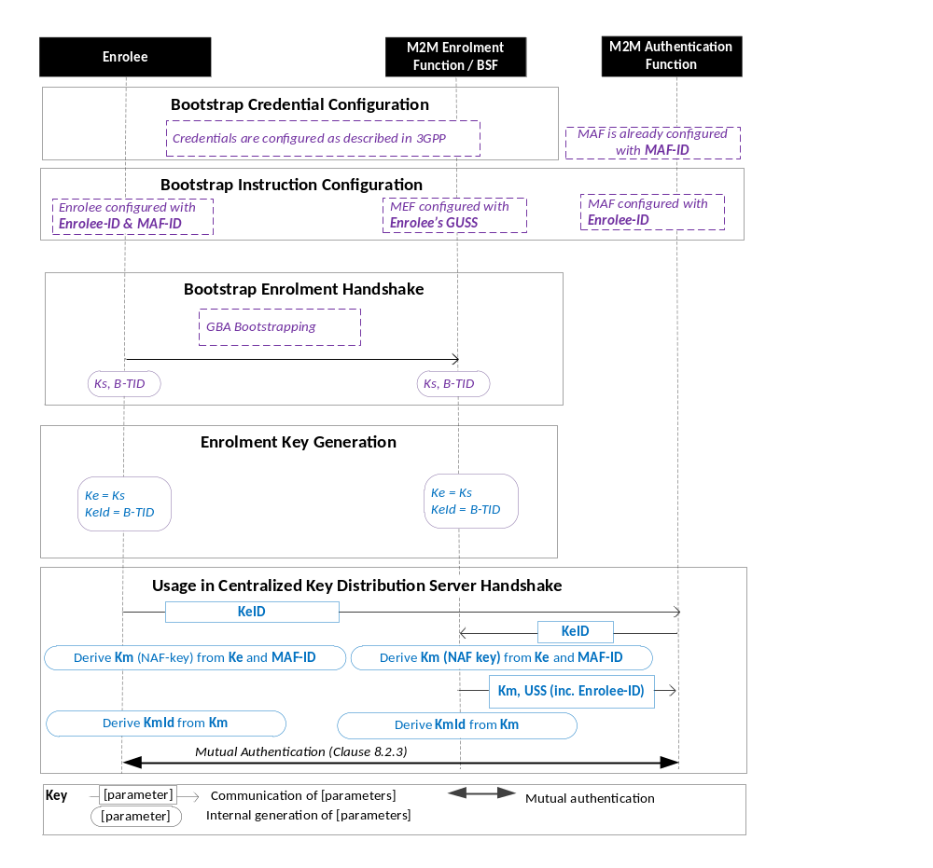
Figure 8.3.3.1-1: The sequence of events when using the GBA-Based Security Bootstrap Framework.
NOTE: The following font colours differentiate the general topic that the text relates to:
Black text contains Security Bootstrap-Framework-independent details.
Blue italic text highlights details specific to this particular Security Bootstrap Framework.
Purple italic text highlights technical actions that may include steps not specified by oneM2M.
Bootstrap Credential Configuration: The credentials configuration for Enrolee and M2M Enrolment Function (MEF) is described in 3GPP specification TS 33.220 [13]. The MEF plays the role of the BSF. The credentials used to perform mutual authentication between Enrolee and MEF are UNSP specific.
Bootstrap Instruction Configuration: the Enrolee, the MEF and the MAF shall be configured with the information needed for authorizing the remote provisioning.
  - The Enrolee shall be configured with Enrolee-Id and MAF-ID.
  - The MEF shall be configured with the Enrolee-ID and the MAF-ID
  - Enrolee’s GBA User Security Settings (GUSS) enables to indicate if Enrolee is allowed to establish a NAF-specific key with the MAF or/and if the BSF can distribute a NAF specific key to the MAF.
- The MAF shall be configured with the Enrolee-ID

Bootstrap Enrolment Handshake:

The Bootstrap Enrolment Handshake enables the establishment of a GBA bootstrapped key (Ks) shared between the Enrolee and the MEF with associated Bootstrapping Transaction Identifier ( B-TID) and key lifetime, by performing to the GBA Bootstrapping phase described in 3GPP TS 33.220 [13].

If a bootstrapped key Ks is already shared between Enrolee and the MEF and still valid, then the Bootstrap Enrolment Handshake phase is not needed. The Enrolment Key Generation phase can take place with the existing GBA Bootstrapped key Ks.

Enrolment Key Generation phase

The Enrolment Key (Ke) shall be the GBA Bootstrapped key (Ks) established during the Bootstrap Enrolment Handshake.

The Enrolment Key Identifier (Ke-ID) shall be the Bootstrapping Transaction Identifier ( B-TID) generated during the Bootstrap Enrolment Handshake.

Usage in Centralized Key Distribution Server Handshake:
- The Enrolee and the MAF shall establish the Master Credential (Km) thanks to procedures described in 3GPP TS 33.220 [13] using the using the Enrolment Key (Ke) as GBA bootstrapped key Ks and the Enrolment Key Identifier (Ke-ID) as B-TID. The MAF plays the role of a NAF.
  - The Enrolee and the MAF shall establish NAF-specific key(s) as described in 3GPP TS 33.220 [13]. A key lifetime is associated to the NAF-specific keys. The MAF also receives the Enrolee’s User Security Settings (USS) from the MEF/BSF.
    - In case of GBA_ME, NAF-specific key is Ks_NAF
    - In case of GBA_U, NAF-specific keys are Ks_int_NAF and Ks_ext_NAF.
  - The Master Credential (Km) shall be the NAF-specific key:
    - In case of GBA_ME, Km = Ks_NAF
    - In case of GBA_U, Km = Ks_int_NAF if HTTP Client application resides in the UICC. Otherwise, Km = Ks_ext_NAF.
  - The Enrolee and the MAF shall derive Master Credential Identifier (Km-Id) from Master Credential (Km).
- Enrolee and MAF shall shall perform (D)TLS-PSK handshake (RFC 4279 [15]) with the Master Credential (Km) as Pre-Shared Key and one of the following TLS ciphersuites:
  - TLS_PSK_WITH_AES_128_CCM (RFC 6655) [21]: Mandatory to support;
  - TLS_DHE_PSK_WITH_AES_128_CCM (RFC 6655) [21]: Recommended to support (optional);
If UICC is used as Secure Environment supporting Security Bootstrap, GBA-U with Kc = Ks_int_NAF shall be used for authentication and key exchange.

9 Security Framework Procedures and Parameters
This clause specifies procedures and parameters of the phases of Security Association Establishment Frameworks (clause 8.2) and Security Bootstrap Frameworks (clause 8.3).

9.1 Security Association Establishment Framework Procedures and Parameters

9.1.1 Credential Configuration Procedures and Parameters
The following Credential Configuration procedures are described in the present clause:
- Credential Configuration of Field-Domain Security Association End-Points (except for the GBA-Based case as discussed above), see Clause 9.1.1.1,
- Credential Configuration of Infrastructure-Domain Security Association End-Points, see Clause 9.1.1.2,
- Credential Configuration of M2M Authentication Functions, see Clause 9.1.1.3,
The following Credential Configuration procedures are specified by other organizations:
- Credential Configuration of Underlying Network Service Provider authentication server (e.g. HLR, HSS or AAA) for the GBA-Based Security Association Establishment Framework. These details are specified by 3GPP, 3GPP2 and ETSI specifications.
- Credential Configuration of Field-Domain Security Association End-Points for the GBA-Based Security Association Establishment Framework. These details are specified by 3GPP, 3GPP2 and ETSI specifications.
Editor’s Note: List any relevant 3GPP, 3GPP2 or IETF specifications.

9.1.1.1 Credential Configuration of Field-Domain Security Association End-Points
Table 9.1.1.1-1 lists the parameters configured to a Field-Domain Security Association End-Points in the Credential Configuration phase.
Table 9.1.1.1-1 Parameters configured to a Field Domain Security Association end-point during the Credential Configuration phase.
Security Association Establishment Framework | Parameter | Mandatory /Optional for this Security Association Establishment Framework
Pre-Provisioned M2M Secure Connection Key | kpsaKey | Mandatory
Pre-Provisioned M2M Secure Connection Key | kpsaId | Mandatory
Certificate Based | thisEntityPrivateKey | Mandatory
Certificate Based | thisEntityCertificate | Mandatory
Certificate Based | thisEntityCertificateChain | Optional
MAF-Based | mafIdentifier | Mandatory
MAF-Based | thisEntityIdentifier | Mandatory
MAF-Based | masterCredential | Mandatory
MAF-Based | masterCredentialIdentifier | Mandatory
MAF-Based | masterCredentialExpiry | Optional
The Credential Configuration of Field-Domain Security Association End-Points for the MAF-Based Security Association Establishment Framework is achieved through either:
- Pre-provisioning via out of band mechanisms which are not specified in the present document.
- Remote provisioning via one of the Security Bootstrap Frameworks in Clause 8.3.
The Credential Configuration phases of other Security Association Establishment Frameworks are performed by pre-provisioning via out of band mechanisms which are not specified in the present document .

9.1.1.2 Credential Configuration of Infrastructure-Domain Security Association End-Points
Table 9.1.1.2-1 lists the parameters configured to Infrastructure-Domain Security Association End-Points in the Credential Configuration phase.
Table 9.1.1.2-1 Parameters configured to an Infrastructure Domain Security Association end-point during the Credential Configuration phase. In the GBA-Based framework, the Infrastructure Domain Security Association end-point plays the role of a GBA NAF.
Security Association Establishment Framework | Parameter | Mandatory /Optional for this Security Association Establishment Framework
Pre-Provisioned M2M Secure Connection Key | kpsaKey | Mandatory
Pre-Provisioned M2M Secure Connection Key | kpsaId | Mandatory
Certificate Based | thisEntityPrivateKey | Mandatory
Certificate Based | thisEntityCertificate | Mandatory
Certificate Based | thisEntityCertificateChain | Optional
MAF-Based | Editor’s note: FFS | Editor’s note: FFS
GBA-Based  Entity plays role of NAF. Details specified in 3GPP 33.220 [13]. Where this description differs from [13], [13] takes precedence | nafPrivateKey | See 3GPP 33.220 [13].
 | nafCertificate | See 3GPP 33.220 [13].
 | nafCertificateChain | See 3GPP 33.220 [13].
 | rootCertificateBSF | See 3GPP 33.220 [13].
The procedure for the Credential Configuration of Infrastructure-Domain Security Association End-Points is expected to use business logic of the M2M Service Provider, and the details are not described in this specification.

9.1.1.3 Credential Configuration of M2M Authentication Functions
Table 9.1.1.3-1 lists the parameters configured to M2M Authentication Functions in the Credential Configuration phase. The M2M Authentication Function’s identifier (MAF-ID) is presumed to have been configured prior to the Credential Configuration phase.
Table 9.1.1.3-1 Parameters configured to a M2M Authentication Functions during the Credential Configuration phase.
Security Association Establishment Framework |  | Parameter | Mandatory /Optional for this Security Association Establishment Framework
MAF-Based | A-to-MAF Authentication | thisEntityIdentifier | Mandatory
MAF-Based | A-to-MAF Authentication | masterCredential | Mandatory
MAF-Based | A-to-MAF Authentication | masterCredentialIdentifier | Mandatory
MAF-Based | A-to-MAF Authentication | masterCredentialExpiry | Optional
MAF-Based | B-to-MAF Authentication | Editor’s note: FFS
The Credential Configuration of M2M Authentication Framework shall be achieved through either:
- Business logic of the Stakeholder operating the M2M Authentication Function, and the details are not described in this specification.
- Remote provisioning via one of the Security Bootstrap Frameworks in Clause 8.3.

9.1.2 Association Configuration Procedures and Parameters
The following Association Configuration procedures are described in this clause:
- Association Configuration of Field-Domain Security Association End-points, see Clause 9.1.2.1,
- Association Configuration of Infrastructure Domain Security Association End-points, see Clause 9.1.2.2,
- Association Configuration of M2M Authentication Functions and Underlying Network Service Provider authentication servers (e.g. HLR, HSS or AAA), see Clause 9.1.2.3.

9.1.2.1 Association Configuration of Field-Domain Security Association End-Points
Table 9.1.2.1-1 lists the parameters configured to Field-Domain Security Association End-Points in the Credential Configuration phase of all Security Association Establishment Frameworks.
Table 9.1.2.1-1 Parameters configured to a Field-Domain Security Association End-Point during the Credential Configuration phase of all Security Association Establishment Frameworks.
Parameters common to all Security Association Establishment Frameworks | Mandatory /Optional for all Security Association Establishment Frameworks
otherEntityIdentifier | Mandatory
associationConfigurationExpiry | Optional
securityAssociationLifespan | Optional
Table 9.1.2.1-2 lists the Security Association Establishment Framework-specific parameters configured to Field-Domain Security Association End-Points in the Credential Configuration phase.
Table 9.1.2.1-2 Security Association Establishment Framework-specific parameters configured to a Field-Domain Security Association End-Point during the Credential Configuration phase.
Security Association Establishment Framework | Parameters specific to the Security Association Establishment Frameworks | Mandatory /Optional for this Security Association Establishment Framework
Pre-Provisioned M2M Secure Connection Key | thisEntityIdentifier | Mandatory
Certificate Based | thisEntityIdentifier | Mandatory
Certificate Based | otherEntityCertificateName | Mandatory
Certificate Based | otherEntityRootOfTrust | Mandatory
MAF-Based | None: the Security Association End-Point is assumed to already know its CSE-ID/AE-ID in this case.
GBA-Based | thisEntityIdentifier |  | Mandatory
This specification provides two procedures for Association Configuration of Field Domain Security Association End-points:
- Integrating Association Configuration with Credential Configuration. Implementation and use of this procedure is optional.
NOTE: This approach has limited flexibility, but can be useful in many cases.
Editor’s Note: We need to determine where and how we describe this procedure.
- A remote management protocols or security administration protocol that provides at least integrity protection and authentication of the configuration source.
Other mechanisms are not prohibited.
NOTE: For example, in some cases it is appropriate to use manual entry via user interface integrated to the Field Domain equipment (provided there is appropriate user authentication).
Editor’s Note: Stage 3 details of the data model are needed.
Editor’s Note: We need to interact with MAS WG5 to determine how to describe the data modelhow to “associate’ the MO with the Security Association End-point – e.g. does the MO path including the identity of the Security Association End-point?

9.1.2.2 Association Configuration of Infrastructure-Domain Security Association End-Points
Table 9.1.2.2-1 lists the parameters configured to Infrastructure-Domain Security Association End-Points in the Association Configuration phase of all Security Association Establishment Frameworks. It is assumed that an Infrastructure-Domain Security Association End-Point knows its CSE-ID/AE-ID prior to Association Configuration.
Table 9.1.2.2-1 Parameters configured to an Infrastructure Domain Security Association end-point during the Association Configuration phase of all Security Association Establishment Frameworks.
Parameter common to all Security Association Establishment Frameworks | Mandatory /Optional for all Security Association Establishment Frameworks
otherEntityIdentifier | Mandatory
associationConfigurationExpiry | Optional
securityAssociationLifespan | Optional
Table 9.1.2.2-2 lists the parameters configured to Infrastructure-Domain Security Association End-Points in the Association Configuration phase.
Table 9.1.2.2-2 Security Association Establishment Framework –specific parameters configured to an Infrastructure Domain Security Association end-point during the Association Configuration phase.
Security Association Establishment Framework | Parameters specific to the Security Association Establishment Framework | Mandatory /Optional for this Security Association Establishment Framework
Pre-Provisioned M2M Secure Connection Key | None
Certificate Based | otherEntityCertificateName | Mandatory
Certificate Based | otherEntityRootOfTrust | Mandatory
MAF-Based | None
GBA-Based | None
The Association Configuration of Infrastructure-Domain Security Association End-Points is expected to use business logic of the M2M Service Provider, and the details are not described in this specification.

9.1.2.3 Association Configuration of M2M Authentication Functions
Table 9.1.2.3-1 lists the parameters configured to M2M Authentication Functions in the Association Configuration phase.
Table 9.1.2.3-1 Parameters configured to a M2M Authentication Functions during the Association Configuration phase.
Security Association Establishment Framework |  | Parameter | Mandatory /Optional for this Security Association Establishment Framework
MAF-Based | A-to-MAF Authentication | otherEntityIdentifier | Mandatory
MAF-Based | A-to-MAF Authentication | associationConfigurationExpiry | Optional
MAF-Based | A-to-MAF Authentication | securityAssociationLifespan | Optional
MAF-Based | B-to-MAF Authentication | Editor’s note: FFS.
This specification assumes that Association Configuration of the M2M Authentication Functions will utilize business logic of the Stakeholder that operates the M2M Authentication Function, and the details are not described in this specification.

9.1.2.4 Association Configuration of UNSP Authentication Servers
Table 9.1.2.4-1 lists the parameters configured to an Underlying Network Service Provider authentication server (e.g. HLR, HSS or AAA) in the Association Configuration phase.
Table 9.1.2.4-1 Parameters configured to an Underlying Network Service Provider authentication server (e.g. HLR, HSS or AAA) during the Association Configuration phase.
Security Association Establishment Framework | Parameter | Mandatory /Optional for this Security Association Establishment Framework
GBA-Based.  Parameters are configured to UE’s GBA User Security Settings (GUSS). GUSS details are specified in 3GPP 33.220 [13]. Where this description differs from [13], [13] takes precedence | thisEntityIdentifier | Mandatory
 | otherEntityIdentifier | Mandatory
 | associationConfigurationExpiry | Optional
 | securityAssociationLifespan | Optional
The Association Configuration of the Underlying Network Service Provider authentication server is achieved by updating the GBA User Security Settings (GUSS) (3GPP 33.220 [13]) of the User Equipment (UE) upon which the Enrolee is executed. This specification assumes that this Association Configuration will utilize business logic of the Underlying Network Service Provider, and the details are not described in this specification.
Editor’s Note: List any relevant 3GPP, 3GPP2 or IETF specifications.

-----------------------Start of change 1-------------------------------------------

