CHANGE REQUEST
Group Name:* | SEC 12
Source:* | Francois Ennesser, Gemalto (ETSI)
Format:* | Face-to-Face
Date:* | 2014-07-20
Contact:* | francois.ennesser@gemalto.com
Reason for Change/s:* | The scenario described in clause 8.3.2 of TS-0003, classified as a Direct Security Bootstrap Framework, seem closer to the definition of Centralized Security Bootstrap Frameworks.
CR against: Release* | 1
CR against: TS/TR* | TS-0003 v0.6.0  (note: This baseline does not incorporate SEC-2014-0335R01, which modifies some text in the clauses that are displaced by the present contribution)
Clauses/Sub Clauses* | 8.3 and subclauses
Type of change: * | Editorial change  Bug Fix or Correction  Change/correction to existing feature or functionality  New feature or functionality
Post Freeze checking:* | This CR contains only essential changes and corrections  YES NO

oneM2M Notice
The document to which this cover statement is attached is submitted to oneM2M. Participation in, or attendance at, any activity of oneM2M, constitutes acceptance of and agreement to be bound by terms of the Working Procedures and the Partnership Agreement, including the Intellectual Property Rights (IPR) Principles Governing oneM2M Work found in Annex 1 of the Partnership Agreement.

Introduction
This CR clarifies that the MEF based security Bootstrap frameworks are centralized security bootstrap frameworks rather than direct security bootstrap frameworks. From the definitions:
direct security framework: Security Framework in which the entities authenticate each other directly, without assistance from a Central Key Distribution Server
centralized security framework: Security Framework in which the entities authenticate each other with the assistance of a Central Key Distribution Server
The MEF in these security bootstrap frameworks plays a role similar to that of the MAF in the symmetric key security association framework, which is classified as a centralized security framework.

-----------------------Start of change 1-------------------------------------------

8.3 Security Bootstrap Frameworks

8.3.1 Overview on Security Bootstrap Frameworks

8.3.1.1 Purpose of Security Bootstrap Frameworks
The MAF-based Security Association Establishment Framework uses a Master Credential (Km) and corresponding Master Credential Identifier (KmId), shared by a CSE/AE and an M2M Authentication Function, to establish security associations between the CSE/AE and other CSEs and/or AEs as described in clause 8.2.3.
The Master Credential (Km) and corresponding Master Credential Identifier (KmId) shall either be pre-provisioned or remotely provisioned to the CSE/AE and M2M Authentication Function.
The methods for pre-provisioning can be deployment dependent. An interoperable pre-provisioning framework based on UICC is described in Annex D.
Clause 8.3 describes the set of remote provisioning mechanisms; called Security Bootstrap Frameworks. An M2M Enrolment Function facilitates the remote provisioning.

8.3.1.2 Overview on Security Bootstrap Frameworks
An AE or CSE that requires remote provisioning of a Master Credential and Master Credential Identifier is called an Enrolee.
The oneM2M system supports the following Security Bootstrap Frameworks:

- Centralized Security Bootstrap Frameworks
- Pre-Provisioned Symmetric Enrolee Key Security Bootstrap Framework: A symmetric key is pre-provisioned to the Enrolee and M2M Enrolment Function for the mutually authentication of those entities. For more details, see clause 8.3.2.1.
- Certificate-Based Security Bootstrap Framework: The Enrolee and M2M Enrolment Function are each issued with
- a Private Signing Key that is known only to that entity,
- a Certificate containing the corresponding Public Verification Key, and
- (Optionally) a Certificate Chain from the entity's Certificate to a Root Certificate.
The Enrolee and M2M Enrolment Function shall validate each other's Certificate before trusting the Public Verification Keys in the Certificate. Within the Security Handshake, the M2M Enrolment Function creates a digital signature of the session parameters using its private signing key and the Enrolee verifies the digital signature using the M2M Enrolment Function's public verification key. Then the roles are reversed: the Enrolee creates a digital signature and the M2M Enrolment Function verifies it. For more details see clause 8.3.2.2.

- GBA-based Security Bootstrap Framework. In this case, the M2M Enrolment Function includes the functionality of a GBA Bootstrap Server Function. This framework uses 3GPP or 3GPP2 symmetric keys to authenticate the Enrolee and the M2M Enrolment Function (which is also a GBA BSF). The details are specified by 3GPP [13] and 3GPP2 [14]. For more details see clause 8.3.2.3.
For a more detailed description of the above Security Bootstrap Frameworks, it is useful to compare the following aspects of the Security Bootstrap Frameworks.
- Bootstrap Credential Configuration: The Enrolee and M2M Enrolment Function are pre-provisioned with the Bootstrap Credential that the entity will use to authenticate itself to the other entity. The mechanisms for this pre-provisioning are not described in this specification.
- Bootstrap Instruction Configuration: The Enrolee and M2M Enrolment Function are provided with
- The M2M Authentication Function Identifier (MAF-ID) identifying the M2M Authentication Function for which the Enrolee is to be remotely provisioned.
NOTE 1: The identity of the M2M Authentication Function is assumed to have been configured prior to the Bootstrap Instruction Configuration phase.
- The CSE-ID or AE-ID that the M2M Authentication Function is to associate with the Enrolee.
Additionally, in the case of Certificate-Based Security Bootstrap Framework:
- The Enrolee is configured with the M2M Enrolment Function URI (for the purpose of routing the (D)TLS messages to the M2M Enrolment Function), M2M Enrolment Function Certificate Name and M2M Enrolment Function Root of Trust that the Enrolee will use to verify the M2M Enrolment Function.
- The M2M Enrolment Function is configured with the Enrolee Certificate Name and Enrolee Root of Trust that the M2M Enrolment Function will use to verify the Enrolee.
- Bootstrap Enrolment Handshake: Identification, authentication and security context establishment between the Enrolee and M2M Enrolment Function.
- Enrolment Key Generation: generating a symmetric Enrolment Key,(Ke) and corresponding Enrolment Key Identifier (KeId) shared by the Enrolee and M2M Enrolment Function, which is used for subsequent generation of the Master Credential (Km).
- Usage in Centralized Key Distribution Server Handshake: During the Centralized Key Distribution Server Handshake of the MAF-Based Security Association Establishment, the following steps occurs
- The Enrolee derives the Master Credential (Km) from the Enrolment Key (Ke) and M2M Authentication Function Identifier (MAF-ID). Details of the derivation are provided in clause 9.4.
- The Enrolee generates the Master Credential Identifier (KmId) from Master Credential (Km) as described in clause 9.1, and stores Km and KmId.
- The Enrolee passes the Enrolment Key Identifier (KeId) to the M2M Authentication Function (see "Centralized Key Distribution Server Handshake" in clause 8.2.3.1)
NOTE 2: When the Enrolee first communicates with the M2M Authentication Function, then the M2M Authentication Function has not yet retrieved the Km from the M2M Enrolment Function. Consequently, the Enrolee provides the KeId to the M2M Authentication function, which is then passed to the M2M Enrolment Function to identify the Enrolment Key. The M2M Enrolment Function then returns the Km from which the M2M Authentication Function can derive the KmId. In subsequent Security Establishments, the Enrolee may provide the KmId or the KeId, and the M2M Authentication Function will know that both identifiers indicate the retrieved Km. For more details, see "Centralized Key Distribution Server Handshake" in clause 8.2.3.1.
- Upon receipt of the KeId, the M2M Authentication Function determines if it already has the corresponding Km and CSE-ID or AE-ID of the Enrolee
- If the M2M Authentication Function already has the corresponding Km and CSE-ID or AE-ID of the Enrolee, then the Km is used for mutual authentication (see "Centralized Key Distribution Server Handshake" in clause 8.2.3.1)
- If the M2M Authentication Function does not have the corresponding Master Credential (Km) and CSE-ID or AE-ID of the Enrolee, then the following steps are followed.
- The M2M Authentication Function (securely) passes the KeId to the M2M Enrolment Function, along with the M2M Authentication Function's URI.
- The M2M Enrolment Function derives the Km from the Ke and MAF-ID. Details of the derivation are provided in clause 9.4.
- The M2M Enrolment Function returns the Km to the M2M Authentication Function. The M2M Enrolment Function also passes the USS, including the CSE-ID or AE-ID of the Enrolee. More details are provided in clause 8.6.
- The M2M Authentication Function generates the Master Credential Identifier (KmId) from Master Credential (Km) as described in clause 9.1, and stores Km and KmId.
- The Master Credential (Km) is used for mutual authentication (see "Centralized Key Distribution Server Handshake" in clause 8.2.3.1).
Figure 8.3.1.2-1 provides a summary of the above defined Security Bootstrap Frameworks.
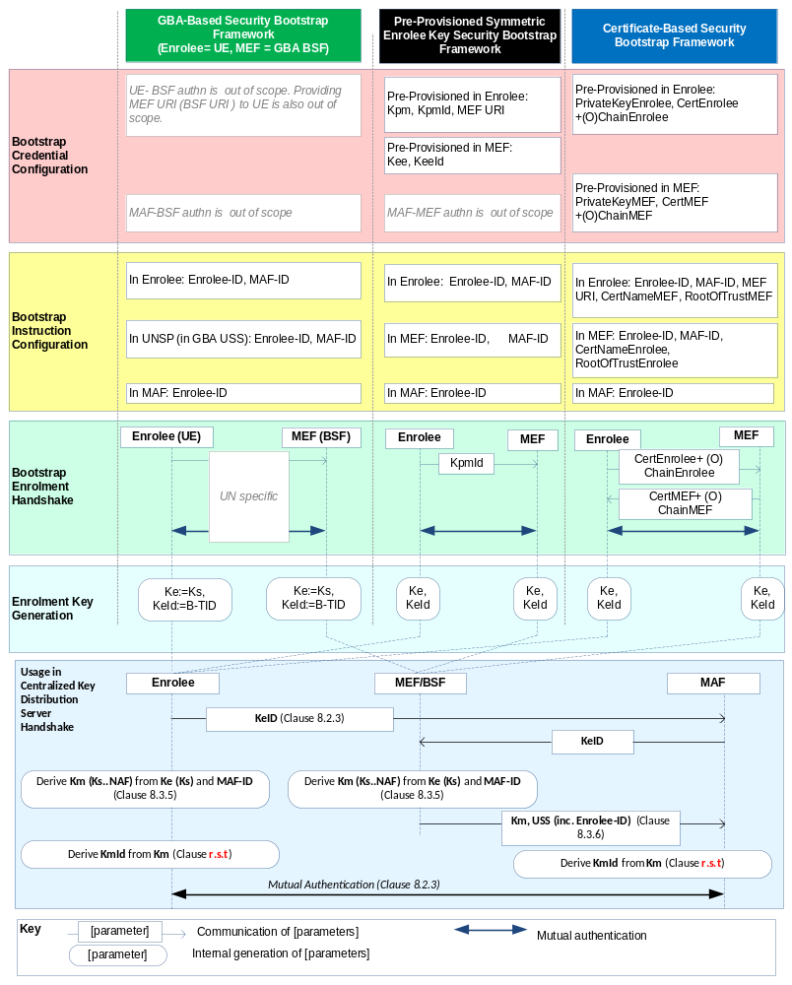
Figure 8.3.1.2-1: Overview of the Security Bootstrap Frameworks supported by oneM2M
Editor's note: In the above figure and other similar ones, more parameters may need to be transferred from MAF to MEF in the "Usage in Centralized Key Distribution Server Handshake". This is FFS. (ACTION Qualcomm)

8.3.2 Centralized Security Bootstrap Framework

8.3.2.1 Pre-Provisioned Symmetric Key Security Bootstrap Framework
This clause describes the Pre-Provisioned Symmetric Key Security Bootstrap Framework. The Bootstrap Credential for this framework is a long-term symmetric key that has been pre-provisioned into the Enrolee and M2M Enrolment Function; this key is called a Pre-Provisioned Symmetric Enrolee Key and is denoted Kpm.
NOTE: Long term Pre-Provisioned Symmetric Enrolee Keys can pose a security risk if not adequately secured, and for this reason it is recommended that Long term Pre-Provisioned Symmetric Enrolee Keys are stored in Secure Environments.
Figure 8.3.2.1-1 illustrates the sequence of events when using the Pre-Provisioned Symmetric Enrolee Key Security Bootstrap Framework.
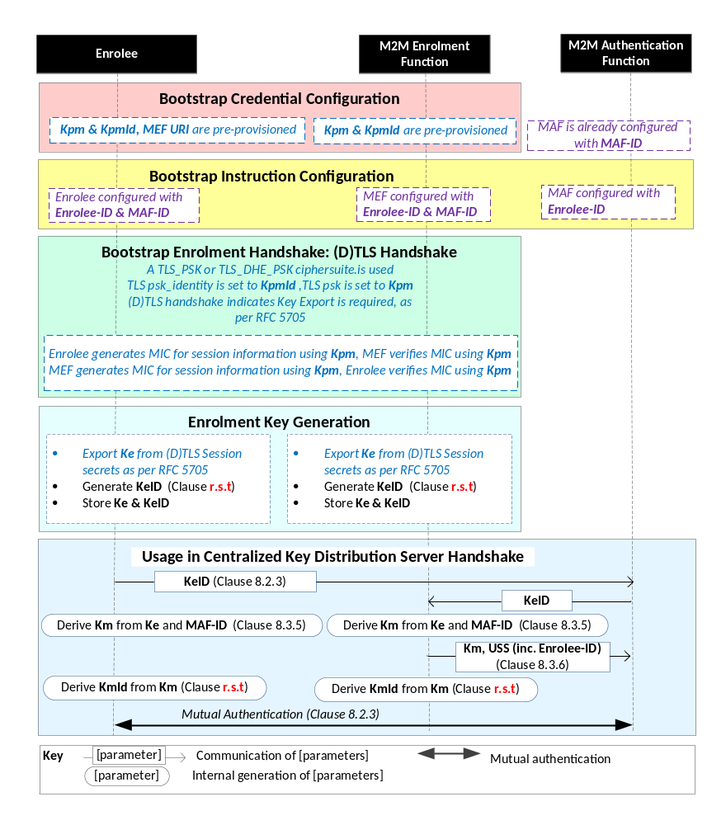
NOTE: The following font colours differentiate the general topic that the text relates to:
Black text contains Security-Bootstrap-Framework-independent details
Blue italic text highlights details specific to this particular Security Bootstrap Framework.
Purple italic text highlights technical actions that may include steps not specified by oneM2M.

Figure 8.3.2.1-1: The sequence of events when using
the Pre-Provisioned Symmetric Key Security Bootstrap Framework
Bootstrap Credential Configuration: The Pre-Provisioned Symmetric Enrolee Key (Kpm) and the corresponding Pre-Provisioned Symmetric Enrolee Key Identifier, denoted KpmId, are pre-provisioned to both entities. The Enrolee is also provisioned with the M2M Enrolment Function's URI (MEF URI), for the purpose of routing the (D)TLS exchange.
NOTE 1: This pre-provisioning (by definition) uses mechanisms not specified by oneM2M.
Bootstrap Instruction Configuration: The Enrolee and M2M Enrolment Function are configured with the information needed for authorizing the remote provisioning:
- The Enrolee is configured with (or otherwise obtains) the following arguments to initiate remote provisioning :
- M2M Authentication Function identity (MAF-ID): Identifying the M2M Authentication Function for which the Enrolee is to be provisioned.
- Enrolee identity (Enrolee-ID): the Enrolee is to use this identity with the identified M2M Authentication Function.
- The Enrolee associates these arguments with the M2M Enrolment Function. The M2M Enrolment Function can be identified to the Enrolee using the Pre-Provisioned Symmetric Enrolee Key Identifier (KpmId) or the M2M Enrolment Function URI.
The mechanisms for achieving this are discussed in clause 8.4.1.3.
- M2M Enrolment Function is configured with the following arguments to authorize the M2M Enrolment Function to remotely provision the Enrolee for a M2M Authentication Function:
- M2M Authentication Function Identity (MAF-ID) of the M2M Authentication Function for which the Enrolee is to be provisioned.
- Enrolee identity (Enrolee-ID). The M2M Enrolment Function is to provide this entity identity for the Enrolee with the Master Credential (Km) to the target M2M Authentication Function, when requested by the M2M Authentication Function.
- The M2M Enrolment Function associates these arguments with an Enrolee. The Enrolee can be identified to the M2M Enrolment Function using the Pre-Provisioned Symmetric Enrolee Key Identifier (KpmId).
The mechanisms for achieving this are discussed in clause 8.4.2.
Bootstrap Security Handshake: The Enrolee and M2M Enrolment Function perform a (D)TLS-PSK handshake [15] to establish a secure session.
- The "psk_identity" parameter [15] is set to the value of the Pre-Provisioned Symmetric Enrolee Key Identifier (KpmId).
- The "psk" parameter [15] is set to the value of the Pre-Provisioned Symmetric Enrolee Key (Kpm).
- Mandatory and optional (D)TLS cipher suites for this phase are specified in clause 9.2.
Enrolment Key Generation:
- The Enrolment Key (Ke) is generated from the (D)TLS session secrets by the Enrolee and M2M Enrolment Function using TLS Key Export (RFC 5705) [18], as described in clause 9.3.
- The Enrolment Key Identifier (KeId) is generated by the Enrolee and M2M Enrolment Function, as described in clause 9.1.
- The Enrolee and M2M Enrolment store the Enrolment Key (Ke) and Enrolment Key Identifier (KeId).
NOTE 2: The Enrolment Key Generation for the Pre-Provisioned Symmetric Enrolee Key Security Bootstrap Framework is identical to the Enrolment Key Generation for the Certificate-Based Security Bootstrap Framework.
Usage in Centralized Key Distribution Server Handshake: See "Overview of Security Frameworks" in clause 8.3.1.

8.3.2.2 Certificate-Based Security Bootstrap Framework
This clause describes the Certificate-Based Security Bootstrap Framework. The Bootstrap Credentials for this framework are Certificates.
Figure 8.3.2.2-1 illustrates the sequence of events when using the Certificate-Based Security Bootstrap Framework.
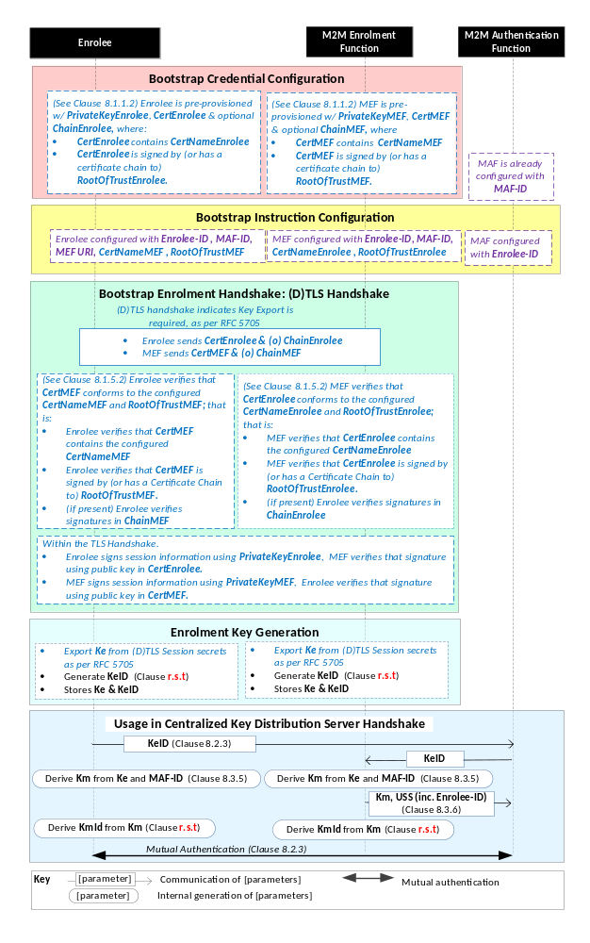
NOTE: The following font colours differentiate the general topic that the text relates to:
Black text contains Security Bootstrap-Framework-independent details.
Blue italic text highlights details specific to this particular Security Bootstrap Framework.
Purple italic text highlights technical actions that may include steps not specified by oneM2M.
Red italic text highlights security-related properties.

Figure 8.3.2.2-1: The sequence of events when using
the Certificate-Based Security Bootstrap Framework.
Bootstrap Credential Configuration: For this Security Bootstrap Framework, Enrolee and M2M Enrolment Function authenticate each other using a Public Key Certificate. The Bootstrap Credentials for the Enrolee and M2M Enrolment Function are pre-provisioned as described in clause 8.1.1.2.1 "Credential Configuration for Certificate-Based Security Frameworks".
NOTE 1: The identities of the M2M Enrolment Function and M2M Authentication Function are assumed to have been configured prior to this phase.
Bootstrap Instruction Configuration: The Enrolee and M2M Enrolment Function are configured with the information needed for authorizing the remote provisioning:
- The Enrolee is configured with (or otherwise obtains) the following arguments to initiate remote provisioning:
- The URI of the M2M Enrolment Function which will facilitate the remote provisioning, for the purpose of routing the (D)TLS exchange.
- The M2M Enrolment Function Certificate Name (M2M Enrolment Function Certificate must include this value in a name field);
- The M2M Enrolment Function Root of Trust (M2M Enrolment Function Certificate must be self-signed using this root of trust, or have a Certificate Chain to this root of trust);
- The target M2M Authentication Function Identity (MAF-ID), with whom the Enrolee is to be provisioned using Security Bootstrap.
- The Enrolee identity (Enrolee-ID): The Enrolee is to use this entity identity with the identified M2M Authentication Function.
The mechanisms for achieving this are discussed in clause 8.4.1.2.
- The M2M Enrolment Function is configured with the following arguments describing Enrolee authorized to perform Security Handshake with M2M Enrolment Function:
- The Enrolee Certificate Name. The Enrolee Certificate must include this value in a name field.
- The Enrolee Root of Trust. The Enrolee Certificate must be self-signed using this root of trust, or have a Certificate Chain to this root of trust.
- The target M2M Authentication Function Identity (MAF-ID), with whom the Enrolee (authenticated using the above Enrolee Certificate Name and Enrolee Root of Trust) is to be provisioned using Security Bootstrap.
- The Enrolee identity (Enrolee-ID). The M2M Enrolment Function is to provide this entity identity for the Enrolee with the Master Credential (Km) to the target M2M Authentication Function, when requested by the M2M Authentication Function.
The mechanisms for achieving this are discussed in clause 8.4.2.
Bootstrap Security Handshake: The Enrolee and M2M Enrolment Function perform a (D)TLS handshake as specified in TLS 1,2 RFC 5246 [16] and DTLS 1.2 RFC 6347 [17] specifications.to establish a secure session.
- Each entity (Enrolee and M2M Enrolment Function) verifies the other entity's certificate as described in clause 8.1.1.2.2 "Certificate Verification".
- The Enrolee and M2M Enrolment Function authenticate each other using the validated certificates as specified in TLS 1.2 RFC 5246 [16] and DTLS 1.2 RFC 6347 [17] specifications.
- Mandatory and optional TLS cipher suites for this phase are specified in clause 9.2.
Enrolment Key Generation:
- The Enrolment Key (Ke) is generated from the (D)TLS session secrets by the Enrolee and M2M Enrolment Function using TLS Key Export (RFC 5705) [18], as described in clause 9.3.
- The Enrolment Key Identifier (KeId) is generated by the Enrolee and M2M Enrolment Function, as described in clause 9.1.
- The Enrolee and M2M Enrolment store the Enrolment Key (Ke) and Enrolment Key Identifier (KeId).
NOTE 2: The Enrolment Key Generation for the Pre-Provisioned Symmetric Enrolee Key Security Bootstrap Framework is identical to the Enrolment Key Generation for the Certificate-Based Security Bootstrap Framework.
Usage in Centralized Key Distribution Server Handshake: See "Overview of Security Frameworks" in clause 8.3.1.

8.3.2.3 GBA-Based Security Bootstrap Framework
To share a long term Master Credential (Km) between an Application Service/Middle Node and an M2M Authentication Function, the M2M Application Service/Middle Node shall perform a successful GBA bootstrapping and derive a NAF key (Ks_(ext/int)_NAF). This NAF key is the Master Credential (Km).
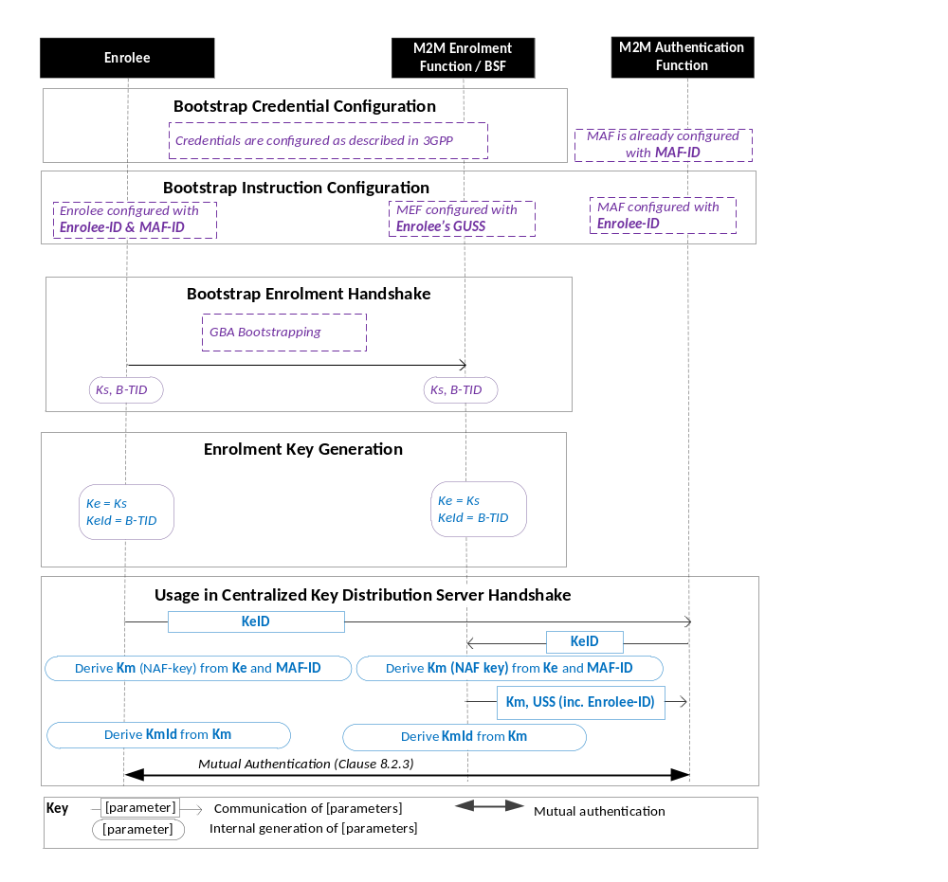
Figure 8.3.3.1-1: The sequence of events when using the GBA-Based Security Bootstrap Framework.
NOTE: The following font colours differentiate the general topic that the text relates to:
Black text contains Security Bootstrap-Framework-independent details.
Blue italic text highlights details specific to this particular Security Bootstrap Framework.
Purple italic text highlights technical actions that may include steps not specified by oneM2M.
Bootstrap Credential Configuration: The credentials configuration for Enrolee and M2M Enrolment Function (MEF) is described in 3GPP specification TS 33.220 [13]. The MEF plays the role of the BSF. The credentials used to perform mutual authentication between Enrolee and MEF are UNSP specific.
Bootstrap Instruction Configuration: the Enrolee, the MEF and the MAF shall be configured with the information needed for authorizing the remote provisioning.
  - The Enrolee shall be configured with Enrolee-Id and MAF-ID.
  - The MEF shall be configured with the Enrolee-ID and the MAF-ID
  - Enrolee’s GBA User Security Settings (GUSS) enables to indicate if Enrolee is allowed to establish a NAF-specific key with the MAF or/and if the BSF can distribute a NAF specific key to the MAF.
- The MAF shall be configured with the Enrolee-ID

Bootstrap Enrolment Handshake:

The Bootstrap Enrolment Handshake enables the establishment of a GBA bootstrapped key (Ks) shared between the Enrolee and the MEF with associated Bootstrapping Transaction Identifier ( B-TID) and key lifetime, by performing to the GBA Bootstrapping phase described in 3GPP TS 33.220 [13].

If a bootstrapped key Ks is already shared between Enrolee and the MEF and still valid, then the Bootstrap Enrolment Handshake phase is not needed. The Enrolment Key Generation phase can take place with the existing GBA Bootstrapped key Ks.

Enrolment Key Generation phase

The Enrolment Key (Ke) shall be the GBA Bootstrapped key (Ks) established during the Bootstrap Enrolment Handshake.

The Enrolment Key Identifier (Ke-ID) shall be the Bootstrapping Transaction Identifier ( B-TID) generated during the Bootstrap Enrolment Handshake.

Usage in Centralized Key Distribution Server Handshake:
- The Enrolee and the MAF shall establish the Master Credential (Km) thanks to procedures described in 3GPP TS 33.220 [13] using the using the Enrolment Key (Ke) as GBA bootstrapped key Ks and the Enrolment Key Identifier (Ke-ID) as B-TID. The MAF plays the role of a NAF.
  - The Enrolee and the MAF shall establish NAF-specific key(s) as described in 3GPP TS 33.220 [13]. A key lifetime is associated to the NAF-specific keys. The MAF also receives the Enrolee’s User Security Settings (USS) from the MEF/BSF.
    - In case of GBA_ME, NAF-specific key is Ks_NAF
    - In case of GBA_U, NAF-specific keys are Ks_int_NAF and Ks_ext_NAF.
  - The Master Credential (Km) shall be the NAF-specific key:
    - In case of GBA_ME, Km = Ks_NAF
    - In case of GBA_U, Km = Ks_int_NAF if HTTP Client application resides in the UICC. Otherwise, Km = Ks_ext_NAF.
  - The Enrolee and the MAF shall derive Master Credential Identifier (Km-Id) from Master Credential (Km).
- Enrolee and MAF shall shall perform (D)TLS-PSK handshake (RFC 4279 [15]) with the Master Credential (Km) as Pre-Shared Key and one of the following TLS ciphersuites:
  - TLS_PSK_WITH_AES_128_CCM (RFC 6655) [21]: Mandatory to support;
  - TLS_DHE_PSK_WITH_AES_128_CCM (RFC 6655) [21]: Recommended to support (optional);
If UICC is used as Secure Environment supporting Security Bootstrap, GBA-U with Kc = Ks_int_NAF shall be used for authentication and key exchange.

-----------------------End of change 1---------------------------------------------

