CHANGE REQUEST
Group Name:* | SEC#12
Source:* | Qualcomm Inc. (TIA)
Format:* | Plenary
Date:* | 2014-07-30
Contact:* | Philip Hawkes, Qualcomm, phawkes@qti.qualcomm.com,  Wolfgang Granzow, Qualcomm, wgranzow@qti.qualcomm.com
Reason for Change/s:* | Bootstrap Cleanup
CR against: | TS-0003 and 0.7.0 DRAFT
Clauses/Sub Clauses  Affected* | 8.3, 10.3.1 “TLS Export Details”, new 10.3.3 “Derivation of Provisioned Security Association Key from Enrolment Key”, new 10.3.4 “Generating KeId”
Intended purpose of  document:* | Decision  Discussion  Information  Other <specify>
Decision requested or recommendation:* | Include the proposed changes in TS-0003

oneM2M Notice
The document to which this cover statement is attached is submitted to oneM2M. Participation in, or attendance at, any activity of oneM2M, constitutes acceptance of and agreement to be bound by terms of the Working Procedures and the Partnership Agreement, including the Intellectual Property Rights (IPR) Principles Governing oneM2M Work found in Annex 1 of the Partnership Agreement.
GUIDELINES for Change Requests:
Provide an informative introduction containing the problem(s) being solved, and a summary list of proposals.
Each CR should contain changes related to only one particular issue/problem.
Follow the principle of completeness, where all changes related to the issue or problem within a deliverable are simultaneously proposed to be made E.g. A change impacting 5 tables should not only include a proposal to change only 3 tables. Includes any changes to references, definitions, and acronyms in the same deliverable.
Follow the drafting rules.
All pictures must be editable.
Do not conflict with the content of an already approved text, by modification, deletion or the addition of an editor’s note.
Check spelling and grammar to the extent practicable.
Use Change bars for modifications.
The change should include the current and surrounding clauses to clearly show where a change is located and to provide technical context of the proposed change. Additions of complete sections need not show surrounding clauses as long as the proposed section number clearly shows where the new section is proposed to be located.
Multiple changes in a single CR shall be clearly separated by horizontal lines with embedded text such as, start of change 1, end of change 1, start of new clause, end of new clause.
When subsequent changes are made to content of a CR, then the accepted version should not show changes over changes. The accepted version of the CR should only show changes relative to the baseline approved text.

Introduction

-----------------------Start of change 1-------------------------------------------

8.3 Remote Security Provisioning Frameworks

8.3.1 Overview on Remote Security Provisioning Frameworks

8.3.1.1 Purpose of Remote Security Provisioning Frameworks
Remote Security Provisioning Frameworks enable the provisioning of a symmetric key shared between two entities. Those two entities can be either a CSE/AE and a M2M Authentication Function (MAF) or two CSEs/AEs.
The provisioned symmetric key can be used for Provisioned Symmetric Key Security Association Establishment Framework or MAF-based Symmetric Key Security Association Establishment Frameworks.
- Provisioned Symmetric Key Security Association Establishment
Provisioned Symmetric Key Association Establishment uses a symmetric key Kpsa and corresponding KpsaId, shared between two entities (Entity A and Entity B), to establish security associations between those two entities (CSE/AEs), as described in clause 8.2.2.1. This symmetric key Kpsa and corresponding KpsaId shall be either pre-provisioned or remotely provisioned to the two CSE/AEs thanks to Remote Security Provisioning Frameworks.
- MAF-based Symmetric Key Security Association Establishment
The MAF-based Security Association Establishment Framework uses a Master Credential (Km) and corresponding Master Credential Identifier (KmId), shared by a CSE/AE and an M2M Authentication Function, to establish security associations between the CSE/AE and other CSEs and/or AEs as described in clause 8.2.3.
The Master Credential (Km) and corresponding Master Credential Identifier (KmId) shall either be pre-provisioned or remotely provisioned to the CSE/AE and M2M Authentication Function.
- General
The method for pre-provisioning can be deployment dependent. An interoperable pre-provisioning framework based on UICC is described in Annex D.
Clause 8.3 describes the set of remotely provisioning mechanisms; called Remote Security Provisioning Frameworks. An M2M Enrolment Function facilitates the remote provisioning.

8.3.1.2 Overview on Remote Security Provisioning Frameworks
An AE or CSE that requires remote provisioning of a Master Credential and Master Credential Identifier or a Provisioned Secure Connection Key (Kpsa) and Provisioned Secure Connection Key Identifier (KpsaId) is called an Enrolee. The AE or CSE with whom the enrolee is to establish a security association is called Enrolee B. The AE or CSE or M2M Authentication Function with whom the enrolee is to establish a shared key is called an Enrolment Target.
The oneM2M system supports the following Remote Security Provisioning Frameworks:
- Centralized Remote Security Provisioning Frameworks
- Pre-Provisioned Symmetric Enrolee Key Remote Security Provisioning Framework: A symmetric key is pre-provisioned to the Enrolee and M2M Enrolment Function for the mutually authentication of those entities. For more details, see clause 8.3.2.1.
- Certificate-Based Remote Security Provisioning Framework: The Enrolee and M2M Enrolment Function are each issued with
- a Private Signing Key that is known only to that entity,
- a Certificate containing the corresponding Public Verification Key, and
- (Conditional on the flavour of the certificate) a Certificate Chain from the entity's Certificate to a Trust Anchor Certificate.
The Enrolee and M2M Enrolment Function shall validate each other's Certificate before trusting the Public Verification Keys in the Certificate. Within the Security Handshake, the M2M Enrolment Function creates a digital signature of the session parameters using its private signing key and the Enrolee verifies the digital signature using the M2M Enrolment Function's public verification key. Then the roles are reversed: the Enrolee creates a digital signature and the M2M Enrolment Function verifies it. For more details see clause 8.3.2.2.
- GBA-based Remote Security Provisioning Framework. In this case, the role of the M2M Enrolment Function is performed by a GBA Bootstrap Server Function. This framework uses 3GPP or 3GPP2 symmetric keys to authenticate the Enrolee and the M2M Enrolment Function (which is also a GBA BSF). The details are specified by 3GPP [13] and 3GPP2 [14]. For more details see clause 8.3.2.3.
For a more detailed description of the above Remote Security Provisioning Frameworks, it is useful to compare the following aspects of the Remote Security Provisioning Frameworks.
- Bootstrap Credential Configuration: The Enrolee and M2M Enrolment Function are pre-provisioned with the Bootstrap Credential that the entity will use to authenticate itself to the other entity. The mechanisms for this pre-provisioning are not described in this specification.
- Bootstrap Instruction Configuration:
The Enrolee and M2M Enrolment Function are provided with e
ither the M2M Authentication Function Identifier (MAF-ID) identifying the M2M Authentication Function for which the Enrolee is to be remotely provisioned when used in conjunction with a MAF-based security association establishment framework; or the identifier of Enrolee B (Enrolee B-ID), when used in conjunction with a Provisioned Symmetric Key Security Association Establishment.
NOTE 1: The identity of the M2M Authentication Function or the Enrolee B is assumed to have been configured prior to the Bootstrap Instruction Configuration phase.
- The M2M Enrolment Function is provided with the CSE-ID or AE-ID that the M2M Authentication Function or Enrolee B is to associate with the Enrolee.
- Additionally, in the case of Certificate-Based Remote Security Provisioning Framework:
  - The Enrolee is configured with the M2M Enrolment Function URI (for the purpose of routing the (D)TLS messages to the M2M Enrolment Function) and M2M Enrolment Function Trust Anchor Certificate that the Enrolee will use to verify the M2M Enrolment Function.
  - The M2M Enrolment Function is configured with the Enrolee Certificate information that the M2M Enrolment Function will use to verify the Enrolee.
- Bootstrap Enrolment Handshake: Identification, authentication and security context establishment between the Enrolee and M2M Enrolment Function.
- Enrolment Key Generation: generating a symmetric Enrolment Key,(Ke) and corresponding Enrolment Key Identifier (KeId) shared by the Enrolee and M2M Enrolment Function, which is used for subsequent generation of the Master Credential (Km) or Provisioned M2M Secure Connection Key (Kpsa).
- Enrolment Phase:
For MAF-based symmetric Key Security Association, the following steps occur during the Centralized Key Distribution Server Handshake of the MAF-Based Security Association Establishment:
- The Enrolee derives the Master Credential (Km) from the Enrolment Key (Ke) and M2M Authentication Function Identifier (MAF-ID). Details of the derivation are provided in clause 9.4.
- The Enrolee generates the Master Credential Identifier (KmId) from Master Credential (Km) as described in clause 9.1, and stores Km and KmId.
- The Enrolee passes the Enrolment Key Identifier (KeId) to the M2M Authentication Function (see "MAF Handshake" in clause 8.2.3.1)
NOTE 2: When the Enrolee first communicates with the M2M Authentication Function, then the M2M Authentication Function has not yet retrieved the Km from the M2M Enrolment Function. Consequently, the Enrolee provides the KeId to the M2M Authentication function, which is then passed to the M2M Enrolment Function to identify the Enrolment Key. The M2M Enrolment Function then returns the Km from which the M2M Authentication Function can derive the KmId. In subsequent Security Establishments, the Enrolee may provide the KmId or the KeId, and the M2M Authentication Function will know that both identifiers indicate the retrieved Km. For more details, see "Centralized Key Distribution Server Handshake" in clause 8.2.3.1.
- Upon receipt of the KeId, the M2M Authentication Function determines if it already has the corresponding Km and CSE-ID or AE-ID of the Enrolee
- If the M2M Authentication Function already has the corresponding Km and CSE-ID or AE-ID of the Enrolee, then the Km is used for mutual authentication (see "MAF Handshake" in clause 8.2.3.1)
- If the M2M Authentication Function does not have the corresponding Master Credential (Km) and CSE-ID or AE-ID of the Enrolee, then the following steps are followed.
- The M2M Authentication Function (securely) passes the KeId to the M2M Enrolment Function, along with the M2M Authentication Function's URI.
- The M2M Authentication Function initiates establishing a mutually-authenticated TLS Session with the M2M Enrolment Function.
      - The M2M Authentication Function authenticates itself to the M2M Enrolment Function using an FQDN certificate containing the FQDN of the M2M Authentication Function.
      - The M2M Enrolment Function authenticates itself to the M2M Authentication Function using an FQDN certificate containing the FQDN of the M2M Enrolment Function.
The M2M Enrolment Function derives the Km from the Ke and MAF-ID. Details of the derivation are provided in clause 10.3.2 “Derivation of Master Credential from Enrolment Key”.
- The M2M Enrolment Function returns the Km to the M2M Authentication Function. The M2M Enrolment Function also passes the USS, including the CSE-ID or AE-ID of the Enrolee.

- The Master Credential (Km) is used for mutual authentication and generation of Kc and KcId as described in MAF-Based Security Association Establishment Framework (see "MAF Handshake" in clause 8.2.3.1).
- The Enrolee and M2M Authentication Function set Master Credential Identifier (KmId) to the value of the Enrolment Key Identifier (KeId).
- The Enrolee and M2M Authentication Function store Km and KmId.
For Provisioned Symmetric Key Security Association Establishment, similar procedure applies where Enrolee B plays the role of M2M Authentication Function, Kpsa plays the role of Km, KpsaId is generated instead of KmId using 10.3.2 “Derivation of Derivation of Provisioned Secure Connection Key from Enrolment Key from Enrolment Key”..
Figure 8.3.1.2-1 provides a summary of the above defined Remote Security Provisioning Frameworks.

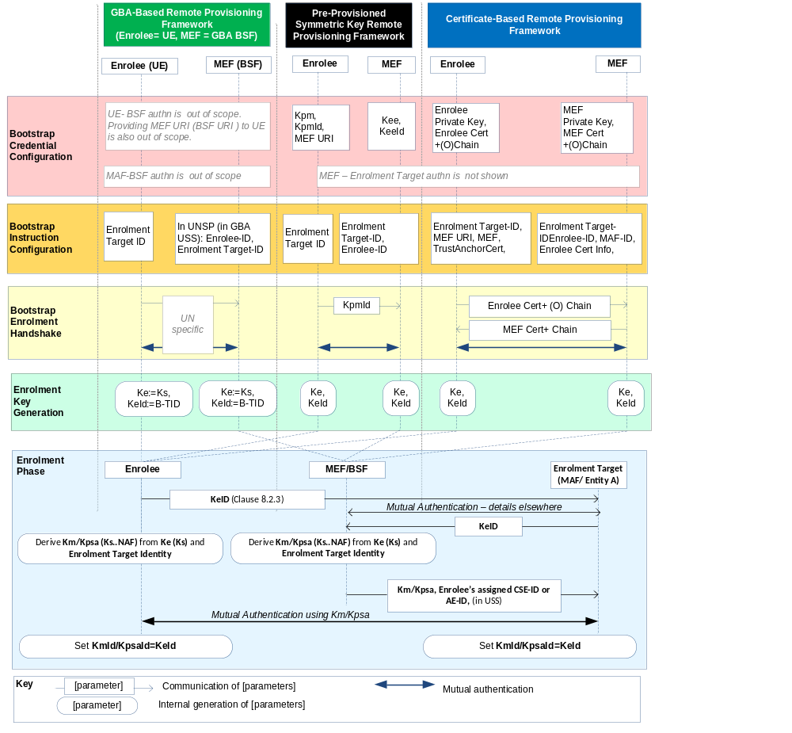Figure 8.3.1.2-1: Overview of the Remote Security Provisioning Frameworks supported by oneM2M
Editor's note: In the above figure and other similar ones, more parameters may need to be transferred from MAF to MEF in the "Usage in Centralized Key Distribution Server Handshake". This is FFS. (ACTION Qualcomm)

8.3.2 Centralized Remote Security Provisioning Framework

8.3.2.1 Pre-Provisioned Symmetric Key Remote Security Provisioning Framework
This clause describes the Pre-Provisioned Symmetric Key Remote Security Provisioning Framework. The Bootstrap Credential for this framework is a long-term symmetric key that has been pre-provisioned into the Enrolee and M2M Enrolment Function; this key is called a Pre-Provisioned Symmetric Enrolee Key and is denoted Kpm.
NOTE: Long term Pre-Provisioned Symmetric Enrolee Keys can pose a security risk if not adequately secured, and for this reason it is recommended that Long term Pre-Provisioned Symmetric Enrolee Keys are stored in Secure Environments.
Figure 8.3.2.1-1 illustrates the sequence of events when using the Pre-Provisioned Symmetric Enrolee Key Remote Security Provisioning Framework.

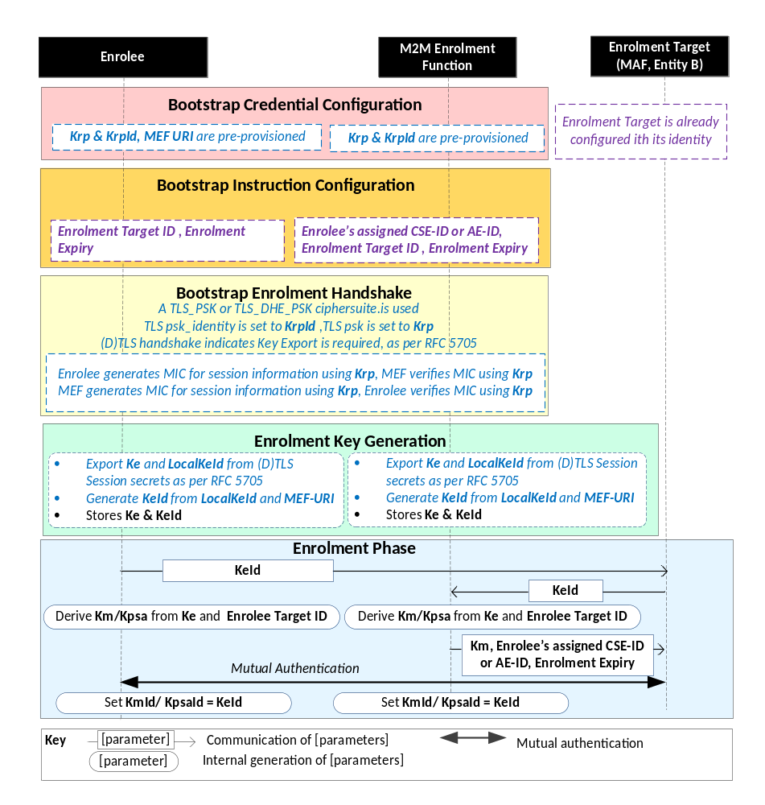

NOTE: The following font colours differentiate the general topic that the text relates to:
Black text contains Security-Bootstrap-Framework-independent details
Blue italic text highlights details specific to this particular Remote Security Provisioning Framework.
Purple italic text highlights technical actions that may include steps not specified by oneM2M.

Figure 8.3.2.1-1: The sequence of events when using
the Pre-Provisioned Symmetric Key Remote Security Provisioning Framework
Bootstrap Credential Configuration: The Pre-Provisioned Symmetric Enrolee Key (Kpm) and the corresponding Pre-Provisioned Symmetric Enrolee Key Identifier, denoted KpmId, are pre-provisioned to both entities. The Enrolee is also provisioned with the M2M Enrolment Function's URI (MEF URI), for the purpose of routing the (D)TLS exchange.
NOTE 1: This pre-provisioning (by definition) uses mechanisms not specified by oneM2M.
Bootstrap Instruction Configuration: The Enrolee and M2M Enrolment Function are configured with the information needed for authorizing the remote provisioning:
- The Enrolee is configured with (or otherwise obtains) the following arguments to initiate remote provisioning :
- Enrolment Target identity: Identifying the Enrolment Target for which the Enrolee is to be provisioned.

- The Enrolee associates these arguments with the M2M Enrolment Function. The M2M Enrolment Function can be identified to the Enrolee using the Pre-Provisioned Symmetric Enrolee Key Identifier (KpmId) or the M2M Enrolment Function URI.

- M2M Enrolment Function is configured with the following arguments to authorize the M2M Enrolment Function to remotely provision the Enrolee for an Enrolment Target:
- Enrolment Target Identity: Identifying thethe Enrolment Target for which the Enrolee is to be provisioned.
- Enrolee;s assigned CSE-ID or AE-ID. The M2M Enrolment Function is to provide this entity identity for the Enrolee with the Km or Kpsa to the Enrolment Target, when requested by the Enrolment Target.
- The M2M Enrolment Function associates these arguments with an Enrolee. The Enrolee can be identified to the M2M Enrolment Function using the Pre-Provisioned Symmetric Enrolee Key Identifier (KpmId).

Bootstrap Security Handshake: The Enrolee and M2M Enrolment Function perform a (D)TLS-PSK handshake [15] to establish a secure session.
- The "psk_identity" parameter [15] is set to the value of the Pre-Provisioned Symmetric Enrolee Key Identifier (KpmId).
- The "psk" parameter [15] is set to the value of the Pre-Provisioned Symmetric Enrolee Key (Kpm).
- The (D)TLS cipher suite profile for this TLS Handshake is specified in clause 10.2.2 “TLS and DTLS Ciphersuites for TLS-PSK-Based Security Frameworks”.
Enrolment Key Generation:
- The Enrolment Key (Ke) and RelativeKeId is generated from the (D)TLS session secrets by the Enrolee and M2M Enrolment Function using TLS Key Export (RFC 5705) [18], as described in clause 10.3.1 TLS Key Export Details..
- The Enrolment Key Identifier (KeId) is generated from the RelativeKeId and the M2M Enrolment Function’s FQDN by the Enrolee and M2M Enrolment Function, as described in clause 10.3.4 “Generating KeId”...
- The Enrolee and M2M Enrolment Function store the Enrolment Key (Ke) and Enrolment Key Identifier (KeId).
NOTE 2: The Enrolment Key Generation for the Pre-Provisioned Symmetric Enrolee Key Remote Security Provisioning Framework is identical to the Enrolment Key Generation for the Certificate-Based Remote Security Provisioning Framework.
Enrolment Phase: See "Overview of Security Frameworks" in clause 8.3.1.

8.3.2.2 Certificate-Based Remote Security Provisioning Framework
This clause describes the Certificate-Based Remote Security Provisioning Framework. The Bootstrap Credentials for this framework are Certificates.
Figure 8.3.2.2-1 illustrates the sequence of events when using the Certificate-Based Remote Security Provisioning Framework.
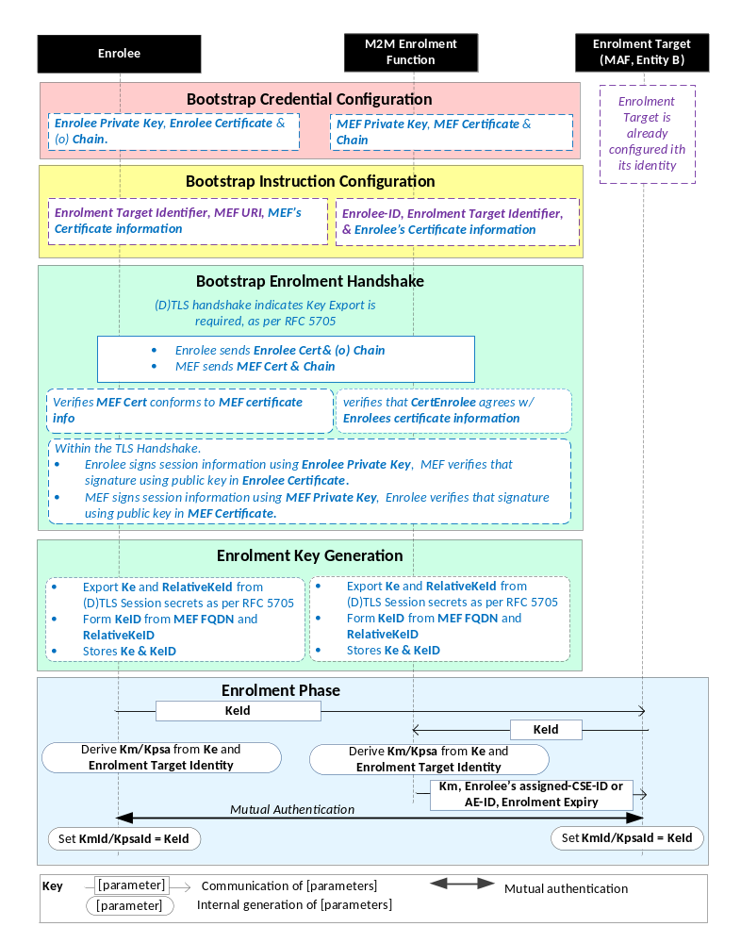

NOTE: The following font colours differentiate the general topic that the text relates to:
Black text contains Remote Security Provisioning-Framework-independent details.
Blue italic text highlights details specific to this particular Remote Security Provisioning Framework.
Purple italic text highlights technical actions that may include steps not specified by oneM2M.
Red italic text highlights security-related properties.

Figure 8.3.2.2-1: The sequence of events when using
the Certificate-Based Remote Security Provisioning Framework.
Bootstrap Credential Configuration: For this Remote Security Provisioning Framework, Enrolee and M2M Enrolment Function authenticate each other using a Public Key Certificate. The Bootstrap Credentials for the Enrolee and M2M Enrolment Function are pre-provisioned as described in clause 8.1.1.2.1 "Credential Configuration for Certificate-Based Security Frameworks".
NOTE 1: The identities of the M2M Enrolment Function and Enrolment Target are assumed to have been configured prior to this phase.
Bootstrap Instruction Configuration: The Enrolee and M2M Enrolment Function are configured with the information needed for authorizing the remote provisioning:
- The Enrolee is configured with (or otherwise obtains) the following arguments to initiate remote provisioning:
- The URI of the M2M Enrolment Function which will facilitate the remote provisioning, for the purpose of routing the (D)TLS exchange.
- Information needed for certificate authentication of the M2M Enrolment Function using an MEF certificate as described in clause 8.1.1.2.4 “Information Needed for Certificate Authentication of another Entity”.

- The identity of the Enrolment Target , with whom the Enrolee is to be provisioned using Remote Security Provisioning.

- The M2M Enrolment Function is configured with the following arguments describing Enrolee authorized to perform Security Handshake with M2M Enrolment Function:
- Information needed for certificate authentication of the Enrolee, as described in clause 8.1.1.2.4 “Information Needed for Certificate Authentication of another Entity”
- .
- The identity of the Enrolment Target, with whom the Enrolee (authenticated using the above Enrolee Certificate information) is to be provisioned using Remote Security Provisioning.
- The Enrolee’s assigned CSE-ID or AE-ID. The M2M Enrolment Function is to provide this entity identity for the Enrolee with the Km or Kpsa to the Enrolment Target, when requested by the Enrolment Target.

Bootstrap Security Handshake: The Enrolee and M2M Enrolment Function perform a (D)TLS handshake as specified in TLS 1,2 RFC 5246 [16] and DTLS 1.2 RFC 6347 [17] specifications.to establish a secure session.
- Each entity (Enrolee and M2M Enrolment Function) verifies the other entity's certificate as described in clause 8.1.1.2.5 "Certificate Verification".
- The Enrolee and M2M Enrolment Function authenticate each other using the validated certificates as specified in TLS 1.2 RFC 5246 [16] and DTLS 1.2 RFC 6347 [17] specifications.
- The (D)TLS cipher suite profile for this (D)TLS handshake is specified in clause 10.2.3 “TLS and DTLS Ciphersuites for Certificate-Based Security Frameworks”.
Enrolment Key Generation:
- The Enrolment Key (Ke) and RelativeKeId are generated from the (D)TLS session secrets by the Enrolee and M2M Enrolment Function using TLS Key Export (RFC 5705) [18], as described in clause 10.3.1 TLS Key Export Details.
- The Enrolment Key Identifier (KeId) is generated by the Enrolee and M2M Enrolment Function, as described in clause 10.y “Generating KeId”.
- The Enrolee and M2M Enrolment store the Enrolment Key (Ke) and Enrolment Key Identifier (KeId).
NOTE 2: The Enrolment Key Generation for the Pre-Provisioned Symmetric Enrolee Key Remote Security Provisioning Framework is identical to the Enrolment Key Generation for the Certificate-Based Remote Security Provisioning Framework.
Enrolment Phase: See "Overview of Remote Security Provisioning Frameworks" in clause 8.3.1.

8.3.2.3 GBA-Based Remote Security Provisioning Framework
To share a long term Master Credential (Km) between an Application Service/Middle Node and an M2M Authentication Function, the M2M Application Service/Middle Node shall perform a successful GBA bootstrapping and derive a NAF key (Ks_(ext/int)_NAF). This NAF key is the Master Credential (Km).
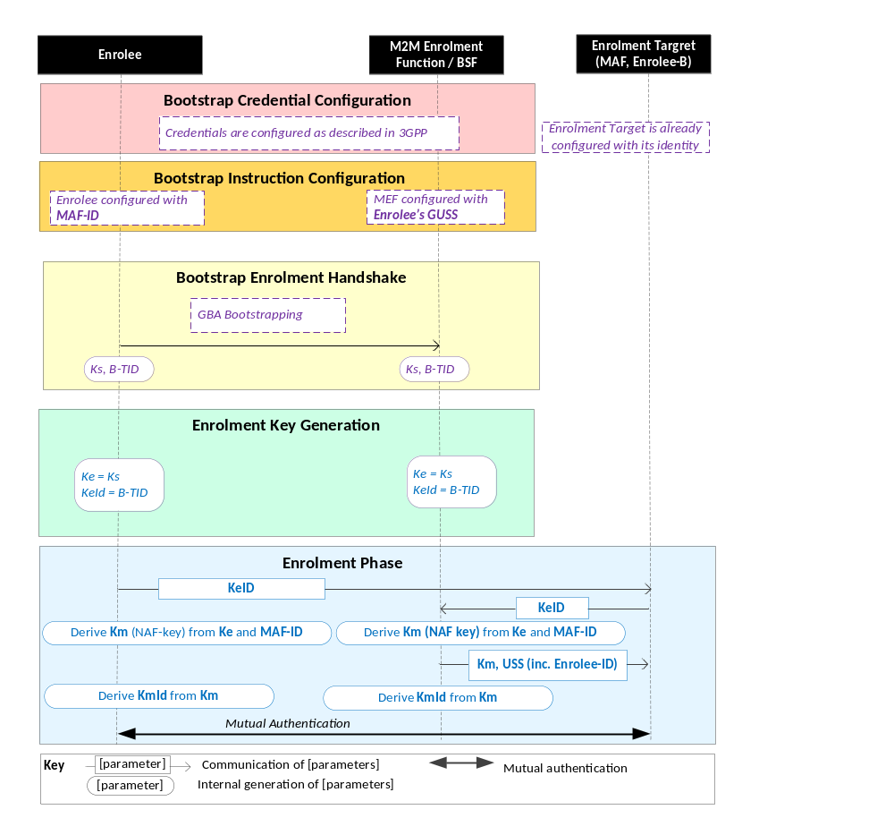
Figure 8.3.3.1-1: The sequence of events when using the GBA-Based Remote Security Provisioning Framework.
NOTE: The following font colours differentiate the general topic that the text relates to:
Black text contains Remote Security Provisioning-Framework-independent details.
Blue italic text highlights details specific to this particular Remote Security Provisioning Framework.
Purple italic text highlights technical actions that may include steps not specified by oneM2M.
Bootstrap Credential Configuration: The credentials configuration for Enrolee and M2M Enrolment Function (MEF) is described in 3GPP specification TS 33.220 [13]. The MEF plays the role of the BSF. The credentials used to perform mutual authentication between Enrolee and MEF are UNSP specific.
Bootstrap Instruction Configuration: the Enrolee, the MEF and the MAF shall be configured with the information needed for authorizing the remote provisioning.
  - The Enrolee shall be configured with the identity of the Enrolment Target with whom the Enrolee is to be provisioned using Remote Security Provisioning.
  - The MEF shall be configured with
    - The identity of the Enrolment Target.
    - The Enrolee’s assigned CSE-ID or AE-ID The M2M Enrolment Function is to provide this entity identity for the Enrolee with the Km or Kpsa to the Enrolment Target, when requested by the Enrolment Target.

  - Enrolee’s GBA User Security Settings (GUSS) enables to indicate if Enrolee is allowed to establish a NAF-specific key with the MAF or/and if the BSF can distribute a NAF specific key to the MAF.

Bootstrap Enrolment Handshake:

The Bootstrap Enrolment Handshake enables the establishment of a GBA bootstrapped key (Ks) shared between the Enrolee and the MEF with associated Bootstrapping Transaction Identifier ( B-TID) and key lifetime, by performing to the GBA Bootstrapping phase described in 3GPP TS 33.220 [13].

If a bootstrapped key Ks is already shared between Enrolee and the MEF and still valid, then the Bootstrap Enrolment Handshake phase is not needed. The Enrolment Key Generation phase can take place with the existing GBA Bootstrapped key Ks.

Enrolment Key Generation phase

The Enrolment Key (Ke) shall be the GBA Bootstrapped key (Ks) established during the Bootstrap Enrolment Handshake.

The Enrolment Key Identifier (Ke-ID) shall be the Bootstrapping Transaction Identifier (B-TID) generated during the Bootstrap Enrolment Handshake.

Enrolment Phase:
- The Enrolee and the MAF shall establish the Master Credential (Km) thanks to procedures described in 3GPP TS 33.220 [13] using the Enrolment Key (Ke) as GBA bootstrapped key Ks and the Enrolment Key Identifier (Ke-ID) as B-TID. The MAF plays the role of a NAF.
  - The Enrolee and the MAF shall establish NAF-specific key(s) as described in 3GPP TS 33.220 [13]. A key lifetime is associated to the NAF-specific keys. The MAF also receives the Enrolee’s User Security Settings (USS) from the MEF/BSF.
    - In case of GBA_ME, NAF-specific key is Ks_NAF
    - In case of GBA_U, NAF-specific keys are Ks_int_NAF and Ks_ext_NAF.
  - The Master Credential (Km) shall be the NAF-specific key:
    - In case of GBA_ME, Km = Ks_NAF
    - In case of GBA_U, Km = Ks_int_NAF if HTTP Client application resides in the UICC. Otherwise, Km = Ks_ext_NAF.
  - The Enrolee and the MAF shall set the Master Credential Identifier (Km-Id) to the value of KeId.
- Enrolee and MAF shall shall perform (D)TLS-PSK handshake (RFC 4279 [15]) with the Master Credential (Km) as Pre-Shared Key in compliance with clause 10.2.2 “TLS and DTLS Ciphersuites for TLS-PSK-Based Security Frameworks”.

If UICC is used as Secure Environment supporting Remote Security Provisioning, GBA-U with Kc = Ks_int_NAF shall be used for authentication and key exchange.

9 Security Framework Procedures and Parameters

-----------------------End of change 1---------------------------------------------

-----------------------Start of change 2-------------------------------------------

10.3.1 TLS Key Export Details
Following successful TLS authentication between the Enrolee and M2M Enrolment Function, the Enrolment Key (Ke) and RelativeKeId are generated from the (D)TLS session secrets by the Enrolee and M2M Enrolment Function by applying TLS Key Export (RFC 5705) [18] using the label “EXPORTER-oneM2M-Bootstrap” and length 48. The Enrolment Key (Ke) is set to the value of the 32 least significant bytes, while RelativeKeId is set to the value of the 16 most significant bytes.
Editor’s note: the label “EXPORTER-oneM2M-Bootstrap” will need to be registered with IANA for inclusion on the TLS parameters registry: http://www.iana.org/assignments/tls-parameters/tls-parameters.xml.

-----------------------End of change 2---------------------------------------------

-----------------------Start of change 3-------------------------------------------

10.3.3 Derivation of Provisioned Secure Connection Key from Enrolment Key
This clause describes the details when generating a Provisioned Secure Connection Key (Kpsa) from an Enrolment Key (Ke) in Remote Provisioning Frameworks.
The following information shall be used when generating Kpsa from Ke:
- The value of the Enrolment Key (Ke);
- Enrolee’s CSE-ID or AE-ID, which shall be encoded to an octet string according to UTF-8 encoding rules as specified in IETF RFC 3629 [19] and apply Normalization Form KC (NFKC) as specified in [20].
The value of Kpsa shall be generated as
Kpsa := HMAC-SHA-256(Ke, “oneM2M Enrolment Key to Provisioned Secure Connection Key derivation” || Enrolee’s CSE-ID or AE-ID),
where HMAC-SHA-256 is defined in RFC 2014 [RFC2014].

-----------------------End of change 3---------------------------------------------

The text should be added as a new sub clause (or sub-sub clause!) of clause 10.

-----------------------Start of change 4-------------------------------------------

10.3.4 Generating KeId
The KeId value shall be formed as
KeId = base64encode(RelativeKeId)@MEF_FQDN,
where
- base64encode(RelativeKeId) denotes the base64 encoding (RFC 3548 [RFC 3548]) of the value of RelativeKeId, and
- MEF_FQDN denotes the FQDN of the M2M Enrolment Function.

-----------------------End of change 4-------------------------------------------

Add the following normative reference

-----------------------Start of Changes to References Section -------------

2.1 Normative references
[RFC3548] RFC 3548 "The Base16, Base32, and Base64 Data Encodings".

-----------------------End of Changes to References -------------

CHECK LIST
- Does this change request include an informative introduction containing the problem(s) being solved, and a summary list of proposals.?
- Does this CR contain changes related to only one particular issue/problem?
- Does this change request make all the changes necessary to address the issue or problem? E.g. A change impacting 5 tables should not only include a proposal to change only 3 tables. Includes any changes to references, definitions, and acronyms in the same deliverable?
- Does this change request follow the drafting rules?
- Are all pictures editable?
- Does this change request avoid conflict with the content of an already approved text, by modification, deletion or the addition of an editor’s note?
- Have you checked the spelling and grammar?
- Have you used change bars for all modifications?
- Does the change include the current and surrounding clauses to clearly show where a change is located and to provide technical context of the proposed change? (Additions of complete sections need not show surrounding clauses as long as the proposed section number clearly shows where the new section is proposed to be located.)
- Are multiple changes in this CR clearly separated by horizontal lines with embedded text such as, start of change 1, end of change 1, start of new clause, end of new clause.?

