CHANGE REQUEST
Group Name:* | SEC#14.3
Source:* | Philip Hawkes, Qualcomm, phawkes@qti.qualcomm.com,  Wolfgang Granzow, Qualcomm, wgranzow@qti.qualcomm.com  Josef Blanz, Qualcomm, jblanz@qti.qualcomm.com
Format:* | Teleconference
Date:* | 2015-01-08
Contact:* | As above
Reason for Change/s:* | This CR provides generic changes (not related to a specific authentication mechanism) to align with changes to the AE Registration process has been updated in TS-0001 clause 10.1.1.2.2.
CR against: | TS-0001 v0.8.1
Clauses/Sub Clauses  Affected* | 6.1.1, 6.1.2.2.1, 8.2.1, 8.3.1.2, 9, new 10.4 “Credential-ID Format”
Intended purpose of  document:* | Decision  Discussion  Information  Other <specify>
Decision requested or recommendation:* | Apply changes to TS-0003

oneM2M Notice
The document to which this cover statement is attached is submitted to oneM2M. Participation in, or attendance at, any activity of oneM2M, constitutes acceptance of and agreement to be bound by terms of the Working Procedures and the Partnership Agreement, including the Intellectual Property Rights (IPR) Principles Governing oneM2M Work found in Annex 1 of the Partnership Agreement.
GUIDELINES for Change Requests:
Provide an informative introduction containing the problem(s) being solved, and a summary list of proposals.
Each CR should contain changes related to only one particular issue/problem.
Follow the principle of completeness, where all changes related to the issue or problem within a deliverable are simultaneously proposed to be made E.g. A change impacting 5 tables should not only include a proposal to change only 3 tables. Includes any changes to references, definitions, and acronyms in the same deliverable.
Follow the drafting rules.
All pictures must be editable.
Do not conflict with the content of an already approved text, by modification, deletion or the addition of an editor’s note.
Check spelling and grammar to the extent practicable.
Use Change bars for modifications.
The change should include the current and surrounding clauses to clearly show where a change is located and to provide technical context of the proposed change. Additions of complete sections need not show surrounding clauses as long as the proposed section number clearly shows where the new section is proposed to be located.
Multiple changes in a single CR shall be clearly separated by horizontal lines with embedded text such as, start of change 1, end of change 1, start of new clause, end of new clause.
When subsequent changes are made to content of a CR, then the accepted version should not show changes over changes. The accepted version of the CR should only show changes relative to the baseline approved text.

Introduction
For each change in this CR, there is a comment identifying one or more of the following reasons for the change:
- ALIGNMENT WITH TS-0001. Changes to align the Security Association Establishment Framework and Remote Security Provisioning Frameworks with changes in TS-0001 Functional Architecture clause 10.1.1.2.2.
- BUG: changes to correct technical information
- EDITORIAL: changes to improve readability. No technical changes.
- TYPO: changes to correct typographic errors. No technical changes
- DEVICE CERT → oCID CERT: at SEC#14.2, Qualcomm introduced the concept of the object-identifier based “oneM2M-Certificate-ID” (abbreviated here to “oCID”). . It was necessary to generalize the device certificates to the oCID certificates in order to support the scenarios described in TS-0001 clause 10.1.1.2.2. oCID certificates may be associated with any of: a single CSE; a single AE; multiple AE with same App-ID on same Node; or multiple AE with multiple App-ID on same Node. Other mechanisms (e.g. TS-0001 clause 10.1.1.2.2) are used to associate the oCID with the CSE-ID, AE-ID, or AE-ID(s) that are authenticated using that certificates. Therefore these changes are indirectly “ALIGNMENT WITH TS-0001”. oCID certificates are described in a parallel CR.

-----------------------Start of change 1-------------------------------------------

6.1.1 Interactions between layers
Before any M2M Common Services layer procedure can take place, connectivity has to be established in the underlying Network Services Layer, which may involve independent provisioning and service registration procedures specified by the underlying network.
The Service Layer Security provisioning (security pre-provisioning or security bootstrapping) and Security Association Establishment procedures specified in the present document can take place independently (and generally consecutively) from any required Network Service Layer connectivity establishment procedures.
Finally, the security provisioning and security association establishment requirements imposed by M2M Application Service Providers have to be accounted for. At the service layer level, the security association establishment results in a TLS or DTLS session which protects messages being exchanged between adjacent AE/CSE, i.e. hop-by-hop. AEs that need to preserve the privacy of their information exchange from untrusted intermediate nodes may be provisioned to support a direct security association between them. Such security associations enable to encrypt the content of resources exchanged between AEs through the service layer.
A credential used in a TLS/DTLS session is either associated with a single CSE/AE on a Node, or with multiple AEs on the same Node: for example, multiple AEs with the same App-ID on the same Node.

-----------------------End of change 1---------------------------------------------

-----------------------Start of change 2-------------------------------------------

6.1.2.2.1 M2M Service Access
AEs and CSEs seeking access to M2M services need to be mutually identified and authenticated with the M2M Service Infrastructure, in order to provide protection from unauthorized access and Denial of Service attacks. This mutual authentication enables to additionally provide encryption and integrity protection for the exchange of messages across a single Mca, Mcc or Mcc’ reference point. In addition, communicating AEs that require similar protection for their own information exchanges may be provisioned to apply the same security method to their communications.

-----------------------End of change 2---------------------------------------------

-----------------------Start of change 3-------------------------------------------

8.2.1 Overview on Security Association Establishment Frameworks
In the present document, security associations are restricted to single hop on Mcc, Mcc’ or Mca reference point.
The oneM2M system supports the following Security Association Establishment Frameworks:
- Security Association Establishment Frameworks:
- Provisioned Symmetric Key Security Association Establishment. A symmetric key is provisioned to the entities: this is called the Provisioned M2M Symmetric Key, and denoted Kpsa. The entities authenticate each other by verifying Message Integrity Codes (MIC) in the Security Handshake which were generated using the symmetric key. For more details see clause 8.2.2.1.
- Certificate-Based Security Association Establishment: The entities are each issued with
- a Private Signing Key that is known only to that entity,
- a Certificate containing the corresponding Public Verification Key, and
- (Optionally) a Certificate Chain from the entity's Certificate to a Root Certificate.
The entities must validate each other's Certificate before trusting the Public Verification Keys in the Certificate. Within the Security Handshake, entity A creates a digital signature of the session parameters using its private signing key and entity B verifies the digital signature using entity A's public verification key. Then the roles are reversed: entity B creates a digital signature and entity A verifies it. For more details see clause 8.2.2.2.
- M2M Authentication Function (MAF)-based Security Association Establishment. This Security Association Establishment Framework uses symmetric keys to authenticate the entity A and the M2M Authentication Function (MAF) and derive a M2M Secure Connection key (Kc) that the MAF delivers to entity B. Then entities then authenticate each other using the M2M Secure Connection key (Kc). For more details see clause 8.2.3.1.
For a more detailed description of the above Security Association Establishment Frameworks, it is useful to compare the following aspects of the Security Association Establishment Frameworks:
- Credential Configuration:
- For MAF-based Security Association Establishment Frameworks:
- Entity A is configured with (or otherwise establishes) the Master Credential (Km) that the entity A will use to authenticate the entity A to the MAF.
- The MAF is configured with the Master Credential (Km) that will be used to authenticate the MAF to entity A.
The details for the GBA-Based Security Association Establishment Framework are out of scope.
- For the Provisioned Symmetric Key Security Association Establishment Framework, each entity is provisioned with the Provisioned M2M Symmetric Key that entities will use to authenticate each other using pre-provisioning or remote provisioning.
- For the Certificate-Based Security Association Establishment Frameworks, each entity is pre-provisioned with the Credential that the entity will use to authenticate itself to the other entity.
- Association Configuration: Configuration of entity identifiers (that is, CSE-ID or AE-ID) for the entities to be authenticated.
Additionally,
- In the case of Certificate-Based Authentication Framework: each entity is configured with the certificate information that the entity will use to verify the other entity. The necessary certificate information is dependent on the flavour of the certificates, with details provided in clause 8.1.2.4 “Information Needed for Certificate Authentication of another Entity”.
- In the case of MAF-Based Authentication Framework: The MAF is provided with the identity of Entity B for which the MAF is authorized to facilitate establishing a secure association with Entity A.
- Association Security Handshake: Identification, authentication and security context establishment between the entities.
  - MAF Handshake: When a MAF-based Security Association Establishment Framework is used, entity A and the MAF perform mutual authentication and generate a M2M Secure Connection Key (Kc) which is then used in the Security Handshake for mutual authentication between entity A and entity B. This is not applicable to Certificate-based or Provisioned Symmetric Key-based Security Association Establishment Frameworks.
Figure 8.2.1-1 provides a summary of the above defined three Security Association Establishment Frameworks.
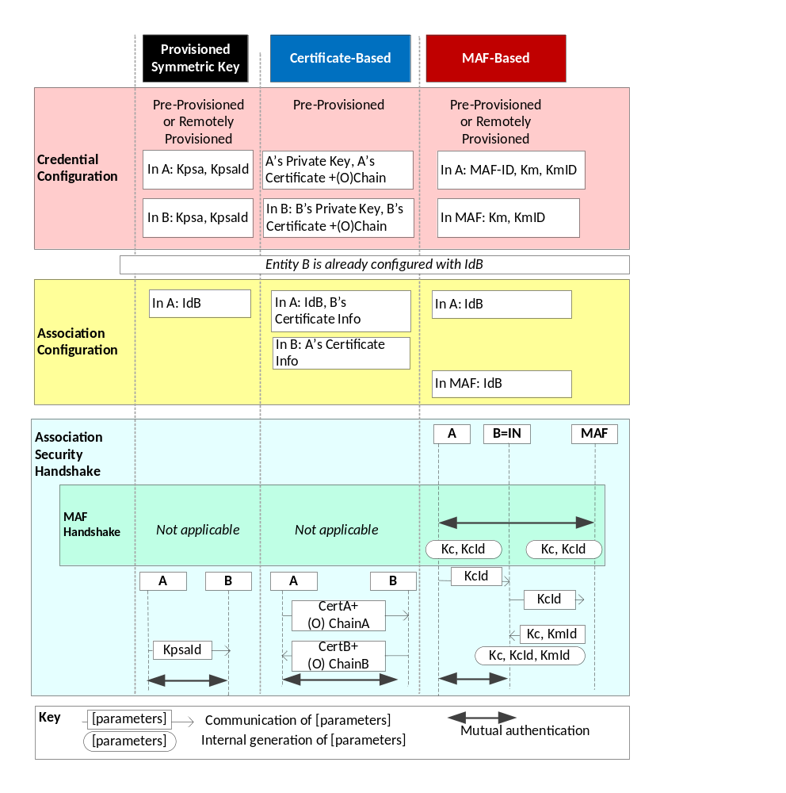
Figure 8.2.1-1: Overview of the Security Association Establishment Frameworks
supported by oneM2M.

-----------------------End of change 3---------------------------------------------

-----------------------Start of change 4-------------------------------------------

8.3.1.2 Overview on Remote Security Provisioning Frameworks
An AE or CSE that requires remote provisioning of a Master Credential and Master Credential Identifier or a Provisioned Secure Connection Key (Kpsa) and Provisioned Secure Connection Key Identifier (KpsaId) is called an Enrolee. The AE or CSE with whom the enrolee is to establish a security association is called Enrolee B. The AE or CSE or M2M Authentication Function with whom the enrolee is to establish a shared key is called an Enrolment Target.
The oneM2M system supports the following Security Bootstrap Frameworks:
- Pre-Provisioned Symmetric Enrolee Key Remote Security Provisioning Framework: A symmetric key is pre-provisioned to the Enrolee and M2M Enrolment Function for the mutually authentication of those entities. For more details, see clause 8.3.2.1.
- Certificate-Based Remote Security Provisioning Framework: The Enrolee and M2M Enrolment Function are each issued with
- a Private Signing Key that is known only to that entity,
- a Certificate containing the corresponding Public Verification Key, and
- (In the case of an oneM2M Certificate ID (oCID) certificate, CSE-ID certificate or AE-ID certificate) a Certificate Chain from the entity's Certificate to a Trust Anchor Certificate.
The Enrolee and M2M Enrolment Function shall validate each other's Certificate before trusting the Public Verification Keys in the Certificate. Within the Security Handshake, the M2M Enrolment Function creates a digital signature of the session parameters using its private signing key and the Enrolee verifies the digital signature using the M2M Enrolment Function's public verification key. Then the roles are reversed: the Enrolee creates a digital signature and the M2M Enrolment Function verifies it. For more details see clause 8.3.2.2.
- GBA-based Remote Security Provisioning Framework. In this case, the role of the M2M Enrolment Function is performed by a GBA Bootstrap Server Function. This framework uses 3GPP or 3GPP2 symmetric keys to authenticate the Enrolee and the M2M Enrolment Function (which is also a GBA BSF). The details are specified by 3GPP [13] and 3GPP2 [14]. For more details see clause 8.3.2.3.
For a more detailed description of the above Remote Security Provisioning Frameworks, it is useful to compare the following aspects of the Remote Security Provisioning Frameworks.
- Bootstrap Credential Configuration: The Enrolee and M2M Enrolment Function are pre-provisioned with the Bootstrap Credential that the entity will use to authenticate itself to the other entity. The mechanisms for this pre-provisioning are not described in this specification.
- Bootstrap Instruction Configuration:
- The Enrolee is provided with
- either
  - The M2M Authentication Function Identifier (MAF-ID) identifying the M2M Authentication Function for which the Enrolee is to be remotely provisioned when used in conjunction with a MAF-based security association establishment framework; or
  - The identifier of Enrolee B (Enrolee B-ID), when used in conjunction with a Provisioned Symmetric Key Security Association Establishment.
NOTE 1: The identity of the M2M Authentication Function or the Enrolee B is assumed to have been configured prior to the Bootstrap Instruction Configuration phase.
- The M2M Enrolment Function may be provided with the CSE-ID or AE-ID that the M2M Authentication Function or Enrolee B is to associate with the Enrolee.
Additionally, in the case of Certificate-Based Remote Security Provisioning Framework:
- The Enrolee is configured with the M2M Enrolment Function URI (for the purpose of routing the (D)TLS messages to the M2M Enrolment Function), and M2M Enrolment Function Trust Anchor information hat the Enrolee will use to verify the M2M Enrolment Function.
- The M2M Enrolment Function is configured with Enrolee’s certificate informationA globally unique name for the certificate
- If the certificate has a certificate chain, then any globally unique name in the subjectAlternativeName element may be used, such as an oneM2M-Certificate-ID. and

- .
- Enrolment Key Generation: generating a symmetric Enrolment Key, (Ke) and corresponding Enrolment Key Identifier (KeId) shared by the Enrolee and M2M Enrolment Function, which is used for subsequent generation of the Master Credential (Km) or Provisioned M2M Symmetric Key (Kpsa).
- Integration to the Association Security Handshake:
For MAF-based symmetric Key Security Association, the following steps occur during the MAF Handshake of the MAF-Based Security Association Establishment:
- The Enrolee derives the Master Credential (Km) from the Enrolment Key (Ke) and M2M Authentication Function Identifier (MAF-ID). Details of the derivation are provided in clause 9.4.
- The Enrolee generates the Master Credential Identifier (KmId) from Master Credential (Km) as described in clause 9.1, and stores Km and KmId.
- The Enrolee passes the Enrolment Key Identifier (KeId) to the M2M Authentication Function (see "MAF Handshake" in clause 8.2.2.3)
NOTE 2: When the Enrolee first communicates with the M2M Authentication Function, then the M2M Authentication Function has not yet retrieved the Km from the M2M Enrolment Function. Consequently, the Enrolee provides the KeId to the M2M Authentication function, which is then passed to the M2M Enrolment Function to identify the Enrolment Key. The M2M Enrolment Function then returns the Km from which the M2M Authentication Function can derive the KmId. In subsequent Security Establishments, the Enrolee may provide the KmId or the KeId, and the M2M Authentication Function will know that both identifiers indicate the retrieved Km. For more details, see "MAF Handshake" in clause 8.2.2.3.
- Upon receipt of the KeId, the M2M Authentication Function determines if it already has the corresponding Km and CSE-ID or AE-ID of the Enrolee
- If the M2M Authentication Function already has the corresponding Km and CSE-ID or AE-ID of the Enrolee, then the Km is used for mutual authentication (see "MAF Handshake" in clause 8.2.2.3)
- If the M2M Authentication Function does not have the corresponding Master Credential (Km) and CSE-ID or AE-ID of the Enrolee, then the following steps are followed.
- The M2M Authentication Function (securely) passes the KeId to the M2M Enrolment Function, along with the M2M Authentication Function's URI.
- The M2M Authentication Function initiates establishing a mutually-authenticated TLS Session with the M2M Enrolment Function.
      - The M2M Authentication Function authenticates itself to the M2M Enrolment Function using an FQDN certificate containing the FQDN of the M2M Authentication Function.
      - The M2M Enrolment Function authenticates itself to the M2M Authentication Function using an FQDN certificate containing the FQDN of the M2M Enrolment Function.
- The M2M Enrolment Function derives the Km from the Ke and MAF-ID. Details of the derivation are provided in clause clause 10.3.2 “Derivation of Master Credential from Enrolment Key”.
- The M2M Enrolment Function returns the Km to the M2M Authentication Function. The M2M Enrolment Function also passes the CSE-ID or AE-ID of the Enrolee (if configured to the M2M Enrolment Function).
- The M2M Authentication Function generates the Master Credential Identifier (KmId) from Master Credential (Km) as described in clause 9.1, and stores Km and KmId.
- The Master Credential (Km) is used for mutual authentication and generation of Kc and KcId as described in MAF-Based Security Association Establishment Framework (see "MAF Handshake" in clause 8.2.2.3).
- The Enrolee and M2M Authentication Function set Master Credential Identifier (KmId) to the value of the Enrolment Key Identifier (KeId).
- The Enrolee and M2M Authentication Function store Km and KmId.
For Provisioned Symmetric Key Security Association Establishment, similar procedure applies where Enrolee B plays the role of M2M Authentication Function, Kpsa plays the role of Km, KpsaId is generated instead of KmId. Generation of Kpsa is described in 10.3.3 “Derivation of Provisioned Secure Connection Key from Enrolment Key”.

Figure 8.3.1.2-1 provides a summary of the above defined Remote Security Provisioning Frameworks.

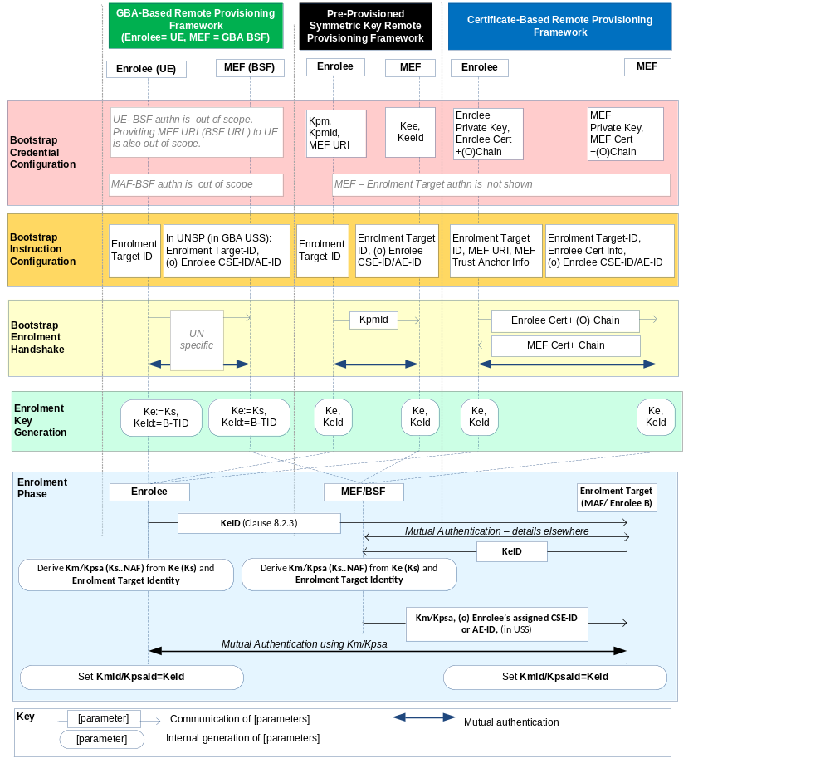Figure 8.3.1.2-1: Overview of the Remote Security Provisioning Frameworks supported by oneM2M

-----------------------End of change 4---------------------------------------------

-----------------------Start of change 5-------------------------------------------

9 Security Framework Procedures and Parameters
This clause specifies procedures and parameters of the phases of Security Association Establishment Frameworks (clause 8.2) and Remote Security Provisioning Frameworks (clause 8.3).

9.1 Security Association Establishment Framework Procedures and Parameters

9.1.1 Credential Configuration Parameters
The following Credential Configuration procedures are described in the present clause:
- Credential Configuration of Entity A and Entity B , see Clause 9.1.1.1,
- Credential Configuration of M2M Authentication Functions, see Clause 9.1.1.2,

9.1.1.1 Credential Configuration of Entity A and Entity B
Table 9.1.1.1-1 lists the parameters configured to a Field-Domain Security Association End-Points in the Credential Configuration phase.
Table 9.1.1.1-1 Parameters configured to a Field Domain Security Association end-point during the Credential Configuration phase.
Security Association Establishment Framework |  | Parameter
Provisioned Symmetric Key |  | Kpsa
 |  | KpsaId
Certificate Based | Entity authenticates itself using a Raw Public Key Certificate | Entity’s Private Key
Certificate Based |  | Entity’s Raw Public Key Certificate
Certificate Based | Entity authenticates itself using a oCID Certificate | Entity’s Private Key
Certificate Based | Entity authenticates itself using a oCID Certificate | Entity’s oCID Certificate and Chain
Certificate Based | Entity authenticates itself using a CSE-ID Certificate | Entity’s CSE-ID
Certificate Based | Entity authenticates itself using a CSE-ID Certificate | Entity’s Private Key
Certificate Based | Entity authenticates itself using a CSE-ID Certificate | Entity’s CSE-ID Certificate and Chain
Certificate Based | Entity authenticates itself using an AE-ID Certificate | Entity’s AE-ID
Certificate Based | Entity authenticates itself using an AE-ID Certificate | Entity’s Private Key
Certificate Based | Entity authenticates itself using an AE-ID Certificate | Entity’s AE-ID Certificate and Chain
MAF-Based | Entity A | MAF Identifier (MAF-ID)
MAF-Based | Entity A | Master Credential (Km Id)
MAF-Based | Entity A | Master Credential Identifier (KmId)
MAF-Based | Entity B | Entity B and MAF shall be able to establish mutually-authenticated secure communication. The details are not specified in the present document
The Credential Configuration of Entity A, Entity B and the MAF for the Provisioned Symmetric Key Security Association Establishment Framework, or the MAF-Based Security Association Establishment Framework is achieved through either:
- Pre-provisioning via mechanisms which are not specified in the present document.
- Remote provisioning via one of the Remote Security Provisioning Frameworks in Clause 8.3.
The Credential Configuration of Entity A and Entity B for the Certificate Security Association Establishment Frameworks is performed by pre-provisioning via mechanisms which are not specified in the present document.

9.1.1.2 Credential Configuration of M2M Authentication Functions
Table 9.1.1.2-1 lists the parameters configured to M2M Authentication Functions in the Credential Configuration phase. The M2M Authentication Function’s identifier (MAF-ID) is presumed to have been configured prior to the Credential Configuration phase.
Table 9.1.1.2-1 Parameters configured to a M2M Authentication Functions during the Credential Configuration phase.
Security Association Establishment Framework |  | Parameter
MAF-Based | A-to-MAF Authentication | (o) Entity A’s CSE-ID or AE-ID (IdA)
MAF-Based | A-to-MAF Authentication | masterCredential (Km)
MAF-Based | A-to-MAF Authentication | masterCredentialIdentifier (KmId)
MAF-Based | B-to-MAF Authentication | Entity B and MAF shall be able to establish mutually-authenticated secure communication. The details are not specified in the present document
The Credential Configuration of M2M Authentication Framework shall be achieved through either:
- Business logic of the Stakeholder operating the M2M Authentication Function, and the details are not described in this specification.
- Remote provisioning via one of the Remote Security Provisioning Frameworks in Clause 8.3.

9.1.2 Association Configuration Procedures and Parameters
The following Association Configuration procedures are described in this clause:
- Association Configuration of Entity A, see Clause 9.1.2.1,

- Association Configuration of Entity B, see Clause 9.1.2.2, and
- Association Configuration of M2M Authentication Functions, see Clause 9.1.2.3.

9.1.2.1 Association Configuration of Entity A
Table 9.1.2.1-2 lists the parameters configured to Entity A in the Association Configuration phase.
Table 9.1.2.1-1 Parameters configured to Entity A and Entity B during the Association Configuration phase.
Security Association Establishment Framework |  | Parameters specific to the Security Association Establishment Frameworks
Provisioned Symmetric Key |  | None
Certificate Based | Entity B is authenticated using Raw Public Key Certificate | Entity B’s identity (IdA or IdB)
Certificate Based | Entity B is authenticated using Raw Public Key Certificate | Entity B’s Public key identifier
Certificate Based | Entity B is authenticated using oCID Certificate | Entity B’s identity (IdA or IdB)
Certificate Based | Entity B is authenticated using oCID Certificate | Entity B’s certificate’s oCID
Certificate Based | Entity B is authenticated using oCID Certificate | Entity B’s trust anchor certificates
Certificate Based | Entity B is authenticated using CSE-ID Certificate | Entity B’s CSE-ID (IdA or IdB)
Certificate Based | Entity B is authenticated using CSE-ID Certificate | Entity B’s trust anchor certificates
Certificate Based | Entity B is authenticated using AE-ID Certificate | Entity B’s AE-ID (IdA or IdB)
Certificate Based | Entity B is authenticated using AE-ID Certificate | Entity B’s trust anchor certificates
MAF-Based |  | Entity B’s CSE-ID or AE-ID (IdB)
Mechanisms for Association Configuration of Entity A shall authenticate the configuration source and provide integrity protection for the configured information communicated from the configuration source to the entity.

9.1.2.2 Association Configuration of Entity B
Table 9.1.2.2-1 lists the parameters configured to Registrar (Entity B) in the Credential Configuration phase.
Table 9.1.2.2-1 Parameters configured to Registrar (Entity B) during the Credential Configuration phase.
Security Association Establishment Framework |  | Parameters specific to the Security Association Establishment Frameworks
Provisioned Symmetric Key |  | None
Certificate Based | Entity A is authenticated using Raw Public Key Certificate | None
Certificate Based | Entity A is authenticated using oneM2M-oCID certificate, CSE-ID certificate or AE-ID certificate | Entity A’s trust anchor certificates
MAF-Based |  | None
Mechanisms for Association Configuration of Entity B shall authenticate the configuration source and provide integrity protection for the configured information communicated from the configuration source to the entity.

9.1.2.3 Association Configuration of M2M Authentication Functions
Table 9.1.2.3-1 lists the parameters configured to M2M Authentication Functions in the Association Configuration phase.
Table 9.1.2.3-1 Parameters configured to a M2M Authentication Functions during the Association Configuration phase.
Security Association Establishment Framework |  | Parameter
MAF-Based | A-to-MAF Authentication | Entity B’s CSE-ID or AE-ID (IdB)
This specification assumes that Association Configuration of the M2M Authentication Functions will utilize business logic of the Stakeholder that operates the M2M Authentication Function, and the details are not described in this specification.

9. 2 Remote Security Provisioning Framework Procedures and Parameters

9.2.1 Bootstrap Credential Configuration Procedures and Parameters
The following Bootstrap Credential Configuration procedures are described in this clause:
- Bootstrap Credential Configuration of Enrolees and Enrolment Targets (except for the GBA-Based case as discussed below), see Clause 9.2.1.1,
- Bootstrap Credential Configuration of M2M Enrolment Functions (except for the GBA-Based case as discussed above), see Clause 9.2.1.2.
The following Bootstrap Credential Configuration procedures are specified by other organizations:
- Bootstrap Credential Configuration of Underlying Network Service Provider authentication servers (e.g. HLR, HSS or AAA) for the GBA-Based Security Association Establishment Framework. These details are specified by 3GPP TS 33.220 [13], 3GPP2 S.S0109-A [14].
- Bootstrap Credential Configuration of Enrolees for the GBA-Based Security Association Establishment Framework. These details are specified by 3GPP TS 33.220 [13], 3GPP2 S.S0109-A [14].

9.2.1.1 Bootstrap Credential Configuration of Enrolee
Table 9.2.1.1-1 lists the parameters configured to Enrolees in the Bootstrap Credential Configuration phase for authentication with the M2M Enrolment Function in the Pre-Provisioned Symmetric Enrolee Key Remote Security Provisioning Framework and Certificate-Based Remote Security Provisioning Framework.
Table 9.2.1.1-1 Parameters configured to Enrolees during the Bootstrap Credential Configuration phase.
Remote Security Provisioning Framework |  | Parameter
Pre-Provisioned Symmetric Enrolment Key authentication |  | Kpm
 |  | KpmId
 |  | MEF URI
Certificate-Based authentication | Entity authenticates itself using a raw public key | Entity’s Private Key
Certificate-Based authentication | Entity authenticates itself using a raw public key | Entity’s Raw Public Key Certificate
Certificate-Based authentication | Entity authenticates itself using a oCID certificate | Entity’s Private Key
Certificate-Based authentication | Entity authenticates itself using a oCID certificate | Entity’s Certificate and Chain
Certificate-Based authentication | Entity authenticates itself using a CSE-ID or AE-ID certificate | Entity’s Private Key
Certificate-Based authentication |  | Entity’s Certificate and Chain
The Bootstrap Credential Configuration of an Enrolee for the Pre-Provisioned Symmetric Enrolee Key Remote Security Provisioning Framework and Certificate-Based Remote Security Provisioning Framework shall authenticate the configuration source and shall provide confidentiality and integrity protection of the configured information communicated from the configuration source to the secured environment of the Enrolee. The present document does not specify any such mechanisms.

-----------------------End of change 5---------------------------------------------

-----------------------Start of change 6-------------------------------------------

9.2.2 Bootstrap Instruction Configuration Procedures and Parameters
The following Bootstrap Instruction Configuration procedures are described in this clause:
- Bootstrap Instruction Configuration of Enrolees, see Clause 9.2.2.1,

- Bootstrap Instruction Configuration of M2M Enrolment Functions, see Clause 9.2.2.3
- Bootstrap Instruction Configuration of Underlying Network Service Provider authentication servers (e.g. HLR, HSS or AAA), see Clause 9.2.2.4.

9.2.2.1 Bootstrap Instruction Configuration of Enrolees
Table 9.2.2.1-1 lists the parameters configured to an Enrolee during the Bootstrap Instruction Configuration phase which are common to all Remote Security Provisioning Frameworks.
Table 9.2.2.1-1 Parameters configured to an Enrolee during the Bootstrap Instruction Configuration phase of which are common to all Remote Security Provisioning Frameworks.
Parameter common to all Remote Security Provisioning Frameworks
Enrolment Target Identifier
(Enrolee B’s AE-ID or CSE-ID, or MAF-ID)
Table 9.2.2.1-2 lists the Remote Security Provisioning Framework–specific parameters configured an Enrolee in the Bootstrap Instruction Configuration phase of the Remote Security Provisioning Framework.
Table 9.2.2.1-2 Remote Security Provisioning Framework –specific parameters configured to an Enrolee during the Instruction Configuration phase of the Remote Security Provisioning Framework.
Remote Security Provisioning Framework | Remote Security Provisioning Framework-specific Parameters
Pre-Provisioned Symmetric Enrolment Key | None
Certificate Based | MEF URI
Certificate Based | MEF Trust Anchor Certificates
GBA-Based | None

Mechanisms for Bootstrap Instruction Configuration of Enrolees shall authenticate the configuration source and shall provide at least integrity protection of the configured information communicated from the configuration source to the Enrolee.

9.2.2.2 Void

during the Bootstrap Instruction Configuration phase.

9.2.2.3 Bootstrap Instruction Configuration of M2M Enrolment Functions
Table 9.2.2.3-1 lists the parameters configured to an M2M Enrolment Function during the Bootstrap Instruction Configuration phase which are common to the Pre-Provisioned Symmetric Enrolee Key Remote Security Provisioning Framework and Certificate-Based Remote Security Provisioning Framework.
Table 9.2.2.3-1 Parameters configured to M2M Enrolment Functions during the Bootstrap Instruction Configuration phase of which are common to the Pre-Provisioned Symmetric Enrolee Key Remote Security Provisioning Framework and Certificate-Based Remote Security Provisioning Framework.
Parameter common to all Remote Security Provisioning Frameworks
Enrolee’s assigned CSE-ID or AE -ID
Enrolment Target Identity
(Enrolee B’s CSE-ID or AE-ID, or MAF-ID)
Table 9.2.2.3-2 lists the Remote Security Provisioning Framework–specific parameters configured to an M2M Enrolment Functions in the Bootstrap Instruction Configuration phase of the Pre-Provisioned Symmetric Enrolee Key Remote Security Provisioning Framework and Certificate-Based Remote Security Provisioning Framework.
Table 9.2.2.3-2 Remote Security Provisioning Framework–specific parameters configured to an M2M Enrolment Function during the Bootstrap Instruction Configuration phase of the Pre-Provisioned Symmetric Enrolee Key Remote Security Provisioning Framework and Certificate-Based Remote Security Provisioning Framework.
Remote Security Provisioning Framework |  | Remote Security Provisioning Framework-specific Parameters
Pre-Provisioned Symmetric Enrolment Key |  | (o) Enrolee’s assigned CSE-ID or AE-ID
Certificate Based | Enrolee is authenticated using a raw public key certificate | Enrolee’s Public key identifier
Certificate Based | Enrolee is authenticated using a raw public key certificate | (o) Enrolee’s assigned CSE-ID or AE-ID
Certificate Based | Enrolee is authenticated using an oneM2M Certificate ID (oCID) certificate | Enrolee’s oneM2M Certificate ID (oCID)
Certificate Based |  | Enrolee’s Trust Anchor Certificates
Certificate Based |  | (o) Enrolee’s assigned CSE-ID or AE-ID
Certificate Based | Enrolee is authenticated using a CSE-ID certificate | Enrolee’s (previously assigned) CSE-ID
Certificate Based | Enrolee is authenticated using a CSE-ID certificate | Enrolee’s Trust Anchor Certificates
 | Enrolee is authenticated using an AE-ID certificate | Enrolee’s (previously assigned) AE-ID
 | Enrolee is authenticated using an AE-ID certificate | Enrolee’s Trust Anchor Certificates

..

9.2.2.4 Bootstrap Instruction Configuration of UNSP Authentication Server
Table 9.2.2.4-1 lists the parameters configured to an Underlying Network Service Provider authentication server (e.g. HLR, HSS or AAA) during the Bootstrap Instruction Configuration phase of the GBA-Based Remote Security Provisioning Framework.
Table 9.2.2.4-1 Parameters configured to M2M Enrolment Functions during the Bootstrap Instruction Configuration phase of the GBA-Based Remote Security Provisioning Framework.
Parameter | Mandatory /Optional for all Remote Security Provisioning Frameworks
(o) Enrolee’s assigned CSE-ID or AE-ID | Mandatory
Enrolment Target Identifier  (Enrolee B’s CSE-ID or AE-ID, or MAF-ID) | Mandatory

The Bootstrap Instruction Configuration of the Underlying Network Service Provider authentication server is achieved by updating the GBA User Security Settings (GUSS) (3GPP TS 33.220 [13]) of the User Equipment (UE) upon which the Enrolee is executed. This specification assumes that this Bootstrap Instruction Configuration utilizes business logic of the Underlying Network Service Provider, and the details are not described in this specification.

-----------------------End of change 6---------------------------------------------

-----------------------Start of change 7-------------------------------------------

10.4 Credential-ID Format
A Credential-ID is a globally unique are used to identify <serviceSubscribedAppRules>
The Credential-ID has two parts:
- Aa type-ID part. The type-ID part is a non-negative integer represented in hexadecimal ASCII characters (0-9, a-f, A-F).
- Aa value part which contains a globally-unique identifier for the entity’s credential. The value part may use the Roman alphabet, numerals, ‘.’, ‘-‘, and ‘@’.
The Credential-ID is formed by concatenating the type part, the character ‘-‘ and the value part.
Table 10.4.2-1 describes the format of the Credential-ID value for the supported values of Credential-ID type-ID..
Table 10.4.2-1 Supported Credential-ID Type-ID values, the corresponding security association establishment framework, a description of the Credential being identified, and the clause where the Credential-ID value format is specified.
Credential-ID type-ID | Security Association Establishment Framework | Credential-ID Description | Credential-ID Value format defined in clause
1 | PSK | User configured KpsaId | TBD
2 | PSK | Enrolled KpsaId | TBD
3 | Certificate-Based | Public Key Identifier (for raw public key certificates) | 10.1.2
4 | Certificate-Based | oneM2M-Certificate-ID (oCID) | 10.1.4
5 | MAF-Based | KmId | TBD

-----------------------End of change 7---------------------------------------------

-Start of changes to Definitions Symbols Abbreviations Acronyms -

3 Definitions, symbols, abbreviations and acronyms

3.1 Definitions
Credential-ID: A globally unique identifier for a credential that was used to authenticate a CSE or AE. This can be used to determine the CSE-ID or AE-ID(s) that may be associated with the entity (see clause 10.1.1.2.2. TS-0001 [1]).
oneM2M-Certificate-ID: An globally unique identifier for the certificate based on Object Identifiers (see Annex H.1 TS-0001 [1]).
<defined term>: <definition>
<defined term>[N]: <definition>

3.2 Symbols
<symbol> <Explanation>

3.3 Abbreviations
<ABBREVIATION1> <Explanation>

3.4 Acronyms
oCID oneM2M-Certificate-ID

---End of changes to Definitions, Symbols, Abbreviations, Acronyms ---

CHECK LIST
- Does this change request include an informative introduction containing the problem(s) being solved, and a summary list of proposals.?
- Does this CR contain changes related to only one particular issue/problem?
- Does this change request make all the changes necessary to address the issue or problem? E.g. A change impacting 5 tables should not only include a proposal to change only 3 tables. Includes any changes to references, definitions, and acronyms in the same deliverable?
- Does this change request follow the drafting rules?
- Are all pictures editable?
- Does this change request avoid conflict with the content of an already approved text, by modification, deletion or the addition of an editor’s note?
- Have you checked the spelling and grammar?
- Have you used change bars for all modifications?
- Does the change include the current and surrounding clauses to clearly show where a change is located and to provide technical context of the proposed change? (Additions of complete sections need not show surrounding clauses as long as the proposed section number clearly shows where the new section is proposed to be located.)
- Are multiple changes in this CR clearly separated by horizontal lines with embedded text such as, start of change 1, end of change 1, start of new clause, end of new clause.?

