CHANGE REQUEST
Group Name:* | SEC#15.2 Conference Call
Source:* | Philip Hawkes, Qualcomm, phawkes@qti.qualcomm.com,  Wolfgang Granzow, Qualcomm, wgranzow@qti.qualcomm.com  Josef Blanz, Qualcomm, jblanz@qti.qualcomm.com
Format:* | Plenary
Date:* | 2015-03-12
Contact:* | As above
Reason for Change/s:* | Essential Corrections to clause 8.3.1.2 “Overview on Remote Security Provisioning Frameworks” to align with proposed essential corrections in clause 8.2.1.
CR against: Release* | Release 1
CR against: TS/TR* | TS-0003 v1.0.1
Clauses/Sub Clauses* | 8.3.1.2
Type of change: * | Editorial change  Bug Fix or Correction  Change/correction to existing feature or functionality  New feature or functionality
Post Freeze checking:* | This CR contains only essential changes and corrections  YES NO

oneM2M Notice
The document to which this cover statement is attached is submitted to oneM2M. Participation in, or attendance at, any activity of oneM2M, constitutes acceptance of and agreement to be bound by terms of the Working Procedures and the Partnership Agreement, including the Intellectual Property Rights (IPR) Principles Governing oneM2M Work found in Annex 1 of the Partnership Agreement.

Introduction
This CR proposes essential corrections to clause 8.3 to align with proposed essential corrections in clause 8.2.1 (which were required to align with TS-0001). These changes were originally proposed in revisions of SEC-2015-0003.

-----------------------Start of change 1-------------------------------------------

8.3.1.2 Overview on Remote Security Provisioning Frameworks
An AE or CSE that requires remote provisioning of a Master Credential and Master Credential Identifier or a Provisioned Secure Connection Key (Kpsa) and Provisioned Secure Connection Key Identifier (KpsaId) is called an Enrolee. The AE or CSE with whom the enrolee is to establish a security association is called Enrolee B. The AE or CSE or M2M Authentication Function with whom the enrolee is to establish a shared key is called an Enrolment Target.
The oneM2M system supports the following Security Bootstrap Frameworks:
- Pre-Provisioned Symmetric Enrolee Key Remote Security Provisioning Framework: A symmetric key is pre-provisioned to the Enrolee and M2M Enrolment Function for the mutually authentication of those entities. For more details, see clause 8.3.2.1.
- Certificate-Based Remote Security Provisioning Framework: The Enrolee and M2M Enrolment Function are each issued with
- a Private Signing Key that is known only to that entity,
- a Certificate containing the corresponding Public Verification Key, and
- (In the case of a device certificate, CSE-ID certificate or AE-ID certificate) a Certificate Chain from the entity's Certificate to a Trust Anchor Certificate.
The Enrolee and M2M Enrolment Function shall validate each other's Certificate before trusting the Public Verification Keys in the Certificate. Within the Security Handshake, the M2M Enrolment Function creates a digital signature of the session parameters using its private signing key and the Enrolee verifies the digital signature using the M2M Enrolment Function's public verification key. Then the roles are reversed: the Enrolee creates a digital signature and the M2M Enrolment Function verifies it. For more details see clause 8.3.2.2.
- GBA-based Remote Security Provisioning Framework. In this case, the role of the M2M Enrolment Function is performed by a GBA Bootstrap Server Function. This framework uses 3GPP or 3GPP2 symmetric keys to authenticate the Enrolee and the M2M Enrolment Function (which is also a GBA BSF). The details are specified by 3GPP [13] and 3GPP2 [14]. For more details see clause 8.3.2.3.
For a more detailed description of the above Remote Security Provisioning Frameworks, it is useful to compare the following aspects of the Remote Security Provisioning Frameworks.
- Bootstrap Credential Configuration: The Enrolee and M2M Enrolment Function are pre-provisioned with the Bootstrap Credential that the entity will use to authenticate itself to the other entity. The mechanisms for this pre-provisioning are not described in this specification.
- Bootstrap Instruction Configuration:
- The Enrolee is provided with either
  - The M2M Authentication Function Identifier (MAF-ID) identifying the M2M Authentication Function for which the Enrolee is to be remotely provisioned when used in conjunction with a MAF-based security association establishment framework; or
  - The identifier of Enrolee B (Enrolee B-ID), when used in conjunction with a Provisioned Symmetric Key Security Association Establishment.
NOTE 1: The identity of the M2M Authentication Function or the Enrolee B is assumed to have been configured prior to the Bootstrap Instruction Configuration phase.

- Additionally, in the case of Certificate-Based Remote Security Provisioning Framework:
- The Enrolee is configured with the M2M Enrolment Function URI (for the purpose of routing the (D)TLS messages to the M2M Enrolment Function), and M2M Enrolment Function Trust Anchor information that the Enrolee will use to verify the M2M Enrolment Function.
- The M2M Enrolment Function is configured with the Enrolee’s certificate information that the M2M Enrolment Function will use to verify the Enrolee. The necessary certificate information is dependent on the Enrolee’s certificate’s flavour, with details provided in clause 8.1.2.4 “Information Needed for Certificate Authentication of another Entity”.
- Bootstrap Enrolment Handshake: Identification, authentication and security context establishment between the Enrolee and M2M Enrolment Function.
- Enrolment Key Generation: generating a symmetric Enrolment Key,(Ke) and corresponding Enrolment Key Identifier (KeId) shared by the Enrolee and M2M Enrolment Function, which is used for subsequent generation of the Master Credential (Km) or Provisioned M2M Symmetric Key (Kpsa).
- Integration to the Association Security Handshake:
For MAF-based symmetric Key Security Association, the following steps occur during the MAF Handshake of the MAF-Based Security Association Establishment:
- The Enrolee derives the Master Credential (Km) from the Enrolment Key (Ke) and M2M Authentication Function Identifier (MAF-ID). Details of the derivation are provided in clause 9.4.
- The Enrolee generates the Master Credential Identifier (KmId) from Master Credential (Km) as described in clause 9.1, and stores Km and KmId.
- The Enrolee passes the Enrolment Key Identifier (KeId) to the M2M Authentication Function (see "MAF Handshake" in clause 8.2.2.3).
NOTE 2: When the Enrolee first communicates with the M2M Authentication Function, then the M2M Authentication Function has not yet retrieved the Km from the M2M Enrolment Function. Consequently, the Enrolee provides the KeId to the M2M Authentication function, which is then passed to the M2M Enrolment Function to identify the Enrolment Key. The M2M Enrolment Function then returns the Km from which the M2M Authentication Function can derive the KmId. In subsequent Security Establishments, the Enrolee may provide the KmId or the KeId, and the M2M Authentication Function will know that both identifiers indicate the retrieved Km. For more details, see "MAF Handshake" in clause 8.2.2.3.
- Upon receipt of the KeId, the M2M Authentication Function determines if it already has the corresponding Km and CSE-ID or AE-ID of the Enrolee:
- If the M2M Authentication Function already has the corresponding Km and CSE-ID or AE-ID of the Enrolee, then the Km is used for mutual authentication (see "MAF Handshake" in clause 8.2.2.3).
- If the M2M Authentication Function does not have the corresponding Master Credential (Km) and CSE-ID or AE-ID of the Enrolee, then the following steps are followed:
- The M2M Authentication Function (securely) passes the KeId to the M2M Enrolment Function, along with the M2M Authentication Function's URI.
- The M2M Authentication Function initiates establishing a mutually-authenticated TLS Session with the M2M Enrolment Function:
* The M2M Authentication Function authenticates itself to the M2M Enrolment Function using an FQDN certificate containing the FQDN of the M2M Authentication Function.
* The M2M Enrolment Function authenticates itself to the M2M Authentication Function using an FQDN certificate containing the FQDN of the M2M Enrolment Function.
- The M2M Enrolment Function derives the Km from the Ke and MAF-ID. Details of the derivation are provided in clause clause 10.3.2 "Derivation of Master Credential from Enrolment Key".
- The M2M Enrolment Function returns the Km to the M2M Authentication Function. If the CSE-ID or AE-ID of the Enrolee is configured to the M2M Enrolment Function, then the M2M Enrolment Function also passes this CSE-ID or AE-ID to the M2M Authentication Function.
Figure 8.3.1.2-1 provides a summary of the above defined Remote Security Provisioning Frameworks.

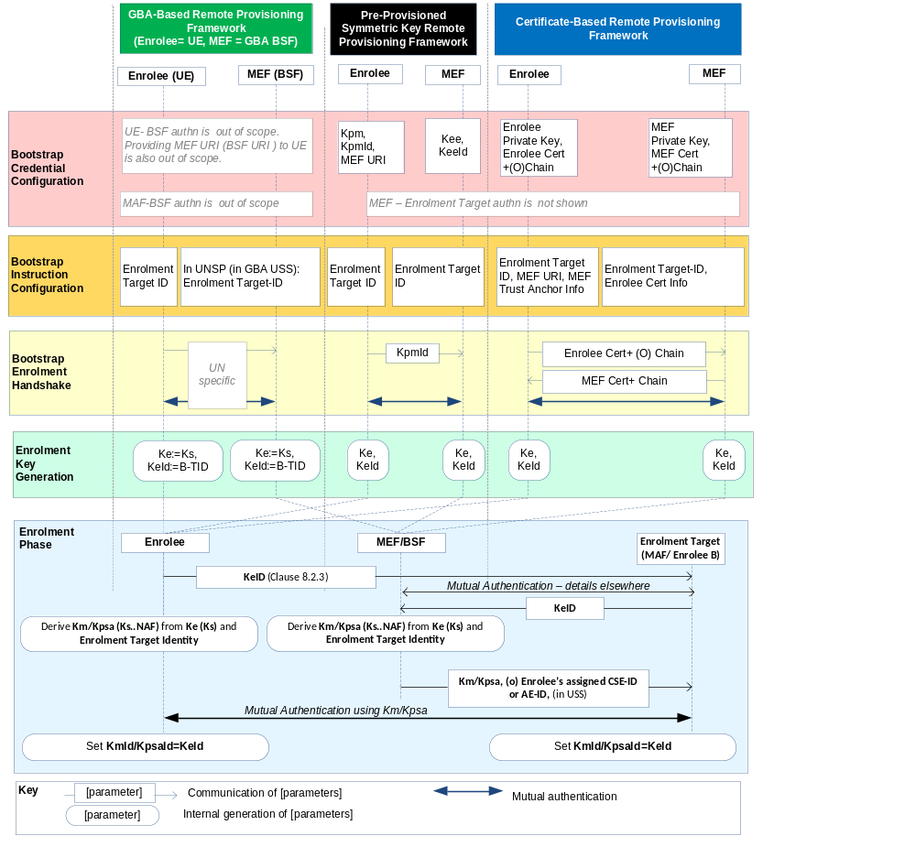Figure 8.3.1.2-1: Overview of the Remote Security Provisioning Frameworks supported by oneM2M

-----------------------End of change 1---------------------------------------------

