CHANGE REQUEST
Meeting:* | SEC#16 at TP#16
Source:* | Philip Hawkes, Qualcomm, phawkes@qti.qualcomm.com,  Wolfgang Granzow, Qualcomm, wgranzow@qti.qualcomm.com  Josef Blanz, Qualcomm, jblanz@qti.qualcomm.com
Date:* | 2015-03-23
Contact:* | As above
Reason for Change/s:* | Essential corrections for aligning the MAF-based SAEF with TS-0001.
CR against: Release* | Release 1
CR against: WI* | Active <Work Item number>  MNT Maintenace / < Work Item number(optional)>  STE Small Technical Enhancements / < Work Item number (optional)>  Only ONE of the above shall be ticked
CR against: TS/TR* | TS-0003 v1.0.1
Clauses/Sub Clauses* | 8.2.2.3
Type of change: * | Editorial change  Bug Fix or Correction  Change to existing feature or functionality  New feature or functionality  Only ONE of the above shall be ticked
Post Freeze checking:* | This CR contains only essential changes and corrections? YES NO  This CR is a mirror CR? YES NO if YES, please indicate the document number of the original CR:  <Document Number)<CR Number of the original CR to the current Release>
Template Version:23 February 2015 (Dot not modify)

oneM2M Notice
The document to which this cover statement is attached is submitted to oneM2M. Participation in, or attendance at, any activity of oneM2M, constitutes acceptance of and agreement to be bound by terms of the Working Procedures and the Partnership Agreement, including the Intellectual Property Rights (IPR) Principles Governing oneM2M Work found in Annex 1 of the Partnership Agreement.

Introduction
This CR provides essential corrections for aligning the MAF-based SAEF with TS-0001. This CR is based on SEC-2015-0448-R03 which was postponed at SEC#15.
R01: Changed to latest template. No change to content, except for a figure that was at the end of the original CR which should not have been in the CR as it is not needed – that figure is not present in this revision.
R02: Updated Figure 8.2.2.3-1 with boxes containing text
- PSK-TLS handshake between A and B. The “psk_identity”parameter is set to the value of the KcId. The “psk” parameter is set to the value of the Kc
- Entity B and MAF communicate over out-of-scope, mutually-authenticated secure channel

-----------------------Start of change 1-------------------------------------------

8.2.2.3 MAF-Based Symmetric Key Security Association Establishment Frameworks
This clause describes the MAF-based Security Association Establishment Framework.
This release addresses the scenario where the Entity B is an Infrastructure Node.

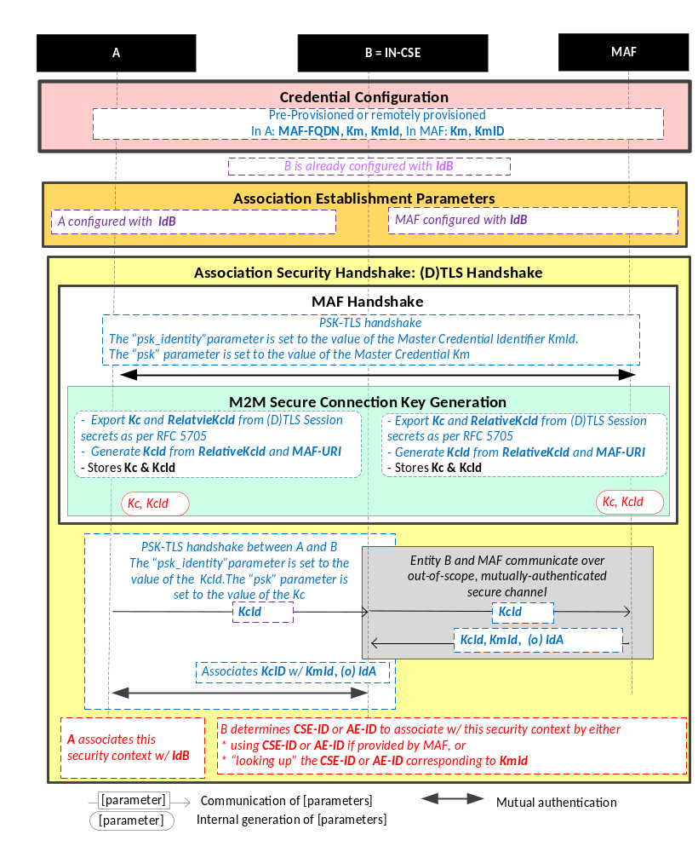
NOTE: The following font colours differentiate the general topic that the text relates to:
Blue italic text highlights details specific to this particular Security Association Establishment Framework.
Purple italic text highlights technical actions that may include steps not specified by oneM2M.
Red italic text highlights security-related properties.

Figure 8.2.2.3-1: The sequence of events when using the
MAF-Based Security Association Establishment Framework
Credential Configuration: The Master Credential (Km) and corresponding Master Credential Identifier (KmId) are either pre-provisioned for Entity A and the MAF or remotely provisioned thanks to Remote Security Provisioning Frameworks described in clause 8.3. The format of KmId is defined in clause 10.6 “KmId Format”. Entity A is also provisioned with the MAF URI to contact during the MAF Handshake. If Entity A is a CSE, then Entity A shall also be configured with its CSE-ID (not shown in the figure).
Association Configuration: Entity A and the MAF shall be configured with the information needed for the authentication and identification during MAF Handshake and Association Security Handshake:
  - Entity A has to know Entity B Identity (IdB)

  - The MAF has to know Entity B Identity (IdB) for which it is authorized to provide Kc. In this case, IdB corresponds to IN Identity.
Association Security Handshake with MAF Handshake:
- MAF Handshake
- The MAF Handshake in MAF-based Security Association Establishment framework enables the establishment of a M2M Secure Connection Key (Kc) and associated M2M Secure Connection Key Identifier (KcId) shared between the Entity A and the MAF thanks to (D)TLS-PSK handshake [Error: Reference source not found]:
- The "psk_identity" parameter [Error: Reference source not found] is set to the value of the Master Credential Identifier KmId.
- The "psk" parameter [Error: Reference source not found] is set to the value of the Master Credential Km.
- M2M Secure Connection Key generation
- The M2M Security Connection Key (Kc) and RelativeKcId are generated from the (D)TLS session secrets by the Entity A and M2M Authentication Function (MAF) using TLS Key Export (RFC 5705) [18], as described in clause 10.3.1 “TLS Key Export Details”.
- The M2M Secure Connection Key Identifier (KcId) is generated from the RelativeKcId and the M2M Authentication Function’s FQDN by the Entity A and M2M Authentication Function, as described in clause 10.3.5 “Generating KcId”.
- The Entity A and M2M Authentication Function store the M2M Secure Connection Key (Kc) and M2M Secure Connection Key Identifier (KcId).
- Entity A sends KcId to Entity B (Infrastructure Node) as the “psk_identity” parameter in a (D)TLS_PSK handshake.
- Entity B and the MAF establish a mutually authenticated secure channel for communication.

NOTE: This specification does not describe details of how the mutually authenticated secure channel is established and does not describe details of how the communication is secured.
- Entity B (Infrastructure Node) requests the M2M Secure Connection Key (Kc) from the MAF.
- The MAF returns Kc, Kc Lifetime, and KmId to Entity B. If MAF is configured with CSE-ID or AE-ID for Entity A (see clause 8.2.1 “Overview of Security Association Establishment Frameworks”), then the MAF shall pass this information to Entity B also.

NOTE: Assigning Kc Lifetime is the responsibility of the MAF.
- Entity A and Entity B complete the (D)TLS-PSK handshake with the “psk” parameter set to the value of the M2M Secure Connection Key (Kc).
- The (D)TLS cipher suite profile for the MAF-Based Security Association Establishment Framework is specified in clause 10.2.2.
- Following successful authentication of Entity B, Entity A associates the security context with Id B (Entity B’s entity identifier) configured to Entity A during Association Configuration.
- Following successful authentication of Entity A, Entity B associates the security context with a CSE-ID or AE-ID :
  - If the MAF provided Entity B with a CSE-ID or AE-ID, then Entity B associates the security context with that CSE-ID or AE-ID.
  - Otherwise, Entity B associates the security context with the Credential-ID formed from KmId (provided by the MAF) as described in clause 10.4 “Credential-ID Details”. Entity B then determines CSE-ID or AE-ID from the Credential-ID as described in clause 8.2.1 “Overview on Security Association Establishment Frameworks”.
- Entity A and Entity B can establish a fresh (D)TLS-PSK handshakes using Kc at any time within the Kc Lifetime. Once Kc Lifetime expires, then Entity B shall fail the (D)TLS-PSK handshake, which indicates to Entity B that a fresh MAF Handshake is required.

-----------------------End of change 1---------------------------------------------

