

oneM2M
Technical Specification
Document Number | TS-0016-V-0.5.0
Document Name: | Secure Environment Abstraction
Date: | 2016-03-18
Abstract: | Defines an API that abstracts from the technical implementation of the secure environment
Template Version:23 February 2015 (Dot not modify)

This Specification is provided for future development work within oneM2M only. The Partners accept no liability for any use of this Specification.
The present document has not been subject to any approval process by the oneM2M Partners Type 1. Published oneM2M specifications and reports for implementation should be obtained via the oneM2M Partners' Publications Offices.

About oneM2M
The purpose and goal of oneM2M is to develop technical specifications which address the need for a common M2M Service Layer that can be readily embedded within various hardware and software, and relied upon to connect the myriad of devices in the field with M2M application servers worldwide.
More information about oneM2M may be found at: http//www.oneM2M.org
Copyright Notification
© 2016, oneM2M Partners Type 1 (ARIB, ATIS, CCSA, ETSI, TIA, TSDSI, TTA, TTC).
All rights reserved.
The copyright extends to reproduction in all media.

Notice of Disclaimer & Limitation of Liability
The information provided in this document is directed solely to professionals who have the appropriate degree of experience to understand and interpret its contents in accordance with generally accepted engineering or other professional standards and applicable regulations. No recommendation as to products or vendors is made or should be implied.
NO REPRESENTATION OR WARRANTY IS MADE THAT THE INFORMATION IS TECHNICALLY ACCURATE OR SUFFICIENT OR CONFORMS TO ANY STATUTE, GOVERNMENTAL RULE OR REGULATION, AND FURTHER, NO REPRESENTATION OR WARRANTY IS MADE OF MERCHANTABILITY OR FITNESS FOR ANY PARTICULAR PURPOSE OR AGAINST INFRINGEMENT OF INTELLECTUAL PROPERTY RIGHTS. NO oneM2M PARTNER TYPE 1 SHALL BE LIABLE, BEYOND THE AMOUNT OF ANY SUM RECEIVED IN PAYMENT BY THAT PARTNER FOR THIS DOCUMENT, WITH RESPECT TO ANY CLAIM, AND IN NO EVENT SHALL oneM2M BE LIABLE FOR LOST PROFITS OR OTHER INCIDENTAL OR CONSEQUENTIAL DAMAGES. oneM2M EXPRESSLY ADVISES ANY AND ALL USE OF OR RELIANCE UPON THIS INFORMATION PROVIDED IN THIS DOCUMENT IS AT THE RISK OF THE USER.

Contents
Contents 3
1 Scope 6
2 References 6
2.1 Normative references 6
2.2 Informative references 6
3 Definitions, symbols and abbreviations 6
3.1 Definitions 6
3.2 Symbols 7
3.3 Abbreviations 7
3.4 Acronyms 7
4 Conventions 7
5 SE Abstraction Architecture 7
5.1 Introduction 7
5.2 AE and CSE access security services within the SE 9
5.3 AE residing within the SE 9
6 Types of Secure Environments 10
6.1 Independent hardware based SE 10
6.2 Integrated Hardware based SE 10
6.3 Software based SE 11
7 Logical Abstraction – SE reference points 11
7.1 Overview 11
7.2 Mcs reference point 11
7.2.1 Secure Environment Identifier (M2M-SE-ID) 11
7.3 SE Discovery and Selection 12
7.3.1 getSecureEnvironment 12
7.3.1.1 Description 12
7.3.1.2 Pre-Conditions 12
7.3.1.3 Signature – getSecureEnvironment 13
7.3.2 getSEFunctions 13
7.3.2.1 Description 13
7.3.2.2 Pre-Conditions 13
7.3.2.3 Signature – getSEFunctions 13
7.3.3 selectSecureEnvironment 13
7.3.3.1 Description 13
7.3.3.2 Pre-Conditions 13
7.3.3.3 Signature – selectSecureEnvironment 14
7.4 AE Discovery and Selection 14
7.4.1 getApplicationEntity 14
7.4.1.1 Description 14
7.4.1.2 Pre-Conditions 14
7.4.1.3 Signature – getApplicationEntity 15
7.4.2 getAEFunctions 15
7.4.2.1 Description 15
7.4.2.2 Pre-Conditions 15
7.4.2.3 Signature – getAEFunctions 15
7.4.3 selectApplicationEntity 15
7.4.3.1 Description 15
7.4.3.2 Pre-Conditions 15
7.4.3.3 Signature – selectApplicationEntity 16
7.5 Secure Environment Management 16
7.6 Sensitive Data Storage 16
7.6.1 <sensitiveDataObject> resource 16
7.6.2 <sensitiveDataObject> Resource Procedures 18
7.6.2.1 CREATE <sensitiveDataObject> 18
7.6.2.2 RETRIEVE <sensitiveDataObject> 19
7.6.2.3 UPDATE <sensitiveDataObject> 19
7.6.2.4 DELETE <sensitiveDataObject> 20
7.6.3 <Profile> resource 20
7.6.4 <profile> Resource Procedures 23
7.6.4.1 CREATE <profile> 23
7.6.4.2 RETRIEVE < profile > 23
7.6.4.3 UPDATE <profile> 24
7.6.4.4 DELETE <profile> 24
7.7 Sensitive Cryptographic Functions 25
7.7.1 <cipher> resource 25
7.7.1.1 <cipher> Resource Procedures 28
7.7.1.1.1 CREATE <cipher> 28
7.7.1.1.2 RETRIEVE <cipher> 28
7.7.1.1.3 UPDATE <cipher> 29
7.7.1.1.4 DELETE <cipher> 29
7.7.1.2 <encrypt> Resource 30
7.7.1.3 <decrypt> Resource 30
7.7.1.4 <generateKey> Resource 30
7.7.2 <rand> resource 30
7.7.2.1 <rand> Resource Procedures 32
7.7.2.1.1 CREATE <rand> 32
7.7.2.1.2 RETRIEVE <rand> 33
7.7.2.1.3 UPDATE <rand> 34
7.7.2.1.4 DELETE <rand> 34
7.7.2.2 <generateRand> Resource 34
7.7.3 <hash> resource 34
7.7.3.1 <hash> Resource Procedures 36
7.7.3.1.1 CREATE <hash> 36
7.7.3.1.2 RETRIEVE <hash> 37
7.7.3.1.3 UPDATE <hash> 37
7.7.3.1.4 DELETE <hash> 38
7.7.3.2 <calculateHash> Resource 38
7.7.4 <signature> resource 39
7.7.4.1 <signature> Resource Procedures 41
7.7.4.1.1 CREATE <signature> 41
7.7.4.1.2 RETRIEVE <signature> 42
7.7.4.1.3 UPDATE <signature> 42
7.7.1.1.4 DELETE <signature> 43
7.7.4.2 <calculateSignature> Resource 43
7.7.4.3 <verifySignature> Resource 43
7.7.4.4 <generateKey> Resource 43
7.8 Secure Connection Establishment 43
7.8.1 <secureConnection> resource 43
7.8.2 <secureConnection> Resource Procedures 46
7.8.2.1 CREATE <secureConnection> 46
7.8.2.2 RETRIEVE <secureConnection> 47
7.8.2.3 UPDATE <secureConnection> 47
7.8.2.4 DELETE <secureConnection> 48
7.8.3 <connectionInstance> resource 48
7.8.4 <connectionInstance> Resource Procedures 51
7.8.4.1 CREATE <connectionInstance> 51
7.8.4.2 RETRIEVE <connectionInstance> 51
7.8.4.3 UPDATE <connectionInstance> 52
7.8.4.4 DELETE <connectionInstance> 53
7.8.5 <connect> Resource 53
7.8.6 <send> Resource 53
7.8.7 <generateKey> Resource 53
7.9 Authentication and Identification 53
7.9.1 <identity> resource 53
7.9.2 <identity> Resource Procedures 56
7.9.2.1 CREATE <identity> 56
7.9.2.2 RETRIEVE <identity> 56
7.9.2.3 UPDATE <identity> 57
7.9.2.4 DELETE <identity> 58
7.9.3 <authenticate> Resource 58
7.9.4 <generateKey> Resource 58
8 Physical Interface 58
8.1 User defined subdivisions of clause(s) from here onwards 58
Proforma copyright release text block 59
Annexes 59
Annex <y>: Bibliography 60
History 60

1 Scope
The present document specifies mechanisms and interfaces to abstract from different technical implementations of a secure environment as defined in [1].
The Scope shall not contain requirements.

2 References
The following text block applies.
References are either specific (identified by date of publication and/or edition number or version number) or non-specific. For specific references,only the cited version applies. For non-specific references, the latest version of the referenced document (including any amendments) applies.

2.1 Normative references
Clause 2.1 only shall contain normative (essential) references which are cited in the document itself. These references have to be publicly available and in English.
The following referenced documents are necessary for the application of the present document.
[1] TS-0003, oneM2M Security Solutions
[2] TS-0001, oneM2M Architecture
[3] ETSI TS 102 221 “Smart Cards; UICC-Terminal Interface; Physical and Logical Characteristics”
[4] GlobalPlatform Device Commitee TEE System Architecture v1.0 specification

2.2 Informative references
Clause 2.2 shall only contain informative references which are cited in the document itself.
The following referenced documents are not necessary for the application of the present document but they assist the user with regard to a particular subject area.
[i.1] oneM2M Drafting Rules (http://member.onem2m.org/Static_pages/Others/Rules_Pages/oneM2M-Drafting-Rules-V1_0.doc)
[i.2] oneM2M TR-0008, “Security Analysis” (Release 2)

3 Definitions, symbols and abbreviations
Delete from the above heading the word(s) which is/are not applicable.

3.1 Definitions
SE-resource: A resource that resides within the Secure Environment and that does not have a representation within a CSE.

3.2 Symbols
Clause numbering depends on applicability.
For the purposes of the present document, the following symbols apply:
Symbol format
<symbol> <Explanation>
<2nd symbol> <2nd Explanation>
<3rd symbol> <3rd Explanation>

3.3 Abbreviations
Abbreviations should be ordered alphabetically.
Clause numbering depends on applicability.
For the purposes of the present document, the following abbreviations apply:
Abbreviation format
<ABREVIATION1> <Explanation>
<ABREVIATION2> <Explanation>
<ABREVIATION3> <Explanation>

3.4 Acronyms
Acronyms should be ordered alphabetically.
Clause numbering depends on applicability.
For the purposes of the present document, the following abbreviations apply:
Acronym format
<ACRONYM1> <Explanation>
<ACRONYM2> <Explanation>
<ACRONYM3> <Explanation>

4 Conventions
The key words “Shall”, ”Shall not”, “May”, ”Need not”, “Should”, ”Should not” in this document are to be interpreted as described in the oneM2M Drafting Rules [i.1]

5 SE Abstraction Architecture

5.1 Introduction
As defined in oneM2M TS-0003 [1], the Secure Environment (SE) provides protected sensitive functions and sensitive data to entitities within the M2M system via the Mcs reference point. The SE is either implemented as a dedicated hardware component or as a trusted logical entity represented by a set of software functions. Depending on the use case and its associated security requirements several different integration scenarios are possible. They are described within this clause. In general the following high level architecture as depicted in figure 5.1-1 applies.
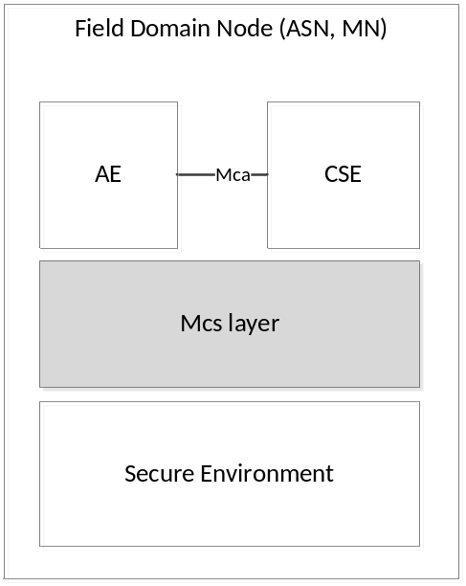
Figure 5.1-1: Secure Environment interworking

5.2 AE and CSE access security services within the SE
In this scenario, both the AE and the CSE reside within the Field Domain Node as depicted in figure 5.2-1. The AE is split into a security and a non security part whereas the security relevant part AE_sec resides within the SE and the corresponding non security relevant part AE_ resides within the application space of the field domain node. The AE_ accesses AE_sec via the Maa reference point. In addition the AE and the CSE can access security services offered by the SE via the Mcs reference point.
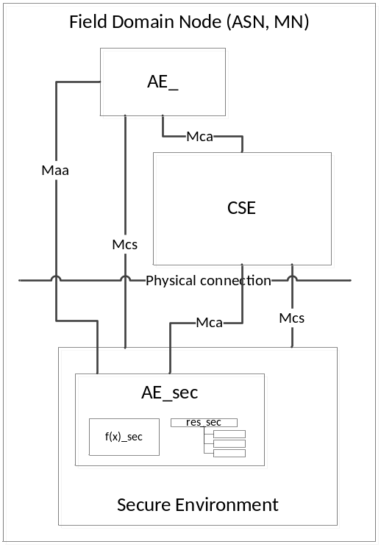
Figure 5.2-1: Secure Environment architecture
The SE is integrated into the Field Domain node as follows:
- Logically: the SE offers its sensitive functions f(x)_sec and its security resources res_sec to AEs and CSEs residing within the field domain node via the Mcs reference point. In addition the AE_sec may offer corresponding services to the AE_ via a proprietary Maa reference point. AE_sec may also access the CSE via the Mca reference point.
- Physically: in case the SE is a dedicated hardware component, it has to be integrated into the field domain node physically including low level drivers that enable logical access to the SE. The physical connection is superfluous in case the SE is implemented in software.

5.3 AE residing within the SE
In this scenario, the entire AE resides within the SE and utilizes security services provided by the SE. In addition the CSE may access the SE for dedicated security services via the Mcs reference point as depicted in figure 5.3-1. The AE may additionally access CSE resources via the Mca reference point.
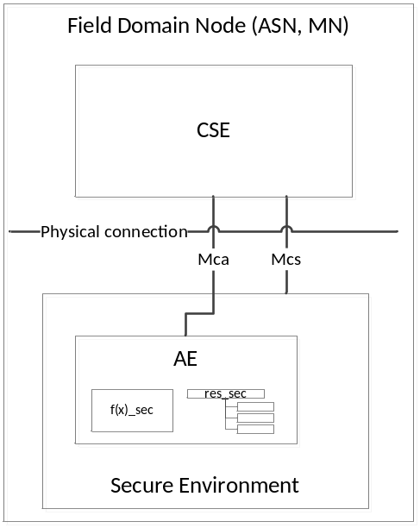
Figure 5.3-1: Secure Environment architecture
The SE is integrated into the Field Domain node as follows:
- Logically: the SE offers sensitive functions f(x)_sec and security resources res_sec to CSEs residing within the field domain node via the Mcs reference point. The AE is integrated within the SE such that it uses SE internal interfaces and methods.
- Physically: in case the SE is a dedicated hardware component, it has to be integrated into the field domain node physically including low level drivers that enable logical access to the SE. The physical connection is superfluous in case the SE is implemented in software.

6 Types of Secure Environments
According to [1], an SE can be implemented in different ways. Within the scope of this specification the following categories are distinguished:
- Independent hardware based SE
- Integrated hardware based SE
- Software based SE

6.1 Independent hardware based SE
Following independent hardware based SEs are considered within the current release of the specification:
- Secure Elements in different form factors including
  - UICC according to [3]
  - and other variants of it such as eSE according to [x]
As outlined in TR-0008 [i.2], such implementations are recommended as countermeasures against key discovery and device cloning for devices that are physically exposed to potential attackers.

6.2 Integrated hardware based SE
Following integrated hardware based SEs are considered within the current release of the specification:
- Trusted Execution Environment according to [4]
According to the security analysis in TR-0008 [i.2], such implementations are appropriate for devices likely to be the target of remote attacks, without being physically accessible to attackers.

6.3 Software based SE
An SE as defined in [1] provides security services to application. In addition to hardware based solutions this can also be provided by a dedicated software implementation such as White Box Cryptography. Such implementations are only appropriate when the lifetime of the asset is limited and the risks of compromission are otherwise mitigated.

7 Logical Abstraction – SE reference points

7.1 Overview
SE reference point shall enable applications and service layer entities which are out of Secure Environments to make use of sensitive functions, sensitive data and applications residing within the Secure Environment, independently of the technical implementation of the Secure Environment, via a logical abstract interface. The logical abstraction interface is between the physical or logical Secure Environments and any external service layer entities and applications. The logical abstraction interface shall access the sensitive functions, sensitive data and applications residing within the Secure Environments regardless of their number and Secure Environment architecture scenarios.

7.2 Mcs reference point

7.2.1 Secure Environment Identifier (M2M-SE-ID)
M2M nodes may contain multiple Secure Environments each associated with a corresponding Secure Environment Identifier (M2M-SE-ID). Each SE contains several M2M Security Services, i.e. sensitive functions and sensitive data. The M2M-SE-ID is assigned to each Secure Environment.
Table 7.2.1-1: Secure Environment Identifier
Identifier | Assigned by | Assigned to | Assigned during | Lifetime | Uniqueness | Used during
M2M Secure Environment Identifier | M2M SE Provider | Secure Environment | Pre- or remote Provisioning or during manufacturing | Life of the M2M Service Registration. | Global per SE and per class of SE | communication establishment with and selection of SE;

M2M-SE-ID is structured as follows:
Type of SE followed by unique ID, where type of SE is defined as given in table 7.1.1-2 and the unique ID is defined as described in Table 7.1.1-1.
Table 7.2.1-2: Type of Secure Environment
Class of SE | Type of Secure Environment | Coding
Independent hardware | UICC | Tbd
Integrated hardware | TEE | Tbd
Software | Security Library | Tbd
...

Editor’s note: further types and classes tbd
Editor’s note: relation between SE-ID and node-ID is FFS. Definition of M2M Service Registration to be added.

7.3 SE Discovery and Selection

7.3.1 getSecureEnvironment

7.3.1.1 Description
This service provides a list of available Secure Environments within the present M2M node including the SE class and type.

7.3.1.2 Pre-Conditions
Type and Class of SE has been assigned during pre-provisioning or remote provisioning.

7.3.1.3 Signature – getSecureEnvironment
Table 7.3.1.3-1: getSecureEnvironment
Parameter name | Direction | Optional | Description
aeId / cseId | IN | NO | Application Entity or CSE ID requesting the list of SE-IDs
applicationId | IN | NO | Application Identifier (App-ID) for the AE
responseType | OUT | NO | Response types:  - List of available SEs incl. their M2M-SE-IDs and their provided security level  - SEs do not exist

Editor’s note: separate access from local entity and remote entities and inclusion of CSEs are for further study.

7.3.2 getSEFunctions

7.3.2.1 Description
This service provides a list of available sensitive functions provided by a given SE.

7.3.2.2 Pre-Conditions
M2M-SE-ID is known to the calling entity (getSecureEnvironment).

7.3.2.3 Signature – getSEFunctions
Table 7.3.2.3-1: getSEFunctions
Parameter name | Direction | Optional | Description
seId | IN | NO | M2M-SE-Identifier
applicationId | IN | NO | Application Identifier (App-ID) for the AE
responseType | OUT | NO | Response types:  - List of available sensitive functions  - No sensitive function available (but SE exists)  - SEs do not exist

7.3.3 selectSecureEnvironment

7.3.3.1 Description
Selects a particular SE available within the present entity.

7.3.3.2 Pre-Conditions
Not applicable.

7.3.3.3 Signature – selectSecureEnvironment
Table 7.3.3.3-1: selectSecureEnvironment
Parameter name | Direction | Optional | Description
seId | IN | conditional | M2M-SE-ID
secLevel | IN | conditional | Types:  SE with highest available security level to be selected  SE with a particular security level to be selected
responseType | OUT | NO | Response types:  - Security level of selected SE together with seId  - Security level or selected SE does not exist
Note: conditional is to be interpreted as mandatory if no other conditional parameter does exist.

7.4 AE Discovery and Selection
Editor’s note: This set of functions may be moved to be part of the SE management functions and may then also be migrated to a restful approach..The list of parameters have to be clarified following clarification of the SE entities architecture.

7.4.1 getApplicationEntity

7.4.1.1 Description
An SE may have one or more AE_SECs. An application provider issuing AE_SECs may want to create, update and delete its AE_SECs within the SE. This service provides a list of AE_SECs available within a given SE.

7.4.1.2 Pre-Conditions
M2M-SE-ID is known to the calling entity (getSecureEnvironment). A security association between the calling entity and the SE is established and the calling entity has sufficient access rights to perform the query.

7.4.1.3 Signature – getApplicationEntity
Table 7.4.1.3-1: getApplicationEntity
Parameter name | Direction | Optional | Description
seId | IN | NO | M2M-SE-Identifier
requesterID | IN | NO | AE-ID or CSE-ID requesting the list of available AE_SECs
responseType | OUT | NO | Response types:  - List of available AE_SECs including their M2M-AE-IDs and their provided security level  - No AE_SEC available (but SE exists)  - SE does not exist  - Access conditions not fulfilled

7.4.2 getAEFunctions

7.4.2.1 Description
This service provides a list of available sensitive functions provided by a given AE_SEC. Unlike getSEFunctions is related with the functions of SE, getAEFunctions is related with dedicated functions to the AE_SEC. For example, a mobile TV application shall get permission to access an SE from the access control function of the SE, and then the application should request the multimedia content decryption to the decoding function of the AE_SEC.

7.4.2.2 Pre-Conditions
M2M-AE-ID is known to the calling entity (getApplicationEntity). A security association between the calling entity and the SE is established and the calling entity has sufficient access rights to perform the query.

7.4.2.3 Signature – getAEFunctions
Table 7.4.2.3-1: getAEFunctions
Parameter name | Direction | Optional | Description
aeId | IN | NO | M2M-AE-Identifier
requesterID | IN | NO | AE-ID or CSE-ID requesting the list of available functions
responseType | OUT | NO | Response types:  - List of available sensitive functions  - No sensitive function available (but AE_SEC exists)  - AE_SECs do not exist  - Access conditions not fulfilled

7.4.3 selectApplicationEntity

7.4.3.1 Description
Selects a particular Application Entity available within the present entity.

7.4.3.2 Pre-Conditions
A security association between the calling entity and the SE is established and the calling entity has sufficient access rights to select the respective AE_SEC.

7.4.3.3 Signature – selectApplicationEntity
Table 7.4.3.3-1: selectApplicationEntity
Parameter name | Direction | Optional | Description
aeId | IN | conditional | M2M-AE-Identifier
secLevel | IN | conditional | Types:  AE_SEC with highest available security level to be selected  AE_SEC with a particular security level to be selected
responseType | OUT | NO | Response types:  - Security level of selected AE_SEC together with aeId  - Security level or selected AE_SEC does not exist  - Access condition not fulfilled
Note: conditional is to be interpreted as mandatory if no other conditional parameter does exist.

7.5 Secure Environment Management

7.6 Sensitive Data Storage

7.6.1 <sensitiveDataObject> resource
Secure Environments provide a service to store and protect sensitive data. Sensitive data objects are represented as SE-resources and are created and managed within the Secure Environment. Requests to SE-resources are using absolute addressing. A <sensitiveDataObject> resource shall represent sensitive data and related information owned by a creator as shown in figure 7.6-1.

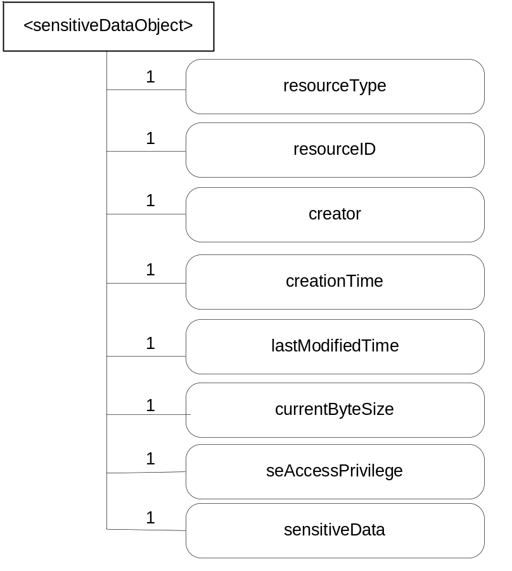
Figure 7.6-1: <sensitiveDataObject>representation
Editor’s note: removal of creationTime and lastModifiedTime is for further study

Attributes in <sensitiveDataObject> are shown in table 7.6-1.
Table 7.6-1: Attributes of <sensitiveDataObject> resource
Attributes of <sensitiveDataObject> | Multiplicity | RW/  RO/  WO | Description | <sensitiveDataObjectAnnc> (MA/OA/NA)
resourceType | 1 | RO | Defines the resource type. | NA
resourceID | 1 | RO | Defines an identifier for the resource.  This attribute shall be provided by the creator. The creator shall assign a resourceID which is unique within its context. | NA
creationTime | 1 | RO | Time/date of creation of the resource.  The creationTime is set by the CSE hosting the SE when the resource is created. | NA
lastModifiedTime | 1 | RO | Last modification time/date of the resource.  This attribute is mandatory. The lastModifiedTime value is set by the Hosting CSE when the resource is created,and the lastModifiedTime value is updated when the resource is updated. | NA
creator | 1 | RO | The AE-ID of the AE creating the resource. | NA
currentByteSize | 1 | RO | Current size in bytes of sensitive data. | NA
sensitiveData | 1 | RW | Contains sensitive data and required information to access and manage sensitive data owned by a dedicated creator | NA
seAccessPrivileges | 1 | WO | Is used to control access to the resource. | NA

Editor’s note: usage of resourceType attribute is for further study

7.6.2 <sensitiveDataObject> Resource Procedures

7.6.2.1 CREATE <sensitiveDataObject>
This procedure shall be used for creating a <sensitiveDataObject> resource.
Table 7.6.2.1-1: <sensitiveDataObject> CREATE
<sensitiveDataObject> CREATE request message parameters
Associated Reference Point | Mcs
Information in Request message | Following parameters shall exist within the Create request:  Operation  To: contains M2M-SE-ID  From Registree AE  Request Identifier  Content: <sensitveData>  Name: name of resource
Processing at Originator before sending Request | Establish security association between creator and SE  Requests from an AE includes their AE-ID
Processing at Receiver | Check seAccessPrivileges and validate request
Information in Response message | Response status codes: ack; successful operation = CREATE; Unsuccessful Operation = C;  Request Identifier
Processing at Originator after receiving Response | n/a
Exceptions | According to [2]

7.6.2.2 RETRIEVE <sensitiveDataObject>
This procedure shall be used for retrieving a <sensitiveDataObject> resource.
Table 7.6.2.2-1: <sensitiveDataObject> RETRIEVE
<sensitiveDataObject> RETRIEVE request message parameters
Associated Reference Point | Mcs
Information in Request message | Following parameters shall exist within the RETRIEVE request:  Operation  To: contains M2M-SE-ID  From Registree AE  Request Identifier
Processing at Originator before sending Request | Establish security association between creator and SE  Requests from an AE includes their AE-ID
Processing at Receiver | Check seAccessPrivileges and validate request
Information in Response message | Response status codes: ack; successful operation = RETRIEVE; Unsuccessful Operation = R;  Request Identifier  Content = Sensitive Data
Processing at Originator after receiving Response | As defined in [2]
Exceptions | As defined in [2]

7.6.2.3 UPDATE <sensitiveDataObject>
This procedure shall be used for updating the attributes and actual data of a <sensitiveDataObject> resource.
Table 7.6.2.3-1: <sensitiveDataObject> UPDATE
<sensitiveDataObject> UPDATE request message parameters
Associated Reference Point | Mcs
Information in Request message | Following parameters shall exist within the UPDATE request:  Operation  To: contains M2M-SE-ID  From Registree AE  Request Identifier  Name  Content = sensitive data and / or attributes
Processing at Originator before sending Request | Establish security association between creator and SE  Requests from an AE includes their AE-ID
Processing at Receiver | Check seAccessPrivileges and validate request
Information in Response message | Response status codes: ack; successful operation = UPDATE; Unsuccessful Operation = R;  Request Identifier
Processing at Originator after receiving Response | As defined in [2]
Exceptions | As defined in [2]

7.6.2.4 DELETE <sensitiveDataObject>
This procedure shall be used for deleting a <sensitiveDataObject> resource.
Table 7.6.2.4-1: <sensitiveDataObject> DELETE
<sensitiveDataObject> DELETE request message parameters
Associated Reference Point | Mcs
Information in Request message | Following parameters shall exist within the DELETE request:  Operation  To: contains M2M-SE-ID  From Registree AE  Request Identifier  Name
Processing at Originator before sending Request | Establish security association between creator and SE  Requests from an AE includes their AE-ID
Processing at Receiver | Check seAccessPrivileges and validate request
Information in Response message | Response status codes: ack; successful operation = DELETE; Unsuccessful Operation = D;  Request Identifier
Processing at Originator after receiving Response | As defined in [2]
Exceptions | As defined in [2]

7.6.3 <Profile> resource
SEs or AE_SECs provide a service to store and protect profile data. A profile is the representation of parameters and data for its application, keys, and load files. The responsibility for defining which SE/AE_SEC can be used as target SEs/AE_SECs for customizing the SE/AE_SEC rests with the SE/AE_SEC issuer. Hence, the AE_SEC issuer defines business rules for each SE/AE_SEC offering in terms of which are acceptable SE/AE_SECs to use for each application for the SE/AE_SEC.
Editor’s note 1: The intention is to have this resource stored in the SE, which assumes presence of a CSE_SEC inside the SE. The figure 5.2-1 does not currently have a CSE-SEC. This conflict first needs to be resolved .

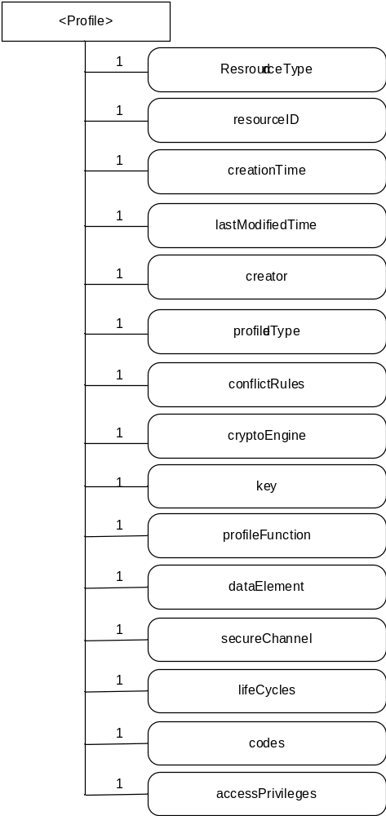
Figure 7.6.3-1: <profile>representation

Attributes in < profile > are shown in table 7.6.3-1.
Table 7.6.3-1: Attributes of < profile > resource
Attributes of <profile> | Multiplicity | RW/  RO/  WO | Description | <profile> (MA/OA/NA)
resourceType | 1 | RO | Defines the resource type. | NA
resourceID | 1 | RO | Defines an identifier for the resource.  This attribute shall be provided by the creator. The creator shall assign a resourceID which is unique within its context. | NA
creationTime | 1 | RO | Time/date of creation of the resource.  The creationTime is set by the CSE hosting the SE when the resource is created. | NA
lastModifiedTime | 1 | RO | Last modification time/date of the resource.  This attribute is mandatory. The lastModifiedTime value is set by the Hosting CSE when the resource is created, and the lastModifiedTime value is updated when the resource is updated. | NA
creator | 1 | RO | The issuer identification of the profile. | NA
profileType | 1 | RO | Profile type:  - SE Profile: SE profiles template or image that describes every SE which will be or has been customized.  - AE_SEC Profile: AE_SEC Profiles contain the scripts necessary to customize the application, including the data preparation. The AE_SEC profiles contain the scripts as well as the data element references and key references required for script execution. | NA
conflictRules | 1 | RO | The rules which the profile must satisfy before being utilized. | NA
cryptoEngine | 0..1 | RO | Describes characteristics of the cryptographic engine in terms of key type and algorithm support. | NA
key | 1..n | RO | Specify key definition inheriting features of specified Key Profile. | NA
profileFunction | 0..n | RO | SE/AE_SEC defined script functions which will be used by the script fragments. | NA
profileData | 0..n | RO | Externally provided parameters and data used by the scripts defined for SE/AE_SEC. | NA
secureChannel | 0..1 | RO | Valid only if the application is a Security Domain | NA
lifeCycles | 1 | RW | The life cycle status of the SE/AE_SEC (created, activated and deactivated) which are defined by the SE/AE_SEC issuers. | NA
codes | 0..n | RO | Describes the different load files where the applet code for the application can be found. | NA
accessPrivileges | 1 | RO | Access control policies and data to control access to the profile of SE/AE_SEC. | NA

7.6.4 <profile> Resource Procedures

7.6.4.1 CREATE <profile>
This procedure shall be used for creating a <profile> resource.
Table 7.6.4.1-1: <profile> CREATE
<profile> CREATE request message parameters
Associated Reference Point | Mcs and Mca
Information in Request message | Following parameters shall exist within the Create request:  Operation  To: The ID of SE/AE_SEC where the <profile> resource is intended to be Created  From: the profile issuer  Content: <profile>  Name: name of profile
Processing at Originator before sending Request | Establish security association between the profile issuer and SE/AE_SEC  Requests from a profile issuer includes its ID.
Processing at Receiver | Check accessPrivileges and validate request. Download profile file and install it.
Information in Response message | Response status codes: ack; successful operation = CREATE; Unsuccessful Operation = C;  Request Identifier
Processing at Originator after receiving Response | n/a
Exceptions | According to [2]

7.6.4.2 RETRIEVE < profile >
This procedure shall be used for retrieving a < profile > resource.
Table 7.6.4.2-1: < profile > RETRIEVE
<sensitiveDataObject> RETRIEVE request message parameters
Associated Reference Point | Mcs and Mca
Information in Request message | Following parameters shall exist within the RETRIEVE request:  Operation  To: The ID of SE/AE_SEC where the <profile> resource is located  From: the profile issuer
Processing at Originator before sending Request | Establish security association between the profile issuer and SE/AE_SEC  Requests from a profile issuer includes its ID
Processing at Receiver | Check accessPrivileges and validate request
Information in Response message | Response status codes: ack; successful operation = RETRIEVE; Unsuccessful Operation = R;  Request Identifier  Content = Sensitive Data
Processing at Originator after receiving Response | As defined in [2]
Exceptions | As defined in [2]

7.6.4.3 UPDATE <profile>
This procedure shall be used for updating the attributes and actual data of a < profile > resource.
Table 7.6.4.3-1: <profile> UPDATE
<profile> UPDATE request message parameters
Associated Reference Point | Mcs and Mca
Information in Request message | Following parameters shall exist within the UPDATE request:  Operation  To: The ID of SE/AE_SEC where the <profile> resource is located  From: the profile issuer  Content: <profile>  Name: name of profile Content
Processing at Originator before sending Request | Establish security association between creator and SE  Requests from a profile issuer includes its ID
Processing at Receiver | Check accessPrivileges and validate request. Set enableSatus as activate or deactivated
Information in Response message | Response status codes: ack; successful operation = UPDATE; Unsuccessful Operation = R;  Request Identifier
Processing at Originator after receiving Response | As defined in [2]
Exceptions | As defined in [2]

7.6.4.4 DELETE <profile>
This procedure shall be used for deleting a <profile> resource.
Table 7.6.4.4-1: <profile> DELETE
<profile> DELETE request message parameters
Associated Reference Point | Mcs and Mca
Information in Request message | Following parameters shall exist within the DELETE request:  Operation  To: The ID of SE/AE_SEC where the <profile> resource is located  From: the profile issuer  Name: name of profile
Processing at Originator before sending Request | Establish security association between creator and SE  Requests from a profile issuer includes its ID
Processing at Receiver | Check accessPrivileges and validate request. Delete profile
Information in Response message | Response status codes: ack; successful operation = DELETE; Unsuccessful Operation = D;  Request Identifier
Processing at Originator after receiving Response | As defined in [2]
Exceptions | As defined in [2]

7.7 Sensitive Cryptographic Functions

7.7.1 <cipher> resource
Secure Environments provide a service for cryptographic operations. A <cipher> resource shall represent sensitive data and related information owned by a creator as shown in figure 7.7.1-1.
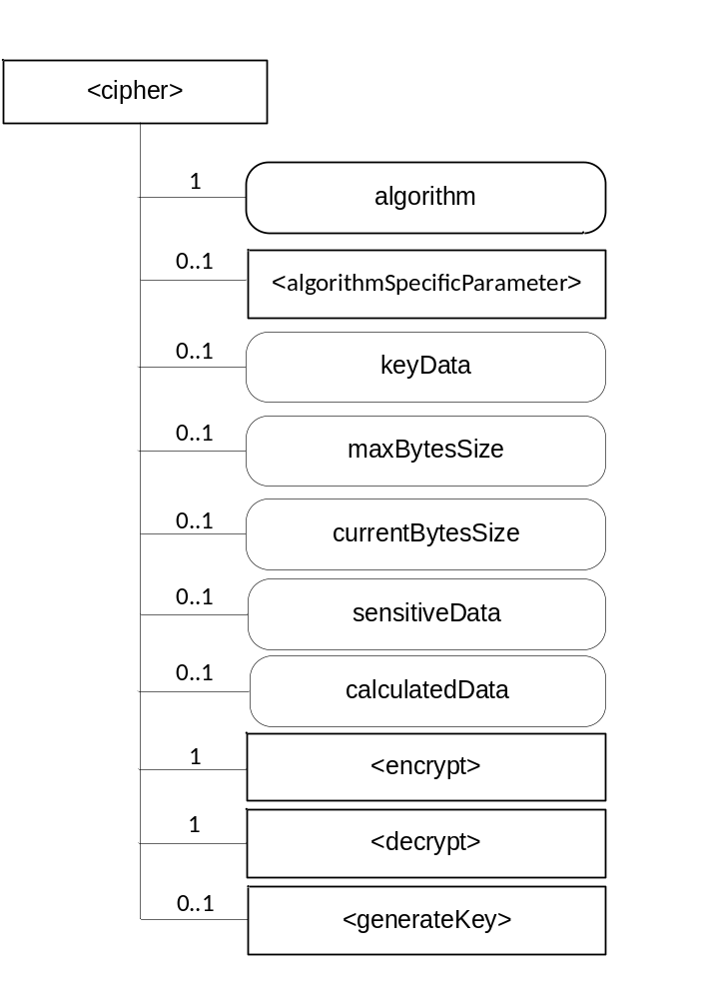
Figure 7.7.1-1: <cipher> representation
The <cipher> resource shall contain the child resources specified in table 7.7.1-1.
Table 7.7.1-1: Child resources of <cipher> resource
Child Resources of <cipher> | Child Resource Type | Multiplicity | Description | <cipherAnnc> Child Resource Types
encrypt | <encrypt> | 1 | See clause 7.7.1.2 | None
decrypt | <decrypt> | 1 | See clause 7.7.1.3 | None
generateKey | <generateKey> | 0..1 | See clause 7.7.1.4 | None
algorithmSpecificParameter | <algorithmSpecificParameter> | 0..1 | See clause 7.7.1.5 | None

Attributes in <cipher> are shown in table 7.7.1-2.
Table 7.7-2: Attributes of <cipher> resource
Attributes of <cipher> | Multiplicity | RW/  RO/  WO | Description | <cipherAnnc> (MA/OA/NA)
resourceType | 1 | RO | Defines the resource type. | NA
resourceID | 1 | RO | Defines an identifier for the resource.  This attribute shall be provided by the creator. The creator shall assign a resourceID which is unique within its context. | NA
resourceName | 1 | WO | This attribute is the name for the resource that is used for 'hierarchical addressing method' to represent the parent-child relationships of resources. | NA
parentID | 1 | RO | This attribute is the resourceID of the parent of this resource. | NA
expirationTime | 1 | RW | Time/date after which the resource will be deleted by the Hosting CSE. | NA
accessControlPolicyIDs | 0..1 (L) | RW | Is used to control access to the resource. If no accessControlPolicyIDs are provided at the time of creation, the accessControlPolicyIDs of the parent resource is linked to this attribute | NA
creationTime | 1 | RO | Time/date of creation of the resource.  The creationTime is set by the CSE hosting the SE when the resource is created. | NA
lastModifiedTime | 1 | RO | Last modification time/date of the resource.  This attribute is mandatory. The lastModifiedTime value is set by the Hosting CSE when the resource is created,and the lastModifiedTime value is updated when the resource is updated. | NA
maxByteSize | 0..1 | RW | Maximum size in bytes of data | NA
currentByteSize | 0..1 | RO | Current size in bytes of sensitive data. | NA
sensitiveData | 0..1 | RW | Contains the input data to be either encrypted or decrypted | NA
calculatedData | 0..1 | RO | Contains the result of the encryption/decryption | NA
algorithm | 1 | WO | Contains the algorithm type of the resource instance | NA
keyData | 0..1 | RW | Contains the value of a key | NA

The following types are defined for the algorithm attribute:
- ALG_AEAD_AES_128_GCM: The AEAD_AES_128_GCM authenticated encryption algorithm works as specified in [RFC5116], using AES-128 as the block cipher, by providing the key, nonce, and plaintext, and associated data to that mode of operation.
- ALG_AEAD_AES_256_GCM: This algorithm is identical to AEAD_AES_128_GCM, but with the following differences: K_LEN is 32 octets, instead of 16 octets, and AES-256 GCM is used instead of AES-128 GCM.
- ALG_AEAD_AES_128_CCM: The AEAD_AES_128_CCM authenticated encryption algorithm works as specified in [RFC5116], using AES-128 as the block cipher, by providing the key, nonce, associated data, and plaintext to that mode of operation.
- ALG_AEAD_AES_256_CCM: This algorithm is identical to AEAD_AES_128_CCM, but with the following differences: K_LEN is 32 octets, instead of 16, and AES-256 CCM is used instead of AES-128 CCM.
- ALG_AEAD_AES_128_CCM_8: The AEAD_AES_128_CCM_8 authenticated encryption algorithm is identical to the AEAD_AES_128_CCM algorithm (see Section 5.3 of [RFC 5116]), except that it uses 8 octets for authentication, instead of the full 16 octets used by AEAD_AES_128_CCM (see Section 6.1 of [RFC 6655]).
- ALG_AEAD_AES_256_CCM_8: The AEAD_AES_256_CCM_8 authenticated encryption algorithm is identical to the AEAD_AES_256_CCM algorithm (see Section 5.4 of [RFC 5116]), except that it uses 8 octets for authentication, instead of the full 16 octets used by AEAD_AES_256_CCM (see Section 6.2 of [RFC 6655]).
- ALG_AES_BLOCK_128_CBC_NOPAD : Cipher algorithm ALG_AES_BLOCK_128_CBC_NOPAD provides a cipher using AES with block size 128 in CBC mode and does not pad input data.

- ALG_AES_CBC_ISO9797_M1: Cipher algorithm ALG_AES_CBC_ISO9797_M1 provides a cipher using AES with block size 128 in CBC mode, and pads input data according to the ISO 9797 method 1 scheme.
- ALG_AES_CBC_ISO9797_M2: Cipher algorithm ALG_AES_CBC_ISO9797_M2 provides a cipher using AES with block size 128 in CBC mode, and pads input data according to the ISO 9797 method 2 (ISO 7816-4, EMV'96) scheme.
- ALG_AES_CBC_PKCS5: Cipher algorithm ALG_AES_CBC_PKCS5 provides a cipher using AES with block size 128 in CBC mode, and pads input data according to the PKCS#5 scheme.

7.7.1.1 <cipher> Resource Procedures

7.7.1.1.1 CREATE <cipher>
This procedure shall be used for creating a <cipher> resource.
Table 7.7.1.1.1-1: <cipher> CREATE
<cipher> CREATE request message parameters
Associated Reference Point | Mcs
Information in Request message | All parameters defined in table 8.1.2-3 of [2] apply with the specific details for:  To: contains M2M-SE-ID or M2M-AE-ID  Content: The resource content shall provide the information as defined in clause 7.7.1.
Processing at Originator before sending Request | According to clause 10.1.1.1.of [2]
Processing at Receiver | According to clause 10.1.1.1.of [2]
Information in Response message | All parameters defined in table 8.1.3-1 of [2] apply with the specific details for:  • Content: Address of the created <cipher> resource, according to clause 10.1.1.1.of [2]
Processing at Originator after receiving Response | According to clause 10.1.1.1. of [2]
Exceptions | According to clause 10.1.1.1. of [2]

If <generateKey> is created, the key to be used will be generated and stored in keyData.

7.7.1.1.2 RETRIEVE <cipher>
This procedure shall be used for retrieving the generated output from all/last input data of the <Cipher> resource.
Table 7.7.1.1.2-1: <cipher> RETRIEVE
<cipher> RETRIEVE request message parameters
Associated Reference Point | Mcs
Information in Request message | According to clause 10.1.2. of [2] with the specific details for:  To: contains M2M-SE-ID or M2M-AE-ID
Processing at Originator before sending Request | According to clause 10.1.2. of [2]
Processing at Receiver | According to clause 10.1.2. of [2]
Information in Response message | All parameters defined in table 8.1.3-1 of [2] apply with specific details for:  Content: Attributes of the <cipher> resources as defined in clause 7.7.1.
Processing at Originator after receiving Response | According to clause 10.1.2. of [2]
Exceptions | According to clause 10.1.2. of [2]

7.7.1.1.3 UPDATE <cipher>
This procedure shall be used for updating the <cipher> resource with data to encrypt or decrypt. It may be necessary to use this procedure several times until all data is transmitted.
Table 7.7.1.1.3-1: <cipher> UPDATE
<cipher> UPDATE request message parameters
Associated Reference Point | Mcs
Information in Request message | All parameters defined in table 8.1.2-3 of [2] apply with the specific details for:  To: contains M2M-SE-ID or M2M-AE-ID  Content = attributes of the <cipher> resource as defined in clause 7.7.1 which need be updated
Processing at Originator before sending Request | According to clause 10.1.3. of [2]
Processing at Receiver | According to clause 10.1.3. of [2]
Information in Response message | According to clause 10.1.3. of [2]
Processing at Originator after receiving Response | According to clause 10.1.3. of [2]
Exceptions | According to clause 10.1.3. of [2]

7.7.1.1.4 DELETE <cipher>
This procedure shall be used for deleting a <cipher> resource.
Table 7.7.1.1.4-1: <cipher> DELETE
<cipher> DELETE request message parameters
Associated Reference Point | Mcs
Information in Request message | All parameters defined in table 8.1.2-3 of [2] apply with the specific details for:To: contains M2M-SE-ID or M2M-AE-ID
Processing at Originator before sending Request | According to clause 10.1.4.1 of [2]
Processing at Receiver | According to clause 10.1.4.1 of [2]
Information in Response message | According to clause 10.1.4.1 of [2]
Processing at Originator after receiving Response | According to clause 10.1.4.1 of [2]
Exceptions | According to clause 10.1.4.1 of [2]

7.7.1.2 <encrypt> Resource
The <encrypt> resource is a virtual resource because it does not have a representation. It is the child resource of a <cipher> resource. When a RETRIEVE request addresses the <encrypt> resource, the sensitiveData of the <cipher> resource is encrypted and the result shall be stored in calculatedData.
The <encrypt> resource inherits access control policies that apply to the parent <cipher> resource.

7.7.1.3 <decrypt> Resource
The <decrypt> resource is a virtual resource because it does not have a representation. It is the child resource of a <cipher> resource. When a RETRIEVE request addresses the <decrypt> resource, the sensitiveData of the <cipher> resource is decrypted and the result shall be stored in calculatedData.
The <decrypt> resource inherits access control policies that apply to the parent <cipher> resource.

7.7.1.4 <generateKey> Resource
The <generateKey> resource is a virtual resource because it does not have a representation. When a RETRIEVE request addresses the <generateKey> resource, the keyData attribute is filled with a key generated according the algorithm attrbute.
The <generateKey> resource inherits access control policies that apply to the parent resource.

7.7.1.5 <algorithmSpecificParameter> Resource
The <algorithmSpecificParameter> contains parameter required for the different algorithm.
The <algorithmSpecificParameter> resource inherits the same access control policies of the parent <cipher> resource, and does not have its own accessControlPolicyIDs attribute.
The <algorithmSpecificParameter> resource is shown in figure 7.7.1.5-1.
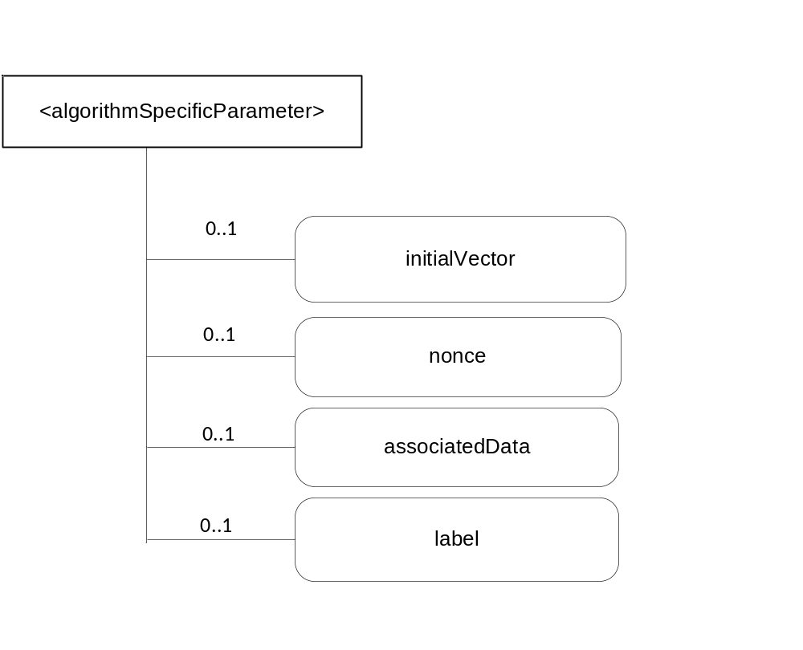
Figure 7.7.1.5-1: <algorithmSpecificParameter> representation
Attributes in <algorithmSpecificParameter> are shown in table 7.7.1.5-1.

Attributes of <algorithmSpecificParameter> | Multiplicity | RW/  RO/  WO | Description | <algorithmSpecificParameterAnnc> (MA/OA/NA)
resourceType | 1 | RO | Defines the resource type. | NA
resourceID | 1 | RO | Defines an identifier for the resource.  This attribute shall be provided by the creator. The creator shall assign a resourceID which is unique within its context. | NA
resourceName | 1 | WO | This attribute is the name for the resource that is used for 'hierarchical addressing method' to represent the parent-child relationships of resources. | NA
parentID | 1 | RO | This attribute is the resourceID of the parent of this resource. | NA
expirationTime | 1 | RW | Time/date after which the resource will be deleted by the Hosting CSE. | NA
accessControlPolicyIDs | 0..1 (L) | RW | Is used to control access to the resource. If no accessControlPolicyIDs are provided at the time of creation, the accessControlPolicyIDs of the parent resource is linked to this attribute | NA
creationTime | 1 | RO | Time/date of creation of the resource.  The creationTime is set by the CSE hosting the SE when the resource is created. | NA
lastModifiedTime | 1 | RO | Last modification time/date of the resource.  This attribute is mandatory. The lastModifiedTime value is set by the Hosting CSE when the resource is created,and the lastModifiedTime value is updated when the resource is updated. | NA
initialVector | 0..1 | RW | AES algorithms, except for ALG_AES_CMAC_128, in CBC mode expect a 16-byte parameter value for the initial vector(IV). | NA
nonce | 0..1 | RW | AEAD algorithms expect a value for the nonce | NA
associatedData | 0..1 | RW | The associated data for AEAD algorithm, which contains the data to be authenticated, but not encrypted. | NA
label | 0..1 | RW | "EXPORTER-oneM2M-Bootstrap" for TLS Key Export for Enrolment Key.  "EXPORTER-oneM2M-Connection" for TLS Key Export for M2M Secure Connection Key.
Table 7.7.1.5-1: Attributes of <algorithmSpecificParameter> resource

7.7.2 <rand> resource
A <rand> resource shall represent random data owned by a creator as shown in figure 7.7.2-1.

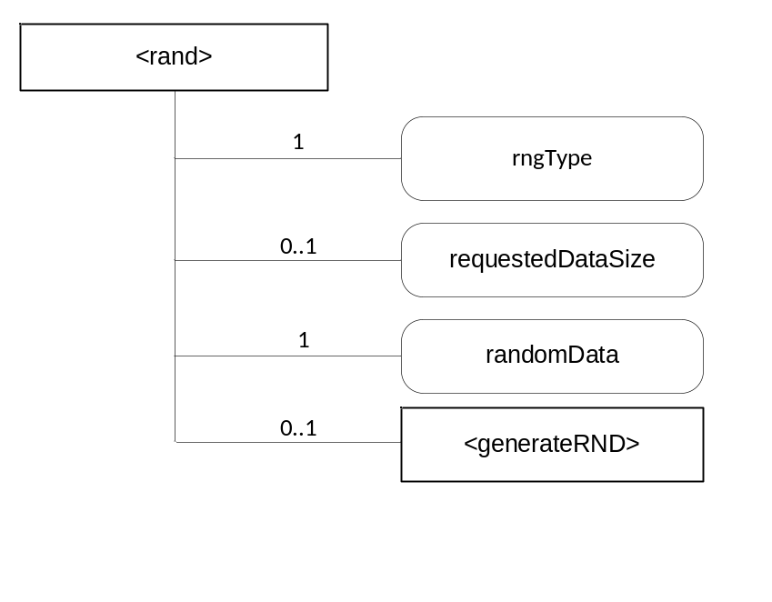
Figure 7.7.2-1: <rand> representation

The <rand> resource shall contain the child resources specified in table 7.7.1-1.
Table 7.7.1-1: Child resources of <rand> resource
Child Resources of <rand> | Child Resource Type | Multiplicity | Description | <randAnnc> Child Resource Types
generateRand | <generateRand> | 1 | See clause 7.7.2.2 | None

Attributes in <rand> are shown in table 7.7.2-2.
Table 7.7.2-2: Attributes of <rand> resource
Attributes of <rand> | Multiplicity | RW/  RO/  WO | Description | <randAnnc> (MA/OA/NA)
resourceType | 1 | RO | Defines the resource type. | NA
resourceID | 1 | RO | Defines an identifier for the resource.  This attribute shall be provided by the creator. The creator shall assign a resourceID which is unique within its context. | NA
resourceName | 1 | WO | This attribute is the name for the resource that is used for 'hierarchical addressing method' to represent the parent-child relationships of resources. | NA
parentID | 1 | RO | This attribute is the resourceID of the parent of this resource. | NA
expirationTime | 1 | RW | Time/date after which the resource will be deleted by the Hosting CSE. | NA
accessControlPolicyIDs | 0..1 (L) | RW | Is used to control access to the resource. If no accessControlPolicyIDs are provided at the time of creation, the accessControlPolicyIDs of the parent resource is linked to this attribute | NA
creationTime | 1 | RO | Time/date of creation of the resource.  The creationTime is set by the CSE hosting the SE when the resource is created. | NA
lastModifiedTime | 1 | RO | Last modification time/date of the resource.  This attribute is mandatory. The lastModifiedTime value is set by the Hosting CSE when the resource is created,and the lastModifiedTime value is updated when the resource is updated. | NA
randomData | 0..1 | RO | Contains random data which can be retrieved by the creator | NA
rngType | 1 | WO | A SE can comprise several RNGs, like pseudo RNGs, physical RNGs, Hybrid RNGs, each one even with different properties. The one requested is given by this attribute | NA
requestedDataSize | 0..1 | RW | Requested amount of randomData in Bytes | NA

7.7.2.1 <rand> Resource Procedures

7.7.2.1.1 CREATE <rand>
This procedure shall be used for creating a <rand> resource.
Table 7.7.2.1.1-1: <rand> CREATE
<rand> CREATE request message parameters
Associated Reference Point | Mcs
Information in Request message | All parameters defined in table 8.1.2-3 of [2] apply with the specific details for:To: contains M2M-SE-ID or M2M-AE-ID  Content: The resource content shall provide the information as defined in clause 7.7.2.
Processing at Originator before sending Request | According to clause 10.1.1.1.of [2]
Processing at Receiver | According to clause 10.1.1.1.of [2]
Information in Response message | All parameters defined in table 8.1.3-1 of [2] apply with the specific details for:  • Content: Address of the created <cipher> resource, according to clause 10.1.1.1.of [2]
Processing at Originator after receiving Response | According to clause 10.1.1.1. of [2]
Exceptions | According to to clause 10.1.1.1. of [2]

7.7.2.1.2 RETRIEVE <rand>
This procedure shall be used for retrieving the random numbers.
Table 7.7.2.1.2-1: <rand> RETRIEVE
<rand> RETRIEVE request message parameters
Associated Reference Point | Mcs
Information in Request message | According to clause 10.1.2. of [2] with the specific details forTo: contains M2M-SE-ID or M2M-AE-ID
Processing at Originator before sending Request | According to clause 10.1.2. of [2]
Processing at Receiver | According to clause 10.1.2. of [2]
Information in Response message | All parameters defined in table 8.1.3-1 of [2] apply with specific details for:  Content: Attributes of the <rand> resources as defined in clause 7.7.2
Processing at Originator after receiving Response | According to clause 10.1.2. of [2]
Exceptions | According to clause 10.1.2. of [2]

7.7.2.1.3 UPDATE <rand>
This procedure shall be used for setting the amount of random data which is requested.
Table 7.7.1.1.3-1: <rand> UPDATE
<rand> UPDATE request message parameters
Associated Reference Point | Mcs
Information in Request message | All parameters defined in table 8.1.2-3 of [2] apply with the specific details for:  To: contains M2M-SE-ID or M2M-AE-ID  Content = attributes of the <rand> resource as defined in clause 7.7.2 which need be updated
Processing at Originator before sending Request | According to clause 10.1.3. of [2]
Processing at Receiver | According to clause 10.1.3. of [2]
Information in Response message | According to clause 10.1.3. of [2]
Processing at Originator after receiving Response | According to clause 10.1.3. of [2]
Exceptions | According to clause 10.1.3. of [2]

7.7.2.1.4 DELETE <rand>
This procedure shall be used for deleting a <rand> resource.
Table 7.7.2.1.4-1: <rand> DELETE
<rand> DELETE request message parameters
Associated Reference Point | Mcs
Information in Request message | All parameters defined in table 8.1.2-3 of [2] apply with the specific details for:  To: contains M2M-SE-ID or M2M-AE-ID
Processing at Originator before sending Request | According to clause 10.1.4.1 of [2]
Processing at Receiver | According to clause 10.1.4.1 of [2]
Information in Response message | According to clause 10.1.4.1 of [2]
Processing at Originator after receiving Response | According to clause 10.1.4.1 of [2]
Exceptions | According to clause 10.1.4.1 of [2]

7.7.2.2 <generateRand> Resource
The <generateRand> resource is a virtual resource because it does not have a representation. When a RETRIEVE request addresses the <generateRand> resource, the randomData attribute is filled with random numbers from a random number generator according the rngType attrbute.
The <generateRand> resource inherits access control policies that apply to the parent resource.

7.7.3 <hash> resource
Secure Environments provide a service for calculating hashes. A <hash> resource shall represent sensitive data and related information owned by a creator as shown in figure 7.7.3-1.
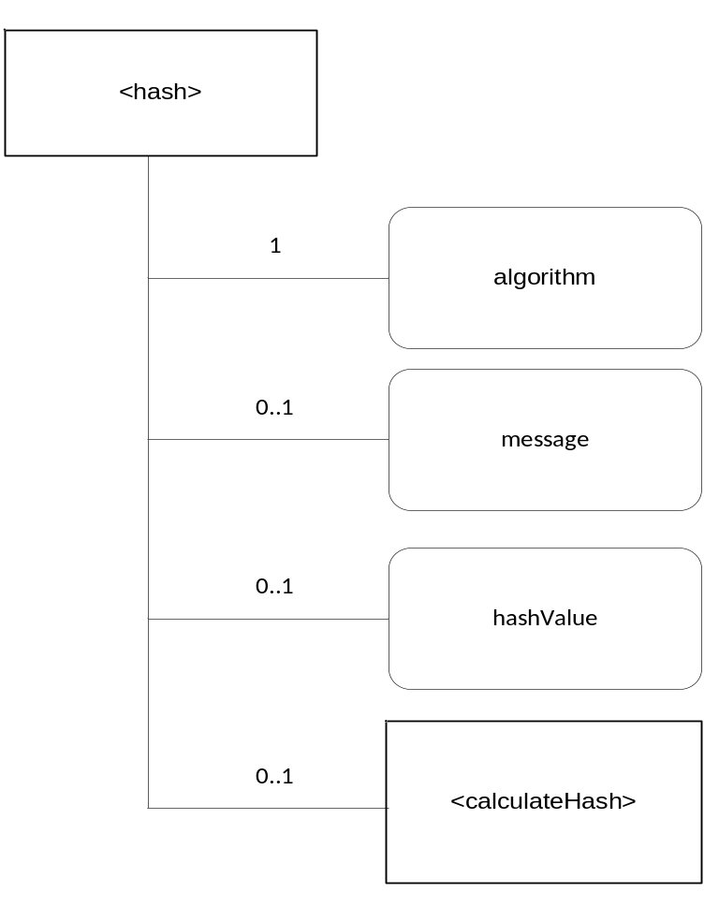
Figure 7.7.3-1: <hash> representation
The <hash> resource shall contain the child resources specified in table 7.7.1-1.
Table 7.7.3-1: Child resources of <hash> resource
Child Resources of <hash> | Child Resource Type | Multiplicity | Description | <hashAnnc> Child Resource Types
calculateHash | <calculateHash> | 1 | See clause 7.7.3.2 | None

Attributes in <hash> are shown in table 7.7.3-2.
Table 7.7.3-2: Attributes of <hash> resource
Attributes of <hash> | Multiplicity | RW/  RO/  WO | Description | <hashAnnc> (MA/OA/NA)
resourceType | 1 | RO | Defines the resource type. | NA
resourceID | 1 | RO | Defines an identifier for the resource.  This attribute shall be provided by the creator. The creator shall assign a resourceID which is unique within its context. | NA
resourceName | 1 | WO | This attribute is the name for the resource that is used for 'hierarchical addressing method' to represent the parent-child relationships of resources. | NA
parentID | 1 | RO | This attribute is the resourceID of the parent of this resource. | NA
expirationTime | 1 | RW | Time/date after which the resource will be deleted by the Hosting CSE. | NA
accessControlPolicyIDs | 0..1 (L) | RW | Is used to control access to the resource. If no accessControlPolicyIDs are provided at the time of creation, the accessControlPolicyIDs of the parent resource is linked to this attribute | NA
creationTime | 1 | RO | Time/date of creation of the resource.  The creationTime is set by the CSE hosting the SE when the resource is created. | NA
lastModifiedTime | 1 | RO | Last modification time/date of the resource.  This attribute is mandatory. The lastModifiedTime value is set by the Hosting CSE when the resource is created,and the lastModifiedTime value is updated when the resource is updated. | NA
algorithm | 1 | WO | Specfies the algorithm for the hash | NA
message | 0..1 | RW | The message which is to be hashed | NA
hashValue | 0..1 | RO | Is the calculated Hash | NA

The following types are defined as algorithm types: SHA256, SHA384, SHA512

7.7.3.1 <hash> Resource Procedures

7.7.3.1.1 CREATE <hash>
This procedure shall be used for creating a <hash> resource.
Table 7.7.3.1.1-1: <hash> CREATE
<hash> CREATE request message parameters
Associated Reference Point | Mcs
Information in Request message | All parameters defined in table 8.1.2-3 of [2] apply with the specific details for:  To: contains M2M-SE-ID or M2M-AE-ID  Content: The resource content shall provide the information as defined in clause 7.7.3.
Processing at Originator before sending Request | According to clause 10.1.1.1.of [2]
Processing at Receiver | According to clause 10.1.1.1.of [2]
Information in Response message | All parameters defined in table 8.1.3-1 of [2] apply with the specific details for:  • Content: Address of the created <hash> resource, according to clause 10.1.1.1.of [2]
Processing at Originator after receiving Response | According to clause 10.1.1.1. of [2]
Exceptions | According to clause 10.1.1.1. of [2]

7.7.3.1.2 RETRIEVE <hash>
This procedure shall be used for retrieving the calculated hash.
Table 7.7.3.1.2-1: <hash> RETRIEVE
<hash> RETRIEVE request message parameters
Associated Reference Point | Mcs
Information in Request message | According to clause 10.1.2. of [2] with the specific details for:  To: contains M2M-SE-ID or M2M-AE-ID
Processing at Originator before sending Request | According to clause 10.1.2. of [2]
Processing at Receiver | According to clause 10.1.2. of [2]
Information in Response message | All parameters defined in table 8.1.3-1 of [2] apply with specific details for:  Content: Attributes of the <hash> resources as defined in clause 7.7.3
Processing at Originator after receiving Response | According to clause 10.1.2. of [2]
Exceptions | According to clause 10.1.2. of [2]

7.7.3.1.3 UPDATE <hash>
This procedure shall be used for updating the <hash> resource with data to be hashed.
Table 7.7.3.1.3-1: <hash> UPDATE
<hash> UPDATE request message parameters
Associated Reference Point | Mcs
Information in Request message | All parameters defined in table 8.1.2-3 of [2] apply with the specific details for:  To: contains M2M-SE-ID or M2M-AE-ID  Content = attributes of the <hash> resource as defined in clause 7.7.3 which need be updated
Processing at Originator before sending Request | According to clause 10.1.3. of [2]
Processing at Receiver | According to clause 10.1.3. of [2]
Information in Response message | According to clause 10.1.3. of [2]
Processing at Originator after receiving Response | According to clause 10.1.3. of [2]
Exceptions | According to clause 10.1.3. of [2]

7.7.3.1.4 DELETE <hash>
This procedure shall be used for deleting a <hash> resource.
Table 7.7.3.1.4-1: <hash> DELETE
<hash> DELETE request message parameters
Associated Reference Point | Mcs
Information in Request message | All parameters defined in table 8.1.2-3 of [2] apply with the specific details for:  To: contains M2M-SE-ID or M2M-AE-ID
Processing at Originator before sending Request | According to clause 10.1.4.1 of [2]
Processing at Receiver | According to clause 10.1.4.1 of [2]
Information in Response message | According to clause 10.1.4.1 of [2]
Processing at Originator after receiving Response | According to clause 10.1.4.1 of [2]
Exceptions | According to clause 10.1.4.1 of [2]

Editor’s note: It is to be discussed, if this resource should be merged with the <Cipher> resource.

7.7.3.2 <calculateHash> Resource
The <calculateHash> resource is a virtual resource because it does not have a representation. When a RETRIEVE request addresses the <calculateHash> resource, the hashValue attribute is filled with the hash calculated over the data in the message attribute according the algorithm attrbute.
The <calculateHash> resource inherits access control policies that apply to the parent resource.

7.7.4 <signature> resource
Secure Environments provide a service for signing messages and verifying signatures. A <signature> resource shall represent sensitive data and related information owned by a creator as shown in figure 7.7.4-1.
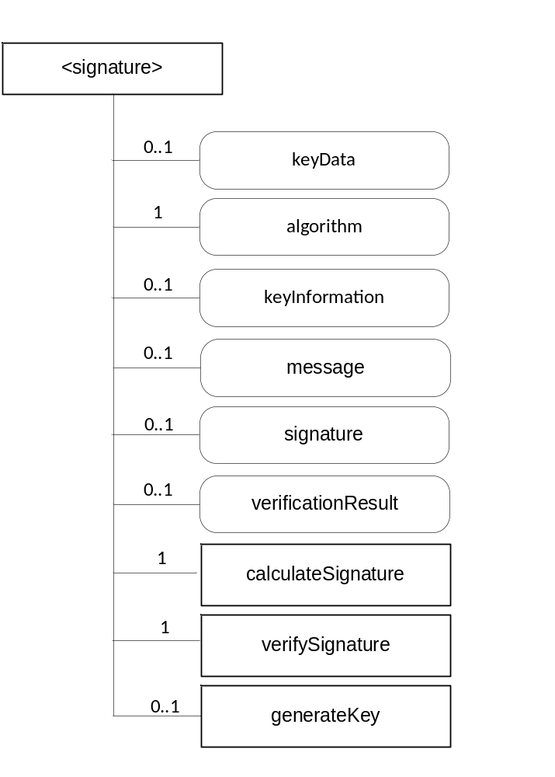
Figure 7.7.4-1: <signature> representation

The <signature> resource shall contain the child resources specified in table 7.7.4-1.
Table 7.7.4-1: Child resources of <signature> resource
Child Resources of <signature> | Child Resource Type | Multiplicity | Description | <signatureAnnc> Child Resource Types
calculateSignature | <calculateSignature> | 1 | See clause 7.7.4.2 | None
verifySignature | <verifySignature> | 1 | See clause 7.7.4.3 | None
generateKey | <generateKey> | 0..1 | See clause 7.7.4.4 | None

Attributes in <Signature> are shown in table 7.7.4-2.
Table 7.7.4-2: Attributes of <signature> resource
Attributes of <signature> | Multiplicity | RW/  RO/  WO | Description | <signatureAnnc> (MA/OA/NA)
resourceType | 1 | RO | Defines the resource type. | NA
resourceID | 1 | RO | Defines an identifier for the resource.  This attribute shall be provided by the creator. The creator shall assign a resourceID which is unique within its context. | NA
resourceName | 1 | WO | This attribute is the name for the resource that is used for 'hierarchical addressing method' to represent the parent-child relationships of resources. | NA
parentID | 1 | RO | This attribute is the resourceID of the parent of this resource. | NA
expirationTime | 1 | RW | Time/date after which the resource will be deleted by the Hosting CSE. | NA
accessControlPolicyIDs | 0..1 (L) | RW | Is used to control access to the resource. If no accessControlPolicyIDs are provided at the time of creation, the accessControlPolicyIDs of the parent resource is linked to this attribute | NA
creationTime | 1 | RO | Time/date of creation of the resource.  The creationTime is set by the CSE hosting the SE when the resource is created. | NA
lastModifiedTime | 1 | RO | Last modification time/date of the resource.  This attribute is mandatory. The lastModifiedTime value is set by the Hosting CSE when the resource is created,and the lastModifiedTime value is updated when the resource is updated. | NA
message | 0..1 | RW | Message either to be signed or to be used to verify a signature, this could be alternatively a hash value | NA
algorithm | 1 | WO | Contains the algorithm type of the resource instance | NA
keyData | 0..1 | WO | Contains the value of the key | NA
keyInformation | 0..1 | RW | Contains information about the key like a certificate | NA
signature | 0..1 | RW | Contains the signature either to be calculated or to be verified | NA
verificationResult | 0..1 | RO | Contains the result of a signature verification operation | NA

The following types are defined for the algorithm attribute:
ALG_AES_CMAC_128 : Signature algorithm ALG_AES_CMAC_128 generates a 16-byte Cipher-based MAC (CMAC) using AES with blocksize 128 in CBC mode with ISO9797_M2 padding scheme.
ALG_AES_MAC_128_NOPAD :Signature algorithm ALG_AES_MAC_128_NOPAD generates a 16-byte MAC using AES with blocksize 128 in CBC mode and does not pad input data.
ALG_ECDSA_SHA_256 :Signature algorithm ALG_ECDSA_SHA_256 generates a 32-byte SHA-256 digest and signs/verifies the digest using ECDSA with the curve defined in the ECKey parameters - such as the P-256 curve specified in the Digital Signature Standards specification[NIST FIPS PUB 186-2].
ALG_ECDSA_SHA_384 :Signature algorithm ALG_ECDSA_SHA_384 generates a 48-byte SHA-384 digest and signs/verifies the digest using ECDSA with the curve defined in the ECKey parameters - such as the P-384 curve specified in the Digital Signature Standards specification[NIST FIPS PUB 186-2].
ALG_ECDSA_SHA_512 :Signature algorithm ALG_ECDSA_SHA_512 generates a 64-byte SHA-512 digest and signs/verifies the digest using ECDSA with the curve defined in the ECKey parameters - such as the P-521 curve specified in the Digital Signature Standards specification[NIST FIPS PUB 186-2].
ALG_HMAC_SHA_256 :HMAC message authentication algorithm ALG_HMAC_SHA_256 This algorithm generates an HMAC following the steps found in RFC: 2104 using SHA-256 as the hashing algorithm.
ALG_HMAC_SHA_384 :HMAC message authentication algorithm ALG_HMAC_SHA_384 This algorithm generates an HMAC following the steps found in RFC: 2104 using SHA-384 as the hashing algorithm.
ALG_HMAC_SHA_512 :HMAC message authentication algorithm ALG_HMAC_SHA_512 This algorithm generates an HMAC following the steps found in RFC: 2104 using SHA-512 as the hashing algorithm.

7.7.4.1 <signature> Resource Procedures

7.7.4.1.1 CREATE <signature>
This procedure shall be used for creating a <signature> resource.
Table 7.7.4.1.1-1: <signature> CREATE
<Signature> CREATE request message parameters
Associated Reference Point | Mcs
Information in Request message | All parameters defined in table 8.1.2-3 of [2] apply with the specific details for:  To: contains M2M-SE-ID or M2M-AE-ID  Content: : The resource content shall provide the information as defined in clause 7.7.1.
Processing at Originator before sending Request | According to clause 10.1.1.1.of [2]
Processing at Receiver | According to clause 10.1.1.1.of [2]
Information in Response message | All parameters defined in table 8.1.3-1 of [2] apply with the specific details for:  • Content: Address of the created <signature> resource, according to clause 10.1.1.1.of [2]
Processing at Originator after receiving Response | According to clause 10.1.1.1. of [2]
Exceptions | According to clause 10.1.1.1. of [2]

If <generateKey> is created, the key to be used will be generated and stored in keyData, in such a case keyInformation is filled with the public part of the generated key.

7.7.4.1.2 RETRIEVE <signature>
This procedure shall be used for retrieving either the calculated signature of the <Signature> resource or the result of the verification of a signature.
Table 7.7.4.1.2-1: <signature> RETRIEVE
<signature> RETRIEVE request message parameters
Associated Reference Point | Mcs
Information in Request message | According to clause 10.1.2. of [2] with the specific details for:  To: contains M2M-SE-ID or M2M-AE-ID
Processing at Originator before sending Request | According to clause 10.1.2. of [2]
Processing at Receiver | According to clause 10.1.2. of [2]
Information in Response message | All parameters defined in table 8.1.3-1 of [2] apply with specific details for:  Content: Attributes of the <signature> resources as defined in clause 7.7.4.
Processing at Originator after receiving Response | According to clause 10.1.2. of [2]
Exceptions | According to clause 10.1.2. of [2]

7.7.4.1.3 UPDATE <signature>
This procedure shall be used for updating the <signature> resource with the message to be signed or to be verified and in the case of verification the signature to be verified.
Table 7.7.4.1.3-1: <signature> UPDATE
<signature> UPDATE request message parameters
Associated Reference Point | Mcs
Information in Request message | All parameters defined in table 8.1.2-3 of [2] apply with the specific details for:  To: contains M2M-SE-ID or M2M-AE-ID  Content = attributes of the <signature> resource as defined in clause 7.7.4 which need be updated
Processing at Originator before sending Request | According to clause 10.1.3. of [2]
Processing at Receiver | According to clause 10.1.3. of [2]
Information in Response message | According to clause 10.1.3. of [2]
Processing at Originator after receiving Response | According to clause 10.1.3. of [2]
Exceptions | According to clause 10.1.3. of [2]

7.7.4.1.4 DELETE <signature>
This procedure shall be used for deleting a <signature> resource.
Table 7.7.4.1.4-1: <signature> DELETE
<signature> DELETE request message parameters
Associated Reference Point | Mcs
Information in Request message | All parameters defined in table 8.1.2-3 of [2] apply with the specific details for:  To: contains M2M-SE-ID or M2M-AE-ID
Processing at Originator before sending Request | According to clause 10.1.4.1 of [2]
Processing at Receiver | According to clause 10.1.4.1 of [2]
Information in Response message | According to clause 10.1.4.1 of [2]
Processing at Originator after receiving Response | According to clause 10.1.4.1 of [2]
Exceptions | According to clause 10.1.4.1 of [2]

7.7.4.2 <calculateSignature> Resource
The <calculateSignature> resource is a virtual resource because it does not have a representation. It is the child resource of a <signature> resource. When a RETRIEVE request addresses the <calculateSignature> resource, the signature is calculated and written in the signature attribute of the <signature> resource.
The <calculateSignature> resource inherits access control policies that apply to the parent <signature> resource.

7.7.4.3 <verifySignature> Resource
The <verifySignature> resource is a virtual resource because it does not have a representation. It is the child resource of a <signature> resource. When a RETRIEVE request addresses the <verifySignature> resource, signature of the is verified and the result shall be stored in verificationResult.
The <verifySignature> resource inherits access control policies that apply to the parent <cipher> resource.

7.7.4.4 <generateKey> Resource
The <generateKey> resource is a virtual resource because it does not have a representation. When a RETRIEVE request addresses the <generateKey> resource, the keyData attribute is filled with a key generated according the algorithm attrbute.
The <generateKey> resource inherits access control policies that apply to the parent resource.

7.8 Secure Connection Establishment

7.8.1 <secureConnection> resource
Secure Environments provide a service to AEs or CSEs to establish a secure connection to a dedicated communication partner. The <secureConnection> resource shall represent the services offered by the Secure Environment to enable the establishment of a secure connection to a communication partner. The services include the following:
- generation of key material within the secure environment that can be used for the establishment of a secure connection by the requesting entity (creator) outside of the secure environment
- acting as secure connection endpoint and sending the data provided by the requesting entity (creator) from within the secure environment with the key material generated and kept inside the secure environment
The <secureConnection> resource is shown in figure 7.8.1-1.

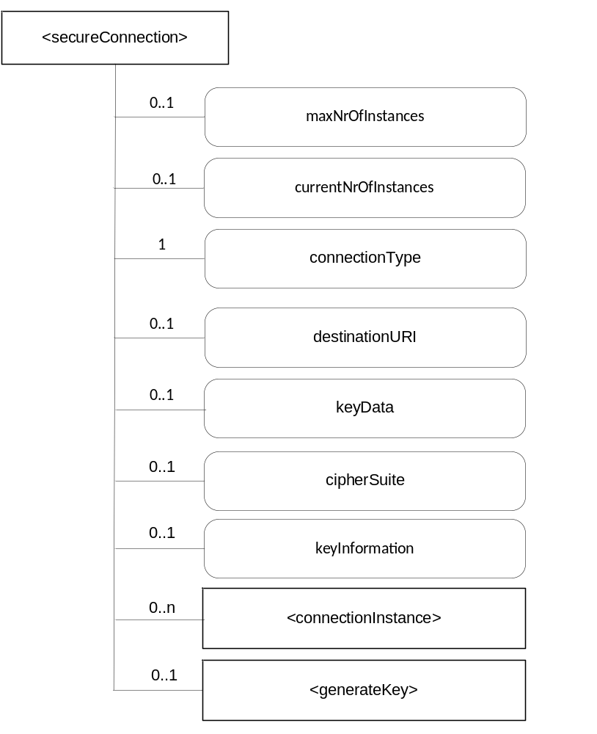
Figure 7.8.1-1: <secureConnection> representation

The <secureConnection> resource shall contain the child resources specified in table 7.8.1-1.
Table 7.8.1-1: Child resources of <secureConnection> resource
Child Resources of <secureConnection> | Child Resource Type | Multiplicity | Description | <secureConnectionAnnc> Child Resource Types
connectionInstance | <connectionInstance> | 0..n | See clause 7.8.3 | None
generateKey | <generateKey> | 0..1 | See clause 7.8.7 | None

Attributes in <secureConnection> are shown in table 7.8.1-2.
Attributes of <secureConnection> | Multiplicity | RW/  RO/  WO | Description | <secureConnectionAnnc> (MA/OA/NA)
resourceType | 1 | RO | Defines the resource type. | NA
resourceID | 1 | RO | Defines an identifier for the resource.  This attribute shall be provided by the creator. The creator shall assign a resourceID which is unique within its context. | NA
resourceName | 1 | WO | This attribute is the name for the resource that is used for 'hierarchical addressing method' to represent the parent-child relationships of resources. | NA
parentID | 1 | RO | This attribute is the resourceID of the parent of this resource. | NA
expirationTime | 1 | RW | Time/date after which the resource will be deleted by the Hosting CSE. | NA
accessControlPolicyIDs | 0..1 (L) | RW | Is used to control access to the resource. If no accessControlPolicyIDs are provided at the time of creation, the accessControlPolicyIDs of the parent resource is linked to this attribute | NA
creationTime | 1 | RO | Time/date of creation of the resource.  The creationTime is set by the CSE hosting the SE when the resource is created. | NA
lastModifiedTime | 1 | RO | Last modification time/date of the resource.  This attribute is mandatory. The lastModifiedTime value is set by the Hosting CSE when the resource is created,and the lastModifiedTime value is updated when the resource is updated. | NA
maxNrOfInstances | 0..1 | RW | Maximum number of direct child <connectionInstance> resources in the <secureConnection> resource. | NA
currentNrOfInstances | 0..1 | RO | Current number of direct child <connectionInstance> resource in the <secureConnection> resource. It is limited by the maxNrOfInstances. | NA
connectionType | 1 | RW | Contains the type of connection that has to be supported.  Supported types are:  TLS; DTLS; SMS; E2EKey | NA
keyData | 0..1 | WO | Contains the key material | NA
keyInformation | 0..1 | RW | Specifies the additional information required for the key and the ciphersuite, e.g. Certificates, rootkeys, the public part of keyData | NA
cipherSuite | 0..1 | RW | Specifies the ciphersuites that are supported.  Supported cipher suites are given in [1] | NA
Table 7.8.1-2: Attributes of <secureConnection> resource

7.8.2 <secureConnection> Resource Procedures

7.8.2.1 CREATE <secureConnection>
This procedure shall be used for creating a <secureConnection> resource.
Table 7.8.2.1-1: <secureConnection> CREATE
<secure Connection> CREATE request message parameters
Associated Reference Point | Mcs
Information in Request message | All parameters defined in table 8.1.2-3 of [2] apply with the specific details for:  To: contains M2M-SE-ID or M2M-AE-ID  Content: The resource content shall provide the information as defined in clause 7.8.1.
Processing at Originator before sending Request | According to clause 10.1.1.1.of [2]
Processing at Receiver | According to clause 10.1.1.1.of [2]
Information in Response message | All parameters defined in table 8.1.3-1 of [2] apply with the specific details for:  • Content: Address of the created <cipher> resource, according to clause 10.1.1.1.of [2]
Processing at Originator after receiving Response | According to clause 10.1.1.1. of [2]
Exceptions | According to clause 10.1.1.1. of [2]

If <generateKey> is created, the key to be used will be generated and stored in keyData, in such a case keyInformation is filled with the public part of the generated key.

7.8.2.2 RETRIEVE <secureConnection>
This procedure shall be used for retrieving information about the <secureConnection> resource.

Table 7.8.2.2-1: <secureConnection> RETRIEVE
<secureConnection> RETRIEVE request message parameters
Associated Reference Point | Mcs
Information in Request message | According to clause 10.1.2. of [2] with the specific details for:  To: contains M2M-SE-ID or M2M-AE-ID
Processing at Originator before sending Request | According to clause 10.1.2. of [2]
Processing at Receiver | According to clause 10.1.2. of [2]
Information in Response message | All parameters defined in table 8.1.3-1 of [2] apply with specific details for:  Content: Attributes of the <secureConnection> resources as defined in clause 7.8.1.
Processing at Originator after receiving Response | According to clause 10.1.2. of [2]
Exceptions | According to clause 10.1.2. of [2]

7.8.2.3 UPDATE <secureConnection>
This procedure shall be used for sending payload data via an established secure connection.
Table 7.8.2.3-1: <secureConnection> UPDATE
<secureConnection> UPDATE request message parameters
Associated Reference Point | Mcs
Information in Request message | All parameters defined in table 8.1.2-3 of [2] apply with the specific details for:  To: contains M2M-SE-ID or M2M-AE-ID  Content = attributes of the <cipher> resource as defined in clause 7.7.1 which need be updated
Processing at Originator before sending Request | According to clause 10.1.3. of [2]
Processing at Receiver | According to clause 10.1.3. of [2]
Information in Response message | According to clause 10.1.3. of [2]
Processing at Originator after receiving Response | According to clause 10.1.3. of [2]
Exceptions | According to clause 10.1.3. of [2]

7.8.2.4 DELETE <secureConnection>
This procedure shall be used for deleting a <secureConnection> resource. Deleting a <secureConnection> resource closes an established secure connection between the originator (creator) and the destination.
Table 7.8.2.4-1: <secureConnection> DELETE
<secureConnection> DELETE request message parameters
Associated Reference Point | Mcs
Information in Request message | All parameters defined in table 8.1.2-3 of [2] apply with the specific details for:  To: contains M2M-SE-ID or M2M-AE-ID
Processing at Originator before sending Request | According to clause 10.1.4.1 of [2]
Processing at Receiver | According to clause 10.1.4.1 of [2]
Information in Response message | According to clause 10.1.4.1 of [2]
Processing at Originator after receiving Response | According to clause 10.1.4.1 of [2]
Exceptions | According to clause 10.1.4.1 of [2]

7.8.3 <connectionInstance> resource
The <connectionInstance> resource represents a data instance in the <secureConnection> resource.
The <connectionInstance> resource inherits the same access control policies of the parent <secureConection> resource, and does not have its own accessControlPolicyIDs attribute.
The services include the following:
- generation of key material within the secure environment that can be used for the establishment of a secure connection by the requesting entity (creator) outside of the secure environment
- acting as secure connection endpoint and sending the data provided by the requesting entity (creator) from within the secure environment with the key material generated and kept inside the secure environment
The <connectionInstance> resource is shown in figure 7.8.3-1.

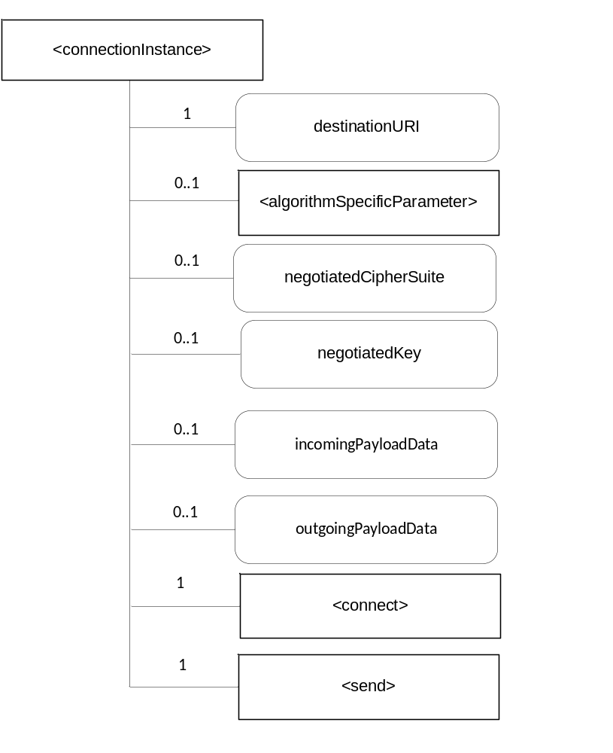
Figure 7.8.3-1: <connectionInstance> representation

The <connectionInstance> resource shall contain the child resources specified in table 7.8.3-1.
Table 7.8.3-1: Child resources of <connectionInstance> resource
Child Resources of <connectionInstance> | Child Resource Type | Multiplicity | Description | <connectionInstance Annc> Child Resource Types
algorithmSpecificParameter | <algorithmSpecificParameter> | 0..1 | See clause 7.7.1.5 | None
connect | <connect> | 1 | See clause 7.8.5 | None
send | <send> | 1 | See clause 7.8.6 | None

Attributes in <connectionInstance> are shown in table 7.8.3-2.

Attributes of <connectionInstance> | Multiplicity | RW/  RO/  WO | Description | <connectionInstance Annc> (MA/OA/NA)
resourceType | 1 | RO | Defines the resource type. | NA
resourceID | 1 | RO | Defines an identifier for the resource.  This attribute shall be provided by the creator. The creator shall assign a resourceID which is unique within its context. | NA
resourceName | 1 | WO | This attribute is the name for the resource that is used for 'hierarchical addressing method' to represent the parent-child relationships of resources. | NA
parentID | 1 | RO | This attribute is the resourceID of the parent of this resource. | NA
expirationTime | 1 | RW | Time/date after which the resource will be deleted by the Hosting CSE. | NA
accessControlPolicyIDs | 0..1 (L) | RW | Is used to control access to the resource. If no accessControlPolicyIDs are provided at the time of creation, the accessControlPolicyIDs of the parent resource is linked to this attribute | NA
creationTime | 1 | RO | Time/date of creation of the resource.  The creationTime is set by the CSE hosting the SE when the resource is created. | NA
lastModifiedTime | 1 | RO | Last modification time/date of the resource.  This attribute is mandatory. The lastModifiedTime value is set by the Hosting CSE when the resource is created,and the lastModifiedTime value is updated when the resource is updated. | NA
destinationURI | 1 | RW | Specifies the end point to which the secure connection shall be established | NA
outgoingPayloadData | 0..1 | RW | Contains the data that has to be sent via the established secure connection | NA
incomingPayloadData | 0..1 | RO | Contains the data that has to be sent via the established secure connection | NA
negotiatedKey | 0..1 | RO | Contains the negotiated key e.g. the pairwiseE2EKey using TLS Exporter specification (RFC 5705). | NA
negotiatedCipherSuite | 0..1 | RO | Is the cipher suite negotiated between the Secure Environment and the remote entity | NA
Table 7.8.3-2: Attributes of <connectionInstance> resource

7.8.4 <connectionInstance> Resource Procedures

7.8.4.1 CREATE <connectionInstance>
This procedure shall be used for creating a <connectionInstance> resource.
Table 7.8.4.1-1: <connectionInstance> CREATE
<connectionInstance> CREATE request message parameters
Associated Reference Point | Mcs
Information in Request message | All parameters defined in table 8.1.2-3 of [2] apply with the specific details for:To: contains M2M-SE-ID or M2M-AE-ID  Content: : The resource content shall provide the information as defined in clause 7.8.3.
Processing at Originator before sending Request | According to clause 10.1.1.1.of [2]
Processing at Receiver | According to clause 10.1.1.1.of [2]
Information in Response message | All parameters defined in table 8.1.3-1 of [2] apply with the specific details for:  • Content: Address of the created <connectionInstance> resource, according to clause 10.1.1.1.of [2]
Processing at Originator after receiving Response | According to clause 10.1.1.1. of [2]
Exceptions | According to clause 10.1.1.1. of [2]

7.8.4.2 RETRIEVE <connectionInstance>
This procedure shall be used for retrieving payload data from a communication partner or to retrieve the negotiated key.

Table 7.8.4.2-1: <connectionInstance> RETRIEVE
<connectionInstance> RETRIEVE request message parameters
Associated Reference Point | Mcs
Information in Request message | According to clause 10.1.2. of [2] with the specific details for:  To: contains M2M-SE-ID or M2M-AE-ID
Processing at Originator before sending Request | According to clause 10.1.2. of [2]
Processing at Receiver | According to clause 10.1.2. of [2]
Information in Response message | All parameters defined in table 8.1.3-1 of [2] apply with specific details for:  Content: Attributes of the <connectionInstance> resources as defined in clause 7.8.3.
Processing at Originator after receiving Response | According to clause 10.1.2. of [2]
Exceptions | According to clause 10.1.2. of [2]

7.8.4.3 UPDATE <connectionInstance>
This procedure shall be used for sending payload data via an established secure connection.
Table 7.8.4.3-1: <connectionInstance> UPDATE
<connectionInstance> UPDATE request message parameters
Associated Reference Point | Mcs
Information in Request message | All parameters defined in table 8.1.2-3 of [2] apply with the specific details for:  To: contains M2M-SE-ID or M2M-AE-ID  Content = attributes of the <connectionInstance> resource as defined in clause 7.8.3 which need be updated
Processing at Originator before sending Request | According to clause 10.1.3. of [2]
Processing at Receiver | According to clause 10.1.3. of [2]
Information in Response message | According to clause 10.1.3. of [2]
Processing at Originator after receiving Response | According to clause 10.1.3. of [2]
Exceptions | According to clause 10.1.3. of [2]

7.8.4.4 DELETE <connectionInstance>
This procedure shall be used for deleting a <connectionInstance> resource. Deleting a <connectionInstance> resource closes an established secure connection between the originator (creator) and the destination.
Table 7.8.4.4-1: <connectionInstance> DELETE
<connectionInstance> DELETE request message parameters
Associated Reference Point | Mcs
Information in Request message | All parameters defined in table 8.1.2-3 of [2] apply with the specific details for:  To: contains M2M-SE-ID or M2M-AE-ID
Processing at Originator before sending Request | According to clause 10.1.4.1 of [2]
Processing at Receiver | According to clause 10.1.4.1 of [2]
Information in Response message | According to clause 10.1.4.1 of [2]
Processing at Originator after receiving Response | According to clause 10.1.4.1 of [2]
Exceptions | According to clause 10.1.4.1 of [2]

7.8.5 <connect> Resource
The <connect> resource is a virtual resource because it does not have a representation. When a RETRIEVE request addresses the <connect> resource, a connection is established to the destination URI. If <negotiatedKey> exists the negotiated key is stored in this attribute.
The <connect> resource inherits access control policies that apply to the parent resource.

7.8.6 <send> Resource
The <send> resource is a virtual resource because it does not have a representation. When a RETRIEVE request addresses the <send> resource, the value of outgoingPayloadData is sent to the destination URI.
The <send> resource inherits access control policies that apply to the parent resource.

7.8.7 <generateKey> Resource
The <generateKey> resource is a virtual resource because it does not have a representation. When a RETRIEVE request addresses the <generateKey> resource, the keyData attribute is filled with a key generated according the algorithm attrbute.
The <generateKey> resource inherits access control policies that apply to the parent resource.

7.9 Authentication and Identification

7.9.1 <identity> resource
Secure Environments provide a service to AEs or CSEs to establish a Identity and provide authentication of this Identity. The <identity> resource shall represent the services offered by the Secure Environment to enable the establishment of a secure Identity. The services include the following:
- generation of an Identity and associated key material within the secure environment
- using the associated key material for authenticating the generated Identity
The <identity> resource is shown in figure 7.9.1-1.

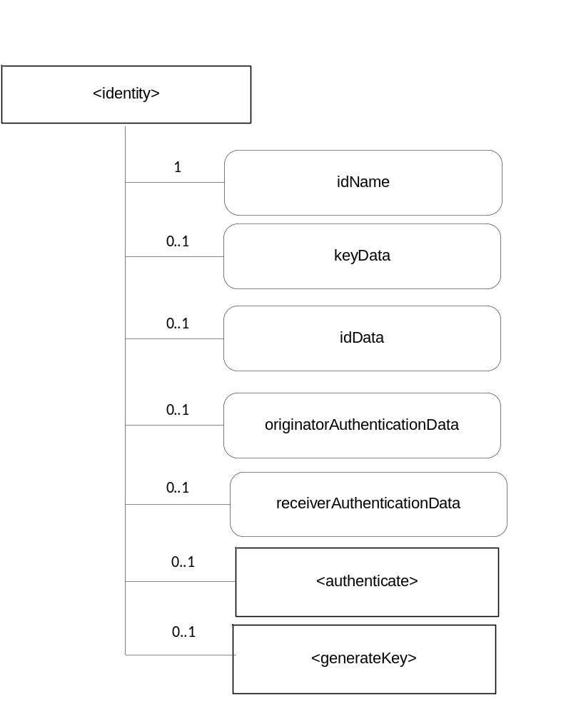
Figure 7.9.1-1: <identity> representation

The <identity> resource shall contain the child resources specified in table 7.9-1.
Table 7.9.1-1: Child resources of <identity> resource
Child Resources of <identity> | Child Resource Type | Multiplicity | Description | <identityAnnc> Child Resource Types
authenticate | <authenticate> | 0..1 | See clause 7.9.3 | None
generateKey | <generateKey> | 0..1 | See clause 7.9.4 | None

Attributes in <Identity> are shown in table 7.9-2.
Table 7.9.1-2: Attributes of <identity> resource
Attributes of <identity> | Multiplicity | RW/  RO/  WO | Description | <identityAnnc> (MA/OA/NA)
resourceType | 1 | RO | Defines the resource type. | NA
resourceID | 1 | RO | Defines an identifier for the resource.  This attribute shall be provided by the creator. The creator shall assign a resourceID which is unique within its context. | NA
resourceName | 1 | WO | This attribute is the name for the resource that is used for 'hierarchical addressing method' to represent the parent-child relationships of resources. | NA
parentID | 1 | RO | This attribute is the resourceID of the parent of this resource. | NA
expirationTime | 1 | RW | Time/date after which the resource will be deleted by the Hosting CSE. | NA
accessControlPolicyIDs | 0..1 (L) | RW | Is used to control access to the resource. If no accessControlPolicyIDs are provided at the time of creation, the accessControlPolicyIDs of the parent resource is linked to this attribute | NA
creationTime | 1 | RO | Time/date of creation of the resource.  The creationTime is set by the CSE hosting the SE when the resource is created. | NA
lastModifiedTime | 1 | RO | Last modification time/date of the resource.  This attribute is mandatory. The lastModifiedTime value is set by the Hosting CSE when the resource is created,and the lastModifiedTime value is updated when the resource is updated. | NA
idName | 1 | WO | Contains the name of the identity | NA
keyData | 0..1 | WO | Contains the value of a key | NA
idData | 0..1 | RW | Contains information associated to the identity and which is necessary for the authentication protocol.  The detailed structure depends on the authentication protocol and could comprise among others public key material, protocol identifier, certificates | NA
originatorAuthenticationData | 0..1 | RW | Contains information provided by the Originator and which is necessary for the authentication protocol.  The detailed structure depends on the authentication protocol and could comprise among others nonces, certificates, signatures | NA
receiverAuthenticationData | 0..1 | RO | Contains information provided by the Receiver and which is necessary for the authentication protocol.  The detailed structure depends on the authentication protocol and could comprise among others nonces, certificates, signatures | NA

7.9.2 <identity> Resource Procedures

7.9.2.1 CREATE <identity>
This procedure shall be used for creating a <identity> resource.
Table 7.9.2.1-1: <identity> CREATE
<identity> CREATE request message parameters
Associated Reference Point | Mcs
Information in Request message | All parameters defined in table 8.1.2-3 of [2] apply with the specific details for:  To: contains M2M-SE-ID or M2M-AE-ID  Content: The resource content shall provide the information as defined in clause 7.9.1
Processing at Originator before sending Request | According to clause 10.1.1.1.of [2]
Processing at Receiver | According to clause 10.1.1.1.of [2]
Information in Response message | All parameters defined in table 8.1.3-1 of [2] apply with the specific details for:  • Content: Address of the created <identity> resource, according to clause 10.1.1.1.of [2]
Processing at Originator after receiving Response | According to clause 10.1.1.1. of [2]
Exceptions | According to clause 10.1.1.1. of [2]

If <generateKey> is created, the key to be used will be generated and stored in keyData, in such a case keyInformation is filled with the public part of the generated key.

7.9.2.2 RETRIEVE <identity>
This procedure shall be used for retrieving the identity and retrieve authentication data according the used authentication protocol.

Table 7.9.2.2-1: <identity> RETRIEVE
<identity> RETRIEVE request message parameters
Associated Reference Point | Mcs
Information in Request message | According to clause 10.1.2. of [2] with the specific details for:  To: contains M2M-SE-ID or M2M-AE-ID
Processing at Originator before sending Request | According to clause 10.1.2. of [2]
Processing at Receiver | According to clause 10.1.2. of [2]
Information in Response message | All parameters defined in table 8.1.3-1 of [2] apply with specific details for:  Content: Attributes of the <identity> resources as defined in clause 7.9.1.
Processing at Originator after receiving Response | According to clause 10.1.2. of [2]
Exceptions | According to clause 10.1.2. of [2]

7.9.2.3 UPDATE <identity>
This procedure shall be used for updating the <identity resource> and sending authentication data according the used authentication protocol.
Table 7.9.2.3-1: <identity> UPDATE
<identity> UPDATE request message parameters
Associated Reference Point | Mcs
Information in Request message | All parameters defined in table 8.1.2-3 of [2] apply with the specific details for:  To: contains M2M-SE-ID or M2M-AE-ID  Content = attributes of the <cipher> resource as defined in clause 7.7.1 which need be updated
Processing at Originator before sending Request | According to clause 10.1.3. of [2]
Processing at Receiver | According to clause 10.1.3. of [2]
Information in Response message | According to clause 10.1.3. of [2]
Processing at Originator after receiving Response | According to clause 10.1.3. of [2]
Exceptions | According to clause 10.1.3. of [2]

7.9.2.4 DELETE <identity>
This procedure shall be used for deleting a <identity> resource.
Table 7.9.2.4-1: <identity> DELETE
<Identity> DELETE request message parameters
Associated Reference Point | Mcs
Information in Request message | All parameters defined in table 8.1.2-3 of [2] apply with the specific details for:To: contains M2M-SE-ID or M2M-AE-ID
Processing at Originator before sending Request | According to clause 10.1.4.1 of [2]
Processing at Receiver | According to clause 10.1.4.1 of [2]
Information in Response message | According to clause 10.1.4.1 of [2]
Processing at Originator after receiving Response | According to clause 10.1.4.1 of [2]
Exceptions | According to clause 10.1.4.1 of [2]

7.9.3 <authenticate> Resource
The <authenticate> resource is a virtual resource because it does not have a representation. It is the child resource of a <identity> resource. When a RETRIEVE request addresses the <authenticate> resource, the originatorAuthenticationData, keyData and idData is used to calculate a value which is stored in retrieverAuthenticationData.
Depending on the authentication protocol it may be necessary to repeat the process of UPDATE originatorAuthenticationData , RETRIEVE <authenticate> and RETRIEVE retrieverAuthenticationData several times.
The <authenticate> resource inherits access control policies that apply to the parent <identity> resource.

7.9.4 <generateKey> Resource
The <generateKey> resource is a virtual resource because it does not have a representation. When a RETRIEVE request addresses the <generateKey> resource, the keyData attribute is filled with a key generated according the algorithm attrbute.
The <generateKey> resource inherits access control policies that apply to the parent resource.

8 Physical Interface
<Text>
Editor’s note: add references to existing specifications in order to specify how to physically access particular types of SE;

8.1 User defined subdivisions of clause(s) from here onwards
<Text>

Proforma copyright release text block
This text box shall immediately follow after the heading of an element (i.e. clause or annex) containing a proforma or template which is intended to be copied by the user. Such an element shall always start on a new page.
Notwithstanding the provisions of the copyright clause related to the text of the present document, oneM2M grants that users of the present document may freely reproduce the <proformatype> proforma in this {clause|annex} so that it can be used for its intended purposes and may further publish the completed <proformatype>.
<PAGE BREAK>

Annexes
Each annex shall start on a new page (insert a page break between annexes A and B, annexes B and C, etc.).
Use the Heading 9 style for the title and the Normal style for the text.
Annex A (Informative): Use Cases
<Text>
<PAGE BREAK>
Annex <B>(Informative/Normative): Remove Informative or Normative as appropriateTitle of annex (style H9)
<Text>
B.1 First clause of the annex (style H1)
<Text>
B.1.1 First subdivided clause of the annex (style H2)
<Text>
<PAGE BREAK>
The following text is to be used when appropriate:

Annex <y>:
Bibliography
The annex entitled "Bibliography" is optional.
It shall contain a list of standards, books, articles, or other sources on a particular subject which are not mentioned in the document itself
It shall not include references mentioned in the document.
Use the Heading 9 style for the title and B1+ or Normal for the text.
- <Publication>: "<Title>".
OR
<Publication>: "<Title>".
<PAGE BREAK>

History
This clause shall be the last one in the document and list the main phases (all additional information will be removed at the publication stage).
Publication history
V1.1.1 | <dd-Mmm-yyyy> | <Milestone>

Draft history (to be removed on publication)
V0.0.1 | 26-03-2015 | Initial skeleton
V0.0.2 | 11-06-2015 | Includes following CRs agreed at SEC#17:  SEC-2015-0528R05-TS-0016_SE_reference_points_overview
V0.1.0 | 24-07-2015 | Includes following CRs agreed at SEC#18:  SEC-2015-0554R01-SE_abstraction_architecture  SEC-2015-0555R02-Types_of_SEs  SEC-2015-0553R02-SE_reference_point
V0.2.0 | 11-09-2015 | Includes following CRs agreed at SEC#19:  SEC-2015-0604R01-TS-0016_sensitive_data_storage_resource
V0.3.0 | 03-12-2015 | Includes following CRs agreed at SEC#20:  SEC-2015-0651R06-TS-0016_AE_discovery_and_selection  SEC-2015-0653R03-TS-0016_Profile_Management
V0.4.0 | 24-02-2016 | Includes following CRs agreed at by email following SEC#20.2:  SEC-2016-0015R04-TS-0016_Secure_Connection  SEC-2016-0016R04-TS-0016_CR_Identity  SEC-2016-0017R04-TS-0016_CR_Cipher  SEC-2016-0031R02-CR_TS-0016_Improvements
V0.5.0 | 18-03-2016 | Includes following CRs agreed at SEC#22:  SEC-2016-0064R01-TS-0016_pCR_cipher  SEC-2016-0072R01-CR_TS-0016_Editorial_changes

