CHANGE REQUEST
Meeting:* | SEC 24
Source:* | François Ennesser, Gemalto (ETSI)
Date:* | 2016-07-18
Contact:* | francois.ennesser@gemalto.com
Reason for Change/s:* | Collection of corrections and clarifications top TS-0003 Rel-2
CR against: Release* | 2
CR against: WI* | Active <Work Item number>  MNT Maintenance / < Work Item number(optional)>  STE Small Technical Enhancements / < Work Item number (optional)>  Only ONE of the above shall be ticked
CR against: TS/TR* | TS-0003 v2.3.0
Clauses/Sub Clauses*
Type of change: * | Editorial change  Bug Fix or Correction  Change to existing feature or functionality  New feature or functionality  Only ONE of the above shall be ticked
Post Freeze checking:* | This CR contains only essential changes and corrections? YES NO  This CR is a mirror CR? YES NO if YES, please indicate the document number of the original CR:
Template Version:23 February 2015 (Dot not modify)

oneM2M Notice
The document to which this cover statement is attached is submitted to oneM2M. Participation in, or attendance at, any activity of oneM2M, constitutes acceptance of and agreement to be bound by terms of the Working Procedures and the Partnership Agreement, including the Intellectual Property Rights (IPR) Principles Governing oneM2M Work found in Annex 1 of the Partnership Agreement.

------------------------------------------------ START OF CHANGES TO TS-0003 v2.3.0 -----------------------------------------

1 Scope
The present document defines security solutions applicable within the M2M system.

2 References

2.1 Normative references
References are either specific (identified by date of publication and/or edition number or version number) or non-specific. For specific references, only the cited version applies. For non-specific references, the latest version of the reference document (including any amendments) applies.
The following referenced documents are necessary for the application of the present document.
[1] oneM2M TS-0001: "Functional Architecture".
[2] oneM2M TS-0011: " Common Terminology".
[3] Void.
[4] oneM2M TS-0004: "Service Layer Core Protocol Specification".
[5] IETF RFC 5246: "The Transport Layer Security (TLS) Protocol Version 1.2".
[6] IETF RFC 6347: "Datagram Transport Layer Security Version 1.2".
[7] ETSI TS 102 225 (V11.0.0): "Smart Cards; Secured packet structure for UICC based applications (Release 11)".
[8] ETSI TS 102 226 (V11.0.0): "Smart Cards; Remote APDU structure for UICC based applications (Release 11)".
[9] 3GPP TS 31.115 (V10.1.0): "Remote APDU Structure for (U)SIM Toolkit applications (Release 10)".
[10] 3GPP TS 31.116 (V10.2.0): "Remote APDU Structure for (Universal) Subscriber Identity Module (U)SIM Toolkit applications (Release 10)".
[11] 3GPP2 C.S0078-0 (V1.0): "Secured packet structure for CDMA Card Application Toolkit (CCAT) applications".
[12] 3GPP2 C.S0079-0 (V1.0): "Remote APDU Structure for CDMA Card Application Toolkit (CCAT) applications".
[13] 3GPP TS 33.220: "Generic Authentication Architecture (GAA); Generic Bootstrapping Architecture (GBA)".
[14] 3GPP2 S.S0109-A: "Generic Bootstrapping Architecture (GBA) Framework".
[15] IETF RFC 4279: "Pre-Shared Key Ciphersuites for Transport Layer Security (TLS)".
[16] Void.
[17] Void.
[18] IETF RFC 5705: "Keying Material Exporters for Transport Layer Security (TLS)".
[19] IETF RFC 3629: "UTF-8, a transformation format of ISO 10646".
[20] "Unicode Standard Annex #15; Unicode Normalization Forms", Unicode 5.1.0, March 2008.
NOTE: Available at http://www.unicode.org.
[21] GlobalPlatform Device Technology TEE Administration framework, DRAFT.
[22] GlobalPlatform Device Technology TEE System Architecture, Version 1.0.
[23] ETSI TS 102 671: "Smart Cards; Machine to Machine UICC; Physical and logical characteristics".
[24] ETSI TS 102 221: "Smart Cards; UICC-Terminal interface; Physical and logical characteristics".
[25] ETSI TS 102 484: "Smart Cards; Secure channel between a UICC and an end-point terminal".
[26] ISO/IEC 7816-4: "Identification cards - Integrated circuit cards - Part 4: Organization, security and commands for interchange".
[27] ETSI TS 101 220: "Smart Cards; ETSI numbering system for telecommunication application providers".
[28] Void.
[29] Void.
[30] Void.
[31] IETF RFC 6655: "AES-CCM Cipher Suites for Transport Layer Security (TLS)".
[32] IETF RFC 5289: "TLS Elliptic Curve Cipher Suites with SHA-256/384 and AES Galois Counter Mode (GCM)".
[33] IETF RFC 2104: "HMAC: Keyed-Hashing for Message Authentication".
[34] IETF RFC 5280: "Internet X.509 Public Key Infrastructure Certificate and Certificate Revocation List (CRL) Profile".
[35] IETF RFC 6960: "X.509 Internet Public Key Infrastructure Online Certificate Status Protocol - OCSP".
[36] IETF RFC 6961: "The Transport Layer Security (TLS) Multiple Certificate Status Request Extension".
[37] IETF RFC 7250: "Using Raw Public Keys in Transport Layer Security (TLS) and Datagram Transport Layer Security (DTLS)".
[38] IETF RFC 7252: "The Constrained Application Protocol (CoAP)".
[39] National Institute of Standards and Technology (July 1999): "Recommended Elliptic Curves for Federal Government user".
NOTE: Available at http://csrc.nist.gov/groups/ST/toolkit/documents/dss/NISTReCur.pdf.
[40] IETF RFC 6920: "Naming Things with Hashes".
[41] IETF RFC 3548: "The Base16, Base32, and Base64 Data Encodings".
[42] IETF RFC 5487: "Pre-Shared Key Cipher Suites for TLS with SHA-256/384 and AES Galois Counter Mode".
[43] IETF RFC 4492: "Elliptic Curve Cryptography (ECC) Cipher Suites for Transport Layer Security (TLS)".
[44] IETF RFC 6066: "Transport Layer Security (TLS) Extensions: Extension Definitions".
[45] IETF RFC 7251: "AES-CCM Elliptic Curve Cryptography (ECC) Cipher Suites for Transport Layer Security (TLS)".
[46] IETF RFC 5480: "Elliptic Curve Cryptography Subject Public Key Information".
[47] GlobalPlatform Device Technology Secure Element Remote Application Management v1.0 GPD_SPE_008.
[48] IETF RFC 5869: HMAC-based Extract-and-Expand Key Derivation Function (HKDF).
[49] IETF RFC 7518 (2015): "JSON Web Algorithms (JWA)".
[50] IETF RFC 7516: “JSON Web Encryption (JWE)”, 2015.
[51] IETF RFC 7515: “JSON Web Signature (JWS)”, 2015.
[52] W3C Recommendation “XML Signature Syntax and Processing v1.1”, 2013, http://www.w3.org/TR/xmlsig-core1/
[53] IETF RFC 7516: “JSON Web Token (JWT)”, 2015
[54] OpenID Foundation, “OpenID Connect Core 1.0”, 2014
[55] W3C Recommendation “XML Encryption Syntax and Processing v1.1”, 2013, http://www.w3.org/TR/xmlenc-core1/

2.2 Informative references
References are either specific (identified by date of publication and/or edition number or version number) or non-specific. For specific references, only the cited version applies. For non-specific references, the latest version of the reference document (including any amendments) applies.
The following referenced documents are not necessary for the application of the present document but they assist the user with regard to a particular subject area.
[i.1] oneM2M Drafting Rules.
NOTE: Available at http://www.onem2m.org/images/files/oneM2M-Drafting-Rules.pdf.
[i.2] Void.
[i.3] Void.
[i.4] oneM2M TR-0008: "Analysis of Security Solutions".
[i.5] eXtensible Access Control Markup Language (XACML) Version 3.0. 22 January 2013. OASIS Standard.
[i.6] Handbook of Applied Cryptography, A. J. Menezes, P. C. van Oorschot, S. A. Vanstone, CRC Press, 1996.
[i.7] Recommendation ITU-T X.509 (10/2012): "Information technology - Open Systems Interconnection - The Directory: Public-key and attribute certificate frameworks".
[i.8] Void.
[i.9] OMA-TS-REST-NetAPI-TerminalLocation-V1-0-20130924-A: "RESTful Network API for Terminal Location", Version 1.0.
[i.10] ISO 3166-1:2013: "Codes for the representation of names of countries and their subdivisions -- Part 1: Country codes".
[i.11] ISO/IEC 7816-5: "Identification cards - Integrated circuit cards - Part 5: Registration of Application Providers".
[i.12] Guide to Attribute Based Access Control (ABAC) Definition and Considerations, NIST Special Publication 800-162.
NOTE: Available at http://nvlpubs.nist.gov/nistpubs/specialpublications/NIST.sp.800-162.pdf.
[i.13] National Institute of Standards and Technology: "Guide to Protecting the Confidentiality of Personally Identifiable Information (PII)".
[i.14] void
[i.15] oneM2M TR-0019 "Dynamic Authorization".
[i.16] oneM2M TR-0012 "End to End security".
[i.17] oneM2M TR-0001: "Use Case collection".
[i.18] IANA JSON Web Token (JWT) registry, http://www.iana.org/assignments/jwt/jwt.xhtml

3 Definitions, symbols and abbreviations

3.1 Definitions
For the purposes of the present document, the terms and definitions given in oneM2M-TS-0011 [2] and the following apply:
additional authenticated data [14]: refers to data that is authenticated, but not encrypted by an authenticated encryption with associated data algorithm.
AE-ID Certificate: certificate with a certificate chain to a trust anchor certificate and containing an AE-ID in the subjectAltName extension
NOTE: An AE_ID certificate can be used to verify that an entity has been assigned the AE-ID in the certificate.
association configuration: phase of a Security Association Establishment Framework in which the entity establishing the Security Association (and the Central Key Distribution Server, in the case of Centralized Security Frameworks), are provided with identities (and any other relevant credentials) to ensure that the security association is established between the intended entities
association security handshake: phase of a Security Association Framework in which the security association endpoints perform mutual authentication
authenticated encryption with associated data [14]: algorithm providing confidentiality for the plaintext and a way to check its integrity and authenticity while providing the ability to check the integrity and authenticity of some additional authenticated data. In this context plaintext refers to data that is authenticated and encrypted
bootstrap credential: pre-provisioned credential enabling mutual authentication of the Enrolee and the M2M Enrolment function
bootstrap credential configuration: phase of a Security Bootstrap Framework in which the Bootstrap Credentials are pre-provisioned to the Enrolee and the M2M Enrolment function
bootstrap enrolment handshake: phase of a Security Bootstrap Framework in which the Enrolee and M2M Enrolment Function perform mutual authentication
bootstrap instruction configuration: phase of a Security Bootstrap Framework in which the Enrolee and M2M Enrolment Function are provided with identities (and any other relevant credentials) to enable the M2M Enrolment function to establish a Master Credential between the intended Enrolee and M2M Authentication Function
bootstrap server function [13]: BSF is hosted in a network element under the control of a Mobile Network Operator. BSF, HSS, and UEs participate in GBA in which a shared secret is established between the network and a UE by running the bootstrapping procedure
NOTE: The shared secret can be used between NAFs and UEs, for example, for authentication purposes.
bootstrapping transaction identifier [13]: bootstrapping transaction identifier (B-TID) is used to bind the subscriber identity to the keying material in GBA reference points Ua, Ub and Zn
CA-Certificate [i.6]: certificate created by one certification authority (CA) certifying the public key of another CA
certificate: See Public Key Certificate.
certificate chain: sequence of one or more CA-certificates, where: the Public Verification Key in each CA-certificate is certified in the previous CA-certificate; and the public key of the first CA-Certificate is trusted a priori
NOTE: Trust in the public key in each CA-certificate can be based on trust in the previous CA-Certificate.
certificate enrolment: a framework providing the ability to provision a certificate to an entity certificates for which the entity knows the private key, and for providing trust anchors for verifying certificates.
certificate name: unique identifier in a name field of a Certificate (e.g. in the X.509 "Subject" or "Subject Alternative Name" attribute)
certificate verification: process necessary to trust an entity's Certificate
certification authority [i.6]: responsible for establishing and vouching for the authenticity of public keys
NOTE: [This] includes binding public keys to distinguished names through signed certificates, managing certificate serial numbers, and certificate revocation.
content encryption key: symmetric key used to encrypt plaintext to produce the ciphertext and generate a Message Integrity Check (MIC)
NOTE: In Authenticated Encryption with Associated Data (AEAD), the content encryption key is used directly, while in other algorithms the content encryption key is used to generate distinct keys for the encryption algorithm and integrity protection algorithm.
credential configuration: phase of a Security Association Establishment Framework in which the Credentials necessary for the Security Association Establishment Framework are configured to the relevant entities and functions
Credential-ID type-ID: portion of a Credential-ID indicating the type of credential being identified
CSE-ID certificate: certificate with a certificate chain to a root of trust and containing a CSE-ID in the subjectAltName extension
NOTE: A CSE_ID certificate can be used to verify that an entity has been assigned the CSE-ID in the certificate.
device certificate: certificate with a certificate chain to a root of trust and containing at least one globally unique hardware instance identifier in the subjectAltName extension
NOTE: A device certificate can be used to verify that an entity is executing on the identified hardware instance.
digital signature [i.7]: information is signed by appending to it an enciphered summary of the information
NOTE: The summary is produced by means of a one-way hash function, while the enciphering is carried out using the private key of the signer.
ESCertKE Initiating End-Point: ESCertKE end-point which initiates the ESCertKE Procedure
ESCertKE Messages: messages exchanged between the ESCertKE Initiating End-Point and ESCertKE Terminating End-Point as part of End-to-End Certificate-based Key Establishment
ESCertKE Procedure: sequence of exchanged ESCertKE Messages and processing based on those ESCertKE Messages, for the purposes of End-to-End Certificate-based Key Establishment
ESCertKE Terminating End-Point: ESCertKE end-point which the ESCertKE Initiating End-Point intends to perform the ESCertKE Procedure
End-to-End Certificate-based Key Establishment: interoperable framework for two end-points to use certificates for establishing end-to-end secret symmetric keys for use in other end-to-end security frameworks such as End-to-End Security of Data (ESData) or End-to-End Security of Primitives (ESPrim)
End-to-End security of data: interoperable framework for protecting data that ends up transported using oneM2M reference points, in order that so transited CSEs do not need to be trusted with that data
End-to-End Security of Primitives: interoperable framework for securing the exchange of oneM2M primitives so CSEs do not need to be trusted with the confidentiality and integrity of the primitives
enrolee: AE or CSE that requires remote provisioning of a symmetric key to be shared with an enrolment target
enrolment key: symmetric key established between an Enrolee and M2M Enrolment Function following successful mutual authentication
NOTE: A symmetric key to be shared by the Enrolee and an Enrolment Target may be derived (at the Enrolee and M2M Enrolment Function) from the currently valid Enrolment Key, and the M2M Enrolment Function subsequently securely delivers the symmetric key to the Enrolment Target.
enrolment key generation: phase of remote security provisioning Framework in which the Enrolee and M2M Enrolment function establish an Enrolment Key and Enrolment Key identifier
enrolment phase: step in the lifecycle of an M2M equipment where it becomes provisioned for operation with a specific M2M Service Provider
enrolment target: M2M Authentication Function, CSE, or AE with whom an Enrolee wishes to establish a symmetric key (master credential or pre-provisioned secure connection key) using remote security provisioning
entity identifier: CSE-ID (or AE-ID respectively) of a CSE (or AE respectively)
ESData Envelope: data object containing the result of protecting an End-to-End Security of Data (ESData) Payload using the ESData procedures
ESData Payload: data to be protected using End-to-End Security of Data (ESData)
FQDN certificate: certificate with a certificate chain to a root of trust and containing an FQDN
generic bootstrap architecture: set of 3GPP and 3GPP2 specifications providing security features and a mechanism to bootstrap authentication and key agreement for application security from the 3GPP and 3GPP2 underlying network authentication mechanisms
inner request primitive: request primitive to be protected by End-to-End Security of Primitives (ESPrim)
inner response primitive: response primitive to be protected by End-to-End Security of Primitives (ESPrim)
message integrity code: tag computed from a message and a symmetric key, and attached to a message
NOTE 1: The purpose of a messages integrity code is to facilitate, without the use of any additional mechanisms, assurances regarding both the source of a message and its integrity.
NOTE 2: A Message Integrity Code is sometimes called a "Message Authentication Code" - "Message Integrity Code" has been used since the abbreviation of "Message Authentication Code" (MAC) might be misunderstood to refer to "Media Access Control". The definition is based on text from [i.6] (p323).
M2M secure connection key: symmetric key established between two entities (CSEs or AEs), by an of M2M Authentication Function, in order to secure the communication between those two entities
NOTE: This M2M Secure Connection Key results from a successful M2M Security Association Establishment procedure.
M2M trust enabler: A stakeholder trusted with enabling authentication of CSEs/AEs to other CSEs/AEs.
MAF Credential Configuration procedure: a MAF Security Framework procedure used for Enrolment Phase of an End-Point by establishing credentials for mutual authentication between an End-Point and an MAF
MAF handshake procedure: a MAF Security Framework procedure in which an entity and the MAF perform mutual authentication and generate a Symmetric Key which can then be used in the Association Security Handshake for mutual authentication between that entity and other entities
MAF key registration procedure: a MAF Security Framework procedure in which an Source End-Point and the MAF generate a Symmetric Key which can then be used for mutual authentication between the Source End-Point and one or more other Target End-Points
MAF key retrieval procedure: a MAF Security Framework procedure in which a Target End-Point and retrieves the Symmetric Key previously generated by the MAF and an Source End-Point, to enable mutual authentication between the Source End-Point and the Target End-Point
master credentials: credentials used to mutually authenticate between an ASN/MN-CSE and the MAF. This is done to secure access to the infrastructure of an M2M Service Provider
NOTE: The Master Credentials are either pre-provisioned or remotely provisioned (without relying on those credentials).
Online Certificate Status Protocol: A protocol for requesting a report on the status of one or more X.509 certificates (IETF RFC 6960 [35])
operational phase: period in the lifecycle of an M2M equipment where it is actually used for providing M2M services
outer request Primitive: request primitive used to transport the data object containing an inner request primitive to which End-to-End Security of Primitives (ESPrim) has been applied
outer response Primitive: response primitive used to transport the data object containing an inner response primitive to which End-to-End Security of Primitives (ESPrim) has been applied
PersonallyIdentifiable Information [13]: Any information about an individual maintained by an agency, including:
- any information that can be used to distinguish or trace an individual's identity, such as name, social security number, date and place of birth, mother's maiden name, or biometric records; and
- any other information that is linked or linkable to an individual, such as medical, educational, financial, and employment information.
policy decision point [i.5]: system entity that evaluates applicable policy and renders an authorization decision
policy enforcement point [i.5]: system entity that performs access control, by making decision requests and enforcing authorization decisions
policy information point [i.5]: system entity that acts as a source of attribute values
policy retrieval point: system entity that retrieves applicable policy or policy set
pre-provisioned secure connection key: Symmetric Key that is pre-provisioned to two entities (which may be AEs or CSEs) to be used for mutual authentication of those entities in Security Association Establishment
pre-provisioned secure connection key identifier: Identifier for a Pre-Provisioned Secure Connection Key
pre-provisioned symmetric enrolee key: Symmetric Key that is pre-provisioned to the Enrolee and M2M Enrolment Function
pre-provisioned symmetric enrolee key identifier: Identifier for a Pre-Provisioned Symmetric Enrolee Key
private signing key: secret key that can generate signatures that can be verified using a corresponding Public Verification Key
public key certificate: electronic document that uses a digital signature to bind a public key with an identity
NOTE: [i.6] A public-key certificate is a data structure consisting of a data part and a signature part. The data part contains cleartext data including, as a minimum, a public [verification] key and a string identifying the part (subject entity) to be associated therewith. The signature part consists of the digital signature of a certification authority over the data part, thereby binding the subject entity's identity to the specified public key.
public key certificate flavour: name describing the usage of a public key certificate within the scope of oneM2M
public key infrastructure: set of hardware, software, people, policies, and procedures needed to create, manage, distribute, use, store, and revoke Public Key Certificates. For more details, see [i.6].
public verification key: credential that can verify digital signatures generated by a corresponding Private Signing Key, but which cannot be used to generate digital signatures
raw public key certificate: certificate comprising only the SubjectPublicKeyInfo structure of an X.509 certificate that carries the parameters necessary to describe the public key [37]
relative enrolment key identifier: part of the enrolment key identifier that is unique within the context of a M2M Enrolment Function
security association establishment: sequential processing of credential configuration, association configuration and association security handshake between two entities
NOTE: Credential configuration and/or association configuration can not be performed if those steps have already been executed before.
security association establishment framework: Security Framework for Security Association Establishment
security bootstrap framework: Security Framework for Remote security provisioning: a mechanism for remotely provisioning a Master Credential and Master Credential Identifier to a Enrolee and an M2M Authentication Function
secure environment: a logical entity that protects Sensitive Data and Sensitive Functions from tampering, unauthorized monitoring or execution and that provides access to these Sensitive Data and Sensitive Functions to authorized oneM2M entities
security framework: set of procedures providing Security Association Establishment or Remote security provisioning
security usage identifier: identifies a security feature (e.g. Security Association Establishment Framework, End-to-End Security of Primitives or End-to-End Security of Data), a protocol used for that security feature, and (where applicable) an option within a single protocol.
NOTE: The security usage identifier is used to limit how a credential may be used.
sensitive function: function processed within the secure environment requiring protection from unauthorized monitoring, tampering or execution and that is operating on sensitive data, e.g. derivation of keys from M2M long-term service-layer keys and cryptographic algorithms
self-signed certificate: Public Key Certificate that is signed by the same entity whose identity it certifies
source ESData end-point: entity producing an End-to-End Security of Data (ESData) Envelope from an ESData Payload
symmetric key: secret key that is shared between two entities
target ESData end-point: entity producing the verified End-to-End Security of Data (ESData) Payload from an ESData Envelope
trust anchor certificate: certificate that is trusted a priori
X.509: ITU-T recommendation for a Public Key Infrastructure

3.2 Symbols
For the purposes of the present document, the following symbols apply:
|| Concatenation

3.3 Abbreviations
For the purposes of the present document, the abbreviations given in oneM2M TR-0004 [i.2] and the following abbreviations apply:
(D)TLS-PSK (D)TLS Pre-Shared Key (ciphersuites)
3GPP2 3rd Generation Partnership Project 2
AAA Authentication, Authorization and Accounting
ABAC Attribte Based Access Control
ACP AccessControlPolicy Instance
AEAD Authenticated Encryption with Associated Data
AE-ID Application Entity Identifier
App-ID Application Identifier
ASN-CSE CSE which resides in the Application Service Node
BSF Bootstrapping Server Function
B-TID Bootstrapping Transaction Identifier
CA Certification Authority
CIDR Classless Inter-Domain Routing
CoAP Constrained Application Protocol
CSE-ID Common Service Entity Identifier
DTLS Datagram Transport Layer Security (Protocol)
ESCertKE End-to-End Certificate-based Key Establishment
Enrolee-ID Enrollee Identity
ESData End-to-End Security of Data
ESF End-to-End Security Function
ESPrim End-to-end Security of Primitives
ETSI European Telecommunications Standards Institute
FQDN Fully Qualified Domain Name
GBA_ME ME-based GBA
GBA_U GBA with UICC-based enhancements
GUSS GBA User Security Settings
HLR Home Location Register
HSS Home Subscriber System
HTTP HyperText Transfer Protocol
HW Hardware
ID Identifier
IdA Identifier for entity A
IdB Identifier for entity B
IN-CSE CSE which resides in the Infrastructure Node
IPv4 Internet Protocol version 4
IPv6 Internet Protocol version 6
IV Initialisation Vector
Kc M2M Secure Connection Key
KcId M2M Secure Connection Key identifier
Ke Enrolment Key
KeId Enrolment Key Identifier
Ker Enrolment Re-Authentication Key
Km Master Credential
KmId Master Credential Identifier
Kpm pre-provisioned credential for Master Credential provisioning
KpmId pre-provisioned credential for Master Credential provisioning Identifier
Kpsa provisioned credential for M2M Security Association Establishment
KpsaId provisioned credential for M2M Security Association Establishment Identifier
Ks temporary Key material referred to in GBA
Ks..NAF Abbreviation of Ks_(int/ext)_NAF
Ks_(ext/int)_NAF Derived key in GBA_ME or Derived key in GBA_U which remains on UICC
Ks_ext_NAF Derived key in GBA_U sent to the ME
Ks_int_NAF Derived key in GBA_U which remains on UICC
Ks_NAF Derived key in the ME
M2M-SP M2M Service Provider
MAF M2M Authentication Function
MAF-ID M2M Authentication Function Identifier
Mca Reference Point for M2M Communication with AE
Mcc Reference Point for M2M Communication with CSE
Mcc' Reference Point for M2M Communication with CSE of different M2M Service Provider
Mcn Reference Point for M2M Communication with NSE
MEF M2M Enrolment Function
MIC Message Integrity Code
MN-CSE CSE which resides in the Middle Node
MTE M2M Trust Enabler
NAF Network Application Function
OCSP Online Certificate Status Protocol
PDP Policy Decision Point
PEP Policy Enforcement Point
PII Personally Identifiable Information
PIP Policy Information Point
PKI Public Key Infrastructure
PRP Policy Retrieval Point
RSPF Remote Security Provisioning Framework
SAEF Security Association Establishment Framework
SE Secure Environment
SUID Security Usage Identifier
SW Software
T&C Terms and Conditions
TEE Trusted Execution Environment
TLS Transport Layer Security (Protocol)
UE (3GPP) User Equipment
UNSP Underlying Network Service Provider
URI Uniform Resource Identifier
USS User Security Settings
XACML eXtensible Access Control Markup Language

4 Conventions
The keywords "Shall", "Shall not", "May", "Need not", "Should", "Should not" in the present document are to be interpreted as described in the oneM2M Drafting Rules [i.1].

5 Security Architecture

5.1 Overview

5.1.0 Introduction
Figure 5.1-1 provides a high level overview of the Security architecture.
The architecture consists of following layers:
- Security Functions layer:
- This layer contains a set of security functions that are exposed at reference point Mca and Mcc. These security functions can be classified into six categories; they are Identification, Authentication, Authorization, Security Association, Sensitive Data Handling and Security Administration.
- Security Environment Abstraction Layer:
- This layer implements various security capabilities such as key derivation, data encryption/decryption, signature generation/verification, security credential read/write from/to the Secure Environments, and so on. The security functions in the Security Functions Layer invoke these functions in order to do the operations related to the Secure Environments. In addition this layer also provides physical access to the Secure Environments. Implementation of this is out of scope of the present document. This layer is not specified in the initial release but is expected to be considered in future releases.
- Secure Environment layer:
- This layer contains one or multiple secure environments that provide various security services related to sensitive data storage and sensitive function execution. The sensitive data includes SE capability, security keys, local credentials, security policies, identity information, subscription information, and so on. The sensitive functions include data encryption, data decryption, and so on. Implementation of secure environments is out of scope of the present document.
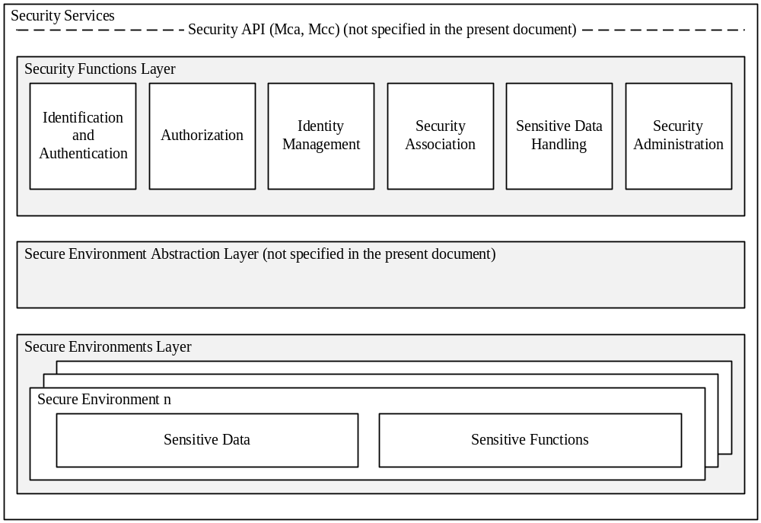
Figure 5.1.1-1: High level overview of the Security architecture
Design principles:
- Security Services are modular and configurable according to the needs of the hosting CSE, its supported reference points and its purpose.
- The architecture is split into several components and sub-components providing a modular design. With this design, mapping of the architecture to different nodes and entities is enabled.
- Depending on the requirements of each entity, Security should consist of components relevant to fulfil the requirements of the respective node or entity and the intended use case.
- The architecture may need to be adapted to be suitable for implementation in different entities. For example, the architecture can be mapped to different device classes.
- The security administration component shall enable administration of all sensitive resources (data and functions) and shall also allow configuration and extension of Security services itself.
- The Secure Environment within the CSE is accessed via the Secure Environment Abstraction layer and shall hold all sensitive resources.

5.1.1 Identification and Authentication
The Identification and Authentication function is in charge of identification and mutual authentication of CSEs and AEs.
Identification is the process of checking if the identity provided for authentication is valid. How to perform an identification process will depend on the purpose of authentication. For example, in the case of resource access, the authentication function may require the identification to check if the AE or CSE has registered with the local CSE; in the case of AE or CSE registration, the authentication function may require the identification to check if the identity provided by an AE or CSE fits a certificate. Once passing this checking process, the AE or CSE is identified, and the identified identity will be supplied to authentication process.
Authentication is the process of validating if the identity supplied in the identification step is associated with a trustworthy credential. How to perform an authentication process will depend on using which mutual authentication mechanism. For example, in the case of using certificate based authentication mechanism, the authentication function may require the authentication to verify a digital signature; in the case of using symmetric key based authentication mechanism, the authentication function may require the authentication to verify a Message Integrity Code (MIC). When this validating process has been completed, the AE or CSE is authenticated.

5.1.2 Authorization
The Authorization function is responsible for authorizing services and data access to authenticated entities according to provisioned Access Control Policies (ACPs) and assigned roles.
Access control policy is defined as sets of conditions that define whether entities should be permitted access to a protected resource. The authorization function may support different authorization mechanisms, such as Access Control List (ACL), Role Based Access Control (RBAC), etc. The Authorization function may need to evaluate multiple access control policies in an authorization process in order to get a finial access control decision. This process is further described in clause 7 "Authorization".
Authorization evaluation process is based on the Service Subscription resource which specifies what M2M Services and M2M Service roles the authenticated entity has subscribed to and the access control policies associated with the protected resource. The authorization evaluation process may also need to consider contextual attributes such as time or geographic location.
Prior to authorization mutual authentication between the originator CSE or AE and hosting CSE shall be performed.

5.1.3 Identity Management
The Identity Management function provides oneM2M identities/identifiers to the requesting entity in case those identities are stored within the secure environment. oneM2M identifiers as defined in the oneM2M Architecture (oneM2M TS-0001 [1]) may also be treated as sensitive data that are accessible to AEs or CSEs and used independently of Authentication or Authorization functions.

5.2 Security Layers

5.2.1 Security Service Layer
The security service layer provides the following services:
- Access Management:
- Authorization.
- Authentication.
- Access Control.
- Sensitive Data Handling:
- Sensitive Functions protection.
- Secure Storage.
- Security Association Establishment:
- Secure Connection via secure session establishment.
- Secure Connection via object security.
- Security Administration (including remote security provisioning).
- Identity Protection.
Each of these services provides functions and resources on the Security Service and Administration API.

5.2.2 Secure Environment Abstraction Layer
The Secure Environment Abstraction Layer (not specified in the present document) provides access to the Secure Environment via a general Security Transport API. A Plug-in associated to the type of Secure Environment shall provide physical/logical connectivity to the secure environment. The Secure Environment Abstraction Layer shall also be accessible on the Service Layer.

5.3 Integration within overall oneM2M architecture
Security services may be provided within the following architectural components and interacts on the different reference points as described in oneM2M TS-0001 [1].
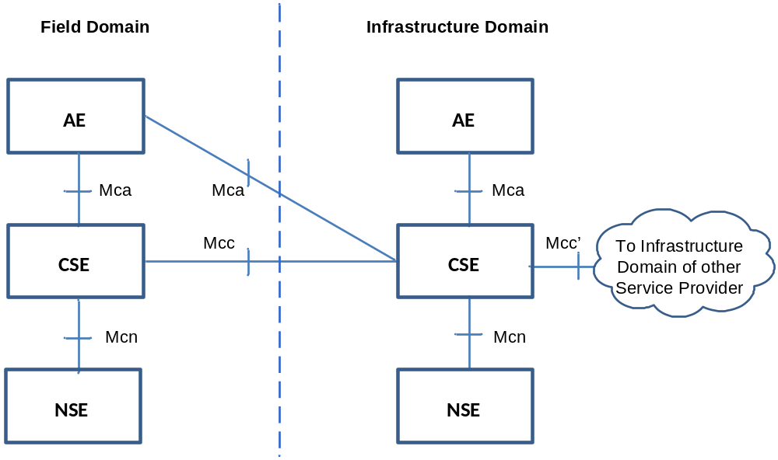
Figure 5.3-1: oneM2M Functional Architecture

6 Security Services and Interactions

6.1 Security Integration in oneM2M flow of events

6.1.1 Interactions between layers
Before any M2M Common Services layer procedure can take place, connectivity has to be established in the underlying Network Services Layer, which may involve independent provisioning and service registration procedures specified by the underlying network.
The Service Layer Security provisioning (security pre-provisioning or security bootstrapping) and Security Association Establishment procedures specified in the present document can take place independently (and generally consecutively) from any required Network Service Layer connectivity establishment procedures.
Finally, the security provisioning and security association establishment requirements imposed by M2M Application Service Providers have to be accounted for. At the service layer level, the security association establishment results in a TLS or DTLS session which protects messages being exchanged between adjacent AE/CSE, i.e. hop-by-hop. AEs that need to preserve the privacy of their information exchange from untrusted intermediate nodes may be provisioned to support a direct security association between them. Such security associations enable to encrypt the content of resources exchanged between AEs through the service layer.

6.1.2 High level sequence of events

6.1.2.1 Enrolment phase
M2M equipments typically require provisioning and configuration phases before being put in actual operation. This may be performed by a pre-provisioning that can be integrated in the manufacturing or product deployment phase, or by means of a security bootstrapping procedure (i.e. remote security provisioning) that takes place before the equipment starts actual operation.
At the service layer level, such provisioning and configuration requires selection of the stakeholder that will provide services through the equipment, especially the M2M Service Provider. This Enrolment phase requires contractual agreements between the stakeholders.
Enrolment phase may occur several times during the lifecycle of an M2M equipment, but is only repeated when a change in the Service Provider affects the provisioning or configuration of the equipment.
The security provisioning phase for the different layers can be combined using a common method of security pre-provisioning.
Remote Security Provisioning Frameworks (RSPF) provide post-provisioning of the essential information to establish a security association between a Field Domain entity and the M2M Authentication Function of a chosen M2M Service Provider. The essential security information includes the security credentials and identifiers. Remote Security Provisioning procedures rely on an M2M Enrolment Function which can be external to the M2M Service Provider to establish appropriate credentials.
- Pre-Provisioned Symmetric Enrolee Key Remote Security Provisioning Framework: A symmetric key is pre-provisioned to the Enrolee and M2M Enrolment Function for the mutual authentication of those entities. For more details, see clause 8.3.2.1.
- Certificate-Based Remote Security Provisioning Framework: The Enrolee and M2M Enrolment Function are each issued and authenticate themselves with private signing keys and Certificates containing the corresponding Public Verification Key. For more details see clause 8.3.2.2.
- GBA-based Remote Security Provisioning Framework. In this case, the M2M Enrolment Function includes the functionality of a GBA Bootstrap Server Function. This framework uses 3GPP or 3GPP2 symmetric keys to authenticate the Enrolee and the M2M Enrolment Function (which is also a GBA BSF). The details are specified by 3GPP TS 33.220 [13] and 3GPP2 S.S0109-A [14]. For more details see clause 8.3.2.3.
Figure 6.1.2.1-1 illustrates the different Remote Security Provisioning Frameworks. Note there is no communication between M2M Entities A and B in the Remote Security Provioning procedure. After successful completion of the Remote Security Provisioning procedure, a Security Association Establishment procedure is applied.
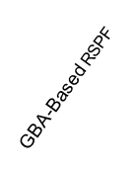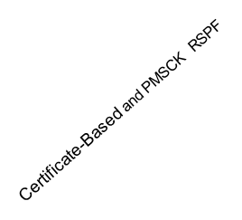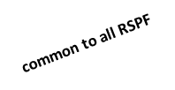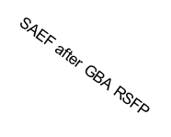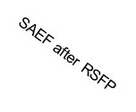
M2M
Entity
A
M2M
Entity
B
UN-SP Domain
Field Domain
3rd Party Domain
or M2M-SP
Infrastructure
Domain
M2M-SP
Infrastructure
Domain
GBA
BSF
(=MEF)
MAF
MEF
SAEF after RSPF
Figure 6.1.2.1-1: Entities involved in Remote Security Provisioning

6.1.2.2 Operational phase

6.1.2.2.1 M2M Service Access
M2M services are offered by CSEs to AEs and/or other CSEs. To be able to use M2M services offered by one CSE, the AEs and/or CSEs need to be mutually identified and authenticated with that CSE, in order to provide protection from unauthorized access and Denial of Service attacks. This mutual authentication enables to additionally provide encryption and integrity protection for the exchange of messages across a single Mca, Mcc or Mcc' reference point. In addition, communicating AEs that require similar protection for their own information exchanges may be provisioned to apply the same security method to their communications.
This is the purpose of the Security Association Establishment procedure, which shall take place before execution of the service related procedures specified in oneM2M TS-0001 [1] for the corresponding reference point.
On the Mca and Mcc reference points, security association establishment between a field domain AE or CSE, respectively, and an IN-CSE is mandatory.
On the Mcc' reference point, security association establishment between IN-CSE and IN-CSE is mandatory.
On the Mca reference point, security association establishment between AE and the CSE in the field domain is strongly recommended.
The security association establishment phase of the M2M Service Layer and M2M Application Layer are generally independent from similar procedures that may be required by the Network Layer, though they may rely on the security services provided by the Network Layer.
The oneM2M system supports the following authentication mechanisms for Security Association Establishment, described in more detail in clause 8.2.1 "Overview on Security Association Establishment Frameworks":
- Provisioned Symmetric Key Security Association Establishment Framework: A symmetric key is pre-provisioned to the Security Association end-points. For more details see clause 8.2.2.1.
- Certificate-Based Security Association Establishment Framework: Security Association end-points authenticate themselves using private signing keys and Certificates containing the corresponding Public Verification Key. For more details see clause 8.2.2.2.
- M2M Authentication Function (MAF) Security Association Establishment Framework: For MAF-based SAEF, the centralized key distribution server is a MAF hosted either by a 3rd party service provider which has a service relationship with the M2M Service Provider (M2M-SP), or hosted by the M2M-SP itself. The MAF authenticates a Field Domain entitiy on behalf of an IN-CSE using a symmetric key. For more details see clause 8.2.2.3.
Figure 6.1.2.2.1-1 illustrates the different use cases and entities involved in the various Security Association Establishment Frameworks (SAEF) considered in the present document.
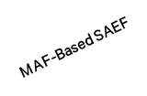
M2M
Entity
A
M2M
Entity
B
UN-SP Domain
Field Domain
3rd Party Domain
or M2M-SP
Infrastructure
Domain

M2M-SP
Infrastructure
Domain

MAF
Provisioned Symmetric Key and Certificate-Based SAEF SAEF

MAF
MAF Based SAEF

MAF
Figure 6.1.2.2.1-1: Entities involved in Security Association Establishment

6.1.2.2.2 Authorization to access M2M resources
Once an AE or CSE has been granted access to M2M services, the Access Control procedure specified in clause 7 of the present document shall be executed before accessing an M2M resource, as specified in oneM2M TS-0001 [1].

6.2 Security Service Layer

6.2.1 Access Management

6.2.1.1 Authentication
This component provides authentication services to the Application Layer. Annex B provides a general description of Authentication mechanisms.

6.2.2 Authorization Architecture
Figure 6.2.2-1 provides a high level overview of a generic authorization architecture. This architecture comprises four subcomponents that are described as follows:
- Policy Enforcement Point (PEP):
- PEP intercepts resource access requests, makes access control decision requests, and enforces access control decisions. The PEP coexists with the entity that need authorization services.
- Policy Decision Point (PDP):
- PDP interacts with the PRP and PIP to get applicable authorization polices and attributes needed for evaluating authorization policies respectively, and then evaluates access request using authorization policies for rendering an access control decision. The PDP is located in the Authorization service.
- Policy Retrieval Point (PRP):
- PRP obtains applicable authorization policies according to an access control decision request. These applicable policies should be combined in order to get a finial access control decision. The PRP is located in the Authorization service.
- Policy Information Point (PIP):
- PIP provides attributes that are needed for evaluating authorization policies, for example the IP address of the requester, creation time of the resource, current time or location information of the requester. The PIP is located in the Authorization service.
The Authorization service may comprise any of the subcomponents: PDP, PRP and/or PIP. This means that the subcomponents PEP, PRP, PDP and PIP could be distributed across different nodes. For example the PEP is located in an ASN/MN and the PDP is located in the IN.
The present release 1 does not support separation of PRP and PIP on different CSE from PDP. The generic procedure described below is provided for information and to support further extensions, while clause 7 provides the details of authorization mechanisms in the current release.
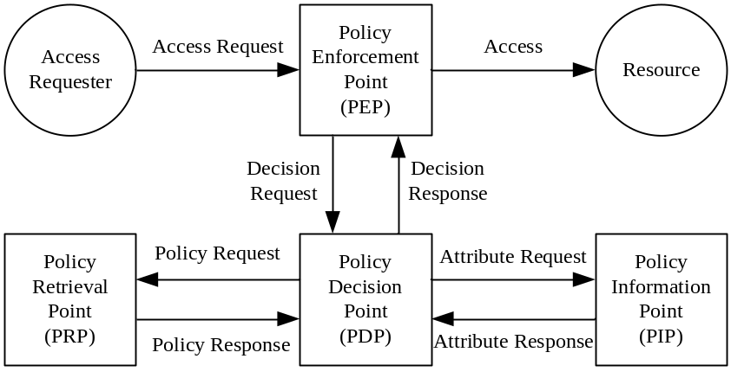
Figure 6.2.2-1: Overview of the authorization architecture
The generic authorization procedure is shown in figure 6.2.2-2.
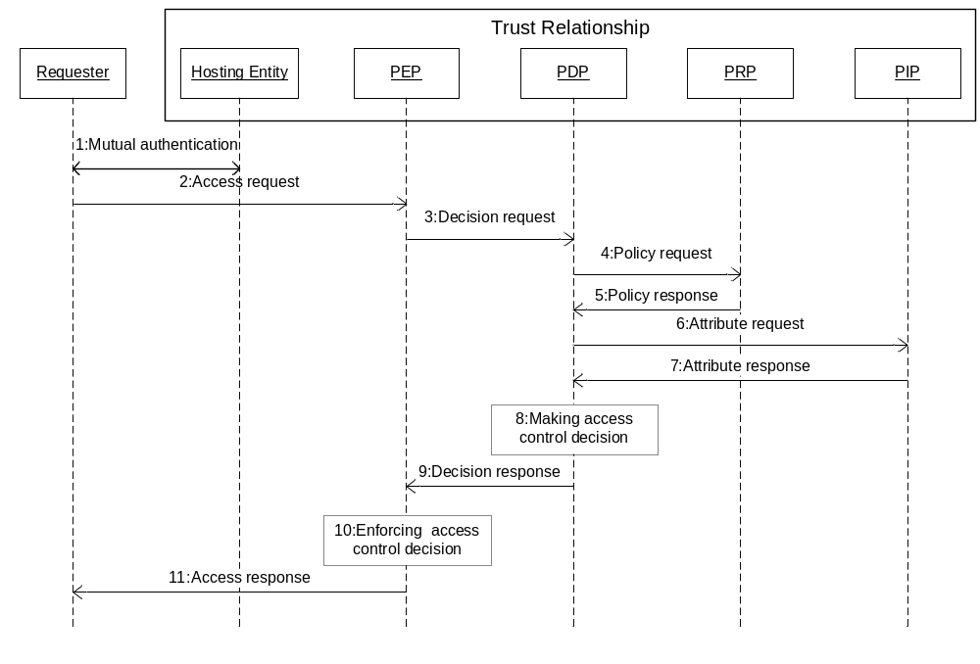
Figure 6.2.2-2: Authorization Procedure
Step 001: Mutual authentication (Pre-requisite).
Step 002: Access Requester sends an Access Request to the PEP.
Step 003: PEP makes an Access Control Decision Request according to the requester's Access Request, and sends the Access Control Decision Request to the PDP.
Step 004: PDP sends an Access Control Policy Request that is generated based on the Access Control Decision Request to the PRP.
Step 005: PRP finds all applicable access control policies to the access request and sends them back to the PDP. When multiple access control polices are involved, the PRP also provides a policy combination algorithm for combining multiple evaluation results into one finial result.
Step 006 PDP sends Attribute Request to the PIP if any attributes are required for evaluating these access control policies.
Step 007: PIP gets required attributes and sends them back to the PDP.
Step 008: PDP evaluates Access Request using access control policies. When there are multiple applicable access control policies, the PEP needs to calculate a final Access Control Decision using the policy combination algorithm.
Step 009: PDP returns the Access Control Decision back to the PEP.
Step 010: PEP enforces the access control decision, i.e. either forwards the Access Request to the resource or denies this access.
Step 011: PEP returns access result back to the Access Requester.

6.2.3 Security Administration

6.2.3.0 Introduction
The Security Administration service shall provide functions to manage the Security functions, resources and attributes. This shall include management of resources provided via the secure environment. In addition it should provide functions to manage sensitive data with their associated identifiers and subscriptions on behalf of other entities. Security administration is therefore dependent upon the type of secure environment being used (independent hardware module, integrated trusted execution environment or software protection). Depending on the type of Secure Environment, distinct existing standards may be used for remote administration of those SEs.

6.2.3.1 Security Pre-Provisioning of SE
Several sensitive data and associated objects are often configured by pre-provisioning of a secure environment (see clause 6.3.1 "Secure Environment") prior to deploying the M2M device it is associated with.
UICCs specified in ETSI TS 102 671 [23] and ETSI TS 102 221 [24] are comonly used for such purpose because their use is required to access some underlying networks, they provide a high security level, and they offer an interoperable transport interface specified in ETSI TS 102 221 [24]. An interoperable oneM2M provisioning framework relying on this interface is specified in annex D.

6.2.3.2 Remote security administration of SE
Security sensitive data and functions that are protected and isolated within the SE may remain remotely accessible to legitimate security admistrators after deployment. Remote security administration differs from standard device management by the requirement that the secure channel established with the administration server shall have its endpoint in the Secure Environment of the M2M Node. Applicable remote security administration protocols are dependent on the risk level of each M2M application and not just on the underlying network technologies. Widespread technologies that enable remote security administration for the different security levels distinguished in oneM2M TR-0008 [i.4] are considered in annex C.
Since remote security administration requires the target sensitive information to be remotely modifiable, protection of such sensitive information from remote software hacking of the device is particularly critical. In case the Secure Environment relies on software protection only, remote security administration of the following data should be allowed only where remote access by potential attackers can be mitigated:
- Private key and associated identifiers.
- Long-term shared symmetric key (compared to expected lifetime of the M2M node) and associated identifiers.
- Any process and parameters thereof that manipulates the above information, i.e. security functions.

6.2.4 Identity Protection
Identity Protection provides services to the Application Layer such as pseudonyms and protecting the anonymity of transactions.

6.2.5 Sensitive Data Handling

6.2.5.0 Introduction
The Sensitive Data Handling service provides certain Sensitive Functions to the Application Layer.
Sensitive Functions shall include following functions:
- Secure Storage.
In addition the service should support the following sensitive functions:
- Cryptographic operations.
- Methods for bootstrapping initial secrets (e.g. GBA).

6.2.5.1 Sensitive Functions
This service shall provide AEs and CSEs with access to Sensitive Functions of the SE.

6.2.5.2 Secure Storage
This service shall provide AEs and CSEs with access to the secure storage capability of the SE. Data securely stored by the AE or CSE shall only be accessible through the Security API and by authorized entities. Secure Storage should be managed by the Secure Environment. Stored data shall be associated with the entity owning the data, i.e. the entity that requested the data to be stored within the secure storage.

6.2.6 Trust Enabler security functions
oneM2M Trust Enabling Architecture may require the presence of security functionalities within the Infrastructure Domain: an M2M Authentication Function (MAF) and an M2M Enrolment Function (MEF), both classified as Trust Enabler Functions (TEF) and serving authentication and end-to-end security purposes, as well as Dynamic Authorization System (DAS) server or Role Authorities serving authorization purposes. The M2M Authentication Function and the M2M Enrolment Functions shall incorporate the ability to provide for End-to-End credential registration and provisioning. In addition, a Privacy Policy Manager functionality (PPM) may be implemented to protect user's privacy. All of these functions can be either under M2M Service Provider control or delegated to a M2M Trust Enabler (i.e. a party trusted by all involved M2M ecosystem stakeholders).
- M2M Enrolment Function (MEF):
- The MEF is used during the enrolment phase and supports the security bootstrap procedure enabling the provisioning of the Master Credentials to be used to mutually authenticate entities accessing the infrastructure of an M2M Service Provider. The MEF relies on an initial credential pre-provisioned in the M2M node (e.g. during manufacturing).
- The credentials provisioned by an MEF can be used for authentication with an M2M Authentication Function in the MAF-Based Security Association Establishment Framework (SAEF), End-to-End Security of Primitives (ESPrim) or End-to-End Security of Data (ESData). Alternatively, the provisioned credentials may be used directly in the SAEF, ESPrim or ESData.
- M2M Authentication Function (MAF), used during the operational phase of M2M Services:
- M2M Master Credentials, used to mutually authenticate CSEs/AEs during the operation phase, shall be securely stored in a specific infrastructure functionality named M2M Authentication Function (MAF).
- The MAF securely contains the set of M2M Master Credentials that are used for authenticating CSEs/AEs that have been enrolled through the M2M SP or M2M Trust Enabler. The MAF stores the M2M Master Credentials and possibly the identifiers of the associated CSE/AE.
- A single MAF may support all communication security services (SAEF, ESPrim, ESData) or only a selection of them. An MAF providing MAF-based SAEF is operated by the M2M SP, or by an M2M Truster Enabler on behalf of the M2M SP. Other MAF can be operated by M2M Trust Enabler or M2M SP, and there is no assumption of a trust relationship existing between the M2M Trust Enabler and m2M SP in those cases.
- The MAF is also in charge of all security operations involving the usage of the M2M Master Credentials.
- Dynamic Authorization System (DAS) server and Role Authorities: These functionalities manage authorization privileges to access resources that may be assigned during operation and are described in clause 7.3 and 7.4, respectively.
- Privacy Policy Manager (PPM): This functionality assists in the management of privacy preferences expressed by data subject with respect to service requirements and applicable regulations, and is described in clause 11.

6.3 Secure Environment Abstraction Layer Components

6.3.1 Secure Environment
The Secure Environment component is a logical entity that provides Sensitive Functions operating on Sensitive Data, Secure Storage and other resources/functions.
The security sensitive data and security functions contained in M2M field domain nodes shall be protected from unauthorized access or alteration, as determined by risk analysis. Sensitive data and functions include security credentials and algorithms that manipulate them. The purpose of the Secure Environment is to provide the required protection level (see table 6.3.1-1) and isolation of security sensitive data and functions within an M2M node. This is especially critical for M2M Nodes that can be remotely or physically accessed by potential attackers.
The choice of a Secure Environment is guided by a risk analysis considering all layers of an M2M application, though it should leverage where possible on capabilities provided by the M2M Service Layer or the Underlying Network, e.g. UICC in 3GPP and 3GPP2 networks, or Trusted Execution Environment requirements.
There is no assumption made on the particular implementation of the Secure Environment. A SE may be implemented as an independent HW Security Element or as an integrated SW function. Each Secure Environment shall be associated with one certain Security Level depending on the particular implementation of the SE. Different Secure Environments may provide different Security Levels and protection levels as indicated in table 6.3.1-1.
Table 6.3.1-1: Classification of Protection levels
Protection Level | Description
0 | No protection. The data are exposed even without active attacks.
1 | Low protection, data are protected from passive observers but could be exposed by active attacks, be they local or remote.  E.g. software solutions exist that rely on general purpose processing hardware of the supporting equipment.
2 | Medium protection, protection of the data from remote attacks is addressed, but local attacks, especially physical attacks, remain possible, ie. Medium protection provides countermeasures against software attacks only  E.g. Software solutions to protect data and sensitive functions rely on specific processing providing enforced isolation and enables sensitive code and data to be kept away from an unprotected operating environment, software and memory. The code running in the protected environment is cryptographically verified for integrity assurance.
3 | High protection, addressing both remote and local attacks to access the data, including attacks involving physical access. This includes strong counter measures against software and hardware attacks, such as detection of abnormal operating conditions and scrambling plus hardware masking of the memory and side channel analysis of operations involving sensitive data.

There shall be at least one Secure Environment, however there may be multiple.

6.3.2 SE Plug-in
The SE Plug-in enables physical access to the respective Secure Environment. Depending on the type of Secure Environment, the SE Plug-in may be implemented differently for each Secure Environment.
NOTE: Specification of the SE Plug-in is out of scope of the present document.

6.3.3 Secure Environment Abstraction
This component is not specified in the present document.

7 Authorization

7.1 Access Control Mechanism

7.1.1 General Description
The M2M authorization procedure controls access to resources and services hosted by CSEs and AEs. The authorization procedure requires that the originator of the resource access request message has been identified to the Authentication Function, and originator and receiver are mutually authenticated with each other.
The resource addressed in a request message has an associated accessControlPolicyIDs attribute (either included explicitly as an attribute of the resource addressed in the request message, implied from the parent of the resource, or set fixed by the system, see clause 9.6.1 of oneM2M TS-0001 [1]). The accessControlPolicyIDs attribute contains a list of identifiers of <accessControlPolicy> resources applicable to the resource addressed in the request message.
The overall structure of <accessControlPolicy> resources is described in clause 9.6.2 "Resource Type accessControlPolicy" of oneM2M TS-0001 [1]).
Each of these <accessControlPolicy> resources include privileges and selfPrivileges attributes, which comprise the information, denoted as access control rules in the present document, that is evaluated against the parameters associated with the request message to obtain the access decision.
Figure 7.1.1-1 illustrates the relation between <accessControlPolicy> resource instances (ACP) and the instances of the protected resources, denoted Resource_1 to Resource_N.
Resource_2
...
ACP_1
ACP_2
ACP_3
ACP_4
Instances of
accessControlPolicy
resources (ACP)

Example:
ACP set = (ACP_1, ACP_2)
assigned to Resource_1

Each ACP includes one privileges and one selfPrivileges attribute.

privileges and selfPrivileges attributes include a set of access control rules (defined in Section 7.3)

List of IDs in accessControlPolicyIDs
attribute of Resource_1
Resource_1
Resource_3
Resource_N
Figure 7.1.1-1: Relation between Resource Instances and Access Control Policies
Access requests to ACP's itself are evaluated against the selfPrivileges attribute of that ACP. Access requests to instances of all other resource types, are evaluated against the privileges attributes of the ACP set associated with the targeted resource.
For requests to <accessControlPolicy> resource type, authorization is granted if the request is evaluated to "Permit" for at least one selfPrivileges attribute. For other resource types, authorization is granted if the request is evaluated to "Permit" for at least one privileges attribute.
The privileges and selfPrivileges defined in the accessControlPolicy resource determine which request originator is allowed to access the resource containing this attribute, for which specific operation (i.e. Create, Retrieve, Update, Delete, etc.) and for which specific context constraints (i.e. constraints regarding access time, originator's IP address and originator's location).
The access control approach specified here conforms to the concept of Attribute Based Access Control (ABAC) as defined in [i.12].
The policies defined in the <accessControlPolicy> resources are enforced by an access control mechanism which employs the authorization logical architecture outlined in clause 6.2.2.
The access control mechanism assembles the information needed to render the access decision which consists of:
- information included in the resource access request message as defined in clause 7.1.2 (table 7.1.2-1);
- contextual information as defined in clause 7.1.2 (table 7.1.2-2);
- tokens (if any) associated with the resource access request;
- the policies governing the access as defined in clause 7.1.3.

7.1.2 Parameters of the Request message
This clause specifies the parameters of a request message which are evaluated by the access control mechanism.
The data types applicable to these parameters are defined in clause 6.4 of oneM2M TS-0004 [4].
The parameters are listed in table 7.1.2-1.
For case where an AE initiates a new registration request to a CSE and has no preference for an assigned AE-ID value, the fr parameter shall not be sent in the request. All other requests shall have the fr parameter present in the request.
Table 7.1.2-1: Parameters indicated in the request message
Parameter | Description | Mandatory/Optional | Usage in access control mechanism
to | URI of target resource | M | Selection of accessControlPolicy associated with the target resource
fr | Identifier representing the originator of the request | M (see Note) | Evaluated against accessControlOriginators in privileges and selfPrivileges attributes
role | Role of the originator | O | Evaluated against accessControlOriginators in privileges and selfPrivileges attributes
op | Requested operation | M | Evaluated against accessControlOperations in privileges and selfPrivileges attributes
fc | filterUsage condition tag in Filter criteria | O | Differentiation between Retrieve and Discovery operations
Tokens | ESData-protected Tokens | O | Contains authorization information (e.g. Role-IDs) to be used in the decision for the request
Token IDs | tokenIds or Local-Token-ID | O | Identifies Tokens containing authorization information (e.g. Role-IDs) to be used in the decision for the request
NOTE: From field is Mandatory in all requests except for AE registration procedure where it is optional.

Table 7.1.2-2 lists the context parameters associated with a request message which are evaluated by the access control mechanism. These parameters are not explicitly included in a request message but can be obtained at the receiver and validated against the context policy parameters as given in table 7.1.2-2.
Table 7.1.2-2: Context parameters associated with a request message

Parameter | Description | Usage in access control mechanism
rq_time | Time stamp when the request message was received at the hosting CSE. Obtained by the hosting CSE's system time clock. | Validated against accessControlTimeWindow parameter in an access control rule, see clause 7.1.3
rq_loc | Location information about the originator of the request. Obtained over the Mcn reference point. | Validated against accessControlLocationRegion parameter in an access control rule, see clause 7.1.3
rq_ip | IP source address associated with the IP packets that carry the request message. Obtained over the Mcn reference point. | Validated against accessControlIpAddress parameter in an access control rule, see clause 7.1.3

Tokens, as defined in clause 7.3.3.1 "Token Structure", may be associated with a request message. A Token may be associated with a request as a result of being included in the Tokens primitive parameter of the request message or identified in the Token IDs primitive parameter of the request message. If the Hosting CSE obtained a token from the Dynamic Authorization System (DAS) Server using Direct Dynamic Authorization, then this Token shall associated with a request if the holder parameter in the Token matches the Absolute AE-ID or CSE-ID of the Originator of the request; such Tokens are obtained using. Dynamic Authorization is specified in clause 7.3.
Table 7.1.2-3 lists the security context parameters associated with a request message.
Table 7.1.2-3: Security Context parameters associated with a request message
Parameter | Description | Mandatory/Optional | Usage in access control mechanism
rq_authn | Boolean value (TRUE/FALSE) indicating if the Originator is considered to have been authenticated by the Hosting CSE, and the From matched the authenticated identity of the Originator. | M | Validated against accessControlAuthenticationFlag parameter in an access control rule, see clause 7.1.3

The following criteria shall be applied to determine if an Originator is considered to have been authenticated by the Hosting CSE.
- If the Originator is an AE registered to the Hosting CSE, then the criteria for deciding whether the Originator is considered authenticated is deployment and/or implementation specific. In some cases it is appropriate to expect TLS or DTLS to be used to protect primitives. In other cases, TLS or DTLS may be un-necessary.

- If the Originator is a CSE registered with the Hosting CSE, then the Originator shall always be considered authenticated because the Mcc is always required to be protected by TLS or DTLS according to a Security Association Establishment Framework (SAEF) as described in clause 8.2. The other CSE may be the Registrar or Registree with respect to the Hosting CSE.
- If the Originator is an AE or CSE registered with a CSE other than the Hosting CSE, then the Originator is considered authenticated by the Hosting CSE if and only if the request primitive is protected using End-to-End Security of Primitives (ESPrim) as described in clause 8.4.

7.1.3 Format of privileges and selfPrivileges Attributes
The privileges and selfPrivileges attributes exhibit the same data type format which is specified as follows.
Each privileges or selfPrivileges attribute comprises a set of access control rules. In the following, the set of access control rules is denoted as acrs and an individual access control rule in this set as acr. The access control rules in acrs are indexed with the letter k. The number of access control rules in the set is denoted with the letter K:
acrs = { acr(1), acr(2), ..., acr(k), ..., acr(K) }
Each access control rule acr(k) is comprised of three type of components, denoted accessControlOriginators, accessControlOperations and accessControlContexts. The accessControlContext component is an optional parameter.
Hence, an access control rule acr(k) is either represented as a pair:
acr(k) = {acr(k)_accessControlOriginators, acr(k)_accessControlOperations}
or as a 3-tuple:
acr(k) = {acr(k)_accessControlOriginators, acr(k)_accessControlOperations, acr(k)_accessControlContexts}
The generic term "access-control-rule-tuple" is used when referring to a rule acr(k).
A set acrs of access control rules may consist of a mix of pairs and 3-tuples. For pairs, any context parameters associated with a request message are admissible.
The three component parameters of an access-control-rule-tuple supported in the present document are shown in table 7.3.1-1.
Table 7.1.3-1: Parameters of an access-control-rule-tuple
Parameter | Usage Description | Mandatory/Optional | Format
accessControlOriginators | Set of Originators that can be authorized | M | List of CSE-IDs and/or AE-IDs, or keyword "all" to grant access to all originators
accessControlOperations | Set of Operations that can be authorized | M | Enumerated list of operations Create Retrieve, Update, Delete, Discover, Notify
accessControlContexts | See table 7.3.1-2 | O | See table 7.3.1-2
accessControlAuthenticationFlag | Indicates whether the rule applies only to Originators which are considered to be authenticated by the Hosting CSE | O | Boolean

The accessControlOriginators parameter comprises a list of CSE-IDs and/or AE-IDs of any format defined in oneM2M TS-0001 [1]. It is allowed to include the wildcard characters, e.g. "*", into the URI string of CSE-ID and AE-ID at any level. Examples include the following: *.mym2msp.org/mycseID,/mycseID/*, mym2msp.org/mycseID,/mycseID/myAE*. If access for all originators should be allowed, the reserved keyword 'all' can be included into the value space of accessControlOriginators. Granting access to all CSE originators of the same M2M SP domain could be represented as/*, all AE-IDs of all CSEs in the same domain as/*/*.
The data type applicable to accessControlOriginators is defined in oneM2M TS-0004 [4].
The accessControlOperations parameter comprises a list of admissible operations which can be any subset of the following elements: Create, Request, Update, Delete, Discover, Notify. While Create, Request, Update, Delete, and Notify operation are explicitly indicated in the op parameter of a request message, the Discovery operation is indicated by op = retrieve in combination with the provisioning of fc and Disrestype parameters in the request message.
The data type applicable to accessControlOperations is defined in oneM2M TS-0004 [4].
The accessControlContexts parameters are listed in table 7.1.3-2.
Table 7.1.3-2: Parameters of accessControlContexts
Parameter | Usage Description | Mandatory/Optional | Formats
accessControlTimeWindow | Set of Time Windows that can be authorized | O | List of time intervals where access can be granted in extended crontab format
accessControlLocationRegion | Set of Location Regions that can be authorized | O | 1) Latitude/longitude coordinates, and a radius defining a circular region around the coordinates  2) Country code
accessControlIpAddress | Set of IPv4 and IPv6 addresses that can be authorized | O | IPv4: dotted-decimal notation with CIDR suffix  IPv6: colon separated groups of hexadecimal digits with CIDR suffix

The accessControlTimeWindow parameter represents a list of elements that comply to the extended crontab syntax as defined in clause 7.3.8 of oneM2M TS-0004 [4]. It allows definition of periodically recurring time intervals at which access shall be granted, when the rq_time parameter associated with the access request message falls into such interval.
For the elements of accessControlLocationRegion there are two representation choices. These can be represented by a 2-character country code or a circle with radius R centred at a point defined in terms of longitude and latitude parameters. Refer to Annex F for detailed information. Each element of accessControlLocationRegion defines an admissible location region, which is compared with the rq_loc parameter associated with the access request message.
The data types applicable to accessControlLocationRegion and rq_loc are defined in oneM2M TS-0004 [4].
The accessControlIpAddress parameter represents a list of IPv4 and IPv6 addresses in dotted-decimal notation with CIDR suffix or colon separated groups of hexadecimal digits with CIDR suffix, respectively. If the rq_loc parameter associated with the access request message matches one of these addresses, access max be granted with regard to this criterion.
The data types applicable toaccessControlIpAddress and rq_ip are defined in oneM2M TS-0004 [4].
The accessControlAuthenticationFlag parameter is a Boolean value. If the accessControlAuthenticationFlag parameter is not present, then the value is assumed to be FALSE. If the accessControlAuthenticationFlag parameter is TRUE, then this indicates that the access control rule applies only to Originators considered to have been authenticated by the Hosting CSE. Clause 7.1.2 specifies the criteria used to decide whether or not the Originator is considered to have been authenticated by the Hosting CSE.

7.1.4 Access Control Decision
The access decision is derived by comparing the parameters associated with a resource access request message as described in clause 7.1.2 with the access control rules included in the privileges or selfPrivileges attributes of all ACP sets assigned to the protected resource by means of the accessControlPolicyIDs, see figure 7.1.1-1.
The result of the access control algorithm, i.e. the access decision, is the overall result of evaluating the applicable set of access control rules, acrs, against the parameters associated with the access request message. This access decision can be represented by a value of binary data type. The overall result of the access decision algorithm is denoted here with the variable name res_acrs:
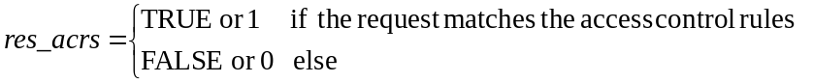
The access control algorithm is specified in clause 7.1.5.
If the access control algorithm yields the result res_acrs = TRUE, the access decision for the requested resource is "Permit".
If the result is res_acrs = FALSE, or the access control algorithm is not capable to derive a final result (e.g. due to indeterminate parameters), the access decision for the requested resource is "Deny".
Access decisions that result in indeterminate access control rules should be logged for diagnostics purposes.

7.1.5 Description of the Access Decision Algorithm
The access control algorithm specified in this clause combines partial access control results obtained for each of the individual access control rules contained in a privileges or selfPrivileges attribute. Further, if multiple ACP instances are assigned to the protected resource, the access control algorithm combines the partial access control results obtained for the individual ACPs of an ACP set.
The algorithm specified in this clause adopts a "Permit-overrides" combining algorithm with respect to access control rules and ACPs as defined in XACML [i.5]. This algorithm has the following behaviour:
- If a decision is "Permit" for only a single access control rule included in the privileges (or selfPrivileges) attribute of a single ACP, the result is "Permit".
- Otherwise, the result is "Deny".
The logic for evaluating a request against a privilege can be described mathematically as follows. A privileges or selfPrivileges attribute included in an <accessControlPolicy> resource represents a set of access control rules, acrs, which is built as in figure 7.1.5-1.
acrs = { acr(1), acr(2), ..., acr(k), ..., acr(K) }
acr(k) = {acr(k)_accessControlAuthenticationFlag,
acr(k)_accessControlOriginators, acr(k)_accessControlOperations, acr(k)_accessControlContexts}
Set of originator parameters. Examples:
{CSE-ID1, AE-ID1, AE-ID2, Role-ID1}
{all}
Set of allowed operations. Examples:
{Create, Retrieve, Update, Delete, Discover, Notify}
{Retrieve, Discover, Notify}

Set of time windows defined by start and end time
Example:
{daily 04:30 – 06:00, 11:30 – 12:30, 22:15 – 00:30}
Set of location regions defined by list of objects representing geographical regions
Example:
{geoRegion1, geoRegion2, geoRegion3}
Set of IP addresses or address blocks
Example (IPv4):
{212.75.201.105, 88.77.0.0/16, 116.27.123.0/24}
Set (list) of M_k context constraints (number of elements M_k can be different for each acr(k)):
{acr(k)_accessControlContext(k, 1), …
…, acr(k)_accessControlContext(k, m), …
…, acr(k)_accessControlContext(k, M_k)}

Set of context constraints consisting of the 3 elements:
{accessControlTimeWindow(k, m), accessControlLocationRegion(k,m), accessControlIpAddress(k, m)}

Figure 7.1.5-1: Logic to evaluate privileges
The parameters associated with a request, which are evaluated against the parameters contained in the access control rules are specified in clause 7.1.3.
The access decision res_acrs defined in clause 7.1.4 is derived by evaluating whether or not the parameters associated with the request message listed in tables 7.1.2-1 and 7.1.2-2 match any of the access control rules contained in the access control rule set defined in clause 7.1.3 as follows:
res_acrs = res_acr(1) OR res_acr(2) ... OR res_acr(k) … OR res_acr(K),
where res_acr(k) represents the logical evaluation result (i.e. TRUE/FALSE or 1/0) of the request parameters against the k^{th} access control rule in the set acrs, which can be expressed as follows:
res_acr(k) = res_authn(k) AND res_origs(k) AND res_ops(k) AND res_ctxts(k), k = 1…K.
The first partial logical result variable res_authn(k) on the right side of above equation is evaluated according to Table 7.1.5-1:
Table 7.1.5-1: Evaluating res_authn(k)
acr(k)_accessControlAuthenticationFlag | rq_authn | res_authn
TRUE | TRUE | TRUE
TRUE | FALSE | FALSE
FALSE | TRUE | TRUE
FALSE | FALSE | TRUE

The remaining 3 partial logical result variables on the right side of above equation can be defined by using the following set function:
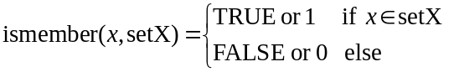
With this definition:
res_origs(k) = ismember(rq_orig, acr(k)_accessControlOriginators)
res_ops(k) = ismember(rq_op, acr(k)_ accessControlOperations)
The third partial logical result res_ctxts(k) is derived as follows
res_ctxts(k) = res_context(k, 1) ... OR res_context(k, m) ... OR res_context (k, M_k),
where:
res_context(k, m) = res_time(k, m) AND res_ip(k, m) AND res_loc (k, m), k = 1…K, m = 1…M_k
and
res_time(k, m) = ismember(rq_time, acr(k)_accessControlTimeWindow(m))
res_ip(k, m) = ismember(rq_ip, acr(k)_accessControlIpAddress(m))
res_loc (k, m) = ismember(rq_loc, acr(k)_accessControlLocationRegion(m))
Thanks to the "Permit-overrides" combining approach, if the access control decision for one access control rule results in res_acr = TRUE, the access control algorithm can stop without evaluating any other applicable access control rules of the current ACP or any other ACPs in the ACP set, and the final access decision is "Permit".

7.2 AE Impersonation Prevention

7.2.1 Registrar verification of AE-ID
Since several AEs can behave maliciously and pretend to be another AE with their ID changed, the Hosting CSE needs prevention mechanism for AE impersonation. This mechanism works at Registrar CSE since Registrar CSE is an entry point of M2M system.
When the Registrar CSE receives a request,the Registrar CSE shall perform the following procedure.
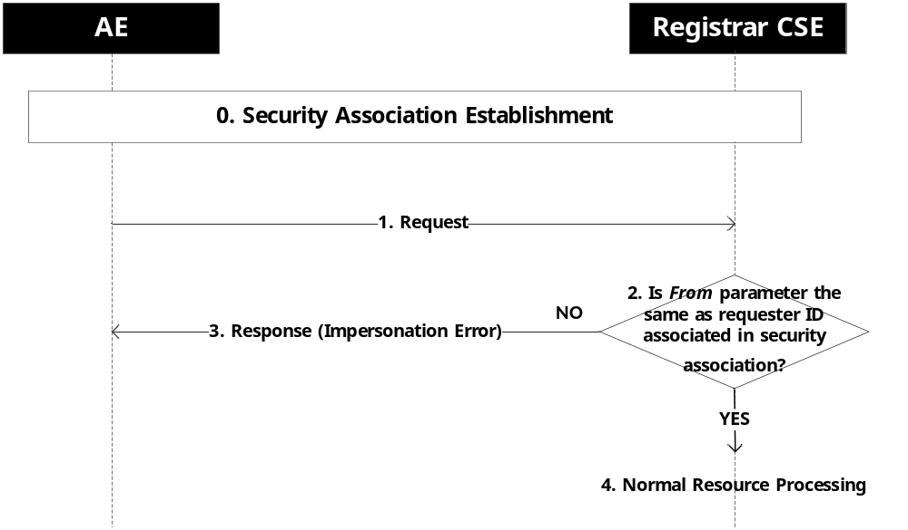
Figure 7.2.1-1: AE impersonation checking procedure
0. Security association establishment is performed.
1. The AE sends a request to Hosting CSE via its Registrar CSE (Hosting CSE is not represented on this figure and can either be the Registrar CSE or another CSE).
2. The Registrar CSE checks if the value in the From parameter is the same as the ID associated in security association.
3. If the value is not the same, the Registrar CSE sends a response with an impersonation error response code.
4. The Registrar CSE performs procedures specified in clause 8.2 of oneM2M TS-0001 [1]. Depending on the number of Transit CSEs, the Registrar CSE either processes the request or forwards it to the Hosting CSE or to another Transit CSE.

7.2.2 Verification Using End-to-End Security of Primitives (ESPrim)
End-to-End Security of Primitives (ESPrim), clause 8.4, allows a Target (a Hosting CSE or AE) to authenticate the Originator of a request primitives that are handled by other CSEs. ESPrim also provides confidentiality and integrity protection of these request and response primitives. The primitives being protected are called the inner primitives. ESPrim encryption is applied to the inner primitives to form ESPrim Objects. Outer primitives are used to transport the ESPrim objects between the Originator and Target CSE or AE. The Originator’s Registrar cannot view the encrypted inner primitive, and cannot verify that the From parameter of the inner primitive is correct. Instead, the Target is expected to verify that the From parameter of the inner primitive agrees with the authenticated identity of the Originator.
When the Target receives an ESPrim-protected request, the Target shall perform the following procedure.
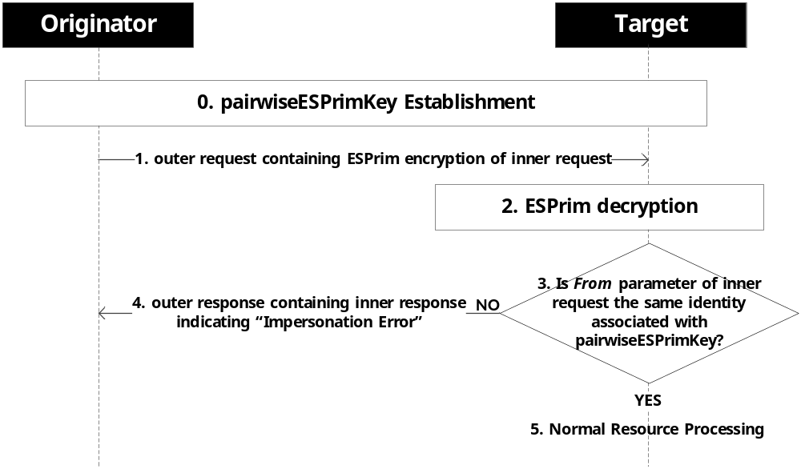
Figure 7.2.2-1: AE impersonation checking procedure
0. The Target and Originator have previously establish a symmetric pairwiseESPrimKey. The Target associates an identity with the symmetric pairwiseESPrimKey.
1. The Originator composes the inner request primitive, encrypts it using ESPrim to form an ESPrim Object, and sends it to the Target as described in clause 8.4.
NOTE: Regardless of whether ESPrim is applied, each Mcc “hop” is always protected using an SAEF, and each Mca “hop” is optionally protected using an SAEF; see clause 6.1.2.2.1.
2. The Target applies the procedures in clause 8.4 to decrypt the ESPrim Object and obtain the inner request primitive.
3. The Target checks if the value in the From parameter is the same as the ID associated with the pairwiseESPrimKey.
3. If the values are not identical, then the Target sends a response with an impersonation error response code.
4. If the values are identical, then the Target records that the Originator has been authenticated, and performs procedures specified in clause 8.2 of oneM2M TS-0001 [1].

7.3 Dynamic Authorization

7.3.1 Purpose of the Dynamic Authorization
The Dynamic Authorization provides an interoperable framework for an Originator to be dynamically issued with temporary permissions providing the Originator with access to one or more resources on one or more CSEs.
Applicable use cases, requirements and proposals are discussed in oneM2M TR-0019 [i.15].
The present document specifies the exchanged Dynamic Authorization parameters and associated processing at the Originator and Hosting CSE. The transport of dynamic authorization parameters is specified in oneM2M TS-0001 [1] and TS-0004 [4].

7.3.2 Dynamic Authorization Stage 2 Details

7.3.2.1 Dynamic Authorization Reference Model

The Dynamic Authorization reference model is shown in figure 7.3.2.1-1.
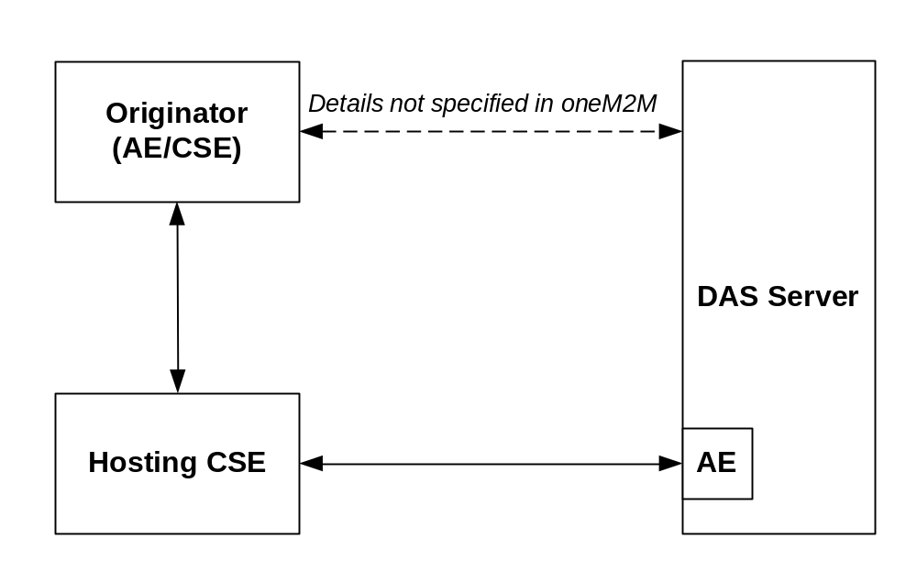
Figure 7.3.2.1-1: Dynamic Authorization reference model
The Dynamic Authorization reference model introduces the following systems and entities:
- Dynamic Authorization System (DAS): A system supporting dynamic authorization on behalf of resources owners. The present document does not describe the processing and exchange of messages within the Dynamic Authorization System. This system may reside either internally or externally within the service provider network.
- Dynamic Authorization System (DAS) Server: A server configured with policies for dynamic authorization, and provided with credentials for issuing Tokens. The DAS Server may include an AE for interaction with the oneM2M system.
The following Dynamic Authorization procedures are specified:
- Direct Dynamic Authorization, summarized in figure 7.3.2.1-2. In this procedure, Hosting CSE interacts with the DAS Server to obtain Dynamic Authorization.
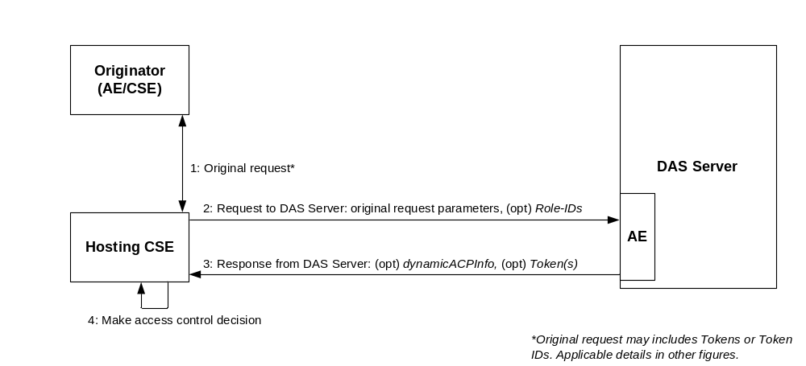
NOTE: Original request may include Tokens or Token IDs. Applicable details in other figures.

Figure 7.3.2.1-2: Direct Dynamic Authorization
- Indirect Dynamic Authorization, summarized in figure 7.3.2.1-3:
- Steps 1-2: The Hosting CSE may provide the Originator with Token Request Information in the unsuccessful response.
- Steps 3: The Originator interacts with the DAS Server with the intention that the DAS Server issue Tokens authorizing the Originator, and the Originator is provided with the Token or a Token-ID. The interaction is not described in the present document.
- Steps 4-7: The Originator provides the Hosting CSE with a Token, Token-ID to indicate that the Token is to be considered in the access decision. In the case of a token-ID, the Hosting CSE retrieves the corresponding Token via an AE of the DAS Server. These are then used in the access decision. The Hosting CSE may provide the Originator with a Local-Token-ID that may be used to identify the Token.
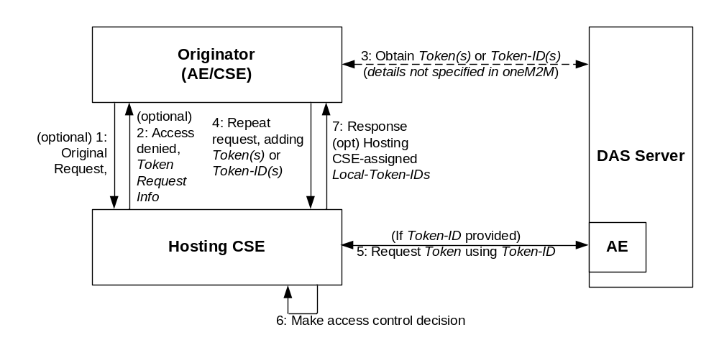
Figure 7.3.2.1-3: Indirect Dynamic Authorization

7.3.2.2 Direct Dynamic Authorization
The present document specifies the exchanged parameters and associated processing at the Hosting CSE. The transport of parameters is specified in clause 11.5.2, oneM2M TS-0001 [1].
The message flow for the Direct Dynamic Authorization is shown in figure 7.3.2.2-1, and described in the following text.
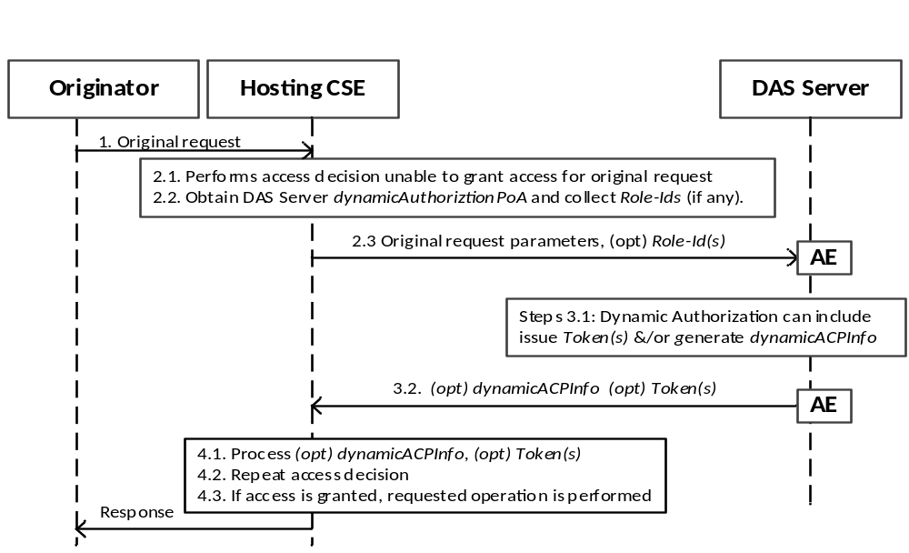
Figure 7.3.2.2-1: Message flow for Direct Dynamic Authorization
1. The Originator sends request (called the request from the Originator for this message flow) to the Hosting CSE. This request may include Tokens or Token-IDs; see the clause 7.3.2.3 "Indirect Dynamic Authorization".
2. Initial Hosting CSE processing:
2.1 If the request from the Originator includes Tokens or Token-IDs then these are processed as described in clause 7.3.2.3 "Indirect Dynamic Authorization". The Hosting CSE evaluates the access decision algorithm, but is unable to grant access for the request from the Originator based on configured access control policies.
2.2 The Hosting HCSE determines the set of DAS Server with which Direct Dynamic Authorization may be performed:
2.2.1 The HCSE examines all accessControlRules for which request satisfies the accessControlOperations and accessControlContexts in the <accessControlPolicy> resources linked to the requested resource. The HCSE collects the set of all Role-IDs in the accessControlOperators of these accessControlRules. This Role-IDs are grouped according to the DAS Server AE-ID identified by the Role-ID.
NOTE 1: Regarding the Role-ID(s) parameter: The Originator would be granted access if a Token(s) is issued which associates the Originator with one or more of the Role-ID(s). Providing this list to the DAS Server allows the DAS Server to select a suitable set of one or more Role-ID(s) to associated with the Originator in Token(s), thereby authorizing the Originator to access the requested resources. The policies configured to the DAS Server would dictate which Role-ID(s) (if any) are included in Token(s) issued to the Originator.
2.2.2 The HCSE shall also collect the set of <dynamicAuthorizationConsultation> resources linked to the requested resource, and group these according to the DAS Server’s dynamicAuthorizationPoA attribute of the <dynamicAuthorizationConsultation> resource.
2.3 The Hosting CSE selects a DAS Server (from the set determined in step 2.2) and sends a oneM2M request message containing the information described in table 7.3.2.2-1. The transport of parameters is specified in step 2.3, clause 11.5.2, oneM2M TS-0001 [1].
Table 7.3.2.2-1: Information sent from Hosting CSE to DAS Server
during the Direct Dynamic Authorization
Parameter | Description | Mandatory/Optional
Originator | Identifier of the Originator of the request received by the Receiver | M
Originator Resource Type | Type of resource targeted by originated request received by Receiver | M
Operation | Type of operation specified in originated request received by the Receiver | M
Originator IP Address | IP address of Originator of request received by Receiver | O
Originator Location | Location of Originator of request received by Receiver | O
Orginator Role IDs | Role IDs of Originator of request received by Receiver | O
Request Timestamp | Timestamp when originated request was received by Receiver | O
Targeted Resource ID | Resource ID targeted by originated request received by Receiver | O
Proposed Privileges Lifetime | Proposed lifetime of authorization privileges requested by the Receiver | O
Role IDs From ACPs | The set of Dynamic Access Roles in the accessControlDynAuthRole parameters associated with the DAS Server AE-ID. | O
Token IDs | The set of token identifiers associated with the Originator | O

3 DAS Server processing:
3.1 The DAS Server processes the received parameters. The DAS Server may decide to provide Token(s) and/or dynamicACPInfo which will be used by the Hosting CSE to create a dynamic <accesscontrolPolicy> resource. The DAS Server applies the policies with which it is configured to decide on the appropriate actions.
NOTE 2: The details of this decision are specific to the Dynamic Authorization System being employed; these details are not visible to the oneM2M system, and are not addressed in the present document.
The Token(s) (if any) shall conform to clause 7.3.3.1 "Token Structure", with the following profile:
- The "holder" parameter shall contain the Originator's Absolute CSE-ID or AE-ID received from the HCSE, and may contain other CSE-IDs and AE-IDS.
- The "audience" parameter shall contain only the HCSEs CSE-ID.
The DAS Server shall apply a ESData protection option to the individual Tokens with the following requirements
- The DAS Server may encrypt the Token such that the Token can be decrypted by the Hosting CSE.
- The Hosting CSE shall be able to verify that the DAS Server issued the token.
The ESData processing results in an ESData envelope which is called the ESData-protected Token for the purposes of this message flow.
If the DAS Server decides to authorize the Hosting CSE to create a dynamic <accesscontrolPolicy> resource, then the DAS Server shall form a dynamicACPInfo parameter containing the following information are listed in table 7.3.2.2-2.
Table 7.3.2.2-2: Information included in the dynamicACPInfo parameter
Parameter | Description | Mandatory/Optional
Granted Privileges | List of granted privileges | O
Privileges Lifetime | Lifetime of granted privileges | O
Tokens | List of issued tokens | O

3.2 The DAS Server shall send the ESData-protected Token(s) (if any) and (optional) dynamicACPInfo parameter via the DAS Server AE to the Hosting CSE. The transport of parameters is specified in step 2.3, clause 11.5.2, oneM2M TS-0001 [1].
4 HCSE Processing:
4.1 The HCSE processes the ESData-protected Token(s) (if present) and dynamicACPInfo parameter (if present):
4.1.1 The HCSE shall perform the following verifications for each ESData-protected Token:
4.1.1.1 The HCSE shall apply ESData processing to the ESData-protected Token to extract the authenticated Token.
4.1.1.2 The HCSE shall perform the following verifications:
4.1.1.2.1 The "issuer" parameter in the Token shall exactly match the identity of the DAS Server.
4.1.1.2.2 The HCSE's CSE-ID shall match the CSE-ID in the "audience" parameter in the Token.
4.1.1.2.3 The "holder" parameter in the Token shall exactly matches the Absolute CSE-ID or AE-ID of the Originator from whom the request was received.
4.1.1.2.4 The HCSE shall verify that the Token has not expired, by comparing the current time to the "notAfter" parameter in the Token.
4.1.1.3 The HCSE shall cache the verified Token, and may later delete the verified Token when the Token expires (as defined in step 4.1.2.4).
4.1.2 If dynamicACPInfo is provided by the DAS Server, then the Hosting CSE shall create a dynamic <accessControlPolicy> resource matching the dynamicACPInfo.
4.2 The Hosting CSE repeats the access decision mechanism in clause 7.1.4 "Access Control Decision".
4.3 If access is granted, then the Hosting CSE performs the operation requested in the request from the Originator, resulting in the Hosting CSE sending a request to the Originator.

7.3.2.3 Indirect Dynamic Authorization
The present document specifies the exchanged parameters and associated processing at the Originator and Hosting CSE. The transport of parameters is specified in clause 11.5.3, oneM2M TS-0001 [1].
The message flow for Indirect Dynamic Authorization is shown in figure 7.3.2.3-1, and described in the following text.
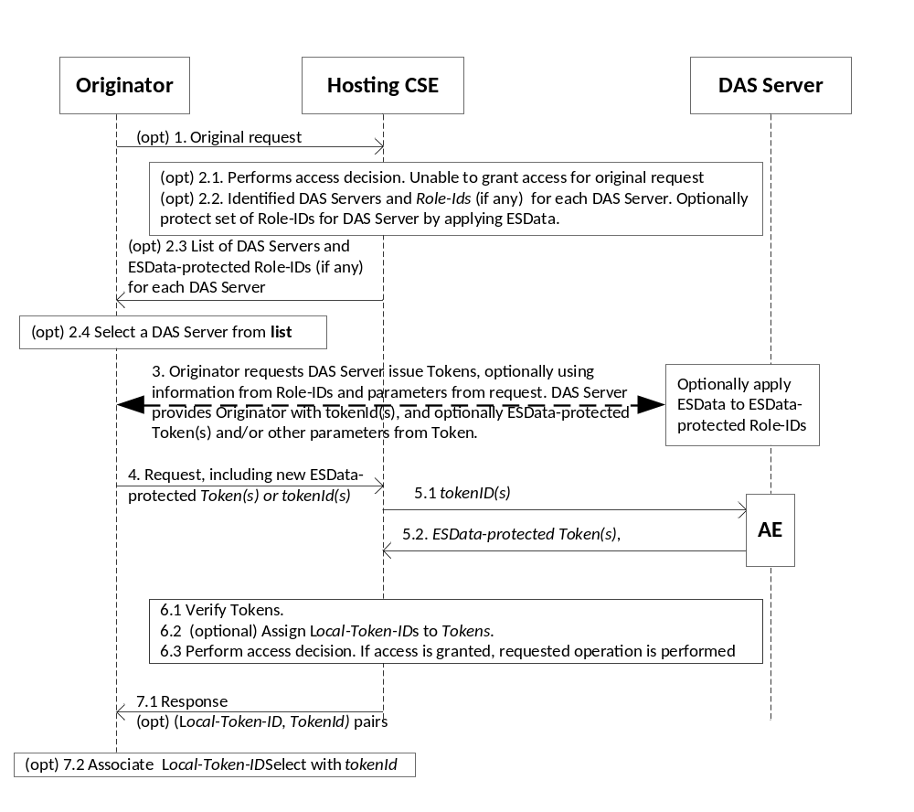
Figure 7.3.2.3-1: Message flow for Indirect Dynamic Authorization
1. (Optional) The Originator sends request to the Hosting CSE. The Originator includes an indication that the Originator is prepared to request Tokens from DAS Servers for this request. This request may include a combination of Tokens, tokenIds, Local-Token-IDs but this message flow assumes that these do not provide sufficient permissions for accessing the requested resource.
2. (Optional) Initial Hosting CSE processing:
2.1 Hosting CSE performs the access decision for the request from the Originator. This call flow assumes that the request from the Originator is denied as a result of the access decision. The Hosting CSE observes the indication that the Originator prepared to request Tokens from DAS Servers for this request.
2.2 The Hosting CSE forms a list of DAS Server's and associated Role-ID(s) (if any) as described in step 2.2.1 of the Direct Dynamic Authorization in clause 7.3.2.3 "Direct Dynamic Authorization".
For each DAS Server, then Hosting CSE may apply ESData to the set of Role-IDs for decryption by the DAS Server. For example, the ESData may encrypt the set of Role-IDs so they are not visible to the Originator.

2.3 The Hosting CSE shall send an unsuccessful response to the Originator, including the list of DAS Servers and associated set of optionally-ESData-protected Role-IDs.
2.4 The Originator selects a DAS Server identified in the response.
3. The Originator shall interact with the DAS Server to request the issuance of a Token. The Originator can provide the optionally-ESData-protected set of Role-IDS to the DAS Server, and parameters from the original resource access request. If the set of Role-IDS is protected using ESData, the the DAS Server applies ESData to extract the set of Role-IDS. The DAS Server issues a Token(s) and provides the tokenId(s) and optionally the ESData-protected Token(s) to the Originator. The DAS Server can also provide the Originator with other parameters from the Token; for example, the time window in which the Token is valid. This interaction is specific to the Dynamic Authorization System technology being used.
4. For request that the Originator wishes to have authorized using an issued Token, the Originator shall add ESData-protected Token provided by the DAS Server or tokenId (if no ESData-protected Token was provided) if the corresponding ESData-protected Token(s) was not provided by the DAS Server. In particular, if the request at step 1 was unsuccessful at step 2.3, then the Originator may repeat the request with new Token(s) and/or tokenId(s). A token may be used in multiple request.
The Originator shall send the request to the Hosting CSE.
5. (Optional) If the request includes tokenId(s), then for each tokenId the Hosting CSE identifies the corresponding DAS Server AE from which to request the corresponding Token:
5.1 The Hosting CSE sends the tokenId(s) to the DAS Server via a DAS Server AE.
5.2 The DAS Server shall return the corresponding valid ESData-protected Token(s) to the Hosting CSE via the DAS Server AE.
6. Hosting CSE Processing:
6.1 Token Processing:
6.1.1 The Hosting CSE shall apply ESData to the ESData-protected Token(s), either provided in the request or retrieved form the DAS Server, to extract the authenticated Token(s).
6.1.2 If a Local-Token-ID was provided in the request, then the Hosting CSE attempts to retrieve the cached token.
6.1.3 The HCSE shall perform the following verifications for each authenticated and cached token associated with the request:
- The HCSE's CSE-ID shall match one of the Absolute CSE-IDs (optionally including wildcards) in the "audience" parameter in the Token.
- The "holder" parameter in the Token shall exactly match the Absolute CSE-ID or AE-ID of the Originator from whom the request was received.
- The HCSE shall verify that the Token is currently valid and not expired, by comparing the current time to the "notBefore" and "notAfter" parameter in the Token. If a cached Token has expired, then the Token may be removed from the cache.
6.1.4 If any identified Token could not be retrieved in steps 5 or 6.1.2, or if any ESData-protected Token-ID failed verification at step 6.1.1, or if any Token failed the verification at step 6.1.3, then the Hosting CSE shall respond with an error.
6.1.5 The Hosting CSE may cache any new Token(s).
6.2 The Hosting CSE may assign Local-Token-ID(s) to cached Token(s).
6.3 The Hosting CSE shall perform the access decision as described in clause 7.1.4, including the information in the Token(s) identified in the request. If access is granted, then the requested operation shall be performed.
7. Response:
7.1 The Hosting CSE sends a response to the Originator. For each new Local-Token-ID(s) that has been assigned, the Hosting CSE provides the Local-Token-ID and corresponding tokenId in the response parameters.
7.2 The Originator associates the Local-Token-ID with tokenId. In subsequent requests, the Originator may use the Local-Token-ID instead of the Token or tokenId.

7.3.2.4 Token Structure
A token is used to carry authorization information that can be roles assigned to the token holder or access control policies applicable to the token holder. The structure of token is shown in figure 7.3.2.4-1, it contains the following data fields:
- version: version of the token.
- tokenID: unique ID of the token.
- holder: ID of the token holder.
- issuer: ID of the token issuer.
- notBefore: token valid from this time.
- notAfter: token expired after this time.
- tokenName: optional, human readable name of the token.
- audience: optional, list of CSE_IDs of the CSEs expected to accept the token
- permissions: permissions associated with the token. Its format is specified in clause 9.6.39 of oneM2M TS-0001 [1].
- extension: used for store other information, e.g. application-specific information.
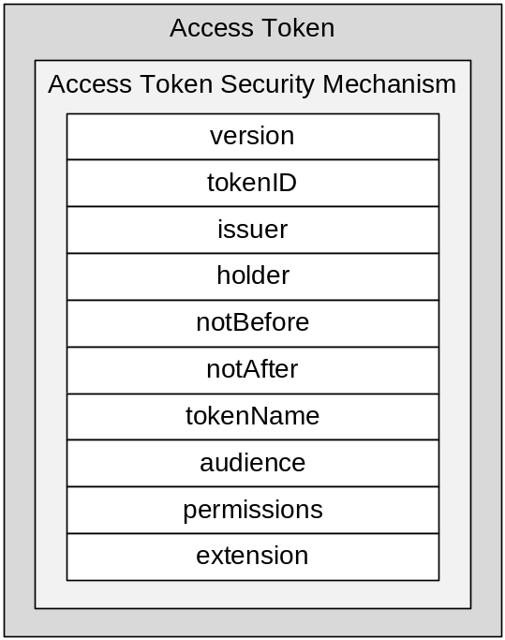
Figure 7.3.2.4-1: Structure of token
A token shall be protected by the ESData security mechanism. A token shall be signed, encrypted or signed and encrypted.

7.3.2.5 Token Evaluation
The generic process of evaluating a token can be described as follows:
- Token security validation: Depending on the security mechanism used by a token, the validation may be:
- verifying signed token,
- decrypting encrypted token or
- decrypting and verifying signed and encrypted token.
After passing the token security validation, the plain text of the token can be used for further validation.
- Token content validation: Depending on the content contained in the token, the validation may check:
- if the identity of the Originator equal to the token holder specified in the holder data field;
- if the token issuer specified in the issuer data field is valid;
- if this token is not expired according to the notBefore and notAfter data fields;
- if the identifier of the Hosting CSE is in the CSE-ID list specified by the audience data field. (In case the audience data field is not empty),
After passing the token content validation, the permissions associated to this token shall be used for access control.
- Token permissions evaluation: Checking the permission element in the permission list one by one until the access request is permitted by one of the permissions or end of the list. For each permission in the list of the permissions the evaluation shall be done as follows:
- Checking resourceIDs element. If it is present, then the authorization information described in privileges and/or roleIDs elements shall apply only to the resources specified by this element. If the privileges element is present, then this element shall be present.
- If the privileges element is present, the access control rules held in this element shall be used as applicable access control policy in the current access control decision making process.
- If the roleIDs element is present, the Role-IDs held in this element shall be used as valid roles in the current access control decision making process.

7.3.2.6 oneM2M JSON Web Tokens (JWTs)

7.3.2.6.1 Introduction to oneM2M JWTs
oneM2M specifies a JSON Web Tokens (JWTs) representation (RFC 7519 [53]) for Tokens used in oneM2M. A JWT compliant with the present clause is called a oneM2M JWT.
Background: A JWT uses either the JSON Web Signature (JWS) Compact Representation, or JSON Web Encryption (JWE) Compact Representation, specified in IETF RFC 7515 [51] and IETF RFC 7519 [53]. The JWT specification RFC 7519 [53] also defines an unsecured JWT which is a JWS using the "alg" Header Parameter value "none" and with the empty string for its JWS Signature value”.
The JWT specification defines a JSON element which is the structure of the payload of the JWS or JWE when used as a JWT. This payload comprises a set of JWT claims, with RFC 7519 [53] standardizing an initial set of JWT claim names. IANA maintains a registry of JWT claim names [i.18].

7.3.2.6.2 oneM2M JWT Profile
oneM2M JWT Claims: Table 7.3.2.6.2-1 provides the mapping from the JWT claim names, in a oneM2M JWT, to the elements of the m2m:tokenObject complex data type described in TS-0004 [4]. Where available, JWT claim names registered with IANA [i.18] have been used. TS-0004 [4] specifies which elements are mandatory and which elements are optional.
Table 7.3.2.6.2-1: The oneM2M JWT claim set and mapping to Token Object elements
Token Object Element Path | Token Object Element Short Name | oneM2M JWT claim name | Where is this JWT claim name defined? | Additional details for mapping from Token Object values values to JWT Claim values
version | tkvr | “tkvr” | TS-0004 [4] short names | Values shall be identical
tokenID | tkid | “jti” | RFC 7519 [53] | Values shall be identical
issuer | tkis | “iss” | RFC 7519 [53] | Values shall be identical
holder | tkhd | “azp” | OpenID Connect Core 1.0 [54] | Values shall be identical
notBefore | tknb | “nbf” | RFC 7519 [53] | Token Object element “notBefore” is in ISO8601 “Basic Format”, see [4]. This element shall be mapped to JWT Claim “nbf” which uses NumericDate format [53].
notAfter | tkna | “exp” | RFC 7519 [53] | Token Object element “notAfter” is in ISO8601 “Basic Format”, see [4]. This element shall be mapped to JWT Claim “exp” which uses NumericDate format [53].
tokenName | tknm | “tknm” | TS-0004 [4] short names | Values shall be identical
audience | tkau | “aud” | RFC 7519 [53] | Token Object element “audience” is a list of m2m:ID. This list shall be mapped to JWT Claim “aud” comprising an array of case-sensitive strings, each containing a StringOrURI value [53].
permissions | tkps | “tkps” | TS-0004 [4] short names | Values shall be identical
extension | tkex | “tkex” | TS-0004 [4] short names | Values shall be identical

oneM2M JWT Security Profile. The JWS Compact Representation and JWE Compact Representation are both supported by ESData (see clause 8.5.3). A oneM2M JWT may use any ESData security class: Encryption-only, Signature-only or Nested-Sign-then-encrypt. A oneM2M JWT may use any algorithm supported by ESData for the JWS Compact Representation and JWE Compact Representation.
A oneM2M JWT may be an unsecured JWT, in which case the oneM2M JWT is considered to use the unsecured ESData security class.
RFC 7519 [53] discusses security considerations of JWTs, and operators of Token Issuers (Dynamic Authorization Servers and Authorization Authorities) should consult that text when deciding on ESData security class and algorithms.

JOSE header parameters of oneM2M JWTs. When the Encryption-only ESData security class is used, then
- The JOSE header of the JWE shall include the “typ” parameters set to “JWT”.
- The JOSE header of the JWE shall not include the “cty” parameter.
When the Signature -only ESData security class is used, then
- The JOSE header of the JWS shall include the “typ” parameters set to “JWT”.
- The JOSE header of the JWS shall not include the “cty” parameter.
When the Nested-Sign-then-encrypt ESData security class is used, then the JWT claims are the payload of a JWS, and the JWS becomes the payload of a JWE. In this case,
- The JOSE header of both the JWS and the JWE shall include the “typ” header parameters set to “JWT”.
- The JOSE header of the JWE shall include the “cty” parameter set to be "JWT", to indicate that a Nested JWT is carried in this JWT.
- The JOSE header of the JWS shall not include the “cty” parameter.

7.3.2.6.3 oneM2M JWT Procedures
Configuring CSEs for verifying Tokens from a Token Issuer. In order for a CSE to verify oneM2M JWTs issued by a particular Token Issuer, the CSE shall be provided with the following information in a secure manner
- The combinations of ESData Security classes and algorithms permitted by the Token Issuer.
- Credentials for verifying Tokens conforming to those ESData Security classes and algorithms, noting that no credentials are needed for verifying tokens using the unsecured ESData Security class.
The present specification does not specify mechanisms for providing this information to the CSE. The present specification does not define data structures for storing this information on the CSE. The security level to apply on each particular CSE has to be derived from application specific risk assessment.

Creating a oneM2M JWT: When a Token Issuer is triggered to create a token, then the Token issuer shall perform the following steps
- The Token Issuer shall form a Token Object of data type m2m:tokenObject, with the permission element using the JSON serialization.
- The Token Issuer shall create the corresponding oneM2M JWT claim set using the mapping in Table 7.3.2.6.2-1.
- The Token Issuer shall select an ESData Security Class, algorithms and corresponding credentials. This step may also be performed before step 1) or between steps 1) and 2).
- The Token Issuer shall create oneM2M JWT using the oneM2M JWT claims, ESData Security Class, algorithms and corresponding credentials. This step uses the process described for JWTs in RFC 7519 [53].
The resulting oneM2M JWT has data type m2m:dynAuthJWT.
Validating a oneM2M JWT: When a CSE receives a oneM2M JWT for use in an access decision, then the CSE shall perform the following steps
- The CSE shall validate that the oneM2M JWT conforms to the m2m:dynAuthJWT data type.
- The CSE shall validate the security of the oneM2M JWT as described in clause 7.3.2.5, using the JWT-specific details in RFC 7519 [53] and configured credentials (if required). A CSE shall discard a oneM2M JWT which uses a ESData Security class or algorithms which are not permitted by the Token Issuer.
- The Token Issuer shall create a Token object from the oneM2M JWT claim set by reversing the mapping in Table 7.3.2.6.2-1.
- The CSE shall validate the Token Object as described in clause 7.3.2.5.
The Token Object permissions element can now be processed as described in clause 7.3.2.5.

7.4 Role Based Access Control

7.4.1 Role Based Access Control Architecture
Figure 7.4.1-1 provides a high level overview of the role based access control architecture in the oneM2M System. The entities related to role issuance and role based access control are described as follows:
- Authorization Authority: It is responsible for assigning roles to Originators through creating <role> and/or <token> resources in Role and/or Token Repositories.
- Role Repository: It is a CSE that is responsible for storing <role> resources.
- Token Repository: It is a CSE that is responsible for storing <token> resources.
NOTE 1: The arrows shown in the figure 7.4.1-1 are the logical relations among the entities and not the registration relations that form the real data paths.
NOTE 2: The functions of PDP and PIP are combined in the Hosting CSE for oneM2M Release 2.

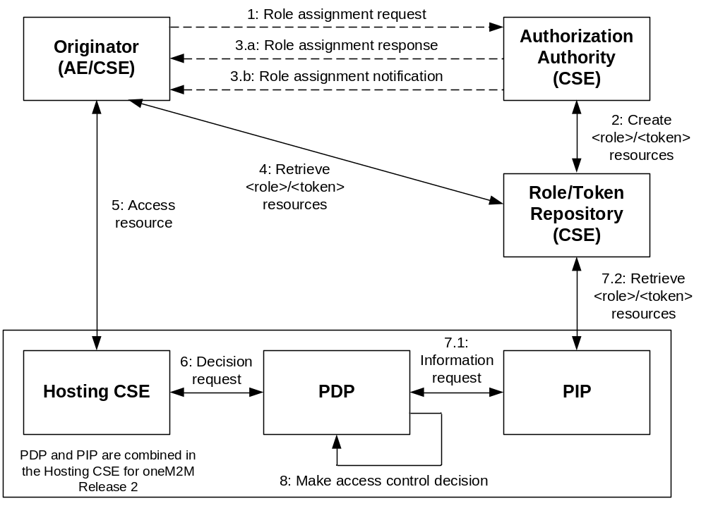
Figure 7.4.1-1. Role based access control architecture
The generic procedure of this architecture is described as follows:
Step 001: An Originator may apply for a role from an Authorization Authority. This step may not exist in some situation, e.g. the Authorization Authority directly assigns a role to an Originator.
This step is not specified in present document.
Step 002: The Authorization Authority shall check if the applied privilege can be assigned to the Originator. If it is permitted, the Authorization Authority need to create a <role> resource that specifies the role assignment in a role repository, or issue a token that contains the assigned role to the Originator. The issued token may be stored in a <token> resource in a token repository.
Step 003: The Authorization Authority informs the Originator the result of a role assignment. The returned information may contain role ID, token ID, token or the information about the created <role> or <token> resources. There are two cases to be considered.
a) In case the Originator sends a role assignment request to the Authorization Authority, the Authorization Authority returns the result of the role assignment via a role assignment response.
b) In case the Authorization Authority directly assigns a role to an Originator, the Authorization Authority informs the result of a role assignment via a role assignment notification.
This step is not specified in present document.
Step 004: The Originator may retrieve the assigned roles and/or tokens from a Role and/or Token Repositories using the information provided by an Authorization Authority in order to get detailed information about the assigned roles and/or tokens.
Step 005: The Originator sends an access request to the target resource in the Hosting CSE. The request may contain the role information that may be the role IDs, tokens or token IDs.
Step 006: The Hosting CSE may send an access control decision request to a PDP.
Step 007: The PDP may need to retrieve the Originator's role assignment information according to the Role-IDs and/or Token-IDs from the Role and/or Token Repositories.
Step 008: The PDP verifies the Originator's roles and/or tokens,and then makes an access control decision according to the access control policies and roles.

7.4.2 Role Issuing Procedure

7.4.2.1 Introduction
There are two ways to assign roles to an Originator.
- One way is to create a <role> resource that describes what role is assigned to the originator. The <role> resources are stored in role repositories from which the AEs and CSEs can retrieve <role> resources in order to get an Originator’s role assignment information.
- Another way is to issue a token that describes what role is assigned to the token holder (i.e. the Originator). The issued token may also be stored in a <token> resource in a token repository from which the issued token can be retrieved.
A <role> resource may also point to a <token> resource in which the token that holds the assigned role is stored through the tokenlink attribute.

7.4.2.2 Role Assignment Procedure
The general procedure of assigning a role to an Originator is shown in the figure 7.4.2.2-1 and described as follows:
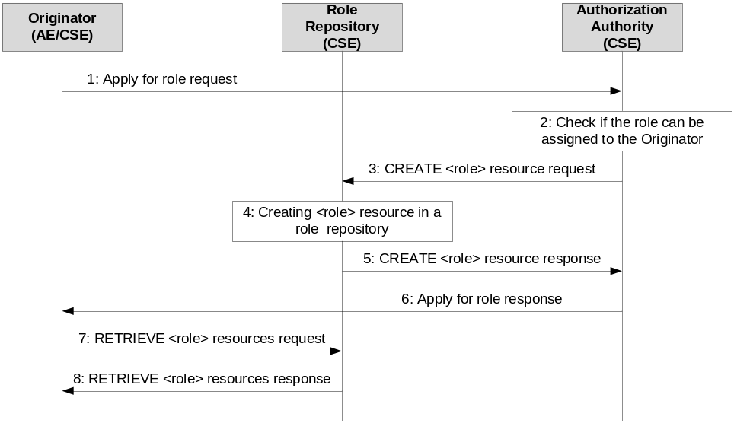
Figure 7.4.2-1: Procedure of role assignment
The procedure of role assignment is:
1. The Originator may send role assignment request to the Authorization Authority. The specification about this step is however out of scope of present document.
2. The Authorization Authority shall check if the applied role can be assigned to the Originator. After passing the privilege authorization check, the Authorization Authority shall assign the role to the Originator.
3. The Authorization Authority shall send a <role> resource creation request to the Role Repository.
4. The Role Repository shall create a <role> resource according to the creation request.
5. The Role Repository shall return the result of <role> resource creation back to the Authorization Authority.
6. The Authorization Authority shall return the result of the role assignment back to the Originator. The specification about this step is however out of scope of present document.
7. The Originator may send <role> resource retrieve request to the Role Repository in order to get the role assignment information.
8. The Role Repository shall return retrieved content of the <role> resources back to the Originator.

7.4.2.3 Issuing Token Associated with Role
The general procedure of issuing a role token (a token associated with assigned role) to an Originator is shown in the figure 7.4.2.3-1 and described as follows:
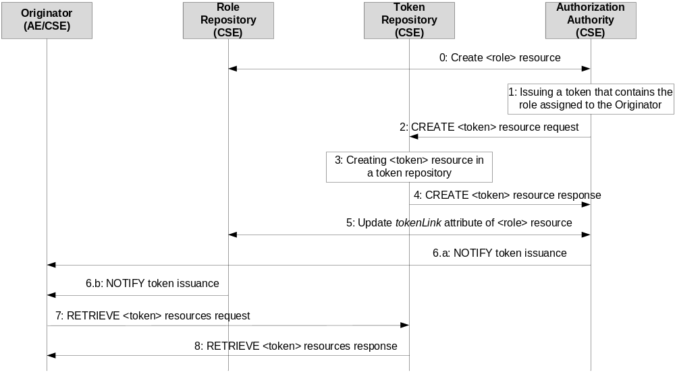

Figure 7.4.2.3-1: Procedure of role token issuance
The procedure of role token issuance is:
0. The Authorization Authority creates a <role> resource in a Role Repository for a role assignment.
1. The Authorization Authority issues a token that contains the role assigned to the Originator.
2. The Authorization Authority shall send a <token> resource creation request to a Token Repository.
3. The Token Repository shall create a <token> resource according to the creation request.
4. The Token Repository shall return the result of <token> resource creation back to the Authorization Authority.
5. The Authorization Authority shall update the tokenLink attribute of the <role> resource with the address of the <token> resource.
6. The token issuance information shall be informed to the Originator. There two ways to deal with the notification:
(a) The Authorization Authority uses the NOTIFY operation inform the Originator.
(b) The Token Repository NOTIFY the Originator according to the subscription made by the Originator to the <role> resource.
7. The Originator may send <token> resource retrieve request to the Token Repository in order to get the token issuance information.
8. The Token Repository shall return retrieved content of the <token> resource back to the Originator.

7.4.3 Role Based Access Control Procedure
The general procedure of using a role in an authorization process is shown in the figure 7.4.3-1 and described as follows:
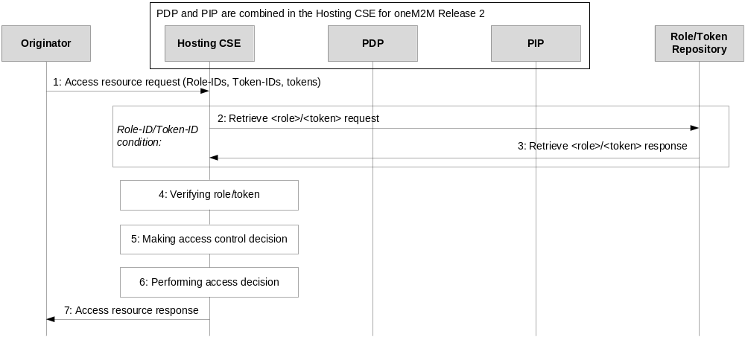
Figure 7.4.3-1: Role based access control procedure
1. The Originator shall include the applicable Role-IDs, Token-IDs or tokens into the request sent to the Hosting CSE.
2. In case of Role-IDs or Token-IDs, the Hosting CSE (acting the role of PIP) shall send a <role> or <token> resource retrieve request to the Role or Token Repository.
3. The Role Repository or Token Repository shall return the attributes of <role> or <token> resource back to the Hosting CSE.
4. The Hosting CSE (acting the role of PDP) shall verify the received roles and/or tokens, the verification shall include: if a role/token is issued by a valid Authorization Authority, if holder of the role/token is equal to the Originator, and if the role/token is still valid. Only valid roles/tokens shall be used for access control.
5. The Hosting CSE (acting the role of PDP) shall evaluate the access request of the Originator using access control policies and/or Role-IDs for making an access control decision as described in clause 7.1.
6. The Hosting CSE shall enforce the access control decision, i.e. either perform the resource access on behalf the Originator or deny the resource access.
7. The Hosting CSE shall return the result of resource access back to the Originator.

8 Security Frameworks

8.1 General Introductions to the Security Frameworks

8.1.0 General
To accommodate the variety of deployment scenarios that can be encountered in M2M applications, the present specification supports a diversity of methods to provision and establish security in M2M systems.

8.1.1 General Introduction to the Symmetric Key Security Framework
In the Security Framework using Symmetric Key, each pair of entities that need to authenticate each other has to be provisioned with its own shared symmetric key. This may be performed through pre-provisioning, e.g. during device manufacturing or deployment, or in the case of security association, a remote security provisioning framework may be used to perform the provisioning.

8.1.2 General Introduction to the Certificate-Based Security Framework

8.1.2.0 Introduction
This clause describes the Credential Configuration and Certificate Verification used in the Certificate-Based Security Association Establishment Framework and Certificate-Based Remote Security Provisioning Framework.

8.1.2.1 Public Key Certificate Flavours
The present document defines procedures using the following Public Key Certificate flavours:
- Raw Public Key Certificates:
- Description: A raw public key certificate (IETF RFC 7250 [37]) contains only the raw public key, without other information normally provided in a certificate. The raw public key certificate is exchanged in the TLS handshake in the place of a traditional certificate (see IETF RFC 7250 [37]).
- Use: A raw public key certificate may be used for authenticating a CSE or AE either during the Association Security Handshake phase of the Certificate-Based Security Association Establishment or during the Bootstrap Enrolment Handshake phase of the Certificate-Based Remote Security Provisioning Framework.
- Device certificates:
- Description: These certificates have a certificate chain to a trust anchor and include one or more globally unique hardware instance identifier (such as the Object Identifier Based M2M Device identifiers discussed in annex H "Object Identifier Based M2M Device Identifier" oneM2M TS-0001 [1]) in the subjectAltName extension of the certificate. A device certificate can be used to verify the identity of the hardware instance on which the entity is being executed.
- Use: Device certificates may be used to authenticate a CSE or AE executing on a specific M2M Device. If the M2M device is an ASN or MN (which supports a CSE), then the device certificate is implicitly associated with the CSE that executes on the device. If the device is an ADN (which does not support a CSE) then the device certificate is not implicitly associated with a specific AE executing on the hardware. A device certificate may be used for authenticating a Field Domain CSE either during the Association Security Handshake phase in the Certificate-Based Security Association Establishment Framework or during the Bootstrap phase of the Certificate-Based Remote Security Provisioning Framework.
- CSE-ID certificates:
- Description: These certificates have a certificate chain to a trust anchor and include the public domain name representation of a CSE-ID (see oneM2M TS-0001 [1]) in the subjectAltName extension of the certificate. A CSE-ID certificate verifies that the entity presenting the certificate has been assigned a particular CSE-ID.
- Use: A CSE-ID certificate may be used to authenticate a CSE only.
- AE-ID certificates:
- Description: These certificates have a certificate chain to a trust anchor and include the full URI representation of an AE-ID in the subjectAltName extension of the certificate. An AE-ID certificate verifies that the entity presenting the certificate has been assigned a particular AE-ID.
- Use: An AE-ID certificate may be used to authenticate an AE only.
- FQDN certificates:
- Description: These certificates have a certificate chain to a trust anchor and include the FQDN of an M2M Enrolment Function in the subjectAltName extension of the certificate. An FQDN certificate verifies that the entity presenting the certificate has been assigned a particular FQDN.
- Use: A FQDN certificate shall be used to authenticate an M2M Enrolment Function to an Enrolee during a Bootstrap Enrolment Handshake phase in a Certificate-Based Remote Security Provisioning Framework.
NOTE: The flavours, and the details specific for these flavours, are specified to support a range of deployment models while ensuring that oneM2M entities have clear procedures for authenticating other oneM2M entities using certificates.
The profiles for these certificates are found in clause 10.1.1 "Certificate Profiles".

8.1.2.2 Certification Path Validation and Certificate Status Verification
If an entity is to authenticate another entity using a device certificate, CSE-ID certificate, AE-ID certificate or FQDN certificate, then the entity shall perform basic certification path validation (section 6.1 of IETF RFC 5280 [34]) as part of verifying the other entity's certificate (see clause 8.1.2.4 "Certificate Verification").
CA certificates shall include the name constraint extensions (clause 4.2.1.10 "Name Constraints" of IETF RFC 5280 [34]) and shall constrain the names (object identifier M2M Device IDs from Annex H "Object Identifier Based M2M Device Identifier" oneM2M TS-0001 [1], public domain name representation of the CSE-ID, Absolute AE-ID or FQDNs) which may be in the subsequent certificate used to authenticate the entity (device certificate, CSE-ID certificate, AE-ID certificate or FQDN certificate respectively).
- Clause 4.2.1.10 "Name Constraints" in IETF RFC 5280 [34] describes how the name constraint extension is used for constraining URIs and FQDNs.
- Clause 10.4.1.4.2 "Profile for Certificate Authority Certificates for Device Certificates" describes how the name constraint extension is used for constraining object identifier M2M Device IDs.
The trust anchor information (section 6.1.1 of IETF RFC 5280 [34]) is provided to the entity during Credential Configuration, Association Configuration, Bootstrap Credential Configuration or Bootstrap Instruction Configuration.
NOTE 1: Section 6.1.1 of IETF RFC 5280 [34] states "The trust anchor information is trusted because it was delivered to the path processing procedure by some trustworthy out-of-band procedure". Credential Configuration, Association Configuration, Bootstrap Credential Configuration and Bootstrap Instruction Configuration satisfy the requirements of being trustworthy out-of-band procedures.
Certificate status verification: In the case of an Infrastructure Domain entity receiving an MEF certificate, the entity shall verify the status of the certificate using a Certificate Revocation List as described in IETF RFC 5280 [34].. A mapping of the Online Certificate Status Protocol (OCSP) onto HTTP may be used, as described in Appendix A of IETF RFC 6960 [35], however a mapping of OCSP onto CoAP is not currently defined. Furthermore, OCSP may also not be easily applicable in all environments. An alternative approach may be using the TLS Certificate Status Request extension (section 8 of IETF RFC 6066 [44]; also known as "OCSP stapling") or preferably the Multiple Certificate Status Extension (IETF RFC 6961 [36]), if available.
NOTE 2: Most of the above paragraph is based on almost identical text in the CoAP specification IETF RFC 7252 [38], a protocol with similar (if not identical) considerations to oneM2M deployments.

8.1.2.3 Credential Configuration for Certificate-Based Security Framework
If an entity is to authenticate itself using a Certificate-Based Security Framework, then the entity shall be pre-provisioned with the following information:
- The entity's Private Signing Key.
NOTE: An entity authenticates itself to other entities by proving that it knows the Private Signing Key corresponding to a particular Public Verification Key.
- The entity's Certificate (and if applicable, Certificate Chain) as described in clause 10.1.1 "Certificate Profiles".
- In the case of a CSE-ID certificate the entity shall be configured with the entity's CSE-ID.
- In the case of an AE-ID certificate the entity shall be configured with the entity's AE-ID.

8.1.2.4 Information Needed for Certificate Authentication of another Entity
Entity A shall be configured to trust the following information in order to authenticate Entity B using the certificate-Based SAEF:
- An indication of the public key certificate flavour of other Entity B's Certificate (that is, raw public key certificate, device certificate, CSE-ID certificate or AE-ID certificate).
- In the case where Entity B's certificate is a raw public key certificate:
- A public key identifier for the raw public key in the certificate (see clause 10.1.2 "Public Key Identifiers").
- In the case where other Entity B's certificate is a device certificate, CSE-ID certificate or FQDN certificate:
- A Globally unique identifier: The globally unique identifier for the entity which is also present in the subjectAltName extension of the other entity's certificate:
- Device Certificate: A globally unique hardware instance identifier (such as the object identifier M2M Device ID in Annex H "Object Identifier Based M2M Device Identifier" oneM2M TS-0001 [1]) that is present in the device certificate.
- CSE-ID Certificate: The public domain name representation of the CSE-ID as defined in oneM2M TS-0001 [1].
- Trust Anchor Information: For the trust anchor certificates of Entity B's certificate chain (see clause 8.1.2.2 "Path Validation and Certificate Status Verification").
Entity B shall be configured to trust the following information in order to authenticate Entity A using the Certificate-Based SAEF:
- An indication of the public key certificate flavour of Entity A's Certificate (that is, raw public key certificate, device certificate or CSE-ID certificate).
- In the case where Entity A's certificate is a raw public key certificate:
- A public key identifier for the raw public key in the certificate (see clause 10.1.2 "Public Key Identifiers").
- In the case where Entity A's certificate is an device certificate, CSE-ID certificate or AE-ID certificate:
- Trust Anchor Information: for the trust anchor certificate for Entity A's certificate chain (see clause 8.1.2.2 "Path Validation and Certificate Status Verification").
In order to authenticate the M2M Enrolment Function using the certificate-based RSPF, an Enrolee shall be configured to trust the trust anchor information of the M2M Enrolment Function's certificate chain.
An M2M Enrolment Function shall be configured to trust the following information in order to authenticate an Enrolee using the certificate-based RSPF:
- An indication of the public key certificate flavour of Entity B's Certificate (that is, raw public key certificate or device certificate).
- In the case where the Enrolee's certificate is a raw public key certificate:
- A public key identifier for the raw public key in the certificate (see clause 10.1.2 "Public Key Identifiers").
- In the case where the Enrolee's certificate is an device certificate, CSE-ID certificate or AE-ID certificate:
- A Globally unique identifier: The globally unique identifier which is also present in the subjectAltName extension of the Enrolee's certificate:
- Device Certificate: A globally unique hardware instance identifier (such as the object identifier M2M Device ID in Annex H "Object Identifier Based M2M Device Identifier" oneM2M TS-0001 [1]) that is present in the device certificate.
- CSE-ID Certificate: The public domain name representation of the CSE-ID as defined in oneM2M TS-0001 [1].
- AE-ID Certificate: The Absolute AE-ID assigned to the AE.
- Trust Anchor Information: for the trust anchor certification for the Enrolee's certificate chain (see clause 8.1.2.2 "Path Validation and Certificate Status Verification").

8.1.2.5 Certificate Verification
This clause describes how an entity authenticates the other entity in the Security Handshake of a Certificate-Based Security Framework.
The other entity's Certificate is received during the Security Handshake.
The other entity's Certificate is verified as follows:
- If the certificate information configured during the Association Configuration or Bootstrap Instruction Configuration indicates that the other entity's Certificate is a raw public key certificate, then the entity verifies that the public key identifier (received during Association Configuration or Bootstrap Instruction Configuration) corresponds matches the raw public key certificate (received during the Security Handshake) using the process described in clause 10.1.2 "Public Key Identifiers".
- If the certificate information configured during the Association Configuration or Bootstrap Instruction Configuration indicates that the other entity's Certificate is a device certificate, CSE-ID certificate, AE-ID certificate or FQDN certificate, then the entity shall perform the following verifications:
- The entity shall look for a match between the globally unique identifier described in clause 8.1.2.4 "Information Needed for Certificate Authentication of another Entity" (received during Association Configuration or Bootstrap Instruction Configuration) and the values in the subjectAltName extension of the other entity's Certificate (received during the Security Handshake). If there is not an exact match, then the entity shall abort the (D)TLS handshake.
- In the case of device certificate, the globally unique identifier is a globally unique hardware instance identifier (such as the object identifier M2M Device ID in Annex H "Object Identifier Based M2M Device Identifier" oneM2M TS-0001 [1]). In this case, the notion of a "match" depends on how the globally unique hardware instance identifier may be represented in the subjectAltName extension.
- In the case of a CSE-ID certificate, the globally unique identifier is the public domain name representation of the CSE-ID as defined in oneM2M TS-0001[1], and a match is a FQDN in the subjectAltName extension in the other entity's certificate that is an exact match for the public domain name representation of the CSE-ID.
- In the case of an AE-ID certificate, the globally unique identifier is the AE-ID, and a match is a URI in the subjectAltName extension in the other entity's certificate that is an exact match for the Absolute AE-ID.
- In the case of an FQDN certificate, the globally unique identifier is the FDQN of the M2M Authentication Function or M2M Enrolment Function, and a match is a URI, FQDN or dNSName in the subjectAltName extension in the other entity's certificate that is an exact match for the FDQN of the M2M Authentication Function or M2M Enrolment Function.
- The entity shall perform path validation and certificate status verification using the trust anchor certificate as described in clause 8.1.2.2 "Path Validation and Certificate Status Verification"). If this verification fails, then the entity shall abort the (D)TLS handshake.
NOTE: After a successful Security Handshake in which the other entity provides a Certificate Chain, the other entity's identity (received during Association Configuration or Bootstrap Instruction Configuration) can be associated with additional information extracted from the other entity's Certificate Chain (e.g. the other entity Manufacturer, other entity owner, or conformance criteria). These details are not described in the present document.

8.1.3 General Introduction to the GBA (Generic Bootstrapping Architecture) Framework
Generic Bootstrapping Architecture (GBA) is a framework that could be used for Remote Security Provisioning.
In case of scenario where the M2M Service Provider and the operator of the underlying network have an agreement to use the underlying network credentials as the basis for security between a M2M Application Service/Middle Node and Infrastructure Node (including the case that the M2M Service Provider and the operator of an underlying network are actually the same entity), GBA procedure could be used.
It is important that this feature is used only within the scope of an appropriate agreement between the M2M Service Provider and the operator of the underlying network. The normative text for the GBA-Based Security Association Establishment Framework (clause 8.2.2.2) and the GBA-Based Security Bootstrap Framework (clause 8.3.2.2) implicitly assumes that such an agreement is already in place. Since the present document is a technical specification, it does not address the details of such an agreement.
A general introduction to GBA is included in oneM2M TR-0008 [i.4].
After a successful GBA bootstrapping, the M2M Application Service/Middle Node and the BSF share a security association which consists of a bootstrapping transaction identifier (B-TID) and key material (GBA bootstrap Ks).
This security association may be used by the M2M Application Service/Middle Node to derive NAF keys (Ks_(ext/int)_NAF) shared between a M2M Application Service/Middle Node and a M2M Infrastructure Node or an M2M Authentication Function.
There are two modes of GBA: ME-based GBA (GBA_ME) and UICC-based GBA (GBA_U). In case of GBA_ME, one NAF-specific key is derived: the key Ks_NAF. In case of GBA_U, two NAF-specific keys are derived: Ks_ext_NAF (available in the ME) and Ks_int_NAF (which remains inside the UICC).
GBA_U requires that the UICC is GBA aware.
The BSF determines which mode to run based on the UICC capability indicated in the GBA User Security Settings (GUSS).
The usage of GBA_U is recommended since it provides a higher level of security than GBA_ME. The implication of this recommendation is that the entity, AE or CSE, using the GBA_U-based NAF keys should be resident in the UICC.

Figure 8.1.3-1: GBA framework. Note that the Network application Function (NAF)
may be an Infrastructure Node or an M2M Authentication Function

8.2 Security Association Establishment Frameworks

8.2.1 Overview on Security Association Establishment Frameworks
The Security Association Establishment Frameworks (SAEF) described in this document, apply to direct connection on Mcc, Mcc' or Mca reference point.
The Security Association Establishment Framework end-points are denoted:
- Entity A, which may be an AE or CSE. This entity always acts as the client of the security association (TLS/DTLS session).
- Entity B, which shall be a CSE. This entity always acts as the server of the security association (TLS/DTLS session).
The oneM2M system supports the following Security Association Establishment Frameworks:
- Security Association Establishment Frameworks:
- Provisioned Symmetric Key Security Association Establishment. A symmetric key is provisioned to the entities: this is called the Provisioned M2M Symmetric Key, and denoted Kpsa. The entities authenticate each other by verifying Message Integrity Codes (MIC) in the Security Handshake which were generated using the symmetric key. For more details see clause 8.2.2.1.
- Certificate-Based Security Association Establishment: The entities are each issued with:
- a Private Signing Key that is known only to that entity;
- a Certificate containing the corresponding Public Verification Key; and
- (Optionally) a Certificate Chain from the entity's Certificate to a Root Certificate.
The entities shall validate each other's Certificate before trusting the Public Verification Keys in the Certificate. Within the Security Handshake, entity A creates a digital signature of the session parameters using its private signing key and entity B verifies the digital signature using entity A's public verification key. Then the roles are reversed: entity B creates a digital signature and entity A verifies it. For more details see clause 8.2.2.2.
- M2M Authentication Function (MAF)-based Security Association Establishment. This Security Association Establishment Framework uses mutual authentication of the entity A and the M2M Authentication Function (MAF) and derive a M2M Secure Connection key (Kc) that the MAF delivers to entity B (via separate mutually-authenticated communication). The entities then authenticate each other using the M2M Secure Connection key (Kc). Each of Entity A and Entity B can use either symmetric key credentials or certificates for mutual authentication with the MAF. For more details see clause 8.2.3.1.
For a more detailed description of the above Security Association Establishment Frameworks, it is useful to compare the following aspects of the Security Association Establishment Frameworks:
- Credential Configuration:
- For the Provisioned Symmetric Key Security Association Establishment Framework, Entity A and Entity B are provisioned with the Provisioned M2M Symmetric Key that entities will use to authenticate each other using pre-provisioning or remote provisioning.
- For the Certificate-Based Security Association Establishment Frameworks, Entity A and Entity B are pre-provisioned with the Credential that the entity will use to authenticate itself to the other entity using pre-provisioning or remote provisioning.
- For the MAF-based Security Association Establishment Framework, the MAF Credential Configuration procedure (clause 8.8.2) is performed twice: once to provision credentials for mutual authentication of Entity A with MAF, and once to provision credentials for mutual authentication of Entity B with MAF.
- Identity Configuration: Identity configuration may occur as part of Credential Configuration, or may occur at a later time.
- For the MAF-based Security Association Establishment Framework:
  - If Entity A is a CSE, then the MAF shall be configured with Entity A’s CSE-ID (denoted IdA).
  - If Entity A is an AE, then the MAF may be configured with Entity A’s AE-ID (denoted IdA).
  - The MAF shall be configured with Entity B’s M2M-SP Assigned CSE-ID (denoted IdB).
  - If Entity A (or Entity B respectively) are remotely provisioned with a symmetric key for use with the MAF, then Entity A (or Entity B respectively) shall perform the MAF KmId Retrieval procedure with the MAF to retrieve the KmId to be used for subsequently authentication with the MAF.
NOTE 2: The current oneM2M specifications do not describe how this information is configured to the MAF.
- Entity A’s knowledge of its identity (IdA) has no impact on the security association establishment.
- Entity B shall be configured with its CSE-ID (IdB) prior to Association Configuration.
- Association Configuration:
- Entity A shall be provided with IdB, the CSE-ID for Entity B.
NOTE 3: The present specification does not describe how Entity A is provided with IdB. Example mechanisms could include configuration via remote management, and discovery mechanisms supported by the Underlying Network(s).
- In the case of Certificate-Based Authentication Framework: each entity (Entity A and Entity B) is additionally is configured with the certificate information that the entity will use to verify the other entity. The necessary certificate information is dependent on the flavour of the certificates, with details provided in clause 8.1.2.4 "Information Needed for Certificate Authentication of another Entity".
- In the case of the MAF-Based Security Association Establishment Framework:
  - The MAF is provided with the identity of Entity B for which the MAF is authorized to facilitate establishing a security association with Entity A.
  - Entity A and the MAF interact, using the MAF Key Registration procedure (clause 8.8.4) to establish M2M Secure Connection Key (Kc) and M2M Secure Connection Key Identifier (KcId) and authorize Entity A to establish a security association with Entity B. This step includes mutual authentication using the MAF Handshake Procedure (clause 8.8.3). This step includes Entity A providing the MAF with IdB. See Note 3 above,
- Association Security Handshake: Identification, authentication and security context establishment between the entities:
- In the case of the MAF-based Security Association Establishment Framework:
- Entity A provides the M2M Secure Connection Key Identifier (KcId) to Entity B.
- Entity B and the MAF interact using the MAF Key Retrieval procedure (clause 8.8.5). This step includesmutual authentication authentication using the MAF Handshake Procedure (clause 8.8.3). Entity B forwards KcId to the MAF and, if Entity B is authorized, the MAF returns the M2M Secure Connection Key (Kc) and either IdA or a globally unique identifier for the credential used by the MAF to authenticate Entity A during Association Configuration,
- The M2M Secure Connection Key (Kc) is then used in the Security Handshake for mutual authentication between Entity A and Entity B.
Entity A associates the resulting security context with IdB: the AE-ID or CSE-ID for Entity B established during Association Configuration.
Entity B associates the security context with one of the following:
- a single Absolute CSE-ID, and indication that Entity A is a CSE;
- a single Absolute AE-ID, and indication that Entity A is a AE; or
- a list of allowed Absolute AE-ID values, and indication that Entity A is an AE. This case applies only when Entity A presents a Device Certificate.
The present document provides the following approaches for Entity B to determine the applicable CSE-ID or AE-ID(s) prior to registration:
- If Entity A is authenticated using a CSE-ID certificate (or AE-ID certificate), then Entity B extracts the CSE-ID (or AE-ID respectively) from the certificate and associates the security context with this CSE-ID (or AE-ID respectively), as described in the certificate profile in Clause 10.1.1 "Certificate Profiles".
- In all other cases, Entity B forms a globally unique Credential-ID (see clause 10.4 "Credential-ID Details") identifying the credential used by Entity A in the security association establishment mechanism. The Credential-ID identifies one of a Kpsa (in the case of a PSK SAEF), certificate (in the case of a Certificate-Based SAEF) or the Km (in the case of an MAF-Based SAEF). Entity B subsequently determines the CSE-ID or AE-ID(s) which are applicable for this Credential-ID.
- If Entity B assigned the AE-ID(s) corresponding to this Credential-ID, then Entity B is responsible for determining the AE-ID(s) corresponding to this Credential-ID.
- Otherwise, the CSE-ID or AE-ID(s) shall be made available to Entity B via one of the following approaches.
- If the Security Association Establishment procedure is facilitated by an M2M Authentication Function, then the M2M Authentication Function may be provided with the CSE-ID or AE-ID and the M2M Authentication Function may provide this to Entity B at the same time as Kc is provided to Entity B. The M2M Authentication Function could have been provided with the CSE-ID or AE-ID during provisioning, including the case where the M2M Authentication Function is provided with the CSE-ID or AE-ID during remote provisioning by an M2M Enrolment Function (which is similar to the case described in the following bullet).
- If the Security Association Establishment procedure uses a Provisioned Symmetric Key which was remotely provisioned to Entity A and Entity B, then the M2M Enrolment Function may provide Entity B with CSE-ID or AE-ID during the Remote Security Provisioning procedure.
- If the M2M Service Provider assigns Entity A's entity identifier(s), then the CSE-ID or AE-ID(s) may be securely configured by the M2M Service Provider to Entity B prior to the Association Security Handshake. For example, the CSE-ID or AE-ID(s) may be configured as part of Credential Configuration or Association Configuration. This specification permits using other mechanisms, with the assumption that the mechanism provides authentication, integrity protection and optionally confidentiality.
EXAMPLE 1: If the M2M Service Provider has the opportunity to configure Entity B prior to deployment, then the M2M Service Provider could configure the CSE-ID or AE-ID(s) to Entity B at this time.
EXAMPLE 2: A secure remote management protocol could be used to configure Entity B with the CSE-ID or AE-ID(s). However, this is not currently an interoperable feature as there is no standardized management object facilitating this management.
- In the case that Entity A is an AE and Entity B is a CSE, the applicable AE-ID(s) may be obtained by retrieving the applicable <serviceSubscribedAppRule> resources which are linked to by the ruleLinks attribute of the Entity B's <serviceSubscribedNode> on the IN-CSE as described in clause 10.1.1.2.2 "Application Entity Registration procedure" in oneM2M TS-0001 [1].
Figure 8.2.1-1 provides a summary of the above defined three Security Association Establishment Frameworks.
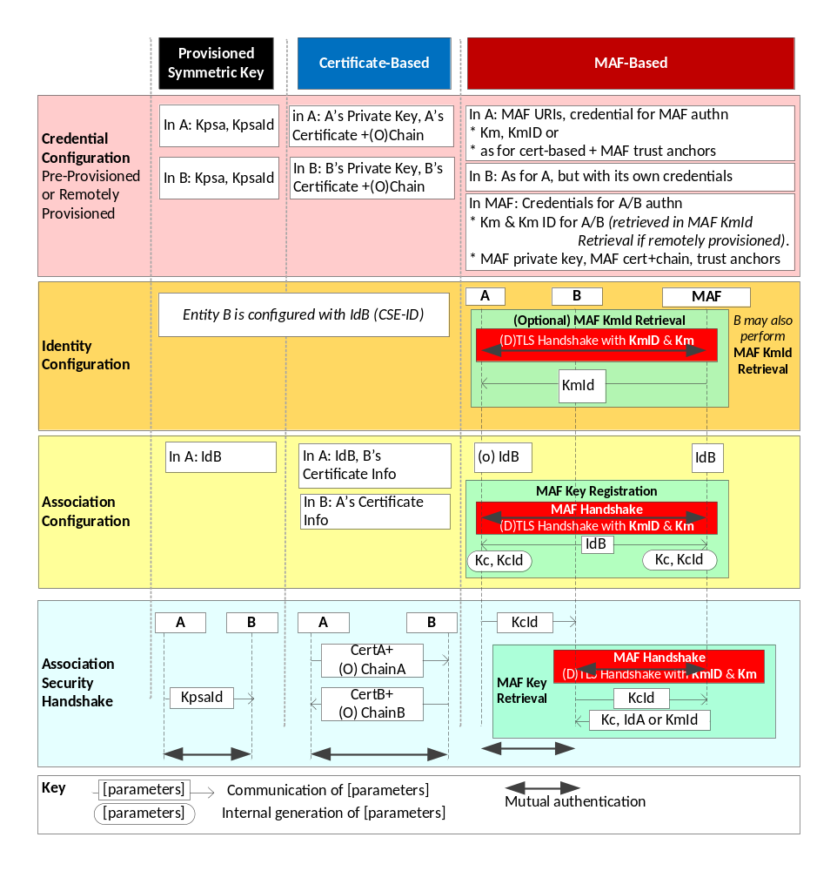
Figure 8.2.1-1: Overview of the Security Association Establishment Frameworks
supported by oneM2M

8.2.2 Detailed Security Association Establishment Frameworks

8.2.2.1 Provisioned Symmetric Key Security Association Establishment Frameworks
This clause describes the Provisioned Symmetric Key Security Association Establishment Framework. This framework enables mutual authentication of two entities corresponding to either two CSEs or a CSE and an AE. The Credential for this framework is a long-term symmetric key that has been provisioned into the entities to be authenticated. This key is called a Provisioned Secure Connection Key and is denoted Kpsa. The provisioning of Kpsa could be a pre-provisioning or a remote provisioning thanks to Remote Security Provisioning Frameworks, as described in clause 8.3. The entities authenticate each other by verifying message authentication codes in the Security Handshake which were generated using the Provisioned Secure Connection Key.
NOTE 1: Long term Provisioned Secure Connection Keys can pose a security risk if not adequately secured, and for this reason long term Provisioned Secure Connection Keys are recommended to be stored in Secure Environments.
Figure 8.2.2.1-1 illustrates the sequence of events when using the Provisioned Symmetric Key Security Association Establishment Framework. In this description, "Entity A" and "Entity B" correspond to either two CSEs or a CSE and an AE or an AE and a CSE (respectively).
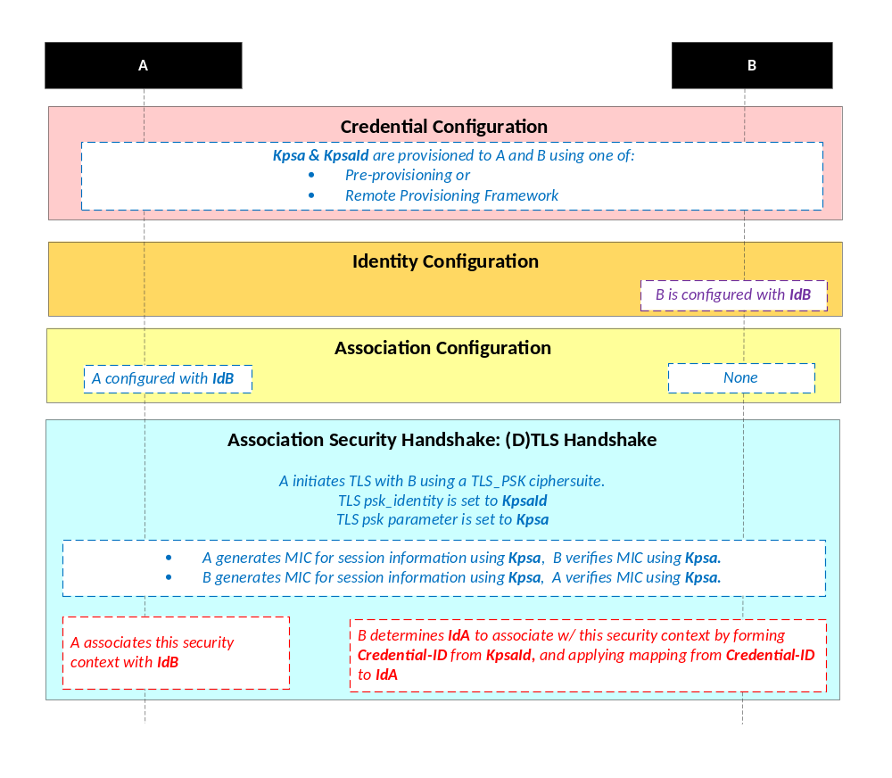
NOTE: The following font colours differentiate the general topic that the text relates to:
Blue italic text highlights details specific to this particular Security Association Establishment Framework.
Purple italic text highlights technical actions that may include steps not specified by oneM2M.
Red italic text highlights security-related properties.

Figure 8.2.2.1-1: The sequence of events when using the Provisioned Symmetric Key
Security Association Establishment Framework
Credential Configuration: The Provisioned Secure Connection Key (Kpsa) and the corresponding Provisioned Secure Connection Key Identifier, denoted KpsaId, are provisioned to both entities either with pre-provisioning or remote provisioning. The format of KpsaId is defined in clause 10.5 "KpsaId Format". If Entity A is a CSE, then Entity A shall also be configured with its CSE-ID (not shown in the figure).
Identity Configuration: See clause 8.3.1.2.
Association Configuration:
- Entity A shall be configured with Entity B identity (IdB). Entity A shall use this identity for Entity B authenticating using the above arguments. This identity is also used to route the (D)TLS exchange.
NOTE 2: Entity A will associate Entity B's identity with messages secured within Security Contexts established using the Provisioned Secure Connection Key Kpsa associated with the Provisioned Secure Connection Key Identifier KpsaId.
- If Entity A is a CSE, then Entity B shall be configured with Entity A’s CSE-ID. If Entity A is an AE, then Entity B may either be configured withEntity A identity (IdA), or may determine IdA during registration (Creation of the <AE> resource). Entity B shall use this identity for Entity A authenticating using the above arguments.
NOTE 3: Entity B will associate the configured Entity A identity with messages secured within Security Contexts established using the Provisioned Secure Connection Key Kpsa associated with the Provisioned Secure Connection Key Identifier KpsaId.
Association Security Handshake: The entities shall perform a (D)TLS-PSK handshake [15] to establish a secure session.
- The "psk_identity" parameter [15] shall be set to the value of the Provisioned Secure Connection Key Identifier KpsaId.
- The "psk" parameter [15] shall be set to the value of the Provisioned Secure Connection Key Kpsa.
- The (D)TLS cipher suite profile for the Provisioned Secure Connection Key Security Association Establishment Framework is specified in clause 10.2.2.
- Following successful authentication of Entity B, Entity A shall associate the security context with Id B (Entity B's entity identifier) configured to Entity A during Association Configuration.
- Following successful authentication of Entity A, Entity B shall associate the security context with a CSE-ID or AE-ID:
- If Entity B was already provided with the CSE-ID or AE-ID corresponding to KpsaId, then Entity B shall associate the security context with that CSE-ID or AE-ID.
- Otherwise, Entity B shall associate the security context with the Credential-ID formed from KpsaId as described in clause 10.4 "Credential-ID Details". Entity B shall then determine CSE-ID or AE-ID from the Credential-ID as described in clause 8.2.1 "Overview on Security Association Establishment Frameworks".

8.2.2.2 Certificate-Based Security Association Establishment Frameworks
This clause describes the Certificate-Based Security Association Establishment Framework.
Figure 8.2.2.2-1 illustrates the sequence of events when using the Certificate-Based Security Association Establishment Framework. In this description, "Entity A" and "Entity B" correspond to either two CSEs or a CSE and an AE.
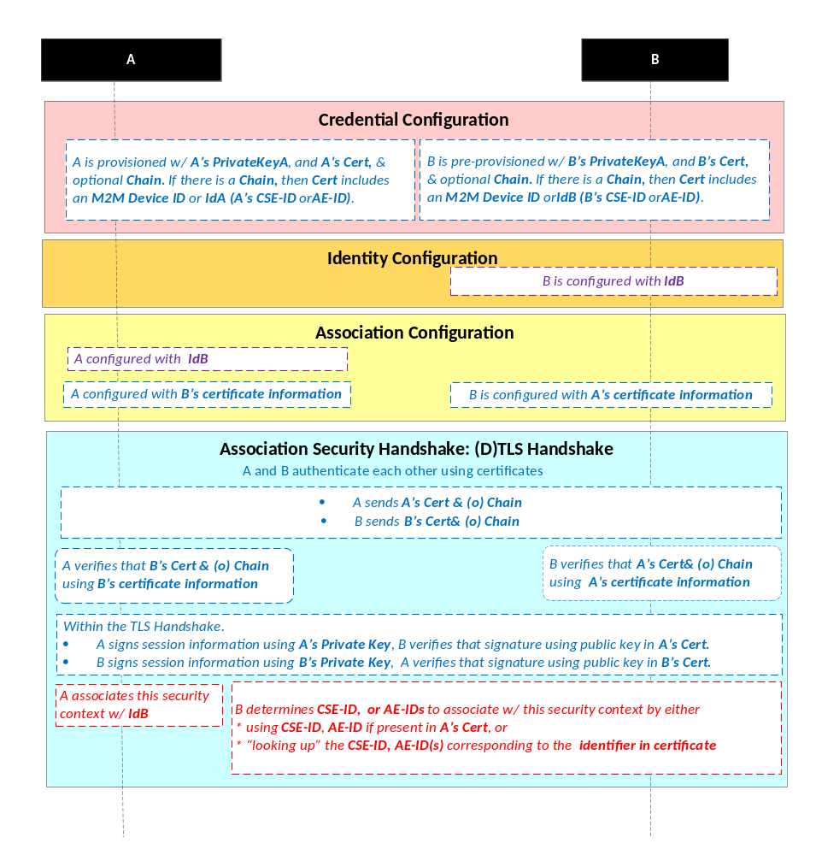
NOTE: The following font colours differentiate the general topic that the text relates to:
Blue italic text highlights details specific to this particular Security Association Establishment Framework.
Purple italic text highlights technical actions that may include steps not specified by oneM2M.
Red italic text highlights security-related properties.

Figure 8.2.2.2-1: The sequence of events when using the Certificate-Based Security
Association Establishment Framework
Credential Configuration: The private keys and certificates for each entity shall be pre-provisioned as described in clause 8.1.2.3 "Credential Configuration for Certificate-Based Security Frameworks". If Entity A is a CSE, then Entity A shall also be configured with its CSE-ID (not shown in the figure).
Identity Configuration: See clause 8.2.1.
Association Configuration: Entity A and Entity B shall be configured with the information needed for the authentication and identification (during Security Handshake) of Entity B and Entity A respectively:
- Entity A shall be commanded to initiate a Security Handshake, and the command includes the following arguments:
- Entity B's certificate information: as described in clause 8.1.2.4 "Information Needed for Certificate Authentication of another Entity".
- Entity B's identity (IdB). Entity A shall use this identity for Entity B authenticating using the above arguments. This is used to route the (D)TLS exchange.
NOTE 1: The Entity A will associate Entity B's identity with messages secured within Security Contexts established in accordance with the configured Entity B's certificate information.
- The Entity B shall be configured with the following arguments describing Entity A authorized to perform Security Handshake with Entity B:
- Entity A's certificate information: as described in clause 8.1.2.4 "Information Needed for Certificate Authentication of another Entity".
Association Security Handshake:
- Each entity shall verify the other entity's certificate as described in clause 8.1.2.2 "Certificate Verification".
- The entities shall authenticate each other using the validated certificates as specified in TLS 1.2 IETF RFC 5246 [5] and DTLS 1.2 IETF RFC 6347 [6] specifications.
- The (D)TLS cipher suite profile for the Certificate-Based Security Association Establishment Framework is specified in clause 10.2.3.
- Following successful authentication of Entity B, Entity A shall associate the security context with IdB (Entity B's entity identifier) configured to Entity A during Association Configuration.
- Following successful authentication of Entity A, Entity B shall associate the security context with a CSE-ID, AE-ID or list of allowed AE-IDs:
- If Entity A establishes a security context by presenting a CSE-ID certificate, then Entity B shall associate the security context with the CSE-ID in the certificate.
- If Entity A establishes a security context by presenting an AE-ID certificate, then Entity B shall associate the security context with the Absolute AE-ID in the certificate.
- If Entity A establishes a security context by presenting a device certificate, then Entity B shall associate the security context with the Credential-ID formed from the globally unique hardware instance identifier in the certificate as described in clause 10.4 "Credential Details". Entity B shall then use Credential-ID to determine the CSE-ID, AE-ID or list of allowed AE-IDs as described in clause 8.2.1 "Overview on Security Association Establishment Frameworks".
- If Entity A establishes a security context by presenting a raw public key certificate, then Entity B shall associate the security context with the Credential-ID formed from the corresponding public key identifier described in clause 10.1.2 "Public Key Identifiers". Entity B shall then use Credential-ID to determine the CSE-ID or AE-ID as described in clause 8.2.1 "Overview on Security Association Establishment Frameworks".

8.2.2.3 MAF-Based Symmetric Key Security Association Establishment Frameworks
This clause describes the MAF-based Security Association Establishment Framework.
This framework uses the MAF Common procedures in clause 8.8, with the following mapping of functional roles:
- Entity A plays the role of the Source End-Point.
- Entity B plays the role of the Target End-Point.
The present clause refers to the entities using only the terminology of Entity A and Entity B.
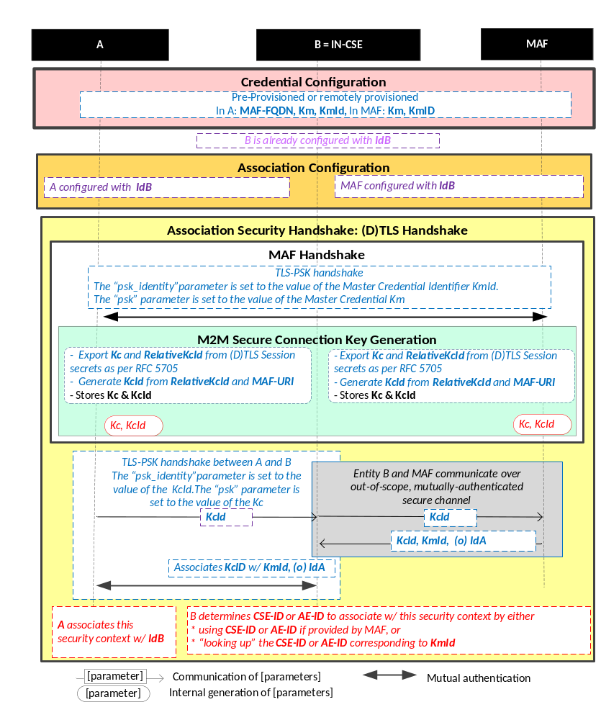
NOTE: The following font colours differentiate the general topic that the text relates to:
Blue italic text highlights details specific to this particular Security Association Establishment Framework.
Purple italic text highlights technical actions that may include steps not specified by oneM2M.
Red italic text highlights security-related properties.

Figure 8.2.2.3-1: The sequence of events when using the
MAF-Based Security Association Establishment Framework
Credential Configuration:
- Entity A (and Entity B respectively) shall be individually provisioned with credentials for mutual authentication with the MAF, as described in MAF Credential Configuration (clause 8.x.2). Pre-provisioning or remote provisioning may be applied. In the case of remote provisioning of symmetric keys, the MAF retrieves the symmetric keys from the MEF during the MAF KmId Retrieval procedure in Identity Configuration.
Identity Configuration:
- If Entity A (or Entity B respectively) are remotely provisioned with a symmetric key for use with the MAF, then Entity A (or Entity B respectively) shall individually perform the MAF KmId Retrieval procedure (clause 8.x.3) with the MAF. This procedure is used to trigger the MAF to (a) retrieve Km from the MEF, and (b) provide the End-Point with the KmId to be used for subsequently authentication with the MAF at step 5.
Association Configuration: Entity A and the MAF shall be configured with the information needed for the authentication and identification during MAF Handshake and Association Security Handshake:
- Authorizing the SAEF.
- Entity A shall be provided with IdB, the CSE-ID for Entity B. See Note 3 in clause 8.2.1.
- The MAF shall be configured with the Entity B Identity (IdB) for which it is authorized to provide Kc for an SAEF.
- Entity A and the MAF shall establish a mutually authenticated secure channel for communication using the MAF Handshake procedure (clause 8.8.4), using the credentials provisioned during Credential Configuration.
- Entity A shall initiate the MAF Key Registration procedure (clause 8.8.5) with the MAF. The MAF Key Registration shall include the Security Usage Identifier (SUID) associated with the MAF-Based SAEF and IdB. This procedure results in
  - Entity A and the MAF establishing a M2M Secure Connection Key (Kc) and associated M2M Secure Connection Key Identifier (KcId).
  - MAF providing the lifetime for the M2M Secure Connection Key (Kc)
The SUID limits the scope within which Kc is authorized to be used. In this case, the SUID is used to ensure that the Entity A shall use Kc only with the MAF-Based SAEF.
Association Security Handshake:
- Entity A shall initiate (D)TLS-PSK handshake with Entity B identified by the MAF, according to clause 10.2.2
- Entity A sends KcId to Entity B (Infrastructure Node) as the "psk_identity" parameter in a (D)TLS_PSK handshake.
- Entity B recognizes the MAF-FQDN part of KcId in the “psk_identity” parameter, and determines that the corresponding M2M Secure Connection Key (Kc) shall be retrieved from the corresponding MAF.
- Entity B and the MAF shall perform the MAF Key Retrieval procedure described in clause 8.8.6.
NOTE 2: The MAF Key Retrieval procedure includes establishing a mutually authenticated secure channel for communication using the MAF Handshake procedure (described in clause 8.8.4), using the credentials provisioned during Credential Configuration.
Entity B shall provide the Security Usage Identifier (SUID) associated with the MAF-Based SAEF and IdB KcId to the MAF, and the MAF shall return Kc, Kc Lifetime, and identity for Entity A to Entity B. The SUID limits the scope within which Kc will be used. In this case, the SUID is used to ensure that the Entity B shall use Kc only with the MAF-Based SAEF.
NOTE 3: Assigning Kc Lifetime is the responsibility of the MAF.
- Entity A and Entity B shall complete the (D)TLS-PSK handshake with the "psk" parameter set to the value of the M2M Secure Connection Key (Kc). The (D)TLS cipher suite profile for the MAF-Based Security Association Establishment Framework is specified in clause 10.2.2.
- Following successful authentication of Entity B, Entity A shall associate the security context with Id B (Entity B's entity identifier) configured to Entity A during Association Configuration.
- Following successful authentication of Entity A, Entity B shall associate the security context with a CSE-ID or AE-ID:
- If the MAF provided Entity B with a CSE-ID or AE-ID, then Entity B shall associate the security context with that CSE-ID or AE-ID.
- Otherwise, Entity B shall associate the security context with the Credential-ID formed from KmId (provided by the MAF) as described in clause 10.4 "Credential-ID Details". Entity B shall then determines CSE-ID or AE-ID from the Credential-ID as described in clause 8.2.1 "Overview on Security Association Establishment Frameworks".
- Entity A and Entity B may establish a fresh (D)TLS-PSK handshake using Kc at any time within the Kc Lifetime. Once Kc Lifetime expires, then Entity B shall fail the (D)TLS-PSK handshake, which indicates to Entity B that a fresh MAF Handshake is required.

8.3 Remote Security Provisioning Frameworks

8.3.1 Overview on Remote Security Provisioning Frameworks

8.3.1.1 Purpose of Remote Security Provisioning Frameworks
Remote Security Provisioning Frameworks (RSPFs) provision credentials to an Enrolee, which is a CSE or AE, as part of the Enrolment of the Enrolee to an M2M SP or M2M Trust Enabler. The credentials are either:
- A symmetric key shared by the Enrolee and an Enrolment Target.
  - If the Enrolment target is an MAF, then the credential can be used for MAF-based SAEF, MAF-based ESPrim and MAF-based ESData Protection Options, with the provisioned symmetric key used for mutual authentication of the Enrolee and the MAF.
  - If the Enrolment target is a CSE or AE, then the credential can be used for only one of PSK-based SAEF or PSK- based ESPrim or PSK-based ESData Protection Options. The provisioned symmetric key used for mutual authentication of the Enrolee and the other CSE or AE.
NOTE: This case should be employed only in cases where the Enrolee is expected to require a symmetric key with relatively few CSE or AE.
- Certificate(s) for which the Enrolee knows the corresponding private key, and a set of trust anchors for authenticating the M2M SP or MTE’s MAF or other entities enrolled with the M2M SP or MTE. These credentials can be used for:
  - Securing communication directly with other CSE or AE using Certificate-Based SAEF, Direct End-to-End Key Establishment using Certificates (ESCertKE), and certificate-based ESData protection options. The other CSEs or AEs use their own certificate(s), chaining to a provisioned trust anchor, in these security frameworks.
  - MAF-based SAEF, MAF-based ESPrim, and MAF-based ESData protection options, with the certificate used for authentication of the Enrolee to the MAF. The MAF would authenticate using its own certificate chaining to a provisioned trust anchor.
Credentials may also be pre-provisioned; that is, provisioned using means other than a Remote Security Provisioning Framework. The method for pre-provisioning can be deployment dependent. An interoperable pre-provisioning framework based on UICC is described in annex D.

8.3.1.2 Overview on Remote Security Provisioning Frameworks
An AE or CSE that requires remote provisioning is called an Enrolee. The AE or CSE with whom the enrolee is to establish a security association is called Enrolee B. The AE or CSE or M2M Authentication Function with whom the enrolee is to establish a shared key is called an Enrolment Target.
The oneM2M system supports the following Security Bootstrap Frameworks:
- Pre-Provisioned Symmetric Enrolee Key Remote Security Provisioning Framework: A symmetric key is pre-provisioned to the Enrolee and M2M Enrolment Function for the mutually authentication of those entities. For more details, see clause 8.3.2.1.
- Certificate-Based Remote Security Provisioning Framework: The Enrolee and M2M Enrolment Function are each issued with:
- a Private Signing Key that is known only to that entity;
- a Certificate containing the corresponding Public Verification Key; and
- (In the case of a device certificate, CSE-ID certificate or AE-ID certificate) a Certificate Chain from the entity's Certificate to a Trust Anchor Certificate.
The Enrolee and M2M Enrolment Function shall validate each other's Certificate before trusting the Public Verification Keys in the Certificate. Within the Security Handshake, the M2M Enrolment Function creates a digital signature of the session parameters using its private signing key and the Enrolee verifies the digital signature using the M2M Enrolment Function's public verification key. Then the roles are reversed: the Enrolee creates a digital signature and the M2M Enrolment Function verifies it. For more details see clause 8.3.2.2.
- GBA-based Remote Security Provisioning Framework. In this case, the role of the M2M Enrolment Function is performed by a GBA Bootstrap Server Function. This framework uses 3GPP or 3GPP2 symmetric keys to authenticate the Enrolee and the M2M Enrolment Function (which is also a GBA BSF). The details are specified by 3GPP TS 33.220 [13] and 3GPP2 S.S0109-A [14]. For more details see clause 8.3.2.3.
For a more detailed description of the above Remote Security Provisioning Frameworks, it is useful to compare the following aspects of the Remote Security Provisioning Frameworks:
- Bootstrap Credential Configuration: The Enrolee and M2M Enrolment Function are pre-provisioned with the Bootstrap Credential that the entity will use to authenticate itself to the other entity. The mechanisms for this pre-provisioning are not described in the present document.
- Bootstrap Instruction Configuration:
- The Enrolee is configured with the M2M Enrolment Function URI (for the purpose of routing the (D)TLS messages to the M2M Enrolment Function).
- The Enrolee and M2M Enrolment Function are provided with either:
- M2M Authentication Function Identifier (MAF-ID) identifying the M2M Authentication Function for which the Enrolee is to be remotely provisioned when used in conjunction with a MAF-based security association establishment framework; or
- The identifier of Enrolee B (Enrolee B-ID), when used in conjunction with a Provisioned Symmetric Key Security Association Establishment.
NOTE 1: The identity of the Enrolment Target is assumed to have been configured to the Enrolment Target prior to the Bootstrap Instruction Configuration phase.
Additionally, in the case of Enrolee B the following information are provided:
- an indication of whether the Kpsa can be used for generation of end-to-end security credentials;
- the security capabilities of the Enrolment Target and the associated security parameters that dictates the mechanisms to generate the credentials; and
- the mechanisms that shall be used to achieve end-to-end security.
Additionally, in the case of Certificate-Based Remote Security Provisioning Framework:
- The Enrolee is configured with the M2M Enrolment Function Trust Anchor CA Certificates that the Enrolee will use to verify the M2M Enrolment Function.
- The M2M Enrolment Function is configured with the Enrolee's certificate information that the M2M Enrolment Function will use to verify the Enrolee. The necessary certificate information is dependent on the Enrolee's certificate's flavour, with details provided in clause 8.1.2.4 "Information Needed for Certificate Authentication of another Entity".
- Bootstrap Enrolment Handshake: Identification, authentication and security context establishment between the Enrolee and M2M Enrolment Function.
- Enrolment Key Generation (details in clause 8.3.2.1): generating a symmetric Enrolment Key,(Ke) and corresponding Enrolment Key Identifier (KeId) shared by the Enrolee and M2M Enrolment Function, which is used for subsequent generation of the Master Credential (Km) or symmetric keys using in PSK-based Security Frameworks; for example,Provisioned M2M Symmetric Key (Kpsa).
- Enrolment Exchange (PPSK and Certificate RSPFs only, details in in clause 8.3.2.1). The MEF may trigger Certificate Enrolment or trigger Remote MAF Enrolment or provide a URI for a remote management server to contact for further configuration:address of the M2M Enrolment Function.
- Certificate Enrolment (clause 8.3.3.1): The Enrolee is issued a certificate via the MEF, with corresponding private keys generated by the Enrolee. The MEF also provides a set of trust anchors.
- Remote MAF Enrolment (clause 8.8.2): The MEF provides a MAF URI if a MAF is to be used. If certificates are to be used for authentication to the MAF, then the certificate and trust anchors provisioned during Certificate Enrolment suffice for mutual authentication of the Enrolee and MAF. If a symmetric key is to be used for authentication to the MAF, then the Enrolee and MEF generate these from the Enrolment Key (Ke). The MEF may repeat the procedure to trigger the Enrolee to enrol with multiple MAF.
- Use of Remotely Provisioned Credentials: (details in clause 8.3.2.1)
- Certificate-Based Security Frameworks: Certificates, and configured trust anchors, are used directly in certificate-based security frameworks with Enrolee B.
- PSK-Based Security Frameworks: The Enrolee and MEF generate symmetric keys from the Enrolment Key (Ke). The Enrolee provides KeId to Enrolee B, and the Enrolee B retrieves the corresponding symmetric key and over a secure connection to the MEF, subject to authorization at the MEF.
- MAF Security Frameworks: If certificates are to be used for authentication to the MAF, then the certificate and trust anchors provisioned during Certificate Enrolment are used for mutual authentication of the Enrolee and MAF. If a symmetric key is used for mutual authentication, then the Enrolee performs the MAF KmId Retrieval procedure, during which the Enrolee provides the Enrolment Key Identifier (KeId) to the MAF, and the MAF is provided with the symmetric key over a secure connection to the MEF, and the MAF provides a KmId for the Enrolee to use in subsequent MAF Handshake procedures.
NOTE 2: If the Enrolment Target hosts a <ServiceSubscribedAppRule> resource, then the fetched credentials from the M2M Enrolment Function or the M2M Authentication Function needs to be stored after the Enrolment Target establishes a secured connection with the Enrolee. A Credential ID value in the format as mentioned in section 10.4 is generated using the credential used for the secured connection establishment and is added into the applicableCredIDs attribute of the <ServiceSubscribedAppRule> resource.
NOTE 3: If the EnroleeID of the Enrolee is retrieved from the M2M Enrolment Function or the M2M Authentication Function, then the same is saved in the allowedAEs attribute of the <ServiceSubscribedAppRule> resource.
Figure 8.3.1.2-1 provides a summary of the above defined Remote Security Provisioning Frameworks.
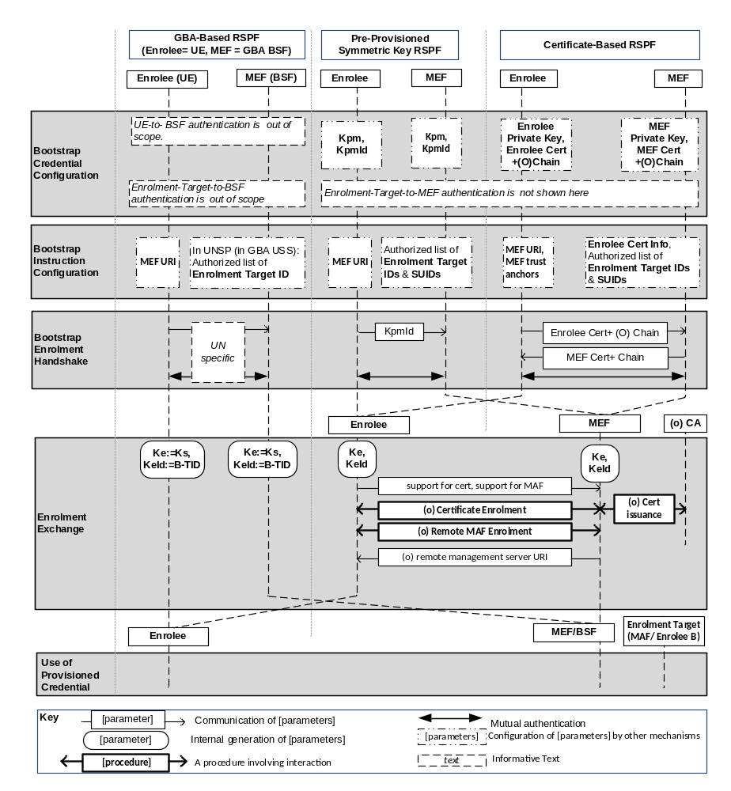
Figure 8.3.1.2-1: Overview of the Remote Security Provisioning Frameworks supported by oneM2M

8.3.2 Detailed Remote Security Provisioning Framework

8.3.2.1 Pre-Provisioned Symmetric Key Remote Security Provisioning Framework
This clause describes the Pre-Provisioned Symmetric Key Remote Security Provisioning Framework. The Bootstrap Credential for this framework is a long-term symmetric key that has been pre-provisioned into the Enrolee and M2M Enrolment Function; this key is called a Pre-Provisioned Symmetric Enrolee Key and is denoted Kpm.
NOTE 1: Long term Pre-Provisioned Symmetric Enrolee Keys can pose a security risk if not adequately secured, and for this reason it is recommended that Long term Pre-Provisioned Symmetric Enrolee Keys are stored in Secure Environments.
Figure 8.3.2.1-1 illustrates the sequence of events when using the Pre-Provisioned Symmetric Enrolee Key Remote Security Provisioning Framework.
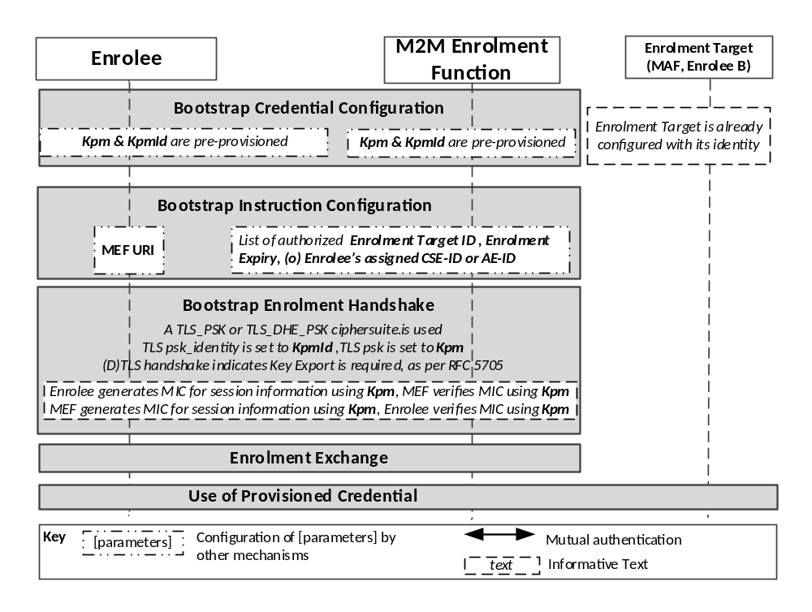
Figure 8.3.2.1-1: The sequence of events when using
the Pre-Provisioned Symmetric Key Remote Security Provisioning Framework
Bootstrap Credential Configuration: The Pre-Provisioned Symmetric Enrolee Key (Kpm) and the corresponding Pre-Provisioned Symmetric Enrolee Key Identifier, denoted KpmId, are pre-provisioned to both entities. The Enrolee is also pre-provisioned with the M2M Enrolment Function's URI (MEF URI), for the purpose of routing the (D)TLS exchange.
NOTE 2: This pre-provisioning (by definition) uses mechanisms not specified by oneM2M.
Bootstrap Instruction Configuration: The Enrolee and M2M Enrolment Function are configured with the information needed for authorizing the remote provisioning:
- The Enrolee is configured with (or otherwise obtains) the following arguments to initiate remote provisioning:
- The Enrolment Target identity: Identifying the Enrolment Target for which the Enrolee is to be provisioned.
- The Enrolee associates these arguments with the M2M Enrolment Function. The M2M Enrolment Function can be identified to the Enrolee using the Pre-Provisioned Symmetric Enrolee Key Identifier (KpmId) or the M2M Enrolment Function URI.
Enrolment Expiry: Life Time to be applied for the key generated, i.e. Ke as mentioned in clause 10.7.
- M2M Enrolment Function is configured with the following arguments to authorize the M2M Enrolment Function to remotely provision the Enrolee for an Enrolment Target:
- The Enrolment Target Identity: Identifying the Enrolment Target for which the Enrolee is to be provisioned.
- Enrolee's assigned CSE-ID or AE-ID (Enrolee-ID). The M2M Enrolment Function is to provide this entity identity for the Enrolee with the Km or Kpsa to the Enrolment Target, when requested by the Enrolment Target.
- The M2M Enrolment Function associates these arguments with an Enrolee. The Enrolee can be identified to the M2M Enrolment Function using the Pre-Provisioned Symmetric Enrolee Key Identifier (KpmId).
Enrolment Expiry: Life Time to be applied for the keys generated, i.e. Ke. The M2M Enrolment Function may provide this lifetime along with Km or Kpsa to the Enrolment Target.
Bootstrap Security Handshake:
- The Enrolee and M2M Enrolment Function shall perform a (D)TLS-PSK handshake [15] to establish a secure session.
- The "psk_identity" parameter [15] is set to the value of the Pre-Provisioned Symmetric Enrolee Key Identifier (KpmId).
- The "psk" parameter [15] is set to the value of the Pre-Provisioned Symmetric Enrolee Key (Kpm).
- The (D)TLS cipher suite profile is specified in clause 10.2.2 "TLS and DTLS Ciphersuites for TLS-PSK-Based Security Frameworks".
Enrolment Key Generation:
- The Enrolment Key (Ke), RelativeKeId, and Enrolment Re-authentication Key (Ker) are generated from the (D)TLS session secrets by the Enrolee and M2M Enrolment Function using TLS Key Export (IETF RFC 5705 [18]), as described in clause 10.3.1 "TLS Key Export Details".
- The Enrolment Key Identifier (KeId) is generated from the RelativeKeId and the M2M Enrolment Function's FQDN by the Enrolee and M2M Enrolment Function, as described in clause 10.3.4 "Generating KeId".
- The Enrolee and M2M Enrolment Function store the Enrolment Key (Ke) and Enrolment Key Identifier (KeId), and Enrolment Re-Authentication Key (Ker).
NOTE 3: The Enrolment Key Generation for the Pre-Provisioned Symmetric Enrolee Key Remote Security Provisioning Framework is identical to the Enrolment Key Generation for the Certificate-Based Remote Security Provisioning Framework.
Enrolment Exchange:
- The Enrolee shall compose a response with a payload containing the following parameters and values. These parameters could be serialized using, for example, XML or JSON formats.
Parameter Name | Parameter Value
Certificate Enrolment Indication | <True/False>
MAF Enrolment Indication | <True/False>
Remote Management Indication | <True/False>

These indications indicate whether or not the Enrolee is prepared to execute these procedures if instructed by the MEF .The Enrolee shall send the request to the MEF’s Enrolment Exchange URI.
- The MEF shall process the request against the preferences for this Enrolee (see pre-conditions) to determine how the Enrolee is to be provisioned.
NOTE 3: The present specification does not define this processing.
- If the Enrolee does not need to be remotely provisioned for certificate-based authentication with Enrolment Targets, then the MEF shall proceed to step 10. To remotely provision the Enrolee for certificate-based authentication with Enrolment Targets, the MEF shall compose a response with a payload containing the following parameters and values. These parameters may be serialized using, for example, XML or JSON formats.
Parameter Name | Parameter Value
Instruction Type | <Indicating Certificate Enrolment>
URI | <Base certificate enrolment URI>

The MEF shall send the response to the Enrolee.
- If the MEF instructs the Enrolee to perform Certificate Enrolment, then the Enrolee shall perform Certificate Enrolment procedure as described in clause 8.3.3.1.
- When Certificate Enrolment is complete, then the Enrolee shall send a request to the MEF indicating success.
- If the Enrolee does not need to be remotely enrolled with a M2M Authentication Function (MAF), then the MEF shall proceed to step 13. To remotely enrol the Enrolee with a MAF, the MEF shall compose a response with a payload containing the following parameters and values. These parameters may be serialized using, for example, XML or JSON formats.
Parameter Name | Parameter Value
Instruction Type | Indicating MAF Enrolment
Credential Type | <Indicating whether to use certificates or symmetric key for authenticating to MAF>
MAF Key Registration URI | <The URI through which MAF Key Registration is performed
MAF Key Retrieval URI | The URI through which MAF Key Retrieval is performed
(Optional) MAF KmId Retrieval URI | The URI from which the MAF-assigned KmId is retrieved.
(Optional) Trust Anchors | Trust anchor CA certificates for MAF certificate
(Optional) Lifetime | Lifetime when the symmetric key shared with MAF will expire

The MEF shall send the response to the Enrolee.
- Upon receipt of this message, the Enrolee shall perform the MAF KmId Retrieval procedure as described in clause 8.8.3. This procedure includes the “Use of Remote Provisioned Credential”.
- When the MAF KmId Retrieval procedure is complete, then the Enrolee shall send a message to the MEF indicating success. The MEF may return to step 10, to provision the Enrolee for another MAF.
- If the Enrolee does not need to be remotely provisioned for remote management server to contact for further configuration, then the MEF shall proceed to step 15. To remotely provision the Enrolee for remote management server, the MEF shall compose a response with a payload containing the following parameters and values. These parameters may be serialized using, for example, XML or JSON formats.
Parameter Name | Parameter Value
Instruction Type | <Indicating Remote Management Server>
URI | <Base URI of Remote Management Server >
Editor’s note: data types for the above parameters need to be specified, either in TS-0003 or in TS-0004
The MEF shall send the response to the Enrolee.
- The Enrolee shall send a message to the MEF acknowledging that it received the instruction. The Enrolee shall initiate contact with the remote management server after the TLS/DTLS session with the MEF is closed.
- The MEF shall send a response indicating the end of the enrolment exchange.
- The MEF shall close the TLS/DTLS session.
Use of Remotely Provisioned Credential: In the case where the Enrolment Target is an MAF, the Enrolee is instructed to contact a specific MAF with which to perform Enrolment.
- If the Enrolee is remotely provisioned with a certificate and trust anchors during the Enrolment Exchange, then the Enrolee may use these in security protocols with the Enrolment Target. Otherwise, the Enrolee shall use the KeID in security protocols with the Enrolment Target as described in the remaining steps.
- The Enrolee shall provide KeId as a symmetric key identifier in the security protocol.
- The Enrolment Target checks to see if it has the credentials associated with KeID and if it does not have the credentials, then the Enrolment Target prepares to fetch the credentials from the MEF.
- The Enrolment Target has been pre-configured with the MEF's FQDN/URL and in order to establish a secured connection, it either uses the PSK credentials or certificate which has also been pre-configured between the Enrolment Target and the MEF. In the case of an Enrolee B, an Enrolment Re-Authentication Key (Ker) established with the MEF may be used for authentication, or a certificate provisioned by the MEF may be used for authentication.
- If the Enrolment Target wishes to fetch any credential information from the MEF, a retrieve request to MEF with the target URI set to/fetchCredentials/<KeId>/<security-usage-identifier> shall be formed, where <security-usage-identifier> is the SUID for the particular usage of the symmetric key. The originator field of the retrieve request (e.g. X-M2M-Origin header when using HTTPS) contains the ID (AE-ID/CSE-ID/MAF-ID) of the Enrolment Target/MAF.
- Upon receiving the retrieve request, the MEF performs the following:
- The MEF extracts the KeId from the Target URI. The MEF shall retrieve the Enrolment Key (Ke) for the corresponding KeId, as per the Enrolment Key Generation process defined in clause 8.3.1.2. If the MEF is unable to retrieve this information, a response shall be sent with an error as per step 'f) vii'.
- The Enrolment Target's ID is extracted from the originator field included in the retrieve request, and the Security Usage Identifier (SUID) is extracted from the target URI. The MEF shall validate if the particular Enrolment Target is allowed to fetch credentials for the Enrolee with the particular Security Usage Identifier.
- If the validation fails, a response shall be sent as per step 'f)vii'. If the validation is successful, then the key shall be generated with the Enrolment Key (Ke) retrieved in step f)i' as mentioned in clause 10.3.7.
- The Enrolee ID corresponding to the KeId is determined by the MEF.
- The Enrolee Lifetime parameter for the KeId is determined by the MEF. This is a pre-configured value which indicates the validity period of the credentials that are provided to the Enrolment Target/MAF.
- A response shall be composed with a payload containing the following parameters and values. These parameters may be serialized using, for example, XML or JSON formats.
Table 8.3.2.1-1
Parameter Name | Parameter Value
Status | True
Credential | <Key>
EnroleeID | <Enrolee ID Value>
Lifetime | <Lifetime of generated Key>

- Upon any errors in the above steps, the MEF shall compose a response with the following parameters.
Table 8.3.2.1-2
Parameter Name | Parameter Value
Status | False
ErrorString | <Failure Reason>

- The Enrolment Target upon receiving the credentials proceeds to use the credentials in the security protocol with the Enrolee.

8.3.2.2 Certificate-Based Remote Security Provisioning Framework
This clause describes the Certificate-Based Remote Security Provisioning Framework. The Bootstrap Credentials for this framework are Certificates.
Figure 8.3.2.2-1 illustrates the sequence of events when using the Certificate-Based Remote Security Provisioning Framework.
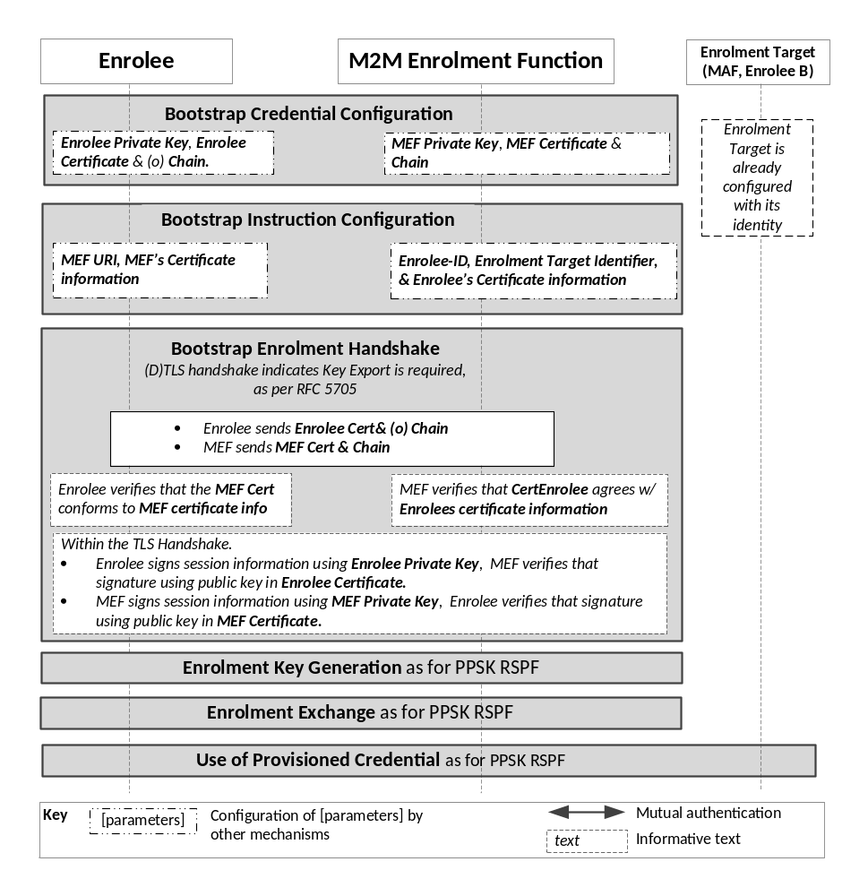
Figure 8.3.2.2-1: The sequence of events when using
the Certificate-Based Remote Security Provisioning Framework
Bootstrap Credential Configuration: For this Remote Security Provisioning Framework, Enrolee and M2M Enrolment Function authenticate each other using a Public Key Certificate. The Bootstrap Credentials for the Enrolee and M2M Enrolment Function are pre-provisioned as described in clause 8.1.2.3 "Credential Configuration for Certificate-Based Security Frameworks".
NOTE 1: The identities of the M2M Enrolment Function and Enrolment Target are assumed to have been configured prior to this phase.
Bootstrap Instruction Configuration: In addition to the information identified in clause 8.3.1.2, the Enrolee and M2M Enrolment Function are configured with the information needed for authorizing the remote provisioning:
- The Enrolee is configured with (or otherwise obtains) the following arguments to initiate remote provisioning:
- Information needed for certificate authentication of the M2M Enrolment Function using an MEF certificate as described in clause 8.1.2.4 "Information Needed for Certificate Authentication of another Entity".
- The M2M Enrolment Function is configured with the following arguments describing Enrolee authorized to perform Security Handshake with M2M Enrolment Function:
- Information needed for certificate authentication of the Enrolee, as described in clause 8.1.2.4 "Information Needed for Certificate Authentication of another Entity".
Bootstrap Security Handshake: The Enrolee and M2M Enrolment Function perform a (D)TLS handshake as specified in TLS 1,2 IETF RFC 5246 [5] and DTLS 1.2 IETF RFC 6347 [6] specifications.to establish a secure session.
- Each entity (Enrolee and M2M Enrolment Function) verifies the other entity's certificate as described in clause 8.1.2.5 "Certificate Verification".
- The Enrolee and M2M Enrolment Function authenticate each other using the validated certificates as specified in TLS 1.2 IETF RFC 5246 [5] and DTLS 1.2 IETF RFC 6347 [6] specifications.
- The (D)TLS cipher suite profile for this 's assigned CSE-ID or AE-ID is specified in clause 10.2.3 "TLS and DTLS Ciphersuites for Certificate-Based Security Frameworks".
Enrolment Key Generation, Enrolment Exchange and Use of Provisioned Credentials:
- The steps are identical to those shown for "Enrolment Key Generation", “Enrolment Exchange” and “Use of Provisioned Credentials” in clause 8.3.2.1 "Pre-Provisioned Symmetric Key Remote Security Provisioning Framework".

8.3.2.3 GBA-Based Remote Security Provisioning Framework
To share a long term Master Credential (Km) or Provisioned Secure Connection Key (Kpsa) between an Application Service/Middle Node and an Enrolment Target, the M2M Application Service/Middle Node shall perform a successful GBA bootstrapping and derive a NAF key (Ks_(ext/int)_NAF). This NAF key is the Master Credential (Km) or Provisioned Secure Connection Key (Kpsa).
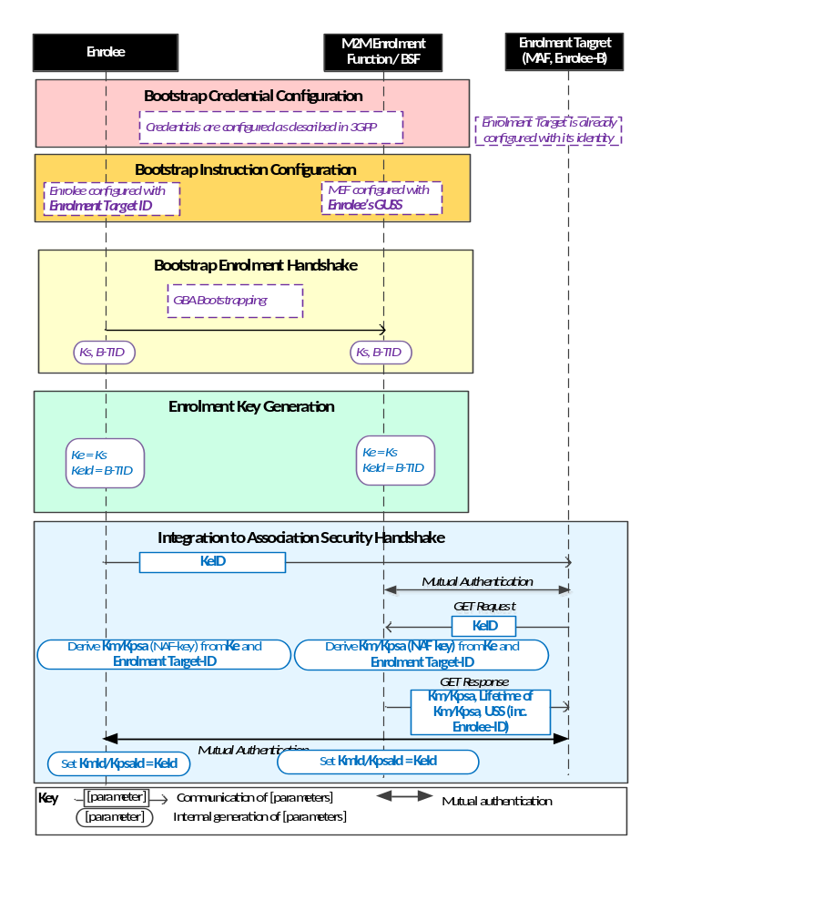
NOTE: The following font colours differentiate the general topic that the text relates to:
Black text contains Remote Security Provisioning -Framework-independent details.
Blue italic text highlights details specific to this particular Remote Security Provisioning Framework.
Purple italic text highlights technical actions that may include steps not specified by oneM2M.
Figure 8.3.2.3-1: The sequence of events when using
the GBA-Based Remote Security Provisioning Framework
Bootstrap Credential Configuration: The credentials configuration for Enrolee and M2M Enrolment Function (MEF) is described in 3GPP specification 3GPP TS 33.220 [13]. The MEF plays the role of the BSF. The credentials used to perform mutual authentication between Enrolee and MEF are UNSP specific.
Bootstrap Instruction Configuration: The Enrolee, the MEF and the Enrolment Target shall be configured with the information needed for authorizing the remote provisioning:
- The Enrolee shall be configured with the Enrolment Target Identity: identifying the Enrolment Target for which the Enrolee is to be provisioned.
- The MEF shall be configured with the Enrolee-ID and the Enrolment Target Identity:
- The Enrolment Target Identity: Identifying the Enrolment Target for which the Enrolee (authenticated using the GBA) is to be provisioned.
- The Enrolee's assigned CSE-ID or AE-ID (Enrolee-ID), The M2M Enrolment Function is to provide this entity identity for the Enrolee with the Km or Kpsa to the Enrolment Target, when requested by the Enrolment Target.
- Enrolee's GBA User Security Settings (GUSS) enables indicating if Enrolee is allowed to establish a NAF-specific key with the Enrolment Target or/and if the BSF can distribute a NAF specific key to the Enrolment Target.
Bootstrap Enrolment Handshake:
The Bootstrap Enrolment Handshake enables the establishment of a GBA bootstrapped key (Ks) shared between the Enrolee and the MEF with associated Bootstrapping Transaction Identifier ( B-TID) and key lifetime, by performing to the GBA Bootstrapping phase described in 3GPP TS 33.220 [13].
If a bootstrapped key Ks is already shared between Enrolee and the MEF and still valid, then the Bootstrap Enrolment Handshake phase is not needed. The Enrolment Key Generation phase can take place with the existing GBA Bootstrapped key Ks.
Enrolment Key Generation phase:
The Enrolment Key (Ke) shall be the GBA Bootstrapped key (Ks) established during the Bootstrap Enrolment Handshake.
The Enrolment Key Identifier (Ke-ID) shall be the Bootstrapping Transaction Identifier ( B-TID) generated during the Bootstrap Enrolment Handshake.
Integration to the Association Security Handshake:
- The Enrolee and the Enrolment Target shall establish the Master Credential (Km) or the Provisioned Secure Connection Key (Kpsa) thanks to procedures described in 3GPP TS 33.220 [13] using the Enrolment Key (Ke) as GBA bootstrapped key Ks and the Enrolment Key Identifier (Ke-ID) as B-TID. The Enrolment Target plays the role of a NAF.
- The Enrolee and the Enrolment Target shall establish NAF-specific key(s) as described in 3GPP TS 33.220 [13]. A key lifetime is associated to the NAF-specific keys. The Enrolment Target also receives the Enrolee's User Security Settings (USS) from the MEF/BSF:
- The FQDN of the NAF, used as input to generate the Ks_(int/ext)_NAF, shall be set as follows:
- In the case where the Enrolment Target is an M2M Authentication Function, then the FQDN of the NAF is set to the FQDN of the M2M Authentication Function.
- In the case where the Enrolment Target is a CSE, then the FQDN of the NAF is set to the public domain name representation of the CSE-ID as defined in oneM2M TS-0001 [1].
- In case of GBA_ME, NAF-specific key is Ks_NAF.
- In case of GBA_U, NAF-specific keys are Ks_int_NAF and Ks_ext_NAF.
- The Master Credential (Km) ) or the Provisioned Secure Connection Key (Kpsa) shall be the NAF-specific key:
- In case of GBA_ME, Km/Kpsa = Ks_NAF.
- In case of GBA_U, Km/Kpsa = Ks_int_NAF if HTTP Client application resides in the UICC. Otherwise, Km/Kpsa = Ks_ext_NAF.
- The Enrolee and the Enrolment Target shall set the Master Credential Identifier (Km-Id) or the Provisioned Secure Connection Key Identifier (Kpsa-Id) to the value of KeId.
Enrolee and Enrolment Target shall perform (D)TLS-PSK handshake (IETF RFC 4279 [15]) with the Master Credential (Km) or Provisioned Secure Connection Key (Kpsa) as Pre-Shared Key in compliance with clause 10.2.2 "TLS and DTLS Ciphersuites for TLS-PSK-Based Security Frameworks". If UICC is used as Secure Environment supporting Remote Security Provisioning, GBA-U with Km/Kpsa = Ks_int_NAF shall be used for authentication and key exchange.

8.3.3 Common Remote Security Provisioning Framework Procedures

8.3.3.1 Certificate Enrolment Procedure call flow
Pre-Conditions:
- The Enrolee and MEF have successfully established a TLS session.
- The M2M Enrolment Function has instructed the Enrolee to perform Certificate Enrolment.
Procedure Description:

- The Enrolee shall request the set of trust anchor CA certificates
- The MEF shall respond with a set of trust anchor CA certificates.
- The Enrolee installs the trust anchor CA certificates.
- The Enrolee shall request Certificate Signing Request (CSR) attributes from the MEF.
- The MEF shall respond with the set of required CSR attributes, which shall include a challengePassword used. The CSR attributes may include identifiers.
- The Enrolee shall generate a public/private key pair of suitable key length.
- The Enrolee shall send a request with the required CSR attributes, including the challengePassword (to verify proof-of-possession of the public key), requested identifiers and EKU(s).
- The MEF shall validate the challenge, identifiers, and EKU(s).
- The MEF shall forward the CSR to the Certificate Authority (CA). The MEF may request the CA to add
  - Extended key usage (EKU) OID(s) of the security usage identifiers (SUIDs) for which the provisioned certificate may be used, or
  - Identifiers in addition to those already in the CSR.
- The CA shall issue the requested certificate.
- The CA delivers the certificate to the MEF.
- The MEF sends the certificate to the Enrolee in the response.
- The Enrolee installs the certificate and associates it with the generated private key.

8.4 End-to-End Security of Primitives (ESPrim)

8.4.1 Purpose of E2E Security of Primitives (ESPrim)
End-to-End Security of Primitives (ESPrim) provides an interoperable framework for securing oneM2M primitives so CSEs (forwarding the primitive) do not need to be trusted with the confidentiality and integrity of the primitive. ESPrim provides mutual authentication, confidentiality, integrity protection and a freshness guarantee (bounding the age of ESPrims).
Applicable use cases and requirements are discussed in oneM2M TR-0012 [i.16].
The present document assumes that the ESPrim end-points are the Originator and Receiver of the primitive.
The present document specifies credential management aspects and data protection aspects for ESPrim. Transport of ESPrims is described in oneM2M TS-0001 [1].

8.4.2 End-to-End Security of Primitives (ESPrim) Architecture
The credential management aspects and data protection aspects for ESPrim are specified in the present clause. Clause 11.3.2, oneM2M TS-0001 [1] specifies the transport of ESPrims.
The primitive to be secured is called the inner primitive, and the primitive which is used to transport a secured inner primitive is called the outer primitive. The inner primitive is protected using encryption and integrity protection which takes a symmetric key sessionE2EPrimitiveKey as input. The sessionESPrimKey is derived from a pairwiseESPrimKey, established between the Originator and Receiver, and a receiverE2ERandObject and originatorE2ERandObject.
Sequence of events for ESPrim consists of three main phases:
- Establishing pairwiseESPrimKey.
- Establishing sessionESPrimKey at the Originator.
- Securing a primitive exchange.
Figures 8.4.2-1 shows the ESPrim message flow for establishing pairwiseESPrimKey and sessionESPrimKey at the Originator. Figure 8.4.2-2 shows the ESPrim message flow for securing a Primitive Exchange.
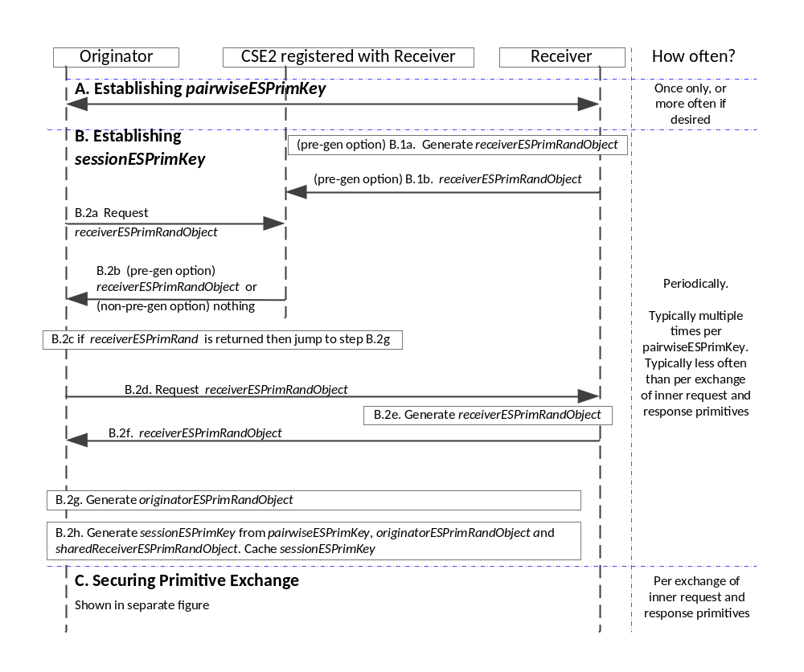
Figure 8.4.2-1: Message flow for establishing pairwiseESPrimKey and establishing sessionESPrimKey at the Originator in the End-to-End Security of Primitives (ESPrim) Procedure
A. Establishing pairwiseESPrimKey: The pairwiseESPrimKey may be established using either of the following frameworks:
- Provisioned pairwiseESPrimKey Framework: The Originator and Receiver shall be provisioned with pairwiseESPrimKey. This credential shall be provisioned via one of:
- pre-provisioning;
- a Remote Security Provisioning Frameworks (RSPF), specified in clause 8.3; or
- End-to-End Security Certificate based Key Establishment (ESCertKE) between the Originator and Receiver, specified in clause 8.7 "End-to-End Security Certificate based Key Establishment (ESCertKE)".
The Originator and Receiver also establish pairwiseESPrimKeyId and optionally pairwiseESPrimKeyLifetime during this process. If no pairwiseESPrimKeyLifetime, is provided, then then pairwiseESPrimKey never expires. The Originator and Receiver cache the (pairwiseESPrimKeyId, pairwiseESPrimKey, (optional) pairwiseESPrimKeyLifetime) object to use for processing subsequent primitives.
- MAF ESPrim Framework: The Originator and M2M Authentication Function (MAF) authenticate each other using symmetric keys (which may be pre-provisioned or remotely provisioned) and derive a M2M Secure Connection key (Kc) and corresponding key identifier (KcId). The Originator generates pairwiseESPrimKey from Kc and a reserved string. The value of KcId is used in phase C as the pairwiseESPrimKeyId in the JWE/XML-ENC object. The Originator caches the (pairwiseESPrimKeyId, pairwiseESPrimKey) pair to use for processing subsequent primitives. The Receiver retrieves Kc and a credential lifetime from the MAF after it receives an inner request primitive secured using the corresponding pairwiseESPrimKey' see step C.6.a.
When pairwiseESPrimKey is established using the MAF option, then it typically has a shorter lifetime than the former option.
- Receiver indicate support for ESPrim: If Receiver supports ESPrim, the Receiver shall ensure the following for the Receiver's <remoteCSE> resource on all CSEs with which the Receiver is registered:
- The Receiver's <remoteCSE> resource shall include the e2eSecInfo attribute.
- The e2eSecInfo attribute in this resource shall indicate support for ESPrim.
B. Establishing sessionESPrimKey at the Originator: The Receiver shall select to either (a) pre-generate a receiverE2ERandObject which is distributed for use by multiple Originators for establishing sessionESPrimKey, or (b) generate a unique receiverE2ERandObject upon request (in which case no action is required prior to receiving such a request). If the Receiver selects to generate a unique receiverE2ERandObject upon request, then In the latter case, the Receiver shall ensure that the sharedReceiverE2ERandObject parameter is not present in the e2eSecInfo attribute in the Receiver's <remoteCSE> resource on all CSEs to which the Receiver is registered. The absence of the sharedReceiverE2ERandObject parameter indicates that the Receiver will provide a unique receiverE2ERandObject upon request.
B.1 (If the Receiver selected to use pre-generation) Receiver pre-generation of sharedReceiverE2ERandObject: If the Receiver selected to pre-generate and distribute a receiverE2ERandObject, the Receiver performs the following steps every time the Receiver wishes to provide a new shared receiverE2ERandObject
B.1a.1 The Receiver shall generate a receiverE2ERandObject including the following parameters:
    - The Receiver shall generate a 128-bit fresh random value ESPrimRandValue.
    - The Receiver shall assign ESPrimRandExpiry, indicating when the receiverE2ERandObject shall cease to be valid.
    - The Receiver shall assign an ESPrimRandID for the receiverE2ERandObject which shall satisfy the following criteria: (a) the ESPrimRandID shall indicate that the receiverE2ERandObject is shared; (b) the ESPrimRandID shall be unique among the shared receiverE2ERandObject issued by the Receiver and valid at the time of issuance. These criteria ensure that the receiverE2ERandObject can be uniquely identified until it expires.
    - The Receiver shall include a list of sessionESPrimKeyGenerationAlgorithmId values identifying the algorithms that the Receiver is willing to use for generating sessionESPrimKey using this receiverE2ERandObject.
    - The Receiver shall include a list of AEADAlgorithmId values identifying the AEAD algorithms that the Receiver is willing to use with this receiverE2ERandObject.
B.1b The Receiver shall update the sharedReceiverE2ERandObject parameter of the e2eSecInfo attribute in the Receiver's <remoteCSE> resource on all CSEs to which the Receiver is registered.
NOTE 1: At a given point in time, multiple Originators will be using identical values for the current sharedReceiverE2ERandObject.
B.2 Originator obtaining receiverE2ERandObject: The Originator shall perform the following steps whenever the Originator establishes a sessionESPrimKey with the Receiver:
B.2a The Originator shall perform a Retrieve on the e2eSecInfo attribute in the Receiver's <remoteCSE> resource on a CSE, here denoted CSE2, with which the Receiver is registered.
B.2b If the e2eSecInfo attribute is present in the Receiver’s <remoteCSE> resource on CSE2, then CSE2 shall return the e2eSecInfo attribute. Otherwise CSE2 returns an error message to the Originator.
B.2c The Originator determines if the Receiver supports ESPrim, which requires that the e2eSecInfo attribute is present and the e2eSecInfo attribute indicates support for ESPrim.
B.2.c.1 If the Receiver does not support ESPrim, then the Originator shall abort the procedure.
B.2c.2 If the Receiver supports ESPrim, and the e2eSecInfo attribute includes a sharedReceiverE2ERandObject parameter , then the Originator examines the ESPrimRandExpiry in this parameter to determine if the sharedReceiverE2ERandObject has expired. If the sharedReceiverE2ERandObject has not expired, then the Originator shall sets receiverE2ERandObject to the value of receiverE2ERandObject and proceed to step B.2g. If the sharedReceiverE2ERandObject has expired, then the Originator shall proceed to step B.2d.
B.2c.3 If the Receiver supports ESPrim, and the e2eSecInfo attribute does not include a sharedReceiverE2ERandObject parameter, then the Originator shall proceed to step B.2d.
B.2d The Originator shall send a message to the Receiver requesting a receiverE2ERandObject.
B.2e The Receiver, upon receiving such a request, shall generate a receiverE2ERandObject including the following parameters:
    - The Receiver shall generate a 128-bit fresh random value ESPrimRandValue.
    - The Receiver shall assign ESPrimRandExpiry, indicating when the receiverE2ERandObject shall cease to be valid.
    - The Receiver shall assign an ESPrimRandID for the receiverE2ERandObject which shall satisfy the following criteria: (a) the ESPrimRandID shall indicate that the receiverE2ERandObject is not shared; (b) the ESPrimRandID shall be unique among the non-shared receiverE2ERandObject issued by the Receiver and valid at the time of issuance. These criteria ensure that the receiverE2ERandObject can be uniquely identified until it expires.
    - The Receiver shall include a list of sessionESPrimKeyGenerationAlgorithmId values identifying the algorithms that the Receiver is willing to use for generating sessionESPrimKey using this receiverE2ERandObject.
    - The Receiver shall include a list of AEADAlgorithmId values identifying the AEAD algorithms that the Receiver is willing to use with this receiverE2ERandObject.
B.2f The Receiver shall send a message to the Originator with the receiverE2ERandObject.
B.2g The Originator shall generate an originatorE2ERandObject including the following parameters:
- The Originator shall generate a 128-bit fresh random value ESPrimRandValue.
- The Originator shall assign ESPrimRandExpiry, indicating when the originatorE2ERandObject shall cease to be valid. The ESPrimRandExpiry shall not be later than the ESPrimRandExpiryin the receiverE2ERandObject obtained in step B.2c or B.2f.
- The Originator shall assign an ESPrimRandID for the originatorE2ERandObjectID which shall satisfy the following criteria: (a) the ESPrimRandID shall indicate that the originatorE2ERandObject is not shared; (b) the ESPrimRandID shall be unique among the non-shared originatorE2ERandObject issued by the Originator and valid at the time of issuance. These criteria ensure that the originatorE2ERandObject can be uniquely identified until it expires.
- The Originator shall include a single sessionESPrimKeyGenerationAlgorithmId identifier for the algorithm that the Originator is applying for generating sessionESPrimKey using this originatorE2ERandObject. This shall be one of the algorithms identified by the sessionESPrimKeyGenrationAlgorithmId values in receiverE2ERandObject obtained in step B.2c or B.2f.
- The Originator shall include a list of AEADAlgorithmId values identifying the AEAD algorithms that the Originator is willing to use with this originatorE2ERandObject. This shall be one or more of the algorithms identified by AEADAlgorithmId in receiverE2ERandObject obtained in step B.2c or B.2f.
B.2h The Originator shall generate the sessionESPrimKey from the pairwiseESPrimKey, receiverE2ERandObject received at step B.2c and originatorE2ERandTuple generated at step B.2.g.

NOTE 2: The sessionESPrimKey used to secure an inner request primitive is always used to protect the corresponding inner response primitive, so sessionESPrimKey should be cached at least until the corresponding inner response primitive is expected to have been received. The Originator typically caches the sessionESPrimKey for a longer period of time since the sessionESPrimKey may be used for securing multiple primitive exchanges.
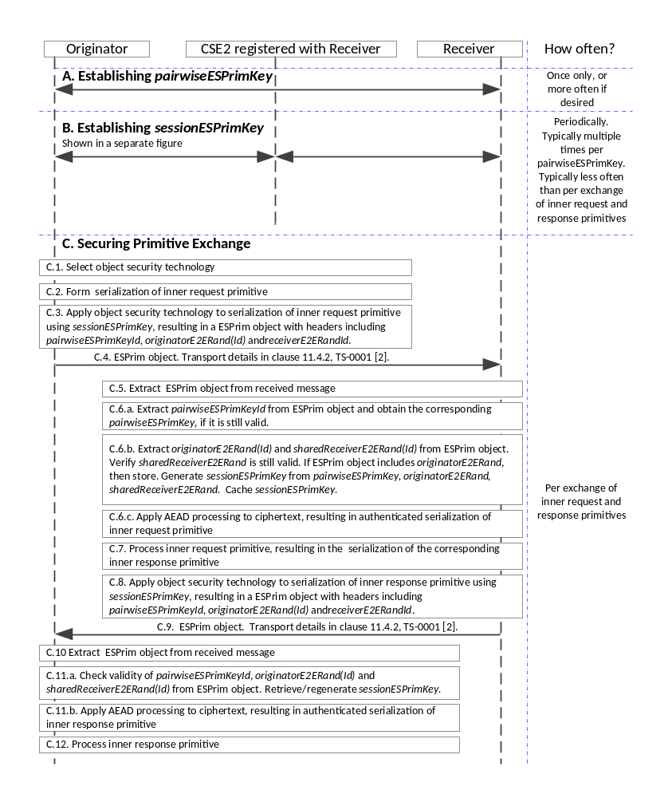
Figure 8.4.2-2: Message flow for securing a primitive exchange
in the End-to-End Security of Primitives (ESPrim) Procedure
C. Securing a Primitive Exchange:
NOTE 3: The Originator selects the type of serialization (e.g. JSON, XML) of the inner request primitive to be secured.
C.1 The Originator selects the object security technology depending on the object security technology supported by the Originator, and the type of serialization of the inner request primitive.

C.2 The Originator shall form the serialization of the inner request primitive.
C.3 The Originator shall produce a ESPrim Object by applying the object security technology as follows:
- One or more headers of the a ESPrim Object shall include the following information
- pairwiseESPrimKeyId
- originatorE2ERandObject used to generate the sessionESPrimKey, or the corresponding ESPrimRandID. If there is the possibility that this ESPrim Object could be the first ESPrim Object received by the Receiver which is secured by the Originator using a specific originatorE2ERandObject, then the full originatorE2ERandObject shall be included. Otherwise, one of originatorE2ERandObject or ESPrimRandID shall be included.
- ESPrimRandID of the receiverE2ERandObject used to generate the sessionESPrimKey.
- AEADAlgorithmId for the ESPrim Object. This shall be one of the AEAD algorithms identified in originatorE2ERandObject.
- The plaintext (to be encrypted) shall be the serialization of the inner request primitive.
- The sessionESPrimKey shall be used directly as the symmetric key providing authenticated encryption of the plaintext, resulting in the ciphertext in the ESPrim Object. The ciphertext is assumed to include the MIC for verifying integrity of the inner request primitive.
C.4 The Originator shall form an outer request primitive for transporting the ESPrim Object as described in in oneM2M TS-0001 [1]. The Originator shall send the outer request primitive to the Receiver.
C.5 The Receiver processes the received outer request primitive to extract the ESPrim Object as described in in oneM2M TS-0001 [1].
C.6 The Receiver shall process the ESPrim Object.

C.6a The Receiver shall extract the pairwiseESPrimKeyId from the ESPrim Object headers and obtain the corresponding pairwiseESPrimKey:
If the pairwiseESPrimKeyId is of the form for a Provisioned pairwiseESPrimKey, then the Receiver shall use the corresponding (previously-provisioned) pairwiseESPrimKey.
If the pairwiseESPrimKeyId is of the form for a MAF pairwiseESPrimKey: If this this is the first time that the Receiver received a message with this pairwiseESPrimKeyId, then the following process shall be performed.
C.6a.1 The Receiver shall identify the MAF from the pairwiseESPrimKeyId (which is a KcId)
C.6a.2 The Receiver shall establish a secure TLS connection to the MAF and request the M2M Secure Connection key (Kc) and Kc Lifetime corresponding to pairwiseESPrimKeyId (which is identical to KcId).
C.6a.3 The MAF shall provide Kc and Kc Lifetime to the Receiver.
C.6a.4 The Receiver shall generate the pairwiseESPrimKey from Kc and a reserved string.
C.6a.5 The Receiver shall set pairwiseESPrimKeyLifetime to Kc Lifetime.
C.6a.6 The Receiver shall cache (pairwiseESPrimKeyId, pairwiseESPrimKey, pairwiseESPrimKeyLifetime) for use for processing subsequent primitives.
If the Receiver has previously cached (pairwiseESPrimKeyId, pairwiseESPrimKey, pairwiseESPrimKeyLifetime), and pairwiseESPrimKeyLifetime has not yet expired, then the Receiver may use the cached pairwiseESPrimKey.
C.6b The Receiver shall apply the following process to generate the sessionESPrimKey:
C.6b.1 The Receiver shall extract ESPrimRandID of the receiverE2ERandObject from the headers of the ESPrim object, and attempt to retrieve the corresponding cached value of receiverE2ERandObject. If no cached value is found, or the cached value is expired, then the Receiver shall respond to the outer request primitive with an error.
C.6b.2 The Receiver shall extract the encoding of the originatorE2ERandObject or ESPrimRandID of the originatorE2ERandObject from the headers of the ESPrim object, and apply the appropriate decoding. If an originatorE2ERandObject is provided then it shall be cached. If an ESPrimRandID is provided then the Receiver shall retrieve the corresponding cached value of originatorE2ERandObject.If no cached value is found, or the cached value is considered expired, then the Receiver shall respond to the outer request primitive with an error message.
The Receiver shall process the originatorE2ERandObject:
C.6b.2.i The Receiver shall check the ESPrimExpiry in the originatorE2ERandObject to verify (a) that this Expiry is not already in the past and (b) the ESPrimExpiry is not later than the ESPrimExpiry in the receiverE2ERandObject.
C.6b.2.ii The Receiver shall extract sessionESPrimKeyGenerationAlgorithmId and verify that the identified algorithm matches one of the sessionESPrimKeyGenrationAlgorithmId in receiverE2ERandObject.
C.6b.2.iii The Receiver shall generate the sessionESPrimKey from the pairwiseESPrimKey, receiverE2ERandObject and originatorE2ERandObject or retrieve the value of sessionESPrimKey if previously generated and cached.
NOTE 4: The sessionESPrimKey used to secure an inner request primitive is always used to protect the corresponding inner response primitive, so sessionESPrimKey has to be cached at least until the corresponding inner response primitive is sent. The Receiver typically caches the sessionESPrimKey for a longer period of time since the originator can use the sessionESPrimKey for securing multiple primitive exchanges.

C.6c Authenticated decryption steps at the Receiver:
C.6c.1 The Receiver shall extract AEADAlgorithmIds in originatorE2ERandObject and verify that the identified set of algorithms is a subset of the set in AEADAlgorithmIds in receiverE2ERandObject.
The Receiver shall process the AEADAlgorithmId in the ESPrim Object headers and verify that the identified algorithm matches one of the AEADAlgorithmIds in originatorE2ERandObject.
C.6c.2 The Receiver shall apply the AEAD Algorithm identifier in the ESPrim Object header to the ciphertext parameter in the ESPrim Object resulting in verified plaintext, using the sessionESPrimKey. The ciphertext is assumed to include the MIC for verifying integrity of the inner request primitive. The authenticated serialization of the inner request primitive is the verified plaintext output by the AEAD algorithm.
C.7 The Receiver shall process the inner request primitive, resulting in a serialization of the corresponding inner response primitive.
NOTE 5: Steps C.2 to C.7 are mirrored closely by C.8 to C.12, with the Originator and Receiver swapping their participation in the exchange, and the request primitives replaced by response primitives. There are minor differences: in particular some of the request processing in Steps C is not required in the response processing since the Originator has already generated sessionESPrimKey; it is only necessary to identify the appropriate sessionESPrimKey, as performed in step C.11.a.
C.8 The Receiver shall use the same sessionESPrimKey as used in the ESPrim Object received at step C.5. Consequently, pairwiseESPrimKeyId, originatorE2ERandObject and receiverE2ERandObject are the same as for the received at step C.5.
The Receiver shall produce an ESPrim Object by applying the object security technology as follows:
- One or more headers of the a ESPrim Object shall include the following information:
- pairwiseESPrimKeyId
- originatorE2ERandObject’s ESPrimRandID .
- receiverE2ERandObject’s ESPrimRandID
- AEADAlgorithmId for the ESPrim Object. This shall be one of the AEAD algorithms identified in originatorE2ERandObject.
- The plaintext (to be encrypted) shall be the serialization of the inner response primitive.
- The sessionESPrimKey shall be used directly as the symmetric key providing authenticated encryption of the plaintext, resulting in the ciphertext in the ESPrim Object. The ciphertext is assumed to include the MIC for verifying integrity of the inner request primitive.
C.9 The Receiver shall form an outer request primitive for transporting the ESPrim Object as described in in oneM2M TS-0001 [1]. The Originator shall send the outer response primitive to the Receiver.
C.10 The Originator processes the received outer response primitive to extract the ESPrim Object as described in oneM2M TS-0001 [1].
C.11 The Originator shall process the ESPrim Object.

C.11a The Originator shall extract, from the headers of the ESPrim object, the values of pairwiseESPrimKeyId, originatorE2ERandObject’s ESPrimRandID, receiverE2ERandObject’s ESPrimRandID. These values shall match the pairwiseESPrimKeyId, originatorE2ERandObject’s ESPrimRandID, receiverE2ERandObject’s ESPrimRandID of a session that the Originator considers to be currently valid.
If any of these values have expired, then the outer response primitive shall be discarded.
NOTE 6: For this reason, the expiry of these values need to be great enough to allow receiving the corresponding inner response primitive.
Otherwise, the Originator shall use the cached value of sessionESPrimKey corresponding to these values, or may regenerate sessionESPrimKey.
C.11b The Originator shall apply the AEAD Algorithm identified in the ESPrim Object header to the ciphertext parameter in the ESPrim Object resulting in verified plaintext, using sessionESPrimKey, The ciphertext is assumed to include the MIC for verifying integrity of the inner request primitive. The authenticated serialization of the inner request primitive is the verified plaintext output by the AEAD algorithm.
C.12 The Originator shall process the inner response primitive.

8.4.3 End-to-End Security of Primitives (ESPrim) Protocol Details

8.4.3.1 End-to-End Security of Primitives (ESPrim) Parameter Definitions

8.4.3.1.1 originatorESPrimRandObject parameter definition
The structure of the originator2ERandObject parameter is shown in Table 8.4.3.1.1-1. This parameter is used in establishing sessionESPrimKey as part of End-to-End Security of Primitives (ESPrim), described in clause 8.4.2. The data type of the originatorESPrimRandObject parameter is specified in clause oneM2M TS-0004 [4].
Table 8.4.3.1.1-1: Structure of the originatorESPrimRandObject parameter
Element Path | Multiplicity | Description
esprimRandID | 1 | An identifier for the originatorESPrimRandObject, assigned by the CSE or AE generating the originatorESPrimRandObject
esprimRandValue | 1 | A 128-bit randomly-generated value.
esprimRandExpiry | 1 | Time when the originatorESPrimRandObject expires
esprimKeyGenAlgID | 1 | The enumerated identifier of the algorithm selected for sessionESPrimKey generation by the CSE or AE generating the originatorESPrimRandObject
esprimProtocolAndAlgIDs | 1 | A list of enumerated identifiers for AEAD Algorithms supported by the CSE or AE generating the originatorESPrimRandObject

8.4.3.1.2 receiverESPrimRandObject parameter definition
The structure of the receiver2ERandObject parameter is shown in Table 8.4.3.1.2-1. This parameter is used in establishing sessionESPrimKey as part of End-to-End Security of Primitives (ESPrim), described in clause 8.4.2. The data type of the receiverESPrimRandObject parameter is specified in oneM2M TS-0004 [4].
Table 8.4.3.1.2-1: Structure of the receiverESPrimRandObject parameter
Element Path | Multiplicity | Description
esprimRandID | 1 | An identifier for the receiverESPrimRandObject, assigned by the CSE or AE generating the receiverESPrimRandObject
esprimRandValue | 1 | A 128-bit randomly-generated value.
esprimRandExpiry | 1 | Time when the receiverESPrimRandObject expires.
esprimKeyGenAlgIDs | 1 | A list of enumerated identifiers for algorithms supported for sessionESPrimKey generation by the CSE or AE generating the receiverESPrimRandObject
esprimProtocolAndAlgIDs | 1 | A list of enumerated identifiers for AEAD Algorithms supported by the CSE or AE generating the receiverESPrimRandObject

8.4.3.1.3 e2eSecInfo resource attribute definition
The e2eSecInfo attribute occurs in the <CSEBase>, <remoteCSE> and <AE> resource types. The structure of the e2eSecInfo resource attribute is shown in Table 8.4.3.1.3-1. This parameter is used in establishing sessionESPrimKey as part of End-to-End Security of Primitives (ESPrim), described in clause 8.4.2. The data types are specified in TS-0004 [4].
Table 8.4.3.1.3-1: Structure of the e2eSecInfo attribute
Element Path | Multiplicity | Description
supportedE2ESecurityFeatures | 1 | A list of Security Usage Identifiers (SUIDs) for the End-to-End Security Features supported by the CSE or AE associated with the <CSEBase>, <remoteCSE> or <AE> resource containing the e2eSecInfo resource attribute.
e2ECertificates | 0..1 | A list of certificates associated with the CSE or AE associated with the <CSEBase>, <remoteCSE> or <AE> resource containing the e2eSecInfo resource attribute.
sharedReceiverE2ERandObject | 0..1 | A receiverE2ERandObject parameter (see clause 8.4.3.1.2) generated by the CSE or AE associated with the <CSEBase>, <remoteCSE> or <AE> resource containing the e2eSecInfo resource attribute.

8.4.3.2 ESPrim Object formatting and processing using the JWE Compact Serialization
Background: JSON Web Encryption (JWE) specified in RFC 7516 [50], provides a simple format for encrypting any data object. Two JWE serializations are provided: a compact, URI-safe serialization, and a JSON serialization.
The JWE End-to-End Security of Primitives (ESPrim) Compact Serialization necessary formatting and parsing can be easily encoded without generic tools for formatting or parsing JSON.
In the JWE Compact Serialization, a JWE is represented as the concatenation of five JWE parameters:
BASE64URL(UTF8(JWE Protected Header)) || ’.’ ||
BASE64URL(JWE Encrypted Key) || ’.’ ||
BASE64URL(JWE Initialization Vector) || ’.’ ||
BASE64URL(JWE Ciphertext) || ’.’ ||
BASE64URL(JWE Authentication Tag)
where BASE64URL(OCTETS) denotes the base64url encoding of OCTETS, per section 2 of the JSON Web Signature specification RFC 7515 [51].
NOTE: If OCTETS is an empty octet sequence, then RFC 7515 [51] defines BASE64URL(OCTETS) to be the empty string.
NOTE: The JWE Compact Serialization is not as flexible as the JWE JSON serialization, however the JWE compact serialization provides sufficient flexibility for ESPrim Objects. Moreover ease of formatting and parsing JWE Compact Serialization provides a simple solution for both XML and JSON representations of primitives
JWE Parameter definitions for ESPrim: Table 8.4.3.2-1, specifies these values of the five JWE parameters when the JWE Compact Serialization
Table 8.4.3.2-1: JWE Components used in ESPrim Objects
JWE value | element type | Empty | Component Content
JWE Protected Header | JSON | Never | See Table 8.4.3.2-2 JWE Protected Header Parameters
JWE Encryption Key | Binary value | Always | This value is empty for the key management mode used for ESPrim
JWE Initialization Vector | Binary value | Conditional | As per RFC 7516 [50]
JWE Ciphertext | Binary value | Never | As per RFC 7516 [50]
JWE Authentication Tag | Binary value | Conditional | As per RFC 7516 [50]
NOTE: whether these components are empty or not is conditional on the algorithm selected for encryption.

Table 8.4.3.2-2 “JWE Protected Header Parameters” describes the parameters in the JWE Protected Header when using JWE for ESPRrim.
Table 8.4.3.2-2: JWE Protected Header Parameters
Element path | Multiplicity for ESPrim | Purpose | Specification of element | Description of assigned value
“alg” | 1 | Key management mode | [50] | “dir” indicating Direct Encryption.
“enc” | 1 | Encryption Algorithm | [50] | The options available here are the same as for ESData use of JWE. See clause 8.7.3 “ESData Protocol Details”
“kid” | 1 | Key identifier | [50] | Identifier for pairwiseESPrimKey
“cty” | 0..1 | Media type of the secured Content | [50] | Dictated by the serialization of the primitive (XML or JSON) selected by the Originator.
“ori” | 1 | Identify originators input to session key generation | Clause 8.4.3.1.1 | esprimRandID of the originatorESPrimRandObject used to generate sessionESPrimKey for this ESPrim Object.
“rri” | 1 | Identify receiver’s input to session key generation | Clause 8.4.3.1.2 | esprimRandID of the receiverESPrimRandObject used to generate sessionESPrimKey for this ESPrim Object.
“oro” | 0..1 | originatorESPrimRandObject | Clause 8.4.3.1.1 using JSON serialization | JSON representation of an originatorESPrimRandObject generated by the Originator. Sent only by the Originator.
“rro” | 0..1 | receiverESPrimRandObject | Clause 8.4.3.1.2 using JSON serialization | JSON representation of an receiverESPrimRandObject generated by the Receiver. Sent only by the Receiver.

The following text provides further explanation of the parameters in the JWE Protected Header when using JWE for ESPRrim.
Recall that an ESPrim Object is formed by encrypting the inner primitive using the symmetric key sessionESPrimKey. The generation of sessionESPrimKey from a pairwiseESPrimKey, originatorESPrimRandObject and receiverESPrimRandObject is separate from the key management available through JWE – from the perpective of JWE, sessionESPrimKey is simply a secret symmetric key value shared between Originator and Receiver. JWE uses the Direct Encryption key management mode in this scenario. The JWE serialization will be required to transport the pairwiseESPrimKey identifier, the esprimRandIDs of the originatorESPrimRandObject identifier, and optionally a receiverESPrimRandObject or originatorESPrimRandObject so that the Originator and Receiver can generate the correct sessionESPrimKey.
- The “alg” (Algorithm) JWE header parameter [50] shall be set to the value of “dir” to indicate Direct Encryption key management mode.
- The “enc” (Encryption Algorithm) JWE header parameter [50] may be selected by the sender of the ESPrimObject. The encryption algorithm shall agrees with the esprimProtocolAndAlgIDs in identified originatorESPrimRandObject and the esprimProtocolAndAlgIDs in the identified receiverESPrimRandObject.
- The “kid” (Key ID) JWE header parameter [50] shall be set to the pairwiseESPrimKey identifier.
- The “cty” shall identify the media type of the representation (JSON or XML) of the inner primitive.
- The esprimRandIDs of the originatorESPrimRandObject and receiverESPrimRandObject shall be communicated in the “ori” (Originator Rand ID) and “rri” (Receiver Rand ID) parameters included in the JWE Protected header. These parameters are specific to oneM2M and shall conform to the definition of the esprimRandID in clauses 8.4.3.1.1 and 8.4.3.1.2.
- The originator may include a originatorESPrimRandObject in an “oro” (Originator Rand Object) parameter – either at the beginning of an ESPrim session or to refresh the session keys “in-band” during an existing ESPrim session. In the former case, “ori” shall match the esprimRandID in the originatorESPrimRandObject, but this restriction does not apply in the latter case. This parameter is defined in clauses 8.4.2 and 8.4.3.1.1, and the JSON representation shall be used.
- The receiver may include a receiverESPrimRandObject in an “rro” (Receiver Rand Object) – either at the to refresh the session keys “in-band” during an existing ESPrim session. This parameter is defined in clauses 8.4.2 and 8.4.3.1.2, and the JSON representation shall be used.
Forming an ESPrim Object: The inner primitive representation shall be encrypted as specified for message encryption in [50], with the following clarification
- The JWE Protected Header shall be composed as described above.
  - The Content Encryption Key (CEK) shall be the sessionESPrimKey generated using the pairwiseESPrimKey, originatorESPrimRandObject and receiverESPrimRandObject identified in the JWE Protected Header.
- The plaintext shall be the inner primitive representation.
- The JWE Initialization Vector, JWE Ciphertext and JWE Authentication Tag shall be generated from the Protected JWE Header, the plaintext and CEK as specified in RFC 7516 [50], according to the identified encryption algorithm
- The JWE Compact Serialization shall be composed from the JWE parameters.
The ESPrim Object is the JWE Compact Serialization.
Processing an ESPrim Object: The JWE Compact Serialization shall be processed as specified for message decryption in [50], with the following clarification
- The JWE Protected Header shall be composed as described above.
  - If originatorESPrimRandObject or receiverESPrimRandObject is included, then these shall be recorded.
  - The Content Encryption Key (CEK) shall be the sessionESPrimKey generated using the pairwiseESPrimKey, originatorESPrimRandObject and receiverESPrimRandObject identified in the JWE Protected Header. The generation of SessionESPrimKey is specified in clause 8.4.2.
- The plaintext shall be generated from the JWE Initialization Vector, JWE Ciphertext, JWE Authentication Tag and CEK as specified in RFC 7516 [50], according to the identified encryption algorithm.

8.5 End-to-End Security of Data (ESData)

8.5.1 Purpose of ESData
End-to-End Security of Data (ESData) provides an interoperable framework for protecting data that ends up transported using oneM2M reference points, in order that so transited CSEs do not need to be trusted with that data. The data to be protected is called the ESData Payload. ESData payload could typically compose all or part of an attribute value (e.g. content attribute value of a <contentInstance> resource) or a primitive parameter (e.g. a signed, self-contained access token communicated in a request primitive to obtain dynamic authorization).
NOTE: Within the scope of clause 8.5, terms including the word "ESData" can be shortened by removing "ESData" to facilitate readability. For example, "ESData Payload" is often shortened to "Payload".
Applicable use cases and requirements are discussed in oneM2M TR-0012 [i.16].
ESData assumes that there is a single ESData Source End-Point applying the ESData processing to the Payload to obtain an ESData Envelope containing the secured data and necessary headers, with one or more ESData Target End-Points applying the ESData processing to the Envelope to extract the verified data. The Payload is composed of plaintext (which is to be encrypted and integrity protected) and associated authenticated data (which is to be integrity protected only).
There is no inherent restriction on which entities can be Source End-points and Target End-Points; these end-points may be entities inside a oneM2M system (that is, AEs and CSEs) or entities outside of a oneM2M system (for example, entities which are part of a system that interworks with oneM2M).
The present document specifies credential management aspects and data protection aspects for ESData. The present document does not address transporting ESData Envelopes.

8.5.2 ESData Architecture

8.5.2.1 List of ESData Security Classes and ESData Protection Options
The following ESData security classes are provided:
- Encryption only: (see note) which offers confidentiality and integrity protection. This payload is protected using symmetric keys, and these symmetric keys are established using one or more of the following:
- Symmetric keys otherwise established with the target end-points. In this case, the source end-point can be authenticated - unless the symmetric key was shared with multiple target end-points.
- Target end-points certificate. When target end-point certificate are used, the target end-point cannot authenticate the source end-point.
NOTE: Strictly speaking, this class provides encryption and integrity protection, but this name aligns usage in protocols such as JSON Web Encryption (JWE) and XML-Encryption which can provide both encryption and integrity protection.
- Signature only: which offers source authentication, integrity protection and (when asymmetric digital signatures are used) non-repudiation. This uses either symmetric keys based MIC or asymmetric digital signatures verified using source end-point certificates.
- Nested Sign-then-Encrypt: This is used in cases where encryption is required in addition to source authentication and/or non-repudiation using a source end-point certificate. A digital signature(s) on the payload is signed first, and then encryptions is applied to combination of the payload and digital signature.
ESData supports using multiple credentials for protecting a single payload unit.
Each ESData Security class supports three ESData protection options, as shown in table 8.5.2.1-1.
Table 8.5.2.1-1: ESData protection options
ESData Security Class | ESData Protection Option | Key Management | Source Verification | Non-Repudiation
Encryption only (8.5.2.2) | Encryption using Provisioned Symmetric ESData Key | Provisioned Symmetric Key | Symmetric | -
Encryption only (8.5.2.2) | Encryption using TEF | TEF | Symmetric | -
Encryption only (8.5.2.2) | Encryption using Target End-Point Certificate | Certificate | - | -
Signature only  (8.5.2.3) | MIC using Provisioned Symmetric ESData Key | Provisioned Symmetric Key | Symmetric | -
Signature only  (8.5.2.3) | MIC using TEF | TEF | Symmetric | -
Signature only  (8.5.2.3) | Digital Signature using End-Point Source End-Point Certificate | Certificate | Certificate | Certificate
Nested-Sign-then Encrypt  (8.5.2.4) | Digital Signature using End-Point Source End-Point Certificate followed by any combination of Encryption-Only Protection Options | Provisioned Symmetric Key(s) and/or TEF(s) and/or Certificate(s) for Encryption. Certificate for Signature | Certificate | Certificate

8.5.2.2 Encryption-Only ESData Security Class

8.5.2.2.1 Encryption-Only ESData Security Class Overview
The ESData protection option supported for the Encryption-Only Security Class are listed in table 8.5.2.1-1 "ESData protection Options".
Encryption-Only ESData supports encrypting using any combination of Protection Options and using multiple credentials for each protection option.
ESData Encryption Mode. ESData Security Class supports two main encryption modes:
- ESData Direct Encryption Mode: In this mode, a symmetric key is used directly in the Encryption algorithm for securing the payload. The Direct Encryption mode is recommended only in scenarios meeting the following criterions:
- Scenarios in which minimizing overhead of data objects is a very high priority.
- The Encryption function will not be used with the same key value more than 2³² times, at least for AES GCM, for the reasons discussed in clause 8.4 of RFC 7518 [49].

This mode shall only be used when there is a single symmetric key being used to protect the payload.
- ESData Encrypted Key Mode: In this mode, the Content Encryption Key (CEK) (used in the Encryption algorithm for securing the payload) is encrypted using one or more credentials and the encrypted CEK is provided in a header with the secured data.
Encryption Mode Applicability Constraints. In scenarios where either:
- encryption using Provisioned Symmetric ESData Key is applied using a single provisioned symmetric key; or
- encryption using TEF is applied using a single TEF-registered symmetric key;
- then either Direct Encryption Mode or Encrypted Key Mode may be applied.
In all other scenarios, Encrypted Key Mode shall be applied.
High Level Sequence of Events. The following text describes the sequence of events when using an Encryption-Only Security Class.
NOTE: The present document does not describe the processes by which the Source End-Point and Target End-Point(s) decide on the credentials to be used for securing a payload, and the encryption algorithm to be applied.
A. Credential Configuration: The Source End-Point obtains the credentials needed to secure the payload for the intended Target End-Point(s). This can include any combination of the Protection Options, multiple credentials allowed for each Protection Options:
- Encryption using Provisioned Symmetric ESData Key: The Source End-Point and Target End-Point(s) are provisioned with Provisioned Symmetric ESData Key as described in clause 8.5.2.2.2 "Encryption using Provisioned Symmetric ESData Key".
- Encryption using TEF: The Source End-Point generates a random secret TEF-registered symmetric key, and registers this key with the TEF as described in clause 8.5.2.2.3 "Encryption using Trust Enabling Function".
- Encryption using Certificates: The Source End-Point obtains the certificate of the Target End-Point as described in clause 8.5.2.2.4 "Encryption using Target End-Point Certificate".
B. Source End-Point CEK Management:
- If Direct Encryption Mode is to be applied, then the Provisioned Symmetric ESData Key or Registered TEF Symmetric Key shall be used directly as CEK. The use of Direct Encryption Mode shall be indicated in the ESData Headers: header parameters of the ESData Envelope. The Provisioned Symmetric ESData Key or Registered TEF Symmetric Key shall be identified in the headers.
- Otherwise, the Source End-Point shall generates a random secret value for the Content Encryption Key CEK and shall encrypt CEK using the credential(s) obtained in Phase A "Credential Management", as described in clauses 8.5.2.2.2, 8.5.2.2.3 and 8.5.2.2.4. Each encrypted CEKs shall be added to the Headers, along with the identifier for the credential which is to be used to decrypt the encrypted CEK. The CEK value may be used for a single payload or may be used for multiple payloads.
C. Source End-Point Encryption:
C.1 The Encryption algorithm shall be identified in the Headers.
C.2 The Source End-Point shall apply the Encryption encryption process for the identified algorithm to the payload using CEK. The plaintext is encrypted to form the ciphertext, and the combination of plaintext and associated Authenticated Data (AAD) is integrity protected by the generated MIC.
C.3 The Source End-Point shall form the Envelope from the Headers, ciphertext, AAD and MIC; this process may include encoding data using, for example, base64.
The present document does not specify how the Envelope is obtained or provided to the Target End Point(s). The following steps are applied at each Target End-Point.
D. Target End-Point CEK Management:
D.1 The Target End-Point parses the Envelope, applying any necessary encoding, and extracts the Header parameters.
D.2 If Direct Encryption Mode is indicated in the Headers, then the Target End-Point shall use the credential identifiers in the Headers to obtain the identified Provisioned Symmetric ESData Key or Registered TEF Symmetric Key (as described in clause 8.2.2.2 or 8.5.2.2.3 respectively). The Target End-Point shall use this symmetric key directly as CEK.
D.3 Otherwise, the Target End-Point shall use the credential identifiers in the Headers to identify an encrypted CEK that can be decrypted by a credential known or available to the Target End-Point. The Target End-Point shall obtain that credential and decrypt the encrypted CEK as described in clauses 8.5.2.2.2 (Provisioned Symmetric ESData Key case), 8.5.2.2.3 (TEF case) and 8.5.2.2.4 (Target End-Point Certificate case). The Target shall use the resulting CEK for processing the secured payload of the Envelope. The Target End-Point may cache the CEK value due to the possibility of that CEK value being used to protect subsequent payloads.
E. Target End-Point Decryption:
E.1 The Target End-Point shall determine the appropriate Encryption algorithm identified in the Headers.
E.2 The Target End-Point shall apply the Encryption decryption process for the identified algorithm to the ciphertext, AAD and MIC using CEK, outputting the verified plaintext and verified AAD.

8.5.2.2.2 Encryption using Provisioned Symmetric ESData Key
For this Protection Option, the Source End-Point and each Target End-Point shall be provisioned with Provisioned Symmetric ESData Key, Provisioned Symmetric ESData Key Identifier and optionally Provisioned Symmetric ESData Key lifetime. This credential shall be provisioned via one of:
- pre-provisioning;
- a Remote Security Provisioning Frameworks (RSPF), specified in clause 8.3; or
- certificate based End-to-End Security Key Establishment between the Originator and Receiver, specified in clause 8.7 "End-to-End Key Establishment using Certificates".

8.5.2.2.3 Encryption using Trust Enabling Function
This is specified in Clause 8.6.

8.5.2.2.4 Encryption using Target End-Point Certificates
8.5.2.2.4.1 Associating Public Key Certificate with Target End-Points
For this Protection Option, each Target End-Point shall be provisioned with a public key certificate which the Source End-Point trusts to be associated with the intended Target End-Point. The following options are supported:
- The Target End-Point Certificates may use the following Public Key Certificate flavours identified in clause 8.1.2.1 "Public Key Certificate Frameworks":
- In the case of a Raw Public Key Certificate, the Source End-Point shall be securely configured (either directly or remotely) to associate the Target End-Point with the raw public key or its hash. The details of this configuration are not provided in the present specification.
- In the case of a Device Certificate:
- The Source End-Point shall be securely configured with the trust anchor in the certificate chain of the Device Certificate; typically during initial provisioning.
- The Source End-Point shall be securely configured to associate the Target End-Point with the globally unique hardware instance identifier. The details of this configuration are nor provided in the present specification.
- In the case of an AE-ID certificate or CSE-ID certificate, the Source-End-Point shall be securely configured with the trust anchor in the certificate chain of the AE-ID certificate or CSE-ID certificate; typically during initial provisioning. The Source End-Point then trusts that the Target End-Point with a particular AE-ID or CSE-ID is associated with the certificate that contains that AE-ID or CSE-ID.
- The Target End-Point Certificates may use other Public Key Infrastructures, particularly when the Target End-Point is in a non-oneM2M system interworking with the oneM2M system. The present document provides no interoperability guarantees when such certificates are used.
Public keys for verifying signature cannot be used for this Protection Option.
8.5.2.2.4.2 Obtaining Target End-Point Certificates
The Source End-Point is unable to secure a message to the Target End-Point before obtaining the Target End-Point's certificate. This specification does not mandate the mechanism by which the Target End-Point's certificate is provided to the Source End-Point using any mechanism, and there are a variety of mechanisms which are suitable. The e2ESecurityParameters is a mechanism provided by oneM2M to allow the Source End-Point to retrieve certificates associated with a CSE or AE.
A Target End-Point AE may make certificates available at the e2ESecurityParameters attribute of the <AE> resource representing that AE. This retrieval process is not a reliably-secure mechanism for associating the Target End-Point with the certificate; clause 8.5.2.2.4.1 "Associating Public Key Certificate with Target End-Points" shall also be applied.
A Target End-Point CSE may make certificates available at the e2ESecurityParameters attribute of the <CSE> and <remoteCSE> resources representing that CSE. This retrieval process is not a reliably-secure mechanism for associating the Target End-Point with the certificate; clause 8.5.2.2.4.1 "Associating Public Key Certificate with Target End-Points" shall also be applied.

8.5.2.3 Signature-Only ESData Security Class

8.5.2.3.1 Signature-Only ESData Security Class Overview
The ESData protection option supported for the Signature-Only ESData Security Class are listed in table 8.5.2.1-1 "ESData protection Options".
NOTE 1: The present specification supports only one Signature-Only ESData Protection Option, but the clause is structured to support additional Signature-Only ESData Protection Options if desired in the future.
Signature-Only ESData supports encrypting using any combination of Protection Options and using multiple credentials for each protection option.
High Level Sequence of Events. The following text describes the sequence of events when using a Signature-Only Security Class.
NOTE 2: The present document does not describe the processes by which the Source End-Point and Target End-Point(s) decide on the credentials to be used for signing a payload, and the algorithms to be applied.
A. Credential Configuration: The Source End-Point obtains the credentials needed to sign the payload for the intended Target End-Point(s). This can include any combination of the Protection Options, multiple credentials allowed for each Protection Options:
- MIC using Provisioned Symmetric ESData Key: The Source End-Point and Target End-Point(s) are provisioned with Provisioned Symmetric ESData Key as described in clause 8.5.2.2.2 "Encryption using Provisioned Symmetric ESData Key".
- MIC using TEF: The Source End-Point generates a random secret TEF-registered symmetric key, and registers this key with the TEF as described in clause 8.5.2.2.3 "Encryption using Trust Enabling Function".
- Digital Signature using Source End-Point Certificates: The Source End-Point selects a private key and corresponding Source End-Point Certificate as described in clause 8.5.2.3.2 "Digital Signature using Source End-Point Certificates".
B. Source End-Point Signing:
B.1 The Payload is encoded, for example, using base 64.
B.2 For each credential, the Source End-Point shall generate array of data elements as follows:
B.2.i The Source End-Point shall form a Header, identifying the digital signature or MIC algorithm, and the credential which can be used by a Target End-Point to verify the digital signature or MIC. If required, the header is also encoded, for example using base64.
B.2.ii The Source End-Point shall generate a signature/MAC by applying the appropriate digital signature or MIC algorithm to the Payload and Header using the appropriate credential, and encoding, for example using base 64.
B.2.iii The Source End-Point shall form a data element from the Headers, Payload and signature/MAC
B.3 The Source End-Point shall form Envelope from the encoded Payload and the array of data elements generated at step B.2.
The present document does not specify how the Envelope is obtained or provided to the Target End Point(s). The following steps are applied at each Target End-Point.
C. Target End-Point Verification:
C.1 The Target End-Point parses the Envelope, extracting the encoded Payload and the array of data elements, each containing a Header and a signature/MAC.
C.2 The Target End-Point shall examine the array of data elements to identify data elements which can be verified by a credential which may be trusted by the Target End-Point. For each such data element:
C.2.i The Target End-Point shall obtain the identified credential according to clauses 8.5.2.2.2 (Provisioned Symmetric ESData Key case), 8.5.2.2.3 (TEF case), 8.5.2.3.2 (using Source End-Point Certificate case).
C.2.ii The Target End-Point shall verify the MIC or signature in using the credential.
C.3 The Target End-Point shall decode the verified encoded Payload - outputting the original Payload - and shall record the credential(s) used to verify the Payload.

8.5.2.3.2 Digital Signature using Source End-Point Certificate
8.5.2.3.2.1 Associating Public Key Certificate with Source End-Point:
For this Protection Option, each Source End-Point shall be provisioned with a public key certificate which the Target End-Point trusts to be associated with the intended Source End-Point. The following options are supported:
- The Source End-Point Certificates may use the following Public Key Certificate flavours identified in clause 8.1.2.1 "Public Key Certificate Frameworks":
- In the case of a Raw Public Key Certificate, the Target End-Point shall be securely configured (either directly or remotely) to associate the Source End-Point with the raw public key or its hash. The details of this configuration are not provided in the present specification.
- In the case of a Device Certificate:
- The Target End-Point shall be securely configured with the trust anchor in the certificate chain of the Device Certificate; typically during initial provisioning.
- The Target End-Point shall be securely configured to associate the Source End-Point with the globally unique hardware instance identifier. The details of this configuration are not provided in the present specification.
- In the case of an AE-ID certificate or CSE-ID certificate, the Target-End-Point shall be securely configured with the trust anchor in the certificate chain of the AE-ID certificate or CSE-ID certificate; typically during initial provisioning. The Target End-Point then trusts that the Source End-Point with a particular AE-ID or CSE-ID is associated with the certificate that contains that AE-ID or CSE-ID.
- The Source End-Point Certificates may use other Public Key Infrastructures, particularly when the Source End-Point is in a non-oneM2M system interworking with the oneM2M system. The present document provides no interoperability guarantees when such certificates are used.
Public keys for verifying signatures shall be used for this Protection Option.
8.5.2.3.2.2 Obtaining Source End-Point Certificates
The Target End-Point is unable to secure a message to the Source End-Point before obtaining the Source End-Point's certificate. This specification does not mandate the mechanism by which the Source End-Point's certificate is provided to the Target End-Point using any mechanism, and there are a variety of mechanisms which are suitable. The e2ESecurityParameters is a mechanism provided by oneM2M to allow the Target End-Point to retrieve certificates associated with a CSE or AE.
A Source End-Point AE may make certificates available at the e2ESecurityParameters attribute of the <AE> resource representing that AE. This retrieval process is not a reliably-secure mechanism for associating the Source End-Point with the certificate; clause 8.5.2.3.2.1 "Associating Public Key Certificate with Source End-Points" shall also be applied.
A Source End-Point CSE may make certificates available at the e2ESecurityParameters attribute of the <CSE> and <remoteCSE> resources representing that CSE. This retrieval process is not a reliably-secure mechanism for associating the Source End-Point with the certificate; clause 8.5.2.3.2.1 "Associating Public Key Certificate with Source End-Points" shall also be applied.

8.5.2.4 Nested Sign-then-Encrypt
For these options, the following high-level steps are performs (Credential Configuration steps and CEK Management steps are not shown):
- The Source End-Point shall generate an inner Envelope containing one or more digital signatures for the inner Payload using one or more certificates according to the "Digital Signature using Source End-Point Certificate" Signature-Only Protection Option in clause 8.5.2.3.
- The Source End-Point shall set the inner Envelope produced by Step 1 to be the plaintext of the outer Payload which is then encrypted using any combination of Encryption-Only Protection Options in clause 8.5.2.2. This results in an outer Envelope.
The present document does not specify how the outer Envelope is obtained or provided to the Target End Point(s). The following steps are subsequently applied at each Target End-Point:
- The Target End-Point shall decrypt the outer Envelope produced by Step 1 using one of the Encryption-Only Protection Options in clause 8.5.2.2, resulting in the outer Payload which is also the inner Envelope.
- The Target End-Point shall verify one or more digital signatures in the inner Envelope using one or more certificates according to the "Digital Signature using Source End-Point Certificate" Signature-Only Protection Option in clause 8.5.2.3, resulting in the verified inner Payload.

8.5.3 End-to-End Security of Data (ESData) Protocol Details

8.5.3.1 Introduction
The End-to-End Security of Primitives (ESData) security classes support protocols shown in Table 8.5.3.1-1
Table 8.5.3.1-1: ESData Security Classes, and mapping to XML-based and JSON-Based security protocols
ESData Security Class | XML-Based | JOSE: JSON-Based Secueity
Encryption only | XML-ENC applied to ESData payload | JWE applied to ESData payload
Signature only | XML-SIG applied to ESData payload | JWS applied to ESData payload
Nested-Sign-then-Encrypt | XML-SIG applied to ESData payload, with XML-ENC applied to the result. | JWS applied to ESData payload, with JWE applied to the result.

The JOSE option allows a flexible JSON Serializations in addition to less flexible Compact Serializations (which are also URI safe). So there are three serialization options: XML, JWE/JWS using JSON Serialization and JWE/JWS using Compact Serializations.

8.5.3.2 Encryption-Only ESData Security Class Protocol Details
To maintain consistency, key management algorithms are provided which are available in both XML-ENC [55] and JSON Web Encryption (JWE) [50]:
- Direct Encryption.
- AES Key Wrap, using 128-bit, 256-bit keys.
- RSA-OAEP with MGF1 with SHA256.
- Elliptic Curve Diffie-Hellman (ECDH) Key Agreement in Ephemeral-Static Mode using AES-Key Wrap.
Table 8.5.3.2-1 identifies the key management algorithms that are supported in XML-Encryption for the Encryption-only ESData Security Class.
Table 8.5.3.2-1: Key management algorithms that are supported in XML-Encryption for Encryption-only ESData Security Class
Key Management | Algorithm |  | <xenc:EncryptionMethod Algorithm="..”> for encrypting the key | Other parameters
Direction Encryption | n/a |  | n/a | <ds:KeyInfo xmlns:ds="http://www.w3.org/2000/09/xmldsig#"> <ds:KeyName>John Smith</ds:KeyName>
Symmetric Key Wrap | AES Key Wrap, with | 128-bit key | http://www.w3.org/2001/04/xmlenc#kwaes128
Symmetric Key Wrap | AES Key Wrap, with | 192-bit key | http://www.w3.org/2001/04/xmlenc#kwaes192
Symmetric Key Wrap | AES Key Wrap, with | 256-bit key | http://www.w3.org/2001/04/xmlenc#kwaes256
RSA | RSA-OAEP with MFG1 and SHA-256 |  | http://www.w3.org/2009/xmlenc11#rsa-oaep | <xenc11:MGF Algorithm="http://www.w3.org/2009/xmlenc11#mgf1sha256>
ECDH Key Agreement | ECDH-ES with AES Key Wrap | 128-bit key | http://www.w3.org/2001/04/xmlenc#kwaes128 | <xenc:AgreementMethod Algorithm=”http://www.w3.org/2009/xmlenc11#ECDH‐ES”>
ECDH Key Agreement | ECDH-ES with AES Key Wrap | 192-bit key | http://www.w3.org/2001/04/xmlenc#kwaes192
ECDH Key Agreement | ECDH-ES with AES Key Wrap | 256-bit key | http://www.w3.org/2001/04/xmlenc#kwaes256

Table 8.5.3.2-2 identifies the payload encryption algorithms that are supported in XML-Encryption for the Encryption-only ESData Security Class.
Table 8.5.3.2-2: Payload encryption algorithms that are supported in XML-Encryption for Encryption-only ESData Security Class
Payload Encryption Algorithm |  | <EncryptionMethod Algorithm="..”>
AES GCM with | 128-bit key | http://www.w3.org/2009/xmlenc11#aes128gcm
AES GCM with | 192-bit key | http://www.w3.org/2009/xmlenc11#aes192gcm
AES GCM with | 256-bit key | http://www.w3.org/2009/xmlenc11#aes256gcm

The output generated by XML-Encryption is serialized as an XML object. The XML-Encryption object may be transported “plain” – with no encoding, or may be encoded in base64.
Table 8.5.3.2-3 identifies the key management algorithms that are supported in JWE for the Encryption-only ESData Security Class.
Table 8.5.3.2-3: Key management algorithms that are supported in JSON Web Encryption (JWE) for Encryption-only ESData Security Class
Key Management | Algorithm |  | “alg”:”..”
Direction Encryption | n/a |  | dir
Symmetric Key Wrap | AES Key Wrap, with | 128-bit key | A128KW
Symmetric Key Wrap | AES Key Wrap, with | 192-bit key | A192KW
Symmetric Key Wrap | AES Key Wrap, with | 256-bit key | A256KW
RSA | RSA-OAEP with MFG1 and SHA-256 |  | “alg”: “RSA-OAEP-256”
ECDH Key Agreement | ECDH-ES with AES Key Wrap | 128-bit key | ECDH-ES+A128KW
ECDH Key Agreement | ECDH-ES with AES Key Wrap | 192-bit key | ECDH-ES+A192KW
ECDH Key Agreement | ECDH-ES with AES Key Wrap | 256-bit key | ECDH-ES+A256KW

Table 8.5.3.2-4 identifies the payload algorithms that are supported in JWE for the Encryption-only ESData Security Class.
Table 8.5.3.2-4: Payload encryption algorithms that are supported in JSON Web Encryption (JWE) for Encryption-only ESData Security Class
Payload Encryption Algorithm |  | “enc”:"..”
AES GCM with | 128-bit key | A128GCM
AES GCM with | 192-bit key | A192GCM
AES GCM with | 256-bit key | A256GCM

The output generated by JWE conforms to either the JWE JSON Serialization or a URI-safe JWE Compact Serialization. The JWE JSON Serialization may be transported “plain” – with no encoding, or may be encoded in base64. TS-0004 [4] defines the datatype m2m:e2eCompactJWE for the JWE Compact Serialization.

8.5.3.3 Signature-Only ESData Security Class Protocol Details
To maintain consistency, signature types are provided which are available in both XML-Signature [52] and JSON Web Signature (JWS) [51].
- HMAC using SHA-256, SHA-384 or SHA-512
- RSA signature using PKCS1-v1.5 and MGF1with SHA-256, SHA-384 or SHA-512
- ECDSA signature using P-256, P-384 or P-512 with SHA-256, SHA-284 or SHA-512 respectively.
Table 8.5.3.3-1 identifies the algorithms that are supported in XML-SIG for Signature-only ESData Security Class.
Table 8.5.3.3-1: Algorithms that are supported in XML-Signature for Signature-only ESData Security Class
Signature Type | Algorithm |  | <SignatureMethod Algorithm="..”>
HMAC | SHA-256 |  | http://www.w3.org/2001/04/xmldsigmore#hmacsha256
HMAC | SHA-384 |  | http://www.w3.org/2001/04/xmldsigmore#hmacsha384
HMAC | SHA-512 |  | http://www.w3.org/2001/04/xmldsigmore#hmacsha512
RSA | RSA PKCS1-v1.5 and MGF1 with: | SHA-256 | http://www.w3.org/2001/04/xmldsigmore#rsasha256
RSA | RSA PKCS1-v1.5 and MGF1 with: | SHA-384 | http://www.w3.org/2001/04/xmldsigmore#rsasha384
RSA | RSA PKCS1-v1.5 and MGF1 with: | SHA-512 | http://www.w3.org/2001/04/xmldsigmore#rsasha512
ECDSA | P-256 and SHA-256 |  | http://www.w3.org/2001/04/xmldsigmore#ecdsasha256
ECDSA | P-384and SHA-384 |  | http://www.w3.org/2001/04/xmldsigmore#ecdsasha384
ECDSA | P-512 and SHA-512 |  | http://www.w3.org/2001/04/xmldsigmore#ecdsasha512

The XML-Signature object may be transported “plain” – with no encoding, or may be encoded in base64.
Table 8.5.3.3-2 identifies the algorithms that are supported in JWS for Signature-only ESData Security Class.
Table 8.5.3.3-2: Algorithms that are supported in JSON Web Signature (JWS) for Signature-only ESData Security Class
Signature Type | Algorithm |  | “alg”:"..”
HMAC | SHA-256 |  | HS256
HMAC | SHA-384 |  | HS384
HMAC | SHA-512 |  | HS512
RSA | RSA PKCS1-v1.5 and MGF1 with: | SHA-256 | RS256
RSA | RSA PKCS1-v1.5 and MGF1 with: | SHA-384 | RS384
RSA | RSA PKCS1-v1.5 and MGF1 with: | SHA-512 | RS512
ECDSA | P-256 and SHA-256 |  | ES256
ECDSA | P-384and SHA-384 |  | ES384
ECDSA | P-512 and SHA-512 |  | ES512
The output generated by JWS conforms to either the JWS JSON Serialization or a URI-safe JWS Compact Serialization. The JWS JSON Serialization may be transported “plain” – with no encoding, or may be encoded in base64. TS-0004 [4] defines the datatype m2m:e2eCompactJWS for the JWS Compact Serialization.

8.5.3.4 Nested-Sign-then-Encrypt ESData Security Class Protocol Details
The high level steps for the Nested-Sign-then-Encrypt ESData Security Class are described in clause 8.5.2.4. The inner Envelope shall be generated and processed according to one or more RSA or ECDSA signature types specified in clause 8.5.3.3. The inner Envelope shall be generated and processed according to one or more any combination of key management algorithms specified in clause 8.5.3.2.

8.6 Remote Security Frameworks for End-to-End Security

8.6.1 Overview on Remote Provisioning and Registration of Credentials for End-to-End Security

8.6.1.1 Introduction
The Remote Provisioning Framework for End-to-End Security shall involve the ability for an entity to register and provision end-to-end credentials by means of a Trust Enabler Function for end-to-end security. An M2M Enrolment Function, M2M Authentication Function or a MN-CSE that is equipped with the ability to register and provision end-to-end security credentials may act as a Trust Enabler Function for end-to-end security.
The End-to-End Security Credentials derived may be used for providing the following security protection mechanisms:
- Message (primitive) integrity and authenticity using a Message Integrity Code (MIC).
- Message (primitive) confidentiality.
- Integrity and authenticity of the data (attributes) using Data Integrity Tag (DIT).
- Confidentiality of data (attributes).
Security protected messages and data (attributes) may be enveloped using ESPrim and ESData respectively using mechanisms described in clause 8.4 "End-to-end security of primitives" and 8.5 "End-to-end security of data". Message authenticity/integrity and confidentiality are provided using ESPrim, while integrity and confidentiality of application Data (attributes) are provided by using ESData Objects.
End-to-End Security may be provided using:
- Leveraging Remote Security Provisioning process based on clause 8.3 and described in clause 8.6.2.
- Using Source-generated Credentials described in clause 8.6.3.

8.6.1.2 Overall Description of Registration and Remote Provisioning for End-to-End Security
This clause provides description of mechanisms that may be employed for generation, registration and provisioning of credential(s) that shall be used for end-to-end security. Based on security requirements or security profile associated with an Entity (e.g. AE) and indicated within the e2eSecInfo attribute described in clause 9.6.1.3.2 in oneM2M TS-0001 [1], appropriate end-to-end security credentials shall be generated. The remote provisioning mechanisms leverages the mechanisms described in clauses 8.3 on the Remote Security Provisioning Frameworks and extends the mechanism in order that end-to-end Security credentials may be registered and shall be provisioned for entities that are more than one-hop away from one another. Figure 8.6.1.1-1 provides a sequence of high-level steps that may be followed for remote registration and provisioning of end-to-end credentials.
The steps involved in end-to-end security protection involve:
- A Source ESP End-Point identifying the right set of security mechanisms and generating appropriate credentials.
- Registering the credentials with a Trust Enabler Function.
- The TEF provisions end-to-end credentials to a Target ESP End-Point.
- Processing of ESData/ESPrim using the end-to-end credentials.
When a Remote Security Provisioning process is used, then steps 1) and 2) shall be primarily performed by a TEF. In the case, where Source-generated end-to-end security credentials are used, then steps 1) and 2) shall be performed by the Source ESF End-Point.
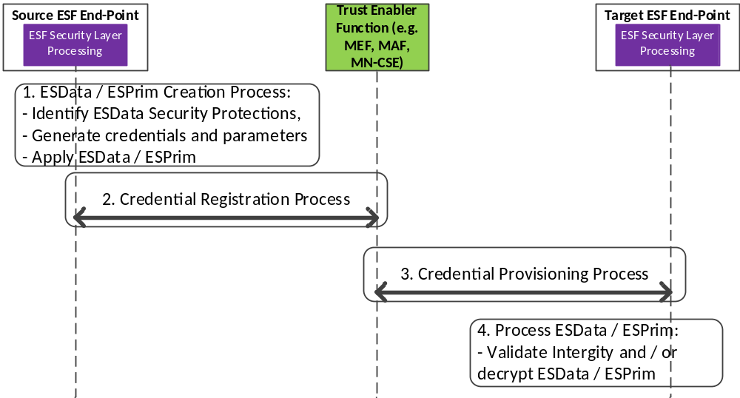
Figure 8.6.1.2-1: provides a high-level summary of Credential Registration and Provisioning Process
The end-to-end credential registration and provisioning process for providing ESData/ESPrim involves the following steps:
- Creation of ESData/ESPrim by the Source ESF End-Point Process involves:
a) Identification of security protectioning mechanisms based on the security requirements associated with the application data.
b) Based upon the security requirements, appropriate security credentials and associated parameters are generated.
c) The application data is then protected using the security credential(s) and associated parameters in order to generate the ESData/ESPrim.
NOTE 1: In the case of Remote Security Provisioning process, this steps a) and b) are performed by a Trust Enabler Function. Whereas in the case of Source-generated, the above described steps are followed by the Source.
- Credential Registration Process:
a) The Source ESF End-Point registers the credential(s) and associated parameters with a Trust Enabler Function.
b) The Source ESP End-Point shall provide the identity of the Target ESF End-Point(s) that is authorized to be provisioned with the end-to-end credentials and associated parameters.
NOTE 2: In the case of Remote Security Provisioning process, the Credential Registration process is performed by a Trust Enabler Function. Whereas in the case of Source-generated, the above described steps are followed by the Source.
- Credential Provisioning/Requisition Process:
a) A Target ESF End-Point may request ESData/ESPrim credentials by using a Credential-Id that was obtained as part of the ESData/ESPrim.
b) Based on the authorization information provided as part of the Credential Registration Process and using the Credential-Id, the Trust Enabler Function provisions the appropriate credentials and associated cryptographic parameters to the authenticated and authorized Target ESF End-Point.
- Process the ESData/ESPrim:
a) The Target ESF End-Point uses the credentials provisioned by the Trust Enabler Function in order to process the ESData/ESPrim.
b) Processing of ESData/ESPrim would involve the integrity verification/authentication of the application data and/or decryption of the data and messages respectively.

8.6.2 Remote Security Provisioning Process for End-to-End Security Credentials
This clause describes the Remote Provisioning of Symmetric End-to-End Security credentials. The end-to-end security credentials shall be generated after having completed the Remote Provisioning of symmetric credentials using the Provisioned Symmetric Key or the MAF-based Symmetric Key Security Association Establishment Processes as described in clause 8.3.
Based on the higher-level requirements, appropriate end-to-end credentials may be generated using Remote Security Provisioning process by using pre-provisioned credentials. Illustrated in figure 8.6.2-1 is a high-level key generation process.
As part of the "End-to-End Key Generation" mechanism, the enrolee and the enrolment target generate end-to-end credentials using the Kpsa as the master key in order to generate the end-to-end master key. If the Enrolee is an AE (Source ESF End-Point), and the Enrolment Target is a CSE (Target ESF End-Point), then an end-to-end master credential, Ke2e_master is generated. An Example of end-to-end key generation using IETF RFC 5869 [48] is provided below.
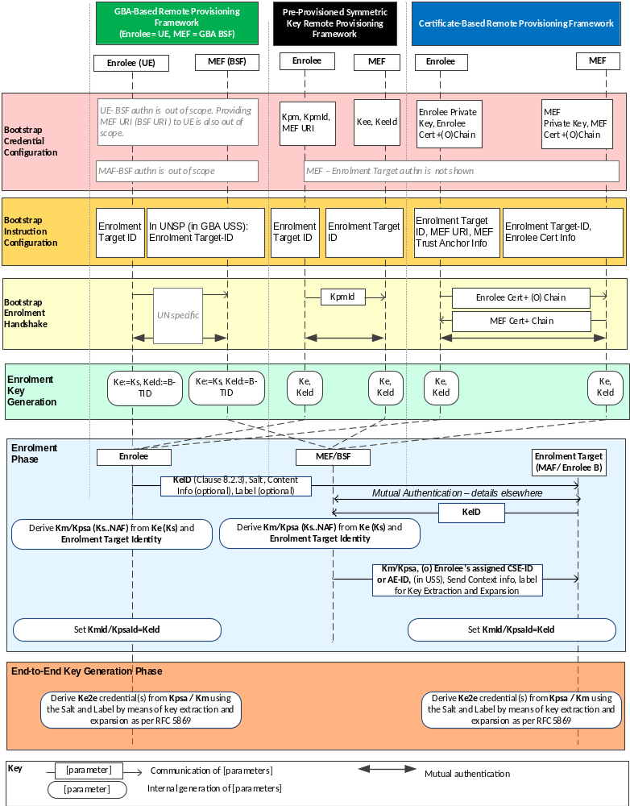
Figure 8.6.2-1: High-level summary of the E2E Remote Security Provisioning Frameworks
Bootstrap Credential Configuration: The Bootstrap Credential Configuration may be based upon the type of Remote Provisioning Framework that is used. When using Symmetric Key Remote Provisioning, the Enrolee, which could be the Source ESF End-Point and the Enrolment targets (Target ESF End-Point) are each pre-provisioned with the Symmetric Enrolee Key (Kpm) and the corresponding Pre-provisioned Symmetric Key Identifier, denoted KpmId. In addition the Source ESF End-Point is provisioned with the Trust Enabler Function address (TEF URI). The mechanism follows the procedures as described in clause 8.3.2.1.
Bootstrap Instruction Configuration: The Source ESF End-Point (Enrolee) and the Trust Enabler Function are configured with the information needed for authorizing the remote provisioning:
- The Source ESF End-Point (Enrolee) is configured with the following arguments to initiate remote provisioning:
a) The Target ESF End-Point's security profile: The Target ESF End-Point's security profile and the associated security capabilities as described in e2eSecInfo attribute may be used to identify the types of security protection mechanisms that shall be used for end-to-end security.
b) The Target ESF End-Point identity: Identifying the Target ESF End-Point for which the Source ESF End-Point is to provision end-to-end security credentials.
c) The Target ESF End-Point's security profile: The Target ESF End-Point's security profile and the associated security capabilities as described in e2eSecInfo attribute can be used to identify the types of security protection mechanisms that shall be used for end-to-end security.
d) The Source ESF End-Point associates these arguments with the Trust Enabler Function (TEF). The Trust Enabler Function can be identified to the Source ESF End-Point using the Pre-Provisioned Symmetric Enrolee Key Identifier (KpmId) and Trust Enabler Function URI.
- M2M Enrolment or Trust Enabler Function is configured with the following arguments to authorize the M2M Enrolment or Trust Enabler Function to remotely provision the Source ESF End-Point for a Target ESF End-Point:
a) The Target ESF End-Point Identity: Identifying the Target ESF End-Point for which the Source ESF End-Point is to be provisioned.
b) Source ESF End-Point's assigned CSE-ID or AE-ID (Source ESF End-Point-ID). The Trust Enabler Function is to provide this entity identity for the Source ESF End-Point with the Km or Kpsa to the Target ESF End-Point, when requested by the Target ESF End-Point.
c) Source ESF End-Point's Security Profile: The security profile of the Source ESF End-Point provides the expected security level described within the e2eSecInfo attribute (see clause 9.6.3 of oneM2M TS-0001 [1]) associated with the Source ESF End-Point.
d) Target ESF End-Point's Security Profile: The security profile of the Target ESF End-Point provides the expected security level described within the e2eSecInfo attribute associated with the Target ESF End-Point.
e) The Trust Enabler Function shall provide detailed key extraction and expansion parameters that are to be used when deriving the end-to-end credentials from the Km or Kpsa to the Source ESF End-Point and the Target ESF End-Point.
f) The Trust Enabler Function shall provide the scope and associated security parameters to the Source ESF End-Point and Target ESF End-Point that determines the protocols and the cryptographic algorithms that shall be used for performing end-to-end security.
- Bootstrap Security Handshake: The Source ESF End-Point and Trust Enabler Function shall perform a (D)TLS-PSK handshake [15] to establish a secure session. The mechanisms follow the process detailed in clause 8.3.2.
- End-to-End Key Generation:
a) The Enrolment Key (Ke) and RelativeKeId is generated from the (D)TLS session secrets by the Source ESF End-Point and Trust Enabler Function using TLS Key Export (IETF RFC 5705 [18]), as described in clause 10.3.1 "TLS Key Export Details". Similarly, the Enrolment Key Identifier (KeId) is generated from the RelativeKeId and the Trust Enabler Function's FQDN by the Source ESF End-Point and Trust Enabler Function, as described in clause 10.3.4 "Generating KeId". The Source ESF End-Point and the Trust Enabler Function stors the Ke and the associated KeId.
b) The end-to-end master key (Ke2e_master) and the E2EKeyId are generated in a similar manner as the Kpsa and the associated KpsaId. If the Source ESF End-Point requests the provisioning of end-to-end keys, then a key extraction based on Kpsa/Km shall be performed.
c) The End-to-End master Key (Ke2e_master) is used to generate specific security protection keys, such as, end-to-end authentication key, end-to-end confidentiality key and other keys depending upon the key extraction and expansion parameters that were provided. The key extraction and expansion are based upon IETF RFC 5869 [48].
NOTE: The End-to-End Key Generation for the Pre-Provisioned Symmetric Enrolee Key Remote Security Provisioning Framework is identical to the End-to-End Key Generation for the Certificate-Based Remote Security Provisioning Framework.

8.6.3 Detailed Description on Source-Generated End-to-End Credentials
This clause describes the Generation and Registration of Symmetric End-to-End Security credentials by a Source ESF End-Point. The end-to-end security credentials that were self-generated by a Source shall be registered with the Trust Enabling Function. Such a mechanism is particularly useful when data (attribute) as well messages targeted for more than one Target are required. In cases, where securing of <contentInstances> resource that is consumed by multiple end entities is required, then Source-Generated credentials shall be used.
A Source that generates data consumed by one or more end entities may generate the appropriate credentials so that either a single attribute (e.g. content attribute value of a <contentInstance> resource or customAttribute of a <flexContainer> resource) or a single addressable element within the attribute may be protected for integrity and confidentiality by means of ESData/ESPrim. In the case of dynamic authorization, all or part of a single primitive parameter value (e.g. a signed, self-contained access token communicated in a request primitive to obtain dynamic authorization) may also be protected using ESData/ESPrim. The entity that generated the ESData/ESPrim then registers the credentials with a Trust Enabler Function.
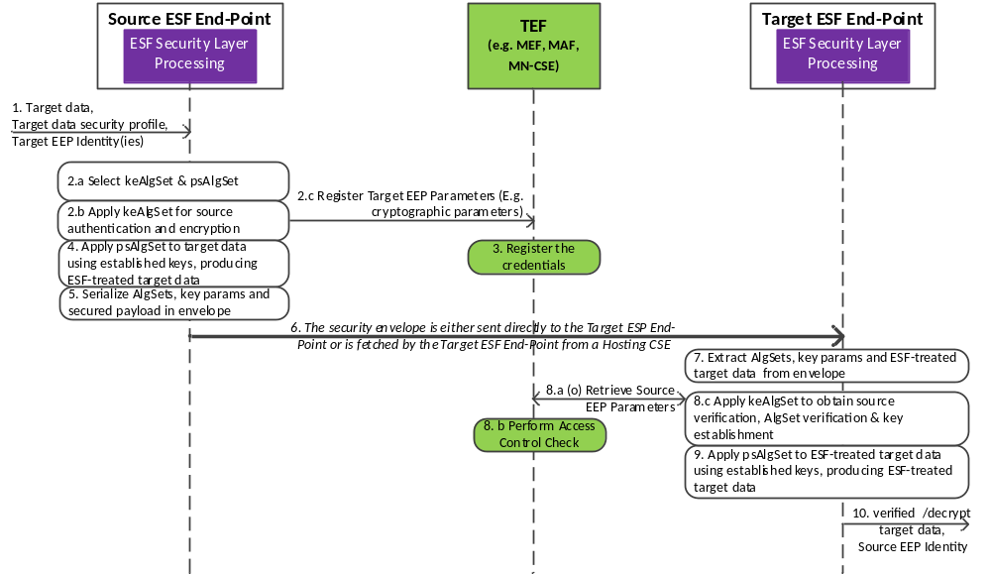
Figure 8.6.3-1
Bootstrap Credential Configuration: It is assumed that the Source ESF End-Point is provisioned with a symmetric key and associated identifier generated as part of the Remote Provisioning Framework with a Trust Enabler Function as described in clause 8.2 or 8.3.. The Target ESF End-Point may be provisioned with the Ke/KeId if the Trust Enabler Function is an M2M Enrolment Function, or with the Km/KmId if the security association was established with an M2M Authentication Function.
Bootstrap Instruction Configuration: The Source ESF End-Point as well as the Target ESF End-Points are provisioned with those Trust Enabler Function's URI that support end-to-end security credential provisioning and registration.
- The Source ESF End-Point is configured with the following arguments to initiate remote provisioning:
a) The identity of the Target ESF End-Point that has to be provided with the ESData/ESPrim and associated End-to-End security credentials.
b) The security requirement associated with the Data (attributes): This is pre-configured and provided by the application. Based on the security protection mechanisms, appropriate security technologies shall be used for protection.
c) Pre-configured with a table listing the security requirement and how that security requirement can be achieved using the appropriate security protection mechanisms (e.g. security protocols, algorithms for integrity, confidentiality, key generation).
d) The Target ESF End-Point Security Profile (optional): The Target ESF End-Point's security profile and the associated security capabilities of the Target ESF End-Point as described in the e2eSecInfo attribute can be used to identify the types of security protection mechanisms that shall be used for providing ESData/ESPrim.
- The Trust Enabler Function is configured with the following arguments to register the ESData/ESPrim security credentials from the Source ESF End-Point and to authorize the Trust Enabler Function to provision only a set of authorized Target ESF End-Point(s) with the relevant ESData/ESPrim security cryptographic parameters:
a) Cryptographic Parameters: A list of end-to-end cryptographic parameters that is identified by a Credential-Id and having associated cryptographic values such as the credential(s), cryptographic algorithm(s), label(s) and random value(s) (e.g. nonce, IV). These parameters are provided by the Source ESF End-Point during the credential registration process. There may be one or more credentials that are associated with one or more security protection mechanisms (e.g. data integrity, data confidentiality). The list may also include scope and usage of the end-to-end security parameters so that the Target ESF End-Point is able to process ESData/ESPrim (e.g. verify the integrity and/or decrypt the ESData/ESPrim).
b) Identity of Target ESF End-Point: Identity of the Target ESF End-Points that shall be provisioned with the requested credentials identified by a Credential-Id. The authorization may be provided and enforced by means of ACPs.
- The Target ESF End-Point is configured with the following arguments:
a) ESData/ESPrim: The Target ESF End-Point is either sent the ESData/ESPrim directly from a Source ESF End-Point, or the Target ESF End-Point fetches the ESData/ESPrim from a hosting entity (e.g. Hosting CSE).
b) Credential-Id: The Target ESF End-Point is provisioned with the Credential-Id, which may be included as part of the ESData/ESPrim.
c) Cryptographic Parameters: The Cryptographic Parameters are provisioned by the Trust Enabler Function after the Trust Enabler Function verifies the access control policies associated with the request from the Source ESF End-Point.
- Security Handshake:
a) The Source ESF End-Point and the Trust Enabler Function perform a (D)TLS handshake [15] to establish a secure session. The mechanisms follow the process detailed in clause 8.3.2. All communications between the Source ESF End-Point and the Trust Enabler Function are secured by means of the established (D)TLS connection.
b) The Target ESF End-Point and the Trust Enabler Function performs a (D)TLS handshake [15] to establish a secure session. The mechanisms follow the process detailed in clause 8.3.2. All communications between the Source ESF End-Point and the Trust Enabler Function are secured by means of the established (D)TLS connection.
- End-to-End Key Generation:
a) The Source ESF End-Point generates credentials that may be based upon:
- Credentials that have been generated using the Enrolment Key, Ke/KeID that has been generated using the Bootstrapped Remote Credential Provisioning Process.
- Credentials generated in a random manner by the Source ESF End-Point and registered with the Trust Enabler Function.

8.7 End-to-End Certificate-based Key Establishment (ESCertKE)

8.7.1 Purpose of ESCertKE
End-to-End Certificate-based Key Establishment (ESCertKE) provides an interoperable framework for two end-points to use certificates for establishing a secret symmetric key called pairwiseE2EKey from which symmetric keys are derived for use in other end-to-end security frameworks such as End-to-End Security of Data (ESData) or End-to-End Security of Primitives (ESPrim).
Applicable use cases and requirements are discussed in oneM2M TR-0012 [i.16].
The present document specifies the ESCertKE messages and associated processing for ESCertKE. The transport of ESCertKE messages is specified in oneM2M TS-0001 [1].

8.7.2 ESCertKE Architecture

8.7.2.1 ESCertKE Reference Model
The entities in the ESCertKE reference model are the ESCertKE Initiating End-Point which initiates the procedure and the single ESCertKE Terminating End-Point with which the ESCertKE Initiating End-Point intends to establish a pairwiseE2EKey.
NOTE: Within the scope of clause 8.7, terms including the word "ESCertKE" can be shortened by removing "ESCertKE" to facilitate readability. For example, "ESCertKE Initiating End-Point" is often shortened to "Initiating End-Point".
The ESCertKE Procedure consists of the Initiating End-Point and Terminating End-Point exchanging a sequence of ESCertKE Messages and apply processing based on those ESCertKE Messages. If the ESCertKE Procedure is successful, then the Initiating End-Point and Terminating End-Point export a pairwiseE2EKey based on the parameters exchanged in the ESCertKE Messages.
There is no inherent restriction on which entities may be an Initiating End-point; these end-points may be entities inside a oneM2M system (that is, AEs and CSEs) or entities outside of a oneM2M system (for example, entities which are part of a system that interworks with oneM2M).
The only restriction on entities which may be Terminating End-Points is that the Terminating End-Point shall be able to receive the unsolicited ESCertKE Message initiating the ESCertKE Procedure. Since oneM2M TS-0001 [1] specifies the transport of ESCertKE messages, TS-0001 also specifies which entities may be Terminating End-Points.

8.7.2.2 ESCertKE Procedure Message Flow
The ESCertKE Messages shall be transported as specified in oneM2M TS-0001 [1]; for example, the <e2EKeyCSE> resource may be used.
The ESCertKE Messages shall contain the TLS v1.2 [5] messages defined in table 8.7.2.2-1 "ESCertKE Message definitions".
The ESCertKE Procedure message flow is shown in figure 8.7.2.2-1, and described in the following text.
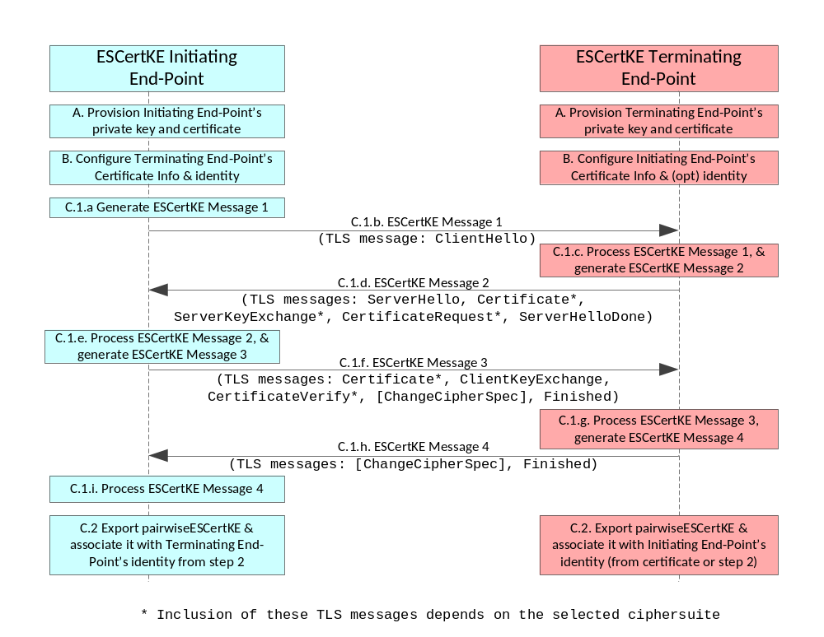
Figure 8.7.2.2-1: ESCertKE Procedure message flow
A. Provisioning Certificates: The ESCertKE endpoints shall be provisioned with private key and certificates described in clause 8.1.2.3 "Credential Configuration for Certificate-Based Security Frameworks". The certificates of the Initiating End-Point and terminating End-Points shall conform to clause 10.1 "Certificate-Based Security Framework Details".
B. Triggering: The Initiating End-Point and Terminating End-Point shall be configured with the information needed for the authentication and identification of the Terminating End-Point and Initiating End-Point respectively:
The Initiating End-Point is commanded to initiate the ESCertKE Procedure, and the command shall include the following arguments:
- The Terminating End-Point's certificate information: as described in clause 8.1.2.4 "Information Needed for Certificate Authentication of another Entity".
- The Terminating End-Point's identity. This identity is used for:
- determining where ESCertKE Message 1 is sent; and
- associating with the established pairwiseE2EKey.
The Terminating End-Point shall be configured with the following arguments describing Initiating Entity authorized to perform the ESCertKE Procedure:
- The Initiating End-Point's certificate information: as described in clause 8.1.2.4 "Information Needed for Certificate Authentication of another Entity":
- In the case where the Initiating End-Point's certificate is a raw public key certificate, the Terminating End-Point shall also be configured with an identity to associate with the established pairwiseE2EKey.
The End-Points may be configured in any order.

C. Establishing pairwiseESCertKE:
C.1 The Initiating End-Point and Terminating End-Point exchange the sequence of four ESCertKE Messages. The ESCertKE Messages shall be generated and processed according to the handshake protocol of TLS v1.2 [5]. The TLS ciphersuites used for the ESCertKE Procedure shall conform to clause 10.2.3 "TLS and DTLS Ciphersuites for Certificate-Based Security Frameworks":
C.1.a The Initiating End-Point shall generate ESCertKE Message 1.
C.1.b The Initiating End-Point shall send ESCertKE Message 1 to the Terminating End-Point identified in step 2.
C.1.c The Terminating End-Point shall process ESCertKE Message 1, and generate ESCertKE Message 2.
C.1.d The Terminating End-Point shall send ESCertKE Message 2 to the Initiating End-Point.
C.1.e The Initiating End-Point shall process ESCertKE Message 2, and generate ESCertKE Message 3.
C.1.f The Initiating End-Point shall send ESCertKE Message 3 to the Terminating End-Point.
C.1.g The Terminating End-Point shall process ESCertKE Message 3, and generate ESCertKE Message 4.
C.1.h The Terminating End-Point shall send ESCertKE Message 4 to the Initiating End-Point.
C.1.i The Initiating End-Point shall process ESCertKE Message 4.
C.2 If the TLS handshake protocol is successful, then the Initiating and Terminating End-Points shall export and cache the pairwiseE2EKey using TLS Exporter specification (IETF RFC 5705 [18]) as described in clause 10.3.1 "TLS Key Export Details".
Table 8.7.2.2-1: ESCertKE Message definitions
ESCertKE Message | Sending End-Point | Possible TLS v1.2 Messages (success case) [5] | Informative Description (normative description is in TLS v1.2 specification [5])
1 | Initiating | ClientHello | List of allowed ciphersuites, random value, indicator to export pairwiseE2EKey.
2 | Terminating | ServerHello | Selected ciphersuite, random value, indicator to export pairwiseE2EKey.
2 | Terminating | Certificate* | Terminating End-Point's certificate (and optionally certificate chain).
2 | Terminating | ServerKeyExchange* | Key exchange parameters generated by the Terminating End-Point. The content of this parameter is dependent on selected ciphersuite.
2 | Terminating | CertificateRequest* | Instructs the Initiating End-Point to authenticate itself with a certificate.
2 | Terminating | ServerHelloDone | Indicates the end of the message.
3 | Initiating | Certificate* | Initiating End-Point's certificate (and optionally certificate chain).
3 | Initiating | ClientKeyExchange* | Key exchange parameters generated by the Initiating End-Point. The content of this parameter is dependent on selected ciphersuite.
3 | Initiating | CertificateVerify | Provides explicit verification of a Initiating End-Point's certificate.
3 | Initiating | [ChangeCipherSpec] | Notifies the Receiving End-Point that subsequent records will be protected under the newly negotiated CipherSpec and keys.
3 | Initiating | Finished | MIC on all preceding parameters exchanged in the procedure. The MIC is generated using session secrets established using the preceding parameters.
4 | Terminating | [ChangeCipherSpec] | See above.
4 | Terminating | Finished | MIC on all preceding parameters exchanged in the procedure. The MIC is generated using session secrets.
NOTE: The inclusion of the TLS messages marked with "*" is dependent on the chosen ciphersuite.

8.8 MAF Security Framework Details

8.8.1 Introduction to the MAF Security Framework Details
Clause 8.8 describes the common details and procedures used in the MAF-based Security Frameworks; in the present specification these frameworks include:
- The MAF-Based Security Association Establishment Framework (SAEF).
- The MAF-Based End-to-End Security of Primitives (ESPrim) Framework.
- The MAF-based End-to-End Security of Data (ESData) Framework.
These frameworks use a MAF to provide authentication and distribution of symmetric key for use by a Source End-Point initiating establishing the symmetric key, and one or more Target End-Points. Table 8.8.1-1 “Mapping of Generic MAF Framework Roles to specific MAF-Based Framework Roles” describes the mapping of Source End-Point and Target End-Point to roles in the specific MAF-Based Frameworks, and the allowed number of Target End-Points.
Table 8.8.1-1: Mapping of Generic MAF Security Framework Roles to specific MAF Security Framework Roles
MAF-Based Security Framework | Source End-Point | Target End-Point | Number of Target End-Points
Security Association Establishment Framework (SAEF) | Entity A | Entity B | 1
End-to-End Security of Primitives (ESPrim) | Originator | Receiver | 1
End-to-End Security of Data (ESData) | Source ESData End-Point | Target ESData End-Point | Any

The generic MAF security framework details specified in clause 8.8 are:
- MAF Credential Configuration (clause 8.8.2): describing the credentials and associated information provisioned to an End-Point and the MAF to enable the End-Point to use the services of the MAF.
- MAF KmId Retrieval Procedure (clause 8.8.3): If a CSE or AE is remotely provisioned with a symmetric key for use with the MAF, then this procedure is used to trigger the MAF to retrieve Km from the MEF. The MAF then provides the End-Point with the KmId to be used for subsequently authentication with the MAF.
- MAF Handshake Procedure (clause 8.8.4): establishing a mutually-authenticated TLS or DTLS session between an End-Point and a MAF.
- MAF Key Registration Procedure (clause 8.8.5): The Source End-Point and MAF perform the MAF Handshake procedure. The Source End-Point may provide a list of possible Target End-Point(s) to the MAF. The MAF and Source End-Point establish a symmetric key and symmetric key identifier, and negotiate information about the credential, which can include:
  - Security Usage Identifier (SUID) for the security feature which is authorized to be secured use this credential. That is, the SUID limits the scope within which the credential may be used.
  - Identity(ies) of the Target End-Point(s) which will be provided with this credential,
  - Lifetime of the credential.
- MAF Key Retrieval Procedure (clause 8.8.6): The Target End-Point and MAF perform the MAF Handshake procedure. The Target End-Point provides the symmetric key identifier and SUID to the MAF. The MAF provides:
  - The symmetric key
  - Identity of the Source End-Point, or an identifier for the credential that the Source End-Point used for mutual authentication with the MAF during the MAF Key Registration procedure..
  - Lifetime of the credential.
The general sequence for using these procedures is shown in Figure 8.8.1-1 and described as follows:
- Each of the Source End-Point and Target End-Point(s) shall separately establish credentials for mutual authentication with the MAF, and shall be configured with the URIs for the MAF Key Registration Procedure and MAF Key Retrieval Procedure. If a symmetric key is remotely provisioned for mutual authentication with the MAF, then the Source End-Point shall also be provided with the MAF KmId Retrieval URI.
- If the Source End-Point is remotely provisioned for mutual authentication with the MAF, then the Source End-Point shall perform the MAF KmId procedure to trigger the MAF to retrieve the Source End-Point’s Master Credential from the MEF. The MAF shall then provide the Source End-Point with the KmId to be used for subsequent authentication with the MAF.
The same procedures shall be performed by a Target End-Point which is remotely provisioned for mutual authentication with the MAF.
- The Source End-Point shall perform the MAF Key Registration procedure to establish a symmetric key and corresponding identifier. The Source End-Point also provides the Security Usage Identifier (SUID) limiting the scope of the credential by identifying the security feature (SAEF, ESPrim, ESData). This procedure includes the MAF Handshake procedure for mutual authentication of the Source End-Point and MAF.
- The Source End-Point shall provide, to the Target End-Point(s), the symmetric key identifier established in the MAF Key Registration procedure. The details of this step depend on the security feature as identified by the SUID.
- The Target End-Point shall perform the MAF Key Retrieval procedure, to retrieve the symmetric key and corresponding information. This procedure includes the MAF Handshake procedure for mutual authentication of the Target -End-Point and MAF.
- The symmetric key shall be used in the security protocol between the Source End-Point and Target End-Point. If the security protocol requires a single symmetric key, then the first half of the distributed symmetric key shall be used. If the security protocol requires two symmetric keys (for example, an encryption key and a separate integrity key), then the two halves of the distributed symmetric key shall be used as the two security protocol symmetric keys. The details of this step depend on the security feature.
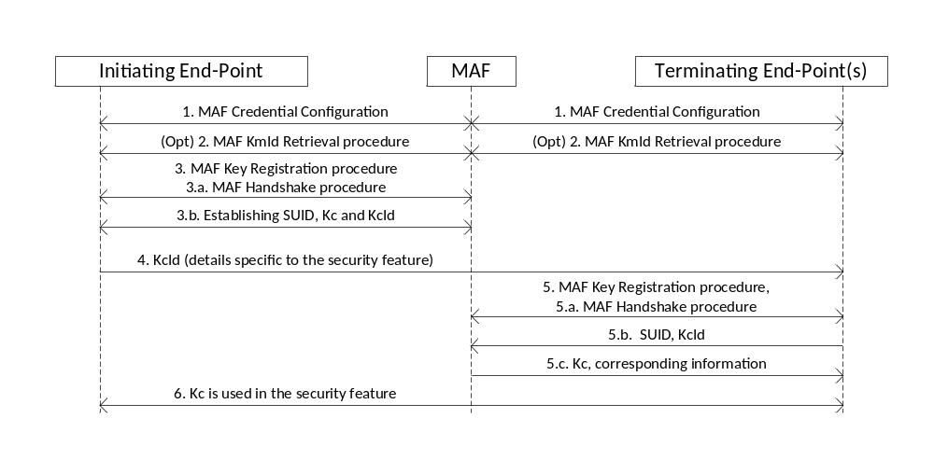
Figure 8.8.1-1: The sequence of events when using the MAF Security Framework as part of a security feature

8.8.2 MAF Credential Configuration Details
The End-Point shall be configured with the following parameters if it is to use the services of an MAF:
- Credentials for mutual authentication of the End-Point and MAF.
- The MAF Key Registration URI.
- The MAF Key Retrieval URI.
- (If remote provisioning is used to establish a symmetric key between an End-Point and the MAF) The MAF KmId Retrieval URI.
The credentials for mutual authentication shall be either pre-provisioned or remotely provisioned thanks to Remote Security Provisioning Frameworks. Either symmetric key credentials or certificate credentials maybe provisioned. Symmetric key credentials may be used for authenticating some End-Points and certificate credentials for authenticating other End-Points. The selection may be based on the capabilities of the End-Point being enrolled.
The details depend on the type of credential (symmetric key or certificates) and, in the case of symmetric keys, the type of provisioning (pre-provisioning or remote provisioning).
- Details specific to Pre-Provisioned Symmetric Keys: the Master Credential (Km) and corresponding Master Credential Identifier (KmId) shall be provisioned to the Enrolee and the MAF. The format of KmId is defined in clause 10.6 “KmId Format”.
- Details specific to Remotely-Provisioned Symmetric Keys:
  - The End-Point and an M2M Enrolment Function (MEF) shall establish an Enrolment Key (Ke) and corresponding Enrolment Key Identifier (KeId) using any Remote Security Provisioning Framework as described in clause 8.3. The MEF shall trigger the End-Point to enrol with the MAF using symmetric key credentials, as described in step 10 in clause 8.3.2.1. The End-Point and MEF shall generate the Master Credential (Km) from the Enrolment Key (Ke) as described in clause 10.3.7 with the Enrolment-Target-ID set to the FQDN of the MAF, and the Security Usage Identifier (SUID) set to indicate “MAF Provisioning”. The SUID limits the scope within which the provisioned key is authorized to be used. In this case, the SUID is used to ensure that the End-point shall use the provisioned key only for authenticating to an MAF.
  - The MAF and MEF shall be provisioned with credentials for establishing a mutually authenticated TLS or DTLS connection.
NOTE: The present document does not standardize these credentials and does not describe how these credentials are established. In general, FQDN certificates will suffice.
  - In this case, the MEF Credential Configuration does not configure all the required information to the MAF:
    - The MAF shall retrieve Km from the MEF as part of MAF KmId Retrieval.
    - The MAF shall assign the Master Credential Identifier (KmId), and communicates KmId to the End-Point, as part of the MAF KmId Retrieval.
- Details specific to Certificates (whether pre-provisioned or remotely provisioned):
  - The End-Point shall be provisioned with an End-Point certificate with optional certificate chain, and one or more MAF trust anchor CA certificates.
Editor’s note: an End-Point certificate profile might be required. Further investigation is required.
  - The MAF shall be provisioned with an MAF-Point certificate chaining to an MAF trust anchor CA certificate, and the End-Point’s Certificate Information as defined in clause 8.1.2.4.
Editor’s note: a MAF certificate profile is required.

8.8.3 MAF KmID Retrieval Procedure
Purpose: This procedure shall be used when remote provisioning is used to establish a symmetric key between an End-Point and the MAF. The End-Point triggers the MAF to retrieve Km from the MEF, and the MAF provides the End-Point wit the Master Credential Id (KmID) to use in subsequent MAF Handshake Procedures.
Pre-Conditions: The End-Point, MAF, and (where applicable) MEF have been provisioned with the parameters described in clause 8.8.2 “MAF Credential Configuration Details”. The details depend on the type of provisioning (pre-provisioning or remote provisioning) and the type of credential (symmetric key or certificates).
Procedure description:
- The End-Point shall establish a TLS (or DTLS) session with the MAF.Steps (b) onwards in the “Use of Provisioned Credential” in clause 8.3.2.1 shall be performed by the End-Point (assuming the role of Enrolee), MEF and MAF (assuming the role of Enrolment Target). The MAF retrieves Km from the MEF as part of this process.
- The End-Point shall send a retrieve request to the MAF KmId Retrieval URI configured by the MEF as part of MAF Credential Configuration.
- Upon receiving the request, the MAF shall compose a response containing the following parameters.
Parameter Name | Parameter Description
Status | Status of the request
Master Credential Id | MAF-Assigned Master Credential ID (KmId).
The MEF shall send the response to the End-Point.
- The End-Point and MAF shall store the parameters. The End-Point shall use this Master Credential ID hereafter when establishing TLS (or DTLS) sessions with the MAF.
- The MAF shall terminate the TLS/DTLS session.

8.8.4 MAF Handshake Procedure
Purpose: A MAF Handshake procedure establishes a mutually authenticated TLS or DTLS session for protecting the communication between an End-Point and MAF. In the case of the MAF Key Registration procedure, the TLS or DTLS session may be used by the Source End-Point and MAF to establish the M2M Secure Connection Key (Kc) and M2M Secure Connection Key Identifier (KcId).
Pre-Conditions: One of the following conditions shall hold:
- The End-Point and MAF have been provisioned with certificates as described in the MAF Credential Configuration details in clause 8.8.2.
- The End-Point and MAF have established a symmetric Master Credential (Km) with corresponding Master Credential Identifier (KmId). The Km and KmId may be pre-provisioned (see clause 8.8.2), or established using Remote Security Provisioning.
NOTE: In the case of establishing Kc via remote provisioning, MAF Handshake cannot be performed during MAF KmId Retrieval because (a) the MAF does not know Kc prior to MAF KmId Retrieval and (b) KmId has not been assigned prior to MAF KmId Retrieval.
Procedure description:
- If the MAF Credential Configuration provisioned a symmetric key to the End-Point, then the End-Point and MAF shall establish the TLS or DTLS session using the TLS-PSK handshake according to clause 10.2.2, with the following details:
  - The "psk_identity" parameter [15] shall be set to the value of the Master Credential Identifier (KmId) established during MAF Credential Configuration.
  - The "psk" parameter [15] shall be set to the value of the Master Credential (Km) established during MAF Credential Configuration.
- If the End-Point and MAF are to authenticate using certificates, then the End-Point and MAF shall establish the TLS or DTLS session using the certificate-based TLS handshake according to clause 10.2.2, with the following details:
  - The TLS server certificate shall be the MAF’s certificate. The End-Point shall verify the MAF’s certificate against the set of provisioned MAF certificate trust anchors as described in clause 8.1.2.5.
  - The TLS client certificate shall be the End-Point’s certificate. The MAF shall verify the End-Point’s certificate against the provisioned End-Point Certificate Information as described in clause 8.1.2.5.

8.8.5 MAF Key Registration Procedure
Purpose: This procedure enables a Source End-Point to establish a symmetric key with the MAF which can be retrieved for use by one or more Target End-Points.
This procedure is performed between the Source End-Point and the MAF.
Pre-Conditions:
- The Source End-Point has performed the MAF Credential Configuration (clause 8.8.2) with the MAF, including configuration of the MAF Key Registration URI.
- The Source End-Point has determined a set of Target End-Points with which a symmetric key needs to be established.
Procedure Description. The procedure comprises the following steps:
- The Source End-Point shall establish a TLS or DTLS session with the MAF using the MAF Handshake procedure, described in clause 8.8.3. A by-product of the MAF Handshake procedure is that the MAF establishes an authenticated identity for the Source End-Point.
- The Source End-Point selects the value of the M2M Secure Connection Key (Kc) to be distributed by the MAF. The value shall be one of the following:
  - The Source End-Point generates M2M Secure Connection Key (Kc) and RelativeKcId from the (D)TLS session secrets using TLS Key Export (RFC 5705) [18], as described in clause 10.3.1 “TLS Key Export Details”.
  - The value of Kc is self-generated by the Source End-Point, independently of the (D)TLS session secrets.
- The Source End-Point shall compose a list of Target End-Points to whom the MAF is authorized to provide Kc:
  - In the case of MAF-Based SAEF or MAF-Based ESPrim: The list shall contain exactly one Absolute AE-ID or Absolute CSE-ID.
  - In the case of MAF-Based ESData: The list shall contain any non-zero number of Absolute AE-ID or Absolute CSE-IDs.
NOTE 1: How the Source End-Point selects the list of Target End-Points is application dependent.
- The Source End-Point shall send a request, to the MAF Key Registration URI, containing the following parameters.
Parameter Name | Parameter Description
SUID | The Security Usage Identifier limiting the security feature in which the symmetric key may be used.
Target End-Point ID List | The list of zero or more identifiers for the initial set of Target End-Points authorized to retrieve the symmetric key.
M2M Secure Connection Key | (Optional) If present, this parameter contains a value for Kc which is self-generated by the Source End-Point. If this parameter is not present, then the Source End-Point and MAF will generate Kc using TLS Exporter

- The MAF shall authorize establishing an M2M Security Connection Key (Kc), based on the authenticated identity for the Source End-Point.
NOTE 2: The present specification provides no details for the authorization of this request.
- If the request included a value in the M2M Secure Connection Key parameter, then the MAF shall store this value as Kc. Otherwise, the MAF shall generate Kc from the (D)TLS session using TLS Key Export (RFC 5705) [18], as described in clause 10.3.1 “TLS Key Export Details”.
- The MAF shall initialize the list of authorized Target End-Points (those End-Points which may to retrieve this credential) to the list provided in the request.
  - In the case of MAF-Based ESData: This list may be further updated by authorized entities during or after the MAF Key Registration procedure.
NOTE 3: The present specification does not provide any details about updating the list of authorized Target End-Points on the MAF. The MAF could provide its own logic and interface allowing subscribers to manage this list.
- The MAF shall select a previously-unused value of RelativeKcId.
- The MAF shall send a response, to the Source End-Point, containing the following parameters.
Parameter Name | Parameter Description
RelativeKcId | The RelativeKcId associated with the M2M Secure Connection Key.

- The Source End-Point and MAF shall store the M2M Secure Connection Key (Kc) and M2M Secure Connection Key Identifier (KcId).
  - The M2M Secure Connection Key Identifier (KcId) is generated from the RelativeKcId and the M2M Authentication Function’s FQDN by the Source End-Point and MAF, as described in clause 10.3.5 “Generating KcId”.
- The MAF shall terminate the TLS or DTLS session between the Source End-Point and MAF.

8.8.6 MAF Key Retrieval Procedure
Purpose: This procedure enables a Target End-Point to retrieve Kc from a MAF corresponding to a KcId received by the Target End-Point.
Pre-Conditions:
- The Target End-Point has performed the MAF Credential Configuration (clause 8.8.2) with the MAF, including configuration of the MAF Key Retrieval URI.
- The Source End-Point has performed the MAF Key Registration Procedure (clause 8.8.2) with the MAF, resulting in an M2M Secure Connection Key (Kc) and M2M Secure Connection Key Identifier (KcId) for a specific Security Usage Identifier (SUID).
- The Target End-Point received an M2M Secure Connection Key Identifier (KcId) from the Initiating-End-Point in a security feature with the SUID which the Source End-Point provided to the MAF during the MAF Key Registration Procedure (clause 8.8.2)
- The Target End-Point may expect that it is authorized to obtain the corresponding M2M Secure Connection Key (Kc)
NOTE: The Target End-Point does not repeat this procedure if it is already in possession of the corresponding M2M Secure Connection Key (Kc).
Procedure Description. The procedure comprises the following steps:
- The Target End-Point shall establish a TLS or DTLS session with the MAF using the MAF Handshake procedure, described in clause 8.8.3. A by-product of the MAF Handshake procedures is that the MAF establishes an authenticated identity for the Target End-Point.
- The Target End-Point shall send a request, to the MAF Key Retrieval URI, containing the following parameters:
Parameter Name | Parameter Description
SUID | Security Usage Identifier for security feature in which the M2M Secure Connection Key Identifier (KcId) was received. This limits the use of Kc to the corresponding security
M2M Secure Connection Key Identifier | The value of KcId received from the Source End-Point

- The MAF shall identify the M2M Security Connection Key (Kc) using M2M Secure Connection Key Identifier (KcId), and verify that the identifier for the type of communication security is correct.
- The MAF shall determine if the Target End-Point is authorized to access the M2M Security Connection Key (Kc) by comparing the authenticated identifier for Target End-Point against the list of identifiers for authorized Target End-Points. If the Target End-Point is not authorized, then the MAF shall send, to the Target End-Point, an error message and terminate the TLS or DTLS session. Otherwise, the MAF shall proceed to the next step.
- The MAF shall send a response, to the Target End-Point, containing the following parameters:
Parameter Name | Parameter Description
Status | Status of the request
M2M Secure Connection Key | The value of the M2M Secure Connection Key (Kc)
End-Point ID | The identity which the MAF associates with the Source End-Point.
Lifetime | Lifetime of the M2M Secure Connection Key

- The Target End-Point shall associate the parameters with KcId.
- The MAF shall terminate the TLS or DTLS session between the Target End-Point and MAF.

9 Security Framework Procedures and Parameters

9.0 Introduction
This clause specifies procedures and parameters of the phases of Security Association Establishment Frameworks (clause 8.2) and Remote Security Provisioning Frameworks (clause 8.3).

9.1 Security Association Establishment Framework Procedures and Parameters

9.1.1 Credential Configuration Parameters

9.1.1.0 Introduction
The following Credential Configuration procedures are described in the present clause:
- Credential Configuration of Entity A and Entity B, see clause 9.1.1.1.
- Credential Configuration of M2M Authentication Functions, see clause 9.1.1.2.

9.1.1.1 Credential Configuration of Entity A and Entity B
Table 9.1.1.1-1 lists the parameters that may be configured to Entity A during the Credential Configuration phase and which are common to all Security Association Establishment Frameworks.
Table 9.1.1.1-1: Parameters that may be configured to Entity A during the Credential Configuration phase and which are common to all Security Association Establishment Frameworks
Parameter common to all Security Association Establishment Frameworks
(If Entity A is a CSE) Entity A's CSE-ID

Table 9.1.1.1-2 lists the parameters configured to a Field-Domain Security Association End-Points in the Credential Configuration phase and which are specific to the Security Association Establishment Framework.
Table 9.1.1.1-2: Parameters configured to a Field Domain Security Association end-point
during the Credential Configuration phase and which are specific to
a Security Association Establishment Framework
Security Association Establishment Framework |  | Parameter
Provisioned Symmetric Key |  | Kpsa
 |  | KpsaId
Certificate Based | Entity authenticates itself using a Raw Public Key Certificate | Entity's Private Key
Certificate Based |  | Entity's Raw Public Key Certificate
Certificate Based | Entity authenticates itself using a Device Certificate | Entity's Private Key
Certificate Based | Entity authenticates itself using a Device Certificate | Entity's Certificate and Chain
Certificate Based | Entity authenticates itself using a CSE-ID Certificate | Entity's CSE-ID
Certificate Based | Entity authenticates itself using a CSE-ID Certificate | Entity's Private Key
Certificate Based | Entity authenticates itself using a CSE-ID Certificate | Entity's Certificate and Chain
Certificate Based | Entity authenticates itself using an AE-ID Certificate | Entity's AE-ID
Certificate Based | Entity authenticates itself using an AE-ID Certificate | Entity's Private Key
Certificate Based | Entity authenticates itself using an AE-ID Certificate | Entity's Certificate and Chain
MAF-Based | Entity A | MAF Identifier (MAF-ID)
MAF-Based | Entity A | Master Credential (Km Id)
MAF-Based | Entity A | Master Credential Identifier (KmId)
MAF-Based | Entity B | Entity B and MAF shall be able to establish mutually-authenticated secure communication. The details are not specified in the present document

The Credential Configuration of Entity A and Entity B for the Provisioned Symmetric Key Security Association Establishment Framework, or the MAF-Based Security Association Establishment Framework is achieved through either:
- Pre-provisioning via mechanisms which are not specified in the present document.
- Remote provisioning via one of the Remote Security Provisioning Frameworks in clause 8.3.
The Credential Configuration of Entity A and Entity B for the Certificate Security Association Establishment Frameworks is performed by pre-provisioning via mechanisms which are not specified in the present document.

9.1.1.2 Credential Configuration of M2M Authentication Functions
Table 9.1.1.2-1 lists the parameters configured to M2M Authentication Functions in the Credential Configuration phase. The M2M Authentication Function's identifier (MAF-ID) is presumed to have been configured prior to the Credential Configuration phase.
Table 9.1.1.2-1: Parameters configured to a M2M Authentication Functions
during the Credential Configuration phase
Security Association Establishment Framework |  | Parameter
MAF-Based | A-to-MAF Authentication | masterCredential (Km)
MAF-Based | A-to-MAF Authentication | masterCredentialIdentifier (KmId)
MAF-Based | B-to-MAF Authentication | Entity B and MAF shall be able to establish mutually-authenticated secure communication. The details are not specified in the present document

The Credential Configuration of M2M Authentication Framework shall be achieved through either:
- Business logic of the Stakeholder operating the M2M Authentication Function, and the details are not described in the present document.
- Remote provisioning via one of the Remote Security Provisioning Frameworks in clause 8.3.

9.1.2 Association Configuration Procedures and Parameters

9.1.2.0 Introduction
The following Association Configuration procedures are described in this clause:
- Association Configuration of Entity A, see clause 9.1.2.1.1.
- Association Configuration of Entity B, see clause 9.1.2.1.2.
- Association Configuration of M2M Authentication Functions, see clause 9.1.2.2.

9.1.2.1 Association Configuration of Entity A and Entity B

9.1.2.1.1 Association Configuration of Entity A
Table 9.1.2.1.1-1 lists the parameters configured to Entity A in the Association Configuration phase and which are common to all Security Association Establishment Frameworks.
Table 9.1.2.1.1-1: Parameters configured to Entity A during the Association Configuration phase and which are common to all Security Association Establishment Frameworks
Parameter common to all Security Association Establishment Frameworks
Entity B's CSE-ID
Table 9.1.2.1.1-2 lists the parameters configured to Entity A in the Association Configuration phase which are specific to the Security Association Establishment Framework.
Table 9.1.2.1.1-2: Parameters configured to Entity A
during the Association Configuration phase which are specific to
a Security Association Establishment Framework
Security Association Establishment Framework |  | Parameters specific to the Security Association Establishment Frameworks
Provisioned Symmetric Key |  | None
Certificate Based | Entity B is authenticated using Raw Public Key Certificate | Entity B's Public key identifier
Certificate Based | Entity B is authenticated using Device Certificate | Entity B's globally unique hardware instance identifier
Certificate Based | Entity B is authenticated using Device Certificate | Entity B's trust anchor information
Certificate Based | Entity B is authenticated using CSE-ID Certificate | Entity B's trust anchor information
Certificate Based | Entity B is authenticated using AE-ID Certificate | Entity B's trust anchor information
MAF-Based |  | ^None

Mechanisms for Association Configuration of Entity A shall authenticate the configuration source and provide integrity protection for the configured information communicated from the configuration source to the entity.

9.1.2.1.2 Association Configuration of Entity B
Table 9.1.2.1.2-1 lists the parameters configured to the Registrar (Entity B) in the Association Configuration phase.
Table 9.1.2.1.2-1: Parameters configured to Entity B during the Association Configuration phase
Security Association Establishment Framework |  | Parameters specific to the Security Association Establishment Frameworks
Provisioned Symmetric Key |  | None
Certificate Based | Entity B is authenticated using Raw Public Key Certificate | None
Certificate Based | Entity B is authenticated using Device Certificate, CSE-ID Certificate or AE-ID Certificate | Entity A's trust anchor information
MAF-Based |  | None

Mechanisms for Association Configuration of Entity B shall authenticate the configuration source and provide integrity protection for the configured information communicated from the configuration source to the entity.

9.1.2.2 Association Configuration of M2M Authentication Functions
Table 9.1.2.2-1 lists the parameters configured to M2M Authentication Functions in the Association Configuration phase.
Table 9.1.2.2-1: Parameters configured to a M2M Authentication Functions
during the Association Configuration phase
Security Association Establishment Framework |  | Parameter
MAF-Based | A-to-MAF Authentication | Entity B's CSE-ID or AE-ID (IdB)

The present document assumes that Association Configuration of the M2M Authentication Functions will utilize business logic of the Stakeholder that operates the M2M Authentication Function, and the details are not described in the present document.

9.2 Remote Security Provisioning Framework Procedures and Parameters

9.2.1 Bootstrap Credential Configuration Procedures and Parameters

9.2.1.0 Introduction
The following Bootstrap Credential Configuration procedures are described in this clause:
- Bootstrap Credential Configuration of Enrolees and Enrolment Targets (except for the GBA-Based case as discussed below), see clause 9.2.1.1.
- Bootstrap Credential Configuration of M2M Enrolment Functions (except for the GBA-Based case as discussed above), see clause 9.2.1.2.
The following Bootstrap Credential Configuration procedures are specified by other organizations:
- Bootstrap Credential Configuration of Underlying Network Service Provider authentication servers (e.g. HLR, HSS or AAA) for the GBA-Based Security Association Establishment Framework. These details are specified by 3GPP TS 33.220 [13], 3GPP2 S.S0109-A [14].
- Bootstrap Credential Configuration of Enrolees for the GBA-Based Security Association Establishment Framework. These details are specified by 3GPP TS 33.220 [13], 3GPP2 S.S0109-A [14].

9.2.1.1 Bootstrap Credential Configuration of Enrolee
Table 9.2.1.1-1 lists the parameters configured to Enrolees in the Bootstrap Credential Configuration phase for authentication with the M2M Enrolment Function in the Pre-Provisioned Symmetric Enrolee Key Remote Security Provisioning Framework and Certificate-Based Remote Security Provisioning Framework.
Table 9.2.1.1-1: Parameters configured to Enrolees
during the Bootstrap Credential Configuration phase
Remote Security Provisioning Framework |  | Parameter
Pre-Provisioned M2M Secure Connection Key authentication. Not applicable to MAF. |  | Kpm
 |  | KpmId
 |  | MEF URI
Certificate-Based authentication | Enrolee authenticates itself using a raw public key | Enrolee 's Private Key
Certificate-Based authentication | Enrolee authenticates itself using a raw public key | Enrolee 's Raw Public Key Certificate
Certificate-Based authentication | Enrolee authenticates itself using a device certificate | Enrolee 's Private Key
Certificate-Based authentication | Enrolee authenticates itself using a device certificate | Enrolee 's Certificate and Chain
Certificate-Based authentication | Enrolee authenticates itself using a CSE-ID or AE-ID certificate | Enrolee 's Private Key
Certificate-Based authentication |  | Enrolee 's Certificate and Chain

The Bootstrap Credential Configuration of an Enrolee for the Pre-Provisioned Symmetric Enrolee Key Remote Security Provisioning Framework and Certificate-Based Remote Security Provisioning Framework shall authenticate the configuration source and shall provide confidentiality and integrity protection of the configured information communicated from the configuration source to the secured environment of the Enrolee. The present document does not specify any such mechanisms.
The Bootstrap Credential Configuration of an Infrastructure Domain Enrolment Target (including an M2M Authentication Functions) expected to use business logic of the Stakeholder operating the Infrastructure Domain Enrolment, and the details are not described in the present document.

9.2.1.2 Bootstrap Credential Configuration of M2M Enrolment Functions
It is assumed that an M2M Enrolment Function already knows its FQDN.
Table 9.2.1.2-1 lists the parameters configured to M2M Enrolment Functions in the Bootstrap Credential Configuration phase for mutual authentication with Enrolees and Enrolment Targets using the Pre-Provisioned Symmetric Enrolee Key Remote Security Provisioning Framework and Certificate-Based Remote Security Provisioning Framework.
Table 9.2.1.2-1: Parameters configured to the M2M Enrolment Function
during the Bootstrap Credential Configuration phase for mutual authentication with Enrolees
and Enrolment Targets using the Pre-Provisioned Symmetric Enrolee Key Remote
Security Provisioning Framework and Certificate-Based Remote Security Provisioning Framework
Remote Security Provisioning Framework | Parameters specific to the Remote Security Provisioning Frameworks
Pre-Provisioned Symmetric Enrolment Key authentication of Enrolee or Enrolment Target | Kpm
 | KpmId
Certificate Based authentication of Enrolee or Enrolment Target | MEF PrivateKey
 | MEF Certificate and Chain

The Bootstrap Credential Configuration of M2M Enrolment Functions is expected to use business logic of the stakeholder operating the M2M Enrolment Function, and the details are not described in the present document.

9.2.2 Bootstrap Instruction Configuration Procedures and Parameters

9.2.2.0 Introduction
The following Bootstrap Instruction Configuration procedures are described in this clause:
- Bootstrap Instruction Configuration of Enrolees, see clause 9.2.2.1.
- Bootstrap Instruction Configuration of M2M Enrolment Functions, see clause 9.2.2.3.
- Bootstrap Instruction Configuration of Underlying Network Service Provider authentication servers (e.g. HLR, HSS or AAA), see clause 9.2.2.4.

9.2.2.1 Bootstrap Instruction Configuration of Enrolees
Table 9.2.2.1-1 lists the parameters configured to an Enrolee during the Bootstrap Instruction Configuration phase which are common to all Remote Security Provisioning Frameworks.
Table 9.2.2.1-1: Parameters configured to an Enrolee during the Bootstrap Instruction
Configuration phase of which are common to all Remote Security Provisioning Frameworks
Parameter common to all Remote Security Provisioning Frameworks
Enrolment Target Identifier
(Enrolee B's AE-ID or CSE-ID, or MAF-ID)

Table 9.2.2.1-2 lists the Remote Security Provisioning Framework-specific parameters configured an Enrolee in the Bootstrap Instruction Configuration phase of the Remote Security Provisioning Framework.
Table 9.2.2.1-2: Remote Security Provisioning Framework - specific parameters configured to
an Enrolee during the Instruction Configuration phase of the Remote Security Provisioning Framework
Remote Security Provisioning Framework | Remote Security Provisioning Framework-specific Parameters
Pre-Provisioned Symmetric Enrolment Key | Enrolment Expiry
Certificate Based | MEF URI
Certificate Based | MEF TrustAnchor Information
GBA-Based | None

Mechanisms for Bootstrap Instruction Configuration of Enrolees shall authenticate the configuration source and shall provide at least integrity protection of the configured information communicated from the configuration source to the Enrolee.

9.2.2.2 Void

9.2.2.3 Bootstrap Instruction Configuration of M2M Enrolment Functions
Table 9.2.2.3-1 lists the parameters configured to an M2M Enrolment Function during the Bootstrap Instruction Configuration phase which are common to the Pre-Provisioned Symmetric Enrolee Key Remote Security Provisioning Framework and Certificate-Based Remote Security Provisioning Framework.
Table 9.2.2.3-1: Parameters configured to M2M Enrolment Functions
during the Bootstrap Instruction Configuration phase which are common to
the Pre-Provisioned Symmetric Enrolee Key Remote Security Provisioning Framework
and Certificate-Based Remote Security Provisioning Framework
Parameter common to all Remote Security Provisioning Frameworks
Enrolment Target Identity
(Enrolee B's CSE-ID or AE-ID, or MAF-ID)

Table 9.2.2.3-2 lists the Remote Security Provisioning Framework-specific parameters configured to an M2M Enrolment Functions in the Bootstrap Instruction Configuration phase of the Pre-Provisioned Symmetric Enrolee Key Remote Security Provisioning Framework and Certificate-Based Remote Security Provisioning Framework.
Table 9.2.2.3-2: Remote Security Provisioning Framework-specific parameters configured
to an M2M Enrolment Function during the Instruction Instruction Configuration phase
of the Pre-Provisioned Symmetric Enrolee Key Remote Security Provisioning Framework
and Certificate-Based Remote Security Provisioning Framework
Remote Security Provisioning Framework |  | Remote Security Provisioning Framework-specific Parameters
Pre-Provisioned Symmetric Enrolment Key |  | Enrolment Expiry
Certificate Based | Enrolee is authenticated using a raw public key certificate | Enrolee's Public key identifier
Certificate Based | Enrolee is authenticated using a device certificate | Enrolee's M2M Device ID
Certificate Based | Enrolee is authenticated using a device certificate | Enrolee's Trust Anchor Information
Certificate Based | Enrolee is authenticated using a CSE-ID or AE-ID certificate | Enrolee's Trust Anchor Information

The present document assumes that Bootstrap Instruction Configuration of the M2M Enrolment Functions utilizes business logic of the Stakeholder that operates the M2M Enrolment Function, and the details are not described in the present document.

9.2.2.4 Bootstrap Instruction Configuration of UNSP Authentication Server
Table 9.2.2.4-1 lists the parameters configured to an Underlying Network Service Provider authentication server (e.g. HLR, HSS or AAA) during the Bootstrap Instruction Configuration phase of the GBA-Based Remote Security Provisioning Framework.
Table 9.2.2.4-1: Parameters configured to M2M Enrolment Functions during the Bootstrap Instruction
Configuration phase of the GBA-Based Remote Security Provisioning Framework
Parameter | Mandatory/Optional for all Remote Security Provisioning Frameworks
Enrolment Target Identifier  (Enrolee B's CSE-ID or AE-ID, or MAF-ID) | Mandatory

The Bootstrap Instruction Configuration of the Underlying Network Service Provider authentication server is achieved by updating the GBA User Security Settings (GUSS) (3GPP TS 33.220 [13]) of the User Equipment (UE) upon which the Enrolee is executed. The present document assumes that this Bootstrap Instruction Configuration utilizes business logic of the Underlying Network Service Provider, and the details are not described in the present document.

9.2.3 End-to-End Credential Configuration Procedures and Parameters

9.2.3.0 Introduction
The following End-to-End Credential Configuration procedures are described in this clause:
- End-to-End Credential Configuration of Source ESF End-Points and Target ESF End-Points, see clause 9.2.3.1.
- End-to-End Credential Configuration of Trust Enabler Functions, see clause 9.2.3.2.
- Configuration parameters for enabling End-to-End Security at Source ESF End-Points and Target ESF End-Points, see clause 9.2.3.3.

9.2.3.1 End-to-End Credential Configuration of Source ESF End-Points and Target ESF End-Points
It is assumed that the Source ESF End-Point and the Target ESF End-Points are configured with the URI of the Trust Enabler Function and have been configured with the appropriate parameters specific to the Remote Security Provisioning Frameworks as described in clause 9.2. In addition, the end-to-end credentials are provisioned and appropriate security parameters are provisioned to the Target ESF End-Points while the Source ESF End-Point can derive the end-to-end credentials on its own using the relevant security parameters that have been provisioned. Table 9.2.3.1-1 provides a list of the parameters.
Table 9.2.3.1-1: Security Credentials and parameters provisioned to the Target ESF End-Points and Source ESF End-Points
Security Protection | End-to-End Security Provisioning Framework Parameters | Description
End-to-End Security Credentials | KpsaId | This is the provisioned credential-Id of the M2M Provisioned Symmetric Key.
End-to-End Security Credentials | Kpsa | This is the M2M Provisioned Symmetric Key. This is used to derive the end-to-end master secret, Ke2e_master as described in clause 10.3.6.
End-to-End Security Credentials | TEF URI | The URI of the trusted-third-party (TEF) entity that is used as the credential generator/registry and enables the registration and generation of end-to-end security credentials.
Cryptographic Parameters | Salt | The salt used for generating the end-to-end credentials. Optional parameter.
Cryptographic Parameters | Key Extraction Algorithm: HMAC-Hash | The Key extraction algorithm that is used for generating the various keys shall follow the mechanisms described in [48].
Cryptographic Parameters | Cryptographic Labels | The labels that are used by the cryptographic algorithms. The labels shall be used according to clause 10.3.6.1.
Types of Credentials | Message Authenticity (Primitive) | The key used for message authentication and integrity of oneM2M primitives. If the keying material is provided then it is generated by the ESF Target End-Point.
Types of Credentials | Message Confidentiality (Primitive) | The key that is used for message confidentiality of oneM2M primitives. If the keying material is provided then it is generated by the Target ESF End-Point.
Types of Credentials | Integrity of Data (Attribute) | Key used for providing integrity of data/attribute. If the keying material is provided then it is generated by the Target ESF End-Point.
Types of Credentials | Confidentiality of Data (Attribute) | Key used for providing confidentiality of data/attributes. If the keying material is provided then it is generated by the Target ESF End-Point.

9.2.3.2 End-to-End Credential Configuration at the M2M Trust Enabler Functions
It is assumed that the Trust Enabler Function is configured with the identities of the entities (ESF Source and Target End-Points) and appropriate parameters specific to the Remote Security Provisioning Frameworks as described in clause 9.2.
In addition, the Trust Enabler Function is provisioned with the appropriate security parameters, so that the End-to-End security credentials can be derived and the set of the cryptographic parameters can be provisioned to the Target ESF End-Points once the Target ESF End-Point has been authenticated. Table 9.2.3.2-1 provides a list of the parameters.
Table 9.2.3.2-1: Security Parameters provisioned at the M2M Enrolment or
Trust Enabler Function and Source ESF End-Point
End-to-End Security Protection | End-to-End Security Provisioning Framework Parameters | Description
End-to-End Security Credentials | Kpm | Pre-provisioned credentials between the Source ESF End-Point and TEF
End-to-End Security Credentials | KpmId | The credential identity of the pre-provisioned credentials
End-to-End Security Credentials | Source ESF End-Point identity (AE-ID/CSE-ID)  Target ESF End-Point identity (CSE-ID) | The entity identity that is pre-provisioned with the end-to-end security credentials
List of required Security Protection and Strength | Message Authentication: (Low - High) | Provides a level of the required strength of the message authentication mechanism
List of required Security Protection and Strength | Message Confidentiality: (Low - High) | Provides a level of the required strength for providing message confidentiality mechanism
List of required Security Protection and Strength | Attribute Integrity: (Low - High) | Provides a level of the required strength for providing attribute integrity
List of required Security Protection and Strength | Attribute Confidentiality: (Low - High) | Provides a level of the required strength for providing attribute confidentiality

9.2.3.3 Configuration parameters for enabling End-to-End Security at Source ESF End-Points and Target ESF End-Points
The Source ESF End-Points and the Target ESF End-Points are provisioned with the cryptographic parameters that are used to enable and verify end-to-end security protection. In the case of the Target ESF End-Point, the Trust Enabler Function provisions the parameters to it after a successful authentication and derivation of the Secure Connection Key (Kpsa). In the case of the Source ESF End-Point, the parameters may have been pre-configured or provisioned in a similar manner as the Target ESF End-Point, that is, once the derivation of the Secure Connection Key (Kpsa) is done, and shared between the Source ESF End-Point and the Target ESF End-Point. Table 9.2.3.3-1 provides a list of the parameters.
Table 9.2.3.3-1: Security Parameters provisioned to the Target ESF End-Point
and the Source ESF End-Point
End-to-End Security Protection | End-to-End Security Provisioning Framework Parameters | Description
End-to-End Security Credentials | e2e_master | The End-to-End master credential
End-to-End Security Credentials | E2EKeyId | End-to-End Master credential identity
End-to-End Security Credentials | Target ESF End-Point Identity (CSE-ID)  Source ESF End-Point Id (AE-ID/CSE-ID) | The identity of the end entity with which the end-to-end credential is associated with
Cryptographic Parameters | Protocol: JWS/JWE, XML Sec | The type of encoding and representation that is used
Cryptographic Parameters | Class of cryptographic algorithms: AEAD (single key) or non-AEAD | Defines the class of cryptographic algorithms that shall be used
Cryptographic Parameters | Message Authenticity Algorithm/Size: HMAC-SHA-256, HMAC-SHA-512 | Indicates the message authentication algorithm and key size
Cryptographic Parameters | Message Confidentiality Algorithm/Size: AES-192/256 | Indicates the message confidentiality algorithm and key size
Cryptographic Parameters | Attribute Confidentiality Algorithm: AES-192/256 | Attribute confidentiality algorithm and key size
Cryptographic Parameters | Attribute Authenticity Algorithm/Size: HMAC-SHA-256 | Attribute authenticity and integrity algorithm and key size
Cryptographic Usage | Message/Attribute Authenticity: Nonce | The random value that was used for providing freshness. This is only stored temporarily associated with an expiration time and communicated to the other end
Cryptographic Usage | Message/Attribute Confidentiality: Initialization Vector | This random value that is used as the initialization vector for the confidentiality algorithm

NOTE: For AEAD class of algorithms where only a single key is used, then only a single key would be generated and an associated cryptographic algorithm (e.g. AES-GCM or AES-CCM) identified. In addition, for AEAD class of algorithms, both an IV and a Nonce would not be generated, rather only a single random value, Nonce, would be generated.

10 Protocol and Algorithm Details

10.1 Certificate-Based Security Framework Details

10.1.1 Certificate Profiles

10.1.1.0 General
NOTE: These certificate profiles are compliant with the CoAP specification IETF RFC 7252 [38].

10.1.1.1 Common Certificate Details
All certificates shall conform to the following profile:
- Certificates shall conform to IETF RFC 5280 [34].
- The certificate shall include a SubjectPublicKeyInfo that indicates an algorithm of id-ecPublicKey with namedCurves secp256r1 [34]; this curve is equivalent to the NIST P-256 curve [39].
- The public key format shall be uncompressed [46].
- The hash algorithm shall be SHA-256.
- The key usage extension shall be included and shall indicate at least digitalSignature.

10.1.1.2 Raw Public Key Certificate Profile
Raw public key certificates shall conform to clause 10.1.1.1 "Common Certificate Details" and IETF RFC 7250 [37].

10.1.1.3 Details Common to Certificates with Certificate Chains
Certificates with Certificate Chains shall conform to the following description:
- These certificates shall conform to clause 10.1.1.1 "Common Certificate Details".
- Certificates shall be signed with ECDSA using secp256r1, and the signature shall use SHA-256.
- Certificate chains should limit the number of intermediate CA certificates to avoid having a negative impact in constrained environments.

10.1.1.4 Profile for Device Certificates and their Certificate Chains

10.1.1.4.1 Profile for Device Certificates
Device certificates shall conform to the following description:
- Device certificates shall conform to clause 10.1.1.3 "Details Common to the Certificates with Certificate Chains".
- The subjectAltName extension of device certificates shall include one or more globally unique hardware instance identifiers.
EXAMPLE: Annex H "Object Identifier Based M2M Device Identifier" oneM2M TS-0001 [1] defines an object identifier -based M2M Device ID that can be used for providing a one or more globally unique hardware instance identifier. An object identifier -based M2M Device ID can be representing in an otherName field in the subjectAltName extension, where:
- otherName "type-ID" component is set to the M2M Device Indication ID (clause H.2.1 "M2M Device Indication ID" oneM2M TS-0001 [1]) arc of the object identifier M2M Device ID; and
- the otherName "value" component is set to the remainder of the object identifier M2M Device ID: Manufacturer ID arc, Model ID arc, Serial Number ID arc and optional Expanded ID arc (see Annex H.2 "OID Based M2M Device Identifier" oneM2M TS-0001 [1]).
NOTE: Providing the Model ID as part of the M2M Device ID can have privacy implications in some scenarios.

10.1.1.4.2 Profile for Certificate Authority Certificates for Device Certificates
Certificate Authority Certificates in the certificate chain for a device certificate shall conform to the following description:
- These certificates shall conform to clause 10.1.1.3 "Details Common to the Certificates with Certificate Chains".
- Certificate Authority Certificates for device certificates are recommended to use the name constraints extension (see clause 4.2.1.10 "Name Constraints" of IETF RFC 5280 [34]) to constrain the globally unique hardware instance identifiers in subsequent device certificates in a certification path.
EXAMPLE: Name constraints are defined in terms of permitted or excluded name subtrees. Subtrees of an object identifier based M2M Device ID name space are represented by an otherName field with:
- "type-ID" set to the M2M Device Indication ID (clause H.2.1 "M2M Device Indication ID" oneM2M TS-0001 [1]) arc of the applicable object identifier M2M Device ID name space; and
- "value" set to set to the remainder of the object identifier identifying the subtree.

10.1.1.5 Profile for AE-ID Certificates and their Certificate Chains
AE-ID certificates and all other certificates in the corresponding certificate chain shall conform to clause 10.1.1.3 "Details Common to Certificates with Certificate Chains".
The full URI representation of the AE-ID shall be included in the subjectAltName extension.
The certificate used to sign the AE-ID certificate shall include nameConstraints satisfied by the hostname part of the full URI representation of the AE-ID.
AE-ID certificates shall not include wildcards.

10.1.1.6 Profile for FQDN Certificates and their Certificate Chains
FQDN Certificates and all other certificates in the corresponding certificate chain shall conform to clause 10.1.1.3 "Details Common to Certificates with Certificate Chains".
An FQDN Certificate shall include the FQDN of the subject M2M Enrolment Function in the subjectAltName extension.
FQDN Certificates shall not include wildcards.

10.1.1.7 Profile for CSE-ID Certificates and their Certificate Chains
CSE-ID certificates and all other certificates in the corresponding certificate chain shall conform to clause 10.1.1.3 "Details Common to Certificates with Certificate Chains".
The subjectAltName extension shall include the public domain name representation of the CSE-ID as defined in oneM2M TS-0001 [1].
CSE-ID certificates shall not include wildcards.

10.1.2 Public Key Identifiers
The public key identifier for a raw public key certificate shall calculated as described in section 2 of IETF RFC 6920 [40] using the SHA-256 hash algorithm. The public key identifier shall be generated using one of the sha-256-120, sha-256-128 or sha-256 hash algorithms specified in IETF RFC 6920 [40].
It is recommended that the public key identifier be as long as practical within the deployment constraints.
The trusted public key identifier (received during Association Configuration or Bootstrap Instruction Configuration) is matched against the raw public key certificate (received during the Security Handshake) using the following procedure:
- A check digest value is computed according to section 2 of IETF RFC 6920 [40] using the hash algorithm identified in the trusted public key identifier.
- The check digest value is compared against the digest value encoded in the trusted public key identifier. If the values are identical then the raw public key certificate matches the trusted public key identifier. Otherwise, the raw public key certificate does not match the trusted public key identifier.

10.1.3 Support Requirements for each Public Key Certificate Flavour
Table 10.1.3 lists, for each of the various types of entity (Field Domain CSE, Field Domain AE, IN-CSE, IN-AE, M2M Authentication Function and M2M Enrolment Function), the flavour of certificate that may be issued to the entity and the flavour of other entity's certificates that the entity is required to be able to process. In this table "O" indicates optional, "M" indicates Mandatory, "CA" indicates that the option is required if the entity supports the certificate-based security association establishment framework, "CB" indicates conditional on the entity supporting certificate-based Remote Security Provisioning framework.
Table 10.1.3-1: Applicability of certificate flavours issued to an entity and flavours
of other entity's certificates that the entity is required to be able to process
Entity | Flavour of certificate may be issued to entity |  |  |  |  | Flavour of other entity's certificates that the entity is recommended to be able to process.
Entity | Raw | Device | CSE-ID | AE-ID | FQDN | Raw | Device | CSE-ID | AE-ID | FQDN
Field Domain CSE | O | O | O | - | - | CA | CA | CA | CA | CB
Field Domain AE | O | O | - | O | - | CA | CA | CA | - | CB
IN-CSE | O | - | O | - | - | CA | CA | CA | CA | -
IN-AE | O | - | - | O | - | CA | - | CA | - | -
MAF | - | - | - | - | M | - | - | - | - | M
MEF | - | - | - | - | M | CB | CB | - | - | M

Mutual authentication between remote management servers and remote management clients is not considered in the present document.Where supported, Remote Security Administration may be used to provision the certificates.

10.2 TLS and DTLS Details

10.2.1 TLS and DTLS Versions
Where TCP payloads are to be secured, TLS v1.2 [5] shall be used.
Where UDP payloads are to be secured, DTLS v1.2 [6] shall be used, noting that the DTLS v1.2 ciphersuites are identical to the TLS v1.2 ciphersuites.
All implementations shall support the Server Name Indication (SNI) to indicate their authority in the SNI HostName field as defined in section 3 of IETF RFC 6066 [44]. This is needed so that when a host that acts as a virtual server for multiple Authorities receives a new TLS or DTLS connection, it knows which keys to use for the TLS or DTLS session.
(D)TLS Clients on any Node and (D)TLS Servers on MNs shall support at least one of the TLS ciphersuites indicated in clause 10.2.2. "TLS and DTLS Ciphersuites for TLS-PSK-Based Security Frameworks" or clause 10.2.3 "TLS and DTLS Ciphersuites for Certificate-Based Security Frameworks".
NOTE: (D)TLS Servers on MN need to support the TLS ciphersuites for those (D)TLS clients they are expected to interact with.
(D)TLS Servers on INs shall support all of the TLS ciphersuites indicated in clause 10.2.2. "TLS and DTLS Ciphersuites for TLS-PSK-Based Security Frameworks" and 10.2.3 "TLS and DTLS Ciphersuites for Certificate-Based Security Frameworks".

10.2.2 TLS and DTLS Ciphersuites for TLS-PSK-Based Security Frameworks
The following Security Frameworks:
- Provisioned Symmetric Key Security Association Establishment Framework;
- MAF-Based Security Association Establishment Framework;
- Pre-Shared Key Remote Security Provisioning Framework;
- GBA-Based Remote Security Provisioning Framework;
shall use one of the key exchange algorithms defined in IETF RFC 4279 [15].
TLS implementations in entities supporting these security frameworks shall implement at least the following TLS ciphersuite:
- TLS_PSK_WITH_AES_128_CBC_SHA256 (IETF RFC 5487 [42]).
DTLS implementations supporting these security frameworks shall implement at least the following ciphersuites
- TLS_PSK_WITH_AES_128_CCM_8 (IETF RFC 6655 [31]).
The security considerations of section 7 of IETF RFC 4279 [15] apply. In particular, applications should carefully weigh whether or not they need Perfect Forward Secrecy (PFS) and select an appropriate ciphersuite (section 7.1 of IETF RFC 4279 [15]).

10.2.3 TLS and DTLS Ciphersuites for Certificate-Based Security Frameworks
The following Security Frameworks:
- Certificate-Based Security Association Establishment Framework;
- Certificate-Based Security Bootstrap Framework;
shall use the standard TLS handshake (IETF RFC 5246 [5]) with the ECDHE_ECDSA Key Exchange (IETF RFC 4492 [43]).
TLS implementations supporting these security frameworks shall implement at least the following ciphersuite:
- TLS_ECDHE_ECDSA_WITH_AES_128_CBC_SHA256, IETF RFC 5289 [32].
DTLS implementations supporting these security frameworks shall implement at least the following TLS ciphersuite:
- TLS_ECDHE_ECDSA_WITH_AES_128_CCM_8, IETF RFC 7251 [45].
Implementations supporting these security frameworks shall support authenticating other entities using all available public key certificate flavours (see clause 8.1.2.1 "Public Key Certificate Flavours"):
- Raw public key certificate: using the mechanism specified in IETF RFC 7250 [37], Implementation shall support receiving and processing raw public keys compliant with section 9.1.3.2 "Raw Public Key Certificates" in IETF RFC 7252 [38].
- All other certificates: X.509 certificates including device hardware identifier. Implementation shall support receiving and processing raw public keys compliant with section 9.1.3.3 "X.509 Certificates" in IETF RFC 7252 [38].

10.3 Key Export and Key Derivation Details

10.3.1 TLS Key Export Details
TLS Key Export Details for Enrolment Key
Following successful TLS authentication between the Enrolee and M2M Enrolment Function, see clause 8.3.1.2, the Enrolment Key (Ke) and RelativeKeId are generated from the (D)TLS session secrets by the Enrolee and M2M Enrolment Function by applying TLS Key Export (IETF RFC 5705 [18]) using the label "EXPORTER-oneM2M-Bootstrap" and length 48. The Enrolment Key (Ke) is set to the value of the 32 least significant bytes, while RelativeKeId is set to the value of the 16 most significant bytes.
TLS Key Export Details for M2M Secure Connection Key
Following successful TLS authentication between the Entiy A and the M2M Authentication Function (MAF), see clause 8.8.5, the M2M Secure Connection Key (Kc) and the M2M Secure Connection Key Identifier (KcId) are generated from the (D)TLS session secrets by the Entity A and the MAF by applying TLS Key Export (IETF RFC 5705 [18]) using the label "EXPORTER-oneM2M-Connection" and length 48. The M2M Secure Connection Key (Kc) is set to the value of the 32 least significant bytes, while M2M Secure Connection Key Identifier (KcId) is set to the value of the 16 most significant bytes.
TLS Key Export Details for pairwiseE2EKey
Following successful TLS authentication between the ESCertKE Initiating End-Point and ESCertKE Terminating End-Point, see clause 8.7.2.2, the pairwiseE2EKey and pairwiseE2EKeyID are generated from the (D)TLS session secrets by the Enrolee and M2M Enrolment Function by applying TLS Key Export (IETF RFC 5705 [18]) using the label "EXPORTER-oneM2M-ESCertKE" and length 48. The pairwiseE2EKey is set to the value of the 32 least significant bytes, while pairwiseE2EKeyID is set to the value of the 16 most significant bytes.

10.3.2 Derivation of Master Credential from Enrolment Key
This clause describes the details when generating a Master Credential (Km) from an Enrolment Key (Ke) in Security Bootstrap Frameworks.
The following information shall be used when generating Km from Ke:
- the value of the Enrolment Key (Ke);
- the M2M Authentication Function Identifier (MAF-ID) shall be encoded to an octet string according to UTF-8 encoding rules as specified in IETF RFC 3629 [19] and apply Normalization Form KC (NFKC) as specified in [20].
The value of Km shall be generated as:
Km := HMAC-SHA-256(Ke, "oneM2M Enrolment Key to Master Credential derivation" || MAF-ID),
where HMAC-SHA-256 is defined in IETF RFC 2104 [33].

10.3.3 Derivation of Provisioned Secure Connection Key from Enrolment Key
This clause describes the details when generating a Provisioned Secure Connection Key (Kpsa) from an Enrolment Key (Ke) in Remote Provisioning Frameworks.
The following information shall be used when generating Kpsa from Ke:
- The value of the Enrolment Key (Ke).
- Enrolee B's CSE-ID or AE-ID (Enrolee-B-ID), which shall be encoded to an octet string according to UTF-8 encoding rules as specified in IETF RFC 3629 [19] and apply Normalization Form KC (NFKC) as specified in [20].
The value of Kpsa shall be generated as:
- Kpsa := HMAC-SHA-256(Ke, "oneM2M Enrolment Key to Provisioned Secure Connection Key derivation" || Enrolee-B-ID);
where HMAC-SHA-256 is defined in IETF RFC 2104 [33].

10.3.4 Generating KeId
The KeId value shall be formed as:
- KeId = base64encode(RelativeKeId)@MEF_FQDN:
where:
- base64encode(RelativeKeId) denotes the base64 encoding (IETF RFC 3548 [41]) of the value of RelativeKeId; and
- MEF_FQDN denotes the FQDN of the M2M Enrolment Function.

10.3.5 Generating KcId
The KcId value shall be formed as
- KcId = base64encode(RelativeKcId)@MAF_FQDN;
where
- base64encode(RelativeKcId) denotes the base64 encoding (IETF RFC 3548 [41]) of the value of RelativeKcId; and
- MAF_FQDN denotes the FQDN of the M2M Authentication Function.

10.3.6 Derivation of End-to-End Master Key from Provisioned Secure Connection Key

10.3.6.1 Introduction
This clause describes the details when generating an End-to-End Master Key (Ke2e_master) based on a successful establishment of security association between a Source ESF End-Point and Target ESF End-Point using a Remote Security Provisioning Framework as described in clause 8.3. The mechanisms to generate the End-to-End Master Key then uses a key extraction process using the Provisioned Secure Connection Key, (Kpsa).
The following information shall be used when generating Ke2e from Kpsa:
- The value of the Provisioned Secure Connection Key (Kpsa).
- Source ESF End-Point B's CSE-ID or AE-ID (Source ESF End-Point-B-ID), which shall be encoded to an octet string according to UTF-8 encoding rules as specified in IETF RFC 3629 [19] and applying Normalization Form KC (NFKC) as specified in [20].
The value of Ke2e_master shall be generated as:
- Ke2e_master = HMAC-Hash (Salt, Kpsa).
NOTE: In the case of Source-generated credentials, a random value generated by the Source ESF End-Point is used instead of the Kpsa in order to generate the Ke2e_master.

10.3.6.2 Key Extraction and Expansion of End-to-End Master Key
The End-to-End Master Key (Ke2e_master) is used to generate the security protection-specific keys. The Key Extraction and Expansion parameters along with the scope are used to generate the various keys. The Key extraction and expansion is performed according to the specifications defined in IETF RFC 5869 [48]. A list of possible End-to-End keys are shown in table 10.3.6.2-1.
Table 10.3.6.2-1: End-to-End Security Keys
Security Protection | Symmetric Keys Generated
Message Authenticity (Primitive) | Ke2e_msg_auth
Message Confidentiality (Primitive) | Ke2e_msg_conf
Integrity of Data (Attribute) | Ke2e_att_auth
Confidentiality of Data (Attribute) | Ke2e_att_conf

The End-to-End security protection keys that are generated by performing a key expansion of the Ke2e_master using mechanisms specified in IETF RFC 5869 [48]. Using the generated end-to-end master key, the associated end-to-end message authentication and or end-to-end message confidentiality keys and attribute keys are generated in the following manner:
- T(0) = empty string (zero length)
- End-to-End Message Authenticity Key (Ke2e_msg_auth) = T(1) = HMAC-Hash (Ke2e_master, T(0) | "E2E Message Authentication Key"| 0x01)
- End-to-End Message Confidentiality Key (Ke2e_msg_conf) = T(2) = HMAC-Hash (Ke2e_master, T(1)| "E2E Message Confidentiality Key"|0x02)
- End-to-End Attribute Authenticity Key (Ke2e_att_auth) = T(3) = HMAC-Hash (Ke2e_master, T(2)| "E2E Attribute Authenticity Key"|0x03)
- End-to-End Attribute Confidentiality Key (Ke2e_att_conf) = T(4) = HMAC-Hash (Ke2e_master, T(3)| "E2E Attribute Confidentiality Key"|0x04)
NOTE 1: If AEAD algorithms are used, where only a single key is used, then either the Ke2e_msg_auth or the Ke2e_msg_conf key may be derived and used for both message authenticity as well as message confidentiality
NOTE2: The Target ESF End-Point may be provisioned with all the required keys, or may be provisioned only with the Master End-to-End key (Ke2e_master) and the associated cryptographic parameters (e.g. labels, random values) which are then used by the Target ESF End-Point in order to generate the keys required for ESPrim and ESData.

10.3.7 Derivation of Usage-Constrained Symmetric Keys from Enrolment Key
This clause describes the details when generating a usage-constrained symmetric key from an Enrolment Key (Ke) in Remote Security Provisioning Frameworks.
The following information shall be used:
- The value of the Enrolment Key (Ke).
- The Security Usage Identifier (SUID) applicable for the usage of the symmetric key.
- Enrolee Target’s Identifier (Enrolment-Target-ID), which is an FQDN which shall be encoded to an octet string according to UTF-8 encoding rules as specified in IETF RFC 3629 [19] and apply Normalization Form KC (NFKC) as specified in [20].
  - If the Enrolment Target is a CSE or AE, then the FQDN representation of the Absolute CSE-ID or Absolute AE-ID shall be used.
The value of the usage-constrained symmetric key shall be generated as:
- HMAC-SHA-256(Ke, "oneM2M Enrolment Key to Usage-Constrained Symmetric Key derivation" || SUID || Enrolment-Target-ID);
where HMAC-SHA-256 is defined in IETF RFC 2104 [33].

10.3.8 sessionESPrimKey Derivation Algorithms

10.3.8.1 Introduction
The sessionESPrimKey is used in End-to-End Security of Primitives (ESPrim), and derived from pairwiseESPrimKey, receiverESPrimRandObject, originatorESPrimRandObject, see clause 8.4.2.
Clause 10.3.8 specifies the algorithms used for derivation of the sessionESPrimKey used in ESPrim. The available algorithms are listed in Table 10.3.8-1.
Table 10.3.8-1: sessionESPrimKey derivation algorithms
Algorithm | Mandatory/Optional | Clause
HMAC-SHA256 | M | 10.3.8.2

10.3.8.2 HMAC-SHA256 sessionESPrimKey Derivation Algorithm
The sessionESPrimkey is derived as
sessionESPrimKey = HMAC-SHA256 (pairwiseESPrimKey,
receiverESPrimRandObject || originatorESPrimRandObject ||
"oneM2M HMAC-SHA256 sessionESPrimKey derivation algorithm"),
where HMAC-SHA-256 is defined in IETF RFC 2104 [33].

10.4 Credential-ID Details
The Credential-ID has two parts:
- A type-ID part. The type-ID part is a non-negative integer represented in a sequence of 2 hexadecimal ASCII characters (0-9, a-f, A-F).
- A value part which contains a globally-unique identifier for the entity's credential. The value part may use the Roman alphabet, numerals, '.', '_', '-', and '@'.
The Credential-ID is formed by concatenating the type part, the character '-' and the value part.
NOTE: A Credential-ID is a globally unique identifier used to identify serviceSubscribedAppRules resources (oneM2M TS-0001[1]).
Table 10.4-1 describes the format of the Credential-ID value for the supported values of Credential-ID type-ID.
Table 10.4-1: Supported Credential-ID Type-ID values, the corresponding security association
establishment framework, a description of the Credential being identified,
and the clause where the Credential-ID value format is specified
Credential-ID Type-ID | Security Association Establishment Framework | Credential-ID Description | Credential-ID Value format defined in clause
00 | PSK | KpsaId | 10.5
01 | Certificate | For Raw Public Key Certificate: Public Key Identifier | 10.1.2
02 | Certificate | For Device Certificate: globally unique hardware instance identifier | 10.1.1.4
03 | Certificate | For CSE-ID Certificate: CSE-ID | oneM2M TS-0001 [1]
04 | Certificate | For AE-ID Certificate: AE-ID | oneM2M TS-0001 [1]
05 | MAF-Based | KmId | 10.6
06 to FF | - | Reserved for future use | -

10.5 KpsaId
The KpsaId shall be of the form
- KpsaId = Issuer_Relative_KpsaId@Issuer_FQDN;
where:
- Issuer_Relative_KpsaId is composed of the Roman alphabet, numerals, '.', '_' and '-' characters. The issuer of KpsaId shall ensure that no two Kpsa have identical Issuer_Relative_KpsaId.
- Issuer_FQDN is an FQDN representing the stakeholder that provisioned Kpsa.
NOTE: This format for KpsaId allows the identity of the Issuer to be extracted from KpsaId.

10.6 KmId Format
The KmId shall be of the form
- KmId = MAF_RELATIVE_KmId@MAF_FQDN;
where:
- MAF_RELATIVE_ KmId is composed of the Roman alphabet, numerals, '.', '_' and '-' characters. The MAF_RELATIVE_KmId is not case sensitive. The MAF shall ensure that no two Km have identical MAF_RELATIVE_ KmID.
- MAF_FQDN denotes the FQDN of the M2M Authentication Function.
NOTE: This format for KmId allows the identity of the M2M Authentication Function to be extracted from KmId.

10.7 Enrolment Expiry
Enrolment Expiry is the life time to be applied for the key generated, i.e. Ke as part of the the Pre-Provisioned Symmetric Key Remote Security Provisioning. Keys that are generated for establishing security associations between Enrolees and the Enrolment Targets (i.e. Km or Kpsa) based upon the enrolment key Ke will not be valid after the lifetime expiration of the enrolment credential Ke. Therefore at the maximum, the lifetime of Km or Kpsa should be set to the lifetime associated with Ke. Once the Enrolment Expiry is exceeded, the Enrolee has to re-initate remote provisioning to re-generate keys as described in the Remote Security Provisioning Frameworks as described in clause 8.3.2.1.

11 Privacy Protection Architecture using Privacy Policy Manager（PPM)

11.1 Introduction
This clause provides an architecture for the Privacy Policy Manager (PPM). PPM is a distributed authorization privacy protection architecture using user's privacy preference.
The PPM is a personal data management framework based on the user's privacy preferences. The PPM creates access control policies from the user's privacy preference and protects the user's Personally Identifiable Information (PII) from unauthorized parties. It may be operated by an M2M Service Provider or another stakeholder acting as trusted third party. If the Service Provider or other stakeholder provides the user's Personally Identifiable Information to third party, the Service Provider or other stakeholder needs the user's acceptance. In case that the user accepted a privacy policy which indicates provision to third party, the Service Provider may provide the Personally Identifiable Information to third party. However, if the privacy policy did not include provision to third party, the Service Provider needs to update the privacy policy and get the user's consent to it.

11.2 Relationship between components of PPM and oneM2M
The PPM shall have the following components. Detail of each component is explained in oneM2M TR-0001-Use_Cases_Collection [i.17]. This clause provides the relationship between the components and components of oneM2M:
- Sophisticated consent mechanism for privacy policy:
- When an end user subscribes to a service which uses an application provided by an IN-AE, the end user becomes a data subject, and the data subject creates a privacy preference and registers it on the PPM.
- This function is described in clause 11.4.1.2.
- Functions of the Policy Decision Point (PDP) and Policy Retrieval Point (PRP):
- PDP:
- When an application requests personal data from an IN-CSE, the PPM replies with an access decision that is decided from access control policies based on the user's privacy preference.
- PRP:
- When an application requests personal data from an IN-CSE, PDP requests access control policies to the PPM. The PPM replies with the access control policies based on the user's privacy preference.
Components of PDP and PRP are defined in:
- Clauses 6.2.2 Authorization Architecture; and
- 7.1 Access Control Mechanism.
- Traceability of personal data usage:
- PPM shall store the access log that records which IN-AE accessed which kind of collected data.
- This function is for further study of oneM2M, but this function can be implemented using components that are defined in oneM2M.

11.3 Privacy Policy Management in oneM2M Architecture

11.3.1 Introduction
There are four procedures in the use of PPM. This clause explains relationships between steps in the PPM scenario and components of oneM2M:
- A data subject joins an IN-CSE such as an M2M Platform.
- A data subject subscribes to a service offered by an IN-AE.
- An IN-AE requests personal data that are stored in an ASN-CSE, MN-CSE or IN-CSE.
- The data subject checks the access log of his/her own personal data and requests the deletion to the IN-AE.

11.3.2 Involved Entities
- Data subject:
- An end user can make use of services on an IN-CSE by subscribing to a service of an IN-AE which provides functions that control access to information in the IN-CSE.
- When an end user subscribes to a service by an IN-AE, the end user becomes a data subject.
- AE:
- An AE collects various kinds of data, such as sensor inputs.
- An AE sends the data to an ASN-CSE, MN-CSE or IN-CSE
- ASN-CSE or MN-CSE:
- Policy Enforcement Point (PEP):
- PEP is one of the functions in the CSE.
- Policy Decision Point (PDP):
- PDP is one of the functions in the CSE.
- Personal Data:
- Personal data is information that can be used on its own or with other information to identify an individual to form Personally Identifiable Information (PII).
- A field domain CSE collects and stores personal data.
- Examples of personal data: Sensor data, Electrical power consumption, Operating state of air conditioner, etc.
- IN-AE:
- An IN-AE provides services to an end user who joins the IN-CSE.
- An IN-AE requests personal data from an IN-CSE in order to provide services.
- IN-CSE:
- M2M Portal:
- An M2M portal is a kind of Web site or Web application managing services provided by an M2M Platform (IN-CSE and related IN-AEs).
- An end user accesses a portal to join an IN-CSE. A data subject accesses the portal to subscribe to a service offered by an IN-AE.
- PPM:
- The PPM shall store access control policies based on user's privacy preference.
- A MN-CSE uses the PPM as PDP or PRP, so the PPM shall support both PDP and PRP functionalities:
- A PPM portal is a kind of Web site or Web application in the PPM.
- An end user accesses a PPM portal to configure the end user's privacy preference.

11.3.3 Management Flow in PPM Architecture

11.3.3.0 Introduction
This clause describes the case where an ASN-CSE or MN-CSE stores personal data.

11.3.3.1 Joining an IN-CSE
When a data subject joins an IN-CSE, the data subject configures a privacy preferences using the PPM. A privacy preference explains what kind of data are allowed to be accessed by IN-AEs. Figure 11.3.3.1-1 illustrates the overview of this process.
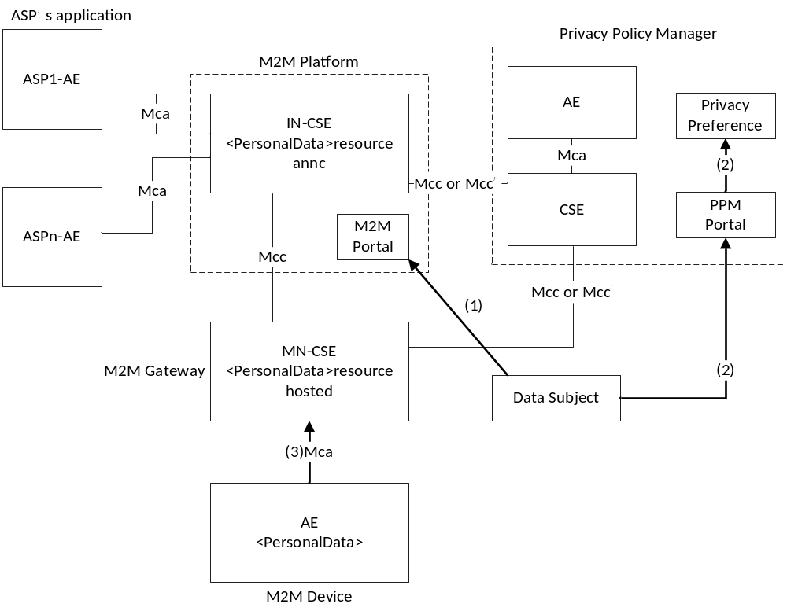
Figure 11.3.3.1-1: A data subject joins an IN-CSE
1. A data subject accesses the M2M portal of an IN-CSE:
- This process is typically uses Web access protocols such as HTTP, HTTPS and so on.
- This process is described in clause 11.4.1.2.
2. A data subject configures a privacy preference and registers it on the PPM portal. Then, the PPM shall create access control policies based on it:
- A data subject accesses the PPM portal, or the M2M portal redirects the data subject to the PPM portal. This process uses Web access protocols.
- This process is described in clause 11.4.1.2.
3. An ASN-CSE or MN-CSE collects and stores data from AE.

11.3.3.2 Subscription to a service by IN-AE
The data subject can subscribe to various kinds of services provided by IN-AEs through the IN-CSE. Service lists are registered on an M2M portal and the data subject can select services to subscribe to. When the data subject subscribes to a service, the data subject needs to accept a privacy policy. In order for the data subject to easily understand this policy, the PPM shall create the customized privacy policy based on the privacy policy provided by the IN-AE and the data subject's privacy preference. Therefore, the data subject can control personal data and agreement implies understanding of the privacy policy. Figure 11.3.3.2-1 shows the overview of this process.
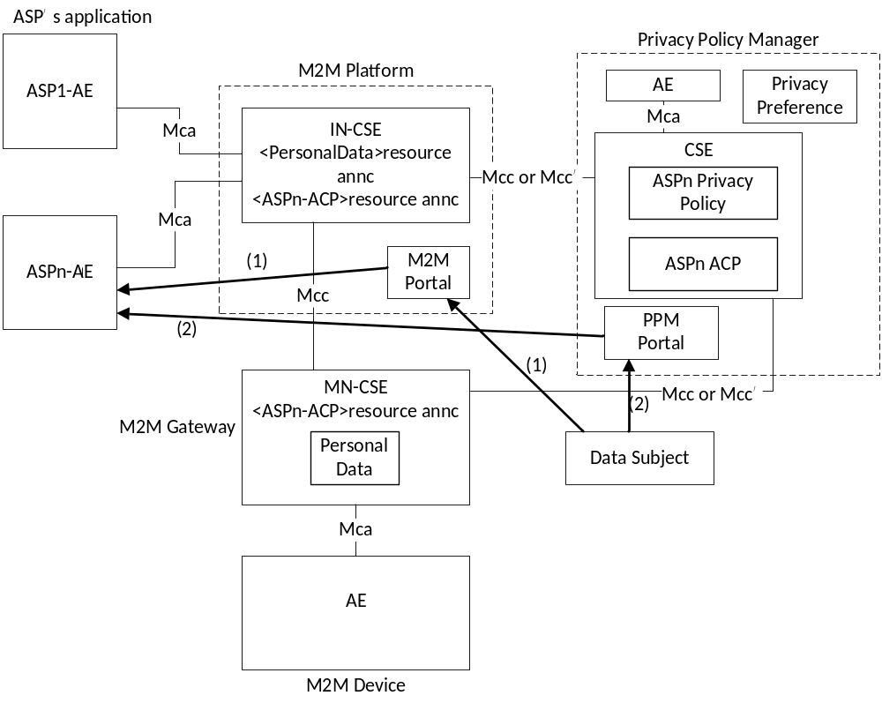
Figure: 11.3.3.2-1 The data subject subscribes to an IN-AE's service
1. The data subject accesses the portal and select an IN-AE's service to subscribe:
- This process typically uses Web access protocols such as HTTP, HTTPS and so on.
- This process is described in clause 11.4.1.1.
2. The data subject needs to accept a privacy policy to subscribe to the IN-AE's service. The PPM shall create the customized privacy policy for each data subject based on the data subject's privacy preference. It is easy for the data subject to confirm differences between the privacy preference and the privacy policy and to understand what kind of personal data are collected by the IN-AE. After the data subject accepts the privacy policy, the data subject can subscribe to the IN-AE's service:
- The function of creating a customized privacy policy is described in clause 11.4.1.3.
3. The PPM shall create or update access control policies using the privacy policy that the data subject accepted:
- The function of creating or updating access control policies in the PPM may rely on the authorization mechanisms specified in clauses 7.3 and 7.4. The details of the synchronization process are not specified in the present document.

11.3.3.3 Request for personal data to the IN-CSE
If the IN-AE needs personal data to provide the service, the IN-AE requests the data from the IN-CSE. The PPM shall work as either PDP or PRP.
- If the PPM works as PDP, PEP receives access decision from the PPM and controls the data access using them. Figure 11.3.3.3-1 illustrates the overview of this process.
- If the PPM works as PRP, PDP retrieves access control policies from the PPM and controls the data access using them. Figure 11.3.3.3-2 illustrates the overview of this process.
A. The PPM works as PDP
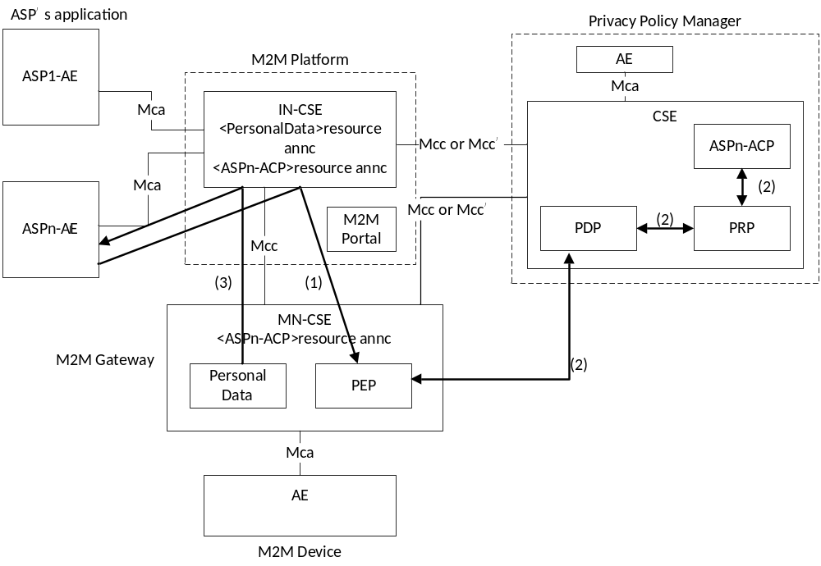
Figure 11.3.3.3-1: Request for personal data to the IN-CSE (the PPM works as PDP)
1. An IN-AE requests personal data from the IN-CSE.
2. PEP in the ASN-CSE or MN-CSE requests "Decision Request" from the PPM. The PPM shall decide to permit/deny access to personal data using access control policies. Then, the PPM shall reply "Decision Response" to the ASN-CSE or MN-CSE:
- In this case, the PPM shall provide an interface that enables access control for personal data using the PPM as PDP.
3. If accessing personal data is permitted, PEP accesses the personal data and sends the personal data to the IN-AE as a response.
B. The PPM works as PRP
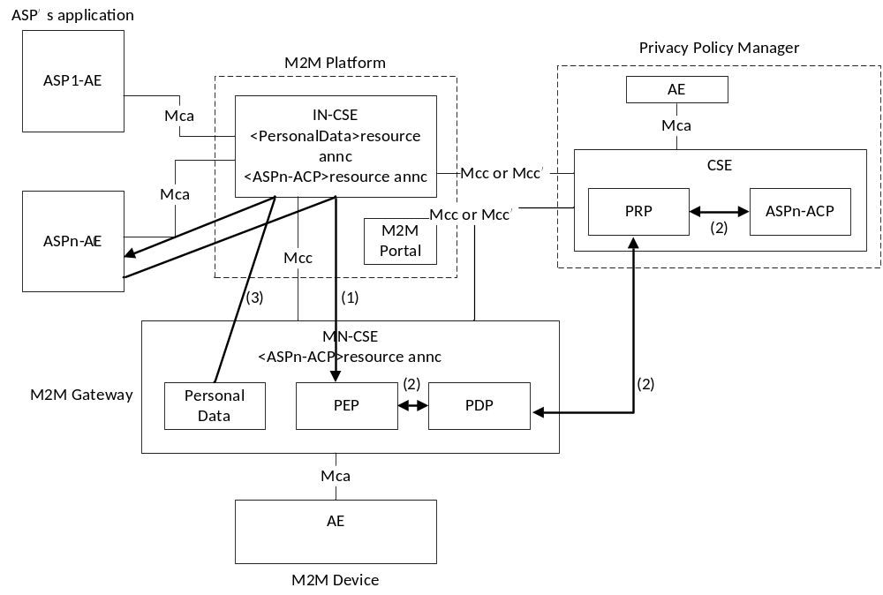
Figure 11.3.3.3-2: Request for personal data to the IN-CSE (the PPM works as PRP)
1. An IN-AE requests personal data from the IN-CSE.
2. PEP in the ASN-CSE or MN-CSE requests "Decision Request" from PDP. PDP requests "Policy Request" from the PPM. The PPM shall collect access control policies about "Policy Request" and send the access control policies as "Policy Response" to PDP in the ASN-CSE or MN-CSE. Then, PDP decides to permit or deny access to the personal data using the access control policies and sends a result as "Decision Response" to PEP:
- In this case, the PPM shall provide an interface that enables access control for personal data using the PPM as PRP. In present release, Direct Dynamic Authorization shall be used, with the PPM acting in the role of Dynamic Authorization Server (DAS). See clause 7.3.2.2 for details.
3. If accessing personal data is permitted, PEP accesses the personal data and sends the personal data to the IN-AE as a response.

11.4 Privacy Policy Manager Implementation Models

11.4.1 Using Terms and Conditions Mark-up Language

11.4.1.0 Introduction
Application/Device 1 to n
Descriptors

Application/Device 1 to n
Provider 1 T&C

Privacy tags 1 to n
Application/Device 1 to n
User #1 Preferences

Privacy tags 1 to n
Application/Device 1 to n
Legal 1 e.g. City

Privacy tags 1 to n
Application/Device 1 to n
Legal 2 e.g. State

Privacy tags 1 to n
Application/Device 1 to n
Presented to user#1 Provider 1 1

Application/Device 1 to n
Provider 2 T&C

Application/Device 1 to n
Presented to user #1 Provider 2

order of precedence
Privacy tags 1 to n
Privacy tags 1 to n
Privacy tags 1 to n
Privacy tags 1 to n
Privacy tags 1 to n
Privacy tags 1 to n
Privacy tags 1 to n
Privacy tags 1 to n
Privacy tags 1 to n
Privacy tags 1 to n
Application/Device 1 to n
Other e.g. Legal 4 Region

Privacy tags 1 to n

Selected (Yes)
Not Selected (No)
OK (Allowed)
Conflict
mandatory
Optional
Key
Application/Device 1 to n
Provider n T&C

Application/Device 1 to n
Legal 3 e.g. country

Figure 11.4.1-1: Privacy Policy Manager Implementation Model Using Terms
and Conditions Mark-up Language
The above model views the components of the Privacy Policy Manager (PPM) for one end user (#1) and one ASP (Provider 1), arranged as a number of selected/not selected filters in a series of stackable Filter Frames.
Four mandatory Filter Frames are defined:
- Descriptor Filter Frame.
- At least one "Provider Terms and Conditions" Filter Frame.
- User Preferences Filter Frame.
- At least one "Presented to user" Filter Frame.
Within each Filter Frame, there are grids representing the Privacy Tags in the Mark-up Language, vertically and the applications and/or devices, horizontally.
For the Provider Terms and Condition Filter Frame and User Preferences Filter Frame, each attribute represented by the privacy tag configured as being "selected" or "not selected" for a particular application/device is modelled by "dropping in" an appropriate coloured filter disc.
Discs at the same positions within one or more similarly structured "Presented to user Filter Frames" detect clear paths through the Filter Frame stack:
- Where provider terms and conditions and user preferences are in agreement, these discs turn green.
- Where the paths are blocked by one or more conflicts, similar detectors turn the discs red.
EXAMPLE: If the Application Service Provider expects the user to agree to location information to be collected and shared with a 3rd party, then the ASP selects those two attributes (clear discs) If the end user has set a preference that they don't want location information to be collected and shared, then there will be black discs in the User Preferences Filter Frame and path through the stack will be blocked.
Optional additional Filter Frames may be placed in the stack to "select" or "not select" those same features again by "dropping in" an appropriate coloured filter disc. For example, a country legal mandate may overrule an application Service Provider or end user selection. The position of these optional Filter Frames determines the precedence, with those at the front overruling those at the back.
The assumption with this model is that the vast majority of the provider attributes selected by the application Service Provider will not conflict with user preferences and will show green. However, there will be a very large numbers of devices, applications and frequency of software updates, and additions replacements of devices. While most will not result in a conflict, those that do will be instantly identified by one or more red discs which are only displayed to the end user, thus avoiding the need to constantly read and reread hundreds of pages of detailed T&C's.
There shall be an instance of this stack for each end user who is registered with the PPM and an instance for each Application Service Provider for which they have subscribed. However, the Descriptor Filter Frame and optional city/state/country/region Filter Frames may be shared resources for these instances.
While the description software implementation of this model is outside the scope of this specification, sample code for implementation of the logic is shown in annex K (informative).

11.4.1.1 Registration of Application Service Provider Privacy Policy
- Optional registration of an applications Privacy Policy shall be part of the process of obtaining a Registered App-ID for each application and version and presenting a security certificate to the oneM2M Registration Authority that is used to authenticate the application and version.
- The ASP shall download an application Terms and Conditions (T&C) import template from the oneM2M App-ID Registry server, if they do not already have the correct application T&C import template.
- The application T&C import template shall list in numeric order the tags in normative annex J.
- NOTE: The format of the T&C import template is left to implementation, as long as it is able to convey the information specified in annex J.
- For each tag in the list, the ASP shall provide a value for all devices and applications in the scope of the application that the ASP is registering in the format defined in normative annex J.
- The ASP shall process the application T&C import template using their local systems and procedures with input from devices vendors and third parties who provide components of their application to create one or more provider T&C's.
- The oneM2M App-ID Registry shall, at a minimum, also provide the ASP with the "descriptors list" in the language of the oneM2M partner to support the ASP in completing the T&C import templates to form the set of Provider T&C for that ASP.
- The security certificate that was used during the App-ID registration process shall also be used to ensure integrity and protect the completed application T&C import template in subsequent storage and transmission.
- The oneM2M App-ID Registry shall check the authenticity and integrity of the ASP T&C's by verifying the signature with the ASP public key certificate during App-ID Registration.
- Each ASP or software vendor T&C completed shall be associated to the App-ID in the oneM2M App-ID Registry.

11.4.1.2 Registration of End User Privacy Preferences
- When an end user subscribes to a service provided by an application service provider, the end user becomes a data subject, and the data subject downloads or views the end user privacy preferences template from the PPM Portal.
- The template used by the end user to state their privacy preferences shall align with the template used by the Application Service Provider i.e. the tags as listed in normative Annex J shall be displayed in the same order.
- The end user selects and deselects attributes to state their privacy preferences which are then registered on the PPM using the same portal.

11.4.1.3 Creating a customized Privacy Policy for each end user
- To make it easy for the data subject to confirm differences between the privacy preference and the privacy policy:
a) If the ASP's selection of the feature represented by the tag value matches the privacy preference selected by the user for that Application/Device, then the corresponding "presented to user" indicator shall be set to green.
b) If the ASP's non selection of the feature represented by the tag value matches the privacy preference set by the user for that Application/Device, then the corresponding "presented to user" indicator shall be set to green.
c) If the ASP's value selected for the feature represented by the tag value matches the privacy preference selected by the user for that Application/Device, then the corresponding "presented to user" indicator shall be set to green.
d) If the ASP's selection of the feature represented by the tag value does not match the privacy preference selected by the user for that Application/Device, then the corresponding "presented to user" indicator shall be set to red.
e) If the ASP's non selection of the feature represented by the tag value does not match the privacy preference selected by the user for that Application/Device, then the corresponding "presented to user" indicator shall be set to red.
f) If the ASP's value set for the feature represented by the tag value does not match the privacy preference set by the user for that Application/Device, then the corresponding "presented to user" indicator shall be set to red.
- The above rules shall be overridden if one or more optional preference profiles are present.
- The order of precedence shall be:
1) Legal Region.
2) Legal Country.
3) Legal City.
4) Legal State.
5) Parental Control.

Annex A (informative):
Mapping of 3GPP GBA terminology
Table A.1 provides a mapping of terminology and abbreviations used in GBA according to 3GPP specification [13] to corresponding oneM2M terminology and abbreviations as used within the present document.
Table A.1
GBA entities, keys and processes | oneM2M Security Bootstrap entities, keys & processes
UE | Enrolee
BSF | MEF
NAF | MAF
Bootstrapping Procedure | Bootstrap Security Handshake + Temporary Enrolment Key Generation
Ks | Ke
B-TID | KeId
Bootstrapping Usage Procedure | Usage in MAF Handshake
NAF FQDN | IdMAF
Ks_(ext/int)_NAF | Km (Master Credential)

Annex B (informative):
General Mutual Authentication Mechanism

B.0 Introduction
oneM2M mutual authentication schemes allow oneM2M entities to prove that they know related credentials such as Master Credentials, without having to exchange value of those credentials, and sensitive data such as security identities and security identifiers. To prevent reading and copying of credentials, a secure environment within the Security CSF provides protection against tampering of those credentials and related processed information.
A general mutual authentication protocol is applied to both symmetric and asymmetric key based schemes. Precise protocol messages and parameters depend on the chosen scheme and the security parameters selected. Typically it consists of following steps as shown in figure B.1.
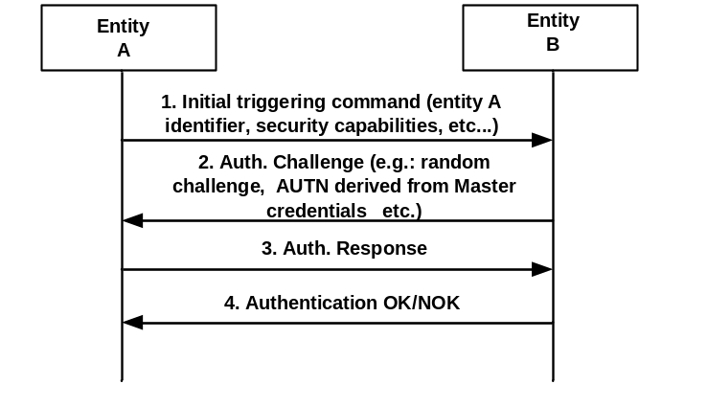
Figure B.1: Mutual Authentication
1. An initial step where an entity A is securely identified to an entity B with whom previous or no previous contact has been made. In this step entity A identifies itself to an entity B protected against eavesdropping, i.e. no exchange of key materials (Master Credentials).
2. In the second step entity B sends a challenge to entity A. The Authentication Challenge consists of a challenge, the authentication token (AUTN) of entity B derived from Master Credentials, etc. The authentication challenge, which may be random or not, depends on the chosen authentication scheme and the security parameters selected for symmetric and asymmetric key based schemes.
3. Entity A replies with an Authentication Response that contains an authentication token (AUTN) derived from its known Master Credentials and the received Authentication Challenge. This Authentication Response is sent if entity B has been successfully authenticated by entity A.
4. Entity B then verifies the relation between entity A's identity and the response received in step 3,. If the verification is positive, entity B is assured that the response has been created by entity A using a secret associated with entity A's identity provided in step 1.

B.1 Group Authentication
The oneM2M transactions may naturally involve groups of M2M entities rather than individual ones. A number of entities are classified as a group due to their proximate locations, having the same features, belonging to the same owner, or any other reasons [i.3]. To get services, all entities in such a group should be authenticated first. The traditional authentication mechanism has two main solutions, the first authentication mechanism is that the service provider authenticates each entity in the group one by one; the second authentication mechanism is that each entity makes mutual authentication with a group agent, then the group agent makes mutual authentication with the service provider. If the first authentication mechanism is used, the resulting authentication overheads of computation and communication may be too high to afford. If the second authentication mechanism is used, it has the following security weaknesses:
- It may exist the man-in-the-middle attack by the group agent: The group agent would be placed in unsecure place or owned by different provider rather than the service provider. If the group agent is compromised or lie to service provider, group agent would act as a middle attacker to make fake authentication to entities and report fake identity to service provider since there is no direct authentication from service provider to each M2M entity.
- Privacy concern: All information from M2M entities is transferred through the group agent, and the group agent knows all information generated by each entity. Based on security consideration, if the group agent is owned by different owner other than the entities' and service providers' owner, the group agent should not get the message.
Hence, the M2M entities (e.g. ASN or ADN) with the same feature can utilize group authentication to service provider (e.g. infrastructure node) in order to provide end-to-end secure tunnel as well as reducing the communication overhead.

Annex C (normative):
Security protocols associated to specific SE technologies

C.0 Introduction
The Secure Environment supporting security functions specified by oneM2M provides a level and a type of protection (e .g. integrity protection, confidentiality, tamper resistance) to the information it contains, independently of the method of protection (e.g. UICC, embedded security element, TEE, etc.). Administration of their content is implementation dependent and relies on existing standards within specific Secure Environment technologies. Some of them are listed below for information.

C.1 UICC
In case of UICC (SE compliant with ETSI TS 102 671 [23]), OTA mechanisms as specified in [7] and [8], and its extensions [9], [10] for 3GPP underlying networks or [11] and [12] for 3GPP2 underlying networks shall be used to securely administrate the sensitive data of the M2M Service Layer. UICC provides the highest protection level 3 against attacks according the Classification of Protection levels table 6.2.1-1 in clause 6.2.1.

C.2 Other secure element and embedded secure element with ISO 7816 interface
In case the Secure Environment is implemented as a security element or as an embedded security element supporting an ISO/IEC 7816 interface [26], example of remote administration can be according to GlobalPlatform Remote Administration [47]. An embedded secure element provides the highest protection level 3 against attacks according the Classification of Protection levels table 6.2.1-1 in clause 6.2.1.

C.3 Trusted Execution Environment
In case the secure environment is implemented as a Trusted Execution Environment (TEE) according to GlobalPlatform [22], remote administration shall be performed according to GlobalPlatform Remote Administration [21]. TEE provides the medium protection level 2 against attacks according the Classification of Protection levels table 6.2.1-1 in clause 6.2.1.

C.4 SE to CSE binding
In case the SE is implemented as an independent security element supporting ETSI TS 102 221 [24], the platform-to-platform secure channel specified in ETSI TS 102 484 [25] provides logical binding of the SE to a specific CSE or AE. This also protects the information exhanged between the SE and the associated entity on physically exposed interfaces, and is therefore recommended for devices that are physically exposed to attackers.

Annex D (normative):
UICC security framework to support oneM2M ServicesD.0 Introduction
This annex is applicable when UICC (a type of Independent Security Element compliant with ETSI TS 102 221 [24] and ETSI TS 102 671 [23]) is involved in M2M service layer security, whether it only serves as a mean to pre-provision M2M Service layer material in M2M Devices/Gateways, or it is further used as Secured Environment in an M2M Device/Gateway.
Specifically, the involvement of UICC in oneM2M security may include any of the following steps:
- Pre-provisioning of initial credentials in M2M nodes by any of the following methods:
- simple pre-provisioning and administration of M2M Service material (initial credentials and other pre-provisioned parameters), i.e. UICC-based M2M service provisioning;
- support for infrastructure assisted bootstrapping of the M2M symmetric credentials by derivation from symmetric Access Network credentials stored in the UICC, using GBA.
- Derivation of a security association key directly derived from symmetric Access Network Credentials, using GBA. Note that this process can be supported by a Network Access Application on the UICC independently of the presence of the information structure specified in the present annex.
The support of UICC provisioning of M2M service subscription information shall be indicated in the M2M Service Table for the corresponding M2M Service Subscription as specified in the present annex.
The support of key derivation using GBA that may be used for bootstrapping or security association shall always be indicated in the Service Table of the UICC application of the Access Network Operator supporting the GBA infrastructure.
At the most basic level, UICC-based M2M pre-provisioning requires an interoperable framework to store and administrate related information in the UICC. Further involvement requires a framework for discovery of available services offered by the UICC for the hosting M2M field node. The purpose of the present annex is to specify this framework, which enables both initial service provisioning and remote security administration of the subscription information during the subscription lifetime.
A common scenario is where an M2M field node holds a UICC application protecting Access Network security credentials, and these credentials are used to derive M2M Service Layer security credentials used for M2M service bootstrapping or security association establishment in the service layer . As these scenarios require a trust agreement between the involved Access Network operator and M2M Service Provider, UICC support for M2M services in such situation shall be handled within the context of the associated Network Access application on the UICC. In particular, the UICC support for M2M credentials derivation using GBA shall be indicated within the UICC application of the Access Network operator. This is specified in clause D.1.
Even when the M2M Service Layer credentials are not derived from Access Network Credentials, the UICC may be used as a secure environment that securely protects the symmetric or asymmetric credential used to root security in an M2M field node. In such cases, the M2M subscription information and related methods constitute an independent application that resides on a UICC, in the sense of ETSI TS 102 221 [24]. In particular, ETSI TS 102 221 [24] specifies the application independent properties of the UICC/terminal interface such as the physical characteristics and the logical structure.
NOTE: A terminal in the sense of TS ETSI 102 221 [24] is the part of the M2M field node that holds the UICC, e.g. a communication modem or an M2M Node processing environment.
The specific properties of the M2M Service Provider Identity Module application holding symmetric credentials is specified in clause D.2.
The storage of M2M information elements in the UICC and the procedures used for communication between the hosting M2M field node and the UICC shall be as specified in the present annex. The present annex uses abbreviations and coding conventions defined in ETSI TS 102 221 [24].

D.1 Access Network UICC-based oneM2M Service Framework

D.1.1 Access Network UICC-based oneM2M Service Framework characteristics
An Access Network UICC-based oneM2M Service Framework is always associated with a single M2M Service Subscription and consists of a single DF, DF_{1M2M}, complying with the specifications in clause D.1.3, implemented in the ADF of a Network Access Application on the UICC. This situation addresses the case where a trust relationship has been established between the M2M SP and the AN operator owning the hosting ADF.
NOTE 1: This does not necessarily imply that the Access Network credentials of the corresponding ADF are used to derive the M2M Service Layer Credentials: e.g. an Access Network operator may refuse derivation from Access Network credentials to an M2M Service Provider, but may still accept to provide space on its UICC to pre-provision independent credentials or support service infrastructure-assisted bootstrapping.
There may be several oneM2M service frameworks (DF_{1M2M}) within the ADF of a single Access Network subscription, in case this Access Network subscription is used by several independent M2M Service subscriptions. The file IDs of the DF_{1M2M} in any ADF shall be listed under the corresponding entry in EF_{DIR} as specified in clause D.1.2.
NOTE 2: A single M2M service layer subscription can also use multiple access networks: such subscriptions are best provisioned in a dedicated ADF as specified in clause D.2.
The content of any DF_{1M2M} in an Access Network application ADF shall be as specified in clause D.1.3.

D.1.2 M2M Service Framework discovery for Access Network UICC
When a UICC Network Access application supports one or more M2M Service subscription, with a DF_{1M2M}, the EF_{DIR} entry corresponding to this UICC Network Access Application shall contain the following M2M related Data Objects:
- oneM2M Service Framework DO: defining the association between the identifier of one M2M Service Subscription provisioned in the ADF and the related DF corresponding to this M2M subscription. Likewise, each M2M Service Subscription is associated to one DF. Each of these DFs is hereafter referred as DF_{1M2M}.
There shall be as many oneM2M Service Framework Data Objects as there are M2M Service Subscriptions provisioned in the ADF.
Table D.1: Coding of oneM2M related DOs
Bytes | Length | Description | Status
1 | 1 | Discretionary template tag = '73' | M
2 | 1 | Length of the discretionary template = X | M
3 to (2+X) | X | Discretionary Template | X

Table D.2: Coding of oneM2M Discretionary Template related DOs
Bytes | Length | Description | Status
1 | 1 | oneM2M service specific data content tag = 'A2' | M
2 | 1 | M2M service specific data content length = Y | M
3 to (2+Y) | Y | M2M service specific data content | M

Table D.3: Coding of oneM2M Service Specific Data Content related DOs
Bytes | Length | Description | Status
1 | 1 | oneM2M supported service provisioning tag = '80' | M
2 | 1 | Length of the M2M supported service provisioning tag = A | M
3 to 4 | 2 | M2M Dedicated File Identifier for following M2M service subscription | M
5 to (A+2) | (A-2) | M2M Subscription Identifier | M

Coding:
- M2M Dedicated File identifier:
- Contain the file identifier of the DF1M2M associated to the provisioning of the M2M Service subscription identified in the DO.
- M2M Subscription Identifier:
- The identifier of the M2M service subscription provisioned in the DF_{1M2M} indicated in the Data Object, encoded in binary format.

D.1.3 Content of files at the DF_{1M2M} level

D.1.3.0 Introduction
This clause specifies the EFs for the M2M service provisioning specific to a single M2M service provider, defining access conditions, data items and coding. A data item is a part of an EF which represents a complete logical entity.
The file structure for DF_{1M2M} is illustrated in figure D.1.
 | ADF_{hosting AN}
DF_{1M2M}
(FID in EF_{DIR})
 |  |  |  | EF_{1M2MST} |  |  | EF_{1M2MSID} |  |  | EF_{1M2MSPID} |  |  | EF_{M2MNID}
 |  |  |  | '6F0A' |  |  | '6F02' |  |  | '6F03' |  |  | '6F04'
 |  |  |  | EF_{CSEID} |  |  | EF_{M2MAEID} |  |  | EF_{INCSEIDS} |  |  | EF_{MAFFQDN}
 |  |  |  | '6F05' |  |  | '6F06' |  |  | '6F08' |  |  | '6F09'
 |  |  |  | EF_{MEFID}
 |  |  |  | '6F07'

Figure D.1: File identifiers and directory structures of DF_{1M2M} in an hosting
Access Network application ADF

D.1.3.1 EF_{1M2MST} (oneM2M Service Table)
This EF indicates which optional oneM2M services are available for the corresponding subscription. If a service is not indicated as available in the oneM2M DF, the hosting M2M field node shall not select this service. The presence of this file is mandatory if optional services are provided by the subscription.
Identifier: '6F0A' |  |  |  | Structure: transparent |  |  | Mandatory
SFI: '0A'
File size: X bytes, X ≥ 1 |  |  |  |  | Update activity: low
Access Conditions:
READ ALW
UPDATE ADM
DEACTIVATE ADM
ACTIVATE ADM
Bytes |  | Description |  |  |  | M/O |  | Length
1 |  | Services n°1 to n°8 |  |  |  | M |  | 1 byte
2 |  | Services n°9 to n°16 |  |  |  | O |  | 1 byte
3 |  | Services n°17 to n°24 |  |  |  | O |  | 1 byte
4 |  | Services n°25 to n°32 |  |  |  | O |  | 1 byte
etc.
X |  | Services n°(8X-7) to n°(8X) |  |  |  | O |  | 1 byte
-Services
Contents: | Service n°1: |  | Local CSE-ID provisioning
 | Service n°2 |  | IN-CSE-ID list provisioning
 | Service n°3 |  | MAF FQDN provisioning
 | Service n°4 |  | Local M2M AE-ID list provisioning
 | Service n°5 |  | Bootstrapping: MEF address provisioning
 | Service n°6  Service n°7  Service n°8 |  | M2M-Node-ID information  GBA Secure Provisioning (see note)  GBA Secure Connection (see note)
NOTE: Services n°7 and 8 can only be available in a oneM2M Service Table located in a DF_{1M2M} hosted in the ADF of the Network Access Application from which the M2M Service Layer credentials are expected to be derived.

The EF shall contain at least one byte. Further bytes may be included, but if the EF includes an optional byte, then it is mandatory for the EF to also contain all bytes before that byte. Other services are possible in the future and will be coded on further bytes in the EF. Coding:
1 bit is used to code each service:
bit = 1: service available;
bit = 0: service not available.
- Service available means that the M2M Service Subscription provisioned in the current DF or ADF has the capability to support the service and that the service is available for the user of the M2M Service Subscription.
Service not available means that the service shall not be used by the M2M Service Subscription user, even if the M2M Service Subscription has the capability to support the service.
First byte:
 |  | b8 |  | b7 |  | b6 |  | B5 |  | b4 |  | b3 |  | b2 |  | b1
 |  |  |  |  |  |  |  |  |  |  |  |  |  |  |  |  |  |  | Service n°1
 |  |  |  |  |  |  |  |  |  |  |  |  |  |  |  |  |  |  | Service n°2
 |  |  |  |  |  |  |  |  |  |  |  |  |  |  |  |  |  |  | Service n°3
 |  |  |  |  |  |  |  |  |  |  |  |  |  |  |  |  |  |  | Service n°4
 |  |  |  |  |  |  |  |  |  |  |  |  |  |  |  |  |  |  | Service n°5
 |  |  |  |  |  |  |  |  |  |  |  |  |  |  |  |  |  |  | Service n°6
 |  |  |  |  |  |  |  |  |  |  |  |  |  |  |  |  |  |  | Service n°7
 |  |  |  |  |  |  |  |  |  |  |  |  |  |  |  |  |  |  | Service n°8

Second byte:
 |  | b8 |  | b7 |  | b6 |  | B5 |  | b4 |  | b3 |  | b2 |  | b1
 |  |  |  |  |  |  |  |  |  |  |  |  |  |  |  |  |  |  | Service n°9
 |  |  |  |  |  |  |  |  |  |  |  |  |  |  |  |  |  |  | Service n°10
 |  |  |  |  |  |  |  |  |  |  |  |  |  |  |  |  |  |  | Service n°11
 |  |  |  |  |  |  |  |  |  |  |  |  |  |  |  |  |  |  | Service n°12
 |  |  |  |  |  |  |  |  |  |  |  |  |  |  |  |  |  |  | Service n°13
 |  |  |  |  |  |  |  |  |  |  |  |  |  |  |  |  |  |  | Service n°14
 |  |  |  |  |  |  |  |  |  |  |  |  |  |  |  |  |  |  | Service n°15
 |  |  |  |  |  |  |  |  |  |  |  |  |  |  |  |  |  |  | Service n°16

etc.

D.1.3.2 EF_{1M2MSID} (oneM2M Subscription Identifier)
This EF contains the oneM2M Subscription Identifier, M2M-Sub-ID. There shall be only one TLV object within this EF.
Identifier: '6F02' |  | Structure: transparent |  |  | Mandatory
SFI: '02'
File size: X bytes |  |  | Update activity: low
Access Conditions:
READ ALW
UPDATE ADM
DEACTIVATE ADM
ACTIVATE ADM
Bytes | Description |  |  | M/O |  | Length
1 | M2M Subscription Identifier TLV data object |  |  | M |  | X bytes

The M2M Subscription Identifier value field shall contain the M2M-Sub-ID encoded as specified in oneM2M TS-0004 [4]. The tag value of the oneM2M Subscription Identifier TLV data object shall be '80'.

D.1.3.3 EF_{1M2MSPID} (oneM2M Service Provider Identifier)
This EF contains the oneM2M Service Provider Identifier, M2M-SP-ID, of the M2M Service Provider related to the subscription in EF_{1M2MSID}. There shall be only one TLV object within this EF.
Identifier: '6F03' |  | Structure: transparent |  |  | Mandatory
SFI: '03'
File size: X bytes |  |  | Update activity: low
Access Conditions:
READ ALW
UPDATE ADM
DEACTIVATE ADM
ACTIVATE ADM
Bytes | Description |  |  | M/O |  | Length
1 | M2M-SP-ID TLV data object |  |  | M |  | X bytes

The M2M-SP-ID Value field shall contain the M2M-SP-ID encoded as specified in TS-0004 [TS0004]. The tag value of the M2M-SP-ID TLV data object shall be '80'.

D.1.3.4 EF_{M2MNID} (M2M Node Identifier)
This EF contains the M2M-Node-ID supporting the local CSE. It may be used to logically bind a UICC to a specific M2M Node. If service n°6 is "available", this file shall be present. There shall be only one TLV object within this EF.
Identifier: '6F04' |  | Structure: transparent |  |  | Optional
SFI: '04'
File size: X bytes |  |  | Update activity: low
Access Conditions:
READ ALW
UPDATE ADM
DEACTIVATE ADM
ACTIVATE ADM
Bytes | Description |  |  | M/O |  | Length
1 to X | M2M-Node-ID TLV object |  |  | M |  | X bytes

The M2M-Node-ID Value field shall contain the M2M-Node-ID encoded as specified in oneM2M TS-0004 [4].

D.1.3.5 EF_{CSEID} (local CSE Identifier)
This EF contains the local CSE Identifier, CSE-ID, for the M2M field node associated to the subscription in EF_{1M2MSID}. If present, this file is used by the M2M field node to pre-provision the CSE-ID. If service n°1 is "available", this file shall be present. There shall be only one TLV object within this EF.
Identifier: '6F05' |  | Structure: transparent |  |  | Optional
SFI: '05'
File size: X bytes |  |  | Update activity: low
Access Conditions:
READ ALW
UPDATE ADM
DEACTIVATE ADM
ACTIVATE ADM
Bytes | Description |  |  | M/O |  | Length
1 | CSE-ID TLV data object |  |  | M |  | X bytes

CSE-ID TLV
Contents:
- The CSE-ID Value field shall contain the local CSE-ID formatted as a URI.
Coding:
- The URI shall be encoded to an octet string according to UTF-8 encoding rules as specified in IETF RFC 3629 [19]. The tag value of the URI TLV data object shall be '80'.

D.1.3.6 EF_{M2MAE-ID} (M2M Application Identifiers list)
This EF contains the list of M2M Application Identifiers (AE-IDs) for the local M2M applications supported by the subscription in EF_{1M2MSID}. If service n°4 is "available", this file shall be present.
Identifier: '6F06' |  | Structure: Linear fixed |  |  | Optional
SFI: '06'
Record length: X bytes |  |  | Update activity: low
Access Conditions:
READ ALW
UPDATE ADM
DEACTIVATE ADM
ACTIVATE ADM
Bytes | Description |  |  | M/O |  | Length
1 to X | M2M AE-ID LV data object |  |  | M |  | X bytes

M2M AE-ID LV
Contents:
- The Value field shall contain the M2M AE-ID formatted as a URI.
Coding:
- The URI shall be encoded to an octet string according to UTF-8 encoding rules as specified in IETF RFC 3629 [19].

D.1.3.7 EF_{INCSEIDS} (M2M IN-CSE IDs list)
This EF contains a list of pre-provisioned IN-CSE-ID used to determine the next point of contact after provisioning or M2M Service Bootstrapping. If service n°2 is "available", this file shall be present.
Identifier: '6F08' |  | Structure: Linear fixed |  |  | Optional
Record length: X bytes |  |  | Update activity: low
Access Conditions:
READ ALW
UPDATE ADM
DEACTIVATE ADM
ACTIVATE ADM
Bytes | Description |  |  | M/O |  | Length
1 to X | IN-CSE-ID LV data object |  |  | M |  | X bytes

IN-CSE-ID LV
Contents:
- The Value field shall contain the IN-CSE-ID formatted as a URI.
Coding:
- The URI shall be encoded to an octet string according to UTF-8 encoding rules as specified in IETF RFC 3629 [19].

D.1.3.8 EF_{MAFFQDN} (MAF-FQDN)
This EF is used to pre-provision the FQDN of the MAF to be used for M2M Service Connection after M2M Service Bootstrapping. If service n°3 is "available", this file shall be present. There shall be only one TLV object within this EF.
Identifier: '6F09' |  | Structure: Transparent |  |  | Optional
Length: X bytes |  |  | Update activity: low
Access Conditions:
READ ALW
UPDATE ADM
DEACTIVATE ADM
ACTIVATE ADM
Bytes | Description |  |  | M/O |  | Length
1 | MAF FQDN TLV data object |  |  | M |  | X bytes

MAF FQDN
Contents:
- The FQDN address of the MAF.
Coding:
- The MAF-FQDN shall be encoded to an octet string according to UTF-8 encoding rules as specified in IETF RFC 3629 [19]. The tag value of the MAF FQDN TLV data object shall be '80'.

D.1.3.9 EF_{MEFID} (M2M Enrolment Function Identifier)
This EF contains one or more M2M Enrolment Function addresses. The first record in the EF shall be considered to be of the highest priority. The last record in the EF shall be considered to be the lowest priority. If service n°5 is "available", this file shall be present.
Identifier: '6F07' |  | Structure: linear fixed |  |  | Optional
Record length: X bytes |  |  | Update activity: low
Access Conditions:
READ ALW
UPDATE ADM
DEACTIVATE ADM
ACTIVATE ADM
Bytes | Description |  |  | M/O |  | Length
1 to X | MEF Address LV data object |  |  | M |  | X bytes

MEF Address LV data object
Contents:
- Address of MEF, in the format of a FQDN, an IPv4 address, or an IPv6 address.
Coding:
- The format of the data object is as follows:
Field | Length (bytes)
Length | 1
Address Type | 1
MEF Address | Address Length

- Address Type: Type of the MEF address.
- This field shall be set to the type of the MEF address according to the following:
Value | Name
0x00 | FQDN
0x01 | IPv4
0x02 | IPv6
All other values are reserved

- MEF Address: Address of the M2M Service Bootstrap Function.
- This field shall be set to the address of the M2M Enrolment Function. When the MEF type is set to 0x00, the corresponding MEF Address shall be encoded to an octet string according to UTF-8 encoding rules as specified in IETF RFC 3629 [19].
Unused bytes shall be set to 'FF'.

D.2 oneM2M Service Module application for symmetric credentials on UICC (1M2MSM)

D.2.0 Introduction
This clause defines the oneM2M Service Module (1M2MSM), an application used for oneM2M Service Layer security functionalities and subscription provisioning based on symmetric credentials. This application resides on the UICC, an IC card specified in ETSI TS 102 221 [24]. In particular, ETSI TS 102 221 [24] specifies the application independent properties of the UICC/terminal interface such as the physical characteristics and the logical structure. There may be several 1M2MSM ADFs on a single UICC, corresponding to independent oneM2M Service Subscriptions.

D.2.1 oneM2M Service Module application file structure
This clause specifies the EFs for the oneM2M service Layer defining access conditions, data items and coding. A data item is a part of an EF which represents a complete logical entity.

D.2.1.1 Content of UICC files at the Master File (MF) level
Files at the UICC MF level are application independent as specified in ETSI TS 102 221 [24]. Only the EF_{DIR} and EF_{ICCID} files are mandatory on UICC for the purpose of 1M2MSM applications. In any case all files shall be as specified in ETSI TS 102 221 [24].

D.2.1.2 Content of files at the 1M2MSM ADF (Application DF) level
The EFs in the 1M2MSM ADF contain oneM2M subscription related information that is required for M2M field nodes operating in an oneM2M environment. This ADF shall be selected using its AID and information in EF_{DIR}. The AID for 1M2MSM applications shall be constructed as specified in ETSI TS 101 220 [27].
NOTE: The ETSI RID can be used for oneM2M pending assignment of a oneM2M dedicated RID in ISO/IEC 7816-5 [i.11].
The File IDs '6F1X' (for EFs), '5F1X' and '5F2X' (for DFs) with X ranging from '0' to 'F' are reserved under the 1M2MSM ADF for administrative use by the card issuer.
The DF_{1M2M} substructure used to isolate the provisioning of network access dependent M2M service related information in a Network Access Application ADF is not needed for access network independent provisioning of an M2M service subscription in a 1M2MSM ADF. Therefore, all the EFs specified in clause D.1.3 shall be present at the 1M2MSM ADF level. The file structure of the ADF_{1M2MSM} is illustrated in figure D.2.
 | ADF_{1M2MSM}
 |  |  |  | EF_{1M2MST} |  |  | EF_{1M2MSID} |  |  | EF_{1M2MSPID} |  |  | EF_{M2MNID}
 |  |  |  | '6F0A' |  |  | '6F02' |  |  | '6F03' |  |  | '6F04'
 |  |  |  | EF_{CSEID} |  |  | EF_{M2MAEID} |  |  | EF_{INCSEIDS} |  |  | EF_{MAFFQDN}
 |  |  |  | '6F05' |  |  | '6F06' |  |  | '6F08' |  |  | '6F09'
 |  |  |  | EF_{MEFID}
 |  |  |  | '6F07'

Figure D.2: File identifiers and directory structures of ADF_{1M2MSM}

D.2.2 oneM2M Subscription related procedures for M2M Service

D.2.2.0 Introduction
This clause specifies the procedures that shall be executed by M2M field nodes to interact with a oneM2M Service Subscription on UICC. They are applicable independently of the file structure supporting the oneM2M Service Subscription (1M2MSM ADF or DF_{1M2M} under a Network Access Application ADF), unless otherwise indicated.

D.2.2.1 Initialization - 1M2MSM Application selection
This procedure only applies to an M2M subscription supported in a 1M2MSM ADF.
If the M2M field node wants to engage in M2M operation, then after UICC activation (see ETSI TS 102 221 [24]), the M2M field node shall select a 1M2MSM application, if a 1M2MSM application is listed in the EF_{DIR} file, using the SELECT by DF name as defined in ETSI TS 102 221 [24].
After a successful oneM2M application selection, the selected oneM2M AID is stored on the UICC. This application is referred to as the last selected 1M2MSM application. The last selected 1M2MSM application shall be available on the UICC after a deactivation followed by an activation of the UICC.
If a oneM2M application is selected using partial DF name, the partial DF name supplied in the command shall uniquely identify a 1M2MSM application. Furthermore if a 1M2M application is selected using a partial DF name as specified in ETSI TS 102 221 [24] indicating in the SELECT command the last occurrence, the UICC shall select the oneM2M application stored as the last oneM2M application. If, in the SELECT command, the options first, next/previous are indicated, they have no meaning if an application has not been previously selected in the same session and shall return an appropriate error code.

D.2.2.2 1M2MSM session termination
This procedure only applies to a oneM2M subscription supported in a 1M2MSM ADF.
The oneM2M UICC session is terminated by the M2M field node as follows:
- The M2M field node shall indicate to the oneM2M UICC application that the termination procedure is starting, by sending a particular STATUS command.
- Finally, the M2M field node deletes all the M2M subscription related information elements from its memory.
- To actually terminate the session, the M2M field node shall then use one of the mechanisms described in ETSI TS 102 221 [24].

D.2.2.3 oneM2M Service discovery procedure
This procedure is used to discover the oneM2M related services offered by a oneM2M UICC.
The M2M field node shall perform the reading procedure with EF_{1M2MST}. If no oneM2M related service is indicated as available, the M2M field node shall assume that only the provisioning of mandatory parameters is available in this ADF.

D.2.2.4 oneM2M Service provisioning procedures
These procedures are used by an M2M field node in order to bootstrap an M2M service subscription provisioned on the UICC.
The M2M field node shall perform the reading procedure with EF_{1M2MSID} and EF_{1M2MSPID,} and EF_{CSEID}, EF_{M2MNID}, EF_{INCSEID}, EF_{MAFFQDN} according to available services indicated in EF_{1M2MST}.

D.2.2.5 oneM2M Application Identifiers provisioning procedure
This procedure provisions a list of M2M Application Identifiers that may be enabled on the M2M node in relation with the oneM2M Service Subscription.
Condition: Service number 4 shall be available in the oneM2M Service Table.
Under this condition, the M2M field node shall perform the reading procedure with EF_{M2MAEID}.

D.2.2.6 oneM2M Secure provisioning related procedures
These procedures are used by the M2M field node to perform M2M Secure Provisioning with the assistance of the UICC, depending on available services in EF_{1M2MST} and the supported AUTHENTICATE commands contexts (e.g. GBA support by a Network Access Application) indicated for the hosting ADF.
Secure Provisioning: MEF address Provisioning:
Condition: Service number 5 shall be available in the oneM2M Service Table.
Under this condition, the M2M field node shall perform the reading procedure with EF_{MEFID}, if the related service is available.
GBA Secure Provisioning:
This procedure is dependent on the Authentication Framework supported by the UICC and indicated in the Service Table of the hosting ADF.
After identifying the supported authentication framework, the M2M field node shall check availability of Service number 7 in EF_{1M2MST}: If the service is available, the D/G M2M Node shall perform GBA-related procedures with AUTHENTICATE - GBA security context (Bootstrapping Mode and Derivation Mode) with the parameters for GBA secure provisioning.

D.2.2.7 oneM2M Security Association related procedures
GBA secure connection:
This procedure is dependent on the Authentication Framework supported by the UICC and indicated in the Service Table of the hosting ADF.
After identifying the supported authentication framework, the M2M field node shall check availability of Service number 12 in EF_{1M2MST}: If the service is available, the M2M field node shall perform a GBA-related procedures with AUTHENTICATE - GBA security context (Bootstrapping Mode and Derivation Mode) with the parameters for GBA Security Association.

Annex E (informative):
Precisions for the UICC framework to support M2M Services

E.0 Introduction
The present annex provides further practical information related to the UICC framework for oneM2M described in annex D.

E.1 Suggested content of the EFs at pre-personalization
If EFs have an unassigned value, it may not be clear from the main text what this value should be. This annex suggests values in these cases.
Table E.1: Pre-personalized EF values
File Identification | Description | Value
'6F02' | 1M2M Service Subscription Identifier | '8000FF…FF'
'6F03' | 1M2M Service Provider Identifier | '8000FF…FF'
'6F04' | M2M Node Identifier | '8000FF…FF'
'6F05' | Local CSE Identifier | '8000FF...FF'
'6F06' | M2M Application Identifiers list | '00FF...FF' for each record
'6F07' | MEF Identifier | '00FF…FF' for each record
'6F08' | IN-CSE Identifiers list | '00FF...FF' for each record
'6F09' | MAF FQDN | '8000FF...FF'
'6F0A' | 1M2M Service Table | Operator/Service Provider dependant

E.2 EF changes via Data Download or CAT applications
This clause defines if changing the content of an EF by the UICC OTA protocol or by a CAT Application is advisable. Updating of certain EFs "over the air" or "over the Internet" could result in unpredictable behaviour of the UE; these are marked "Caution" in the table below. Certain EFs are marked "No"; under no circumstances should "over the air/over the internet" changes of these EFs be considered.
Table E.2: EF update behaviour
File identification | Description | Change advised
'6F02' | 1M2M Service Subscription Identifier | No
'6F03' | 1M2M Service Provider Identifier | No
'6F04' | M2M Node Identifier | Caution
'6F05' | Local CSE Identifier | Caution
'6F06' | M2M Application Identifiers list | Caution
'6F07' | MEF Identifier | Caution
'6F08' | IN-CSE Identifiers list | Caution
'6F09' | MAF FQDN | Caution
'6F0A' | 1M2M Service Table | Caution

E.3 List of SFI values at the ADF_{M2MSM} or DF_{M2M} level
Table E.3: SFI values
File Identification | SFI | Description
'6F02' | '02' | M2M Service Subscription Identifier
'6F03' | '03' | M2M Service Provider Identifier
'6F04' | '04' | M2M Node Identifier
'6F05' | '05' | Local CSE Identifier
'6F06' | '06' | M2M Application Identifiers list
'6F0A' | '0A' | 1M2M Service Table

All other SFI values are reserved for future use.

E.4 UICC related tags defined in annex J
Table E.4: UICC tags
Tag | Name of Data Element | Usage
'80' | MAF FQDN TLV data object | EF_{MAFFQDN}
'80' | M2M-Node-ID TLV Data Object | EF_{M2MNID}
'80' | Local CSE-ID TLV data object | EF_{CSEID}
'80' | M2M-SP-ID TLV data object | EF_{1M2MSPID}
'80' | M2M Subscription Identifier TLV data object | EF_{1M2MSID}
NOTE: The value 'FF' is an invalid tag value.

Annex F (normative):
Acquisition of Location Information for Location based Access Control

F.0 Introduction
When a request (resource access) is evaluated by a Hosting CSE and an accessControlLocationRegions parameter is defined in the privileges attribute of the <accessControlPolicy> resources, the Hosting CSE checks whether the location of the Originator of a request is in the specific regions or not. Therefore, the Hosting CSE retains the location of the Originator otherwise the Hosting CSE shall acquire the location or deny the access. This annex describes how to describe the location regions and obtain the location of the Originator.

F.1 Description of Region

F.1.1 Circular Description
The practical way of describing the region or area is the circular presentation and generally the circle is characterized by the co-ordinates of a center point of the circle and a radius. Geographically, the center point and radius is described as longitude and latitude, and meter respectively. For this description, the accessControlLocationRegions parameter shall be represented as a circle.
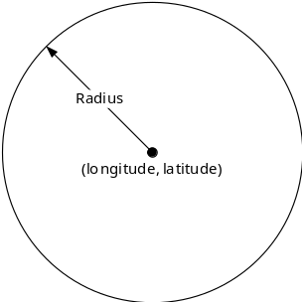
Figure F.1

F.1.2 Country Description
Another simple way of describing the region or area is the country presentation. ISO-3166-1 alpha 2 codes [i.10] are two-letter country codes to represent countries and special regions of geographical interest. For example, KR is a code for Korea, Republic of.

F.2 Acquisition of Location Information

F.2.0 Introduction
As mentioned above, when accessControlLocationRegions parameter is defined, the Hosting CSE shall check the location of the Originator for access control. This clause describes how the Hosting CSE checks or obtains the location. The procedures shall be varies based on the region description, circle and country.

F.2.1 Circular Description
If the circular description is used as the location context constraints, the Hosting CSE shall check whether it has the current location of Originator or not. If not, it shall obtain the location of Originator. TS-0001 [1] defines a resource type for acquisition of location of a Target Node, <locationPolicy>. In order to , therefore, obtain the location of Originator, the Hosting CSE shall create <locationPolicy> and set the relevant attributes as follows:
- locationSource: Reliability of the location information is crucial so the location shall be obtained from trusted network. If the location is obtained by the other sources, the location information can be easily masqueraded. (i.e. GPS spoofing). Therefore, the locationSource attribute shall be set to 'network-based'.
- locationTargetID: The Target Node shall be the Originator that needs to authorize the sent requests. The locationTargetID attribute shall be set to identifier of the Originator.
Note that the other attributes are determined by local policies of Hosting CSE as described in clause 9.6.9 of oneM2M TS-0001 [1] and in order to obtain the location from the network, the Hosting CSE shall transform the oneM2M specified location request into network specified request.
NOTE 1: Refer to oneM2M TS-0004 [4] that describes how to convert the oneM2M-specified request to 'OMA RESTful NetAPI for Terminal Location' specified request in clause annex F.
Since the region information (circular description) is defined by the accessControlLocationRegions parameter, the Hosting CSE can utilize the circular region information when it requests the location information from the network. OMA RESTful NetAPI for Terminal Location specification [i.9] specifies resource types as an area (region)-based location notification service, 'CircleNotificationSubscription'. If therefore the Hosting CSE subscribes to the notification service with circular region defined as acccessControlLocationRegions parameter, the Hosting CSE can always determine whether the Originator is in the regions or not. The figure below demonstrates how to acquire the location of the Originator when the accessControlLocationRegions parameter is defined.
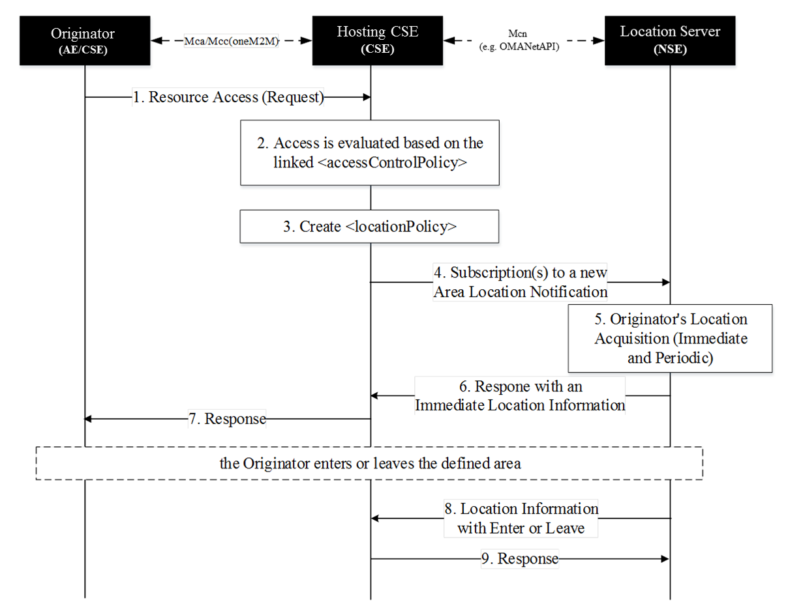
Figure F.2
1. The Originator sends a request to access a resource.
2. The Hosing CSE shall evaluate the received request against the linked <accessControlPolicy> resource. If one of rule tuples that is about the request originator contains the accessControlLocationRegions parameter (circular description) and the Hosting CSE does not store the location of the Originator, the Hosting CSE shall do either continue the next step or deny the access.
If the Hosting CSE has the location of the Originator, it is used for applying access control policy.
NOTE 2: The Hosting CSE shall deny the access due to the fact that the Originator is not subscriber of the network or any other reasons (e.g. connection lost, server malfunction).
3. The Hosting CSE creates the <locationPolicy> resource and set relevant attributes as mentioned above.
4. The Hosting CSE subscribes to a new area location notification service toward Location Server in the Network. The area information shall be based on the area defined by the accessControlLocationRegions parameters. If the multiple regions are defined, the multiple subscriptions shall be set.
5. The Location Server immediately obtains the location's Originator.
NOTE 3: After the immediate location acquisition, the Location Server periodically obtains the location's Originator to check whether the Originator is in the area or not. The frequency and duration can be defined by local policies.
6. The Location Server responses the immediate location information of the Originator toward Hosting CSE.
7. Based on the received location of the Originator and other access control policies the request can be either granted or denied. The Hosting CSE responses regarding the request (step 1).
8. When the Originator crossed in(enter) or out(leave) the area, the Location Server shall notify of the Hosting CSE the location change. Thus, the Hosting CSE can keep track of the location's Originator and easily evaluate the access against location context constraint.
9. The Hosting CSE response the notification.

F.2.2 Country Description
Generally, the Originator's country-scale location can be determined by the Originator's IP address. If the Hosting CSE can distinguish the country using the Originator's IP address and it is also matched with the defined acccessControlLocationRegions parameter, the Hosting CSE shall grant the request subject to the acceptance of the other access control policies. Note that how to transform the IP address into country is out of scope.
However, if Hosting CSE cannot distinguish the country using the Originator's IP address, The Hosting CSE shall obtain the location coordinate (i.e., longitude and latitude) of the Originator from network and the Hosting CSE can distinguish the country using the location if available. The way of obtaining the location coordinate is defined in annex F of oneM2M TS-0004 [4]. Note that how to transform the location into country is out of scope.

Annex G (informative):
Access Control Decision Request
An Access Control Decision Request as introduced in the Authorization Architecture in clause 6.2.2 is generated by a PEP according to an Originator's access request and extra information provided by the hosting CSE using the format specified by the PDP. The PEP can send the Access Control Decision Request to a PDP for an access control decision.
The PDP asks the PRP to retrieve all applicable access control policies according to the Access Control Decision Request, and then uses the Access Control Decision Request to evaluate the retrieved access control policies for an access control decision. An Access Control Decision Request from PEP to PDP can contain the following information:
- An Originator: It represents the ID of the Originator that sends an access request to the target resource.
- A Resource: It represents the URI of the target resource which the Originator wants to access.
- An Operation: It represents the operation which the Originator wants to perform on the target resource.
- An AccessTime: It represents the time of access.
- A LocationRegion: It represents the location of the Originator.
- An IPAddress: It represents the IP Address of the Originator.
The URI of the target resource is used to locate the target resource and then find the associated access control policies.
The ID of Originator is used to compare with the rule component subjects in order to check if a rule is applicable to the Access Control Decision Request.
The operation is used to compare with the rule component operations in order to check if the operation is permitted by the rule.
The AccessTime, LocationRegion and/or LocationRegion are used to check the rule component contexts in order to ensure some extra conditions are satisfied to using the rule for making an access control decision.

Annex H (informative):
Implementation Guidance and index of solutions
The use of the present document involves a context-specific risk assessment process from which relevant security solutions are identified.
Clause 6 provides an overview of oneM2M security procedures. Clause 6.1.1 presents the interactions between layers, clause 6.1.2 introduces the sequence of events, and clause 6.2 provides further background especially for authorization (clause 6.2.2).
Clause 7 on Authorization and Access Control applies regardless of the type of credentials used.
The present annex provides a table to assist implementers in identifying which clauses of the present document are relevant for a given type of credential.
Table H.1: Index of clauses specifying procedures per credential types
Procedure/Solution | PSK | Certificates | GBA/MAF
Remote security provisioning | 8.3.2.1 | 8.3.2.2 | 8.3.2.3 (GBA)
Remote security provisioning | 9.2.1.1 |  | 9.2.1.2, 9.2.2.3, 9.2.2.4 (GBA)
Security Association Establishment | 8.2.1
Security Association Establishment | 9.1.1.1, 9.1.2.1 |  | 9.1.1.2, 9.1.2.2 (MAF)
Security Association Establishment | 8.1.1, 8.2.2.1 | 8.1.2, 8.2.2.2 | 8.1.3, 8.2.2.3 (MAF)
Algorithm details | 10.2.1
Algorithm details | 10.2.2, 10.3 | 10.1, 10.2.3, 10.3

Annex I (informative):
Bibliography
- Open Mobile API specification V2.02.
- GlobalPlatform Device Technology TEE Client API Specification, Version 1.0.
- 3GPP TS 33.222: "Generic Authentication Architecture (GAA), Access to network application functions using Hypertext Transfer Protocol over Transport Layer Security (HTTPS) (Release 12)".
- 3GPP TS 24.109: "Bootstrapping interface (Ub) and network application function interface (Ua); Protocol details (Release 12)".
- 3GPP TS 29.109: "Protocols details Generic Authentication Architecture (GAA); Zh and Zn Interfaces based on Diameter protocol; Stage 3 (Release 12)".

Annex J (normative):
List of Privacy Attributes
Table J.1
Tag ID | Tag Name | Value | Parameter | Tag description (short form) | full Tag description | Notes
1.0 | Who | Null | Null | Name of party | The trading name of the device or service provider asking for access to the users smart devices/network/data
1.0 | Who | variable | Txt | company name | The name of the company that is requesting access to the user's smart devices and specifying their terms
1.0 | Who | variable | Country code | Location | The country where the device or service provider is located
1.0 | Who | variable | Txt | Company Registration number | Company Registration number
1.1 | ID |  |  |  | Options for how applications and devices are uniquely identified
1.1 | ID |  | Txt | Model number | These are the mobile number(s) of the device(s) if included in the ASP's service
1.1 | ID |  | Txt | Version | These are the version number(s) of the device(s) if included in the ASP's service
1.1 | ID |  | oneM2M Defined format | Registered App ID | These are the Registered App ID of the apps if included in the ASP's service
1.1 | ID |  | Country codes | Country codes where approval has been granted ( if needed | Device or app accreditation may only be valid in certain countries
2.0 | What |  |  | Data Classification Type | What is the type of data that the device/service will access? With the higher the value the more sensitive the data is.
2.0 | What | NA | Yes/No | No data gathered | the device does not gather any data, this could be output device, such as a light switch, that only receives instructions
2.0 | What | Non personal data | Yes/No | data not linked to a person | The data cannot be linked to a person, this could be applicable if the device was a door sensor that can only report then it was opened or closed.
2.0 | What | Anonymized data | Yes/No | Data is collected about a person but anonymized | Data is collected about a person but anonymized to remove or summarize any data that would allow an individual to the identified/profiled
2.0 | What | Personal data | Yes/No | Data that can be directly linked to an identify | The data gather can be linked to an identifier that is unique to an individual or small group (e.g. family members in the same home)
2.0 | What | Sensitive personal data | Yes/No | Data that can be linked to identify, of a more sensitive nature. | The EU DPA defines certain types of sensitive person data. Additional types such as banking should also be considered to see if they fall within this area.
2.0 | What | Medical data | Yes/No | Data related to an individual's health/fitness etc. | Data about illnesses, treatments or general wellbeing.
3.0 | When | Null | null | When the data is collected | How often data is sent
3.0 | When | NA | Yes/No | Not data collected | The device/service does not collect data, e.g. an end device such as a light
3.0 | When | Event based | Yes/No | Triggered by an event | Device only gathers data when triggered, such as a door sensor triggering a camera
3.0 | When | Variable Monthly | 1 to 12 | data Is sent monthly | The device/services only gathers the data as a monthly transfer. For example a smart fridge, sending a routine operational status report.
3.0 | When | Weekly | Yes/No | data is sent weekly | The device/service only gathers the data as a weekly transfer. For example a diagnostic status report from your fire detection system, including sensor test results, predicted remaining battery life.
3.0 | When | Daily | Yes/No | data is sent daily | The device/service only gathers the data on a daily transfer. For example a smart fridge sending the items that have run out as a Grocery list to the users preferred retailer so the retailer can short list them for inclusion in the users shopping basket.
3.0 | When | hourly | 1 to 24 | Data is sent every X hours | The device/service only gathers the data on an hourly transfer. For example a house alarm reporting it is armed and all sensors have reported they are active. So user alarm app/alarm monitoring service knows that system is still operational and someone has not been able to disable the alarm ability to send an alert.
3.0 | When | minutes | 1 to 60 | data is sent every X minutes | The device/service only gathers the data every 15th minutes. For example smart meters reporting back their usage figures.
3.0 | When | Real time-triggered | Yes/No | The data is sent continuously then triggered. | The data is sent in real time, when a specific event triggers it. E.g. The house alarm reports an internal door opening while alarm it set, this triggers the streaming of security cameras.
3.0 | When | Real time-full | Yes/No | The data is sent continuously at all times | The data is sent in real time for the duration of the device being active. For example CCTV data being sent to offsite storage.
3.1 | Time period | Null |  | time period of data | When data is sent, does it cover a time period
3.1 | Time period | NA | Yes/No | Not data collected | The device/service does not collect data, e.g. an end device such as a light
3.1 | Time period | summary/current status | Yes/No | The device send its current status | The Device sends the current status data, with no history e.g. the current status of a door sensor (open/closed) and not the log of when the door was opened and closed.
3.1 | Time period | Sample | Yes/No | The data covers a short period of time. | The data covers a sample of data from a short period of time, such a periodic sampling of heart rhythm being sampled several times a day.
3.1 | Time period | full history | Yes/No | The full data captured by the device is provided | The full data captured by the device is provided, either sent in real time (3.0) or history uploaded retrospectively.
3.2 | Sample rate | Null |  | the time period between data sampling | How long in seconds between samples been taken.
3.2 | Sample rate | NA | Yes/No | Not data collected | The device/service does not collect data, e.g. an end device such as a light
3.2 | Sample rate | Variable |  | value is seconds between data capture points | How long between readings that the device takes measured in seconds.
3.2 | Sample rate | Streamed data | Yes/No | Data is captured continuously | Data is captured continuously, such as a smart security camera able to stream the feed to the user.
4.0 | Where -stored | Null |  | Where the data is stored | Were the data created by the device or used by the service is stored
4.0 | Where -stored | NA | Yes/No | Not data collected | The device/service does not collect data, e.g. an end device such as a light
4.0 | Where -stored | Local | Yes/No | The data is only stored locally | The data is stored within the network of smart devices (e.g. within the home)
4.0 | Where -stored | variable |  | Nation/block | The nation were the data stored, or if part of a wider framework (such as the EU)
4.1 | Where -collected |  |  | Where the data is collected from. | Where is the data collected from -note this may be redundant for consumer, but could be used for external feeds such as weather reports. May also be relevant to services so they can state the tries of devices they will pull data from, as they may not want access to all smart devices in the location.
4.1 | Where -collected | NA | Yes/No | Not data collected | The device/service does not collect data, e.g. an end device such as a light
4.1 | Where -collected | Device | Yes/No | Data is collected just the specific device covered by T&C | The terms & conditions (also well as users privacy settings) are only be evaluated against the data collected by the specific device.
4.1 | Where -collected | Smart device network | Yes/No | Data is collect from all devices on the users network | The data is collected from all the devices* that form the users smart device network.
4.1 | Where -collected | variable |  | External feed | Data comes from an external feed, and is combined with data gather. E.g. Weather forecasts combined with users building utilization patens to predict, then to turn heating up so the building is at the desired temperature when the user arrives. | Note: this would be descriptive and the user would have two options. Disable or substitute (e.g. they have their own compatible weather station, instead of getting a feed from the meteorological office.
4.2 | Where -Processed | Null |  | Where is the data processed | Where (physical location) the data is processed. This may be different from the storage location
4.2 | Where -Processed | NA | Yes/No | Not data collected | The device/service does not collect data, e.g. an end device such as a light
4.2 | Where -Processed | Local | Yes/No | The data is only processed locally | The data in only processed on the device, or with the user's network of smart devices.
4.2 | Where -Processed | Variable |  | Nation/block | The nation were the data stored, or if part of a wider framework (such as the EU)
4.3 | Where -Accessed | Hull |  | Were the data is accessible from | Where the supplier/vendor/legal restrictions allow the data stored to be accessed from.
4.3 | Where -Accessed | NA | Yes/No | Not data collected | The device/service does not collect data, e.g. an end device such as a light
4.3 | Where -Accessed | Local | Yes/No | The data is only processed locally | The data in only processed on the device, or with the user's network of smart devices.
4.3 | Where -Accessed | Variable |  | Nation/block | The nation were the data stored, or if part of a wider framework (such as the EU)
5.0 | Why | Null |  |  | The prime reason why personal data is being collected and to allow any change of use to be notified to the user
5.0 | Why | Yes/No | Yes/No | For Direct Delivery of the service | The ASP collects information for the direct delivery of the service | E.g. using location for paging from a base station that the user is currently registered at
5.0 | Why | Yes/No | Yes/No | To improve ASP's and their partners products and services | The ASP collects information to improve ASP's and their partners products and services
5.0 | Why | Yes/No | Yes/No | To personalize services | The ASP collects information to personalize ASP's and their partners products and services | " our customers that selected this also selected these"
5.0 | Why | Yes/No | Yes/No | A legal requirement | The ASP collects information to meet a legal requirement | E.g. Minimum age of intended user used to determine access to resources
6.0 | Retention | Null |  | How long is data retained | How long the data (defined above) is kept in its current level of detail
6.0 | Retention | NA | Yes/No | Not data collected | The device/service does not collect data, e.g. an end device such as a light
6.0 | Retention | Zero retention | Yes/No | Zero data retention | After processing data, its immediately deleted
6.0 | Retention | Minutes | 1 to 60 | Data is kept for X minutes | Data is kept for 15 minutes before being deleted. E.g. the device only holds the last set of readings and collects new ones every 15 minutes.
6.0 | Retention | hour | 1 to 24 | Data is kept for X hour | Data is kept for X hours
6.0 | Retention | Day | 1 to 7 | data is kept for X day
6.0 | Retention | week | 1 to 4 | Data is kept for X week
6.0 | Retention | Month | 1 to 12 | Data is kept for X month
6.0 | Retention | Year | 1 to 10 | data is kept for X year
6.0 | Retention | forever |  | The data will be kept for ever | The data will be stored without a defined retention/deletion policy.
6.1 | retention -anonymized | null |  | how long anonymized data is kept | How long any anonymized or other derived data that is not directly linked to a unique identify is kept. E.g. stats on power usage by geo location
6.1 | retention -anonymized | Zero retention | Yes/No | Zero data retention | After processing data, its immediately deleted
6.1 | retention -anonymized | Minutes | 1 to 60 | Data is kept for X minutes | Data is kept for 15 minutes before being deleted. E.g. the device only holds the last set of readings and collects new ones every 15 minutes.
6.1 | retention -anonymized | hour | 1 to 24 | Data is kept for X hour | Data is kept for X hours
6.1 | retention -anonymized | Day | 1 to 7 | data is kept for X day
6.1 | retention -anonymized | week | 1 to 4 | Data is kept for X week
6.1 | retention -anonymized | Month | 1 to 12 | Data is kept for X month
6.1 | retention -anonymized | Year | 1 to 10 | data is kept for X year
6.1 | retention -anonymized | forever |  | The data will be kept for ever | The data will be stored without a defined retention/deletion policy.
6.2 | retention -summary | Null |  | how long summary data is kept | How long summary data is kept, e.g. how much total power was used per month based on meter readings taken every 15 minutes.
6.2 | retention -summary | Zero retention | Yes/No | Zero data retention | After processing data, its immediately deleted
6.2 | retention -summary | Minutes | 1 to 60 | Data is kept for X minutes | Data is kept for 15 minutes before being deleted. E.g. the device only holds the last set of readings and collects new ones every 15 minutes.
6.2 | retention -summary | hour | 1 to 24 | Data is kept for X hour | Data is kept for X hours
6.2 | retention -summary | Day | 1 to 7 | data is kept for X day
6.2 | retention -summary | week | 1 to 4 | Data is kept for X week
6.2 | retention -summary | Month | 1 to 12 | Data is kept for X month
6.2 | retention -summary | Year | 1 to 10 | data is kept for X year
6.2 | retention -summary | forever |  | The data will be kept for ever | The data will be stored without a defined retention/deletion policy.
7.0 | Sharing -full | Null |  | Who the full data is shared with. | Who outside the company has access to the full data by type
7.0 | Sharing -full | NA | Yes/No | Data is not shared outside the company | Data is not shared outside the company providing the device/service with not processing contracted out
7.0 | Sharing -full | Group | No/scope and reason | Data is only shared with companies in the same group | Data is only shared within other companies in the same group.
7.0 | Sharing -full | Infrastructure provider | Yes/No | Data is stored on 3rd party infrastructure | The data is stored on a separate company's servers e.g. the company providing the device/service uses a cloud provider for storage or processing. | Note: the answers for where reflect the 3rd party as well as the company offering the service/device.
7.0 | Sharing -full | Subcontractor | Yes/No | Data is shared with subcontractor(s) | Data is shared with one or more subcontractors who provide part of the service. | Note: the answers about location etc. reflect all subcontractors used.
7.0 | Sharing -full | Other contracted parties ancillary functions | No/scope and reason | Data is shared with other parties under contract | Data is shared with other parties under contract that provide additional (non-core) functions to use/operation of device. Such as providing newsletters, marketing offers etc. Local warranty repair places etc.
7.0 | Sharing -full | Affiliate | No/scope and reason | Data is shared with other private entities | Data is shared with other parties who have no direct or indirect involvement in the device/service. E.g. device suppliers sharing data with channel partners so they can target campaigns.
7.0 | Sharing -full | Public bodies | No/scope, reason, bodies | Data is shared with key public bodies | Data is shared then certain conditions with certain bodies. E.g. on triggering of an alarm, data for your security devices is shared with police so they can respond in a suitable fashion. Or if a medical alarm goes off the ambulance service/hospital etc. are sent details so they can respond.
7.1 | Sharing -anonymized | Null |  | Who the data is shared with. | Who outside the company has access to anonymized data by type of user
7.1 | Sharing -anonymized | NA | Yes/No | Data is not shared outside the company | Data is not shared outside the company providing the device/service with no processing contracted out
7.1 | Sharing -anonymized | Group | No/scope and reason | Data is only shared with companies in the same group | Data is only shared within other companies in the same group.
7.1 | Sharing -anonymized | Infrastructure provider | Yes/No | Data is stored on 3rd party infrastructure | The data is stored on a separate company's servers. E.g. the company providing the device/service uses a cloud provider for storage or processing.
7.1 | Sharing -anonymized | Subcontractor | Yes/No | Data is shared with subcontractor(s) | Data is shared with one or more subcontractors who provide part of the service.
7.1 | Sharing -anonymized | Other contracted parties ancillary functions | No/scope and reason | Data is shared with other parties under contract | Data is shared with other parties under contract that provide additional (non-core) functions to use/operation of device. Such as providing newsletters, marketing offers etc. Local warranty repair places etc.
7.1 | Sharing -anonymized | Affiliate | No/scope and reason | Data is shared with other private entities | Data is shared with other parties who have no direct or indirect involvement in the device/service. E.g. device suppliers sharing data with channel partners so they can target campaigns.
7.1 | Sharing -anonymized | Public bodies | No/scope, reason, bodies | Data is shared with key public bodies | Data is shared then certain conditions with certain bodies. E.g. on triggering of an alarm, data for your security devices is shared with police so they can respond in a suitable fashion. Or if a medical alarm goes off the ambulance service/hospital etc. are sent details so they can respond.
7.2 | Sharing -summary | Null |  | Who the data is shared with. | Who outside the company has access to summary data by type of user
7.2 | Sharing -summary | NA | Yes/No | Data is not shared outside the company | Data is not shared outside the company providing the device/service with no processing contracted out
7.2 | Sharing -summary | Group | No/scope and reason | Data is only shared with companies in the same group | Data is only shared within other companies in the same group.
7.2 | Sharing -summary | Infrastructure provider | Yes/No | Data is stored on 3rd party infrastructure | The data is stored on a separate company's servers. E.g. the company providing the device/service uses a cloud provider for storage or processing.
7.2 | Sharing -summary | Subcontractor | Yes/No | Data is shared with subcontractor(s) | Data is shared with one or more subcontractors who provide part of the service.
7.2 | Sharing -summary | Other contracted parties ancillary functions | No/scope and reason | Data is shared with other parties under contract | Data is shared with other parties under contract that provide additional (non-core) functions to use/operation of device. Such as providing newsletters, marketing offers etc. Local warranty repair places etc.
7.2 | Sharing -summary | Affiliate | No/scope and reason | Data is shared with other private entities | Data is shared with other parties who have no direct or indirect involvement in the device/service. E.g. device suppliers sharing data with channel partners so they can target campaigns.
7.2 | Sharing -summary | Public bodies | No/scope, reason, bodies | Data is shared with key public bodies | Data is shared then certain conditions with certain bodies. E.g. local councils gathering average water usage by geo-location.
8.0 | informing | Null
8.0 | informing | Y/N | Y/N | T&C's sent to email address registered by the end user | The device vendor application providers send their tag values in this table to an email address registered by the end user
8.0 | informing | URL | ACME.com/English/device type/model/T&C | T&C's by displayed URL | The device vendor application providers make their tag values in this table available at a URL | Could be automatically processed by the PPM portal
8.0 | informing | URL | ACME.com/English/device type/model/T&C | T&C's by URL stored in device | The device vendor application providers make their tag values in this table available at a URL stored in the device | Could be automatically processed by the PPM portal and or device
8.0 | informing | Y/N | Y/N | T&C;s on local Screen ( if present ) | The device vendor application providers make their tag values in this table available on the device screen ( if present)
8.0 | informing | Y/N | Y/N | On remote screen associated with user | The device vendor application providers make their tag values in this table available on remote screen associated with user
8.0 | informing | Y/N | Y/N | By post | The device vendor application providers send their tag values in this table to an postal address registered by the end user
8.0 | informing | Y/N | Y/N | SMS ( txt) | The device vendor application providers send their tag values in this table to an SMS number registered by the end user
9.0 | Obtaining consent | Null
9.0 | Obtaining consent |  | Y/N | Consent by In app default | User has to accept default by a single click in the app
9.0 | Obtaining consent |  | Y/N | Consent by End user signed document | Summary XML signed with end users private key e.g. digital signature
9.0 | Obtaining consent |  | Y/N | Consent by oneM2M recommended method | A oneM2M recommended method {TBA} | If this is defined in the future
10.0 | Protection | Null |  |  | Five levels to describe how well that the end user privacy and security is protected are defined. Level 1 is the lowest and Level 5 the highest. Each of these levels provides requirements expected for a claim at that level | These levels align with those already proposed by oneM2M WG4
10.0 | Protection | Protection level claimed | 1 | Protection level claimed = 1 | Level 1: lowest level with minimal claims that the end user privacy and security is protected. This level is used when minimum risk is associated with a breach of end user security and privacy
10.0 | Protection | Protection level claimed | 2 | Protection level claimed = 2 | Level 2: provides some level of confidence that the end user privacy and security is protected. Entities prove, through a secure authentication protocol, that the entity has control of the sensitive data/credentials. Controls are in place to protect against attacks on stored sensitive data/credentials.
10.0 | Protection | Protection level claimed | 3 | Protection level claimed = 3 | Level 3: provides high confidence that the end user privacy and security is protected. This level is needed when substantial risk is associated with breach of end user security and privacy. Multi-factor authentication is used. Any sensitive data or information exchanged in authentication protocols is cryptographically protected in transit and at rest.
10.0 | Protection | Protection level claimed | 4 | Protection level claimed= 4 | Level 4: provides very high confidence that the end user privacy and security is protected. This level is used when high risk is associated with a breach of end user security and privacy. This level provides the highest level of end user security and privacy. In addition to Level 3 this level requires the usage of tamper resistant hardware devices for the storage of all sensitive data such as cryptographic keys
10.0 | Protection | Protection level claimed | 5 | Protection level claimed = 5 | As level 4 but evidence of external accreditation/assurance available | May depend on work of oneM2M on device certification
11.0 | Age | Null |  |  | When relevant to privacy settings options for how the end users age can be determined e.g. DOB age range etc.
11.0 | Age | DD/MM/YYY |  | Date Of Birth | Claimed Date Of Birth of the end user to determine access to resources
11.0 | Age | Numeric value or range of values |  | Minimum age of intended user | Minimum age of intended user used to determine access to resources
11.0 | Age | DD/MM/YYY |  | Maximum age of device ( shelf life) | Maximum age of device ( shelf life) used to determine access to resources | For devices with embedded batteries that have a shelf life or chemicals in medical devices etc.

Annex K (informative):
Terms and Conditions Mark-up Language implementation rules
Typical implementation rules are shown below and are repeated for each row.
Note on conventions: {} identifies the answers to earlier if statement, [] identifies the Filter Frame and () contain comments. The logic has been shown with indents to better show the nesting of the statements. The logic works by checking the same rows on the Filter Frames being checked.
To generate the summary value for each row the follow logic is used.
If [Current Filter Frame] Value, is not equal to NA (Not applicable= No preference or limit set)?
{Yes} Is [Current Filter Frame] value equal to [Previous Filter Frame] summary value (compound value) of?
{Yes} [Current Filter Frame] Summary value equals Value set.
{No} is [current Filter Frame] Value set ="Yes"?
{Yes} [Current Filter Frame] Summary value set as [Previous Filter Frame] Summary value
{No} [Current Filter Frame] Summary value set as [Current Filter Frame] Summary value.
{No} [Current Filter Frame] summary value set as [Previous Filter Frame] Summary value
To generate the T&C acceptable symbol the following logic is used.
If [Current Filter Frame] Value equals "Yes"?
{Yes] [Current Filter Frame] T&C Acceptable set as "☺" (the smiley is used so the result displayed to the user is language agnostic as well as only requiring a small amount of screen space).
{No} [Current Filter Frame] Value equal [Previous Filter Frame]?
{Yes} [Current Filter Frame] T&C acceptable set as "☺"
{No} [Current Filter Frame] T&C Acceptable set as "☹"

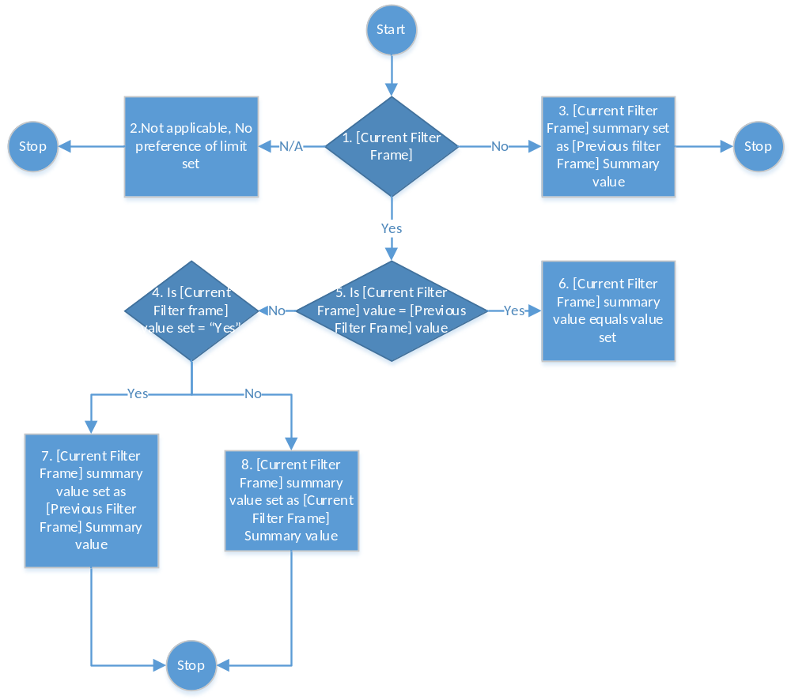
Figure K.1

