Input Contribution
Meeting ID* | SEC #26
Title:* | Use Case of Decentralized Authentication
Source:* | Jie Shi, Huawei, shi.jie1@huawei.com  Guilin Wang, Huawei, wang.guilin@huawei.com
Uploaded Date:* | 2016/12/07
Document(s)  Impacted* | TR-xxxx Decentralized Authentication
Intended purpose of  document:* | Decision  Discussion  Information  Other <specify>
Decision requested or recommendation:* | It is proposed to agree the content in this contribution.
Template Version:23 February 2015 (Dot not modify)

oneM2M Notice
The document to which this cover statement is attached is submitted to oneM2M. Participation in, or attendance at, any activity of oneM2M, constitutes acceptance of and agreement to be bound by terms of the Working Procedures and the Partnership Agreement, including the Intellectual Property Rights (IPR) Principles Governing oneM2M Work found in Annex 1 of the Partnership Agreement.

-----------------------start of change 1---------------------------------------------

X.1 Use case of Decentralized Authentication for Electronic Toll Collection (ETC) service
This use case is excerpted from TR-0026 and two security requirements are added.

X.1.1 Description
ETC is an important part of Intelligent Transportation System (ITS). It is vigorously promoted in many countries.
ETC aims to eliminate the delay on toll roads by collecting tolls electronically. ETC determines whether the vehicles passing are enrolled in the program, alerts enforcers for those that are not, and electronically debits the accounts of registered vehicle owners without requiring them to stop.
In the ETC Use Case, On Board Unit (OBU) is a dedicated device located in the vehicle and it can communicate with the local RSUs only. Stated differently, the communication between OBU and ETC platform is via the RSUs. With a vehicle moving, the OBU would connect to the next RSU and release connection with the previous RSU. It is necessary for the OBU to 'register' with ETC Service Platform for receiving M2M system services. The term 'registration' here refers to an OBU having its contextual information available at the ETC Service Platform. Such registration information is for the duration of an OBU being subscribed to services from the ETC Service Platform. At the same time, OBU 'registers' with local RSUs also, as OBU connects to different RSUs. Such registration context at the RSUs is temporary, and gets released as the OBU moves out of the range of the RSU and connects to the next RSU. The OBU uses its connectivity with local RSUs for achieving communication with ETC Service Platform.
As regards the 'registration context' between the OBU and the ETC Service Platform, the contextual information needs to reflect the complete profile of the OBU at the ETC Service Platform. Such information can include OBU identity, credentials, service subscription information, payment history, account balance etc. This is referred to here as 'full registration'.
As regards the 'registration context' between the OBU and the RSU, such contextual information is a subset of the contextual information at the ETC Service Platform for the said OBU. The information in this subset needs to be sufficient for the RSU to identify the OBU to the ETC Service Platform for the OBU to receive desired services without compromising any sensitive information to the RSU. This is referred to here as 'lightweight registration'

X.1.2 Source
REQ-2014-0431R03 Use cases for Electronic Toll Collection (ETC) service
REQ-2014-0449R02 Use cases for Electronic Toll Collection (ETC) service

X.1.3 Actors
- Vehicle Owner enrolls for ETC service.
- On Board Unit (OBU) is a M2M device used to store information such as identifier of the vehicle. The OBU typically does not communicate with the ETC Service Platform directly while receiving services. Direct communication between OBU and the ETC Service Platform may however be supported, out of band, for example for subscribing for ETC services.
- Road Side Unit (RSU) is a device which is an intermediate entity and is available to connect from OBU to the ETC Service Platform. Typical role of RSU can be implemented as an M2M gateway, and it may provide other functions as well (e.g., traffic light control, barrier control etc.).
- ETC Service Platform is responsible for collecting the information regarding the OBU via the RSU, including information such as location information from the RSU.
- ETC Service Provider provides its own M2M services for the user (OBU) through the ETC Service Platform.

X.1.4 Pre-conditions
- Vehicle owner enrolls his/her vehicle for ETC services.
- All RSUs have their respective context (registration information) available at the ETC Service Platform.

X.1.5 Triggers
A vehicle equipped with OBU drives close to an electronic road charging station which equipped with RSU.

X.1.6 Normal Flow
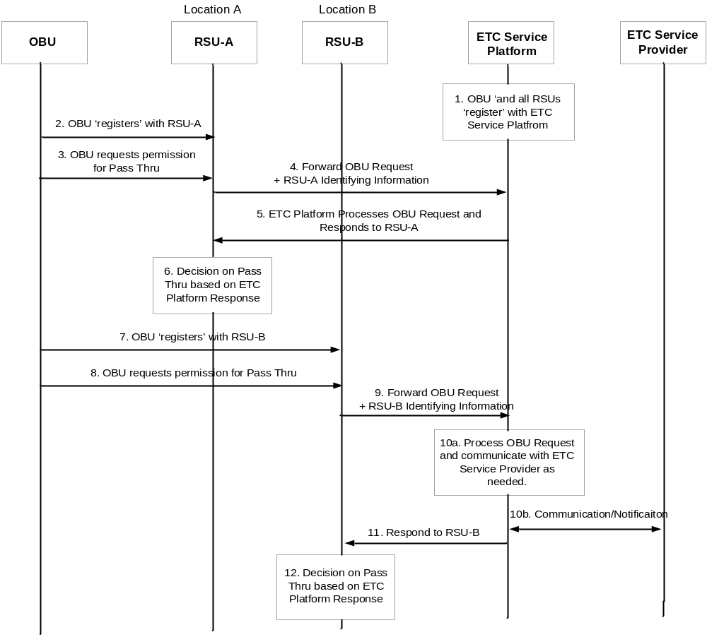
Figure X.1-1 Normal Flow for Electronic Toll Collection (ETC) service

- Vehicle owner subscribes to ETC services and the OBU is 'registered' with the ETC Service Platform. All RSUs are also registered with the ETC Service Platform.
- Note: The term 'registration' refers to communication and resulting contextual information of the registering entity at the registered entity.
- When the vehicle goes to a highway entrance (location A), OBU registers with RSU-A.
- The Vehicle (OBU) sends a request to ETC Service Platform via RSU-A asking for permission to pass through.
- RSU-A forwards the request from the OBU along with its own identifying information e.g. location information, to the ETC Service Platform.
- ETC Service Platform processes the request for the OBU, received from RSU-A, and responds to RSU-A. The processing at ETC Service Platform can include charging the 'toll' to OBU account and updating account balance etc., for the OBU. The response to RSU-A includes the recommended action for the OBU for pass through.
- RSU-A decides whether vehicle can pass through according to the response from the ETC Service Platform.
- The vehicle drives to the highway exit at location B, and OBU registers to RSU at location B (RSU-B).
- The vehicle sends a request to ETC Service Platform via RSU-B asking for permission for pass through.
- RSU-B forwards the request for the OBU along with its own information e.g. location information to the ETC Service Platform.
- ETC Service Platform processes the request for the OBU received from RSU-B. The processing at ETC Service Platform can include charging the 'toll' to OBU and updating account balance etc. for the OBU. The ETC Service Platform may communicate with the ETC Service Provider, as needed, while processing the request from the OBU.
- ETC Service Platform responds to RSU-B by including information such as the recommended action for the OBU to pass through.
- RSU-B decides whether vehicle can pass through according to the response from the ETC Service Platform.

X.1.7 High Level Illustration
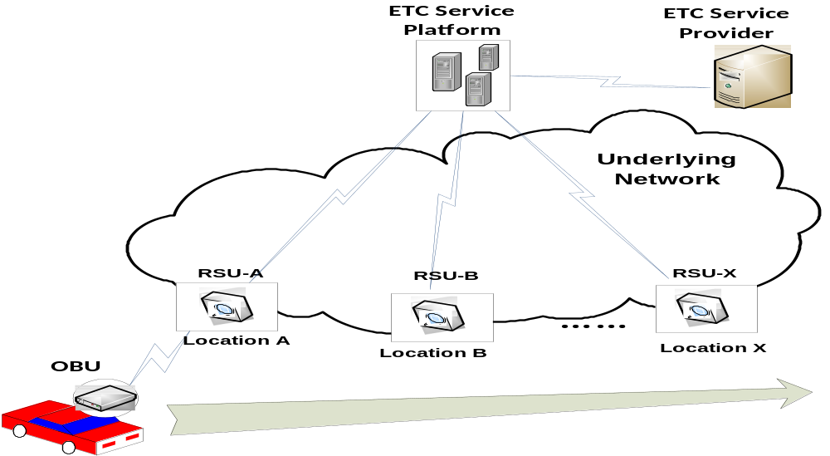
Figure x.1-2 High Level Illustration for Electronic Toll Collection (ETC) service

X.1.8 Potential Requirements
- The M2M system shall provide the capability for an M2M device to maintain registration with multiple entities simultaneously.
- The registration shall be able to include information that identify the peer entity, and other information such as its management privilege, subscription etc., that are necessary for the conduct of the respective peer relationships.
- It shall be possible for some registrations to hold the complete set of information context about the peer entity. This is refereed to as "full registration".
- It shall be possible for some registrations to hold only a subset of information context about the peer entity. This is referred to as "lightweight registration".
- It shall be possible for "lightweight registration" at different entities that pertain to a common peer entity, to hold different sets of information, if needed, about the common peer entity.
- It shall be possible to correlate the "full registration" and the "lightweight registration" that pertain to a common peer entity.
- It shall be possible to distinguish the "full registrations" and the "lightweight registrations" that pertain to a common peer entity.
- Many M2M devices (e.g. OBU) shall be able to performan mutual authentication with many M2M gateways to make sure the peer entity is a legal entity in the same M2M system. The mutual authentication shall be performed without involving any authentication server and as efficient as possible, e.g., the authentication message shall be as small as possible.
- Entities are all provisioned with appropriate credentials but shall not provisioned the credentials of their peer entites.

-----------------------End of change 1---------------------------------------------

