INPUT CONTRIBUTION
Group Name:* | MAS WG
Title:* | Adding semantics in OneM2M Architecture  Cross-domain scenarios, common terms to describe sensors, interoperability issues Semantic Web Guidelines for domain knowledge interoperability to build the Semantic Web of Things
Source:* | Eurecom, Amelie Gyrard, Christian Bonnet
Contact: | Amelie Gyrard, gyrard@eurecom.fr, Christian Bonnet, bonnet@eurecom.fr
Date:* | 2014-04-07, Last update: 2014-06-04
Abstract:* | This contribution proposes to share lessons learned:  - How to integrate semantics in the OneM2M architecture.  - Provide concrete cross-domain uses cases by being inspired by existing domain ontologies that we have already referenced for various uses cases (weather, transport, smart home, health, agriculture, tourism)  - Interoperability issues to reuse rules and ontologies generated by ontology/rule editor tools or semantic web frameworks.  - Propose a nomenclature for common terms to describe sensor and their measurements  - Popularize and spread the semantic web best practices, semantic web tools, and interoperability issues encountered with semantic web tools
Agenda Item:* | Tbd
Work item(s): | MAS
Document(s)  Impacted* | Study of Existing Abstraction & Semantic Capability Enablement Technologies for consideration by oneM2M.
Intended purpose of  document:* | Decision  Discussion  Information  Other <specify>
Decision requested or recommendation:* | This is an informative paper proposed by the French Eurecom institute as a guideline to MAS contributors on Semantic web best practices, as it was suggested during MAS#9.3 call. Amélie Gyrard is a new member in oneM2M (via ETSI PT1).

oneM2M IPR STATEMENT
Participation in, or attendance at, any activity of oneM2M, constitutes acceptance of and agreement to be bound by all provisions of IPR policy of the admitting Partner Type 1 and permission that all communications and statements, oral or written, or other information disclosed or presented, and any translation or derivative thereof, may without compensation, and to the extent such participant or attendee may legally and freely grant such copyright rights, be distributed, published, and posted on oneM2M’s web site, in whole or in part, on a non-exclusive basis by oneM2M or oneM2M Partners Type 1 or their licensees or assignees, or as oneM2M SC directs.
- Content
1. Content 3
2. List of Figures 6
2. Scope 7
3. References 8
4. Definitions, symbols, abbreviations and acronyms 11
4.1 Definitions 11
4.2 Symbols 11
4.3 Acronyms 11
5. Introduction 12
6. Integrate semantics in OneM2M Architecture 13
6.1 ETSI M2M architecture 13
6.2 OneM2M 14
7. Cross-domain uses cases: the weather domain can be reused in all domains 14
7.1 Weather & Transport 15
7.2 Weather & Smart Home 16
7.3 Weather & Agriculture 21
7.4 Smart Home & Healthcare 21
8. Our proposed nomenclature to describe, measurement and domain terms 23
8.1 Sensor names 23
8.2 Actuator names 25
8.3 RFID tags common terms 26
8.4 Measurement names 26
8.5 Domains 27
9. Our vision to improve related standards 27
9.1 W3C SSN 27
9.1.1 Standardize sensor-based domain ontologies 27
9.1.2 An ontology to explicitly describe the ssn:observationValue concept 30
9.2 W3C Web of Things 31
9.3 W3C OWL 31
9.4 IERC 31
10. Semantic web guidelines 31
10.1 Design your ontology 31
10.2 Describe domain knowledge at least written in English 31
10.3 Ontology best practices 32
10.3.1 Choose a good namespace 32
10.3.2 Publish online the ontology 33
10.3.3 Ontology URI deferencable, Content Negociation Problem 33
10.3.4 Reuse existing ontologies 35
10.3.5 Server-side configuration, Vapour 37
10.3.6 Ontology metadata: LOV recommendation 39
10.3.7 Provide an ontology documentation 40
10.3.8 Validate with OOPS 40
10.3.9 Validate your ontology with semantic web validators 41
10.4 Separate the ontology and the dataset 42
10.5 Dataset best practices 43
10.5.1 Documentation 43
10.5.2 Some tools to publish your data 43
11. Ontology matching issues 44
11.1 Combine two classes with the exact same word 44
11.2 Cannot map ontologies accessible through HTTPS 45
11.3 Do not use the etymology of words 46
11.4 Cannot interlink heterogeneous entities 46
12. Ontology interoperability 48
12.1 Protégé: ontology editor tool 48
12.2 OWL API: creating, manipulating and serialising OWL Ontologies. 48
12.3 TopBraid: build semantic web and linked data applications 49
13. Rules interoperability 50
13.1 OWL rules interoperability 51
13.1.1 OWL restrictions 52
13.1.2 OWL rules with OWL API 52
13.1.3 OWL rules with Protégé 53
13.1.4 OWL rules with OWLed2 54
13.1.5 OWL rules with topBraid 54
13.2 SWRL (Semantic Web Rule Language) 55
13.2.1 Jena rules 55
13.2.2 SWRL and DLSafeRule 55
13.2.3 Jess rules 56
13.3 SPIN (SPARQL Inferencing Notation) 56
13.4 RIF (Rule Interchange Format) 57
14. Reference the domain knowledge 57
14.1 Ontology catalogue 57
14.1.1 Linked Open Vocabularies (LOV) 57
14.1.2 Linked Open Vocabularies for Internet of Things (LOV4IoT) 58
14.2 Dataset catalogue 58
14.3 Rules Catalogue 60
15. Semantic web tools 60
15.1 Ontology editors, semantic API or framework 60
15.2 Linked Data API 61
15.3 Mapping tools 61
15.4 Linked data search search engines 62
15.5 Linked data browsers 62
15.6 Semantic Reasoner 62
15.7 Converter 62
15.8 Others 62
16. Syntax 62
16.1 Turtle 62
16.2 N3 Error! Bookmark not defined.
16.3 Rdf/xml Error! Bookmark not defined.

- List of Figures
Figure 1. Our propose semantic- based ETSI M2M architecture 13
Figure 2. Our proposed semantic-based OneM2M architecture 14
Figure 2. Reusing domain knowledge to build cross-domain ontology-based applications 15
Figure 3 Part of the ontology of activities - Riboni et al. [45] 18
Figure 4 Part of the ontology of symbolic locations - Riboni et al. [45] 19
Figure 5 Color code for the ontology status 28
Figure 6 Ontology status in the building automation domain 29
Figure 7 More 184 ontology status are classified by domain 30
Figure 5 Ontology only written in Chinese, Spanish or German is not easily reusable 32
Figure 6 Lafti et al. [29] design an health ontology both in English and French 32
Figure 7 The ontology does not have a good namespace 33
Figure 8 Bad practice since ontologies are in a zip file 33
Figure 9 Content negociation problem 34
Figure 10 The namespace and the ontology URI are not identical 34
Figure 11 The namespace and the ontology URI are identical 35
Figure 12 Staroch et al. define a smart home ontology related to the weather [50]. 36
Figure 13 SWEET ontologies 37
Figure 14 Vapour tool failed 38
Figure 15 Vapour error indicates to see the RFC 2616, section 14.30 39
Figure 16 Ontology metadata recommended by LOV 39
Figure 17 Documentation example 40
Figure 18 Do not describe 2 ideas in the same concept 40
Figure 19 RDF validator 41
Figure 20 The Oops tool detects errors when developing ontologies 42
Figure 21 The instance drunk (NamedIndividual) should be in a separate file (the dataset) 42
Figure 22 Linked Open Data Best practices 43
Figure 23 LogMap tool 44
Figure 24 LogMap works when tey are exactly the same words 45
Figure 25 LogMap issue with HTTPS 45
Figure 26 LogMap issue with the local file 46
Figure 27 LogMap does not detect that fog and foggy referred to the same idea 46
Figure 28 LogMap to interlink the driver state in two ontologies does not work since we cannot interlink classes, properties or instances. 47
Figure 29 Grausberg et al. [19] [18] defined the driver state (tired, drunk, stressed, distracted, ill, medicated) 47
Figure 30 Morignot et al. [36] [40] defined the driver emotion (tired, drunk, nervous, relaxed). 48
Figure 31 Chien et al. [14] design a tourism ontology with Protege 48
Figure 32 Ontology designed with OWL API [6] 49
Figure 33 Lopez et al. designed an emotion ontology [33] with TopBraid 49
Figure 34 Bujan et al. designed a tourism ontology with TopBraid and the rdf/xml syntax [2] and not in english 50
Figure 35 Hennessy, Ray et al. designed an emotion ontology with TopBraid and the turtle syntax [25] 50
Figure 36 Wongpatikaseree et al. [59] defines rules to infer activities 52
Figure 37 The Star-city ontology [30] defines rules to infer if it is snowy 52
Figure 38 The ThinkHome ontology [28] [44] defines rules to infer if it is snowy in the building automation domain. 53
Figure 39 Food tiscaly ontology[7] implemented with Protege 53
Figure 40 Ruta et al. [48] describe safety devices (abs, esp, and snow chains) related to the snow 54
Figure 41 Hennessy et al. [25] designed an health ontology in turtle with TopBraid 55
Figure 42 Vincent et al. [55] [56] design Jena rules in the security domain 55
Figure 43 Morignot et al. [36] [40] design DLSafeRule in the transportation system 55
Figure 44 Zografistou et al. [63] design Jess rules 56
Figure 45 Su et al. [52] design SPIN rules in the health domain 56
Figure 46 Efstathiou et al. [35] design SPIN rules in the smart home domain. 57
Figure 47 The Linked Open Vocabularies (LOV) catalogue 58
Figure 51 DataHub 59
Figure 52 Linked Open Data search engine 59
Figure 53 Protégé Editor tool 61

- Scope
The present document describes semantic web guidelines such as the best practices, interoperability issues, the semantic tools, and domain ontologies already existing to build the Semantic Web of Things (SWoT), a new field to combine Semantic Web technologies and Internet of Things.

We aim to bridge the gap between the Semantic Web and Internet of Things communities.
- References
[1] Kenza Abdelaziz, Philippe Roose, Sebastien Laborie, France Anglet, Bernd Amann, Tayeb Lemlouma, and France Lannion. Toward a context-aware and automatic evaluation of elderly dependency in smart homes and cities.
[2] Robert Barta, Christina Feilmayr, Birgit Pröll, Christoph Grün, and Hannes Werthner. Covering the semantic space of tourism: an approach based on modularized ontologies. In Proceedings of the 1st Workshop on Context, Information and Ontologies, page 1. ACM, 2009.
[3] AJ Bermejo, J Villadangos, JJ Astrain, and A Cordoba. Ontology based road traffic management. In Intelligent Distributed Computing VI, pages 103–108. Springer, 2013.
[4] Diego Berrueta and Jon Phipps. Best practice recipes for publishing rdf vocabularies-w3c working group note. World Wide Web Consortium (WC), Aug.,.: http://www. w3. org/TR/2008/NOTE-swbp-vocab-pub-20080828/.(Cit. on pp.,), 2008.
[5] D. Bonino and F. Corno. Dogont-ontology modeling for intelligent domotic environments. The Semantic Web-ISWC 2008, pages 790–803, 2008.
[6] Paul Brandt, Twan Basten, Sander Stuiik, Vinh Bui, Paul de Clercq, Lus Ferreira Pires, and Marten van Sinderen. Semantic interoperability in sensor applications making sense of sensor data. Ín Computational Intelligence in Healthcare and e-health (CICARE), 2013 IEEE Symposium on, pages 34–41. IEEE, 2013.
[7] F Calore, D Lombardi, Enrico Mussi, Pierluigi Plebani, and Barbara Pernici. Retrieving substitute services using semantic annotations: A foodshop case study. In Business Process Management Workshops, pages 508–513. Springer, 2008.
[8] Harry Chen. An intelligent broker architecture for context-aware systems. PhD proposal in Computer Science, University of Maryland, Baltimore, USA, 2003.
[9] Harry Chen, Tim Finin, and Amupam Joshi. Semantic web in the context broker architecture. Technical report, DTIC Document, 2005.
[10] Harry Chen, Tim Finin, and Anupam Joshi. An ontology for context-aware pervasive computing environments. The Knowledge Engineering Review, 18(03):197–207, 2003.
[11] Harry Chen, Tim Finin, and Anupam Joshi. The soupa ontology for pervasive computing. In Ontologies for agents: Theory and experiences, pages 233–258. Springer, 2005.
[12] Harry Chen, Tim Finin, Anupam Joshi, Lalana Kagal, Filip Perich, and Dipanjan Chakraborty. Intelligent agents meet the semantic web in smart spaces. Internet Computing, IEEE, 8(6):69–79, 2004.
[13] Harry Chen, Filip Perich, Tim Finin, and Anupam Joshi. Soupa: Standard ontology for ubiquitous and pervasive applications. In Mobile and Ubiquitous Systems: Networking and Services, 2004. MOBIQUITOUS 2004. The First Annual International Conference on, pages 258–267. IEEE, 2004.
[14] Hung-Yu Chien, Shyr-Kuen Chen, Ching-Yang Lin, Jia-Ling Yan, Wei-Chen Liao, Huan-Yi Chu, Kuan-Ju Chen, Bo-Fan Lai, and Yi-Ting Chen. Design and implementation of zigbee-ontology-based exhibit guidance and recommendation system.
[15] M. Compton, P. Barnaghi, L. Bermudez, R. Garcia-Castro, O. Corcho, S. Cox, J. Graybeal, M. Hauswirth, C. Henson, A. Herzog, et al. The ssn ontology of the w3c semantic sensor network incubator group. Web Semantics: Science, Services and Agents on the World Wide Web, 2012. http://www.w3.org/2005/Incubator/ssn/ssnx/ssn.
[16] Luke Ruth et Michael Hausenblas David Wood, Marsha Zaidman. Linked Data. Structured Data on the Web. 2014.
[17] Robert Eigner and Georg Lutz. Collision avoidance in vanets-an application for ontological context models. In Pervasive Computing and Communications, 2008. PerCom 2008. Sixth Annual IEEE International Conference on, pages 412–416. IEEE, 2008.
[18] Simone Fuchs, Stefan Rass, and Kyandoghere Kyamakya. Integration of ontological scene representation and logic-based reasoning for context-aware driver assistance systems. Electronic Communications of the EASST, 11, 2008.
[19] Simone Fuchs, Stefan Rass, Bernhard Lamprecht, and Kyandoghere Kyamakya. A model for ontology-based scene description for context-aware driver assistance systems. In Proceedings of the 1st international conference on Ambient media and systems, page 5. ICST (Institute for Computer Sciences, Social-Informatics and Telecommunications Engineering), 2008.
[20] Amelie Gyrard. A machine-to-machine architecture to merge semantic sensor measurements. In Proceedings of the 22nd international conference on World Wide Web companion, pages 371–376. International World Wide Web Conferences Steering Committee, 2013.
[21] Amélie Gyrard and Christian Bonnet. Semantic Web best practices: Semantic Web Guidelines for domain knowledge interoperability to build the Semantic Web of Things, 04 2014.
[22] Amélie Gyrard, Christian Bonnet, and Karima Boudaoud. Enrich machine-to-machine data with semantic web technologies for cross-domain applications. In WF-IOT 2014, World Forum on Internet of Things, 6-8 March 2014, Seoul, Korea, Seoul, KOREA, REPUBLIC OF, 03 2014.
[23] Janna Hastings, Werner Ceusters, Barry Smith, and Kevin Mulligan. The emotion ontology: enabling interdisciplinary research in the affective sciences. In Modeling and Using Context, pages 119–123. Springer, 2011.
[24] Tom Heath and Christian Bizer. Linked data: Evolving the web into a global data space. Synthesis lectures on the semantic web: theory and technology, 1(1):1–136, 2011.
[25] Rim Helaoui, Daniele Riboni, and Heiner Stuckenschmidt. A probabilistic ontological framework for the recognition of multilevel human activities. In Proceedings of the 2013 ACM international joint conference on Pervasive and ubiquitous computing, pages 345–354. ACM, 2013.
[26] Mark Hennessy, Chris Oentojo, and Steven Ray. A framework and ontology for mobile sensor platforms in home health management. In Engineering of Mobile-Enabled Systems (MOBS), 2013 1st International Workshop on the, pages 31–35. IEEE, 2013.
[27] Alan Jovic, Dragan Gamberger, and Goran Krstacic. Heart failure ontology. Bio-algorithms and med-systems, 7, 2011.
[28] Taehyung Kim, N Bae, M Lee, Changsun Shin, Jangwoo Park, and Yongyun Cho. A study of an agricultural ontology model for an intelligent service in a vertical farm. International Journal of Smart Homes, 7(4), 2013.
[29] M.J. Kofler, C. Reinisch, and W. Kastner. An intelligent knowledge representation of smart home energy parameters. In Proceedings of the World Renewable Energy Congress (WREC 2011), Linköping, Sweden, 2011.
[30] Fatiha Latfi, Bernard Lefebvre, and Céline Descheneaux. Ontology-based management of the telehealth smart home, dedicated to elderly in loss of cognitive autonomy.
[31] Freddy Lécué, Simone Tallevi-Diotallevi, Jer Hayes, Robert Tucker, Veli Bicer, Marco Sbodio, and Pierpaolo Tommasi. Star-city: Semantic traffic analytics and reasoning for city?
[32] Guanyu Li, Di Ma, and V Loua. Fuzzy ontology based knowledge reasoning framework design. In Software Engineering and Service Science (ICSESS), 2012 IEEE 3rd International Conference on, pages 345–350. IEEE, 2012.
[33] Hang Liu. Improving semantic interoperability in remote patient monitoring. Master’s thesis, 2013.
[34] Juan López, Rosa Gil, Roberto Garcá, Idoia Cearreta, and Nestor Garay. Towards an ontology for describing emotions. Emerging Technologies and Information Systems for the Knowledge Society, pages 96–104, 2008.
[35] Laurent Mazuel, Jean Charlet, et al. Alignement entre des ontologies de domaine et la snomed: trois études de cas. In Actes de la 20ème conférence Ingénierie des Connaissances-IC2009, 2009.
[36] Georgios Meditskos, Stamatia Dasiopoulou, Vasiliki Efstathiou, and Ioannis Kompatsiaris. Ontology patterns for complex activity modelling. In Theory, Practice, and Applications of Rules on the Web, pages 144–157. Springer, 2013.
[37] Philippe Morignot and Fawzi Nashashibi. An ontology-based approach to relax traffic regulation for autonomous vehicle assistance. CoRR, abs/1212.0768, 2012.
[38] Natalya F Noy, Deborah L McGuinness, et al. Ontology development 101: A guide to creating your first ontology, 2001.
[39] Federica Paganelli and Dino Giuli. An ontology-based context model for home health monitoring and alerting in chronic patient care networks. In Advanced Information Networking and Applications Workshops, 2007, AINAW’07. 21st International Conference on, volume 2, pages 838–845. IEEE, 2007.
[40] Federica Paganelli and Dino Giuli. An ontology-based system for context-aware and configurable services to support home-based continuous care. Information Technology in Biomedicine, IEEE Transactions on, 15(2):324–333, 2011.
[41] Evangeline Pollard, Philippe Morignot, and Fawzi Nashashibi. An Ontology-based Model to Determine the Automation Level of an Automated Vehicle for Co-Driving. In 16th International Conference on Information Fusion, Istanbul, Turquie, July 2013.
[42] Andreas Pomarolli, Stefan Anderlik, and Josef Küng. R2rif-rule integration plugin for protégé owl. In Computer Aided Systems Theory–EUROCAST 2011, pages 137–144. Springer, 2012.
[43] Davy Preuveneers, Jan Van den Bergh, Dennis Wagelaar, Andy Georges, Peter Rigole, Tim Clerckx, Yolande Berbers, Karin Coninx, Viviane Jonckers, and Koen De Bosschere. Towards an extensible context ontology for ambient intelligence. In Ambient intelligence, pages 148–159. Springer, 2004.
[44] Alan Rector, Nick Drummond, Matthew Horridge, Jeremy Rogers, Holger Knublauch, Robert Stevens, Hai Wang, and Chris Wroe. Owl pizzas: Practical experience of teaching owl-dl: Common errors & common patterns. In Engineering Knowledge in the Age of the Semantic Web, pages 63–81. Springer, 2004.
[45] C. Reinisch, M.J. Kofler, F. Iglesias, and W. Kastner. Thinkhome energy efficiency in future smart homes. EURASIP Journal on Embedded Systems, 2011:1, 2011.
[46] Daniele Riboni and Claudio Bettini. Cosar: hybrid reasoning for context-aware activity recognition. Personal and Ubiquitous Computing, 15(3):271–289, 2011.
[47] Daniele Riboni and Claudio Bettini. Owl 2 modeling and reasoning with complex human activities. Pervasive and Mobile Computing, 7(3):379–395, 2011.
[48] Daniele Riboni, Linda Pareschi, Laura Radaelli, and Claudio Bettini. Is ontology-based activity recognition really effective? In Pervasive Computing and Communications Workshops (PERCOM Workshops), 2011 IEEE International Conference on, pages 427–431. IEEE, 2011.
[49] Michele Ruta, Floriano Scioscia, Filippo Gramegna, and Eugenio Di Sciascio. A mobile knowledge-based system for on-board diagnostics and car driving assistance. In UBICOMM 2010, The Fourth International Conference on Mobile Ubiquitous Computing, Systems, Services and Technologies, pages 91–96, 2010.
[50] Oumy Seye, Catherine Faron-Zucker, Olivier Corby, and Corentin Follenfant. Bridging the gap between rif and sparql: Implementation of a rif dialect with a sparql rule engine. AImWD 2012, page 19, 2012.
[51] Kerry-Louise Skillen, Liming Chen, Chris D Nugent, Mark P Donnelly, William Burns, and Ivar Solheim. Ontological user modelling and semantic rule-based reasoning for personalisation of help-on-demand services in pervasive environments. Future Generation Computer Systems, 2013.
[52] Paul Staroch. A weather ontology for predictive control in smart homes. Master’s thesis, 2013.
[53] Thanos G Stavropoulos, Dimitris Vrakas, Danai Vlachava, and Nick Bassiliades. Bonsai: a smart building ontology for ambient intelligence. In Proceedings of the 2nd International Conference on Web Intelligence, Mining and Semantics, page 30. ACM, 2012.
[54] Chuan-Jun Su, Chang-Yu Chiang, and Meng-Chun Chih. Ontological knowledge engine and health screening data enabled ubiquitous personalized physical fitness (ufit). Sensors, 14(3):4560–4584, 2014.
[55] Mará Taboada, Mará Jesús Sobrido, Verónica Colombo, and Belén Pilo. A semantic web approach to integrate phenotype descriptions and clinical data. In Knowledge Representation for Health-Care, pages 16–26. Springer, 2011.
[56] Pierre-Yves Vandenbussche and Bernard Vatant. Metadata recommendations for linked open data vocabularies. Version, 1:2011–12, 2011.
[57] Johann Vincent, Christine Porquet, Maroua Borsali, and Harold Leboulanger. Privacy protection for smartphones: an ontology-based firewall. In Information Security Theory and Practice. Security and Privacy of Mobile Devices in Wireless Communication, pages 371–380. Springer, 2011.
[58] Johann Vincent, Christine Porquet, Idriss Oulmakhzoune, et al. Ontology-based privacy protection for smartphone: A firewall implementation. In International Conference on Secure Networking and Applications (ICSNA), 2011.
[59] Anusha Indika Walisadeera, Gihan N Wikramanayake, and Athula Ginige. An ontological approach to meet information needs of farmers in sri lanka. In Computational Science and Its Applications–ICCSA 2013, pages 228–240. Springer, 2013.
[60] Zachary Wemlinger and Lawrence Holder. The cose ontology: Bringing the semantic web to smart environments. In Toward Useful Services for Elderly and People with Disabilities, pages 205–209. Springer, 2011.
[61] Konlakorn Wongpatikaseree, Mitsuru Ikeda, Marut Buranarach, Thepchai Supnithi, Azman Osman Lim, and Yasuo Tan. Location-based concept in activity log ontology for activity recognition in smart home domain. In Semantic Technology, pages 326–331. Springer, 2013.
[62] Wen Yao, C Chu, Akhil Kumar, and Zang Li. Using ontology to support context awareness in healthcare. In Proceedings of the 19th Workshop on Information Technologies and Systems: Dec 14-15 2009; Phoenix, AZ, USA, 2009.
[63] Wen Yao and Akhil Kumar. Conflexflow: Integrating flexible clinical pathways into clinical decision support systems using context and rules. Decision Support Systems, 55(2):499–515, 2013.
[64] Jun Zhao et al. Publishing chinese medicine knowledge as linked data on the web. Chinese medicine, 5(1):1–12, 2010.
[65] Dimitra Zografistou. Support for context-aware healthcare in ambient assisted living. Master’s thesis, 2012.
- Definitions, symbols, abbreviations and acronyms
  - Definitions
SPIN: A W3C recommendation to design semantic-based rules.
SPARQL: A query language for RDF.
Jena: A framework to build semantic web applications.
AndroJena: A light version of Jena for constrained devices.
Sensor-based domain ontologies: Domain ontologies describing sensors, their measurement and related rules to infer new information in various IoT domains such as smart home, intelligent transportation systems, agriculture, tourism, healthcare, etc.
W3C SSN: is a working group for semantic sensor networks and designs a standardized ontology inspired by existing sensor ontologies.
  - Symbols

Good practices are explained

You can encounter some difficulties or errors by using tools.

  - Acronyms
IoT Internet of Things
M2M Machine-to-Machine
W3C World Wide Web Consortium
W3C SSN W3C Semantic Sensor Networks
W3C WoT W3C Web of Things
LOV Linked Open Vocabularies
SWoT Semantic Web of Things
SPIN (SPARQL Inferencing Notation)
SPARQL SPARQL Protocol and RDF Query Language
RDF Resource Description Framework
RDFS Resource Description Framework Schema
OWL Ontology Web Language
SWRL Semantic Web Rule Language
RIF Rule Interchange Format
M3 Machine-to-Machine ontology
SSN Semantic Sensor Networks
WoT Web of Things
- Introduction
Semantic Web of Things (SWoT) is a new field to combine Semantic Web technologies and Internet of Things. Firstly, domain experts constantly redefined new domain knowledge (ontology and rules) without considering the existing ones. Secondly, domain experts are not aware of the semantic web best practices or semantic web tools.
Our vision is that the OneM2M standard is relevant to provide:
- A semantic-based OneM2M architecture. We have already proposed a semantic-based ETSI M2M architecture in a previous work [20]. We updated this work to be compliant with the one proposed by OneM2M (see section 6).
- Cross-domain scenarios. We reference more 200 sensor-based domain ontologies to inspire us to build cross-domain scenarios which are relevant for OneM2M scenarios (see section 7).
- A nomenclature to describe common sensor, measurement and domain terms in a uniform way (see section 8). Indeed, there is a need to explicitly describe these information in all layers of the OneM2M architecture to ease interoperability, since we have discovered that existing works do not use the same terms to describe sensors and their measurements. We designed the Machine-to-Machine Measurement (M3) ontology according to this nomenclature [20] [22] to provide a basis for reasoning that can ease the development of cross-domain applications. Indeed, we define and link rules related to the sensor measurements described in a uniform way in M3.
- Standardize sensor-based domain ontologies (see section 9.1.1) as W3C SSN Working Group has standardized the W3C SSN ontology to combine existing sensor ontologies.
- Interoperability issues encountered with ontology editor tools (see section 12) to extract rules (see section 13) from existing sensor and ontology-based works.
- Popularize and vulgarize semantic web best practices and encourage domain experts to choose semantic web tools to develop the domain knowledge, in order to easily reuse their ontology-based works as presented in the OneM2M draft document [21] and remind in section 10. The following guidelines should be taken into account when defining new domain knowledge.

Such standardizations are relevant for other standardizations such as W3C SSN, W3C Web of things or IERC.
- Integrate semantics in OneM2M Architecture
We present in this section our proposed semantic-based architectures inspired by ETSI and OneM2M architectures.
  - ETSI M2M architecture
To handle heterogeneous sensors, protocols and formats, our proposed architecture is inspired by the ETSI M2M architecture. In our M2M-based architecture [20], as depicted in Figure 1, we integrate semantic web technologies both in the M2M gateways and the M2M applications. We propose two kinds of M2M gateways due to various treatments:
- M2M sensor gateways, use a protocol (senML or SWE) to retrieve heterogeneous M2M data measured by M2M devices and convert them in XML to provide an interoperable measurement. The sensor gateways forward these XML measurements to the aggregation gateways.
- M2M aggregation gateways semantically annotate XML M2M measurements. It is achieved by using semantic web languages (RDF, RDFS, OWL) and sensor-based domain ontologies.
Sophisticated semantic treatments are performed in M2M applications through semantic-based reasoning by reusing already defined sensor-based domain ontologies and semantic web technologies such as the SPARQL language, the Jena semantic web framework, the SWRL language to describe rules and the Linked Open Data.

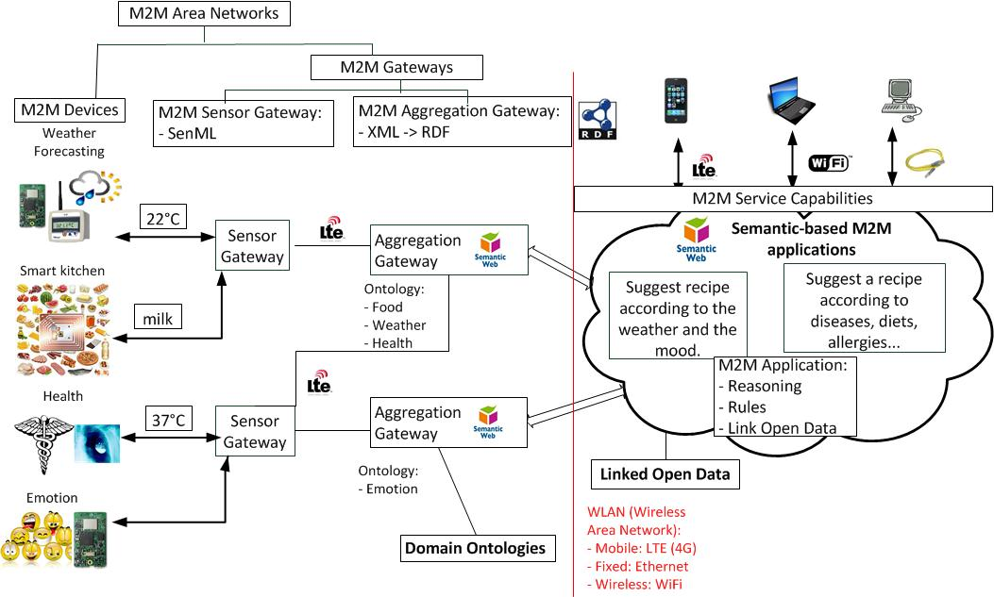
Figure 1. Our propose semantic- based ETSI M2M architecture
In our scenario, we have two aggregation gateways, the former manages semantic data related to food and the weather forecasting, the latter stores semantic data related to health and the brain waves to detect emotional states. M2M applications query both aggregation gateways and provide sophisticated web services such as suggesting the menu for dinner adapted to weather, season, user's health, mood and according to food available in the kitchen.
  - OneM2M
Our proposed semantic-based OneM2M architecture, as depicted in Figure 1, is composed of:
- Resource Gateway or Resource Server such as Raspberry Pi where we can integrate our SWoT framework to add semantics to sensor data and infer new information. The framework can be integrated as a JAR in Raspberry Pi.
- Semantic-based M2M Applications:
  - Accessible as RESTful web services in the cloud. Computers can query these web services. Developers get XML results, parse it and display it as they intent to without learning semantic web technologies. RESTful web services provide SPARQL queries already designed. This solution provides default scenarios but is not enough generic. A solution to be more generic could be to integrate the ELDA Linked Data API.
  - Use a SPARQL endpoint to query our semantically enriched sensor data, more generic but developers must be experts in SPARQL.
  - Integrate our SWoT framework in mobile devices. A light version of the Jena framework such as AndroJena could be integrated in constrained devices such as mobile phones.
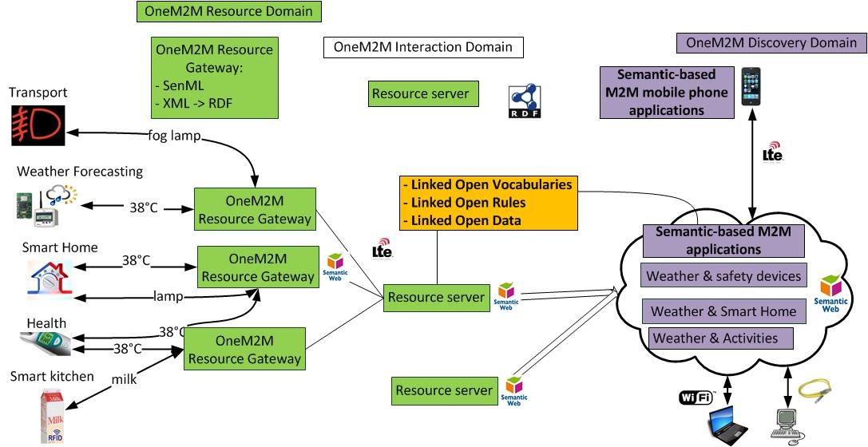
Figure 2. Our proposed semantic-based OneM2M architecture
- Cross-domain uses cases: the weather domain can be reused in all domains
We referenced domain ontologies which could be reused and extended with new concepts for use cases. The following ontologies are available and authors are improving the ontologies according to the semantic web guidelines. To find the corresponding ontology URL or more ontologies, you can search on this web page: http://www.sensormeasurement.appspot.com/?p=ontologies and the LOV project (http://lov.okfn.org/dataset/lov/).

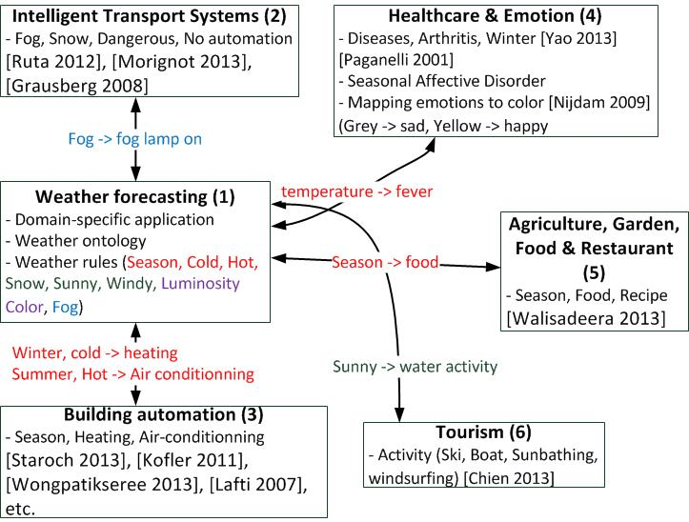
Figure 3. Reusing domain knowledge to build cross-domain ontology-based applications
  - Weather & Transport
Morignot et al. [37] [41] define two ontologies, the first one to deduce when it is better to be fully manual or automated according to environmental conditions and driver's state described in the second ontology. Indeed, lasers can be affected by bad weather conditions when it is rainy or snowy.
Ruta et al. [49] and Grausberg et al. [19] [18] design ontologies and describe that Weather conditions, Emotion Driver and Road type have to be taken into account when driving. Weather concepts were already defined in weather ontologies [45] [52] but they are not reused. Ruta et al. [49] design Semantic Web Rule Language (SWRL) rules that could be reused in other intelligent transportation systems, for example, switch on the fog lamp when it is foggy.
Ruta et al. [49] design rules such as :
- Rule HighWindSpeedSensorCar: IF HighWind THEN hasSensor_Speed (car) = Low_Speed
- Rule SnowySpeedSafetyDevice: IF Snowy THEN hasSensor_Speed = Low_Speed AND hasSafety_Device = (Snow_Chains, ABS, ESP)
- Rule RainySpeedSafetyDevice: IF Rainy THEN hasSensor_Speed = Low_Speed AND hasSafety_Device = (ABS, ESP)
- Rule FoggySpeedSafetyDevice: IF Foggy THEN hasSensor_Speed = Low_Speed AND hasSafety_Device = (Fog_Lamp, ABS)
Escola et al. [3] described rules in their ontology which is now referenced on LOV, such as change line, decelerate, accelerate, maintain distance with car in front and maintain speed.
Li et al. [32]describe the car ontology with related rules.
Eigner et al. [17] describe an ontology, but only in German, it is not easily reusable without labels or comments at least in English.
  - Weather & Smart Home
Staroch [52] designs an ontology for smart homes and related to the weather. This ontology is referenced by LOV. This ontology deduces if there is a need to irrigate the garden, to open the windows and when do we have to keep them shut, do we need sun protection? They define numerous concepts related to weather sensors such as temperature, humidity, dew point, wind speed and direction, precipitation intensity and probability, atmospheric pressure, cloud cover, solar radiation, sun’s position. They define more 50 SWRL rules defined as OWL restrictions in his ontology to deduce new information, for instance with a temperature measurement, we can infer:
- Frost (for an observed temperature value of below 0°C)
- Cold (at least 0°C and less than 10°C)
- Below room temperature (at least 10°C and less than 20°C)
- Room temperature (at least 20°C and at most 25°C)
- Above room temperature (more than 25°C and at most 30°C)
- Heat (more than 30°C).
Staroch’s rules:
- Wind direction in ° (West, East, North, South)
- Wind speed in m/s (Calm/Light/Strong, Storm, Hurricane)
- Temperature in °C (Frost, Cold, Below room temperature, room temperature, above room temperature, heat)
- Atmospheric pressure in hPa (very low, low, average, high, very high)
- Cloud cover in okta (Clear sky, partly cloudy, mostly cloudy, overcast, unknown cloud cover)
- Humidity in % (Very, Dry, Average, Moist, Very Moist)
- Precipitation mm/h (No rain, light, medium, heavy, extremely heavy, tropical storm rain)
- Solar radiation in W/m² (No radiation, Low, Medium, High, Very High)
- Sun position in ° (North, East, West, South)
- Sun elevation angle in degree (day, solar twilight, sun below horizon, twilight, civil twilight, nautical twilight, astronomical twilight, night)
Kofler et al. [29] propose the ThinkHome ontology [45], where they describe:
- Energy: nonrenewable energy such as coal, nuclear, oil, natural gas and renewable energy like water wind, solar, wood…
- Energy providers: electric, gas, water, wood.
- Energy tariffs
- Energy facilities
- Energies properties
Their prototype propose a self-regulation of heating and cooling system tailored to schedule (nigh-time, weekends, holidays, seasons). In their weather ontology, they defined more 40 rules related to wind speed, temperature, air quality and humidity described as owl:Restriction in the ontology:
- 16 rules related to wind speed deduce the kind of wind (Storm, NoWind, Light/Gentle, Fresh/Moderate/Strong Breeze, Light/Strong Wind, Thunderstorm, ViolentStorm, Hurricane, Fresh/Moderate/Strong Gale, AiringWeatherState, LightAir)
- 15 rules related to temperature (SnowyWeatherState, Cold, Thunderstorm, RoomTemperature, Frost, ExtremeHeat, AiringWeatherState, BelowOrZeroTemperature, ExtremeFrost, AboveRoomTemperature, CoolingWeatherState, Heat, BelowRoomTemperature, AboveZeroTemperature, RainyWeatherState)
- 5 rules related to air quality (VeryLow/VeryHigh/Medium/Low/High AirPollution)
- 4 rules related to humidity (Dry, Moist, Optimum, HumidifyingWeatherState)
Wongpatikaseree et al. [61] design the Ontology Based Activity Recognition (OBAR) system including an ontology to detect 13 activities in a smart home such as working on a computer, watching TV, reading a book, scrubbing the floor, sweeping the floor, sitting on the toilet, taking a bath, lying down & relaxing, sleeping, making coffee, cooking, eating or drinking, washing dishes. These rules are defined as OWL restrictions in the ontology. These rules are deduces from the following sensors:
- Water flow sensors to detect if sink, shower or flushing are used
- Magnetic sensors to deduce if cupboards have been opened or closed
- Gyroscope to detect if broom, mop or coffee bottle objects are used
- Infrared sensors to detect human location
- Pressure sensor attached on the bed to infer if the user used the object.
- Ultrasonic sensors are used to detect human position (standing, sitting, lying down)
Bonino et al. [5] design the DogOnt ontology, referenced by LOV, is one of the first ontology respecting the semantic web guidelines in the building automation domain. They describe the following concepts:
- Building environment (Room in a house such as Bathroom, Bedroom, DiningRoom, Kitchen, LivingRoom, Lobby, StorageRoom)
- Building thing: controllable (fridge, oven, coffee maker, alarm clock, printer) or not (wall, floor).
- Functionality (temperature regulation, light regulation)
- State (temperature state, light intensity state, on/off state, open/close state)
- {Humidity, Temperature, Pressure} MeasurementNotification
Riboni [48] [25] [47] [46] propose a human activity recognition ontology:
- Concepts: activity (bathing, brushing teeth, combing hair, eating, showering, sleeping), building, bus, car, carnaval party, clothing, beach, river, road, bedroom, beach umbrella
- Sensors and actuators used: Humidity, light, temperature, pressure
- Rules: temperature pressure, door status (open close), light status (high low medium off), phone status (busy, idle), water heater status (on off)
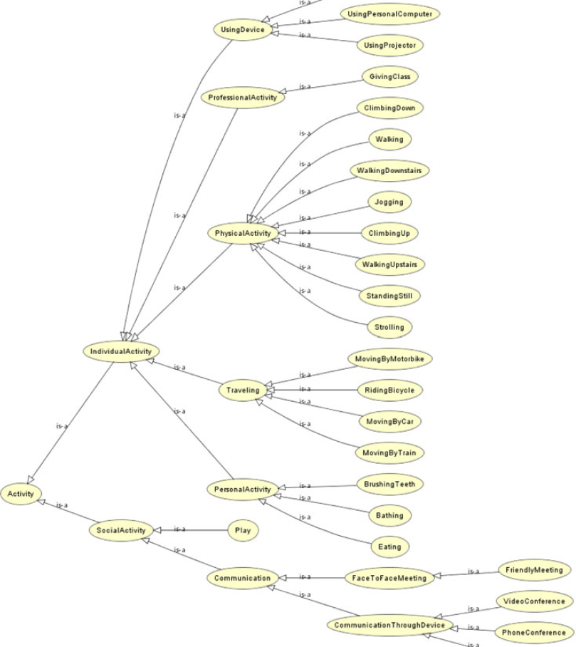
Figure 4 Part of the ontology of activities - Riboni et al. [46]

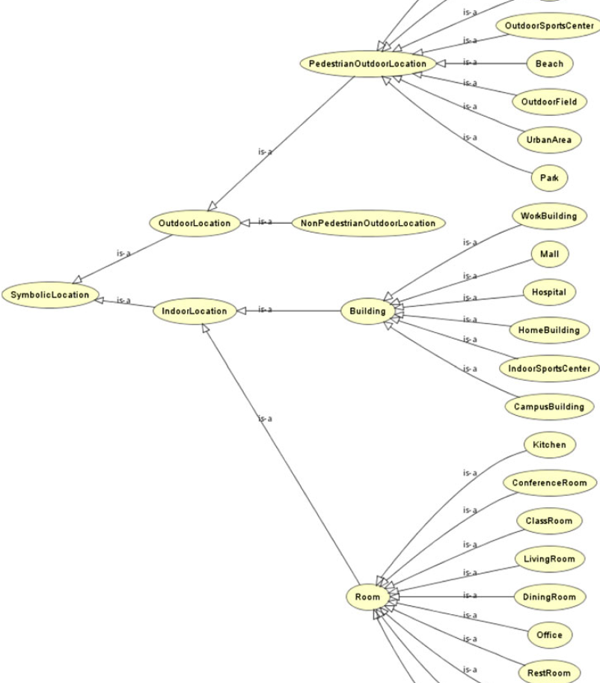
Figure 5 Part of the ontology of symbolic locations - Riboni et al. [46]
Liming Chen et al. [51] describe activities such as have bath, brushteeth, wash hands, make tea, make chocolate, make coffee, make pasta, make sandwitch, watch television.
Bonsai [53]:
- Concepts: Noise, co2 level, room, air condition, light,
- Technologies used: zigbee, z-wave, W3C SSN ontology, DUL, protege editor tool

Wemlinger et al. [60] define the COSE ontology and numerous sensors (binary pressure sensor, barometric pressure sensor, passive infrared sensor, gyroscope, shake sensor, accelerometer, smoke alarm, microphone, contact sensor, flow sensor) to deduce activities (cleaning, cooking, drinking, eating, making phone call, toileting, washing hands).
Preuveneers et al. define the Codamos [43] ontology. This work is based on sensors (Temperature, Pressure, Humididity, Lighting, Noise) and defined the related rules such as turn on/off the lights according to the weather (cloudy, rainy) or if the person is located in the room.
Chen, Finin, Joshi and Perich worked on the SOUPA (Standard Ontology for Ubiquitous and Pervasive Applications) ontology [10] [11] [13] to describe user profiles, beliefs, desires, etc. and the COBRA architecture [8] [9] [12] to build smart meeting rooms. COBRA (Context Broker Architecture) developed by Chen, Finin et al. is a centralized architecture for context-aware systems in smart environment based on semantic web languages. This architecture does not use SWE standards. They developed EasyMeeting, an intelligent meeting room based on the COBRA architecture. They define a policy language for users to control the sharing of their information and two ontologies SOUPA and COBRA-ONT. The ontology COBRA-ONT is for modeling context in an intelligent meeting room:
- Places (a physical location: longitude, latitude, and string name). They propose AtomicPlace (a room, an hallway, stairway, restroom, parking lot) and CompoundPlace (e.g., Campus or building are comprised of rooms)
- Agents are Person (name, homepage, email address) or SoftwareAgent.
- Agent’s Location can detect some inconsistencies (a person who are in the same time in a parking lot and in a room).
- Agent’s Activity represents for instance a meeting (A PresentationSchedule with the start time, the end time, the presentation title etc.)
The SOUPA Ontology is split into:
- SOUPA Core which attempt to define generic vocabularies that are universal for different pervasive computing applications.
- SOUPA Extension defines additional vocabularies for supporting specific types of applications.
The Soupa ontology defined by Chen et al. is composed of 11 ontologies (assertion, association, conference, contact, event, news, person, photo, project, publication, research). The person ontology redefines similar concepts without be linked to the FOAF ontology (name, firstName, middleName, lastName) and propose additional concepts such as PhDStudent, Visitor, GuestSpeaker, Professor, Student, etc. and interesting properties such as biography, relatedPublications to obtain additional information about the person.
  - Weather & Agriculture
Walisadeera et al. [59] define an ontology related to smart farm and weather conditions (season, rainfall, temperature, humidity, wind, sunlight, CO2).
Kim et al. [28] design a smart farm ontology and take into account weather conditions too. They describe rules related to perfect growing (e.g., cabbage temperature is 19°C).
  - Weather & Tourism
Chien et al. [14] describe 13 rules implemented with SWRL-IQ Plugin Protégé or as owl:Restriction in the ontology to suggest activities (e.g., boat).
  - Smart Home & Healthcare
Lafti et al. [30] design 7 ontologies using Protegé:
- Equipment smart home ontology contains the description of all pieces of equipment that can be found in the habitat in order to ensure the patient safety included Sensors such as motion detector, temperature, body temperature, presence detector, gas, light, blood pressure, fall detector and actuators (door, drawer, cupboard, window).
- Person and medical history ontology describes the patient concept, his diseases, allergies, and the person concept including the relationships with the family. Unfortunately is not linked with well-known ontologies such as FOAF or relationships. Common concepts are has Allergy, hasDisease, Allergy, ArterialHypertension, Diabetes, Person, Patient.
- Task ontology recognizes activities using Bayesian networks. Activities describes are Brushing, Cooking, crying, eating, reading (Book, Newspaper), Sitting, Sleeping (Bed, Sofa), Speaking, Standing, Walking, Washing (Clothes, Dishes, Face, Hands), etc.
- Habitat ontology describes the smart home with Rooms concepts such as Bedroom, Bathroom, Dining Room, Hall, Kitchen, Living Room.
- Software application
- Behavior
- Decision
Yao et al. [62] [63] propose the CONFlexFlow (Clinical Context based Flexible workflow) framework, design 2 ontologies (clinical context ontology and heart failure ontology) and the two kind of reasoning (rule-based and ontology-based reasoning). They use Protégé 3.4 to design the ontology, the Jess rule engine to enable SWRL reasoning, the SWRLJessTab Protégé plugin to implement rules and the Pellet reasoned to find inconsistencies and infer new instances or classes. They define 18 rules:
- Patient Evaluation Rules (PER) evaluate a patient’s medical history, social background, habits, symptoms prior to a physical examination.
- Patient Diagnosis Rules (PDR) evaluate patient’s signs (high blood pressure or abnormal heart rhythm) to infer symptoms such as (blood cell disorder, directly heart failure, heart disease or circulation disorder.
- Patient Treatment Rules (PTR) suggest treatment such as surgical therapy, medication or device therapy.
- Patient Prescription Checking Rules (PCR) to deal with drug interaction (allergy-drugs effects, dosage checking and insurance checking) to avoid prescription errors.
Hennessy et al. [26] propose two ontologies : Healthcare Semantics Lite (HSL) to represent the patient and another ontology dedicated to the medical context. The both ontologies enable to reduce the interoperability issues between medical sensors, smartphones and hospital patient record systems. They use the Schema.org, an ontology supported by Google, Yahoo, etc. The medical reading concepts defined are: WeightScale, Temperature, Pulse, BloodPressure and Glucose. They used the SPINMap and SPIN to define rules, REST-full web services, the Amazon EC2 cloud-based server, SPARQLMotion scripts and the TopBraid semantic web tool.
Roose et al. [1] uses various sensors and actuators such as ultrasonic water flow meter, ip camera, flush detector, light switch, door, fridge sensor, hob sensor, mixer tap, mobile phone gps and sound detector. They use the Jena framework, Protégé and SWRL to deduce activities (dressing, eating, elimination, hygiene, lie down, preparation eating, etc.)
Lukkien, brandt [6] [33] propose an ontology for a remote patient monitoring.
Paganelli [39] [40] design an ontology to monitor and assist patient at home and a reasoning for alarm situation handling. Their work are based on biomedical en environmental sensors and define four ontologies:
- The patient-personal domain ontology to estimate patient’s health status (body temperature, heart rate frequency, pulse oxymetry, systolic and diastolic blood pressure, glycemia). When a measured value falls out of the thresholds, the rules trigger alarms (very low, low, medium and high)
- The home domain ontology to monitor environmental parameters (temperature, humidity) and detect abnormal situations with the help of gas and fire detectors.
- The alarm management ontology to trigger alarm.
- The social context ontology to alert available persons (nurse, caregiver, family member)via SMS or email.
They propose two kind of reasoning:
- Ontology-based reasoning to determine class subsumption.
- User defined rule-based reasoning to make inferences over the knowledge base. For instance, they describe rules to trigger alarms and alert available people in case of the heart rate frequency is less than 40 beat/minute and systolic blood pressure is higher than 160mm/Hg.
Taboada et al. [55] define SWRL rules using the Protégé SWRLTab to reason about juvenile cataracts.
Jovic [27] define the heart failure ontology.
Zhao [64]
Ontoreachir [35] defines 2039 concepts and 200 relations for the reanimation surgery domain. We link concepts related to Disease and blood measurements (HypertensionArterielle, Hypoglycemie).
Physicology describes concepts related to blood (Pressure, Glucose).
The registry ontology defines interesting concepts related to Patient or Person (name, age, height, weight, sex, blood type) and numerous diagnostics. This ontology is not linked to the FOAF ontology whereas both ontologies describe a Person and have some properties in common (hasName).
- Our proposed nomenclature to describe, measurement and domain terms
We propose to use common terms to describe sensors, measurements, actuators and domains. Of course, we should improve it all together. This work synthetizes all concepts found in existing ontologies and are implemented in the M3 ontology to unify rules related to these sensors (Figure 6).
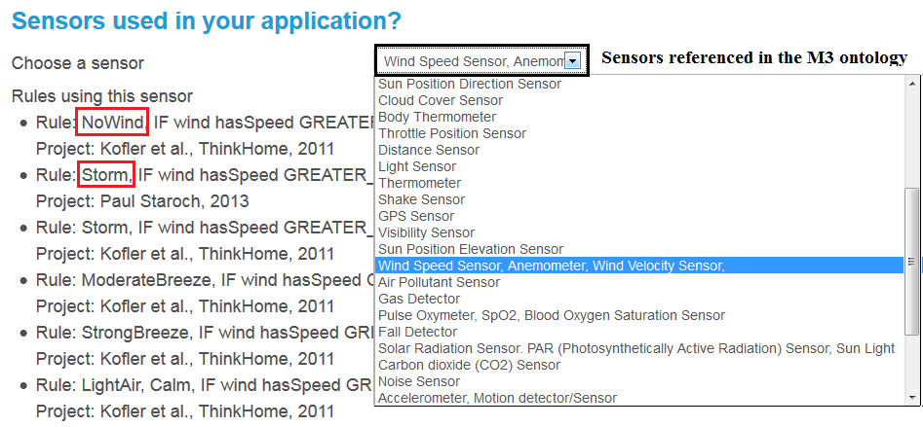
Figure 6. Sensors referenced in the M3 ontology and the related rules
  - Sensor names
E.g., precipitation and rainfall sensor have the same meaning and represents the same sensor, we should explicitly describe this information in machine to machine communications to ensure interoperability in each layer of the OneM2M architecture.
    - Generic
Sensor & measurement name | Description, other names | Unit
humidity | Hygrometer, humidity sensor, moisture sensor, soil moisture probes | %
temperature | Thermometer, temperature sensor, thermistor | °C
luminosity | Light, luminosity, illuminance, lighting | lux
gps | Global positioning system, gps, location sensor | lon, lat, alt
frequency |  | Hz
shake | Shake sensor, vibration
    - Weather
Sensor & measurement name | Description, other names | Unit
precipitation | Precipitation sensor, rainfall sensor, rain fall, pluviometer, rain, rainfall gauge | mm/h or mm
wind speed | Wind speed sensor, wind velocity sensor, anemometer | m/s or MPH
wind direction | Wind direction | degree
sun direction | sun position direction to detect east, west, south, north | degree
atmospheric pressure | Atmospheric pressure sensor, Barometer, barometric pressure sensor | hPA
cloud cover | Cloud cover sensor | okta
sun elevation | sun position elevation to detect (twilight, day, night, etc.) | degree
solar radiation | Solar radiation sensor, par (photosynthetically active radiation) sensor, sun light, solar sensors, sun’s radiation intensity | watts per meter square
visibility | Visibility sensor to detect fog | miles
    - Healthcare
Sensor & measurement name | Description, other names | Unit
blood pressure | blood pressure meter, sphygmomamometer, MAP (Mean arterial pressure), CVP (central venous pressure) | mmHg
body temperature | Body thermometer | °C
cholesterol | cholesterol | mmol/L or g/L
heart beat | Pulse sensor, pulse oxymeter, pulse-ox, heart beat, heart rate, pulse rate, cardiac frequency | bpm
skin conductance | skin conductance, galvanic skin response sensor, GSR, sweating
weight | Weight sensor, body weight | kg
glucose | Glucometer, glucose sensor, blood glucose meter, blood sugar level | g/L
spO2 | Pulse oxymeter, spO2, blood oxygen saturation sensor, pulse and oxygen in blood sensor | %
    - Smart home
Sensor & measurement name | Description, other names | Unit
presence | Presence sensor, occupancy detector, pyroelectric IR occupancy, intrusion detector/ trespassing, infrared sensor, motion sensor, motion detector, motion sensor
water flow | water flow sensor attached to sinks, showers, flushing
gyroscope | Gyroscope attached to objects (e.g., mop) to detect if they are used | rad/s
sound | Noise, sound, microphone, audio sensor | dB
pressure | Pressure for beds, sofa, couch to detect (lying, sitting)
acceleration | Accelerometer | m/s²
magnetic field | Magnetometer, magnetic sensor attached to cupboards to detect if they are opened or closed
Camera | Video sensor
    - Transport
Sensor & measurement name | Description, other names | Unit
speed | Speed sensor, speedometer, velocity sensor (car)
tire pressure
fuel | Fuel level
distance | Distance sensor
rpm | Position and/or rotational speed
maf | mass air flow sensor | maf
    - Air quality
Sensor & measurement name | Description, other names | Unit
air pollutant | Air pollutant sensor
oxygen | oxygen sensor
no | Nitrogen oxide sensor
CO | Carbon monoxide CO sensor
SO2 | Sulfure dioxide sensor
CO2 | Carbon Dioxyde Sensor | Ppm (parts per million)
  - Actuator names
Actuator name | Description, other names
fog lamp | Fog lamp
light | Light actuator
abs | Abs, anti-lock braking system
esp | Electronic stability program
seat belt | Seat belt tension sensor
air conditioner | Air conditioner, ac
heating
ventilation
curtain
window
cupboard
dish washer
washing machine
drawer
door
boiler
coffee | Coffee machine, coffee maker
computer | Computer, pc
shower | Water actuator
tv | tv, television
lavatory
fridge | Refrigerator, fridge
  - RFID tags common terms
RFID tags name | Description, other names
food | food
book | book (isbn)
cd | cd, music
dvd | dvd, movie
clothes | clothes, garments
toothbrush
broom
mop
bed
Sofa
pill box
passport
luggage
parking space
toll
animal
payment card
transit pass
  - Measurement names
E.g., t temp and temperature have the same meaning and represents the temperature measurement.
The same as the one referenced for sensors
Measurement names | Description, other names
lon | longitude
lat | latitude
Others measurements are the same than those referenced for sensors
  - Domains
E.g., Aix means Air en Provence which is a city.
E.g., you use the temperature in the health domain enable the computer to understand that the measurement corresponds to a body temperature.
Domain name | Description, other names
home or building or room (kitchen, bathroom, living room, dining room) | Smart home, building automation
health | healthcare
weather | Weather forecasting, meteorology
agriculture | Agriculture, smart farm, garden
environment | Environment (earthquake, flooding, forest fire, pollution)
emotion | Affective science, emotion, mood, emotional state; brain wave
transportation | Intelligent transportation systems (ITS), smart car/vehicle, transportation
tourism
location or city | Location, place, gps coordinates
rfid | Tracking rfid goods
other
- Our vision to improve related standards
  - W3C SSN
    - Standardize sensor-based domain ontologies
In the W3C SSN XG Final Report, they explicitly describe as a future work to standardize the SSN ontology to bridge the Internet of Things.
The W3C working group have designed the “Review of sensor and observation ontologies” web page to reference sensor ontologies, the ontology URL and related papers to later design the W3C SSN ontology to combine, merge and standardize in a unify way all existing ontologies.
We have done a synthesis table with more 200 sensor-based domain ontologies in our web page. The sensor-based domain ontologies are classified by:
- Domains such as building automation, healthcare, security, weather forecasting, intelligent transportation systems, affective science, tourism, agriculture, food, environment, IoT, music, measurement/unit, etc.
- Date
- Ontology status as displayed in the Figure 7:
  - Colored in white: Domain experts do not answer to emails asking them to share their ontology
  - Colored in red: the ontology cannot be shared for diverse reasons (lost, confidential, etc.)
  - Colored in purple: domain experts intent to share and publish the ontology online soon
  - Colored in green: the ontology is published online but not according to the semantic web best practices
  - Colored in yellow: the ontology is published online and the semantic web best practices are complied with
  - Colored in orange: few of them were already published online according to the semantic web best practices
W3C SSN has combined several domain-independent sensor ontologies and standardized it. We think about the same process to standardize sensor-based domain ontologies to ensure domain interoperability between names of sensors and their measurements. For instance, in the automation domain, we could create a standardize ontology to combine existing 30 smart home ontologies in a uniform way since they redefine always the same concepts (e.g., temperature, humidity, light) without using explicitly the same terms (e.g., light and luminosity).
Such standardizations enable to ease sensor-based domain knowledge interoperability to later link rules related to the sensor measurement concepts defined in the ontology, since existing ontology mapping tools and ontology editor tool interoperability issues are not enough mature to automatically align sensor-based domain ontologies.

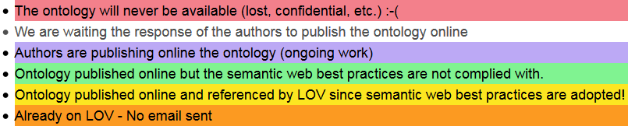
Figure 7 Color code for the ontology status
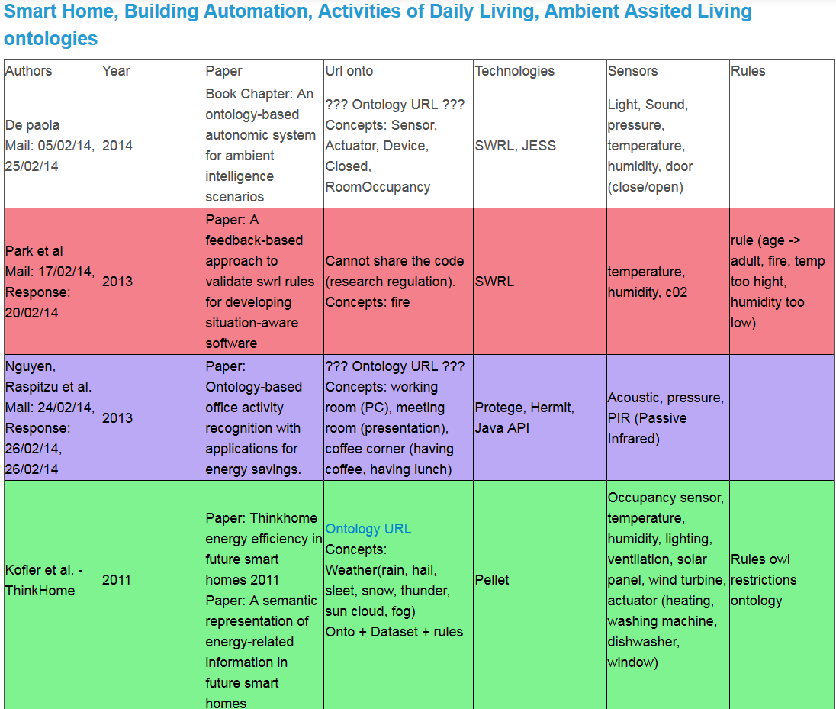
Figure 8 Ontology status in the building automation domain

Domain | #No ontologies | # No answer | # onto online | # onto lost | # onto in development | # ref by lov
Transport | 28 | 12 | 5 | 5 | 5 | 1
Building Automation | 32 | 10 | 8 | 4 | 7 | 3
Smart cities | 2 | 0 | 2 | 0 | 0 | 0
Healthcare | 35 | 11 | 12 | 7 | 5 | 0
Security | 24 | 7 | 10 | 1 | 2 | 4
Tourism | 26 | 10 | 9 | 4 | 2 | 1
Affective Science | 6 | 2 | 2 | 0 | 0 | 2
Food, Beverage, Restaurant | 23 | 10 | 9 | 0 | 3 | 1
Agriculture | 8 | 5 | 2 | 1 | 0 | 0
Weather | 9 | 2 | 5 | 0 | 0 | 2
Earthquake, pollution, environment | 7 | 4 | 3 | 0 | 0 | 0
Total | 200 (100%) | 77(36%) | 68(34%) | 20 (11%) | 25 (13%) | 13 (6%)
Figure 9 More than 200 ontology status are classified by domain
    - An ontology to explicitly describe the ssn:observationValue concept
The W3C SSN ontology [15] describes sensors, observations, and related concepts but does not describe domain concepts, time, locations, etc. these are intended to be included from other ontologies via OWL imports. The SSN ontology describes semantic sensor networks and does not provide detailed descriptions for the observation and measurement data. We underline that there is a need to standardize the domain ontologies that they mentioned to unify concepts. This is why we designed the Machine-to-Machine (M3) ontology to describe common sensor and their measurements in a uniform way. We think about an improvement of this ontology as a standardized extension of the ssn:observationValue concept. Further, the M3 ontology is a synthesis of common sensor and measurement type used in existing ontology-based works. Once, this step achieve, we could combine sensor-based rules which are related to these concepts.
The M3 ontology’s goals are:
- Describe common sensors in a uniform way (See section 8.1)
- Describe common actuators (See section 8.2)
- Describe common RFID tags (See section 8.3)
- Describe common sensor measurements (See section 8.4)
- Describe common domains (ssn:featureOfInterest) (See section 8.5)
We designed the Linked Open Rules to share and reuse existing sensor-based domain rules according to the M3 concepts defined in the ontology to ease the reasoning.
Is it possible to describe actuators or RFID tags with W3C SSN? Usually, an actuator has a state such as on/off, open close, etc., we describe this property in the M3 ontology.
  - W3C Web of Things
This document is relevant too for the W3C Web of Things due to:
- Cross-domain scenarios. They are interesting by several scenarios such as smart home, vehicles, building automation, medical which perfectly fits to OneM2M and our scenarios.
- 200 sensor-based domain ontologies that we referenced are relevant for W3C Web of things too.
- Nomenclature to describe sensors and their measurements in a unify way since synonyms and etymology are not easily detected by smart devices.
- Interoperability issues encountered to combine sensor-based domain ontologies and rules together.
- The OneM2M architecture could interest W3C Web of Things too.
  - W3C OWL
We detected that an ontology written with OWL cannot be loaded by different OWL-based softwares. It is not normal. Softwares generate code not compliant with OWL (e.g., OWL API generated file cannot be read by the Jena Semantic Web framework). A same ontology cannot be read by all of these software.
  - IERC
They were interested by our idea to share, combine and reused sensor-based domain rules to build the “Linked Open Rules”. Further, the “Linked Open Vocabularies” is a catalogue to reference more than 400 well-designed ontologies. Unfortunately, more 200 sensor-based domain ontologies are not referenced on this catalogue due to lack of semantic best practices.
- Semantic web guidelines
  - Design your ontology
You can find tutorials to design your first ontology:
- Ontology Development 101: A Guide to Creating Your First Ontology [38]
- OWL Pizzas: Practical Experience of Teaching OWL-DL: Common Errors and Common Patterns [44]
  - Describe domain knowledge at least written in English
Describe your domain knowledge at least in English. You can describe labels and comments in various languages if needed. In the Figure 10, as you can see, if you are not familiar with the Chinese, Spanish or German language you cannot easily reuse these works.

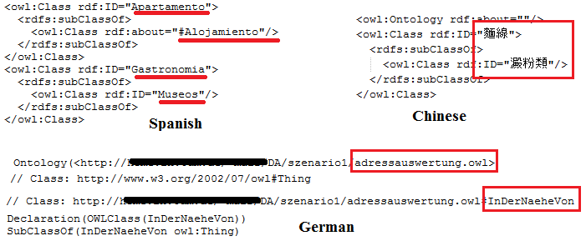
Figure 10 Ontology only written in Chinese, Spanish or German is not easily reusable

The good practice is to describe your ontology at least in English and if needed in another language as depicted in Figure 11. Document the domain knowledge (concepts, properties, instances) with human-friendly labels and comments (rdfs:label and rdfs:comment, dcterms:description) is recommended.
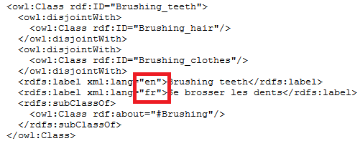
Figure 11 Lafti et al. [30] design an health ontology both in English and French
  - Ontology best practices
    - Choose a good namespace
As you can see in the Figure 12, the ontology does not have a good name since it is called unnamed.owl
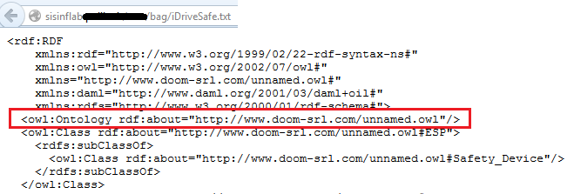
Figure 12 The ontology does not have a good namespace
The good practice is to have the same URI for both the namespace and the ontology location as depicted in the Figure 16. This mechanism is called URI deferencable. For example, the URI http://www.gdst.uqam.ca/Documents/Ontologies/HIT/Task_SH_Ontology.owl entered on a web browser gives access to the ontology.
    - Publish online the ontology
Publish online the ontology on your server. Choose a cool URI.
The OWL file is directly accessible through the Web not in a zip file or other as depicted in the Figure 13.

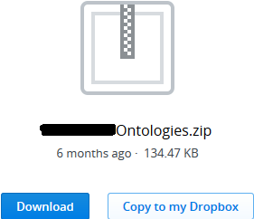
Figure 13 Bad practice since ontologies are in a zip file
    - Ontology URI deferencable, Content Negociation Problem
Once the ontology is published online, the ontology can be submitted to the LOV project.
Frequently, domain experts encountered the problem Content Negociation Problem as depicted in the Figure 14.
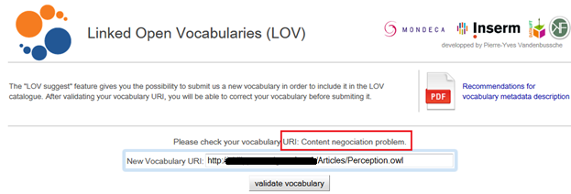
Figure 14 Content negociation problem
When we look up the namespace of the ontology on a Web browser, we should find the ontology. The namespace of the ontology should be the same that the location of the ontology, it is called URI deferencable. In the Figure 15, this is not the case the namespace URI and the ontology URI are not identical, this is why the LOV project generated the context negociation error.
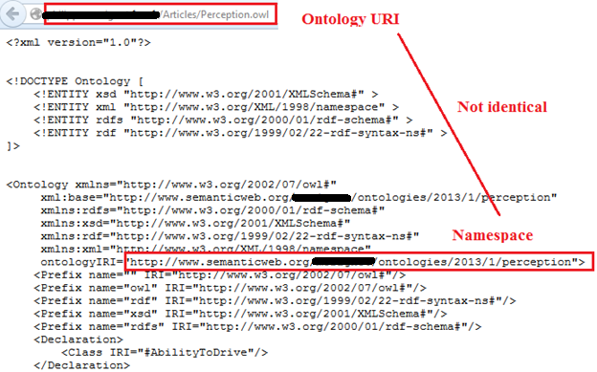
Figure 15 The namespace and the ontology URI are not identical
The good practice is to have the same URI for both the namespace and the ontology location as depicted in the Figure 16. This mechanism is called URI deferencable.

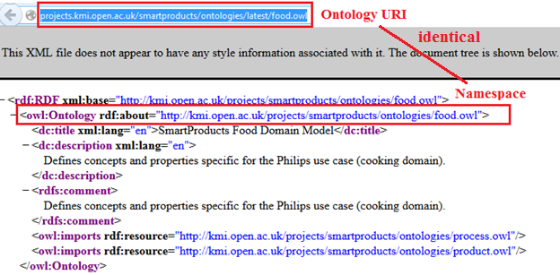
Figure 16 The namespace and the ontology URI are identical
    - Reuse existing ontologies
Reuse domain knowledge rather than reinventing them:
- The ontology should reuse existing ontologies wherever possible.
- Add owl:equivalentClass for common concepts already defined in existing ontologies
- The class or properties are those from the ontologies referenced on LOV.
- Link common concept (owl:equivalentClass or rdfs:subClassOf) with well-known ontologies (e.g., Person is already described in FOAF)
- You can always extend an ontology to fit your needs
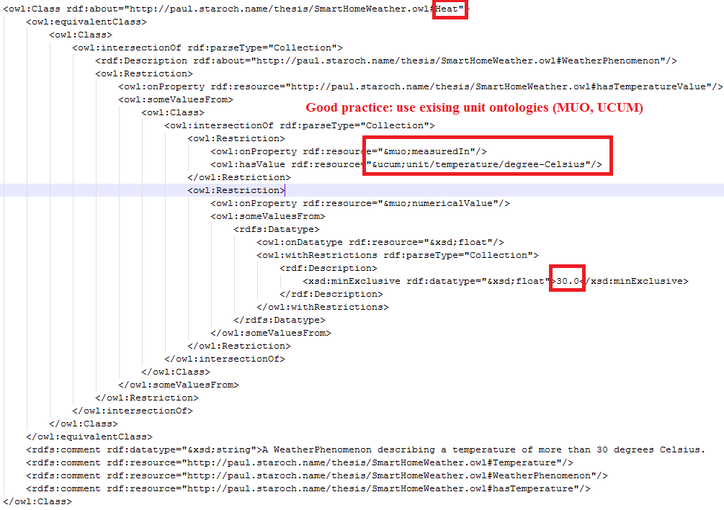
Figure 17 Staroch et al. define a smart home ontology related to the weather [52].
Some ontologies are not longer maintained but cannot be ignored.
This is the case for SWEET implemented by the NASA which design about 6000 concepts in 200 separate ontologies.
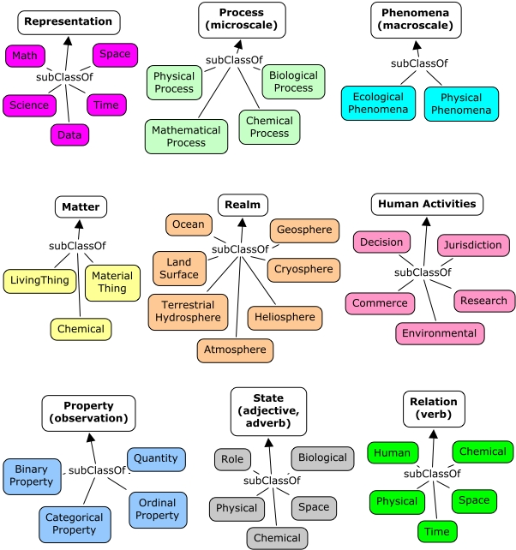
Figure 18 SWEET ontologies
Some ontologies are still maintained but is linked to ontologies which are not maintained anymore, for example the emotion ontology [23] which is based on the OBO ontology.
    - Server-side configuration, Vapour
Vapour is a link data validator to check whether the data are correctly published according to the semantic web guidelines, as defined by the Linked Data principles, the Best Practice Recipes and the Cool URIs.

Vapour checks three tasks:
- 1st request while dereferencing resource URI without specifying the desired content type (HTTP response code should be 200)
- 1st request while dereferencing resource URI without specifying the desired content type (HTTP response code should be 200)
- 1st request while dereferencing resource URI without specifying the desired content type (Content type should be 'application/rdf+xml')

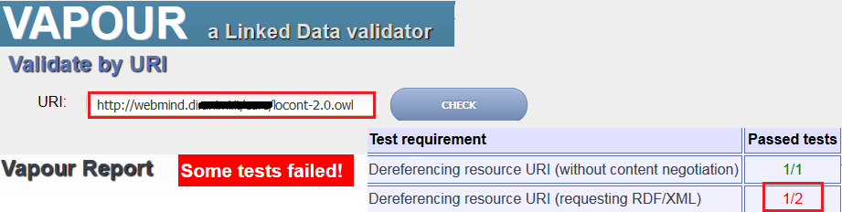
Figure 19 Vapour tool failed

The domain experts have to correct the error “1st request while dereferencing resource URI without specifying the desired content type (Content type should be 'application/rdf+xml'): Failed”.

The solution is to configure the server. For instance for Apache server you can change the httpd.conf configuration file and add the following line.
AddType application:rdf+xml .rdf
Or you can add this information in the .htaccess file in the directory on the server where the RDF files are placed.

This is a main issue to achieve this task, since some authors share their ontologies:
- On a personal web page, they cannot control the server
- Use google app engine

Some domain experts try to host their ontologies on GitHub, it was a good idea, but it generates an error on Vapour:
IlegalLocationValue: the value of the location header in the response (https://github.com/ngankam/ontology/blob/master/instrusion_description_in_wsn) is not an absolute URI (see the RFC 2616, section 14.30)

https://tools.ietf.org/html/rfc2616

14.30 Location

The Location response-header field is used to redirect the recipient
to a location other than the Request-URI for completion of the
request or identification of a new resource. For 201 (Created)
responses, the Location is that of the new resource which was created
by the request. For 3xx responses, the location SHOULD indicate the
server's preferred URI for automatic redirection to the resource. The
field value consists of a single absolute URI.

Location = "Location" ":" absoluteURI

An example is:

Location: http://www.w3.org/pub/WWW/People.html

Note: The Content-Location header field (section 14.14) differs
from Location in that the Content-Location identifies the original
location of the entity enclosed in the request. It is therefore
possible for a response to contain header fields for both Location
and Content-Location. Also see section 13.10 for cache
requirements of some methods.

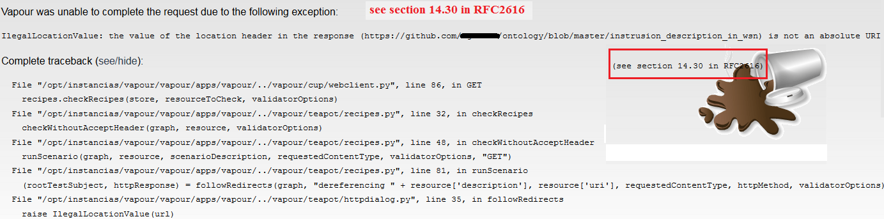
Figure 20 Vapour error indicates to see the RFC 2616, section 14.30
    - Ontology metadata: LOV recommendation
Reference your ontology on LOV(see section Ontology catalogue)
- Add ontology metadata recommended by LOV as depicted in the Figure 21 [56]
- Metadata Recommendations For Linked Open Data Vocabularies
- A code example is available in the Annexe
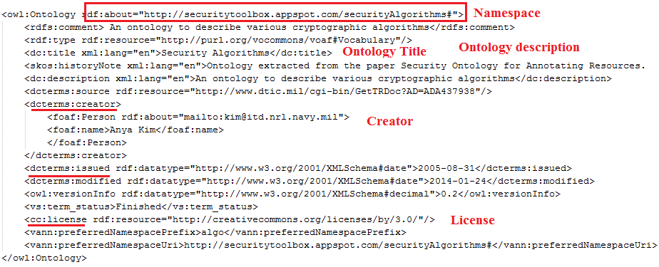
Figure 21 Ontology metadata recommended by LOV
Frequently domain experts encountered some errors when submitting their ontology to LOV.

If this is the case, check:
- Test the ontology URL on Vapour
- Test the ontology URL on RDF Triple-Checker
- The ontology best practices
    - Provide an ontology documentation
- Parrot is a web service, there is nothing to install. Less than 30 minutes to add a documentation to your dataset or ontology.
- Neologism. Need to install the software
- SpecGen . Need to install the software
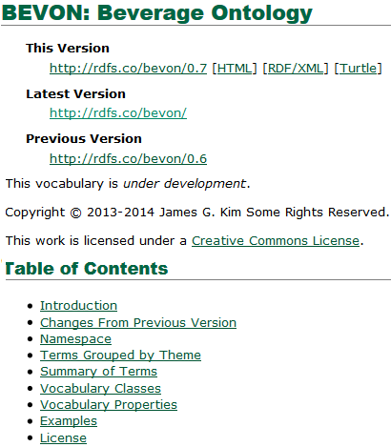
Figure 22 Documentation example

    - Validate with OOPS
The Oops tool will detect common errors. An example is to avoid to have two ideas in a same concept as depicted in the Figure 23.

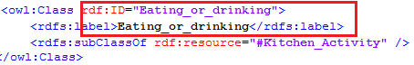
Figure 23 Do not describe 2 ideas in the same concept
    - Validate your ontology with semantic web validators
They are more and more tools implemented by the semantic web community to detect common errors when developing your RDF data or ontologies.
- RDF Validator is used to check your RDF documents as depicted in the Figure 24.
- OWL Validator is used to check your OWL documents.
- OOPS! (OntOlogy Pitfall Scanner!) is a tool to detect common ontology errors as depicted in the Figure 25.
- The RDF Triple-Checker tool helps find typos and common errors in RDF data
- Vapour is a link data validator to check whether the data are correctly published according to the semantic web guidelines, as defined by the Linked Data principles, the Best Practice Recipes and the Cool URIs.
- RDFAbout is a RDF Validator and Converter between the RDF/XML format and N3 (Notation 3 or N-Triples Turtle).

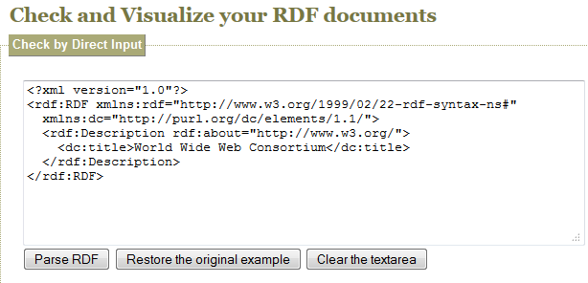
Figure 24 RDF validator

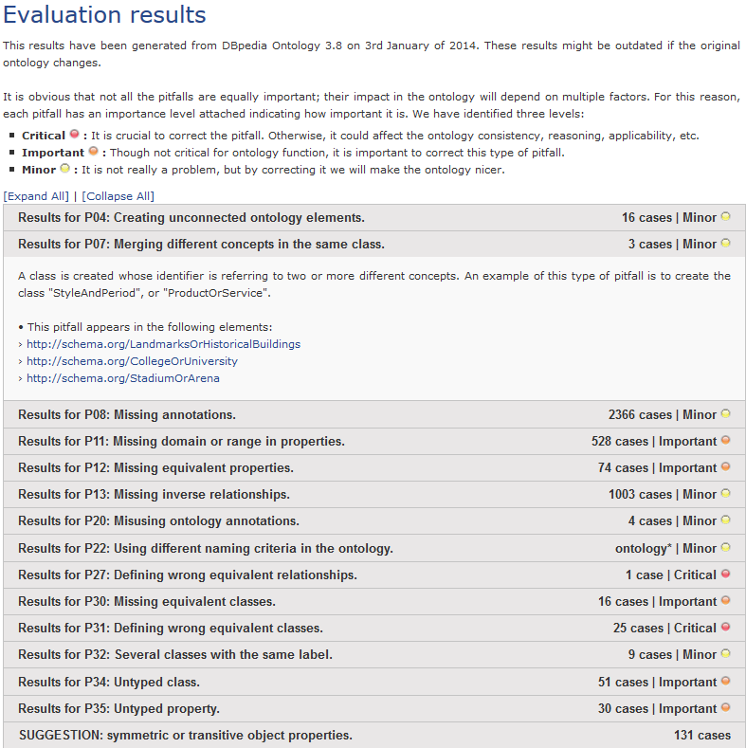
Figure 25 The Oops tool detects errors when developing ontologies
  - Separate the ontology and the dataset
Ontologies should only contain classes and properties whereas datasets should contains instances and relationships between the instances.
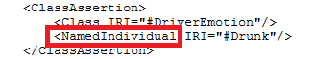
Figure 26 The instance drunk (NamedIndividual) should be in a separate file (the dataset)
  - Dataset best practices
    - Documentation
Books:Some documents to create a well-designed dataset:
- Linked Data: Evolving the Web into a Global Data Space. [24]. This book introduces the principles for publishing Linked Data or designed Linked Data applications. 2011
- Linked Data. Structured Data on the Web. 2014 [16]
- Best Practice Recipes for Publishing RDF Vocabularies. (More difficult to read) [4]
- How to Publish Linked Data on the Web
- Linked Data (design issues)
- Linked Open Data

    - Some tools to publish your data
Some tools to publish your data:
- D2R server enables to publish your database schema as a SPARQL endpoint.
- Jena fuseki
- SPARQL endpoint
- Reference your dataset on DataHub and other related tools (see section Dataset catalogue).

Linked Data is about using the Web to connect related data that wasn't previously linked, or using the Web to lower the barriers to linking data currently linked using other methods.
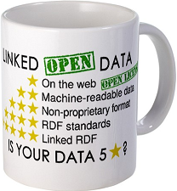
Figure 27 Linked Open Data Best practices

- Ontology matching issues
The LogMap is a mapping tool for ontologies to detect common concepts and properties in different ontologies.
This is a web service easy to use compared to others tools such as Silk where configurations need to be indicated according to the Silk language.
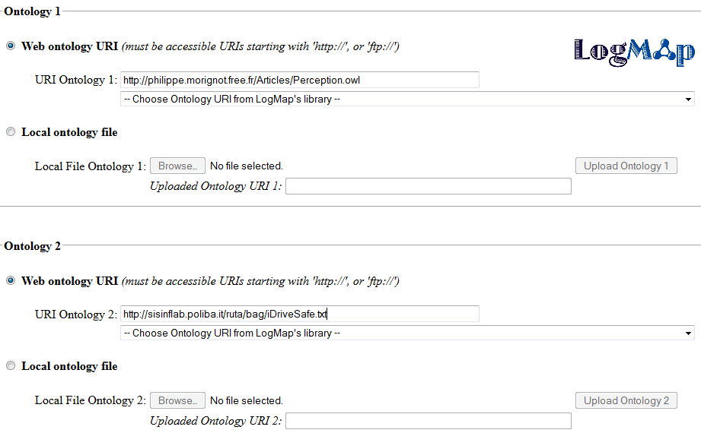
Figure 28 LogMap tool

  - Combine two classes with the exact same word
This example works because the two ontologies are almost written in the same way, the name is exactly the same in both ontologies:
- Wongpatikseree et al. <owl:Class rdf:ID="Sleeping">
- Riboni et al. <owl:Class rdf:about="#Sleeping">

Results:
<entity1 rdf:resource="http://www.hozo.jp/owl/smart_home_adl2-1.owl#Sleeping"/>
<entity2 rdf:resource="http://webmind.dico.unimi.it/CARE/locont.owl#Sleeping"/>
http://csu6325.cs.ox.ac.uk/output/matching_11_04_2014__14_43_24_806/mappings.rdf

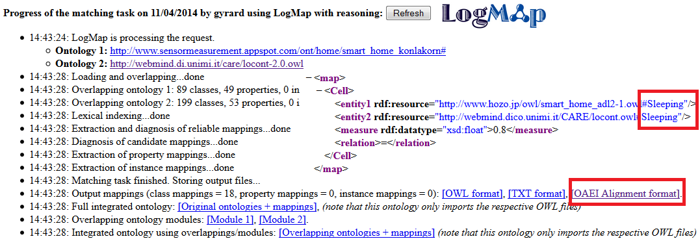
Figure 29 LogMap works when tey are exactly the same words
  - Cannot map ontologies accessible through HTTPS
The LopMap cannot be used if the ontology is accessible through HTTPS.
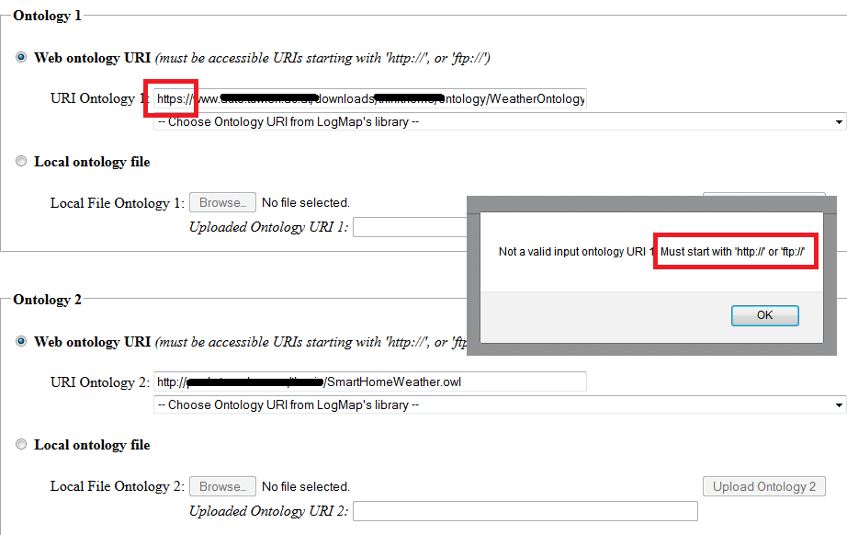
Figure 30 LogMap issue with HTTPS
We save the copy of the ontology as a local file but it does not work either.
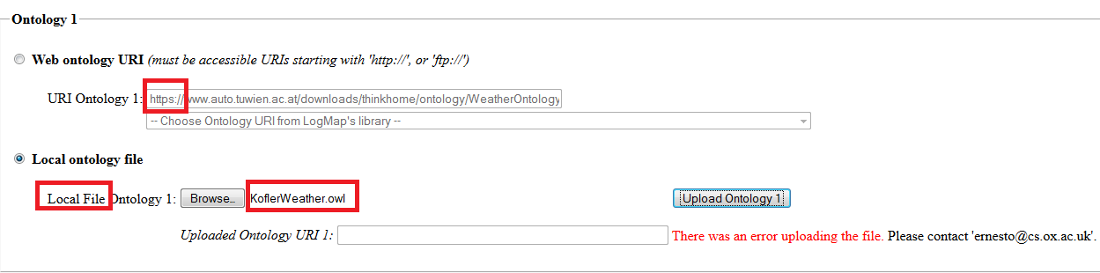
Figure 31 LogMap issue with the local file
  - Do not use the etymology of words
The logMap does not detect the same concept (foggy & fog, snow & snowy or rain & rainy). It detects only the class road type and state. For instance:
- Morignot et al. [37] [41] define the weather conditions (foggy, rainy, snowy, sunny).
- Ruta et al. [49] define weather classes (clear, snow, cloudy, fog, weak wind, rain)

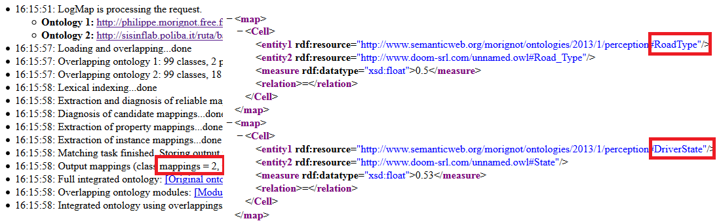
Figure 32 LogMap does not detect that fog and foggy referred to the same idea
  - Cannot interlink heterogeneous entities
The LogMap tool cannot interlink entities from different types (classes, properties, instances or datatype). For instance, we cannot link these two ontologies even if they are the same notions such as tired and drunk:
- Morignot et al. [37] [41] define the driver emotion (tired, drunk, nervous, relaxed) as an instance in their ontology.
- Grausberg et al. [19] [18] define the driver state (tired, drunk, stressed, distracted, ill, medicated) as a possible value of the property state.

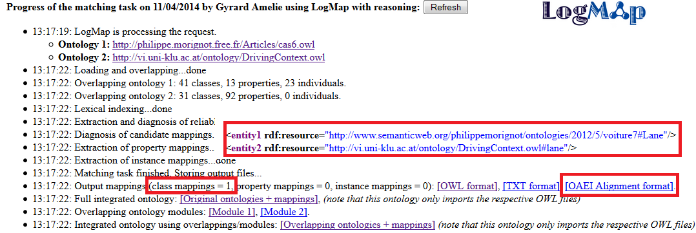
Figure 33 LogMap to interlink the driver state in two ontologies does not work since we cannot interlink classes, properties or instances.
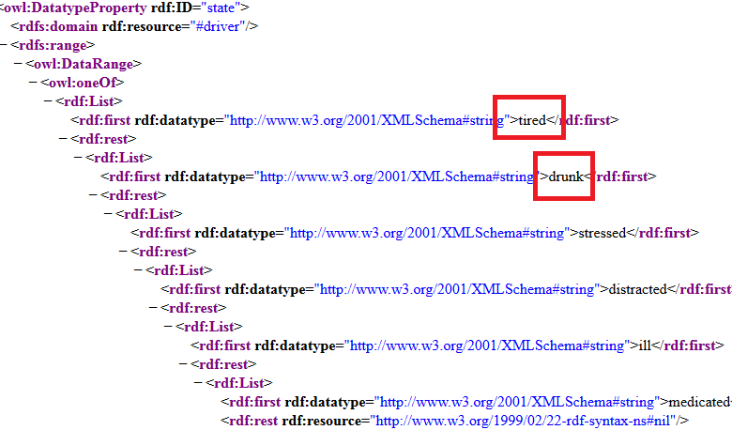
Figure 34 Grausberg et al. [19] [18] defined the driver state (tired, drunk, stressed, distracted, ill, medicated)

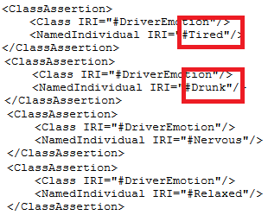
Figure 35 Morignot et al. [37] [41] defined the driver emotion (tired, drunk, nervous, relaxed).
- Ontology interoperability
We referenced in this section usual tools to design ontologies used by domain experts.
- Protégé is the most used ontology free editor tool to design a new ontology as depicted in the Figure 56 and proposes various plugin for ontology visualization, writing rules, etc.
- OWL API
- TopBraid
- More tools are referenced in the section Ontology editors, semantic API or framework.
  - Protégé: ontology editor tool
Protégé is a popular tool for ontology editing and representation.
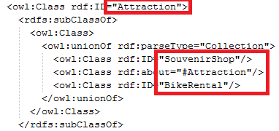
Figure 36 Chien et al. [14] design a tourism ontology with Protege

  - OWL API: creating, manipulating and serialising OWL Ontologies.

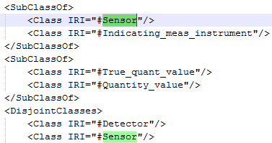
Figure 37 Ontology designed with OWL API [6]
  - TopBraid: build semantic web and linked data applications
TopBraid is a commercial solution to build semantic web and linked data applications

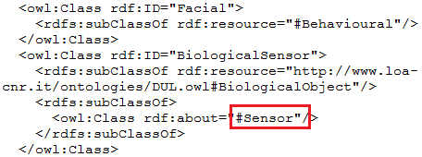
Figure 38 Lopez et al. designed an emotion ontology [34] with TopBraid

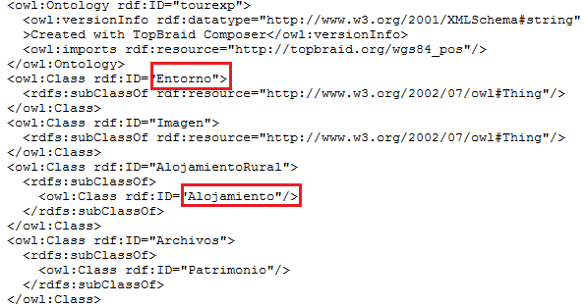
Figure 39 Bujan et al. designed a tourism ontology with TopBraid and the rdf/xml syntax [2] and not in english

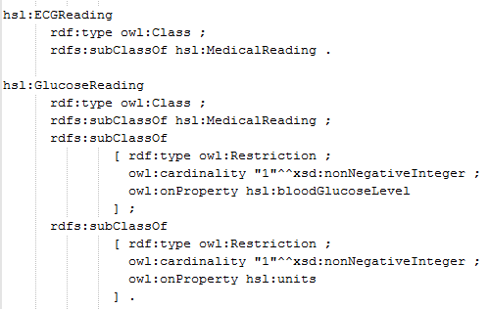
Figure 40 Hennessy, Ray et al. designed an emotion ontology with TopBraid and the turtle syntax [26]
- Rules interoperability
There is a need to work on the interoperability of the different implementation of ontologies and rules generated by software and semantic tools.
Various languages have been referenced to describe the semantic web rules as depicted in Figure 41:
- SWRL (Semantic Web Rule Language) is frequently used by domain experts since it is easy to use and already implemented by software. This language is not advocated by the semantic web community.
- SPIN (SPARQL Inferencing Notation) is advocated by semantic web experts since it is a W3C recommendation since 2013.
- RIF (Rule Interchange Format). Usual software used by domain experts do not implement RIF.
- Rules describes as restriction in the ontologies

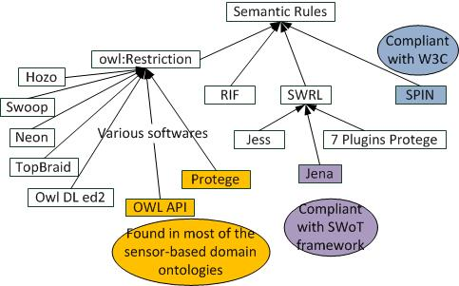
Figure 41 Linked Open Rules interoperability issues
  - OWL rules interoperability
Frequently rules are directly described as restrictions in ontologies. Interoperability issues have been discovered for interlining these rules: the syntax is not identic according to the software used, they do not use the exact same term (snowy, snow, snowy weather state).
Example how to combine rules related to the same concept snow:
Rule 1 (smart home domain): Snowy = belowOrZeroTemperature and Precipitation [29] [45] (Figure 44) is implemented with the OWL API.
Rule 2 (smart city domain): Snowy = belowOrZeroTemperature and Precipitation [31] (Figure 43) is implemented with the OWL API.
Rule 3 (transport domain): Snow -> safety device ABS, ESP, and snow chains [49] (Figure 46) is implemented with OWLed2
    - OWL restrictions
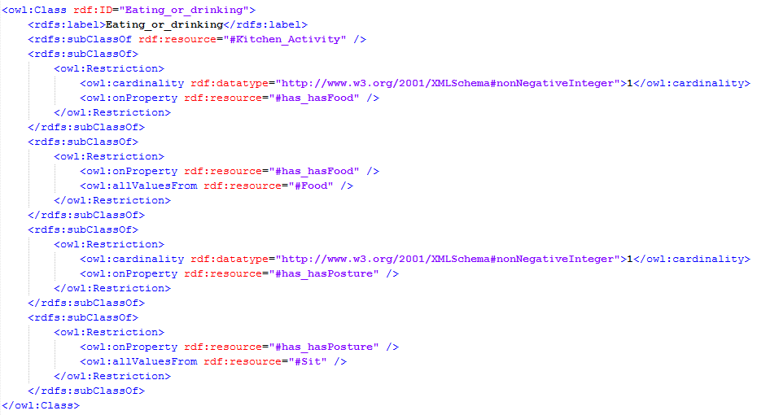
Figure 42 Wongpatikaseree et al. [61] defines rules to infer activities

    - OWL rules with OWL API

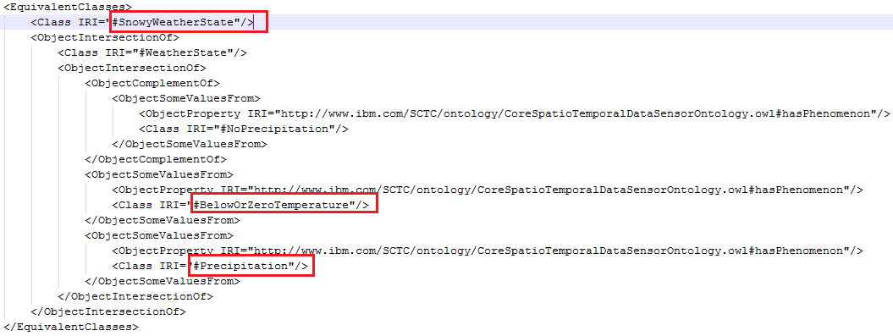
Figure 43 The Star-city ontology [31] defines rules to infer if it is snowy
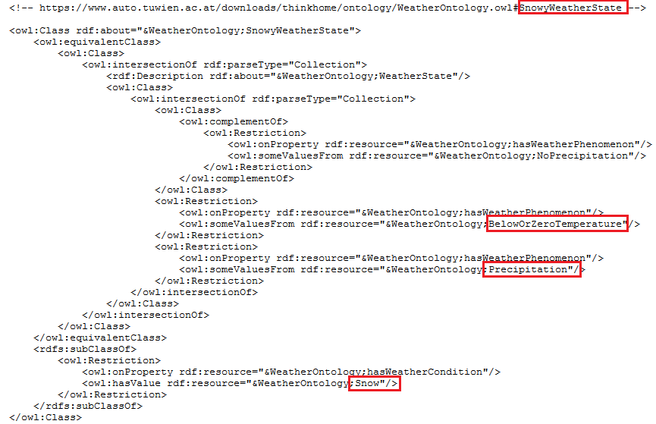
Figure 44 The ThinkHome ontology [29] [45] defines rules to infer if it is snowy in the building automation domain.
    - OWL rules with Protégé
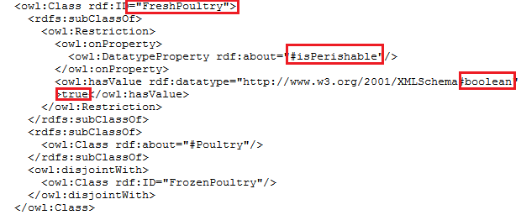
Figure 45 Food tiscaly ontology[7] implemented with Protege

    - OWL rules with OWLed2
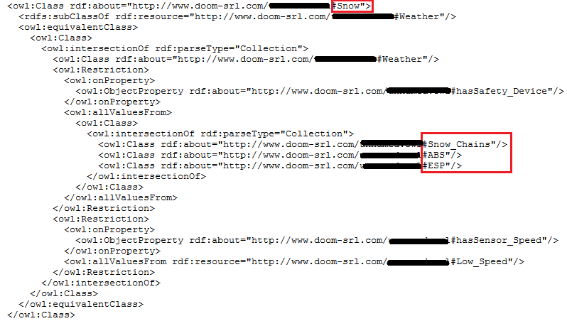
Figure 46 Ruta et al. [49] describe safety devices (abs, esp, and snow chains) related to the snow
    - OWL rules with topBraid
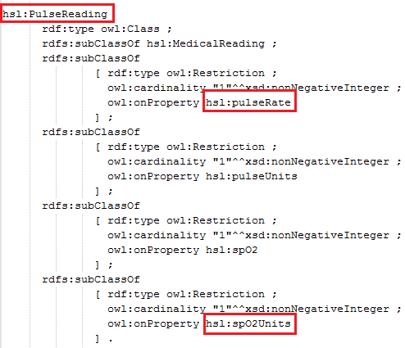
Figure 47 Hennessy et al. [26] designed an health ontology in turtle with TopBraid
  - SWRL (Semantic Web Rule Language)
SWRL (Semantic Web Rule Language), based on OWL and RuleML, is the most popular rule language since it is easy to use and used by domain experts. This language is not advocated by the semantic web community.
Unfortunately, the syntax varying according to the software or inference engine employed (OWL restrictions in the ontology, Jena, SWRL Tab protege, Pellet, Fact++, etc.):
- JenaRules, JenaRules wiki
- SWRL Tab (Plugin Protege) [O'Connor 2006]
- SWRL DL Safe Rule that restricts rules to operate on only known individuals of ontology.
- SWRLJess Tab (Plugin Protege)
- SWRL-IQ (Plugin Protege)
- SQWRL (Plugin Protege)
- SWRLDroolsTab (Plugin Protege)
    - Jena rules
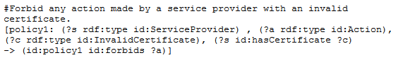
Figure 48 Vincent et al. [57] [58] design Jena rules in the security domain
    - SWRL and DLSafeRule
SWRL DL Safe Rule restricts rules to operate on only known individuals of ontology.
These SWRL rules are developed with the SWOOPS tool. The syntax is again different.
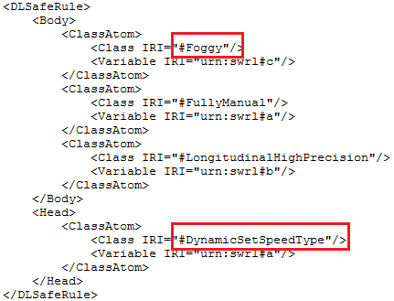
Figure 49 Morignot et al. [37] [41] design DLSafeRule in the transportation system

    - Jess rules
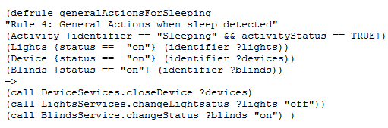
Figure 50 Zografistou et al. [65] design Jess rules
  - SPIN (SPARQL Inferencing Notation)
SPIN (SPARQL Inferencing Notation) is advocated by semantic web experts since it is a W3C recommendation:
- Jena SPIN rules (Jena ARQ API)
- SPIN SPARQL syntax
- SPARQL CONSTUCT (equivalent to SWRL rules)
- SPINMap is used by Hennessy et al. [26] in a health-based work.
- SPARQL Motion

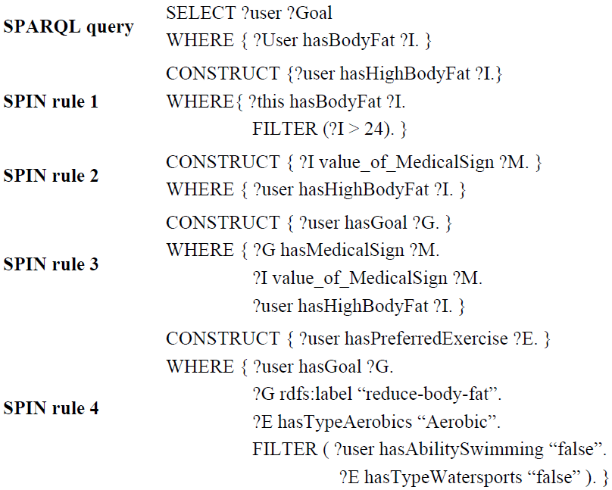
Figure 51 Su et al. [54] design SPIN rules in the health domain

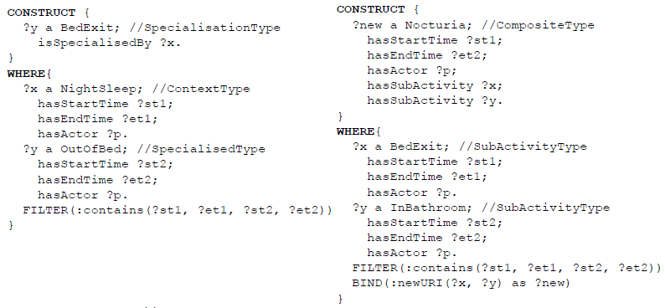
Figure 52 Efstathiou et al. [36] design SPIN rules in the smart home domain.
  - RIF (Rule Interchange Format)
RIF (Rule Interchange Format). Usual software used by domain experts do not implement RIF:
- RIF2SPARQL and RIF validator [50]
- Paper: R2RIF - Rule Integration Plugin for Protege OWL [42] - No plugin found
- RIF implementations
- Reference the domain knowledge
Once domain experts have designed and implemented their domain knowledge, they can share it through the Web. They can share the ontologies, datasets and rules.
  - Ontology catalogue
    - Linked Open Vocabularies (LOV)
The Linked Open Vocabularies is a catalogue, created by the semantic web community which references more than 412 well-designed ontologies according to the semantic web best practices as depicted in the Figure 53.
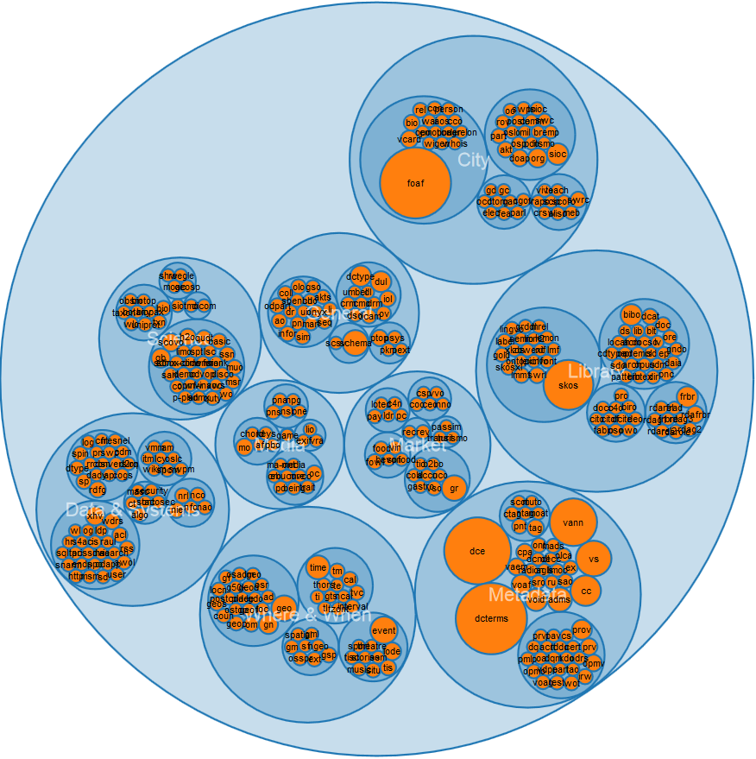
Figure 53 The Linked Open Vocabularies (LOV) catalogue
    - Linked Open Vocabularies for Internet of Things (LOV4IoT)
More than 200 sensor-based domain ontologies have been designed by domain experts in various domains and cannot be referenced on the LOV catalogue since they do not respect the semantic web best practices. For this reason, these ontologies have been referenced on our web site (see section 9.1.1 for more information).
  - Dataset catalogue
- The DataHub project proposes an easy way to get, use and share data as depicted in the Figure 54.
- The Linked Open Data search engine as depicted in the Figure 55.

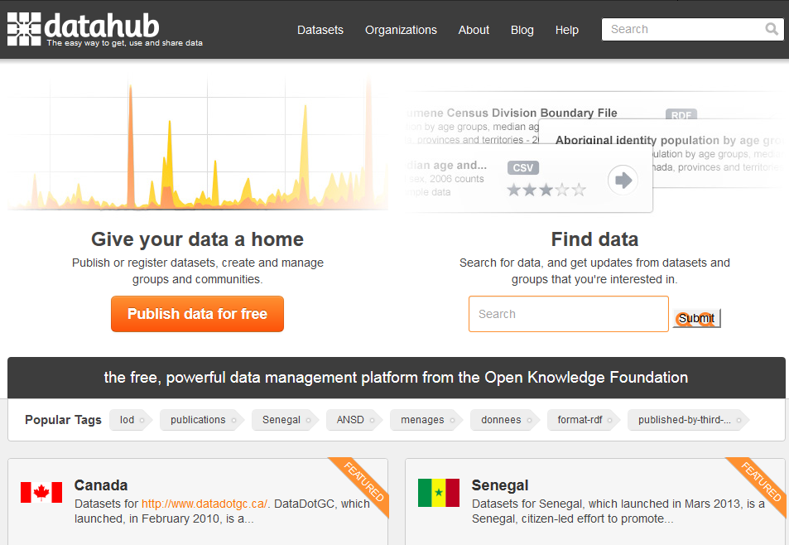
Figure 54 DataHub

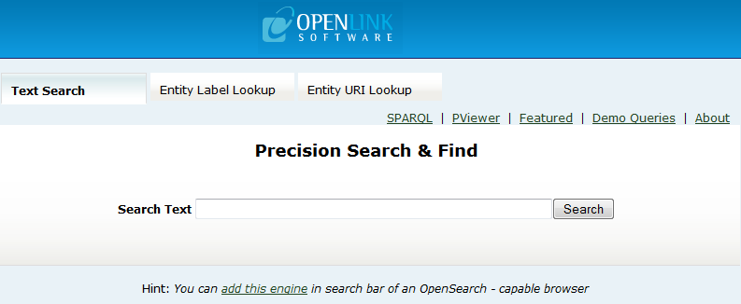
Figure 55 Linked Open Data search engine

  - Rules Catalogue
The “Linked Open Rules”, a work in progress, intents to share reuse and combine existing semantic web rules.
- Semantic web tools
  - Ontology editors, semantic API or framework
- Protégé is the most used ontology free editor tool to design a new ontology as depicted in the Figure 56 and proposes various plugin for ontology visualization, writting rules, etc.
- Callimachus
- TopBraid is a commercial solution to build semantic web and linked data applications
- SWOOP is a tool for creating, editing, and debugging OWL ontologies.
- Jena compatible with JAVA
- Virtuoso
- Sesame
- NeOn Toolkit
- OWL API as depicted
- OWLed2
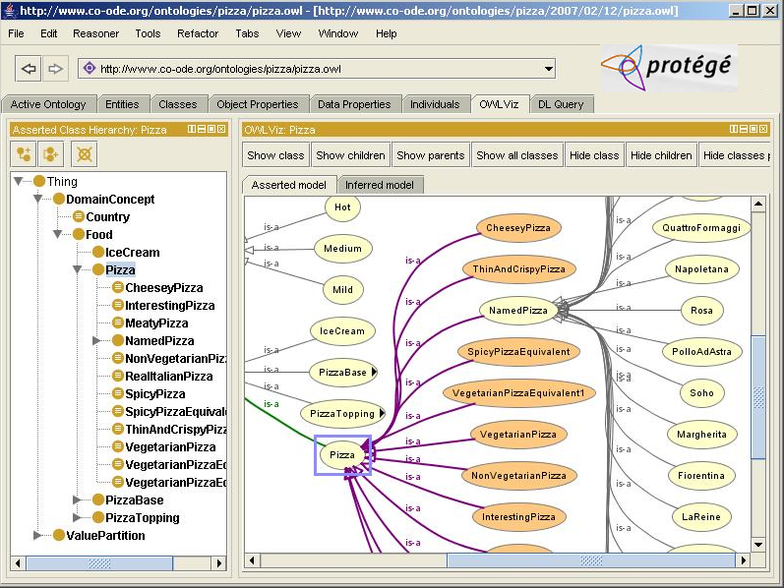
Figure 56 Protégé Editor tool
  - Linked Data API
- ELDA provides web services without the need for end-users to write SPARQL queries.
  - Mapping tools
- LogMap is used to link ontologies with each other
- Silk is used to link datasets with each other
- Alignment API
- SameAS is used to link datasets with each other
- LIMES (Linked Discovery Framework for Metric Spaces)
- RiMOM
- idMash
- ObjectCoref
  - Linked data search search engines
- Sindice provides API which can be used by Linked Data applications.
- Watson provides API which can be used by Linked Data applications.
- Swoogle provides API which can be used by Linked Data applications.
- OpenLink Data Explorer
- SchemaCache
- SchemaWeb
- Sig.ma
- Falcons
- SWSE
  - Linked data browsers
- Disco hyperdata browser
- Tabulator browser
- LinkSailor
- LOD Browser switch
  - Semantic Reasoner
- Jess
- Pellet is an OWL 2 reasoner for JAVA.
  - Pellet - Protege
  - Pellet - Jena
- Racer
- Kaon
- Fact++
- Hermit
  - Converter
- Datalift
- SenML to RDF Converter
  - Others
- Pubby
- Sindice Web data inspector: http://inspector.sindice.com/
- Purl
- Pachube
- URI validator: http://www.hyperthing.org/
- DSNotify informs consuming applications about changes.
- RDFa Distiller and Parser: http://www.w3.org/2007/08/pyRdfa/
- Syntax
- Turtle is more readable by human and compact
- N-Triples or N3 is compact and easy to parse
- JSON-LD
- RDF/XML is widely supported by tools that consume Linked Data.
- Annexe A: Ontology LOV metadata
Example:
<owl:Ontology rdf:about="http://securitytoolbox.appspot.com/securityAlgorithms#">
<rdfs:comment> An ontology to describe various cryptographic algorithms</rdfs:comment>
<rdf:type rdf:resource="http://purl.org/vocommons/voaf#Vocabulary"/>
<dc:title xml:lang="en">Security Algorithms</dc:title>
<skos:historyNote xml:lang="en">Ontology extracted from the paper Security Ontology for Annotating Resources. [Kim et al. 2005] (See APPENDIX D. OWL Representations of the NRL Security Ontology) Security ontology to faciliate web service description and discovery.</skos:historyNote>
<dc:description xml:lang="en">An ontology to describe various cryptographic algorithms</dc:description>
<dcterms:source rdf:resource="http://www.dtic.mil/cgi-bin/GetTRDoc?AD=ADA437938"/>
<dcterms:creator>
<foaf:Person rdf:about="mailto:kim@itd.nrl.navy.mil">
<foaf:name>Anya Kim</foaf:name>
</foaf:Person>
</dcterms:creator>
<dcterms:issued rdf:datatype="http://www.w3.org/2001/XMLSchema#date">2005-08-31</dcterms:issued>
<dcterms:modified rdf:datatype="http://www.w3.org/2001/XMLSchema#date">2014-01-24</dcterms:modified>
<owl:versionInfo rdf:datatype="http://www.w3.org/2001/XMLSchema#decimal">0.2</owl:versionInfo>
<vs:term_status>Finished</vs:term_status>
<cc:license rdf:resource="http://creativecommons.org/licenses/by/3.0/"/>
<vann:preferredNamespacePrefix>algo</vann:preferredNamespacePrefix>
<vann:preferredNamespaceUri>http://securitytoolbox.appspot.com/securityAlgorithms#</vann:preferredNamespaceUri>
</owl:Ontology>

http://www.sensormeasurement.appspot.com/?p=ontologies
http://www.sensormeasurement.appspot.com/m3#
http://code.google.com/p/elda/
http://code.google.com/p/androjena/
http://elite.polito.it/ontologies/dogont.owl
http://ebiquity.umbc.edu/ontology/
http://www.gdst.uqam.ca/Documents/Ontologies/HIT/
http://composing-the-semantic-web.blogspot.fr/2011/04/spinmap-sparql-based-ontology-mapping.html
Search on google (filetype:owl Ontoreachir)
Search on google (filetype:owl Physicology)
http://ontology-for-registry-of-children-with-special-needs.googlecode.com/svn-history/r23/trunk/Registry3.4.4.owl
http://www.w3.org/2005/Incubator/ssn/XGR-ssn-20110628/
http://www.w3.org/2005/Incubator/ssn/wiki/Review_of_Sensor_and_Observations_Ontologies
http://www.sensormeasurement.appspot.com/?p=ontologies
http://www.w3.org/Provider/Style/URI.html
http://csu6325.cs.ox.ac.uk/
http://www.doom-srl.it/index.php?option=com_content&task=view&id=20&Itemid=30&lang=en
http://composing-the-semantic-web.blogspot.fr/2011/04/spinmap-sparql-based-ontology-mapping.html
http://lov.okfn.org/dataset/lov/
http://www.sensormeasurement.appspot.com/?p=ontologies
http://datahub.io/en/
http://protege.stanford.edu/
http://www.doom-srl.it/index.php?option=com_content&task=view&id=20&Itemid=30&lang=en
http://code.google.com/p/elda/
http://alignapi.gforge.inria.fr/

