Invitation to the 37th oneM2M
Technical Plenary (TP37) Meeting
17-21 September 2018
in Bundang, Korea

Dear Sir/Madam,

TTA is pleased to invite you to the 37th oneM2M Technical Plenary (TP37) meeting. Please see below for the meeting logistics and details associated with TP37.
You are also kindly invited to attend the IoT Week Korea 2018 to be held during 12~14 September 2018 and the Industry Day at COEX Convention Center in Seoul Korea. Please refer to http://www.iotweek.kr/ for further information.

Meeting Location
Telecommunications Technology Association (TTA)
47 Bundang-ro, Bundang-gu, Seongnam-city, 13591, Korea
Web: www.tta.or.kr

Schedule
12~14 September 2018 – Wed~Fri | IoT Week Korea 2018 | @ COEX Convention Center
13 September 2018 – Thursday | OCEAN Open Source Summit | @ COEX Convention Center
14 September 2018 – Friday | Industry Day | @COEX Suite#402
17 September 2018 - Monday | TP37 | 08:30 – 18:30 @TTA
18 September 2018 - Tuesday | TP37 | 08:30 – 18:30 @TTA
19 September 2018 - Wednesday | TP37 | 08:30 – 18:30 @TTA
20 September 2018 - Thursday | TP37 | 08:30 – 18:30 @TTA
21 September 2018 - Friday | TP37 | 08:30 – 18:30 @TTA

oneM2M Meeting Contact
Peter J. Kim
Chief Researcher, TTA Stadardization Division
Tel: +82.31.780.9084 | Mobile: +82.10.5111.1078
Email: pjk@tta.or.kr

Meeting Registration
Please register for the meeting on the oneM2M portal. If you do not have a portal account please apply at http://Member.oneM2M.org (“Get Login ID” link - left of the home page).

Alternatively login to the portal, go to the Meeting tab and click on the “R” for registration next to the TP37meeting.

Please register as soon as possible in order to ensure a place as meeting space is limited. Late registrations will be allowed if space permits.

I look forward to seeing you in Bundang Korea.

Yours sincerely,
KeunKu Lee
VP of TTA
ANNEX A

Useful Information for the meeting

Getting to TTA
For information on getting to TTA, please refer to the link: https://www.tta.or.kr/eng/new/about/contact_staff.jsp

From Incheon Airport
Please note that a new terminal, TERMINAL 2, at the Incheon airport is in operation for Korean air, Delta, Air France, KLM. Please check your arrival terminal to plan your trip to Bundang. More information can be found at: https://www.airport.kr/ap/en/index.do

From Gimpo Airport
For those who are arriving at Gimpo International Airport, please refer to http://www.airport.co.kr/gimpoeng/main.do for more information.

Meeting facilities at TTA
TTA Grand Conference Room (9th floor)
- Meeting room hours: 08:30 ~ 18:00
- Registration: Monday morning at 08:30
- Google map: Click here

Hotels near TTA
You are responsible for booking your own hotel. Following are list of hotels near TTA facility. Some hotels may need to be booked via hotel reservation sites (i.e. booking.com, hotels.com, etc.) Any changes or cancellation to the reservation should be made to the hotel directly or with the agency you booked with.

Hotel | Web/Phone | Remark
Hotel Gallery | http://www.galleryhotel.co.kr/english/index.jsp  +82-31-702-8200 | 3min walk
Hotel S.R  (Reopening in May) | http://www.srhotel.co.kr  +82-31-702-6565 | 3min walk
Bundang Mate Tourist Hotel | http://www.matehotel-bundang.co.kr/eng/main/main.php  +82-31-705-5111 | 5min walk
JS Hotel Bundang | Available via Booking.com  +82-31-1877-8006 | 5min walk
Bundang Regency Hotel | Available via Booking.com  +82-10-9813-0218 | 5min walk
Residence Pangyo | Available via Hotels.com or Expedia.com | 15min by Taxi
Courtyard Marriott Pangyo | +82-31-8060-2000  http://www.marriott.com/hotels/travel/selpn-courtyard-seoul-pangyo/ | 15min by Taxi

Incheon Airport - COEX Convention Center - TTA
Incheon Airport, COEX Convention Center and TTA are NOT closely located. Please visit Seoul Metro website to plan your subway route. (Click here)

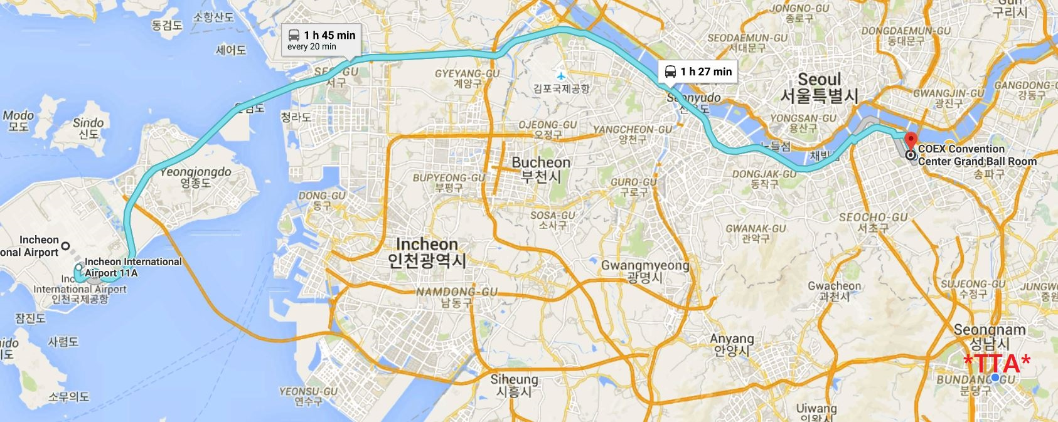

Wireless LAN & Electricity
The meeting will be paperless and WiFi will be available. Please make sure you have AC adapters for 220 volts at 60 Hz. (plug type C & F). Voltage converters will not be provided at the meeting place.

 (Type C)  (Type F)
Meals
- Individuals are responsible for their own breakfast, lunch and dinner arrangements
- There are many restaurants in the vicinity of TTA

Invitation letter
- Entry visa may be necessary for participants from some countries to enter Korea. To check the visa requirements, please contact the Korean Embassy in your country. Kindly visit the website of Ministry of Foreign Affairs for more details. (click here)
- Those participants who required visa-supporting documents to enter Korea are advised to complete the ANNEX C “INVITATION LETTER REQUEST FORM for VISA” and e-mail the form together with a “copy of their passport (photograph page)” to the TTA (yaeseul.park@tta.or.kr) by no later than 31st July 2018.
- As requirements for visa application may change from time to time, please check with your nearest Korean Embassy before departure.
- Advance submission of applications is recommended.

ANNEX B

Partner Membership Contacts

For information related to the membership of oneM2M Partner and participation in the oneM2M Partnership Project, please find below the relevant contacts:

Partner Membership Contacts
Partner | Contact Person | E-mail
ARIB | Kazuo NAKAMURA | k-nakamura@arib.or.jp
ATIS | Steve BARCLAY | sbarclay@atis.org
CCSA | Shizhuo ZHAO | zhaosz@ccsa.org.cn
ETSI | Karen HUGHES | Karen.Hughes@etsi.org
TIA | Victoria MITCHELL | vmitchell@tiaonline.org
TSDSI | Bindoo SRIVASTAVA | bindoo@tsdsi.org
TTA | Peter KIM | pjk@tta.or.kr
TTC | Mitsuru YAMADA | yamada@s.ttc.or.jp

ANNEX C

INVITATION LETTER REQUEST FORM for VISA

For those who require VISA to visit Korea, please fill out below information completely and send it along with a photocopy of your passport to the contact person below no later than 31st July 2018. TTA will provide you with the invitation letter for your visa processing. (TTA does not provide visa services.)

PLEASE VERIFY THAT ALL INFORMATION IS ACCURATE AND WILL BE VALID AT THE TIME OF THE EVENT.
**Late submission will NOT be processed. **
First name
Last name
Gender
Birth date (dd/mm/yy)
Passport number
Nationality
Company
Position
Mailing address
Postal Code
E-mail address
Phone number
Arrival Date
Departure Date
Please contact the Korean Embassy at your country for further information.
https://www.visa.go.kr/openPage.do?MENU_ID=10101

Contact person for invitation letter request form:
Yaeseul (Angela) Park
E-mail: yaeseul.park@tta.or.kr
Tel: +82.31.780.9090

