Invitation to oneM2M TP 39
2019-02-18 to 2019-02-22 in the NH Hotel, Málaga, Spain

Dear Sir/Madam,
In the context of the EU-funded project “International Digital Cooperation - ICT Standardisation” (InDiCo), ETSI is pleased to invite you to the 39th meeting of the oneM2M Partnership Project.

ETSI is implementing the InDiCo project, which is part of an action launched by the Service for Foreign Policy Instrument (FPI) of the European Commission, working with DG CONNECT and the European External Action Service (EEAS). This action aims at strengthening European cooperation with identified actors regarding the development of open international ICT standards in the area of the IoT, 5G, Cloud computing, Big Data and Cyber Security and other priority topics (e.g. Intelligent Transport Systems, Distributed Ledger Technologies). The project is contributing to this objective by supporting the oneM2M Partnership Project in hosting a Technical Plenary meeting in Spain, with a view to stimulate participation of European players in this global standardisation activity.

Further information on the InDiCo project will be provided during the meeting.
Meeting Location | oneM2M Meeting Contact
NH Málaga  Calle San Jacinto, 2  29007 Málaga, Spain  T. +34 95 2071323  nhmalaga@nh-hotels.com | Contact Name  Elisabetta Comin  T:+33 492 944 255  Elisabetta.comin@etsi.org

Meeting Schedule
Monday | 08:30 to 17:30
Tuesday | 08:30 to 18:30
Wednesday | 08:30 to 18:30
Thursday | 08:30 to 18:30
Friday | 08:30 to 17:30

Meeting Registration
Please register for the meeting on the oneM2M portal by loging in to the portal and going to the Meeting tab. Click on the “R” for registration next to the TP 39 meeting

If you do not already have a oneM2M portal account please apply by going to the oneM2M portal: http://Member.oneM2M.org and request a username and password using the link on the bottom left of the home page (Get login ID).

Please register as soon as possible in order to ensure a place as meeting space is limited. Late registrations will be allowed if space permits. We look forward to seeing you in Málaga.

Yours sincerely,

On behalf of ETSI,
Luis Jorge Romero
Director General
On behalf of InDiCo,
Xavier Piednoir
Project Manager
ANNEX A
Useful Information for the meeting

Travel from Malaga airport to NH Hotel (city center)

From the airport it is a 25-minutes journey by car to NH Hotel.
Taxi cost is 15€-25€. Uber also available.
Trains are available every 20 min ( https://www.aeropuertodemalaga-costadelsol.com/transportation/train-to-airport.htm), “Centro-Alameda” is the closest train station (5 minutes walk from the hotel).

HOTELS IN MALAGA CITY CENTER

Hotel NH Málaga****
Located in city center, close to the historic and commercial area, in front of “El Corte Inglés” shopping center.
Address: CalleSan Jacinto 2, 29007
Tel. (+34) 95 207 13 23 -Fax: (+34) 95 239 38 62
http://www.nh-hoteles.es/hotel/nh-malaga

NH Hotel offers negotiated accommodation rates, as follows (prices VAT incl.):
- Standard Double, single occupancy: 125,40€ per night (bed and breakfast)
- Standard Double, double occupancy: 138,60€ per night (bed and breakfast)
Should you wish to book at NH Hotel Malaga, please fill in the “Hotel Reservation Form” on the last page.
The cut-off date for the offer is 28th January 2019.

AC Hotel Málaga Palacio by Marriott****
Located in a beautiful spot in the heart of the city center, beside the Cathedral, with views of the harbor and the marina. It has a terrace on the top open all year long.
Address: Cortina del Muelle, 1 -Málaga
Tel: (+34) 952 21 51 85 -Fax: (+34) 952 22 51 00
Email for reservations: reservas.mpalacio@ac-hotels.com
http://www.marriott.com/hotels/travel/agpmg-ac-hotel-malaga-palacio/

Hotel Molina Lario****
Right in front of the Malaga Palacio hotel, this design hotel has one of the best summer terraces with views and atmosphere of the city.
Address: Molina Lario, 20-22 -Málaga
Tel. (+34) 95 206 20 02 -Fax: (+34) 95 206 20 01
Email for reservations: recepcionml@galleryhoteles.com
http://www.hotelmolinalario.com/en

Hotel RoomMate Larios****
Boutique design hotel, located in the most emblematic street of Malaga, in the heart of the city.
Address: C/ Marqués de Larios, 2, 29005 -MálagaTel. (+34) 952 22 22 00 -Fax. (+34) 952 22 24 07
Email for reservations: larios@room-matehotels.com
http://larios.room-matehotels.com/

Hotel Room Mate Valeria****
Design hotel in Plaza de la Marina, in the heart of the city with views of the sea and the port of Malaga.
Plaza del Poeta Alfonso Canales, 5, 29001 -MálagaTel. (+34) 952 060 401
Email for reservations : valeria@room-matehotels.com
https://room-matehotels.com/es/valeria/

Other hotels close to meeting location:

Hotel Ibis Malaga Centro Ciudad
Hotel Ibis Budget Malaga Centro
Hotel Novotel Suites Malaga Centro

RESTAURANTS NEARBY (less than 10 min walk)

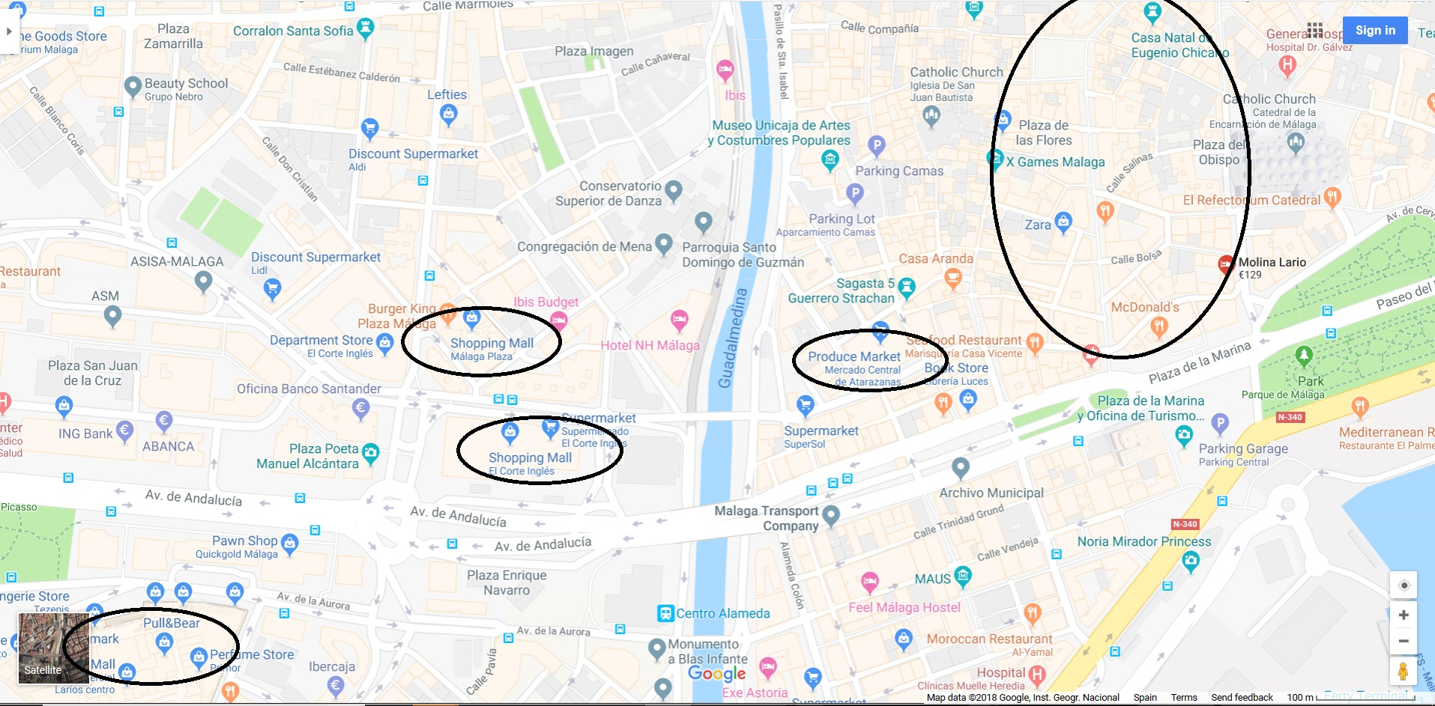

GENERAL INFORMATION

MALAGA AIRPORT
http://www.aena.es/en/malaga-airport/index.html

Avda. Garcia Morato, s/n
290004 -Malaga
Tel. (+34) 952 048 484 - Arrivals (+34) 952 048 838 - Departures: (+34) 952 048 804
servicios_aeropuertuarios@aena.es
Centro de Información: (+34) 913 211 000

Useful Infos
http://www.andalucia.com/travel/airports/malaga/train-station.htm
http://andalucia.com/travel/airports/malaga/train-station.htm

TAXI: (+34) 952 33 33 33
EMERGENCIES:112 POLICE: 092

Invitation letter
Delegates who require a personal invitation letter for their visa application are requested to contact Karen Hughes (karen.hughes@etsi.org).

Meeting facilities
- Meeting room access Times:
  - Morning opening: 08:30
  - Evening closing: 18:30
- Registration: Monday morning at 08:30
- Power sockets (http://www.worldstandards.eu/electricity/plugs-and-sockets/ )

Catering

Two coffee breaks will be provided.

Lunches and evening meals are not provided, however there are restaurants and cafes a short walk from NH Hotel.

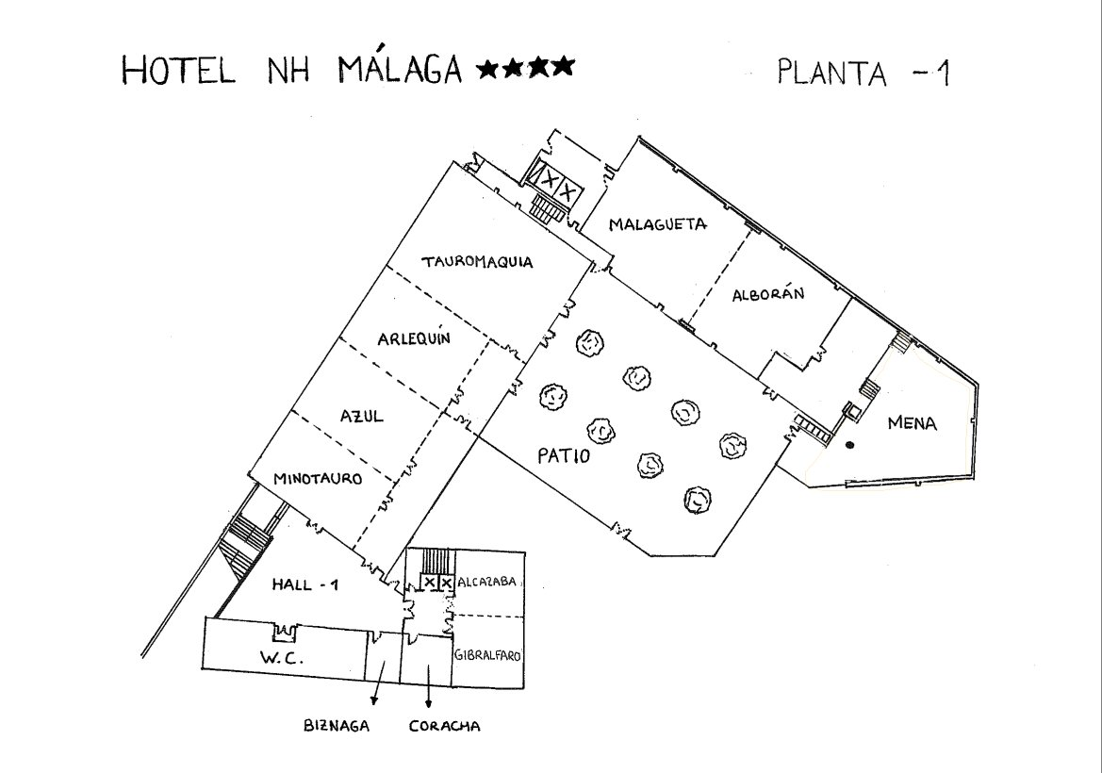

HOTEL RESERVATION FORM: Hotel NH Malaga

Please complete this form and return it, either by fax to +34 95 239 38 62 or by email to nhmalaga@nh-hotels.com.

(ETSI) - “ONEM2M February 18-22”
Date of arrival

Date of Departure

Number of nights

Room type required

Title

Surname

First Name

Company

Mailing address

Telephone

Fax

Email

Credit card type

Credit card number

Name on card

Expiry date

Signature

Date

Cancellation Policies:
- Free up to 15 days prior to arrival date
- 1-night expense from 14 to 7 days prior to arrival date
- Non-refundable from 6 days prior to arrival date

