Invitation to the 45th oneM2M Technical Plenary (TP45) Meeting

20~24 April 2020,
Jeju, Korea

Dear Sir/Madam,

TTA is pleased to invite you to the 45th oneM2M Technical Plenary (TP45) meeting. Please see below for the meeting logistics and details associated with TP45.
Meeting Location
Jeju Shinhwa World
8 Sinhwayeoksa-ro 304 beon-gil, Andeok-myeon Seogwipo-si,
Jeju, Korea
Web: https://www.shinhwaworld.com/

Anticipated TP Meeting Schedule |  |  |  | oneM2M Meeting Contact
20 April 2020 – Mon | TP45 & WGs | 09:00 – 18:00 |  | Peter J. Kim  Chief Researcher, TTA Stadardization Division  Tel: +82.31.780.9084  Mobile: +82.10.5111.1078  Email: pjk@tta.or.kr
21 April 2020 – Tue | TP45 & WGs | 09:00 – 18:00
22 April 2020 – Wed | TP45 & WGs | 09:00 – 18:00
23 April 2020 – Thu | TP45 & WGs | 09:00 – 18:00
24 April 2020 – Fri | TP45 & WGs | 09:00 – 18:00

Meeting Registration
Please register for the meeting on the oneM2M portal if you have an oneM2M portal account. Alternatively, login to the portal, go to the Meeting tab and click on the “R” for registration next to the TP45 meeting.

If you do not have a portal account please apply at http://Member.oneM2M.org (“Get Login ID” link - left of the home page).

Please register as soon as possible to ensure appropriate preparation of the meeting.
I look forward to seeing you in Jeju Korea.

Yours sincerely,
Kyoung Cheol KOO
VP of TTA

ANNEX A

Meeting Location and Logistics Information

Meeting Location: | Jeju Shinhwa World Landing Convention Center  8 Sinhwayeoksa-ro 304 beon-gil, Andeok-myeon Seogwipo-si, Jeju, Korea  Tel: +82-64-908-8800  Resort Website: https://www.shinhwaworld.com/
Hotel Reservations: | TTA has negotiated sleeping room rate at the following hotels which are all located within the Shinhwa World resort;  Hotel Name Room types* Discounted Rate**  Jeju Shinhwa World Landing Resort Superior Room(King/Twin), Deluxe Family Twin From 100,000 KRW  Jeju Shinhwa World Shinhwa Resort Superior Room(King/Twin), Deluxe Room(King/Twin), Deluxe Family Twin From 120,000 KRW  Jeju Shinhwa World Marriott Resort Deluxe Room(King) From 198,000 KRW  Somerset Jeju Shinhwa World Family Suite From 220,000 KRW  *Check for further room details at the time of check-in.  **Tax and Svc charge will be added at the time of check-out.  Individuals will need to book their own rooms using Jeju Shinhwa World special room rate at the following link: http://bitly.kr/DTjEVhs1

Logistics information

Hotel Location

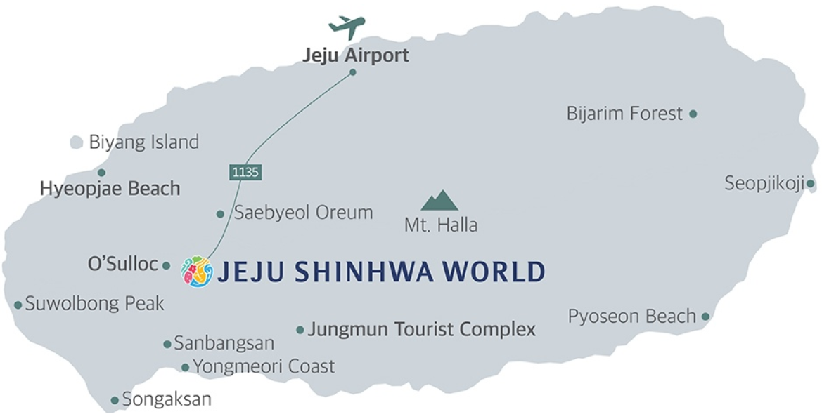

Jeju Airport to hotel shuttle service

You must present your hotel booking confirmation(mobile or print) to board the shuttle for FREE.

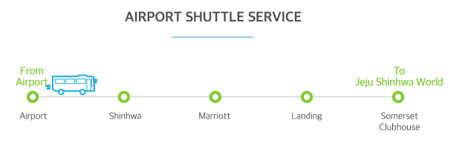

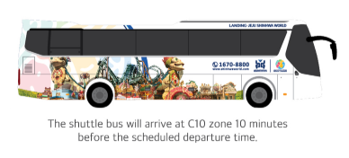
Bus graphic maybe different depending on the season. Look for ‘Jeju Shinhwa World’ on the side of the bus.

Airport Shuttle Schedule

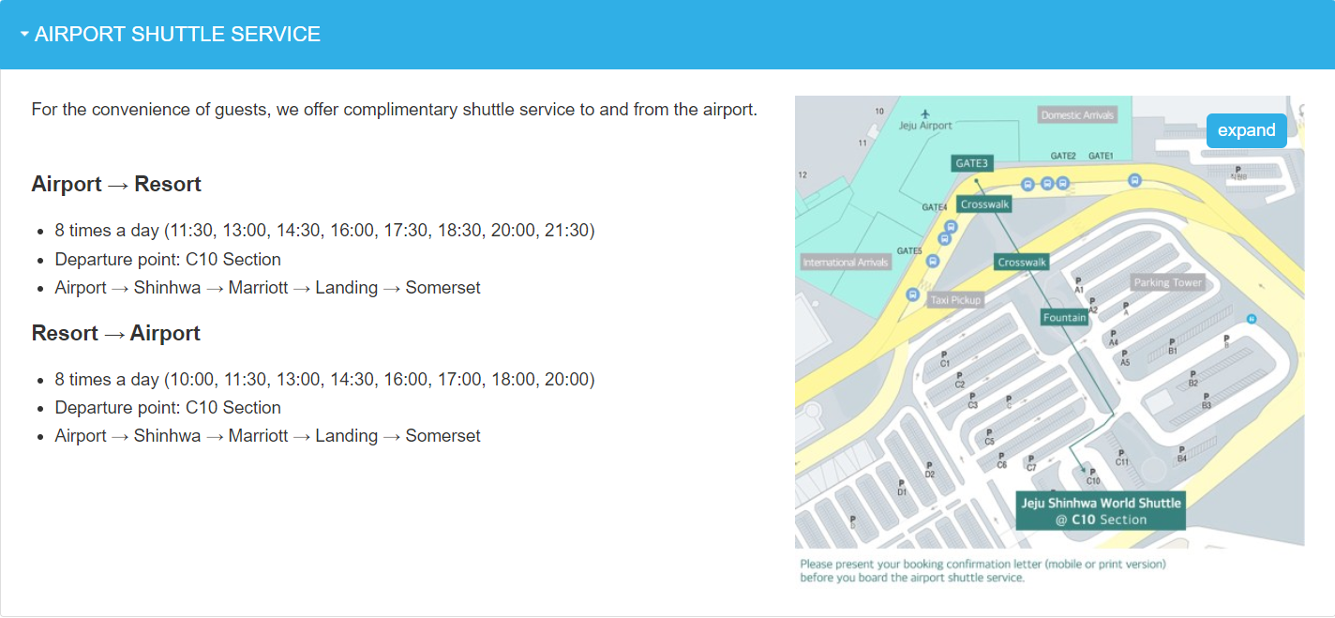

※You can also take taxi or public bus. Please check the hotel website for details.

Jeju Shinhwa Resort Hotel Layout

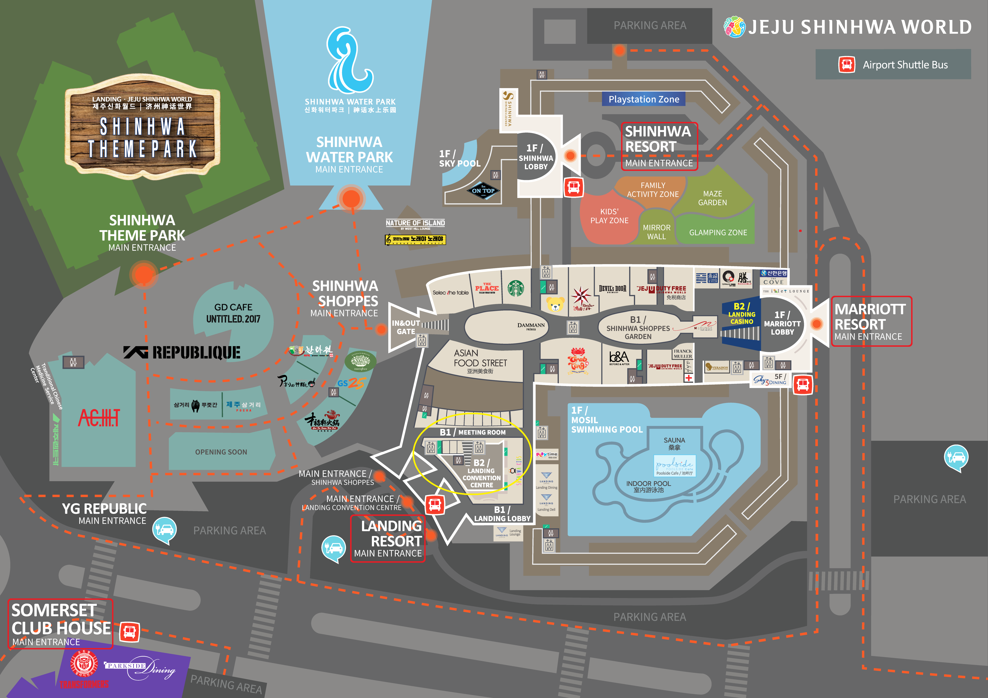

Meeting Rooms (Landing Convention Cener Floorplan)

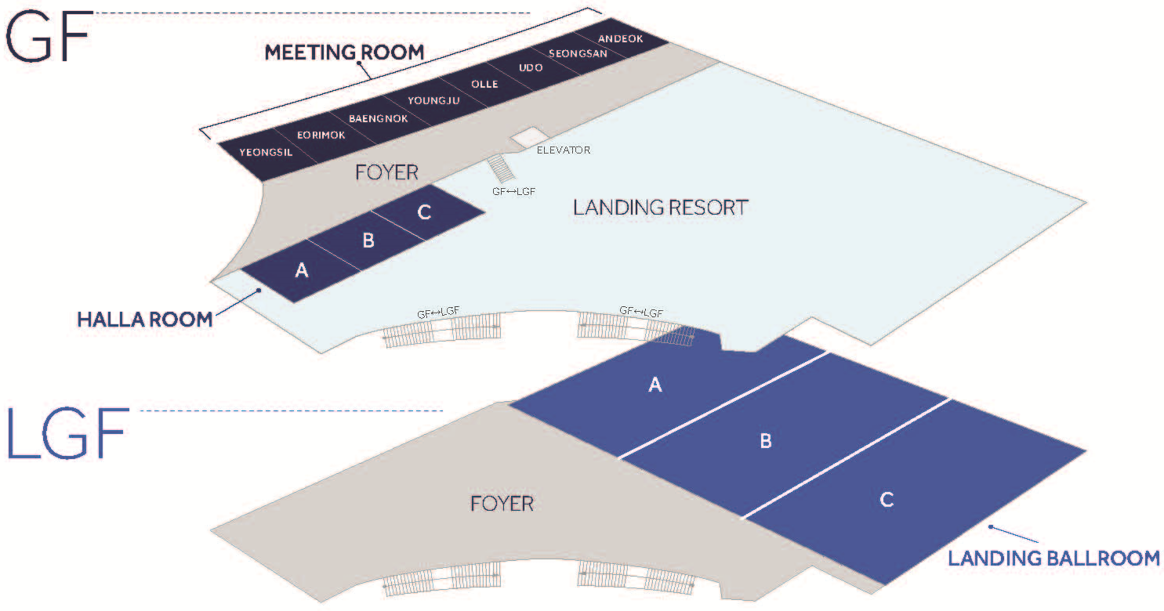
Halla Room A&B (TP & WGs)

Practical Information

General information about Jeju Island.
- Jeju Tourist Information Center

Wireless LAN & Electricity
- The meeting will be paperless and WiFi will be available. Please make sure you have AC adapters for 220 volts at 60 Hz. (plug type C & F).
- Voltage converters will not be provided at the meeting place.
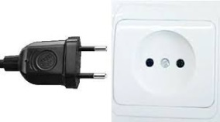 (Type C) (Type F)

Weather
- April in Jeju is typically the 6th coldest month of the year. Daytime maximum temperatures average around a cool 16°C (60°F), whilst at night 7°C (45°F) is normal.

Time Zone
- Korean Standard Time (GMT+9)

Currency & Exchange
- Korean currency unit is KRW (indicated as ￦). Bank notes are ￦50,000, ￦10,000, ￦5,000, ￦1,000 bills and coin denominations are ￦500, ￦100, ￦50, ￦10.
- Most shops and restaurants accepts VISA and Mastercard credit cards.
- Participants are requested to check with local banks or financial services for latest rates. Information is also available at https://www.xe.com/currencyconverter/convert/?Amount=1&From=USD&To=KRW

Meals
- Individuals are responsible for their own breakfast, lunch and dinner arrangements
- There are many restaurants within the Shinhwa World Resort

Emergencies
- 119 for Fire and Medical emergencies
- 112 for Police

Invitation letter
- Entry visa may be necessary for participants from some countries to enter Korea. To check the visa requirements, please contact the Korean Embassy in your country or visit the website of Ministry of Foreign Affairs for more details as requirements for visa application may change. (click here)
- Participants who required visa-supporting documents to enter Korea are advised to complete the ANNEX C “INVITATION LETTER REQUEST FORM for VISA” and e-mail the form together with a “valid copy of their passport (photograph page)” to TTA (pjk@tta.or.kr) by “no later than 15th March 2020”.
- Advance submission of applications is highly recommended as it may take few weeks for the embassy to process your visa request.
- By default, visa invitation letters will be issued via e-mail.

ANNEX B

Partner Membership Contacts

For information related to the membership of oneM2M Partner and participation in the oneM2M Partnership Project, please find below the relevant contacts:

Partner Membership Contacts
Partner | Contact Person | E-mail
ARIB | Kazuo NAKAMURA | k-nakamura@arib.or.jp
ATIS | Steve BARCLAY | sbarclay@atis.org
CCSA | Shizhuo ZHAO | zhaosz@ccsa.org.cn
ETSI | Karen HUGHES | Karen.Hughes@etsi.org
TIA | Victoria MITCHELL | vmitchell@tiaonline.org
TSDSI | Bindoo SRIVASTAVA | bindoo@tsdsi.org
TTA | Peter KIM | pjk@tta.or.kr
TTC | Masaomi Sumita | sumita@s.ttc.or.jp

ANNEX C
INVITATION LETTER REQUEST FORM for VISA
For those who require VISA to visit Korea, please fill out below information completely and send it along with a valid photocopy of your passport to the contact person below no later than 15th March 2020. TTA will provide you with the invitation letter for your visa processing. (TTA does not provide visa services.)

PLEASE VERIFY THAT ALL INFORMATION IS ACCURATE AND WILL BE VALID AT THE TIME OF YOUR ENTRY TO KOREA.
**Late submission will NOT be processed. **

First Name (Given Name)

Last Name(Family Name)

Gender

Birth date (DD/MM/YYYY)

Passport number

Passport Issue Date

Passport Expire Date

Expected Travel Dates(DD/MM - DD/MM)

Nationality

Company Name

Position (Title)

Mailing Address

City, State/Province, Country

Postal Code

E-mail Address

Phone Number

Fax Number
Please contact the Korean Embassy at your country for further information.
https://www.visa.go.kr/openPage.do?MENU_ID=10101

Contact person for invitation letter request form:
Peter J. Kim
E-mail: pjk@tta.or.kr
Tel: +82.31.780.9084

