Input Contribution
Meeting ID* | TST 27.1
Title:* | TS-0019-Abstract Test Method - Upper Tester Control Message Format
Source:* | Ting Martin Miao, KETI, martin.miao@keti.re.kr  Abdullah Aziz, Sejong University, G2016FFM082@sju.ac.kr  JaeYoung Hwang, Sejong University, forest62590@sju.ac.kr
Uploaded Date:* | 2017-03-08
Document(s)  Impacted* | TS-0019
Intended purpose of  document:* | Decision  Discussion  Information  Other <specify>
Decision requested or recommendation:*
Template Version:23 February 2015 (Dot not modify)

oneM2M Notice
The document to which this cover statement is attached is submitted to oneM2M. Participation in, or attendance at, any activity of oneM2M, constitutes acceptance of and agreement to be bound by terms of the Working Procedures and the Partnership Agreement, including the Intellectual Property Rights (IPR) Principles Governing oneM2M Work found in Annex 1 of the Partnership Agreement.

Introduction
This contribution proposes definitions of upper tester control message format to standardize the format of triggering messages that are used in communication exchange between TTCN-3 Test System and the System Under Test (ADN-AE).

-----------------------Start of change 1--------------------------------------------

5 Abstract Test Method (ATM)

5.4 Ports and ASPs (Abstract Services Primitives)
The oneM2M ATS implements four ports:
- The mcaPort
- The mccPort
- The acPort
- The utPort

5.4.1 mcaPort and mccPort
These ports are used to send and receive the following message sets;
- Request Primitives messages in accordance with oneM2M TS-0004 standard [2].
- Response Primitives messages in accordance with [2].
Two primitives are currently defined for these two ports indicated as Table 1:
- The M2MRequestPrimitive - to send or receive oneM2M messages to/from the IUT. Depending on the IUT to be tested:
  - If the IUT is an AE, these messages are either received or sent by the tester which is associated with the CSE role through the mcaPort.
  - If the IUT is a CSE, these messages are either sent by the tester when it plays the AE role through the mcaPort or received by the tester when it plays the CSE role through the mccPort.
- The M2MResponsePrimitive - to send or receive oneM2M messages to/from the IUT. Depending on the IUT to be tested:
  - If the IUT is an AE, these messages are either sent or received by the tester which is associated with the CSE role through the mcaPort.
  - If the IUT is a CSE, these messages are either sent by the tester when it plays the CSE role through the mccPort or received by the tester when it plays the AE role through the mcaPort.
Both primitives contain another parameters that permits to dynamically configure the test adaptor for every single sending. These parameters are:
- Host: IP address of the IUT
- XML Namespace
- Protocol binding
- Serialization
Table 1 Mapping of TTCN-3 Primitives to oneM2M Service Primitives
TTCN-3 Primitive | oneM2M Message | Direction | IUT
M2MRequestPrimitive | Request Primitive | ←  → | AE
M2MRequestPrimitive | Request Primitive | →  ← | CSE
M2MResponsePrimitive | Response Primitive | →  ← | AE
M2MResponsePrimitive | Response Primitive | →  ← | CSE

5.4.2 utPort

5.4.2.0 Introduction
The utPort has been included in the oneM2M ATS in order to be able to stimulate the IUT and receive extra information from IUT upper layers. The utPort can be applied to automated AE testing shown as section 5.4.2.1.
Editor’s Note: The utPort can also be provided for future extension.

5.4.2.1 Usage for Automated AE Testing
The utPort can be used to implement the automated AE testing when SUT is an AE.
The utPort is in charges of the communication between TTCN-3 Test Component module in Test Sytem and the Upper Tester Application in SUT.
Functionalities that TTCN-3 Test Component module and the Upper Tester Application are required to implement are listed as following:
- Both the TTCN-3 Test Component module and the Upper Tester Transport module open a utPort respecitively to buildd a upper tester transport link between each other;
- TTCN-3 Test Component is able to configure the Test System and send (standardized) triggering commands to the SUT (Upper Tester Application);
- Upper Tester Application can process the triggering command messages received from Test System (TTCN-3 Test Component) and stimulates IUT to act following the corresponding triggering command i.e. sending oneM2M service primitives to Test System through port mca.
Primitives defined for utPort are listed as following:
- The UtStart primitive used to initialize IUT.
- The UtTrigger primitive used to trigger upper layer events in IUT i.e. sending oneM2M service primitives to Test System through mca port.
- The UtStartResult primitive used to receive responses from upper layer result of initialization in IUT.
- The UtTriggerResult primitive used to receive responses from upper layer result of triggering event in IUT.
Editor’s Note: The format of primitives defined for utPort is supposed to be defined here in the future.
The Upper Tester Application in SUT (AE) can be implemented as an embedded source code within an AE. An example for implementation of automated AE test for Registration is shown as Figure Y.

SUT

TEST SYSTEM

TTCN-3 Test Component
-

CSE

Upper Tester Application

IUT (AE)

Stimulate Registration

Stimulate Container Create

Registration

Container Create

Trigger Registration

Function call

utPort

utPort

mcaPort

mcaPort

Ut

Mca

Figure Y. An example for automated AE test for Registration

.5.4.2.2 Upper Tester Control Message Format

5.4.2.2.1 Introduction
The upper tester control messages are used by utPort for communication exchange between TTCN-3 Test System (hereafter short for TS) and the Upper Tester (hereafter short for UT) in the System Under Test using UDP/TCP connection. A list of control message types that can be used by utPort includes but not limit to:
- Initiate command that is used by TS to switch on the IUT with the “initial state”.
- Trigger command initialized by TS to send a triggering message including profile relevant information to the UT to execute specific tasks.
- Teminate command that is TS sends close communication notification to the IUT to terminate all communication exchange between each other.
Each control message type maps to particular message formats for exchanging data and those message formats are defined by TTCN-3 primitives such as UtStart, UtStartResult, UtTrigger primitive. Details for the definition of those primitives are to be introduce in section 5.4.2.2.2. A mapping between the upper tester control message type to TTCN-3 primitives are defined as table 5.4.2.2.1-1.
Table 5.4.2.2.1-1 Mapping of TTCN-3 Primitives to oneM2M Service Primitives
Upper Tester Control  Message Type | TTCN-3 Primitives | Direction
Upper Tester Control  Message Type | TTCN-3 Primitives | TS | UT
Initiate | UtStart Primitive | →
Initiate | UtStartResult Primitive | ←
Trigger | UtTriggerPrimitive | →
Terminate | UtTerminate Primitive | →
Terminate | UtTerminateAck Primitive | ←
Editor’s Note: Additional upper tester control message types might be added later to implement additional functionalities in utPort.

5.4.2.2.2 Control Message Format
The upper tester control message type are stored using one Byte (eight bits) and all integer values are encoded in little-endian byte order (least significant byte first) shown as Figure 5.4.2.2.2-1 and the interger value of each control message is defined at table 5.4.2.2.2-1.
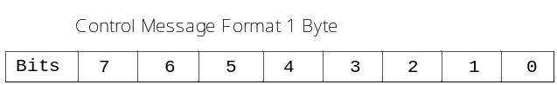
Figure 5.4.2.2.2-1 Control message type format

Table 5.4.2.2.2-1 Upper Tester Control Message Type Value
Control Message Type | Value\Bit | 7 | 6 | 5 | 4 | 3 | 2 | 1 | 0
INNITIATE | 0x00(0) | 0 | 0 | 0 | 0 | 0 | 0 | 0 | 0
TRIGGER | 0x01(1) | 0 | 0 | 0 | 0 | 0 | 0 | 0 | 1
TERMINATE | 0x02(2) | 0 | 0 | 0 | 0 | 0 | 0 | 1 | 0

5.4.2.2.3 Control Communication Protocol
Protocol used for proceeding communications between TS and Upper Tester Application is designated to the Hypertext Transfer Protocol (HTTP) protocol owning it is an application protocol that is widely supported by most all IoT devices and various intrinsic features such as persistent connection, ease of programming, flexibility etc.

5.4.2.2.3 Control Message Serialization
Control commands that are wrapped within a request body of HTTP message shall be serialized into JavaScript Object Notation (JSON) because it is very lightweight and easy to parse and generate for machines.
The UtStartResult Primitive and UtTriggerPrimitive shall be serialized into a JSON format before transporting in HTTP message for exchanging the control commands between TS and Upper Tester Application.

-----------------------End of change 1--------------------------------------------

-----------------------Start of change 2--------------------------------------------

5.4.2.2.2 Common Upper Tester Control Primitives

A.1. UtStart and UtStartResult Primitive
UtStart primitive is defined as a request primitive that is initialized by Test System containing initiate command to a target IUT and the UtStartResult primitive is used when the IUT sends back a response as a result of the Initiate request, which includes the IUT initiate status information and one (or a set of ) feature(s) information that the IUT supports. The feature set information included in the UtStartResult primitive will be refered by the Test System to send a Trigger primitive where includes a particular testcase mapped to one feature.
Sending UtStart messge is the fundamental to send Trigger and/or Terminate message to the IUT.
The message flow is shown in Figure A.1-1 and the field values defined in UtStart and UtStartResult primitives are encoded in little-endian byte order (least significant byte first) as depicted in Figure A.1-2 and A.1-3.
Table A.1-1 lists a mapping table that maps each field of UtStart and UtStartResult primitive to oneM2M data types.
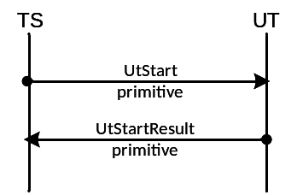
Figure A.1-1 Initiate message flow
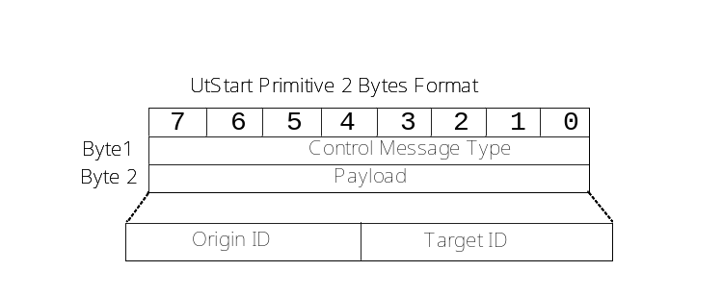
Figure A.1-2 UtStart primitive format
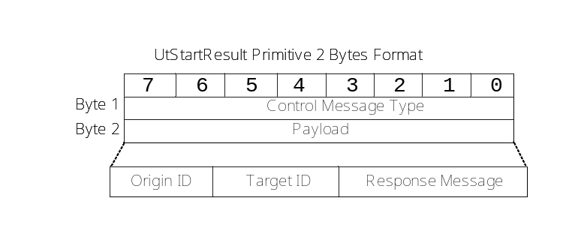
Figure A.1-3 UtStartResult primitive format
Table A.1- Mapping table between each field in UtStart and UtStartResult primitive and oneM2M data types
Field | Mapping to oneM2M data types | Example
Origin ID | Identity of the originator | HTTP X-M2M-Origin header
Target ID | Access address of the destination | Target URI  i.e. http://{IP-address}:{port}
Response Message | Response message including response status code and profile identifier | HTTP 200 (OK)  {  "UtTrigger":{  "FeatureIDs":  [ "CE/REG/00002/00001",  "CE/REG/00002/00002 "]  }  }
*:Refer to defined status summary table for Upper Tester control.

A.2. UtTerminate and UtTerminateAck Primitive
UtTerminate primitive is defined as a request primitive that is initialized by Test System to terminate the control to the connected IUT and then the IUT sends back a UtTerminate primitive including indication information of closed connection and clear all memory data that in use. The UtTerminate message is only effective to IUT when IUT is connected to the Test System.
The message flow is shown in Figure A.2-1 and the field values defined in UtTerminate and UtTerminateAck primitives are encoded in little-endian byte order (least significant byte first) as depicted in Figure A.2-2 and A.2-3.
Table A.2-1 lists a mapping table that maps each field of UtTerminate and UtTerminateAck primitive to oneM2M data types.
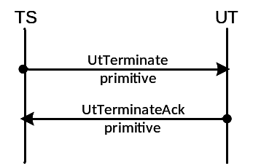
Figure A.2- Terminate message flow
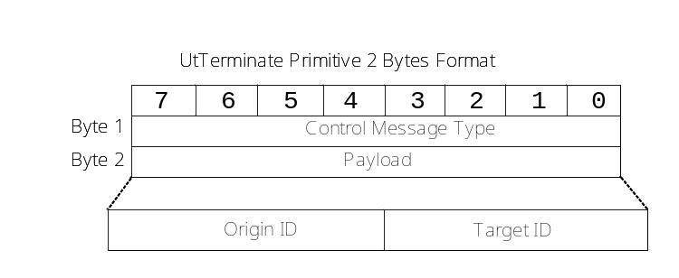
Figure A.2- UtTerminate primitive format
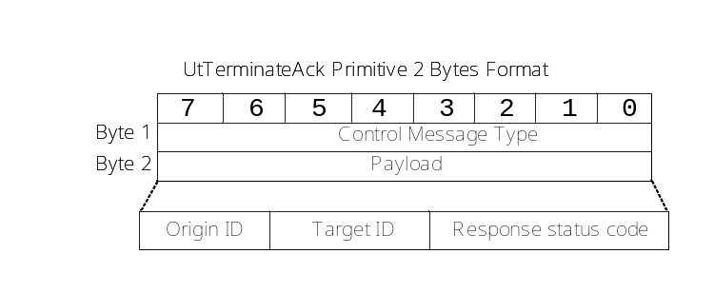

Figure A.2- UtTerminateAck primitive format
Table A.2- Specific attributes of UtTerminate and UtTerminateAck primitive
Field | Description | Data Type | Example
Origin ID | Identity of the originator | xs:anyURI | HTTP X-M2M-Origin header
Target ID | Accessible URI of the destination | m2m:ipv4 (and m2m:ipv6) | http://{IP-address}:{port}
Response Status Code | Response status code* |  | 2000(OK)
Response Status Code | Response status code* | m2m:responseStatusCode | 2000(OK)
Note | *Refer to defined status summary table for Upper Tester control.

A.3. UtTrigger Primitive
UtTrigger primtive is used for triggering progress as depicted as Figure A.3-1. The UtTrigger primitive is initialized by the Test System to send triggering message to the target IUT. The Test System would not expect any response from the Upper Tester Application and rather start waiting to receive oneM2M request primitives from the Upper Tester Application. The payload of Trigger primitive consists of OriginID, TargetID, FeatureID, and TestcaseID four fields, where the FeatureID field value is mapped to the feature ID in TS-0031 [] feature catelog and the TestcaseID maps to a particular single testcase that belongs to the feature category set by the featureID field value.
The triggering primitive is stored using two Bytes, one Byte is to store upper tester control message type and the other one Byte stores the payload indicating the concrete triggering information.
Each field value in Figure A.3-2 and A.3-3 is encoded in little-endian byte order (least significant byte first).
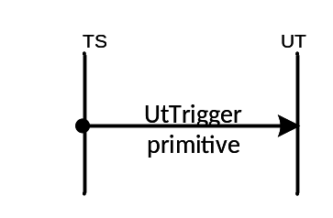
Figure A.3-1 Trigger message flow

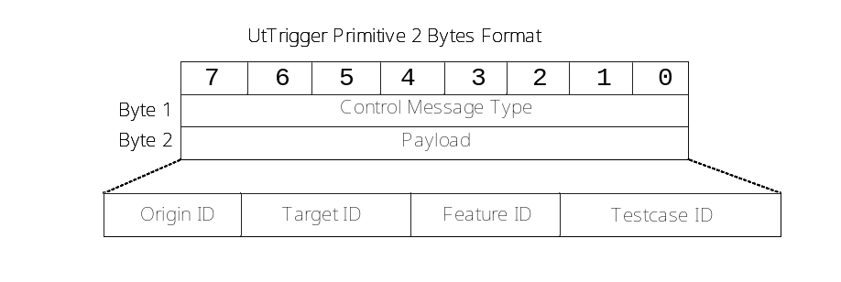
Figure A.3-2 UtTrigger primitive format

Table A.3-1 lists a mapping table that maps each field of UtTrigger primitive to oneM2M data types.
Table A.3- Specific attribuite of UtTrigger primitive
Attribute | Description | Data Type | Example
Origin ID | Identity ID of the originator | xs:anyURI | HTTP X-M2M-Origin header
Target ID | Accessible URI of the destination | m2m:ipv4 (and m2m:ipv6) | 10.125.0.0/16  (and abcd:ffff:abb0:aaaa::/64)
Feature IDs | Feature IDs that are refered to a list of features in oneM2M feature catalog | m2m:listOfURIs | CE/REG/00002/00001 CE/REG/00002/00002
Testcase ID | Testcase ID that maps to Feature ID category | xs:anyURI | TP/oneM2M/CSE/REG/BV/001

Appendix:
Summary of Response Status Code for control messages
Response Status Code | Status Message | Interpretation | References
2005 | INNITIALIZED | The targeted IUT is connected to and initialized by the Test System | NA
2006 | TERMINATED | The target IUT is terminated and released from the control of Test System. | NA
4007 | CONNECT_ERROR | Connection error | NA
4008 | REQUEST_TIMEOUT | Reques timeout error | TS-0004[]
5000 | INTERNAL_SERVER_ERROR | Internal server error | TS-0004[]
5103 | TARGET_NOT_REACHABLE | Target not reachable | TS-0004[]
… | … | … | ...
Editor’s Note: The table will be updated later!

-----------------------End of change 2--------------------------------------------

