Input Contribution
Meeting ID* | RDM 43
Title:* | Industrial Domain Ontology Mapping
Source:* | Chengsui Lu, Hitachi, cslu@hitachi.cn
Date:* | 2019-12-2
Input related to* | WI-0075 Industrial Domain Information Model Mapping & Semantics Support  TR-0049 Industrial Domain Information Model Mapping & Semantics Support
Intended purpose of  document:* | Decision  Discussion  Information  Other <specify>
Impacted other TS/TR(s) | <TS/TR number>, <Version Number>, and <Description on which aspect should be reflected in this TS/TR>
Decision requested or recommendation:* | To agree on the industrial domain ontology mapping solution between OPC-UA Information Models and oneM2M Base Ontologies.
Template Version: January 2017 (Do not modify)

oneM2M Notice
The document to which this cover statement is attached is submitted to oneM2M. Participation in, or attendance at, any activity of oneM2M, constitutes acceptance of and agreement to be bound by terms of the Working Procedures and the Partnership Agreement, including the Intellectual Property Rights (IPR) Principles Governing oneM2M Work found in Annex 1 of the Partnership Agreement.

8.2 Semantics support by oneM2M
Editors’ note: This sub-clause studies how advanced semantics features in oneM2M e.g. data annotation could enable the industrial domain.

-----------------------Start of Change 1-------------------------------------------
To support semantics features, e.g. semantic reasoning, semantic mashup, etc., in the industrial domain, we try to map OPC-UA IMs [i.5] to oneM2M Base Ontologies [i.13] represented as OWL file according to the definition of each IM and ontology, as shown in Table 8.2-1.
In general, OPC-UA Object should be corresponded to oneM2M Device, similarly as in the subclause 8.1.1.
By the same manner, OPC-UA ObjectType should be mapped to oneM2M Thing, which is a superclass of Device.
Note that OPC-UA ReferenceType is suggested to map with hasThingRelation, that is one of Object Properties of Thing.
There is no oneM2M Base Ontology to match with OPC-UA View, but View could be mapped to the mashup of a group of hasThingRelation.
Besides, OPC-UA VariableType should be mapped to oneM2M VariableConversion, and OPC-UA DataType would be mapped to oneM2M Variable. Furthermore, OPC-UA Variable is mapped as oneM2M MetaData.
Moreover, OPC-UA Method should be mapped to oneM2M Service, which could hasOperation and ExposesFuntion.
Table 8.2-1: Mapping Principle between OPC-UA IMs and oneM2M Base Ontologies
OPC-UA IM | oneM2M Base Ontologies
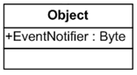 | 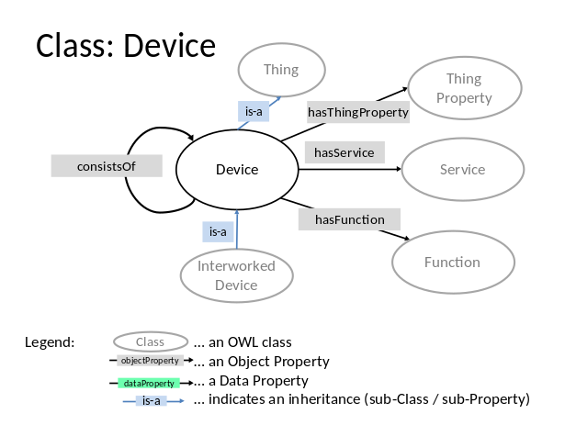
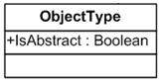 | 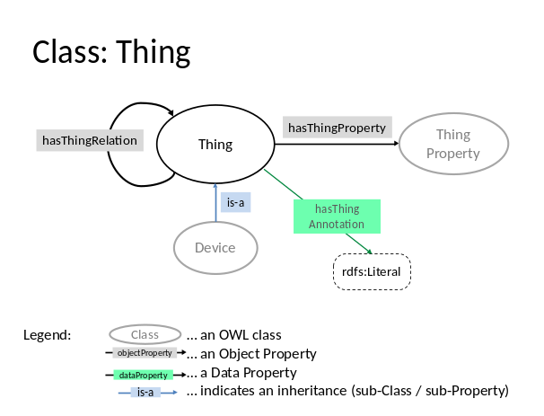
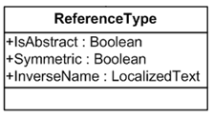 | Thing Object Properties: hasThingRelation
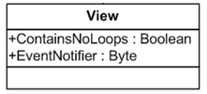 | Mashup of hasThingRelation of Thing Object Properties
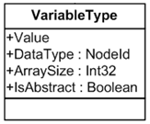 | 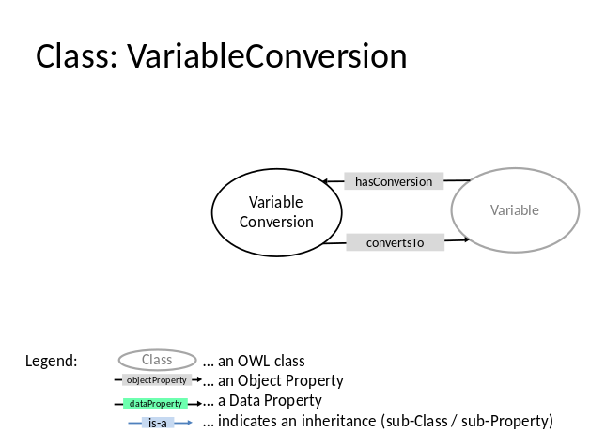
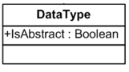 | 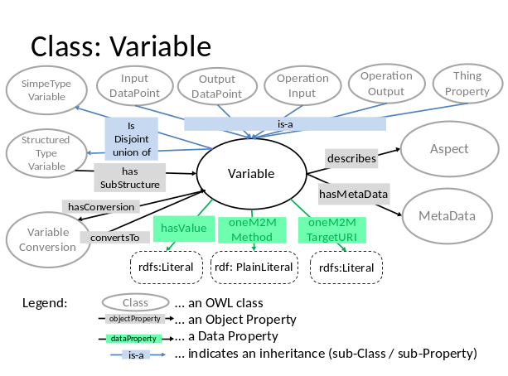
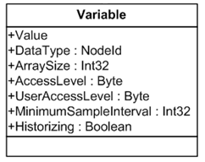 | 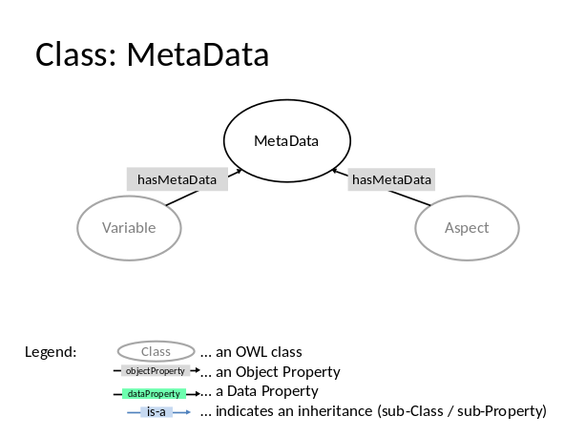
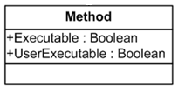 | 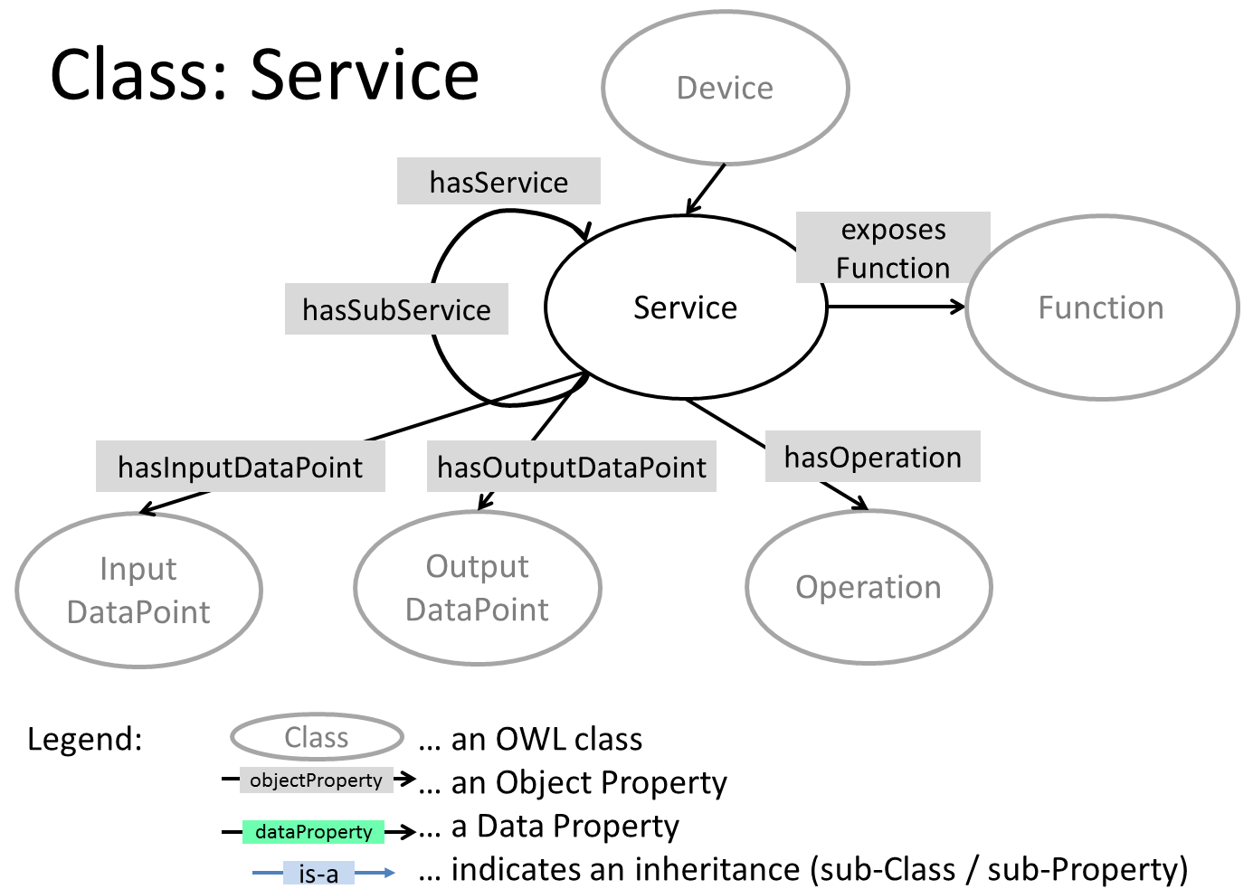

Based on the above mapping principle between OPC-UA IMs and oneM2M Base Ontologies, semantics enhancements could be further enabled, e.g. semantic access control, semantic query, semantic reasoning, etc., as in [i.14] for the industrial domain.

----------------------- End of Change 1-------------------------------------------

-----------------------Start of Change 1-------------------------------------------

2.2 Informative references
[i.13] oneM2M TS-0012: "Base Ontology".
[i.14] oneM2M TS-0030: "Ontology based Interworking".

----------------------- End of Change 1-------------------------------------------

